Luke Pinkham
P151970

Materials & manufacturing report
Polymer Moulded Water Bottle Assembly

Executive Summary

Billions of people worldwide drink or have drank bottled water at some stage during their lives. Large demand for bottled water has resulted in a competitive market full of companies selling their product. The development of a wide range of synthetic thermoplastics have enabled companies to mass produce high volumes of plastic bottles at low costs, enabling rapid distribution of bottled water to retailers, with the aim of maximising profits. The report will analyse the different costs involved in the manufacturing process and explain any variables that may contribute to the final production cost. The competitive UK market for bottled water will be analysed closely, as will the most popular bottled water brands ranked by consumption.

Table of Contents
1. Executive Summary 1
2. Introduction 3
3. History 3
4. Material & Environmental Factors 4
4.1 Material 4
4.2 Recycling 5
5. Manufacturing Process & Brands 6
5.1 Process 6
5.2 Bottled Water Brands UK (2016) 8
6. Summary 9
7. Reference List 10
8. Table of Sources 11

Introduction

The report will identify and justify the material and manufacturing process used for the production of polymer moulded bottle assembly for bottled water. The different types of production processes, process limitations, costs/lead times, functionality of part and product life cycle will all be discussed.
In recent years’ water has undergone a crucial transformation from essential and indispensable necessity for human survival to an economic good linked to market rules, thanks to which the multinational corporations greatly profit (Valentino, 2017). Many would argue water should be unbound from market rules and especially from power, and everyone should be guaranteed the access without discriminations or ties to economic interest (Valentino, 2017). Unfortunately, this is not the case, resulting in a huge demand globally for the mass production of polymer moulded water bottles.

History

In 1662 water is first bottled for sale in the United Kingdom’s Holy Well bottling plant (Hurley, 2016). The practise grows popular with the bottling of mineral spring water across Europe and the US in the 1700s, since the natural springs were believed to have healing and therapeutic effects (Hurley, 2016). Originally bottled water was distributed and sold in glass bottles. The first plastic water bottles were not produced until the early 1970s and were made of polyethylene terephthalate (PET).
Bottled water is simply rain water filtered. Despite this in the early 2000s the tap vs. bottled war fully engaged, with beverage companies playing to consumers fears of illness and contamination from tap sources (Hurley, 2016). In the present day there are high numbers of companies selling bottled water worldwide in a fierce and highly competitive market.
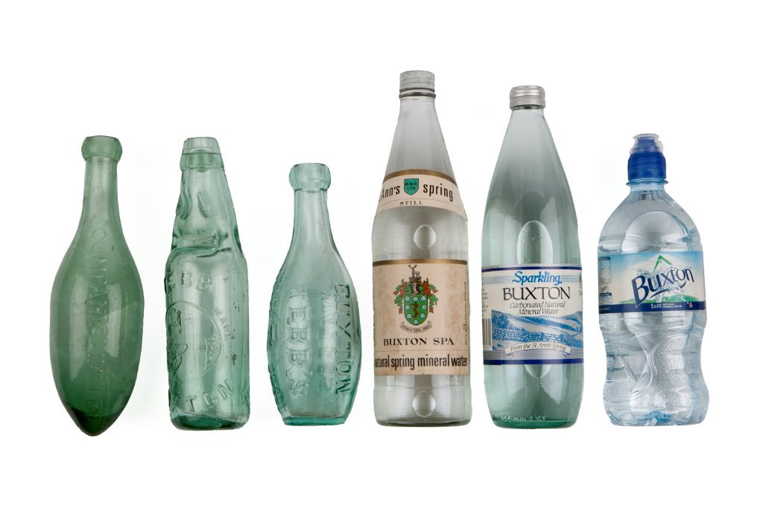Figure 1 – Water Bottles Through Time (Perry, 2017).

Material & Environmental Factors

4.1 Material
The majority of water bottles today are produced using a specific type of plastic or combination of various types, although glass bottles are still used by some companies. As previously mentioned plastic bottled water was not widely used until the early 1970s, a couple of hundred years after the discovery of plastic. In the past plastics were derived from nature; it was not until the 1900s that the production of purely synthetic plastics began (Flint, 2017).
Polyethylene terephthalate (PET), high density polyethylene (HDPE), low density polyethylene (LDPE) polyvinyl chloride (PVC), polycarbonate (PC) and polypropylene can be used in the production of plastic bottles. PET is a thermoplastic polymer that can be either transparent or opaque, depending on the exact material composition (thomasnet, n.d.) PET is widely used in the production of plastic bottles; a lightweight but strong plastic, it is resistant to the effects of damage of chemicals and moisture, also possessing good insulating properties (Flint, 2017). PET is produced from petroleum hydrocarbons through a reaction between ethylene glycol and terephthalic acid (Plastic Bottle Manufacturing, n.d.). To produce plastic bottles, the PET is first polymerized to create long molecular chains (thomasnet, n.d.). HDPE is the most common plastic used for bottle production, mainly because it is impact resistant, has an impressive moisture barrier and is economical. LDPE has identical composition to HDPE, however is less economical. PC is a transparent plastic which is commonly used in the production of water bottles.
Material costs for the production of plastic bottles varies dramatically around the world, mainly due to the differences in raw material costs and energy prices (economist, 2014). The main type of plastic used, polyethylene terephthalate (PET), is made from naphtha, an oil derivative, which can be partly substituted with ethane, a natural-gas derivative. Very little ethane is traded internationally, so only places where natural gas is cheap and abundant use it to make PET (economist, 2014). Naturally different energy costs in countries are also a key factor in determining the final energy costs including gas and electric. Due to the many different combination of polymers used in production, they are readily available and can be recycled at a cost.
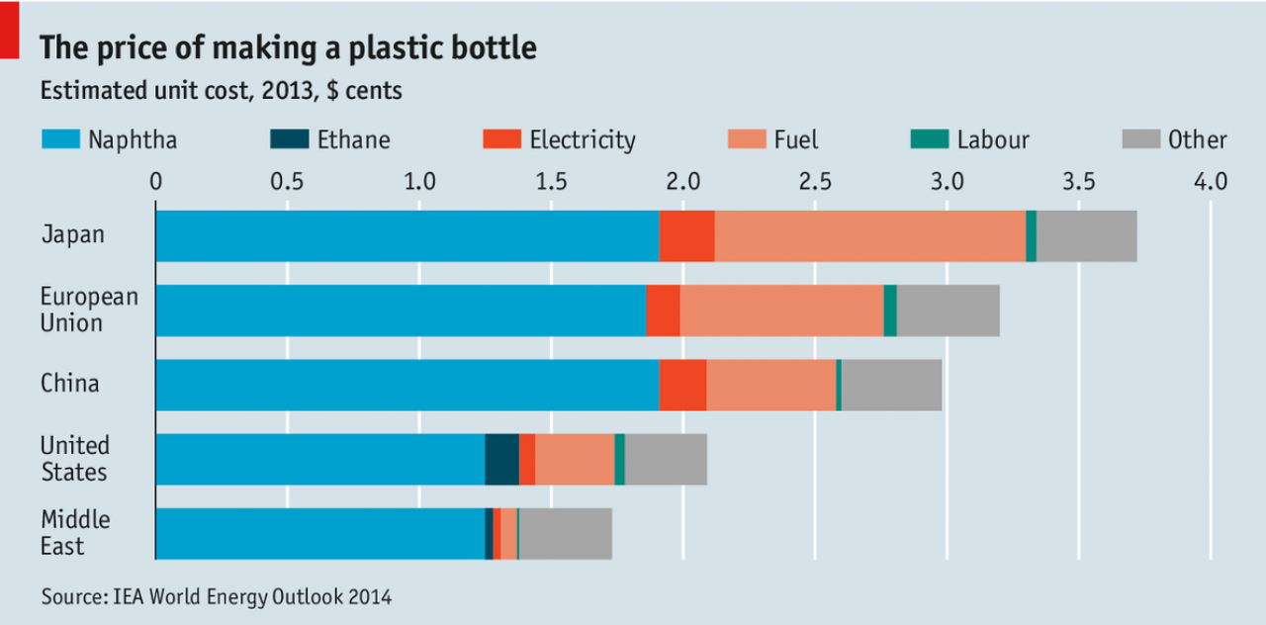
Figure 2 – Price of making a plastic bottle by region (economist, 2014).

4.2 Recycling
Plastics used in the production of plastic bottles are highly recyclable and this in itself is a large business. Most countries have recycling programmes filtered down from the government to cities/districts and taken on board by local councils to manage household waste. The councils will supply all households with various recycling bins and arrange collection dates for each type of recyclable waste. Many of which will require that each household washes all plastic waste before it is put out for collection. In England and Wales these requirements are laid out in a piece of legislation, the Environmental Protection Act (EPA) 1990 (letsrecycle, n.d.). Private recycling companies are another way to dispose of recyclable waste. Whether the waste is recycled to new products and resold at a cost or the existing product is altered for an alternative use, both benefit the environment in a positive way. Another benefit of recycling plastics are the huge savings in energy costs used in the production process. Recycling plastic requires only a tenth of the energy needed to create new plastic from raw materials (Kazmeyer, n.d.).
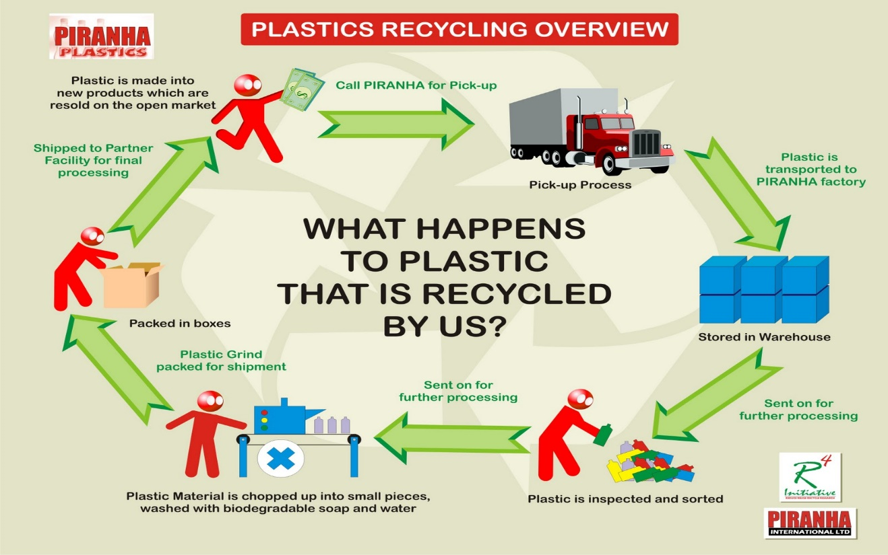
Figure 3 – Plastic Recycling Process ‘Piranha Plastics’ (Zafar, 2016).
There is a global problem with waste plastics that are not being recycled. Our demands for the mass production of cheap, versatile, liquid resistant, lightweight, strong and flexible plastic products have resulted in us becoming careless with regards to the disposing of these products appropriately. All characteristics listed ensure the waste product are non-biodegradable, therefore cause a major issue on a global scale when not recycled appropriately. From 2017 alone it is estimated that 5 million plastic bags will make their way into the ocean, either indirectly due to poor waste management or directly by people who are not aware of the significant consequence to the environment from their actions (Ocean4, 2017). Waste plastics being dumped into the ocean are responsible for killing high numbers of marine life, a problem which many charities and marine activists are campaigning to raise awareness of in order to prevent the unnecessary killing of marine life.

Manufacturing Process & Brands

5.1 Process
The manufacturing process used to produce large amounts of polymer moulded bottle assembly is ‘blow moulding’. Groover states that blow moulding is a moulding process in which air pressure is used to inflate soft plastic inside a mould cavity (Groover, 2010). It is an important industrial process for making one-piece hollow plastic parts with thin walls, such as bottles and similar containers (Groover, 2010). Because many of these items are used for consumer beverages for mass markets, production is typically organized for very high quantities (Groover, 2010). Blow moulding is limited to thermoplastics. Other applications for blow moulding include large shipping drums for liquids/powders, gasoline tanks, large storage tanks and toys.
There are three main types of blow moulding, extrusion, injection and stretch moulding. Both methods involve the fabrication of a starting tube of molten plastic (parison), the parison is then inflated to the required shape (Groover, 2010).
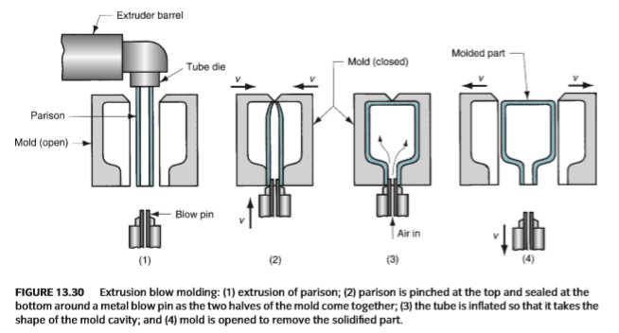
Figure 4 – Extrusion Blow Moulding Process (Groover, 2010).
The simplest form of blow moulding is extrusion blow moulding. The process can be used to create diverse bottle and container shapes, sizes with varying neck openings (theplasticbottlecompany, n.d.). Production rate can produce up to 350 bottles per hour, depending on the machine (theplasticbottlecompany, n.d.). The process has a high rate of production, low investment costs to set up and is suitable for small production runs; however, has a high scrap rate, less control over wall thickness and it is not easy to trim excess plastic (theplasticbottlecompany, n.d.).
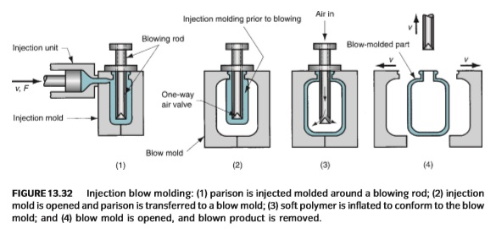
Figure 5 – Injection Blow Moulding Process (Groover, 2010).
Injection blow moulding often has superior rates of production, greater dimensional accuracy, lower scrap rates, and less wasteful of material than extrusion blow moulding (Groover, 2010). Unfortunately, injection blow moulding has higher start-up costs, higher tooling costs and cannot produce containers as large as that of extrusion blow moulding because the mould in injection blow moulding is far more expensive for large parisons (Groover, 2010).
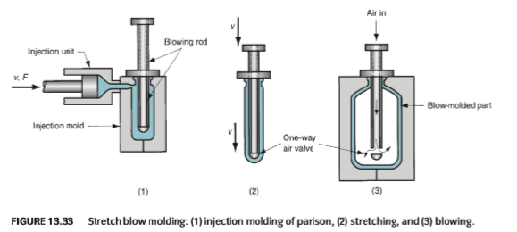
Figure 6 – Stretch Blow Moulding Process (Groover, 2010).
The most common use for stretch blow moulding is PET water bottles. The process is similar of that to injection blow moulding, however the parison is stretched in the process. The start-up costs of stretch blow moulding are higher than the other two processes, nevertheless production rates can be far superior to both extrusion and injection blow moulding.

5.2 Bottled Water Brands UK (2016)
In ‘Figure 7’ the most used brands of bottled mineral water in the United Kingdom are ranked in order (2016). The most popular brand of bottled mineral water by user in the UK as of 2016 was Evian with an estimated 8.76 million users (statista, 2017). Highland Spring Water came in second place with an estimated 7.5 million users, followed by Buxton Spring in third place with just under 7.4 million users.
The total volume of bottled water drank in the UK has gradually increased since 2010. At the beginning of the decade, bottled water consumption was approximately 1.9 billion litres, a figure that increased to 2.56 billion litres by 2015 (statista, 2017).
Bottled water consumption in the UK represents only a small fraction of the global bottled water consumption. In 2012, 288 billion litres of water were consumed worldwide and this figure was predicted to reach 391 billion liters by the end of 2017 (statista, 2017).
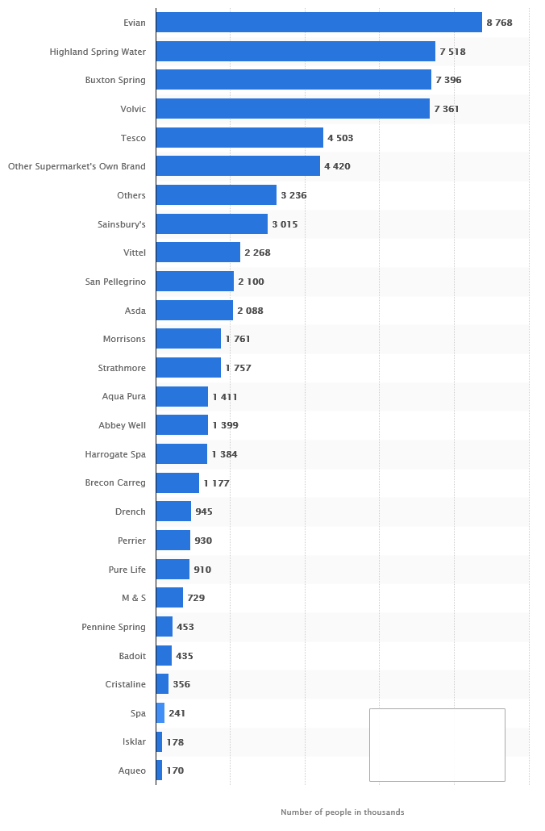
Figure 7 – Most consumed brands of bottled mineral water (UK) (statista, 2017).

Summary

Currently the global demand for bottled water is extremely high, resulting in a fiercely competitive market consisting of many different sized companies. Technological developments in the blow moulding manufacturing processes have enabled vast numbers of bottles to be produced over short time periods, allowing rapid distribution to retailers resulting in maximised profits. Increased bottle production has a negative effect on the environment if waste products are not recycled. A fraction of profits generated from companies selling bottled water could be invested back into recycling projects, to help manage and raise awareness of the global recycling dilemma. Furthermore, governments must accept more responsibility for the recycling problem and work together in order to create a greener environment for future generations.

Reference List

Brands of bottled mineral water ranked by number of users in the United Kingdom (UK) in 2016 (in 1,000). (2017). Retrieved from statisata.com: https://www.statista.com/statistics/308644/leading-brands-of-bottled-mineral-water-in-the-uk/
Flint, D. (2017, April 24). What Are the Raw Materials of Plastic Bottles. Retrieved from sciencing: https://sciencing.com/raw-materials-plastic-bottles-5747796.html
Groover, M. P. (2010). Fundamentals of Modern Manufacturing (4th Edition). Hoboken: John Wiley & Sons.
How Much Trash is in Our Ocean. (2017, January 20). Retrieved from 4ocean.com: https://4ocean.com/blogs/blog/how-much-trash-is-in-our-ocean
Hurley, A. (2016, February 23). A Brief History of Bottled Water. Retrieved from The Kitchn: https://www.thekitchn.com/a-brief-history-of-bottled-water-228642
Kazmeyer, M. (n.d.). How Much Energy Does Recycling Save? Retrieved from homeguides: http://homeguides.sfgate.com/much-energy-recycling-save-79720.html
legislation. (n.d.). Retrieved from letsrecycle.com: https://www.letsrecycle.com/councils/legislation/
Perry, J. (2017, November 2). Bottled History. Retrieved from Pocketwonders: https://www.pocketwonders.co.uk/facts/bottled-history/
Plastic Bottle Manufacturing. (n.d.). Retrieved from thomasnet: https://www.thomasnet.com/articles/materials-handling/plastic-bottle-manufacturing/
The price of making a plastic bottle. (2014, November 15). Retrieved from economist: https://www.economist.com/news/economic-and-financial-indicators/21632569-price-making-plastic-bottle
Valentino, M. C. (2017). The Bottled Water Industry: Monopoly and Competitiveness. Calitatea: Acces la Success; Bucharest.
What Is The Difference Between Injection And Blow Moulding? (n.d.). Retrieved from theplasticbottlecompany.com: https://www.theplasticbottlecompany.com/difference-injection-blow-moulding/
Zafar, S. (2016, July 26). Plastic Recycling Overview. Retrieved from rainbowplastics.net: http://www.rainbowplastics.net/faq.htm

Table of Sources

Figure 1 – Water Bottles Through Time (Perry, 2017)………………………………………………………………………3
Figure 2 – Price of making a plastic bottle by region (economist, 2014)…………………………………………….4
Figure 3 – Plastic Recycling Process ‘Piranha Plastics’ (Zafar, 2016)……………………………………………………5
Figure 4 – Extrusion Blow Moulding Process (Groover, 2010)……………………………………………………………6
Figure 5 – Injection Blow Moulding Process (Groover, 2010)…………………………………………………………….7
Figure 6 – Stretch Blow Moulding Process (Groover, 2010)……………………………………………………………….7
Figure 7 – Most used brands of bottled mineral water (UK) (statista, 2017)……………………………………..8

