E-portfolio
Steffan Rhys Jones

Study Skills for Psychology
ECPS4018

Table of Contents

Task One: Article Summary: When winners need help 3.

Task Two: Infographic 4

Task Three: Essay Plan 5

Library Search Screenshot 6

Summary of Sources 7

References 8

Task one
Article: When winners need help
This article discusses the common misconceptions that athletes at high levels portray an image of exceptional health. They are seen, according to, Holland et al, (2010) and Macnamara et al (2010), as being resilient, focused, confident and composed. However, there is an increase in evidence that elite athletes are just like everyone else and are just as susceptible to developing mental health illnesses, such as, ‘depression, anxiety, eating disorders, obsessive-compulsive disorders, addictions and substance misuse’, (Larkin, 2017).
To explore why athletes are just as vulnerable, consideration must be made for the ‘environmental and social contexts’ (Larking, 2017), in which the sports are run. It is important to understand the strict regime and the pressure that surrounds the athletes, the need to be the best, consistently perform at a high level, not obtain injuries, as well as social media influences, the expectation to be positive role models and not to be seen negatively in the media. Every single aspect of their lives can become somewhat micromanaged to keep up appearances.
Although it is perceived that keeping active is beneficial for mental health, evidence suggests that it can have an adverse effect at an elite level. A contributing factor is the misleading information which deems elite athletes immune to mental health illnesses due to sport and exercise being advertised as a ‘preventative measure in mental health’, (Larkin, 2017), by the media and government agencies.
With all this in mind there is still a stigma surrounding accessing help for mental health, (Abram et al, 2008). Kamm, (2005), states that athletes are seen as weak by their coaches or teammates for seeking help, with Watson, (2006), adding that there is a reluctance with professional coaches to make referrals to mental health practitioners.
Larkin, (2017), believes that ‘recognising and supporting the early signs of mental ill-health and making it something that the elite sporting community can talk about openly’ is something that needs to be addressed.

Task Two
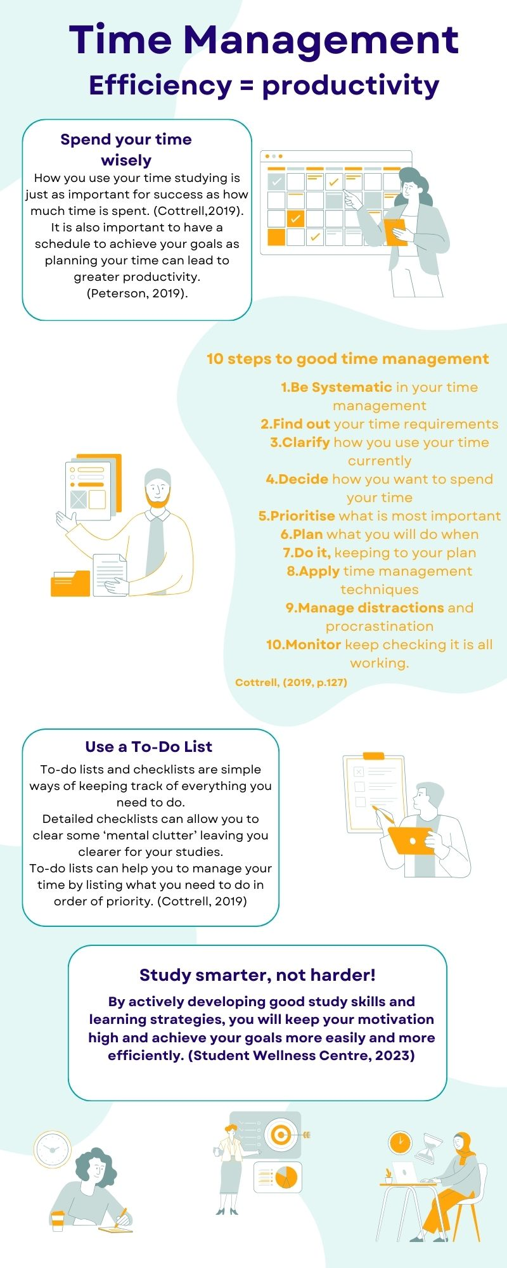
Infographic

Task Three

Essay Outline
‘Consider the theory and evidence that relates to at least two psychological explanations for our understanding of human behaviour`.
Title: The Biological and Behavioural Approach to Psychology
Introduction (200 words):
- Essay aims - discuss biological and behavioural approach.
- Brief description of essay contents.
- Biological approach brief explanation
- Behavioural approach brief explanation in contrast to biological.

Main body (1600 words):
- Use Glassman (2013) to describe biological approach.
- McGurk (1975) to contribute to this.

- Discuss the difference between Monozygotic and Dizygotic twins.
- Monozygotic – develop from same fertilized egg.
- Dizygotic- develop from separate fertilized eggs.
- Monozygotic – unique as they have some genetic inheritance.
- Dizygotic – only share around 50% of genetic inheritance.

- Gross (2020) – should there be a link between genetics and measured intelligence then there should be a higher concordance rate with Mono twins.
- Look at Gross (2020) work and outline this.
- What did this show?

- Bouchard et al (1990), discussed studies of Di and Mono twins raised apart from birth.
- Look at this in more detail.
- However, Bouchard et al (1990), state although there is great evidence for the influence of genetic heredity it does not take away the value or importance of parenting and education.

- Kolb (2016), - ‘Brian and behaviour differ greatly but are linked’.
- Explore this more.
- Damasio et al (1994), evidence from clinical observation.
- Case of Phineas Gage.
- Kolbe (2016), hypothalamus.

- Glassman (2013), behaviour can’t be fully explained through biology alone.
- Gross (2020), - Skinners classical and operant behaviour.

- Gross (2020), Ivan Pavlov – classical conditioning.
- Explain study and conclusion/findings.

- Ross (2020) – Skinner’s belief that behaviour is not provoked by specific stimulus.
- Respondent and operant behaviour.
- Skinner Box.

- Cognitive behaviour therapy.

- Hy XZ et al (2006), - OCD.
- Definition.

- Solomon (1984), Quote about human behaviour.
- Gazzaniga (2018), - Charles Darwin’s evolutionary theory – ‘The origin of species’.

Conclusion (200 words):
- Both biological and behavioural approaches have a place in the theory of human behaviour.
- Both disregard theory of free will.

Library search screenshot
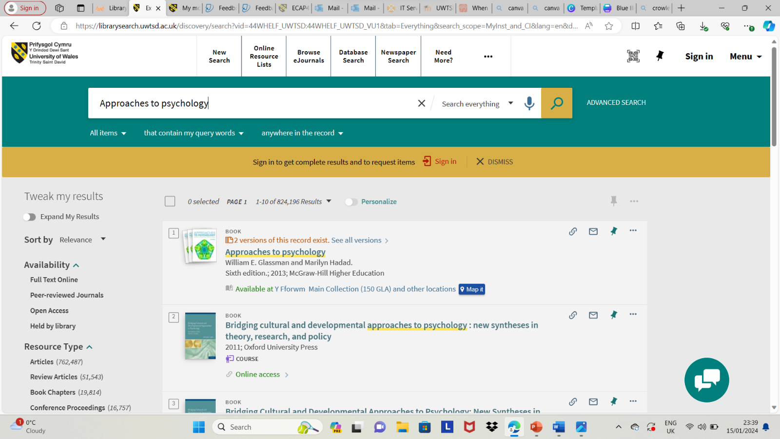

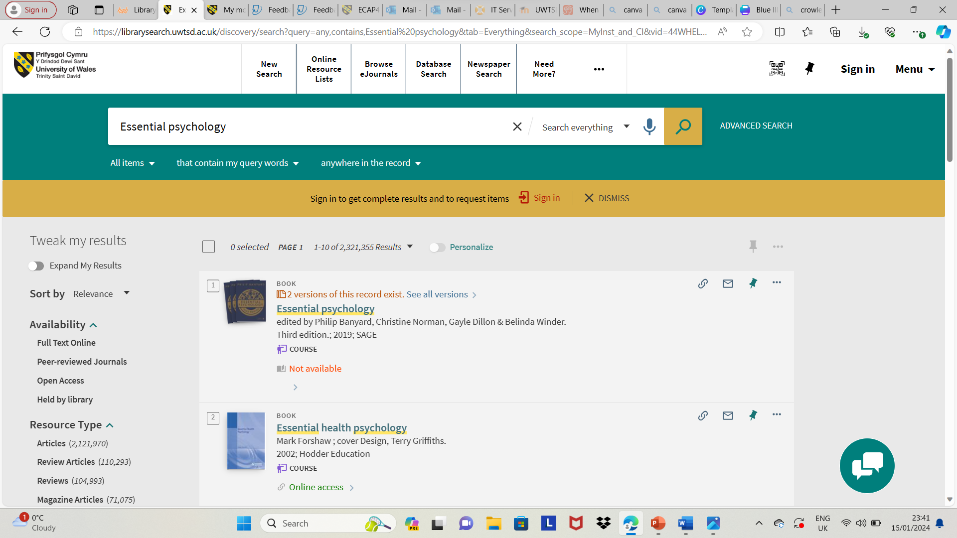

Summary of sources

Online library searches for relevant books and articles. Visit to library for relevant books.

Reference List
Abram, K.M., Paskar, LD., Washburn, J.J., & Teplin, L.A. (2008). Perceived barriers to mental health services among youths in detention. Journal of the American Academy of Child and Adolescent Psychiatry, 47(3), 301-308

Banyard, P., Norman, C., Dillon, G., & Winder., B. (2019). Essential psychology: SAGE.
Bouchard, T. J., Lykken, D. T., McGue, M., Segal, N. L., & Tellegen, A. (1990). Sources of human psychological differences: The Minnesota study of Twins Reared Apart. Science (American Association for the Advancement of Science), 250(4978), 223–228. https://doi.org/10.1126/science.2218
Center for Substance Abuse Treatment. Brief Interventions and Brief Therapies for Substance Abuse. Rockville (MD): Substance Abuse and Mental Health Services Administration (US); 1999. (Treatment Improvement Protocol (TIP) Series, No. 34.) Chapter 4—Brief Cognitive-Behavioural Therapy. Available from: https://www.ncbi.nlm.nih.gov/books/NBK64948/
Cottrell, S. (2019) The Study Skills Handbook. 5th edn. London: Red Globe Press
Damasio, H., Grabowski, T., Frank, R., Galaburda, A. M., & Damasio, A. R. (1994). The return of Phineas Gage: Clues about the brain from the skull of a famous patient. Science.
Glassman, W. E., & Hadad, M. (2013). Approaches to psychology (Sixth edition.). McGraw-Hill Higher Education page 40
Gazanigga, MS, (2018). Psychological Science. (6th ed.) W.W. Norton & Company Ltd.
Gross, R., (2020). Psychology: The science of mind and behaviour. (8th ed.) Hodder Education Group.
Higgs, S., Cooper, A., & Lee, J. (2023). Biological psychology (3rd ed). SAGE. Page337
Holland, M.J., Woodcock, C., Cumming, J., & Duda, J.L. (2010). Mental qualities and employed mental techniques of young elite team sport athletes. Journal of Clinical Sport Psychology, 4, 19-38.
Hu XZ, Lipsky RH, Zhu G, Akhtar LA, Taubman J, Greenberg BD, Xu K, Arnold PD, Richter MA, Kennedy JL, Murphy DL, Goldman D. Serotonin transporter promoter gain-of-function genotypes are linked to obsessive-compulsive disorder. Am J Hum Genet. 2006 May;78(5):815-826. doi: 10.1086/503850. Epub 2006 Mar 28. PMID: 16642437; PMCID: PMC1474042.
Iversen, L.L. (1979). The chemistry of the brain. Scientific American.
Kamm, R.L. (2005). Interviewing principles for the psychiatrically aware sports medicine physician. Clinics in Sports Medicine, 24(4), 745–769.
Kolb, B., Whishaw, I. Q. & Teskey, G. C. (2016). An introduction to brain and behaviour. (Fifth Ed). Worth. Page3, 410
MacNamara, Á., Button, A. & Collins, D. (2010). The role of psychological characteristics in facilitating the pathway to elite performance. Part 1: Identifying mental skills and behaviours. The Sport Psychologist, 24(1), 52–73.
McGurk, H. (1975). Growing and changing. Methuen.
Skinner, B.F. (1938). The behaviour of organisms. Appleton-Century-Crofts.
Solomon, P. (1984). Bridges from behaviorism to biopsychology. Behavioral and Brain Sciences, 7(4), 498-498. doi:10.1017/S0140525X00026935
Tyerman, A. (2018). Psychological effects of brain injury. Headway the Brain Injury Association.
https://www.headway.org.uk/media/3999/psychological-effects-of-brain-injury-e-booklet.pdf
Watson, J.C. (2006). Student-athletes and counseling: Factors influencing the decision to seek counseling services. College Student Journal, 40(1), 35.
WordToTheWise (2019) Jordan Peterson: Make A damn schedule. Available at: https://www.youtube.com/watch?v=bCMkhCV2HWE (Accessed 28 December 2023).

