Course: MSc Engineering Project Management
Module: ACEA7003 Masters Project
Assignment: Are Risk Assessment Tools Effectively used in Project Management, and is there a Need for a Customisable Framework to Enhance Risk Management to Ultimately Improve Project Outcomes?
University number: 1809810
Date submitted: 14/01/2026
Word count: 16868

Contents

1. Executive Summary 6

2. Acknowledgements 7

3. Declaration Statement 8

4. Title 9

5. Introduction 10
5.1. Background and Context. 12
5.2. Aims and Objectives. 14
5.3. Significance of the Research. 15

6. Literature Review 16
6.1. Risks in Project Management. 17
6.2. Different Tools Available for Project Management Risks. 21
6.3. Perception of Risk and Risk Management Tools. 25
6.4. Risk Management and its Impact on Project Outcomes. 32
6.5. Is There a ‘Universal Fit’ Risk Management Tool? 35

7. Methodology. 38
7.1. Methodology Choice. 39
7.2. Question Design. 41
7.3. Sampling. 45

8. Results 46
8.1. Participant Demographics (Questions 1 & 2) 46
8.2. Current Use of Risk Assessment Tools (Questions 3 &4). 48
8.3. Effectiveness of Risk Management. 50
8.4. Need for a Customisable Framework. 53
8.5. Open-ended Feedback. 55

9. Discussion. 56
9.1. Current Use of Risk Assessment Tools. 57
9.2. Effectiveness and Limitations of Current Practices. 60
9.3. Tool Misapplication and Misclassification. 63
9.4. Risk Management and its Impact on Project Outcomes. 66
9.5. The Case for a Customisable Framework. 68
9.6. Summary 72
9.7. Conclusion and Limitations 74
9.8. Closing Reflections. 78

10. Recommendations & Further Work 79

11. References 82

12. Appendix 87
12.1. Survey Questionnaire. 87
12.2. Proposed Timeline Gantt Chart. 91
12.3. Participant Demographics. 92
12.4. Current Use of Risk Assessment Tools. 94
12.5. Effectiveness of Risk Management 96
12.6. Need for a Customisable Framework 99
12.6. Open-ended Feedback. 101

Table of Figures

Figure 1 - Methodology Sampling 45
Figure 2 - Participant Job Title & Sector 46
Figure 3 - Participant Project Experience 47
Figure 4 - Participant Use of Risk Assessment Tools 48
Figure 5 - Participant Use and Opinion of Risk Assessment Tools 49
Figure 6 - Participants Use and Opinion of Risk Assessment Tools 50
Figure 7 - Participants Project Deviations 51
Figure 9 - Participant Views on Need for Customisable Framework 53
Figure 10 - Participant Views on Customisable Framework Requirements 54
Figure 11 - Survey Questionnaire - Section 1 87
Figure 12 - Survey Questionnaire - Section 2 87
Figure 13 - Survey Questionnaire - Section 3 88
Figure 14 - Survey Questionnaire - Section 4 89
Figure 15 - Survey Questionnaire - Section 5 90
Figure 16 - Survey Questionnaire - Section 6 90
Figure 17 - Link to Forms Survey 90
Figure 18 - Proposed Project Timeline 91

Table of Tables

Table 1 - Various Critical Risks in Industrial Projects 19
Table 2 - Comparison of Project Management Risk Analysis Tools 23
Table 3 - Risk Management Tool Application 26
Table 4 - Survey Methodology Analysis 40
Table 5 - Sample Question Design Survey 44
Table 6 - Participant Understanding of Risk and Appropriate Risk Tool 52
Table 7 - Questionnaire Q1 Data Set 92
Table 8 - Questionnaire Q2 Data Set 92
Table 9 - Questionnaire Q3 Data Set 92
Table 10 - Questionnaire Q4 Data Set 93
Table 11 - Questionnaire Q5 Data Set 94
Table 12 - Questionnaire Q6 Data Set 94
Table 13 - Questionnaire Q7 Data Set 94
Table 14 - Questionnaire Q8 Data Set 95
Table 15 - Questionnaire Q9 Data Set 95
Table 16 - Questionnaire Q10 Data Set 96
Table 17 - Questionnaire Q11 Data Set 96
Table 18 - Questionnaire Q12 Data Set 96
Table 19 - Questionnaire Q13 Data Set 97
Table 20 - Questionnaire Q14 Data Set 97
Table 21 - Questionnaire Q15 Data Set 98
Table 22 - Questionnaire Q16 Data Set 99
Table 23 - Questionnaire Q17 Data Set 99
Table 24 - Questionnaire Q18 Data Set 99
Table 25 - Questionnaire Q19 Data Set 100
Table 26 - Questionnaire Q20 Data Set 101
Table 27 - Questionnaire Q21 Data Set 102

1. Executive Summary

This report investigates the effectiveness of risk assessment tools in project management and whether there is a need for a customisable framework to improve risk mitigation and project outcomes. Large-scale industrial projects, spanning construction, energy, and manufacturing sectors, face increasingly complex risks that, if not managed effectively, can lead to delays, budget overruns, and loss of stakeholder confidence.

The literature highlights a broad range of risks: financial, technical, operational, environmental, and regulatory, and assesses the established tools such as Failure Modes and Effects Analysis (FMEA), Monte Carlo simulation, Strengths, Weaknesses, Opportunities and Threats (SWOT) analysis, and risk matrices in mitigating these. Whilst theoretically robust and supported by international frameworks like ISO 31000 and PMBOK, their use in practice is inconsistent. Barriers include organisational resistance, lack of training, tool complexity, and reliance on intuition over structured methods. The underpinning theme is that no single “universal fit” tool exists, and adaptive, context-sensitive approaches are needed.

The methodology adopted was a descriptive survey of professionals across multiple sectors, capturing both quantitative and qualitative insights. Data revealed that although most practitioners acknowledged the value of risk tools, their routine application was often fragmented. Challenges included poor integration with project workflows, limited flexibility, and lack of stakeholder engagement. Importantly, many participants supported the need for a more adaptable and user-friendly framework that is tailored to industry-specific requirement. Features such as AI-based prediction, real-time collaboration, and integration with project management software were highlighted.

Overall, findings indicate that while risk assessment tools contribute positively to project outcomes when applied systematically, knowledge gaps and incorrect application limit effectiveness. The study concludes that current practices alone are insufficient to ensure resilience in uncertain environments. It therefore advocates the development of a customisable risk management framework that combines standardisation with flexibility, supports analytics, and fosters organisational learning.

This research also exposes the gap between risk management theory and practice. It provides support that embedding a culture of proactive, adaptable risk management, supported by tailored tools, can improve not only project performance but also resilience, adaptability, and sustainability. Recommendations for further work include piloting the proposed framework in real-world industry settings and exploring AI-driven predictive tools can strengthen risk governance.

2. Acknowledgements

The author wishes to express sincere gratitude to the academic staff and supervisors at the University of Wales Trinity Saint David for their continuous guidance, encouragement, and constructive feedback throughout the development of this dissertation. Their expertise and support have been central to the successful completion of this research.

Appreciation is also extended to the employees of Tata Steel and other professionals who participated in the anonymous questionnaire. Their willingness to share valuable insights and practical experiences provided the foundation for the study and significantly enriched its findings.

The author further acknowledges the unwavering support of family and peers, whose encouragement and understanding have been a constant source of motivation during this academic journey.

3. Declaration Statement

Author’s Declaration

I declare that the work in this dissertation was carried out in accordance with the regulations of UWTSD. The work is original except, where indicated by special references in the text and no part of the dissertation has been submitted for any other degree.

Any views expressed in the dissertation are those of the author and in no way represent those of the UWTSD.

The dissertation has not been presented to any other University for examination either in the United Kingdom or overseas.

I hereby give permission for my work, if accepted, to be available for photocopying and inter-library loan, and for the title and summary to be made available to outside organisations.

Signed: DM Thomas …………..

Date: 14/01/2026……………………….

4. Title

Are Risk Assessment Tools Effectively used in Project Management, and is there a Need for a Customisable Framework to Enhance Risk Management to Ultimately Improve Project Outcomes?

5. Introduction

Risk management is not merely a procedural component but a strategic imperative in the successful execution of large-scale industrial projects. As articulated by (Jacqueline Jepson, 2018), these ventures, ranging across construction, manufacturing, and energy sectors, operate within environments that are inherently volatile and complex. They are routinely exposed to multifaceted risks including regulatory delays, supply chain disruptions, geopolitical instability, technological failure, and workforce-related issues (Hetemi, 2021). The consequences of such risks can be severe, not only compromising timelines and budgets but also eroding stakeholder confidence and regulatory compliance.

Within this context, the systematic use of risk assessment tools becomes indispensable (Bannerman, 2008). Tools such as Failure Modes and Effects Analysis (FMEA), Monte Carlo simulation, SWOT analysis, and Risk Breakdown Structures (RBS) are designed to proactively identify, evaluate, and mitigate potential threats. These instruments provide a structured pathway to transform uncertainty into quantifiable and manageable parameters, thereby enhancing decision-making and contingency planning (Bannerman, 2008).

The theoretical endorsement of these tools stands in stark contrast to their inconsistent real-world application, as noted by (Chapman & Ward, 1997). Despite the widespread development of risk management frameworks, such as ISO 31000, the PMBOK, (Project Management Body of Knowledge) risk management process, and PRAM (Project Risk Analysis and Management) (Pattberg, 2005), empirical evidence suggests that their adoption remains fragmented and sporadic, particularly in fast-paced or resource-constrained environments. Organisational culture, project complexity, lack of training, and managerial resistance are frequently cited as barriers to the routine institutionalisation of these practices (Aerts, 2017).

This discrepancy raises critical questions:
- Are these tools perceived as too complex or time-consuming for practical application?
- Do project teams undervalue formal risk processes in favour of experience-based intuition?
- Are organisations failing to cultivate a risk-aware culture that prioritises proactive rather than reactive measures?

The proposed research thus gains relevance in seeking to interrogate the gap between theoretical risk management paradigms and their actual utilisation in project environments (Khan, 2024). By evaluating whether risk assessment tools are routinely employed and examining their tangible contributions to project outcomes, the study aims to bridge this theory-practice divide. Importantly, the findings may inform best practices and policy recommendations for embedding risk management more deeply into organisational project governance frameworks.

This line of inquiry aligns with the growing scholarly consensus that project success is no longer defined solely by the 'iron triangle' of cost, time, and scope (Hetemi, 2021) but also by the project's resilience in the face of uncertainty. Thus, understanding and improving the institutionalisation of risk assessment tools is not just about preventing failure, but about enabling adaptive and sustainable project execution in an increasingly uncertain global landscape.

415

5.1. Background and Context.

Industrial project management has undergone significant maturation over the past few decades, transitioning from a focus on cost and schedule control to a more holistic, risk-informed paradigm (Enrico Zio, 2012). At the heart of this evolution are structured frameworks, risk management process and various risk matrix models, which have been instrumental in formalising the identification, analysis, and prioritisation of risks (Gusmão, 2003). These tools offer a standardised vocabulary and methodology, empowering project teams to convert uncertainties into structured insights that inform tactical and strategic decisions (Dragan Komljenovic, 2020).

Theoretical contributions from systems thinking, complexity theory, and contingency planning have further reinforced the scientific rigor of risk management. Empirical studies have consistently shown that structured approaches, such as those embedded in PMBOK, PRINCE2, and ISO 31000, can significantly reduce project failure rates when appropriately applied (Merkourios Papanikolaou, 2020). For instance, Monte Carlo simulations allow for probabilistic forecasting, while risk registers enable real-time tracking of risk evolution. These tools enhance transparency, foster accountability, and enable dynamic responses to emerging threats.

However, as (Behrad Barghi, 2020) rightly emphasises, the rapidly evolving and inherently complex nature of industrial projects, especially those involving interdisciplinary coordination, technological integration, and global supply chains, continues to outpace many traditional risk frameworks. Risks in such environments are not always predictable or linear; they are often emergent, shaped by a confluence of technical, organisational, and external factors. Thus, the static application of conventional tools may prove insufficient unless complemented by adaptive and learning-oriented strategies.

Historical evidence corroborates this critique. Iconic project failures, such as the Boston Big Dig, the Berlin Brandenburg Airport, and several large-scale oil and gas ventures, have demonstrated that overlooked or underestimated risks can lead to budget overruns in the billions and delays spanning decades (Whyte, 2021). These failures often stem not from a lack of risk tools, but from failure to embed risk thinking into the organisational culture and decision-making hierarchy. Risk was either assessed too late, ignored due to political or economic pressures, or addressed without sufficient stakeholder involvement.

Contemporary case studies in the energy sector, particularly in offshore wind, nuclear, and liquified natural gas infrastructure, highlight similar patterns. As (Dr Mohammad Taghipour, 2015) notes, inadequate scenario planning, flawed risk quantification, and fragmented inter-organisational communication continue to hinder effective mitigation (Ashish Kumar Loomba, 2021). These shortcomings highlight the critical importance of integrating systematic and continuous risk assessment into all phases of the project lifecycle, from feasibility and procurement to execution and closure.

The increasing prevalence of digital transformation, cyber-physical systems, and sustainability pressures introduces new dimensions of risk, which demand more agile, real-time, and predictive risk management. Emerging tools powered by AI, machine learning, and data analytics are beginning to fill this gap by offering predictive capabilities and scenario modelling (Roy, 2024). However, their efficacy remains contingent on organisational readiness, data quality, and managerial openness to change.

While the formalisation of risk management through frameworks represent a substantial advance in industrial project governance, its success in practice hinges on continuous adaptation, leadership commitment, and cultural alignment. There is a pressing need to move from compliance-based application of risk tools to a more strategic and embedded model of risk governance, one that treats risk not merely as a constraint, but as a source of insight and opportunity (Smith, 2020).

515 (930)

5.2. Aims and Objectives.

The primary aim of this research is to critically evaluate the effectiveness of established risk assessment tools within industrial project management and determine their appropriateness for enhancing project performance, outcomes and resilience. In an era marked by increasing complexity, globalisation, and technological acceleration, traditional risk tools are under growing scrutiny for their adaptability, predictive capacity, and real-world impact. This study does not merely investigate tool usage in isolation but rather situates it within the broader systemic and organisational context that governs how risk is perceived, assessed, and managed.

To achieve this aim, the research is structured around four interrelated objectives that address both diagnostic and prescriptive aspects of risk management:

- Identify and classify critical risks in industrial projects, including financial, technical, operational, environmental, and regulatory risks.
- Analyse the extent to which current risk assessment frameworks and tools are utilised in industrial project management.
- Assess the impact in mitigating project risks.
- Assess the need to develop a flexible and scalable risk management framework to bridge gaps and enhance risk preparedness.

173 (1097)

5.3. Significance of the Research.

This study is particularly relevant to industries where project complexity and uncertainty converge, such as energy, construction, and infrastructure development. These sectors routinely face interdependent risks, technical, financial, regulatory, yet evidence suggests that risk assessment tools are often inconsistently applied or poorly integrated into project workflows (Bannerman, 2008). Investigating the routine use of these tools provides valuable insights for project manager, policymakers, and researchers, into both organisational behaviour and systemic inefficiencies.

By bridging the divide between theoretical principles and real-world practice, the research challenges the assumption that risk frameworks alone ensure project resilience. As (Behrad Barghi, 2020) notes, effectiveness depends not on the availability of tools, but on context-aware, adaptive application. The study aims to expose how embedded practices, tool fatigue, or managerial inertia can undermine risk mitigation, while also identifying high-impact interventions. The findings aim to improve methodologies, optimise risk mitigation strategies, and ultimately increase likelihood of project success

Furthermore, the rise of AI, machine learning, and predictive analytics promises to redefine risk management through real-time forecasting and pattern recognition, revolutionising risk management practices. However, these advancements are not without risks—namely, data bias, automation overconfidence, and loss of interpretability (Roy, 2024). Without critical oversight, such tools could obscure rather than clarify risk exposure.

Ultimately, this research contributes to both academic discourse and professional practice by evaluating not just whether risk tools work, but under what conditions they are effective, scalable, and ethically deployed.

228 (1325)

6. Literature Review

Effective risk management is widely recognised as a cornerstone of successful project execution. However, despite the availability of numerous established risk assessment tools, many projects continue to encounter cost overruns, schedule delays, and compromised quality due to unforeseen risks (T. Raz, 2001). This persistent challenge raises a critical question, are current risk assessment tools being effectively utilised in practice, or is there a pressing need for a more customisable framework to enhance risk mitigation and improve project outcomes? As (Irem Dikmen, 2004) suggests, the limitations in existing approaches may stem not from a lack of tools but from their inadequate contextual application in complex project environments.

This literature review aims to critically evaluate the effectiveness of current risk assessment tools in project management, with a particular focus on their practical implementation, strengths, and limitations. The study is structured around four key areas:
- Identifying common risks in project management.
- Assessing the variety of risk management tools available.
- Examining cases where appropriate risk management tools have demonstrably improved project outcomes.
- Exploring the argument that no single risk assessment tool is universally effective.

The research builds upon the premise that while risk management frameworks offer structured methodologies, the inherently dynamic, complex, and multifaceted nature of industrial and infrastructure projects often renders these frameworks insufficient. Projects typically demand risk strategies that are adaptable, capable of being tailored to specific industry requirements, regulatory contexts, and varying project scales. Therefore, the review synthesises insights from academic literature, industry analyses, and practical case studies to evaluate whether a flexible and customisable risk assessment framework could address these deficiencies. Ultimately, the study aims to contribute meaningfully to ongoing discourse on improving project outcomes through enhanced risk management, offering insights that could support the development of more responsive, data-driven risk assessment methodologies.

287 (1612)

6.1. Risks in Project Management.

Risk management is undeniably vital for project success, yet its theory and practice face significant challenges (Bannerman, 2008) (Roger Atkinson, 2006). While the literature emphasise the importance of managing risks, they also reveal gaps and limitations in how risk management is approached in research and practice (Bannerman, 2008) (Roger Atkinson, 2006). One major issue is the definition and conceptualisation of risk. The traditional view of risk as a probability-weighted impact, (R = P x I) is prevalent, but this approach has limitations (Roger Millera, 2001). Many critical risk factors cannot be easily quantified probabilistically, leading to qualitative assessments that may lack precision (Bannerman, 2008). Furthermore, a narrow focus on foreseeable impacts neglects unforeseen threats, potentially undermining the comprehensiveness of risk management efforts (Bannerman, 2008).

The sources highlight several common risk factors that frequently contribute to project failures. Effective risk management in industrial projects necessitates a comprehensive, multi-layered strategy that integrates several risk categories. (Karel de Bakker, 2010) (Lore Criss power, 2009). However, beyond financial and technical concerns, organisational factors often play a more critical role in project failures (Karel de Bakker, 2010). Issues such as insufficient top management commitment, lack of user engagement, and poorly defined or evolving project requirements frequently undermine success (Lore Criss power, 2009). Various risk categories are discussed, each with its potential impact and mitigation strategy (Karel de Bakker, 2010) (Lore Criss power, 2009).

Risk Category | Specific Risk | Potential Impact | Mitigation Strategies
Financial Risks | Cost Overruns | Increased project costs, budget deficits, need for additional funding. | Detailed cost estimation, contingency reserves, regular budget reviews.
Financial Risks | Funding Shortfalls | Project delays, inability to complete phases, investor withdrawals. | Diversified funding sources, early stakeholder engagement, financial stress testing.
Financial Risks | Currency Fluctuations | Increased import costs, unpredictable financial planning. | Hedging strategies, local sourcing of materials, flexible contracts.
Financial Risks | Market Volatility | Higher raw material costs, inflation reducing purchasing power. | Long-term supplier agreements, commodity price monitoring, financial forecasting.
Financial Risks | Contractual Payment Risks | Cash flow problems, disputes with suppliers, legal actions. | Clear contract terms, escrow payment mechanisms, milestone-based payments.
Technical Risks | Design Flaws | Rework, structural failures, delays, increased costs. | Rigorous design reviews, simulation testing, peer evaluations.
Technical Risks | Unproven Technology | Performance failures, increased maintenance, reputational damage. | Technology readiness assessments, phased implementation, pilot projects.
Technical Risks | Integration Issues | Operational inefficiencies, system incompatibility, software failures. | Standardised systems, cross-functional coordination, interoperability testing.
Technical Risks | Equipment Failure | Downtime, production losses, higher maintenance costs. | Preventive maintenance, real-time monitoring, redundancy planning.
Technical Risks | Lack of Standardisation | Compliance issues, need for costly redesigns, global market limitations. | Adoption of international standards, early regulatory consultations, compliance audits.
Operational Risks | Supply Chain Disruptions | Material shortages, increased costs, timeline extensions. | Multi-supplier strategies, real-time inventory tracking, local sourcing.
Operational Risks | Workforce Issues (strikes, skill shortages) | Productivity losses, training costs, project slowdowns. | Competitive wages, continuous training programs, labour relations management.
Operational Risks | Project Delays | Increased financing costs, contractual penalties, reduced investor confidence. | Agile project management, risk-adjusted scheduling, early issue identification.
Operational Risks | Cybersecurity Threats | Data breaches, operational disruptions, intellectual property theft. | Cybersecurity training, encryption, intrusion detection systems.
Operational Risks | Process Inefficiencies | Waste of resources, increased operational costs, reduced output. | Lean management practices, process automation, continuous improvement initiatives.
Environmental Risks | Pollution & Waste Management Issues | Regulatory fines, legal battles, negative public perception. | Sustainable waste disposal, strict compliance with regulations, green technologies.
Environmental Risks | Climate Change Impact | Weather-related delays, infrastructure damage, higher insurance costs. | Climate-resilient infrastructure, weather impact forecasting, risk-adjusted planning.
Environmental Risks | Natural Disasters (earthquakes, floods) | Physical destruction, financial losses, safety risks. | Disaster response plans, resilient construction materials, insurance coverage.
Environmental Risks | Environmental, Social, Governance (ESG) Compliance | Loss of investors, brand reputation damage, project cancellations. | Transparent ESG reporting, sustainability initiatives, stakeholder engagement.
Environmental Risks | Biodiversity & Land Use Conflicts | Legal disputes, restrictions on project development. | Early environmental assessments, engagement with local communities, conservation efforts.
Regulatory & Legal Risks | Policy & Trade Law Changes | Tariffs, trade restrictions, increased compliance costs. | Proactive policy monitoring, trade diversification, regulatory advocacy.
Regulatory & Legal Risks | Permitting & Licensing Delays | Project postponements, legal penalties, operational stoppages. | Early engagement with regulators, compliance audits, efficient documentation.
Regulatory & Legal Risks | Intellectual Property Risks | Patent violations, lawsuits, technology loss. | Strong IP protections, legal agreements, patent monitoring.
Regulatory & Legal Risks | Corporate Social Responsibility (CSR) Compliance | Public protests, legal challenges, investor withdrawals. | Community engagement, ethical labour practices, transparent reporting.
Regulatory & Legal Risks | Liability & Litigation | Legal disputes, compensation claims, insurance premium hikes. | Legal risk assessments, liability insurance, contract dispute resolution mechanisms.
Table 1 - Various Critical Risks in Industrial Projects
(Bannerman, 2008) (Schieg, 2010) (Karel de Bakker, 2010) (Lore Criss power, 2009) (Roger Atkinson, 2006) (Pollyana Notargiacomo Mustaro, 2013)

A key challenge lies in integrating risk management with broader project management practices and governance (Karel de Bakker, 2010). Risk management is often treated as a separate process rather than an embedded component of project management (Bannerman, 2008) (Roger Atkinson, 2006). This disconnect can lead to a lack of sustained risk monitoring and control throughout the project lifecycle (Karel de Bakker, 2010). Organisational factors such as insufficient top management commitment, lack of user engagement, and evolving project requirements frequently undermine project success (Lore Criss power, 2009). Trust and communication play a vital role in managing risks and uncertainty. Open communication channels, collaboration among stakeholders, and a culture of trust can facilitate early risk identification and effective response strategies (Schieg, 2010). However, balancing trust with necessary controls and governance mechanisms remains a challenge, particularly in complex projects (Roger Atkinson, 2006) (Cervone, 2006). While structured methodologies provide a strong foundation, their effectiveness depends on how well risk considerations are embedded in strategic decision-making, institutional learning, and stakeholder collaboration (Schieg, 2010).

Empirical evidence supporting the effectiveness of risk management is limited (Karel de Bakker, 2010). Some studies suggest that risk management practices often deviate from prescribed guidelines, and that knowledge of risks does not automatically translate into effective risk mitigation. The ‘evaluation approach’ to risk management, which focuses on identifying risk factors, may not directly contribute to project success unless it is integrated with active risk management practices (Bannerman, 2008) (Pollyana Notargiacomo Mustaro, 2013). However, structured mitigation strategies remain underutilised. That said, even where benefits from well-defined risk portfolios incorporating systematic assessment and response planning are evident, such as in industrial construction projects (Schieg, 2010), the ongoing debate between formal and informal risk management illustrates that while this offers a robust foundation, flexible and adaptive approaches remain critical in high-uncertainty environments.

While risk management is essential for project success, its effectiveness hinges on a comprehensive understanding of risk, the use of appropriate management approaches, integration with project practices, and a culture of trust and open communication. Further research is needed to explore the nuances of risk management in different project contexts and to develop more robust and practical approaches for managing both known and unforeseen threats (Bannerman, 2008).

514 (2126)

6.2. Different Tools Available for Project Management Risks.

To maximise the effectiveness of project risk management (PRM) tools, a strategy is required that acknowledges their inherent constraints and capitalises on potential strengths. The literature suggest that tailoring for specific contexts, ensuring data reliability, fostering seamless integration, facilitating experience transfer, and standardising terminology surpasses the theory and enhances project results (Irem Dikmen, 2004) (T. Raz, 2001)

Adaptability of risk management tools is essential to this, demanding a shift from the current generic approach to bespoke solutions that meet the complexities unique project landscapes (Jacqueline Jepson, 2018). The one-size-fits-all approach often fails as it neglects the variability inherent in project types, sectors and scales, using tools ill-suited for specific scenarios.

The distinction between "hard" and "soft" projects further complicates the application of risk management strategies Hard projects used in engineering for example, benefit from structured risk frameworks where predefined methodologies enhance predictability and control. These result in significant economic benefits from rigorous risk analysis, portfolio management, and structured decision-making processes (Schieg, 2010). In contrast, soft projects, which operate in environments with higher uncertainty, require more adaptability, stakeholder trust, and responsiveness to ambiguity (Cervone, 2006). In such contexts, targeted risk resolution focusing on critical threats can improve project outcomes (Pollyana Notargiacomo Mustaro, 2013).

Formal risk management methodologies often face resistance in academic and research-based projects as accountability structures are poorly defined and there is insufficient institutional support (Lore Criss power, 2009). Construction projects characterised by their singular nature and susceptibility to external factors, necessitate tools capable of accommodating fluid objective functions and a myriad of potential risk scenarios (Jacqueline Jepson, 2018) (Irem Dikmen, 2004). Project managers must, therefore, leverage their expertise to adapt and customise checklists and methodologies from previous experience, ensuring their relevance to the current project's distinct risks and objectives (T. Raz, 2001).

The seamless integration of risk management activities into the broader project management ecosystem represents a critical ask, demanding departure from siloed approaches towards holistic, interconnected frameworks, linking technical ability with human factors and organisational needs (Robert Pellerin, 2018) (Irem Dikmen, 2004). A fragmented landscape of tools and methodologies, lacking interoperability and coherence, stifles information flow and efficiency, and increases the likelihood of overlooked risks (Irem Dikmen, 2004). Risk management should not operate in isolation, it should be embedded as an intrinsic element of the project lifecycle (Robert Pellerin, 2018) (Antonio G. Sanjuana, 2013). The table below summarises widely used tools and their associated strengths and weaknesses.

Tools/Technique | Strengths | Weaknesses
Look-up Methods (Checklists, Prompt Lists, Industry Knowledge Bases) | Easy to implement and understand.  Used consistently by project managers. Help ensure procedures and processes are appropriately covered.  Facilitate gathering information on potential risks from similar projects or professional networks. | Can be too generic if not tailored to the specific project.  Reliance on existing knowledge may overlook novel risks.  Effectiveness depends on the quality and relevance of the information in the knowledge base.
Supporting Methods (Brainstorming, Document Review, Lessons Learned) | Brainstorming: Rapidly implemented, encourages open discussion, and can be used with other techniques.  Document Review: Helps identify risks embedded in project documentation.  Lessons Learned: Leverages past experiences to avoid repeating mistakes. | Brainstorming: Can be unproductive without structure or focus.  Document Review: Time-consuming, requires thoroughness.  Lessons Learned: Requires good systems for capturing and accessing data; may be poorly implemented in some organisations.
Scenario Methods (Cause & Consequence Analysis, What-If Analysis) | Help anticipate sequences of events and potential impacts.  Facilitate the development of mitigation strategies10. - "What-if" analysis is commonly used in discussions. | Underutilised despite familiarity with the concept.  May be confused with other techniques (e.g., Cause & Effect Analysis).  Effectiveness depends on the ability to envision a range of plausible scenarios.
Functional Analysis (HASOP) | Structured and systematic examination of potential hazards.  Identifies risks to people, equipment, and organisational objectives. | Not widely understood or applied.  May be confused with hazard investigation processes.  May be primarily related to Occupational Health & Safety rather than general risk management.
Control Assessments (Bow Tie Analysis, Contingency Planning) | Bow Tie Analysis: Diagrammatic method for understanding causes and consequences, shows preventative and mitigation controls.  Contingency reserves allow flexibility. | Not widely known or used.  Bow Tie Analysis: May only be used on very high-impact risks.  PERT may be misunderstood.
Evaluation Methods (Consequence/Probability Matrix, Cost-Benefit Analysis) | Consequence/Probability Matrix: Combines consequence and probability to calculate a risk level.  Cost-Benefit Analysis: Determines whether a risk action is worth the cost. | Lack of time and data doesn’t support quantitative analysis.  Informal application of Cost-Benefit Analysis.  Experienced PMs use evaluation methods less.
Multi-Criteria Analysis (AHP, etc.) | A structured multi-attribute decision method for risky situations. | Reasonable understanding but little actual application.
Statistical Methods (Monte Carlo Simulation) | Provides quantitative risk analysis. | Requires high-quality data, which is often lacking.  Often time-consuming and costly. Oversimplification of risk cross-dependencies can mislead results.
Table 2 - Comparison of Project Management Risk Analysis Tools
(Jacqueline Jepson, 2018) (Robert Pellerin, 2018) (Irem Dikmen, 2004) (Diana White, 2002) (Antonio G. Sanjuana, 2013) (T. Raz, 2001)

The inconsistent and often ambiguous terminology persistently impedes clear communication and shared understanding (Jacqueline Jepson, 2018). The proliferation of definitions and overlapping concepts breeds confusion, hindering the ability to effectively apply risk management principles and develop standardised methodologies (Robert Pellerin, 2018). A concerted effort towards terminological harmonisation, coupled with the establishment of universally accepted definitions for key risk management constructs, is essential for fostering a common language and facilitating seamless collaboration across project teams and organisations (Jacqueline Jepson, 2018).

The journey towards realising the full potential of PRM tools demands a holistic and adaptive approach, one that transcends the limitations of theoretical models and embraces the complexities of real-world project environments (Jacqueline Jepson, 2018). However, a review of PRM tools and methodologies highlights persistent misalignment between theoretical frameworks and their practical application. While the literature highlights the importance of structured risk assessment and project control, they also identify significant variation in challenges and effectiveness across different sectors, methodological limitations, and an associated underutilisation of advanced quantitative techniques (Robert Pellerin, 2018).

(T. Raz, 2001) stresses the necessity of organisation-wide investment in PRM processes, advocating a standardised, systematic approach to risk assessment that aligns with the decision-support methodologies proposed by (Vanessa Manotas Niño, 2014). However, despite emphasis on methodological standardisation, critical gaps remain in tool integration. (Irem Dikmen, 2004) critiques existing PRM tools for their lack of interoperability, which limits their adaptability in dynamic project environments. Similarly, (Jacqueline Jepson, 2018), observe that construction project managers often bypass statistical risk assessment methods due to the uniqueness of each project and time constraints, resulting in a reliance on intuitive, experience-based risk management strategies.

A sector-specific perspective is provided by (Antonio G. Sanjuana, 2013), who develop a project management (PM) assessment tool tailored for construction projects, integrating established standards to measure project success. This contrasts with the broader perspective of (Robert Pellerin, 2018), who advocate for adaptive decision-making and stochastic modelling to address uncertainties in complex projects. Their research suggests that AI-enhanced tools and probabilistic risk assessment methods could significantly improve risk prediction accuracy, thereby bridging the gap between theoretical methodologies and real-world applications.

The literature underscores that while risk management methodologies provide essential structure and guidance, their practical application is often constrained by organisational behaviour, stakeholder biases, and industry-specific challenges. Effective risk management requires more than just identifying risks, it demands integration into a dynamic, iterative process that fosters proactive engagement, empirical validation, and collaboration. Only through such an adaptive and context-sensitive approach can risk management meaningfully contribute to project success. There is a need for PRM frameworks that not only standardise risk assessment methodologies but also accommodate industry-specific challenges, foster knowledge-sharing mechanisms, and incorporate feedback loops for continuous improvement. The integration of AI-driven risk management tools, as suggested by (Robert Pellerin, 2018), offers a promising solution by enhancing predictive accuracy and decision-making efficiency. However, achieving widespread adoption will require overcoming key barriers, including organisational resistance, specialised training, and the challenge of balancing standardisation with flexibility for diverse project environments. These more complex needs are explored further below.

820 (2946)

6.3. Perception of Risk and Risk Management Tools.

Understanding risk and risk assessments is central to effective decision-making in complex and uncertain environments (Kolios, 2018) (Gul M, 2018). The literature provides a broad and critical overview of the diverse methods used to identify, analyse, document, and control risks across multiple industries (Imene Mohammedi, 2024). These methods, while varying in complexity and applicability, are unified under international standards such as ISO 31000 and ISO/IEC 31010 (Muhammet Gul, 2018) (Whiting, n.d.). The tools are grouped into five functional categories: Risk Identification Methods, Risk Analysis Tools (Qualitative & Quantitative), Functional & Failure Analysis Techniques, Risk Documentation & Monitoring Tools, and Risk Control & Visualisation Methods (Whiting, n.d.) (Kolios, 2018). This categorisation not only highlights methodological diversity but also underscores sector-specific adaptations and common challenges in data availability, subjectivity, and communication (Muhammet Gul, 2018).

Category | Method | Description | Best Applied To
Risk Identification Methods | Brainstorming (Supporting Methods) | A collaborative approach that gathers insights from stakeholders to identify a broad range of risks. | Early-stage projects where diverse perspectives help uncover unforeseen or complex risks
Risk Identification Methods | Checklists (Look-up Methods) | Use of pre-defined lists based on historical data and best practices to identify common or known risks. | Routine operations or compliance-based environments where recurring risks are likely
Risk Analysis Tools (Qualitative & Quantitative) | Qualitative Risk Matrices | Categorises risks (e.g., low/medium/high) based on likelihood and impact using a color-coded matrix . | Prioritising risks when quantitative data is limited or subjective judgment is sufficient.
Risk Analysis Tools (Qualitative & Quantitative) | Monte Carlo Simulations | A quantitative method that uses repeated random sampling to predict risk impact based on probability distributions. | Financial modelling, project timelines, or other scenarios with variable outcomes.
Risk Analysis Tools (Qualitative & Quantitative) | Cost-Benefit Analysis (CBA) | Compares the cost of implementing risk controls with the expected benefits. | Justifying investment in mitigation strategies where financial data is available.
Functional & Failure Analysis Techniques | FMEA (Failure Mode and Effects Analysis) | Identifies potential failure modes, their causes, and consequences, assigning severity, occurrence, and detection scores. | Manufacturing, engineering, or system design to proactively address process or component failures
Functional & Failure Analysis Techniques | HAZOP (Hazard and Operability Study) | Systematic review of processes to identify deviations from normal operation and their hazards. | Chemical, industrial, or high-risk operational systems.
Functional & Failure Analysis Techniques | Ishikawa (Fishbone) Diagrams | Visual tool for root cause analysis, categorising causes under factors like manpower, methods, materials, etc. | Complex problems with multiple potential causes, especially in quality control or process improvement.
Risk Documentation & Monitoring Tools | Risk Registers | A structured log of identified risks, their assessments, mitigation measures, and status updates. | All projects requiring ongoing risk tracking, communication, and auditability.
Risk Documentation & Monitoring Tools | Lessons Learned Databases | Repositories of past project experiences to inform future risk planning. | Projects or industries with recurring risk patterns or lessons from failures.
Risk Control & Visualisation Methods | Bow Tie Analysis (Control Assessments) | Visual tool that maps the pathway from risk causes to consequences, showing preventive and reactive controls. | High-impact or safety-critical risks, where control measures must be clearly understood and communicated.
Risk Control & Visualisation Methods | Workshops | Interactive sessions to co-create risk responses, plans, and controls. | Complex projects requiring cross-functional input or stakeholder buy-in.
Table 3 - Risk Management Tool Application

(Kolios, 2018) (Peeters, 2015) (Whiting, n.d.) (Gul M, 2018) (Muhammet Gul, 2018) (Imene Mohammedi, 2024) (Peeters W, 2015) (Temitope, 2024) (Ferro, 2020)

As described in section 6.2, risk identification is the initial step of any comprehensive risk management framework. This is of particular importance during conceptual and planning project stages, when uncertainties are high and data limited (Peeters, 2015). Use of techniques such as Hazard Identification, Delphi and Fishbone offer a defined approach to risk identification, meaning potential risks are systematically addressed (Imene Mohammedi, 2024). However, despite wide adoption, these techniques are constrained by their reliance on existing knowledge and expert judgment, which may lead to blind spots or the exclusion of risks (Kolios, 2018) (Peeters, 2015).

Risk analysis follows, involving the systematic evaluation of both likelihood and potential impact of identified risks. Analytical frameworks used for this purpose are typically classified as qualitative, quantitative, or hybrid models, each offering advantages and limitations depending on the context of application (Peeters, 2015).

A recurring theme is dominance of qualitative over quantitative methods due to data scarcity, project uniqueness, time and budget constraints (Muhammet Gul, 2018). Data integrity and accessibility of data form the core of effective risk analysis, yet these are frequently undermined by the lack of reliable information and the prohibitive costs associated with its collection and scrutiny (Jacqueline Jepson, 2018). Quantitative risk analysis, predicated on robust historical data, often falters in the face of incomplete or irrelevant datasets. Such risk methodologies are often structured, providing comprehensive guidelines for risk identification, assessment, and mitigation, but empirical studies indicate that organisations often favour qualitative risk assessments driven by intuition and subjective judgment (Robert Pellerin, 2018). This reliance on qualitative methods, while needed, can lead to inconsistencies and introduces the potential for bias and oversight of quantitative insights, compromising the accuracy and objectivity of risk evaluations (Jacqueline Jepson, 2018) (Vanessa Manotas Niño, 2014). This is of particular risk in industries where structured risk management is not deeply embedded in organisational culture (Bannerman, 2008) (Roger Atkinson, 2006). Moreover, the traditional risk model (R = P × I) often falls short in capturing unforeseen risks, underscoring the need for more adaptable strategies (Roger Millera, 2001). Although structured frameworks such as PMBoK and ISO 9000 provide standardised approaches, their adoption remains inconsistent. Studies also reveal commonly used tools, such as requirements and subcontractor management, are highly effective, whereas risk control mechanisms tend to be underused, considered inefficient or overly complex.

Of qualitative methods, Risk Matrix remains widely adopted across industries due to its simplicity and ease of communication (Peeters, 2015). It facilitates risk ranking based on predefined scales of likelihood and consequence. However, this approach is often undermined by its inherent subjectivity, lack of standardised terminology (e.g., varying interpretations of "likelihood" versus "probability"), and arbitrary categorisation of risk levels. These weaknesses can impair consistency and comparability across projects or organisations (Temitope, 2024).

Quantitative methods offer a more robust framework for risk assessment through numerical modelling. Monte Carlo Simulation (MCS), for example, enables the generation of probabilistic risk profiles by simulating thousands of potential scenarios, capturing the variability and uncertainty in complex systems (Ferro, 2020) (Temitope, 2024). This approach is particularly valuable in engineering, finance, and infrastructure projects where precise modelling is feasible. Cost-Benefit Analysis (CBA) serves as a complementary technique, especially in public-sector decision-making, weighing the economic efficiency of risk mitigation strategies against their expected benefits. While more data-intensive, CBA helps to rationalise resource allocation by linking risk reduction efforts directly to economic outcomes (Peeters, 2015) (Kolios, 2018).

Risk Scoring Models and Multi-Criteria Decision Analysis (MCDA) represent hybrid approaches that integrate both qualitative and quantitative tools. These methods assign weighted scores to risks based on multiple evaluation criteria, such as severity, frequency, and detectability, and are useful for prioritising interventions when resources are constrained (Muhammet Gul, 2018). When extended with fuzzy logic, MCDA becomes particularly effective in scenarios characterised by incomplete or imprecise data, allowing for the structured incorporation of expert judgment. Nevertheless, the application of these techniques often demands specialised analytical expertise and reliable datasets, which may pose barriers for under-resourced organisations (Peeters, 2015) (Kolios, 2018).

Functional and failure analysis methodologies provide essential insights into how systems may malfunction, as well as the potential consequences. Among the most established are Failure Mode and Effects Analysis (FMEA) and its more comprehensive extension, Failure Mode, Effects, and Criticality Analysis (FMECA). These bottom-up approaches systematically assess failure modes at the component level, tracing their impact on higher-level system functions. (Imene Mohammedi, 2024) Despite widespread application in safety-critical industries, traditional FMEA has been subject to criticism due to its use of subjective scoring systems, particularly the Risk Priority Number (RPN), which lacks sensitivity and discriminative power (Kolios, 2018) (Whiting, n.d.). In response, researchers have introduced enhancements such as the Cost Priority Number (CPN), which incorporates the financial consequences of failure, and Correlation-FMEA, which considers the interdependence of failure modes, addressing limitations of conventional models in capturing systemic risk behaviour (Kolios, 2018) (Whiting, n.d.).

Another pivotal methodology, the Hazard and Operability Study (HAZOP), utilises a structured, guide-word-based framework to identify process deviations and their underlying causes (Imene Mohammedi, 2024). This technique is especially valuable in high-risk process industries for uncovering hidden hazards during system design or modification. Root cause analysis tools like the Cause-and-Effect Diagram (Fishbone or Ishikawa diagram) complement these, mapping the causal pathways for failure events. These visual tools support teams in identifying not just immediate triggers but also systemic weaknesses (Temitope, 2024).

While these methods support reliability, their effectiveness is strongly influenced by the expertise, collaboration, and interpretative consistency of the team. Misapplication or poor understanding can result in overlooked failure modes or underestimated consequences, emphasising the need for skilled input and rigorous application (Imene Mohammedi, 2024).

Systematic documentation and continuous monitoring of risks are essential for ensuring threats are not only identified but also actively tracked, re-assessed, and managed throughout the project life cycle. These practices underpin transparency, accountability, and adaptive decision-making in environments characterised by uncertainty and change (Ferro, 2020) (Temitope, 2024). Central to formal risk governance are risk registers and risk logs, which serve as repositories for cataloguing identified risks, their qualitative and quantitative assessments, mitigation strategies, ownership assignments, and review dates (Imene Mohammedi, 2024). When effectively maintained, these tools enable traceability and prioritisation of risk responses. However, where historical precedent is lacking, practitioners may turn to analogous data sets or surrogate risk profiles derived from similar projects (Temitope, 2024). This carries limitations due to context sensitivity and potential misalignment in relevance.

To support learning and organisational memory, lessons-learned databases are increasingly useful. These capture post-project insights on risk occurrences, control effectiveness, and response adequacy (Ferro, 2020). When integrated with risk registers, they help prevent recurrence of avoidable risks and support knowledge transfer across project teams and organisational units, meaning risk management processes become more scientific and less influenced by perception (Temitope, 2024).

Advanced analytical methods such as Bayesian Updating facilitate model refinement by incorporating newly observed data to update probability, ensuring risk assessments evolve with emerging evidence. Sensitivity analysis complements this by identifying key risk drivers and revealing how variations in input assumptions affect overall outcomes (Temitope, 2024). Despite their value, these tools often suffer from inconsistent implementation and low stakeholder engagement, resulting in potential for interpretation bias. Addressing this gap requires improved risk culture, cross-functional training, and institutional support (Kolios, 2018).

Bow-Tie Analysis (BTA), and Fault or Event Tree Analysis for controlling, communicating, and visualising risks play a pivotal role in translating complex risk information into actions for decision-makers. Such tools offer a clear, structured format to support both diagnostic and predictive thinking (Imene Mohammedi, 2024). This not only enhances strategic clarity but also operational responsiveness by aligning risk awareness across technical and non-technical stakeholders. Recent enhancements, such as the incorporation of Bayesian inference and fuzzy logic (Kolios, 2018) (Whiting, n.d.), have expanded BTA's scope, allowing it to support probabilistic risk assessment and handle uncertainty in a more rigorous, data-driven manner. This minimises introduction of perception bias.

Complementary tools have emerged to support evaluation and communication. The Goal Tree framework, linking high-level objectives to critical success factors and performance criteria, offers a structured process for assessing adequacy and completeness of risk assessments. Similarly, The Risk Canvas offers a structured space for conducting, documenting and communicating risk assessments. These tools are especially valuable for fostering consistency, particularly in multidisciplinary teams (Whiting, n.d.).

Standardisation of visual risk tools, particularly risk matrices used in cross-sectoral projects helps facilitate comparability and collaboration across organisational and cultural boundaries, improving risk communication (Vanessa Manotas Niño, 2014). However, the effectiveness is frequently hampered by ambiguous terminology, inconsistent formatting, and poor visual design, which can obscure key insights or mislead stakeholders. Addressing these limitations requires greater emphasis on design clarity, terminological precision, and user-centred communication strategies. By prioritising customisation, data quality, integration, experience transfer, and standardised terminology, project managers can be supported to navigate uncertainty with greater confidence and consistency. This should translate into consistently superior outcomes (Vanessa Manotas Niño, 2014) (T. Raz, 2001)

In addition, the role of human factors, such as project managers' personality traits and risk propensity, significantly influences risk perception and decision-making (Chun Mei Wang, 2016). Studies have shown that personality traits like extraversion, agreeableness, and conscientiousness can influence risk perception. This highlights the importance of considering individual characteristics in risk assessment, and tailoring risk management strategies accordingly (Chun Mei Wang, 2016).

The implied knowledge and accumulated insight of experienced project managers constitute an invaluable asset, yet this is not well disseminated or employed (Jacqueline Jepson, 2018). While seasoned practitioners rely on their past experiences and professional networks to navigate complex risk landscapes, this dependence on individual expertise can inadvertently perpetuate blind spots and block innovation (Jacqueline Jepson, 2018) (Vanessa Manotas Niño, 2014). Establishing robust mechanisms for knowledge transfer and experience sharing, such as comprehensive corporate risk/response repositories, empowers project teams to collate intelligence, mitigate recurring risks, and cultivate a culture of continuous learning and improvement (Jacqueline Jepson, 2018).

Bridging theory and practice is a central theme in the literature. The integration of industry professionals into academic project management programs offers a solution to this gap, a study by (Robin S. Poston, 2011) on academic project management programs underscoring the importance of industry collaboration in education. By involving practitioners in curriculum development and classroom activities, academia can ensure programs align with industry demands and provide students with real-world experiences (Vasilis Gkogkidis, 2020). This collaboration is essential for developing project managers capable of navigating evolving industry challenges with a consistent, evidence-based approach. Mentorship programs, case studies, and post-analyses of actual projects further enhance learning and enable students to develop critical thinking and problem-solving skills (Robin S. Poston, 2011). These all promote better understanding of risk management tools and less perception bias.

1733 (4679)

6.4. Risk Management and its Impact on Project Outcomes.

Highlighted across multiple sources, assessing project management effectiveness involves a multifaceted approach. It necessitates a move beyond simplistic metrics to one incorporating both tangible and intangible factors influencing project outcomes (Abdurrahman Abubaker Gasemagha, 2021) (Majid Al-Nabae, 2021). The traditional focus on the "iron triangle" of time, cost, and quality remains important, but a comprehensive understanding requires additional considerations such as client satisfaction, team dynamics, risk management, and the broader organisational context (Majid Al-Nabae, 2021).

Effective risk management requires a proactive approach to identifying, assessing, and mitigating potential threats (James M. Lyneis, 2007) System dynamics offer a powerful methodology for understanding complex interactions, using models to simulate the impact of various risks on project performance and to evaluate the effectiveness of different risk management strategies (Robin S. Poston, 2011). By modelling feedback loops, nonlinear relationships, and the accumulation of project progress and resources, system dynamics can reveal the underlying drivers of cost and schedule overruns. This approach facilitates post-mortem assessments, risk assessments, and the development of effective change management strategies. Additionally, fostering managerial flexibility and incorporating real options theory can enhance project robustness and resilience in the face of uncertainty (James M. Lyneis, 2007).

Human factors also play a pivotal role in project outcome, underscoring the importance of leadership, communication, and team collaboration (Robin S. Poston, 2011) (Vasilis Gkogkidis, 2020). The evolving role of the project manager extends beyond traditional responsibilities of managing time, budget, and quality to include navigating complexity, leading teams, and implementing adaptive decision-making. Effective project managers blend technical expertise with the soft skills to support motivation, conflict management, fostering of a collaborative environment, and response to uncertainty (Abdurrahman Abubaker Gasemagha, 2021) (Robin S. Poston, 2011). Furthermore, recognising and addressing cultural and political factors within the project team and the broader organisation can significantly impact project performance (Majid Al-Nabae, 2021) (Abdurrahman Abubaker Gasemagha, 2021).

Organisational maturity in project management can be supported by structured frameworks such as Project Management Maturity Models (PMMM), which help organisations, including educational institutions, to gauge their capabilities in project management and identify areas for improvement (C. Demira, 2010). These models offer a roadmap for enhancing project delivery, but their successful implementation hinges on tailoring them to the specific needs and organisational constraints (C. Demira, 2010). By leveraging frameworks, incorporating industry expertise into academic programs, and utilising methodologies such as system dynamics, organisations can enhance their project management capabilities and achieve sustainable success (C. Demira, 2010). Furthermore, emphasising knowledge management, continuous learning, and a focus on both tangible and intangible performance indicators can foster a culture of excellence and drive continuous improvement in project outcomes. For example, by capturing and disseminating lessons learned from past projects, driving knowledge and continuous learning, organisations can improve their project management practices and enhance future performance. Post-mortem analyses, knowledge sharing platforms, and training programs can facilitate this process further (Majid Al-Nabae, 2021) (Robin S. Poston, 2011).

To support continuous learning across project lifecycles, performance measurement should therefore extend beyond traditional financial indicators to encompass non-financial aspects such as employee satisfaction, innovation, and stakeholder engagement. Key Performance Indicators (KPIs) provide a means of quantifying progress towards project goals and identifying areas for improvement (Majid Al-Nabae, 2021) (Abdurrahman Abubaker Gasemagha, 2021). However, these should be aligned with the project's objectives and the organisation's strategic priorities, rather than focus on compliance alone (Abdurrahman Abubaker Gasemagha, 2021).

The literature on project management underscores the need for a multidimensional approach that integrates structured evaluation, experiential learning, and system dynamics to enhance adaptability, efficiency, and long-term project success. Maturity models, as endorsed by (Majid Al-Nabae, 2021), provide a systematic framework for assessing an organisation’s project management capabilities, facilitating continuous performance improvement and informed decision-making. However, (James M. Lyneis, 2007) critique the static nature of these models, arguing that project environments are inherently dynamic and require continuous feedback mechanisms to effectively manage complexity and uncertainty. Consequently, system dynamics emerges as a vital tool for understanding how project variables interact over time, enabling managers to anticipate challenges and refine strategies accordingly to positively impact project outcomes (James M. Lyneis, 2007).

Risk management emerges as a critical theme for positive outcomes, with academics advocating contrasting approaches. Project outcomes are influenced by both technical competencies and human and organisational factors, including stakeholder engagement, knowledge management, and training in risk management. (Majid Al-Nabae, 2021), (James M. Lyneis, 2007) (Abdurrahman Abubaker Gasemagha, 2021) collectively highlight successful outcomes depend on effective management of both tangible and intangible resources. (James M. Lyneis, 2007), in particular, explores the compounding effects of execution errors, demonstrating how minor inefficiencies can escalate into major risk challenges when feedback loops are poorly managed. The findings suggest leveraging system dynamics can mitigate such risks, providing a predictive framework to anticipate unintended consequences and optimise strategies in response to changing conditions in real-time. In contrast, (Majid Al-Nabae, 2021) advocates a structured approach to risk mitigation, emphasising pre-emptive planning and strategic controls. These contrasting view reflect a broader debate in project management: whether traditional risk frameworks, focused on predefined mitigation strategies, remain sufficient in today’s rapidly evolving project landscapes or whether adaptive, feedback-driven methods offer greater resilience.

Despite these challenges, improving project outcomes through effective risk management remains a priority. Success depends not only on selecting the appropriate methodologies but also on integrating rapid response capabilities, institutional learning, and a balanced approach to both anticipated and emergent risks. (Roger Millera, 2001) advocate for "real options" as a proactive risk-shaping strategy, emphasising the importance of flexibility in risk resolution. Additionally, (Roger Atkinson, 2006) argue that while traditional success metrics focus on time and budget constraints, modern perspectives increasingly highlight stakeholder satisfaction and strategic impact as critical indicators of effective risk management. This shift suggests that rather than rigid adherence to predefined risk frameworks, organisations should adopt a context-driven approach that provides the ability to deliver a project the meets its objectives and can withstand uncertainty.

870 (5549)

6.5. Is There a ‘Universal Fit’ Risk Management Tool?

Industrial risk management is a multifaceted domain characterised by theoretical advancements and practical challenges. A significant theme is the evolution of risk perception, transitioning from a variance in cost or duration estimations to its recognition as an inherent project attribute (Taroun, 2014). This shift has spurred the development of various risk modelling techniques, with the Probability-Impact (P-I) model being the most prevalent. However, researchers have highlighted limitations with its ability to manage project complexity and interdependency of risks (Taroun, 2014). The practical application of these sophisticated models lags behind theoretical progress, with professionals often relying on experience and simpler tools (Taroun, 2014).

A key gaps identified in the literature is the absence of a comprehensive risk assessment approach that captures risk impact across different project objectives (Taroun, 2014) (Ali Akbari Ahmadabadi, 2019). While some studies advocate the use of "risk cost" as a common scale to assess financial impacts, there is a need for models that integrate financial, safety, and environmental aspects. Furthermore, the subjectivity inherent in risk assessment has led to the application of Fuzzy Set Theory (FST) and Analytical Hierarchy Process (AHP) to handle uncertainty and complexity. These methods, however, are not without limitations, and their combined use does not automatically overcome individual shortcomings (Taroun, 2014).

Decision Support Systems (DSS) are increasingly recognised as essential tools for project planning and control, particularly in managing portfolios of projects in rapidly changing environments (Hazır, 2014) (Taroun, 2014). They combine data analysis with analytical models to support decision-making, offering potential for early warnings and effective corrective actions (Hazır, 2014). However, successful implementation requires careful consideration of the models used and their integration with project management software (Hazır, 2014).

Despite evidence suggesting that extensive tool adoption correlates positively with improved project performance, simple traditional software solutions, such as Excel and Microsoft Project, are still frequently used, likely due to ease-of-use and familiarity. Despite their widespread use, these lack the sophistication to address the nuanced requirements of comprehensive risk management. This underscores the need for more integrated, user-friendly tools that enhance decision-making while minimising complexity for project managers.

The literature also emphasises the importance of learning from past projects through the creation of risk event histories and lessons-learned databases (I. Dikmena, 2008). These repositories should include both tangible and intangible risk factors, as well as the links between risk sources and outcomes, to assess project vulnerability. However, the effectiveness of these databases depends on capturing not just "what was done" but also the reasons "why" and "how," along with generic lessons that can improve performance in future projects (I. Dikmena, 2008).

Emerging trends include the use of multi-objective optimisation (MOO) techniques to address complex project management challenges (Kai Guo, 2022). MOO allows for the simultaneous consideration of multiple objectives, such as cost, time, quality, and safety, which is particularly relevant in areas like structural health monitoring and emergency management (Chun Mei Wang, 2016) (Kai Guo, 2022). Another trend is the focus on risk interaction and the development of risk path models to improve risk response strategies (Taroun, 2014) (Ali Akbari Ahmadabadi, 2019). These models use techniques like Structural Equation Modelling (SEM) to assess risks, their interactions, and their impact on project success (Ali Akbari Ahmadabadi, 2019).

Despite advancements in risk modelling and assessment, several challenges remain in translating these theoretical developments into practice. These include subjectivity of risk ratings, difficulty of capturing and transferring knowledge, and limited adoption of sophisticated tools (Taroun, 2014) (I. Dikmena, 2008). Professionals often prefer intuitive, experience-based decision-making over analytical models, citing concerns about data availability, methodological complexity, and the time-intensive nature of quantitative risk assessments. DSS, which have the potential to streamline risk analysis and integrate it with project management functions, are underutilised. This reluctance is further exacerbated by scepticism toward statistical models and the absence of a unified framework that effectively integrates diverse project objectives and stakeholder concerns. Future work should focus on developing more comprehensive and user-friendly tools that integrate various risk factors, consider stakeholder perceptions, promote organisational learning and integrate quantitative rigor with practical usability (Taroun, 2014) (Dong Zhao, 2016).

As mentioned, the literature also underscores the critical role of human factors in shaping risk assessments. Traditional models often overlook the social and psychological dimensions of decision-making, yet these play a crucial role in determining risk response strategies. Addressing these gaps requires not only improved risk assessment methodologies but also enhanced training and knowledge-sharing mechanisms to foster organisational learning and more effective risk management practices (Chun Mei Wang, 2016).

Future tools should bridge the gap between academic advancements and industry needs by enhancing accessibility, improving stakeholder engagement, and fostering a more comprehensive understanding of risk interactions within industrial projects. The integration of AI-driven risk management tools, as suggested by (Robert Pellerin, 2018), offers a promising solution by enhancing predictive accuracy and decision-making efficiency. However, achieving widespread adoption will require overcoming key barriers, including organisational resistance, need for specialised training, and challenge of balancing standardisation with flexibility required for diverse project environments.

761 (6310)

7. Methodology.

Research methodology provides a structured framework for the systematic collection, analysis, and interpretation of data (Khairul Baharein, 2008). It ensures that research is conducted in a logical, reproducible, and objective manner, facilitating the development of reliable and valid conclusions (Pinsonneault, 1993).

Methodologies are broadly categorised into quantitative, qualitative, and mixed methods approaches. Quantitative research emphasises numerical data and statistical analysis, offering measurable and valid findings, qualitative in contrast, explores deeper insights by focusing on context, meaning, and subjective experiences (Taherdoost, 2020). Mixed methods integrates both approaches, providing a comprehensive understanding, combining statistical rigor with contextual depth (Battaglia, 2008).

Interviews gain comprehensive insights while also capturing non-verbal cues such as body language (Fink, 2017), particularly valuable for exploring complex issues. However, skilled interviewers are required and can be time-intensive for both participants and researchers. While group interviews may optimise resources, they can also inhibit full disclosure of behaviours (Fink, 2017) (Taherdoost, 2020). Direct observations are impractical for industrial projects, as their extended timelines make data collection challenging (Taherdoost, 2020).

A well-structured methodology encompasses research design, sampling techniques, data collection methods, and analysis strategies. It also considers ethical guidelines, reliability, and validity to ensure research integrity. Additionally, challenges such as bias, data limitations, and methodological constraints must be acknowledged and addressed to enhance study credibility and robustness (Fink, 2017).

198 (6508)

7.1. Methodology Choice.

An anonymous descriptive research survey methodology was deemed the most suitable for this study. It allows for collection of objective, quantifiable, and experience-based data from a diverse group of professionals, ensuring a well-rounded understanding of the subject (Fink, 2017).

Topic: | Strengths: | Limitation:
Anonymity for Honest & Unbiased Responses. | Risk management is a critical and sensitive aspect of project management. By ensuring anonymity, participants are more likely to provide honest insights into the effectiveness of risk assessment tools without fear of professional repercussions. Helping uncover genuine challenges, gaps, and potential improvements in risk management practices. | While anonymity promotes honesty, it can also limit the depth of data collected. Participants might avoid providing detailed or identifying information, which could be valuable for a more nuanced understanding of the issues.
Descriptive Research. | A descriptive research survey is most suitable as it allows for the systematic collection and analysis of data regarding how risk assessment tools are used across different industries and project environments. Helps to identify patterns, trends, and gaps without manipulating variables, making it suitable for understanding the current state of risk management practices. | A key limitation of descriptive research is its inability to establish cause-and-effect relationships. Surveys can reveal associations or correlations, but they cannot definitively explain why certain risk management practices are more effective than others.
Broad & Representative Data Collection. | Surveys enable data collection from a large and diverse sample, ensuring that insights are relevant to different industries and project types. This broad perspective helps assess whether the need for a customisable framework is industry-specific or universally applicable. | Ensuring a truly representative sample can be challenging and costly. Bias in sample selection can limit the validity of the findings. For example, if certain industries are over-represented in the sample, the conclusions may not accurately reflect the experiences of all industries.
Practical & Efficient Approach. | Surveys are cost-effective and time-efficient, allowing for the collection of significant amounts of data within a short period. The structured nature of the questionnaire ensures that responses can be quantified and analysed effectively, leading to clear, evidence-based conclusions. | The structured nature of questionnaires may restrict the richness and complexity of the data collected. While closed-ended questions are easy to quantify, they may not capture the full range of participants' experiences or perspectives. Open-ended questions can provide more detailed insights, but they can also be challenging to analyse systematically
Ethical Considerations | Surveys, when properly designed, can protect the privacy and confidentiality of participants. Informed consent can be obtained, and data can be anonymous to prevent identification of individuals. | Despite efforts to protect participant data, there are still risks of breaches or unintended disclosures. The reliance on self-reporting may also introduce biases if participants are not fully truthful due to social desirability or other factors.
Data Analysis & Interpretation. | Quantitative data obtained through surveys can be analysed using statistical methods to identify significant relationships and trends. Allowing researchers to draw evidence-based conclusions and make projections. | The interpretation of survey data can be subjective, and researchers' biases may influence the conclusions drawn. Additionally, correlations identified in the data do not necessarily imply causation, which can lead to misinterpretations.
Survey Design & Implementation. | A well-designed survey can efficiently collect data from a large sample, providing a broad overview of the population of interest. Standardised questions ensure that data is consistent and comparable across participants. | Designing an effective survey requires expertise in questionnaire development, sampling techniques, and data analysis. Poorly worded questions, biased samples, or low response rates can compromise the validity and reliability of the findings.
Longitudinal Analysis. | Surveys can be administered repeatedly over time to track changes in attitudes, behaviours, or outcomes. Longitudinal studies can provide valuable insights into trends and patterns of change. | Longitudinal surveys can be expensive and time-consuming to conduct. Participant attrition (loss of participants over time) can also introduce bias and affect the validity of the findings.
Table 4 - Survey Methodology Analysis
(Taherdoost, 2020) (Fink, 2017) (Pinsonneault, 1993) (Khairul Baharein, 2008) (Battaglia, 2008)

Survey methodology is a multifaceted approach with notable strengths and limitations that must be carefully considered in research design (Fink, 2017). While valuable for gathering broad data and identifying trends, survey effectiveness depends on addressing potential biases, ensuring ethical practices, and acknowledging limitations of descriptive research. Benefits of anonymity must be weighed against need for detailed insights and recognise correlations do not confirm causation. (Taherdoost, 2020)

Practical efficiency and broad reach make surveys attractive, but the structured nature of questionnaires can restrict depth of response. Longitudinal studies offer insights into changes over time but are resource-intensive and prone to participant attrition (Stanfcheva, 2023). By understanding and mitigating these limitations, researchers can leverage the strengths to obtain meaningful and reliable results (Fink, 2017). Ultimately, a balanced approach acknowledging both advantages and disadvantages of surveys will lead to more robust and insightful outcomes (Taherdoost, 2020).
170 (6678)

7.2. Question Design.

The design of effective research questions and a well-structured questionnaire is essential to facilitate the collection of meaningful data (Fink, 2017). Given the diverse nature of industries and project environments, questions must ensure the research captures a broad spectrum of experiences and perspectives (Stanfcheva, 2023). The questionnaire consists of closed questions (quantitative data), which measure trends, frequencies, and effectiveness, alongside open-ended questions (qualitative data), which capture deeper insights into the challenges and perceptions in project management (Fink, 2017). The question design includes demographic segmentation to identify variations across industries and experience levels, as well as targeted inquiries on risk assessment tool usage, effectiveness, and limitations (Stanfcheva, 2023).

Section | Question | Type | Response Options
Participant Demographics | Q1. What is your job title? | Open-ended. | --
Participant Demographics | Q2. What sector do you primarily work in? | Multiple choice. | Construction.  Engineering.  IT & Software.  Project Team.  Other (Please specify)
Participant Demographics | Q3. How many years of experience do you have in project management? | Multiple choice. | 0 - 2 years.  2 - 5 years.  5 - 10 years.  10-15 years.  15-20 years.  20+ years.
Participant Demographics | Q4. What size/scale of the projects you typically manage? | Multiple choice. | Small - < £50,000.  Small to Medium - £50,000 - £100,000.  Medium - £100,000- £250,000.  Medium to Large - £250,000 - £500,000.  Large - >£500,000.
Current Use of Risk Assessment Tools | Q5. Do you currently use risk assessment tools in your project management process? | Yes/No. | Yes.  No.
Current Use of Risk Assessment Tools | Q6. Which risk assessment tools do you use? | Multiple choice. (select all that apply) | Qualitative risk matrices.  Monte Carlo simulations.  FMEA.  Risk registers.  Functional Analysis. (HASOP).  Supporting Methods (Brainstorming).  Control Assessments (Bow Tie Analysis).  Look up Methods (Check Lists).  Custom-built tools.  Cost Benefit Analysis (CBA).  Ishikawa (Fishbone) Diagrams.  None.  Other (please specify).
Current Use of Risk Assessment Tools | Q7. How frequently do you conduct formal risk assessments in your projects? | Multiple choice. | Never.  Only at the project initiation stage.  Occasionally (As risks arise).  Regularly (Predefined intervals).  Continuously (Throughout the project lifecycle).
Current Use of Risk Assessment Tools | Q8. How effective do you find the current risk assessment tools you use? | Likert Scale. | Not effective.  Somewhat effective.  Moderately effective.  Effective.  Very effective.  N/A.
Current Use of Risk Assessment Tools | Q9. What are the biggest challenges in using these tools? | Multiple choice. (select all that apply) | Too complex/difficult to use.  Requires too much time and effort.  Not aligned with project needs.  Lack of tool training.  Lack of risk knowledge/understanding.  Lack of tool awareness.  Lack of tool flexibility.  Lack of stakeholder engagement.  Other (Please specify).
Effectiveness of Risk Management | Q10. How often do you believe risk assessment has led to improved project outcomes? | Likert Scale. | Never.  Rarely.  Sometimes.  Often.  Always.  N/A.
Effectiveness of Risk Management | Q11. Have risk assessments in your projects successfully prevented major risks from materialising? | Multiple choice. | Always (Every time).  Yes (Most of the time).  Sometimes.  Rarely.  No.  N/A.
Effectiveness of Risk Management | Q12. Have you encountered project failures due to ineffective risk management? | Yes/No. | Yes.  No.
Effectiveness of Risk Management | Q13. In your opinion, what are the most common risk factors affecting project success? | Multiple choice. (Select all that apply) | Budget overruns.  Schedule delays.  Scope creep.  Resource constraints.  Stakeholder conflicts.  Technical failures.  Other (please specify).
Effectiveness of Risk Management | Q14. Do you believe that risk assessment tools need improvement to be more effective? | Yes/No/Maybe. | Yes.  No.  Maybe.
Effectiveness of Risk Management | Q15. Based on your understanding, categorise each of the risk assessment tools. | Multiple Choice.  (Match the risk tool to its category). | Category  - Risk Identification Methods.  - Risk Analysis Tools (Qualitative & Quantitative).  - Risk Control & Visualisation Methods.  - Functional & Failure Analysis Techniques.  - Risk Documentation & Monitoring Tools. | Risk Assessment Tool  - Qualitative risk matrices.  - Monte Carlo simulations.  - FMEA.  - Risk registers.  - Functional Analysis. (HASOP).  - Supporting Methods (Brainstorming).  - Control Assessments (Bow Tie Analysis).  - Look up Methods (Check Lists).  - Cost-Benefit Analysis (CBA).  - Ishikawa (Fishbone) Diagrams.
Need for a Customisable Framework | Q16. Do you think a more customisable risk assessment framework could enhance risk management? | Yes/No/Maybe. | Yes.  No.  Maybe.
Need for a Customisable Framework | Q17. What features would you like to see in a customisable risk assessment framework? | Multiple choice. | Industry-specific risk identification.  AI-based risk prediction.  Integration with project management software.  More user-friendly interfaces.  Real-time collaboration and reporting .  Other (please specify).
Need for a Customisable Framework | Q18. Would you be willing to adopt a new risk assessment framework if it improved risk identification and mitigation? | Yes/No/Maybe. | Yes.  No.  Maybe (depends on ease of use and implementation)
Need for a Customisable Framework | Q19. What are the main barriers to adopting a new risk assessment framework? | Multiple choice. (select all that apply) | Resistance to change.  Lack of management support.  Cost of implementation.  Training requirements  Integration with existing tools.  Other (please specify)
Open-ended Feedback | Q20. In your experience, what has been the most effective risk management strategy in your projects? | Open-ended. | --
Open-ended Feedback | Q21. What recommendations would you suggest for improving risk management practices in project management? | Open-ended. | --
Table 5 - Sample Question Design Survey
(Fink, 2017) (Stanfcheva, 2023) (Pinsonneault, 1993) (Taherdoost, 2020) (Battaglia, 2008)

The questionnaire explores whether current tools are adequate for addressing modern project challenges or if a more adaptable and customisable framework is required. It also examines barriers to adopting new methodologies, offering a comprehensive perspective on factors influencing risk management effectiveness. By structuring questions to capture both statistical trends and real-world experiences, this research aims facilitate a deeper understanding of risk assessment in project management (Battaglia, 2008) (Fink, 2017). The findings will contribute to determining whether existing tools sufficiently support risk mitigation or if the development of a new, more customisable risk management framework is necessary to enhance project outcomes (Fink, 2017).
See appendix 12.1 for questionnaire.
200 (6878)

7.3. Sampling.

Sampling is a fundamental aspect, determining how data is collected and analysed to draw conclusions (Fink, 2017). In most research studies, surveying an entire population is impractical due to constraints such as time, cost, and accessibility. The effectiveness of a study depends on suitability of sampling technique, errors leading to bias, affecting validity of the findings (Battaglia, 2008) (Fink, 2017). The sampling frame refers to the difference between the target population and individuals who participate in the survey.

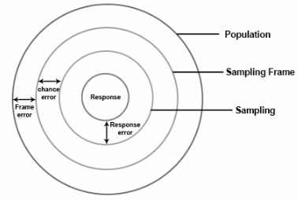
Figure 1 - Methodology Sampling
(Byjus, 2025)

Key challenges in sampling include coverage errors, sampling errors, and nonresponse bias, which can impact the accuracy of results. Nonresponse bias also impacts the actual sample obtained. When surveying a population with low participation rates, it is essential to incorporate this factor into the survey methodology to maintain validity of the findings. Therefore, careful selection of the sampling frame and method is essential for obtaining reliable findings (Byjus, 2025) (Taherdoost, 2020). The following survey sampling frame is proposed;
- Initial UK wide company distribution.
- Follow up response rate after 2-3-week period.
- Push for response/completion based on survey response.
- Follow up response rate after 4-6-week period.
- Consider extension to data gathering or opening up to wider UK company audience.

A proposed 36-week timeline, presented through a Gantt chart, see appendix 12.2, has been designed to accommodate flexibility in data collection and analysis phases, allowing for adjustments based on response rates, data quality, and emerging logistical considerations throughout the project lifecycle. 226 (7104)

8. Results

The research questionnaire achieved a response rate of approximately 64.3%, with 36 responses received from 56 distributed surveys. The response rate indicates a strong level of participant engagement, providing a robust empirical foundation for subsequent data analysis. Demonstrating that the sampling strategy effectively captured a diverse range of professional perspectives, particularly among individuals occupying project management and engineering roles within industrial sectors. The high response rate can be attributed to the systematic approach adopted during data collection, including the pilot testing of the questionnaire and the use of reminder emails to encourage participation.

8.1. Participant Demographics (Questions 1 & 2)

The participant demographics reveal a sample with strong technical expertise with notable representation from project-focused roles, which is directly relevant to evaluating the effectiveness of risk assessment tools in project management.

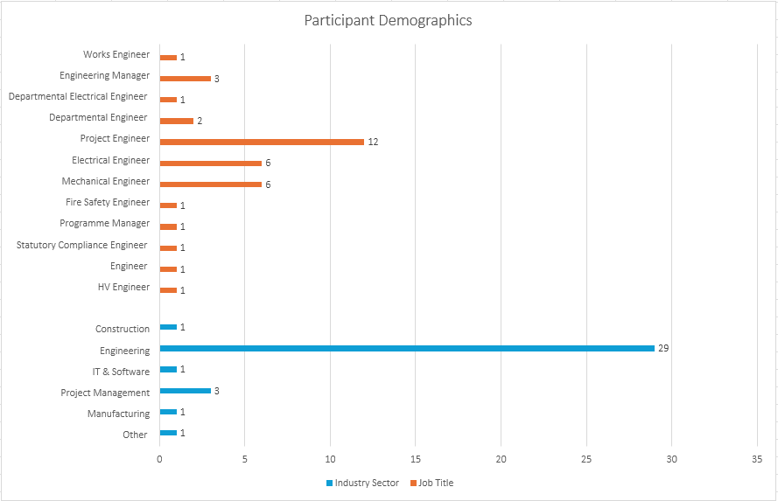
Figure 2 - Participant Job Title & Sector

Project Engineers represent the largest group (33.3%), supported by Engineering Managers (8.3%) and Programme Managers (2.8%), reflecting significant involvement from individuals responsible for delivering and coordinating projects. When combined with Electrical and Mechanical Engineers (both 16.7%), the dataset demonstrates a strong base of technical professionals who are often at the forefront of applying risk assessment in practice. Niche roles such as Fire Safety Engineer, Statutory Compliance Engineer, and HV Engineer further broaden the pool of perspectives, though their low frequency (2.8% each) reduces their overall influence. Some ambiguity in titles, such as overlapping “Departmental Engineer” categories and the generic use of “Engineer,” may indicate inconsistencies in role classification but does not diminish the overall insight into project-related responsibilities.

From a sector perspective, four fifths of respondents identified Engineering as their primary field, with Project Management accounting for 8.3%. While the dataset is clearly weighted toward engineering, the strong presence of project engineers, managers, and programme managers means that project management considerations are well embedded in the responses. The inclusion of perspectives from construction (2.8%), IT & Software (2.8%), manufacturing (2.8%), and other sectors (2.8%) provides some cross-industry balance, though their influence is limited by sample size.

The majority of participants had significant experience with nearly 40% reporting over 15 years project-related roles.

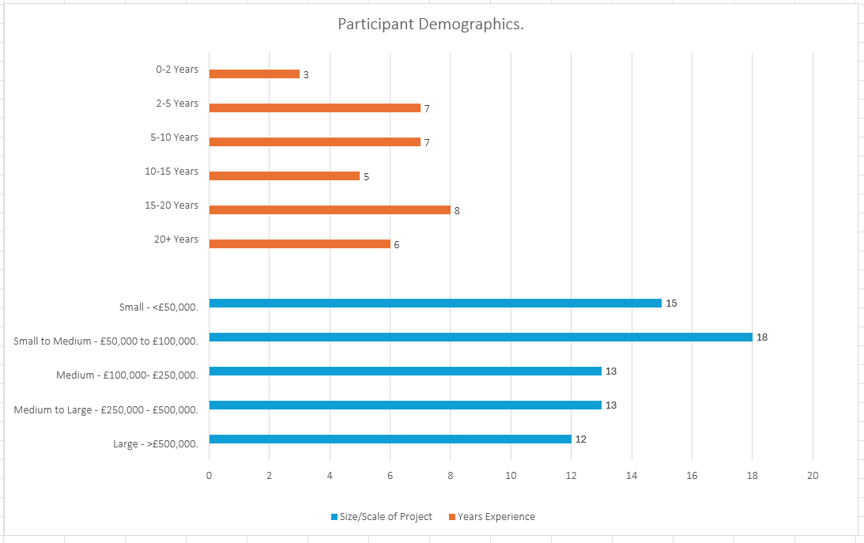
Figure 3 - Participant Project Experience

Project scale reflects a healthy diversity, with almost half (48%) involved in projects under £100,000, and over a third engaged in projects exceeding £250,000, including nearly 20% managing high-value projects (>£500,000).
367 (7471)

8.2. Current Use of Risk Assessment Tools (Questions 3 &4).

All participants reported using risk assessment tools in their project management activities, however the types of tools employed varied in both the sophistication and consistency of practices. The most frequently used tools included Risk Register, Failure Mode and Effects Analysis (FMEA), and Functional Analysis (HASOP). Additionally, methods such as the Ishikawa (Fishbone) Diagram and Cost Benefit Analysis (CBA) are frequently applied, reflecting the importance of root cause analysis and financial evaluation in decision-making processes that underpin project planning and execution.

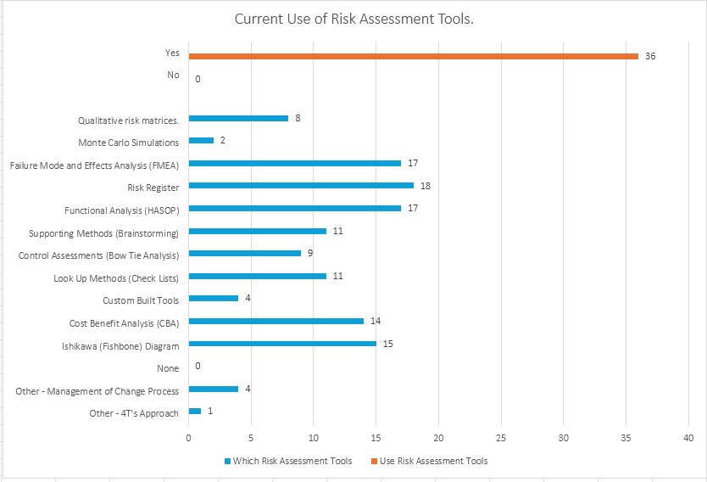
Figure 4 - Participant Use of Risk Assessment Tools
In contrast, more advanced or resource-intense tools, such as Monte Carlo Simulations and the 4T’s Approach, were only used by a small minority. The presence of custom-built tools and processes such as Management of Change also highlights the tendency of a small number within the organisation to adapt or develop bespoke solutions in order to align risk assessment more closely with their unique project environments.

While risk assessment tools are widely used in project management, the results demonstrate inconsistency in their application and is often misaligned with best practice standards such as PMBOK (Project Management Body of Knowledge) and ISO 31000. Nearly a third of respondents complete assessments only at initiation, and less than a quarter undertake continuous assessment throughout the product cycle. From an effectiveness standpoint, the mixed perceptions of tool performance further underline this gap. Although 45.2% of participants rated tools as effective, only 4.8% considered them very effective, with nearly half reporting moderate or limited effectiveness.

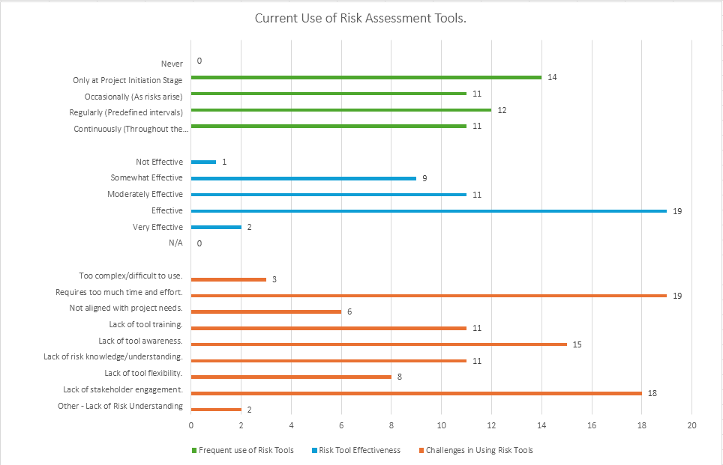
Figure 5 - Participant Use and Opinion of Risk Assessment Tools

The challenges identified by participants provide insight into why this disconnect exists. The most significant barriers were organisational rather than technical: excessive time and effort requirements (39.6%), lack of stakeholder engagement (37.5%), and lack of awareness (31.3%).

276 (7747)

8.3. Effectiveness of Risk Management.

Despite the widespread adoption of risk assessment tools in project management, their effectiveness in consistently improving project outcomes remains uncertain. Perceptions of tool effectiveness were mixed. Whilst around half of respondents considered their risk assessments to be effective, only a small proportion regarded them as highly effective in improving outcomes. Similarly, when considering risk prevention, no respondents indicated that risks were always prevented by assessments, and most noted only partial success in mitigating major threats.

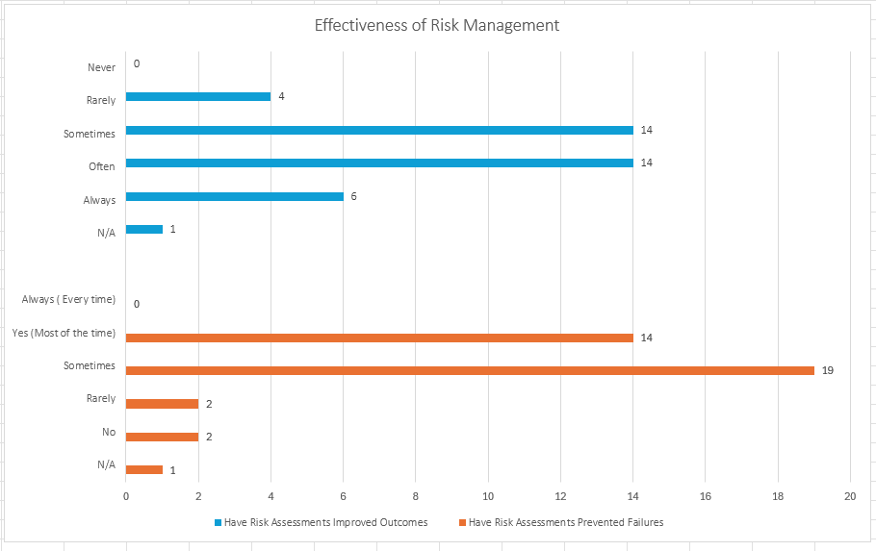
Figure 6 - Participants Use and Opinion of Risk Assessment Tools

Additionally, the survey as illustrated below, provided valuable insights into the current state of risk management practices in project management and highlights the perceived shortcomings of existing risk assessment tools. Almost 70% reported experiencing project failings attributable to ineffective risk management.

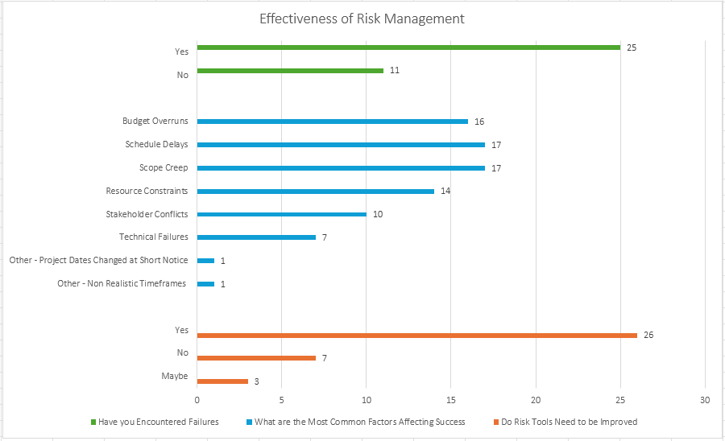
Figure 7 - Participants Project Deviations

The most frequently cited risk factors highlighted budget overruns, schedule delays, scope creep, and resource constraints, all of which align closely with the traditional project management “iron triangle” of cost, time, and scope (Hetemi, 2021).

In relation to the tools, nearly three quarters (72.2%) expressed the belief that current tools require improving to be truly effective, with less than 10% disagreeing with this approach. The 20% of respondents who selected “maybe” suggests some uncertainty or variability across industry; however, the overall consensus is clear, existing tools are not fully meeting practitioners’ needs.

Participant’s understanding of risk and appropriate choice of risk tool, as shown below, highlighted both areas of strength and critical gaps in knowledge. So many percent, correctly classified FMEA within Functional and Failure Analysis Techniques and Qualitative Risk Matrices under Risk Analysis Tools, with a similar accuracy achieved with of Bow Tie Analysis under Control and Visualisation methods.

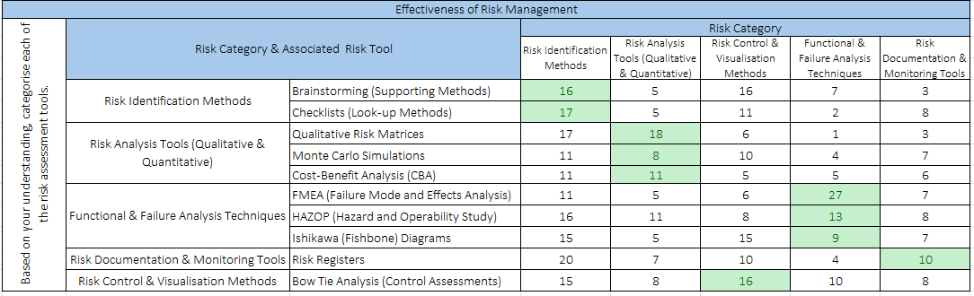
Table 6 - Participant Understanding of Risk and Appropriate Risk Tool

However, the survey also revealed a significant proportion of misclassifications. For instance, Brainstorming and Checklists, both foundational to Risk Identification, were often mis-classified as analysis or control tools, and Risk Registers under identification, rather than Documentation and Monitoring.

302 (8049)

8.4. Need for a Customisable Framework.

There was strong support for the development of a customisable risk assessment framework with 83.3% of respondents agreeing that such a framework would enhance risk management practices.

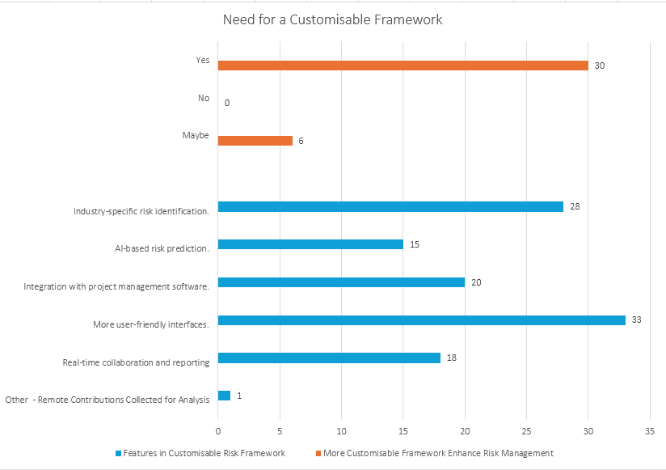
Figure 9 - Participant Views on Need for Customisable Framework

The features respondents desired included usability with more user-friendly interfaces, industry specific tailoring, integration with project management software, real-time collaboration, and clearer communication tools.

As shown below, in line with the identified need for a customisable framework, a similar number of participants, 88.8%, were willing to adopt such a risk assessment framework if it was shown to be effective.

The main barriers to adoption of such a framework were identified as associated training requirements, resistance to change, and lack of management support.

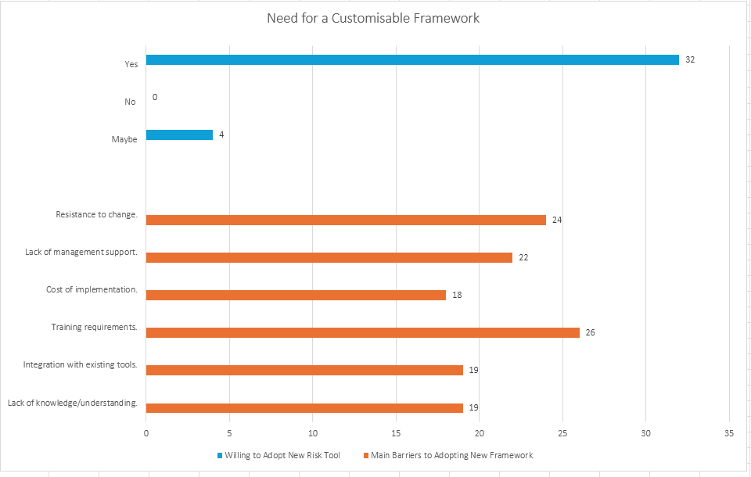
Figure 10 - Participant Views on Customisable Framework Requirements

109 (8158)

8.5. Open-ended Feedback.

Qualitative responses highlighted several themes. Formal tools such as risk registers, risk matrices, and FMEA were identified as the most effective strategies by respondents, especially when used iteratively.

Respondents also valued proactive strategies. aligned with the principle of forward planning. including scenario testing (such as use of test rigs), early brainstorming, and continuous review.

Human and organisational factors emerged strongly from the survey, with multidisciplinary collaboration, expertise, leadership, and stakeholder engagement repeatedly cited as essential in shaping outcomes.

A key concern raised by respondents was lack of standardisation in current practice, with a repeated emphasis on the confusion brought about by use of multiple, inconsistent tools, leading to inconsistency and comparability across projects.

Another strong theme from the responses concerns competency and training. Participants noted that while tools exist, their effectiveness is often constrained by the limited capability of users to apply them meaningfully.

144 (8302)

9. Discussion.

This research set out to evaluate whether current risk assessment tools used in industry are effective in project management and whether a more customised framework could improve risk management and consequently project outcomes. The findings indicate a complex picture of current risk practice, with some contradiction. While risk management tools are widely embedded within project processes, their practical application, perceived effectiveness and alignment with best-practice frameworks such as PMBOK and ISO 31000 inconsistent and incomplete. Respondents expressed strong support for the development of a flexible and user-centred framework that could integrate existing tools while adapting to diverse project contexts. These findings echo concerns raised in literature about the persistent gap between theoretical models and their translation into practice, emphasising the need for balance between standardisation and adaptability (Bannerman, 2008)(Hilson, 2023) (Aven, 2016).

The demographic profile of the respondents, the majority engineers and project-related managers, displays a strong technical/operational skillset reflecting the reality of practice. However, caution must be taken with the wider application of findings across industry sectors as there was limited representation of dedicated project managers, and this was within one industry organisation only. Perspectives may therefore be shaped by established organisational practices, which may under-represent the more agile approaches of less-experienced individuals, or other sectors. However, the range of project scales represented strengthens the dataset, highlighting differences between larger high value projects, typically utilising formal, systematic methodologies, and informal, ad-hoc practices adopted for smaller projects. Whilst the diversity is advantageous, the bias The variation highlights potential disparities in tool effectiveness and adaptability of existing frameworks across the project management landscape.

The discussion below reviews the findings alongside the current literature as presented in section 6, assessing the impact of culture, training, methodological constraints and individual behaviours on risk management effectiveness.
287 (8589)

9.1. Current Use of Risk Assessment Tools.

The results suggest that risk assessment tools are widely employed within project management, indicating that structured risk management is now an established expectation, institutionalised within project environments. This aligns with the literature, which reports that formal risk processes have shifted from being optional add-ons to integral components of project delivery (Zou, 2017) (Jacqueline Jepson, 2018). This suggests a mature recognition within organisations of risk process as integral, determinant of project outcomes, rather than optional. The embedding of risk tools also indicates that practitioners recognise their value in improving foresight, accountability, and compliance with industry frameworks.

However, this widespread adoption continues to mask significant variation in the application of such tools, and therefore how this translates to meaningful practice. Traditional tools such as risk registers, FMEA, HAZOP and cost-benefit analysis dominate practice in both industry and academic research, their popularity reflecting their accessibility and familiarity (Kolios, 2018). These tools are valued for their structured documentation, systematic identification, and accountability (Rostami, 2016). For example, risk registers enable traceability throughout the project lifecycle, while FMEA supports reliability assessments by systematically analysing potential failure points. Whilst such tools offer clear outputs, there is a risk that practitioners may lean towards comfort/familiarity and routine rather than suitability. This becomes more problematic in complex projects where advanced analytics or probabilistic modelling would benefit insight. While effective at providing visibility and structure, risk registers and qualitative matrices are limited in their ability to capture the probabilistic nature of uncertainty or to model complex interdependencies between risks. This approach also limits innovation (Kolios, 2018).

This is supported by the observation that the more advanced techniques, such as Monte Carlo simulations, and the 4T’s approach were rarely employed. These findings reinforce a reliance on simpler methods, reflecting key concerns such as insufficient analytical capability, time pressures, data limitations, and a preference for intuitive decision-making as identified in the literature (T. Raz, 2001) (Robert Pellerin, 2018). Similarly, Bannerman argues that advanced quantitative approaches, although powerful, are often underutilised due to their perceived complexity and the lack of practitioner expertise (Bannerman, 2008). However, the finding that a small number of respondents, reported the use of custom-built or modified tools/processes such as Management of Change systems, is encouraging, indicating an emerging recognition that traditional tools may not always be sufficient in addressing the diversity of risks encountered across projects; tailoring risk practices to context rather than relying exclusively on standardised approaches (Marle, 2016). The limited application of more complex methods, with continued reliance on qualitative methods, raises concerns about risk management in large-scale or high-uncertainty projects. This reinforces the question of whether organisations are selecting tools based on ease/convenience or appropriateness.
From a project management perspective, this reliance on familiar tools presents a duality. On the one hand, the use of accessible and well-understood methods increases the likelihood of consistent application across projects. This is particularly important in environments where time and resource constraints make the adoption of complex quantitative methods impractical. On the other hand, the preference for simplicity risks oversimplifying or overlooking systemic risks, particularly in high-value projects where the consequences of uncertainty are significant. As Aven argues, effective risk management requires tools that not only provide structure but also reflect the dynamic and probabilistic nature of real-world uncertainty (Aven, 2016).

The pattern of risk assessment tool use also identified a significant finding relating to timing of tool application. Whilst tools are embedded in practice, nearly a third of respondents conduct risk assessment at project initiation, with only the minority applying throughout the project lifecycle. This sharply contrasts with iterative, cyclical recommendations within frameworks such as PMBOK and ISO 31000, suggesting that risk management is approached as a compliance formality rather than integrated into decision-making processes. This creates a disconnect between theory and practice, and lack of organisational governance, with a failure to capture evolving risks and new threats (Merkourios Papanikolaou, 2020) (Muhammet Gul, 2018). Similar findings were noted in the literature, where the snapshot principle of risk management was a common occurrence (Schieg, 2010) (Karel de Bakker, 2010). The evidence from the survey suggests that while tools are formally adopted, their purpose is fundamentally undermined, leaving them less able to positively influence outcomes.

Project scale also appears to impact on tool selection, the size and complexity of projects often correlating with the formality of risk processes. Smaller projects often rely on more informal approaches, whereas larger more complex projects typically demand more sophisticated systematic, quantitative methods. The underrepresentation in the survey of advanced tools may reflect the financial and technical scale of many respondents’ projects, however indication that there is a tendency of the organisation to underutilise advanced methods, even where they would offer significant insight and advantage, re-enforces the gap in risk assessment robustness.

Central to effective use appears to be the influence of organisational and cultural factors. Cited barriers such as time pressure, lack of training and stakeholder engagement suggest that organisational system, behaviours and culture shape tool effectiveness. Tools such as Monte Carlo simulations demand not only technical expertise but also leadership support, training, and an organisational culture that values data-driven decision-making. This re-forces findings within the literature that effective risk management is people-driven, shaped by leadership and culture. This is resonated by Khadgi (2025), who argues that without stakeholder engagement and cultural integration, risk management processes struggle to generate real value (Khadgi, 2025).

In summary, the findings highlight a paradox: although universal adoption suggests a mature and embedded approach to PRM, their application remains inconsistent, driven by tradition rather than best practice or suitability. Familiarity provides consistency but limits adaptability and tools that offer the depth required for more advanced projects. The findings reinforce the case for a customisable risk management framework that balances useability with analytical maturity and encourage a lifecycle approach. Alongside this, cultural and organisational barriers would need to be addressed to ensure that risk tools move beyond compliance to become genuinely value-adding elements of project management.

947 (9536)

9.2. Effectiveness and Limitations of Current Practices.

Although as described above the survey confirmed universal adoption of risk assessment tools, their perceived effectiveness varied. Whilst nearly half rated tools as generally “effective,” very few considered them “highly effective”. This suggests that adoption does not necessarily guarantee meaningful impact. This echoes many of the findings above, and within the literature that tools alone cannot ensure effectiveness. Appropriate choice, consistent application and integration into organisational decision-making, culture, and stakeholder engagement is key to delivering value (Hilson, 2023) (Gul M, 2018).

As in 9.1 above, a key limitation to the effectiveness of any risk management tool, is their use across all project lifecycle phases, spanning identification, analysis, response planning, and monitoring (Merkourios Papanikolaou, 2020). Yet the survey revealed that nearly a third of participants restrict risk assessment to the initiation stage of projects, treating it as a ‘one-off’ activity rather than a sustained, value-adding process. This suggests again that in many cases, risk management is reduced to a procedural exercise rather than embedded in strategic activities. As argued by Zwikael and Ahn, mechanical ‘tick box’ approaches undermine the ability risk tools to effectively influence outcomes (Ofer Zwikael, 2010). The failure to conduct iterative assessments also risks leaving projects vulnerable to evolving risks that emerge during execution, a problem particularly acute in dynamic environments where scope, timelines, and resources are subject to change. Such an approach is likely to have influenced participants view of true effectiveness.

Similarly, the perceived limitations of tool effectiveness appear to be shaped less by technical shortcomings and more by organisational and cultural barriers, echoing earlier themes in 9.1. Lack of time, stakeholder engagement, training and awareness were identified as key constraints. These factors are consistent with literature which advocates project governance as fundamental to effective practice: risk management is fundamentally a human and organisational activity rather than a purely technical one. Khadgi (2025) notes that frameworks such as PRINCE2 stress the importance of stakeholder involvement in the risk process, yet many organisations continue to treat risk management as the responsibility of a select few rather than shared (Khadgi, 2025). Similarly, Cagliano emphasises that effectiveness increases when risk processes are iterative, collaborative, and embedded in daily routines (Cagliano, 2015). Consistent with the literature, the survey suggests that without stakeholder ownership, insufficient training, and weak cultural integration undermine the value of tools. Even when they are technically sound, even the most well-designed tools will fail to achieve their potential (Aven, 2016).

Mixed perceptions of tool effectiveness also reflects wider issues in project outcomes. As section 9.4 highlights, familiar risks such as budget overrun, schedule delays, and scope creep were persistent, influencing respondents’ opinions that most tools are only partially effective in improving outcomes. While most participants acknowledged risk assessments to be beneficial, very few reported that tools “always” improve outcomes. These results resonate with Hetemi, who argues that risk tools cannot be effective in avoiding such challenges unless they are employed as part of robust planning, monitoring and control processes (Hetemi, 2021). This partial effectiveness suggests that tools are often decoupled from the strategic decision-making and organisational learning processes that ultimately shape project outcomes. These issues are emphasised by Aven (2016), who stresses that risk management should not be confined to technical assessment but must inform governance and continuous improvement (Aven, 2016). Without this, the capacity of risk tools to influence project success, and therefore be deemed effective, will be inherently limited.

Perceived effectiveness is also greatly influenced by tool choice. As detailed in 9.1 above, project scale should influence choice but is not seemingly always the case. A simple tool in a complex project is unlikely to effectively model complexity or quantify uncertainty, and therefore be perceived as ‘ineffective’. This supports Hillson’s critique of a ‘one-size-fits-all’ approach which, while offers consistency, fails to account for sectoral and contextual differences. (Hilson, 2023). In practice, tools that are effective in one sector or project type may be less suited to another. For example, manufacturing and engineering projects may benefit from FMEA and HAZOP due to their technical focus, whereas IT projects may require approaches better suited to rapidly changing requirements and iterative development cycles. This approach may largely have influenced the perceived effectiveness rating of respondents.

Compounding these perceptions of effectiveness is knowledge and competence in the correct application of tools as described in detailed in 9.3. Misclassification of tools, such as brainstorming and checklists as analysis methods, or risk registers as identification tools, suggest poor understanding of how tools should function. Misapplication can create false confidence, poor prioritisation, and incomplete assessments, reinforcing the perception that tools, and in fact risk management itself, are ineffective (Hilson, 2023) (Bannerman, 2008).

Taken collectively, the findings suggest that the effectiveness of risk assessment tools in project management is constrained by three interrelated factors:
- Procedural application, whereby tools are applied only at the initiation stage rather than continuously, diverging from PMBOK and ISO 31000 principles.
- Organisational and cultural barriers, including lack of stakeholder engagement, limited training, and insufficient integration into governance structures.
- Knowledge gaps and misapplications, which undermine the ability of tools to generate accurate and actionable insights.

These limitations echo themes in the literature: that tools alone cannot guarantee effectiveness; rather, effectiveness emerges from the interplay between methodological rigour, organisational culture, and practitioner competence (Cagliano, 2015) (Ofer Zwikael, 2010).

The implication for practice is that improving effectiveness requires more than introducing new tools or enforcing compliance with existing ones. It demands investment in training, leadership support for stakeholder engagement, and cultural shifts that treat risk management as an ongoing strategic activity. From a theoretical perspective, the findings support calls for frameworks that balance standardisation with flexibility, enabling project managers to adapt tools to context while maintaining alignment with best-practice principles (Hilson, 2023) (Aven, 2016).

916 (10452)

9.3. Tool Misapplication and Misclassification.

The effectiveness of risk assessment tools depends not only on their presence within project management but also how well they are understood and applied (Merkourios Papanikolaou, 2020). Despite widespread adoption (see 9.1), the survey revealed significant misclassification and misapplication of tools, suggesting a lack of clear understanding of their purpose and correct use. This reflects a critical barrier to achieving value and meaningful outcomes from risk management. As noted in section 9.2, such misunderstandings contribute to the perception of tool effectiveness as they are not being applied with methodological accuracy.

A significant proportion of widely recognised tools were misclassified. Brainstorming and checklists, both foundation techniques for risk identification, were misinterpreted as analysis or control methods, and risk registers as identification tools rather than documentation/monitoring instruments. This reflects a weak or incomplete understanding of the lifecycle of risk management, presenting a risk of merging distinct stages of the risk process. This can undermine the rigour of assessments, consequently leading to incomplete or misleading results (Merkourios Papanikolaou, 2020).

Misclassification further extended to the more complex tools. Monte Carlo simulations, a quantitative risk analysis method, were categorised as an identification tool, and Ishikawa diagrams a control tool rather than a functional and failure analysis method. Cost benefit analysis was also occasionally placed outside its analytical category, raising concerns that financial evaluation may be separated from its intended purpose in evaluating risk mitigation against potential returns. Such misclassifications are important; they not only highlight knowledge gaps but also risk undermining the very purpose of these tools. Misused tools can negatively impact decision-making and hide outstanding risks, creating a false sense of security where teams believe risks are adequately managed, yet underlying threats remain unresolved (Hilson, 2022). When brainstorming is treated as an analysis technique rather than an identification method, early-stage risks may be mistaken for fully evaluated ones, giving project teams a false sense of preparedness. Similarly, treating risk registers as static identification devices rather than dynamic monitoring tools can lead to risks being recorded without continuous follow-up, and the project vulnerable to emerging threats (Aven, 2016). Bannerman similarly cautions that using probabilistic models outside of their intended analytical context, such as Monte Carlo simulations as identification tools, their results may be misinterpreted, leading to decisions based on incomplete or misleading data. Outputs become divorced from qualitative project realities (Bannerman, 2008). The same logic applies to Ishikawa diagrams, when applied as control methods rather than root cause analysis techniques, teams may focus on addressing symptoms rather than underlying drivers of risk, resulting in ineffective mitigation strategies (Kause, 2012).

The consequences of such misapplications extend beyond technical inefficiency. When used incorrectly they can risk decisions made on flawed assumptions, waste organisation resources, and create misplaced confidence in the adequacy of risk strategies. In practice, this may translate into poorly informed project decisions, unmanaged residual risks, and ultimately, higher likelihoods of budget overruns, schedule delays, or scope creep; challenges that respondents identified as recurring risks in their projects, and likely influences on their perception.

The origins of some of the findings appear to be linked to capability, experience and culture. The sampling was dominated by technically oriented professionals, such as engineers, rather than those with dedicated project management backgrounds. While this demographic brings practical expertise in applying tools, they may be less familiar with the broader methodological frameworks, such as PMBOK and ISO 31000 that detail correct tool use. This may go some way to explaining the gaps evident in understanding. The findings also reinforce some of the wider organisational and cultural issues described in 9.2, with lack of awareness, poor training and capability development, and insufficient stakeholder engagement cited as key barriers to effective tool use. These barriers point not only to issues of communication and culture but also to limited investment in ensuring practitioners understand both the purpose and correct application of risk assessment methods; the value of tools being undermined by capability and support. This supports the argument by Cagliano (2015) that risk management effectiveness depends as much on practitioner competence as on the tools themselves: without adequate training, even well-designed tools risk being applied inappropriately (Cagliano, 2015). This finding is supported by prior observations that a cultural attitude to risk management as a ‘tick-box’ exercise will inherently undermine effective deployment (Ofer Zwikael, 2010).

In addition, the problem of misapplication and misunderstanding is likely compounded by the lack of shared common language and conceptual clarity within organisations. A risk register, for example, can mean different things to different practitioners if its role in monitoring versus identification is misunderstood. Such confusion undermines organisational learning, with data from past projects difficult to compare or consistently interpret. This is supported by Aven (2016), which notes that fragmented approaches to risk management limit transparency and weaken an organisation’s ability to accumulate knowledge systematically from past experiences (Aven, 2016). The misapplications within the surveyed population suggest some fragmentation could be present.

Taken together, the findings suggest that misunderstanding and misapplication are a significant barrier to risk management effectiveness. A customisable risk management framework could help to mitigate some of these challenges by providing a structured, context-based process that provides clear guidance on tool selection and application. This would support practitioner understanding and tool alignment with specific stages of the risk process, reducing the likelihood incorrect use and increase their overall effectiveness. Such customisation would need to balance structured, repeatable processes with flexibility to adapt to project-specific contexts, as it is recognised that overly rigid guidance risks discouraging adoption or failure to accommodate sector-specific nuances, while overly flexible approaches risk fragmentation and inconsistency. (Aven, 2016) (Hilson, 2023) (Hilson, 2022). A customisable framework could therefore provide both clarity and adaptability, ensuring tools are correctly applied while allowing adjustments for project size, industry, and complexity. The challenge around to misunderstanding and misapplication however can not be addressed by frameworks alone. As highlighted throughout sections 9.1-9.3, practitioner knowledge, organisational culture, training and stakeholder engagement must also be addressed.

957 (11409)

9.4. Risk Management and its Impact on Project Outcomes.

The effectiveness of risk management cannot be evaluated solely in terms of tool adoption or practitioner familiarity; its true measure lies in its ability to influence project outcomes. The survey findings align with, as expected, those opinions on the effectiveness of risk assessment tools, revealing that although risk assessment tools are widely employed, their contribution to preventing failures and impact on project outcomes is inconsistent.

Although the majority of respondents acknowledged that risk assessment tools have impacted positively on their projects, very few reported they ‘always’ improved outcomes, and none stated that risks were consistently prevented. This reinforces earlier findings throughout Sections 9.1-9.3, that tools are widely use but not fully effective due to inconsistent application, organisational barriers and knowledge gaps; there remains a persistent gap between the theoretical potential of risk tools and their practical application (Aven, 2016) (Hilson, 2023). When tools are isolated from the wider project environment, for example as previously stated treated as checklists rather than embedded processes, their capacity to influence outcomes diminishes significantly (Ofer Zwikael, 2010). The finding reinforces a common theme throughout the literature, effectiveness of tools depends not merely on technical design but on their integration into governance and decision-making structures (Gul M, 2018).

A significant proportion of respondents (69.4%) reported experiencing project failures as a result of ineffective risk management, highlighting the consequences of weak risk practices. The nature of these cited failures; budget overruns, schedule delays, scope creep, and resource constraints, align with well-documented challenges in project management, the classic “iron triangle” of cost, time, and scope (Hetemi, 2021). These recurring risks indicate systemic weaknesses in planning, monitoring, and controlling processes, all of which are central, not peripheral to project performance. These findings mirror consistent findings in the literature that risk management is often undervalued as a strategic enabler of project success; it should be embedded and integrated into core-decision making (Aven, 2016) (Hilson, 2022), rather than viewed as a support function (Rostami, 2016) (Zou, 2017). The survey findings reinforce the position that shortcomings in risk assessment practices can have direct and often severe consequences for project delivery.

The findings also again highlighted the importance of integration and timing. A significant cited contribution in the survey to the adverse project outcomes identified a disconnect between tool use and their ability to generate relevant strategic insight. As described in 9.2, participants reported using tools at project initiation, but failed to monitor across the lifecycle despite PMBOK and ISO3000 instructing lifecycle monitoring for detecting evolving risks. This static approach leaves projects vulnerable to new or evolving risks, particularly in complex dynamic projects This will reduce the ability and effectiveness of any tool to positively influence outcomes.

Human and organisational factors continue their prominence, with secondary challenges such as stakeholder conflicts and technical failures, continuing to significantly influence outcomes. These findings align with Chapman and Ward’s emphasis on the importance of interpersonal and organisational factors in risk management (Chapman, 2011), with underestimation of for example unmanaged conflict escalating into scope creep, resource disputes, or delays. While technical risks may be easier to identify and quantify, Marle (2016) recognises that social complexities, such as multi-stakeholder environments, can be as damaging as technical errors and require careful communication, alignment of expectations, and active engagement across diverse project sectors (Marle, 2016). Furthermore, as evidenced by Aven (2016), for effective adaptive risk management to be supported, processes must inform governance; this level of integration is not evident from the questionnaire results (Aven, 2016). The role of leadership is critical, as Gul notes, effectiveness depends on embedding risk management into organisational governance and culture. Leaders who treat risk processes as strategic priorities can create the conditions for tools to have real impact, ensuring that assessments inform planning, resourcing, and stakeholder engagement (Muhammet Gul, 2018). By contrast, in organisations where risk is treated as an administrative burden, tools are unlikely to influence outcomes meaningfully. These findings underscore those barriers identified in 9.2 and reaffirm the need for frameworks that extend beyond technical tools to incorporate stakeholder engagement and cultural integration.

Previous findings relating to projects scale and misapplication of tools, in particular the limited use of more advanced tools such as Monte Carlo simulations in larger, more complex projects also shape the findings around outcomes. These techniques offer analytical and probabilistic capability, providing valuable insights, especially in capturing complex relationships or evolving uncertainties. Yet they remain underutilised due to perceived complexity. This is likely to weaken any positive relationship between risk assessment and project outcomes. Similarly, misclassifying and therefore incorrectly applying tools is likely to mislead assessments, distort decision making and negatively affect outcomes, compromising project success.

In summary, the findings demonstrate the impact of risk assessment tools on project outcomes is both significant and inconsistent. Tools are widely used, yet their contribution to preventing project failures is undermined by misapplication, inadequate integration, and cultural barriers. The findings demonstrate that ineffective risk management fundamentally contribute to project deviations and failures, perceived as as poor outcomes. As above, there exists a structural weakness in the implementation, monitoring and responses to risk assessments. If tools are to consistently improve outcomes, they must be correctly applied, continuously integrated into project lifecycles, and supported by organisational culture and leadership. The findings reinforce the case for a customisable context-sensitive risk management framework that strengthens the ability of risk assessments to produce actionable insight and enhance project outcomes. 864 (12273)

9.5. The Case for a Customisable Framework.

The results from the survey, combined with various challenges presented in earlier sections demonstrate that despite widespread use, application of risk tools is inconsistent, effectiveness variable and integration into project management governance poor. These findings point to a pressing need for a more flexible, adaptable and context-sensitive approach to risk management. There is a strong justification for the development of a customisable risk management framework that can accommodate the diverse contexts, complexities and organisational environments in which it operates.

The survey demonstrated overwhelming support, with 83.3% of respondents in favour of a customisable framework, and 88.8% willing to adopt one providing it improves outcomes. This indicates there is a wide recognition current tools have several shortcomings; whilst they offer value, their rigidity and generalised design limit their effectiveness in diverse project environments. This is supported by the literature, which cautions against a ‘one-size-fits all solution’ (Kutsch, 2010). The features most prioritised by respondents shed light on what such a framework should entail, reflecting practical concerns rather than simply technical ability.

Usability emerged as the foremost requirement, with calls for more user-friendly interfaces to ensure accessibility across all levels of expertise. Respondents expressed a desire for useability and clarity within a framework, reflecting tools are applied rigidly and without iteration resulting in a risk assessment that is not representative of the true project environment. This underpins the principle that tools must not create additional burdens but should streamline decision-making processes. Current practice is dominated by inconsistent application and a tendency towards traditional familiar tools, particularly risk registers, FMEA and HAZOP. This is likely because they are simple, accessible and well-understood, yet they may not provide the flexibility or depth required in complex or dynamic environments, a view echoed by Kutsch and Hall (2010), who found that overly complex methodologies often discourage consistent use (Kutsch, 2010). The fact that practitioners are aware of these shortcomings suggests both an openness and an appetite for innovation in risk management practice. Similarly, a clear capability gap is evident with frequent misclassification and subsequent misapplication of tools, undermining risk processes and their effectiveness. Any re-designed framework must therefore assess this gap, with clearer guidance and embedded learning. Respondents also emphasised the importance of sector-specific tailoring, reflecting risks identified in earlier sections where tools evidently did not cater for project scale, context or complexity. Generic frameworks overlook these variances, creating blind spots that jeopardise project success. By enabling sector-specific tailoring, a customisable framework could enhance relevance and applicability. This would support risks being identified and managed in ways that reflect the realities of each project.

Integration with project management software and real-time collaboration capability emerged as another priority, reflecting issues identified in earlier sections, where risk management was considered procedural rather than functional. Risk tools were treated as standalone systems, divorced from scheduling, resource, and communication. This failure to integrate undermines their ability to influence day-to-day decision-making and weakens influence on project outcomes. Respondents highlighted that risk management should not be an adjunct but an embedded component of ongoing project monitoring and reporting. The call for integration is consistent with the principles of ISO 31000, which emphasises that risk management must be embedded within organisational systems and processes rather than treated as a separate activity (Muhammet Gul, 2018). Achieving this would provide more relevance to the tools and potentially reduce the current perceptions that they are more of an administrative task or burden. In line with this, addressing stakeholder engagement was also deemed an essential feature. This aligns with earlier findings where stakeholder engagement, poor communication and ownership were reported to reduce quality and impact of any risk assessment. This mirrors that of Khadgi (2025), who underscores that PRINCE2 highlights active stakeholder involvement and communication as essential to effective risk management. A customisable framework with collaborative features could strengthen stakeholder engagement by making risks more visible and fostering shared ownership across project teams (Khadgi, 2025).

While some respondents expressed interest in advanced capabilities such as AI-based risk prediction, these were ranked lower than usability and integration. Although this could reflect capability gaps in the use of existing tools, it suggests that practitioners recognise the potential in emerging technologies but view them as secondary to more immediate concerns of accessibility and embedding. The priority for respondents is not necessarily innovation for its own sake but ensuring that risk management becomes a practical, effective, everyday part of project management routines.

The design of any customisable framework requires careful balancing between standardisation and flexibility in risk management. Aven (2016) and Hillson (2023) argue that rigid, one-size-fits-all approaches often fail to capture the nuanced realities of projects, particularly in contexts characterised by complexity and uncertainty (Aven, 2016) (Hilson, 2023). Conversely, overly flexible approaches risk fragmentation and inconsistency, undermining comparability across projects and limiting organisational learning. The challenge, therefore, is to strike a balance. A customisable framework should preserve core principles, such as iterative assessment, stakeholder engagement, and alignment with best-practice standards like PMBOK and ISO 31000, while allowing adaptation to project-specific needs. This reflects Hillson’s (2022) call for “structured flexibility,” whereby risk frameworks provide both guidance and adaptability without sacrificing rigour (Hilson, 2022). A modular-type framework with advanced, flexible components where advanced techniques could be applied as appropriate may offer a solution.

Despite strong support for a customisable framework, the survey also highlighted potential barriers to adoption which need to be addressed. Training requirements were identified as the most significant obstacle, followed by resistance to change and lack of management support. Change management literature consistently highlights that adoption of new systems is often hindered by established practices, competing priorities, and scepticism among stakeholders (Chapman, 2011). These barriers reflect organisational and cultural challenges outlined in earlier sections where capability, misapplication and poor leadership undermine effectiveness. These findings reinforce that however technically capable; no framework can succeed without associated cultural and capability investment. As Cagliano (2015) stresses, risk management is as much a human process as it is a technical one, requiring experiential learning and scenario-based training to embed practices into organisational culture (Cagliano, 2015).

Taking respondent requirements and literature insights together, several design principles can be proposed for an enhanced customisable framework:
- Usability and Accessibility – Tools must be intuitive and user-friendly, reducing complexity and encouraging consistent application (Kutsch, 2010).
- Sector-Specific Relevance – The framework should allow tailoring of risk identification and mitigation strategies to reflect industry-specific risks.
- Integration with Project Systems – Risk management must be embedded within scheduling, resourcing, and communication tools, ensuring relevance to everyday project activities (Muhammet Gul, 2018).
- Iterative and Continuous Assessment – Processes should align with PMBOK and ISO 31000 by emphasising ongoing risk monitoring throughout the project lifecycle (Merkourios Papanikolaou, 2020).
- Stakeholder Engagement – The framework should foster collaboration, visibility, and shared ownership of risks, consistent with PRINCE2 principles (Khadgi, 2025).
- Structured Flexibility – Core principles should remain standardised to ensure comparability, but adaptation should be encouraged to accommodate project scale, complexity, and sector-specific requirements (Hilson, 2023).
- Capacity Building – Training and capability development should be embedded as integral components of framework adoption, addressing the knowledge gaps and misclassifications identified in the survey.

Overall, the findings consistently support the case for a customisable, integrated, context-sensitive framework is supported by both analytical depth and theoretical reasoning. It presents an opportunity to address current limitations by improving useability, aligning with project management processes, enhancing stakeholder engagement and collaboration, and strengthening accountability and communication. Practitioners recognise the shortcomings of existing tools and overwhelmingly support the idea of a more adaptable system. This is echoed in the literature, which reinforces that flexibility, when balanced with structure, is essential for addressing the complexities of contemporary projects. With appropriate design alongside addressing cultural and capability-related challenges, a customisable framework could bridge the gap between theory and practice, offering a more effective, integrated, and context-sensitive approach to risk management that enables project success.

1264 (13537)

9.6. Summary

Several common themes emerged from the findings of the study relating to the use, perceived effectiveness and limitations of risk assessment tools used in project management. Although widely adopted, application of the tools was inconsistent, practice being shaped more by organisational habits and user familiarity rather than best-practice frameworks. Traditional, simpler tools such as risk registers and FMEA dominated practice, largely due to their simplicity and accessibility. However this reliance was at the expense of more analytical methods, which remain underused due to perceived complexity and associated resource requirements, even when projects would benefit from a more advanced approach to improve insight.

Perception of tool effectiveness was variable, with limited support for them being highly effective. Established evidence points to organisational, cultural and capability-related issues playing a significant role in the value provided by risk management practices, and this was supported by the survey where time pressures, stakeholder engagement and training were frequently cited barriers. Without these, the iteration and integration into decision-making is limited, and subsequently the effectiveness of managing risk and impacting outcomes. Confusion around the purpose or categorisation of current common tools further undermine perceived effectiveness. Inappropriate use is likely to lead to weak assessment and reduced rigour over risks, resulting in an assumption that there is a failing of the risk tool itself, rather than a lack of methodological understanding.

The impact of these shortcomings is reflected in respondents’ experience of project outcomes. Cited deviations from budget, time and scope constraints are issues that effective risk management should mitigate. As a result of this, tools were rarely considered consistently effective, reinforcing the fact that without the right environment where risk management is iterative, effectively integrated into project governance and supported with capability, no tool alone is likely to provide optimal outcomes.

The evidence that risk management shortcomings contribute directly to project failures has important implications. For practice, it underscores the necessity of moving beyond adoption metrics to focus on effectiveness, integration, and adaptability. Risk tools must not only be present but must also influence decision-making in ways that reduce uncertainty and strengthen resilience. This requires investment in training, stakeholder engagement, and leadership support, as well as a cultural shift towards treating risk management as a strategic function. The findings highlight the need to explore frameworks that can bridge the gap between theory and practice. Existing standards such as PMBOK and ISO 31000 provide valuable principles, but their translation into practice remains inconsistent. Practitioners desire frameworks that are not only theoretically robust but also flexible enough to adapt to different contexts, scales, and industries. This sets the stage for considering whether a customisable framework could provide the platform for projects to proactively address risk management, supporting greater project resilience and consistent delivery of outcomes.

There is evidently strong support for such a customisable context-sensitive risk management framework that supports useability, clear guidance, sector-specific relevance and integration into current project management systems. There is a need to address the current risk management landscape to one which incorporates a flexible approach that balances methodological rigour, practitioner understanding and stakeholder engagement, supporting effective, continuous, collaborative risk management across the whole project lifecycle.

522 (14059)

9.7. Conclusion and Limitations

The study offers important insights how risk assessment tools are used in practice in project management, their perceived effectiveness, and the growing demand for a more customisable framework. While existing literature has long emphasised the importance of risk management (Aven, 2016) (Hilson, 2022) (Rostami, 2016) this research provides empirical evidence from practitioners that not only confirms but also extends these arguments.

One of the clearest contributions is the confirmation that risk management significantly and directly influences project outcomes. Nearly 70% of respondents reported project underperformance and failures linked to poor risk practices, validating earlier research arguments that challenges such as threats of cost overruns, delays, and scope creep (Hetemi, 2021), will persists while risk processes are poorly applied, and that structured risk management is a cornerstone of project success (Zou, 2017). By documenting practitioners’ experiences, this study moves beyond theorisation to demonstrate the real-world consequences of ineffective risk practices. It reinforces the notion that risk management is not a peripheral process but a key determinant of project success.

The study also provides an indication of why current tools fall short, insights into the persistent “theory–practice gap” in PRM, and his has important implications for the direction of travel. For practice, it underscores the necessity of moving beyond adoption metrics to focus on effectiveness, integration, and adaptability. Risk tools must not only be present but must also influence decision-making in ways that reduce uncertainty and strengthen resilience. This requires investment in training, stakeholder engagement, and leadership support, as well as a cultural shift towards treating risk management as a strategic function. The findings highlight the need to explore frameworks that can bridge the gap between theory and practice. Existing standards such as PMBOK and ISO 31000 provide valuable principles, but their translation into practice remains inconsistent. These standards emphasise iterative, lifecycle-wide risk processes (Muhammet Gul, 2018) (Merkourios Papanikolaou, 2020), yet many practitioners restrict assessments to the initiation stage. This supports arguments that risk management often becomes a compliance-driven activity rather than a strategic enabler (Ofer Zwikael, 2010). Cultural factors, treating risk as an administrative burden, and organisational factors, lack of training and leadership support, are critical barriers to alignment. Practitioners desire frameworks that are not only theoretically robust but also flexible enough to adapt to different contexts, scales, and industries, and can address these cultural and organisation barriers.

Another key contribution is highlighting the limitation in practice of many of the widely use tools. Risk registers, FMEA, and HAZOP remain dominant, yet only approximately 5% of respondents rated tools as “very effective” while suggesting practical effectiveness may be more limited than the literature assumes. This finding extends knowledge that barriers to effectiveness lie less in the tools themselves and more in their application, integration, and cultural support. Whilst advanced techniques like Monte Carlo simulations are recognised in scholarship as powerful quantitative tools (Bannerman, 2008), their limited use in practice reflects barriers of expertise, time, and organisational buy-in. Similarly, the misclassification of tools demonstrates that knowledge gaps significantly constrain effectiveness. By exposing these gaps, the study highlights the need for capacity-building measures, such as training and scenario-based exercises, that go beyond tool provision.

Perhaps the most significant contribution of this study is its empirical support for the need for a customisable risk management framework. While scholars have argued conceptually for the balance of standardisation and flexibility, this research provides practitioner evidence that confirms and strengthens their claims (Aven, 2016) (Hilson, 2023). Over 83% of respondents expressed support for such a framework, and nearly 90% indicated willingness to adopt it, demonstrating a strong appetite for reform within the professional community. Respondents prioritised usability, sector-specific tailoring, integration with project systems, and stakeholder collaboration, providing practical guidance on what customisation should look like. This represents an important extension of the literature, which has often debated flexibility at a conceptual level without grounding it in practitioner perspectives. By surfacing these practitioner-defined priorities, the study offers a valuable bridge between academic theory and project management practice.

From a practical perspective, the findings have several implications. Firstly, they underscore the need for organisations to invest in training and capacity building. Knowledge gaps and misclassifications are not trivial errors but threats to project performance. Addressing these requires structured programmes that embed risk competence into organisational culture, consistent with an emphasis on experiential learning (Cagliano, 2015). Secondly, the findings highlight the importance of leadership in embedding risk management. Lack of stakeholder engagement and resistance to change suggest that leadership sponsorship and cultural integration are as important as methodological design. Leaders must position risk management as a strategic priority, not a compliance task, if frameworks are to deliver consistent value. Finally, the study suggests that technology can play a critical role in enhancing usability and integration. By embedding risk tools into project management platforms and enabling collaborative access, organisations can reduce procedural burdens and increase transparency.

While the study makes valuable contributions, its limitations must also be acknowledged. The sample was drawn from a single organisation and heavily weighted towards technically oriented professionals, particularly engineers, with fewer dedicated project managers represented. While this provides valuable insight into how risk tools are applied in practice, it may underrepresent perspectives from project managers in non-technical sectors and therefore may limit generalisability. Similarly, the modest sample size (36 participants) limits the conclusions of the findings. Although the dataset provided a diverse spread of project values and sectors, broader studies would be necessary to validate the conclusions across different industries and organisational contexts. Further limitations lie in the reliance on self-reported data. While participants provided valuable insights into their perceptions and practices, these accounts may not always align with actual behaviours or outcomes. Triangulating survey findings with case studies, observational data, or quantitative performance measures would strengthen future research.

While the study provides valuable insight into the use and effectiveness of risk management tools, its limitations must be acknowledged. The online survey facilitated efficient data collection, especially that of a quantitative nature. However, online surveys can be subject to bias, with responses reflecting socially acceptable and simple, quick answers over true opinion. Self-selection bias also presents a challenge as voluntary participation may have increased representation of individuals with experience or a particular interest in the area. The reliance on self-reported data also introduces caution about recall and interpretation. While participants provided valuable insights into their perceptions and practices, these accounts may not always align with actual behaviours or outcomes.

Anonymity, whilst ethically sound and conducive to honest responses, resulted in limitations to data analysis. The opportunity to compare responses by role and experience, gaining insight into how demographics influenced perception of risk management, was restricted. While the structured nature of the questionnaire captured quantitative trends effectively, deeper qualitative insights were limited. This constrained the ability to explore the context behind, and gain further understanding of, the responses. Similarly, the lack of opportunity to obtain clarification or follow-up also means that some questions or responses may have been misinterpreted.

Beyond the above limitations, it is noted that responses were captured at a single point in time, meaning changes in attitude, practices or tool effectiveness over a project lifecycle or in response to developments, could not be accounted for. The study’s scope and sample responses were drawn from a single organisation, heavily weighted towards technically oriented professionals, particularly engineers, with fewer dedicated project managers represented. While this provides valuable insight into how risk tools are applied in practice, it may underrepresent perspectives from project managers in non-technical sectors and therefore may limit generalisability. Similarly, the modest sample size (36 participants) limits the breadth of the conclusions. Although the dataset provided a diverse spread of project values and sectors, broader studies would be necessary to validate the conclusions across different industries and organisational contexts.

To strengthen further research these limitations should be addressed. Using mixed methods and triangulating survey findings with case studies, observational data, or performance metrics, along with broadening the data with a cross-sectoral and multi-organisational approach would achieve this.

Overall, the study makes three key contributions to knowledge:
- Confirms the central role of risk management in project outcomes, reinforcing existing literature with practitioner evidence.
- Extends knowledge on the limitations of current tools, highlighting misapplications, knowledge gaps, and cultural barriers as critical constraints.
- Adds empirical weight to theoretical calls for a customisable framework, offering concrete practitioner-defined features that could guide its development.

Reflecting on these contributions, the study situates itself within broader academic debates about the theory–practice gap, the balance between standardisation and flexibility, and the strategic role of risk management in projects. While acknowledging its limitations, the research provides a valuable foundation for further inquiry and practical innovation, pointing towards the development of frameworks that are both rigorous and adaptable, thereby better aligning with the realities of contemporary project management. The evidence from the questionnaire, when viewed alongside scholarly literature, provides a strong foundation for conceptualising a more effective model of risk management. Such a framework must combine usability with methodological rigour, standardisation with flexibility, and technical processes with cultural integration. By doing so, it could resolve the paradox previously identified: widespread adoption but inconsistent effectiveness of tools. Ultimately, the case for an enhanced model rests not only on practitioner demand but also on the demonstrated limitations of existing practices. A framework that is customisable, modular, and user-centred could move risk management beyond compliance and transform it into a genuinely strategic driver of project outcomes.

1535 (15594)

9.8. Closing Reflections.

The study set out to assess and evaluate the use and effectiveness of risk assessment tools in project management and consider whether a more customised adaptable framework would improve outcomes. A review into established literature was initially undertaken, integrating these findings with practical experience from practitioners involved in project management. integrating findings from the questionnaire analysis with insights from established literature has been critically examined. The findings present a nuanced picture: although risk management tools are universally adopted, their application is often inconsistent, their effectiveness variable, and their ability to positively influence project outcomes constrained by knowledge gaps, capability and cultural, and organisational barriers.

Risk management remains a key determinant of project performance and success. The study reinforced that risk management is not a peripheral function but the foundation of project delivery, integral to achieving objectives relating to cost, time, quality, and stakeholder satisfaction; project failures are directly linked to inadequate risk practices (Zou, 2017) (Hetemi, 2021) (Rostami, 2016). Yet evidence shows that organisations continue to use tools superficially, in the main at project initiation rather than embedded throughout the lifecycle as part of project governance and a key determinant of decision-making. This disconnect strongly mirrors that seen in the literature and is a key driver for the need to change.

The strong support for customisable frameworks is indicative that there is increasing recognition that current rigid approaches to risk management cannot support the complexity or diversity of the modern project landscape. Practitioners need tools that offer this adaptability yet remain straight forward to use and easily integrated into workflows. The value of collaboration and stakeholder engagement cannot be underestimated. To achieve a shared responsibility throughout the project team, risk management needs to evolve beyond simply technical capability, human and organisational factors continuing to weave across many of the current barriers.

Technical improvements in isolation will therefore not address the existing barriers and close the current gap. Deep seated cultural and capability issues need to be simultaneously addressed, requiring investment in training, leadership and organisational realignment. Only with this will the capability of risk management truly be exploited, embedding risk management into everyday practice.

In summary, whilst acknowledging it limitations and the need for further work, the evidence for the development of a customisable framework, one that combines usability with methodological depth, standardisation with flexibility, and technical processes with cultural integration is clear. Such a framework has the potential to transform risk management into a genuine strategic enabler, delivering more consistent, resilient, and successful project outcomes.
410 (16004)

10. Recommendations & Further Work

The study has shown that there are several gaps in, and barriers to, effective use of risk tools and therefore risk management practices. Consequently, there are a number of opportunities to strengthen this. While risk assessment tools are widely embedded, their application is inconsistent and constrained by several factors. Based on the findings, several recommendations emerge.

The first, and supportive of one of the main project objectives, is the development of a modular and customisable framework for risk management. Over 83% of participants agreed on its necessity, and nearly 90% indicated a willingness to adopt it if it improved outcomes. Such a framework should retain core principles consistent with established best practice standards like ISO 31000 and PMBOK, while enabling tailoring to project scale, complexity, and sector-specific context (Jacqueline Jepson, 2018). Features incorporated should include those highlighted by respondents, including user-friendly templates, dashboards, and reporting functions, along with integration with digital project management systems to ensure risk practices are embedded into everyday workflows, and recue the perception that they are an administrative task or burden.

The second is to embed risk management across the project lifecycle. Current practice often concentrates risk assessment at project initiation, leaving little attention to emerging risks during execution and delivery. Organisations should treat risk management as an iterative, continuous process, updating risk registers regularly, with key milestone reviews. Use of scenario modelling and simulation techniques would support anticipation dynamic risks and pro-active decision making (Enrico Zio, 2012).

To support this, the third recommendation is to put significant investment into training and capability development. A recurring theme in the findings was that tool ineffectiveness often reflected knowledge gaps rather than technical limitations of the tools themselves. Organisations should therefore deliver scenario-based training, run cross-functional workshops, and embed continuous professional development for project managers (T. Raz, 2001). Strengthening competence would ensure risk management is applied strategically rather than as a compliance exercise.

Similarly fostering stakeholder engagement and organisational buy-in needs to be addressed. Respondents emphasised the need for cultural commitment, collaboration and shared ownership, central to driving effective risk management. Stakeholders should be involved in risk identification and mitigation planning, supported by transparent communication channels that build trust and reduce perception gaps (Schieg, 2010). Leadership investment is vital, as management commitment is consistently linked to more effective risk practices (Dragan Komljenovic, 2020). In parallel, organisations should introduce systematic auditing and continuous improvement processes. Regular audits, structured feedback loops, and benchmarking against industry peers would ensure risk management remains dynamic, adaptive, and aligned with evolving project challenges (Robin S. Poston, 2011).

Alongside framework design, there is a need to standardise the use of core tools. Tools such as risk registers, matrices, and FMEA should be standardised to enable consistency and comparability across projects. Overly complex quantitative techniques, such as Monte Carlo simulation, should be simplified to encourage appropriate adoption and more meaningful engagement.

The findings of this study open several avenues for future work. Further studies could explore how customisable frameworks might be operationalised in practice. Comparative analyses across sectors could help determine how modular frameworks could balance industry-specific needs with overarching consistency. Research could investigate the role of emerging technologies such as artificial intelligence in enhancing risk prediction and analysis.

While these recommendations provide a pathway for strengthening practice, the study’s limitations underscore the need for further research. The reliance on a single organisation constrains the breadth of findings, meaning the results should be treated as indicative rather than representative of the entire project management field. To expand applicability, future research should adopt cross-sectoral and multi-organisational designs, comparing industries such as IT, healthcare, and infrastructure (Ashish Kumar Loomba, 2021). Longitudinal studies would also be valuable to track the implementation and effectiveness of customisable frameworks over multiple project lifecycles, allowing evaluation of their sustainability, scalability, and long-term contribution to outcomes (Merkourios Papanikolaou, 2020).

Emerging technologies represent another key area for investigation. AI, predictive analytics, and machine learning hold potential for real-time risk forecasting (Roy, 2024), but they raise concerns about data quality, bias, interpretability, and over-reliance on automation. Future work should explore hybrid approaches that integrate predictive analytics with human judgment to balance efficiency with accountability.

Additionally, organisational and cultural dynamics deserve further exploration. This study highlighted resistance to change and lack of management support as barriers equal in weight to technical limitations. Future research should therefore examine strategies for embedding risk culture, leadership styles that foster engagement (Aerts, 2017), and cross-cultural differences in risk perception and adoption (Whyte, 2021). Testing of prototype frameworks in practice should be undertaken to assess usability, adoption, and their impact on project performance, including cost, time, and stakeholder satisfaction. Such validation would ensure that conceptual models translate into operationally effective tools.
This research has shown that risk assessment tools are widely used but underutilised in their strategic potential. The strong practitioner demand for a flexible, user-centred framework reflects both a practical need and an academic opportunity. At the same time, the single-organisation limitation must be emphasised: while the findings are internally valid and capture real challenges, they cannot be assumed to represent the project management landscape in its entirety. Nonetheless, the findings align with existing themes presented in the literature. The recommendations presented, spanning framework design, tool standardisation, training, cultural embedding, and auditing, offer practical measures for bridging theory and practice, while the avenues for further research highlight the importance of technological innovation, cultural awareness, and longitudinal evidence. Taken together, these steps would enable the development of risk management frameworks that are not only methodologically robust but also contextually adaptable, user-centred, and operationally effective.

860 (16864)

11. References

Abdurrahman Abubaker Gasemagha, T. O. K., 2021. Project Manager Role in Project Management Success. International Journal of Academic Research in Business & Social Sciences , 11(3), pp. 1345-1355.
Aerts, G. D. M. &. H. E., 2017. Knowledge transfers and project-based learning in large scale infrastructure development. International Journal of Project Management, 35(5), pp. 828-838.
Ahmetaj, M. &. A. B., 2020. Agile risk management framework for complex projects.. International Journal of Business and Management, 15(3), pp. 23-34.
Ali Akbari Ahmadabadi, G. H., 2019. Risk assessment framework of PPP-megaprojects focusing on risk ineraction and project success. Transportation Research Part A, Volume 124, p. 169188.
Antonio G. Sanjuana, T. F., 2013. The Application of Project Management Standards and Success Factors to the Development of a Project Management Assessment Tool. SciVerse Science Direct , Volume 74, pp. 91-100.
Ashish Kumar Loomba, V. E. B. D. J. S., 2021. Risk-informed field development workflows.. Journal of Petroleum Science and Engineering, Volume 197.
Aven, T., 2016. Risk assessment and risk management: Review of recent advances on their foundation. European Journal of Operational Research, Volume 253, pp. 1-13.
Aven, T., 2016. Risk assessment and risk management: Review of recent advances on their foundation. European Journal of Operational Research, 253(1), pp. 1-13.
Bannerman, P. L., 2008. Risk and risk management in software projects: A reassessment. The Journal of Systems and Software, Volume 81, pp. 2118-2133.
Battaglia, M. P., 2008. Encyclopedia of Survey Research Methods. Thousand Oaks: SAGE Publications, Inc..
Behrad Barghi, S. S. s., 2020. Qualitative and quantitative project risk assessment using a hybrid PMBOK model developed under uncertainty conditions. Heliyon, 6(1).
Boardman, A. E. G. D. H. V. A. R. &. W. D. L., 2017. Cost-Benefit Analysis: Concepts and Practice., Cambridge : Cambridge University Press..
Bower, D. &. A. S., 2019. Enhancing risk management in projects: Towards a practical framework.. International Journal of Project Management,, 37(8), pp. 1015-1027.
Byjus, 2025. www.byjus.com. [Online]
Available at: https://byjus.com/maths/sampling-error/
[Accessed 18 02 2025].
C. Demira, I. K., 2010. Project Management Maturity Model (PMMM) in educational organisations. Procedia Social and Behavioral Sciences , Volume 9, p. 1641–1645.
Cagliano, A. C. G. S. &. R. C., 2015. Choosing project risk management techniques: A theoretical framework. Journal of Risk Research, 18(2), pp. 232-248.
Cagno, E. C. F. &. M. M., 2011. Risk analysis in project management: An integrated methodology. Project Management Journal, 42(1), pp. 56-72.
Cervone, H. F., 2006. Project risk management. OCLC Systems & Services, 22(4), pp. 256-262.
Chapman, C. &. W. S., 2011. How to manage project opportunity and risk: Why uncertainty management can be a much better approach than risk management. s.l.:John Wiley & Sons.
Chapman, C. B. & Ward, S., 1997. Project Risk Management. In: Processes, Techniques, and Insights. Chichester: John Wiley & Sons, Ltd.
Chun Mei Wang, B. B. X. S. J. Z. Y. Q. C., 2016. Influence of personality and risk propensity on risk perception of Chinese construction project managers. International Journal of Project Management , Volume 34, p. 1294–1304.
Diana White, J. F., 2002. Current practice in project management - an empiricl study. International Journal of Project Management , Volume 20, pp. 1-11.
Dong Zhao, A. P. M. B. M. K. T. H. M. H. L., 2016. Stakeholder perceptions of risk in construction. Safety Science, Volume 82, p. 111–119.
Dr Mohammad Taghipour, Z. H. M. S. M. M., 2015. Construction projects risk management by risk allocation approach using PMBOK standard. Journal of Applied Environmental and Biological Sciences, 5(12), pp. 323-329.
Dragan Komljenovic, G. A.-N. a. J.-F. B., 2020. Risk-informed decision-making in asset management as a complex adaptive system of systems. International Journal of Strategic Engineering Asset Management, 3(3), pp. 198-238.
Enrico Zio, N. P., 2012. Overview of risk-informed decision-making processes. s.l.:FonCSI.
Eybpoosh, M. D. I. &. B. M. T., 2015. Identification of risk paths in international construction projects using structural equation modeling.. Journal of Construction Engineering and Management, 141(9).
Ferro, R. M. O., 2020. Quality Risk Management, its tools and practical applications, s.l.: Universidade de Lisboa.
Fink, A., 2017. How to conduct surveys:a step by step guide. Los Angeles: Sage.
Foster, J. &. A. L., 2020. Risk management in the age of agility: Adaptive frameworks for dynamic projects.. Project Leadership and Society.
Gul M, A. M., 2018. A comparative outline for quantifying risk ratings in occupational health and safety risk. Journal of Cleaner Production, 06(106).
Gusmão, C. M. G. d., 2003. ISO, CMMI and PMBOK Risk Management: a Comparative Analysis. The International Journal of Applied Management and Technology, 1(1), pp. 65-76.
Hazır, Ö., 2014. A review of analytical models, approaches and decision support tools in project monitoring and control. International Journal of Project Management , Volume 33, pp. 808-815.
Hetemi, E. v. M. A. &. J. A., 2021. The recursive interaction of institutional fields and managerial legitimation in large-scale projects. International Journal of Project Management, 39(3), pp. 231-244.
Hilson, D., 2022. Extending the risk process to manage opportunities. International Journal of Project Management, 20(3), pp. 235-240.
Hilson, D., 2023. The risk management handbook: A practical guide to managing the multiple dimensions of risk. 2 ed. s.l.:Kogan Page.
I. Dikmena, M. B. C. A. J. T. G. A., 2008. Learning from risks: A tool for post-project risk assessment. Automation in Construction, Volume 18, pp. 42-50.
Imene Mohammedi, W. B. M. B., 2024. Enhancing the Golden Triangle (Cost, Time, Quality) in Infrastructure Projects through Risk Management. Journal of Corporate Governance, Insurance, and Risk Management , 11(4), pp. 227-245.
Irem Dikmen, M. T. B. A. E. A., 2004. A critical review of risk management support tools, Ankara: Middle East Technical University.
Jacqueline Jepson, K. K. K. L., 2018. Insights into the application of risk tools and techniques. nternational Journal of Construction Management, 20(8), pp. 2331-2327.
James M. Lyneis, D. N. F., 2007. System dynamics applied to project management: a survey, assessment and directions for future research. Wiley InterScience, Volume 23, pp. 157-189.
Kai Guo, L. Z., 2022. Multi-objective optimization for improved project management: Current tatus and future directions. Automation in Construction, Volume 139, pp. 104-256.
Karel de Bakker, A. B. H. W., 2010. Does risk management contribute to IT project success? A meta-analysis. International Journal of Project Management, Volume 28, pp. 493-503.
Kause, A. &. S. J., 2012. The use of cause–effect diagrams in risk analysis: A case study.. Reliability Engineering & System Safety, pp. 126-133.
Khadgi, M. U. D. F., 2025. Towards AI/ML-Powered Hybrid Project Management Strategy for the Healthcare Sector. Singapore, Springer.
Khairul Baharein, M. N., 2008. A Strategic Research Methodology. American Journal of Applied Sciences , 5(11), pp. 1602-1604.
Khan, M. M. J. &. L. L., 2024. Integrated alliance system architecture for lifecycle risk management. nternational Journal of Agile Systems and Management, 17(4), pp. 421-454.
Kolios, M. L. &. A., 2018. A review of reliability-based methods for risk analysis and their application. Renewable and Sustainable Energy Reviews, Volume 93, pp. 1065-1076.
Kutsch, E. &. H. M., 2010. Deliberate ignorance in project risk management.. International Journal of Project Management,, 28(3), pp. 245-255.
Lore Criss power, D. G. K., 2009. Project management and suces in acadmic research. Research Series, Volume 2.
Majid Al-Nabae, D. S., 2021. Factors That Influencing Project Management Performance: A Review. International Journal of Academic Research in Business & Social Sciences, 11(8), pp. 628-643.
Marle, F. &. V. L.-A., 2016. Project risk management processes: Improving coordination using a clustering approach.. Research in Engineering Design, 27(4), pp. 346-365.
Marle, F. &. V. L. A., 2016. Managing project risks as knowledge management. International Journal of Project Management,, 34(3), pp. 366-378.
Merkourios Papanikolaou, Y. X., 2020. Risk-Informed performance assessment of construction projects. Sustainability, Thessaloniki, Greece: Aristotle University of Thessaloniki.
Muhammet Gul, M. F. A., 2018. A comparative outline for quantifying risk ratings in occupational health and safety risk. Journal of Cleaner Production, Volume 18.
Ofer Zwikael, M. A., 2010. The effectiveness of risk management: An analysis of project risk planning across industries and countries.. Risk Analysis, 31(1), pp. 25-37.
Pattberg, P., 2005. The institutionalization of private governance. Governance , 18(4), pp. 589-610.
Peeters W, P. Z., 2015. An Approch towards global standardisation of the risk matrix. Journal of Space Safety Engineering, 2(1).
Peeters, W. a. P. Z., 2015. An approach towards global standardization of the risk matrix. Journal of Space Safety Engineering, 2(1), pp. 31-40.
Pinho, C. L. J. &. A. A., 2022. Project risk management: The impact of stakeholders and collaboration., s.l.: Procedia Computer Science.
Pinsonneault, A., 1993. Survey Research Methodology in management information systems. Journal of management information systems, 10(2), pp. 75-105.
Pollyana Notargiacomo Mustaro, R. R., 2013. Project Management Principles Applied in Academic Research Projects. Issues in Informing Science and Information Technology , Volume 10.
Robert Pellerin, N. P., 2018. A review of methods, techniques and tools for project. International Journal of Production Research, 57(7), pp. 2160-2178.
Robin S. Poston, S. M. R., 2011. Designing an Academic Project Management Program_ A Collaboration betweena University and a PMI Chapter. Journal of Information Systems Education, 22(1).
Roger Atkinson, L. C. S. W., 2006. Fundamental uncertainties in projects and the scope. International Journal of Project Management, Volume 24, pp. 687-698.
Roger Millera, D. L., 2001. Understanding and managing risks in large engineering projects. International Journal of Project Management, Volume 19, pp. 437-443.
Rostami, A., 2016. Tools and techniques in risk identification: Research trends.. International Journal of Project Management, 34(3), pp. 457-470.
Roy, A., 2024. Risk analysis of implementing Machine Learning in construction projects, Stockholm: Department of Computer and System Science, Stockholm University.
Schieg, M., 2010. Risk management in construction project management. Journal of Business Economics and Management, 7(2), pp. 77-83.
Smith, C. L., 2020. Risk-Informed Applications and Science Past,, Idaho: U.S. Department of Energy.
Stanfcheva, S., 2023. How to run surveys: aguide to creating your own variation and revealing the invisible. Annual review of ecconomics, 15(1), pp. 205-234.
T. Raz, E. M., 2001. Use and benefits of tools for project risk management. International Journal of Project Management, Volume 19, pp. 9-17.
Taherdoost, H., 2020. Sampling Methods in Research Methodology; How to Choose a Sampling Technique for Research. International Journal of Academic Research in Management , 5(2).
Taroun, A., 2014. Towards a better modelling and assessment of construction risk: Insights from a literature review. International Journal of Project Management , Volume 32, pp. 101-115.
Temitope, A. O., 2024. Project Risk Management Strategies: Best Practices for Identifying, Assessing, and Mitigating Risks in Project Management. | IRE Journals, 7(10), pp. 2456-8880.
Vanessa Manotas Niño, P. C. ,. L. G., 2014. A review of methodologies and tools for project risk management. Guayaquil, Latin American and Caribbean Conference for Engineering and Technology.
Vasilis Gkogkidis, N. D., 2020. Co-Creating Educational Project Management Board Games to Enhance Student Engagement, Southampton: University of Southampton Business School.
Whiting, J., n.d. The significance and impact of new international risk management standards, Brisbane : Workplace Risk Pty Ltd.
Whyte, J. &. D. A., 2021. Reframing systems integration: A process perspective on projects. Project Management Journal, 52(2), pp. 168-184.
Zou, Y. K. A. &. J. S. W., 2017. A review of risk management through BIM and BIM-related technologies. Safety Science , Volume 97, pp. 88-98.

12. Appendix

12.1. Survey Questionnaire.

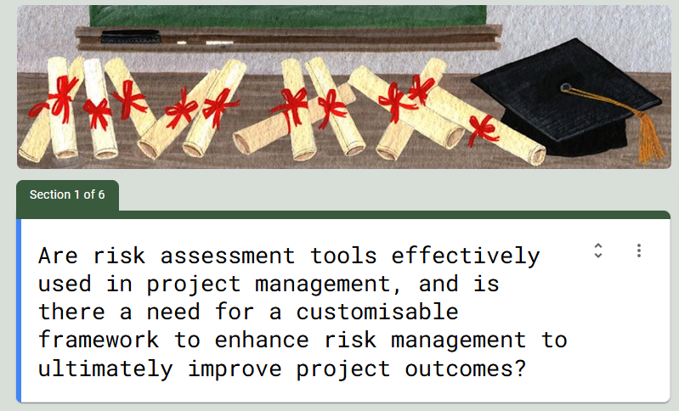
Figure 11 - Survey Questionnaire - Section 1
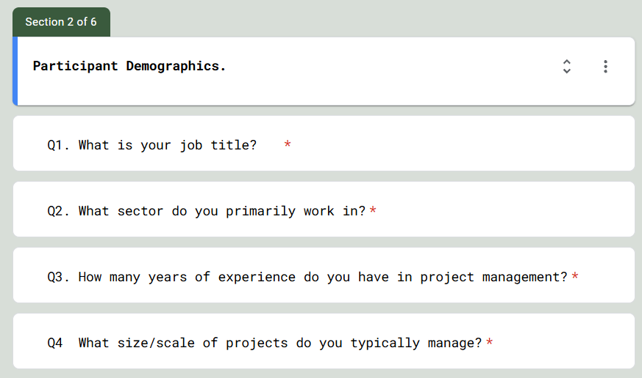
Figure 12 - Survey Questionnaire - Section 2

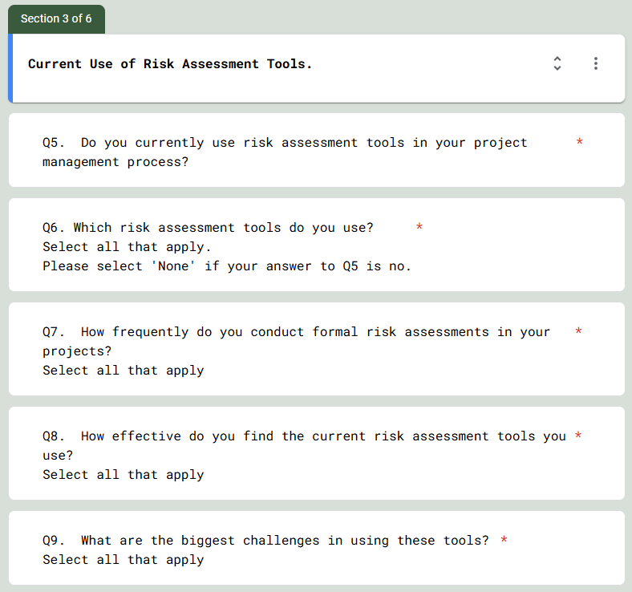
Figure 13 - Survey Questionnaire - Section 3
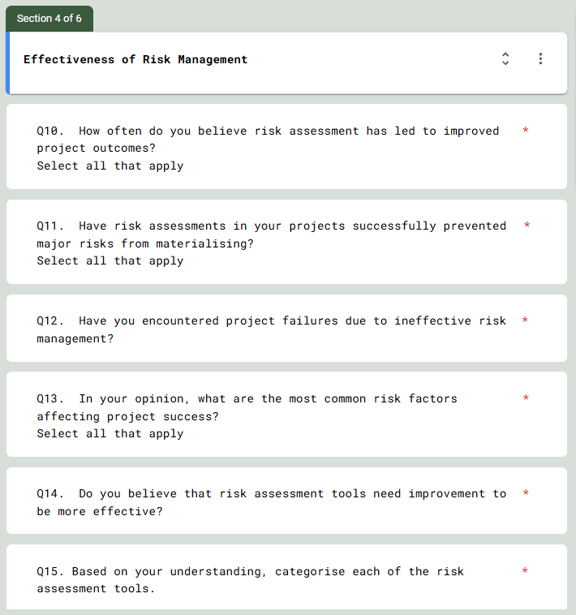
Figure 14 - Survey Questionnaire - Section 4

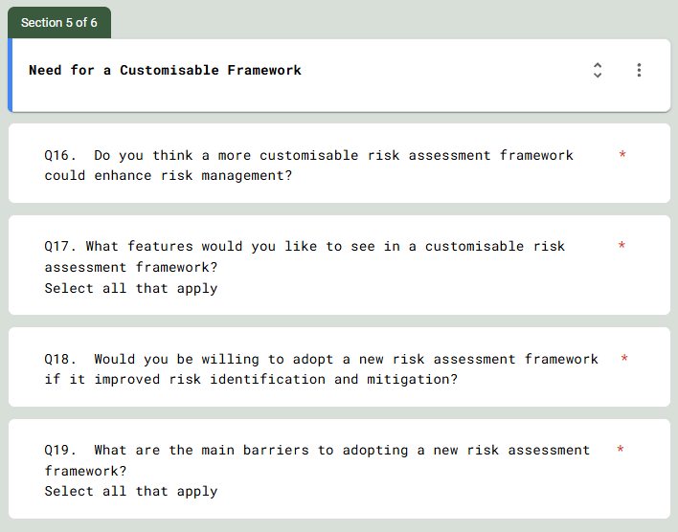
Figure 15 - Survey Questionnaire - Section 5
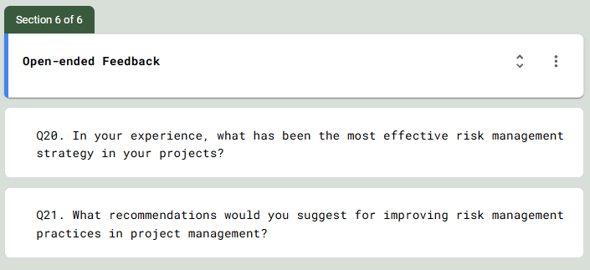
Figure 16 - Survey Questionnaire - Section 6

https://docs.google.com/forms/d/1Fnjj393c6TpvkQBeAsMNhDAD5PzUbqBf11emUogvz_c/edit
Figure 17 - Link to Forms Survey

12.2. Proposed Timeline Gantt Chart.

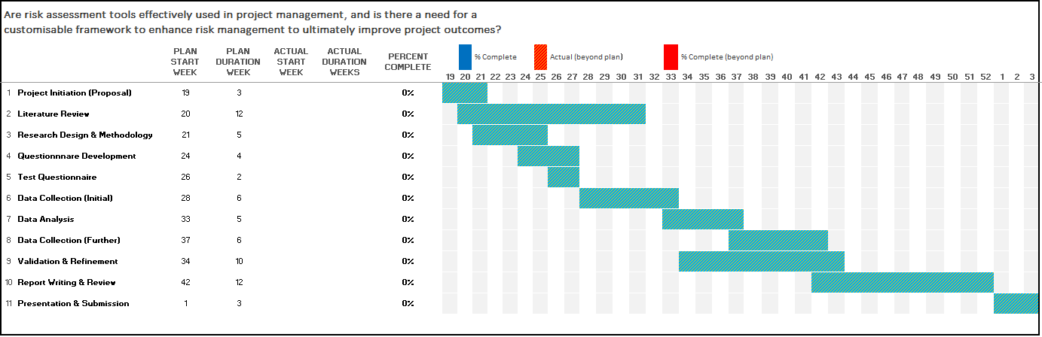
Figure 18 - Proposed Project Timeline

12.3. Participant Demographics.

Participant Demographics
Q1. What is your job title? | Job Role | No | %
Q1. What is your job title? | Works Engineer | 1 | 2.78%
Q1. What is your job title? | Engineering Manager | 3 | 8.33%
Q1. What is your job title? | Departmental Electrical Engineer | 1 | 2.78%
Q1. What is your job title? | Departmental Engineer | 2 | 5.56%
Q1. What is your job title? | Project Engineer | 12 | 33.33%
Q1. What is your job title? | Electrical Engineer | 6 | 16.67%
Q1. What is your job title? | Mechanical Engineer | 6 | 16.67%
Q1. What is your job title? | Fire Safety Engineer | 1 | 2.78%
Q1. What is your job title? | Programme Manager | 1 | 2.78%
Q1. What is your job title? | Statutory Compliance Engineer | 1 | 2.78%
Q1. What is your job title? | Engineer | 1 | 2.78%
Q1. What is your job title? | HV Engineer | 1 | 2.78%
Table 7 - Questionnaire Q1 Data Set

Participant Demographics
Q2. What sector do you primarily work in? | Sector | No | %
Q2. What sector do you primarily work in? | Construction | 1 | 2.78%
Q2. What sector do you primarily work in? | Engineering | 29 | 80.56%
Q2. What sector do you primarily work in? | IT & Software | 1 | 2.78%
Q2. What sector do you primarily work in? | Project Management | 3 | 8.33%
Q2. What sector do you primarily work in? | Manufacturing | 1 | 2.78%
Q2. What sector do you primarily work in? | Other | 1 | 2.78%
Table 8 - Questionnaire Q2 Data Set

Participant Demographics
Q3. How many years of experience do you have  in project management? | Years | No. | %
 | 0-2 Years | 3 | 8.33%
 | 2-5 Years | 7 | 19.44%
 | 5-10 Years | 7 | 19.44%
 | 10-15 Years | 5 | 13.89%
 | 15-20 Years | 8 | 22.22%
 | 20+ Years | 6 | 16.67%
Table 9 - Questionnaire Q3 Data Set
Participant Demographics
Q4. What size/scale of projects do you typically manage? | Value | No.
Q4. What size/scale of projects do you typically manage? | Small - <£50,000. | 15
Q4. What size/scale of projects do you typically manage? | Small to Medium - £50,000 to £100,000. | 18
Q4. What size/scale of projects do you typically manage? | Medium - £100,000- £250,000. | 13
Q4. What size/scale of projects do you typically manage? | Medium to Large - £250,000 - £500,000. | 13
Q4. What size/scale of projects do you typically manage? | Large - >£500,000. | 12
Table 10 - Questionnaire Q4 Data Set

12.4. Current Use of Risk Assessment Tools.

Current Use of Risk Assessment Tools.
Do you currently use risk assessment tools in your project management process? | Response | No. | %
 | Yes | 36 | 100.00%
 | No | 0 | 0.00%
Table 11 - Questionnaire Q5 Data Set

Current Use of Risk Assessment Tools.
Which risk assessment tools do you use? | Risk Assessment Tool | No
Which risk assessment tools do you use? | Qualitative risk matrices. | 8
Which risk assessment tools do you use? | Monte Carlo Simulations | 2
Which risk assessment tools do you use? | Failure Mode and Effects Analysis (FMEA) | 17
Which risk assessment tools do you use? | Risk Register | 18
Which risk assessment tools do you use? | Functional Analysis (HASOP) | 17
Which risk assessment tools do you use? | Supporting Methods (Brainstorming) | 11
Which risk assessment tools do you use? | Control Assessments (Bow Tie Analysis) | 9
Which risk assessment tools do you use? | Look Up Methods (Check Lists) | 11
Which risk assessment tools do you use? | Custom Built Tools | 4
Which risk assessment tools do you use? | Cost Benefit Analysis (CBA) | 14
Which risk assessment tools do you use? | Ishikawa (Fishbone) Diagram | 15
Which risk assessment tools do you use? | None | 0
Which risk assessment tools do you use? | Other - Management of Change Process | 4
Which risk assessment tools do you use? | Other - 4T's Approach | 1
Table 12 - Questionnaire Q6 Data Set

Current Use of Risk Assessment Tools.
How frequently do you conduct formal risk assessments in your projects? | Frequency | No
 | Never | 0
 | Only at Project Initiation Stage | 14
 | Occasionally (As risks arise) | 11
 | Regularly (Predefined intervals) | 12
 | Continuously (Throughout the project life cycle) | 11
Table 13 - Questionnaire Q7 Data Set

Current Use of Risk Assessment Tools.
How effective do you  find the current risk assessment tools you use? | Effectiveness | No
 | Not Effective | 1
 | Somewhat Effective | 9
 | Moderately Effective | 11
 | Effective | 19
 | Very Effective | 2
 | N/A | 0
Table 14 - Questionnaire Q8 Data Set

Current Use of Risk Assessment Tools.
What are the biggest challenges in using these tools? | Challenges | No
What are the biggest challenges in using these tools? | Too complex/difficult to use. | 3
What are the biggest challenges in using these tools? | Requires too much time and effort. | 19
What are the biggest challenges in using these tools? | Not aligned with project needs. | 6
What are the biggest challenges in using these tools? | Lack of tool training. | 11
What are the biggest challenges in using these tools? | Lack of tool awareness. | 15
What are the biggest challenges in using these tools? | Lack of risk knowledge/understanding. | 11
What are the biggest challenges in using these tools? | Lack of tool flexibility. | 8
What are the biggest challenges in using these tools? | Lack of stakeholder engagement. | 18
What are the biggest challenges in using these tools? | Other - Lack of Risk Understanding | 2
Table 15 - Questionnaire Q9 Data Set

12.5. Effectiveness of Risk Management

Effectiveness of Risk Management
How often do you believe risk assessment has led to improved project outcomes? | Improved Project Outcomes | No
 | Never | 0
 | Rarely | 4
 | Sometimes | 14
 | Often | 14
 | Always | 6
 | N/A | 1
Table 16 - Questionnaire Q10 Data Set

Effectiveness of Risk Management
Have risk assessments in your projects successfully prevented major risks from materialising? | Risk Prevention | No
 | Always ( Every time) | 0
 | Yes (Most of the time) | 14
 | Sometimes | 19
 | Rarely | 2
 | No | 2
 | N/A | 1
Table 17 - Questionnaire Q11 Data Set

Effectiveness of Risk Management
Have you encountered project failures due to ineffective risk management? | Project Failings | No
 | Yes | 25
 | No | 11
Table 18 - Questionnaire Q12 Data Set

Effectiveness of Risk Management
In your opinion, what are the most common risk factors affecting  project success? | Project Failings | No
 | Budget Overruns | 24
 | Schedule Delays | 23
 | Scope Creep | 21
 | Resource Constraints | 21
 | Stakeholder Conflicts | 14
 | Technical Failures | 8
 | Other - Project Dates Changed at Short Notice | 1
 | Other - Non-Realistic Timeframes | 1
Table 19 - Questionnaire Q13 Data Set

Effectiveness of Risk Management
Do you believe that risk assessment tools need improvement to be more effective? | Improved Risk Assessment Tools | No
 | Yes | 26
 | No | 3
 | Maybe | 7
Table 20 - Questionnaire Q14 Data Set

Effectiveness of Risk Management
Based on your understanding, categorise each of the risk assessment tools. | Risk Category & Associated Risk Tool |  | Risk Category
 |  |  | Risk Identification Methods | Risk Analysis Tools (Qualitative & Quantitative) | Risk Control & Visualisation Methods | Functional & Failure Analysis Techniques | Risk Documentation & Monitoring Tools
 | Risk Identification Methods | Brainstorming (Supporting Methods) | 16 | 5 | 16 | 7 | 3
 | Risk Identification Methods | Checklists (Look-up Methods) | 17 | 5 | 11 | 2 | 8
 | Risk Analysis Tools (Qualitative & Quantitative) | Qualitative Risk Matrices | 17 | 18 | 6 | 1 | 3
 | Risk Analysis Tools (Qualitative & Quantitative) | Monte Carlo Simulations | 11 | 8 | 10 | 4 | 7
 | Risk Analysis Tools (Qualitative & Quantitative) | Cost-Benefit Analysis (CBA) | 11 | 11 | 5 | 5 | 6
 | Functional & Failure Analysis Techniques | FMEA (Failure Mode and Effects Analysis) | 11 | 5 | 6 | 27 | 7
 | Functional & Failure Analysis Techniques | HAZOP (Hazard and Operability Study) | 16 | 11 | 8 | 13 | 8
 | Functional & Failure Analysis Techniques | Ishikawa (Fishbone) Diagrams | 15 | 5 | 15 | 9 | 7
 | Risk Documentation & Monitoring Tools | Risk Registers | 20 | 7 | 10 | 4 | 10
 | Risk Control & Visualisation Methods | Bow Tie Analysis (Control Assessments) | 15 | 8 | 16 | 10 | 8
Table 21 - Questionnaire Q15 Data Set

12.6. Need for a Customisable Framework

Need for a Customisable Framework
Do you think a more customisable  risk assessment framework could  enhance risk management? | Customisable Framework | No
 | Yes | 30
 | No | 0
 | Maybe | 6
Table 22 - Questionnaire Q16 Data Set

Need for a Customisable Framework
What features would you like to see  in a customisable risk assessment framework? | Features | No
 | Industry-specific risk identification. | 28
 | AI-based risk prediction. | 15
 | Integration with project management software. | 20
 | More user-friendly interfaces. | 33
 | Real-time collaboration and reporting | 18
 | Other - Remote Contributions Collected for Analysis | 1
Table 23 - Questionnaire Q17 Data Set

Need for a Customisable Framework
Would you be willing to adopt a new risk assessment framework if it improved risk identification and mitigation? | Adopt new RA Framework | No
 | Yes | 32
 | No | 0
 | Maybe | 4
Table 24 - Questionnaire Q18 Data Set

Need for a Customisable Framework
What are the main barriers to adopting a new risk assessment framework? | Barriers for Adopting new framework | No
 | Resistance to change. | 24
 | Lack of management support. | 22
 | Cost of implementation. | 18
 | Training requirements. | 26
 | Integration with existing tools. | 19
 | Lack of knowledge/understanding. | 19
 | Other | 0
Table 25 - Questionnaire Q19 Data Set

12.6. Open-ended Feedback.

Open-ended Feedback
In your experience, what has been  the most effective risk management strategy in your projects? | Most effective risk management strategy
 | Building test rigs to mimic the project
 | Risk Matrices
 | Early identification of risk through brainstorming sessions
 | FEMA
 | Risk register and aspects & impacts register.
 | Forward planning due to technical delays to completing project
 | Employ an experienced team made up from all disciplines, identify the key risks and agreed countermeasures or mitigation.
 | Risk assessment matrix and hazop.
 | Continuous Review of Risk Process / Documentation
 | Simple risk register with calibrated risk grid
 | using risk register to focus on risks that will have the highest business impact
 | Planning, engagement with the parties actually doing the work, experience and leadership.
 | Experience and Knowledge
Table 26 - Questionnaire Q20 Data Set

Open-ended Feedback
What recommendations would you suggest for improving risk management practices in project management? | Recommendations
 | More auditing
 | Training
 | Integrating risk management into every stage of project regular reviews and not just at the start
 | specific question relating to the project not general questions which could be open to different interpretation. Simple and quick to fill in, keep people engaged.
 | Real-time training, using real scenarios applicable to that Project Team. Must be simple to use and easily understood. Visually effective, so explain the risk and the mitigation easily. The risk management practice must be consistent across multiple workstreams, such as the template and the content within it should be the same from a Process Safety reporting aspect as it is for Environmental Aspects & Impacts register.
 | All team members using same metrics
 | Have the correct level of competencies and experience on the team.
 | Use 1 type of risk assessment/matrix to suit all circumstances.
 | Stakeholder Communication
 | Apply the appropriate tool for the job, normally governed by the size/cost of the project
 | The business should standardise to one set tool/approach so that continuity can be provided.
 | Setting the standard prior to undertaking the work
 | Stakeholder Communication
 | Make it easier and simpler
 | Full stakeholder involvement
 | Better awareness and understanding. A 'Buy in' from all stakeholders to understand the need for improving risk management practices.
 | Apply the appropriate tool for the job, normally governed by the size/cost of the project
 | Simplify RA and make them more manageable.
 | More user friendly.
 | The business should standardise to one set tool/approach so that continuity can be provided.
 | hands on training and use of specialist companies
 | Setting the standard prior to undertaking the work
 | Make it easier and more user friendly
Table 27 - Questionnaire Q21 Data Set

