

Management Economics Assignment 1 LCBB5003
Name of student: Elena Miloshevska 2024564
Name of lecturer: Juan Carlos

Date: 05.09.2022

DESCRIPTION OF BUSINESS

Two brothers, Richard and Maurice laid the foundation of McDonald’s in 1940 in California and now in the current era it is known as the best fast-food restaurant in the industry of fast food. Currently, there are approximately 32,000 restaurants in 119 different countries offering services to 60 million customers every day and generating a profit ratio of almost 15 billion per year. McDonald’s long-term financial plan is to create a feasible franchise that is expected to make cost-effective revenues and short-term financial goals choose to commence a business by the appropriate flow of earnings and adequate consumer base; moreover, the business is applying energetic management and strategies of development to plunge into overseas industry and to execute honour in the market of oversees fast food (Magnani, 2022). The restaurant is known for raising label and emotional connections between loyal customers and the proficiency they are offering, and the restaurant is increasing its brand image by setting up its Corporate Social Responsibility (CSR) strategy. The main mission of the restaurant is to build tasty food for its customers at a very reasonable price and accessible to everyone, and the vision is to proceed with speed to impulse effective growth rate and become the best restaurant in the world for giving the best services to customers every day (Barman et al., 2021). According to Phillips (2019), the best things about McDonald’s are the easy way to get fresh fries, their special sauce, breakfast available all day, and whenever asking for a bill, will receive the best service. The reason for choosing McDonald’s is its high brand awareness worldwide, strong brand image, training provided to its employees for 9 months, continuous business support, and good marketing strategy.

DEMAND AND MARKET EQUILIBRIUM

The demand for products of McDonald’s is elastic as fluctuations in price are created by the firm’s administrative impacts and decisions such as subsidy policies and taxes that can lead the way to variations in demand in the short run. The curve of demand can shift from the right or left (increase or decrease), for instance
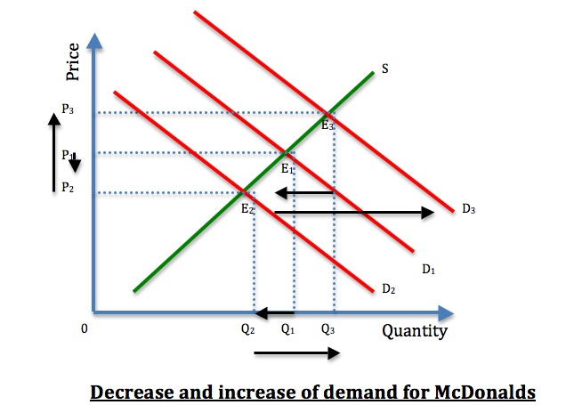
Supply and demand curves have quantity on the horizontal axis and price on the vertical axis, and the curves of demand and supply for McDonald’s emerge on the same graph and cooperatively supply and demand to analyse the quantity and price sold.
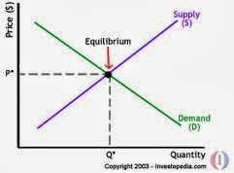

Price of Substitutes
Burger king is the straightest contender for McDonald’s, with a profit of approximately 20$ billion in 2020 worldwide. Substitute firms' availability guarantees a ruthless environment; this is very important because it assists in retaining prices low and maintaining standards high (Boyce, 2021). In easy words, when the price for particular good rises, there is an increase in demand for substitute goods; therefore, when McDonald’s rise the cost of its burger from 10$ to 17$, consumers will switch to Burger King and will receive a burger for 10$, so it means that when McDonald’s increase its cost the demand for Burger King will automatically rise. Price is not the single element when talking about substitute products.
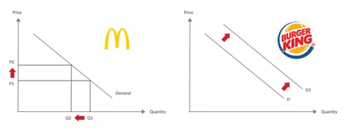
Alternate goods might accomplish customer needs and wants when variable shifts, and there are many factors like quality, geography, and price. According to Boyce (2021), if one among them adjusts, it is important to use substitute goods, and the reason for adapting substitutes are consumers’ tastes, geography, income, quality, price, and quantity.
Price of complements
Complements products have negative cross elasticity of demand, which means any fluctuation in the cost of complement products will directly affect the change in demand for the particular good. The drinks sold at McDonald’s have many alternates in the shape of other beverages symbol offered by many other restaurants, and the price of Pepsi at McDonald’s will be the same as at Burger King. McDonald’s offers many brands within specific beverages area like soda, tea, and coffee, and this involves its branded drinks and foods in which customers can rapidly discover substitutes in its competitors’ stores, while for other foods and burgers, there is a little change in the components used to prepare them (Baker et al., 2020). Therefore, McDonald’s does not have any compliments, and the exclusion is whenever customers purchase a meal from McDonald’s and eat a meal with beverages purchased from other restaurants. Additionally, in many situations, food items or drinks are complementary products that McDonald’s does not recommend. Moreover, many customers do not depend on complementary products; they will prefer McDonald’s hamburger or its close substitute.
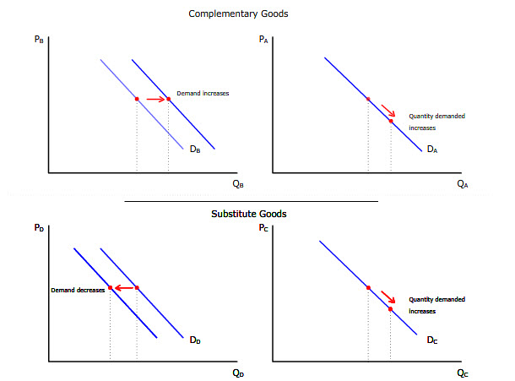

Consumer Income
According to Croal (2022) normal disposable income of a household in the UK was £31,400 at the end of the financial year 2021, which changed the first year of the (COVID-19) epidemic, which was a yearly rise of 2%, formed on approximate from the Office for National Statistics (ONS). Disposable income demonstrates a little decrease of 0.6%, an outcome of an ordinary drop-down at the base of the income distribution, comparative balance over the middle, and a little drop at the peak of the distribution. The normal growth income of people that lives in retired houses was 7.0%. This occurred after a decrease of 3.7% the last year, and from Financial Year Ending 2019 to 2021, retired households experienced low-income growth compared to non-retired houses (Croal, 2022). Income is the main factor when calculating the change in demand for any good that is luxury or necessity; if consumer income rises, they will manage to spend more money. Therefore, according to Ashenfelter and Jurajda (2022), an increase in income tends to increase demand for McDonald's because income increases customers' buying power. Further, if there is a decrease in income, so automatically demand is increased for McDonald's will also reduce.
Consumer tastes & Preferences
The behaviour of consumers is always evolving and changing; the switch in taste and preferences can be seen continuously and has remarkably changed the business world. Due to the pandemic, online shopping is a great shift and has big changes in consumers’ shopping habits (Wertz, 2022). For the taste of the meal, this aspect mostly focuses on customer preferences, and in the fast-food industry, the marketing technique is very homogeneous along with the services or products they serve customers (Machado, 2020). A small transformation in consumer preferences can emerge in a maximum change in the quantity demanded products of McDonald’s; for instance, if the client planned to bring change in their diet plan by becoming weight conscious, therefore, they do not demand food from McDonald any-longer, and they will avoid fast food so in this way demand for McDonald’s decreases.
Consumer expectations of price
The price of the products of McDonald’s relies on its strategic location in the fast-food industry; simultaneously, prices are very sensitive to any variation from the point of market equilibrium (Xie, 2021). If McDonald’s increases the cost of its burger compared to other fast-food restaurants in the UK, then customers purchase burgers from other brands and avoid McDonald’s. According to Mondal and Giri (2022), the demand for McDonald’s products is elastic as price adjustments created by the agreement or financial effects, which include subsidy policies and taxes from the government, are the reasons for to shift in demand in the short-term period. The elastic demand for its products is at high risk in the market, and the quality of food offered by McDonald’s is a cause of consideration for many investors (Barrett et al., 2020). The demand for its foods and drinks has been stabilising for previous years; however, the business still records marginal growth as the complete demand and need for fast foods.
Demographics
According to Consumer News and Business Channel (CNBC), McDonald’s UK mentions high inflation and rotation in high cost, as the company explains the increasing prices on every product. The price provided by McDonald’s is always engaging to the customers, which has allowed consumers to be capable of purchasing their products since high purchasing power continues for quite a long time. Moreover, they also introduce healthy products for their loyal customers, which include organic milk and vegetarian burgers, and also customers have better choices to select the tastiest and most delicious items from their menu (Kuuluvainen et al., 2022). The main reason for the increase in their demand is product diversification, which has gradually raised the demand for hamburgers. Further, Kuuluvainen et al. (2022) stated that price fluctuation and product diversification lead the way to an adjustment in the equilibrium price. When the market value decreases, the demand for hamburgers increases, producing a rise in demand for the particular product with a net profit in the equilibrium price. Similarly, when prices are high, the demand falls, and the effect is a drop in the equilibrium price.
SUBSTITUTION EFFECTS

The substitution effect connects to the switch in demand for a product as an outcome of a change in the respective cost of the product related to that of other substitute products. In simple words, according to Waterlander et al. (2019), the substitution effect demonstrates the change in the quantity of a product purchased to the change in the price of connected goods. The effect of substitution is almost connected to the income that enables businesses to raise their prices without dropping demand. For instance, McDonald’s products price rises by 10%, and under the substitution effect, customers will prefer Burger King, presuming its prices continue the same. If the economy income grows, McDonald’s range could seize some extra income through high prices. According to Boyce (2020), if consumers’ disposable income increases, they can set a higher value on their favored products. Therefore, McDonald’s can high its cost by 10% if customers choose it over Burger King; rather, they might still purchase products from there.
The substitution effect does not appear every time, especially for normal products and these products are minor to their substitutes, then a price rise can mean that these products are still more economical than their substitutes. Boyce (2020) stated that unusually customers will have no choice but to purchase normal products because they are still inexpensive compared to their substitutes, and these inferior products proceed opposite to the mechanisms of demand and the normal supply (Boyce, 2020). The example given by Boyce (2020) is that Kim likes to eat a burger from McDonald’s daily, and Kim earns 110$ daily, the burger costs 5$, and the burger price at Burger King is 6$. However, McDonald’s increased the cost of burgers to 10$, although his earnings per day remained the same, so James started purchasing burgers from Burger King at the cost of 6$; this led to a decrease in demand for McDonald’s.
McDonald’s has encountered many opponents because of the entrance of new restaurants in the fast-food sector, and as a result, the demand for its products has reduced (Rose et al., 2022). Negative performances because of economic change led to a drop in demand. However, McDonald’s is still maintaining marginal growth in demand because of its expansion in different countries. According to Dadich et al. (2018), health care has built a negative impact on the business, impelling customers to shift to its competitors; by analysing this issue, McDonald’s is seeing to bring some change in the menu and start awareness advertisements that will notify people about their healthy foods. McDonald’s can maximise its profit ratio by using different techniques; for instance, it only provides its products to 1% of the total population of the world, and hence it can maximise its revenue by choosing more markets to grow the number of sales and further, the business should also review corporate social responsibility advantages to create loyalty and trust of the customer (Kalogiannidis, 2021). The firm’s agenda should be to attain a highly sustainable competitive edge. There are many methods by which McDonald’s continues its competitive advantage, such as attaining public links, extensive advertising, fulfilling consumer demands by serving healthy foods, and capital investment. According to Sjödin et al. (2020), the restaurant should research customers’ needs and develop the best techniques to create good customer relationships, which will help build loyalty and trust. Another way of increasing its profit is through research and innovations to ease the delivery of different services. Automation will enable the business to increase restaurant occurrence beyond its help by combining them with consumers’ social lifestyles.
PRICING POLICY
Pricing policy is an important condition of McDonald’s marketing strategy and mix, and it operates on two pricing strategies: low-cost pricing and bundling pricing. According to Dwivedi (2021), the main idea is to “think globally and act locally”.
Low-Cost pricing strategy

In this strategy, a restaurant provides low prices to encourage demand and seize additional market share. This technique is especially appropriate when the product does not have economies of scale, and competitive advantage can help the organisation increase revenue (Fainshmidt et al., 2019). Moreover, McDonald’s recognises this pricing strategy very well and has retained the pricing of products very low to sell in large quantities. Further, economies of scale also affect the minor cost of buying for McDonald’s, and the outcome of purchasing in large quantities is a steep reduction from suppliers. According to Eisyami et al. (2022), the operating margin of McDonald’s is 37%, the average profit margin for Quick Service Restaurant (QSR) is about 6 to 9%, and a low-cost pricing strategy has worked extremely strong for McDonald’s.

Bundle pricing strategy

When two products are merged and are sold as one total bundle for a low price, then the single price connected is called the bundle pricing strategy. Dwivedi (2021) stated that the configuration of products is more science than art, and McDonald is determined this many years ago. It assembles a bundle of different items on the menu to allow its customers to purchase additional and the price of the bundle remains very low as compared to individual prices because people manage to purchase bundles rather than a single item (Dwivedi, 2021). By applying this pricing strategy, McDonald’s accomplished high revenue and high-profit ratio.

References

‌ Boyce, P. 2021. What are Substitute Goods? | 11 Examples. [online] Boycewire.com. Available at: https://boycewire.com/substitute-goods-definition/ [Accessed 2 Aug. 2022].
‌ Kalogiannidis, S., 2021. Business Trust and Communication as Predictors of Business Growth. WSEAS Transactions on Business and Economics, 18, pp.1512-1522.
‌ Phillips, H. 2019. The 10 Best Things About McDonald’s. [online] Eat This Not That. Available at: https://www.eatthis.com/why-mcdonalds-best-fast-food-chain/ [Accessed 2 Aug. 2022].
‌ Xie, E., 2021. Inference in Games without Equilibrium Restriction: An Application to Restaurant Competition in Opening Hours. Journal of Business & Economic Statistics, pp.1-14.
Ashenfelter, O. and Jurajda, Š., 2022. Minimum Wages, Wages, and Price Pass-Through: The Case of McDonald’s Restaurants. Journal of Labor Economics, 40(S1), pp.S179-S201.
Baker, P., Machado, P., Santos, T., Sievert, K., Backholer, K., Hadjikakou, M., Russell, C., Huse, O., Bell, C., Scrinis, G. and Worsley, A., 2020. Ultra‐processed foods and the nutrition transition: Global, regional and national trends, food systems transformations and political economy drivers. Obesity Reviews, 21(12), p.e13126.
Barman, A., Das, R. and De, P.K., 2021. Impact of COVID-19 in food supply chain: Disruptions and recovery strategy. Current Research in Behavioral Sciences, 2, p.100017.
Barrett, C.B., Reardon, T., Swinnen, J. and Zilberman, D., 2020. Agri-food value chain revolutions in low-and middle-income countries. Journal of Economic Literature, 58, pp.1-67.
Boyce, P. (2020). Substitution Effect Definition. [online] Boycewire.com. Available at: https://boycewire.com/substitute-effect-definition/#:~:text=he%20substitution%20effect%20is%20also,McDonalds%20increases%20by%2010%20percent. [Accessed 6 Aug. 2022].
Croal, P. 2022. Average household income, UK. [online] Ons.gov.uk. Available at: https://www.ons.gov.uk/peoplepopulationandcommunity/personalandhouseholdfinances/incomeandwealth/bulletins/householddisposableincomeandinequality/financialyearending2021#:~:text=Median%20household%20disposable%20income%20in,(ONS)%20Household%20Finances%20Survey. [Accessed 2 Aug. 2022].
Dadich, A., Collier, A., Hodgins, M. and Crawford, G., 2018. Using positive organizational scholarship in healthcare and video reflexive ethnography to examine positive deviance to new public management in healthcare. Qualitative health research, 28(8), pp.1203-1216.
Dwivedi, C. (2021). Marketing Strategy of McDonald’s that makes you ‘loving it’. [online] The Strategy Story. Available at: https://thestrategystory.com/2021/08/04/mcdonalds-marketing-branding-strategy-mix/ [Accessed 5 Aug. 2022].
Eisyami, S., Nadiah, S., Zahrah, S., Kee, S.C. and Singhal, I., 2022. A Case Study of Consumer Satisfaction That Leads to Loyalty towards McDonald’s. International journal of Tourism and hospitality in Asia Pasific (IJTHAP), 5(2), pp.75-86.
Fainshmidt, S., Wenger, L., Pezeshkan, A. and Mallon, M.R., 2019. When do dynamic capabilities lead to competitive advantage? The importance of strategic fit. Journal of Management Studies, 56(4), pp.758-787.
‌Kuuluvainen, S., Päällysaho, M., Rajala, T., Risu, E., Turunen, A. and Vitikka, M., 2022. Restaurants and Carbon Foodprint Mission Zero Foodprint Workbook.
Magnani, G., 2022. Managing the “4Ps” in Culturally Distant Countries: From Theory to Business Practice. In Marketing in Culturally Distant Countries (pp. 131-184). Springer, Cham.
Mondal, C. and Giri, B.C., 2022. Investigating strategies of a green closed-loop supply chain for substitutable products under government subsidy. Journal of Industrial and Production Engineering, 39(4), pp.253-276.
‌Rose, N., Reeve, B. and Charlton, K., 2022. Barriers and Enablers for Healthy Food Systems and Environments: The Role of Local Governments. Current Nutrition Reports, pp.1-12.
Sjödin, D., Parida, V., Jovanovic, M. and Visnjic, I., 2020. Value creation and value capture alignment in business model innovation: A process view on outcome‐based business models. Journal of Product Innovation Management, 37(2), pp.158-183.
Waterlander, W.E., Jiang, Y., Nghiem, N., Eyles, H., Wilson, N., Cleghorn, C., Genç, M., Swinburn, B., Mhurchu, C.N. and Blakely, T., 2019. The effect of food price changes on consumer purchases: a randomised experiment. The Lancet Public Health, 4(8), pp.e394-e405.
Wertz, J. 2022. Changes In Consumer Behavior Brought On By The Pandemic. Forbes. [online] 14 Apr. Available at: https://www.forbes.com/sites/jiawertz/2021/01/31/changes-in-consumer-behavior-brought-on-by-the-pandemic/?sh=326c8a8c559e [Accessed 2 Aug. 2022].

