Study In UK, (2025).

Building Women’s Enterprise Resilience through microfinance in boko haram-affected communities of northern Nigeria: a critical research study of humanitarian-development interventions in conflict economies
Advancing to Doctoral Research Stage LCDB7012: Task 1 Portfolio

21 July 2026
Student: Sabrina Reid ID: 1920873
Lecturer: Dr Stephen Malone

Table of Contents
1. Introduction, Research Context and Rationale 4
1.0 Introduction 4
1.1 Research Title 4
1.2 Research Background 4
1.3 Research Problem 6
1.4 Research Rationale 7
Academic Significance 7
Policy and practice significance 8
Relevance to Doctor of Business Administration research 9
1.4 Purpose of the Portfolio 9
2 Research Objectives, Methodological Preparation and Learning Journey 9
2.1 Research Aim and Objectives 9
2.2 Philosophical and Methodological Preparation 11
2.3 Pilot Data Planning 12
2.4 Research Journey and Learning Development 12
Stage 1: Identifying the Research Problem 14
Stage 2: Exploring the Literature 16
Stage 3: Developing the Theoretical Framework 16
Stage 4: Refining the Research Design 16
Stage 5: Critical Reflection 17
Stage 6: Paradigm Reflection 17
2.5 Reflection 17
3 Critical Literature Review, Evidence Matrix and Conceptual Framework 18
Proposed Conceptual Framework 19
3.1 Critical Review of the Literature 19
3.2 Critical Evaluation of the Evidence 21
Source Review and Evidence Matrix 23
3.3 Developing the Conceptual Framework 25
Critical Literature Review Map 26
Theoretical Integration 27
3.4 Kuhnian Interpretation 29
3.5 Contribution to the Research Plan 29
4 Research Design and Methodology 29
4.1 Research Philosophy 31
4.2 Research Approach 31
4.3 Research Strategy 32
4.4 Research Design 32
4.5 Data Sources 32
4.6 Data Collection and Analysis 33
4.7 Rigour, Validity and Reliability 33
4.8 Ethical Considerations 33
4.9 Kuhnian Perspective 34
Kuhn’s cycle of scientific development concept 34
4.10 Contribution of the Methodology 35
5 Critical Reflection and Research Development 35
5.1 Identifying the Research Problem 36
5.2 Literature Review and Intellectual Development 37
5.3 Theoretical Integration 38
5.4 Methodological Development 39
5.5 Critical Reflection and Paradigm Development 39
5.6 Kuhnian Reflection 39
5.7 Reconciling Competing Paradigms 41
5.8 Ethical Reflection 41
5.9 Overall Reflection 41
6 Final Research Proposal, Contribution to Knowledge, Conclusion and Next Steps 42
6.1 Final Research Proposal 42
Final DBA Research Title 42
6.2 Contribution to Knowledge 42
Theoretical Contributions 42
Methodological Contribution 43
Practical contribution 43
6.3 Kuhnian Contribution 43
6.4 Overall Portfolio Reflection 44
6.5 Conclusion 44
6.6 Next Steps 45
Overall Portfolio Summary 45
Reference 45
Appendix 62
1. What, why, How, and How Quadrants 62
2. The Four-Quadrant Blueprint Mapping 62
3. The master synthesis pitch 63
4. 1st elevator pitch before condensed 63
5. A pitch to consider 64
6. Identifying relevant Articles 65

1. Introduction, Research Context and Rationale

1.0 Introduction
This portfolio summarises my Doctor of Business Administration (DBA) research on enhancing women's enterprise resilience through microfinance and humanitarian interventions in Northern Nigeria, affected by Boko Haram. It details my engagement with literature, methodological preparation, and reflective practice, aiming to fill a critical gap in enterprise resilience research. The study explores how these programs can strengthen women-owned businesses in conflict zones, addressing limited evidence on their combined effectiveness. The goal is to inform decision-making, policy development, and program design while enhancing academic understanding of enterprise resilience in fragile environments.

1.1 Research Title
Building Women’s Resilience through Microfinance in Boko Haram-Affected Communities of Northern Nigeria: A Critical Review of Humanitarian-Development Interventions in Conflict Economies.

1.2 Research Background

Boko Haram insurgency and Conflict economies
The Boko Haram insurgency has significantly altered the socio-economic landscape of North-Eastern Nigeria, resulting in one of Africa's most enduring conflict economies. Ongoing insecurity has hampered economic growth, increased poverty and unemployment, discouraged investment, and hindered small and medium-sized enterprises (SMEs). This is due to infrastructure destruction, market closures, insecurity, and trade disruptions (Aruofor and Ogbeide, 2022; World Bank, 2015; Brenchenmacher, 2019; Idika-Kalu, 2020; Tafida and Amurtiya, 2023). As a result, these conditions have seriously undermined business continuity and sustainable livelihoods throughout the region.

Economic disruption affecting women entrepreneurs
Women entrepreneurs have been disproportionately affected by recent disruptions. Despite showing remarkable resilience by sustaining micro and small enterprises through strategies like livelihood diversification, informal savings groups, social networks, and microfinance (Omar, Magaji, and Jafaru, 2025; Bello, 2026), many still face high business failure rates, limited access to finance and markets, gender-blind policies, insecurity, and socio-cultural barriers that hinder enterprise growth (Shallangwa and Wilson, 2022; Ayogu and Everistus, 2015; Zoramawa, Umar, and Balarabe, 2023; World Bank Group, 2023; Lawan, 2017; Kabeer, 2002). These ongoing challenges underscore the need to better understand the factors that enhance women's enterprise resilience in conflict-affected economies.
The image below depicts a few sticky notes employed during the evolution of my research ideas:
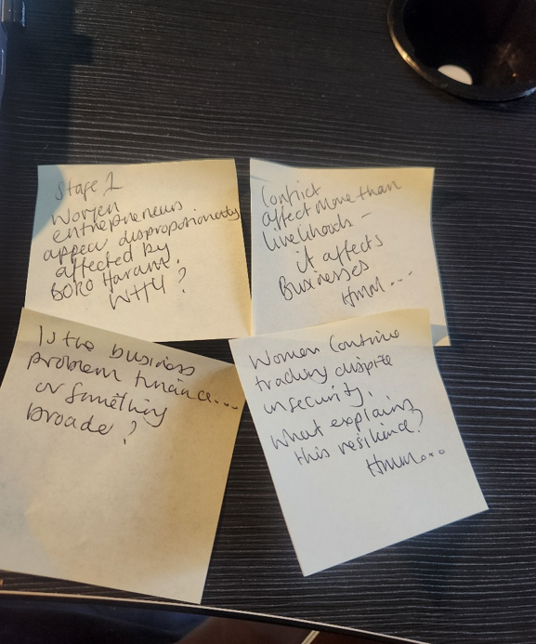

Figure 1: sticky notes: Source(s): Authors’ Work

Role of microfinance in post-conflict livelihood recovery
Microfinance has emerged as a prominent strategy for promoting financial inclusion and empowering women economically. However, the empirical evidence surrounding its effectiveness is mixed. While some studies indicate improvements in enterprise performance, welfare, and employment (Dupas and Robinson, 2013; Karlan and Zinman, 2008; Babajide, 2012; Nwanyanwu, 2011), others find limited effects on business growth and household income, especially in conflict-affected areas (Attanasio et al., 2015; Garba, 2026).
Financial inclusion alone does not ensure enterprise resilience. Although group lending can reduce adverse selection through peer monitoring and the building of social capital, its success is highly context dependent. Moreover, financial exclusion remains a challenge in North-Eastern Nigeria (Fletschner and Kenney, 2011; Stiglitz, 1990; Ghatak, 1999; Armendáriz and Morduch, 2010; CBN, 2022; EFInA, 2023).

Emergence of humanitarian-development nexus interventions
Humanitarian responses have evolved from solely providing emergency relief to adopting a humanitarian-development approach. This new approach recognises that achieving sustainable recovery requires integrating humanitarian assistance with livelihood restoration, enterprise support, infrastructure rehabilitation, and institutional strengthening (Ada and Abdullahi, 2022; ILO, 2003; Sphere Association, 2018). This shift is especially important in Borno State, where prolonged reliance on humanitarian aid has shown that emergency relief alone is insufficient for achieving sustainable economic recovery (Kallon, 2019; Ada and Abdullahi, 2022).

Evidence gaps in enterprise resilience
SMEs play a crucial role in economic growth and employment but face significant challenges due to limited resources, unstable operating environments, and weak institutional support (Eniola and Entebang, 2017; Eggers, 2020; Kaplinsky and Kraemer-Mbula, 2022). While enterprise resilience is increasingly recognised as the ability to absorb, adapt to, and recover from disruptions (Hillmann and Guenther, 2021; Brito et al., 2022; Do et al., 2022), there is a lack of evidence on how microfinance and humanitarian-development interventions can work together to enhance women's enterprise resilience in conflict-affected economies. This gap in understanding motivates the proposed research.

1.3 Research Problem
Research has greatly improved our understanding of financial inclusion, women's entrepreneurship, livelihood recovery, and humanitarian assistance. However, these themes are often explored in isolation, resulting in fragmented insights into how enterprises can remain resilient in conflict situations. Specifically, there is a lack of research on how financial services, social capital, institutional support, and humanitarian-development interventions work together to enhance the long-term resilience of women entrepreneurs.
As a result, organisations that implement microfinance and livelihood programs continue to experience uncertainty about which interventions are most effective, for whom they are beneficial, and under what specific conditions they produce sustainable outcomes for enterprises. This lack of evidence hinders microfinance institutions, humanitarian organisations, NGOs, and policymakers from designing interventions that effectively support long-term economic recovery in conflict-affected Northern Nigeria.

1.4 Research Rationale

Academic Significance
This research addresses an important gap at the intersection of women’s entrepreneurship, enterprise resilience, humanitarian-development interventions and conflict economies. Existing studies frequently investigate financial inclusion, livelihood recovery, humanitarian assistance or enterprise resilience independently. Comparatively few studies examine how these elements interact to influence women’s long-term enterprise resilience within protracted conflict settings.
The image below depicts a few sticky notes employed during the evolution of my research ideas:


Figure 2: sticky notes: Source(s): Authors’ Work

This proposed study adds to the existing literature by combining Enterprise Resilience Theory, the Sustainable Livelihoods Framework, Social Capital Theory, and the Humanitarian-Development Nexus into a unified conceptual framework. This multidisciplinary approach enhances current research by illustrating enterprise resilience as the result of the interplay between financial, social, institutional, and humanitarian mechanisms, rather than viewing it solely as a product of financial inclusion.

Policy and practice significance
The study has significant practical importance. Women-owned businesses play a crucial role in supporting household livelihoods, generating employment, and aiding local economic recovery in communities affected by conflict. By identifying the factors that enhance the resilience of these enterprises, the research will offer evidence-based guidance for microfinance institutions, humanitarian organisations, NGOs, development agencies, and policymakers. This guidance aims to help them design more effective, gender-responsive, and conflict-sensitive interventions.

Relevance to Doctor of Business Administration research
This research closely aligns with the objectives of a DBA by addressing a complex organisational challenge that has clear implications for business practice. Instead of developing theory in isolation, the study aims to generate practical knowledge that can enhance program design, organisational decision-making, and policy implementation. In this way, it embodies the DBA's focus on producing research that contributes to both academic scholarship and professional practice.

1.5 Purpose of the Portfolio

Research planning
This portfolio showcases the development of my doctoral research, from initial topic exploration to a cohesive DBA proposal. It highlights how systematic literature reviews, critical reflection, theoretical integration, and methodological preparation have clarified the research problem, the conceptual framework, and the research design. Additionally, it illustrates the evolution of my doctoral thinking through engagement with various theoretical perspectives and Kuhn's (1962) concept of paradigm development.
Instead of proposing a complete overhaul of the existing financial inclusion paradigm, this portfolio advocates an evolutionary extension that incorporates resilience, livelihoods, social capital, and humanitarian-development perspectives. The following sections outline this progression and lay the intellectual, theoretical, and methodological foundations for the proposed DBA research.

2 Research Objectives, Methodological Preparation and Learning Journey

2.1 Research Aim and Objectives

The Overarching aim of this research is:
To critically evaluate how microfinance and humanitarian-development interventions strengthen women’s enterprise resilience in Boko Haram-affected communities in Northern Nigeria.
This objective emphasises the DBA’s aim to address complex organisational challenges and generate evidence for improving business practices, policies, and programs. The study examines the interplay of financial, social, institutional, and humanitarian mechanisms to enhance enterprise resilience in conflict-affected economies.
To achieve this aim, three interconnected research objectives have been adopted:

Research Objectives
1. Explore factors influencing enterprise resilience in conflict economies.
2. Develop a conceptual framework linking microfinance, enterprise resilience, and women’s entrepreneurship.
3. Inform future policy and programme design through evidence-based recommendations.
This text examines factors influencing enterprise resilience and aims to develop a practical framework for humanitarian organisations, microfinance institutions, NGOs, and policymakers in conflict-affected areas. It views resilience as a multifaceted process that requires integrated economic, social, and institutional support, moving beyond previous studies that focused solely on financial inclusion.

Potential Research Question
The preliminary research question guiding the study is:
How does microfinance contribute to building women’s enterprise resilience in Boko Haram-affected communities of Northern Nigeria?

This question is supported by four subsidiary questions:
- What enterprise challenges do women-owned enterprises experience?
- How effective are humanitarian-development interventions?
- What resilience mechanisms emerge among women entrepreneurs?
- What contextual factors influence intervention outcomes?
Collectively, these questions provide a coherent structure for investigating women’s enterprise resilience from organisational, institutional and humanitarian perspectives.

2.2 Philosophical and Methodological Preparation
Developing a suitable philosophical position was key in refining the research design. This study adopts Pragmatism, backed by Critical Realism, as a foundation to address enterprise resilience in conflict economies. A mind map was created to aid in the research development:
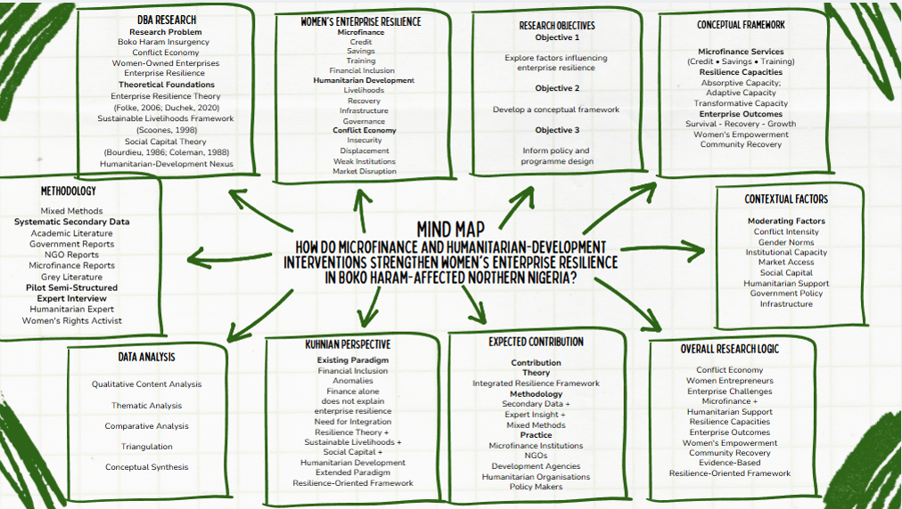

Figure 3: Mind Map: Source(s): Authors’ Work

Pragmatism emphasises effective methods for tackling research problems rather than sticking to a single philosophical tradition (Morgan, 2007). This is suitable for enterprise resilience, which relies on measurable outcomes and context-driven social processes. Critical realism complements this by recognising that observable outcomes are shaped by deeper social and structural mechanisms in conflict environments (Bhaskar, 2008). Together, these viewpoints provide a robust framework for analysing enterprise resilience at various levels. This study critiques the limitations of current financial inclusion theories in conflict economies, informed by Kuhn's (1962) concept of scientific paradigms. It enhances these theories by integrating Enterprise Resilience Theory and the Humanitarian-Development Nexus, offering an evolutionary contribution to knowledge.
Using an abductive mixed-methods design, the research combines secondary data analysis and a pilot interview with a humanitarian development or women’s rights practitioner. This approach allows for iterative refinement of understanding based on new findings (Dubois and Gadde, 2002), particularly where existing theories fall short in explaining enterprise resilience in conflict settings.
Data will be systematically gathered from peer-reviewed literature, government publications, NGO reports, humanitarian agencies, and credible grey literature. To ensure methodological rigour, the study will employ transparent search procedures, quality appraisal, thematic analysis, conceptual synthesis, and triangulation (Tranfield, Denyer, and Smart, 2003; Snyder, 2019).

2.3 Pilot Data Planning
Due to the ethical and security challenges of conducting primary research in Boko Haram-affected areas, this study relies primarily on secondary evidence. However, a brief pilot interview will be conducted with an experienced humanitarian or women's rights practitioner to enhance the literature.
Instead of generating primary empirical findings, the interview will serve three purposes:
- Validating themes emerging from the literature;
- Refining the conceptual framework; and
- Informing the final research design.
The pilot planning process systematically identifies relevant literature, categorising sources to focus on women's entrepreneurship, enterprise resilience, humanitarian-development interventions, and conflict economies. This structured selection creates a transparent foundation for the upcoming critical literature review.

2.4 Research Journey and Learning Development
This portfolio documents the progression of my doctoral thinking from an initial research interest to a coherent DBA research proposal. The journey has been characterised by continuous reflection, critical engagement with the literature and increasing methodological sophistication.
The appendix contains the following items for this portfolio research:
1. What, why, how, and How Quadrants; 2. The Four-Quadrant Blueprint Mapping
3. The master synthesis pitch; 4. 1st elevator pitch before condensed
5. A pitch to consider; 6. Initial chart for Identifying relevant Articles
The image below depicts a few sticky notes employed during the evolution of my research ideas:
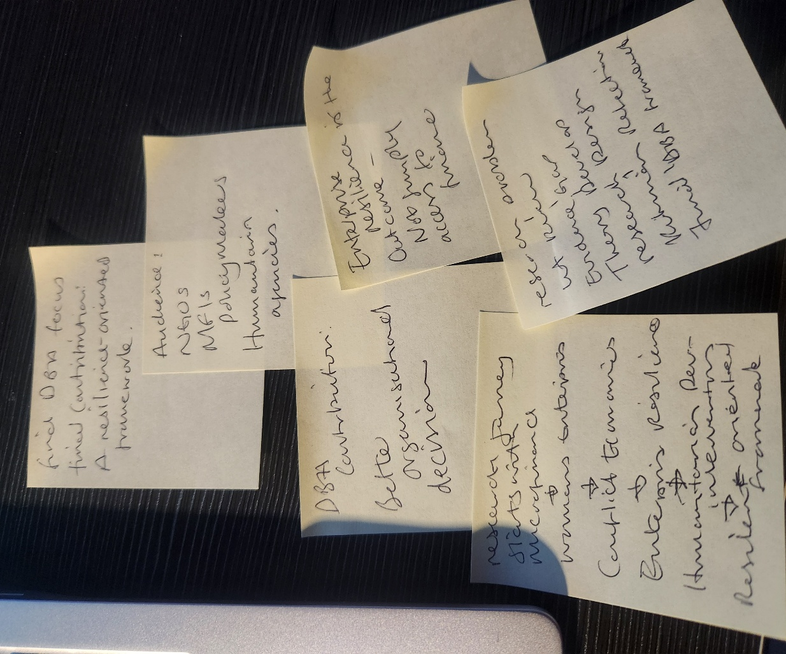

Figure 4: sticky notes: Source(s): Authors’ Work

Stage 1: Identifying the Research Problem
The research explored the economic impact of the Boko Haram insurgency on women-owned businesses in Northern Nigeria. While earlier studies noted business disruption, displacement, restricted market access, and financial exclusion, there is limited evidence on the long-term effectiveness of microfinance in enhancing enterprise resilience.
The following slides stem from earlier research, which contributed to my decision for this portfolio research:
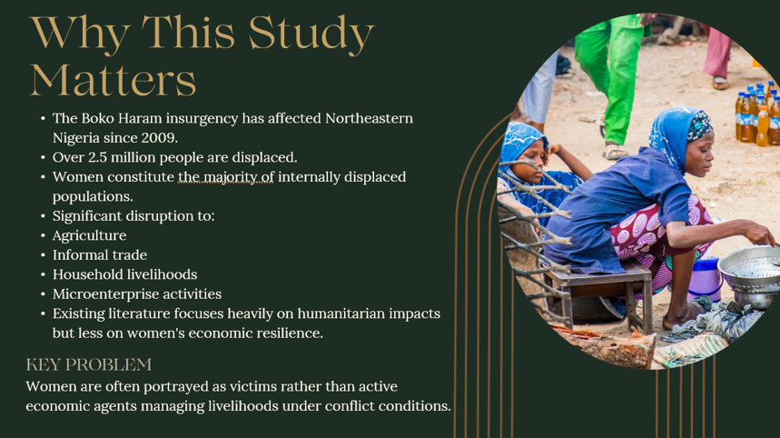

Figure 5: Presentation slide on ‘Why this study matters’: Source(s): Authors’ Work

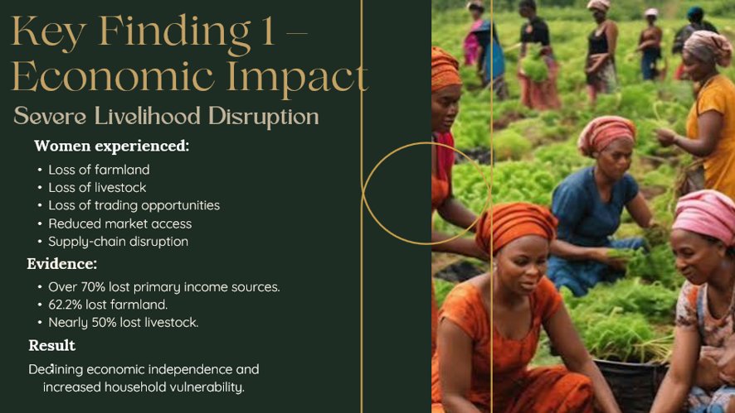

Figure 6: Presentation slide on ‘Key Finding 1 Economic Impact’: Source(s): Authors’ Work

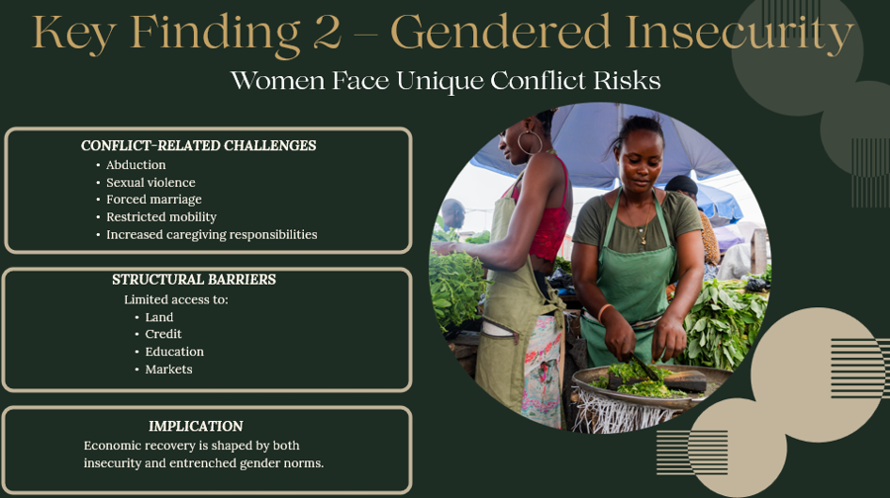

Figure 7: Presentation slide on ‘Key Findings 2 Gendered Insecurity’: Source(s): Authors’ Work

This stage focused research on women’s entrepreneurship towards enterprise resilience, microfinance, and humanitarian-development interventions.

Stage 2: Exploring the Literature

Systematic engagement with academic and grey literature identified four dominant themes:
- Women’s entrepreneurship in conflict economies;
- Microfinance and financial inclusion;
- Enterprise resilience; and
- Humanitarian-development interventions.
The review found mixed evidence on the effectiveness of microfinance. While many studies noted improved financial access, few showed sustained enterprise growth or survival. This inconsistency indicates that enterprise resilience involves factors beyond financial inclusion, including social and institutional influences.

Stage 3: Developing the Theoretical Framework
As the literature review progressed, it became clear that no single theoretical perspective fully explained women’s resilience in conflict settings. Therefore, four complementary perspectives were integrated:
- Enterprise Resilience Theory;
- Sustainable Livelihood Framework;
- Social Capital Theory; and
- Humanitarian-Development Nexus.
Collectively, these perspectives conceptualise enterprise resilience as a multidimensional process influenced by financial resources, adaptive capacity, social networks and institutional support. This represented a significant shift away from viewing financial inclusion as the principal explanation of enterprise success.

Stage 4: Refining the Research Design
Engaging with research philosophy refined the study by adopting pragmatism and incorporating Critical Realism. This provided a coherent framework for an abductive mixed-methods design that combines secondary evidence with expert insight. It boosted my confidence in selecting appropriate methods for the research problem rather than adhering to a single methodological tradition.

Stage 5: Critical Reflection
The key development emerged from an evaluation of the microfinance literature, revealing that greater financial access often did not improve enterprise resilience. This led to a shift in perspective, recognising resilience as a broader adaptive process influenced by financial, social, institutional, and humanitarian factors. This insight enhanced the research's conceptual framework by incorporating multiple perspectives rather than focusing solely on financial inclusion.

Stage 6: Paradigm Reflection
Studying Kuhn’s (1962) concept of scientific paradigms has significantly shaped my understanding of knowledge development. Rather than replacing the dominant financial inclusion paradigm, my research aims to extend it by integrating resilience, livelihoods, social capital, and humanitarian-development perspectives. This study builds on established scholarship and addresses important anomalies in the existing literature, enhancing my appreciation of the relationship between philosophy, theory, methodology, and applied research practice.

2.5 Reflection
This portfolio documents my doctoral journey, showcasing systematic literature review, theoretical integration, methodological refinement, and critical reflection. I have gained confidence in questioning dominant assumptions about financial inclusion, recognising anomalies, and forming comprehensive interpretations. This process reflects my growth as an independent researcher, capable of critically evaluating evidence and producing relevant, practice-oriented research.
The image below depicts some sticky notes which were employed during my thought process for the evolution of the portfolio research ideas: 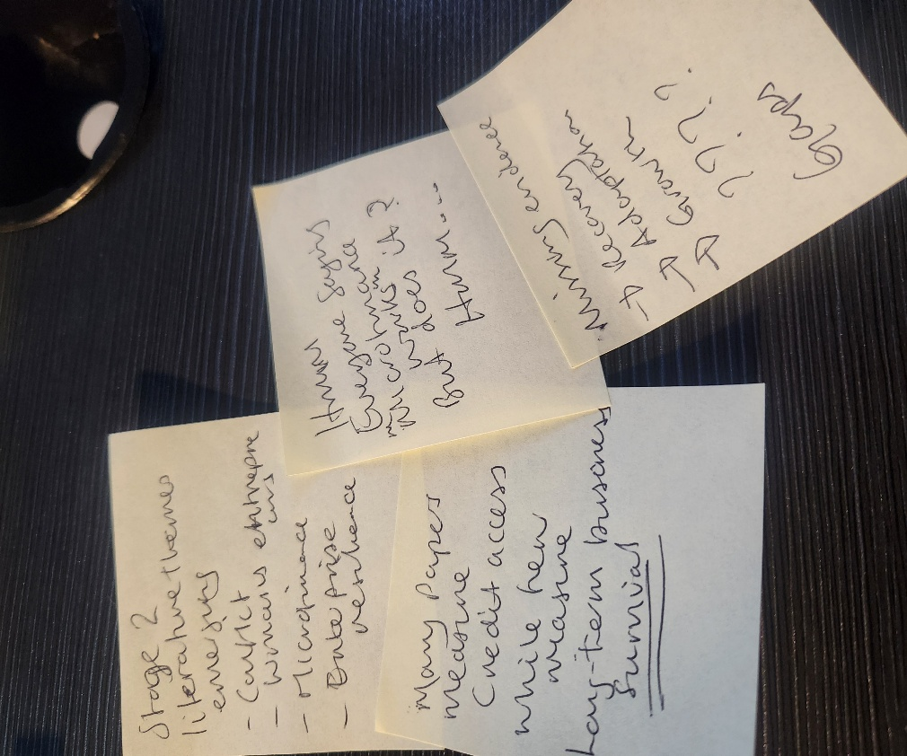

Figure 8: sticky notes: Source(s): Authors’ Work

3 Critical Literature Review, Evidence Matrix and Conceptual Framework
This section synthesises the literature supporting the proposed research by critically examining key theoretical perspectives, empirical evidence, and methodologies. Rather than summarising previous studies in isolation, it evaluates the strengths, limitations, and interconnections of existing evidence to identify the knowledge gap justifying the DBA research. This establishes a theoretical foundation for a resilience-oriented framework that explains how microfinance and humanitarian-development interventions strengthen women’s enterprise resilience in Boko Haram-affected communities in Northern Nigeria.

Proposed Conceptual Framework
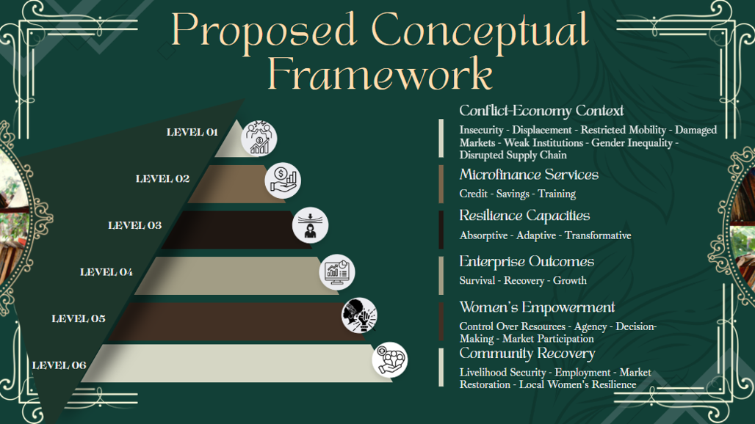

Figure 9 Proposed Conceptual Framework: Source(s): Authors’ Work

3.1 Critical Review of the Literature
Armed conflict reshapes economic systems by raising transaction costs, restricting mobility, damaging infrastructure, and weakening institutions (Justino, 2012; Collier, 2019). These disruptions disproportionately impact women, leading to livelihood loss, displacement, and increased household responsibilities (Okoli and Azom, 2019; Iman et al., 2020). Despite their significant role in household resilience and local economic recovery, women-owned enterprises face ongoing barriers to finance, markets, and business support (Brush et al., 2009; Minniti, 2010).
Microfinance has gained popularity as a means to enhance women's economic participation, but its effectiveness varies. While it improves access to credit, enterprise resilience often requires more than just financial support (World Bank, 2015). Success depends on factors like business training, savings options, and market access (Cooke et al., 2022). Financial inclusion should be viewed as part of a broader strategy for resilience rather than a standalone solution.
Resilience encompasses more than financial resources. Key capacities include absorption, adaptation, and transformation (Folke, 2006). Organisational resilience involves anticipation, coping, and adaptation during disruptions (Williams et al., 2017; Duchek, 2020). However, these concepts are rarely applied to women-owned microenterprises in conflict areas, where resilience is shaped by household resources, informal institutions, humanitarian aid, and local governance.
The sustainable livelihoods framework emphasises that resilience relies on interactions among financial, human, social, physical, and natural capital (Scoones, 1998). In conflict settings, livelihood disruption often leads to displacement and weakened infrastructure, rendering finance-focused interventions inadequate because they overlook broader structural issues that affect enterprise resilience. Recent humanitarian literature promotes the humanitarian-development nexus to link emergency aid with long-term recovery. Programs in the Lake Chad Basin show that combining stabilisation, infrastructure, governance, and social cohesion can support recovery (UNDP, 2021b; UNDP, 2022). However, evaluations often focus on outputs rather than long-term outcomes such as enterprise survival and growth, resulting in limited evidence of how these interventions enhance enterprise resilience.
The literature shows that enterprise resilience results from interactions among financial, social, institutional, and humanitarian mechanisms, rather than a single intervention. However, empirical research on these relationships in conflict-affected Northern Nigeria is limited.
The image below depicts some sticky notes which were employed during my thought process for the evolution of the portfolio research ideas:
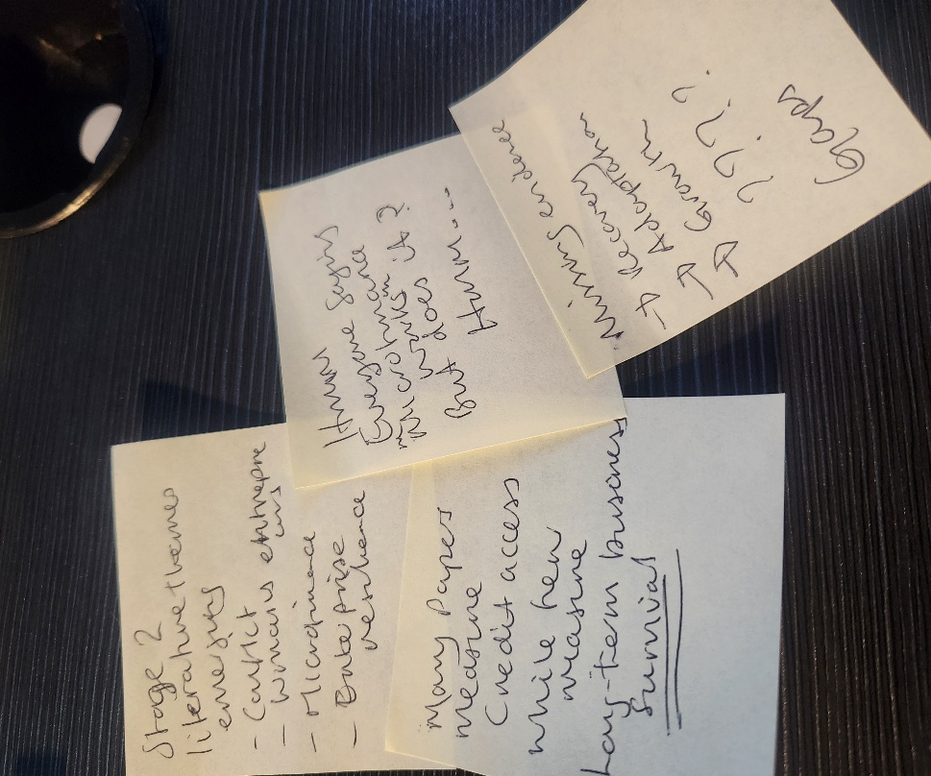

Figure 10: sticky notes: Source(s): Authors’ Work

3.2 Critical Evaluation of the Evidence
To ensure methodological rigour, the study employs a systematic evidence matrix to evaluate academic and grey literature on women's enterprise resilience in conflict economies. The evidence includes strong theoretical foundations in entrepreneurship and resilience, along with valuable insights from microfinance studies and reports by organisations such as UNDP and the World Bank. However, limitations exist, such as the inapplicability of some conceptual studies to Northern Nigeria and the reliance of empirical research on small case studies. Institutional reports may showcase successes but often underreport challenges, underscoring the need to triangulate evidence from multiple sources.

Accordingly, each source will be evaluated using consistent criteria, including:
- Authority and credibility;
- Methodological transparency;
- Relevance to the research objectives;
- Geographical and population suitability;
- Measurement validity;
- Potential institutional or publication bias;
- Consistency with other evidence; and
- Capacity to support either casual or interpretive conclusions.
Triangulation will systematically compare peer-reviewed literature, government publications, humanitarian reports, and credible evidence. Contradictory findings will be critically examined to enhance theoretical understanding and strengthen the final synthesis. Validity will be improved by clearly defining constructs, particularly differentiating enterprise resilience from financial inclusion or women’s empowerment. Reliability will be bolstered through standardised extraction templates, transparent coding, and thorough documentation. These procedures will establish a rigorous foundation for the systematic literature review.
The following is a systematic evidence review table that supports the research journey:

Source Review and Evidence Matrix
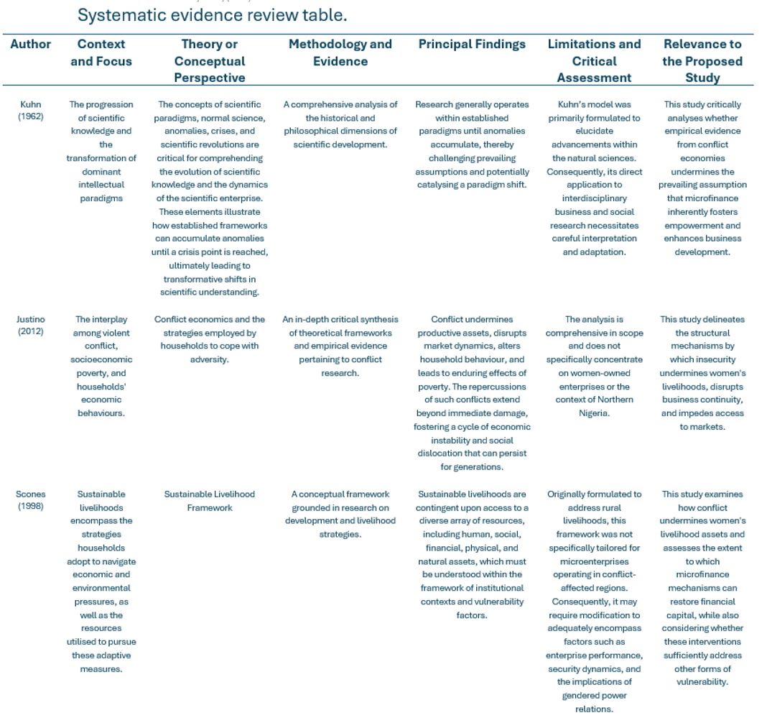
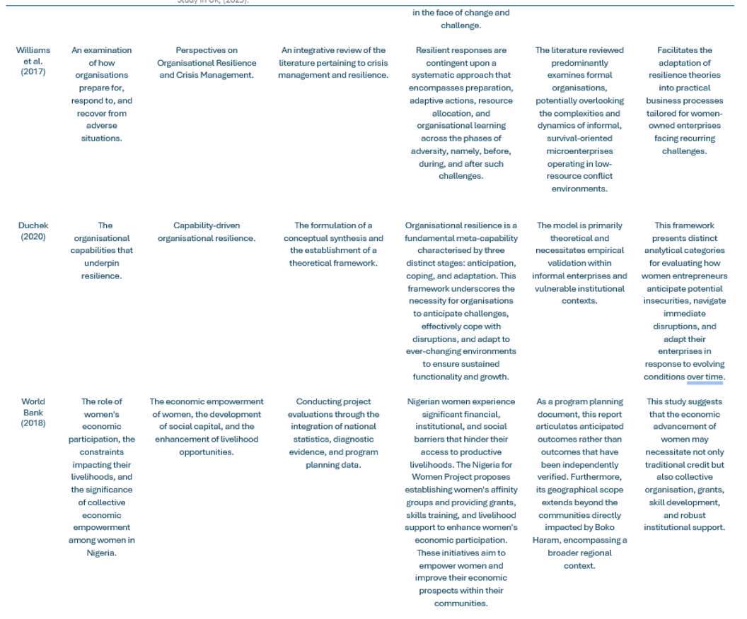
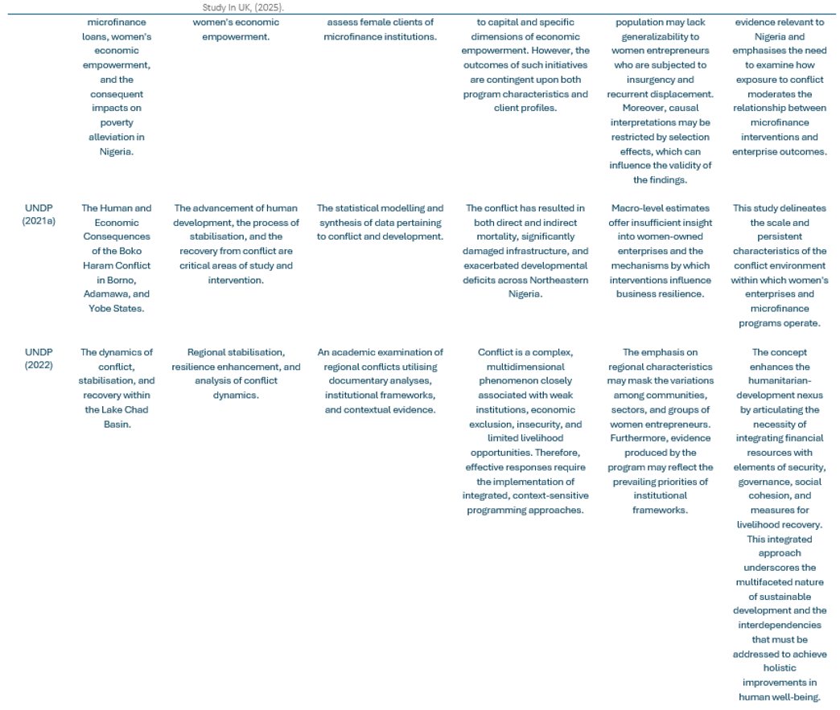

Figure 11: Source review and evidence matrix: Source(s): Authors’ Work

3.3 Developing the Conceptual Framework
No single theoretical perspective fully explains women’s enterprise resilience in conflict economies. This research develops a conceptual framework that integrates four complementary perspectives:
- Enterprise Resilience Theory;
- Sustainable Livelihoods Framework;
- Social Capital Theory; and
- Humanitarian-Development Nexus
These theories offer complementary insights into how women-owned enterprises survive and adapt in fragile environments. The framework views microfinance services, credit, savings, and business training as resources that enhance resilience capacities.:
- Absorptive capacity;
- Adaptive capacity;
- Transformative capacity.
These capacities influence business outcomes such as survival, recovery, and growth. The model suggests a conditional relationship between financial inclusion and enterprise performance, emphasising that resilience relies on broader contextual factors, not just finance.

Critical Literature Review Map
This portfolio item features a thematic literature map shown below, on conflict economies, women's entrepreneurship, microfinance, enterprise resilience, and humanitarian-development interventions. It highlights key research for the proposed DBA study and emphasises Resilience Theory, the Sustainable Livelihoods Framework, and Social Capital Theory: 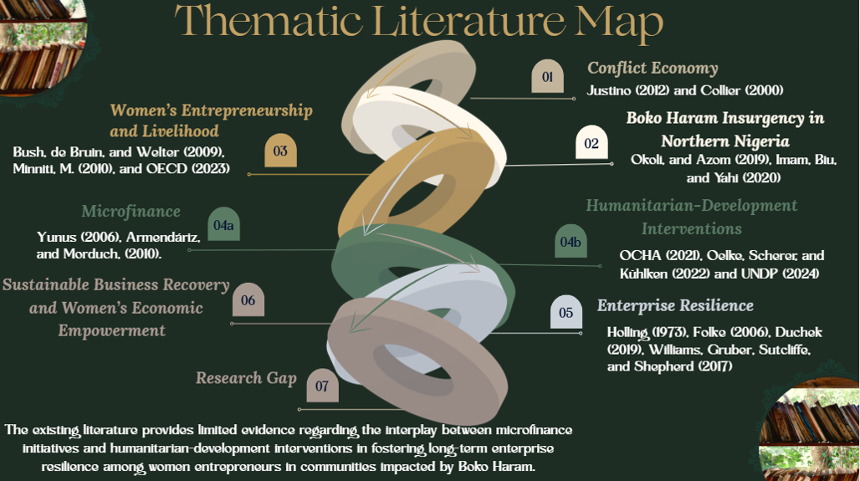Figure 12: Thematic Literature Map: Source(s): Authors’ Work
The following table showcases the development of scholarship through theoretical integration:

Theoretical Integration

Theoretical Integration
Theory | Contribution to the framework
Resilience Theory | This study explores the mechanisms through which enterprises absorb, adapt to, and undergo transformation in the aftermath of conflict-related shocks (Folke, 2006; Duchek, 2020).
Sustainable Livelihood Framework | This study illuminates the intricate interactions among financial, human, social, physical, and natural capital within the contexts of vulnerability and institutional frameworks (Scoones, 1998).
Social Capital Theory | This study elucidates how trust, social networks, and collective relationships facilitate or hinder access to resources and shape adaptive processes, as discussed by Bourdieu (1986) and Coleman (1988).
Women’s Economic Empowerment | This research investigates the extent to which financial and entrepreneurial outcomes contribute to enhancing women’s resources, agency, and achievements, as articulated in Kabeer's (1999) framework.
Conflict-Economy Perspective | This study examines how insecurity, displacement, and institutional weakness affect relational dynamics within the proposed framework (Justino, 2012).

Figure 13: Theoretical integration: Source(s): Authors’ Work

Women’s empowerment is crucial for enterprise resilience, but it does not automatically result from access to finance. According to Kabeer (1999), true empowerment requires women to have access to resources, agency, and control over business decisions. Without decision-making authority or in the face of restrictive gender norms, improved financial access may not enhance empowerment.
Additionally, resilient women-owned enterprises play a vital role in community recovery by boosting household livelihoods, creating jobs, and stimulating local economies. Social Capital Theory highlights the significance of trust, collective action, and social networks in resource mobilisation (Bourdieu, 1986; Coleman, 1988). Humanitarian-development interventions also provide essential support through governance, infrastructure, and livelihood restoration, promoting sustainable recovery in conflict-affected areas.
The proposed conceptual relationship may therefore be summarised as follows:
- Microfinance services strengthen resilience capacities.
- Resilience capacities improve enterprise outcomes.
- Enterprise resilience supports women’s empowerment.
- Women’s empowerment contributes to community recovery.
- Conflict intensity, market access, institutional capacity, gender norms and social capital moderate these relationships.
- Humanitarian-development interventions enhance enterprise resilience by integrating finance with broader economic and institutional support.
This framework, therefore, clearly distinguishes among financial inputs, resilience mechanisms, and enterprise outcomes, positioning microfinance as an enabling resource operating within a broader resilience system rather than as an independent determinant of enterprise success.

3.4 Kuhnian Interpretation
The literature reveals anomalies in the financial inclusion paradigm, which assumes that improved access enhances women’s empowerment and enterprise growth. However, in conflict-affected economies, financial inclusion alone seldom leads to sustained enterprise resilience (Banerjee et al., 2015; World Bank, 2015). Instead of rejecting this paradigm, the study extends it by integrating Enterprise Resilience Theory, the Sustainable Livelihoods Framework, Social Capital Theory, and the Humanitarian-Development Nexus, offering a more comprehensive view of women's enterprise resilience, consistent with Kuhn’s (1962) perspective on the evolution of scientific knowledge through paradigm refinement.

3.5 Contribution to the Research Plan
The literature review, evidence matrix and conceptual framework collectively establish the intellectual foundation for the proposed DBA research. They:
- Refine the research problem and objectives;
- Identify the principal theoretical perspectives informing the study;
- Distinguish enterprise resilience from financial inclusion;
- Establish transparent procedures for evidence selection and appraisal;
- Identify appropriate resilience indicators;
- Recognise methodological limitations and potential bias; and
- Justify the development of a resilience-oriented framework capable of informing theory, policy and organisational practice.

4 Research Design and Methodology
This section outlines the methodology framework for the DBA research, demonstrating alignment between the research problem, philosophical stance, methodology, and methods. Each decision is justified in relation to the study's aim of exploring how microfinance and humanitarian-development interventions enhance women's enterprise resilience in Boko Haram-affected communities in Northern Nigeria. The methodology is designed to produce both theoretically informed and practically relevant knowledge to aid organisational decision-making and policy development.
The image below shows several sticky notes used during my thought process for developing the portfolio research ideas:
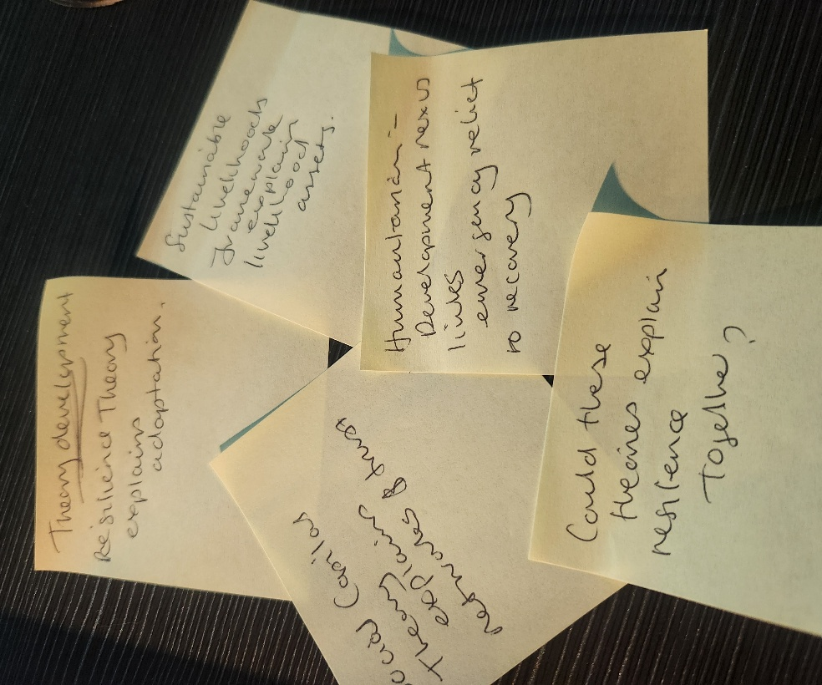

Figure 14: sticky notes: Source(s): Authors’ Work

The Saunders Research Onion (Saunders et al., 2023) provides a key framework for the study, guiding it from philosophical stance to data collection with a clear methodological approach as shown below:
Research Onion Diagram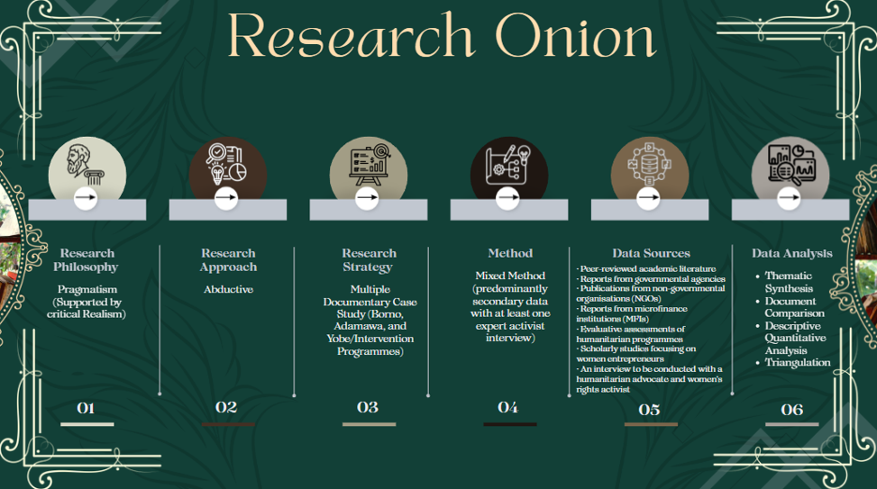

Figure 15: Research onion: Source(s): Authors’ Work

4.1 Research Philosophy
This study employs Pragmatism, supported by Critical Realism, as its philosophical framework. Pragmatism focuses on selecting research methods that effectively address the problem rather than adhering to a specific tradition, enabling the integration of qualitative and quantitative evidence to understand women's enterprise resilience in conflict economies and to inform policymaking (Morgan, 2007). Critical Realism adds depth by acknowledging that observable enterprise outcomes are shaped by underlying social, institutional, and structural factors in conflict settings (Bhaskar, 2008). Thus, Pragmatism and Critical Realism form a strong foundation for exploring enterprise resilience as both a measurable result and a socially embedded process.

4.2 Research Approach
The research adopts an abductive approach, enabling a dynamic interaction between empirical evidence and theoretical explanation (Dubois and Gadde, 2002). This method is well-suited for tackling complex organisational issues with incomplete explanations while refining existing theories. The study employs abduction to create a resilience-oriented framework, drawing on Enterprise Resilience Theory, the Sustainable Livelihood Framework, Social Capital Theory, and the Humanitarian-Development Nexus. These concepts are enhanced through systematic analysis of secondary evidence and expert validation, promoting theoretical advancement in line with empirical insights...

4.3 Research Strategy
A multiple-case study documentary strategy compares evidence from conflict-affected areas in Borno, Adamawa, and Yobe States (Yin, 2018). This approach examines published evidence from humanitarian programs, government reports, academic research, and evaluations, rather than focusing on individual organisations. Given the limited access to these communities due to security and logistical constraints, this strategy enables robust analysis of interventions and enhances the transferability of findings. Comparing evidence across programs and locations uncovers patterns and contextual differences in conflict settings.

4.4 Research Design
The study employs a mixed-methods design, integrating qualitative literature, quantitative program evidence, and a pilot semi-structured interview with an experienced practitioner in humanitarian-development or women’s rights. This approach recognises that understanding women's enterprise resilience in conflict economies requires diverse evidence. Qualitative insights reveal women's experiences and responses, while quantitative data provide program statistics and evaluations. Pilot interviews help validate themes and refine the conceptual framework, enhancing the interpretation of secondary evidence.

4.5 Data Sources
The study relies predominantly on systematic secondary data drawn from multiple complementary sources, including:
- Peer-reviewed academic literature;
- Government publications;
- NGO reports;
- Humanitarian agency publications;
- Microfinance institution reports;
- Programme evaluations;
- Studies focusing on women entrepreneurs; and
- Credible grey literature.
These sources offer comparative evidence across various organisations, interventions, and conflict contexts, enabling analysis of organisational practices and policy implementation while mitigating the limitations of single-case studies. A pilot interview with an experienced humanitarian-development or women’s rights practitioner will further validate interpretations from the literature without replacing systematic secondary analysis.

4.6 Data Collection and Analysis
Secondary evidence will be collected through transparent search procedures and quality appraisal, following established literature review methods (Tranfield, Denyer and Smart, 2003; Snyder, 2019). Searches will cover academic databases and credible grey literature using keywords related to women’s entrepreneurship, enterprise resilience, microfinance, and Boko Haram. Studies will undergo qualitative content analysis and thematic synthesis, using standardised coding and extraction templates. Triangulation will be employed to analyse diverse evidence and address contradictions, enhancing rigour and credibility...

4.7 Rigour, Validity and Reliability
Maintaining methodological rigour in conflict settings is essential for research design. Validity is enhanced by clearly defining constructs that separate enterprise resilience from financial inclusion, women’s empowerment, and organisational performance. Using standardised extraction templates and transparent coding will improve reliability and facilitate consistent interpretation across diverse evidence sources.
Qualitative evidence will be appraised for credibility, trustworthiness, and relevance (Lincoln and Guba, 1985). It will be evaluated using reliability measures and methodological quality. Triangulation across multiple sources enhances confidence in the final synthesis by minimising reliance on any single publication or perspective.

4.8 Ethical Considerations
The research primarily uses secondary evidence but emphasises ethical considerations. It will respectfully represent conflict-affected women, accurately attribute published work, and responsibly interpret sensitive information. The pilot interview will adhere to university ethical guidelines, ensuring informed consent, confidentiality, and voluntary participation. Care will be taken to avoid stereotyping and misrepresentation of vulnerable populations. Ethical practice includes responsible scholarship and culturally sensitive interpretation throughout the research process.

4.9 Kuhnian Perspective
The methodological design reflects Kuhn’s (1962) idea that research evolves within established paradigms while addressing anomalies through empirical investigation. Rather than viewing philosophical traditions as competing, this study integrates Pragmatism and Critical Realism to enhance the financial inclusion paradigm.
Pragmatism utilises both quantitative evidence, like program data and performance indicators, and qualitative studies with expert interpretations (Morgan, 2007). Critical Realism connects observable outcomes to structural mechanisms such as conflict, gender norms, and market conditions (Bhaskar, 2008).
This approach fosters a resilience-oriented framework that integrates financial, social, institutional, and humanitarian perspectives, refining existing knowledge without rejecting established theories. The next slide illustrates Kuhn’s cycle of scientific development.:

Kuhn’s cycle of scientific development concept


Figure 16: Kuhn’s cycle of scientific development concept: Source(s): Authors’ Work

4.10 Contribution of the Methodology
The proposed methodology provides a coherent and rigorous framework for investigating women’s enterprise resilience within conflict-affected Northern Nigeria. By integrating systematic secondary evidence with limited expert insight, the research combines philosophical coherence, methodological rigour and practical relevance. This design is expected to generate robust evidence to inform organisational practice, policy development, and future research, while supporting the development of a resilience-oriented humanitarian-development framework grounded in the realities of conflict economies.

5 Critical Reflection and Research Development
A DBA involves more than just methodological skills; it requires critical reflection and the integration of theory with practice. This portfolio captures my research evolution and doctoral thinking through research notes, mind maps, and engagement with the literature. I refined my broad research interest into a coherent and practice-oriented DBA proposal. Reflective practice played a key role in questioning assumptions and enhancing the research design.
The image below displays several sticky notes I used while brainstorming portfolio research ideas:
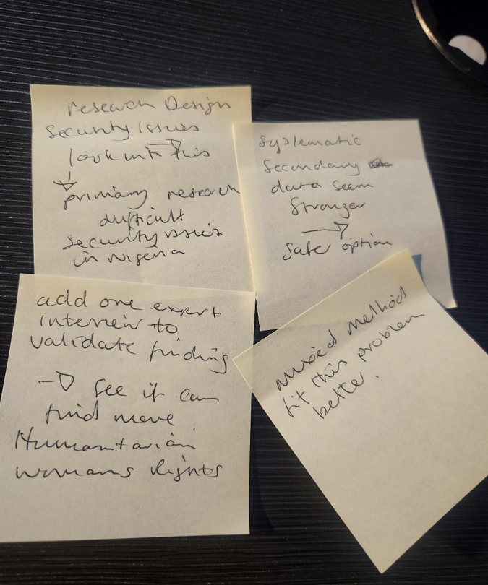

Figure 17: sticky notes: Source(s): Authors’ Work

5.1 Identifying the Research Problem
The research examined the economic impact of the Boko Haram insurgency on women-owned businesses in Northern Nigeria, highlighting disruptions, displacement, and financial exclusion. While microfinance is often viewed as crucial for women's recovery, evidence of its long-term effectiveness in building resilience in conflict-affected communities is limited. The study shifted to explore how microfinance interacts with humanitarian-development efforts to support women's enterprises and enhance organizational resilience in fragile environments.

5.2 Literature Review and Intellectual Development
A systematic review of academic and grey literature further shaped the study's direction. Four dominant themes consistently emerged:
- Women’s entrepreneurship with conflict economies;
- Microfinance and financial inclusion;
- Enterprise resilience; and
- Humanitarian-development interventions.
Evidence shows that while microfinance can improve access to financial services, few studies prove it leads to sustained enterprise survival or long-term growth. This suggests that enterprise resilience involves not just financial inclusion but also a mix of financial, institutional, social, and contextual factors. This realization shifted my perspective, leading me to see resilience as a multidimensional process needing broader theoretical explanations.
The following chart illustrates the Key themes emerging from the literature:
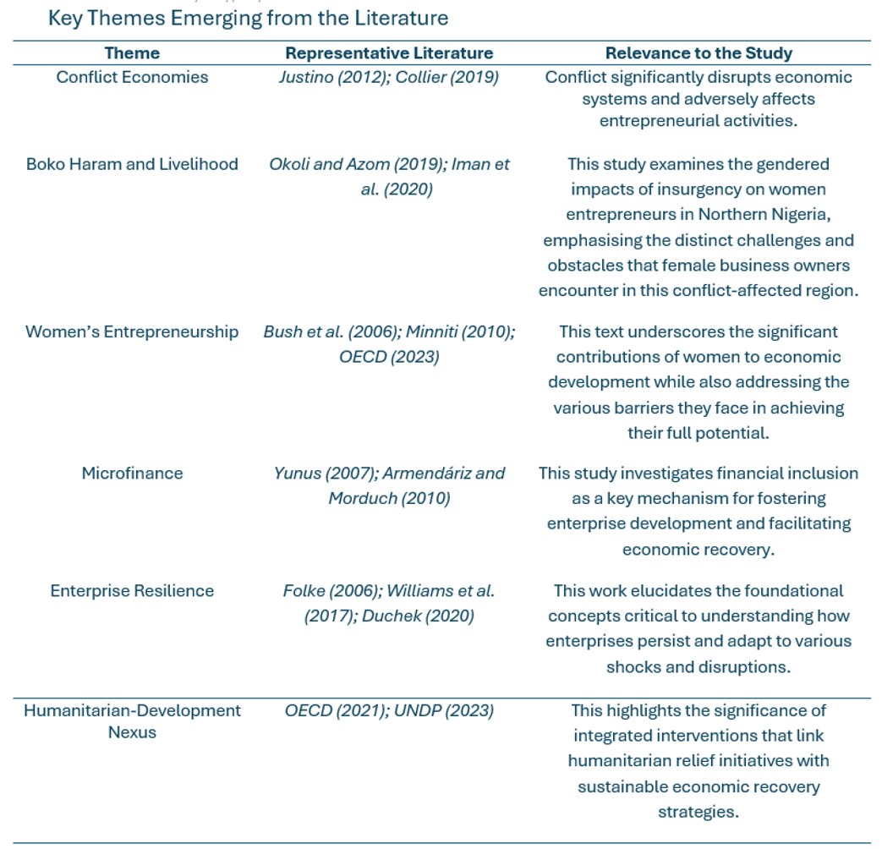

Figure 18: Key Themes Emerging from the Literature: Source(s): Authors’ Work

5.3 Theoretical Integration
As my understanding of the literature grew, it became clear that no single theoretical framework fully explained women’s enterprise resilience in conflict economies. Thus, the research integrates four complementary perspectives:
- Enterprise Resilience Theory;
- Sustainable Livelihoods Framework;
- Social Capital Theory; and
- Humanitarian-Development Nexus.
Each theory provides a distinct perspective: Enterprise Resilience Theory focuses on organisational adaptation following disruptions; the Sustainable Livelihoods Framework broadens resilience to encompass diverse livelihood assets; Social Capital Theory emphasises relationships and trust in access to resources; and the Humanitarian-Development Nexus links enterprise resilience to long-term recovery. Integrating these views redefines enterprise resilience as the interplay among financial resources, adaptive capacity, institutional support, and humanitarian intervention, rather than just finance.

5.4 Methodological Development
Reflection influenced the methodological design, leading me to adopt a Pragmatist and Critical Realist approach. Initially considering a conventional qualitative method, I recognised that the complexity of women's enterprise resilience required a mixed-methods strategy that integrated secondary data and expert insights. This methodology supports measurable program outcomes and aligns with DBA research objectives. The decision to focus on secondary evidence stemmed from security concerns, ethical considerations, and limited access to conflict areas. A pilot interview with a humanitarian or women's rights practitioner provides valuable context while preserving methodological integrity.

5.5 Critical Reflection and Paradigm Development
A critical evaluation of microfinance literature revealed that improved financial access doesn't always lead to enterprise resilience, prompting a reassessment of my assumptions. I began to view resilience as an adaptive process shaped by financial, social, institutional, and humanitarian factors, shifting my focus from financial inclusion to how women-owned enterprises survive in conflict economies. Reflective practices enhanced my conceptual framework and methodology, fostering continual questioning of dominant assumptions and boosting my confidence in engaging with established scholarship.

5.6 Kuhnian Reflection
Kuhn’s (1962) theory of scientific paradigms significantly shaped my understanding of knowledge development during the DBA journey. While literature often claims that microfinance empowers women through financial inclusion and better enterprise performance (Kabeer, 1999; Armendariz and Morduch, 2010), the evidence in this portfolio highlights several key anomalies. The image below displays several sticky notes I used while brainstorming portfolio research ideas:
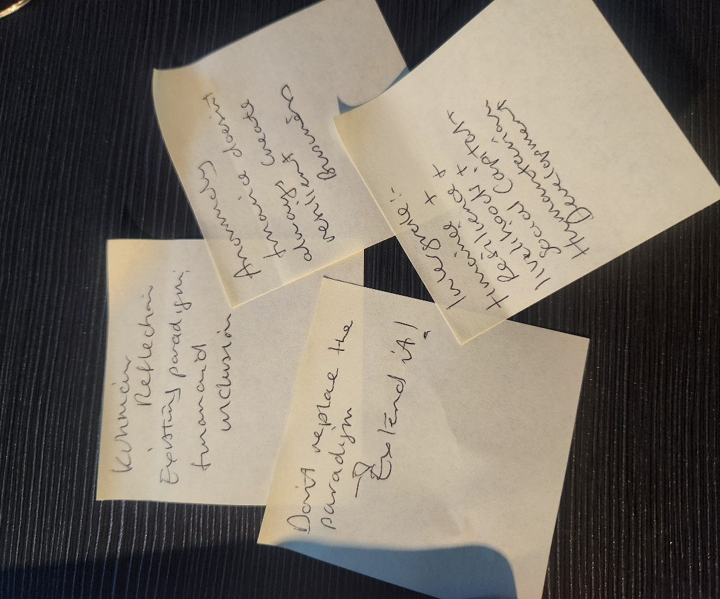

Figure 19: sticky notes: Source(s): Authors’ Work

Improved access to finance does not always enhance enterprise resilience. Financial inclusion may not empower women in the presence of gender inequalities. The effectiveness of microfinance varies in conflict settings with insecurity and weak institutions. Sustainable enterprise resilience often relies on complementary support, such as business training, social capital, and market access.
In line with Kuhn (1962), unresolved inconsistencies present opportunities to refine theories rather than reject existing knowledge. This study extends the financial inclusion paradigm by integrating Enterprise Resilience Theory, the Sustainable Livelihoods Framework, Social Capital Theory, and the Humanitarian-Development Nexus, offering a more comprehensive understanding of women’s enterprise resilience and grounding it in established scholarship.

5.7 Reconciling Competing Paradigms
An important outcome of this reflection is recognising that competing theoretical perspectives need not be mutually exclusive. The proposed framework reconciles four complementary paradigms.
The Economic Paradigm views finance as a key driver of enterprise performance (Banerjee, Karlan, and Zinman, 2015). The Social Paradigm emphasises the role of social capital and networks in accessing resources (Bourdieu, 1986; Coleman, 1988). The Resilience Paradigm focuses on capacities that help enterprises endure disruptions (Folke, 2006; Duchek, 2020). Lastly, the Humanitarian Paradigm highlights the need for coordinated support for sustainable recovery (UNDP, 2022).
The proposed framework integrates multiple perspectives on enterprise resilience, viewing it as the result of interactions among financial, social, institutional, and humanitarian mechanisms, rather than a single intervention. This multidisciplinary approach acknowledges the complexity of conflict economies and the practical focus of DBA research.

5.8 Ethical Reflection
This research relies on secondary evidence and prioritises ethical responsibility. It emphasises the accurate representation of conflict-affected women, the avoidance of stereotypes, and respectful engagement with vulnerable populations. The pilot interview will follow university ethical standards, including informed consent and confidentiality. Ethical considerations extend beyond compliance, reflecting a commitment to responsible scholarship and the creation of practical knowledge that respects the dignity of those impacted by conflict.

5.9 Overall Reflection
This portfolio highlights my doctoral journey, from identifying a business problem to developing a comprehensive DBA research proposal. Through a literature review, engagement with theory, and methodological refinement, I crafted a research design that is both theoretically sound and practically relevant. This process has strengthened my skills as an independent researcher, boosting my confidence in identifying anomalies and building evidence-based arguments.

6 Final Research Proposal, Contribution to Knowledge, Conclusion and Next Steps

6.1 Final Research Proposal

Final DBA Research Title
BUILDING WOMEN’S ENTERPRISE RESILIENCE THROUGH MICROFINANCE IN BOKO HARAM-AFFECTED COMMUNITIES OF NORTHERN NIGERIA: DEVELOPING A RESILIENCE-ORIENTED HUMANITARIAN-DEVELOPMENT FRAMEWORK FOR CONFLICT ECONOMIES
The refined title captures the intellectual journey of the portfolio, which evolved from a focus on microfinance and women’s entrepreneurship to a broader examination of enterprise resilience in conflict economies. It better represents the study’s theoretical integration, methodological approach, and its contributions to both scholarship and practice.

6.2 Contribution to Knowledge
This DBA research proposal addresses a gap in the literature on how microfinance and humanitarian-development interventions enhance women’s enterprise resilience in conflict-affected Northern Nigeria. Existing research often treats financial inclusion, livelihood recovery, humanitarian assistance, and enterprise resilience as separate issues, providing limited insight into their collective impact in fragile environments (Banerjee, Karlan, and Zinman, 2015; UNDP, 2022).

Theoretical Contributions
The principal theoretical contribution is the development of an integrated resilience-oriented framework synthesising four complementary perspectives:
- Enterprise Resilience Theory;
- Sustainable Livelihood Framework;
- Social Capital Theory; and
- Humanitarian-Development Nexus
The framework illustrates how financial, social, institutional, and humanitarian mechanisms interact to affect enterprise resilience in conflict economies (Folke, 2006; Scones, 1998). This approach enhances research on financial inclusion by highlighting that sustainable resilience depends on broader organisational and contextual factors, not just financial services.

Methodological Contribution
The research uses a mixed-methods design that integrates systematic secondary evidence with expert insights. It combines qualitative literature, quantitative program data, and a pilot expert interview, applying abductive reasoning and triangulation to examine complex organisational issues in conflict settings (Morgan, 2007; Dubois and Gadde, 2002). This approach provides a broader analysis than a single case study while maintaining ethical and security standards in affected communities, demonstrating how secondary evidence can inform organisational decision-making.

Practical contribution
The resilience-oriented framework provides practical guidance for various stakeholders.
The research outlines principles for microfinance institutions to create conflict-sensitive financial services that encompass savings, business training, and flexible products, rather than just credit provision.
The study advocates for integrated livelihood recovery programs for NGOs and humanitarian organisations that merge enterprise development with social and institutional support.
The research emphasises the need for development agencies to connect humanitarian aid with long-term economic recovery through coordinated interventions.
The findings provide recommendations for policymakers to enhance women’s enterprise resilience, aid gender-responsive policy development, and support sustainable economic recovery in conflict-affected Northern Nigeria.

6.3 Kuhnian Contribution
Kuhn’s (1962) concept of scientific paradigms serves as a key lens for evaluating the literature on financial inclusion. This dominant paradigm has deepened our understanding of women’s economic empowerment, highlighting the significance of access to credit, savings, and financial services. Yet, a systematic review of the literature uncovers several unresolved anomalies. Improved financial access does not always enhance enterprise resilience, as growth is limited by insecurity, weak institutions, and restrictive gender norms. Humanitarian interventions may aid immediate recovery, but do not ensure sustainable enterprise outcomes.
The proposed research enhances the financial inclusion paradigm by incorporating resilience, livelihoods, social capital, and humanitarian-development perspectives. This approach aligns with Kuhn’s view of scientific progress as an evolutionary refinement of theory rather than a radical shift. Consequently, the study offers a more comprehensive understanding of women’s enterprise resilience while building on existing scholarship (Kuhn, 1962).

6.4 Overall Portfolio Reflection
This portfolio outlines the development of a DBA research project on women's entrepreneurship and the economic impact of Boko Haram insurgency. The literature review highlighted inconsistencies in the effectiveness of microfinance in conflict economies, leading to a resilience-oriented framework that extends beyond financial inclusion.
Theoretical and methodological refinement utilised Pragmatism and Critical Realism to support an abductive mixed-methods design, integrating secondary evidence with expert insights while maintaining practical focus and philosophical coherence.
My growth as a researcher has involved critical reflection, enhancing my ability to evaluate theories, challenge assumptions, and synthesise evidence into coherent arguments. I can now identify gaps, recognise anomalies, and propose evidence-based solutions that are both academically and professionally relevant.

6.5 Conclusion
This portfolio establishes a foundation for DBA research, highlighting that understanding women's enterprise resilience in conflict economies requires an integrated approach. It encompasses resilience, livelihoods, social capital, and humanitarian-development interventions, rather than just financial inclusion. Women's resilience is shaped by financial resources, institutional capacity, social relationships, adaptive capabilities, and humanitarian support. The proposed resilience-oriented framework provides a theoretical basis for assessing practices and guiding program design, policy development, and future research. By integrating Enterprise Resilience Theory, the Sustainable Livelihoods Framework, Social Capital Theory, and the Humanitarian-Development Nexus, the study aims to enhance understanding of enterprise resilience in conflict-affected Northern Nigeria, in line with the DBA’s goal of advancing applied research in scholarship and practice.

6.6 Next Steps
The next phase of the doctoral research will implement the developed methodological framework, focusing on key activities including:
- Completing the systematic literature review.
- Refining the conceptual framework.
- Finalising the secondary-data extraction protocol and pilot interview guide.
- Conducting a systematic evidence extraction and quality appraisal.
- Undertaking the pilot expert interview to validate emerging themes.
- Completing thematic synthesis and triangulation.
- Developing the proposed resilience-oriented humanitarian-development framework
- Producing evidence-based recommendations for microfinance institutions, humanitarian organisations, development agencies and policymakers.
These activities will provide the necessary foundation for the DBA research, ensuring alignment of research objectives, theoretical framework, and methodology.

Overall Portfolio Summary
This research outlines the development of a DBA proposal focused on how microfinance and humanitarian-development interventions enhance women's enterprise resilience in Boko Haram-affected Northern Nigeria. Grounded in Pragmatism and informed by Critical Realism and Kuhn's paradigm theory, the study offers a resilience-oriented framework that expands the traditional financial inclusion perspective. It aims to guide organisational decision-making, improve humanitarian efforts, and support sustainable recovery in conflict-affected economies.

Reference
Ada, J., and Abdullahi, M. (2022) 'The impact of humanitarian aid on post-conflict development in Borno State', International Journal of Peace and Development Studies, 13(1), pp. 1-16. Available at: https://academicjournals.org/journal/IJPDS/article-full-text-pdf/1899E2168455 (Accessed: 20 June 2026).
Akerlof, G. (1970) 'The Market for "Lemons": Quality Uncertainty and the Market Mechanism', The Quarterly Journal of Economics, 84(3), pp. 488-500. Available at: https://captgouda24.github.io/nicholas-decker.github.io/pdfs/Akerlof_The_Market_For.pdf (Accessed: 26 July 2026).
Amalachukwu Ibeneme (2025). Livelihood Support as one of the Foundations of Sustainable Peace [United Nations Development Programme (UNDP)]. Available at: https://www.undp.org/nigeria/stories/livelihood-support-one-foundations-sustainable-peace (Accessed: 29 June 2026).
Anderson, M. (1999). Do No Harm: How Aid Can Support Peace or War: "Indications" for Assessing Aid’s Impacts on Conflict. Lynne Rienner Publishers. Available at: https://www.cdacollaborative.org/wp-content/uploads/2016/02/Indications-for-Assessing-Aids-Impacts-on-Conflict.pdf (Accessed: 21 June 2026).
Armendáriz, B., and Morduch, J. (2010). The Economics of Microfinance, second edition. The Massachusetts Institute of Technology (MIT) Press. Available at: file:///C:/Users/Student/Downloads/Theeconomicsofmicrofinance...pdf (Accessed: 13 July 2026).
Aruofor, R., Ogbeide, D. (2022). 'The Impact of Boko Haram Insurgency and Banditry on The Nigerian Economy: Understanding The Causes and Feedback', International Journal of Innovative Development and Policy Studies, 10(1), pp. 14-26. Available at: https://www.seahipublications.org/wp-content/uploads/2024/12/IJIDPS-M-2-2022.pdf (Accessed: 4 June 2026).
Attanasio, O., Augsburg, B., de Haas, R., Fitzsimons, E., and Harmgart, H. (2015) 'The Impacts of Microfinance: Evidence from Joint-Liability Lending in Mongolia', SSRN Electronic Journal,7(1), pp. 90-122. Available at: https://www.researchgate.net/publication/228320282_The_Impacts_of_Microfinance_Evidence_from_Joint-Liability_Lending_in_Mongolia (Accessed: 17 July 2026).
Ayogu, D., and Everistus, O. (2015) 'Assessment of the Contribution of Women Entrepreneurs towards Entrepreneurship Development in Nigeria', International Journal of Current Research and Academic Review, 3(10), pp. 190-207. Available at: https://www.ijcrar.com/vol-3-10/Ayogu,%20Deborah%20U.%20and%20Agu,%20Everistus%20Ogadimma2.pdf (Accessed: 6 June 2026).
Babajide, A. (2012) 'Effects of Microfinance on Micro and Small Enterprises (MSEs) Growth in Nigeria', Asian Economic and Financial Review, 2(3), pp. 463-477. Available at: https://www.researchgate.net/profile/Babajide-Abiola-2/publication/254391715_Effects_of_Microfinance_on_Micro_and_Small_Enterprises_MSEs_Growth_in_Nigeria/links/56cc3aca08ae5488f0dcecc7/Effects-of-Microfinance-on-Micro-and-Small-Enterprises-MSEs-Growth-in-Nigeria.pdf (Accessed: 17 June 2026).
Bakhtiari, S., Breunig, R., Magnani, L., and Zhang, J. (2020). Financial Constraints and Small and Medium Enterprises: A Review. Discussion paper series, IZA DP No. 12936. IZA Institute of Labour Economics. Available at: https://d1wqtxts1xzle7.cloudfront.net/89133768/dp12936-libre.pdf?1659218225=&response-content-disposition=inline%3B+filename%3DFinancial_Constraints_and_Small_and_Medi.pdf&Expires=1786485012&Signature=Gva1GK-w7NAtcHnaeBI7qNFZChsrm5mUjd9Os4968DjhTQLLnevV1pjzA87Lh5OFVxUakYunHDaKP1~qhgo-DKQvaVfw4-z4LFJIMRfWf2UWQpl8TQlPj5DZEPVXBxeD25IvtiMtdiyiCLUmhecds~tatMi5f4twA3V2C~ZTqlMSLM6~dA~bF5yzzJjAVTz9QTo9DImcbaJXQne0pgD2oWys8tAYo4kVMWKPokQfWMCGK8wPeMgOvBXrmqaiP5iIMkrJxXeXoL4ugvoflbPAQptZmBWFacllFUqImanY2DODfqGG2laUl8ljrsza1o-x5iVVmmCA1ZkCIAdPYAYYCQ__&Key-Pair-Id=APKAJLOHF5GGSLRBV4ZA (Accessed: 21 July 2026).
Banerjee, A., Karlan, D., and Zinman, J. (2015) 'Six Randomized Evaluations of Microcredit: Introduction and Further Steps', American Economic Journal, 7(1), pp 1-21. Available at: https://pdfs.semanticscholar.org/67f3/50dc60927dfe2b1de7efb46a6ce76180d217.pdf (Accessed: 16 July 2026).
Bello, B. (2026) 'Women Entrepreneurship, Financial Inclusion, And Intergenerational Wealth Creation in Monguno, Nigeria (SDG 5 & SDG 10)', Federal Polytechnic Monguno, pp. 1-17. Available at: file:///C:/Users/Student/Downloads/ssrn-6706718.pdf (Accessed: 26 July 2026).
Bi, M., and Zhang, Z. (2023) 'Exploring the Path of Autonomous Development: the Development Dilemma and Coping Strategies of Sub-Saharan Africa in the Post-epidemic Era', Journal of the Knowledge Economy, 15(1), pp. 5043-5071. Available at: https://www.researchgate.net/publication/369922211_Exploring_the_Path_of_Autonomous_Development_the_Development_Dilemma_and_Coping_Strategies_of_Sub-Saharan_Africa_in_the_Post-epidemic_Era (Accessed: 21 July 2026).
Bird, A. (2012) 'The Structure of Scientific Revolutions and its Significance: An Essay Review of the Fiftieth Anniversary Edition', The British Journal for the Philosophy of Science, 63 (4), pp. 859-883. Available at: https://www-jstor-org.uwtsd.idm.oclc.org/stable/23356448?sid=primo&seq= (Accessed: 29 June 2026).
Bourdieu, Pierre. (1986) 'The Forms of Capital', J.G. Richardson (ed.), Handbook of Theory and Research for the Sociology of Education. New York: Greenwood Press, pp. 241-258. Available at: https://www.ucg.ac.me/skladiste/blog_9155/objava_66783/fajlovi/Bourdieu%20The%20Forms%20of%20Capital%20_1_.pdf (Accessed: 29 June 2026).
Brechenmacher, S. (2019). Carnegie Endowment for International Peace Report Part Title: Front Matter Report Title: Stabilizing Northeast Nigeria After Boko Haram. Carnegie Endowment for International Peace. Available at: https://carnegieendowment.org/research/2019/05/stabilizing-northeast-nigeria-after-boko-haram (Accessed: 4 June 2026).
Brito, R., Lenz, A., and Pacheco, M. (2022) 'Resilience building among small businesses in low-income neighborhoods', Journal of Small Business Management, 60(4), pp. 1-36. Available at: https://www.researchgate.net/publication/360415590_Resilience_building_among_small_businesses_in_low-income_neighborhoods (Accessed: 21 July 2026).
Bush, C., de Bruin, A., and Welter, F. (2009) 'A gender‐aware framework for women's entrepreneurship', International Journal of Gender and Entrepreneurship, 1(1), pp. 8-24. Available at: https://www.researchgate.net/publication/235302742_A_gender-aware_framework_for_women%27s_entrepreneurship (Accessed: 10 July 2026).
Central Bank of Nigeria (CBN) (2011). Revised Microfinance Policy Regulatory and Supervisory Framework for Nigeria. CBN Available at: https://www.cbn.gov.ng/OUT/2011/CIRCULARS/OFIS/OFISD-02-2011.PDF (Accessed:17 June 2026).
Central Bank of Nigeria (CBN) (2020) Financial Inclusion. CBN Available at: https://www.cbn.gov.ng/dfd/Financialinclusion.html (Accessed: 17 June 2026).
Central Bank of Nigeria (CBN) (2022) Payments System Supervision. CBN Available at: https://www.cbn.gov.ng/PaymentsSystem/ (Accessed: 17 June 2026).
Coleman, J. (1990). Foundations of Social Theory. The Belknap Press of Harvard University Press. Available at: https://archiv.soms.ethz.ch/teaching/FS09_FCSS/Coleman1990_Social_Norms.pdf (Accessed: 18 June 2026).
Coleman, J. (1988) 'Social Capital in the Creation of Human Capital', American Journal of Sociology, 94, pp.95-120. Available at: https://strategy.sjsu.edu/www.stable/pdf/Coleman,%20J.%20S.,%201988,%20American%20Journal%20of%20Sociology%2094%2095-120.pdf (Accessed: 16 July 2026).
Collier, P. (2000). Economic Causes of Civil Conflict and their Implications for Policy. Vol. 5. World Bank.
Cooke, E. and Amuakwa-Mensah, F. (2020) 'Microfinance loans, women’s economic empowerment, and poverty: a case study of Baobab Microfinance Company', Journal of Development Effectiveness, 14 (1): Assessing the impact of private investments while building research capacity, pp. 34-55. Available at: https://www.tandfonline.com/doi/full/10.1080/19439342.2021.1953568?scroll=top&needAccess=true#abstract (Accessed: 16 July 2026).
Creswell, J., and Piano Clark, V. (2007). Designing and Conducting Mixed Methods Research, 3rd ed. Sage Publications. Available at: https://d1wqtxts1xzle7.cloudfront.net/50852793/j.1753-6405.2007.00096.x20161212-28331-1f4ar07-libre.pdf?1481575051=&response-content-disposition=inline%3B+filename%3DDesigning_and_conducting_mixed_methods_r.pdf&Expires=1786801346&Signature=Y6SIla7jbuE33dN3lCkCZ4OSVECaW1xoqpQwYb6B2HzUiZPRRs7yy0bxoRqQ2jq02RAsTDIT0Zp5Blcpqok2NfFilgWjZnSyFJrTt-sI6fNS-7aIOIEQZoEb2vWd5ftZSj6pVU9cNXk9c7Tyh1a7rna4QU63AACXYRfQ1dAAS6nhgwXW3aTZFklbbCPAe5lCUaf8R9-EzRbjyCEaKeKH-PYX6jy5ax0wCFeh~4qZDBuQgtpEH2zHvKi7ZC8Xx72cQJkLzkWoKkbzVkMFXPewXPQQIJdtwTAf-AzTAfsVvP6TMP5ZPP9Kr95ohyOBg1Nqxi1uhgDBY6qBzHZobZ~G2g__&Key-Pair-Id=APKAJLOHF5GGSLRBV4ZA (Accessed: 21 July 2026).
Denicolai, S., Zucchella, A., and Magnani, G. (2021) 'Internationalization, digitalization, and sustainability: Are SMEs ready? A survey on synergies and substituting effects among growth paths', Technological Forecasting and Social Change, 166(2). Available at: https://www.scribd.com/document/1036463331/Internationalization-Digitalization-And-Sustainability-Are-SMEs-Ready (Accessed: 21 July 2026).
Do, H., Budhwar, P., Shipton, H., Nguyen, H., Nguyen, B. (2022) 'Building organizational resilience, innovation through resource-based management initiatives, organizational learning and environmental dynamism', Journal of Business Research, 141, pp. 808-821. Available at: https://www.sciencedirect.com/science/article/pii/S014829632100905X (Accessed: 21 July 2026).
Dooluman, S., Okonkwo, P., and Ogbonna, E. (2026). 'Co-operative Financing and Livelihood Recovery among Smallholder Farmers in Insecurity-Affected Nigerian Communities', SSR Journal of Economics, Business and Management, 3(7), pp. 29-36. Available at: https://ssrpublisher.com/wp-content/uploads/2026/07/Co-operative-Financing-and-Livelihood-Recovery-among-Smallholder-Farmers-in-Insecurity-Affected-Nigerian-Communities.pdf (Accessed: 10 July 2026).
Dubois, A., and Gadde, L. (2002) 'Systematic combining: an abductive approach to case research', Journal of Business Research, 55, pp. 553-560. Available at: https://www.sciencedirect.com/science/article/pii/S0148296300001958 (Accessed: 18 July 2026).
Duchek, S. (2019) 'Organizational resilience: a capability-based conceptualization', Business Research, 13, pp. 215-246. Available at: https://link.springer.com/article/10.1007/s40685-019-0085-7 (Accessed: 13 July 2026).
Dupas, P., and Robinson, J. (2013) 'Savings Constraints and Microenterprise Development: Evidence from a Field Experiment in Kenya', American Economic Journal: Applied Economics, 5 (1), pp. 163-192. Available at: https://www.gov.uk/research-for-development-outputs/savings-constraints-and-microenterprise-development-evidence-from-a-field-experiment-in-kenya (Accessed: 16 June 2026).
Effiom, L., and Edet, S. (2020) 'Financial innovation and the performance of small and medium-scale enterprises in Nigeria', TJournal of Small Business and Entrepreneurship, 34(2), pp. 141-174. Available at: https://www.researchgate.net/publication/342600336_Financial_innovation_and_the_performance_of_small_and_medium_scale_enterprises_in_Nigeria (Accessed: 21 July 2026).
Enhancing Financial Innovation and Access (EFInA) (2023). Access To Financial Services In Nigeria (A2F) 2023 Survey Report. Unlocking Insight to Accelerate Financial and Economic Inclusion. Enhancing Financial Innovation and Access Available at: https://a2f.ng/wp-content/uploads/2024/07/A2F-2023-SURVEY-REPORT-1.pdf (Accessed: 17 June 2026).
Eniola, A., and Entebang. H. (2017) 'SME Managers and Financial Literacy', Global Business Review, 18(3), pp. 559-576. Available at: https://www.researchgate.net/publication/315804109_SME_Managers_and_Financial_Literacy (Accessed: 21 July 2026).
European Investment Bank (2025). Empowering women-led businesses worldwide: A resilience toolbox. Available at: https://www.eib.org/en/press/news/empowering-women-led-businesses-worldwide-a-resilience-toolbox (Accessed: 29 June 2026).
Evans, S., Vladimirova, D., Holgado, M., Van Fossen, K., Yang, M., Silva, E., and Barlow, C. (2017) 'Business Model Innovation for Sustainability: Towards a Unified Perspective for Creation of Sustainable Business Models', Business Strategy and the Environment, 26(3), pp. 1-12. Available at: https://onlinelibrary.wiley.com/doi/full/10.1002/bse.1939 (Accessed: 21 July 2026).
Garba, I. (2026). Entrepreneurial Finance, Microcredit, and Sustainable Wealth Creation Among Rural Households In Monguno, Nigeria. Federal Polytechnic Monguno. Nigerian Tertiary Education Trust Fund. Available at: https://papers.ssrn.com/sol3/papers.cfm?abstract_id=6710558 (Accessed: 10 June 2026).
Fletschner, D., and Kenney, L. (2014) 'Rural Women’s Access to Financial Services: Credit, Savings, and Insurance', Gender in Agriculture, pp. 187-208. Available at: https://openknowledge.fao.org/server/api/core/bitstreams/cb5b4916-5836-4e37-a1f5-58be3415875f/content#page=195 (Accessed: 17 June 2026).
Folke, C. (2006) 'Resilience: The emergence of a perspective for social–ecological systems analyses', Global Environmental Change, 16, pp. 253-267. Available at: https://artlesstanzim.wordpress.com/wp-content/uploads/2014/05/21.pdf (Accessed: 13 July 2026).
Garmezy, N. (1991) 'Resilience in Children's Adaptation to Negative Life Events and Stressed Environments', Paediatric Annals, 20(9), pp. 459-466. Available at: https://journals.healio.com/doi/abs/10.3928/0090-4481-19910901-05 (Accessed: 29 June 2026).
Ghatak, M. (1999) 'Group lending, local information and peer selection', Journal of Development Economics, 60(1), pp. 27-50. Available at: https://www.sciencedirect.com/science/article/abs/pii/S0304387899000358 (Accessed: 18 June 2026).
Green Bank (2023). Grameen Bank at a Glance. 6 September 2011. Available at: https://www.youtube.com/watch?v=MgYes4bA7oM (Accessed: 16 June 2026).
Guiso, L., Sapienza, P., and Zingales, L. (2004) 'Does Local Financial Development Matter?', The Quarterly Journal of Economics, 119(3), pp. 929-969. Available at: https://www.jstor.org/stable/25098706 (Accessed: 17 June 2026).
Hillmann, J., and Guenther, E. (2020) 'Organizational Resilience: A Valuable Construct for Management Research?', International Journal of Management Reviews, 23(1), pp. 7-44. Available at: https://www.researchgate.net/publication/343690154_Organizational_Resilience_A_Valuable_Construct_for_Management_Research (Accessed: 21 July 2026).
Hock-Doepgen, M., Clauss, T., Kraus, S., and Cheng, C. (2021) 'Title of article', Journal of Business Research, 130, pp. 683-697. Available at: https://www.sciencedirect.com/science/article/pii/S0148296319307659 (Accessed: 21 July 2026).
Holling, C. (1973) 'Resilience and Stability of Ecological Systems', Annual Review of Ecology and Systematics, 4, pp. 1-23. Available at: https://pure.iiasa.ac.at/id/eprint/26/1/RP-73-003.pdf (Accessed: 10 July 2026).
Idika-Kalu, C. (2020) 'The Socioeconomic Impact of the Boko Haram Insurgency in the Lake Chad Basin Region', in S. Khan and Z. Yu (ed.), Terrorism and Developing Countries. Intech Open, pp. 1-10. Available at: https://www.researchgate.net/publication/341191086_The_Socioeconomic_Impact_of_the_Boko_Haram_Insurgency_in_the_Lake_Chad_Basin_Region (Accessed: 4 June 2026).
Imam, A., Biu, H., and Yahi, M. (Y2020) Women’s informal peacebuilding in North East Nigeria. Available at: https://www.cmi.no/publications/7296-womens-informal-peacebuilding-in-north-east-nigeria (Accessed: 12 July 2026).
International Labour Organisation (ILO) (2003) Local Economic Development in Post-Crisis Situations: Operational Guide. International Labour Organisation. Available at: https://www.ilo.org/sites/default/files/wcmsp5/groups/public/@ed_emp/documents/publication/wcms_115919.pdf (Accessed: 20 June 2026).
International Organization for Migration (IOM) (2023) Progress 2023 Periodic Global Report on the State of Solutions to Internal Displacement. Description, International Organization for Migration (IOM), Available at: https://dtm.iom.int/sites/g/files/tmzbdl1461/files/progress/PROGRESS%20REPORT%202023.pdf (Accessed: 20 June 2026).
Justino (2012) War and Poverty. Conflict, Violence and Development Research Cluster. IDS Working Paper Volume 2012 No. 391. CVD WP9. Institute of Development Studies. Available at: https://onlinelibrary.wiley.com/doi/pdf/10.1111/j.2040-0209.2012.00391.x (Accessed: 12 July 2026).
Kabeer, N. (1999). The Conditions and Consequences of Choice: Reflections on the Measurement of Women's Empowerment. UNRISD Discussion Paper No. 108, August 1999. United Nations Research Institute. Available at: https://www.files.ethz.ch/isn/28994/dp108.pdf (Accessed: 16 July 2026).
Kabeer, N. (2002) 'Resources, Agency, Achievements: Reflections on the Measurement of Women's Empowerment', Development and Change, 30(3), pp.435-464. Available at: https://d1wqtxts1xzle7.cloudfront.net/30868111/kabeer-dev_ch-99-libre.pdf?1363363333=&response-content-disposition=inline%3B+filename%3DResources_agency_achievements_Reflection.pdf&Expires=1786560951&Signature=N4XoT2EkEdj6ug0rz2QCXU7XeApUmQKWsTRKFi4BnMhCaDzR7T-jBA3FSVMBekYql3ZBUTffVw8Pky6WXRtV~Kdng~c67KWwWt8Qr4bFC5mQtkNkxBcMcTimoaw2vHfqsjMxbsVKbPWCG~LGK6Xmv9vkpX~aTphgHC1922LwgHeP6tFLS6dPc7oxG20HZibfwrOVoXleUz2-urb5pxuaNiNdqe2gbCdsONJtg8L3gYNmAyM66tBclxqDnI4k84bvAYUwDynWoR245nScYqD5DnybFTjKKQxYiMQ3wk08kvJR6at7jHWwfK9NgyvKonY0SbXt10X90pPivmnyNOr1zQ__&Key-Pair-Id=APKAJLOHF5GGSLRBV4ZA (Accessed: 26 July 2026).
Kallon, E. (2019) Civil-Security Cooperation in Humanitarian Interventions in the North East Workshop. Opening Remarks by the Resident and Humanitarian Coordinator in Nigeria 6 November 2019, Maiduguri, Nigeria. United Nations Available at: file:///C:/Users/Student/Downloads/UN%20Humanitarian%20Coordinator%20Keynote%20Remarks%20-%20Civil-Security%20Cooperation....pdf (Accessed: 21 June 2026).
Karlan, D., and Zinman, J. (2008) 'Credit Elasticities in Less-Developed Economies: Implications for Microfinance', American Economic Review, 98(3), pp. 1040-1068. Available at: https://www.povertyactionlab.org/sites/default/files/research-paper/208%20Credit%20Elasticities%20June%2008.pdf (Accessed: 16 June 2026).
Kaplinsky, R., Kraemer-Mbula, E. (2022) 'Innovation and uneven development: The challenge for low- and middle-income economies', Research Policy, 51 (2), pp. 1-14. Available at: https://www.researchgate.net/publication/356266567_Innovation_and_uneven_development_The_challenge_for_low-_and_middle-income_economies (Accessed: 21 July 2026).
Khurana, I., Dutta, D., and Ghura, A. (2022) 'SMEs and digital transformation during a crisis: The emergence of resilience as a second-order dynamic capability in an entrepreneurial ecosystem', Journal of Business Research, 150, pp. 623-641. Available at: https://www.sciencedirect.com/science/article/pii/S0148296322005902 (Accessed: 21 July 2026).
Kuhn, T. (1962). The Structure of Scientific Revolutions. The University of Chicago Press. Available at: https://www.lri.fr/~mbl/Stanford/CS477/papers/Kuhn-SSR-2ndEd.pdf (Accessed: 16 July 2026).
Kuhn, T. (1970). The Structure of Scientific Revolutions. The University of Chicago. Available at: https://www.lri.fr/~mbl/Stanford/CS477/papers/Kuhn-SSR-2ndEd.pdf (Accessed: 29 June 2026).
Lawan, U. (2017). Female entrepreneurship in Nigeria: An investigation. PhD Thesis. Robert Gordon University. Available at: https://www.academia.edu/105272297/Female_entrepreneurship_in_Nigeria_an_investigation (Accessed: 6 June 2026).
Limbu, S., and Bordoloi, N. (2015) 'Women Entrepreneurship: Problems and Prospects in Rural Assam', International Journal of Interdisciplinary Research in Science, Society and Culture (IJIRSSC), 1(1), pp. 117-125. Available at: https://www.researchgate.net/publication/334224560_Women_Entrepreneurship_Problems_and_Prospects_in_Rural_Assam (Accessed: 6 June 2026).
Lincoln, Y., and Guba, E. (1985). Naturalist Inquiry. Sage Publications.
Marcum, J. (N. a). Internet Encyclopedia of Philosophy: A Peer-Reviewed Academic Resource. Available at: https://iep.utm.edu/kuhn-ts/ (Accessed: 29 June 2026).
Mauro, P. (1995) 'Corruption and Growth', The Quarterly Journal of Economics, 110 (3), pp. 681-712. Available at: https://homepage.ntu.edu.tw/~kslin/macro2009/Mauro%201995.pdf (Accessed: 17 June 2026).
Mazzei, M., Flynn, B., and Haynie, J. (2016) 'Moving beyond initial success: Promoting innovation in small businesses through high-performance work practices', Business Horizons, 59(1), pp. 51-60. Available at: https://www.sciencedirect.com/science/article/pii/S0007681315001147 (Accessed: 21 July 2026).
Miklian, J., and Hoelscher, K. (2021) 'SMEs and exogenous shocks: A conceptual literature review and forward research agenda', International Small Business Journal: Researching Entrepreneurship, 40(2), pp. 178-204. Available at: https://journals.sagepub.com/doi/pdf/10.1177/02662426211050796 (Accessed: 21 July 2026).
Minniti, M. (2010) 'Female Entrepreneurship and Economic Activity', The European Journal of Development Research, 22, pp. 294-312. Available at: https://link.springer.com/article/10.1057/ejdr.2010.18 (Accessed: 13 July 2026).
Morgan, D. (2007) 'Paradigms Lost and Pragmatism Regained: Methodological Implications of Combining Qualitative and Quantitative Methods', Journal of Mixed Methods Research, 1(1), pp. 48-76. Available at: https://www.researchgate.net/publication/240730449_Paradigms_Lost_and_Pragmatism_Regained_Methodological_Implications_of_Combining_Qualitative_and_Quantitative_Methods (Accessed: 18 July 2026).
Nwanyanwu, J. (2011) 'Microfinance in Nigeria: Problems and Prospects', African Research Review, 5(2), pp. 87-103. Available at: file:///C:/Users/Student/Downloads/ajol-file-journals_336_articles_67307_submission_proof_67307-4009-137619-1-10-20110621.pdf (Accessed: 17 June 2026).
Obamuyi, T. M. (2007).' An exploratory study of loan delinquency among small and medium enterprises in Ondo State, Nigeria. 'Labour and Management in Development, 8, pp. 1-10. Available at: https://fliphtml5.com/wvam/lnyr/basic (Accessed: 17 June 2026).
OCHA (2021) Humanitarian Needs Overview Nigeria. Humanitarian Programme Cycle 2021
Issued March 2021. OCHA Available at: file:///C:/Users/Student/Downloads/Nigeria%20HNO%202021%20(1).pdf (Accessed: 13 July 2026).
OECD (2023) OECD SME and Entrepreneurship Outlook 2023. Better Policies for Better Lives. OECD Available at: https://www.oecd.org/content/dam/oecd/en/publications/reports/2023/06/oecd-sme-and-entrepreneurship-outlook-2023_c5ac21d0/342b8564-en.pdf (Accessed: 13 July 2026).
Oelke, S., Scherer, A., and Kühlken, H. (2022). The humanitarian-development-peace (HDP) Nexus: challenges in implementation. KfW Development Research Development in Brief. Kreditanstalt für Wiederaufbau. Available at: file:///C:/Users/Student/Downloads/2022_03_24_EK_HDP-Nexus_EN.pdf (Accessed: 10 July 2026).
Okoli, C., and Azom, S. (2019) 'Boko Haram insurgency and gendered victimhood: women as corporal victims and objects of war', Small Wars and Insurgencies, 30 (6-7), pp. 1214-1232. Available at: https://www.researchgate.net/publication/335939777_Boko_Haram_insurgency_and_gendered_victimhood_women_as_corporal_victims_and_objects_of_war (Accessed: 12 July 2026).
Olojo, A. (2019). How viable is dialogue with al-Shabaab and Boko Haram? Policy Brief. Institute for Security Studies (ISS). Available at: https://www.researchgate.net/publication/335882148_How_viable_is_dialogue_with_al-Shabaab_and_Boko_Haram (Accessed: 21 June 2026).
Omar, A., Magaji, S., and Jafaru, Y. (2025) 'Building Back Bolder: Examining Women’s Economic Empowerment and Adaptive Capacity in Insecure Regions of Borno State, Nigeria', International Journal of Innovative Psychology and Social Development, 13(4), pp. 240-253. Available at: https://www.researchgate.net/profile/Jafaru-Yakubu/publication/398370561_Building_Back_Bolder_Examining_Women's_Economic_Empowerment_and_Adaptive_Capacity_in_Insecure_Regions_of_Borno_State_Nigeria/links/6932d80c06a9ab54f8444d70/Building-Back-Bolder-Examining-Womens-Economic-Empowerment-and-Adaptive-Capacity-in-Insecure-Regions-of-Borno-State-Nigeria.pdf (Accessed: 26 July 2026).
Otache, I., and Usang, O. (2021) 'Innovation capability and SME performance in times of economic crisis: does government support moderate?', African Journal of Economic and Management Studies, 13(1), pp. 76-88. Available at: https://www.researchgate.net/publication/356357448_Innovation_capability_and_SME_performance_in_times_of_economic_crisis_does_government_support_moderate (Accessed: 21 July 2026).
Page, M., McKenzie, J., Bossuyt, P., Boutron, I., Hoffmann, Mulrow, C., Shamseer, L., Tetzlaff, J., Akl, E., Brennan, S., Chou, R., Glanville, J., Grimshaw, J., Hróbjartsson, A., Lalu, M., Li, T., Loder, E., Mayo-Wilson, E., McDonald, S., McGuinness, L., Stewart, L., Thomas , J., Tricco, A., Welch, V., Whiting, P., and Moher, D. (2021) 'The PRISMA 2020 statement: an updated guideline for reporting systematic reviews', Research Methods and Reporting, 372, pp. 1-9 . Available at: https://www.bmj.com/content/bmj/372/bmj.n71.full.pdf?utm (Accessed: 18 July 2026).
Putnam, R. (2000). Bowling Alone: The Collapse and Revival of American Community. Publisher. Available at: https://communistcaucus.com/wp-content/uploads/2021/12/Bowling-Alone.pdf (Accessed: 17 June 2026).
Richter, C., Kraus, S., Brem, A., and Durst, S. (2017) 'Digital entrepreneurship: Innovative business models for the sharing economy', Creativity and Innovation Management, 26(3), pp. 300-310. Available at: https://www.researchgate.net/publication/319158073_Digital_entrepreneurship_Innovative_business_models_for_the_sharing_economy (Accessed: 21 July 2026).
Saunders, M., Lewis, P., Thornhill, A. (2023) Research Methods for Business Students Ninth Edition. Pearson. Available at: https://moodle.uwtsd.ac.uk/pluginfile.php/1157902/mod_resource/content/1/2023RMBChapter4andPreface.pdf (Accessed: 19 February 2026).
Scoones, I. (1998) 'Sustainable Rural Livelihoods. A Framework for Analysis', Institute of Development Studies, 72, pp. 1-22. Available at: https://www.researchgate.net/publication/270588972_Sustainable_Rural_Livelihoods_A_Framework_for_Analysis_IDS_Working_Paper_72 (Accessed: 13 February 2026).
Shallangwa, G., Wilson, B. (2022) 'Meeting the Challenges of Sustainable Women Entrepreneurship Development in North Eastern Nigeria', Journal of Economics, Finance and Management Studies, 5, pp. 1281-1288. Available at: https://d1wqtxts1xzle7.cloudfront.net/98888633/9-libre.pdf?1676884057=&response-content-disposition=inline%3B+filename%3DMeeting_the_Challenges_of_Sustainable_Wo.pdf&Expires=1784395908&Signature=PAW2kz44e6qTkh6ffNf0Pn90oAZPPwNqrfNFqQM61zoRLFNci9IpSgyhKUtILv6SW00PpJg4CAd2~9jp1cSJov5m4GdTG2JHSsQQTCOncI9K7RURTcrQjnO3ElLpbBBXPSffDY3w8lwaQ5JwZ6qqPe6MPGLIH2xjlU9qSLIsjyw8EHNGQYOTUwm6RQNRzBlTvkqFQuAP~MjBB2RuOyeoWHPbfGOfkfGRB8T3NCrv9iNp43BIf4S8zJggHsRROYGu4vaKKeqEO~rwTLkLg7VxFldv6CH3WvjF6p2FjuZWwMF6a29tJpUProZccFfASqTgz9TY9PRNB9SYpjq7VM315A__&Key-Pair-Id=APKAJLOHF5GGSLRBV4ZA (Accessed: 4 June 2026).
Snyder, H. (2019) 'Literature review as a research methodology: An overview and guidelines', Journal of Business Research, 104, pp. 333-339. Available at: https://www.sciencedirect.com/science/article/pii/S0148296319304564 (Accessed: 18 July 2026).
Sonna, O., Chinedu, I., and Ikenna, A. (2026) 'Infrastructure Resilience and Performance of Small and Medium Scale Enterprises in Anambra State, Nigeria', Journal of Family Business and Management Studies, 18(1), pp. 49-66. Available at: https://www.fbmsjournal.com/wp-content/uploads/2026/01/04_User-125_Infrastructure-Resilience-and-Performance-of-Small-and-Medium-Scale-Enterprises-in-Anambra-State-Nigeria.pdf (Accessed: 20 June 2026).
Sphere Association (2018). The Sphere Handbook: Humanitarian Charter and Minimum Standards in Humanitarian Response, Fourth Edition. Practical Action Publishing Available at: https://spherestandards.org/wp-content/uploads/Sphere-Handbook-2018-EN.pdf (Accessed: 21 June 2026).
Stiglitz, J. (1990) 'Peer Monitoring and Credit Markets', The World Bank Economic Review, 4(3), pp. 351-366. Available at: https://users.nber.org/~rdehejia/!@$devo/Lecture%2006%20Microcredit/supplemental/Stiglitz_PMCR.pdf (Accessed: 17 June 2026).
Stiglitz, J., Weiss, A. (1981) 'Credit Rationing in Markets with Imperfect Information', The American Economic Review, 71(3), pp. 393-410. Available at: https://static.stevereads.com/papers_to_read/credit_rationing_in_markets_with_imperfect_information.pdf (Accessed: 26 July 2026).
Tafida, A., and Amurtiya, M. (2023) 'Boko-Haram Insurgency and Rural Livelihood Dilemma: Implication for Sustainable Development in North-East Nigeria', Problemy Ekorozwoju – Problems of Sustainable Development, 18(1), pp. 216-225. Available at: https://www.researchgate.net/publication/366412289_Boko-Haram_Insurgency_and_Rural_Livelihood_Dilemma_Implication_for_Sustainable_Development_in_North-East_Nigeria (Accessed: 4 June 2026).
The World Bank (2015). North-East Nigeria Recovery Peace Building Assessment. Volume 1 Synthesis Report. International Bank for Reconstruction and Development / The World Bank. Available at: https://documents1.worldbank.org/curated/en/753341479876623996/pdf/110424-v1-WP-NorthEastNigeriaRecoveryandPeaceBuildingAssessmentVolumeIweb-PUBLIC-Volume-1.pdf (Accessed: 4 June 2026).
Tranfield, D., Denyer, D., and Smart, P. (2003) 'Towards a Methodology for Developing Evidence-Informed Management Knowledge by Means of Systematic Review', British Journal of Management, 14, pp. 207-222. Available at: https://josephmahoney.web.illinois.edu/BADM504_Fall%202019/6_Tranfield,%20Denyer%20and%20Smart%20(2003).pdf (Accessed: 18 July 2026).
UNDP (2024). Regional Stabilization Facility for the Lake Chad Basin Region Report. African Union. UNDP Available at: https://www.undp.org/sites/g/files/zskgke326/files/2026-04/rsf_report_final.pdf (Accessed: 13 July 2026).
UNICEF (2016) Meet the uprooted children and families of Borno State, Nigeria. Available at: https://www.unicef.org/stories/meet-uprooted-children-and-families-borno-state-nigeria (Accessed: 21 June 2026).
United Nations Development Programme (UNDP) (2021a). Assessing the Impact of Conflict on Development in North-East Nigeria. Abuja: UNDP Nigeria. United Nations Development Programme. Available at: https://files.acquia.undp.org/public/migration/ng/Assessing-the-Impact-of-Conflict-on-Development-in-NE-Nigeria---The-Report.pdf (Accessed: 16 July 2026).
United Nations Development Programme (UNDP) (2021b). United Nations Development Programme Regional Stabilization Facility Nigeria Window 2021 Annual Report. United Nations Development Programme Available at: https://www.undp.org/sites/g/files/zskgke326/files/2022-10/Regional%20Facility%20%20Annual%20Report%202021_0.pdf (Accessed: 16 July 2026).
UNDP (2022) Conflict Analysis in the Lake Chad Basin 2020-2021 Trends, development and implications for peace and stability. United Nations Development Programme Available at: https://www.undp.org/sites/g/files/zskgke326/files/2022-08/Conflict%20Analysis%20in%20the%20Lake%20Chad%20Basin.pdf (Accessed: 16 July 2026).
United Nations Development Programme (UNDP) (2025). Livelihood Support as one of the Foundations of Sustainable Peace. Available at: https://www.undp.org/nigeria/stories/livelihood-support-one-foundations-sustainable-peace (Accessed: 29 June 2026).
Williams, T., Gruber, D., Sutcliffe, K., and Shepherd, D. (2017) 'Organizational Response to Adversity: Fusing Crisis Management and Resilience Research Streams', The Academy of Management Annals, 11(2), pp. 733-769. Available at: https://www.researchgate.net/publication/314119574_Organizational_Response_to_Adversity_Fusing_Crisis_Management_and_Resilience_Research_Streams (Accessed: 13 July 2026).
Woolcock, M., and Narayan, D. (2000) 'Social Capital: Implications for Development Theory, Research, and Policy', The World Bank Research Observer, 15(2), pp. 225-249. Available at: https://www.researchgate.net/publication/5217916_Social_Capital_Implications_for_Development_Theory_Research_and_Policy (Accessed: 17 July 2026).
World Bank Group (2023). Women, Business and the Law 2023. Library of Congress Control Number: 2023900716. International Bank for Reconstruction and Development / The World Bank. Available at: https://globalcompact.at/wp-content/uploads/2023/03/2023_Women_Business_Law.pdf (Accessed: 26 July 2026).
World Bank (2015). Microfinance – A Critical Literature Survey. IEG Working Paper 2015/ 4. Independent Evaluation Group, The World Bank Group. Available at: https://documents1.worldbank.org/curated/en/588931467993754857/pdf/Microfinance-a-critical-literature-survey.pdf (Accessed: 16 July 2026).
Yin, R. (2018). Case Study Research and Applications: Design and Methods (6th ed.). Sage Publication, Inc. Available at: https://www.google.co.uk/books/edition/Case_Study_Research_and_Applications/uX1ZDwAAQBAJ?hl=en&gbpv=1&pg=PT11&printsec=frontcover (Accessed: 18 July 2026).
Yunus, M. (2006). Nobel Prize lecture, The Nobel Foundation https://www.nobelprize.org/prizes/peace/2006/yunus/lecture/.
Zoramawa, L., Umar, S., and Balarabe, T. (2023) 'Analysis of the Factors Affecting the Performance and Success of Rural-Women Entrepreneurs: Evidence from North Eastern Nigeria, International Journal of Research, 7(4), pp. 312-322. Available at: https://www.researchgate.net/profile/Lawali-Zoramawa/publication/375489288_Analysis_of_the_Factors_Affecting_the_Performance_and_Success_of_Rural-Women_Entrepreneurs_Evidence_from_North_Eastern_Nigeria/links/654bf6fb3fa26f66f4e7573b/Analysis-of-the-Factors-Affecting-the-Performance-and-Success-of-Rural-Women-Entrepreneurs-Evidence-from-North-Eastern-Nigeria.pdf (Accessed: 6 June 2026).

Appendix

What, why, How, and How Quadrants

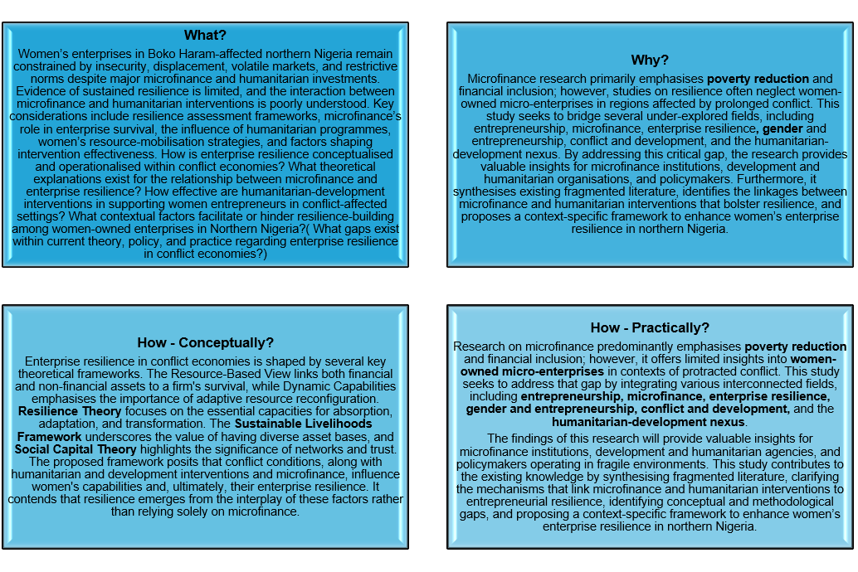

Figure 20: What, why, How, and How Quadrants: Source(s): Authors’ Work

The Four-Quadrant Blueprint Mapping

Quadrant 1: The Practical Problem. What is the broad, recurring real-world corporate industry pain point?  A persistent challenge in conflict-affected economies is sustaining women-owned enterprises. Insurgency disrupts access to finance, markets, supply chains, and institutional support, thereby undermining business resilience. Despite substantial investments in microfinance and humanitarian-development programs, stakeholders still lack definitive evidence regarding which interventions most effectively foster long-term recovery, continuity, and growth for these businesses. | Quadrant 2: The Specific Context. Where is this happening? (Bind by industry, sector, scale, or region)  This challenge is especially pronounced in the microfinance, development finance, and humanitarian sectors functioning in conflict-affected areas of Northern Nigeria, particularly in the Northeast states of Borno, Yobe, and Adamawa. It predominantly impacts women-owned micro and small enterprises, as well as humanitarian agencies, NGOs, microfinance institutions, and policymakers dedicated to fostering economic recovery and resilience in these regions.
Quadrant 3: The Theoretical Lens. What established academic theory or model will guide my analysis?  This analysis will be informed by three primary frameworks: Resilience Theory, the Sustainable Livelihoods Framework, and Social Capital Theory. These frameworks demonstrate how financial resources, social networks, and adaptive capabilities equip women entrepreneurs to endure, adapt to, and recover from economic shocks arising from conflict, while also preserving enterprise performance and fostering long-term resilience. | Quadrant 4: The Empirical Access. How will I secure permission to extract data or interview subjects?  This review is a critical literature review based on secondary data, eliminating the need for interviews or primary data collection. The information will be drawn from publicly available peer-reviewed journal articles, books, reports, and grey literature. Although the requirements for ethical approval are minimal, all sources will be appropriately cited, critically assessed, and utilised in accordance with copyright and academic integrity standards.

Figure 21: The Four-Quadrant Blueprint Mapping: Source(s): Authors’ Work

The master synthesis pitch

THE MASTER 4-SENTENCE SYNTHESIS PITCH: Combine my four quadrants above into a single, cohesive statement. This is the exact script I will read to my peers during Phase 2 (Executive) and Phase 3 (Academic) of the Crucible.

Women-owned businesses in Northern Nigeria's Boko Haram-affected communities encounter persistent challenges in accessing finance, markets, and maintaining business continuity. Despite significant investments in microfinance and humanitarian-development programs, there is limited evidence regarding which interventions most effectively promote long-term enterprise resilience. This critical literature review, informed by Resilience Theory, the Sustainable Livelihoods Framework, and Social Capital Theory, synthesises existing evidence to identify effective resilience-building strategies and highlight knowledge gaps. The insights generated from this review aim to support policymakers, development practitioners, and microfinance institutions in enhancing the sustainability of women's enterprises within conflict-affected economies.

Figure 22: The Master Synthesis Pitch: Source(s): Authors’ Work

1st elevator pitch before condensed
1st elevator pitch before condensed:
The sustainability of women-owned micro and small enterprises in conflict-affected economies presents a significant challenge, particularly in the Boko Haram-impacted states of Borno, Yobe, and Adamawa in Northern Nigeria. Ongoing insecurity disrupts access to finance, markets, supply chains, and institutional support, thereby undermining the resilience of these enterprises and restricting opportunities for long-term growth and recovery. Despite substantial investments in microfinance and humanitarian-development interventions, there remains insufficient evidence on the most effective approaches to strengthening the business resilience of women-owned enterprises operating in conflict zones.
This study addresses this challenge through a critical review of primary data and secondary literature sourced from peer-reviewed journals, policy reports, books, and grey literature. Grounded in Resilience Theory, the Sustainable Livelihoods Framework, and Social Capital Theory, the review investigates how financial capital, social networks, and adaptive capabilities contribute to enterprise resilience in contexts marked by chronic insecurity. By synthesising existing evidence on microfinance and humanitarian-development interventions, the study seeks to identify knowledge gaps and provide policymakers, development practitioners, microfinance institutions, and humanitarian organisations with valuable insights to enhance the resilience, continuity, and sustainability of women-owned enterprises in conflict-affected regions.

Add a nod to the practice and policy in the elevator pitch-

A pitch to consider
A pitch to consider:
Women‑owned micro and small enterprises in conflict‑affected Borno, Yobe, and Adamawa struggle to remain sustainable as Boko Haram–related insecurity disrupts finance, markets, supply chains, and institutional support. Despite major microfinance and humanitarian‑development investments, evidence on what truly builds enterprise resilience is limited.
This study critically reviews primary and secondary literature, using Resilience Theory, the Sustainable Livelihoods Framework, and Social Capital Theory to examine how financial capital, social networks, and adaptive capabilities support business continuity under chronic insecurity. It synthesises insights, identifies knowledge gaps, and offers evidence‑based guidance to policymakers, practitioners, microfinance institutions, and humanitarian actors to strengthen the resilience and sustainability of women‑owned enterprises in conflict‑affected economies.

Identifying relevant Articles Table
Title of Paper/article selected from the literature review  Date  Author  Journal and Web address | What was the key Research Question explored in the article? | What was the Nature of the data collected – method used | What were the Key Findings and Limitations of the article | How relevant is this research article to my research? Will my research contribute to this research in any way?
1  Impact of Boko Haram Insurgency on Bodija Market Traders  2024  By: Sogo Bamimore  SSRN:  https://papers.ssrn.com/sol3/papers.cfm?abstract_id=4894274 | What are the specific economic losses and disruptions experienced by traders in the Bodija market due to the Boko Haram insurgency in northern Nigeria? 2. What adaptive strategies do traders in the Bodija market employ to mitigate the effects of Boko Haram-related risks on their businesses and personal safety? 6 3. What are the specific government policies in the mitigation of the impact of the Boko Haram insurgency on traders? | Qualitative research employing thematic analysis | Bamimore’s study shows Boko Haram’s insurgency severely disrupted Bodija Market supply chains, increased transport risks, raised costs, and reduced traders’ profits. Insecurity along Northern trade routes caused delays, losses, and price volatility, leading to market instability. Traders faced significant operational uncertainty as sourcing goods from affected regions became harder and riskier. The study has several limitations. It focuses on traders in Bodija Market, limiting the generalisability of the findings to other populations and potentially failing to accurately reflect the experiences of traders in areas affected by Boko Haram. The cross-sectional design captures experiences at a single point in time, limiting insights into long-term resilience. Additionally, the qualitative analysis makes it difficult to establish causal relationships or measure impacts statistically. Finally, focusing on one market and conflict context prevents comparative evidence from being drawn across other markets facing similar insurgency challenges. | This study is relevant because it demonstrates how the Boko Haram insurgency has disrupted traders' livelihoods, supply chains, and economic activity, and identifies resilience strategies employed in conflict-affected markets. However, its contribution to my study is limited, as it does not focus on women entrepreneurs, microfinance, or humanitarian-development interventions. My research enhances this work by examining how microfinance strengthens the resilience of women-owned businesses in communities in Northern Nigeria affected by Boko Haram.
2  Building Back Bolder: Examining Women's Economic Empowerment and Adaptive Capacity in Insecure Regions of Borno State, Nigeria  2025  By: Amina Omar  Magaji Sule and  Jafaru Yakubu  ResearchGate:  https://www.researchgate.net/profile/Jafaru-Yakubu/publication/398370561_Building_Back_Bolder_Examining_Women's_Economic_Empowerment_and_Adaptive_Capacity_in_Insecure_Regions_of_Borno_State_Nigeria/links/6932d80c06a9ab54f8444d70/Building-Back-Bolder-Examining-Womens-Economic-Empowerment-and-Adaptive-Capacity-in-Insecure-Regions-of-Borno-State-Nigeria.pdf | women’s economic coping strategies (petty trading, cooperatives, informal savings, microcredit)  • their adaptive capacity in conflict‑affected environments  • the relationship between empowerment initiatives and resilience  • the role of community‑level support systems (faith‑based networks, NGOs, cooperatives) | Mixed-methods approach, the study  integrates quantitative data from 300 survey participants along with qualitative perspectives gathered  from interviews and focus group discussions (FGDs). | The study finds that women in insecure Borno communities rebuild livelihoods through petty trading, savings groups, cooperatives, and NGO support. Economic empowerment—credit, skills, and social networks—strengthens resilience, though mobility limits and gendered risks persist. Social capital is crucial, but sustained recovery requires targeted, protection‑integrated interventions. The study's insights were constrained by its small sample size, its focus on a specific locality, and its reliance on self-reported data, which may introduce bias. Insecurity in the region limited researchers' access to the most affected areas, further diminishing the representativeness of the findings. While the qualitative design offered valuable depth, it also limited generalisability and made it challenging to draw strong causal conclusions about women’s empowerment and adaptive capacity. | This article is particularly relevant as it investigates women's economic empowerment and adaptive capacity in regions of Borno State affected by Boko Haram. It effectively aligns with themes of resilience within conflict economies. The piece offers valuable contextual insights into the coping strategies women utilise, though it places less emphasis on specific mechanisms related to microfinance and entrepreneurship.
3  Female Entrepreneurship as a Catalyst for Inclusive Growth in Post-Conflict North-East Nigeria  2025  By: Umar Bobboi and Nafisa Jibrin Sule  Journal of Business Dev. and Management Res. (JBDMR):  https://africanscholarpub.com/ajbdmr/article/view/1009/987 | Female entrepreneurship is conceptualised as a significant driver of inclusive economic growth in the post-conflict context of North-East Nigeria. This article examines the role of women-led enterprises in facilitating economic recovery, generating employment opportunities, and fostering community development. It investigates the hypothesis that empowering female entrepreneurs may not only expedite the reconstruction process following conflict but also broaden participation in regional economic development. | The study employed primary quantitative data collected through structured questionnaires completed by female entrepreneurs in post-conflict North-East Nigeria. Utilising a survey design that incorporated descriptive statistics and regression analysis, the research examined the role of women-led enterprises in fostering inclusive growth. This methodology enabled an assessment of business performance, the challenges encountered, and the contributions to local economic recovery. | Female entrepreneurship is vital for fostering inclusive growth in post-conflict North-East Nigeria, as it generates income, creates jobs, and aids in community recovery. Women-led enterprises not only enhance household welfare but also stimulate local economic activity, despite challenges such as financing constraints, insecurity, and inadequate infrastructure. Empowering female entrepreneurs is essential for reconstruction and broader development efforts. However, the study is limited by factors such as a small, localised sample, reliance on self-reported data, restricted access to highly insecure areas, and a quantitative design that constrains a more in-depth exploration of the cultural and contextual influences on the impact of women's entrepreneurship. | This paper is extremely pertinent, as it explores female entrepreneurship in post-conflict North-East Nigeria and directly addresses women's entrepreneurship and resilience in communities impacted by Boko Haram. It makes a valuable contribution to my research by providing insights into women-led economic recovery and inclusive growth, though it gives less emphasis to microfinance as a means of fostering resilience.
4  Women Entrepreneurship, Financial Inclusion, and Intergenerational Wealth Creation in Monguno, Nigeria (SDG 5 and SDG 10)  2026  By: Baba Alhaji Bello  SSRN:  https://papers.ssrn.com/sol3/papers.cfm?abstract_id=6706718 | How do women’s entrepreneurship and financial inclusion contribute to intergenerational wealth creation in Monguno, Nigeria, and in what ways do these processes advance Sustainable Development Goals (SDG) 5 (gender equality) and SDG 10 (reduced inequalities)? | The research utilised primary data gathered through structured questionnaires and interviews with women entrepreneurs in Monguno. Employing a mixed-methods approach, it combined quantitative survey analysis with qualitative insights to investigate how financial inclusion, savings practices, and business activities foster intergenerational wealth creation and support the advancement of SDGs 5 and 10 in a conflict-affected context. | Women’s entrepreneurship and financial inclusion in Monguno significantly contribute to intergenerational wealth creation by enhancing business stability, household welfare, and children's education through initiatives such as savings groups, access to credit, and digital finance. Despite challenges such as insecurity and limited capital, women actively work to reduce gender and income inequalities, thereby advancing Sustainable Development Goals (SDGs) 5 and 10. However, the findings of this study are limited by a small, locality-specific sample, potential biases in self-reported data, restricted access to highly insecure areas, and a cross-sectional design that hinders analysis of long-term wealth-creation pathways. | This research is extremely pertinent as it delves into women’s entrepreneurship and financial inclusion in Monguno, a region in Northern Nigeria affected by Boko Haram. It closely aligns with themes of microfinance, resilience, and economic recovery in conflict-impacted economies. By providing evidence that financial inclusion fosters women’s economic empowerment and facilitates long-term wealth creation, the article makes a significant contribution to my research. However, my study expands upon this by specifically examining the mechanisms of business resilience within entrepreneurial environments shaped by conflict.
5  Entrepreneurial Finance, Microcredit, And Sustainable Wealth Creation Among Rural Households in Monguno, Nigeria  2026  By: Isa Garba  SSRN:  https://papers.ssrn.com/sol3/papers.cfm?abstract_id=6710558 | This research paper contends that entrepreneurial finance and microcredit are essential for fostering sustainable wealth creation among rural households in Monguno. It investigates how access to microcredit, along with effective savings mechanisms and financial services, enhances household economic stability, promotes asset accumulation, and supports long-term improvements in livelihoods within a resource-poor, conflict-affected rural context. | The study utilised primary data collected through structured questionnaires and interviews with rural households in Monguno. It employed a mixed-methods design, combining quantitative survey analysis with qualitative narratives. This approach aimed to evaluate the effects of entrepreneurial finance and microcredit on household income, asset accumulation, and long-term wealth creation within a rural economy impacted by conflict. | Entrepreneurial finance and microcredit improved income, asset accumulation, and long‑term wealth creation for rural households in Monguno by expanding business activities and strengthening economic resilience. Yet insecurity, high repayment pressures, and low financial literacy limited overall impact. The study’s evidence is constrained by a small, rural sample, self‑reported data prone to bias, restricted access to highly insecure areas, and a cross‑sectional design that prevents causal inference and limits understanding of long‑term microcredit and wealth‑creation dynamics. | This article is relevant because it explores entrepreneurial finance and microcredit in Monguno, a conflict-affected area in Northern Nigeria, aligning with themes of microfinance and economic resilience. It contributes to my research by providing insights into how microcredit supports sustainable wealth creation among vulnerable households. However, it contributes indirectly, focusing more broadly on rural households rather than specifically on women entrepreneurs and business resilience in Boko Haram-affected communities.
6  Faith-Based Resources and Durable Solutions: Islamic Social Finance and the Protection of Internally Displaced Women and Children in Borno State, Nigeria  2026  By: Zara Muhammad Jajere  Multidisciplinary Research and Development Journal International:  https://mdrdji.org/index.php/mdj/article/view/262/212 | In what ways can faith-based resources, specifically Islamic social finance, offer sustainable solutions that bolster the protection, welfare, and long-term resilience of internally displaced women and children in Borno State? | The study employed primary qualitative data obtained through interviews, focus group discussions, and field observations involving internally displaced women, children, and faith-based organisations in Borno State. With a qualitative, exploratory design, the research examined how Islamic social finance mechanisms and faith-based resources enhance the protection, welfare, and sustainable solutions for internally displaced women and children in a conflict-affected setting. | Islamic social finance and faith-based support through mechanisms such as zakat, waqf, and community networks have significantly enhanced the protection, welfare, and resilience of internally displaced women and children. This assistance has improved their access to basic necessities, fostered psychosocial stability, and created livelihood opportunities. However, challenges such as limited funding and ongoing insecurity have hindered the implementation of sustainable solutions. Moreover, the study's findings are restricted by a small, locality-specific sample, a reliance on self-reported narratives that may be biased, researchers' limited access to highly insecure areas, and a qualitative design that does not facilitate causal inference or long-term impact assessment. | This article is of moderate relevance as it investigates Islamic social finance and support mechanisms for internally displaced women and children in Borno State, which has been impacted by Boko Haram. It closely aligns with themes of conflict economies and resilience. Although it indirectly informs my research by emphasising faith-based financial protection systems and sustainable livelihood solutions, my study delves deeper by specifically addressing women's entrepreneurship, microfinance, and business resilience in conflict-affected communities in Northern Nigeria.
8  Poverty Reduction Strategies for Sustainable Economic Growth: Implications for Women's Empowerment in Nigeria  2026  By: Tolulope Yamah  Advances in Law, Pedagogy, and Multidisciplinary Humanities:  https://jurnal.fs.umi.ac.id/index.php/alpamet/article/view/1073/719 | This study examines the influence of cultural norms on the empowerment of Indigenous women entrepreneurs in Nigeria and how these dynamics contribute to poverty-reduction strategies for sustainable economic growth. It investigates the impact of traditional beliefs, gender-based expectations, and community practices on women's access to resources, entrepreneurial engagement, and decision-making authority. Furthermore, the study seeks to identify policy or structural frameworks that can effectively enhance women's empowerment within culturally rooted contexts. | The study employed qualitative data collected through interviews, focus group discussions, and document analysis involving Indigenous women entrepreneurs and community stakeholders. By adopting an exploratory qualitative design, the research enabled a thematic analysis of how cultural norms, gender expectations, and poverty-reduction strategies intersect to influence women's empowerment. This methodology contributed to the development of a sustainable framework that links cultural context, entrepreneurship, and economic growth. | Cultural norms play a crucial role in shaping the entrepreneurial empowerment of Indigenous women in Nigeria. Factors such as patriarchal expectations, restricted mobility, and unequal access to resources hinder business growth. However, support from kinship networks, evolving attitudes, and targeted poverty-reduction strategies can pave the way for empowerment. To achieve sustainable growth, it is vital to implement policies that are culturally informed and gender inclusive. However, the study's reliance on conceptual frameworks and secondary data limits its empirical validation. It fails to account for regional and community-specific nuances and does not test causal mechanisms. Furthermore, its national focus diminishes the generalizability of its findings, and the absence of primary data restricts a thorough understanding of context-specific dynamics of empowerment. | This article is moderately relevant because it addresses poverty reduction and women’s empowerment in Nigeria, aligning with the broader themes of women’s entrepreneurship and economic resilience in my research. It contributes indirectly by offering valuable insights into empowerment strategies and sustainable economic growth. However, it does not specifically focus on microfinance, conflict economies, or communities affected by Boko Haram. My study contributes to this discussion by examining how microfinance supports the business resilience of women entrepreneurs in conflict-affected Northern Nigeria.
9  Exploratory Study of Interventions and Challenges Faced By Indigenous NGOs Supporting Start-Up Businesses (Established By Young Entrepreneurs) In Nigeria's Niger-Delta Region  By: Ejejigbe, Mackson Sheyi.  ProQuest:  https://www.proquest.com/openview/c24031669818c0560e63e87e9667a2b3/1?pq-origsite=gscholar&cbl=2026366&diss=y | This study explores the role of Indigenous NGOs in the Niger Delta in supporting startup businesses established by young entrepreneurs, while also considering the challenges that influence the effectiveness of these initiatives. It examines how NGO-led training, funding, mentorship, and capacity-building efforts contribute to youth enterprise development. Additionally, the study identifies the structural, financial, and socio-political barriers that hinder this impact, with the goal of uncovering strategies to reinforce sustainable entrepreneurship support systems within the region. | The study employed qualitative data obtained through semi-structured interviews, focus group discussions, and document reviews involving personnel from Indigenous NGOs, young entrepreneurs, and community stakeholders in the Niger Delta. An exploratory qualitative design enabled a thematic analysis of NGO interventions, support mechanisms, and operational challenges. This analysis provided valuable insights into how capacity-building initiatives, funding, and mentorship programs impact the development of youth startups in the region. | The study revealed that Indigenous NGOs play a critical role in supporting youth start-ups in the Niger Delta by offering training, mentorship, funding, and business development services. However, their impact is hampered by limited resources, political interference, insecurity, and weak institutional capacity. Despite these challenges, NGO interventions have significantly enhanced the entrepreneurial skills and confidence of young individuals, underscoring the need for more robust, well-resourced support systems for emerging entrepreneurs. | This article holds moderate relevance as it examines NGO interventions and the challenges faced by start-up businesses in a conflict-sensitive region of Nigeria. It aligns with themes of entrepreneurship support and resilience, indirectly contributing to your research by highlighting the institutional and developmental barriers that entrepreneurs encounter. However, it diverges from your study by focusing specifically on the Niger-Delta region, youth entrepreneurs, and NGO support, rather than on women entrepreneurs, microfinance, and the resilience of businesses in Northern Nigeria affected by Boko Haram.
10  Exploring the Strategies for Building Resilience to Poverty in Bauchi State, Nigeria  By: Umar Farouk Musa  Ibrahim Suleiman  Journal of International Studies:  https://e-journal.uum.edu.my/index.php/jis/en/article/view/jis2020.16.9/2766 | This study explores effective strategies for building household resilience to poverty in Bauchi State, with an emphasis on their interactions with local socio-economic realities. It examines how livelihood diversification, social support systems, skills acquisition, and community-based initiatives contribute to poverty alleviation. Furthermore, it investigates the contextual factors that either facilitate or impede households’ capacity to endure economic shocks and achieve sustainable, long-term resilience. | The study employed quantitative data collected via structured questionnaires distributed to households in selected communities throughout Bauchi State. A survey research design enabled statistical analysis of factors such as livelihood strategies, income sources, coping mechanisms, and access to social support. Both descriptive and inferential techniques were utilised to evaluate how these factors contribute to fostering resilience to poverty within the local socio-economic context. | The study reveals that households in Bauchi State cultivate resilience against poverty through various strategies, including diversifying their livelihoods, acquiring new skills, leveraging social networks, and benefiting from community-based support systems. Access to credit, participation in cooperative groups, and the availability of informal safety nets further enhance their coping ability. However, challenges such as low-income levels, limited government support, and susceptibility to economic shocks impede long-term resilience. The authors highlight the importance of strengthening local strategies to achieve sustainable poverty reduction. | This article is moderately relevant because it investigates resilience-building strategies against poverty in Bauchi State, Northern Nigeria, aligning with themes of resilience and socio-economic survival in vulnerable environments. It contributes indirectly to my research by offering insights into adaptive coping and livelihood sustainability. However, it does not specifically address women’s entrepreneurship, microfinance, or Boko Haram-related conflict economies. My study advances this area by focusing on women entrepreneurs and the role of microfinance in strengthening business resilience within conflict-affected communities.
Taraba International Journal of Social Sciences Research:  https://oer.tsuniversity.edu.ng/index.php/tijossr/article/view/1468 | This study examines the impact of insecurity on the socioeconomic development of women employed in the informal sector of Taraba State. It analyses how factors such as violence, fear, mobility restrictions, and disruptions in market activities affect women’s income generation, business stability, and overall well-being. Furthermore, it examines the structural, security, and policy conditions necessary to safeguard women's livelihoods and facilitate sustainable socioeconomic participation amid persistent insecurity. | The study employed quantitative data collected through structured questionnaires distributed to women engaged in the informal sector across various regions of Taraba State. A survey research design enabled statistical analysis of the effects of insecurity on women’s income, business operations, mobility, and overall well-being. Descriptive techniques were utilised to investigate the relationship between insecurity and the socioeconomic development of women within the informal economy. | The study revealed that insecurity considerably undermines the socioeconomic development of women in the informal sector of Taraba State. Persistent violence, fear, and mobility restrictions disrupt their trading activities, diminish income, and elevate vulnerability. Women encounter increased operational costs, market instability, and psychological stress. Despite their resilience, the prevailing insecurity restricts business growth and economic participation. This underscores the urgent need for stronger security measures to safeguard women's livelihoods. | This article is highly relevant, as it examines the effects of insecurity on women’s socioeconomic activities in Nigeria’s informal sector, aligning closely with themes of resilience and survival in unstable environments. It offers valuable insights into the economic vulnerabilities and adaptive responses of women facing insecurity. However, its contribution to my research is indirect, as it does not specifically address microfinance, entrepreneurship development, or the experiences of communities affected by Boko Haram. My study expands on this discussion by focusing on the resilience of women entrepreneurs in conflict-affected economies.
The Role of Microfinance in Economic Development: A Critical Review of Impact and Effectiveness  By: Chandrakant Jalhare  2025  International Journal of Innovations In Science, Engineering, and Management  https://ijisem.com/journal/index.php/ijisem/article/view/231/207 | Microfinance research prioritises poverty reduction and financial inclusion, while resilience studies overlook women‑owned micro‑enterprises in conflict. This study integrates entrepreneurship, microfinance, resilience, gender, conflict, and humanitarian‑development research to inform practitioners and policymakers. It contributes by synthesising fragmented literature, identifying resilience mechanisms, exposing research gaps, and proposing a framework for women’s enterprise resilience in northern Nigeria. | The study employed primary survey data gathered from market traders through structured questionnaires and face-to-face interviews. A cross-sectional research design was used to capture traders' experiences at a specific point in time. The data focused on aspects such as insecurity, economic losses, coping strategies, and perceptions of government responses. Descriptive statistics were then applied to analyse the data and identify patterns regarding the impact of Boko Haram on traders in Bodija Market. | The study revealed that the Boko Haram insurgency significantly disrupted trading activities, reduced customer turnout, increased operating costs, and resulted in income losses for traders at Bodija Market. In response to these challenges, traders adopted informal coping strategies, such as diversifying their suppliers and reducing inventory levels. However, the study has several limitations, including its focus on a single market, a small sample size, reliance on self-reported perceptions, and a cross-sectional design that does not capture long-term resilience or adaptation. | The Bodija Market study is pertinent because it illustrates how insecurity linked to Boko Haram disrupts trade, reduces income, and compels individuals to adopt informal coping strategies. These issues are essential for understanding conflict economies. However, the study does not address microfinance, women entrepreneurs, or humanitarian and development interventions. My research builds on this work by examining how microfinance and external support influence the resilience of women’s enterprises in northern Nigeria. This approach offers a gender-focused, intervention-oriented, and theoretically integrated contribution that goes beyond the article’s descriptive analysis of market impacts.
The Impact of Boko Haram Terrorism on Socio-Economic  Conditions in Northeastern Nigeria  By: Samira Ibrahim  2025  https://www.proquest.com/openview/fa219eb1eea7653b6e8a7832ef7d26d1/1?pq-origsite=gscholar&cbl=18750&diss=y | How has Boko Haram’s terrorism affected socio‑economic conditions in Northeastern Nigeria, particularly in terms of livelihoods, poverty, displacement, infrastructure, and overall regional development? | The study employed a mixed-methods approach, integrating qualitative and quantitative data sources, including surveys, interviews, and secondary socio-economic statistics from Northeastern Nigeria. This methodological framework facilitated a comprehensive exploration of households’ experiences, economic losses, and the ramifications of displacement, as well as the broader community-level impacts resulting from the terrorism perpetrated by Boko Haram, an extremist group notorious for inflicting significant harm and violating human rights. | The key findings reveal that Boko Haram has led to substantial livelihood losses, widespread displacement, destruction of infrastructure, and heightened poverty in Northeastern Nigeria. Nonetheless, the study is limited by several factors, including data constraints arising from insecurity, restricted access to affected communities, reliance on secondary sources, and challenges in acquiring reliable, representative socio-economic information. | This article is particularly relevant because it explores how Boko Haram impacts socio-economic conditions, which closely aligns with your focus on livelihoods, resilience, and economic participation. My research further enriches this discourse by introducing an intersectional, business-focused, and mechanism-driven analysis that is not covered in the study, thereby strengthening the evidence surrounding economic recovery and vulnerability.
Impact Of Boko Haram Insurgency on Migrants’  Poverty Level in Southern Borno, Nigeria: A  Study of Some Selected Local Government Areas  By: Istifinus Tijjani, Godwin Boniface, Aliyu Alhaji Jibrilla, Adamu Yahya,  2025  file:///C:/Users/Student/Downloads/V10-I4-014-IMPACT+OF+BOKO+HARAM+INSURGENCY+ON+MIGRANTS%E2%80%99+POVERTY+LEVEL+IN+SOUTHERN+BORNO+NIGERIA+A+STUDY+OF+SOME+SELE.pdf | The study asked how Boko Haram’s insurgency has affected migrants’ poverty levels in Southern Borno, examining whether displacement, insecurity, and disrupted livelihoods significantly worsen economic conditions across selected local government areas. | The study utilised a combination of surveys and structured interviews conducted with migrants in selected Local Government Areas (LGAs) of Southern Borno. Descriptive statistics were employed to analyse the impact of Boko Haram-related displacement and insecurity on poverty levels within the affected population. | The study's key findings reveal that Boko Haram has significantly exacerbated poverty among migrants by causing displacement, disrupting livelihoods, and limiting access to income and essential services. However, the study does have certain limitations: insecurity hindered data access, the sample sizes were small, and the reliance on self-reported and localised data affects the generalisability of the results. | This study is significant as it establishes a connection between insurgency, displacement, and poverty, three critical drivers of economic vulnerability. My research enriches this discussion by examining business engagement, various intersectional factors, and resilience strategies, providing a nuanced and practical understanding of how young Black men navigate economic challenges in insecure or exclusionary environments.

Figure 23: Identifying relevant Articles Table: Source(s): Authors’ Work

