Interview Structure

Q.1) Is task-chunking something you regularly integrate into your lessons?

Q2.) Do you believe task-chunking is an important part of learners' development and progress?

Q3.) What teaching strategies have you integrated into your lessons to ensure learner retention?

Q4.) What strategies do you use to assess learner retention throughout your lessons?

Formal Observation Schedule

Learner A |  | LOs Achieved
Topic A | LO 1 | LO 2 | LO 3 | LO 4 | LO 5
Topic B | LO 1 | LO 2 | LO 3 | LO 4 | LO 5
Learner B |  | LOs Achieved
Topic A | LO 1 | LO 2 | LO 3 | LO 4 | LO 5
Topic B | LO 1 | LO 2 | LO 3 | LO 4 | LO 5
Learner C |  | LOs Achieved
Topic A | LO 1 | LO 2 | LO 3 | LO 4 | LO 5
Topic B | LO 1 | LO 2 | LO 3 | LO 4 | LO 5
Learner D |  | LOs Achieved
Topic A | LO 1 | LO 2 | LO 3 | LO 4 | LO 5
Topic B | LO 1 | LO 2 | LO 3 | LO 4 | LO 5
Learner E |  | LOs Achieved
Topic A | LO 1 | LO 2 | LO 3 | LO 4 | LO 5
Topic B | LO 1 | LO 2 | LO 3 | LO 4 | LO 5
Learner F |  | LOs Achieved
Topic A | LO 1 | LO 2 | LO 3 | LO 4 | LO 5
Topic B | LO 1 | LO 2 | LO 3 | LO 4 | LO 5

Questionnaire
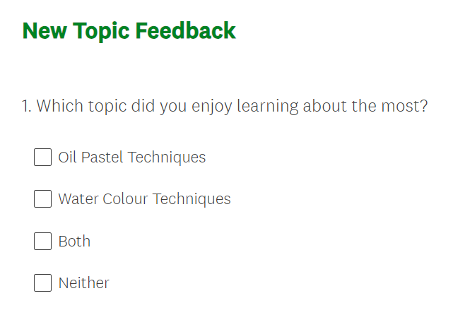

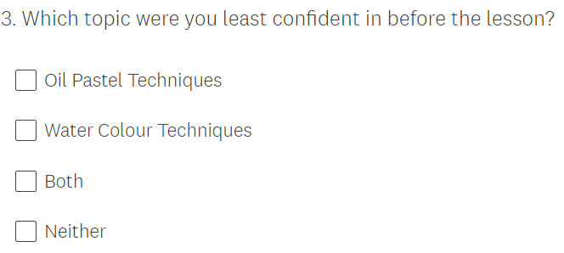
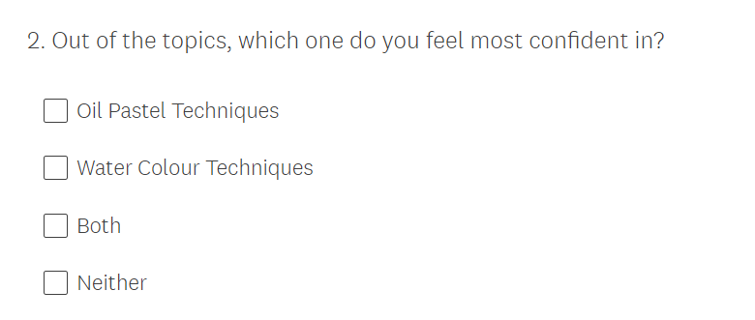

(Screen Caps of online survey)

Ethics Form

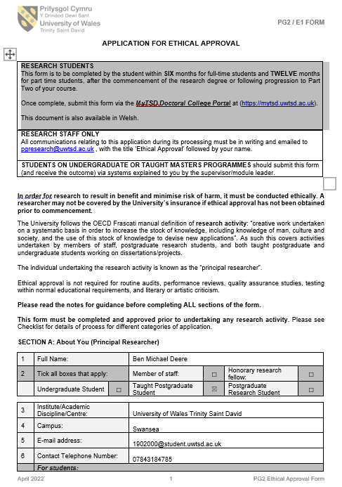
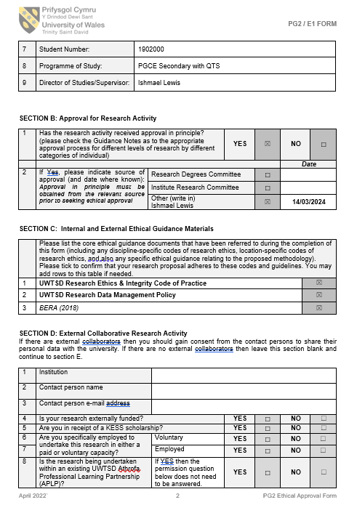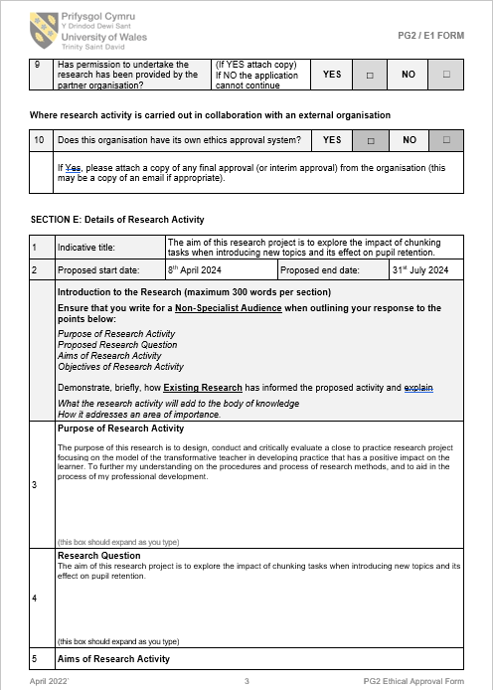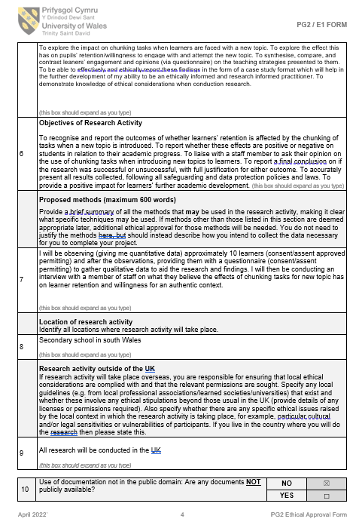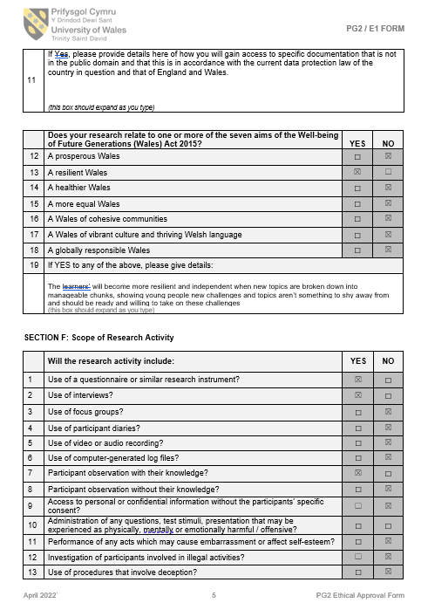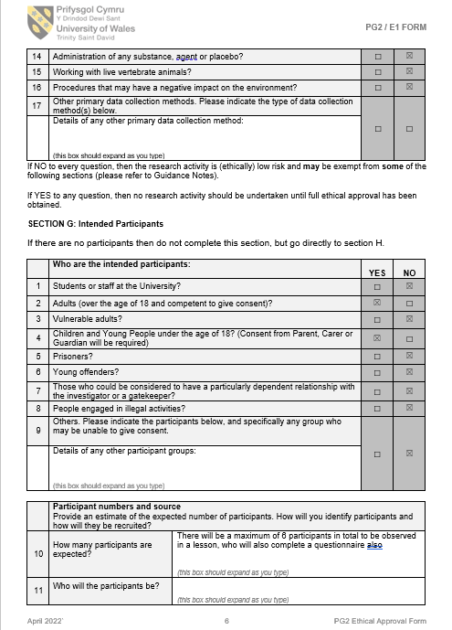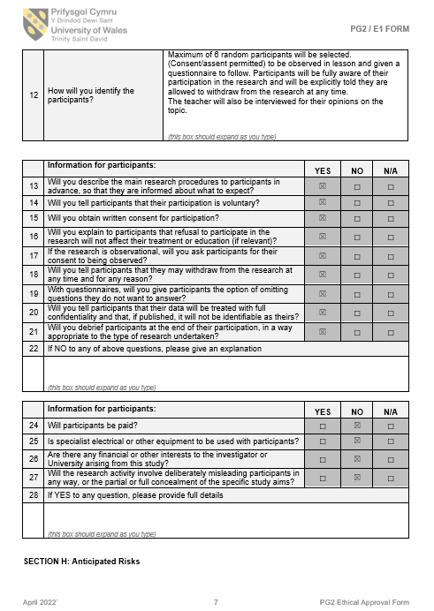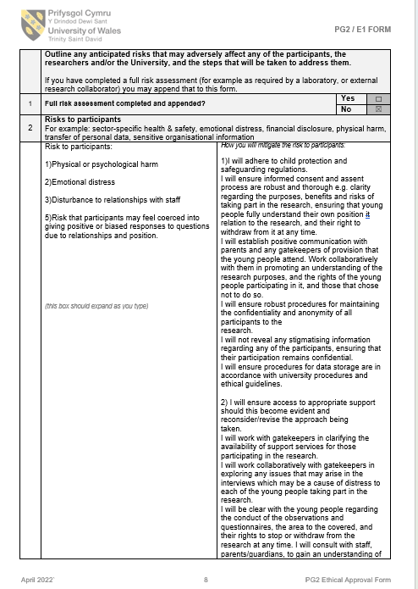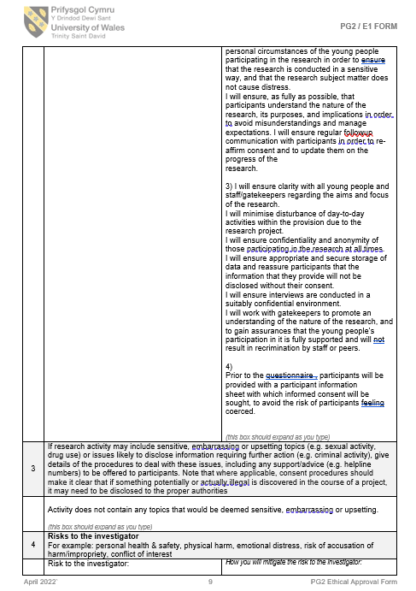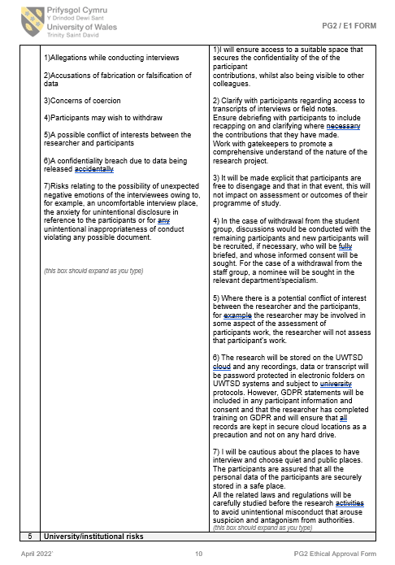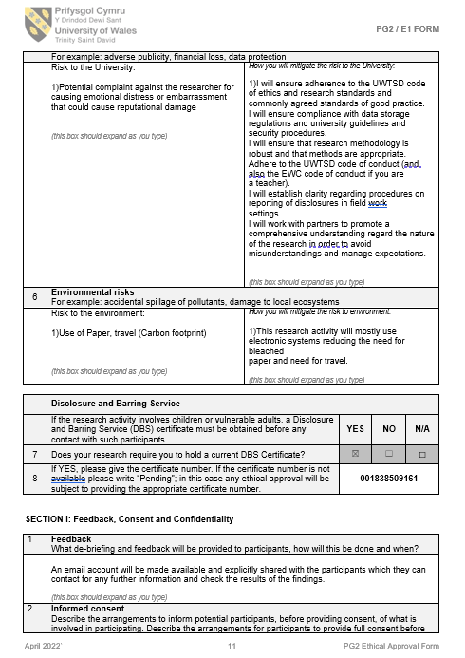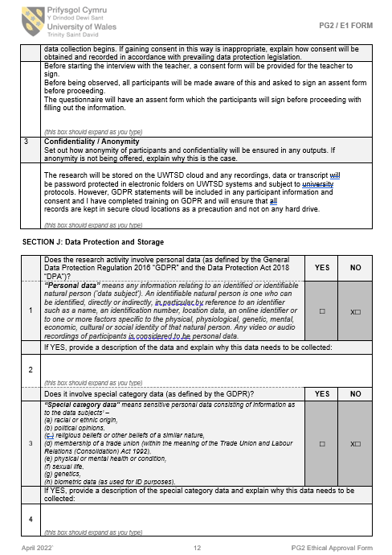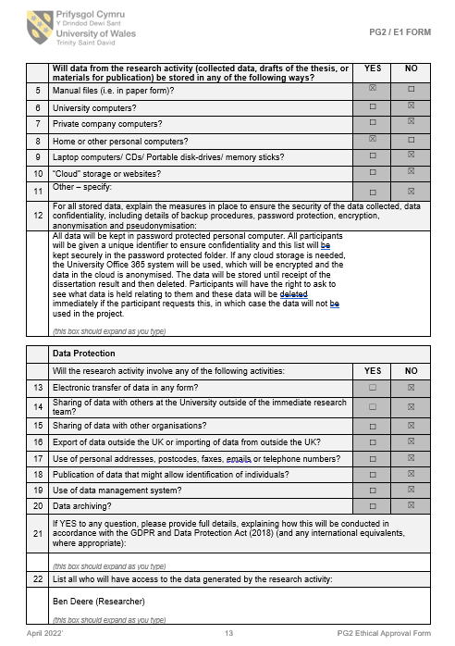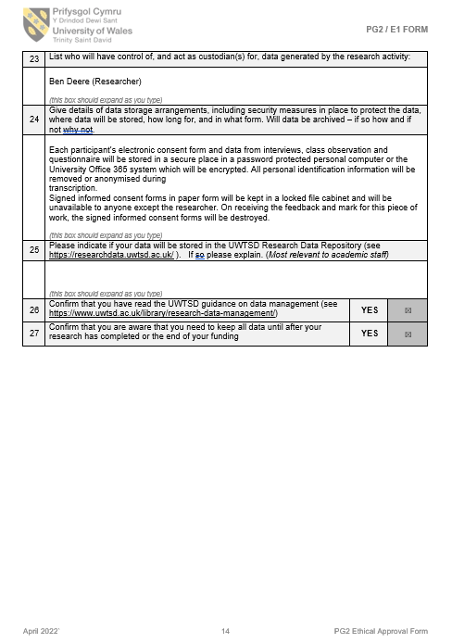

Parental Consent and Assent Forms

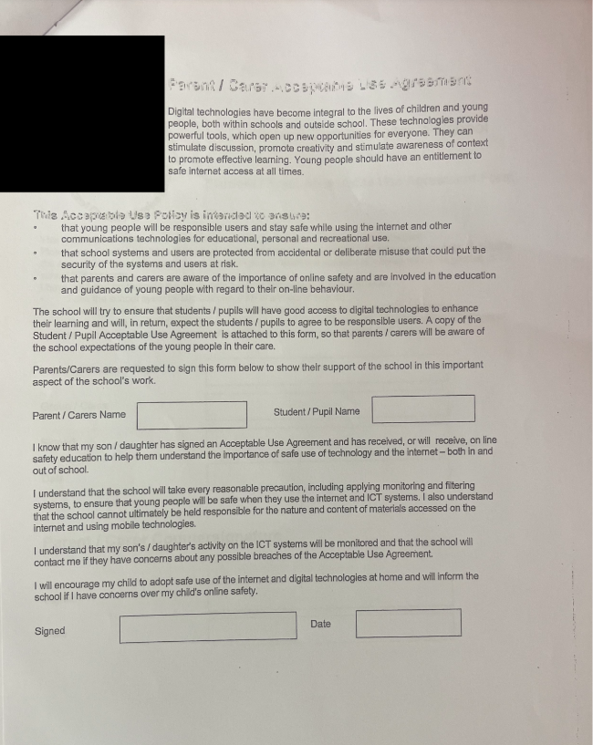

(This is the School’s parental consent form which is used for all consent involving learner data collection etc.)


