
Development workplace critical thinking Shabilah Hussain 1806501
BMSW5001

[Date]
University of Wales Trinity Saint David

Executive Summary

This report analyses how beliefs, attitudes and values influence on workplace behaviour. The main body commences with identifying values attitudes and beliefs ,management practises of Tesco plc, and how those practises impact on organisational success, employee’s behaviour and stakeholder’s satisfaction. To implement critical evaluation researcher used Pearson’s R.E.D. Model, the one of critical thinking models.

Table of Contents
Executive Summary 1
Introduction 2
Main Findings 4
Conclusion (average of 10% of word count) 5
Bibliography 6
UPDATE TABLE FREQUENTLY – CHECK IT HAS BEEN UPDATED PRIOR TO SUBMISSION

Introduction
This report summarises and identifies key points of values and beliefs and attitudes for an organisation and Tesco and how values, beliefs and attitudes impact on their work environment the report will analyse management theories and critically assess and beliefs, attitudes and values of its employees. Tesco was founded by Jack Cohen. Cohen was a British businessman and entrepreneur and had opened his first store in London 1929. Tesco plc is recognised grocery and general product retail chain. At present, it is largest supermarket. Tesco has the highest private sector of employer in the United Kingdom (Tesco, annual report,2009) in 2009 it had over 320,000 employees over the world. Tesco expanded internationally across Asia and European countries.

Main Findings

Values, attitude and beliefs impacts workplace behaviour
Values, attitudes and beliefs are important to organisation performance and to employees. This can improve individual behaviour and can contribute to business success. Tesco will set values so the employers can contribute to. The organisation will have an idea, a vision to how they would like to improve the business and set goals to how will they achieve this in certain time frame. Values are those things we hold dearly and usually take the form of principles or beliefs that guide the action. Values will drive them towards a vision. Value are strong influence on behaviours. Employers and employees will need to establish “what is important” and what can motivate them. These are all questions that shape a vision some organisations look at simplistic approach “mission statement” however there is no real connection and does not influence people. Values are essential part of leadership they are also key part of what motivates people. If staff are not committed to a set of particular value there will be no drive forward, no direction and no effective teamwork, whereas if they do have a set of value the staff will be more efficient team and better productive working environment.

Fig 1 The diagram below illustrates Personal beliefs, values, attitudes and behaviour

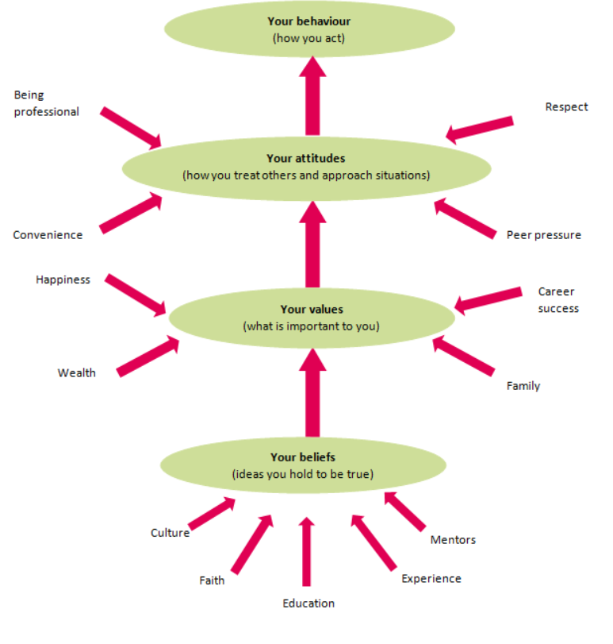
Fig 1 beliefs are individual in an organisation for e.g. Tesco have their own belief which they hold to be true because they have been told is true by people who they trust. A person can base a belief upon certainties e.g. faith, education, experience and culture once someone accepts belief, they will defend it. Values are long lasting “what is important” to a person, they become standard by which people order their lives and make their choices. A belief will develop into a value when commitment grows and when make their choices, values can relate to happiness, wealth success or family. Attitude are how an individual feel and act upon a current situation before making a decision that results in behaviour.
A lack of self-awareness can lead to negative behaviour and result in not achieving a goal.

Fig 2 Pearson R.E.D model critically analysing, Tesco core values and Management theories

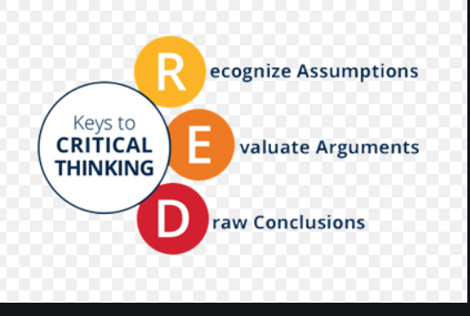

The model critically analysing statements that are implied to be true and evaluate arguments and to draw a conclusion follow from the available evidence.
Tesco started off selling food, since then have expanded selling clothing, electronics, finance services etc. Tesco UK stores have expanded stores which are extra, superstore, metro and express to meet customer needs. Tesco make sure they employee staff who are motivated, flexible and well trained and have knowledge of customer needs. Tesco employees’ range of roles from customer assistant to department manager and warehouse. Tesco values understanding people, customers and colleague and to continue growth
Vroom expectancy theory Fig 3 related to how a person perceives the relationship between three things effort, performance and rewards vroom focus on these three factors:

Vrooms expectancy theory fig 3
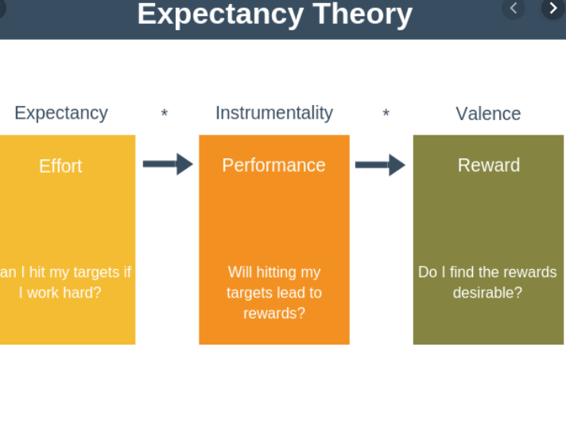
Expectancy -individuals perception or belief act will produce a particular outcome.
Instrumentality- the extent to which the individual perceives that effective performance will lead to desired rewards
Valence-the strength of the belief that attracts rewards that are potentially available
This concept is for human motivation. Vroom states these are the first steps an individual take for performance and rewards. If staff at Tesco feel valued, the factors include:
- Appreciation of hard work e.g. incentives
- A sense of achievement
- Empowerment
- Opportunity for development
Tesco have variety of employees who will work hard to meet business needs so that they can reduce cost in labour therefore create a better impact on consumers, supported employees are more likely to focus better and are less likely to make errors, cause problems in the workplace. This shows they are loyal and have fewer absentees. Organisation without values and beliefs will negatively impact workplace and how professionally they carry out work
Tesco focus on their staff and customers to achieve skilled staff workers, relationship among employee’s job security, personal development and high productivity. They offer rewards to employee’s staff discount, flexible working and gym member ship.
The behaviour of someone from hunger, desire which leads to an outcome of satisfaction in a job role. Those in managerial and supervisory need to be aware how to support employees. If employees are hardworking and reliable, they are more likely to be treated with respect and trust. Abraham Maslow hierarchy of need is one of the most popular models, the model shows how people are motivated, and they can achieve a better quality of life, Maslow hierarchy theory was published in 1954, the need to how to encourage people. Fig 4,

Fig 4 Maslow’s theory

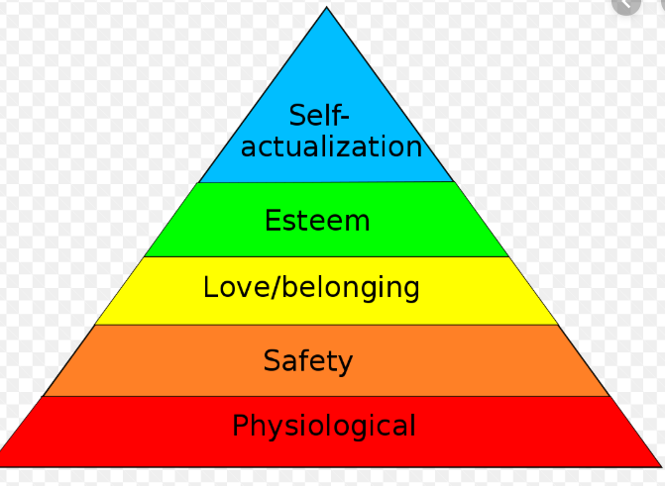

The requirements are as follows:
Physiological needs – needs for food and sleep etc
Safety needs -a stable environment
Love needs – affectionate relations with others and group
Esteem needs -self-respect and esteem for others
Self-actualisation needs- the requirements for self-fulfilment
Maslow theory suggest, starting with the basic physiological need and then progressing up the hierarchy until a group needs are satisfied. Maslow theory provides a useful early framework about a variety of needs, and people may experience at work and ways in which employers could meet their needs. On the other hand, the theory is not always in order. Alderfer (1972) argued that the individual needs, as being on a continuum, rather than hierarchy. He suggested that people were more likely to move up and down at different levels. He indicated that there were only three significant factors in life, the basis of life social and interpersonal need and personal development needs. Drucker(1974)stated that Maslow had not said if an individual was satisfied at what stage. McGregor fig 5 theory x and theory y have made a high impact on managerial work in the workplace. The model supports managerial style. The theory explains if the people are seen liking a job role, they are committed and can affect a person in a job role. The two approaches are closely related to Maslow higher level of needs and self-actualisation.

Fig 5 McGregor theory X and Y
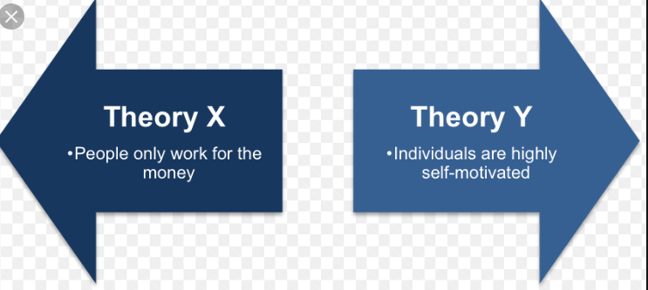

Tesco focus on their staff and customers to achieve skilled staff workers, relationship among employee’s job security, personal development and high productivity. They offer rewards to employee’s staff discount, flexible working and gym member ship.
Taylor scientific management theory states “one that is motivated works purely for money”. Tesco has similar link to Taylors theory they currently have a reward programme which offers employees financial reward packaging. Tesco go beyond Taylor’s theory the supporting different lifestyles, pay increasing and improve training and development for staff. Tesco create a good working environment they want their staff feel valued, this increases communication with staff Tesco will ask for feedback from staff which helps them to develop their understanding skill and job satisfaction.by using surveys this will capture how they feel in the job role and what improvement to consider, on the other hand in some other organisation such as smaller business e.g. Sports direct will not have this process for e.g. local shops and small warehouses. Survey can help build a good working environment.
Tesco also offers employers lifestyle breaks they can take 4-12 week off, career breaks which allows 6 months to 5 years away and have the right to return, they also offer a good pension scheme this show that they offer good benefits to employees.
Using two factor Herzberg theory fig 6 which outlines the two factors hygiene and the satisfiers. hygiene factors are put in place to avoid negativity in a workplace. This makes staff feel that they are been cared for if these factors are thought to be unsatisfactory by the employees then this would mean they are dissatisfied in working there. Following values and beliefs allow people to grow and creates job satisfaction Herzberg states that truly motivate an individual employee an organisation needs to create conditions that make them feel worth and to work in a workplace.

Fig 6 Herzberg Two factor Theory
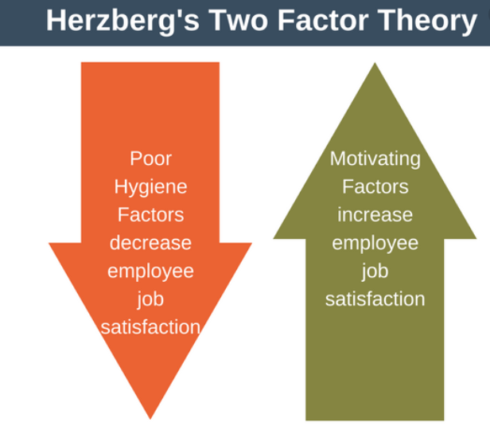
For example, hygiene factors for Tesco employee can be dissatisfied if the wage has not been increased. however, promotion activities in Tesco will allow employees to move up in the business not staying in one department the hygiene factors:
- Pay and benefits
- Company policy and administration
- Relationship with co workers
- Job security
- Working condition
- Personal life
Tesco will persuade employees to feel valued with appropriately timed communication, involving in decision making in key areas of working life. Tesco staff can even influence what goes out on the shop floor for food. Tesco value each other and everyone so that the business grows and has a good reputation.
For example, hygiene factors for Tesco employee can be dissatisfied if the wage has not been increased. however, promotion activities in Tesco will allow employees to move up in the business not staying in one department the hygiene factors:
- Pay and benefits
- Company policy and administration
- Relationship with co workers
- Job security
- Working condition
- Personal life
Tesco will persuade employees to feel valued with appropriately timed communication, involving in decision making in key areas of working life. Tesco staff can even influence what goes out on the shop floor for food. Tesco value each other and everyone so that the business grows and has a good reputation.
Employers and line mangers need to have understanding of these theories so that they need to know how to value employees working below so that the organisation can achieve better results if they do not follow good management this can de motivate and will impact on trusting the organisation and will reduce efficiency.
Managers can see and understand what employers are working toward such as goals and beliefs so that the company goes in the right direction it will show which employee is committed in doing well and would look at the pros and cons which concept is best for them looking at various theories in order to understand and to be proud of the organisation performance. This allows managers to communicate with employees to gain knowledge so that workers can produce high level of quality. Communication is essential in an organisation with out communication this will reflect badly on the organisation

Conclusion
Values, attitudes and belief effect on organisation behaviour Schwartz(1992) described value as desirable, transitional goals. Changing in significance that serves as guiding principles in people lives believed to have a significant influence on behavioural and emotional of individuals (Rokeach 1973) Beliefs and attitudes and values contribute to organisational success to help the business succeed, Values are stable long-lasting beliefs about what is important to a person. They become standards by which people order their lives and make their choices. A belief will develop into a value when the person’s commitment to it grows and they see it as being important.Recognising individuals and companies values can help to create successful outcome as individuals find significance to their work and organisations get a committed work force that functions well. Value managed organisations outperform others; growth in revenue, rate of job creation is higher, growth in stocks is higher, profit performance is higher and turnover is lower.

Bibliography

References
McGregor,D.M. (1960) the human side of enterprise, McGraw hill, New York.
Taylor,F. (2003) principles of scientific management, Mineola, NY,Dover Publications (originally published in 1911).
Maslow,A.H.(1943)’A theory of human motivation’, psychological review
Vroom,V.and Jago,A.G.(1988) The new leadership managing participation in organisations.Englewood. Cliffs,NJ: Prentice Hall.
Rollinson, Derek. Organisational Behaviour and Analysis : An Integrated Approach. 4th ed. Harlow: Financial Times Prentice Hall, 2008. Print.
Schwartz, S. H. (1992). Universals in the content and structure of values: Theory and empirical tests in 20 countries. In M. Zanna (Ed.), Advances in experimental social psychology (Vol. 25, pp. 1-65). New York: Academic Press. http://dx.doi.org/10.1016/S0065-2601(08)60281-6
Rokeach, M (1973). The nature of human values. New York: Free Press.
Tesco(2019) Core Purpose and Value. https://www.tescoplc.com/about/how-we-do-business/core-purpose-and-values/ (Accessed:10 November 2019)
Clutterbuck,D.(1998) learning alliances: tapping into talent,London,Chartered Institute of personnel and development.
Alderfer, C.(1972)Existence, relatedness and growth, Collier Macmillan.
Drucker,P.(1974)Management: Tasks, Responsibilities, Practice Heinemann

Tesco (2019) Motvivation theory in practice.http://www.thetimes100.co.uk/case-study–motivational-theory-in-practice-at-tesco–132-396-3.php(accessed:10 November 2019)

Bibliography

Alderfer, C.(1972)Existence, relatedness and growth, Collier Macmillan.
Baines,P.,C. And Paige,k.(2010)Marketing,2nd edn, Oxford University Press
Bennett, M., Shangreaux, C., Many heads, T.T., Bent, K., Rose, L., McKay, V., Douglas, J. and Scott, M., 2005. Applying Maslow’s hierarchy theory. The First Peoples Child and Family Review, 2(1), pp.89-116.
Bramley, P. (2003). Evaluating Training. CIPD.
Cascio,W. And Aguinis, H(2010) Applied Psychology in Human Resource Management international Edition,7th ed, Pearson.
Clutterbuck,D.(1998) learning alliances: tapping into talent,London,Chartered Institute of personnel and development.

Taylor, F.(1911)the principles of scientific management, Harper and Brothers

Tesco(2019) Core Purpose and Value. https://www.tescoplc.com/about/how-we-do-business/core-purpose-and-values/ (Accessed:10 November 2019)

Appendix
This section should include any supporting documentation/evidence. Take care not to include documentation that is particularly large. You should also include the source of the information within this section in your reference list.

