Rhodri Jones Workings sheet
Mathematics Exam 2
Analytical Methods (ACHA4000, ACMA4006)
10th December 2021

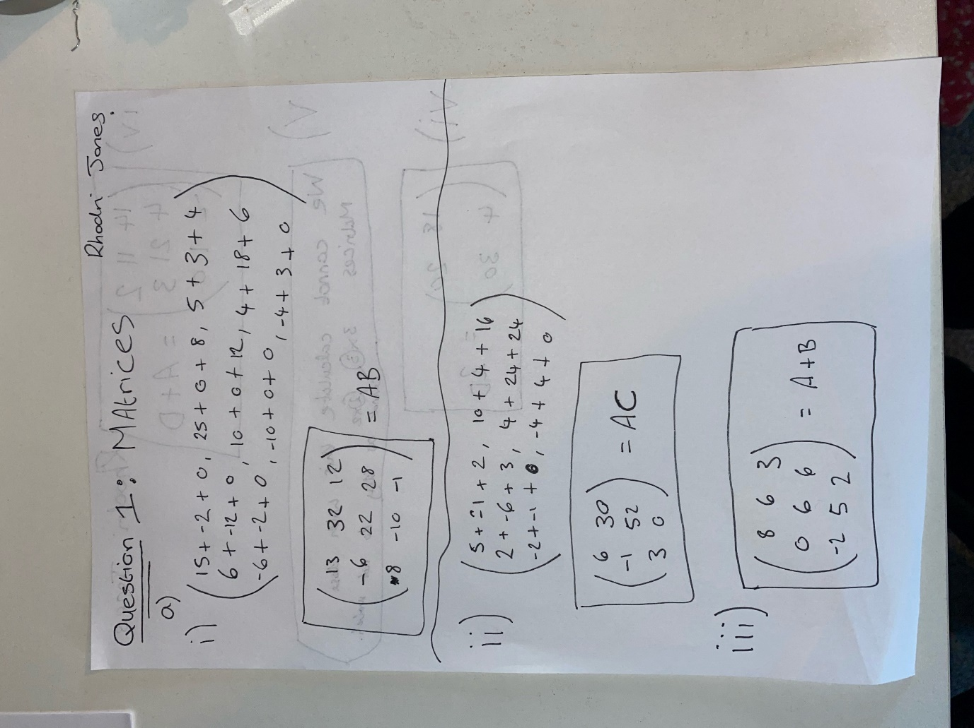

Rhodri Jones Workings sheet
Mathematics Exam 2
Analytical Methods (ACHA4000, ACMA4006)
10th December 2021

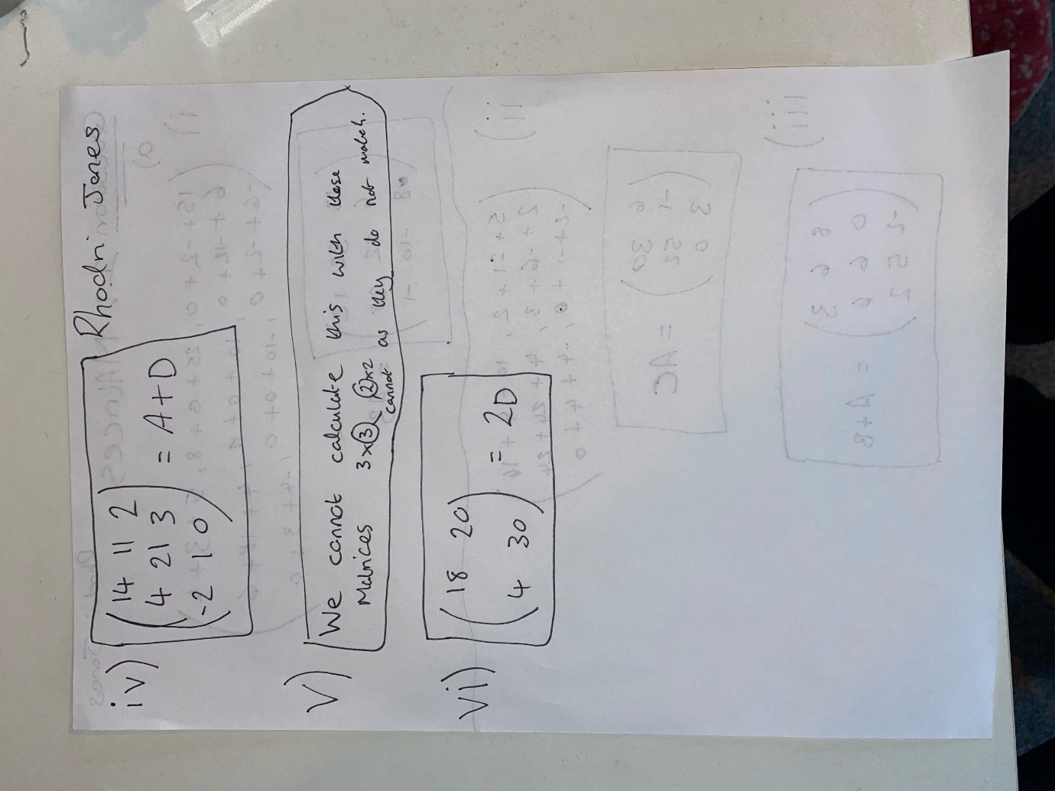

Rhodri Jones Workings sheet
Mathematics Exam 2
Analytical Methods (ACHA4000, ACMA4006)
10th December 2021

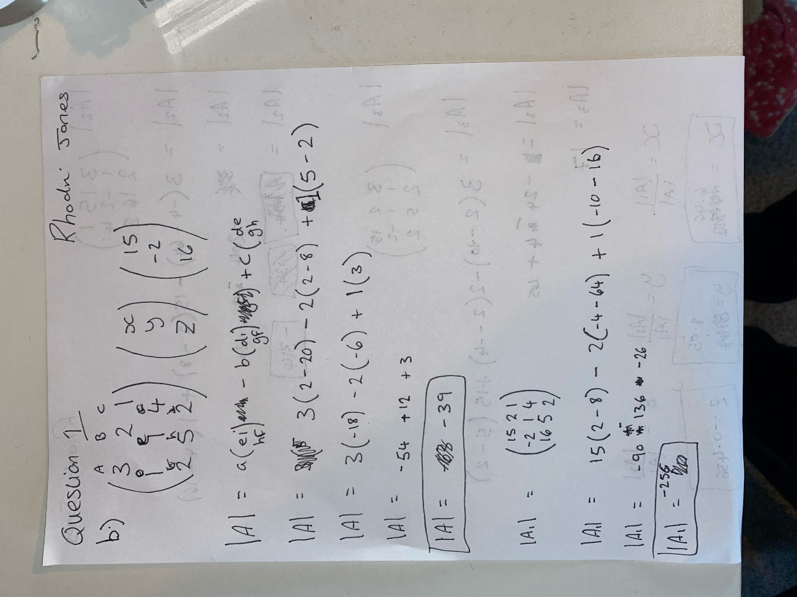

Rhodri Jones Workings sheet
Mathematics Exam 2
Analytical Methods (ACHA4000, ACMA4006)
10th December 2021

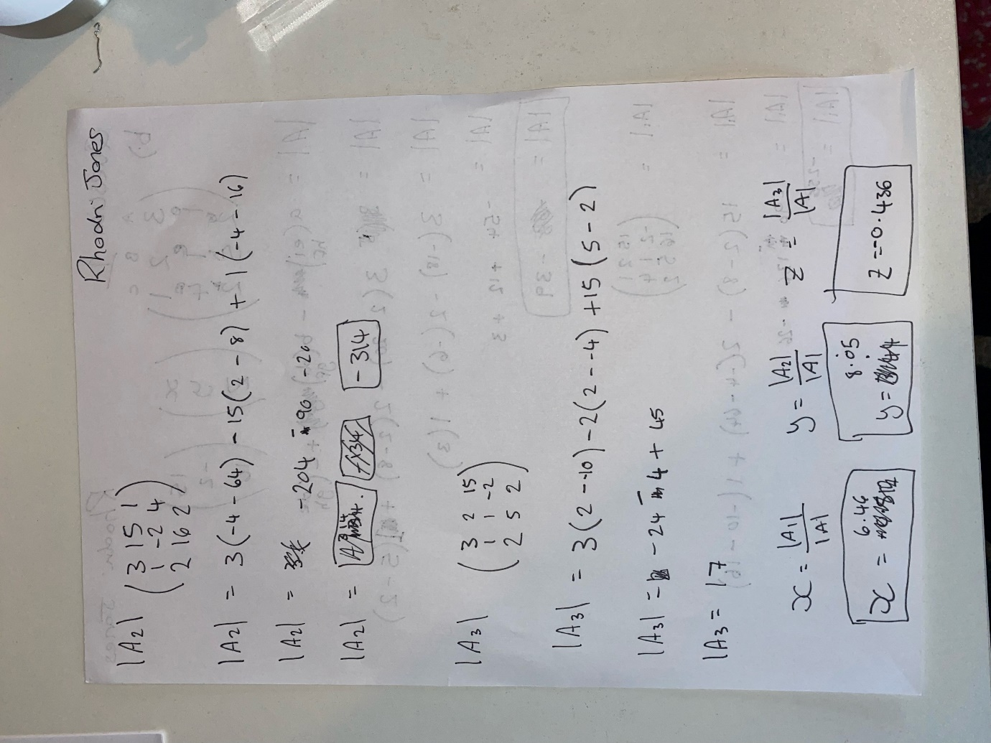

Rhodri Jones Workings sheet
Mathematics Exam 2
Analytical Methods (ACHA4000, ACMA4006)
10th December 2021

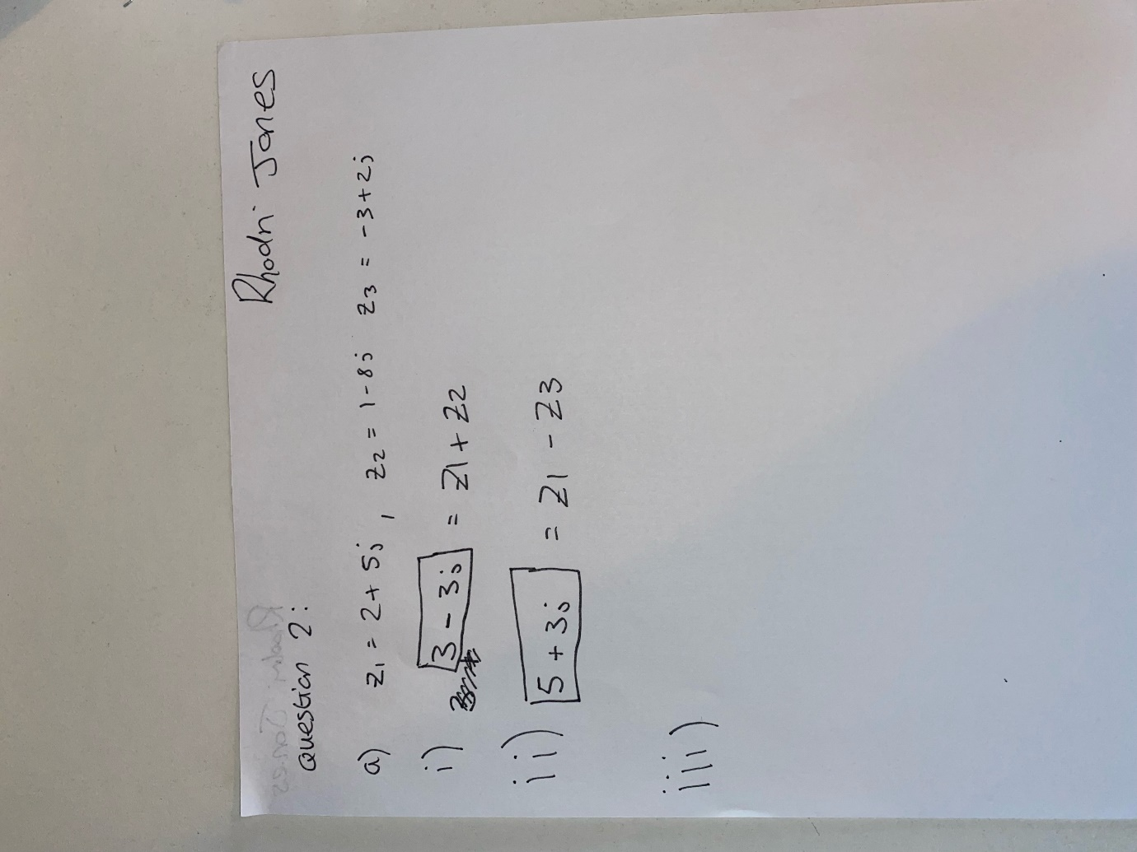

Rhodri Jones Workings sheet
Mathematics Exam 2
Analytical Methods (ACHA4000, ACMA4006)
10th December 2021

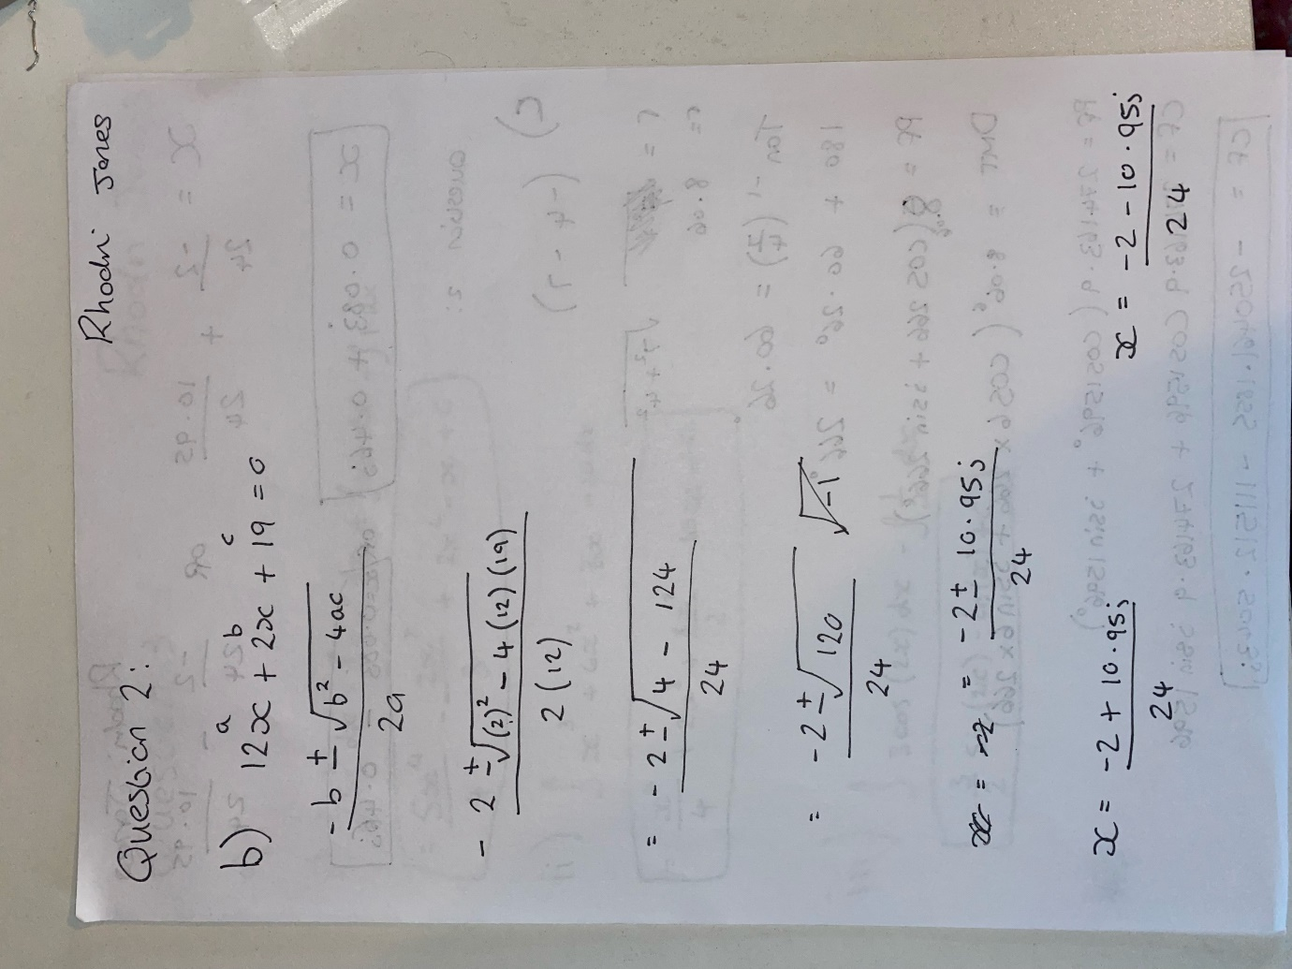

Rhodri Jones Workings sheet
Mathematics Exam 2
Analytical Methods (ACHA4000, ACMA4006)
10th December 2021

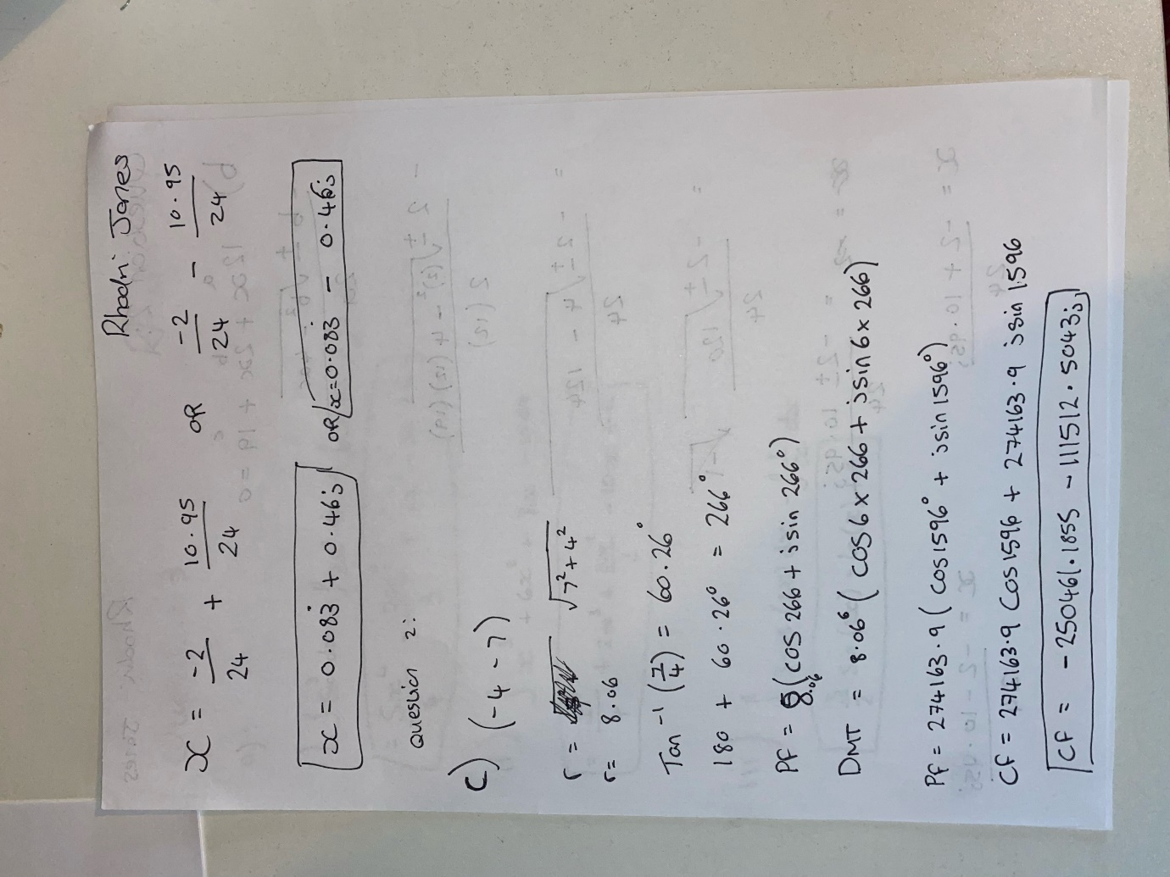

Rhodri Jones Workings sheet
Mathematics Exam 2
Analytical Methods (ACHA4000, ACMA4006)
10th December 2021

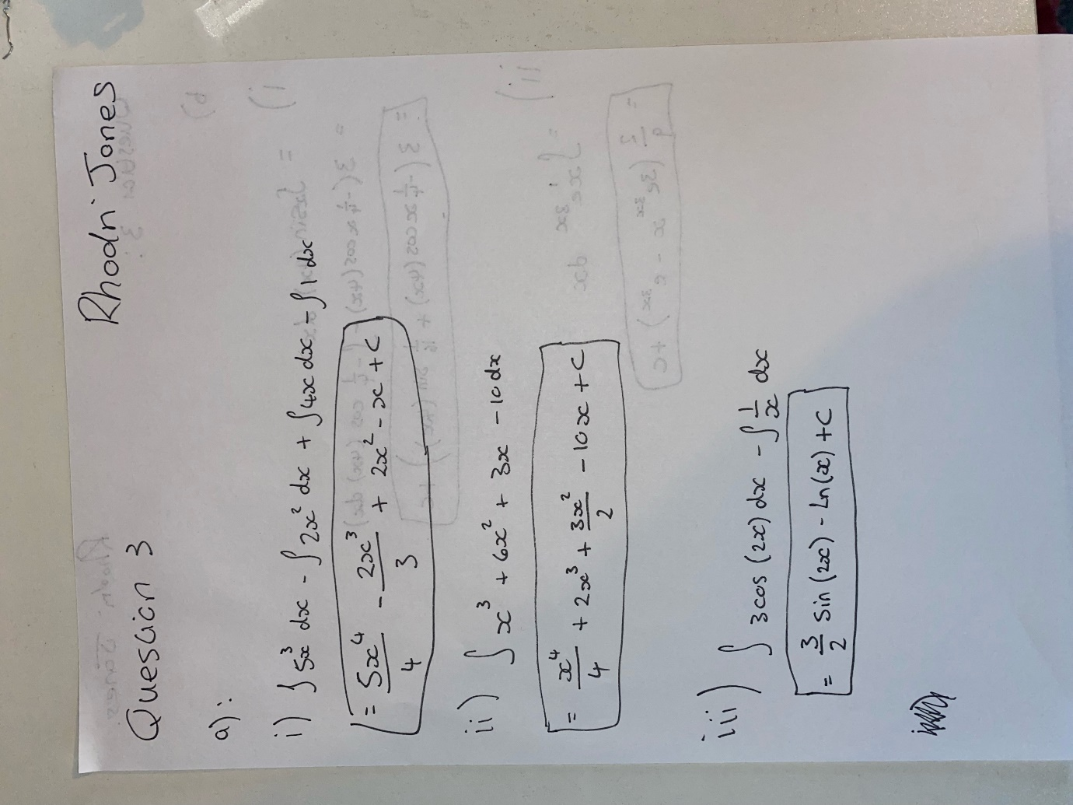

Rhodri Jones Workings sheet
Mathematics Exam 2
Analytical Methods (ACHA4000, ACMA4006)
10th December 2021

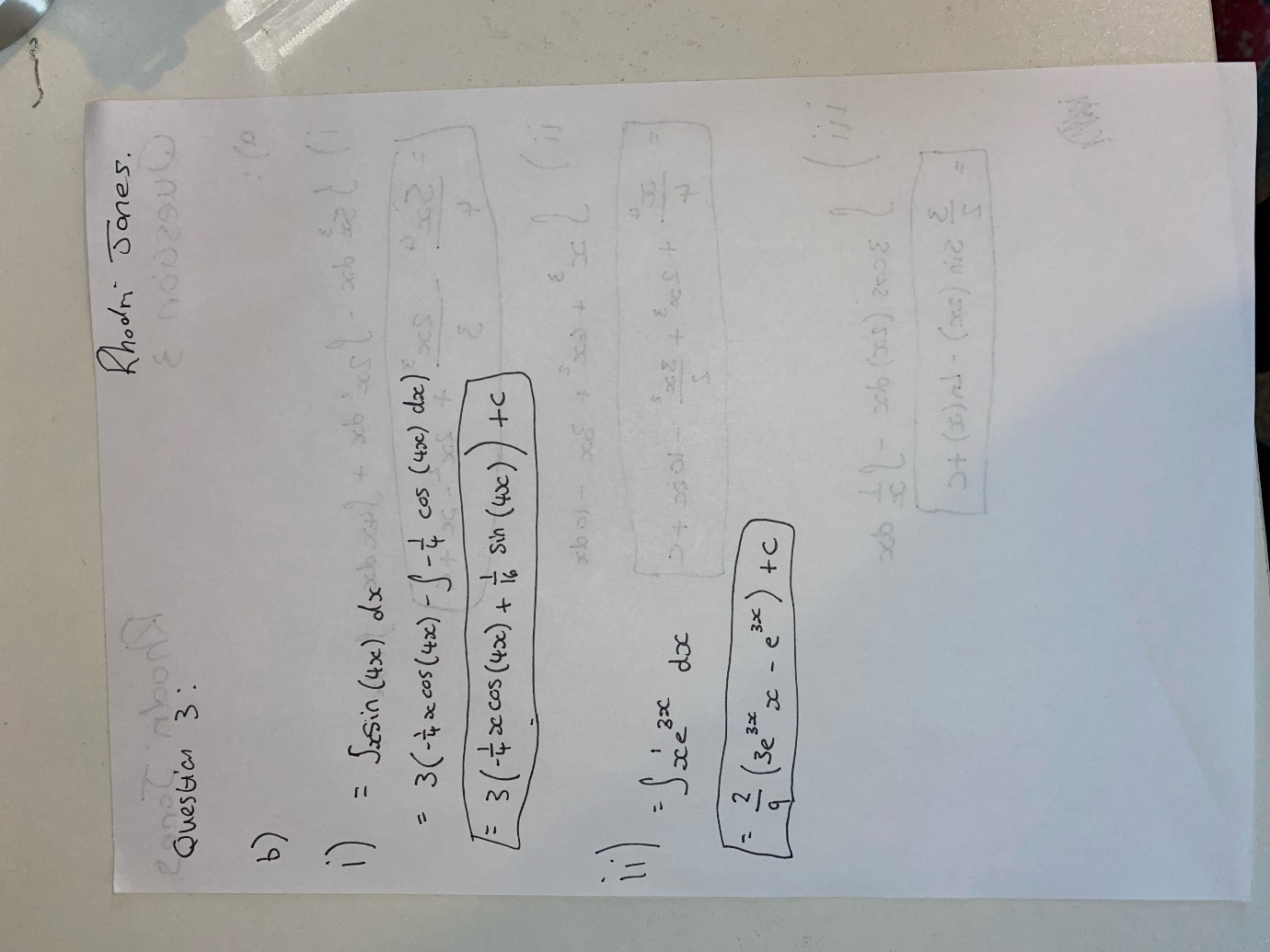

Rhodri Jones Workings sheet
Mathematics Exam 2
Analytical Methods (ACHA4000, ACMA4006)
10th December 2021

Rhodri Jones Workings sheet
Mathematics Exam 2
Analytical Methods (ACHA4000, ACMA4006)
10th December 2021

Rhodri Jones Workings sheet
Mathematics Exam 2
Analytical Methods (ACHA4000, ACMA4006)
10th December 2021

