MODULE TITLE: ENTREPRENEURSHIP
MODULE CODE: LCBB5001
STUDENT NAME: PRIMAVERA MIHAELA DOBRE
STUDENT ID:2119074
LECTURER NAME: LAILA MAZOUZ
ASSESSMENT 1: ESSAY

Table of Contents
Introduction 3
Business Idea 3
Idea Rationale 5
PEST Analysis 6
Knowledge and Skills 8
Conclusion 9
Reference List 10
Appendix 1: SWOT 12
Appendix 2: Skill Audit 12
Appendix 3: PDP 13

Introduction
Entrepreneurship is defined as the process of finding solutions which are innovative in nature as per the accurate identification of gaps in the targeted industry. An entrepreneur is an individual who accepts these challenges and runs their own business by establishing a proper business framework and objectives for sustained success. The name of the business venture is Cyberautics Technologies which will be focused on rendering nickel-based batteries as the core product idea for EV Automobile Companies. With reference to the Innovation Entrepreneurship Theory, the current UK economy will be considered by the entrepreneur for adding creativity and innovation which is crucial for business development. This agile approach will help in enhancing demand while reducing production costs. According to the Statista Report, the demand for nickel in Electric Vehicle (EV) batteries will increase by 66, 5000 metric tons worldwide by 2025. The nickel will be exported from Indonesia by Cyberautics Technologies for making nickel-based batteries. EV Automobile companies like Tesla, Toyota, Ford, BMW and Guangzhou Xiaoping will be targeted by Cyberautics Technologies for promoting products and services.

Business Idea
Cyberautics Technologies is a private business venture and will be requiring five members to commence this business. The headquarters will be located in London, UK and the capital for starting this business venture will cost approximately 2000 Euros. The five members will comprise of Chief Executive Officer (CEO), Chief Technology Officer (CTO), Chief Financial Officer (CFO), Managing Director (MD) and Electrical Engineer (Automobile Specialisation).
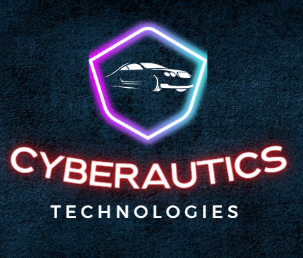
Figure 1: Company Logo
(Source: Self-Developed)
Employee strength of 50 will be needed to meet the business objectives. The Production Department will be handling the manufacturing of Nickel-based Batteries, quality assurance and facilities planning. The Supply Chain Department will be handling the sourcing of the Nickel Component, and the Engineering Department will conduct Research and Development Tests along with battery design for optimum services of the battery (Calearo et al. 2019). The Administration Department will be handling the Finance, Information Technology and Human Resources. The Marketing and Sales Department will be handling the International and Domestic Imports and Exports, automobile components and Warehouses.
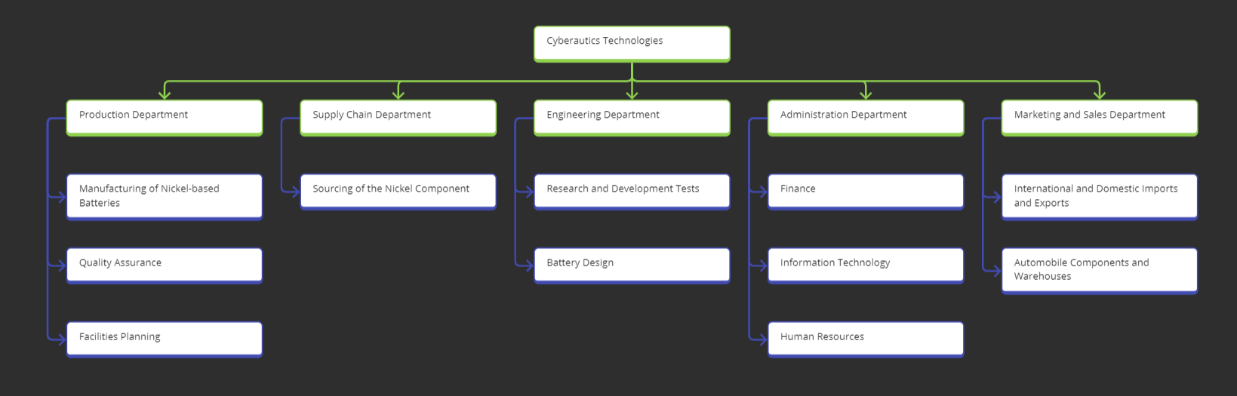
Figure 2: Organisation Structure of Cyberautics Technologies
(Source: Self-Developed)
Cyberautics Technologies will be developing NMC (Nickel-Manganese-Cobalt) batteries and incorporating technology by using manganese and cobalt along with nickel. The battery will have a long operating life which will last approximately 20 years and can operate within -40 degrees Fahrenheit or -40 degree Celsius. The composition ratio of nickel will be 84%, aluminium will be 4% and Cobalt will be 12%, based on lithium ions (Hsieh et al. 2019). The battery is cheaper than nickel metal hydride, however, is more expensive than a core lithium-based battery. Also, Cyberautics Technologies will be increasing the cycle life by 2000 recharge and discharge cycles and implementing power tools for making the battery vibration resistant. The main objective of this business venture will be to highlight the significance of nickel as the battery for electric vehicles will not only have a longer operating and cycle life but also will promote stability and wider operating range as per the temperature differences.
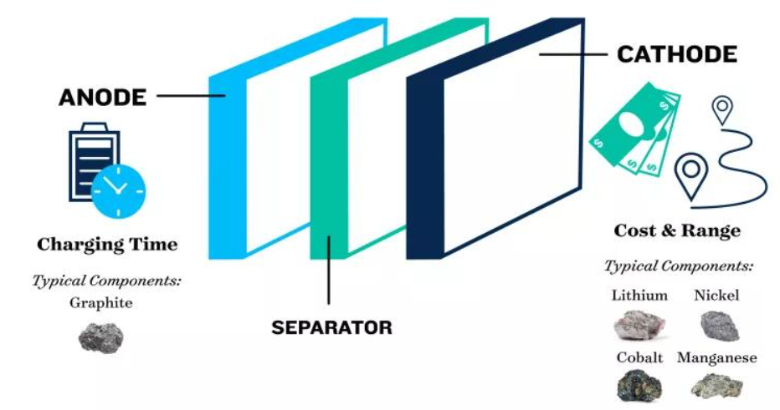
Figure 3: Components of NMC Battery for EV
(Source: Hantanasirisakul and Sawangphruk, 2023))

Idea Rationale
The sales of electric vehicles have increased by 70% by 2022 globally as the battery used are useful for saving energy and protecting the environmental sustainability prospects as per the International Energy Agency (Zhang et al. 2023). The purpose of Cyberautics Technologies here is to make a battery which will be based on nickel as the main component while including lithium, Cobalt and manganese. Hybrid Electric vehicles (HEVs) mostly use this type of battery and the demand for this has increased from 330 GWh in 2021 to 550 GWh in 2022. The opportunity to use this 55% increase in global demand by automobile manufacturers is the main objective of Cyberautics Technologies. The increase in the demand for electric vehicle batteries is mainly due to the lack of availability of critical materials. The demand for nickel as the core mineral element of batteries has increased by 180% since 2017 (Cusenza et al. 2019). The business venture of Cyberautics Technologies will help in exporting these critical minerals for supporting the energy transition from traditional vehicles to electric vehicles in order to keep up with the incorporation of clean energy technology. It is pivotal for the company to promote security sustainability and resilience while accelerating innovation by using advanced technology which will require critical minerals in smaller quantities and optimise the battery size for recycling and development for future research.
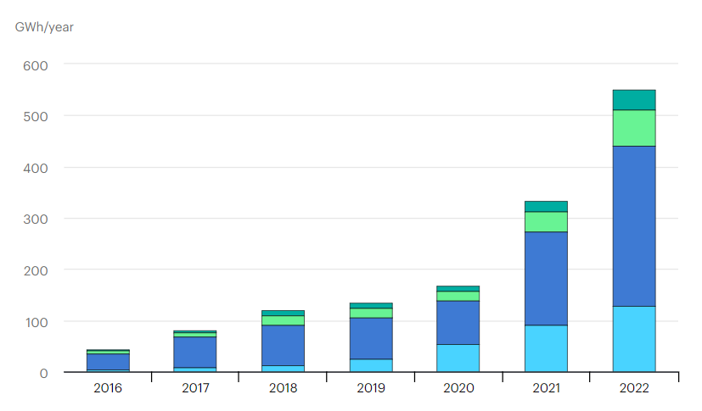
Figure 4: Nickel Mineral for EV Battery
(Source: Wang et al. 2020)

PEST Analysis
This type of interpretation is useful for Cyberautics Technologies to comprehend the external or macro environment as factors which may potentially affect the smooth functioning of business operations. It is crucial for understanding the targeted market and economic condition and analysing the business framework for measuring the critical factors for quality foresight.
Political Factors
Government policies force strict rules which are based on the emissions done by automobile vehicles as per the carbon emissions and its detrimental impact on the global environment and climate. Approximately 1.2 trillion euros has been invested by the UK Government as a part of a cross-partisan infrastructure plan. 7.5 trillion Euros will be spent by the UK Government for building a network of charging stations for electric vehicles and this will help the UK residents to a major extent. The European Union is also planning to launch the European Green Vehicles Initiative (EGVI) in order to support the usage of electric vehicles (Fichtner, 2022). This initiative will act as a competent opportunity for Cyberautics Technologies to build partnerships between business and public automobile sectors such that green transportation solutions can be provided effectively by means of selling NMC (Nickel-Manganese-Cobalt) batteries. Also, the government subsidies will act as another political element which will help in increasing the acceptance of electric vehicles in other developing nations and reducing the cost of owning electric vehicles for the mass market in the UK.
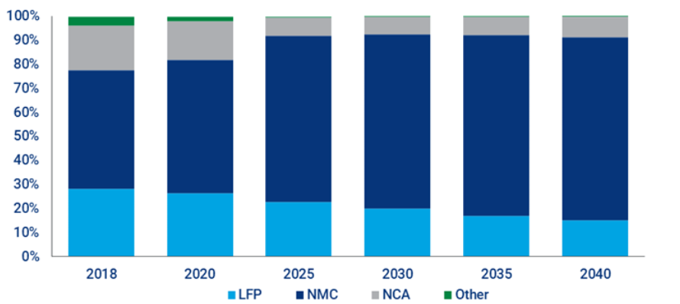
Figure 5: Demand for EV batteries as per battery-type
(Source: Chu et al. 2020)
Economic Factors
The demand for Hybrid electric vehicles is increasing at a substantial rate of 83.9%. The usage of green energy for protecting the environment will enhance employment opportunities in the UK to a major extent, especially in the electric automobile industry. The sales of NMC (Nickel-Manganese-Cobalt) batteries by Cyberautics Technologies will increase by 56.8% as per the sale of electric vehicles since it is beneficial for the global economy. However, due to the lack of abundant minerals used in the battery component, the cost of exporting nickel from Indonesia will cost Cyberautics Technologies by 42%. Therefore, the research and development team of the company need to incorporate advanced technology to optimise the usage of abundant components in the battery as per the Limited production factors. Also, professional training for automobile Technology trends needs to be conducted by Cyberautics Technologies to the current employee's strength from time to time in order to stay updated and adept with technology incorporation for modernising battery design, components as well as usage.
Social Factors
The preferences of global consumers play an active role in Cyberautics Technologies and it has been observed that mostly the younger generation are concerned about protecting the environment and favouring electric vehicles over conventional transporting mediums. The Global transition towards building a more Sustainable Society is to lower the impact of carbon footprint on the environment. The battery used by electric vehicles will help confer social standing and equate class status for boosting profitability. The increasing preference for using green technology and renewable energy act as dynamic opportunities for Cyberautics Technologies to anticipate as well as enhance demand by 350.37 billion euros by 2029 as per the research conducted by Data Bridge Market (Saldana et al. 2022). The Global market worth of these batteries is increasing at a CAGR rate of 18.48% with an incremental growth of 37.69 within 2025 and contributing a growth of 67%. Also, consumers residing in the EU region are highly aware of significant issues such as traffic congestion, air pollution, noise pollution and travel expenses which contribute to 81% of hindrances faced and these are all solved by the NMC (Nickel-Manganese-Cobalt) batteries of electric vehicles.
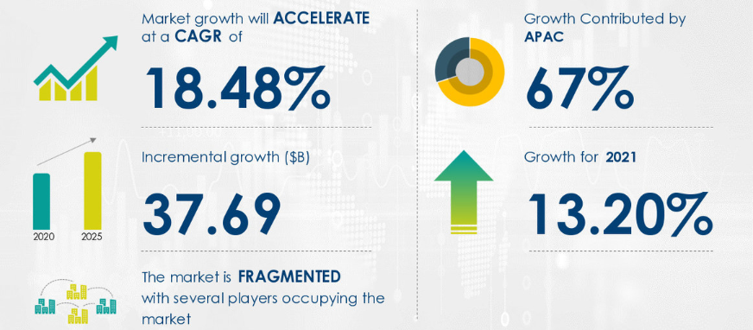
Figure 6: Global Market Worth of NMC Battery
(Source: Baccouche et al. 2022)
Technological Factors
The Technology used in electric car batteries is evolving at a rapid rate which means that incorporating Technology trends help in reducing the time needed to charge these electrical batteries. Also, the advancement is useful in decreasing energy loss and EV stations have become more accessible to UK residents and are influencing more sales and usage of electric vehicles as a whole. Large-scale automobile companies such as Tesla, BMW, and Toyota are constantly looking for opportunities to innovate battery Technology. This market gap will be used by Cyberautics Technologies for improving the battery Technology such that people after charging the NMC (Nickel-Manganese-Cobalt) battery for 5 minutes can travel up to 160 km (Held et al. 2022). However, the lack of charging station in the UK acts as a barrier which raises the cost of the NMC battery to a major extent. This issue can be solved by market adoption and technology advancement by Cyberautics Technologies.

Knowledge and Skills
Mechatronics Engineering Knowledge
It is necessary for the entrepreneur to have an idea about the electrical, mechanical and electronic engineering system which will include a combination of computer science, robotics, electronics, system control, telecommunication and product engineering. The metamorphosing of automotive electronics has transformed over the years from the conventional usage of IC engines to EV vehicles. The entrepreneur will be responsible for establishing a competent business framework and using the mechatronics engineering knowledge to develop algorithms for NMC (Nickel-Manganese-Cobalt) battery management design systems and development.
Cross-Domain Skills
The skills include managing and implementing the Optimisation and modelling of tools and methods for a systematic approach towards battery development. The entrepreneur is required to have subject matter knowledge about vehicle mechanics, electric powertrain controls, sensing and actuation technology, along with software knowledge of MATLAB, AUTOSAR and Helix QAC (Xiong et al. 2020). A thorough understanding will help the entrepreneur in developing a proper design of the NMC (Nickel-Manganese-Cobalt) battery as per EMC compliance along with functional testing. This type of system-level thinking along with embedded product development will enhance the usage of creative innovation for increasing battery capacity.

Conclusion
The essay showcases the significance of NMC (Nickel-Manganese-Cobalt) batteries as per the increasing demand for electric vehicles in the UK. A business idea of Cyberautics Technologies has been introduced along with PEST analysis for the interpretation of external factors. The business idea has been justified with reference to market demand and research. Lastly, entrepreneurial knowledge and skills have been discussed for the successful launch of this business idea.

Reference List
Baccouche, I., Jemmali, S., Manai, B., Nikolian, A., Omar, N. and Essoukri Ben Amara, N., 2022. Li‐ion battery modeling and characterization: an experimental overview on NMC battery. International Journal of Energy Research, 46(4), pp.3843-3859.
Calearo, L., Thingvad, A. and Marinelli, M., 2019, September. Modeling of battery electric vehicles for degradation studies. In 2019 54th International Universities Power Engineering Conference (UPEC) (pp. 1-6). IEEE.
Chu, A., Allam, A., Arenas, A.C., Rizzoni, G. and Onori, S., 2020. Stochastic capacity loss and remaining useful life models for lithium-ion batteries in plug-in hybrid electric vehicles. Journal of Power Sources, 478, p.228991.
Cusenza, M.A., Bobba, S., Ardente, F., Cellura, M. and Di Persio, F., 2019. Energy and environmental assessment of a traction lithium-ion battery pack for plug-in hybrid electric vehicles. Journal of cleaner production, 215, pp.634-649.
Fichtner, M., 2022. Recent research and progress in batteries for electric vehicles. Batteries & Supercaps, 5(2), p.e202100224.
Hantanasirisakul, K. and Sawangphruk, M., 2023. Sustainable Reuse and Recycling of Spent Li‐Ion batteries from Electric Vehicles: Chemical, Environmental, and Economical Perspectives. Global Challenges, 7(4), p.2200212.
Held, M., Tuchschmid, M., Zennegg, M., Figi, R., Schreiner, C., Mellert, L.D., Welte, U., Kompatscher, M., Hermann, M. and Nachef, L., 2022. Thermal runaway and fire of electric vehicle lithium-ion battery and contamination of infrastructure facility. Renewable and Sustainable Energy Reviews, 165, p.112474.
Hsieh, I.Y.L., Pan, M.S., Chiang, Y.M. and Green, W.H., 2019. Learning only buys you so much: Practical limits on battery price reduction. Applied Energy, 239, pp.218-224.
Saldana, G., San Martín, J.I., Zamora, I., Asensio, F.J., Onederra, O. and Gonzalez-Perez, M., 2022. Empirical calendar ageing model for electric vehicles and energy storage systems batteries. Journal of Energy Storage, 55, p.105676.
Wang, F., Deng, Y. and Yuan, C., 2020. Design and cost modeling of high capacity lithium ion batteries for electric vehicles through a techno-economic analysis approach. Procedia Manufacturing, 49, pp.24-31.
Xiong, S., Ji, J. and Ma, X., 2020. Environmental and economic evaluation of remanufacturing lithium-ion batteries from electric vehicles. Waste Management, 102, pp.579-586.
Zhang, H., Xue, B., Li, S., Yu, Y., Li, X., Chang, Z., Wu, H., Hu, Y., Huang, K., Liu, L. and Chen, L., 2023. Life cycle environmental impact assessment for battery-powered electric vehicles at the global and regional levels. Scientific Reports, 13(1), p.7952.

Appendix 1: SWOT
STRENGTHS | WEAKNESSES
- Selling NMC (Nickel-Manganese-Cobalt) batteries to EV automobile companies  - The NMC battery composition ratio of nickel will be 84%, aluminium will be 4% and Cobalt will be 12%, based on lithium ions. | - Employees may not be adept with mechatronics engineering skills and knowledge  - The battery design and deployment can cost higher than usual due to high export costs.
OPPORTUNITIES | THREATS
- Exporting Nickel from Indonesia  - Using CSR policies to gain subsidies from UK Government | - Evolving Technological Trends in EV batteries  - Lack of Nickel as abundant material

Appendix 2: Skill Audit
SKILL AREA | DESCRIPTION OF SPECIFIC SKILL | EVIDENCE OF SKILL | HOW AM I DOING?
Communication Skills | This will help me in communicating with other team members without any jargon. | I have been conducting weekly seminars on mechatronics as well as meetings for enhancing team dynamics. | I am lacking in eradicating the cultural barriers among employees.
Management Skills | This will help me in centralising the business framework and delegating responsibilities as per the skill set of employees. | I have been incorporating a transformational leadership style for increasing employee morale and work output. | I am successful in strengthening relationship between management and team members.

Appendix 3: PDP
DEVELOPMENT GOAL | HOW IMPORTANT IS IT | ACTIVITIES TO BE UNDERTAKEN | RESOURCES I NEED | START DATE | END DATE | CRITERIA FOR SUCCESS
NMC Battery Knowledge | To understand the mineral components and usage in EV battery | Enrolling in online courses and gaining industrial exposure | Referring to government publications | 24.07.23 | 08.11.23 | By gaining subsidy from the UK government
Mechatronics Engineering | To enhance battery design and optimise usage | Getting theoretical knowledge of cross-domains expertise | Referring business journals | 15.08.23 | 18.12.23 | By collaborating partnership with EV automobile companies

