
Master of Business Administration
International Business pathway

Assessment: Individual report Weight: 100%

Module Name: International Business Concepts

Module code: LCMB7034

Lecturer Name: Jean Wang

Student Name: Om Sadrakar
Student ID: 2526083

Word Count: 5062

Submission Date: 14/08/2026

AI Use Acknowledgement
I acknowledge the use of AI tools (Grammarly / ChatGPT) during the final preparation of this assignment, specifically for proofreading, grammar checking, and language refinement. The tool was used strictly to review sentence structure, correct spelling or grammatical errors, and ensure academic tone throughout the document.
No AI was used for content generation, critical analysis, or drafting any portion of the report or reflective account. All research, ideas, framework applications, and writing remain my original work. I confirm that I have not presented any AI-generated text as my own. I maintain copies of my original notes, drafts, and planning materials, which can be provided as evidence if requested.

Table of Contents
Section 1: International Market Entry Analysis 3
1.1 Introduction 3
1.2 Organizational Classification and Global Strategy 3
1.3 Macro-Environmental Appraisal and Market Attractiveness 5
1.4 Entry Mode Strategy 11
1.5 Conclusion and Recommendations 14
Section 2: Reflective Account Using Gibbs' Reflective Cycle 16
References 19

Section 1: International Market Entry Analysis

1.1 Introduction
This report analyses the decision affecting the international market entry of Primark, which is a European-based quality fashion retailer, and evaluates Australia as a target market. Primark is selected as it is a large multinational retailer that has its own unique model of low costs and an expansion agenda. In order to have a viable and real expansion prospect to test, Australia is selected since it is a stable, high-income market where Primark has no operational base, and thus it is a real and viable expansion opportunity.

1.2 Organizational Classification and Global Strategy
Strategic Categorization
The Bartlett and Ghoshal model (1989) categorises the multinational firms based on two competing pressures, namely, global integration pressure and local responsiveness pressure. This model is chosen as it approaches the relationship between the international strategy and internationalisation of a firm and how it organises its activities and knowledge in different countries, and hence can be used to describe choices made by a company, whether to standardise or adapt internationally (Grant and Phene, 2022). The framework yields four strategic types, but they are summarised in the diagram below.
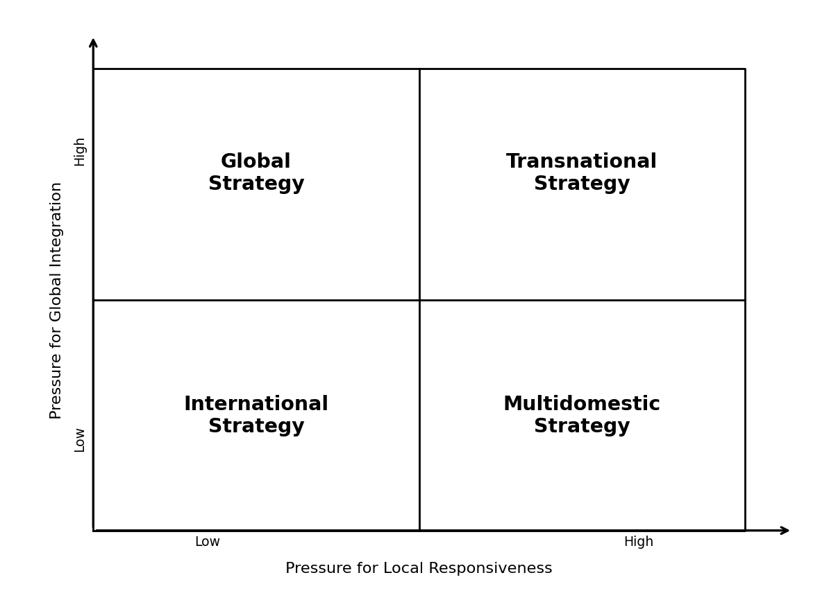
Figure 1: The Bartlett and Ghoshal model (1989) Framework
(Source: By Author)
Once this framework is used in applying it to Primark, this firm falls under the global strategy most comfortably since it experiences a significant pressure of integration and a weak pressure of local responsiveness. Price is the main competitive factor of Primark, and it maintains its low prices by buying in large volumes in the centre and having very large volumes of orders and a very standardised formula of stores, which is repeated in each country. The company keeps advertising and product repositioning expenditures and adaptation to a minimum, which implies that it does not have its ranges fitted to each national market in the manner that a multidomestic firm would. This mass and centralised strategy enables Primark to capture high economies of scale, and it is the scale benefits upon which Primark has based its competitive advantage. The biggest weakness of this strategy is that a highly standardised model may not perform well when local preferences, laws, or, at any rate, when the expectations of the channels vary markedly with the home base, and tension arises when the company thinks about a distant market like Australia. Totally, the classification proves that Primark is driven by efficiency and consistency as opposed to local flexibility, and any entry decision needs to be made based on that strategic rationale.
Global Configuration
Primark is currently geographically located in Europe with a large network of stores in the United Kingdom, the United Kingdom, Ireland, Spain, Portugal, France, Germany, Italy and the United States and a few other neighbouring countries and more recently in the United States. The company expands virtually by use of physical outlets in the most strategic high street and shopping malls, and it has never pursued a full transactional e-commerce channel; instead, it has preferred to enjoy the economies of scale provided by the physical outlets. This structure contributes to the competitive advantage of this firm in a number of ways. The thick network of stores in Europe enables the distribution of buying volumes in a variety of stores, thereby increasing purchasing power in negotiations with the suppliers, as well as reducing unit costs. These stores are supplied efficiently through a centralised sourcing network, which is concentrated in low-cost manufacturing regions in Asia, without compromising the value proposition. The low costs of marketing and online fulfilment are maintained, and as a result, the savings are passed on to the shoppers in the form of low prices, and this strengthens customer loyalty and high store productivity.
The international operations create value, in value-creating terms, primarily based on cost leadership and scale, as opposed to higher prices or localisation, so every new market will be anticipated to be part of the same integrated system. The store-based structure is also determining the rate of growth, since growth is more about acquiring large, well-situated retail spaces than it is about creating an online logistics facility, and that is why site-selection and property strategy are the key factors in all new markets that the firm is contemplating. It has worked well in Primark in terms of closeness and the cultural and geographic proximity of the markets; however, this arrangement also implies that the firm is bringing a culture that is sensitive to proximity and density to a distant and relatively small market like Australia, in which store economics and supply lines do not act as they do in the dense European core.

1.3 Macro-Environmental Appraisal and Market Attractiveness
Overview
Australia represents a stable and high-income economy situated in the Asia Pacific region, which is characterised by its small but wealthy population and highly developed retail market. The external environment analysis is essential due to the fact that internationalisation represents a large investment of time and effort, and knowing the political, economic, legal, and cultural situation beforehand enables the firm to assess whether the market has the potential to support its business strategy and where the key threats are. In this chapter, we will use four frameworks, which complement each other, to evaluate the environment of the country. Institutional theory will be employed for assessing the political and legal environment, economic environment analysis will be used for evaluating market attractiveness, while the CAGE framework will be utilised for measuring cultural distance.
Political Environment
Australia has a very stable political environment, and one of the most appealing factors to foreign retailers is the ability of the government to be stable in policies, since the government is predictable and the rule of law is very well established. The country has an open trade policy and is involved in many free trade agreements in the Asia Pacific region, which facilitates the easy flow of imported goods on which a sourcing-led retailer such as Primark relies. The policy about foreign investment usually tends to be congenial, with larger investments tabled by the national foreign investment authority; hence, approval processes should be planned more than expected. There is transparency in taxation, and it is uniformly administered, and the business environment offered by the government is generally favourable without any of the special incentives that a value retailer will depend on. The political risk is not high; there is not much risk of instability, expropriation, or sudden change of policy. The key opportunity in this area is that, as the system is stable and open, it lowers the uncertainty that is assigned to investment in a large store. Another clear industrial and trade policy of the government is to promote open competition, meaning that Primark would receive no favour in comparison with the already established local and international competitors, and instead would compete with others without protectionism. The biggest risk is not political but regulatory since a market that is properly governed implements its rules equally seriously, and this increases the cost of compliance of foreign firms entering the market, hence the firm should count as a real strength its political stability in Australia, but cost accounted the regulatory compliance costs that come with it.
Legal Environment
The legal climate is complex and intensely imposed, affecting the operating model of Primark directly. The business laws are explicit yet severe, and the area of employment law is especially crucial, due to the comparatively high minimum wages, penalty rates, and effective labour protection, which increase the labour costs of operating staff-intensive stores. Consumer protection law is solid and provides solid rights to the customers towards the quality of products and fair trading; thus, consistency in the standard needs to be upheld. The level of intellectual protection is high, safeguarding the brand and designs of the firm, and competition law is also fully implemented to avoid anti-competitive business practices. The firm has data protection and privacy regulations that cover any data of its customers. Regulation of the environment is also gaining momentum, as the actions of textile waste and supply chain become more scrutinised, and modern slavery reporting mandates safeguard disclosure over sourcing. Combined with these legal characteristics imply that a foreign retailer has no easy time importing its home practices due to the fact that employee costs, trading standards, and transparency of supply chains are all more strictly regulated than in some of the markets that Primark has entered. This would mean that Australia is a predictable and legally safe market, but a high compliance/ high labour cost country, and its characteristics glare directly against the low cost logic on which Primark is based, which means that the firm must make contingency plans to absorb higher operating costs and stronger governance than its stores in Europe normatively.
Economics and Market Appeal
- Size and Buying Power
The population of Australia is around 27 million, which is small in terms of the large European markets that Primark already has, so the sheer size of the customer base is a literal limitation in terms of the range to which the business may grow. The market is not large, which it partly compensates for by its richness (gross domestic product is high), through which disposable income is strong, and whose middle-income range is vast and stable, which means they shop regularly in terms of clothing. Such high purchasing power and value-taking culture are appealing, as the offer of Primark is convincing to people used to the idea of fashion that is cheap, no matter what kind of income they have.
- Stability of the Economy and Economic Growth
The overall economy is in good health, with inflation having calmed down to recent highs, a generally stable exchange rate, and certain stable long-term growth. Confidence regarding consumer spending is promoted. The retail clothing industry itself is not only mature, but is performing at moderate growth, and the intensity of rivalry is high with well-established domestic chains of value and international competitors already operating in the sector and serving the price-sensitive market. Infrastructure is an ambivalent picture. The country has a well-developed logistics and systems of digital connections and supply chains, yet the geographical distance between the country and Europe remains, making it difficult to establish the distribution methods that this firm has prepared. The attractiveness of the market is the stability and wealth, but the disadvantageous aspects of the opportunity are that the population is small and the competition and distance are high, which indicates that the opportunity is solid and not exceptional.
Cultural Environment Using the CAGE Framework
Culture will be analysed by using the CAGE tool with an emphasis on the cultural distance parameter. Cultural distance indicates the similarity or dissimilarity of consumers and business practices between the home country and the target market.
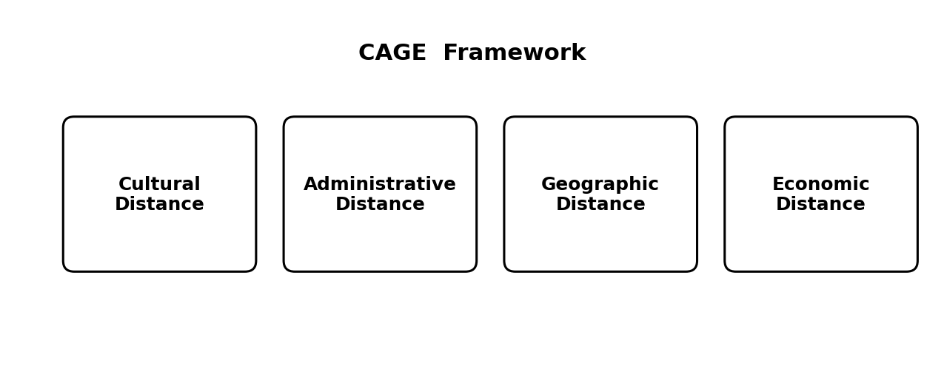
Figure 2: CAGE Framework
(Source: By Author)
The cultural distance is also low on language, since Australia is an English-speaking market, which makes it unnecessary to translate branding, signage, and communication. Consumer behaviour and purchasing habits are generally Western and accustomed, thus the shopper is well acquainted with the fast fashion format, reacts well to value pricing, in very much the same manner as European customers (Bläse et al. 2024). Nevertheless, there is one crucial point: Australian customers have become so accustomed to online shopping that their familiarity with online shopping is now making Primark feel extremely uneasy with its conventional store-only model. Religion and values do not pose significant obstacles, but the values of sustainability are increasing, and can influence the brand perception, as fast fashion is becoming more and more challenged.
They need to win consumer trust, as the existing brand recognition in the market is low, and the communication style is straightforward and informal, which is why it fits the image of accessibility of the Primark brand. In the category of adaptation, there is a marketing implication that the firm will need to create product awareness on a low level, a product implication that ranges can continue to be highly-standardised with light product seasonalisation to the inverted calendar, and a human resource implication that management practices should adapt to strong local employment standards (Arnold and Dombrowski, 2022). The general compatibility is close with the culture, and the key cultural issue is reputational and channel-based instead of close to the values clash.
Overall Market and Attractiveness Assessment
All these analyses put together, Australia is a market that is appealing and yet not risk-free. The main opportunities include a stable and affluent economy, a value-critical and expanding consumer population, an open and conducive institutional environment, and a familiar English-speaking culture that would save on the cost of adapting. Threats that take precedence are the harsh regulatory and labour conditions, small market size compared to Europe, high market competition that already exists in the value segment, as well as the reputational burden that surrounds fast fashion. This balance is summarised in the table below around the major dimensions.
Dimension | Key Opportunity | Key Risk
Political & Legal | Stable government and an open, transparent foreign investment regime | Strict labour laws and modern slavery reporting raise compliance costs
Economic | High disposable income and a large, value-conscious middle class | Small population and intense retail competition limit sales scale
Cultural | English language and Western shopping habits reduce adaptation needs | Rising sustainability awareness challenges the fast fashion image
Operational | Geographic closeness to Asian sourcing hubs shortens supply lines | The long distance from European distribution centres adds logistics cost
The market is still a good choice despite the risks due to the stability, prosperity, and cultural similarities of Australia, which reduce the level of risk of such a big investment. The risks are significant, but not too serious, and they determine the approach that the company should use for entering the market (Burström et al. 2021).
Market Entry Analysis Using Dunning's OLI Framework
The OLI framework by Dunning helps explain the international production choice of a firm through three categories of advantages: ownership, location, and internalisation, and this framework will be used to bring together the above analysis into one entry decision.
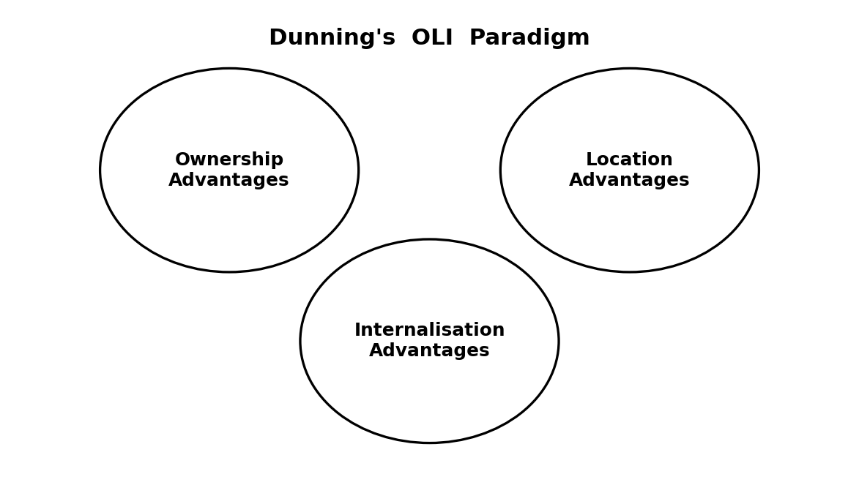
Figure 3: Dunning’s OLI Paradigm
(Source: By Author)
Ownership Advantages
Primark has some distinct benefits that it will be able to bring into a new market. It stands to gain the most out of its purchasing volume, as well as its sourcing network worldwide, which enables it to offer prices that will hardly be matched by competitors. It also enjoys robust financial support of its parent group, extensive experience in operating large format value stores, and a familiar brand and store experience in the markets that it already transacts in (Belitski et al. 2025). The obvious disadvantage of the Australian situation is that this brand awareness is currently absent on the local scale; the company has to use its cost and operational benefits to position itself and not rely on an already existing reputation.
Location Advantages
The latter analysis follows the earlier evaluation and is the location advantage of Australia. The political and legal situation is free and clear, the purchasing power is high, and the English language and Western culture of making purchases make adaptation cheaper (Gourevitch, 2021). One such beneficial effect is that, despite being more geographically distant than Europe, Australia is geographically much closer to the Asian manufacturing regions that supply Primark than Europe, and this can help streamline and simplify part of the supply chain. Though with these strong points stand the weaknesses of the small market, the high cost and intense competition of labour, and so the location provides a good base of operation and a small-scale limit (Lin et al. 2021).
Internalisation Advantages
The issue of internalisation is whether they should have the firm in direct control of operations instead of operating through the developing process of a license, franchise, exporting, or outsourcing. The case of internalising in the case of Primark is strong since its entire proposal lies in very close control of cost, quality, experience of stores, and supply chain, and these can hardly be ensured by independent partners (Wang, 2024). To ensure that the integrity of the low-price model is safeguarded, protect intellectual property and brand image, and enable the firm to control the customer experience, direct control is provided. Any transfer of such functions to a third party would threaten the very strengths that have enabled the firm to attain competitiveness. It is best to internalise the operation.
Recommended Entry Mode
The OLI analysis holds the three combined to make a wholly owned subsidiary as the ideal entry mode, which it provides in the form of the firm's own stores as opposed to franchising, export, or a licensing agreement. This ownership benefit is most pronounced in a firm that has ownership over the operations, when location is consistent to allow direct investment, and when the internalisation logistics give a strong preference to the direct control of cost and quality (Silva et al. 2023). The high resource utilisation and risk compared to a lighter mode are risks, but it is the only type of subsidiary that fully protects the cost leadership and brand experience that the success of Primark is built on, and the evidence therefore supports it as the best mode to take into the market. The structure also clarifies that the lesser aspects, which are the little local brand awareness, and its distance/competitiveness exposures are a problem to be handled in this mode, but not an excuse to move out of direct entry, since a lighter structure would cash in on the control that creates the advantage of the firm in the first place (Maira, 2024).

1.4 Entry Mode Strategy
Historical Pattern Recognition
The global growth of Primark has been a steadily planned movement. The firm has been practically solely expanded by organic, wholly owned stores, establishing its own stores in every new country and developing a network of stores step by step instead of taking over existing stores or using acquaintances. It has largely shunned franchising, joint ventures, and big mergers, instead copying its well-tested store model and taking it to other parts of the world, notably continental Europe and, more recently, the United States. This leading mode indicates the strategic rationale of the firm, as it is through this direct ownership of stores that it can guard its low-cost model, ensure consistency of customer experience, and retain a tight control of its supply chain (Lubis and Muniapan, 2024). The trend is not hence arbitrary but an established articulation of how the company generates value, and it provides an excellent anticipation in a way that any entry into Australia would adhere to the same wholly owned, store-based strategy.
Strategic Fit and Justification
The biggest question to ask is whether this historical mode is suitable for the Australian market, and an analysis indicates that it is still the right general option, but that it should be used sparingly. On the fit front, a wholly owned subsidiary fits well with the strong need for control possessed by the firm that became apparent during the OLI analysis, and the political and legislative policy of Australia is stable, and hence a direct investment is reasonably safe in terms of political risks. Institutions in the country secure property and enforce contracts with credibility, which lessens the threat that tends to drive firms to a lower commitment mode in less stable markets (Maira, 2024). On the deeper side of things, there are increased financial and operational risks than in the core markets in Primark.
The market size is small, the competition is stiff, labour and distance between distribution centres in Europe make the supply chain difficult, and a large and fast store roll-up would tie up a lot of resources in a market with a small limit. It also has a channel risk, since the Australian customers demand a robust online alternative, which the classic Primark concept lacks. Flexibility versus control, the firm must have the control that ownership provides, but it must have flexibility to experiment with the market without making substantial investments. The most persuasive argument is thus that it should retain the wholly owned mode but implement it cautiously, with a one-stage entry of a limited number of flagship stores in the biggest cities first, and then any further expansion (Wang, 2024). This maintains long-term strategic fit to the lowest downside risk. It would also make sense to localise the model, e.g., through regional sourcing and logistics services to address the distance factor and by re-evaluating the resistance of the firm to an online channel within a market where online shopping is more than just integrated into everyday life.
Strategic Evaluation of Primark's Recommended Entry Mode for Australia
Strategic Factor | Assessment for Australia | Implications for Primark's Entry Strategy
Control over Operations | Australia has a clear legal system and good safeguard of business properties, which enables foreign investors to maintain the total control of business operations. | Wholly owned subsidiary will allow Primark to retain its standardised store operations, pricing and supply chain management, without relying on outside partners.
Financial Commitment | Bigger retail outlets can be very costly to open because they need a huge amount of investment in property, personnel and logistics. The market size is relatively small, which heightens the risk of investments. | Growth needs to start with a few flagship stores and then invest more capital in expanding nationwide.
Political and Regulatory Risk | Australia has a secure political climate that is governed by foreseeable regulations, but labour norms and compliance requirements are rather high. | Direct investment is encouraged by low political uncertainty, operating costs should be carefully planned through compliance.
Market Competition | The apparel industry is full of domestic and foreign players that identify good competition hence making the entry a tough challenge. | Primark has to make a distinction of its value-for-money offer, slowly establishing a local brand name.
Supply Chain Efficiency | Australia is close to the manufacturing industries in Asia, which facilitate sourcing products, whereas the distance between the country and the European distribution network of Primark is one of the barriers to logistics. | By creating sourcing and distribution with regional capabilities, the efficiency of the inventory would increase and the costs of transportation decreased in the long run.
Consumer Shopping Behaviour | Australian consumers are gradually changing the concept of physical shopping into combining this digital shopping and demands convenient omnichannel shopping. | Although continuing with the physical store concept, Primark ought to consider a few digital projects, like Click and Collect or online product enquiry, as the way to address the changing customer expectations.
Long-Term Strategic Fit | Moderate market size fits positively with the international long-term growth objectives of Primark in Australia based on the stable economy and purchasing power. | Staged entire ownership growth offers strategic flexibility and maintains both global cost leadership and operation uniformity of the company.

1.5 Conclusion and Recommendations
Conclusively, Australia is an appealing and challenging target market for Primark. It provides political stability, high purchasing power, cultural proximity, and convenient proximity to the Asian supply base of the firm, but it also has a limited population, high labour rates and compliance ratios, stiff competition, and an online anticipation that alters the traditional format of the firm. The strategic analysis demonstrates that Primark is a global strategy firm, whose strengths are based on scale, cost, and a standardised model, and the OLI framework, as well as the history of expansion of the firm itself, clearly indicate it would like direct, wholly owned entry. It is recommended that Primark should adopt its long-standing trend of rolling out the 100 per cent owned subsidiary into Australia, but rather by rolling out flagship stores in the largest metropolitan regions in stages, and not roll out nationwide. This feature enables the company to maintain control over its cost leadership and brand experience, experiment with consumer response, and risk containment. In conjunction with this, the company will need to make adjustments in the fringes by establishing regional supply agreements to deal with the distance factor, as well as the firm heavily considering a digital sales channel to suit the local shopping trends. Treated in this careful manner, entering into Australia can add both international presence to Primark and stay true to the strategy that is at the heart of its competitive advantage.

Section 2: Reflective Account Using Gibbs' Reflective Cycle
Introduction
The Reflective Cycle refers to a framework created by Gibbs with the aim of helping the individual who is going through the experience to weigh each and every experience in a systematic manner in order to enhance his or her further learning and professional practice (Praveena et al. 2025). In this reflection, I critically evaluate how I researched, analysed, and prepared my international market entry report. I reflect on the research strategies I employed, the problems which I had to face, the way I better them, and the way the theories, lectures, academic readings, and discussions on the case studies of this module helped me to understand international business strategy better.
Description
When I started this assessment, I thoroughly read the assignment brief to get acquainted with the requirements of the assignment and anticipated learning outcomes. To handle it in this manner, I broke down the report into small portions as opposed to doing it as a big piece of work. My main goal was to find a multinational corporation that has no substantial presence in an appropriate target country. Having considered numerous different companies, I chose Primark and Australia as the company of choice due to the combination being a feasible opportunity of operating internationally based on publicly available evidence. Thereafter, I gathered data using different credible sources such as academic journal articles, reports released by companies, governmental publications, and business databases. I planned my information as per each assessment criterion and the theoretical frameworks needed in the report before commencing the writing process.
Feelings
In the opening stage, I was overwhelmed by the fact that the report demanded that a few international business theories be applied in the course of a single integrated analysis. I also had a concern regarding the choice of a good company and target market, as well as making sure that my choice will have the support of recent evidence. My self-belief advanced as my research developed, as I slowly became sure that I could do it well due to the possibility to arrange information based on separate schemes. The division of the report into smaller steps also decreased the pressure, and I managed to concentrate on the higher-quality and evidence-based analysis.
Evaluation
Reflectively, a major strength of my strategy was the sufficient time to gather credible and current evidence prior to the composition of the report. The reliance on scholarly journals and the use of the company documents and official governmental publications helped me to enhance the credibility of my analysis and justified my suggestions. The global business systems presented in the course also gave a rational framework which assisted me analyse the market entry decision as opposed to merely explaining the external environment. Nevertheless, I had a number of difficulties. The data in various sources sometimes contradicts especially about assuring the presence of the company internationally and analysing the prevailing conditions in the market. I have thus cross-examined several resources prior to coming up with conclusions.
Analysis
Writing this assignment made a great contribution to my knowledge on how international business theories can be used to supplement each other in making an analysis of a practical organisational decision. I was taught to combine the Bartlett and Ghosal model, institutional analysis, CAGE framework, and Dunning OLI paradigm as individual concepts, but I found out to use each one of these concepts to create the complete market entry suggestion. The application of these theories to the potential expansion of Primark showed how strategic choices need to take into consideration organisational capabilities, as well as external environmental conditions.
It is also the process of research that enhanced my critical ability to analyse evidence. I studied different academic sources, company magazines, and government presses and then compared the information prior to making conclusions. This enhanced the trustworthiness of my results and allowed me to create a balanced argument backed by valid evidence. Saunders, Lewis, and Thornhill (2019) remind us that academic research is effective when a number of credible sources are assessed, and I have found this practice especially helpful during the assignment (Habiba and Islam, 2022).
The other valuable lesson was to know how to do better critical thinking. In the beginning, I concentrated on describing the environmental factors separately, but I soon began to realise that my best approach to successful academic analysis is to describe how the environmental factors impact the strategic decisions and how they all interrelate with one another. This transformation prompted me to consider opportunities, risks, and long-term strategic implications, and not merely to give factual information. As described by McGarr (2021), reflection facilitates learning further by making people challenge their assumptions, and this is an activity that assisted me in bettering my analytic thinking as well as writing.
The module lectures, academic readings, classroom discussions, and practical examples also helped me develop my knowledge regarding international expansion. They established that market attractiveness alone is insufficient to make the internationalisation process successful, as it should be accompanied by the conditions of institutions, organisational strategy, competitive advantage, and selection of entry mode. Thinking about every step in the assignment helped me to realise how my research and skills of analysis improved throughout the process. According to Lubicz-Nawrocka and Bovill (2023), the process of reflection converts experience into a meaningful learning process, and I think that it perfectly describes my experience in the course of performing this assessment.
Action Plan and Conclusion
On balance, this assignment has enabled me to enhance my research and analytical capabilities as well as enhance my cultural knowledge of the international market entry strategy. I learnt to be more confident in applying theoretical works to business situations and make recommendations using reliable evidence. In my upcoming tasks, I will start the literature search sooner, I will further structure my research notes, and I will develop a broader rationale of the possible market and decide before that. I will also enhance my critical writing even more by focusing more on evaluation and synthesis as opposed to description. In general, this evaluation has improved my knowledge of the international business strategy and equipped me with useful academic and professional skills, which I will further acquire in the course of my future studies.

References
Arnold, N. and Dombrowski, S. (2022) Dynamics of Standardised Quality. Long-term shifts in organic product qualification. Valuation Studies, 9(1), pp.141-170.
Belitski, M., Martin, J., Stettler, T. and Wales, W. (2025) International expansion and global scaling strategies. In Handbook of Research on Scaling and High-Growth Firms (pp. 314-341). Edward Elgar Publishing.
Bläse, R., Filser, M., Kraus, S., Puumalainen, K. and Moog, P. (2024) Non‐sustainable buying behavior: How the fear of missing out drives purchase intentions in the fast fashion industry. Business Strategy and the Environment, 33(2), pp.626-641.
Burström, T., Parida, V., Lahti, T. and Wincent, J. (2021) AI-enabled business-model innovation and transformation in industrial ecosystems: A framework, model and outline for further research. Journal of Business Research, 127, pp.85-95.
Gourevitch, P.A. (2021) International trade, domestic coalitions and liberty: Comparative responses to the crisis of 1873–1896. In The Political Economy: Readings in the Politics and Economics of American Public Policy (pp. 279-299). Routledge.
Grant, R. and Phene, A. (2022) The knowledge-based view and global strategy: Past impact and future potential. Global Strategy Journal, 12(1), pp.3-30.
Habiba, U. and Islam, M.E. (2022) Assessing the quality and credibility of scholarly information resources: an investigation into information behaviours of university faculty members. The Electronic Library, 40(3), pp.237-255.
Lin, W.T., Chen, Y.Y., Ahlstrom, D. and Wang, L.C. (2021) Does international expansion constrain growth? Business groups, internationalization, institutional distance, and the Penrose effect. Multinational Business Review, 29(1), pp.70-95.
Lubicz-Nawrocka, T. and Bovill, C. (2023) Do students experience transformation through co-creating curriculum in higher education?. Teaching in Higher Education, 28(7), pp.1744-1760.
Lubis, M. and Muniapan, B. (2024) International market development Strategies for enhancing global expansion in the export industry. Involvement International Journal of Business, 1(1), pp.14-28.
Maira, K. (2024) Business scaling strategies in international markets: Analysis of expansion and localization models. Холодная наука, (10), pp.7-14.
McGarr, O. (2021) The use of virtual simulations in teacher education to develop pre-service teachers’ behaviour and classroom management skills: Implications for reflective practice. Journal of Education for Teaching, 47(2), pp.274-286.
Praveena, K.S., Juslin, F., Patil, C.M. and Bhargavi, K. (2025) Using gibb's reflective model approach for enhancing project-based learning among students through reflective assessment. Journal of Engineering Education Transformations, pp.148-155.
Silva, L.A.D., COSTA JÚNIOR, J.F.D. and ARAÚJO, A.G.D. (2023) International expansion strategy in fast-growing businesses: using bayesian networks to identify influencing factors. International Journal of Business and Management, 19(1), p.1.
Wang, S.H. (2024) Benefits or costs? Exploring the international expansion process of the business group. International Marketing Review, 41(6), pp.1300-1329.
Williams, T., Kallas, E., Garcia, E., Fitzroy, A. and Sithole, P. (2024) International business expansion strategies: A data-driven approach with ibm spss. APTISI Transactions on Management, 8(2), pp.131-138.

