2D and 3D Modelling of shaped charge liner formation

William Critchley

L5 - Advanced Physics of OME (ACDB5015)

Wales Institute for Science and Art
University of Wales Trinity Saint David



Contents

Abstract 2
Contents 3
Figures 4
Shaped Charges 5
Background 5
Examples 5
Mistel 5
M1 Bazooka 5
Future development 5
Modelled example 6
Modelling 7
Eulerian 7
Lagrangian 7
Smooth Particle Hydrodynamics (SPH) 7
Comparison 7
2D Modelling 8
Thick Liner 8
Thin Liner 14
Comparison 19
3D Modelling 20
Simple Techniques 20
Advanced meshing techniques 23
Comparison 24
Discussion 25
Conclusion 26
References 27

Figures
Figure 1: shaped charge with dimensions [3] 6
Figure 2: modelled shaped charge liner in ABAQUS 6
Figure 3: Thick liner meshing 1 8
Figure 4: Thick liner meshing 2 9
Figure 5: Detonation wave transferring 9
Figure 6: detonation wave propagation through the liner 10
Figure 7: Late detonation wave propagation 10
Figure 8: Late detonation liner wave propagation 11
Figure 9: Liner stresses 11
Figure 10: Liner stresses 2 12
Figure 11: Liner stresses 3 12
Figure 12: Jet velocities 13
Figure 13: Thin liner meshing 14
Figure 14: Thin liner meshing 2 14
Figure 15: detonation wave propagation 15
Figure 16: Detonation wave transition to liner 15
Figure 17: Detonation wave progression 16
Figure 18: detonation wave propagation through liner 16
Figure 19: Jet formation 17
Figure 20: Jet formation 2 17
Figure 21: Jet formation 3 and velocity plot 18
Figure 22: Velocity graph 18

Shaped Charges

Background
The Phenomenon of shaped charges was first partially discovered by Professor Charles E. Munroe. The Munroe effect was first characterised by the stamping of letter into steel when covered with explosive [1][2]. This principle was later developed during the second world for use in anti-tank weapons due to the shaped charge’s ability to penetrate thick armour for a relatively small warhead.
Shaped charges function via the use of a cavity in an explosive charge, usually lined with a metal liner, to focus the energy of an energetic material’s detonation onto a point. This forms a high velocity metal “jet” which is propelled forwards at extremely high velocities, and thus with extremely high kinetic energy. This allows it to easily displace and pierce through the target substance, allowing it to penetrate and defeat materials an unshaped charge would be unable to damage. These liners are often ductile metals such as copper since these materials respond well under very high hydrodynamic stresses and form a jet well instead of breaking apart.

Examples
Shaped charges have been used in a number of different industries including; oil and gas, demolitions, humanitarian demining and arms development. Shaped charges were first used in weapons in the early 1900’s, one example being a British torpedo trialled in 1913; though issues with fuzing limited their use until World War 2. [1]

Mistel
Mistel was a proposed WW2 German defence project that suggested deploying a modified bomber aircraft fitted with an extremely large shaped charge in the nose. This aircraft would be piloted from a ”parasitic” fighter aircraft mounted on top, or “piggyback”. The pilots would fly the joined aircraft to the target and then detach the lower, unmanned bomber aircraft and allow it to fly into the target, with the pilots escaping in the fighter. The shaped charge deployed in the bomber aircraft was reported to contain 1720 kg of explosive with a soft metal liner reportedly 30mm thick. [1]

M1 Bazooka
The M1 was an American man-portable anti-tank weapon designed to fire a High Explosive Anti-Tank (HEAT) rocket containing a shaped charge warhead, this allowing it to penetrate the armour on German tanks. This allowed infantry to have a lightweight weapon capable of defeating armoured vehicles at an increased standoff, significantly enhancing their battlefield capability [1]

Future development
Since these initial developments numerous studies have been undertaken about shaped charge performance and effects, including. [1]
- Extreme altitude effects
- Behind armour Effects
- Shaped charges under water
- Shaped charges underground
- Liner material
- Liner geometries
- Shaped charges vs live ordnance
- Shaped charges vs fuel tanks

Modelled example
The example modelled in this study is a “bi-apex-angle” shaped charge constructed of a liner starting with a 40-degree angle at the apex then later widening to a 60-degree angle. This example was chosen due to the available literature and previous simulation conducted, thus providing a set of modelled results that can be compared to in later analysis. [3]
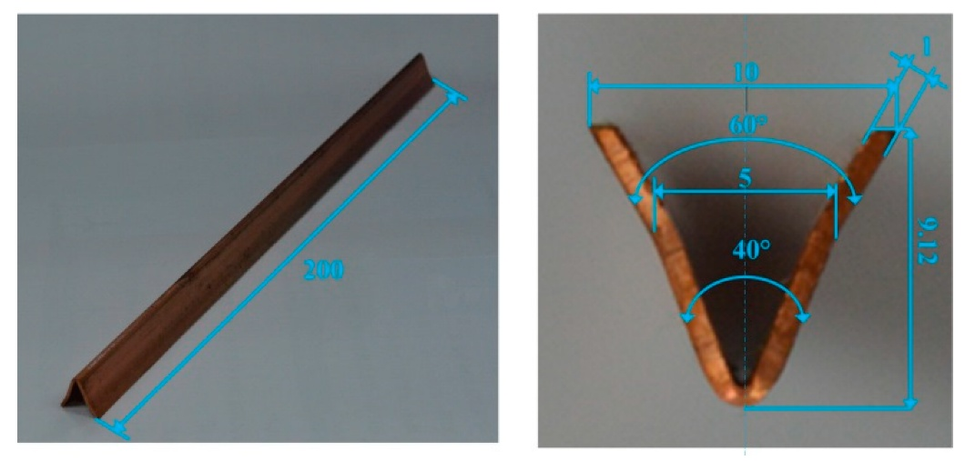
Figure 1: shaped charge with dimensions [3]
The model of this shaped charge constructed for simulation in this work was converted to a conical shaped charge rather than a linear one to better fit modelling limitations.
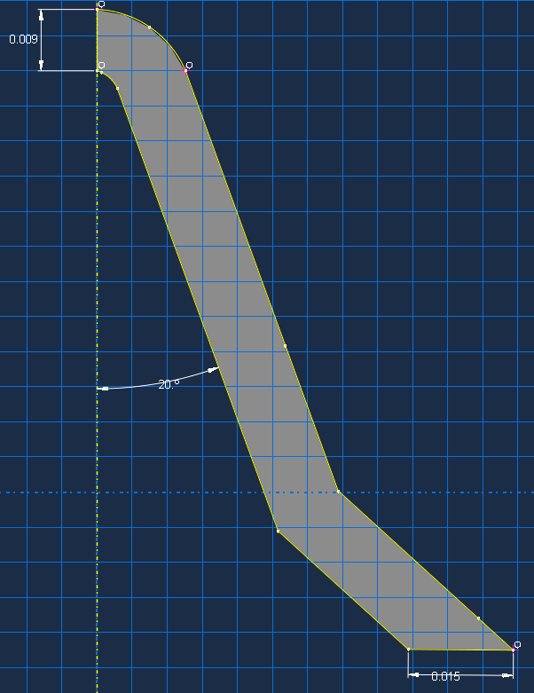
Figure 2: modelled shaped charge liner in ABAQUS
Figure 2 shows the completed liner component after modelling in ABAQUS. Two further components, the explosive charge/fill and a case to contain it were then modelled around the liner.
The final model used copper [4] for the liner, steel [5] for the casing and RDX [6,7,8] for the explosive fill. The model was initially constructed using PETN as the explosive fill, though it was immediately apparent that this was causing issues for the simulation, and resulted in extremely poor performance at driving the liner. As such, it was changed to RDX which provided much better performance, both in jet formation and general simulation running.

Modelling
When modelling a shaped charge, a range of software models can be used. In this specific case, the ABAQUS suite was used, as experience was held in this software making the learning curve easier on students. The assignment required assessing 2 different designs of shaped charge with a variance in a design parameter, for example, liner geometry, explosive type or liner thickness.
For this study it was chosen to initially look at the change in performance when a thick vs thin liner was used. The liner shown in figure 2 is the thicker of the two liners with an approximate thickness of 10mm, with the thinner liner having a thickness of approximately 5mm.

Eulerian
Eulerian simulation involves a fixed mesh that stays stationary during the simulation, the event is then simulated inside of this mesh. The mesh itself is rigid and doesn’t deform, instead the software tracks how all the elements would move through the mesh thereby removing the potential for the simulation to crash due to excessive element distortion. Because of the disconnect between the mesh and the simulation bodies, this type of simulation is good at simulating explosive detonations and shaped charge liners due to their high speeds, extremely high pressures and excessive deformation. It does, however, require a large amount of computing power to run successfully. [9,10]

Lagrangian
Lagrangian refers to the “standard” running of a simulation; one where a mesh is attached to the modelled parts to form elements. These elements, and thus the mesh and the model itself, deform when subjected to stress and strain. This allows for the stress patterns to be displayed across the modelled component/material itself as the simulation runs, with each element representing a tiny part of the material; this could be thought of as if the modelled part was built of Lego with each brick being an element. [9,10]

Smooth Particle Hydrodynamics (SPH)
Smooth Particle Hydrodynamics involves converting the elements in a simulation into smooth (spherical) particles when they pass a certain time step. This allows computing resources to be freed up and the simulation to continue running where it would have otherwise crashed. The software replaces the mesh of elements with a large number of particles that can’t be deformed further, only move/slide past each other as if they were the molecules in a liquid, thus alleviating the issue of overly deformed elements. With some tuning SPH can give an accurate representation of what a jet would look like later in its formation cycle, without highly distorted elements. [11]

Adaptive meshing
Adaptive meshing involves pausing the simulation after a certain given time step and re meshing the now changed geometry. This means that deformed elements are converted into a larger number of smaller, undeformed elements to allow the simulation to continue running without excessively distorted elements causing issues. This method can take a lot of time if appropriate computing resources aren’t available, due to the ever-increasing number of elements.

Comparison
Each method has its pros and cons as to why you should run each one, with each being optimised for a specific kind of physical interaction, use scenario or computing hardware available.
For the simulation within this report, Eulerian simulation allows for the best replication to the real world but is also the most computationally demanding, and as such takes the most time. However, the students have greater experience with langrangian simulation, and given the limited time and resource available, it was felt that this was the best option for this task. When combined with Adaptive Meshing and Smooth Particle Hydrodynamics, this could moderate the computational requirements and minimise the risk of issues due to excessive element distortion.

2D Modelling

Thick Liner
The focus of the meshing within the simulation was the liner, with a large proportion of the available elements (250,000 allowed on the ABAQUS educational licence) being utilised within the liner allowing to deform with the most realism.
Triangular (“Tri”) elements were used due to the liner shape, as it contains angles and curves that are difficult to mesh using square elements, and would result in the elements starting the simulation already deformed to a significant degree.
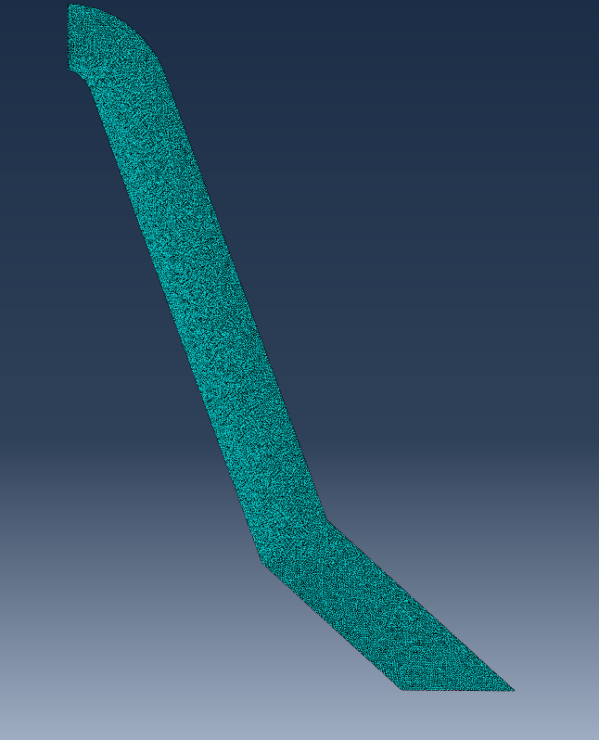
Figure 3: Thick liner meshing 1
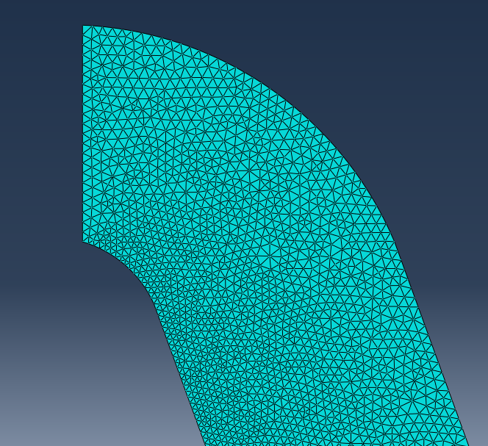
Figure 4: Thick liner meshing 2
Figure 4 shows the meshing of the liner up close and how there is a finer mesh in the leading edge and towards the apex of the cone as this is where the greatest amount of deformation will be occurring.
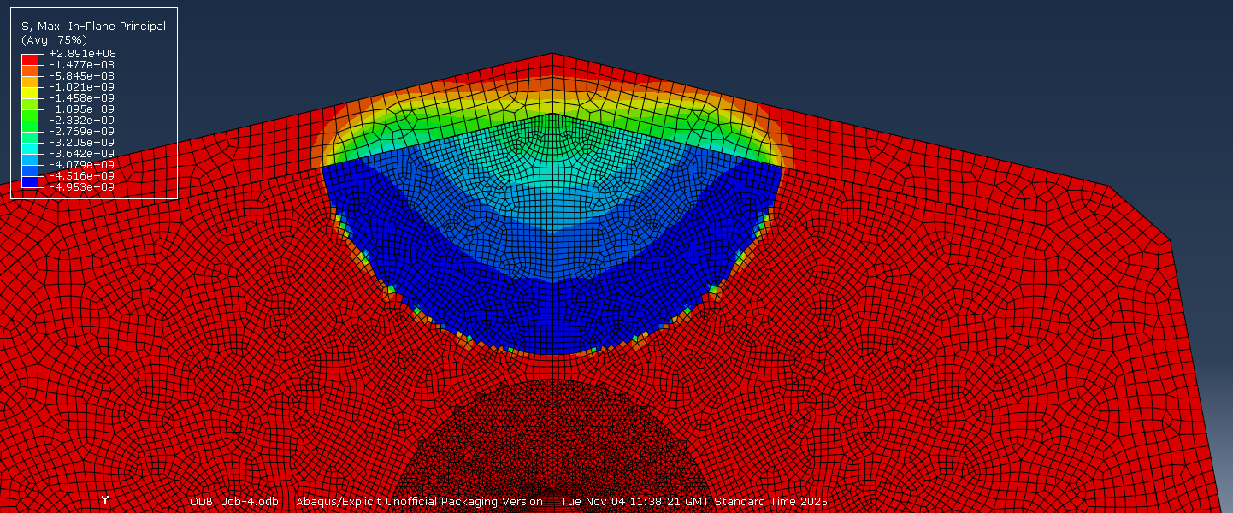
Figure 5: Detonation wave transferring
Figure 5 shows how the detonation wave transfers through explosive and then interfaces with the different material of the liner.
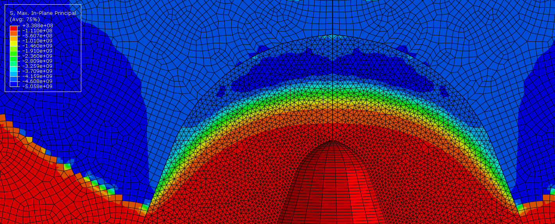
Figure 6: detonation wave propagation through the liner
Figure 6 shows how the detonation wave transfers into the liner and then travels at a different speed due to the differing density of the explosive fill and the liner, and the faster speed of sound within the copper liner, with a clear front of stress levels as the liner is compressed by the detonation wave.
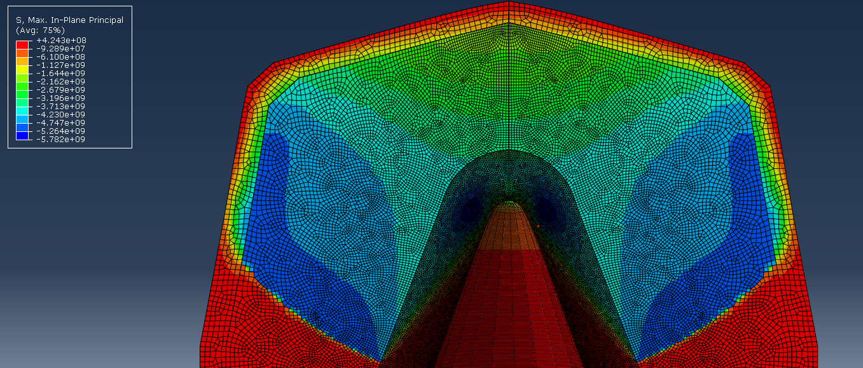
Figure 7: Late detonation wave propagation
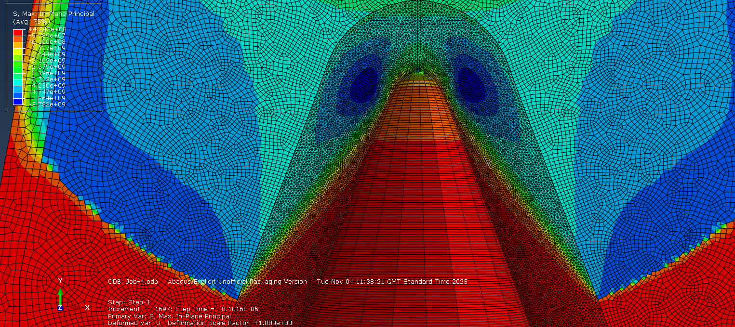
Figure 8: Late detonation liner wave propagation
Figure 8 shows the large gradient of stress and strain experienced by the liner as it begins to collapse and move towards forming a jet, with a strain hotspot surrounding the rear/apex of the liner where the material is being accelerated forwards and it want to tear away from the rest of the liner it is connected to.
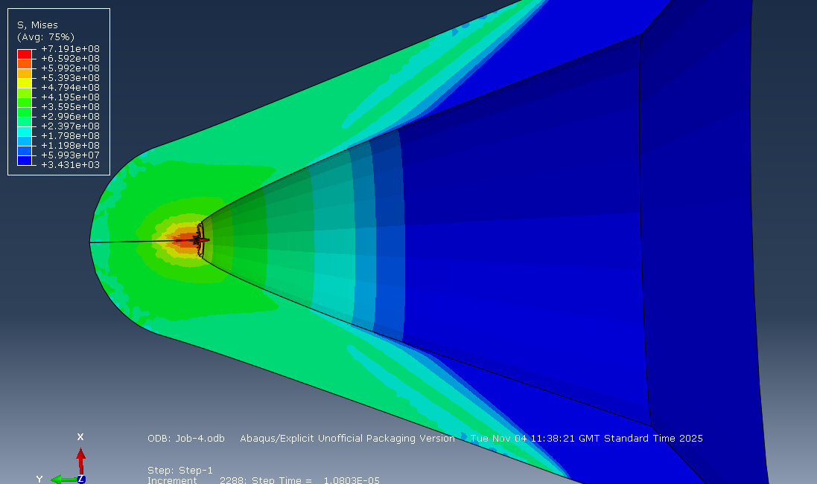
Figure 9: Liner stresses
Figure 9 shows compression of the liner at the apex (shown in red) where the jet is beginning to form. This shows how the liner is collapsing pushing inside apex of the liner forwards, forming the initial tip of the jet.
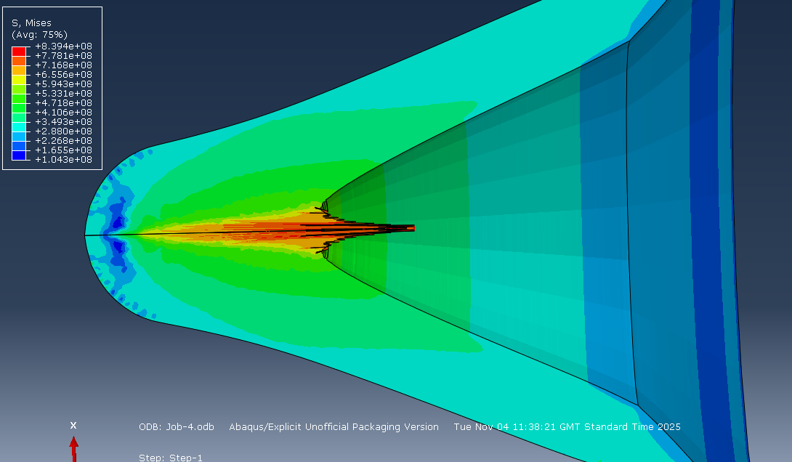
Figure 10: Liner stresses 2
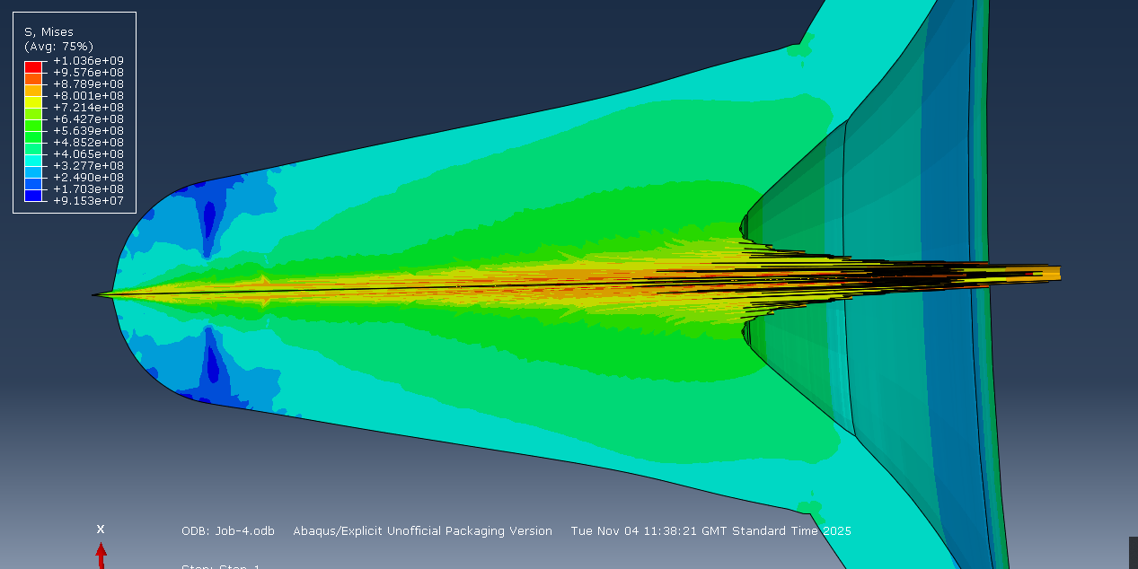
Figure 11: Liner stresses 3
Figures 10 and 11 shows the later stages of jet formation and how the stresses are incredibly high, with the liner collapsing increasing amounts and thus beginning to form the iconic shaped charge profile as the jet accelerates forward.
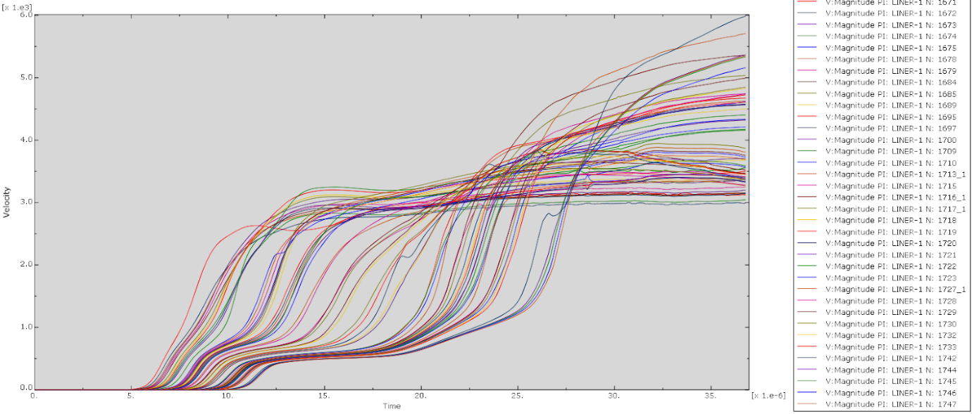
Figure 12: Jet velocities
Figure 12 shows the plot of the velocities for the front elements of the shaped charge jet. It contains a range of velocities, from 3000 m/s up to 6000 m/s with the majority falling in the 3250 m/s – 4600 m/s range. This is comparable to the modelling results from the source the charge came from.[1] The paper shows with a liner of 10 mm velocities in the range of 2500 m/s – 3500 m/s. This comparability shows how if modelled correctly results can be similar between modelling solutions.

Thin Liner
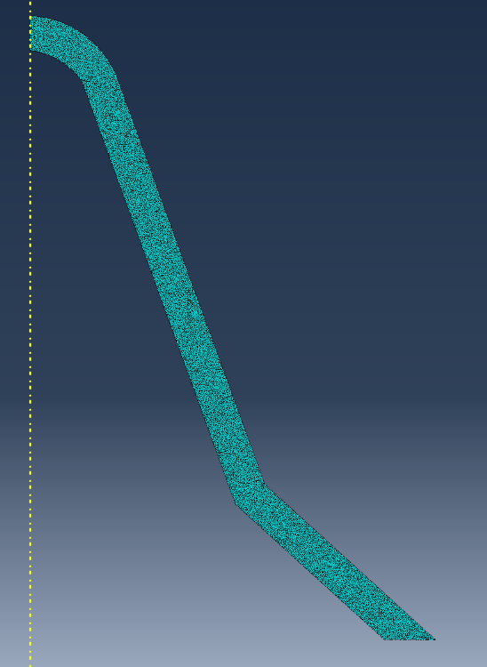
Figure 13: Thin liner meshing
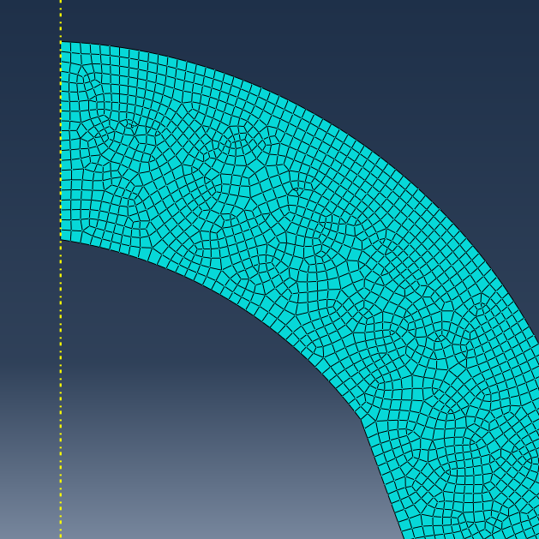
Figure 14: Thin liner meshing 2
Figures 13 and 14 both show the meshing of the liner, and how it is slightly coarser that the previous run with the first, thicker liner. This allowed this simulation to run more smoothly and for longer before crashing. This shows how have a massively fine mesh is not necessarily the best way to improve simulation performance, as whilst smaller elements reduce the amount of distortion, they require a larger amount of computing power to track and model accurately.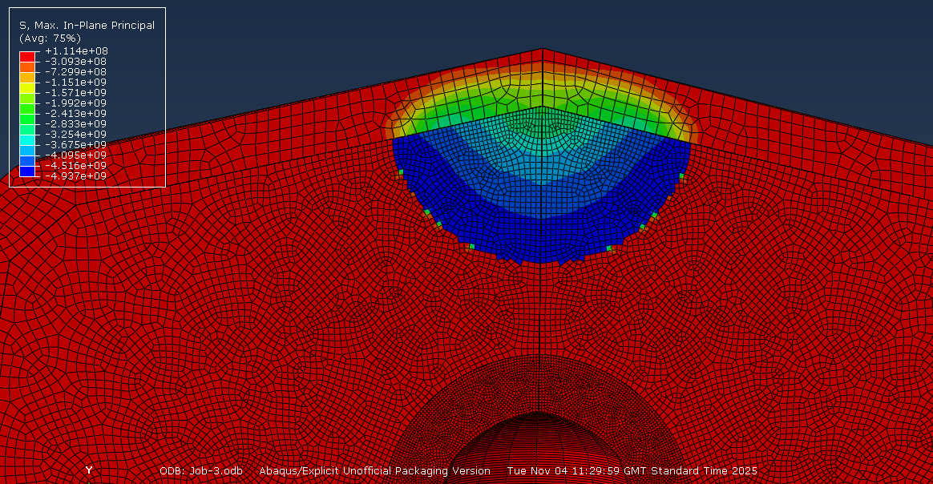
Figure 15: detonation wave propagation
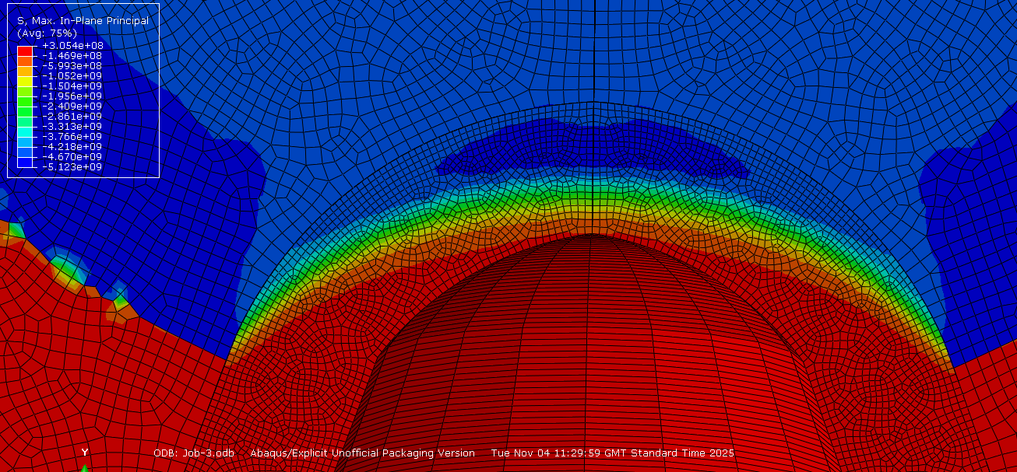
Figure 16: Detonation wave transition to liner
Figures 15 and 16 shows the initial wave propagation from the detonation point, down through the explosive a into the liner. It shows the different wave speeds in the materials due to the differing density of the explosive fill and the liner, and the faster speed of sound within the copper liner.

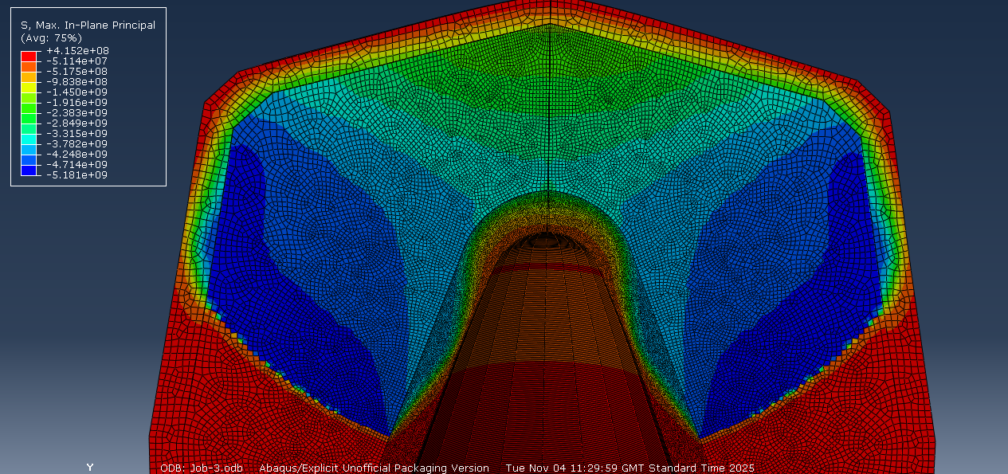
Figure 17: Detonation wave progression
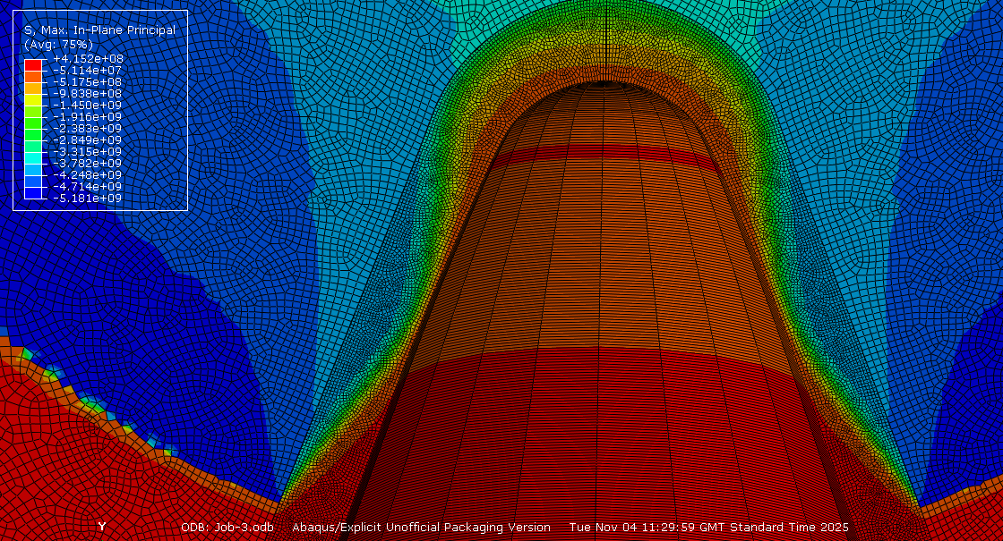
Figure 18: detonation wave propagation through liner
Figures 17 and 18 both show the same time step and how it clearly displays the detonation wave moving through the liner with a clear peak and trough shown where the high pressure front has moved through.
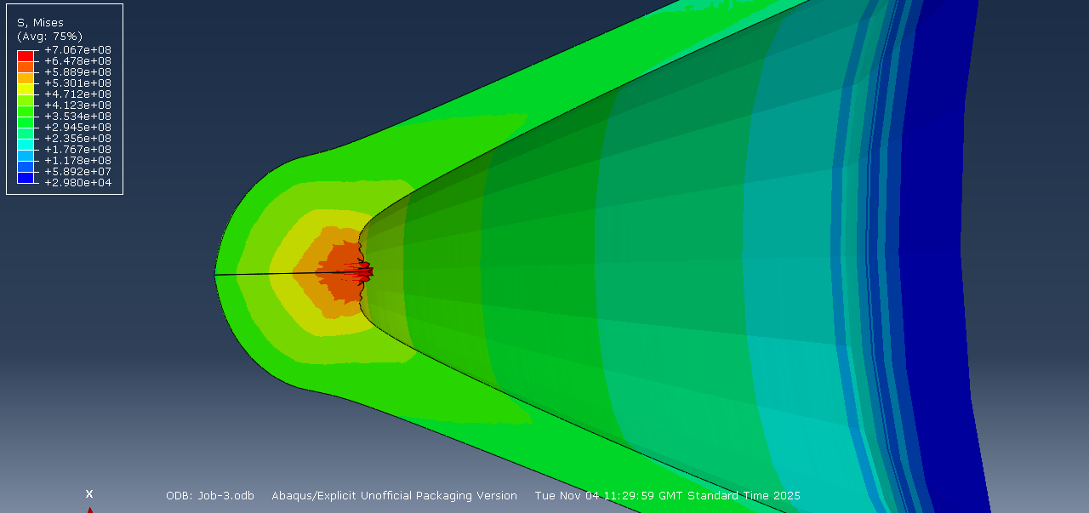
Figure 19: Jet formation
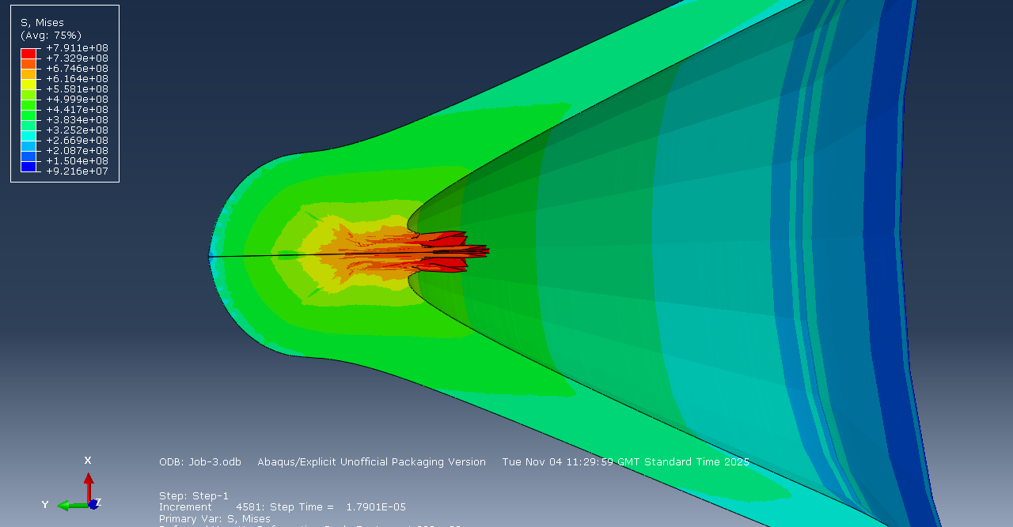
Figure 20: Jet formation 2
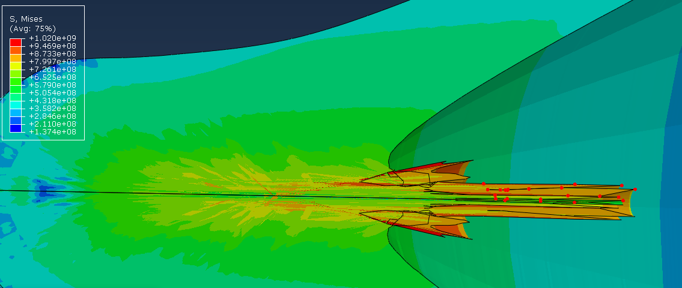
Figure 21: Jet formation 3 and velocity plot
Figures 19, 20 and 21 all highlight how the coarser mesh has allowed this simulation to run for longer as the jet can be seen extending even further in front of the cone that in the previous example. The stresses shown are largely compression in these examples but in figure 21 some tension can be seen towards the back of the jet where it can be assumed the copper in the liner is being pulled forward by the material that has been propelled by the initial shock wave.
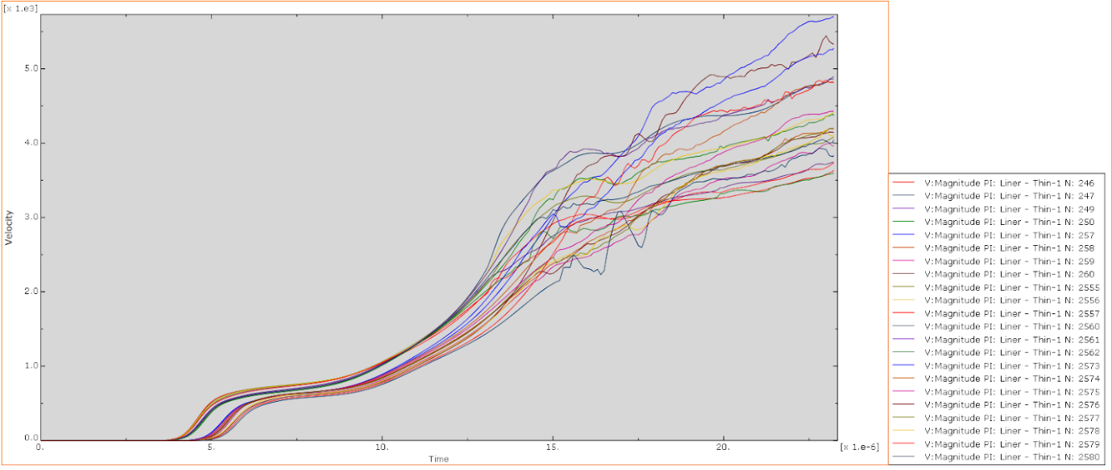
Figure 22: Velocity graph
This velocity graph shows how the values fall into the range of 3500 m/s – 5750 m/s with the majority in the range 3500 m/s – 4900 m/s. The data displayed in the original source shows a 5mm liner (assumed as falling between the values of 4mm and 6mm) as having velocities approximately 3500m/s – 5000 m/s. this places this liner in the exact right ballpark as the initial simulation this is being compared to showing its accuracy.

Comparison
Both the thick and thin liner fell within the reasonable bounds for the velocities expected and performed well under simulation. The decision has been made to move forward with the thinner liner for 3D modelling, this has been done for a number of reasons.
When modelling in 3D the element and node limits imposed by the software become an immediate concern as 3D modelling uses considerably more elements that 2D modelling meaning the models have to be coarser. This issue became clear when initially attempting to mesh the thicker liner in 3D, the number of elements in that part alone exceeded the number allowed for the whole simulation. This thinner liner allows for a greater mesh size to be kept for the part and it is twice as this allowing for a large number of elements to be removed while keeping the same level of accuracy.
The paper this shaped charge design was taken from also has a graph of velocity results of a range of different modelled explosive compounds which includes C-4. C-4 is made up of large majority RDX with 91% being the explosive compound with the remaining 9% being made up of plasticiser [12] and a trace amount of taggant to trace the explosive. Considering how similar raw RDX and C-4 will behave when detonated, I will be using this as a more accurate comparison for the 3D model.
To summarise, this paper will now look at the modelling of the 5 mm liner in the 3D plane as well as implementing an advanced simulation technique, this is due to have better data from later comparison and an easier time of accurately simulating the charge.

3D Modelling

Simple Techniques
The meshing for the 3D model was carefully adjusted to just sit within the limits of the ABAQUS (student) software licence limit of 250,000 elements. This did involves using a much coarser, less than ideal mesh for both the explosive and the liner since the 3D model uses a far greater number of elements in a full 360-degree model rather than one 2D “slice”. Consideration will be given to this in the conclusion.
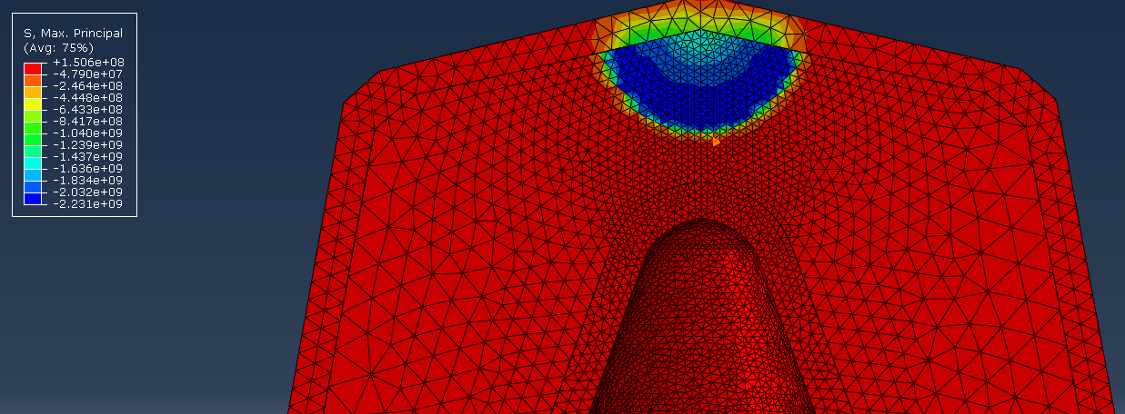
Figure 23: Initial blast propagation
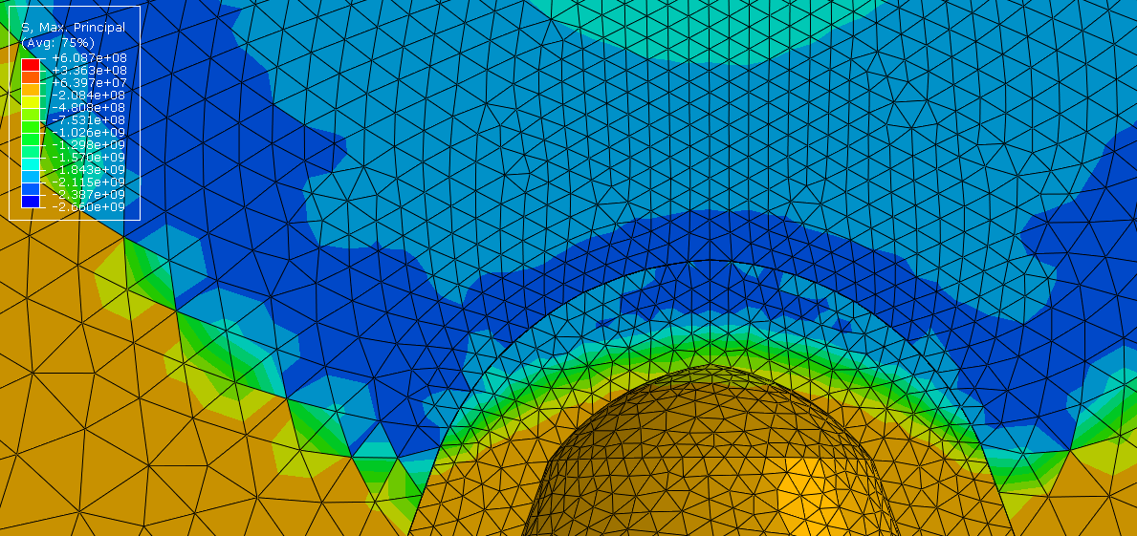
Figure 24: Detonation wave transfer to liner
Figures 24 and 25 both show the initial detonation wave propagation through the explosive and liner with different pressure wavefront clearly seen inside both the reacted explosive and the liner and the wave transfers. This stress is all compressive, this is well shown in figure 23.
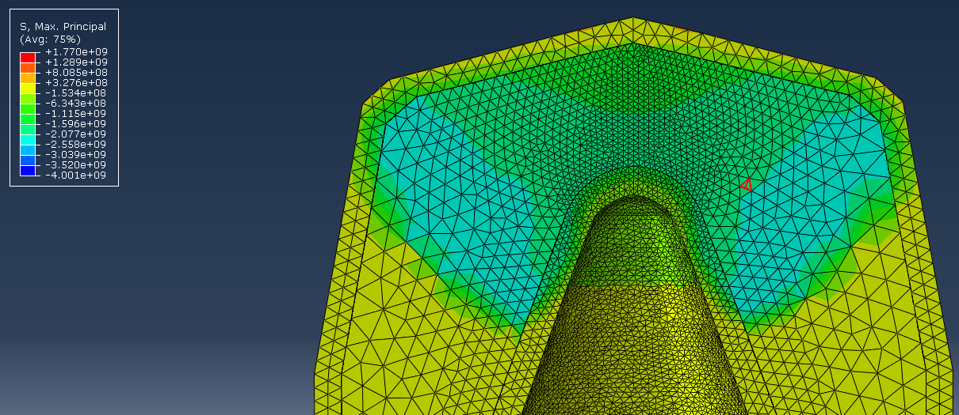
Figure 25: Further detonation wave propagation
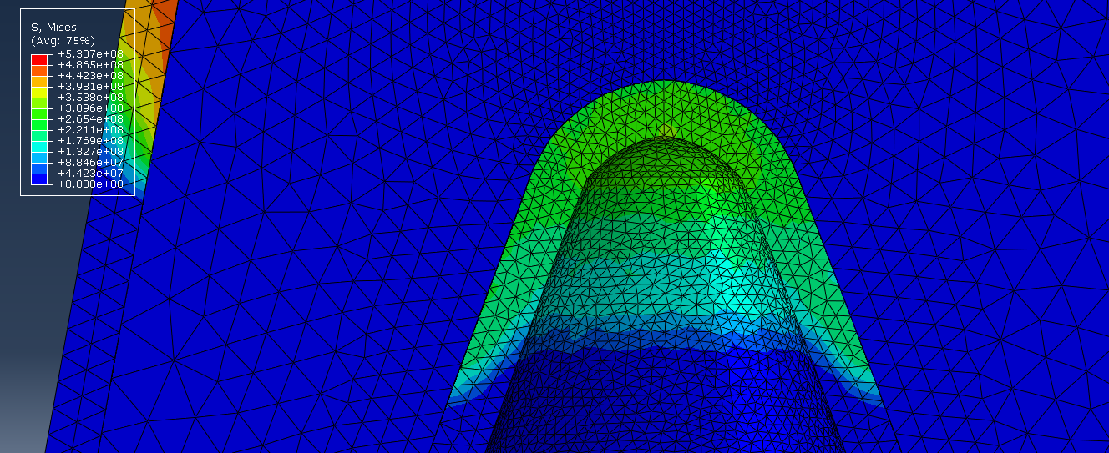
Figure 26: Detonation wave propagation in the liner
Figures 25 and 26 further show how the detonation wave progresses through both materials with slight differences in speed and exact nature of propagation.
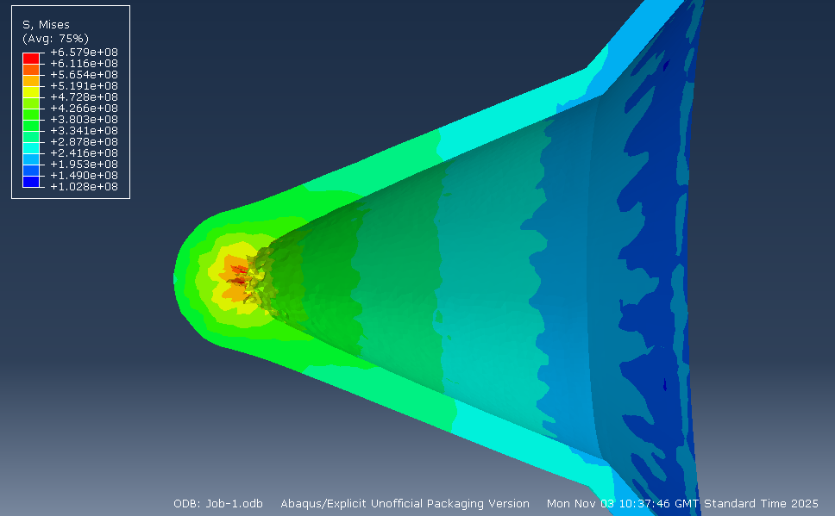
Figure 27: Initial jet formation
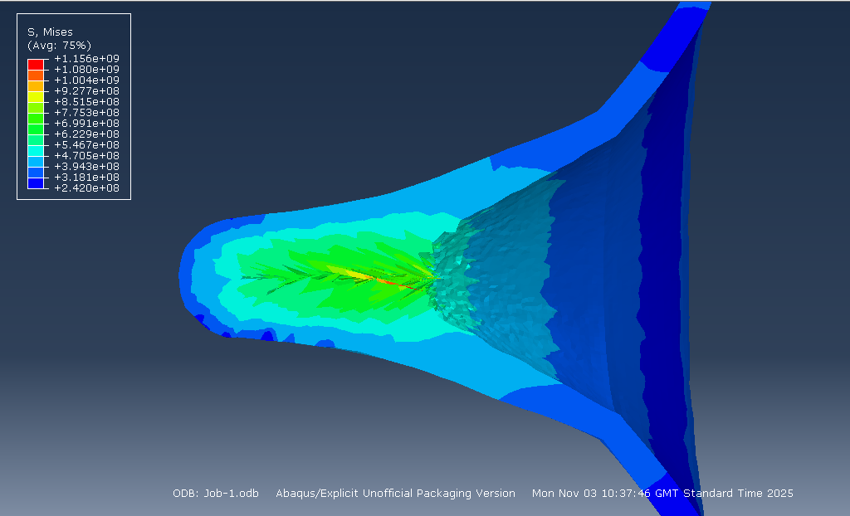
Figure 28: Jet formation 2
In figures 27 and 28 the jet can be seen starting to form. However, in the 3d example it looks different to the models seen in the 2d example with a lot more pointed ends of elements implying greater distortion and perhaps not as accurately representing the charge. The distortion is well showcased with a singly highly distorted element seen in red across the centre of figure 28. The stresses this individual element is undergoing are massive compared to the other elements around it already showing potential issues with this method.
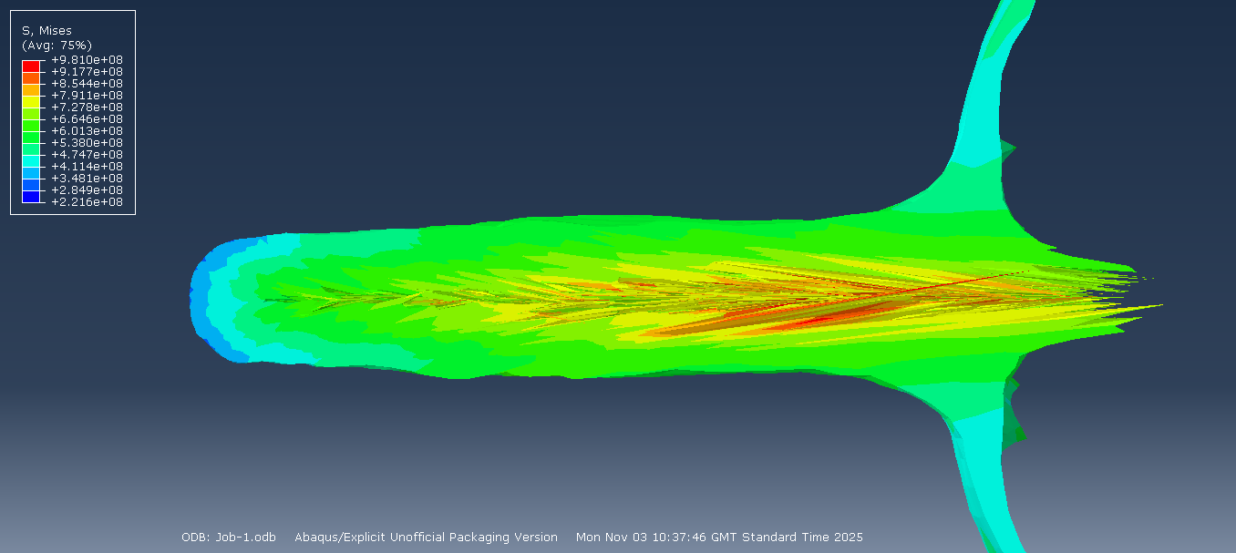
Figure 29: Jet formation 3
Figure 29 shows the jet formation at the time of the simulation crashing. This outline looks very similar to ones shown in the paper though it is missing most of the jet shooting out of the front of this shape. It is unclear why this is occurring, but it is hypothesised this is due to instead of rear elements being properly pushed forwards they are instead greatly distorting making the simulation harder to run and not giving accurate results.
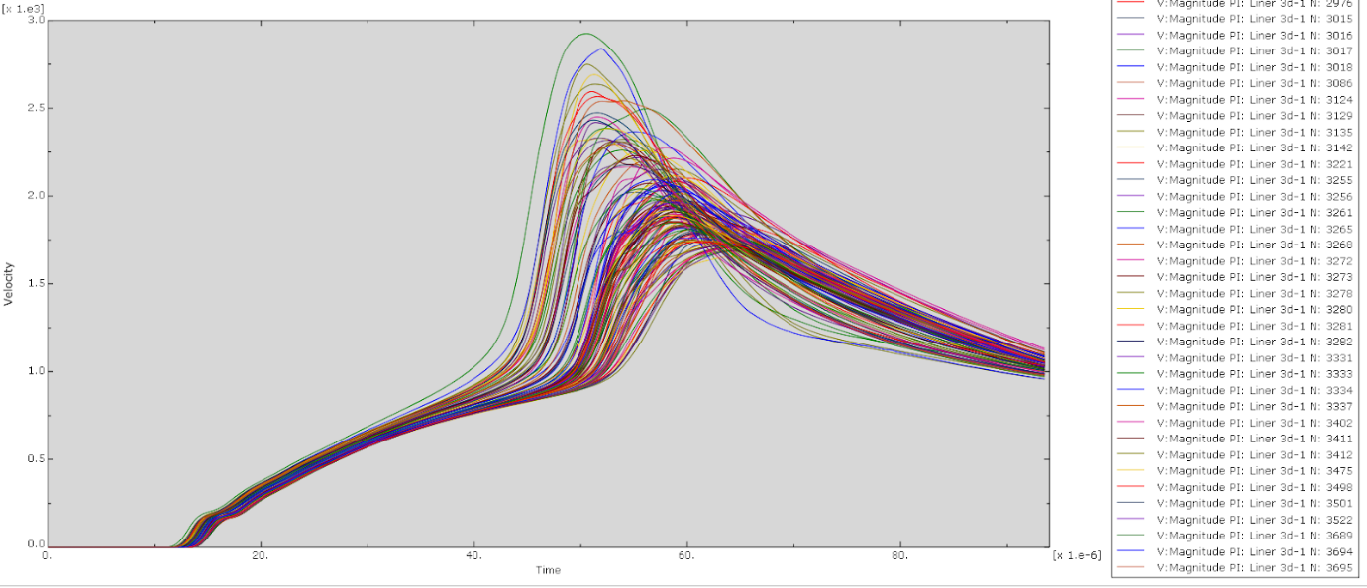
Figure 30: Velocity plot
The velocity plot shown in figure 30 is another example of how the 3D simulation seems to not be running correctly. It shows the jet to have a very uniform velocity with a range of only approximately 950 m/s – 1150 m/s, this is massively below what would be expected of a shaped charge. The deviation from the expectation and the previously modelled results imply that this simulation is flawed in some way and needs to be worked on and improved to give more accurate results.

Advanced meshing techniques
After completing a basic simulation approach, it was selected to attempt to use Smooth Particle Hydrodynamics to allow the simulation to run for longer and the jet to fully form and show the correct formation. It was hope that this new method would allow the once heavily distorted elements to convert to particles and travel along their correct trajectory.
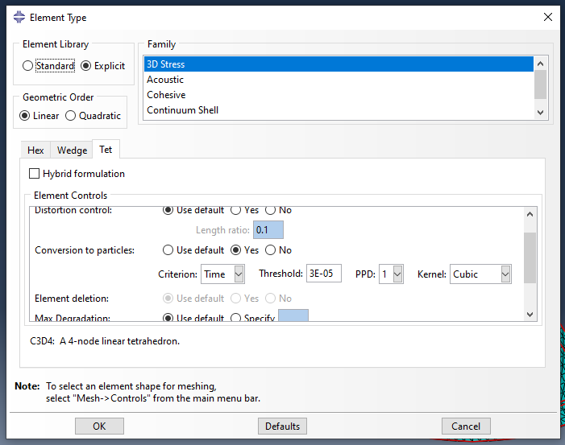
Figure 31: SPH parameters
When initially trying to run SPH a number of errors was run into relating to a number of issues. Having consulted with the lecturer, effort was made to resolve these. Initially the simulation would reach the first time step and then not convert to particles. This was accompanied by an error relating to the smoothing length of the particles. This value could not be edited inside ABAQUS, and thus edits had to be made to the software file which was then run via windows command line. This initially solved a number of errors but still left with the elements not converting to particles.
After numerous attempts were made to resolve this error and after discussing potential next streps with the lecturer it was agreed this was a lost cause and to attempt a different advanced simulation technique.
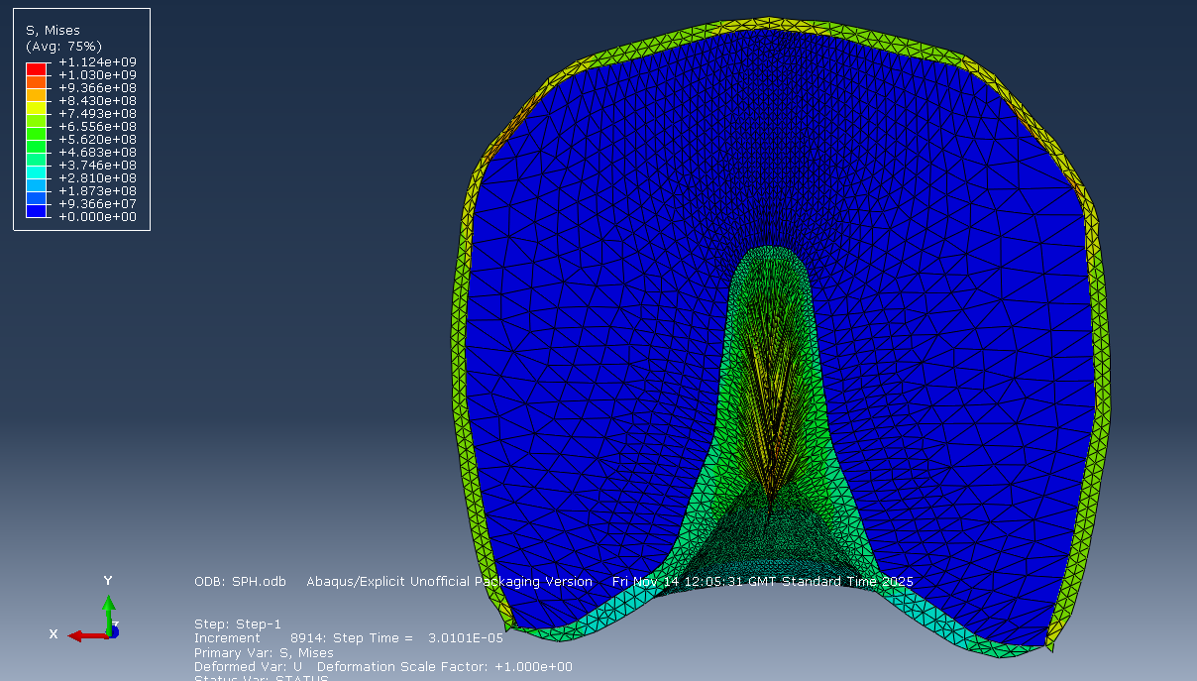
Figure 32: Simulation running post conversion point
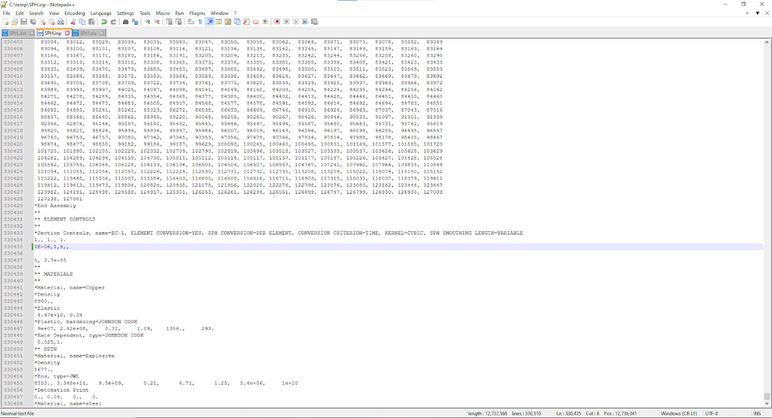
Figure 33: Changes made to the code inside the software

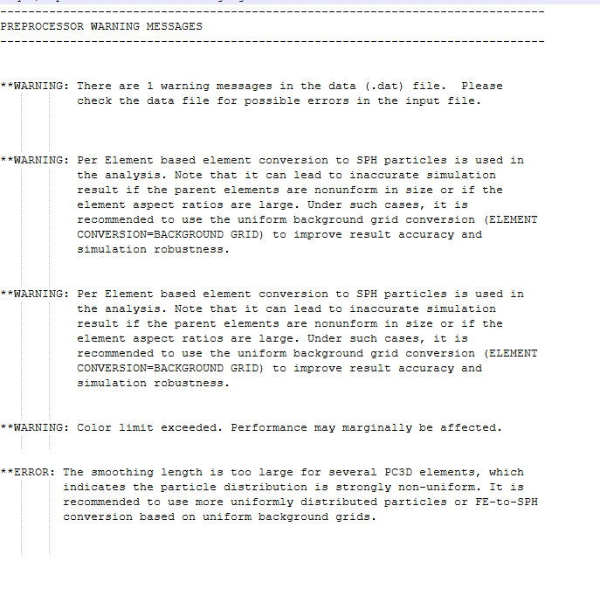
Figure 34: Error messages 1
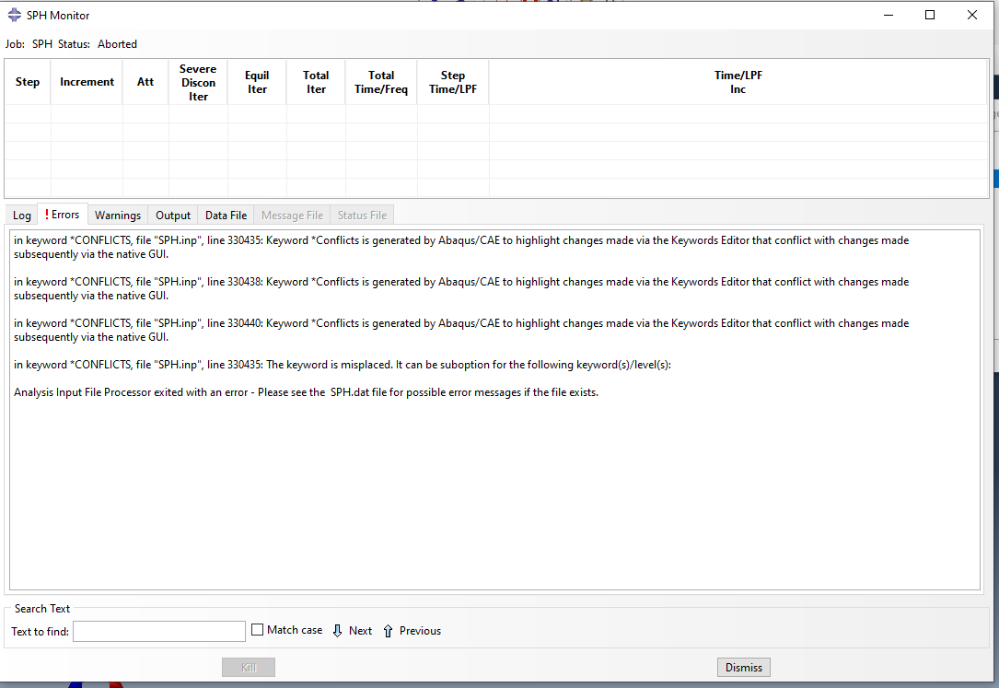
Figure 35: Error messages 2
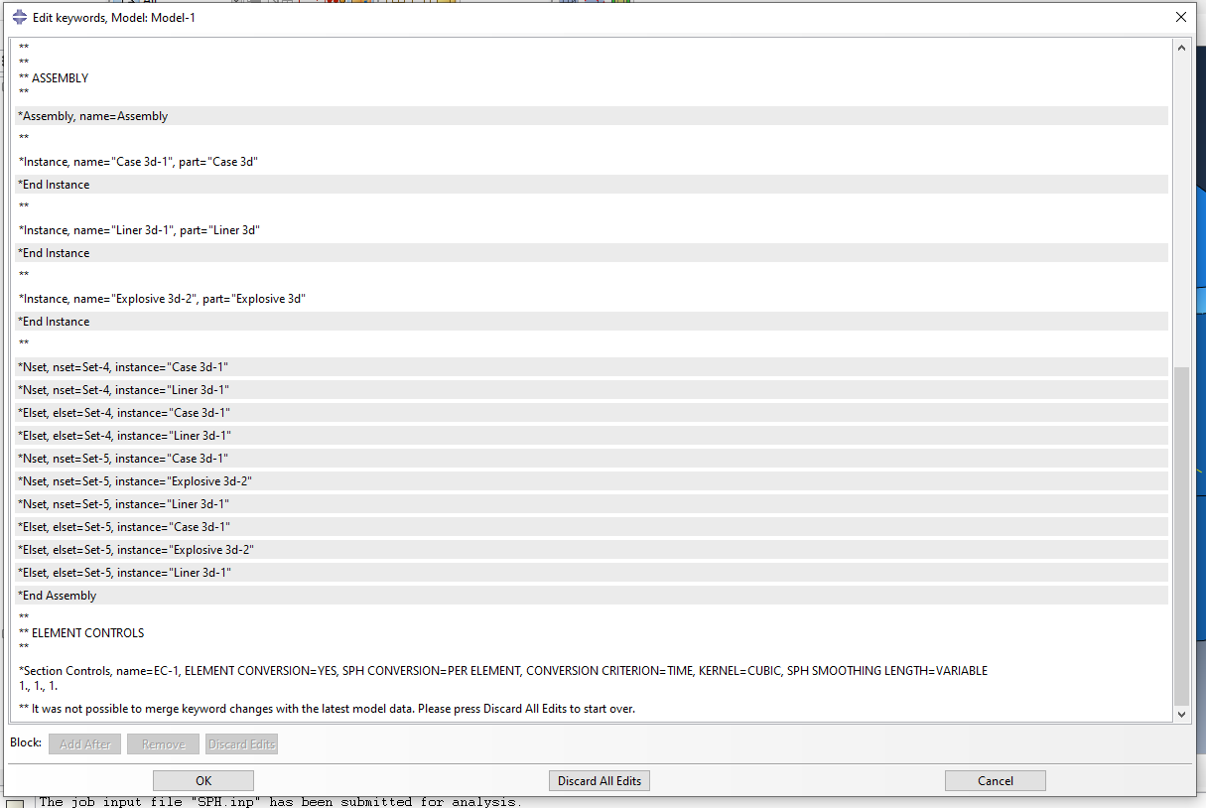
Figure 36: Smoothing length controls inside the job code

Adaptive Meshing
Adaptive meshing involves pausing the simulation after a certain given time step and re-meshing the now changed geometry. This means that deformed elements are converted back into a larger number of smaller undeformed versions to allow the simulation to continue running with less risk of excessive element distortion. This method can take a lot of time if appropriate computing resources aren’t available. Due to the time spent trying to fix SPH there was not enough time to properly explore adaptive meshing and therefore it will be brought up in the conclusion as potential future work to improve this simulation.
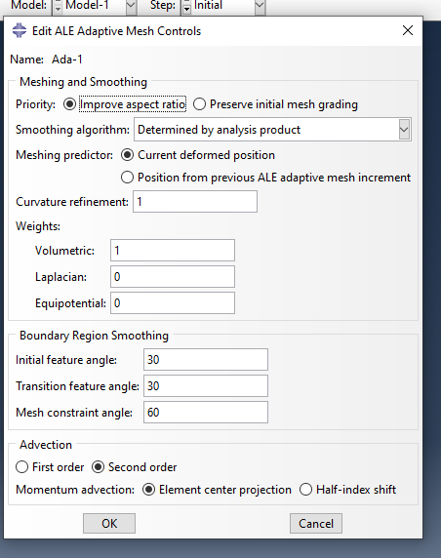
Figure 37: Adaptive meshing controls

Comparison
2D and 3D both have their pros and cons when it comes to simulations with 3D often offering a better look at how realistic, complex 3D structures behave under complex forces. 2D simulations are usually less complex or simplified versions of the 3D structures, but this allows for them to have greater detail within software /processing limits with parts broken down into more elements meaning they can be more accurately represented.
In the case of this simulation of the shaped charge, the evidence gathered during these simulations clearly shows the 2D simulation is superior, this is because not only does the simulation give a better picture of the shaped charges jet formation, but it also has more precise results on the velocity plots. In comparison the 3D simulation provides generally worse results, looking worse in the deformation of the elements and also falls flat on the velocity comparison with results falling well below what is expected.
The 3D simulation clearly needs more work put into it to get effective results, with adaptive meshing likely being the first thing that should be attempted. This would allow the simulation to run for longer and hopefully generate better results.
These simulations, whilst different, clearly show how effective these methods are at representing real design changes, with clear differences being present between the initially attempted PETN and RDX explosive fill and the 10mm and the 5mm shaped charge liner thickness.

Discussion
While writing this report it was noticed that a mistake was made on the scaling of the shaped charge. What should have been mm was interpreted as cm as no units were given on the reference image. This was identified post-simulation via re-reading the reference text. This has caused the shaped charge modelled to be 10x bigger than intended. Whilst an unintentional error, it has shown that in theory, to a certain extent, the scale on a model such as this matters a bit less if the percentage error is kept exactly the same across all of the values. With the shaped charge liner intended to be 1mm and 0.5mm instead of 10mm and 5mm, which in hindsight does seem thick for a cutting charge blade. Although, in final (simulated) practice this error was offset by the 10x larger quantity of explosive placed to drive it.
There may have been potential benefits to doing it this way as the values being calculated were further away from zero allowing the simulation to deform them further before reaching an error. And it also opens up an alley for further research into whether this phenomenon was one of luck or Is a scalable idea that can be potentially trialled. This could allow for designed to be mocked up on a smaller mm/cm scale before being placed into larger weapon systems to reduce the costs or research and development.
The errors causing the 3D code not to run properly were likely user caused and had more time been available for practical work a solution could have been found by reworking the simulation from the ground up and comparing the two files. This would both provide the user with more experience with the ABAQUS software suite, complex problem solving and shaped charge modelling as a whole.

Conclusion
2D and 3D modelling have been proven to be effective methods of analysing shaped charge designs as performance differences could easily be seen between different cone geometries and different explosive types. This had given more time for the learning of different systems and the building of expertise with modelling in relation the OME field building on the first physics module.
It gave a clear understanding of the different types of modelling and advanced software simulation methods and when you might want to apply them to augment a simulation that is otherwise having issues or to gain greater confidence in your results by validating then in another way.
The task also highlighted the exact nature of simulation software, and how one seemingly minor number, change or setting can have a drastic effect on the final outcome.

References
[1] J. C. Stroub et al., Investigation of Dome Shaped Charge Jet Formation Using A High Speed X-Ray System, U.S. Army Ballistic Research Laboratory, Technical Report AD-A220095, Nov. 1990. [Online]. Available: https://apps.dtic.mil/sti/tr/pdf/ADA220095.pdf
[2] P. R. Gudheti, A. Patel, and S. De, “Numerical simulation of high-velocity impact using coupled Eulerian–Lagrangian approach,” Int. J. Impact Eng., vol. 180, Aug. 2025. [Online]. Available: https://www.sciencedirect.com/science/article/pii/S0734743X25001769
[3] T. Z. Khan, K. Choudhry, S. Riaz, and M. Ahmad, “Finite element modelling of material deformation: comparison between Eulerian and Lagrangian approaches,” Appl. Sci., vol. 8, no. 10, p. 1863, Oct. 2018. [Online]. Available: https://www.mdpi.com/2076-3417/8/10/1863
[4] Massachusetts Institute of Technology, “Material Properties of Copper.” [Online]. Available: https://www.mit.edu/~6.777/matprops/copper.htm
[5] Senthil K., M. A. Iqbal, P. Bhargava, and N. K. Gupta, “Experimental and numerical studies on mild steel plates against 7.62 API projectiles,” Procedia Engineering, vol. 173, pp. 369–374, 2017. Available: https://www.sciencedirect.com/science/article/pii/S187770581634423X?ref=pdf_download&fr=RR-2&rr=9b9bf2a409f1d7e3
[6] T. J. Ahrens et al., “Shock compression of condensed matter,” in EPJ Web of Conferences, vol. 10, 2010. [Online]. Available: https://www.epj-conferences.org/articles/epjconf/pdf/2010/09/epjconf_nmh2010_00007.pdf
[7] T. J. Ahrens, High-Pressure Shock Compression of Solids, Wiley-VCH, 1994, ch. 1. [Online]. Available: https://application.wiley-vch.de/books/sample/3527349383_c01.pdf
[8] Q. L. Chen et al., “Smoothed particle hydrodynamics simulation of fluid flows,” Chinese Phys. B, vol. 25, no. 7, Jul. 2016. [Online]. Available: https://cpb.iphy.ac.cn/article/2016/1836/cpb_25_7_076202.html
[9] M. Rakhsha, C. E. Kees, and D. Negrut, “Lagrangian vs. Eulerian: An analysis of two solution methods for free-surface flows and fluid–solid interaction problems,” Fluids, vol. 6, no. 12, p. 460, 2021. [Online]. Available: https://www.mdpi.com/2311-5521/6/12/460
[10] J. R. Asay and M. Shahinpoor, “Comparison of Lagrangian and Eulerian finite element approaches in shock physics,” Int. J. Numer. Methods Eng., vol. 62, no. 5, pp. 600–614, 2005. [Online]. Available: https://www.sciencedirect.com/science/article/pii/S0045782505001982?via%3Dihub
[11] C. Zhang, Y. Zhu, D. Wu, and X. Hu, Review on Smoothed Particle Hydrodynamics: Methodology Development and Recent Achievement, May 2022. [Online]. Available: https://arxiv.org/abs/2205.03074
[12] U.S. Government Accountability Office, Production, Distribution, and Storage of C-4 Explosive, June 1990. [Online]. Available: https://www.gao.gov/assets/nsiad-90-139fs.pdf

