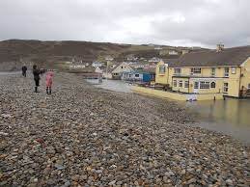

Newgale Road Relocation
EIA Analysis

Trace King | Sustainable Construction | 2021
Table of Contents
Table of Figures 1
Abstract 2
1.0 Introduction 2
2.0 What is an Environmental Impact Assessment? 2
2.1 Stages of EIA 4
Screening 4
Scoping 4
Environmental Statement Preparation 4
Consultation and submission of a planning application 5
Decision Making 5
2.2 Legislation Of EIA uk 5
2.3 EIA Case Study 6
3.0 The Proposed development 6
3.1 Why is The Project Proposed? 7
3.2 Impact on Local Community 8
3.3 Future Risks and Health Implications. 8
4.0 Evaluation of EIA 9
4.1 Strengths 9
Noise Levels. 12
Air Quality 14
GreenHouse Gas Emissions 15
Landscape and Townscape 16
4.2 Weaknesses 17
5.0 Conclusion 17
References 18

Table of Figures

Abstract

Newgale beach is predicted to be encroaching on the existing road within the next 20 years. Atkins and Pembrokeshire County Council have developed proposals to mitigate this.
This report analyses the depth of the report and highlights the issues that creating a new road would cause. The protection of residents, wildlife and the levels of CO2 that this new road would cause are potential causes for concern.

1.0 Introduction

The purpose of this report is to define an Environmental Impact Assessment (EIA) and to explain how they are used in conjunction with planning applications to local government bodies. In addition, it will be used to highlight when an EIA is required and the stages of the assessment process, both prior to and between planning applications. A case study will also be used to evaluate the EIA's overall effectiveness and to determine whether the EIA addressed all the potential environmental impacts associated with the project in question, as well as to critique the assessment and identify key areas for improvement. A comprehensive evaluation will then be conducted to determine whether the Environmental Impact Assessment was thorough and effective, or ineffective and lacking in required information. After evaluating the case study, recommendations will be made regarding the EIA and how it can be improved.

2.0 What is an Environmental Impact Assessment?

EIA is a comprehensive information gathering exercise carried out by the developer that allows a local planning authority to understand the environmental effects of a development before deciding whether the project can go ahead or not.
The emphasis on using the best available sources of objective information and for developers to compile information in a systematic, holistic, and robust manner is crucial to EIA. In theory, a well-researched and objective EIA submission should enable the entire community to fully comprehend the true impact of the proposed development.
An EIA should result in higher development standards and, in some cases, no development at all. EIA also aids in determining the effectiveness of mitigation measures proposed for a development and whether they will ensure that no significant impact occurs.
EIA should be a methodical process that results in a final written product, known as the Environmental Statement.
To ensure the validity of the EIA, they should be conducted over an extended period to observe seasonal animal migration habits, as short-term observational studies frequently produce skewed data and miss species occupation.
In the United Kingdom, EIA is mandated by the European Union's EIA Directive. The Town and Country Planning (Environmental Impact Assessment) Regulations 2017 in England implement the Directive. Wales, Scotland, and Northern Ireland all have similar regulations. Official guidance on the interpretation of Regulations and the procedures for evaluating ESs is available online.
Separate legislation governs EIA for development not covered by town and country planning laws, such as highways, power plants, water resources, land drainage, forestry, pipelines, and harbour works. Several of these will be classified as nationally significant infrastructure projects, which the Planning Inspectorate will oversee on behalf of the Secretary of State under the 2008 Planning Act.
To determine whether an Environmental Impact Assessment is required, a project is classified into Schedule 1 or Schedule 2.
Schedule 1 developments or projects are generally those with the potential for the greatest environmental impact, coastal flood defenses, new roads, large industry, power generation. This scale of development always requires an EIA, and if one is not completed, the project will be automatically denied planning permission.
Schedule 2 developments do not always require an EIA; this is dependent on factors such as the size and location of the project. Wind farms, small industrial developments, golf courses, and larger housing proposals are all examples of Schedule 2 development. Other examples include vacation villages and other tourism-related items. If your development falls under Schedule 2, it is recommended that it be screened to determine whether an EIA is required. This would be handled by the local government.

2.1 Stages of EIA

The government specifies five stages that must be completed in order to complete an Environmental Impact Assessment.

Screening
Determining whether a proposed project falls within the scope of the Schedule 1 or 2 Regulations and whether it is likely to have a significant environmental impact, necessitating an assessment.

Scoping
Identifying the scope of issues that should be considered during the assessment and reported in the Environmental Statement. The applicant may request a scoping opinion from the local planning authority regarding the information that should be included (this is referred to as a 'scoping opinion').
The Town and Country Planning Regulations 2017 require that copies of an EIA scoping opinion for a project be made available for public inspection. This will enable members of the local community to voice their concerns about a development and to inspect the assessment conducted by the Local Authorities, as well as their final opinion on whether an EIA will be completed.

Environmental Statement Preparation
If an assessment is determined to be necessary, the applicant must prepare and submit an Environmental Statement. The Environmental Statement must include at a minimum the information reasonably necessary to assess the development's likely significant environmental effects and to comply with regulation 18(3). (4).
To ensure the Environmental Statement's completeness and quality, the developer must ensure that it is prepared by competent experts. The Environmental Statement must be accompanied by a statement from the developer describing the developer's expertise or qualifications in relation to the subject matter.

Consultation and submission of a planning application
The Environmental Statement (along with the development application to which it pertains) must be made available electronically and via public notice. The statutory ‘consultation bodies' and the general public must be consulted on the proposed development and the Environmental Statement. “The Environmental Statement must be placed on Part I of the planning register, as should any related screening or scoping opinion or direction as soon as possible after publication” (Gov.uk, 2020)

Decision Making
The Environmental Statement, along with any other relevant information and any comments or representations made on it, must be considered by the local planning authority and/or the Secretary of State when determining whether to grant consent for the development. The public must be notified electronically and via public notice of the decision and the primary reasons for it.

2.2 Legislation Of EIA uk

The Town and Country Planning Act of 1990, “An Act to consolidate certain enactments relating to town and country planning (excluding special controls in respect of buildings and areas of special architectural or historic interest and hazardous substances) with amendments to give effect to Law Commission recommendations,” is a significant law (Town and Country Planning Act, 1990). This Act establishes policies for development and land use changes in an area, considering the area's appearance, physicality, and environmental impact as a result. The Act establishes guidelines for local planning and granting permission to construct or develop projects of all types. Additional revisions have been made to this Act to ensure that the legislation is current and to provide a framework for new uses that may have an environmental impact. Although the Town and Country Planning Act 1990 contains a substantial amount of framework, the decision-making process is highly variable depending on the location, nature of the project, anticipated environmental impact, and opinion of stakeholders and the Local Authority, which can be significantly influenced by biased and personal opinions, and restrictions on construction in areas such as national parks.
The UK's regulations have been criticised for not fully interpreting the EIA Directive's spirit. Individual cases involving large-scale development proposals have sparked contentious debates about the quality of the EIA conducted. Third parties have also complained to the European Commission about the UK government's failure to fully implement the EU Directive on environmental impact assessment. Such issues are still being litigated in the courts.
The UK left EU on 31 January 2020. A transition period ended on 31 December 2020, during which the UK continued to be treated as an EU member state and subject to EU law. The EIA Directive has been transposed into UK law through the EIA Regulations, which will remain in force until they are revised.

2.3 EIA Case Study

Our case study in this report is one which EIA data is exceptionally important both to monitor current damages being caused to the area, residents, and wildlife, as well as the proposed development to alleviate the inconvenience of those effected by the current frequent storm and flood damages.
We will critique the EIA submitted to Pembrokeshire County Council for the development of a new road to bypass Newgale beach which will result in fewer road closures, and inconvenience to the residents. Several options were presented in order to provide the most suitable solution for an alternative to the current A487. (Atkins, 2017)

3.0 The Proposed development

A route redirection removing through access at the point of Newgale village to mitigate future modelled issues with the loss of road along the beach front behind the shingle bank. A choice of proposals were presented for discussion from raising the current road height, to bolstering existing flood defences.
This will provide residents with an alternative route when the road floods, and a permanent road when the existing road is inundated by the forecasted sea level rise, high tides, and storm surges.

3.1 Why is The Project Proposed?

Inundation flood models are showing countries all over the world are going to lose many miles of coastline by the year 2050, the Paris Agreement 2015 has set carbon emissions targets to attempt to minimize the sea temperature increase, this could potentially slow the melting of the glaciers and the rising sea levels. If this is not addressed like many climate control agreements previously then the modelled data shows many areas in west Wales would cease to exist. (UNFCCC, 2015)
As one such low lying sea front village the road is currently protected by an inadequate shingle bank. This regularly gets toppled over, and in recent years this has become more regular occurrence with sea flood waters reaching further back into the nearby Brandy Brook River. Without considerable investment required to implement highly developed robust the flood defenses the most suitable method for the short term would be to reroute the existing road preventing on-going continued road closures which has the repercussion of creating excessive traffic on alternative routes. Many of these alternative routes are single track roads, unsuitable for traffic other than the agricultural vehicles that use them most.
The Residential area of Newgale is safely above sea level and rising on a hill to further higher altitudes, however much of the local tourist activities and retail area are positioned squarely in the area which is most prone to flood damage from rising sea waters.
This proposal is a mediatory measure and with predicted sea level rises by 2050 it is entirely feasible that there may not be a viable beach front area unless action is taken to relocate all the road level service.
The shingle bank at Newgale, Pembrokeshire Coast National Park, protects the A487 and the village of Newgale from the sea. The shingle bank was overtopped and the A487 was flooded during the winter storms of 2013/14. Numerous times since that winter storm the shingle bank has been breached.
This results in road closures, and with sea levels predicted to rise, this type of event is expected to become more and more frequent and severe. When the road is closed, a 6.2-kilometer detour via single-lane rural roads through Roch and Penycwm is used. This route is incapable of carrying a high volume of traffic, necessitating the provision of a transportation solution.

3.2 Impact on Local Community

As a small immediate community, the loss of the main road to Haverfordwest could result in transport connection issues via bus services, reduced passing trade, logistics issues delivering goods to residents and retailors alike and as time passes those businesses will be left to the mercy of the sea without sufficient construction proposals to hold back the sea.
As a wider community of Newgale, Roch, Pen Y Cwm, St Davids, Solva improved roads would greatly benefit the local area, helping to prevent long detours, with less through traffic having to take the beach front road through Newgale noise and pollution levels would be significantly reduced vastly improving the quality of life for the residents.
The new road could also provide access to areas currently inaccessible and provide long term future areas for development of new towns and villages along its route.

3.3 Future Risks and Health Implications.

The adjacent Brandy Brook River flows directly onto Newgale beach, future loss of the road, and failure to adequately address and maintain the failings of the current shingle bank may well result in relocation of the shale. The shale relocation could well cause a whole host of further problems and issues if it were to have a dam like effect upon the river. With the natural flow of the river being disturbed this may cause serious flooding issues further upriver, and dramatically expanding modelled flood plain and disturbing other villages and rural areas. Flooding can have the two-tier effect of overloading sewerage transport systems which can result in waste matter making its way into solid and potentially onto the beach, into the sea. This would create very unhealthy and unsanitary conditions, which would have a severe detrimental effect on the local tourism economy for which much of the area is reliant but may well also extend out to the houses in the area leaving residents without adequate sanitation.
The public house and surf shop directly adjacent to the road which have already suffered water damage on several occasions in the past are predicted to be completely under water at low tide by 2050 estimations of up to 8ft water level increase.

4.0 Evaluation of EIA

To critically evaluate the Environmental Impact Assessment, we will be comparing the report to the main issues highlighted in Section 3. We will also consider problems and solutions identified by the developer prior to the project's design.
We will discuss the strength and weaknesses of the depth of testing, and the accuracy of the produced results, providing recommendations for improvement, while developing a greater knowledge of the intricacies of EIA. It is critical to assess the threats, risks, sustainability, and social impact that a proposal of this scale will have on the local community, and to critique the developer's strategy for avoiding, eliminating, or mitigating negative impacts on the area, their plans for compensatory measures, as well as their methods for overcoming issues such as national park construction limitations. However, the definitions of strength, weakness, and effectiveness are subjective to the stakeholder, who may have divergent interests and opinions, values, or even morals. To evaluate an Environmental Impact Assessment, it is critical to maintain objectivity in order to make clear recommendations and conclusions.
By using critical analysis post submission, we improve our knowledge for future proposals and inform ourselves of missed opportunities to develop better proposals, better projects, and new ways to protect the countryside.

4.1 Strengths

This report is extremely in depth. At 160 pages from a brief skim read of the paper it appears to be well constructed, and aimed at providing clear, concise and complete knowledge of the proposals from the very beginning. It highlights its aims to help to contribute to the Well-Being Wales act 2015.
The EIA explains its requirement for public funds at the beginning of the report, and how using 2 appraisals would provide the most suitable list of possible proposal. When a project of this nature includes the use of public funds, full disclosure must be given; if not a project can be halted if details are found to being withheld at any point. The writer highlights the current ongoing issues faced by councils maintaining the Newgale road to an adequate and sufficient standard, which leads clearly into the reasoning for developing a proposal to best combat it. The report introduces the legislation, regulations and Welsh Transport Planning and Appraisal Guidance (WelTAG) as its guidance in a clear manner to ensure the reader can easily understand it and conduct their own research to clarify what it means.
By producing traffic forecasts for a range of difference scenarios they presented high levels of information from no change to minimum change to extensive change, as a forecast this is only an estimation but the level of their observations and testing areas shows they aim for the success of this project on a social, economic and environmental front.
The assessment also presents the masterplan strategy for Newgale, without going into further detail but it does give an idea that further works to protect the area may be put in place in the future.
It presents all the initial options as highlighted in the list below. To anyone not from the local area this would not make sense, but to residents who are used to using many of these routes when the beach is closed, they can easily visualize how the proposals would affect the area.
The Planning Stage Report recommended the following route alternatives for further consideration:
Option 2b: bolstering sea defenses.
Option 2c: putting the existing road on an embankment (either behind the shingle ridge or possibly as a defence).
Option 2d: putting the existing road on a bridge, viaduct, or culverted causeway.
Option 3b: building a bridge, viaduct, or culverted causeway behind the Duke of Edinburgh Inn.
Option 4: Newgale Farm to Wood Farm
Option 5: Southwood Farm to Newgale Farm
Option 7: partially on existing road and track: 'Penycwm – Llethr – (Site of) Brawdy Mill' – new road including Brandy Brook crossing.
Option 8: an embankment or viaduct further inland to connect to the existing A487.
Option 9: departing from Roch, skirting the marshy land, crossing Brandy Brook at its eastern terminus, and rejoining the A487 at Penycwm.
Option 11: Maintain existing route but upgrade Diversion Route (C3062-C3063-C3010) over time to accommodate increased traffic.

The proposals considered every possible method to cross Newgale seafront as well as routes much further back from the area. Which were then narrowed down by an environmentally based TPO.
‘TPO2 - To conserve and enhance the natural beauty, wildlife and cultural heritage of the Pembrokeshire Coast National Park avoiding, or at least minimising, adverse effects on the natural environment caused by traffic and associated infrastructure’.
Figure 1 shows the proposed alternative route the council has considered the most plausible course of action, over a variety of developments including a viaduct directly over the valley of Newgale.

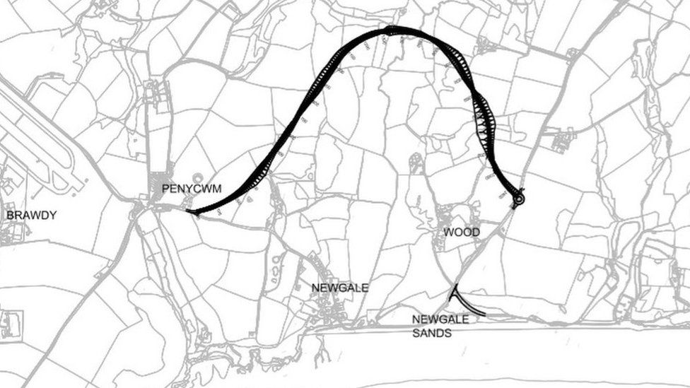Figure 1 Proposed New Road (BBC, 2018)

Figure 2 highlights the current diversion road that residents and commuters must take when the shingle is displaced over the road due to sea water tidal flood surges. The route itself is time consuming and drivers are often not made aware of diversions until they reach Newgale itself.
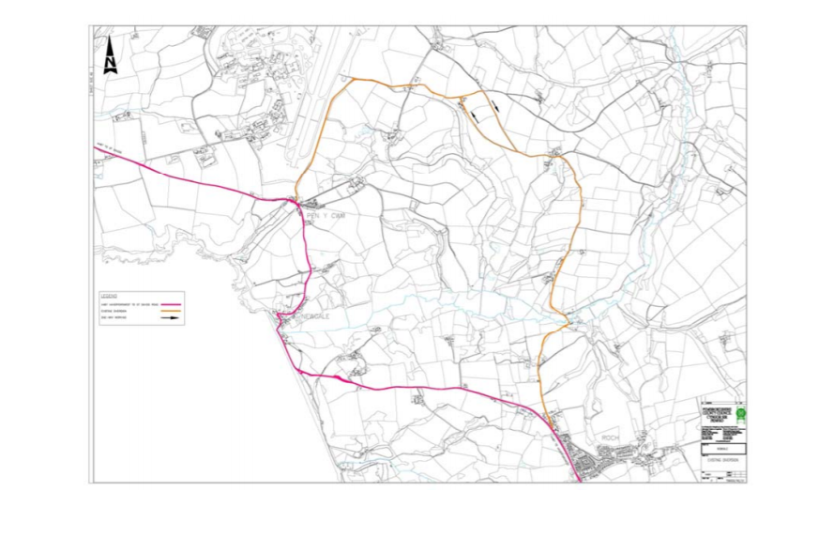
Figure 2 Current Road Diversion

Noise Levels.

As with all road expansion projects there are some considerations to be made. First, there is the initial increase in noise as a direct result of road construction and then there is the everyday operational noise of having motor vehicle traffic in an area where there once was none in small towns and villages where houses front onto roads very closely some without the protection of even a pavement or planting. Increasing heavy freight traffic through areas like this I more than likely to cause high levels of noise disturbance, many of the existing roads in the area are single track roads and are often occupied by slow moving agricultural traffic.
Tables 1-3 highlight a range of data collected by Atkins to determine the most effective proposal with the least effect on the residents and wildlife through noise pollution. Increases in noise are a major contributing factor in resident refusal to accept new proposals, they may be willing to accept short term construction noise but increased noise pollution and vibration from traffic can be detrimental to the residents in the immediate area and may even be a cause of long-term health issues. With such highly detailed levels of transparency in the preliminary testing process residents can see how much impact the project will have on their lives going forward from start of construction, completion, and long-term use.

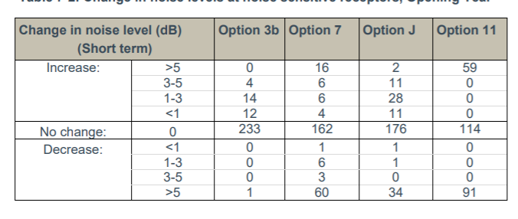
Table 1 Short Term Noise Change
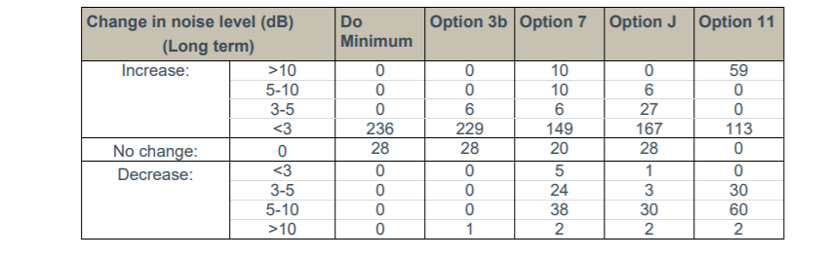
Table 2 Long Term Noise Change

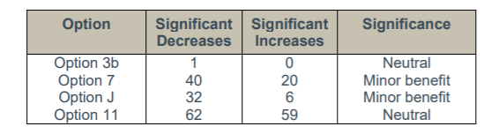
Table 3 Significant Changes to Areas
As the proposals were concentrated down to 4 the requirement for testing zones was also reduced, but enough data was collected to demonstrate to the residents, local authority, wildlife agencies that overall, the noise levels upon completion would be demonstrably neutral or beneficial.
The noise results indicate that Option 3b would produce the most similar noise climate to the current one. Options J and 7 have more noise benefits than drawbacks, and it is believed that the number of negative impacts associated with these options could be reduced using implementation of noise mitigation strategies. Option 11 has the most negative consequences and is the most difficult to mitigate.
The level of testing is sufficient; however, I believe using testing at all locations for all options would have given a far greater insight, resulting in possible further options for expansion in the area.

Air Quality

As an area of outstanding natural beauty and a much sought-after area for getting away into fresh air, clean air is a large part of the attraction to Newgale, Solva, St. Davids. Any new development cannot interfere with that too much or risk reducing the areas income as incoming tourism plays a significant part in theses' areas local economy.
With carbon emissions currently at the forefront of much legislation and the driving force behind many construction projects, improving air quality is seen as a vital component to any new proposals. When that proposal involves increasing traffic through previously quiet towns, villages, and hamlets it is especially vital that as much is done as possible to mitigate any increased air pollution that comes from the increased number of motor vehicle through traffic. As the through traffic that will be diverted from Newgale will be largely commuters, tourists, and traffic that would be diverted should other roads be closed due to accidents which happen frequently on some roads in the area.
Each option had their vehicle emissions calculated using the DMRB21 method, detailed emission functions for various vehicle types and pollutants were used that were dependent on average traffic speed, road type, and composition (percentage heavy duty vehicles [HDV]). The proposed options and the surrounding local road network were assessed using traffic data. For the opening year, the data included annual average daily traffic (AADT) flows, average daily speed, and percentage HDV for four options (Option 3b, Option 7, Option 11, and Option J) (2022).
As shown in Table 4 enough data was recorded to formulate a substantial level change both positive and negative.
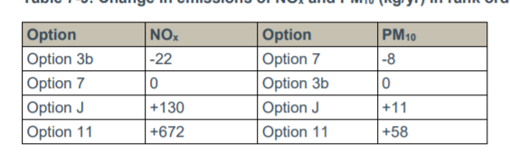
Table 4 Gas Emissions Changes for Each Option

Highlighting the increased air quality due to less traffic at the existing road would have been beneficial, and their chart is incorrectly formatted. Is this a mistake? It would appear so. This may have resulted in decisions being made incorrectly if it was not highlighted at consultation stage meetings.

GreenHouse Gas Emissions

The assessment was carried out in accordance with WelTAG guidance (June 2008)20. There is a requirement to assess changes in CO2 emissions over a 60-year appraisal period beginning in 2022 and ending in 2081, and to calculate a Net Present Value (NPV) for this period. Traffic data for four different scenarios (Option 3b, Option 7, Option 11, Option J, and a 'Do Minimum' (DM) scenario) were provided for the years 2022 and 2037.
Outside of construction, transport is the second highest contributor to c carbon emissions, 15% of the greenhouse gases in the atmosphere are from road vehicular transport (H, 2020), and in small villages with no industry, this is often the only source of pollution they encounter. The Climate Change Act of 2008 lays out a strict legally binding contract to its commitment to reduce greenhouse gas emissions by 2050.
The Atkins EIA emphasises the additional mileage that the new routes would result in for residents over a 60-year period. As shown in Table 5, the extra mileage increases CO2 emissions; however, only Option 3b benefits those residents and road users.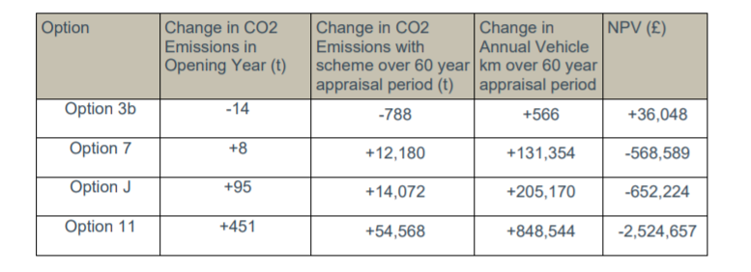
Table 5 CO2 Emissions and milage changes

As a county with higher levels of poverty than the national average, this data is extremely important to the public in order to make the best possible decision that will have the least impact on their already limited incomes, and with more people becoming aware of their carbon footprint, the increase in CO2 emissions will also drive many decisions, 14,000 miles extra per year would seem untenable to many people.

Landscape and Townscape

With much legislation required for construction seeing a report highlight that they have used methods created via using multiple sources and guidelines, to develop a proposal that was usable and inclusive for all.
By giving a short explanation of the short-term immediate effects of the project, and again highlighting that if no change were to take place, the report shows that the contractor is willing to absorb the loss of hedgerow and amount of cut and fill work associated with any of the options for development.
In the long term the effects are much greater and indicating they may possibly move the existing hedgerow to new roadside locations to fulfill compensatory measures is a clear benefit as the wildlife that use those hedges would return soon after construction activity ceased.
Seemingly careful thought to the visual impact a new road would have on the extensively rural area, and its level of mitigation shows the contractor aims to provide a transport link that is in keeping with the existing roads in the area.

4.2 Weaknesses

While the report makes it abundantly clear that the primary objective, aside from providing a new futureproof transportation link, is to preserve the rural aesthetic, it falls short of adequately considering how to construct more robust flood defences that would largely prevent flooding and develop a sustainable, safe recreational area and through road for residents and commuters alike. The road will be impassable by 2036, and the public house, as well as the surf shop, are on the same level as it. Permanent flooding of that road would also result in the closure of the buildings adjacent to it, resulting in a loss of tourist revenue each year. Saltwater inundation will eventually force its way upriver and have a severely detrimental effect on the local eco system, harming fragile wildlife habitats, altering soil PH levels and dramatically altering the size and mapping of the current floodplain.
The proposed road is too long, it winds out too far to then return on itself, and while we understand that is how local roads are built, it will result in excessive extra miles and unacceptable increases of levels of excess CO2 emissions at a time when the UK is committed to drastically reducing them. The longer road would increase both construction time and cost, as well as cause additional and unwanted traffic congestion on the existing narrow roads used by many logistics vehicles to deliver supplies and materials to local businesses and farming industry
The new roads also border on an active military base, which has its own artillery traffic on a regular basis.
No mention is made of any inclusion of cycle paths, and options to decrease the number of cars on the road by increasing other clean transport options. As an area now long standing with the triathlon community the inclusion or development of safe places to cycle to and from the surrounding areas would seem to be a major oversight.
Their CO2 testing did not allow for the shift we are seeing from combustion engines to electric vehicles which the government are now actively seeking legislation to gradually eliminate combustion engines. As the report was in 2017 before the recent spearhead toward carbon neutrality this may have been less prevalent at the time, but some mention toward the decline of the combustion engine may have shown a marked reduction in the CO2 measures.

5.0 Conclusion

With rising sea levels an ongoing concern, I do not believe that a new road away from Newgale is the answer. The UK is surround by towns and village like Newgale, and we cannot justify moving a road every time the water gets close. What happens to the people who live there, the livelihoods of the people who own businesses there? There must be another way to defend places like Newgale from a watery fate, because one road moved today are waves lapping at the doors of the people the new road is designed to help. If no one lives there, no one benefits from the new road. Once the council stop maintaining the shingle bank there will be no lower Newgale, and with a 4-8ft predicted sea rise by 2050 homes that are currently out of reach of the tides, will not be out of reach of the storms.
This would result in the expensive mediation of moving a whole village of people away from a decaying coastline, in an area with excessive homelessness. If this happened all over the UK, we would soon increase the housing crisis and give up miles of land to the sea. Whatever option is chosen for the Newgale road will be an example to the rest of the UK and World of how to address the global warming crisis.

References
Atkins. (2017, July). Newgale WelTAG Stage 1 Assessment Report. Retrieved May 1, 2021, from Pembrokeshire.gov.uk: https://www.pembrokeshire.gov.uk/objview.asp?object_id=3835&language=
BBC. (2018, September 25). Newgale A487: £30m new route for storm-ravaged road. Retrieved from BBC.CO.UK: https://www.bbc.co.uk/news/uk-wales-45641147
Gov.uk. (2020, May 13). https://www.gov.uk/guidance/environmental-impact-assessment. Retrieved from Gov.uk: https://www.gov.uk/guidance/environmental-impact-assessment
H, R. (2020, October 6). Cars, planes, trains: where do CO2 emissions from transport come from? Retrieved from Our world in data: https://ourworldindata.org/co2-emissions-from-transport
UNFCCC. (2015). The Paris Agreement. Retrieved from unfccc.int: https://unfccc.int/process-and-meetings/the-paris-agreement/the-paris-agreement

