Reflective Review of Learning Journey
Career development professionals provide services and activities which assist individuals or organisations seeking support to affect a wide range of career transitions. Career development can be related to various stages, be it during your education years from ideas of young people. This include educational choices, work experience and internships, labour market entry, skills and vocational training, job search, management level change , promotion or transfer redundancy, entrepreneurial business development, working identity change, disability and stress related career development issues, adjustments to life-work balance, returners to the labour market, portfolio working and pre-retirement choices.
Services and activities may be delivered in college, university, schools , public employment , training organisations , the workplace or voluntary sector it can be provide on an individual or group basis and may be in person or from social media “ videocall” they can share ideas , tools and resources.
Career development planning is a purposeful and orderly method for reviewing the current situation in career, deciding where are versus level we want to be and making use of goal setting to successfully implement the plans. Employers are often looking for skills and qualifications.
Tips for Career Growth and Development
- Set goals and create a plan to achieve them
- Develop a timeline, including milestones
- Utilize company programs
- Own your career path
- Write it down
Career management is a must if you expect to gain maximum success and happiness from the hours we invest in work.
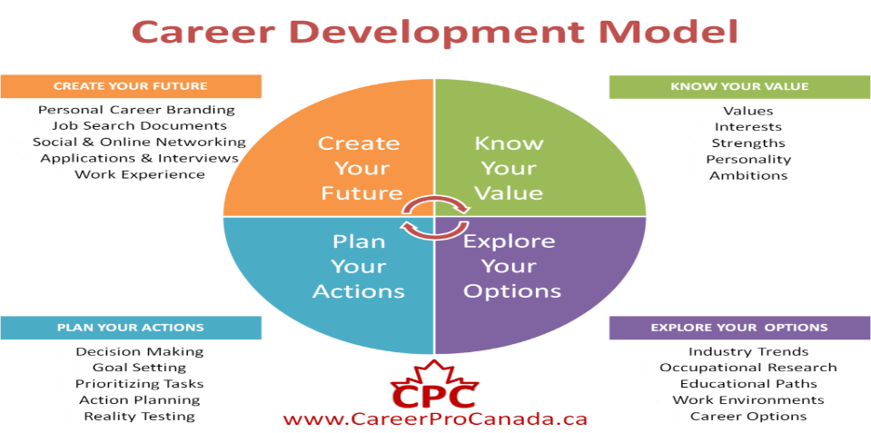

Employability is a word often tossed around during discussions related to getting a job or hiring someone. Even so, not many grasp the whole spectrum of skills, attributes and factors that influence each person’s employability. Interestingly, the term defines a broader spectrum of components than what we usually understand by it.
Ronald McQuaid and Colin Lindsay in a paper they published in the Urban Studies Journal called The Concept of Employability, explain that “many policy-makers have recently used the term as shorthand for ‘the individual’s employability skills and attributes’”.
In the past decade or two, McQuaid and Lindsay argue that the term’s usage has increased because of its potential role in tackling the social inclusion of disadvantaged groups, a reaction to the consequences of high levels of the long-term unemployed and inactivity, as well as a trend that encompasses new types of relationships between employers and employees.
Developing your employability characteristics that are necessary and are usually desired by employers? These differ from industry to industry, and from employer to employer. However, let’s have a look at a few examples of what constitutes employability.
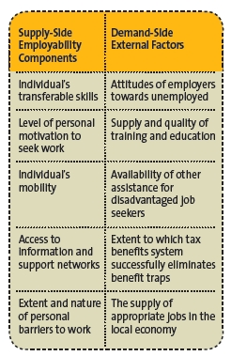

Transferable skills, essentials skills for every jobseeker include:
- Communication
- Teamwork
- Time management
- Problem Solving
- Organisation
- Learning
- Listening
- Creativity
- Leadership
Development of these skills comes through a combination of reading, learning, and practice.
Learning Style: The VARK Questionnaire
The acronym “VARK” is used to describe four modalities of student learning that were described in a 1992 study by Neil D. Fleming and Coleen E. Mills. These different learning styles—visual, auditory, reading/writing and kinaesthetic—were identified after thousands of hours of classroom observation. The authors also created an accompanying questionnaire for educators to give to students to help them identify and understand their own learning preferences.
Students who best internalize and synthesize information when it is presented to them in a graphic depiction of meaningful symbols are described as visual learners. They may respond to arrows, charts, diagrams and other visualizations of information hierarchy, but not necessarily to photographs or videos. Visual learners tend to be holistic learners who process information best when it is presented to them as a robust whole rather than piecemeal, they tend to see positive educational outcomes when they are presented with summarizing charts and diagrams rather than sequential slides of information.
Auditory (or aural) learners are most successful when they are given the opportunity to hear information presented to them vocally. Because students with this learning style may sometimes opt not to take notes during class in order to maintain their unbroken auditory attention, educators can erroneously conclude that they are less engaged than their classmates. However, these students may simply have decided that notetaking is a distraction and that their unbroken attention is a more valuable way for them to learn. Auditory learning is a two-way street: Students who fall into this modality often find success in group activities where they are asked to discuss course materials vocally with their classmates, and they may benefit from reading their written work aloud to themselves to help them think it through.
Students who work best in the reading/writing modality demonstrate a strong learning preference for the written word. This includes both written information presented in class in the form of handouts and PowerPoint slide presentations as well as the opportunity to synthesize course content in the completion of written assignments. This modality also lends itself to conducting research online, as many information-rich sources on the internet are relatively text-heavy.
Reading/writing-oriented students should be encouraged to take copious notes during classroom lectures to help them both process information and have an easier time recalling it later.
Kinaesthetic learners are hands-on, participatory learners who need to take a physically active role in the learning process in order to achieve their best educational outcomes. They are sometimes referred to as “tactile learners,” but this can be a bit of a misnomer; rather than simply utilizing touch, kinaesthetic learners tend to engage all their senses equally in the process of learning.

Findings Scoring Chart
Question | A Category | B Category | C Category | D Category
1 | V | A | R | K
2 | R | V | A | K
3 | A | R | V | K
4 | K | V | R
5 | K | V | R | A
6 | A | R | K | V
7 | V | R | A | K
8 | A | V | K
9 | K | R | A
10 | V | A | R | K
11 | K | A | R | V
12 | A | R | V
13 | R | V | K | A
The scoring Chart show the results of my preferred learning style which is Visual and Kinesthetic. I calculated the letters in yellow to get the result for each VARK category.
- Total number of Vs Yellow: 4
- Total number of As Yellow: 2
- Total number of Rs: 2
- Total number of Ks: 5
Scoring and Interpreting The learning Style Questionnaire
Total
2 | 7 | 1 | 5
4 | 13 | 3 | 9
6 | 15 | 8 | 11
10 | 16 | 12 | 19
17 | 25 | 14 | 21
23 | 28 | 18 | 27
24 | 29 | 20 | 35
32 | 31 | 22 | 37
34 | 33 | 26 | 44
38 | 36 | 30 | 49
40 | 39 | 42 | 50
43 | 41 | 47 | 53
45 | 46 | 51 | 54
48 | 52 | 57 | 56
58 | 55 | 61 | 59
64 | 60 | 63 | 65
71 | 62 | 68 | 69
72 | 66 | 75 | 70
74 | 67 | 77 | 73
79 | 76 | 78 | 80
Activist | Reflector | Theorist | Pragmatist
6 | 8 | 9 | 11

The results present my preferred learning style is identified as ‘Pragmatist ‘. A pragmatist is pragmatic someone who is practical and focused on reaching a goal. Pragmatists are keen on trying out ideas, theories and techniques to see if they work in practice. They positively search out new ideas and take the first opportunity to experiment with applications. They are the sorts of people who return from management courses with new ideas that they want to make it on practice. They see a solution for all problems using the problems opportunity to ‘challenge’.
Pragmatists Weaknesses:
- On balance, task oriented not people oriented.
- Not very interested in theory or basic principles.
- Impatient with waffle.
Pragmatists Strengths:
- Keen to test things out in practice.
- Technique oriented
- Practical, down to earth, realistic
Swot Analysis

SWOT analysis is knowledge of the internal strengths and weaknesses, along with the opportunities and threats facing a business, project or programme can paint a broad picture of its current status. This analysis helps to understanding and avoids relying on habit or instinct, helping leaders and managers to make informed decisions about the actions available to them.
SWOT analysis can be useful for lots of contexts, including:
- Planning
- Problem solving
- Personal – development planning
- Strategic decision making
In each area SWOT what questions, you could ask as a part of our analysis?
Strengths
Your strengths are an integral part of your organization, so think about what makes it "tick." What do you do better than anyone else? What values drive your business? What unique or lowest-cost resources can you draw upon that others can't? Identify and analyse your organization.
Weaknesses

Weaknesses, like strengths, are inherent features of your organization, so focus on your people, resources, systems, and procedures. Think about what you could improve, and the sorts of practices you should avoid.
Opportunities
You should also watch out for changes in government policy related to your field. And changes in social patterns, population profiles, and lifestyles can all throw up interesting opportunities.
Threats
Always consider what your competitors are doing, and whether you should be changing your organization's emphasis to meet the challenge. But remember that what they're doing might not be the right thing for you to do and avoid copying them without knowing how it will improve your position.

Strengths | Weaknesses
Confident  Good listener  Empower others  Quick learner  Punctual | Decision making  Impatient  Motivated  Good communication skills  Argumentative
Opportunities | Threats
Personal development  Employment  Learn | Unemployed  Lose my family/friends

SMART GOALS

Goals are part of every aspect of business/life and provide a sense of direction, motivation, a clear focus, and clarify importance. By setting goals for yourself, you are providing yourself with a target to aim for. A SMART goal is used to help guide goal setting. SMART is an acronym that stands for Specific, Measurable, Achievable, Realistic, and Timely. Therefore, a SMART goal incorporates all these criteria to help focus your efforts and increase the chances of achieving that goal.
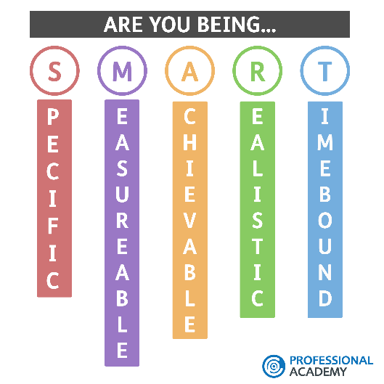
S - Specific: what exactly do you want to have completed?
M- Measurable: how will you know whether you have completed it or not?
A- Achievable: are you likely to be able to achieve this goal/complete this work…?
R- Realistic: in the timescale you have allocated?
T- Time Based: By when do you want to have completed this?
MY SMART GOALS
My smart goal is to pass my course focusing on my assignments and presentation in class to improve that I need to organize my time and practice a lot. Practice is the key for success and results. The duration of it is until the final day of my course from there I will see results.
Achieve ‘Certificate of Higher Education: Skills for The Workplace’ by course end date.

Kolb's Learning Cycle
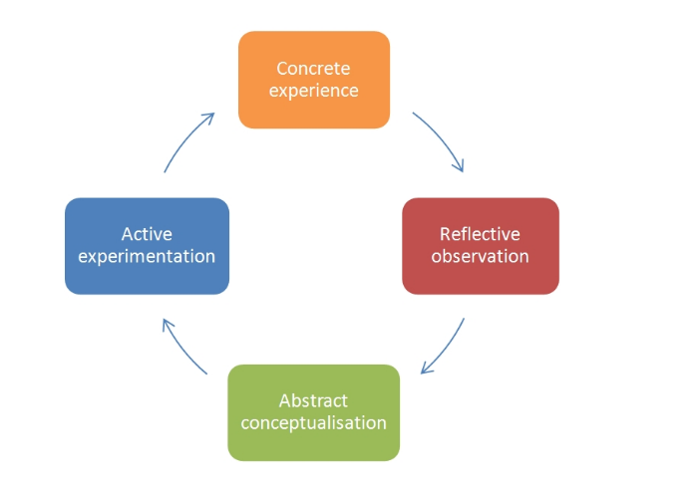

Kolb's learning theory in 1974 sets out four distinct learning styles, which are based on a four-stage learning cycle (see above). Kolb explains that different people naturally prefer a certain single different learning style. Various factors influence a person's preferred style. For example, social environment, educational experiences, or the basic cognitive structure of the individual.

The GO MAD framework
In 1999 Andy Gilbert and Ian published Chakrvorty developed the Go Mad Thinking model System with the book originally. The framework can be used at a personal level by applying the key principals to making a difference in your life. It can also be used at a more- in depth application for large scale changes and business improvement programmes.
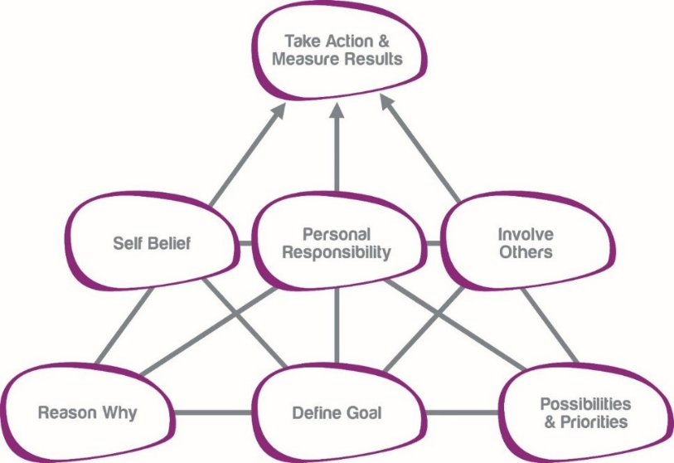

Using the GO MAD framework, the learners will gain focus by developing the ability to define clear goals about anything, improve actions by learning how to generate numerous possibilities and discover how to think in a solution focused way to accelerate results.
Principal 1 – Considers WHY you want to a make a difference.
Principal 2 – Focus on WHAT difference you want to make.
Principal 3 – Concentrate on HOW to make a difference.

Conclusion
From this report I have reflected and reviewed my learning journey this process will help me to develop my personal skills and mentality. Using the SWOT analysis, I have the highlighted my strengths, weaknesses and threats and change it into opportunities using SMART goals. This report helped me to organise my goals plan which steps I should follow to be successful.

References:
- SimplyPsychology ‘ Kolb´s Learning Styles and Experiential Learning Cycle´ - https://www.simplypsychology.org/learning-kolb.html (2017)
- MyStarJob.com ‘What makes you employable? ‘ http://mystarjob.com/articles/story.aspx?file=/2013/9/21/mystarjob_careerguide/13596333&sec=mystarjob_careerguide (2013)
- KUTheUniversityOfKansas ‘ 4 Different Learning Styles you should Know: The VARK Model https://educationonline.ku.edu/community/4-different-learning-styles-to-know (2019)
- Teach Make a Difference ‘ Learning Styles’ https://teach.com/what/teachers-know/learning-styles/ (2019)
- GoMad Thinking ‘Better Results’ https://www.gomadthinking.com/ (2019)

https://www.thecdi.net/About/CareerDevelopment

