Management and Organisational Behaviour
BA International Hotel Management
Written report

Student name: Irina Almajanu
Student ID: 2127615
Module Teacher Name: Giulia Chifari

Module: BMIH5004

Table of Contents
Introduction 3
Overview of the Hyatt Hotel Group 3
Evaluation of organisational structure, culture and goals 4
Recent change initiatives along with their impact and management by the Hyatt Hotel Group 7
Analysis of the strategic direction of the organisation and current performance of the Business 9
Conclusion 11
Reference 12

Introduction
The market of business in general is very competitive. In this context, the sustainability of leadership of a business needs effective management and constant growth (Iqbal and Ahmad, 2021). The structure of an organisation plays an important role in maximising its performance (Ahmed et al., 2020). In addition to this, organisational culture also can have a significant influence on the workforce's ability (Khan et al., 2021). The aim of this study is to produce an audit case study on the Hyatt Hotel Group. In this regard, the study is going to focus on evaluating its culture, structure and goals. Moreover, it will also help to assess the recent change initiatives adopted by the company along with its impact and management process. Strategic directions along with the current business performance of Hyatt Hotel Group are also going to be discussed in this study.

Overview of the Hyatt Hotel Group
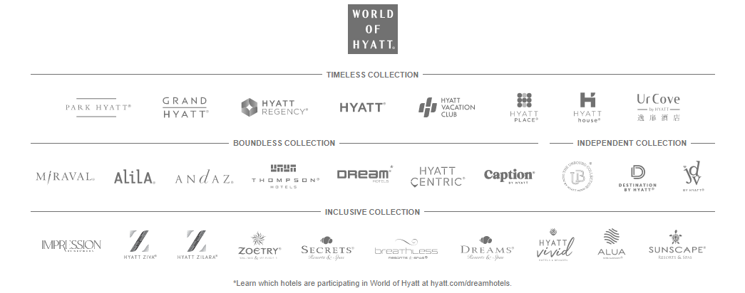
Figure 1: Subsidiaries of Hyatt Hotel Group
(Source: Hyatt, 2024)
Hyatt Hotel Group is known to all by the name; "Hyatt Hotels & Resorts". It was founded by Jay Pritzker and is currently owned and managed by the Pritzker family. It is a multinational brand that operates in the hospitality industry. The headquarters of the brand are located in Illinois in Chicago, United States (Hyatt, 2024). The company has been running its hospitality business since 1957. The mission of the company is to "remain committed to caring for people so they can be their best" (Hyatt, 2024). people. It has to go through various changes and challenges as well during these years. However, it has managed to be one of the well-known brands across the globe. It has a huge chain of resorts, holiday properties, businesses and luxurious hotels. In this context, it can be stated that Hyatt Hotel Group owned around 28 subsidiaries (Hyatt, 2024). It helped the brand to reach out to more customers around the world. In this context, it also can be stated that the strategic management of Hyatt Hotel Group is on point for maximising its reach and profit opportunities.

Evaluation of organisational structure, culture and goals
The structure of an organisation helps to understand the management process. It generally helps to outline the leadership and communication process followed in an organisation. The CEO of an organisation leads and manages all the functions; marketing, finance, human resources and so on (Shet et al., 2021). On the other hand, these functions are managed by separate teams for an easy and hassle-free management process (Azman et al., 2021). Being one of the leading hospitality brands, Hyatt Hotel Group also follows a systematic approach in its management process. The organisational division of the company follows an effective communication process as well. According to the management and communication process, it can be understood that Hyatt follows a functional structure.
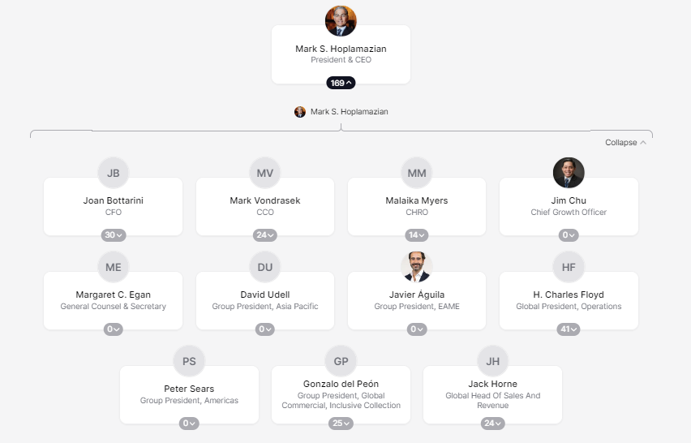
Figure 2: Organisational Chart
(Source: Theorg, 2024)
Mark S. Hoplamazian is the president and CEO of the Hyatt Hotel Group. Around 169 staff are currently working for the company. The organisational staff are divided into three teams; "the CEO and Executive team", "the Board of Directors" and “the leadership team” (Theorg, 2024). These teams can help in the effective management of the company.

Figure 3: Corporate culture of Hyatt Hotel Group
(Source: Hyatt, 2024)
Organisational culture is determined by the company's values and attitudes towards its stakeholders. These can have a significant influence on the behaviour of the employees. Employees' satisfaction along with customers' experience can be managed by cultural practices. The mission of Hyatt Hotel Group is to care for people. It is caring towards its staff as well as customers. Incorporation of inclusive culture in the organisation along with prioritising the well-being of the staff helped Hyatt to ensure the satisfaction of its employees (Hyatt, 2024). The establishment of a sense of belonging and community can help the company to ensure a positive and encouraging work culture. The priority of the Hyatt Hotel Group is to provide opportunities to all employees for growth and excellence through training and opportunities for career mobility (Hyatt, 2024). In addition to this, an inclusive culture in an organisation can help to facilitate a positive and supportive culture at the workplace.
The goal of an organisation helps to determine its progress and success. The mission of the company is to "deliver a distinctive experience to its guests". The vision of the company is to become a "world of understanding and care" (Hyatt, 2024). The goal of the Hyatt Hotel Group is to advance its purpose of care. The purpose of the company is to care for people. Governance of diversity, equity and inclusion helps Hyatt to proceed towards its goals. Henceforth, it can be stated that foundation is important for continuity of purpose. The foundation of the goal for Hyatt is its values and purpose.

Recent change initiatives along with their impact and management by the Hyatt Hotel Group
Hyatt is focused on advancing its care for managing responsible business along with people and the planet. Hyatt announced its progress in facilitating a positive impact on the environment and society. In this context, the company is working to strengthen the use and management of renewable energy in its hotels. The use of renewable energy is an effective way to promote sustainability (Zafar et al., 2020). In addition to this, it is also working for the survivors of human trafficking through various initiatives of the Hyatt Hotel Foundation. These initiatives help Hyatt Hotel Group to manage its commitment towards the care for people, the planet and responsible business. It observes ESG strategy to improve its contribution and accountability towards the environment, society and governance (Hyatt Newsroom, 2023). It helps the brand to achieve the trust and faith of its colleagues along with customers, hotel owners, investors and other communities. ESG strategy helps to enhance the management process of an organisation (Niu et al., 2022). The company also displays its annual report to facilitate transparency in its management process.
"Advancing environmental action" is a recent initiative adopted by Hyatt Hotel Group. Organisation of pilot programme help in reducing the waste of food across the Asia Pacific in 2022 (Hyatt Newsroom, 2023). Moreover, it is also promoting the use of renewable energy for generating electricity around Europe and the US. In addition to this, Hyatt also offers carbon-neutral meetings and events for its customers and guests (Hyatt Newsroom, 2023). Apart from this, climate change along with the conservation of water resources, recycling of waste and responsible resourcing are part of the recent initiatives of Hyatt. The constant and effective initiatives of a business towards environmental protection can help a company stay committed to its care for the planet (Osterwalder et al., 2020). These initiatives required changes in the management process of the company. Hyatt is working to improve and advance its management process for adopting these initiatives. It is setting the bar high in the hospitality industry in terms of change and sustainability.
"Supporting the survivors of human trafficking" is also one of the recent initiatives of Hyatt Hotel Group. The company provides career pathways to the young people to reinforce the sense of belonging among the staff, customers, investors and other members of Hyatt Group. Around 360 women get promoted to senior leadership positions globally since June 2020 (Hyatt Newsroom, 2023). The change in management of human resource management is an effective and influential initiative that is managed by the incorporation of new and innovative ideas for ensuring equal opportunity for all in the company irrespective of gender differences (Triana et al., 2021). Hyatt emphasises increasing opportunities for employment and even promoting the acceptance of diversity across the globe. The company is working to safeguard human rights and promote the well-being of society. It also takes the initiative for the "safe house project" to help the survivors of human trafficking (Hyatt Newsroom, 2023). Hyatt is able to provide adequate resources and support to the survivors of human trafficking through this project. It helps to enhance the commitment of Hyatt Hotel Group towards the achievement of care for people.
"New focus on working with other businesses" is one of the recent initiatives of Hyatt Hotel Group for ensuring the management of responsible business (Hyatt Newsroom, 2023). The company emphasises new areas while working with other businesses. It focuses on the opportunity of the owner along with supplier and operator engagement. Development of a "suppliers code of conduct" along with a diversity program for the suppliers can help the company to carry out effective management of procurement (Hyatt Newsroom, 2023). Incorporating effective strategies to manage the resourcing and development of a business helps to restructure and manage an effective and responsible business. Resourcing along with other approaches to business management can help Hyatt to ensure a responsible business management process.

Analysis of the strategic direction of the organisation and current performance of the Business
Business opportunities can be managed and directed by strategic planning. It plays an important role in the decision-making process. The strategic direction of an organisation plays an important role in maximising the opportunity of a business to achieve its goals (Pasaribu et al., 2021). Hyatt Hotel Group developed the strategy; RiseHY for increasing the opportunity of profit in the competitive market. Creating a broad pipeline to increase employment opportunities for youth in the hospitality industry helps the company improve its hiring process (Playbook2working with Hyatt, 2023). In addition to this hiring 10,000 youths into the Hyatt Hotel Group by 2025 (Playbook2working with Hyatt, 2023). It helps the company to ensure effective performance of the company. Hyatt enhances the quality of its potential candidates by the use of assessments along with work-based experiences (WBEs) (Playbook2working with Hyatt, 2023). It helped the company to develop the productivity and efficiency of the workforce.
Improving the retention rate of employees through encouraging the managers to adopt effective hiring strategies It helps Hyatt to facilitate effective employee management and development of potential workforce as well. Both of these aspects can help to enhance the sustainability of the company. In addition to this, these strategies can help Hyatt to improve its service quality. The company is looking for a good partnership with shared goals along with open communication and clear expectations (Playbook2working with Hyatt, 2023). These practices are part of the partnership management in Hyatt Hotel Group. Restoration of mutual trust along with the dedication of staff and support of leaders can help an organisation to ensure an effective and sustainable partnership (Lansing et al., 2023). The strategic management of partnership management can help the brand to increase its potential to be one of the influential market leaders.
Hyatt Hotel Group has recently created a new record of total fee revenue of $ 250 million. The pipeline of the availability of rooms expanded to the number of 123,000. Net income of the company in the third quarter of 2023; $ 68 million (Hyatt Hotels Corporation, 2023). Diluted EPS was $ 0.63. It helped to understand that the operation and management process of Hyatt was on track. According to the CEO of Hyatt Hotel Group, MarkS. Hoplamazian, "We had a tremendous quarter, largely driven by the strength of our core business" (Hyatt Hotels Corporation, 2023). It helped to understand that the current performance of the company was very good.

Conclusion
Hyatt Hotel Group is a multinational hospitality brand with headquarters located in Chicago. The mission of the company is to care for people. Hyatt follows a functional structure for managing its business. The value of the company is to care for people; customers, guests, colleagues, investors, partners and so on. In addition to this, the goal of Hyatt is advancing the care for people, the planet and a responsible business management process. Providing adequate employment and safety to the survivors of human trafficking along with increasing the use of renewable electricity and responsible business approaches are the recent initiatives adopted by the company. The company has to improve its operations to ensure effective adoption of the initiatives. Staff retention along with increasing the number of hires and establishment of good partnerships are the strategic plan of Hyatt to increase its revenue rate. Additionally, the revenue rate of Hyatt in the third quarter of 2023 is quite significant.

Reference
Ahmed, E.R., Alabdullah, T.T.Y., Shaharudin, M.S. and Putri, E., (2020). Further Evidence on The Link Between Firm'S Control Mechanisms and Firm Financial Performance: Sultanate of Oman. Journal of Governance and Integrity, 4(1), pp.6-11.
Azman, N.A., Mohamed, A. and Jamil, A.M., (2021). Artificial intelligence in automated bookkeeping: a value-added function for small and medium enterprises. JOIV: International Journal on Informatics Visualization, 5(3), pp.224-230.
Hyatt Hotels Corporation, (2023). Hyatt Reports Third Quarter 2023 Results. (Online). Available at: <https://investors.hyatt.com/news/investor-news/news-details/2023/Hyatt-Reports-Third-Quarter-2023-Results-11-02-2023/default.aspx> [Accessed on 19 January 2024].
Hyatt Newsroom, (2023). Hyatt Shares Environmental and Social Impact Reporting, Eclipses Critical DE&I Goals and Sustains Momentum with Key 2023 Initiatives. (Online). Available at: <https://newsroom.hyatt.com/news-releases?item=124405#:~:text=Hyatt%20also%20announced%20progress%20across,empower%20survivors%20of%20human%20trafficking.> [Accessed on 19 January 2024].
Hyatt, (2024). Culture. (Online). Available at: <https://about.hyatt.com/en/world-of-care/caring-for-people/culture.html#:~:text=Our%20commitment%20to%20caring%20for,listening%20and%20fueled%20by%20care.> [Accessed on 19 January 2024].
Hyatt, (2024). DEI report of Hyatt. (Online). Available at: <https://about.hyatt.com/content/dam/hyatt/woc/DEIReport.pdf> [Accessed on 19 January 2024].
Hyatt, (2024). Our Brands. (online). Available at: <https://about.hyatt.com/en.html> [Accessed on 19 January 2024].
Hyatt, (2024). The history of Hyatt. (online). Available at: <https://about.hyatt.com/en/hyatthistory.html> [Accessed on 19 January 2024].
Hyatt, (2024). World of Hyatt. (online). Available at: <https://about.hyatt.com/en/contact-world-of-hyatt.html> [Accessed on 19 January 2024].
Iqbal, Q. and Ahmad, N.H., (2021). Sustainable development: The colors of sustainable leadership in learning organization. Sustainable Development, 29(1), pp.108-119.
Khan, M.S., Saengon, P., Charoenpoom, S., Soonthornpipit, H. and Chongcharoen, D., (2021). The impact of organizational learning culture, workforce diversity and knowledge management on innovation and organization performance: A structural equation modeling approach. Human Systems Management, 40(1), pp.103-115.
Lansing, A.E., Romero, N.J., Siantz, E., Silva, V., Center, K., Casteel, D. and Gilmer, T., (2023). Building trust: Leadership reflections on community empowerment and engagement in a large urban initiative. BMC Public Health, 23(1), p.1252.
Niu, S., Park, B.I. and Jung, J.S., (2022). The effects of digital leadership and ESG management on organizational innovation and sustainability. Sustainability, 14(23), p.15639.
Osterwalder, A., Pigneur, Y., Smith, A. and Etiemble, F., (2020). The invincible company: how to constantly reinvent your organization with inspiration from the world's best business models (Vol. 4). John Wiley & Sons.
Pasaribu, F., Bulan, T.R.N. and Pratama, K., (2021). Impact Of Strategic Leadership and Organizational Innovation on The Strategic Management: Mediational Role of It Capability. Polish Journal of Management Studies, 24.
Playbook2working with Hyatt, (2023). Working with Hyatt. (Online). Available at: <https://about.hyatt.com/content/dam/HyattStories/risehy/resources/Playbook2WorkingwithHyatt.pdf> [Accessed on 19 January 2024].
Shet, S.V., Poddar, T., Samuel, F.W. and Dwivedi, Y.K., (2021). Examining the determinants of successful adoption of data analytics in human resource management–A framework for implications. Journal of Business Research, 131, pp.311-326.
Theorg, (2024). Hyatt organisational chart. (online). Available at: <https://theorg.com/org/hyatt> [Accessed on 19 January 2024].
Triana, M.D.C., Gu, P., Chapa, O., Richard, O. and Colella, A., (2021). Sixty years of discrimination and diversity research in human resource management: A review with suggestions for future research directions. Human Resource Management, 60(1), pp.145-204.
Zafar, M.W., Shahbaz, M., Sinha, A., Sengupta, T. and Qin, Q., (2020). How renewable energy consumption contribute to environmental quality? The role of education in OECD countries. Journal of Cleaner Production, 268, p.122149.

