Marketing Fundamentals
Assignment - 1
PROGRAMME: BA BUSINESSES MANAGEMENT
MODULE TITLE: MARKETING FUNDAMENTALS
MODULE CODE: LCBB4004
ASSIGNMENT TITLE: ASSESSMENT 1
MARKETING FUNDAMENTALS: ANALYSIS AND EVALUATION
STUDENT NAME:ANCA LARISA COSTACHE
STUDENT NUMBER:2021935

Contents
Task – 1: 2
Write an individual essay providing a critical analysis and evaluation of the following: processes and stages of marketing including the role of the marketing mix 2
Introduction: 2
Stage – 1: Evaluation of marketing functions: 2
Stage – 2: Marketing strategies: 4
Stage – 3: Evaluation of marketing techniques: 6
Conclusion: 8
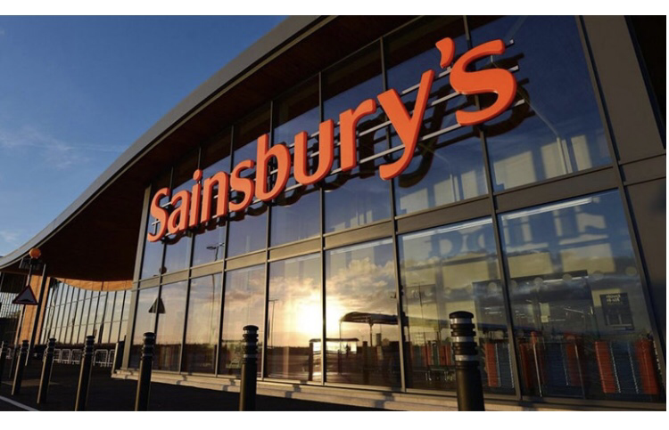
References: 8

Task – 1:

Write an individual essay providing a critical analysis and evaluation of the following: processes and stages of marketing including the role of the marketing mix

Introduction:
Marketing has been described by Raven (1992) as the process through which value is exchanged between the organisations and the customers. Therefore, the focus of marketing can be summarised in the word, ‘value’. Here, value is identified by assessing the needs of the customers and then, the organisations develop products and services that could offer the value. Customers on their end, purchase product at a price, thereby, exchanging value with the organisations.
The discussion offered in this paper offers a perspective into the processes of marketing adopted by ta business organisation. So, the paper presents different theoretical models and processes used in the process of marketing.

Stage – 1: Evaluation of marketing functions:
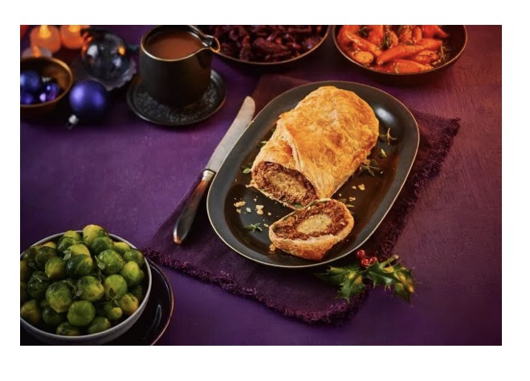
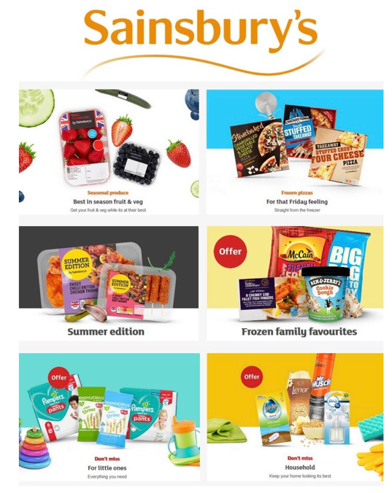
The first stage in the marketing process adopted by the business organisation entail a detailed assessment of the different processes used in the marketing activities and evaluates how they could benefit the organisation. From this evaluation, organisation become aware of the processes that they would adopt based on their marketing goals and objectives. The marketing process offers four stages on the marketing activities adopted by a business organisation.

  - Promotion:
Butler and Rose (2011) opine that organisations like Sainsbury use promotions to achieve different objectives. Promotions help in creating market awareness about products and services and so, if Sainsbury develops a new product, it would promote its product to bring the new product into the awareness of the customers. Promotions also help in attracting customers which help increase sales.
  - Product management:
Marketing functions bring in the task of product management the product management approach entails a process where market information is evaluated to assess the needs and requirements of the customers along with their preferences. The information is evaluated to develop different products and services, thereby, helping businesses create more value for he customers.
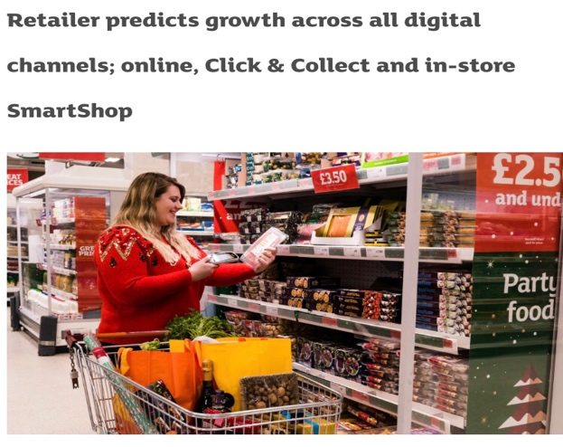
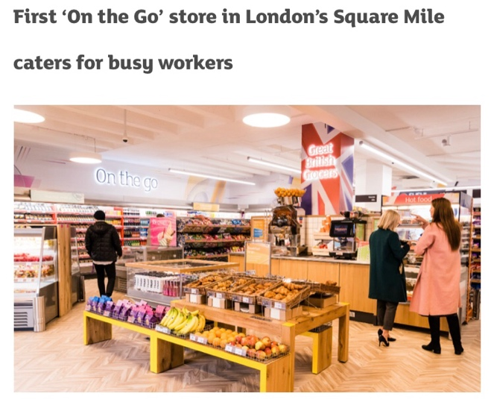

  - Marketing information management:
Butler and Rose (2011) observe that businesses work with different sources of information which is evaluated to assist the business in its decision making processes. The information of market conditions reveals opportunities and threats, needs and preferences of the customers. Information of the market also helps in conducting essential marketing techniques like market segmentation.

  - Distribution:
Distribution is used as the processes through which products are made available to the customers. Customers who wish to purchase Sainsbury products would be able to do so by going to Sainsbury stores or through online platforms of Sainsbury. This way, different companies look to create the most effective distribution strategy, given the nature of their products and their intended target market.
  - Standardisation and measures:
Martin (2010) says that standardisation is a practice through which the organisation sets a clear guideline on the standards for its products to maintain product uniformity and reduction in variations in product quality. Standardisation is used as an important part by manufacturing companies which manufactures different products.

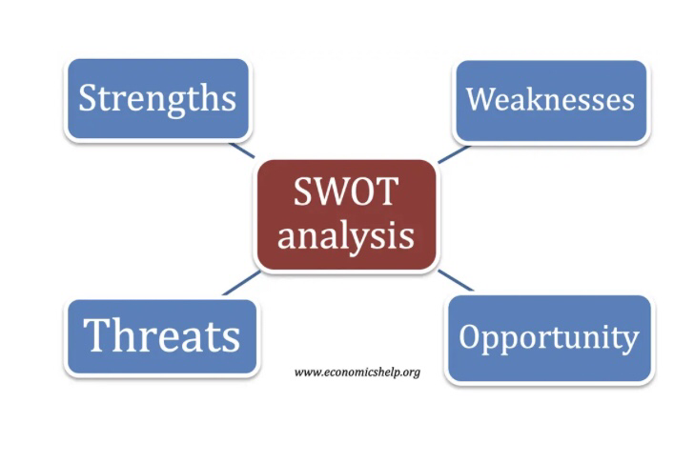
Stage – 2: Situational Analysis (SWOT analysis):
The situational analysis studied through the Swot analysis offers an assessment of the internal environment through the observation of strengths and weaknesses and the external situation in the form of threats and opportunities.
Strengths: Sainsbury has a huge production base and capabilities to manufacture a range of products. The organisation also possesses huge base of employees to perform its activities and it helps to serve the customers across the large base of Sainsbury stores located across the UK and European markets. This allows the organisation to sell its products across a large base of customers.
Weaknesses: Sainsbury has lost much of its market share over the pat many years. Despite its gradual comeback, Sainsbury has been falling behind the market leader, Tesco. The organisation also faces stiff challenges in the market due to ite market competition which has made the market price sensitive, forcing organisations to maintain affordable prices by reducing profit margins.
Opportunities: Sainsbury could enter new market and expand its market base, especially in developing countries that offer larger opportunities. Large consumer markets in Asia could help Sainsbury increase its sales. The organisation could also look to diversify to other product segments like electronics.
Threats: the rising inflation is a huge challenge for Sainsbury because it is pushing up costs even as the organisation tries to cut down on its product margins to offer affordable prices. The intense competition also causes challenges as there are plenty of alternatives for the customers.

Stage – 3: Evaluation of marketing techniques:
Another important stage in the marketing processes and functions adopted by leading organisations like Sainsbury is the process where the organisation applies three important marketing techniques, segmentation, targeting and positioning. The application of these techniques also forms an important part of the executional approaches of a marketing plan.
Segmentation:
The segmentation process is defined by Brooks (2013) as the tool to create market divisions that help understand the customers, their needs and other essential aspects that influence their purchasing decisions. Important segmentation criteria followed by different companies is the demographics segmentation approach where market divisions are created on the basis of demographic factors. Sainsbury uses income levels as criteria for its market segments. The income levels of the customers are categorised into higher income, middle income and lower income segments. This means that customers in the higher income segment have the purchasing power to buy higher priced products while middle and lower income segments prefer affordable products.
Targeting:
Martin (2010) says the target market is the approach where organisations choose market segments for particular products and services and look to create more sales in the segment by designing specific promotional content. A wide range of Sainsbury’s groceries are aimed at the middle income segments. According to Martin (2010), the organisation looks to offer differentiated products and use competitive pricing for the products. This makes the products affordable and fair priced while it looks to attract customers through the product differentiation. Organisations could choose to target a single market segment in a concentrated targeting approach. Some organisations also use multiple segments which is called differentiated targeting approach.
  - Positioning:
According to Butler and Rose (2011), positioning is defined as the distinguishable identify that a certain product occupies in the mind of the customers. Organisations look to create brand identify that associates qualities to certain products and services. Sainsbury’s positioning follows the differentiation approach. Sainsbury seeks to emphasise on the quality of its products and so, the band identity of Sainsbury is developed on the perception of quality products at fair prices. Here, Sainsbury’s products justify the prices and hence, it occupies the position as a brand that offers quality and differentiated products.

Stage – 4: Marketing strategies:
The paper studies the application of the marketing mix as a theoretical model that helps build concrete marketing strategy by assessing the four important aspects of marketing, namely, product, place, price and promotions. This section looks at the application of the marketing mix by Sainsbury and also compares how the approaches differ for its competitor, Asda.
  - Price:
Through the price strategy, businesses develop their pricing for their different products and services in accordance to their marketing objectives and goals. Close observation of the pricing strategies of Sainsbury reveal interesting differences on the pricing approach of the two competitors in the retail sector.
Martin (2010) observes Sainsbury uses a competitive pricing strategy, where the prices are set after studying the market prices and prices of other competitors. Here, the prices are matched according to the market prices and so, there is little price difference in the products offered by different companies that use competitive pricing. However, Asda’s pricing strategy is different from Sainsbury because the company uses the pricing approach where the prices are lower than cost other competitors. While Sainsbury offer a wider range of products, Asda looks to attract customers through its attractively low prices.

  - Product:
  - The paper presents is observation of how the pricing strategy influences the products and the nature of products of an organisation. Brooks (2013) observes that Sainsbury follows the approach of differentiation and so, it offers a wide range of products that offer different features and unique qualities. This approach to product development is influenced by the differentiation approach used by Sainsbury. Stuebs and Sun (2010) says that Asda’s approach is called the cost leadership approach where the organisation is aiming to offer lower priced products; however, the cost minimisation approach also forces organisations to compromise on product quality. So, while Sainsbury looks to offer unique products, Asda looks to offer the most attractively price products. This clearly shows that difference in the product strategies adopted by both Sainsbury and Asda. So, customers who seek better quality of products look at Sainsbury while Asda attracts customers who seek the more affordable product.
  - Place:
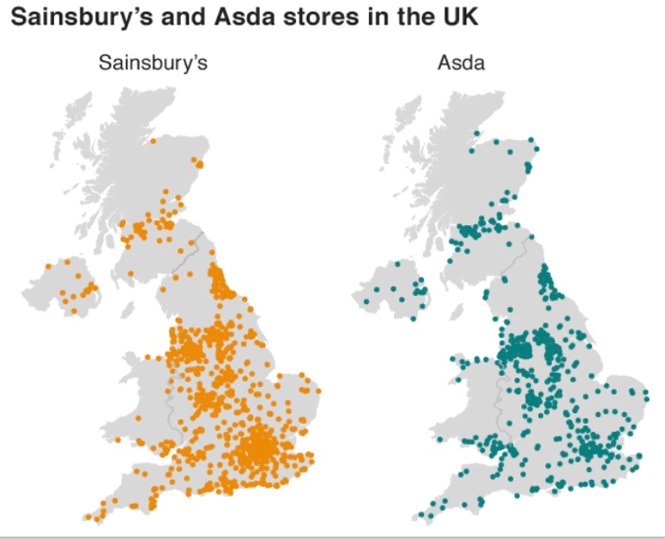
The difference seen in product and pricing approaches of Sainsbury and Asda comes to a stop at distribution approaches because both the organisations have similar distribution approaches. Stuebs and Sun (2010) observes that Sainsbury and Asda products are only available across Sainsbury and Asda stores or through online platforms of the respective companies. So, customers who wish to purchase Sainsbury products visit the numerous Sainsbury stores or purchase them from Sainsbury’s website. A similar approach is seen for Asda. This helps understand that both the companies also look to offer purchase convenience to their customers. Sainsbury’s and Asda have numerous stores across UK to offer ease of purchase to the customers. In contrast, car manufacturing companies like Toyota use selective distribution, offering its products through selective dealers.
  - Promotions:
Promotions are used to create market awareness and increase sales. Stuebs and Sun (2010) observes that businesses use different approaches to promote their products or services. Some organisations use mass media platforms like television and newspaper, however, mass media requires generalised marketing content aimed at a larger audience. Some organisations look at targeted promotions to target specific customers.
Sainsbury uses a range of promotional activities. It places advertisements across newspapers, billboards and television. Brooks (2013) observes that it helps the organisation to reach out to larger base of customers. The organisation also uses targeted promotions and sends fliers, targeted emails and notification messages to a target base of customers. The organisation is able to spend more funds on promotions than Asda because of Asda’s cost leadership strategy. The need for reducing costs forces Asda to limit its mass media promotions. However, the company uses targeted promotional approaches as they are cost effective.

Conclusion:
The paper has spoken about three important processes of marketing adopted by a leading organisation like Sainsbury. In the first stage, the organisation adopts an understanding of different marketing functions to understand what functions would benefit the organisation in the accomplishment of its goals. The paper presents a detailed evaluation of the application of marketing mix and studies how Sainsbury conducts its market strategies through the theory. Lastly, the paper also offers an understanding of the three important marketing techniques used in the process of execution of the marketing plan.

References:
- Raven, B.H., 1992. A power/interaction model of interpersonal influence: French and Raven thirty years later. Journal of Social Behavior & Personality.
- Butler, M. and Rose, E. eds., 2011. Introduction to organisational behaviour. Kogan Page Publishers.
- Martin, J., 2010. Key concepts in human resource management. Sage Publications.
- Stuebs, M. and Sun, L., 2010. Business reputation and labor efficiency, productivity, and cost. Journal of Business Ethics, 96(2), pp.265-283.
- Brooks, I., 2013. Organisational behaviour: individuals, groups and organisation. Pearson Education.
- Kotler, P., 2012. Kotler on marketing. Simon and Schuster
- Bradley, F., 2015. International marketing strategy. Pearson Education.
- Ferrell, O.C. and Hartline, M., 2012. Marketing strategy, text and cases. Nelson Education.
- Constantinides, E. and Holleschovsky, N.I., 2016, April. Impact of online product reviews on purchasing decisions. In International Conference on Web Information Systems and Technologies (Vol. 2, pp. 271-278). SCITEPRESS
- Kish, P., Riskey, D.R. and Kerin, R.A., 2011. Measurement and tracking of brand equity in the global marketplace‐The PepsiCo experience. International Marketing Review.
- Elena, K., 2016. Marketing strategy of Jaguar Land Rover in the Russian market.
- Vargo, S.L. and Lusch, R.F., 2004. The four service marketing myths: remnants of a goods-based, manufacturing model. Journal of service research, 6(4), pp.324-335.
- Kapferer, J.N. and Bastien, V., 2017. The specificity of luxury management: Turning marketing upside down. In Advances in luxury brand management (pp. 65-84). Palgrave Macmillan, Cham.
- Keegan, W.J., 2017. Global marketing management. Pearson India.
- Riesenbeck, H. and Perrey, J., 2009. Power brands: Measuring, making, and managing brand success. John Wiley & Sons.

