NAME:
NOSHEEN MANZOOR
2218718

MODULE:
LCMB 7002
FINANCIAL MANAGEMENT
FINANCIAL PERFORMANCE & MANAGEMENT

LECTURER:
PATRICK YEBOAH

WORD COUNT:
5358

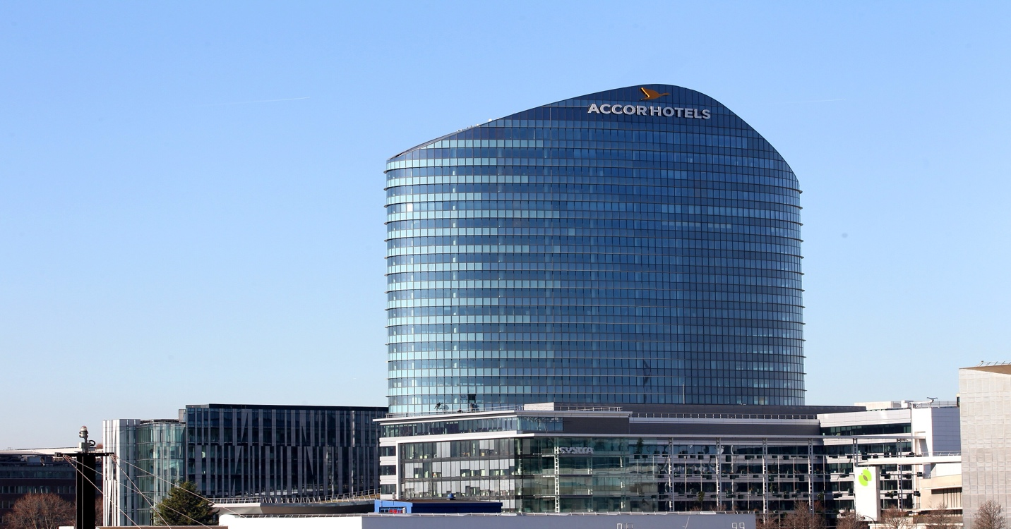

Table of Contents
FINANCIAL STATEMENT (Last five years) 4
Balance Sheet Analysis (2021- 2025) 4
Profitability Ratio Analysis 6
Cash Flow Statement 8
Gearing 10
Investment 12
Dividends and Shareholder Returns 12
Identify trends, strengths and potential threats 12
Five-Year Financial Trend Summary 12
Key Trends 13
Strengths 14
Potential Threats 14
WORKING CAPITAL MANAGEMENT Analysis 15
Assessing the cash operating cycle 15
Strategies to improve liquidity through working capital reforms 18
short-term vs long-term financing options 19
Strategic Financial Restructuring Plan 20
Recommended restructuring options 20
Impact on Shareholder value, debt structure and operational flexibility 20
International and ethical considerations 21
Investment Appraisal and Capital Budgeting 22
REFERENCE LIST: 24

INTRODUCTION:
Accor SA represents a leading global hospitality organisation and the largest hotel group in Europe, operating a multi-brand portfolio that encompasses over 45 brands across diverse market segments. Following the strategic divestment of most of its owned real estate assets through the 2018 AccorInvest transaction (Accor,2018), the company transitioned towards an asset-light operating model centred on franchising and hotel management contracts. This strategic shift has significantly altered Accor’s financial structure by reducing capital expenditure requirements and exposure to property-related risks, while enhancing scalability and return on invested capital. As a result, the company exhibits relatively low fixed-asset intensity and modest working-capital requirements. Nevertheless, its earnings remain strongly dependent on operational performance metrics, particularly Revenue per Available Room (RevPAR), which reflects the combined effects of occupancy rates and average room pricing across its portfolio.
This report presents a comprehensive Financial Health Assessment of Accor SA over the five-year period from 2021 to 2025, encompassing the company’s recovery from the disruption caused by the COVID-19 pandemic and its subsequent transition to a post-pandemic operating environment characterised by record profitability, enhanced shareholder returns, and a progressively more leveraged capital structure. Drawing upon data obtained from Accor’s audited annual reports, consolidated financial statements, and reputable financial databases, including Yahoo Finance, MarketScreener, and Macrotrends, the analysis evaluates the company’s financial performance and position through a detailed examination of its financial statements. A comprehensive ratio analysis is undertaken across key dimensions of financial health, including profitability, liquidity, operational efficiency, solvency, investment performance, and cash-flow generation. The report further identifies significant financial trends, assesses the organisation’s principal strengths and vulnerabilities, and benchmarks Accor’s liquidity position against selected publicly listed competitors within the global hospitality sector to provide a broader industry context.
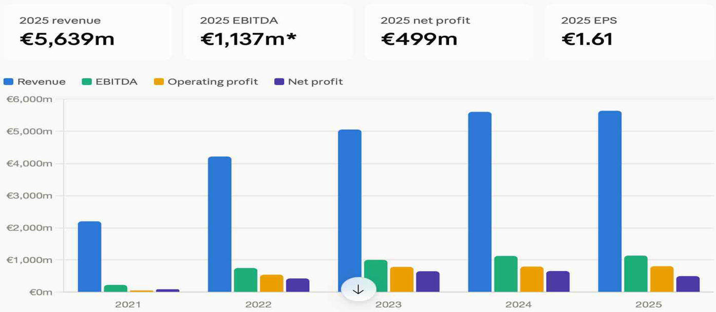
Figure 1: Accor Annual Report 2025

FINANCIAL STATEMENT (Last five years)
Accor’s income statement reflects a strong post-pandemic recovery trajectory, followed by a period of sustained growth and operational resilience. Group revenue increased significantly from a pandemic-affected €2.204 billion in 2021 to €5.639 billion in 2025, representing growth of more than 150% over the period. Similarly, net profit attributable to shareholders improved substantially, rising from €85 million in 2021 to a peak of €633 million in 2023. Although net earnings subsequently declined to €449 million in 2025, this reduction largely reflects the absence of exceptional gains from asset disposals that had positively influenced reported profits in 2023 and 2024. Notably, Recurring EBITDA—Accor’s primary measure of underlying operational performance—demonstrated consistent year-on-year growth, reaching a record €1.201 billion in 2025, an increase of 13.3% compared with the previous year. This performance highlights the effectiveness of the group’s asset-light business model and the successful recovery of key operating indicators, including occupancy rates and average daily room prices.

Balance Sheet Analysis (2021- 2025)
Item (€m) | 2021 | 2022 | Change | 2023 | 2024 | 2025 | 21-25 change
Total Assets | 10,769 | 11,713 | +8.8% | 11,176 | 12,057 | 11,744 | +9.1%
Current Assets | 3,079 | 3,584 | +16.4% | 2,781 | 2,970 | 2,905 | –5.7%
Non-current Assets | 7,691 | 8,129 | +5.7% | 8,395 | 9,087 | 8,839 | +14.9%
Total Equity | 4,597 | 5,456 | +18.7% | 5,311 | 5,469 | 4,717 | +2.6%
Current Liabilities | 2,635 | 2,920 | +10.8% | 2,821 | 2,819 | 2,773 | +5.2%
Non-current Liabilities | 3,537 | 3,337 | -5.7% | 3,044 | 3,770 | 4,254 | +20.3%

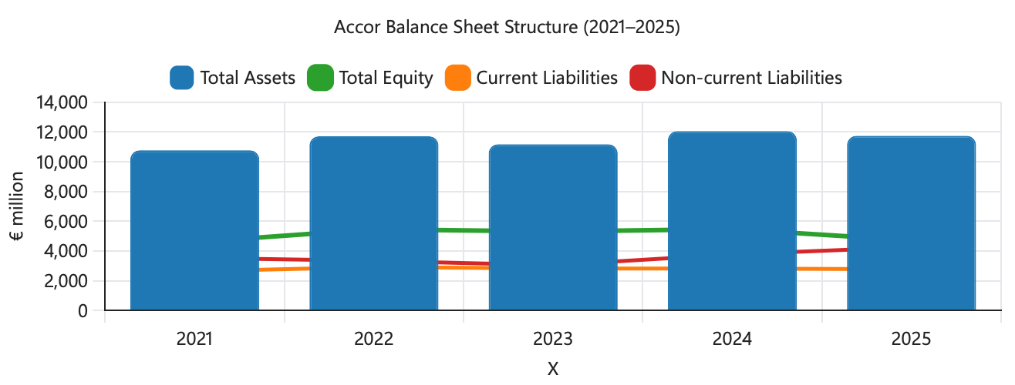
Figure 2: Accor annual report 2021; 2022; 2023; 2024; 2025
An examination of the balance sheet reveals a company that has prioritised shareholder value creation through substantial capital distributions rather than the accumulation of excess cash reserves. Strong cash generation has supported an active capital return strategy, comprising both share repurchases and a progressively increasing dividend. Consequently, total shareholders’ equity declined from approximately €5.46 billion in 2022 to €4.72 billion in 2025 (Accor 2025). At the same time, net financial debt increased steadily from €1.844 billion at the end of 2021 to €3.064 billion by 2025. This rise in leverage reflects a combination of strategic financing decisions, including the funding of share buyback programmes, hybrid bond refinancing activities, and the acquisition of Royal Holiday Group, with a significant proportion of these initiatives financed through additional borrowing. While these actions have enhanced shareholder returns and supported strategic expansion, they have also increased the group’s exposure to financial risk through a more leveraged capital structure.
€m (FY, Dec year-end) | 2021 | 2022 | 2023 | 2024 | 2025
Revenue | 2,204 | 4,224 | 5,056 | 5,606 | 5,639
Recurring EBITDA | 22 | 675 | 1,003 | 1,120 | 1,201
Net profit (period) | 85 | 426 | 633 | 657 | 449
Basic EPS (€) | 0.19 | 1.40 | 2.23 | 2.34 | 1.61
Total assets | 10,769 | 11,713 | 11,176 | 12,057 | 11,744
Total equity | 4,597 | 5,456 | 5,311 | 5,469 | 4,717
Current assets | 3,079 | 3,584 | 2,781 | 2,970 | 2,905
Current liabilities | 2,635 | 2,920 | 2,821 | 2,819 | 2,773
Cash and equivalents | 1,666 | 1,643 | 1,279 | 1,244 | 1,205
Net financial debt | 3,202 | 2,869 | 2,624 | 3,002 | 3,663
Table 1: Sources: Accor full-year results press releases (2021–2025); Yahoo Finance.
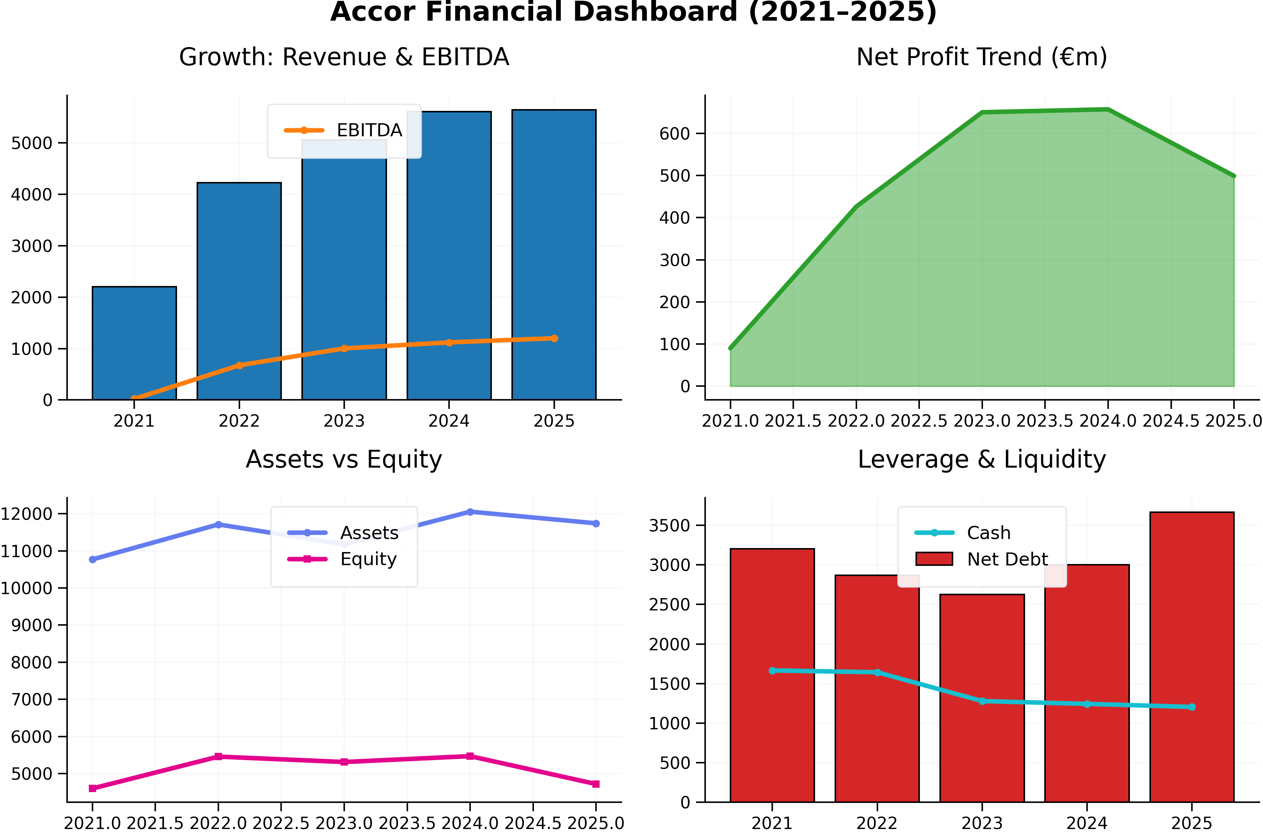
Figure 3: Accor annual report 2021 - 2025

Profitability Ratio Analysis
Accor’s profitability improved significantly during the post-pandemic recovery period, although growth has become less pronounced since 2023. The group’s net profit margin increased from 3.9% in 2021 to a peak of 12.5% in 2023 (Accor 2023), reflecting the strong recovery in global travel demand and improved financial performance. However, the ratio subsequently declined to 10.9% in 2024 and 8.0% in 2025, largely due to the reduced contribution of exceptional gains, particularly those associated with AccorInvest-related asset disposals that had enhanced earnings in previous years. Nevertheless, a more reliable indicator of underlying performance, Recurring EBITDA margin, has shown continuous improvement throughout the period, rising from negligible levels in 2021 to 21.3% in 2025. This consistent upward trend demonstrates the growing effectiveness of Accor’s asset-light business model and highlights its ability to generate sustainable operating profits from increasing occupancy levels and room rates. Consequently, while reported net profitability has moderated following the decline in one-off gains, the company’s core operating performance remains strong and continues to exhibit positive long-term momentum.

Profitability Ratio | 2021 | 2022 | 2023 | 2024 | 2025
Recurring EBITDA margin | 1.0% | 16.0% | 19.8% | 20.0% | 21.3%
Net profit margin | 3.9% | 9.5% | 12.5% | 10.9% | 8.0%
Return on Equity (ROE) | 1.96% | 7.4% | 11.9% | 11.2% | 9.5%
Return on Assets (ROA) | 0.84% | 3.4% | 5.6% | 5.1% | 3.8%

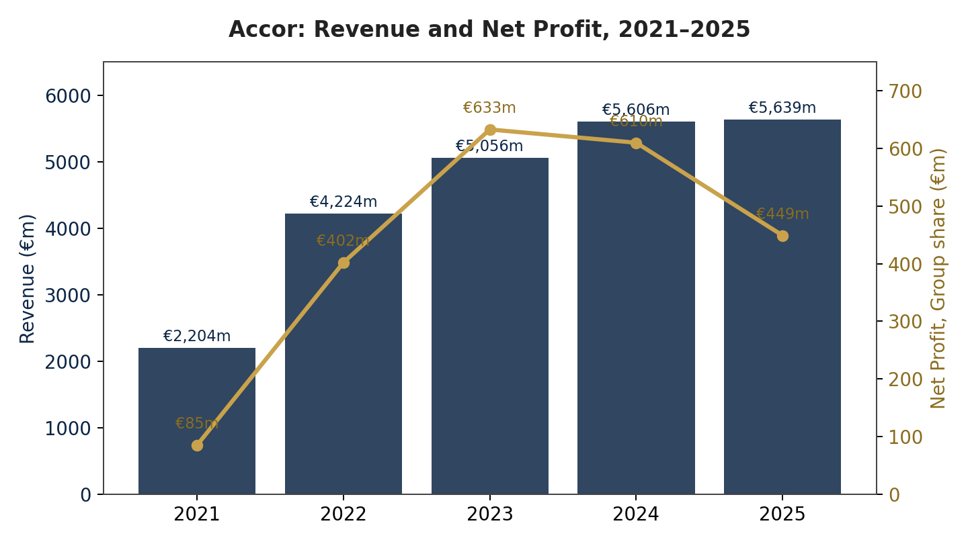
Figure 4: Revenue and net profit, Group share, 2021 – 2025

Cash Flow Statement
€m (FY, Dec year-end) | 2021 | 2022 | 2023 | 2024 | 2025
Net cash flow from operating activities | (240) | 511 | 669 | 733 | 810
Capital expenditure | (80) | (111) | (254) | (293) | (197)
Free cash flow | (320) | 400 | 415 | 440 | 613
Net cash flow from investing activities | (99) | (157) | 16 | (358) | (331)
Net cash flow from financing activities | (466) | (381) | (1,045) | (400) | (494)
Net change in cash and equivalents | (1,610) | (54) | (718) | (50) | (30)
FCF margin (FCF ÷ Revenue) | (14.5%) | 9.5% | 8.2% | 7.9% | 10.9%
Source: Accor cashflow statement (2021-2025)

Due to improved hotel performance and increased occupancy, Accor's operational cash flow recovered from a €240 million outflow to €810 million between 2021 and 2025. Despite increased investment in expansion and technology, free cash flow also improved, rising from -€320 million to €613 million. While financing operations were negative because to dividends, share buybacks, and debt management, investing cash flows varied based on asset sales and purchases. Although shareholders should be aware that the company's reported recurring free cash flow may change significantly owing to adjustments for one-time factors, overall, Accor's better cash generation indicates greater operational recovery.

Industry Benchmark
Cash Flow Item (€m) | 2021 | 2022
Net cash flow operating Activities | (240) | 511
Recurring operating cash flow | (97) | 640
Funds from operations | (52) | 584
From a negative €240 million in 2021 to a positive €511 million in 2022, operating cash flow dramatically increased, indicating a solid improvement in the business's operations. Increased demand for hotels, greater occupancy rates, rising management and franchise fees, enhanced operational effectiveness, and improved working capital management all contributed to this turnaround. Furthermore, funds from operations rose from a €52 million deficit to €584 million, indicating that Accor's primary business was once again producing strong cash flows.
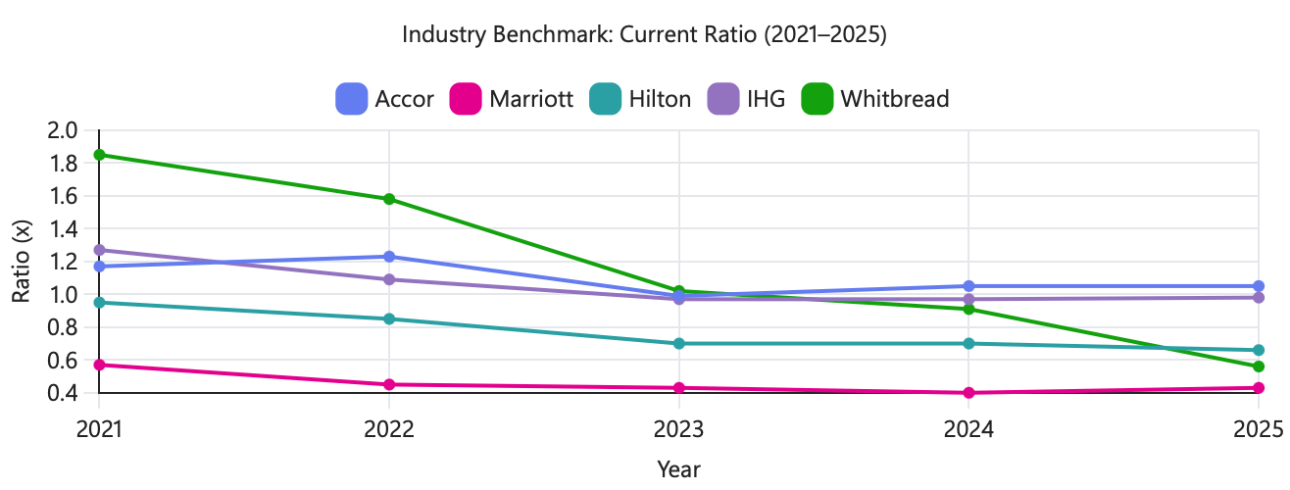
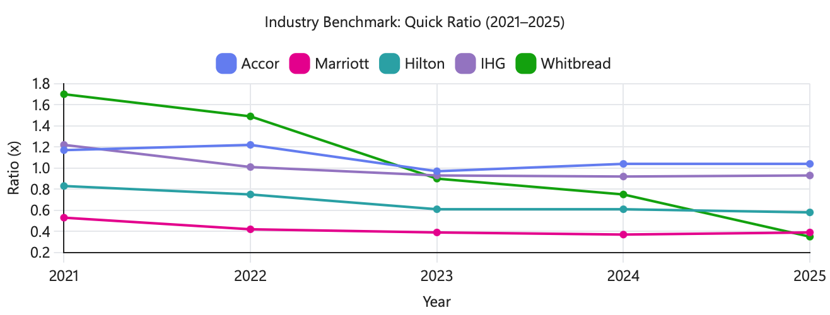
Figure 5:
Throughout the time, Accor and IHG's liquidity remained comparatively constant, with current and quick ratios staying near the 1.0x benchmark. Marriott, on the other hand, continuously performed below 1.0x, indicating a more aggressive liquidity stance. Over the course of the five years, Hilton's liquidity also gradually decreased. Whitbread saw the most decline, going from having the best liquidity position at the beginning of the period to having the worst by 2025. Overall, the comparison shows that Accor's liquidity position in the hotel sector remained relatively stable and robust.
Liquidity
Liquidity Ratio | 2021 | 2022 | 2023 | 2024 | 2025
Current ratio (Current assets ÷ Current liabilities) | 1.17x | 1.23x | 0.99x | 1.05x | 1.05x
Quick ratio ((Current assets − Inventory) ÷ Current liabilities) | 1.17x | 1.22x | 0.97x | 1.04x | 1.04x
Cash ratio (Cash & equivalents ÷ Current liabilities) | 0.63x | 0.56x | 0.45x | 0.44x | 0.44x
Working capital (€m) | 444 | 664 | (40) | 151 | 132
Operating cash flow ratio (OCF ÷ Current liabilities) | (0.09x) | 0.18x | 0.24x | 0.26x | 0.29x
Since 2021, Accor's liquidity situation has steadily deteriorated, with the cash ratio dropping from 0.63x to 0.44x and the current ratio decreasing from 1.17x to around 1.05x in 2025. However, this is not a sign of worse operations, but rather of intentional capital deployment through buybacks and dividends. The quick ratio is nearly the same as the current ratio since Accor has very little inventory.
Accor's operational cash flow ratio increased from -0.09x to 0.29x, indicating better cash generation despite decreased balance sheet liquidity. This is in line with its asset-light hotel strategy, which maintains liquidity despite having small cash reserves thanks to quick consumer payments. Because of its high cash conversion and business model, Accor's lower liquidity ratios are therefore less problematic.
Efficiency
The asset turnover ratio significantly improved, indicating that the business made better use of its resources to produce income. This shows higher revenue production from current resources and a rebound in hotel occupancy levels, both of which boost overall operational performance.
Efficiency Indicator | 2021 | 2022 | 2023 | 2024 | 2025
Asset turnover (Revenue ÷ Total assets) | 0.20x | 0.36x | 0.45x | 0.46x | 0.48x
Hotel portfolio (rooms, year-end) | 777,714 | 802,269 | 821,518 | ~850,000 | 881,427
Hotel portfolio (properties, year-end) | 5,298 | 5,445 | 5,584 | ~5,700 | 5,836

Gearing
Leverage represents the most notable area of weakening financial health during the period under review. Accor’s net financial debt increased consistently across four of the five years, rising from €1.844 billion in 2021 to €3.064 billion in 2025, while the company’s equity base declined as a result of ongoing share repurchase programmes. Consequently, key leverage indicators have deteriorated significantly, with the net debt-to-equity ratio increasing from approximately 30% in 2022 to around 65% by 2025. Likewise, the gross debt-to-equity ratio rose from roughly 61% to more than 90% over the same period. Despite this increase in leverage, the group has benefited from a relatively low and stable average borrowing cost of between 2.5% and 3.0%, while maintaining a well-structured debt maturity profile averaging three to four years and with no significant short-term refinancing pressures. These factors help to contain immediate liquidity and refinancing risks. Nevertheless, the overall trend is clear: Accor’s capital structure has become considerably more debt-dependent in 2025 compared with the period immediately following the pandemic, increasing the company’s exposure to financial risk and interest-rate fluctuations in the longer term.

Gearing Ratio | 2021 | 2022 | 2023 | 2024 | 2025
Net financial debt (€m) | 3,202 | 1,658 | 2,074 | 2,495 | 3,663
Net debt / Equity (gearing) | n/a | 30.4% | 39.1% | 45.6% | 64.9%
Gross debt / Equity | n/a | 60.8% | 63.5% | 68.4% | 91.1%
Average cost of debt | n/a | ~1.9-2.5% | 2.5% | 2.5% | 2.97%

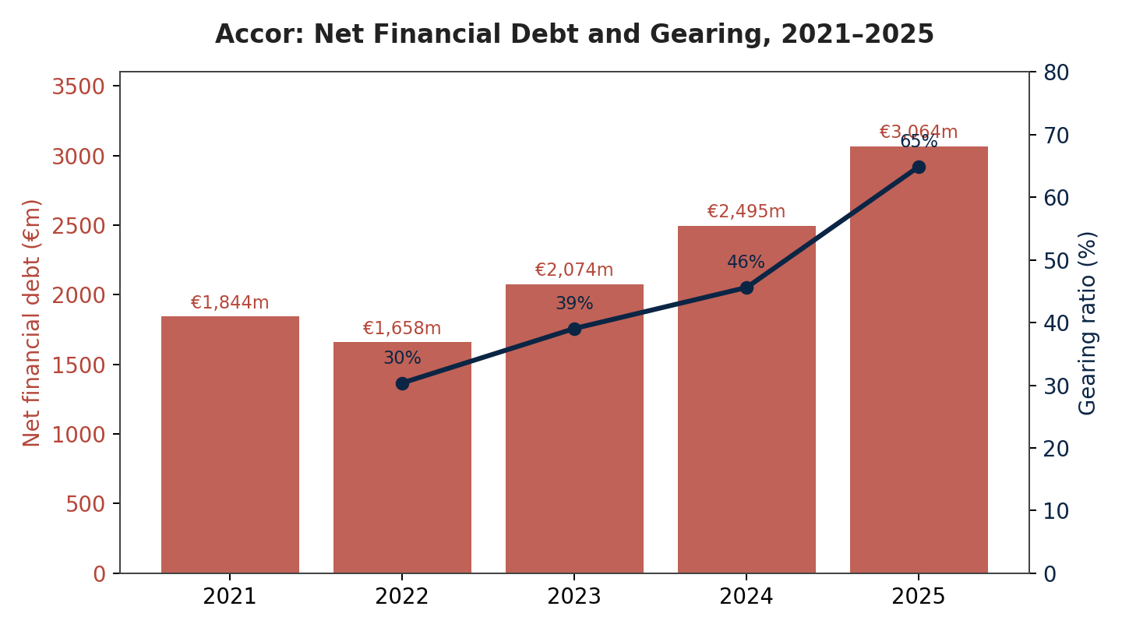
One of the most important problems found in the five-year financial review is the dramatic rise in the debt-to-equity ratio. A decrease in shareholders' equity, an increase in non-current borrowings, and the effect of share repurchase programs, which decreased equity, were the main causes of this increase. The corporation is therefore more vulnerable to financing risk, higher borrowing costs, and more vulnerability to future interest rate increases due to the larger debt-to-equity ratio, which indicates increasing financial leverage.

Investment
Earnings Per Share (EPS)
EPS (€) | 2021 | 2022 | 2023 | 2024 | 2025
Basic EPS | 0.19 | 1.40 | 2.23 | 2.34 | 1.61
Diluted EPS | 0.19 | 1.39 | 2.22 | 2.33 | 1.61

Dividends and Shareholder Returns
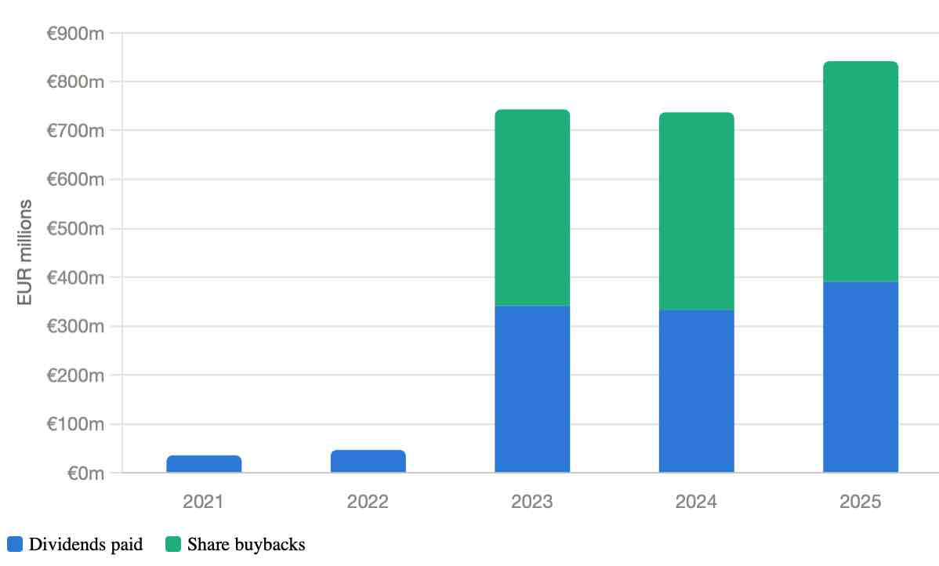
Despite a drop in reported earnings, Accor has raised shareholder payouts; total cash returned climbed from €743 million in 2023 to €843 million in 2025. This shows an emphasis on cash-flow-driven returns, which are partially backed by increased borrowing. The P/E ratio increased from 13.6x to 29.2x indicates that despite short-term earnings pressure, investors are still optimistic about Accor's long-term EBITDA growth.

Identify trends, strengths and potential threats

Five-Year Financial Trend Summary
Indicator (€m) | 2021 | 2022 | 2023 | 2024 | 2025
Revenue | 2,204 | 4,224 | 5,056 | 5,606 | 5,639
Net Profit | 85 | 426 | 633 | 657 | 449
Total Equity | 4,597 | 5,456 | 5,311 | 5,469 | 4,717
Operating Cash Flow | (240) | 511 | 669 | 733 | 810
Cash Balance | 1,666 | 1,643 | 1,279 | 1,244 | 1,205
Basic EPS | 0.19 | 1.40 | 2.23 | 2.34 | 1.61
ROE | 2.0% | 7.8% | 12.2% | 12.0% | 9.5%
ROA | 0.8% | 3.6% | 5.8% | 5.5% | 4.3%
Net Profit Margin | 4.1% | 10.1% | 12.9% | 11.7% | 8.0%
Operating Margin | 2.4% | 12.9% | 15.4% | 14.0% | 14.3%

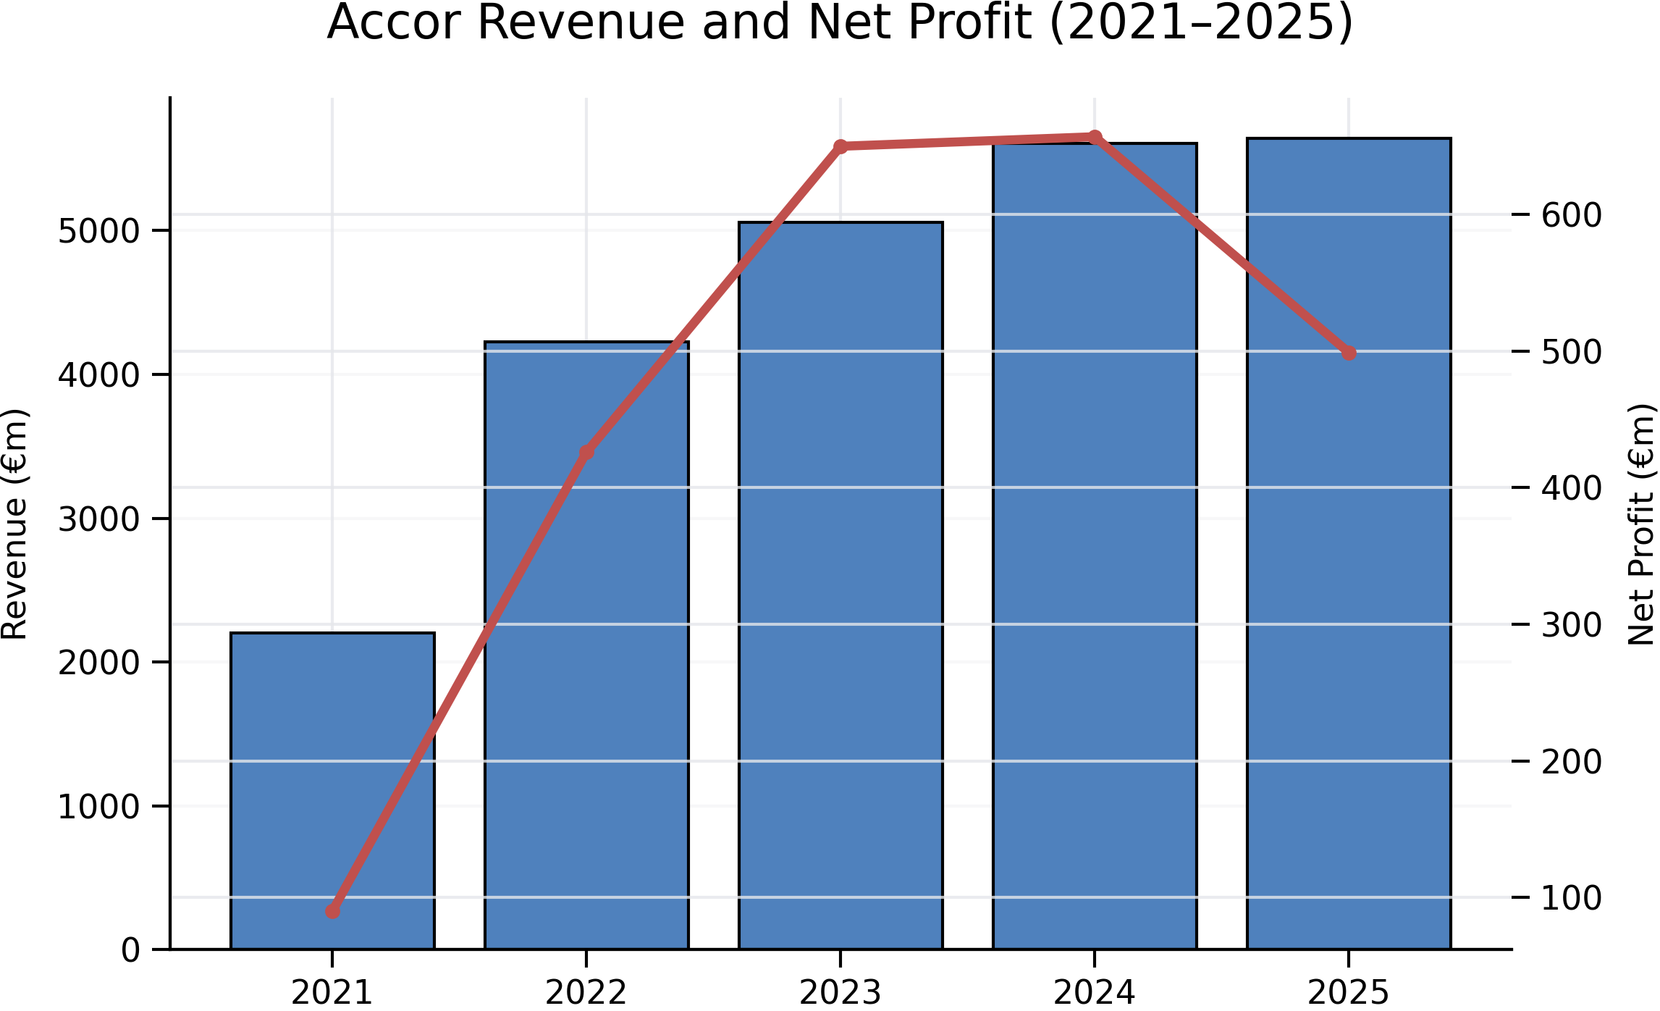

Key Trends
- Sustained operational recovery and growth: Since 2021, Accor has delivered consistent year-on-year increases in both revenue and recurring EBITDA, reflecting the continued recovery of global travel demand. This improvement has also translated into significantly stronger operating efficiency, with the EBITDA margin almost doubling compared with 2022 levels.
- Greater volatility in bottom-line performance: While underlying operating earnings have shown steady improvement, net profit has experienced greater fluctuations. This volatility can largely be attributed to the reduced impact of exceptional and non-recurring items that contributed substantially to earnings in the years following the 2023 peak.
- Progressive increase in financial leverage: The group's leverage position has strengthened over the period, with debt levels rising steadily. This trend has been driven primarily by strategic shareholder distribution initiatives, including share repurchase programmes and dividend payments, rather than by weaknesses in operating performance.
- Tightly managed liquidity position: Although liquidity ratios remain relatively low by traditional benchmarks, According to Sikveland et al., (2022) Accor continues to maintain adequate financial flexibility through active cash management and access to committed credit facilities. This approach is consistent with the practices commonly adopted across the asset-light hospitality sector.

Strengths
- Scalable asset-light business model: According to Blal and Bianchi (2019) Accor’s reliance on management and franchise fees enables the company to benefit from strong operational leverage as RevPAR improves, while requiring relatively limited capital investment and reinvestment compared with revenue growth.
- Well-diversified portfolio and market presence: According to Marklin and Bianchi (2022) the group’s extensive range of brands, spanning economy to luxury segments, combined with its broad international footprint, reduces dependence on individual markets and customer segments. In particular, the Luxury & Lifestyle division has emerged as the company’s strongest growth driver and most profitable business segment.
- Demonstrated operational execution: Between 2023 and 2025, Accor consistently met or surpassed its EBITDA growth targets, reflecting effective strategic execution, disciplined cost management, and management’s ability to deliver on market expectations.
- Prudent debt management: The company benefits from a relatively low and stable cost of borrowing, averaging approximately 2.5–3.0%, alongside a diversified debt maturity structure. This reduces short-term refinancing pressures and enhances financial flexibility despite higher leverage levels.

Potential Threats
- Increasing financial leverage and reduced balance-sheet flexibility: The steady rise in gearing has weakened Accor’s financial headroom, potentially limiting its capacity to pursue future acquisitions or withstand adverse economic conditions. According to Garcia-Gomez et al., (2021) If leverage continues to increase, the group may also face heightened scrutiny from creditors and rating agencies, with potential implications for its creditworthiness.
- Pressure on shareholder perceptions: Since reaching its peak in 2023, both net profit margin and earnings per share (EPS) have declined. Although this trend is largely attributable to the reduced contribution of exceptional gains rather than a weakening of core operations, inadequate communication of this distinction could negatively affect investor confidence and market sentiment.
- Exposure to external economic and geopolitical risks: As Accor’s earnings are heavily dependent on RevPAR performance, the company remains vulnerable to fluctuations in global travel demand arising from economic slowdowns, geopolitical instability, or currency volatility. This risk is particularly relevant in key markets such as Brazil, Turkey, and Egypt, where exchange-rate movements have already had an adverse impact on reported financial results.
- Greater dependence on debt-financed capital returns: According to Bourke et al., (2020) the continued use of borrowing to support shareholder distributions, including dividends and share repurchases, increases the group’s financial risk profile. Should growth in recurring free cash flow weaken, maintaining these capital-return programmes could place additional pressure on liquidity and leverage metrics, potentially constraining future strategic flexibility.

WORKING CAPITAL MANAGEMENT Analysis

Assessing the cash operating cycle
€m, Dec year-end | 2021 | 2022 | 2023 | 2024 | 2025
Inventories | 9 | 19 | 36 | 39 | 34
Trade receivables | 631 | 794 | 824 | 803 | 829
Other current assets | 322 | 403 | 434 | 504 | 478
Operating current assets | 962 | 1,216 | 1,294 | 1,346 | 1,341
Trade payables | 391 | 489 | 515 | 557 | 526
Other current liabilities | 609 | 859 | 887 | 847 | 823
Operating current liabilities | 1,000 | 1,348 | 1,402 | 1,404 | 1,349
Operating working capital | (38) | (132) | (108) | (58) | (8)

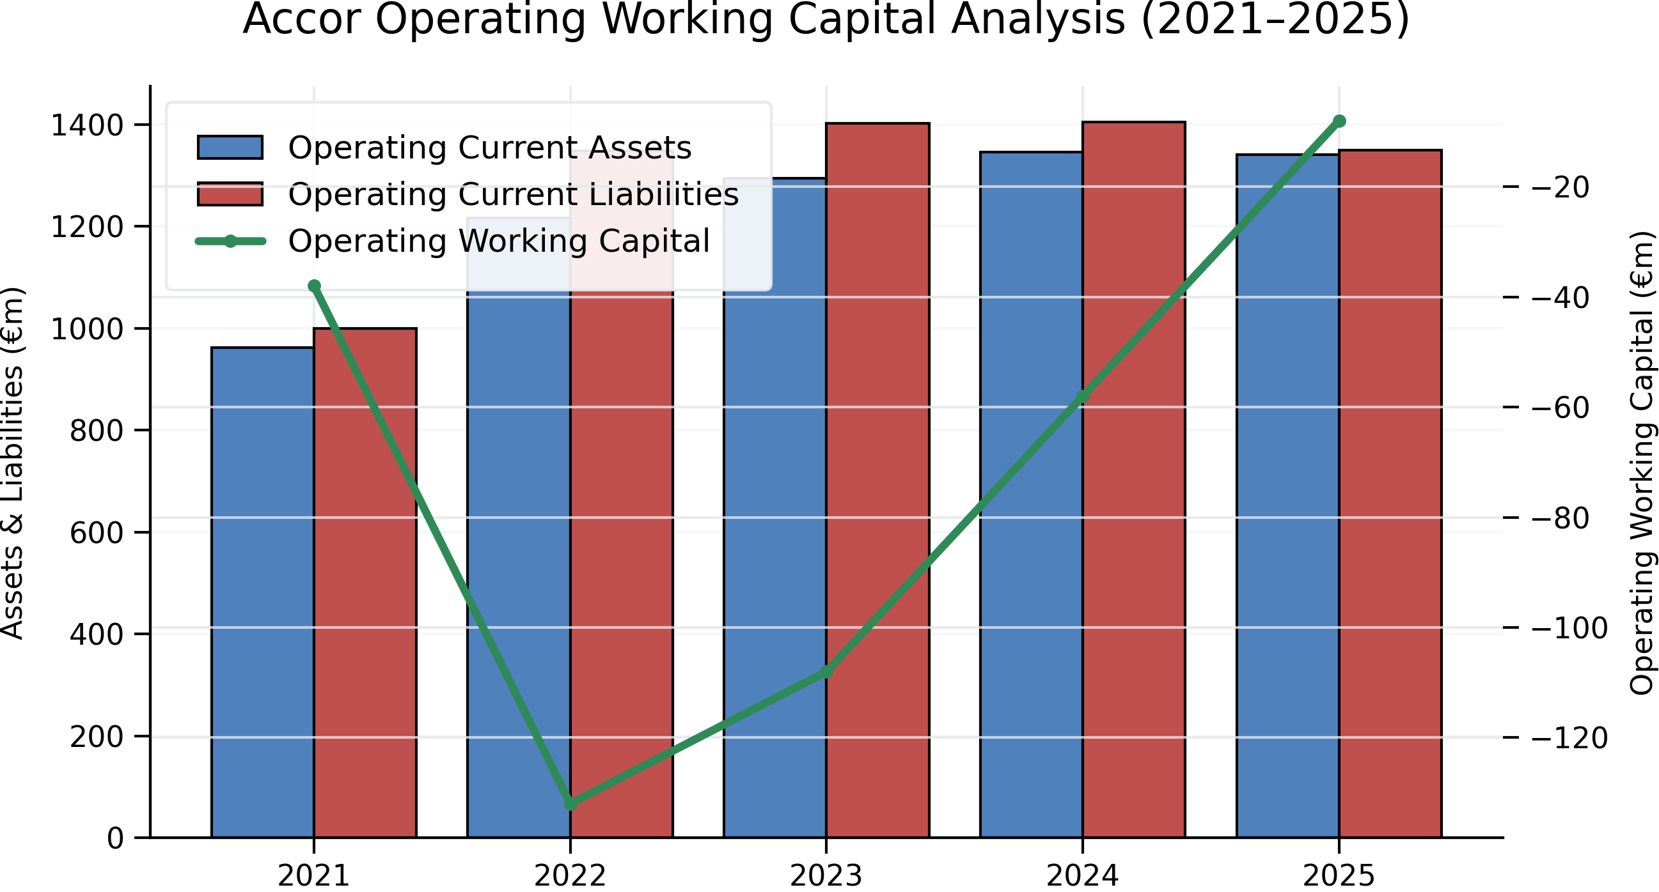
The graph clearly demonstrates that from 2021 to 2025, operational working capital was negative every year due to operating current liabilities exceeding operating current assets. Nonetheless, the deficit decreased from -€132 million in 2022 to -€8 million in 2025, indicating a steady improvement in Accor's working capital situation.
Compared to a normal manufacturing or retail company, Accor has a fundamentally advantageous cash operating cycle thanks to its underlying business strategy. According to Seo et al., (2021) as a hotel operator that has gradually moved toward an asset-light, management-and-franchise model, Accor collects the majority of room revenue at or before check-out or through pre-paid online travel agency bookings, settles supplier invoices on standard commercial terms of 30 to 60 days, and carries very little inventory (mostly food, beverage, and housekeeping supplies at owned or leased properties). Low inventory days, short receivable days, and relatively longer payable days usually result in a short cash conversion cycle (CCC), which may even be negative at times when advance reservations and loyalty program prepayments are high.

Days ratio | 2021 | 2022 | 2023 | 2024 | 2025
Days Sales Outstanding (DSO) | 105 | 69 | 60 | 52 | 54
Days Inventory Outstanding (DIO) | 61 | 85 | 104 | 106 | 99
Days Payables Outstanding (DPO) | 65 | 50 | 46 | 45 | 43
Cash Conversion Cycle (DSO+DIO−DPO) | 100 | 103 | 117 | 113 | 109
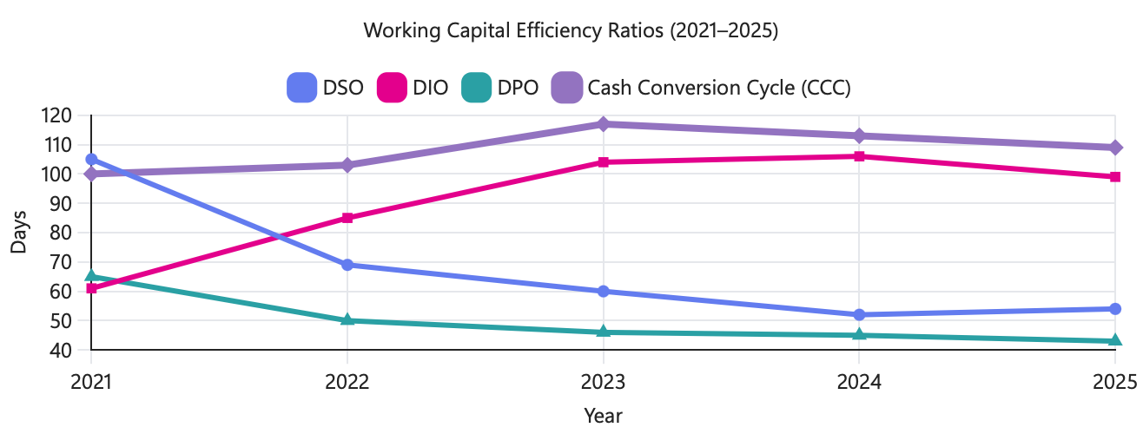
Over the time, Accor's working capital efficiency shown a variety of patterns. While DIO grew from 61 to 99 days, indicating slower inventory turnover, DSO reduced from 105 to 54 days, showing better receivables collection. DPO decreased from 65 to 43 days, indicating faster payment to suppliers. The Cash Conversion Cycle thus continued to be comparatively high, reaching a peak of 117 days in 2023 before somewhat improving to 109 days in 2025.
The instinctive expectation outlined in the majority of hospitality working-capital literature differs significantly from this calculated CCC, and the difference is instructive in and of itself. There are two things to unpack. First, DSO dropped precipitously from 105 days in 2021 to 52 days in 2024, in line with the post-pandemic normalization of B2B invoicing to corporate accounts and hotel owners. Then, it ticked back up to 54 days in 2025, a slight but directionally consistent signal with the concern expressed regarding the aging of corporate and standard accounts receivables as travel volumes recovered unevenly across regions.
This situation immediately relates to the income trajectory examined in the previous research. While EBITDA and operational profit were stable but net profit fell precipitously, revenue increased from €2.2 billion in 2021 to €5.6 billion in 2024 before levelling out in 2025. Because most guests pay in advance or at the time of departure, Accor quickly converts revenue into cash, so a decline in reported net profit caused by below-the-line items (financing costs, taxes, disposals) does not necessarily indicate a working capital or liquidity problem. This is why the cash-cycle lens helps explain why liquidity risk is lower than the decline in net profit alone might suggest. However, three particular stresses are worth examining.
First, as corporate travel volumes rebounded unevenly across regions in 2024–2025, receivable days might increase in the corporate and group/MICE categories, where invoicing and payment terms of 30–90 days are typical. Second, payment days need to be actively controlled. While extending supplier terms excessively to save cash improves the CCC mechanically, doing so puts the supply chain and franchisee relationships at danger, which is an operational and reputational risk rather than just a financial one. Third, because Accor is an asset-light franchisor and has a tiny, owned working capital base in relation to system-wide hotel revenue, its liquidity is more susceptible to management contracts and franchisee fee collection discipline than to the conventional retail-style stock-to-cash cycle.
Although the cash operating cycle seems structurally sound overall, the 2025 decline in net profit relative to flat revenue calls for closer observation of the ageing of receivables and any decline in fee income quality, as these are the working-capital items most likely to indicate stress before it shows up in the P&L.

Strategies to improve liquidity through working capital reforms
Receivables Acceleration: To turn receivables into cash more quickly, tighten credit conditions for corporate and group accounts, provide early-payment discounts, and increase the usage of virtual cards and pre-authorization payments at booking.
Dynamic and centralised treasury: According to Bihari and Walter (2018) using cash pooling and netting across Accor's several national entities to reduce dependency on external short-term borrowing by funding working capital requirements elsewhere with surplus cash in strong markets.
Payables optimisation, not just extension: According to Wuttke et al., (2013) negotiating longer terms with big suppliers where relationship risk is minimal, but combine this with supply-chain finance programs that allow franchise partners and smaller suppliers to get early payment from a bank at Accor's credit rating, safeguarding the ecosystem while keeping Accor's own cash on hand.
Revenue-management-driven prepayment: extend non-refundable and prepaid pricing structures through direct channels to decrease reliance on OTA settlement cycles, which sometimes cause guest stays to lag by several weeks, and to bring in cash earlier.
Working capital KPIs and governance: incorporate CCC, days sales outstanding, and days payable outstanding as tracked metrics at the business-unit level, with escalation triggers, so that any drift (like the pattern suggested by the 2025 profit decline) is detected early rather than only appearing in annual results.
Together, these changes seek to significantly shorten the cycle and provide a liquidity buffer without the need for costly outside funding, which is especially beneficial considering the earnings compression that was already apparent in 2025.

short-term vs long-term financing options
Overdraft facilities, commercial paper, trade credit, revolving credit facilities (RCFs), and other short-term instruments are more affordable and adaptable, making them ideal for financing seasonal fluctuations in working capital (e.g., filling the gap between low-season cash generation and payables due). Their main disadvantage is refinancing risk: as short-term facilities must be turned over, Accor is vulnerable to the possibility that spreads could widen or credit conditions tighten at the very moment the firm needs liquidity the most, as many hospitality businesses did in 2020–2021.
According to Bello and Sensini (2020) Bonds, term loans, and equity are examples of long-term financing. Although they have a higher explicit cost of capital, they eliminate the risk of refinancing during the course of the instrument and are more suitable for financing long-term projects like hotel renovations or acquisitions. The matching principle should guide the financing choice: while short-term, seasonal fluctuations are effectively funded with short-term facilities like an RCF, permanent or structural working capital needs (a stable minimum balance of receivables, cash float, and inventory that never really disappears) are best funded with longer-term, more stable capital.
A balanced approach is necessary given Accor's current profile, which includes strong EBITDA generation but a decline in net profit and EPS in 2025. This involves maintaining a well-diversified RCF for flexibility and seasonal needs while avoiding further long-term debt issuance until the cause of the 2025 profit fall is determined. This is because overcommitting to long-term fixed obligations during a period of profit pressure would reduce financial flexibility just when it is most valuable.

Strategic Financial Restructuring Plan

Recommended restructuring options
Three restructuring factors (flat revenue, strong EBITDA, poor net profit, and EPS) are viable options for Accor, each focusing on a distinct facet of the 2025 performance decline.
Ongoing asset-light transition or divestiture: sell any remaining owned real estate to franchise agreements or long-term management. Since owned real estate is capital-intensive and subject to property cycles, this is an extension of a technique Accor has previously implemented and immediately increases cash generation and return on capital invested.
Selective merger or brand-portfolio acquisition: targeted acquisitions of complementary luxury, midscale, or lifestyle brands, or a merger with a regional operator, can add scale and fee income without proportionate capital investment, but only if funded cautiously to prevent exacerbating the leverage picture behind the 2025 profit decline.
Equity injection or capital markets action: If the decline in net profit in 2025 is associated with increased net finance costs, a targeted equity raise or reinvestment of divestiture proceeds could be used to deliver the balance sheet. This would directly address the EPS dilution observed in the data (EPS fell proportionately more than net profit, consistent with a higher share count or financing drag).
Prioritising ongoing divestiture and asset-light conversion, using the proceeds first to lower net debt and finance costs, and only pursuing bolt-on M&A once the balance sheet impact of 2025's profit decline is understood are the most reasonable short-term recommendations. According to Abdullah and Zaby (2021) a sizable equity raise should be held in reserve rather than used proactively, as issuing equity while the share price reflects a profit decline would be dilutive at an unfavourable valuation.

Impact on Shareholder value, debt structure and operational flexibility
Over the medium term, divestiture-led restructuring often increases shareholder value because it can finance special dividends or buybacks, relieves capital locked up in low-yielding property, and increases EBITDA margins by changing the earnings mix toward high-margin fee revenue. However, given that 2025's profit was already worse than the trend indicated by EBITDA, transaction expenses and disposal gains or losses might increase reported net profit volatility in the short run. If the 2025 profit-to-EBITDA gap is caused by finance costs, utilizing divestiture proceeds to retire debt immediately reduces leverage ratios and interest costs. This would help explain and reverse some of the difference.
In contrast, a merger or acquisition usually results in a short-term rise in debt or the number of shares, thus it must be sized carefully to prevent exacerbating the pressure already seen in EPS. The asset-light strategy usually improves operational flexibility because it lowers fixed capital commitments and property-cycle risk, enabling quicker reaction to demand shocks. The pandemic period, which is represented in the 2021 data, reinforces this lesson.

International and ethical considerations
Taxation: Any restructuring plan should be examined for compliance with OECD BEPS principles and local substance requirements to prevent reputational and financial risk from aggressive tax positioning. Cross-border divestitures and management contract restructuring raise questions about transfer pricing and permanent establishment across Accor's numerous tax jurisdictions.
Currency risk: According to Geyer-Klingeberg et al., (2019) as a multi-currency, multi-jurisdiction group, disposal proceeds, financing costs, and translated earnings are subject to FX movements; any restructuring should be accompanied by a review of hedging policy to ensure that currency volatility does not mask the underlying operating performance that the restructuring is intended to enhance.
Inflation: The real value of fixed-fee management contracts and the attractiveness of sale-and-manage transactions (buyers price in future cost pressure) are both impacted by wage and input cost inflation in the hospitality sector. Therefore, contract structures should incorporate inflation-linked fee escalators whenever feasible.
CSR and ESG: any divestiture or M&A activity should be evaluated for its impact on employees (redundancy handling, retraining, fair treatment of franchisee staff) and Accor's sustainability commitments (energy and carbon performance of divested versus retained assets); According to Moussa et al., (2026) ESG-linked financing terms are increasingly linked to debt in the hospitality sector and, if targets are credibly met, can reduce the cost of the long-term financing discussed in Section 2c.
When taken as a whole, the restructuring strategy should be implemented in the following order: sell, borrow, then selectively buy. Deal screening should incorporate tax, currency, inflation, and ESG factors rather than addressing them after the fact.

Investment Appraisal and Capital Budgeting
Assumptions and results
Metric | Project A | Project B | Project C
PBP | 4 years 182 days | 4 years 199 days | 3 years 219 days
ARR | 1.6% | 2.0% | 6.0%
NPV | –£6.55m | –£6.08m | +£0.86m
PI | 0.87 | 0.88 | 1.02
IRR | ~3.5% | ~3.3% | ~8.6%

Key Workings (NPV at 8%, £m):
A: (10x0.926) + (12x0.857) + (14x0.794) + (10x0.735) + (8x0.681) =43.46 → NPV = –6.55
B: 11 x annuity factor (5years, 8%) = 11 x 3.993 = 43.92 → NPV = –6.08
C: (5x0.926) + (10x0.857) + (20x0.794) + (25x0.735) + (5x0.681) = 50.86 → NPV = +0.86

Only Project C clears the 8% hurdle rate, its IRR (8.6%) exceeds the discount rate, giving it the only positive NPV and a PI above 1.

Recommendation
Project C is the only investment that adds value based on NPV, PI, and IRR, which are the theoretically superior criteria since they take into account the time value of money and the whole cash flow stream. While both A and B destroy shareholder value at this discount rate (NPV of −£6.55m and −£6.08m, respectively), its NPV of +£0.86m shows that it is likely to deliver a return above the 8% cost of capital. This is confirmed by Project C's IRR of 8.6%; it is the only project whose IRR is higher than the needed return of 8%.
A separate but complimentary tale is told by the payback period. In addition, Project C returns its investment the quickest—in 3 years and 219 days as opposed to more over 4 years for A and B. Liquidity is important because C delivers funds to the company sooner, According to Atrill (2020) lowering financing risk exposure and enhancing the company's capacity to satisfy short-term obligations or reinvest. Payback, however, should supplement rather than replace the NPV-based choice since it overlooks cash flows after the cut-off point and the time value of money (Watson and Head 2019).
Due to its backloaded and quickly increasing cash flows (£20 million and £25 million in Years 3–4), Project C's ARR (6.0%) is three to four times larger than that of A or B. If a product is increasing its market share, for instance, this growth trajectory could also be appealing.
It's important to examine non-financial factors as well. Political risk (regulation change, currency exposure if international) might jeopardize the back-loaded cash flows that Project C depends on for its net present value (NPV) advantage if it represents entrance into a new or more risky market. According to Arnold (2013) reputational risk and client loyalty are also important; a project with quickly increasing cash flows may rely on repeat business or customer retention, both of which include execution risk. Even in the absence of a positive net present value at this rate, Projects A and B, with flatter or falling cash flow patterns, could represent more stable, lower-risk companies (such as established markets), which could appeal to a risk-averse board.
CAPITAL RATIOING WITH 100M LIMIT
At most two projects can be sponsored with the £100 million available, with each project costing £50 million. Since all three projects are indivisible and of comparable size, the goal under capital rationing is to maximize net present value (NPV) per pound invested, or rank by Profitability Index (PI). As a result, PI ranking and total NPV ranking coincide.
PI ranking: A (0.87) > B (0.88) > C (1.02)
Therefore, Project C + Project B is the best combination, with a combined NPV of −£5.22m, the least value-destructive pairing (compared to −£5.69m for C+A or −£12.63m for A+B).
However, this result highlights a drawback of forcing a two-project selection: since only Project C adds value on its own, the financially optimal choice under unconstrained choice would be to invest just £50 million in Project C alone and return or redeploy the remaining £50 million elsewhere (e.g., debt reduction, other investment opportunities), rather than accepting a second negative-NPV project just to use up the capital ceiling.

REFERENCE LIST:
Abdullah, S.M. and Zaby, S. (2021) “Seasoned equity offerings and differences in share-price impact by firm categories,” International journal of financial studies, 9(3), pp. 1–10. Available at: https://doi.org/10.3390/ijfs9030036.

Accor (2018) Consolidated Financial Statements and Notes, December 31, 2018. Paris: Accor SA. Available at: https://assets.group.accor.com

Accor (2025) 2024 Universal Registration Document including the Annual Financial Report. Paris: Accor SA. Available at: https://assets.group.accor.com

ACCOR 2025 report. https://press.accor.com/full-year-2025-results-solid-results-above-2025-guidance/?lang=eng

Arnold, G. (2013) Corporate Financial Management. 5th edn. Harlow: Pearson.

Atrill, P. (2020) Financial Management for Decision Makers. 9th edn. Harlow: Pearson.

Bello, C. and Sensini, L., (2020). Financing decisions of SMEs in the hotel industry. International Journal of Academic Research in Accounting, Finance and Management Sciences, 10(2), pp.9-14.

BERLINGER, E., BIHARY, Z. and WALTER, G., 2018. Corporate cash-pool valuation: a Monte Carlo approach. Studies in Economics and Finance, 35(1), pp. 153-162.

Blal, I. and Bianchi, G. (2019) “The asset light model: A blind spot in hospitality research,” International journal of hospitality management, 76, pp. 39–42. Available at: https://doi.org/10.1016/j.ijhm.2018.02.021.

Bourke, J.G., Izadi, J. and Olya, H.G. (2020) “Failure of play on asset disposals and share buybacks: Application of game theory in the international hotel market,” Tourism management, 77. Available at: https://doi.org/10.1016/j.tourman.2019.103984.
García-Gómez, C.D. et al. (2021) “Leverage and performance: the case of the U.S. hospitality industry,” Quantitative finance and economics, 5(2), pp. 228–246. Available at: https://doi.org/10.3934/QFE.2021010.

Geyer-Klingeberg, J., Hang, M. and Rathgeber, A.W. (2019) “What drives financial hedging? A meta-regression analysis of corporate hedging determinants,” International review of financial analysis, 61, pp. 203–221. Available at: https://doi.org/10.1016/j.irfa.2018.11.006.

Märklin, P. and Bianchi, G. (2022) “A Differentiated Approach to the Asset-Light Model in the Hotel Industry,” Cornell hospitality quarterly, 63(3), pp. 313–319. Available at: https://doi.org/10.1177/19389655211006076.

Moussa, T. et al. (2026) “Sustainability Performance, Cost of Debt, and Institutional Environment Quality: Global Evidence From the Hospitality and Tourism Industry,” Business strategy and the environment, 35(2), pp. 1712–1734. Available at: https://doi.org/10.1002/bse.70230.

Seo, K. et al. (2021) “The asset-light business model and firm performance in complex and dynamic environments: The dynamic capabilities view,” Tourism management, 85. Available at: https://doi.org/10.1016/j.tourman.2021.104311.

Sikveland, M., Xie, J. and Zhang, D. (2022) “Determinants of capital structure in the hospitality industry: Impact of clustering and seasonality on debt and liquidity,” International journal of hospitality management, 102. Available at: https://doi.org/10.1016/j.ijhm.2022.103172.

Watson, D. and Head, A. (2019) Corporate Finance: Principles and Practice. 8th edn. Harlow: Pearson.

Wuttke, D.A., Blome, C. and Henke, M. (2013) “Focusing the financial flow of supply chains: An empirical investigation of financial supply chain management,” International journal of production economics, 145(2), pp. 773–789. Available at: https://doi.org/10.1016/j.ijpe.2013.05.031.


