Reward for Performance and Contribution (BMPD5021)
The aim of this Reward Management presentation it to provide senior management with a general understanding of the impact reward strategies can have and how it can be linked to organisational performance.
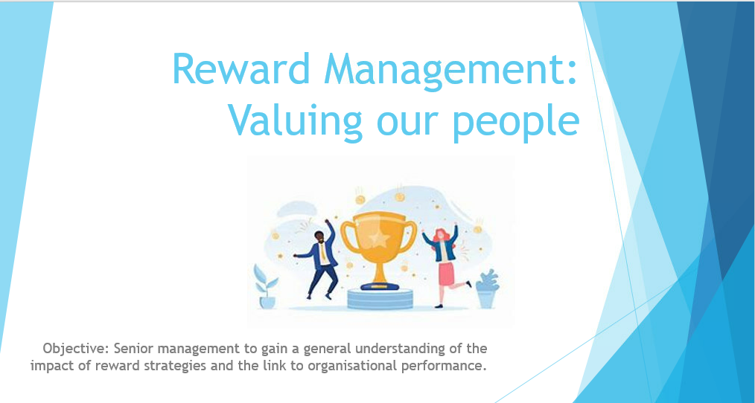

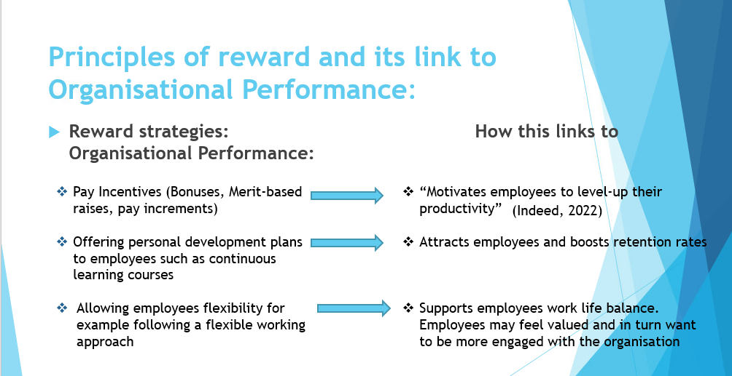

The term ‘Reward Management’ can be explained as benefits that attract, retain and engage employees. There are many reward options available to reward employees and recognise their contribution. Effective reward packages meet the needs of employees and its organisation’s purpose fairly and responsibly (Cotton, 2022).
Armstrong and Taylor explain “Reward management is concerned with the strategies, policies and practices required to ensure that the value of people and the contribution they make to achieving organizational, departmental and team goals is recognized and rewarded” (Armstrong and Taylor, 2014).

‘Total reward’ model covers all aspects of workplace rewards including pay, benefits, work environment and personal development opportunities. In contrast, strategic reward focuses solely on the design and implementation of reward policies.
Other principles of reward include intrinsic (internal) and extrinsic (external) rewards, for example internal rewards may come from an accomplished sense once you have completed a deadline whereas external rewards are usually financially based such as bonus’ (Miller, 2021).
All principles of reward must remain equal, fair, consistent and transparent across an organisation. This enables management to promote a culture of trust whilst balancing internal fairness. Reward policies can be utilized to integrate rewards for employees in line with business objectives by engaging employees and recognizing good work, which could implement a drive in performance and boost organisational reputation and attraction.
Research shows that reward policies can lead to organisational success through driving positive behaviors and values, benefit the organisation financially, it can promote fairness, equality and trust within an organisation and ultimately employees tend to be more committed to delivering their roles to a high standard (Dunn-Coleman, 2020).
All pay and reward policies in the UK must meet the legal requirements, for example The Equal Pay Act 1970 and The National Minimum Wage regulations.

1.2)
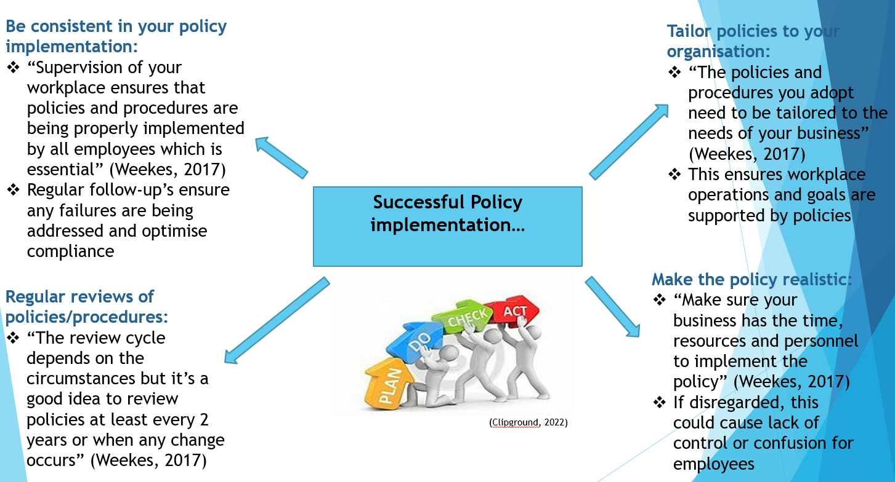

Incentives are important tools for driving employee engagement and performance, and often offer a way to invest in both your employees and your company. Educational and training incentives for example are a great way to reward team members. These types of incentives offer the employee a break from their typical work routine and provide them with opportunities to improve on their expertise. “Offering incentives with long-term benefits can create even better outcomes for both the employee and the company” (Fleet, 2017).
Line managers have a role in implementing effective policies, for example Senior Management should ensure efficiency in rewarding outstanding work and promote transparency when recognizing good work relating to reward and recognition. Managers could create positive recognition programs to engage employees. Managers should follow the regulations set out by The Equality Act 2010 embeds that all policies are to be fair, equitable and consistent (HR HelpBoard, 2022).
Balancing internal equality with external competitiveness can be a challenge as organisation’s must attract, retain and satisfy internal employees in order to be successful so finding a fair balance is vitally important (Greene, 2020).
If incentives are not implemented properly there is risk of both underperformance and decreased job satisfaction.

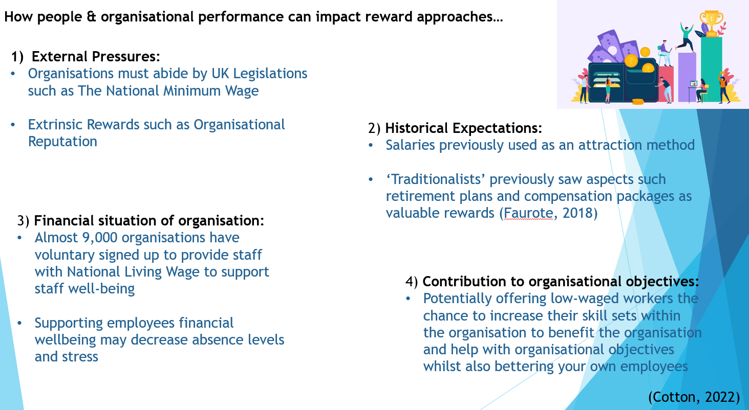

People and organizational performance can impact the approach to reward as “Performance can be traced back to the behavior of people on the shop floor” (Wainwright, 2018), especially if employees work in a certain way or behave in a way that contributes to organisational goals. “Task performance is often regarded as the most important aspect of work-related behavior and is regularly used as a synonym for overall job performance” (Wainwright, 2018).
Research shows people management has a significant impact on performance, although it can be argued that the effectiveness with which organisations manage, develop and stimulate their employees is an important cornerstone for how organisations perform overall (Wainwright, 2018).
Reward systems are primarily used to attract, engage and retain staff via both financial and non-financial reward strategies which vary across different organisation types. The behavior of employees may influence certain decisions on the reward approach for example, staff benefits help retain employees while financial incentives such as bonuses are used to motivate employees (Rose, 2018). Each individual may be attracted to different reward incentives depending on their own opinion, for example parents may be more attracted to flexible working opportunities which is non-finical where as a newly graduate may be more attracted to career progression opportunities which brings pay increases.

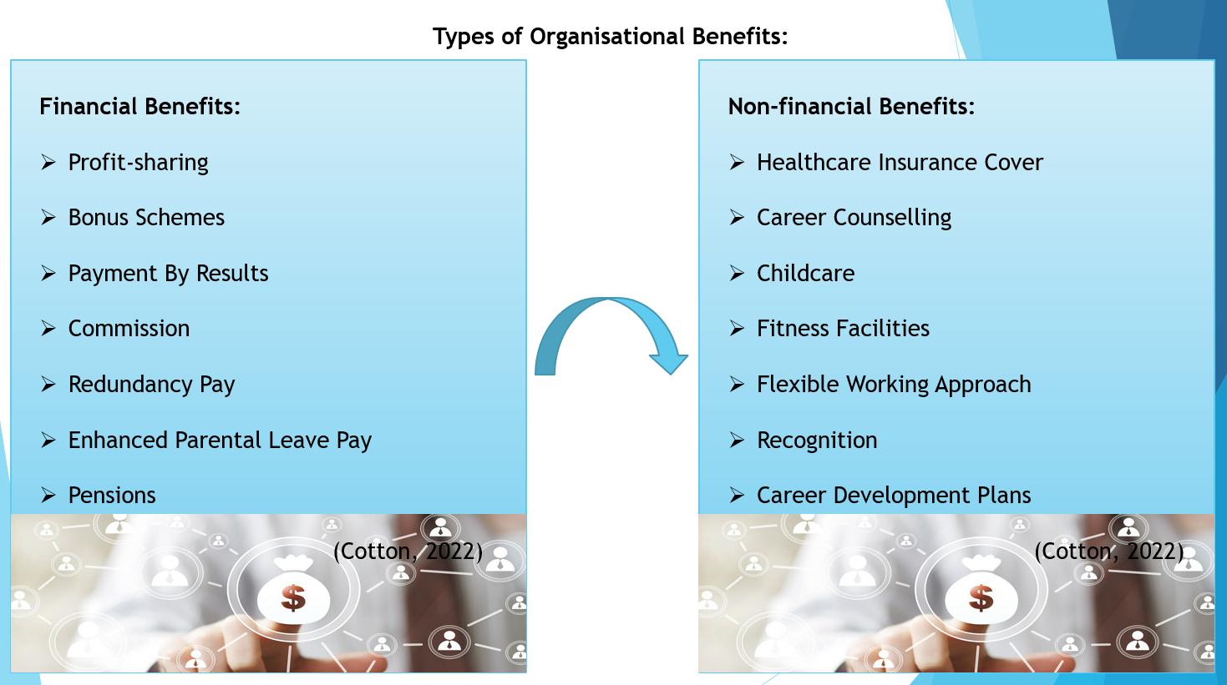
There are a many different types of benefits that can be offered by organisations – each with their own merits.
Flexible Working:
Allowing employees the flexibility of working from home or allowing flex in their working hours can increase employees job satisfaction and commitment to the organisation, as this allows employees feel more fulfilled in their personal lives and provides the opportunity to spend more time with their families and friends, especially beneficial for parents who must balance their career with child care or other family commitments (Indeed, 2021).
Pensions:
Pensions are a statutory benefit in line with legal requirements, however packages offered by organisations vary. CIPD explains that “Pension contributions and benefits are influenced by HM Revenue & Customs limits and vary from time to time” (Cotton, 2022). An employer might contribute to or match a certain amount of those funds. “Retirement plans include profit-sharing, stock bonus, employee stock ownership and cash balance plans” (Indeed, 2021).

Annual Leave Pay:
Employers must provide staff with the legal amount annual leave including bank holidays and a set number of days for personal hours per year. Annual leave pay provides employees with the opportunity to take time off away from work to focus on other commitments such as family holidays, birthdays, and time with loved ones. Overall, annual leave is a chance for staff to reset and refresh themselves, allowing for better performance.

Healthcare & Risk Benefits:
Providing employees with benefits that support their health and welfare can provide employees with a sense of health security and help improve their well-being. Some health care benefit examples are occupational sick pay, life insurance, fitness facilities, and eye care vouchers. “Each policy's purpose is to reduce an employee's out-of-pocket costs when paying for medical procedures or expenses” (Indeed, 2021).

2.1)
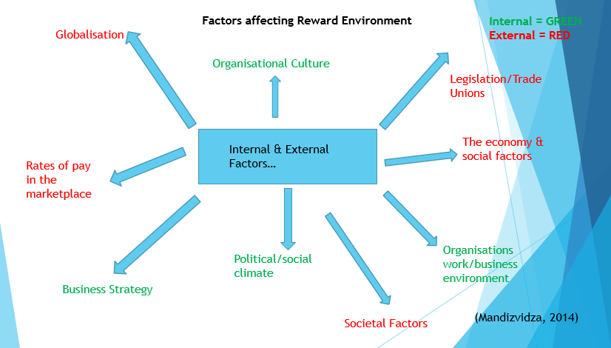
Before organisations implement reward systems, it is important managers assess how each reward could influence the business and its employees. Organisations may wish to consider the impact that particular reward systems may have and if the systems would contribute to the productivity of the organisation, and also consider if specific rewards meet strategic business goals and objectives as well as benefitting employees fairly (Cotton, 2021).
According to Michael Armstrong and Duncan Brown the strategic view over the reward system is necessary for business as “company goals and reward, if reached, offer an overview over the future, “a sense of purpose”, designs the process of it, steps and accountabilities and alignment between company goals and efforts, with rewards” (Armstrong & Brown, 2001).
Common reward packages include private, public and voluntary packages. Reward packages differ across organisations for many reasons, such as regional differences in pay, occupational classification, labour force trends, international comparisons and pay reviews. Although packages may differ across businesses’, legislations such as The Equality Act have been put in place to protect staff from any unfairness.
The main sections of how reward systems are designed for business use include job evaluation, market rate analysis, performance management, best practice, and both financial and non-financial benefits provided to employees (Cotton, 2021).

2.2)
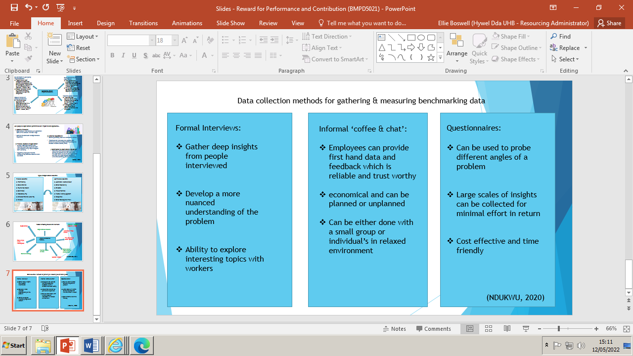
Benchmarking can be used to compare organizational strategies and performance by accessing how well organisations are doing and also highlight which areas need to be supported through increased productivity. “The ultimate aim of benchmarking is to explore what strategies you can implement or how you can tweak existing strategies to improve your performance” (Symanto, 2021). When collecting data it is important that the reliability of the data is taken into account and appropriate measurement approaches are utilized to gain a clear understanding of the insights.
Organisations can take a look into data such as hours employees have worked, rates of inflation, recruitment processes and open vacancies, bargaining and industrial disputes, reward and salary surveys and payroll data to collect business statistics and highlight how internal and external factors/environments can have an impact on reward strategies.
Internal benchmarking could be an ideal approach for collecting data to gain an insight into how reward strategies can be impacted. Internal benchmarking is based on the comparison of teams and organisations within the company to explore best practices and roll them out across other similar teams. For example, “your sales department northwest is doing particularly well – compare their strategies against those of lower-performing teams, ascertain what could be causing their success, and roll out the same strategy across teams in other locations” (Symanto, 2021).

2.3)
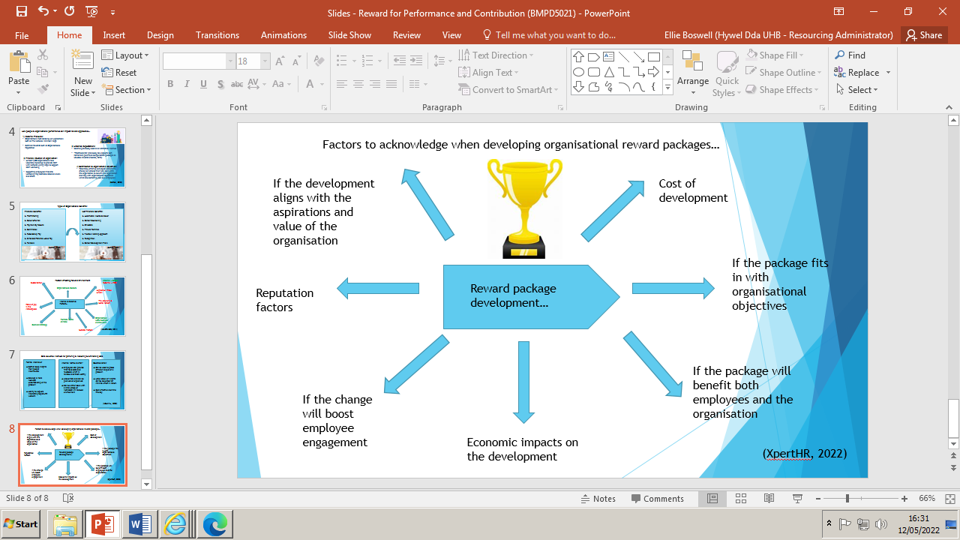

Benchmarking data can be used to develop appropriate organizational reward packages based on insights gained from data. Some examples of reward packages that can be developed from data collection include:
Grade & Pay Structures:
Developing a pay structure involves evaluating jobs and establishing associated salary ranges and grades based on market data and the company’s compensation policy. This can be done based off data collected during benchmarking. “The pay structure of each role is decided based on factors including responsibility, experience and education, key skills, effort/impact, and working conditions” (Lumen, 2022).

Job Evaluation Schemes:
Job evaluation is a way to work out the relative importance of different jobs in an organisation. In order to build an analytical job evaluation scheme it is importance to look into every factor of a role and score it accordingly to find out where the role sits within your organisation. Benefits of job evaluation schemes include a “clear recognition of a jobs value and new jobs can easily be evaluated and placed into hierarchy” (Acas, 2022).

Market rates:
Market rates (also known as pay benchmarking) are a way of collecting data on the pay rates for similar jobs in other organisations to establish their market rate and track movements in those rates, allowing managers to develop rates packages. “The aim is to set the employer's own pay rates at an appropriate level to recruit and retain the staff it needs” (Cotton, 2021).

2.4)
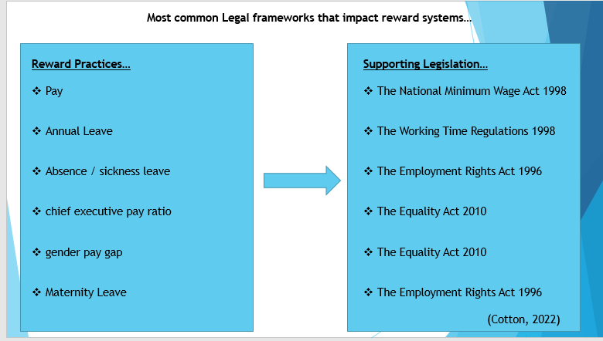
Legislative requirements are put in place to protect both employees and organisations with the purpose of providing frameworks for organisations to follow. Legislations can have an impact on reward practices such as the following:
Equal Pay and Reward
Organisations have a duty to provide employees with the bare minimum payment of minimum wage as set out by The National Minimum Wage Act. Equal pay is the right for men and women to be paid equally, as it’s an aspect of UK sex discrimination law which has been in force for over 40 years. If men and women are not receiving equal pay, the employer must prove that the reason isn’t gender-related (Cotton, 2019).
Working Time
Employees have a requirement to work the agreed amount of working hours within their contact as set out by an organisation, although there may be flexibility to work these hours across a monthly basis or a flexible working approach may be adopted where by employees can fit working hours alongside other life commitments. “The Working Time Regulations 1998 apply to all businesses that have employees. You must take reasonable steps to ensure that employees do not work more than an average of 48 hours a week (excluding lunch breaks)” (VisitBritian, 2022).
Annual leave
“Employees are entitled to 5.6 weeks' paid leave a year and rest periods of a specified length in each working day and in each seven day period” (VisitBritian, 2022). The Working Time Regulations 1998 sets out legislation that states mangers must set out an employee's paid holiday entitlement in their ‘written statement of employment’.

1.5)
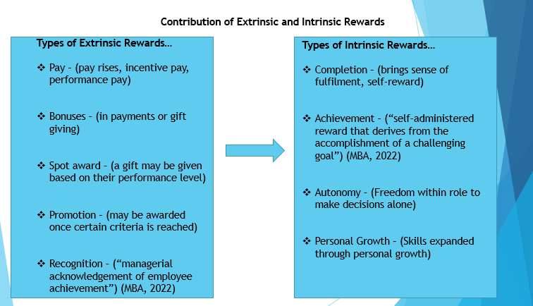
Extrinsic rewards are used by organisations to reward employees’ needs indirectly through financial rewards and incentives such as pay increases or bonuses. This type of reward is considered extrinsic because they are external to the completion of the work itself and are controlled by other people and not employees (Khern-am-nuai et al., 2018). Extrinsic reward are typically used as a form of motivating employees to improve their performance and contribute more to the organisation. Extrinsic rewards do not tend to have a lasting effect of employee engagement as once the pay increase/bonus has been received, employees may not be motivated if pay is not due to be increased further.
Intrinsic rewards are a form of motivation for employees through their own good work. For example if an employee feels that the word that they are outputting is of value or has been completed to a high standard may bring a sense of pride / motivation from within their self. Company MBA explain that “intrinsic rewards come from inside an individual rather than from any external rewards, such as monetary incentives” and say that intrinsic rewards are more sustainable and feel more rewarding as it is an individual experience of self-administered reward (MBA, 2022).
3.1)
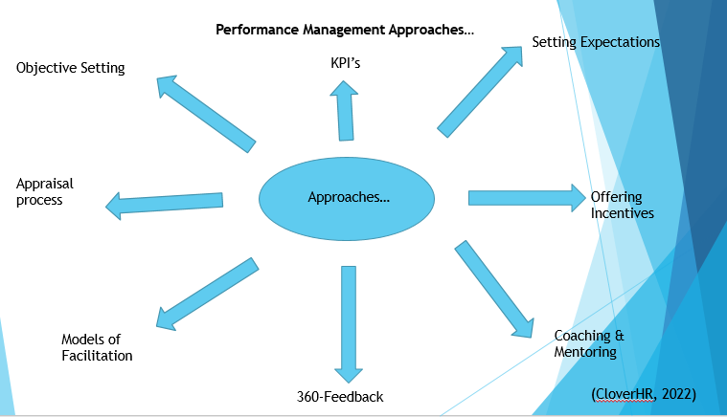
Organisations can take many different approaches to performance management which can be used by line managers to make effective reward judgements. “Performance management is an ongoing process between a manager and an employee which is used to maintain and improve the performance of a workforce, and supports accomplishment of the strategic objectives of the company. It helps companies become more successful and stay ahead of their competitors” (CloverHR, 2022).
Monitoring and Feedback
Feedback and regular reviews allows managers to keep track of an organisational performance and provides teams with ownership of their development. It also allows an opportunity to provide help and support if employee’s needs this to help achieve their goals. This approach can be completed through progress checks with engagement from both Management and employee involvement to provide different aspects of feedback (CloverHR, 2022).
Continuous Professional Development
Continued professional development can be carried out in a variety of ways such as conferences, mentoring and coaching. “Two of the most important steps are making the organisational and individual performance objectives clear and using feedback to review and improve processes and performance” (CloverHR, 2022). CPD takes a different approach to both feedback and goal setting approaches as CPD can be sculpted to benefit the organisations strategic plans.

Planning and Goal Setting

Organisations should focus on planning for future success through both long-term and short-term goals. Long-term goals are the most important on a large scale as they will determine the direction your business is going to take and how it is going to grow/where it will be in five to ten years (Rees, 2022). In comparison to other performance management approaches goal setting is a popular choice of approach due to sustainability and realistic outlook on succession planning.

3.3)
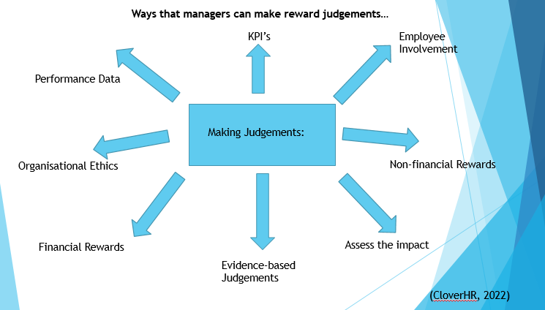
Line Managers are able to make reward judgements based on organisational approaches to reward by the use of policies and based off organisational values/beliefs. CIPD suggests that when managers are making reward judgements “Employers should find out what attracts, keeps and inspires their current and future people, and explore how best they can meet these needs - as well as meeting the requirements of the business within the appropriate legal and regulatory environment” (Cotton, 2022).
Appraisals can be used to have one-to-one’s with employees in order to gain a more positive outlook into how the organisation is performing. This can be beneficial for moving towards the values and beliefs of the company and allow employees to feel more engaged within their roles. Higher rates of employee engagement may prompt a more dedicated workforce, which in turn could lead to a clearer reward opportunity for employees.
Performance based on key performance Indicators show where performance is high and where support is needed or expectations should be adjusted (Baravik, 2021). This is helpful for managers as when managers set and track KPIs for employees, they unlock key insights about performance and productivity. KPIs help to identify employees’ strengths and implement strategies that produce results. (Baravik, 2021).
The credibility of reward judgements relies on line managers being seen as fair and consistent in reward practices. It is down to managers to make sound judgements that are aligned to business goals and organisational culture. When deciding on reward judgements it is important to assess and measure progress of reward management practices through mechanisms such as peer reviews and employee satisfaction surveys (Reward First, 2021).

3.2)
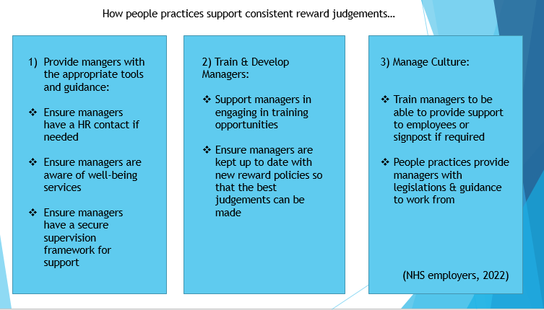
The role of people practices has a great impact on supporting line mangers to make consistent and appropriate reward judgements as people practices support the maintenance of equality, fairness and transparency within organisations. People practices support both extrinsic and intrinsic rewards, and ensures that relevant legislation is being followed in order to make appropriate decisions for example, appropriate pay is backed up by The National Minimum Wage Act 1998.
People practice encourages that line managers should be provided with the necessary training to manage a workforce effectively, deliver high levels of communication skills, have the ability to communicate well with employees and have sensitive conversations if required and ultimately be able to make decisions confidently.
The 2019 CIPD Reward Management survey indicates that “People professionals spend a lot of time on pay management in regards to structures, levels and progression. But are their efforts having a positive impact?” (CIPD, 2019). To help organisations derive value from their pay system, people professionals should focus on the encouraging people practices such as equal pay, fairness & employee wellbeing.
2.3)
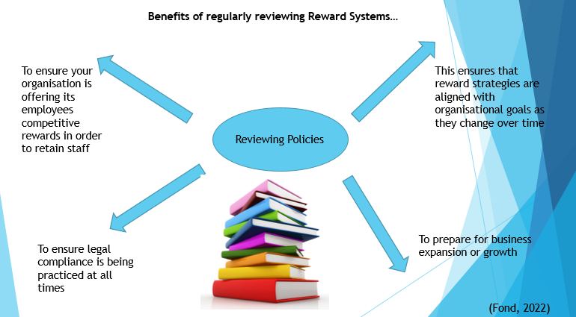
Looking at my own organisation, if I were to suggest one way to improve our reward system I would suggest having frequent reviews of our reward policies in order to keep them refreshed and employees engaged. Research states that “Employees can quickly become bored with certain rewards, which can decrease the value of the reward over time. If you want employees to constantly strive for excellence, update your rewards often to create a sense of urgency with your employees” (Fond, 2019).
I believe regular reviews of the reward system would be beneficial as my organisations objectives and goals change very frequently meaning that benchmarks for rewards and recognition should also evolve in line with objectives. “Rewards should always be incentivizing, not a “given” in the workplace. Refresh them often to ensure your employees are always excited about their rewards program” (Fond, 2019).

Summary

In summary, after looking into all aspects of reward management I believe reward policies can have a big impact on organisational performance and staff engagement for a number of reasons. My finding have indicated to me that when staff feel valued and treated well in their workplace, overall employees are more dedicated to their roles, commitment levels are higher, employees have a better sense of purpose and rewards & recognition for good work improves employees physiological well-being.

Word count = 4,075

References:
- Cotton, Charles. (2022). Reward: an introduction.
Available at: https://www.cipd.co.uk/knowledge/fundamentals/people/pay/reward-factsheet/. (Accessed on: 05.05.22)
- Miller, Vicky. (2021). Differences Between Intrinsic and Extrinsic Rewards. Available at: https://www.wikijob.co.uk/jobs-and-careers/employment/intrinsic-rewards/. (Accessed on 06.05.22)
- Armstrong & Taylor. (2014). Handbook of Reward Management Practice. 6th Edition Handbook.
- Dunn-Coleman. (2020). Five ways your reward strategy can support your organization’s purpose, values and culture. Available at: https://reba.global/resource/five-ways-your-reward-strategy-can-support-your-organisation-s-purpose-values-and-culture.html/. (Accessed on: 06.05.22)
- Indeed For Employers. (2022). Employee Incentive Programs: 32 Examples for Your Business. Available at: https://www.indeed.com/hire/c/info/employee-incentive-program/. (Accessed on 06.05.22)
- Maull, Fleet. (2017). How To Implement Incentives That Actually Work. Available at: https://www.forbes.com/sites/forbescoachescouncil/2017/04/24/how-to-implement-incentives-that-actually-work/. (Accessed on 06.05.22)
- Greene, Robert. (2020). Balancing Internal Equity with External Competitiveness. Available at: https://www.linkedin.com/pulse/balancing-internal-equity-external-competitiveness-challenge-greene/. (Accessed on: 06.05.22)
- ClipGround. (2022) Available at: https://clipground.com/clipart-project-implementation.html
(Accessed on: 09.05.22)
- Weekes, Joanna. (2017). Step-by-Step: How to implement effective policies and procedures. Available at: https://healthandsafetyhandbook.com.au/bulletin/step-by-step-how-to-implement-effective-policies-and-procedures/. (Accessed on 09.05.22)
- Wainwright, Bronwyn. (2018). what is employee performance? Available at: https://www.effectory.com/knowledge/what-is-employee-performance/. (Accessed on: 09.05.22)
- Rose, M. (2018). Reward management: a practical introduction. NY: Kogan Page Publishers.
- Faurote, Cassandra. (2018). Compensation Sense: How to Balance Total Rewards Expectations for Different Generations in the Workforce. Available at: https://www.totalrsolutions.com/total-rewards-different-generations-in-the-workforce/. (Accessed on: 09.05.22)
- Cotton, Charles. (2022). Workplace pensions. Available at: https://www.cipd.co.uk/knowledge/fundamentals/people/benefits/workplace-pensions-factsheet./. (Accessed on: 09.05.22)
- Indeed. (2021). Why Are Employee Benefits Important? Types and Advantages. Available at: https://www.indeed.com/career-advice/career-development/why-are-employee-benefits-important/. (Accessed on: 09.05.22)
- Dinu, Aida. (2021). Reward Management – Environment. Available at: Reward management - Environment #rewardstrategy #rewardandrecognition #swotanalysis #pestlee #management #employeeengagement (linkedin.com). (Accessed on 10.05.22)
- Mandizvidza, Albert. (2014). Rewards and Incentives. Available at: Rewards and incentives (linkedin.com). (Accessed on 11.05.22)
- Symanto. (2021). Benchmarking Data: Collection, Analysis & Interpretation. Available at: https://www.symanto.com/blog/benchmarking-data-collection-analysis-interpretation/. (Accessed at: 11.05.22)
- Ndukwu, Daniel. (2020). 7 data collection methods. Available at: 7 Data Collection Methods for Qualitative and Quantitative Data - KyLeads. (Accessed on: 11.05.22)
- ACAS. (2022). Job evaluation: considerations and risks. Available at: https://www.acas.org.uk/sites/default/files/2021-03/job-evaluation-considerations-and-risks-advisory-booklet.pdf. (Accessed on 11.05.22)
- Lumen. (2022). Developing a pay structure. Available at: Developing a Pay Structure | Human Resources Management (lumenlearning.com). (Accessed on: 11.05.22)
- Cotton, Charles. (2021). Job Evaluation & Market Pricing. Available at: Job Evaluation & Market Pricing | Factsheets | CIPD. (Accessed on 11.05.22)
- XpertHR. (2022). How to develop a reward strategy. Available at: XpertHR_article_115194.pdf.
(Accessed on: 12.05.22)
- Cotton, Charles. (2019). Equal Pay. Available at: Equal Pay | Factsheets | CIPD (cipduat.co.uk). (Accessed on: 12.05.22)
- Khern-am-nuai. (2018). Extrinsic versus Intrinsic Rewards. Available at: Extrinsic versus Intrinsic Rewards for Contributing Reviews in an Online Platform | Semantic Scholar. (Accessed on: 12.05.22)
- CloverHR. (2022). Performance Management Tips. Available at: Top 7 Performance Management Tips and Techniques | (cloverhr.co.uk). (Accessed on: 12.05.22)
- Rees, Sullivan. (2022). Goal Setting. Available at: SULLIVAN REES Planning and goal setting | SULLIVAN REES. (Accessed on 12.05.22).
- Reward First. (2012). Reward First. Available at: Tips for making the most of line managers | Reward First ® People Consulting (reward-first.com). (Accessed on 13.05.22)
- CIPD. (2019) Reward Management Report. Available at: reward-management-report-2019-2_tcm18-68009.pdf (cipd.co.uk). (Accessed on 13.05.22)
- NHS Jobs. (2022). Supporting Line Managers. Available at: Health and wellbeing top tips for supporting line managers | NHS Employers. (Accessed on 13.05.22)
- Fond. (2022). Rewards & Recognition. Available at: 10 Ways to Increase Employee Productivity with Rewards and Recognition (fond.co). (Accessed on 13.05.22)
- TOP 7 PERFORMANCE MANAGEMENT TIPS AND NI

