Title Page:
Name of report: Transforming Hotel Arts Barcelona into a Sustainable Luxury Haven
Name of the hotel and the department: Hotel Arts Barcelona, Guest Services Transformation
Name: Ruxandra Laczko
Student number: 2107521
Module: Organisational Consultancy BMIH6005
Lecturer: Jaliya DeSilva
Name of your company: Eco Lux Hospitality Consulting
Date report will be delivered to the client: 17.11.2023.

1.Content page:
Title Page: 1
1.Content page: 2
2.Executive summary: 2
Findings and analysis. 3
Recommendations to the client 4
Action Plan: 4
Conclusion. 5
3.Introduction: 5
4.Introduction of the hotel. 8
5.Analysis of the hotel. 9
PESTLE analysis: 9
SWOT analysis. 14
TOWS: 16
6.Recommendations and Change Management 17
6.1. Enhanced security measures: 17
Service excellence training: 19
Communication and guest engagement. 20
Measuring and reporting: 22
Action plan: 23
Conclusion: 25
Reference list 25

2.Executive summary:
The analysis of Hotel Arts Barcelona, incorporating TripAdvisor reviews and strategic tools like SWOT, TOWS, and PESTLE, reveals potential areas for improvement. The historical context of Ritz-Carlton's journey adds depth, and the emphasis on customer feedback aligns with hospitality best practices.
The next steps involve addressing identified issues transparently, engaging stakeholders effectively, and implementing strategic measures for improvement. The commitment to maintaining the Ritz-Carlton legacy underscores the pursuit of continued success for Hotel Arts Barcelona in the competitive hospitality sector.

The comprehensive PESTLE analysis provides a foundation for understanding the external factors influencing Hotel Arts Barcelona. By addressing these factors strategically, the consultancy firm aims to guide the hotel toward improvements, aligning its services with the Ritz-Carlton brand legacy and ensuring enhanced guest satisfaction.
Addressing weaknesses (Maintenance and Guest Services) capitalising on opportunities (Market Expansion, Experience Enhancement, Technological Integration, Sustainability Initiatives, Collaborations and Partnerships: Forming partnerships with local businesses and luxury brands can enhance the overall guest experience. Social Media Engagement: Leveraging social media for wider audience reach and direct guest engagement), implementing strategic measures can position Hotel Arts Barcelona to navigate threats and further leverage its strengths for sustained success (Luxurious Brand, Distinctive Visual Image, Service Quality.)
TOWS analysis is employed to align internal strengths with external opportunities, address weaknesses to capitalize on opportunities, leverage strengths to mitigate threats, and address weaknesses to minimize the impact of threats. Regular reassessment and consideration of organisational, environmental, and strategic elements are emphasized for successful strategy implementation in the dynamic hospitality and tourism industry.

Findings and analysis.
- Enhanced Security Measures:
- Emergency Response Plan: Develop and update a comprehensive emergency response plan.
- Guest Verification: Implement thorough guest verification processes during check-in.
- Collaboration with Local Authorities: Establish a strong relationship with local law enforcement.
- Training and Awareness: Provide regular training for staff on security protocols.
- Secure Payment Systems: Implement and regularly update secure payment systems.
- Regular Security Audits: Conduct regular security audits to identify vulnerabilities. Regular assessments and adjustments based on emerging threats are essential.
- Adaptability After COVID-19: Understand and adapt to changing consumer behaviour post-COVID-19.
- Service Spirit: Emphasize the importance of service spirit in the success of the hospitality industry.
- Core Values: Align with core values, such as Marriott's commitment to continuous improvement and guest care.
- Customer Needs: Fulfil customer needs and expectations to avoid losing competitive advantages.
- Frontline Employees: Empower frontline employees to build strong relationships with guests.
- Human Resource Management: Implement flexible and effective human resource management to manage seasonal changes.
- Employee Retention: Reduce employee turnover to improve training and compliance with service standards.
- Addressing the issue of seasonal workers and low employee retention is crucial for maintaining high-quality customer service in the hospitality industry.
- Communication and Guest Engagement:
- Smart Service Introduction: Embrace smart services in hospitality to personalize the guest experience.
- Data Collection: Utilize advanced technology for data collection, analysing customer behaviour, preferences, and history.
- Online Reviews: Recognize the importance of online reviews and manage them effectively.
- Communication Changes: Adapt communication strategies to changes driven by smartphones and social media.
- Review Responses: Respond actively to online reviews to enhance communication and customer engagement.
The use of advanced technology, smart services, and effective communication can significantly impact guest experience and satisfaction, leading to increased efficiency, revenue, and competitiveness in the hotel industry.

Recommendations to the client
Organisational consultants face challenges in achieving clear outcomes for clients, making it difficult for clients to judge the effectiveness of consulting services. Physical, cultural, and political challenges in client-consultancy relationships can occur, influencing effectiveness.

Action Plan:

- Engage stakeholders collaboratively.
- Include employee representatives in decision-making.
- Evaluate organisational culture for improvement.
- Assess employee morale and retention factors.
- Allocate resources for cultural initiatives.
- Include employee recognition programs.
- Security Measures Implementation:
- Embed a culture of safety through training.
- Recognize and reward participation in security protocol.
- Integrate cultural sensitivity training.
- Implement initiatives for exceptional service.
- Communicate the importance of a respectful work environment.
- Share success stories of employee contributions.
- Develop career growth opportunities.
- Introduce flexible scheduling and benefits.
- Monitoring and Evaluation:
- Assess the impact of cultural initiatives on satisfaction.
- Monitor retention rates and adjust strategies.

Conclusion.
By fostering a culture of safety and inclusivity, engaging stakeholders, and implementing strategic measures, the plan aims to ensure the hotel's adaptability and success in the dynamic hospitality industry. The commitment to continuous monitoring and evaluation reflects a proactive stance towards meeting evolving industry standards and stakeholder expectations, ultimately contributing to the hotel's long-term resilience and success.

3.Introduction:
This report should structure the analysis of Hotel Arts Barcelona according to TripAdvisor hotel reviews, to find issues that need to be addressed, using these relevant information's, can be found the most common issues, and be addressed accordingly. To include a complete report of the hotel's potential improvements with academic support and backup, research, market research, framework of SWOT, TOWS, and PESTLE analysis, needs to be done, and organisational consultancy strategy needs to be implemented.
According to research (Phadermrod, Crowder and Wills, 2019) SWOT analysis is a strategic tool to find an organisation strength, weaknesses, these factors are internal, and they can be controlled in an organisation to achieve its mission. While opportunities and threats are external forces that may allow or obstruct the organisation desire to achieve the targeted goals.
A TOWS analysis matrix is used on a situational analysis to develop strategic decisions within an organisation, department or team (de Bruin, 2019).
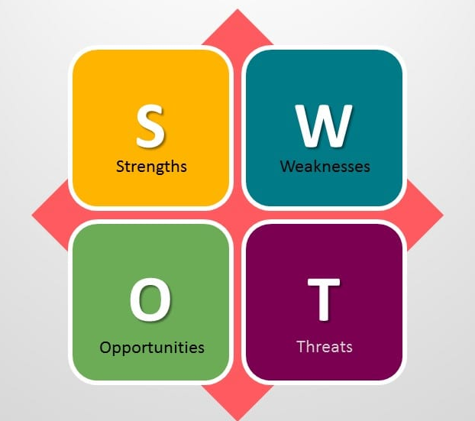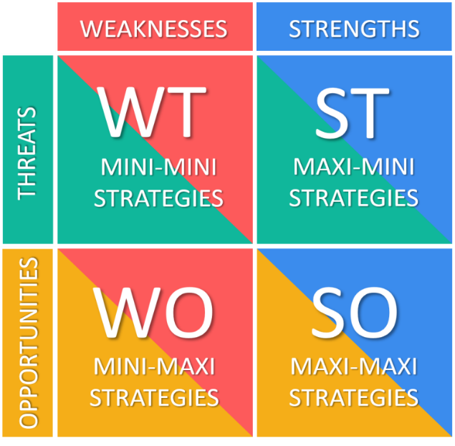
(de Bruin, 2019).
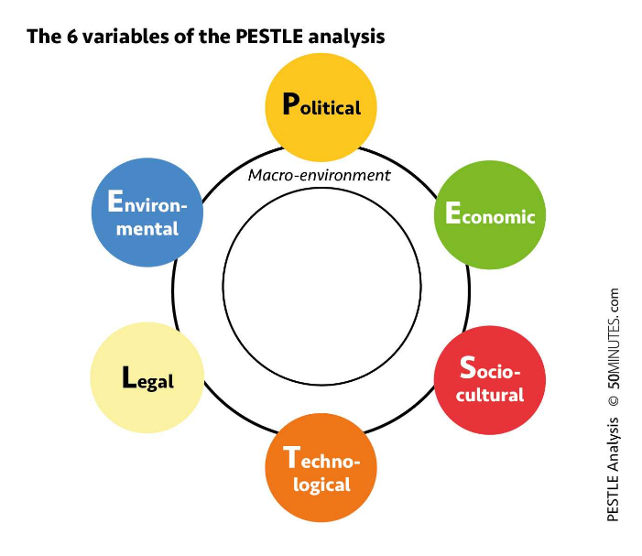
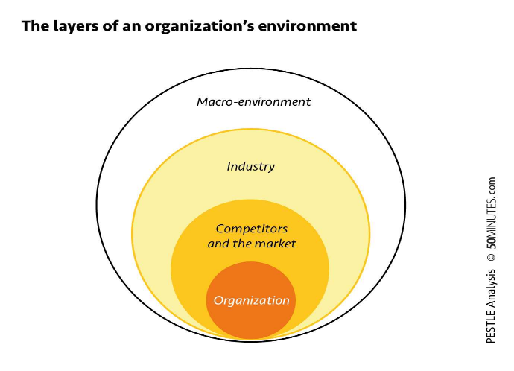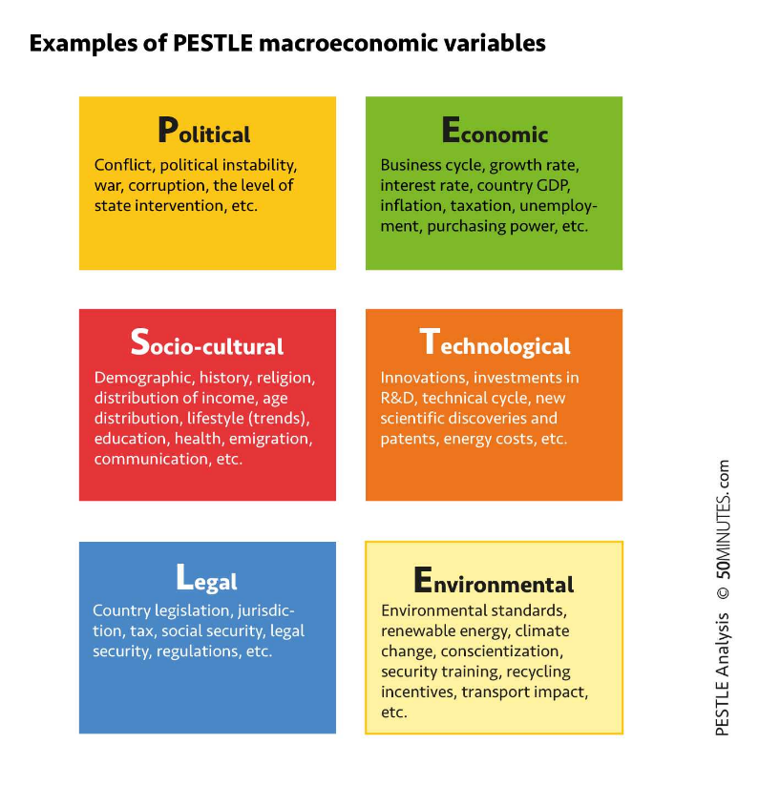
(Thomas Del Marmol, 2021).
According to Thomas Del Marmol (2021) the PESTLE analysis allows any organisation to identify future macroeconomic variables of different scenarios and anticipate the strategies that need to be followed for a successful development and sustainability of a business. The objective of the PESTLE analysis is to identify the unavoidable macroeconomic changes that might impact the development of a company significantly in terms of product, brand, or the entire organisation.
- Political variables are the government pressure, monetary policy.
- Economic variables can be inflation and fluctuations in monetary.
- Socio-cultural variables are the demographic, age distribution, buying behaviour, history, traditions, religion, socio-cultural influences like fashion, media.
- Technological factors include the use of internet which is a significant competitive advantage for any business.
- Legal factors include the labour laws, trading laws.
- Environmental variables include the sustainable development, climate change, pollution that can directly affect a business.
The Eco Lux Hospitality Consulting company will do its best to address those problems with honesty and accountability, making sure that the hotels shareholders, stakeholders, employees and management have a clear understanding of the situation and are ready for changes and new challenges. Engaging and actively communicating with everyone.

4.Introduction of the hotel.
Hotel Arts Barcelona (www.ritzcarlton.com.) It's a luxurious hotel located in the vibrant city of Barcelona, known for its modern architecture and stunning views of the Mediterranean Sea. According to www.ritzcarlton.com the Hotel Arts Barcelona is a premier destination, offering excellent customer service, with amazing views for city and the Mediterranean beach, is the tallest building at the coastal, mixed with art, luxurious suits and personalised service. The hotel is a 5-star luxurious accommodation offering concierge service, luxury dining, spa, Michelin star restaurant and rooftop cocktail bar. The luxury hotel with a perfect location on the beach have spacious garden, infinity pool, swimming pool, art gallery with 500 pieces of artwork collection. Offering rooms for small and medium gatherings, any type of event, with outdoor spaces and indoor. Built in 1991 the hotel has its unique design that transformed the urban landscape (Hotel Arts.).
According to Michelli (2011) the history and the legacy of Ritz-Carlton Hotels it is to inspire the delivery of highest quality of service and luxury to customers. Throughout the years the Ritz-Carlton have become one of the worlds famous luxury hotel brands. The Ritz-Carlton Hotel Company had leadership from around the world and when Horst Schulze takes over the president position, with a steady phase he expanded the brand. However, because of the economic impact on business the financial challenges were greater. Soon Marriott International purchased 49 percent of the stake in Ritz-Carlton (1996), and today the hotel brand is fully owned by Marriott International, supporting economically and socially, and its culture has remained individual in accordance with research (Michelli, 2011).
According to Schulze (2019) to gather information from customers is to follow up surveys of customers or members of hotel on satisfaction level and then management should focus on what they really want, like, expectations, how to make service better, if they would recommend to others. Shultz (2019) describes ways to get feedback such as follow-up phone calls, online questionnaire, comment cards. For complainers should be a strategic team to act when following the trends and react when needed. However, Shultz recommends outside companies to analyse data, organising research information of customers services, new trends of dissatisfaction or demands, it can cost but strategically worth, and helps the organisation to take effective measures.
According to Yeung (2006) in his article describes the Ritz-Carlton success in people management as everyday execution, which consist in taking care of people, trusting, developing, and providing a happy environment to work in it.
5.Analysis of the hotel.
Service lacking guest satisfaction:
According to TripAdvisor (2023) the hotel met some unsatisfactory complains about guest services, which does not meet the Ritz-Carlton brand legacy.
As research describes Ritz-Carlton as a luxurious brand, but by analysing the data from customers experience it can be described as the hotel lack employee engagement, communication, security services, non-happy environments for working, it might need refurbishment, lack of luxurious guest service, training and development, lack of labour.
The consultancy firm will analyse data and collect relevant information to improve the quality of the services.
For data collection and analysis, the use of PESTLE, SWOT, TOWS, will be done, to find solutions.

PESTLE analysis:
Political factors:
According to Dinia et al. (2022) the covid-19 outbreak have given the world socio-economic challenges, study refer to political factors that may affected a country such as strict lockdown measures on those wealthier countries when the economic loss was greater, but they resource too.
According to research (Rodríguez-Fuentes and Padrón-Marrero, 2008) about the monetary policy in Spain, resulted the monetary loss of own, while conversing to euro, left countries in shock.
The labour law in Spain have been improved to being comprehensive and protect employees, recent legislation upgraded the workplace safety law, gender equality, data protection, remote working, social security, training and temporary employment contracts legislation, and country scores high for work-life balance according to Expat Guide to Spain | Expatica (2023).
Economic factors:
According to Spulbar and Birau (2020) the past plays a big role in predicting future inflation (backward-looking). But as things stabilize, people should focus more on predicting and planning for the future (forward-looking). This means central banks will pay more attention to their forecasts and what people expect to happen, shaping their strategies for keeping prices steady.
According to the comment on inflation from leaders in the EU (ETUC | European Trade Union Confederation, 2023) can determine that the inflation targeting the poorest people, because of the prices on rising the big corporations are the ones with the greatest profit.
According to economy-finance.ec.europa.eu (2023) the latest update of economic forecast for Spain the second half of year 2023 will not grow faster than in first half, with the tourism sector slowing down and people will spend less, main trading partners having tighter finances.
Spain's Gross Domestic Product, which measures the total value of goods and services produced in the country, has been on the rise, reaching 1,329 billion euros in 2022. This puts Spain as the 15th largest economy globally. However, when looking at GDP per capita (which divides the GDP by the population), Spain's standing drops, with 29,421 US dollars per person in 2022, showing a bit of a dip.
Breaking it down by regions, places like Madrid and the Basque Country have a much higher GDP per capita compared to Andalusia and the Canary Islands. The service sector is dominating the Spanish economy, with tourism being a significant player. Before the pandemic, Spain had one of the largest shares of GDP from tourism in Western countries. However, with COVID-19, the tourism sector took a hit, causing a substantial drop in Spain's GDP in 2020. While there's a recovery expected in 2021, it seems like Spain's economic growth might face challenges in the coming years due to the lingering impact of the pandemic, especially on the tourism sector, which isn't expected to fully bounce back until 2024, this information is statistic and not fully liable to economic (Statista, 2023).
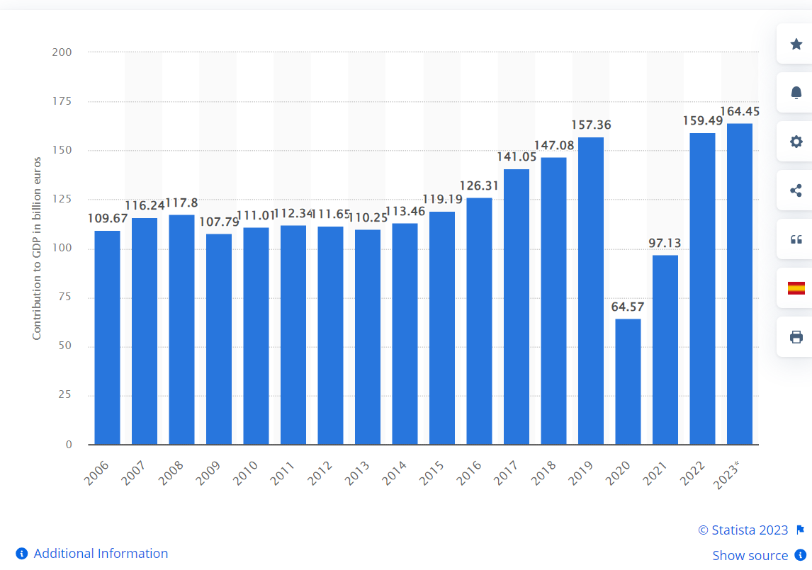(Statista, 2023).
Socio-cultural factors:
The hotel is in an urban area, close to city and sea, allowing travellers to commute easier to the touristic spots.
The COVID-19 pandemic has shifted tourism to rural and nature destinations in Spain. The community of Galicia is benefiting from this trend. Despite challenges, initiatives in inland territories, driven by local actors, have been successful. Ecocultural resources, like natural and cultural attractions, empower local communities for sustainable development. Global Geoparks, recognized by United Nations Educational, Scientific and Cultural Organization (UNESCO, 2022), play a role in this empowerment. Tourism becomes a tool for preserving these resources and promoting sustainability through small-scale, emotionally driven experiences (Fernandes, 2022).
The main obstacle for entrepreneurship among young people in rural areas is a significant fear of business failure, suggesting the need for targeted policy interventions, research focuses on two socio-cultural variables, but there's potential to include more in future studies, the study is limited to Spain, and conducting similar research in different territorial contexts, both in developed and developing economies, could provide a more comprehensive understanding of the role of socio-cultural factors in entrepreneurship (Gómez-Araujo and Bayon, 2017).
According to Britannica (2023) the Spanish culture and social behaviour are traditional, here are some examples:
- The organisation of the day, the lunch to be set between 2-3 pm which was followed by a nap, but this custom is in decline.
- The food and drink are local products.
- The roman-catholic religion was the main religion, but with new generation and modernisation, younger people tend to change their religion.
- Music plays great importance in the culture such as stringed instruments.
- The artistic heritage was one of the greatest in Europe such as Pablo Picasso and Francisco de Goya.
- Architect heritage from Antoni Gandi the Muslim and Christian design of the Expiatory Temple of the Holy family Barcelona.
- Sports are the skiing, scuba diving, football, but bull fighting is considered as a national spectacle.
Technological factors:
Online reservation, social networking, mobile booking, security network.
According to Abdelnour-Nocera and Igi Global (2013) Organisations are realising the importance of involving new users in software migration to reduce resistance to change. Stakeholder resistance often arises from a lack of consultation and involving them early ensures the software meets user requirements. However, challenges emerge due to a lack of consensus on computer software issues. Managers prioritize cost savings, while end users focus on features, creating conflicts. Effective communication about computing strategies is crucial to minimize resistance and gain stakeholder support.
The unfamiliarity of open-source software may cause resistance among end users accustomed to proprietary software. Financial benefits driving migration may not directly benefit end users, who face challenges in learning new software. Overall, addressing stakeholder expectations, effective communication, and recognizing end users' concerns are essential for successful data moving from old system to a new one. Technology is a revolution about smart and connected machines, the development of the internet, artificial intelligence, robotics, biotechnology will be the future, and will transform the society according to research (Diaz and Pedro, 2019).
According to Ramos, Almeida and Fernandes (2020) the role of social media is a popular platform that allows users to share information, have real time conversations, and this trend is useful for travellers, to book they preferences, also organisations and travel firms are using to market their products.
Events such as terrorist attack, new viruses, natural disasters, economic crises can directly affect tourists with a negative impact on the tourism revenue. These treats are varied from region to region. security measures are a need in the tourism sector to protect travellers, the modern technology is useful to protect them from potential threats. To gain competitive advantage is to promote the wellbeing of customers with service quality improvements and the market position of given destinations compared to other competitors. The level of safety may influence the quality of service in a tourist accommodation, that they provide such level of security services or number of security measures installed accordingly to (Nagaj and Žuromskaitė, 2020).
Environmental factors:
According to Bellinger (2000) the central and eastern Europe and parts of the baltic region, may be influenced by the “western style system and more specifically the requirements of Eu directives” the environmental legislation practice is limited in most countries.
The recognition of climate action and human rights issue within the environment, the legislation implementing is a high concern (Ivano Alogna, Bakker and Gauci, 2021).
Within the hotel such environmental factors are recycling, sustainability, renewable energy, transportation impact, incentives.
Environmental practice they have is recycling and reduce water, and carbon footprint.
Legal factors:
The country legislation, jurisdiction, social security, legal security, regulations that may impact the hotel competitive advantage, labour laws, migration.
In reference to Collins, Ewing and Mccolgan (2019) the globalisation take effect on workers, with competitive pressures on employers to improve productivity while reducing labour cost. Laws are introduced to protect workers, such as discrimination, unfair dismissal, annual leave payment, claims for unfair dismissal, redundancy payment and so on.
These external factors represent the PESTLE analysis made for the hotel which is in Spain.

SWOT analysis.
Strengths of the hotel:
According to Giglio et al. (2019) the demand for luxury brands brings challenges to brand managers, with researchers suggesting that the visual image of a destination or place can influence tourists' behaviour during the stay or visiting a place.
Hotel Arts Barcelona have the competitive advantage of its brand which is belong to Ritz-Carlton. Its visual imagine stand out from the coast and have a new style design. Understanding the factors that influence hotel choice and customer satisfaction is crucial for the success of any hotel (Igi Global and Information Resources Management Association, 2020). The service quality, room service, hotel facilities, room comfort, reservation process plays important role when rating a hotel. When customers perceive a hotel as providing high-quality service, it not only boosts their attitude towards the brand but also influences their intention to choose that hotel over others according to Liu et al. (2017), and when perceived quality then is more likely to create positive brand recognition.

Weaknesses of the hotel:
Based on customer feedback, the hotel can improve its maintenance, improve guest services, upgrade facilities, improve security and provide tailored guest experiences.

Opportunities of the hotel:
- Market Expansion: Explore new markets or customer segments, both domestically and internationally. Attracting a diverse range of guests can open new revenue streams. According to Smith (1978) people tend to worry about financial aspect of a vacation, this concern might go away when the holiday is over, and stress have been removed. The hotel could promote lower prices on the occupancy rate to attract new customers.
- Experience Enhancement: Continuously improve guest experiences by introducing unique services, exclusive packages, or collaborations with local attractions (Lee, Lee and Koh, 2019).
- Technological Integration: Embrace technology to enhance customer service, streamline booking processes, and stay ahead in terms of smart hotel features. The human factor is crucial, in an industry where customer experience is paramount, the skills, adaptability, and attentiveness of employees can make or break the success of a service. It emphasizes the importance of ongoing training and development for staff to stay attuned to changing consumer tastes and deliver on evolving expectations. It's a dynamic environment and to stay innovative and flexible is the key (Mazurek, 2020).
- Sustainability Initiatives: According to Kish and Quilley (2021) given the growing importance of sustainability, implementing eco-friendly practices can not only appeal to environmentally conscious guests but also contribute positively to the hotel's image. Green energy and recycling are one way to be practice sustainability (Marcio Batista Pereira, Luiz and Júlio Vieira Neto, 2022).
- Collaborations and Partnerships: Form partnerships with local businesses, art institutions, or luxury brands to create exclusive packages or events, enhancing the overall guest experience (Lee, Lee and Koh, 2019).
- Social Media Engagement: Leverage social media to connect with a wider audience, showcase the hotel's unique features, and engage with guests directly (Ramos, Almeida and Fernandes, 2020).
Research Shahid and Paul (2022) suggested that the luxury idea is not just a material attribute but creating memories with a long-lasting impression on the hotel, strengthening the brand loyalty and word of mouth is an invaluable aspect for the hospitality industry.
Threats of the hotel:
Competitors: some examples of nearby hotels with good review and lower price range but 4–5-star hotels can be found near the Hotel Arts, Hotel Duquesa de Cordona is a 5-star boutique hotel (Duguesa de Cardona, 2023). Also, the Serras Barcelona have one of the best reviews, but it looks like the smuggling and theft is a serious issue around hotels according to TripAdvisor (2023).
Online reputation, reviews can be negative, any issues related to theft or safety concerns, new competitors, changing consumer preferences, or economic fluctuations can impact a hotel's market share. Pandemics and Health Concerns. Ensuring robust cybersecurity measures is crucial to protect guest data.: Changes in local or international regulations can impact hotel operations. Staying compliant with evolving laws and regulations is essential.

TOWS:
Strength-Opportunity (SO) Strategies:
Leverage the strong Ritz-Carlton brand to expand into new markets and attract a diverse range of guests (www.ritzcarlton.com, 2023).
Enhance the guest experience by introducing unique services and collaborations with local attractions.
Strength-Threat (ST) Strategies:
Address the competitive challenge posed by nearby hotels by highlighting the unique design and visual appeal of Hotel Arts Barcelona (Hotel Arts, 2023).
Strengthening security measures and guest services to mitigate potential issues highlighted in customer feedback, makes customers feels safe (Nagaj and Žuromskaitė, 2020).
Weakness-Opportunity (WO) Strategies:
Investing in maintenance, facility upgrades, and tailored guest experiences to capitalize on market expansion opportunities it’s a great opportunity.
The hotel should embrace sustainability initiatives and technological integration to improve guest services and enhance the hotel's image.
Weakness-Threat (WT) Strategies:
Focus to be on addressing weaknesses identified in customer feedback to mitigate potential negative online reviews.
By staying vigilant on security concerns highlighted in the TripAdvisor reviews and to implement measures to ensure guest safety.
These strategies aim to leverage strengths to capitalize on opportunities, address weaknesses to take advantage of opportunities, leverage strengths to mitigate threats, and address weaknesses to minimize the impact of threats. It's a dynamic process, and regular reassessment based on the changing business environment is crucial, studies highlight the importance of considering various factors, including organisational, environmental, and strategic elements, in the process of implementing strategies in the dynamic and competitive hospitality and tourism industry. Emphasising on frameworks and understanding the role of different variables is crucial for achieving successful strategy implementation (J. Harrington et al., 2014).

6.Recommendations and Change Management (1900 words)

6.1. Enhanced security measures:
Enhancing security in a hotel is crucial for the safety and well-being of guests and staff. Here are some effective strategies to improve hotel security:
Surveillance Systems: | Install high-quality CCTV cameras in key areas, such as entrances, lobbies, hallways, parking lots, and other vulnerable spots.  Ensure that surveillance systems are regularly maintained and upgraded to the latest technology.
Access Control: | Implement access control systems, such as key card entry, to restrict unauthorized access to certain areas.  Regularly audit and update access permissions for staff and guests.
Security Personnel: | Employ trained security personnel to monitor and patrol the premises.  Ensure security staff is visible and vigilant, acting as a deterrent to potential threats (Groenenboom and Jones, 2003).
Emergency Response Plan: | Develop and regularly update an emergency response plan that includes procedures for various scenarios, such as fire, natural disasters, or security breaches.  Conduct regular drills to ensure staff is well-prepared in case of an emergency.
Guest Verification: | Implement thorough guest verification processes during check-in, including the use of identification documents.  Monitor guest lists and be vigilant for any suspicious behaviour.
Secure Wi-Fi Networks: | Ensure that the hotel's Wi-Fi network is secure to prevent unauthorized access and potential cyber threats.  Educate guests and staff about safe online practices.
Lighting: | Maintain well-lit premises, including parking areas and entry points, to discourage criminal activity.  Consider motion-activated lights for additional security.
Baggage Screening: | implement baggage screening procedures for both guests and staff to prevent the entry of unauthorized items.  Train staff to recognize and report any suspicious activity.
Collaboration with Local Authorities: | Establish a strong relationship with local law enforcement agencies.  Collaborate on security initiatives, share information about potential threats, and seek guidance on best practices.
Training and Awareness: | Provide regular training for staff on security protocols, emergency response procedures, and recognizing potential security threats.  Encourage a culture of awareness and reporting among staff.
Secure Payment Systems: | Implement secure payment systems to protect guest financial information.  Regularly update and audit these systems to ensure they meet industry standards.
Regular Security Audits: | Conduct regular security audits to identify vulnerabilities and areas for improvement.  Seek input from security professionals to ensure the effectiveness of security measures.
A comprehensive approach that combines technology, personnel, and proactive measures is key to enhancing security in a hotel. Regular assessments and adjustments based on emerging threats or industry best practices are essential for maintaining a secure environment. According to Groenenboom and Jones (2003) in security measures within the hotel the leaders of security shared they view of how important is to prevent crime, and main objective should be to reassess security departments while redefining roles and responsibilities. Chan and Lam (2013) suggest that safety security is important when considering selecting a hotel for business or leisure travel, thus hotels seem to follow local regulations, what guests expect and what they experience remain questionable.

Service excellence training:
According to Prasad (2023) the consumer behaviour changed and might be unpredictable after covid-19 pandemic. Study about customer service and excellence showed that does not matter in what industry, the customer expects quality service with reasonable prices, and for this the customer satisfaction always should be positive, and organisations should thrive to give better service for competitive advantages (Singh, Devesh Bathla and Singh, 2023).
Service spirit plays the most important role in the success of hospitality industry, does not matter the background, position or title ones have suggested Walker (2020). Marriott International successfully referred for its core values such as “Take care of Marriott people, and they will take care of Marriott guests”, with commitment to continuous improvement, hard work and fun. In short, the service spirit is to make guest experience memorable, and the Ritz-Carlton experience “the ladies and gentlemen taking care of ladies and gentlemen” should be exceptional (Walker, 2020). According to Luo and Qu (2016) hotels that are successful companies in the hospitality business intend to fulfil customer needs and wants, but in practical these needs are not always fulfilled by service providers, even when market research have identified the common needs of customers, therefore those organisation that are not meet customer needs and expectations may lose competitive and financial advantages.
Wood (2013) explains some of the key concepts in hospitality such as frontline employees that are the primary contact with guests and they should build the relationship with the organisations, while engaging with them, maintaining a good relationship, managing excellent behaviour, thus they have acces to sensitive information about customers, they are empowered to satisfy guests needs. The human resource management are responsible for to manage employees within an organisation, this includes recruitment, training and development, reward system, evaluation of performance, and their approach should be flexible and effective to manage resources in importance to the organisations performance. Hospitality seems to be an industry that ever change, labour turnover is high, and human resource management is the one who should recruit or reduce staff depends on the season of the year accordingly to the occupancy rate, thus unskilled or semi-skilled labour are often to be seen (Wood, 2013).
This issue can be one of the main reasons why hotel employees does not have the high intensity training in guest services, and they do not comply with the hotel brand high customer service quality standards, thus this issue to be solved, firstly employee retention rate should be reduced, additional training requirements for guest service, should be implemented. However, because of the seasonal workers and might be other reasons to, hotel might employ new staff when need so the guest service will be always affected. Workers might not tend to love their job only working to survive and to have financial sources.
Within Spain the tourism industry is one of the highest levels of income to the country revenue, and labour for hospitality should be able to replace.

Communication and guest engagement.
According to Kabadayi et al. (2019) hotels and hotel chains have introduced the smart service in the hospitality, and general service providores, and smart services are not only the idea but the use of advanced technology, and the use of technology can benefit service providers by collecting data from users, and that why they can personalise the guest experience.
According to Hadeel Sa’ad AL-HYARI, Hisham Mohammad AL-SMADI and WESHAH (2023) the advanced technology can determine the future development of guest experience and satisfaction rate while, collecting data, analysing customer behaviour, preferences, and history. Also, the AL Technology increasingly have become useful in hotel industry to analyse hotel efficiency, increase revenue, and stay competitive in the market.
The communication has been changed in the past due to the advance of technology of smartphones and social media, this is followed by easier customer engagement, such as review writing of experience or problems on social media platform such as TripAdvisor or Airbnb, these reviews can influence other customers behaviour, while reading and these reviews could reduce the cost of marketing of the organisation and enhance competitive advantage (Fang, Zhang and Li, 2020).
Research suggested the importance of the online reviews and how managers should manage online reviews, while solving any issues or improving services (Park and Allen, 2012). In this case Hotel Art is responding to its online reviews and this can be classified as good communication within hotel management and customers.
The research suggests that when people have good experiences at green hotels, they like enjoying nice smells, feeling positive emotions, doing fun activities, or having interesting interactions, they get inspired to do more environmentally friendly things. Making hotels enjoyable and memorable, using things like pleasant scents or cool technology, can inspire guests to be more eco-friendly. This is crucial for green hotels to succeed in their marketing and encourage customers to care more about the environment suggest Kwon and Boger (2020).
If a hotel handles a complaint well, the customer may become more loyal and engaged in positive behaviours, like helping the hotel save costs. On the other hand, if the complaint handling is not satisfactory, the customer might engage in negative behaviours, such as using more resources than needed. Customer reactions to a hotel's service recovery efforts, whether positive or negative, influence their loyalty and subsequent conduct during their stay, like helping or harming the hotel. The study suggests that customer emotions and their identification with the hotel play a crucial role in shaping this way of behaving (Zoghbi-Manrique-de-Lara, Suárez-Acosta and Aguiar-Quintana, 2013).
Umasuthan, Park and Ryu (2017) suggest that hoteliers should take in consideration the feelings of guests, may this be positive or negative emotions on a received service while emphasising on the importance of employee-customer interaction and recent events in hospitality indicate the dissatisfaction of guest satisfaction within the provided service and this may affect guest loyalty.
An and Ozturk (2022) suggest that hotels focusing on service quality see increased guest satisfaction and, eventually, better profits. By emphasising the importance of good relationships with guests and highlights that customer service and the attitude of hotel staff are crucial factors in how guests evaluate their stay. Good service quality and positive guest experiences contribute to a hotel's reputation and profitability. The online social media platform is a crucial tool for customers to evaluate or select their next destination and can negative or positively affect an organisation business competence.

Measuring and reporting:
By satisfying stakeholders, businesses ensure continuity and success, stakeholders with resources are more likely to invest for the long term, leading to higher employment rates and better overall performance. To gain support, managers focus on building relationships with stakeholders and environmental activists to showcase the company's green performance. Studies suggest that good management practices positively impact social and environmental performance but may have a negative effect on economic performance (Chirața Caraiani et al., 2018).
According to Sturdy, Wylie and Wright (2013) organisational consultants are contacted by clients to figure out how to achieve their goals, with professional strategy when they are uncertain. However, it comes with big challenge, the outcome and the consulting can be unclear, making it hard for clients to judge the professional effective service product. When clients have had similar experiences with consultants, the result may not be desired, thus the lack of clarity can also affect the assessment of the quality of hiring. The relationship is important weather the consultant will act in the client's interest. Consultants are promoting their services, but the uncertainty and professional purchase will remain, that is why consultants should do their best to satisfy customer needs with clear business project.
According to Sturdy et al. (2010) physical, cultural, and political challenges in client-consultancy relationships can occur, and how they can be analysed involves considering physical interaction, cultural alignment, and political acceptance, each presenting its own set of complexities and factors influencing effectiveness.
Achieving alignment between the values of organisational members, the change intervention, and the selected approach is crucial for success (Hamlin, Ellinger and Jones, 2018).
There can be challenges and failure this are some key points that might be the reasons:
- Managers often lack essential knowledge in change management principles, especially in the "soft" aspects like behavioural change and interpersonal communication.
- Managers sometimes opt for quick-fix solutions due to short-term thinking, skipping essential phases in the change process. This can lead to unsatisfactory results and program failure.
- Managers may overlook the significance of strong leadership and cultural considerations in the change process.
- Managers need to understand the distinction between 'change' and 'transition' and focus on the 'soft' human aspects of change management.
- Managers often underutilize human resources department practitioners when addressing human aspects of change.
- The dominant focus on personnel administration and a perception that human resources is more about training and development than strategic organisational development (Hamlin, Ellinger and Jones, 2018).
According to Wang et al. (2021) to keep an organisation running smoothly and effective while offering excellence service places like hotels and restaurants rely on their employees not only to do their job but also to go above and beyond.
Making significant changes for diversity, equity, and inclusion requires collaboration between those providing funding, organisational leaders, and their respective experts and members, this is important for the hotel, because of its wide labour background. Consultants play a crucial role in this process. They help interpret the goals and culture of organisations, design, and support initiatives, and translate learning into practical plans and models for social change explains research (Clohesy, Dean-Coffey and McGill, 2019).

Action plan:
Action Plan for Hotel Security and Guest Service Excellence with a Focus on Culture, Respect for Labor, and Employee Retention
Stakeholder Analysis: | Identifying and engage stakeholders, fostering a collaborative culture.  Considering employee representatives in decision-making to ensure a diverse perspective. (management, leaders, human resources management).
Needs Assessment: | To evaluate the organisational culture and identify areas for improvement: guest services, security measures, strengthening customers safety feeling, prevent crime.  Assess employee morale and identify factors affecting retention.
Budget Planning: | Allocating resources for cultural initiatives promoting diversity and respect.  To include employee recognition programs within the budget to enhance job satisfaction.
Security Measures Implementation: | Embed a culture of safety and vigilance through ongoing training.  Recognize and reward employees for active participation in security protocols.
Guest Service Enhancement: | Integrate cultural sensitivity training to enhance guest interactions.  Implement initiatives recognising employees for exceptional service.  Reward system.
Communication Strategy: | Communicate the importance of a respectful work environment.  Regularly share success stories of employees contributing to security and service excellence.
Employee Retention Initiatives: | Develop career growth opportunities within the organisation.  Introduce flexible scheduling and benefits to enhance employee well-being.
Monitoring and Evaluation: | Regularly assess the impact of cultural initiatives on employee satisfaction.  Monitor employee retention rates and adjust strategies as needed.

Conclusion:
In conclusion, the comprehensive action plan addresses key areas for improvement in hotel management, emphasizing security, guest service excellence, and employee retention within Hotel Art Barcelona. By engaging stakeholders, assessing needs, allocating resources strategically, and implementing targeted measures, the plan aims to foster a culture of safety, inclusivity, and employee satisfaction. Continuous monitoring and evaluation will ensure adaptability and effectiveness, aligning the hotel with evolving industry standards and stakeholder expectations. This proactive approach not only enhances the overall guest experience but also contributes to the hotel's long-term success and resilience in a dynamic hospitality landscape.

Reference list
Abdelnour-Nocera, J. and Igi Global (2013). Knowledge and technological development effects on organizational and social structures. Hershey, Pa.: Igi Global (701 E. Chocolate Avenue, Hershey, Pennsylvania, 3, Usa.
An, Q. and Ozturk, A.B. (2022). Assessing the effects of user-generated photos on hotel guests’ price, service quality, overall image perceptions and booking intention. Journal of Hospitality and Tourism Technology. doi:https://doi.org/10.1108/jhtt-05-2021-0146.
Bellinger, E.G. (2000). Environmental assessment in countries in transition. Budapest; New York: Ceu Press.
Britannica (2023). Spain - Daily life and social customs. [online] Encyclopedia Britannica. Available at: https://www.britannica.com/place/Spain/Daily-life-and-social-customs (Accessed 11 Nov. 2023).
Chan, E.S.W. and Lam, D. (2013). Hotel safety and security systems: Bridging the gap between managers and guests. International Journal of Hospitality Management, [online] 32, pp.202–216. doi:https://doi.org/10.1016/j.ijhm.2012.05.010.
Chirața Caraiani, Camelia Iuliana Lungu, Dascălu, C. and Florian Colceag (2018). Models for Measuring and Reporting of Green Performance. IGI Global eBooks. doi:https://doi.org/10.4018/978-1-5225-3909-4.ch010.
Clohesy, S., Dean-Coffey, J. and McGill, L. (2019). Leveraging Effective Consulting to Advance Diversity, Equity, and Inclusion in Philanthropy. The Foundation Review, 11(3). doi:https://doi.org/10.9707/1944-5660.1483.
Collins, H., Ewing, K.D. and Mccolgan, A. (2019). Labour law. Cambridge: Cambridge University Press.
de Bruin, L. (2019). SWOT Analysis (and TOWS Matrix) EXPLAINED with EXAMPLES | B2U. [online] B2U - Business-to-you.com. Available at: https://www.business-to-you.com/swot-analysis/ (Accessed 10 Nov. 2023).
Diaz, V.G.-P. and Pedro, J. (2019). Handbook of Research on Industrial Advancement in Scientific Knowledge. IGI Global.
Dinia, L., Iannitti, V.A., Mangini, F., Di Lascio, F. and Frezza, F. (2022). Understanding the Spread of COVID-19 Based on Economic and Socio-Political Factors. Sustainability, 14(3), p.1768. doi:https://doi.org/10.3390/su14031768.
Duguesa de Cardona (2023). Hotel Duquesa de Cardona (4*) in Barcelona. [online] www.hduquesadecardona.com. Available at: https://www.hduquesadecardona.com/en/ (Accessed 12 Nov. 2023).
economy-finance.ec.europa.eu. (2023). Economic forecast for Spain. [online] Available at: https://economy-finance.ec.europa.eu/economic-surveillance-eu-economies/spain/economic-forecast-spain_en. (Accessed: 12.11.2023).
ETUC | European Trade Union Confederation. (2023). IMF hitting wrong target on inflation. [online] Available at: https://www.etuc.org/en/pressrelease/imf-hitting-wrong-target-inflation (Accessed 11 Nov. 2023).
Expat Guide to Spain | Expatica. (2023). Labor laws in Spain: a guide for expat employees | Expatica. [online] Available at: https://www.expatica.com/es/working/employment-law/spain-labor-laws-104542/ (Accessed 11 Nov. 2023).
Fang, S., Zhang, C. and Li, Y. (2020). Physical attractiveness of service employees and customer engagement in tourism industry. Annals of Tourism Research, 80, p.102756. doi:https://doi.org/10.1016/j.annals.2019.102756.
FernandesG. (2022). Challenges and new opportunities for tourism in inland territories: ecocultural resources and sustainable initiatives. Hershey, Pennsylvania: Business Science Reference.
Giglio, S., Pantano, E., Bilotta, E. and Melewar, T.C. (2019). Branding luxury hotels: Evidence from the analysis of consumers’ ‘big’ visual data on TripAdvisor. Journal of Business Research, 119. doi:https://doi.org/10.1016/j.jbusres.2019.10.053.
Gómez-Araujo, E. and Bayon, M.C. (2017). Socio-cultural factors and the entrepreneurship of youths in rural regions. Review of Business Management, [online] 19(64), pp.200–218. doi:https://doi.org/10.7819/rbgn.v0i0.2695.
Groenenboom, K. and Jones, P. (2003). Issues of security in hotels. International Journal of Contemporary Hospitality Management, 15(1), pp.14–19. doi:https://doi.org/10.1108/09596110310458945.
Hadeel Sa’ad AL-HYARI, Hisham Mohammad AL-SMADI and WESHAH, S.R. (2023). The Impact of Artificial Intelligence (Ai) On Guest Satisfaction in Hotel Management: An Empirical Study of Luxury Hotels. The Impact of Artificial Intelligence (Ai) On Guest Satisfaction in Hotel Management: An empirical study of luxury hotels, 48(2 supplement), pp.810–819. doi:https://doi.org/10.30892/gtg.482spl15-1081.
Hamlin, B., Ellinger, A.D. and Jones, J. (2018). Evidence-based initiatives for organizational change and development. Hershey: Business Science Reference (An Imprint Of Igi Global.
Hotel Arts. (2023). Experience a Luxurious 5* Stay beside the Sea | Hotel Arts Barcelona. [online] Available at: https://www.hotelartsbarcelona.com/en/ [Accessed 23 Oct. 2023].
Igi Global and Information Resources Management Association (2020). Destination management and marketing: breakthroughs in research and practice. Hershey, Pennsylvania (701 E. Chocolate Avenue, Hershey, Pennsylvania, 17033, Usa): Igi Global.
Ivano Alogna, Bakker, C. and Gauci, J.-P. (2021). Climate Change Litigation: Global Perspectives. BRILL.
J. Harrington, R., K. Chathoth, P., Ottenbacher, M. and Altinay, L. (2014). Strategic management research in hospitality and tourism: past, present and future. International Journal of Contemporary Hospitality Management, 26(5), pp.778–808. doi:https://doi.org/10.1108/ijchm-12-2013-0576.
Kabadayi, S., Ali, F., Choi, H., Joosten, H. and Lu, C. (2019). Smart service experience in hospitality and tourism services. Journal of Service Management, [online] 30(3), pp.326–348. doi:https://doi.org/10.1108/josm-11-2018-0377.
Kish, K. and Quilley, S. (2021). Ecological Limits of Development. Routledge.
Kwon, J. and Boger, C.A. (2020). Influence of brand experience on customer inspiration and pro-environmental intention. Current Issues in Tourism, pp.1–15. doi:https://doi.org/10.1080/13683500.2020.1769571.
Lee, M., Lee, S. (Ally) and Koh, Y. (2019). Multisensory experience for enhancing hotel guest experience. International Journal of Contemporary Hospitality Management, 31(11), pp.4313–4337. doi:https://doi.org/10.1108/ijchm-03-2018-0263.
Liu, M.T., Wong, I.A., Tseng, T.-H., Chang, A.W.-Y. and Phau, I. (2017). Applying consumer-based brand equity in luxury hotel branding. Journal of Business Research, [online] 81(192-202), pp.192–202. doi:https://doi.org/10.1016/j.jbusres.2017.06.014.
Luo, Z. and Qu, H. (2016). Guest-Defined Hotel Service Quality and Its Impacts on Guest Loyalty. Journal of Quality Assurance in Hospitality & Tourism, pp.1–22. doi:https://doi.org/10.1080/1528008x.2015.1077185.
Marcio Batista Pereira, Luiz, O. and Júlio Vieira Neto (2022). Waste Management Analysis for Energy Generation. In: BOOK Frameworks for sustainable development goals to manage economic, social, and environmental shocks and disasters. IGI Global, pp.176–191. doi:https://doi.org/10.4018/978-1-6684-6750-3.ch010.
Mazurek, M. (2020). The Innovative Social Technologies and Their Impact on Knowledge Management Processes. In: Handbook of research on social media applications for the tourism and hospitality sector. IGI Global.
Michelli, J.A. (2011). The new gold standard: 5 leadership principles for creating a legendary customer experience courtesy of the Ritz-Carlton Hotel Company. New York Mcgraw Hill Professional.
Nagaj, R. and Žuromskaitė, B. (2020). Security Measures as a Factor in the Competitiveness of Accommodation Facilities. Journal of Risk and Financial Management, [online] 13(5), p.99. doi:https://doi.org/10.3390/jrfm13050099.
Park, S.-Y. and Allen, J.P. (2012). Responding to Online Reviews. Cornell Hospitality Quarterly, 54(1), pp.64–73. doi:https://doi.org/10.1177/1938965512463118.
Phadermrod, B., Crowder, R.M. and Wills, G.B. (2019). Importance-Performance analysis-based SWOT analysis. International Journal of Information Management, 44(12), pp.194–203. doi:https://doi.org/10.1016/j.ijinfomgt.2016.03.009.
Prasad, S. (2023). COVID-19 and Cognitive vs. Emotional Consumer Variations on Decision Making. Advances in marketing, customer relationship management, and e-services book series, pp.92–111. doi:https://doi.org/10.4018/978-1-6684-5853-2.ch005.
RamosC.M.Q., AlmeidaC.R. and Fernandes, P.O. (2020). Handbook of research on social media applications for the tourism and hospitality sector. Hershey, PA: IGI Global, Business Science Reference.
Rodríguez-Fuentes, C.J. and Padrón-Marrero, D. (2008). Industry Effects of Monetary Policy in Spain. Regional Studies, 42(3), pp.375–384. doi:https://doi.org/10.1080/00343400701291583.
Schulze, H. (2019). Excellence Wins. Zondervan.
Shahid, S. and Paul, J. (2022). Examining guests’ experience in luxury hotels: evidence from an emerging market. Journal of Marketing Management, 38(13-14), pp.1–29. doi:https://doi.org/10.1080/0267257x.2022.2085768.
Singh, A., Devesh Bathla and Singh, A. (2023). To Study the Service Gap Between Customer Perceptions and Expectations in Services Provided by Cab Aggregators. Advances in marketing, customer relationship management, and e-services book series, pp.337–352. doi:https://doi.org/10.4018/978-1-6684-5853-2.ch017.
Smith, V.L. (1978). Hosts and guests. Oxford: Blackwell.
Spulbar, C. and Birau, R. (2020). Emerging research on monetary policy, banking, and financial markets. Hershey, Pennsylvania (701 E. Chocolate Avenue, Hershey, Pennsylvania, 17033, USA): IGI Global.
Statista (2023). Topic: GDP in Spain. [online] Statista. Available at: https://www.statista.com/topics/7776/gdp-in-spain/#topicOverview (Accessed 11 Nov. 2023).
Sturdy, A., Handley, K., Clark, T. and Fincham, R. (2010). Management Consultancy. OUP Oxford.
Sturdy, A., Wylie, N. and Wright, C. (2013). Management Consultancy and Organizational Uncertainty. International Studies of Management & Organization, 43(3), pp.58–73. doi:https://doi.org/10.2753/imo0020-8825430304.
Thomas Del Marmol (2021). PESTLE Analysis [ePub] [electronicresource] : Prepare the best strategies in advance. 50Minutes.com.
Tripadvisor. (n.d.). HOTEL ARTS BARCELONA - Updated 2023 Reviews (Catalonia). [online] Available at: https://www.tripadvisor.co.uk/Hotel_Review-g187497-d190635-Reviews-Hotel_Arts_Barcelona-Barcelona_Catalonia.html (Accessed 23 Oct. 2023).
Tripadvisor. (2023). SERRAS BARCELONA - Updated 2023 Reviews (Catalonia). [online] Available at: https://www.tripadvisor.co.uk/Hotel_Review-g187497-d7142609-Reviews-Serras_Barcelona-Barcelona_Catalonia.html (Accessed 12 Nov. 2023).
Umasuthan, H., Park, O.-J. and Ryu, J.-H. (2017). Influence of empathy on hotel guests’ emotional service experience. Journal of Services Marketing, 31(6), pp.618–635. doi:https://doi.org/10.1108/jsm-06-2016-0220.
UNESCO (2022). Home | UNESCO. [online] www.unesco.org. Available at: https://www.unesco.org/en (Accessed 11 Nov. 2023).
Walker, J.R. (2020). Introduction To Hospitality, Global Edition. S.L.: Pearson Education Limited.
Wang, D., Ma, E., Kim, Y.S., Liu, A. and Berbekova, A. (2021). From good soldiers to happy employees: Exploring the emotional and well-being outcomes of organizational citizenship behaviour. Journal of Hospitality and Tourism Management, 49, pp.570–579. doi:https://doi.org/10.1016/j.jhtm.2021.11.005.
Wood, R.C. (2013). Key Concepts in Hospitality Management. SAGE.
www.ritzcarlton.com. (2023). The Ritz-Carlton, Barcelona | Luxury Hotel in Barcelona. [online] Available at: https://www.ritzcarlton.com/en/hotels/bcnrz-hotel-arts-barcelona/overview/?scid=cf432f1f-54d2-411a-89ce-225188630324 (Accessed 23 Oct. 20230.
Yeung, A. (2006). Setting people up for success: How the Portman Ritz-Carlton hotel gets the best from its people. Human Resource Management, 45(2), pp.267–275. doi:https://doi.org/10.1002/hrm.20108.
Zoghbi-Manrique-de-Lara, P., Suárez-Acosta, M.A. and Aguiar-Quintana, T. (2013). Hotel Guests’ Responses to Service Recovery. Cornell Hospitality Quarterly, 55(2), pp.152–164. doi:https://doi.org/10.1177/1938965513513348.

