Celebrating Language & Culture
Belonging to Wales
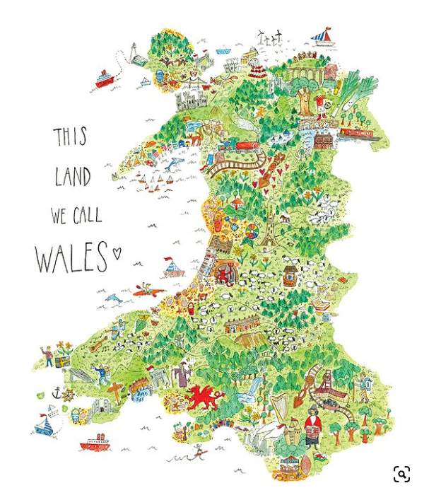

(Sophia Illustration, 2023)

Rationale | - | 3
Overview of activities | - | 8
Evaluation of activities | - | 10
Reference list | - | 12
Appendices | - | 18
Contents
Word Count Target = 2500 +/- 10% range = 2250 to 2750
Actual Word Count = 2644 excluding references and appendices

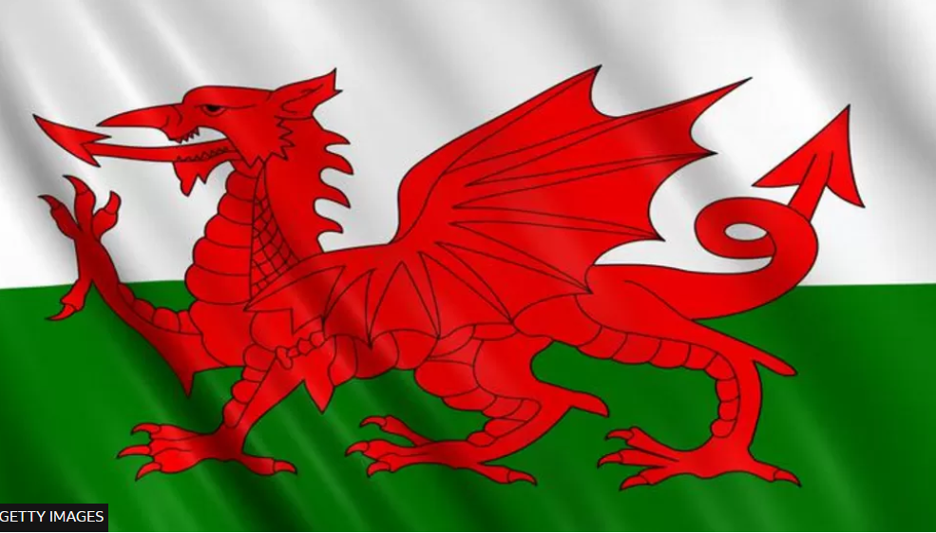
Rationale
Language, culture and belonging
The Cambridge dictionary (2023) defines ‘language’ as the communication system of sounds, words, grammar and gestures used by the individuals of a specific community; ‘culture’ as the way of life followed by the individuals of a specific community, which incorporates their customs and beliefs; and ‘belonging’ as the successful meeting of an individual’s basic human need to feel comfortable, able, welcome and fully accepted as a member of a specific community.
Identity
The Cambridge dictionary (2023) defines ‘identity’ as being, believing or feeling, that an individual, community, organisation or geographical area has commonly recognised and associated attributes, which permit membership and belonging to a particular culture or ethnicity. Jones (2019) states that the Welsh language, the Welsh identity and a sense of place are inextricably linked. The Curriculum Cymreig (2003) strategically aims to support students to learn what makes Welsh life distinctive, to celebrate this diversity, to enable students to acquire a real sense of identity and to instil within students the positive benefits of the sense of belonging that this facilitates,
Brief history of Welsh language & culture and recent Welsh language & culture policies
The ancient Celtic language of Cymraeg (Welsh) has been spoken in various forms in Wales since around 600 BC (Akorbi, 2023). In addition to the national language of Cymraeg, with all of its regional dialects, Wales also has its own identifiable culture, comprising of its unique, history, religion/beliefs, employment/livelihoods, architecture/historic buildings, dress/clothing, leisure activities, geography, natural habitats, food/drink, sports and the arts. These are not only national to Wales but are also diverse and locality specific, to communities within smaller geographical areas of Wales (Morgan, 2008). Since 1067, Wales as a region, has endured multiple challenges to the survival of its language and culture, for example, the Norman Invasion, King Edward I’s annexation of Wales, King Henry VIII’s multiple Acts of Union, native population emigration, non-native population immigration plus the subjugation of its language, justice, public-office and education systems (Mercer, 2004), (Morgan, 2008). See appendix one.
Following the establishment of The Welsh Office in 1964 and Devolution for Wales in 1998, Welsh governance, to arrest the decline in Welsh language speakers and culture, has repeatedly taken action. For example, Curriculum Cymreig (2003) was launched to statutory enforce in state schools the teaching of Welsh culture throughout several curriculum subject areas. Similarly, Iaith Pawb The National Action Plan for a Bilingual Wales (2003) was launched to promote the Welsh Language. In 2017, to extend its effort to arrest the decline and to begin to initiate growth, the Welsh Government launched its strategies’ Cymraeg 2050, for a million Welsh speakers by 2050, Siarter Iaith (The Welsh Language Charter) National Framework and Welsh in Education: Action Plan for 2017-21. See appendix two.
Since the introduction of these and other Welsh Government’s actions, the census of 2021 reported that 17.8% of the population of Wales were able to speak Welsh, which after the marginal recovery of the figures in the 2001 and 2011 censuses, showed that the numbers of Welsh speakers were again declining (ONS, 2023). See appendix three.
Benefits of bilingualism including those experienced within cultural identity and belonging
The motivational advantages to encourage individuals to be bi-lingual and learn the Welsh language are numerous. The ability to speak Welsh is listed as desirable or essential in Wales’ job vacancies with the level of fluency required indicated in the job specification (Jones & Martin-Jones, 2004); it permits the bi-lingual person to integrate and belong to their local community’s Welsh cultural identity (Lewis, 2013); it leads to better emotional mental health, as it facilitates the meeting of, the basic human need, of belonging to a community (Maslow, 1943). Other benefits include positive cognitive outcomes which include greater attention, working memory, linguistic awareness of other languages and greater abstract and symbolic skills (Adescope et al, 2010). Statistics from around the world support the view that children who are bi or plurilingual have better life outcomes than those who are mono-lingual, develop greater executive control and are more effective at learning further languages (Cummins, 2013). Opposingly there is no data available to support the misconceptions that bi and pluri-linguistic individuals speak later, are confused, mixing up their languages and suffer educational delay (Multilingual Children’s Association, 2004). The Future Generations Commissioner of Wales’, in the Future Generations Report 2020, discusses the evolving journey Wales is making towards the positive socio-economic benefits that a thriving and resilient Welsh language and culture facilitates.
Theory/policy/educational pedagogy
There are multiple theories regarding the development of language, bilingualism and plurilingualism. For example for language development; Skinner’s theory (1957) on behaviourist operant conditioning states language learning is gained via the imitation of others which is reinforced by positive rewards; Bruner’s theory (1983) discusses a language acquisition support system (LASS), at a specific development period, when more knowledgeable others support language development. Vygotsky (1978) suggests language acquisition is via the use of modelling. Piaget (1936) states that the four stages of cognitive development facilitate language learning. Whilst Chomsky (1957) states that humans have an innate language acquisition device (LAD) which has the fundamentals of language development within it at birth. Theories of second language learning include Cummins (Shoebottom, 2017) who states that individuals use the language acquisition of their first language, known as Common Underlying Proficiency (CUP) to assist the development of their second language. He believed that students took approximately two years of immersion in the target second language, to develop conversational fluency and this was known as Basic Interpersonal Communications Skills (BICS), whilst it took approximately five to seven years to develop academic fluency of the target language, known as Cognitive Academic Language Proficiency (CALP). Another second language theory is that of Krashen (Montgomery School, 2023) who hypothesises it is natural communication and meaningful interaction in the second language that facilitates second language acquisition. He states that ‘comprehensible input’ of ‘current knowledge plus one’, is the key to its acquisition. Colin Baker (CiLT, 2005) theorises on plurilingualism, that in the cognitive areas of the brain, the learning of multiple languages is facilitated by the previous knowledge of other languages feeding the development and acquirement of more. Therefore, in plurilingualism each additional language acquisition surrounds previous language learning. Baker also hypothesises on the requirement in today’s and tomorrow’s world for individuals to become pluri-linguistic to facilitate global citizenship.
These theories can be directly linked into Welsh Government policies such as Welsh in Education Action Plan 2017-21 (2017) via the objectives and key actions contained within it, regarding schools’ curriculum, assessment and pedagogy; the Siarter Iaith: National Framework (2017) for implementation in Wales’ Welsh medium schools; the Siarter Iaith Gymraeg Campus - Criw Cymraeg Framework (2017) for implementation in Wales’ English medium schools; and the Cwricwlwm Cymreig, history and the story of Wales Final Report (2017) which all directly influence curriculum planning of Welsh language and culture. Whilst Donaldson’s Successful Futures report (2015) states the four purposes of education, the ethos of which, underpins the requirement for Welsh language and culture as an invaluable element of the curriculum. It also gives specific suggested criteria regarding Welsh language education. The Well-being of Future Generations (Wales) Act (2015) documents the seven well-being goals for Wales namely; a prosperous Wales; a resilient Wales; a healthier Wales; a more equal Wales; a Wales of more cohesive communities; a Wales of vibrant culture and thriving Welsh language; a globally responsible Wales. See appendix four. These well-being goals require the robust underpinning of effective Welsh language and cultural education in order to be achieved. Finally, policies such as Making Languages Count (2010), Supporting Triple Literacy (2011) and Global Futures (2015) support tri and plurilingualism, which aids the Welsh Governments’ well-being goal of creating effective global citizenship within Wales. All of these theories and policies in turn cascade into grass root educational policies and the face-to-face practice delivered within the schools and institutions of the education sector in Wales, as Ysgol Aberconwy’s Welsh Language, Culture and Bilingualism policy (2020) illustrates.
Schools’ significance in sustaining and growing Welsh language and culture
The significance of the strategic position of schools in Welsh language and culture can be indicated firstly by the negative effects that the historic subjugation of the Welsh language and culture schools experienced. For example via the Blue Books of Treason of 1847 (Roberts,1998) when Welsh language and culture were blamed for Wales’ low standards of education, which in reality, could be mitigated, as being due to the negative effect of education being taught solely through the medium of English to mono-language Welsh speaking children. Similarly, the Welsh Not of 1847 (Welsh Not, 2023), a school based system of humiliation and punishment inflicted on Welsh speaking pupils, originating from the school’s officials’ belief that Welsh language and culture were a sickness to be stamped out, additionally the Education Act (1944) which made zero provision for the Welsh language or culture to be taught within it. These actions within education all contributed to the loss of the Welsh language and culture historically seen across Wales (Jones and Roderick, 2003). Whilst, secondly the significance of the importance of schools and education in sustaining and growing Welsh language and culture can be conversely positively indicated, by the number of policies in the last twenty years, that Welsh Government has implemented, in the Welsh education system, on the subject, as is illustrated in appendix two. It is also indicated by the unique position schools provide in the life of all Welsh students, families and local communities, alongside the association that many schools’ encourage and foster with the Mentrer Iaith organisation, with their complimentary role in promoting Welsh language and culture in the local community (Menter Iaith Sîr Benfro, 2023). Furthermore, the implementation of the Curriculum for Wales (2022), right across the Welsh education system has enormous potential within its strategies to further the aims of the Welsh Government’s vision of one million Welsh speakers by 2050, alongside its seven well-being goals (Welsh Government, 2015). Since 2013 Local Authorities in Wales have been required to develop and implement a ten-year Welsh in Education Strategic Plan (WESP) which lays out their criteria on how they intend to improve the provision of Welsh medium education in their area. For example. Pembrokeshire County Council’s WESP can be found online (PCC, 2023).
Overview of Welsh language & culture activities in education

There are multiple frameworks and their associated activities which can be used in Welsh language and culture pedagogy in schools, for example:
Siarter Iaith Gymraeg - Cymraeg Campus framework (2017) - for incorporating Welsh language and culture right across school life. This links with Carl Rogers’ (1969) theory and enables educators to present learning opportunities through multiple learning styles of visual, audio or kinaesthetic (Bates, 2019).
Cwricwlwm Cymreig (2003) - with its cross curricula Welsh culture learning strategies. This again links with Carl Rogers’ (1969) theory and enables educators to present learning opportunities through multiple learning styles of visual, audio or kinaesthetic (Bates, 2019).
Amser Slot Drilio - a daily classroom timetabled slot which is dedicated to learning a small amount of Welsh language or culture, which the video at Amser Slot Drilio St Helen's Welsh frills video (youtube.com) (Amser Slot Drilio, 2023) demonstrates. This can be linked to Vygotsky’s (1978) theory on social constructivism.
Siaradwr Cymraeg yr Wythnos - the Welsh speaker of the week award, when certificates are awarded each week in assembly, to teacher nominated students, who have used Welsh well during the week, see appendix five for an example. This can be linked to Skinner’s (1938) theory on operant conditioning.
Y Gromlech (2023) - a website which provides multiple Welsh language and culture information that can assist lesson planning, which once again links with Carl Rogers’ (1969) theory and enables educators to present learning opportunities through multiple learning styles of visual, audio or kinaesthetic (Bates, 2019).
Duolingo-Welsh (2023) - an online interactive artificially intelligent learning application that guides students through learning Welsh at a pace suited to them using positive rewards. This can also be linked to Skinner’s (1938) theory on operant conditioning.
Shwmae Day (2023) - an annual day designed to celebrate the Welsh Language and culture. It started in 2013 and is celebrated in the majority of schools with multiple activities based on the Welsh language and culture taking place. This can be linked to Skinner’s (1938) operant conditioning, Dewey’s 1987 theory on experiential learning (Bates, 2019) and Vygotsky’s (1978) social constructivism.
Urdd (2023) - The Urdd is a youth organisation started in 1922 designed to give opportunities for eight to twenty-five year olds to celebrate, preserve, use and grow Welsh Language and culture. The Urdd eisteddfod is an annual event with multiple Welsh language and culture competitions which school children participate in. The Urdd residential centres are centres where school children go to stay and are immersed in Welsh language and culture through multiple activities for the duration of their stay. This links to Dewey’s 1987 theory on experiential learning (Bates, 2019).
Meithrin Cymru Club Cwtsh (2023) - A Welsh government initiative to support communities to learn Welsh language. Many schools run its courses for carers, parents, grandparents and the wider community around the child, to learn to speak Welsh. This can be linked to Bronfenbrenner theory (Simply Psychology, 2023) and the micro and meso-systems around the child.

Critical evaluation of Welsh language & culture activities in education

Turning now to evaluate the merits and challenges regarding the activities overviewed in the previous section:
Siarter Iaith Gymraeg - Cymraeg Campus framework (2017) – Ysgol Gymraeg Pen-y-Garth (2023) report the framework has had a positive effect on the attainment of their bi-lingual pupils. NPT Authority (2022) state they can report no negative effects from its implementation.
Cwricwlwm Cymreig (2003) – The Cwricwlwm Cymreig, history and the story of Wales final report in 2017 listed six recommendations for further refinements to be made to the curriculum, whilst Dan Evans-Kanu (Medium, 2021) states there are failures in its effective delivery being consistent across the education system in Wales. However, Estyn’s report of 2005 into the progress being made by the Cwricwlwm Cymreig, reported it was a significant feature of improving standards of achievement regarding Welsh culture in 75% of classes across Wales.
Amser Slot Drilio, Siaradwr Cymraeg yr Wythnos – Benefits include that the delivery of these can maximise the positive emotional benefits of positive reinforcement theories such as Skinner’s (1938) operant conditioning theory whilst promoting positivity around Welsh language and culture. Negatives are lower achieving pupils can be excluded from it (Bates, 2019).
Y Gromlech (2023) – Benefits include it is linked into the Siarter Iaith framework.
Duolingo-Welsh (2023) – Medium (2023) state that whilst the convenience and bite size learning is advantageous the lack of real-life community immersion is a disadvantage.
Shwmae Day (2023) - Merthyr Council (2023) reports that Shwmae day ignites passion in Welsh language and culture and brings about positive emotional benefits from its celebration in learners.
Urdd (2023) – The Welsh Youth Parliament (2023) report that the Urdd is a positive and prominent opportunity for the youth of Wales to immerse themselves in Welsh language and culture. Nation Cymru (2020) report that the Urdd requires Welsh Government financial support to continue to survive.
Meithrin Cymru Club Cwtsh (2023) – Caerphilly Council (2023) report that the benefits of the scheme are that it is free and that it extends bilingualism from the child into the family network and community around the child. Negatively it says that although some evening and online provision is available it can still be prohibitive for busy working adults to attend.
To conclude, the positive effects of these activities are numerous however the 2021 census results would indicate that there is still much to be done regarding Welsh language and culture within educational provision, in order to successfully meet the Welsh Government’s target of one million Welsh speakers by 2050 and its seven well-being goals for Wales.


“Cenedl heb iaith, cenedl heb galon"
A nation without a language is a nation without a heart.
Welsh Government (2023)

Welsh Government (2023)

Reference List
Adescope, O. O., Lavin, T., Thompson, T. and Ungerleider, C. (2010) ‘A systematic review and meta-analysis of the cognitive correlates of bilingualism’, Review of Educational Research, 80(2), pp. 207-245.
Akorbi (2023) Where do Celtic languages come from? Available at: Where Do Celtic Languages Come From? | Akorbi (Accessed: 8 December 2023).
Amser Slot Drilio (2023) Amser slot drilio. Available at: Amser Slot Drilio St Helen's Welsh frills video (youtube.com) (Accessed: 15 December 2023).
Bates, B. (2019) Learning theories simplified. 2nd edn. London: Sage.
Bruner, J. S. (1983) Child’s talk: learning to use language. New York: Norton.
Caerphilly Council (2022) Five Year Welsh Language Strategy. Available at: Caerphilly County Borough Five Year Welsh Language Strategy 2022-2027 (Accessed: 15 December 2023).
Cambridge Dictionary (2023) Online Search. Available at: https://dictionary.cambridge.org/dictionary/english/ (Accessed 12 December 2023).
Cherry, K. (2022) Piaget’s 4 Stages of Cognitive Development Explained: Background and Key Concepts of Piaget’s Theory. Available at: Piaget's Stages of Cognitive Development Explained (verywellmind.com) (Accessed: 14 December 2023).
Chomsky, N. (1957) Syntactic structures. The Hague: Mouton Publishers.
CiLT (2005) Plurilingual and Positive. Available at: positively_plurilingual.pdf (upenn.edu) (Accessed 14 December 2023).
Cummins, J. (2013) The Intellectual and Cognitive Advantages of Bilingual Education. UWTSD: International Conference – Educational Society of the European Regions and the School of Welsh and Bilingual Studies, UWTSD 13.09.13.
Duolingo - Welsh (2023) Duolingo – Welsh. Available at: The world's best way to learn Welsh - Duolingo (Accessed: 15 December 2023).
Estyn (2005) Y Cwricwlwm Cymraeg – A Report into Progress Made. Available at: Estyn (ioe.ac.uk) (Accessed: 15 December 2023).
Future Generations Commissioner for Wales (2020) The Future Generations Report 2020. Available at: Chap-3-Culture-and-Lang.pdf (futuregenerations.wales) (Accessed: 14 December 2023).
Getty Images (2023) Welsh Flag. Available at: 154 Welsh Flag Stock Photos, High-Res Pictures, and Images - Getty Images (Accessed: 12 December 2023).
Jones, D. V. and Martin-Jones, M. (2004) Bilingual education and language revitalization in Wales: Past achievements and current issues. Medium of Instruction Policies: Which Agenda? Whose Agenda? pp. 43-70. Aberystwyth: University of Wales. Available at: Bilingual education and language revitalization in Wales: Past achievements and current issues | Request PDF (researchgate.net) (Accessed 13 December 2023).
Jones, G. E. and Roderick, G. W. (2003) A history of education in Wales. Cardiff: University of Wales Press.
Jones, R. (2019) ‘Place and identity: Wales, ‘Welshness’ and the Welsh Language’, Geography, 104(1), pp. 19-27.
Learn Welsh Cymru (2023) Wales and the Welsh language. Available at: Wales and the Welsh language | Learn Welsh (Accessed: 9 December 2023).
Lewis, H.G. (2013) The Intellectual and Cognitive Advantages of Bilingual Education. UWTSD: International Conference – Educational Society of the European Regions and the School of Welsh and Bilingual Studies, UWTSD 13.09.13.
Maslow, A. H. (1943) ‘A theory of human motivation’, Psychological Review, 50, pp. 370–396.
Medium (2021) Lessons and recommendations for the teaching of Welsh history and citizenship based on the failures of previous initiatives. Available at: Lessons and recommendations for the teaching of Welsh history and citizenship based on the failures of previous initiatives | by Dan Evans- Kanu | Medium (Accessed: 15 December 2023).
Medium (2023) Duolingo: Pros and Cons. Available at: Duolingo: Pros and Cons of the World’s Most Popular Language Learning App | by Marwane Samii | Medium (Accessed: 15 December 2023).
Meithrin Cymru Clwb Cwtsh (2023) Clwb Cwtsh - Learn Welsh. Available at: Clwb Cwtsh | Learn Welsh (Accessed on 15 December 2023).
Menter Iaith (2023) Menter Iaith Sir Benfro. Available at: Y Digwyddiad | Arwain Sir Benfro (Accessed 14 December 2023).
Mercer, K (2004) The Welsh language: Cultural preservation or a losing battle? Published Presidential Thesis. Available at: https://scholarworks.uni.edu/pst/24 The Welsh language: Cultural preservation or a losing battle? (uni.edu) (Accessed: 9 December 2023).
Merthyr.gov (2023) Shwmae Event 2023. Available at: Get Ready to Celebrate Welsh Culture at the Diwrnod Shwmae Su’mae Event | Merthyr Tydfil County Borough Council (Accessed: 15 December 2023).
Montgomery School (2023) Stephen Krashen and Language Acquisition. Available at: Stephen Krashen and Language Acquisition (montgomeryschoolsmd.org) (Accessed: 14 December 2023).
Morgan, G. (2008) A brief history of Wales. Talybont: Y Lolfa.
Multilingual Children’s Association (2004) Frequently Asked Questions. Available at: FAQ; Multilingual Children's Association (Accessed 13 December 2023).
Nation Cymru (2020) The Urdd one of Wales’ greatest successes. Available at: The Urdd is one of Wales’ greatest successes – we cannot let it fail (nation.cymru) (Accessed: 15 December 2023).
NPT.Gov (2022) WESP Evaluation Report. Available at: App B - Welsh In Education Strategic Plan 2022-2032.pdf (npt.gov.uk) (Accessed 15 December 2023).
ONS (2023) Census 2021 Welsh Language Statistics. Available at: Welsh language, Wales - Office for National Statistics (ons.gov.uk) (Accessed 12 December 2023).
PCC (2023) Pembrokeshire County Council Welsh in Education Strategic Plan. Available at: Welsh in Education Strategic Plan - Pembrokeshire County Council (Accessed 14 December 2023).
Roberts, G. T. (1998) The language of the blue books the perfect instrument of empire. Cardiff: University of Wales Press.
Rogers, R. C. (1969) Freedom to Learn. Colombus: Merril.
Shoebottom. P. (2017) The language learning theories of Professor J. Cummins. Available at: The language learning theories of Professor J. Cummins (internationalschooltutors.de) (Accessed: 14 December 2023).
Shwmae Day (2023) What is Shwmae Day? Available at: What is Diwrnod Shwmae Su’mae? (Accessed 15 December 2023).
Siaradwr Cymraeg yr Wythnos - Twinkl (2023) Siardwr Cymraeg yr Wythnos Certificates. Available at: Cymraeg Campus: Siaradwr yr Wythnos Award Certificate Pack (twinkl.co.uk) (Accessed: 15 December 2023).
Simply Psychology (2023) Bronfenbrenner’s Ecological Systems Theory. Available at: Bronfenbrenner's Ecological Systems Theory (simplypsychology.org) (Accessed 15 December, 2023).
Skinner, B. F. (1957) Verbal behavior. Englewood Cliffs: Prentice-Hall.
Sophia Illustration (2023) Cultural map of Wales. Available at: Ihttps://www.sophiasillustration.co.uk/ (Accessed 12 December 2023).
The Welsh Not (2023) The Welsh Not. Available at: About – welshnot (Accessed: 9 December 2023).
The Welsh Youth Parliament (2023) 16 Reasons to visit the Urdd Eisteddfod. Available at: 16 Reasons to Visit the Urdd Eisteddfod (senedd.wales) (Accessed: 15 December 2023).
UK Parliament (2023) The Education Act of 1944. Available at The Education Act of 1944 - UK Parliament (Accessed: 10 December 2023).
Urdd (2023) About the Urdd. Available at: Urdd Eisteddfod | Urdd Gobaith Cymru (Accessed 15 December 2023).
Vygotsky, L. S. (1978) Mind in society: The development of higher psychological processes. Cambridge: Harvard University Press.
Welsh Government (2022) Curriculum for Wales 2022: Available at: curriculum-for-wales-guidance.docx (live.com) (Accessed: 10 December 2023).
Welsh Government (2022) Curriculum for Wales Overview. Available at: Curriculum for Wales: overview | GOV.WALES (Accessed: 14 December 2023).
Welsh Government (2017) Cymraeg 2050: a million Welsh Speakers. Available at: Cymraeg 2050: A million Welsh speakers (gov.wales) (Accessed: 10 December 2023).
Welsh Government (2003) Developing the curriculum cymreig 2003. Available at: developing-the-curriculum-cymreig.pdf (gov.wales) (Accessed: 10 December 2023).
Welsh Government (2017) Education in Wales: Our National Mission 2017-21. Available at: education-in-wales-our-national-mission.pdf (gov.wales) (Accessed: 10 December 2023).
Welsh Government (2015) Global Futures – a 5-year plan to improve and promote MFL. Available at: global-futures-a-plan-to-improve-and-promote-modern-foreign-languages.pdf (gov.wales) (Accessed: 11 December 2023).
Welsh Government (2010) Making Languages Count, Modern Foreign Languages in Secondary Schools and Learning Pathways 14-19. Available at: 4150622.pdf (core.ac.uk) (Accessed: 11 December 2023).
Welsh Government (2023) Media Service Image. Available at: Vive Le Cymru! Welsh culture to wow Rugby World Cup fans in France (gov.wales) (Accessed: 15 December 2023).
Welsh Government (2021) ONS Censuses Statistics 1921 to 2021. Available at: Welsh language in Wales (Census 2021) | GOV.WALES (Accessed 13 December 2023).
Welsh Government (2017) Siarter Iaith Gymraeg Cymraeg Campus – Criw Cymraeg. Available at: Cymraeg Campus Language Charter Handbook ENGLISH (d6vsczyu1rky0.cloudfront.net) (Accessed: 14 December 2023).
Welsh Government (2017) Siarter iaith national framework. Available at: siarter-iaith-framework.pdf (gov.wales) (Accessed: 10 December 2023).
Welsh Government (2015) Successful futures: an independent review of curriculum and assessment arrangements in Wales by Prof Donaldson. Available at: successful-futures.pdf (gov.wales) (Accessed: 10 December 2023).
Welsh Government (2010) Supporting triple literacy language learning - English, Welsh - Modern Foreign Language in Key Stage 2 and 3. Available at: supporting-triple-literacy-language-learning-in-key-stages-2-and-3.pdf (gov.wales) (Accessed: 11 December 2023).
Welsh Government (2017) The Cwricwlwm Cymreig, history and the story of Wales – Final Report. Available at: Local and Welsh history in the Curriculum in Wales (gov.wales) (Accessed: 10 December 2023).
Welsh Government (2015) The Well-being of future generations seven wellbeing goals image. Available at: The Well-being of Future Generations | GOV.WALES (Accessed: 14 December 2023).
Welsh Government (2015) Well-being of future generations (Wales) act 2015. Available at: 42329 WBFG Essentials Guide (gov.wales) (Accessed: 10 December 2023).
Welsh Government (2017) Welsh in education Action Plan 2017-21. Available at: Welsh in education action plan (gov.wales) (Accessed: 10 December 2023).
Ysgol Aberconwy (2022) School Policy for Welsh Language, Culture and Bilingualism. Available at: https://www.aberconwy.conwy.sch.uk/wp-content/uploads/2022/10/43-Welsh-Language-and-Bilingualism-policy.pdf (Accessed: 14 December 2023).
Ysgol Gymraeg Pen-y-Garth (2023) Siarter Iaith. Available at: Siarter Iaith – Ysgol Pen y Garth (Accessed: 15 December 2023).

Appendices
APPENDIX ONE:
Timeline – Events effecting the Welsh Language and Culture of Wales
Date | Details | Reference
4000 to 3000 years ago | The Celtic language originated in central Europe.  This earliest form of the Celtic language is known as Proto-Celtic. It developed as one of the Indo-European languages, which spread to be spoken as various languages right across Europe, as far as present-day Turkey.  The earliest Celtic language-based scripts found on mainland Europe, date from 600 BC and were found in the Alps region of Italy.  Proto-Celtic originated languages in Europe have now been almost completely replaced by other languages and have become extinct, with the exception of the few remaining Celtic language areas currently found in Brittany, Cornwall, Wales, Ireland, Isle of Man and Scotland. | Akorbi (2023) Where do Celtic languages come from? Available at: Where Do Celtic Languages Come From? | Akorbi (Accessed: 8 December 2023).
2500 years ago | Proto-Celtic arrived in Ireland around 2,500 years ago where it developed into Irish Gaelic (Goidelic Celtic), it in turn, in the 10th century, subsequently migrated to the Western Scottish Islands and Highlands and also to the Isle of Man where it further developed from Middle Irish Gaelic into Scottish Gaelic and Manx respectively.  Irish Gaelic, Scottish Gaelic and Manx, known as Q-Celtic are considered to be the first cousin languages of Cymraeg, Cumbric, Cornish and Breton known as P-Celtic, as both Q-Celtic (Goidelic) and P-Celtic (Brythonic) come from the same Indo-European language root of Proto-Celtic. | Akorbi (2023) Where do Celtic languages come from? Available at: Where Do Celtic Languages Come From? | Akorbi (Accessed: 8 December 2023).
600 BC | Proto-Celtic language first arrived in mainland Britain from Europe at around 600 BC. In mainland Britain, the Proto-Celtic language evolved into the Brythonic (British) Celtic language, which subsequently became the predominant language spoken by the Ancient Britons throughout Britain. | Historic UK (2023) The Welsh language. Available at: The Welsh Language - Historic UK (historic-uk.com) (Accessed: 8 December 2023).
43 AD | Around the time of the Roman Invasion of Britain the Brythonic Celtic language remained as the predominant language spoken in mainland Britain however some Latin influences via the Romans developed within it. | Historic UK (2023) The Welsh language. Available at: The Welsh Language - Historic UK (historic-uk.com) (Accessed: 8 December 2023).
410 AD to 1066 AD | During the time of the Anglo-Saxons the Brythonic Celtic language very gradually evolved into the early foundations of the regional Celtic languages in Britain, of Cymraeg (Welsh) & Cornish in the South Western areas of Britain and in the North of England & Lowland Scotland it evolved into Cumbric which was very closely linked to Welsh. The old name for Cumbria being Hen Ogledd or Cymri. Cumbric became extinct in the 12th century.  The Brythonic Celtic Language variants of Cymraeg, Cumbric, Cornish and Breton are considered to be sibling languages of each other. | Historic UK (2023) The Welsh language. Available at: The Welsh Language - Historic UK (historic-uk.com) (Accessed: 8 December 2023).  Wikipedia (2023) Cumbric. Available at: Cumbric - Wikipedia (Accessed: 8 December 2023).
5th and 6th Century | The Cymraeg (Welsh) & Cornish regional versions of the Brythonic Celtic language were introduced via migrants from Southwestern Britain into the Western area of the Brittanny peninsula in France (then known as the Armorican peninsula) where it subsequently further developed into the Breton Celtic language. | Britannica (2023) Breton Language. Available at: Breton language | History, Grammar & Dialects | Britannica (Accessed: 8 December 2023).
600 AD | Earliest written Cymraeg (Welsh) emerges via the Bards Aneirin and Taliesin. | Historic UK (2023) The Welsh language. Available at: The Welsh Language - Historic UK (historic-uk.com) (Accessed: 8 December 2023).
700 AD | Earliest surviving inscribed Cymraeg (Welsh) word, on a gravestone in St Cadfan’s church in Tywyn.  First known use of the word ‘Cymru’ to describe speakers of Cymraeg (Welsh) right across Britain. | Historic UK (2023) The Welsh language. Available at: The Welsh Language - Historic UK (historic-uk.com) (Accessed: 8 December 2023).  Welsh Government (2023) The Welsh Language. Available at: The history of the Welsh language | Visit Wales (Accessed: 9 December 2023).
1000 AD | Welsh Laws known as Cyfraith Hywel were composed by Hywel ap Cadell King of Wales. A 13th century copy of these still exists. | Historic UK (2023) The Welsh language. Available at: The Welsh Language - Historic UK (historic-uk.com) (Accessed: 8 December 2023).
1000 AD to 1536 AD | Middle Cymraeg (Welsh) language period. | Historic UK (2023) The Welsh language. Available at: The Welsh Language - Historic UK (historic-uk.com) (Accessed: 8 December 2023).
1067 to 1405 AD | The Norman Conquest and its aftermath in Wales. Following the Norman Conquest of England, the Normans invaded Wales, initially their fortunes waxed and waned as the Welsh resisted, however ultimately, they established a network of Norman Castles throughout Wales and held onto the areas protected by their Castles. Notably the Welsh Marches, Gwent, North Wales and South Pembrokeshire. Many areas around the Castles were Anglicised, with the native Welsh being forcible pushed out into the poorer agricultural areas of the hills and mountains. South Pembrokeshire, below the geographical ‘Landsker Line’, was additionally forcibly ethnically cleansed of its Welsh population, with Flemish, loyal to the Normans, brought in, to settle in the area. South Pembrokeshire became known as ‘Little England Beyond Wales’ and was used by the Normans as a staging post in their conquest of Ireland. | Wikipedia (2023) Norman invasion of Wales. Available at: Norman invasion of Wales - Wikipedia (Accessed 10 December 2023).  Pembroke & Monkton History (2023) The Earldom of Pembroke. Available at: Earldom of Pembroke (pembrokeandmonktonhistory.org.uk)  (Accessed 10 December 2023).
1200 AD to  1300 AD | Memories of earlier storytelling and the use of Middle Cymraeg (Welsh) inspire the creation of the Mabinogion manuscript. | Historic UK (2023) The Welsh language. Available at: The Welsh Language - Historic UK (historic-uk.com) (Accessed: 8 December 2023).
1250 AD | The Black Book of Carmarthen – The earliest manuscript found written wholly in Welsh. A collection of poems including some about Myrddin (Merlin). Now housed in the National Library of Wales in Aberystwyth. | Historic UK (2023) The Welsh language. Available at: The Welsh Language - Historic UK (historic-uk.com) (Accessed: 8 December 2023).
1283 AD | Gruesome execution, which was the 1st incidence of Dragging, Hanging, Drawing and Quartering, of the Prince of Wales, Dafydd ap Gruffydd III, the last native Welsh Prince, during the English Conquest of Wales by King Edward I of England. | Wikipedia (2023) Dafydd ap Gruffydd - Last native Prince of Wales. Available at: Dafydd ap Gruffydd - Wikipedia (Accessed: 9 December 2023).
1284 AD | Following King Edward I’s successful Conquest of Wales, Wales was legally annexed to England and was excluded from its own independent parliamentary representation. Wales was legally classified as ‘The Principality of Wales’ plus the, many feudal statelets called the ‘Marcher Lordships’ both were effectively unified with England under the annex laws. The English ‘county system’ was extended across all of Wales. | Wikipedia (2023) Laws in Wales Acts 1535 and 1542.  Laws in Wales Acts 1535 and 1542 - Wikipedia (Accessed: 9 December 2023).
1301 AD | King Edward I created the English Crown’s ‘The Prince of Wales’ title, to be held by the eldest English Monarch’s son from this point forward. | Britannica (2023) Prince of Wales - British Monarchy. Available at: Prince of Wales | British Monarchy, Heir Apparent, Succession | Britannica (Accessed: 9 December 2023).
1400 AD to 1415 AD | Owain Glyndŵr’s Welsh Rebellion or The Welsh Revolt as it was also known was the last War of Independence Wales raged. During 1403 to 1406 Owain had recaptured most of Wales and had taken control of a number of Welsh Castles from the English, he also formed a Welsh Parliament at Machynlleth. However the English fought back and in 1409, when the majority of Welsh lands and castle’s had been retaken by the English, when the English recapture of Harlech castle occurred, the rebellion was mostly ended, however Owain Glyndŵr continued orchestrating small pockets of resistance, using guerilla tactics, right up to his death in 1415. Owain’s son Maredudd ab Owain accepted a pardon from the English Crown and the Rebellion was formally ended. | Wikipedia (2023) Gyndŵr Rebellion. Available at: Glyndŵr rebellion - Wikipedia (Accessed: 9 December 2023).
1535/36 AD | First round of King Henry VIII’s Acts of the Union which legally fully incorporated Wales as part of England, bringing Wales under the rule of England, with English legislated to be Wales’ sole official language. | Wikipedia (2023) Laws in Wales Acts 1535 and 1542.  Laws in Wales Acts 1535 and 1542 - Wikipedia (Accessed: 9 December 2023).
1542/43 AD | Second round of King Henry VIII’s Acts of the Union which legally brought Wales’ legal & public administration systems under England’s rules and systems with the only language used within them to be English. Welsh was the predominant first language of the people of Wales. This effectively denied Welsh speakers their legal rights. Historically this is one of the multiple English actions that led to the Cymraeg saying “"cenedl heb iaith, cenedl heb galon" which translated means “a nation without a language, is a nation without a heart”. Cymraeg (Welsh) was not reintroduced into legal courts in Wales until 1967. | Wikipedia (2023) Laws in Wales Acts 1535 and 1542.  Laws in Wales Acts 1535 and 1542 - Wikipedia (Accessed: 9 December 2023).  Ifor ap Glyn (2023) Heart of the Nation. Available at: Ifor ap Glyn On Speaking Welsh |The Welsh Language | Wales.com  (Accessed: 9 December 2023).
1549 AD | Third round of Henry VIII’s Acts of Uniformity legislated that all forms of public worship in Wales were conducted under the Church of England denomination and were to be conducted in the language of English. Historically education had been the preserve of the Church and Churches formed Sunday Schools to teach singing and writing to children and adults. | Welsh Government (2023) The Welsh Language. Available at: The history of the Welsh language | Visit Wales (Accessed: 9 December 2023).
1563 AD | In 1563 Queen Elizabeth I, permitted the Bible and the Book of Common Prayer to be translated into Welsh. Copies of which were permitted to be held in Welsh Churches but not to be used in public services. | Welsh Government (2023) The Welsh Language. Available at: The history of the Welsh language | Visit Wales (Accessed: 9 December 2023).
1650 AD | Oliver Cromwell concerned at the low level of education in Wales, with 20% of the Welsh population estimated to be illiterate, formed a commission to create 60 grammar type schools in Wales to provide elementary education to the Welsh population through the medium of English. However, by 1660 most had closed due to lack of take-up. | Wikipedia (2023) History of education in Wales. Available at: History of education in Wales - Wikipedia (Accessed: 9 December 2023).
1650 AD through to 1900 AD | Emigration of Welsh speakers to North America and Patagonia fed into the decline of Welsh speakers in Wales. | Wikipedia (2023) Welsh Americans. Available at: Welsh Americans - Wikipedia (Accessed: 9 December 2023).
1760 AD to 1990 AD | The Industrial Revolution – Resulted in huge amounts of migrant workers moving into Wales, who brought their own languages and cultures with them diluting the Welsh language and Welsh culture. | Wikipedia (2023) Industrial Revolution in Wales. Available at: Industrial Revolution in Wales - Wikipedia (Accessed: 9 December 2023).
1790 AD | The revival of the Eisteddfod. An act which is credited with facilitating the survival of the Welsh language after eight centuries plus of colonialism. | Wikipedia (2023) Eisteddfod Available at: Eisteddfod - Wikipedia (Accessed: 9 December 2023).
1831 AD | Armed uprising in Merthyr between the mainly Welsh oppressed work force and the predominantly English factory, metal works and mine owners. | Wikipedia (2023) Industrial Revolution in Wales. Available at: Industrial Revolution in Wales - Wikipedia (Accessed: 9 December 2023).
1839 AD | Armed uprising by the Chartists in Newport, Gwent between the mainly Welsh oppressed work force and the predominantly English factory, metal works and mine owners | Wikipedia (2023) Industrial Revolution in Wales. Available at: Industrial Revolution in Wales - Wikipedia (Accessed: 9 December 2023).
1839 AD to 1844 AD | The Rebecca Riots were a protest in rural South and Mid Wales against the high tolls which had to be paid on the local turnpike roads to predominantly English landlords and the deprivation the rural communities faced. | Wikipedia (2023) Industrial Revolution in Wales. Available at: Industrial Revolution in Wales - Wikipedia (Accessed: 9 December 2023).
1841 AD | First Welsh language newspaper, Seren Gomer, was launched in Swansea. | Learn Welsh Cymru (2023) Wales and the Welsh language. Available at: Wales and the Welsh language | Learn Welsh (Accessed: 9 December 2023).
1847 AD | The Treason of the Blue Books – Partly as a result of the social uprisings in Wales, William Williams an MP in the English government requested an inquiry into the state of education in Wales. The inquiry’s results were published in blue covered books. The inquiry was undertaken by three non-Welsh speaking commissioners who used English speaking Anglican clergyman to inform them. The inquiry concluded and published, that the Welsh speaking population were ignorant, lazy and immoral and that this was solely caused by them speaking the Welsh language and their Anglican Church nonconformity. The recommended cure was to stamp the Welsh language out. | Wikipedia (2023) Industrial Revolution in Wales. Available at: Industrial Revolution in Wales - Wikipedia (Accessed: 9 December 2023).
1847 AD | The ‘Welsh Not’ – at the time of the Treason of the Blue Books, many schools in Wales chose to introduce the ‘Welsh Not’ to assist them in the curing the ‘sickness’ of the Welsh Language. It consisted of a wooden board with either ‘Welsh Not’ or ‘WN’ engraved on it and a loop of rope attached to it. If a child was caught speaking Welsh, it was hung around their neck to display their wickedness. It was passed from child to child throughout the day as they were caught speaking Welsh. The child wearing it at the end of the school day was beaten. | The Welsh Not (2023) The Welsh not. Available at: About – welshnot (Accessed: 9 December 2023).
1851 AD | The completion of the railway network in Wales led to greater urbanisation, industrialisation, and migration of population, coupled with the railway authority’s policy not to employ Welsh speakers, led to a further decline in Welsh speakers and traditional culture. | Mercer, K (2004) The Welsh language: Cultural preservation or a losing battle? Published Presidential Thesis. Available at: https://scholarworks.uni.edu/pst/24 The Welsh language: Cultural preservation or a losing battle? (uni.edu) (Accessed: 9 December 2023).  Science Direct (2022) Railways, divergence, and structural change in 19th century England and Wales. Available at: Railways, divergence, and structural change in 19th century England and Wales - ScienceDirect (Accessed: 9 December 2023).
1870 AD | Education Act which made English the compulsory language to be used in all schools throughout Wales. It is widely believed that this single piece of legislation was the single most damaging piece of legislation negatively impacting the Welsh language and the education of first language Welsh children, | Wikipedia (2023) Elementary Education Act 1870. Available at: Elementary Education Act 1870 - Wikipedia (Accessed: 9 December 2023).
1886 AD | The formation of Cymru Fydd (The Wales to Come) by notable London Welsh individuals. Its main aim was to achieve self-government for Wales and it went onto create 1892 branches in Wales. It collapsed in 1896 after a failed attempt to merge it into a branch of the liberal party. | Wikipedia (2023) Industrial Revolution in Wales. Available at: Industrial Revolution in Wales - Wikipedia (Accessed: 9 December 2023).
1911 AD | Census – 43.5% of the population of Wales reported as being Welsh speakers for the first time Welsh was the minority language spoken in Wales. | Learn Welsh Cymru (2023) Wales and the Welsh language. Available at: Wales and the Welsh language | Learn Welsh (Accessed: 9 December 2023).
1914-18 AD | The first world war accelerated the decline of the Welsh language with 20,000 Welsh speakers dying in the conflict. | Learn Welsh Cymru (2023) Wales and the Welsh language. Available at: Wales and the Welsh language | Learn Welsh (Accessed: 9 December 2023).
1918 AD | The Spanish Flu epidemic killed up to 11,400 of the population of Wales. | BBC (2023) How Spanish flu devasted Wales in 1918. Available at: How Spanish flu epidemic devastated Wales in 1918 - BBC News (Accessed: 9 December 2023).
1921 AD | Census – a further decline from the 1911 census was recorded, in 37.1% of the Welsh population being recorded as Welsh speakers. | Learn Welsh Cymru (2023) Wales and the Welsh language. Available at: Wales and the Welsh language | Learn Welsh (Accessed: 9 December 2023).
1930s AD | The Great Depression caused many Welsh speakers to move from rural areas and out of Wales in search of work. | Mercer, K (2004) The Welsh language: Cultural preservation or a losing battle? Published Presidential Thesis. Available at: https://scholarworks.uni.edu/pst/24 The Welsh language: Cultural preservation or a losing battle? (uni.edu) (Accessed: 9 December 2023).
1939 AD to 1945 AD | The second world war gave rise to fears that similar negative affects as the first world war had had on the Welsh language would be seen again. A fall in Welsh speakers did occur but this was due to war evacuees coming from England and from English speaking radio and tv reaching into Welsh communities. | Mercer, K (2004) The Welsh language: Cultural preservation or a losing battle? Published Presidential Thesis. Available at: https://scholarworks.uni.edu/pst/24 The Welsh language: Cultural preservation or a losing battle? (uni.edu) (Accessed: 9 December 2023).
1939 AD | Pwyllgor Amddiffyn Diwylliant Cymru (The Committee for the Defence of the Culture of Wales) was founded and reflected the fear that the war would have a negative effect on the Welsh language. The committee later became known as Undeb Cymru Fydd (The New Wales Union) | Mercer, K (2004) The Welsh language: Cultural preservation or a losing battle? Published Presidential Thesis. Available at: https://scholarworks.uni.edu/pst/24 The Welsh language: Cultural preservation or a losing battle? (uni.edu) (Accessed: 9 December 2023).
1944 AD | The 1944 Education Act dictated the framework for all state education to be taught in schools right across the UK, it had no provision for the Welsh language. | UK Parliament (2023) The Education Act of 1944. Available at: The Education Act of 1944 - UK Parliament (Accessed: 10 December 2023).
1945 to 1982 AD | The £10 POMS scheme. Australia needed a workforce and the £10 passage scheme was launched. For £10 you could book a passage to Australia (children travelled free). On arrival you would be assisted to find work and accommodation in Australia. The scheme resulted in the migration of Welsh people to Australia, keen to take up the offer. | Sky History (2023) The True story of the ‘ten-pound poms’. Available at: The true story of the 'Ten Pound Poms' | Sky HISTORY TV Channel (Accessed: 10 December 2023).
1962 AD | A BBC radio lecture Tynged yr Iaith (The fate of the language) by Saunders Lewis prophesised the extinction of the Welsh Language. The lecture had a profound impact and led to the formation of the pressure group Cymdeithas Yr Iaith Gymraeg (Welsh Language Society) whose primary aim was to campaign for Welsh language reforms. | Learn Welsh Cymru (2023) Wales and the Welsh language. Available at: Wales and the Welsh language | Learn Welsh (Accessed: 9 December 2023).
1964 AD | The Welsh Office was established in Cardiff and Wales was given a Welsh Secretary of State in the UK parliament.  Administrative authority over economic planning, housing, local government, Welsh National Parks, historic buildings and cultural activities was granted to The Welsh Office.  The Welsh Office became increasingly involved in Welsh Language rights. | Learn Welsh Cymru (2023) Wales and the Welsh language. Available at: Wales and the Welsh language | Learn Welsh (Accessed: 9 December 2023).
1967 AD | The Welsh Language Act was passed by The Welsh Office which once more gave people the right to speak in Welsh in Wales’ Courts and to have official forms provided to them in Welsh. | Learn Welsh Cymru (2023) Wales and the Welsh language. Available at: Wales and the Welsh language | Learn Welsh (Accessed: 9 December 2023).
1977 AD | The Welsh language BBC Radio Cymru was launched. | Learn Welsh Cymru (2023) Wales and the Welsh language. Available at: Wales and the Welsh language | Learn Welsh (Accessed: 9 December 2023).
1982 AD | The Welsh language TV channel S4C was launched. | Learn Welsh Cymru (2023) Wales and the Welsh language. Available at: Wales and the Welsh language | Learn Welsh (Accessed: 9 December 2023).
1980s AD | High unemployment in Wales forces large scale population migration to find work, resulting in more Welsh people leaving Wales. | Parliament UK (2023) Unemployment (South Wales) Nov 1980. Available at: Unemployment (South Wales) (Hansard, 21 November 1980) (parliament.uk) (Accessed: 10 December 2023).
1988 AD | The Education Reform Act. This act reformed the 1944 Act of what should be taught in state schools across the UK. It launched the national curriculum and recognised Welsh as a ‘core-subject’ in Welsh medium schools in Wales and recognised Welsh as a foundation subject in English medium schools in Wales. It also permitted schools to opt out of local authority funding and be funded by central UK government. | UK Parliament (2023) Education Reform Act 1988. Available at: Education Reform Act 1988 - UK Parliament (Accessed: 10 December 2023).
1991 AD | Census reports 18.6% of the population of Wales are Welsh speakers. The first time the census has reported a slowing of the decline and the start of a stabilisation of the number of Welsh Speakers in Wales. | Learn Welsh Cymru (2023) Wales and the Welsh language. Available at: Wales and the Welsh language | Learn Welsh (Accessed: 9 December 2023).
1993 AD | The Welsh Language Board was established and was awarded an annual grant of £13m to promote and facilitate the use of the Welsh Language. | Learn Welsh Cymru (2023) Wales and the Welsh language. Available at: Wales and the Welsh language | Learn Welsh (Accessed: 9 December 2023).
1993 AD | The Welsh Language Act was passed. Welsh was given official recognition to be promoted and the use of Welsh in public life to be facilitated. | Learn Welsh Cymru (2023) Wales and the Welsh language. Available at: Wales and the Welsh language | Learn Welsh (Accessed: 9 December 2023).
1996 AD | The Strategy for Welsh Language was launched with its four main challenges for Welsh language promotion.  - Increase the number of Welsh speakers  - Provide opportunities for Welsh to be spoken  - Change the habits of language use by encouraging people to take advantage of the opportunities for Welsh to be spoken provided.  - Strengthen Welsh as the language of the community.  The impact of the strategy has been evaluated and reviewed regularly by the Welsh Language Board and its successors. | Legislation.Gov.UK (2023) The Welsh Language Schemes (Public Bodies) Order 1996. Available at: The Welsh Language Schemes (Public Bodies) Order 1996 (legislation.gov.uk) (Accessed: 10 December 2023).
1998 AD | Devolution for Wales - The Government of Wales Act 1998 provided for the establishment of the National Assembly for Wales. | Gov.UK (2023) Devolution settlement Wales. Available at: Devolution settlement: Wales - GOV.UK (www.gov.uk) (Accessed: 10 December 2023).
2003 AD | Welsh Government launch ‘Iaith Pawb’ - A National Action Plan for a Bilingual Wales | Learn Welsh Cymru (2023) Wales and the Welsh language. Available at: Wales and the Welsh language | Learn Welsh (Accessed: 9 December 2023).
2004 AD | The enlargement of the EEC triggered a large-scale inward migration of Eastern European workers into Wales who brought with them their own languages and cultures, resulting in greater language and cultural diversity within Wales. | Welsh Government (2023) Impact of Eastern European Immigration. Available at: https://www.gov.wales/sites/default/files/statistics-and-research/2018-12/090923-impact-migration-central-eastern-european-countries-labour-market-en.pdf (Accessed: 10 December 2023).
2011/2 AD | The Welsh Language Measure was passed and The Welsh Language Board was replaced by the Welsh Language Service. It created the Welsh Language Commissioner post who is responsible for promoting and facilitating the use of the Welsh language in Wales. Today they are awarded an annual grant of £40m. | Learn Welsh Cymru (2023) Wales and the Welsh language. Available at: Wales and the Welsh language | Learn Welsh (Accessed: 9 December 2023).
2017 AD | The Welsh Government launches its Cymraeg 2050 strategy to increase the number of Welsh speakers to one million by 2050. | Learn Welsh Cymru (2023) Wales and the Welsh language. Available at: Wales and the Welsh language | Learn Welsh (Accessed: 9 December 2023).

APPENDIX TWO:
Timeline – Modern-day policies influencing education in Wales regarding Welsh Language and Culture
Date | Details | Reference
1944 AD | The 1944 Education Act dictated the framework for all state education to be taught in schools right across the UK, it had no provision for the Welsh language. | UK Parliament (2023) The Education Act of 1944. Available at: The Education Act of 1944 - UK Parliament (Accessed: 10 December 2023).
1964 AD | The Welsh Office was established in Cardiff and Wales was given a Welsh Secretary of State in the UK parliament.  Administrative authority over economic planning, housing, local government, Welsh National Parks, historic buildings and cultural activities was granted to The Welsh Office.  The Welsh Office became increasingly involved in Welsh Language rights. | Learn Welsh Cymru (2023) Wales and the Welsh language. Available at: Wales and the Welsh language | Learn Welsh (Accessed: 9 December 2023).
1967 AD | The Welsh Language Act was passed by The Welsh Office which once more gave people the right to speak in Welsh in Wales’ Courts and to have official forms provided to them in Welsh. | Learn Welsh Cymru (2023) Wales and the Welsh language. Available at: Wales and the Welsh language | Learn Welsh (Accessed: 9 December 2023).
1988 AD | The Education Reform Act. This act reformed the 1944 Act of what should be taught in state schools across the UK. It launched the national curriculum and recognised Welsh as a ‘core-subject’ in Welsh medium schools in Wales and recognised Welsh as a foundation subject in English medium schools in Wales. It also permitted schools to opt out of local authority funding and be funded by central UK government. | UK Parliament (2023) Education Reform Act 1988. Available at: Education Reform Act 1988 - UK Parliament (Accessed: 10 December 2023).
1990 AD | The England & Wales National Curriculum for Education makes Welsh a compulsory subject for Key Stages 1, 2, and 3 in Wales. | Legislation.Gov (2023) The Education (National Curriculum)(Assessment Arrangements in English, Welsh, Mathematics and Science) (Wales) Order 1990. Available at: The Education (National Curriculum)(Assessment Arrangements in English, Welsh, Mathematics and Science) (Wales) Order 1990 (legislation.gov.uk) (Accessed: 10 December 2023).
1990 AD | The UN Convention on the Rights of the Child. Right No: 30 states that a child has the right to speak their own language and to follow their family’s way of life. | UNICEF (2023) UN Rights of the Child. Available at: UNCRC_summary-1_1.pdf (unicef.org.uk) (Accessed: 10 December 2023).
1993 AD | The Welsh Language Board was established and was awarded an annual grant of £13m to promote and facilitate the use of the Welsh Language. | Learn Welsh Cymru (2023) Wales and the Welsh language. Available at: Wales and the Welsh language | Learn Welsh (Accessed: 9 December 2023).
1993 AD | The Welsh Language Act was passed. Welsh was given official recognition to be promoted and the use of Welsh in public life to be facilitated. | Learn Welsh Cymru (2023) Wales and the Welsh language. Available at: Wales and the Welsh language | Learn Welsh (Accessed: 9 December 2023).
1996 AD | The Strategy for Welsh Language was launched with its four main challenges for Welsh language promotion.  - Increase the number of Welsh speakers  - Provide opportunities for Welsh to be spoken  - Change the habits of language use by encouraging people to take advantage of the opportunities for Welsh to be spoken provided.  - Strengthen Welsh as the language of the community.  The impact of the strategy has been evaluated and reviewed regularly by the Welsh Language Board and its successors. | Legislation.Gov.UK (2023) The Welsh Language Schemes (Public Bodies) Order 1996. Available at: The (Accessed: 10 December 2023).
1998 AD | Devolution for Wales - The Government of Wales Act 1998 provided for the establishment of the National Assembly for Wales. | Gov.UK (2023) Devolution settlement Wales. Available at: Devolution settlement: Wales - GOV.UK (www.gov.uk) (Accessed: 10 December 2023).
1999 AD | From September 1999 the Welsh Assembly makes Welsh compulsory, to be taught at Key Stage 4, in all state schools in Wales, whether they be Welsh or English medium schools. | Senedd.Wales (2023) Welsh Second Language. Available at: Cymraeg Ail Iaith (senedd.wales) (Accessed: 10 December 2023).
2002 AD | ACCAC (QCAA) publish Languages Count - The National Languages Strategy for Wales. | hwb.gov.uk (2023) Languages Count – The National Languages Strategy for Wales. Available at: making-the-link-language-learning-5-14.pdf (gov.wales) (Accessed: 11 December 2023).
2003 AD | Welsh Government launch ‘Iaith Pawb’ - A National Action Plan for a Bilingual Wales | Learn Welsh Cymru (2023) Wales and the Welsh language. Available at: Wales and the Welsh language | Learn Welsh (Accessed: 9 December 2023).
2003 AD | ACCAC (QCAA) publish Developing the Curriculum Cymreig. | hwb.gov.wales (2023) Developing the curriculum cymreig 2003. Available at: developing-the-curriculum-cymreig.pdf (gov.wales) (Accessed: 10 December 2023).
2007 AD | Welsh Assembly Government publish Defining Schools According to Welsh Medium Provision which sets out the criteria to categorise all State schools in Wales according to their Welsh Language provision status. | Gov.wales (2023) Defining schools according to Welsh medium provision. Available at: Defining Schools Eng.pdf (gov.wales) (Accessed: 10 December 2023).
2008 AD | Welsh Government launch Foundation Phase Education Framework with compulsory Welsh language learning. | hwb.gov.wales (2023) Foundation phase framework 2008. Available at: foundation-phase-framework.pdf (gov.wales) (Accessed: 10 December 2023).
2008 AD | Welsh Assembly Government publish Education for Sustainable Development and Global Citizenship. One element of which is about developing learners and citizens who appreciate their role in the local, wider and global community. | gov.wales (2023) Education for sustainable development and global citizenship for schools. Available at:  common-understanding-for-school.pdf (gov.wales)  (Accessed: 10 December 2023).
2010 AD | Welsh Government publish Making Languages Count, Modern Foreign Languages in Secondary Schools and Learning Pathways 14-19. | core.ac.uk (2023) Making Languages Count, Modern Foreign Languages in Secondary Schools and Learning Pathways 14-19. Available at: 4150622.pdf (core.ac.uk) (Accessed: 11 December 2023).
2011/2 AD | The Welsh Language Measure was passed and The Welsh Language Board was replaced by the Welsh Language Service. It created the Welsh Language Commissioner post who is responsible for promoting and facilitating the use of the Welsh language in Wales. Today they are awarded an annual grant of £40m. | Learn Welsh Cymru (2023) Wales and the Welsh language. Available at: Wales and the Welsh language | Learn Welsh (Accessed: 9 December 2023).
2011 AD | Welsh Government publish Supporting triple literacy language learning – English, Welsh and a Modern Foreign Language. | gov.wales (2023) Supporting triple literacy language learning – English, Welsh – Modern Foreign Language in Key Stage 2 and 3. Available at: supporting-triple-literacy-language-learning-in-key-stages-2-and-3.pdf (gov.wales) (Accessed: 11 December 2023).
2014 AD | Donaldson Report commissioned to review curriculum and assessment in Wales | Wikipedia (2023) Curriculum for Wales. Available at:  Curriculum for Wales (2022–present) - Wikipedia  (Accessed: 10 December 2023).
2014 AD | Welsh Government publishes Qualified for Life an education improvement plan for 3 - 19 year olds in Wales. | ioe.ac.uk (2023) Qualified for Life an Education Improvement Plan for 3 - 19 year olds in Wales. Available at: Layout 1 (ioe.ac.uk) (Accessed: 11 December 2023).
2015 AD | Successful Futures – Prof Graham Donaldson’s Independent Review of Curriculum and Assessment Arrangements in Wales is published. | gov.wales (2023) Successful futures: an independent review of curriculum and assessment arrangements in Wales by Prof Donaldson. Available at: successful-futures.pdf (gov.wales) (Accessed: 10 December 2023).
2015 AD | Welsh Government publish A curriculum for Wales – a curriculum for life, including the four purposes of education. | ioe.ac.uk (2023) A curriculum for Wales – a curriculum for life. Available at: A curriculum for Wales – a curriculum for life (ioe.ac.uk) (Accessed: 11 December 2023).
2015 AD | Well-Being of Future Generations (Wales) Act 2015. Goal No. 7 is to create a Wales of vibrant culture and a thriving Welsh language by 2050. | gov.wales (2023) Well-being of future generations (Wales) act 2015. Available at: 42329 WBFG Essentials Guide (gov.wales) (Accessed: 10 December 2023).
2015 AD | Welsh Government publish Global Futures – a 5 year plan to improve and promote MFL. | gov.wales (2023) Global Futures – a 5 year plan to improve and promote MFL. Available at: global-futures-a-plan-to-improve-and-promote-modern-foreign-languages.pdf (gov.wales) (Accessed: 11 December 2023).
2015 AD | Welsh Government revise the Foundation Phase Education Framework. One revision being the strategies to include Cwricwlwm Cymreig within Foundation Phase Education. | gov.wales (2023) Foundation phase framework (revised 2015). Available at: foundation-phase-framework.pdf (gov.wales) (Accessed: 10 December 2023).
2017 AD | The Welsh Government launches its Cymraeg 2050 strategy to increase the number of Welsh speakers to one million by 2050. | Gov.Wales (2023) Cymraeg 2050: a million Welsh Speakers. Available at: Cymraeg 2050: A million Welsh speakers (gov.wales) (Accessed: 10 December 2023).
2017 AD | The Welsh Government launches its Welsh in Education Action Plan for 2017-2021. | Gov.Wales (2023) Welsh in education. Available at: Welsh in education action plan (gov.wales) (Accessed: 10 December 2023).
2017 AD | The Welsh Government publishes ‘Cwricwlwm Cymreig, history and the story of Wales – Final Report’. | Gov.Wales (2023) The Cwricwlwm Cymreig, history and the story of Wales. Available at: Local and Welsh history in the Curriculum in Wales (gov.wales) (Accessed: 10 December 2023).
2017 AD | Siarter Iaith (National Language Charter) Framework for schools implemented right across Wales. | gov.wales (2023) Siarter iaith framework. Available at: siarter-iaith-framework.pdf (gov.wales) (Accessed: 10 December 2023).
2017 AD | The Welsh Government publishes Education in Wales: Our national mission 2017-21. | gov.wales (2023) Education in Wales: Our National Mission 2017-21. Available at: education-in-wales-our-national-mission.pdf (gov.wales) (Accessed: 10 December 2023).
2020 AD | The Welsh Government publishes ‘The Future Generations Report 2020’ | Future Generations. Wales (2023) Future Generations Report 202 - At a glance. Available at: At-A-Glance-FG-Report.pdf (futuregenerations.wales) (Accessed: 10 December 2023).
2020 AD | The Curriculum and Assessment (Wales) Act passed into law. | Wales.gov (2023) Curriculum and Assessment (Wales) Act. Available at: Curriculum and Assessment (Wales) Act | GOV.WALES  (Accessed: 10 December 2023).
2022/23 AD | The new National Curriculum for Wales launched and rolled out. | Wikipedia (2023) Curriculum for Wales 2022. Available at: Curriculum for Wales (2022–present) - Wikipedia  (Accessed: 10 December 2023).  Hwb.gov.wales (2023) Curriculum for Wales Guidance. Available at: curriculum-for-wales-guidance.docx (live.com) (Accessed: 10 December 2023).
2022 AD | Local Authorities in Wales must produce a Welsh in Education Strategic Plan (WESP) as per the guidance given and implement it in their Local Authority schools. | Pembrokeshire.gov.uk (2023) Welsh in education strategic plan. Available at:  Welsh in Education Strategic Plan - Pembrokeshire County Council (Accessed: 10 December 2023).

APPENDIX THREE:
Censuses Statistics
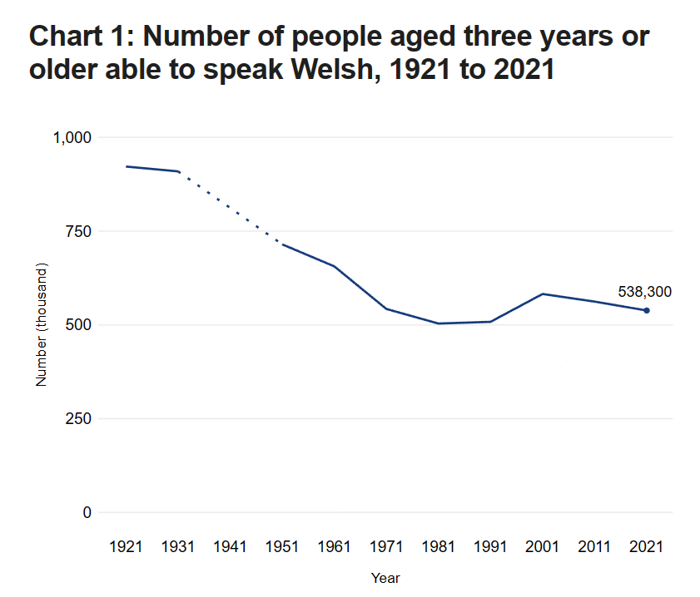

Welsh Government, 2023

APPENDIX FOUR:
The Well-being of Future Generations Act
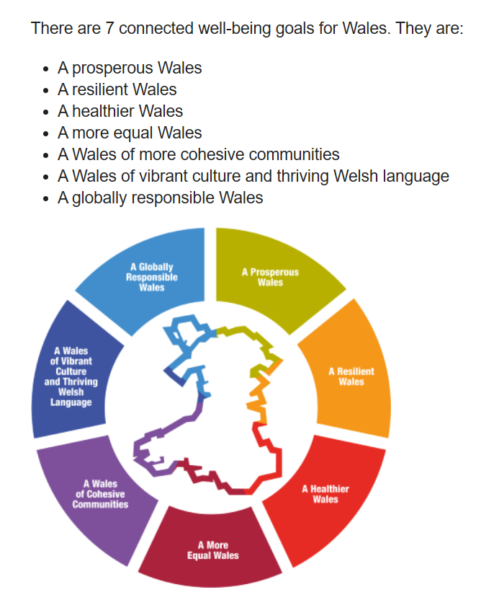

Welsh Government, 2023

APPENDIX FIVE:
Siaradwr Cymraeg yr Wythnos Certificates

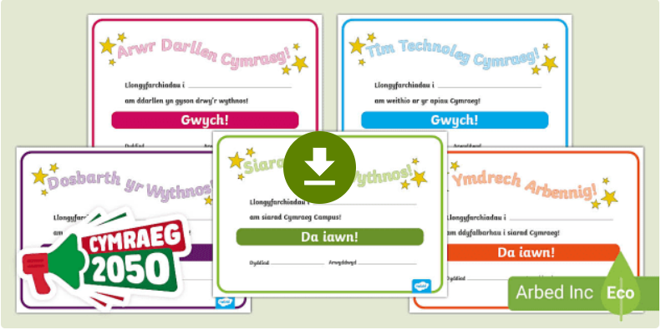

Siaradwr Cymraeg yr Wythnos - Twinkl, 2023

