Placement Proposal and Implementation Plan

Wolfscastle Country Hotel: Kitchen Procurement Procedures

Author: William Crews
Student Number: 1708089
University of Wales Trinity Saint David
Module: SBUS6202
Lecturer: Davina Evans
Date of Submission: 04/11/2019

Wolfscastle Country Hotel is a four-star (Visit Wales), twenty-bedroom hotel located in Pembrokeshire, Wales, founded in 1976 by Andrew Stirling, who continues to own and run the hotel today. In addition to the bedrooms, Wolfscastle operates a well-respected (two AA Rosette) brasserie and restaurant, large function suite for weddings and events and a spa (www.wolfscastle.com, 2019). Over the years, profits rose steadily until 2004. Since this time, rising costs of goods, wages, increased competition and other factors have eroded the gains, according to Mr. Stirling. Maintaining profit margins has become key, however, in the day-to-day running of the hotel kitchen, buying decisions are sometimes made hastily, or simply not researched well enough, due to time constraints and the pressures of work in a busy kitchen.
As General Manager for Wolfscastle from 2009 to 2017, whilst not directly involved with kitchen buying decisions during my tenure, I was keenly aware of the continual need to keep costs under control. I approached Andrew with my proposal to identify the top 20 highest cost/volume items, research supplier options, negotiate prices and produce a new supplier list for the kitchen, to which he has agreed.
The placement I will undertake at Wolfscastle Country Hotel has three aims:
- Study current procurement methods, items and suppliers for the kitchen at Wolfscastle Country Hotel, identify the 20 highest volume or highest cost items regularly purchased.
- Research options and negotiate agreements with suppliers to lower costs of the 20 highest volume/cost items whilst retaining quality and furthering the use of local produce and sustainable options.
- Produce a comprehensive list of suppliers for the items that offer the best option for quality and local provenance at the most competitive price.
To meet these aims, the objectives will be to firstly meet with the head chef to discuss what they feel are the most important items purchased to determine if specific items must be maintained, or if substitutes can be made. Also, this meeting will help to identify the level of purchasing that comes from local suppliers. I will develop an understanding of any specific negotiations that have been made between the head chef and suppliers. The next step will be to meet with the hotel’s bookkeeper to study the kitchen invoices for the past three months to identify the top twenty spends made by the kitchen. From this list, I will then contact the suppliers to attempt to negotiate better pricing, whilst also researching alternative suppliers. Every attempt will be made to buy local produce where possible to lessen the impact on the environment. The final objective and intended outcome will be to produce a new purchasing list which ranks suppliers in order of preference as to cost, locality and quality.
Setting SMART goals allows you to clarify your aims, focus the objectives needed to achieve them and plan your time and resources effectively. The term is attributed to Peter Drucker’s Management by Objectives concept and was first written about by George T. Doran in 1981. Since then, Robert S. Rubin has written about SMART, stating that it has come to mean different things to different people. The most widely accepted is that they are Specific, Measurable, Achievable, Relevant and Time-bound. This approach is well-suited to short-term projects such as this. (Mind Tools, 2019)
The aims and objectives for the placement are SMART in nature because they are:
- Specific – (identify top 20 items, negotiate lower prices, produce supplier list)
- Measurable – (negotiated prices will be compared to current)
- Achievable – (Placement will research top 20 items to limit the scale of the project)
- Relevant – (Research will provide a valuable resource for the organisation)
- Time-bound – (Project has a definite start and end date – 01/11/19 to 31/01/2020)
A Pre-Placement Skills Audit has been completed and included as Appendix A. Several areas have been identified as needing to be addressed to further my professional development and will be improved upon during the placement. By gaining insight into the chef’s decision-making processes and learning why he chooses certain products or suppliers, I will develop my skills of looking at the whole system whilst trying to solve problems (in this case, lower costs while maintaining quality). During the research, I will need to balance the cost of products with the cost to the environment, allowing me to develop a critical understanding of those connections. The reflective journal and critical appraisal portions of the assessments will help to develop skills of self-reflection and analysis.
A Gantt chart has been created (see below) to set out the timeline for the placement which will allow the objectives to be completed and the aims realised. A Gantt chart is an effective visual project-planning tool used to schedule tasks and track the progress of a project (Tran, L, 2015).
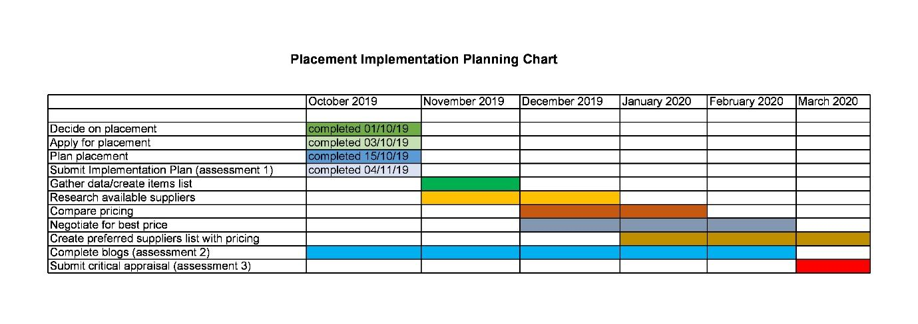
For the reflective journal and critical appraisal, Gibb’s Reflective Cycle will be used as a guide. As Gibbs said:
It is not sufficient simply to have an experience in order to learn. Without reflecting upon this experience it may quickly be forgotten or its learning potential lost. It is from the feelings and thoughts emerging from this reflection that generalisations or concepts can be generated. And it is generalisations which enable new situations to be tackled effectively. (Gibbs, 1988.)

Image: www.crowe-associates.co.uk, 2019)
This internship will provide me with valuable experience which will bolster some of the skills identified in the pre-placement skills audit (appendix A). It will add to the skills of negotiation and product sourcing along with networking and costing products and maintaining margins that I have developed during a twenty-five year career in hospitality.

References
Crowe Associates (2019) Gibb’s Reflective Cycle. Retrieved from https://www.crowe-associates.co.uk/coaching-tools/gibbs-reflective-cycle/

Gibbs, G. (1988). Learning by Doing. A Guide to Teaching and Learning Methods. Oxford: Oxford Brookes Further Education Unit
Mind Tools (2019) SMART Goals How to Make Your Goals Achievable. Retrieved from www.mindtools.com, https://www.mindtools.com/pages/article/smart-goals.html
Tran, L, (2015) The Importance of the Gantt Chart and the Critical Path for Project Management. Retrieved from https://www.inloox.com/company/blog/articles/the-importance-of-the-gantt-chart-and-the-critical-path-for-project-management/

Wolfscastle Country Hotel (2019) About Us. Retrieved from www.wolfscastle.com




