
Master of Business Administration (MBA)

Module Title: Human Capital Management
Module Code: LCMB7023
Lecturer’s Name: Dr. Lakshani Mendis (London)

Assessment Title:
Integrated Human Capital Blueprint:
Aligning People and Performance at Aether Innovations
Student Name: Artiben Rupeshkumar Shailar
Student ID: 2532580
Contents
1. Introduction 4
1.1 Organisational Context 4
1.2 Purpose and Scope of Report 4
2. Critical Analysis of Current Culture and Work Practices 5
2.1 Innovation Culture in Technology Firms 5
2.2 Contemporary Work Practices 5
2.3 Diagnosis of Aether’s Challenges 6
3. Cultural and Structural Initiatives for Innovation 7
3.1 Cultural Foundations for Innovation 7
3.2 Structural Mechanisms to Embed Innovation 8
3.3 Leadership and Organisational Reinforcement 9
4. Future of Work Model 9
4.1 Structured Hybrid Work Design 9
4.2 Task-Based Work Allocation 10
4.3 Collaboration Systems and Leadership Adaptation 10
5. Impact on Motivation and Performance 11
5.1 Employee Motivation 11
5.2 Organisational Performance Outcomes 12
6. Conclusion 13
Part 2: Reflection 13
7. Reflective Learning Using Gibbs/Kolb 13
7.1 Learning Experience and Evaluation 13
7.2 Critical Analysis of Development 14
7.3 Action Plan for Future Development 14
8. AI and Future Professional Relevance 15
8.1 Impact of AI on Work 15
8.2 AI as a Professional Tool 16
8.3 Maintaining Human Value 16
Reference List 18

1. Introduction

1.1 Organisational Context
Aether Innovations is a technology firm with 300 employees, which once was growing rapidly but currently, the growth is slow, people are leaving, and dissatisfied customers. These problems are linked. When the employees are not been engaged, the company would not come up with many new ideas that would reduce the quality of the products and the feeling of the customers. To illustrate the case, Microsoft only improved its performance after altering its culture and way of thinking by its workers. It is not so much about operations, but there is a more systemic problem of people, culture and performance systems that do not work together in So Aether (Hariyani et al., 2024).

1.2 Purpose and Scope of Report
In this report, a new HR plan will be developed that would restore innovation, engagement, and performance at Aether Innovations. Figure 1 demonstrates that good HR systems align the results of the company with talent management, job design and performance practices. The purpose of the report is to create a culture that shall make innovation, add structural changes and create a future of working (Cheong et al., 2024).
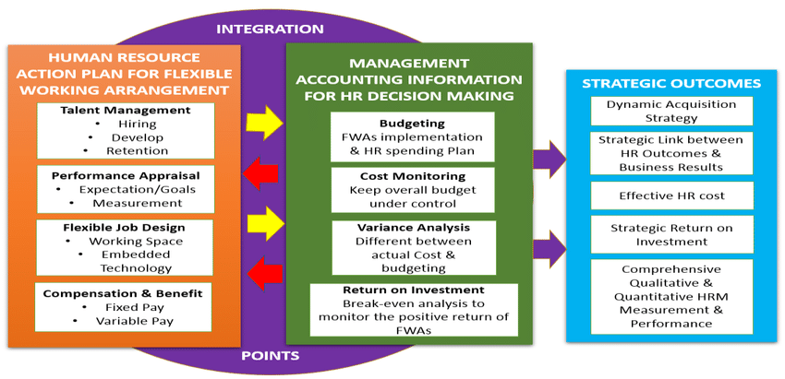
Figure 1. Integrated HR strategic outcomes framework

2. Critical Analysis of Current Culture and Work Practices

2.1 Innovation Culture in Technology Firms
Technology companies usually claim they prize fast change, experimentation, rapid experimentation and never becoming stagnant. These visible actions presented in Figure 2 by Schein are only the tip of the iceberg of a culture. Under these, the company has its true values and greater beliefs that permeate the way of action of people. Therefore a company may describe the process of innovation as such but make risks, failure, or disagreement be punished. Innovation in these locations is not real, but a mere word. Safe environment is also important since the workers will be free to share ideas, challenge poor decisions and learn through errors when they do not fear being blamed. Microsoft is a good example. Since Satya Nadella, learning, openness, and teamwork became the focus of the change at the company, showing that the true innovation occurs when underlying assumptions are changed, rather than with slogans or rules (Qiang, 2025).
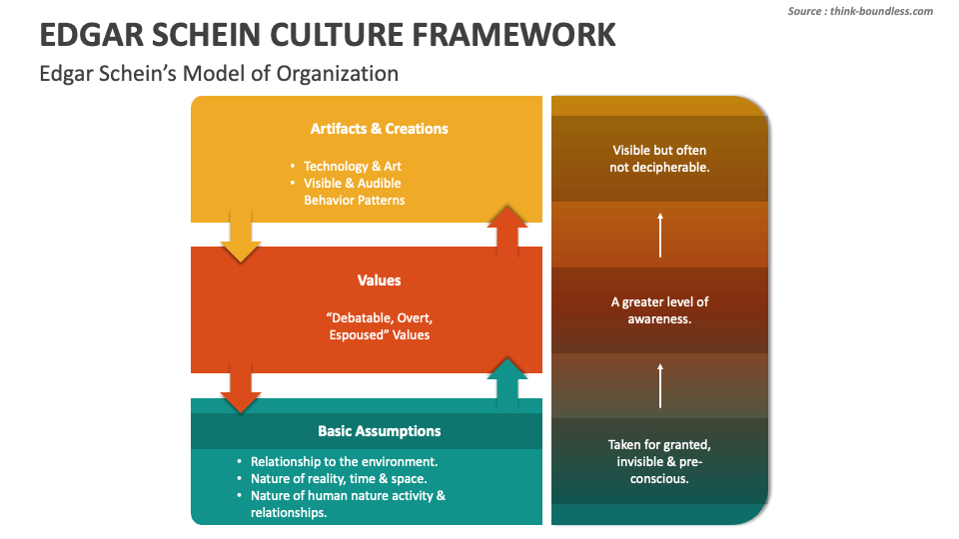
Figure 2. Schein organisational culture analytical framework

2.2 Contemporary Work Practices
A combination of office and remote work, online solutions, and flexible working hours are becoming common among modern tech companies in order to increase productivity and present employees with more options. Figure 3 demonstrates that the establishment of hybrid work presupposes planning, staff contribution, and the willingness of organizations, rather than a policy. In practice, hybrid work can be more flexible and it can assist people to concentrate on individual tasks, but of course, it has trade-offs. Informal learning, spontaneous problem solving, and developing relationships tend to get weak in times when individuals are not together physically. According to McKinsey, the value of a work model is influenced more by a practice and environment created around it than the policy itself (McKinsey & Company, 2023).
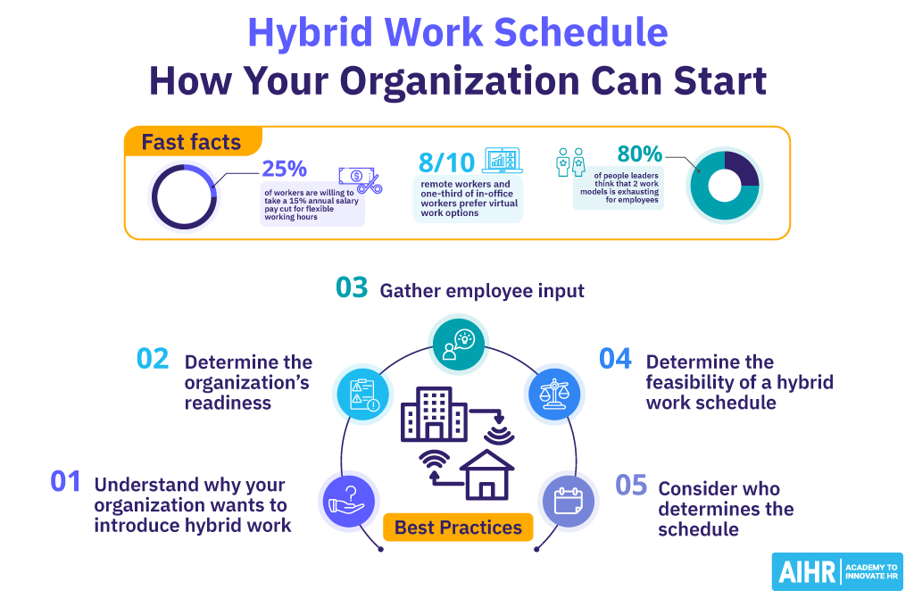
Figure 3. Structured hybrid work implementation model

2.3 Diagnosis of Aether’s Challenges
The reason why Aether has weak innovation is not probably due to a deficiency of talent; however, there are no defined cultural and work systems that transform ideas into deliverables. When employees lack support, but have pressure, innovation will be stalled and burnout increase is likely. People will tend to leave when growing is put on hold and work is not connected with the purpose. Such a high turnover undermines team learning, coordination, and consistency of the services provided, which may reduce the customer satisfaction (Obeng and Atan, 2024).

3. Cultural and Structural Initiatives for Innovation

3.1 Cultural Foundations for Innovation
Innovation of Aether is enhanced when its culture promotes daily activities on new ideas, testing, and learning. All these elements need to be established within the company, which means that psychological safety, autonomy, purpose, and employee participation should not be established separately. Psychological safety is important since individuals are able to speak more when they feel safe to challenge decisions, propose changes and also share their mistakes without having to be blamed. Project Aristotle by Google discovered that the psychological safety was the most influencing element in the team performance, which demonstrated that innovation was highly dependent on the social atmosphere within groups (Poyton, 2024).
Another very important thing is autonomy and purpose. Self-determination theory provides that individuals are better motivated when they have choice, competence and feel related to their work. This applies to staff in Aether whereby they should receive targets yet be at liberty to determine how they tackle issues and the reason their contribution is important to customers and the business. Once they are trusted and feel valued, individuals become more happy to share ideas and go beyond the bare minimum.
The system is complete with participation of the employees. Employees can be given room and encouragement when they are invited to discussions, feedback loops, and improvement forums as demonstrated by 3M which has had a long-running culture of 15% where employees are given time to work on self-directed projects and innovation ends up being useful and more creative (Wang, 2013).
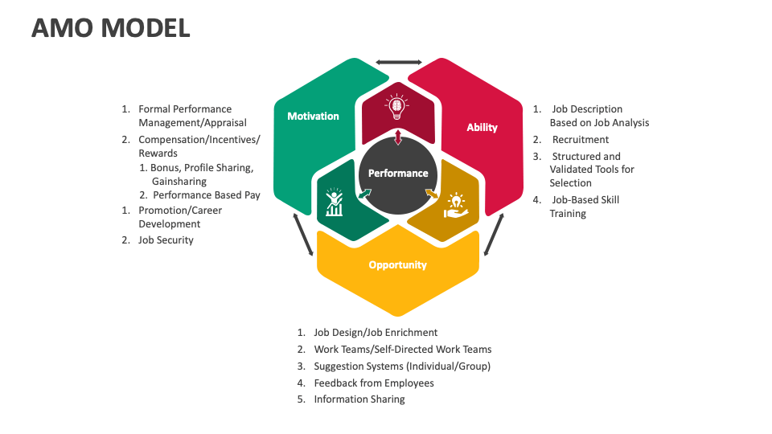
Figure 4. Ability motivation opportunity performance model

3.2 Structural Mechanisms to Embed Innovation
Aether should also have good systems of transforming creative ideas into actual business outcomes. Innovation represented as a pipeline is presented in figure 5, with the flow of ideas beginning with the starting point and problem definition to testing, incubation, and integration. It is significant as the innovation cannot be reliant on a hare-brained idea. It ought to go through a cyclic procedure. Innovation sprints should be the initial structural mechanism in the case of Aether. They are brief, concentrated work periods during which teams solve a certain issue, experiment, and demonstrate a solution in practice. Innovation sprints minimize time wastage and promote trial and error (Frode Heldal, 2023).
The second process is cross-functional cooperation. Aether ought to form project teams comprising of individuals in the engineering, product, HR, operations, and customer-facing functions. This is important since innovation is enhanced when the various areas of knowledge are combined to address a single business issue. Cross-functioning can also enhance customer satisfaction since the product decisions are more informed by broader internal knowledge than by technical thinking.
The third system is intrapreneurship system. The employees are supposed to be in a position to suggest ideas, get small internal funding and trial promising projects in a gradual manner. This will result in ownership and ability to innovate long term. Still, there are risks. Excessive side projects may divide people and noisy teams may get favors over the quiet teams who may be as able as noisy teams (Bernstein et al., 2024).
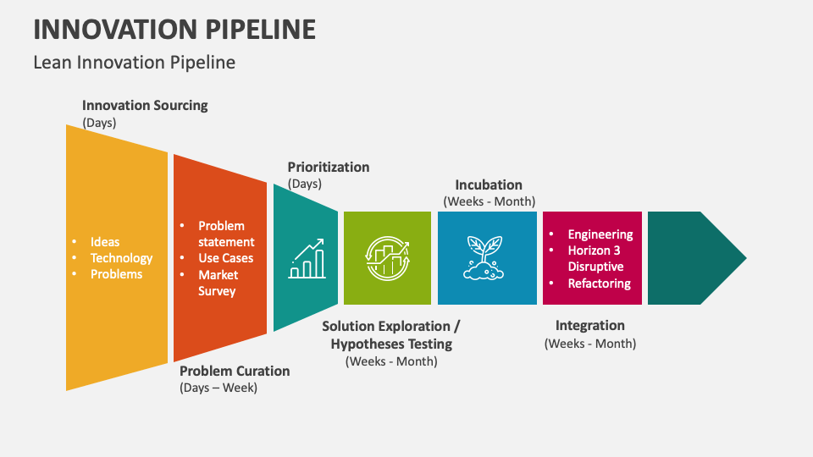
Figure 5. Organisational innovation pipeline process model

3.3 Leadership and Organisational Reinforcement
To transform the culture at Aether, it has to be assisted by leaders and rules on a daily basis. The leaders must coach rather than command. That is to say that they listen, open to questions, and view mistakes as learning opportunities. When the managers desire new ideas and punish employees when they fail to do so, then people would not ever try again.
Rules and routines are also important. Meetings, reviews, training sessions and project planning should involve new ideas. That is why new ideas are normal, not extraordinary, according to 3M, leaders must create a work environment where employees are allowed and encouraged to experiment. That demonstrates that culture is not only grown by words but by leaders and systems (Hisrich and Soltanifar, 2020).

4. Future of Work Model

4.1 Structured Hybrid Work Design
Aether must employ an unambiguous hybrid model, which is work purpose based, rather than personal preference. The office attendance should be two days a week when employees can work together, find solutions to problems and discuss the new ideas. The remaining days need working at home on profound work, analysis and project completing themselves. This is superior to a highly flexible policy as it does provide the rules, is able to keep everybody on track and is just. This concept is supported by figure 6 that reveals that the availability of the correct tools and skills enables individuals to be more creative in the workplace and do better (Chaiyapruksayanonde and Ponchaitiwat, 2025).

4.2 Task-Based Work Allocation
Job should be given according to the kind of work. Creative activities such as brainstorming, design reviews, product planning, and problem solving are best conducted face to face since they are more suited to fast chats, trusting and energy. Analytical work like coding, report writing, reviewing data and documentation can on the other hand be performed at home with minimal interruption (Yang et al., 2021).
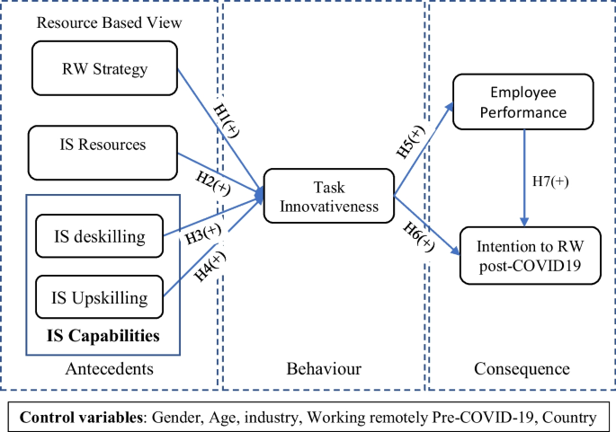
Figure 6. Employee innovation performance causal framework

4.3 Collaboration Systems and Leadership Adaptation
The hybrid working process will be effective only to the extent Aether develops good digital infrastructure and adheres to a strict teamwork culture. As Figure 7 indicates, digital ecosystems require integrated workflows, joint platforms and explicit interaction between users and contributors. Aether is consequently to employ mutual files, searchable databases, computerized white board, and explicit meeting protocols. GitLab is an appropriate example as it relies heavily on written work processes and the shared open knowledge to ensure every person can work remotely on a large scale (Choudhury et al., 2020).

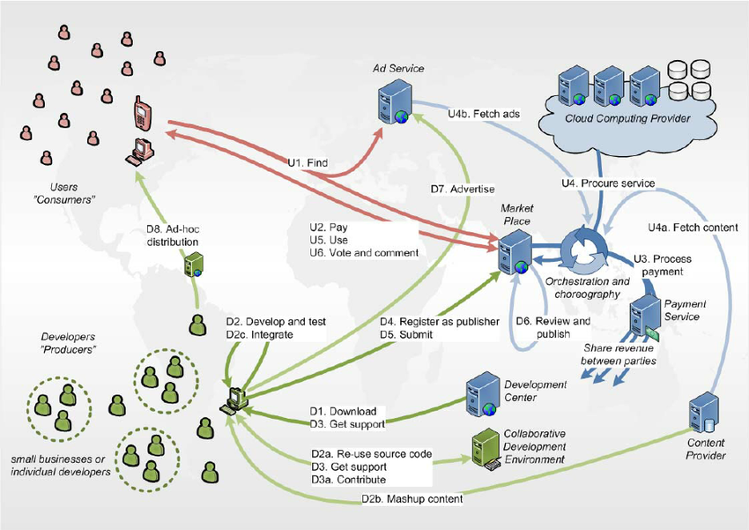
Figure 7. Digital collaboration ecosystem workflow model

5. Impact on Motivation and Performance

5.1 Employee Motivation
The plan will have the capacity to enhance motivation as the workforce will be provided with increased freedom, development, and bond. The primary concept of the self-determination theory is presented in Fig. 8: individuals become more motivated in case they are free, skilled, and have good relationships. Aether will grant people increased freedom due to flexible work and greater influence in innovation. Competency will improve via cross-team, brief innovation and more definitive development opportunities. Connection shall increase through frequent office work and improved interaction amongst team members. This is also explained by the job demands- resources model (Demerouti, 2025).
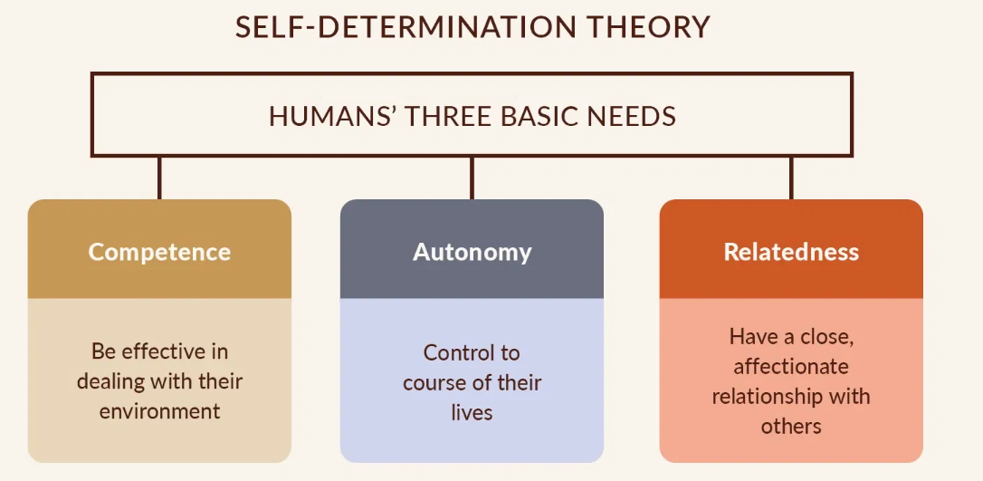
Figure 8. Self-determination theory motivation model

5.2 Organisational Performance Outcomes
The primary advantage of this strategy is that it makes the relation between the feeling of the employees and the performance of the company direct. Figure 9 demonstrates the interdependence: HR practices determine the results of employees such as skills, commitment, and flexibility that in turn determine productivity and quality of the services. In the case of Aether, the culture of innovation would be stronger, which would help it increase the volume of ideas and speed of actions, which would enable the company to respond to the needs of the market and develop. Increased participation and training are supposed to reduce turnover and retain the team knowledge as well as prevent disruption (Deepalakshmi et al., 2024).
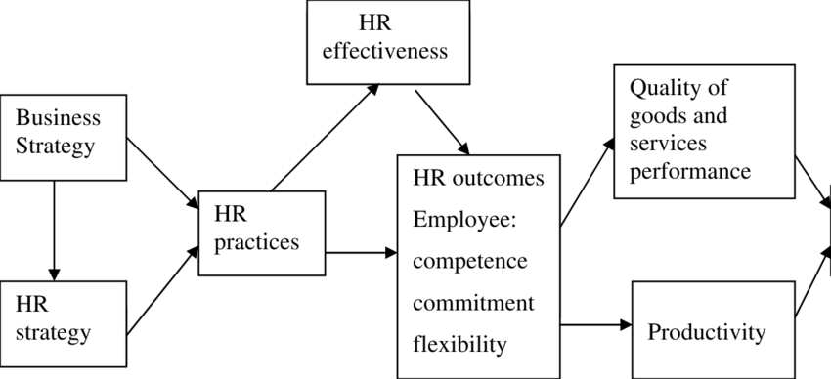
Figure 9. HR practices performance linkage framework

6. Conclusion
People issues and system problems are the cause of Aether problems and not the slowing down of the business. The lack of innovation, elevated turnover rates among the employees, and their dissatisfied customers demonstrate that culture, job design, and performance expectations are incompatible. The proposed workforce plan in this report comprises the psychological safety, autonomy, employee participation, innovation frameworks, and definite hybrid work arrangement. All these changes have the potential to enhance motivation, working cooperatively with other teams and enhance the quality of innovation (Vitasek, 2025).

Part 2: Reflection

7. Reflective Learning Using Gibbs/Kolb

7.1 Learning Experience and Evaluation
Through the reflective cycle developed by Gibbs, I can affirm that this module has transformed my way of thinking concerning the human capital management. Initially, I perceived HR as some support function in terms of recruitment, training and employee relation. However, this module has helped me realize that HR is not just about administration. HR is closely related to strategy, innovation, performance, long-term success of the organisation. The most valuable lesson to me was that. It has also become clear to me that weak people practices result in weak business performance (Weekly, 2021).
One of my strengths when it comes to learning was that I could connect theory and actual organisational issues. Indicatively, I learned the impacts of culture on innovation, motivation on retention, and leadership behaviour on employee performance. This took me out of a fundamental perspective to the practical and strategic perspective of HRM. I was also more confident when dealing with models to explain business problems in a straightforward manner (Teece, 2018).
Meanwhile, I discovered certain weaknesses. At the beginning I gave too much attention to theory and definitions, instead of examining how such concepts operate within actual organisations. I also noted that I never thought critically. I would at times just accept management ideas without doubting whether they could be practicable in various business situations. The model by Gibbs assisted me in realizing this gap.

7.2 Critical Analysis of Development
I have gained much knowledge on the HR strategy. I would imagine that it was just good rules to hire, train and review. Now I realize that it is broader and more complicated. It entails the establishment of systems that connect people, work, leaders, and culture to the goal of the organization. This has changed my thoughts dramatically. I now understand that robust HR practice is not only concerned with correcting employee issues, but it should also make space to allow innovation, flexibility and performance.
The new perspective was based on the analysis of such concepts as psychological safety, self-determination theory, and strategic HRM. These theories have educated me that not only rules or rewards make employees perform well. They perform well under the conditions of being trusted, supported, skilled, and being involved. My personal development was also impacted by this. I understood that in order to become a better professional, I should not only enhance my technical skills but also communication, teamwork, and critical thinking (June 5 and 2019).
The reason why this reflection is significant is that it demonstrates a greater lesson. The HR strategy is only successful when it is a system. As an instance, the culture could be weak and thus, training will not enhance the performance. Similarly, flexible work in and of itself cannot enhance engagement when the leadership is weak. This has transformed my perception of management issues. I now think more like in a linked manner. This implies that I cannot study subjects independently in my personal development.

7.3 Action Plan for Future Development
There are three aspects of my future development plan that include; thinking strategically, becoming a better leader and learning all the time. First, I will have to master a habit of examining the problems of the company in depth. To accomplish this, I will read additional journal articles, case studies, and industry reports concerning strategic HR, innovation, and future work. Another task that I will train in writing is short analysis notes in order to be able to connect ideas with real business problems (Coursera Staff, 2024).
Second, I would like to be a more efficient leader. That is how to get more proficient possessing the skill of talking, listening, and decision-making. I will enhance this by participating in the group discussion, paying attention to the feedbacks, and observing how the good leaders handle the people in the case of change. I also desire to be more confident when I make ideas simple and professional.
Third, I will keep learning. I will complete brief online courses in digital HR, workforce analytics and innovation management. The topics are important due to the fact that the work world is evolving rapidly. I also intend to develop a growth attitude whereby I view failures as learning opportunities. This course of action is achievable since it combines both study, capacity building, and practice. It will assist me in becoming a better and more flexible HR professional in the long run (Gardner, 2021).

8. AI and Future Professional Relevance

8.1 Impact of AI on Work
In most industries, AI is already transforming the way work is being done. Figure 10 indicates that a substantial number of HR leaders believe generative AI will have an impact on entry-level, mid-level, and expert work, particularly in the tech and telecom sector. It implies that AI is not only replacing routine jobs but it also transforms the skills requirements at each level. The AI tools can now be used to perform tasks such as drafting, data processing, reporting, and basic analysis faster. As such, employees will require enhanced digital capabilities, flexibility and problem-solving capabilities (Kassa and Worku, 2025).
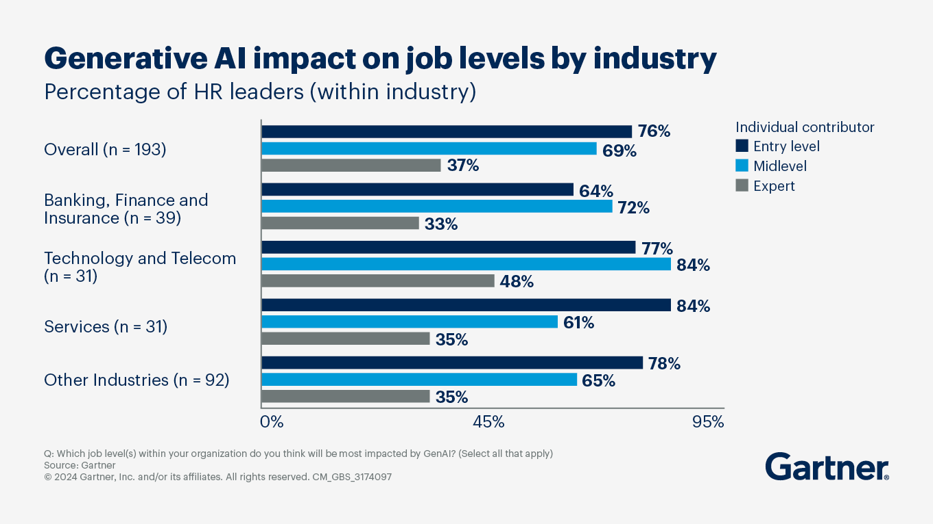
Figure 10. Generative artificial intelligence workforce impact

8.2 AI as a Professional Tool
I believe that AI is my work assistant and not a substitute to human beings. It may help me to be more productive as it can provide me with ideas, write first drafts, summarize data, and arrange data. It may also be useful in the process of analysis, as it allows identifying patterns, comparing facts and accelerating research. AI can provide me with various choices, situations, and facts in a nutshell when it comes to decision making. However, I am also aware that AI outcomes should be verified due to their possibility of being incorrect, incomplete, and excessively abstract. The optimal solution is therefore to have AI as an assistant but have humans give the final decisions, analyze the outcomes, and accountability (Zeiser, 2024).

8.3 Maintaining Human Value
I should develop abilities that a machine is unable to entirely replicate to remain valuable to work in an AI-driven workplace. Figure 11 reveals such skills as being creative, working together, talking with other people, and critical thinking. I would also include leading, knowing how to feel and being a good moral decision maker. This is important since the companies require individuals with the ability to see the big picture, maintain good relationship and make justifiable decisions during difficult circumstances. Robots are capable of processing information, but they are not going to substitute human empathy, ethical reasoning, and broad thinking. That is why I would like to become a professional who works with AI intelligently and at the same time introduces evident human value through understanding, responsibility, and leadership (Murire, 2024).
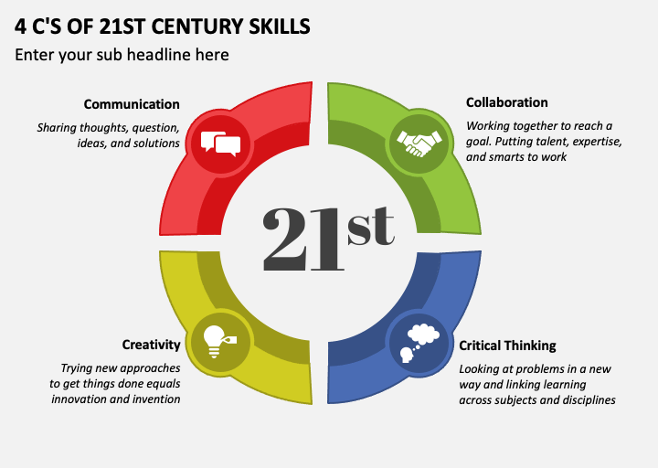
Figure 11. Twenty first century skills framework

Reference List
Bernstein, E.S., Gupta, P., Mortensen, M. and Leonardi, P.M. (2024). Collective attention and relational overload: A theory of transactive control in high-permeability intraorganizational environments. Research in Organizational Behavior, 44, p.100209. doi: https://doi.org/10.1016/j.riob.2024.100209.
Chaiyapruksayanonde, C. and Ponchaitiwat, K. (2025). Supportive Work Environments, Innovative Work Behavior, and Job Performance in the Hospitality Industry: Empirical Evidence from Thailand. Tourism and Hospitality, 6(1), p.20. doi: https://doi.org/10.3390/tourhosp6010020.
Cheong, C., She, L., Ma, L., Karim, S., Chan, L., Chong, P.L., Choong, P.W., Gan, C.C., Gultom, N.D., Homer, S.T., Hossain, S.M., Leong, K.Y., Nga, J., Piprani, A.Z., Poon, W.C., Singh, J., Tehseen, S. and Mei, E. (2024). Building a culture of innovation: Innovation 360°. Global business and organizational excellence. doi: https://doi.org/10.1002/joe.22255.
Choudhury, P., Crowston, K., Dahlander, L., Minervini, M.S. and Raghuram, S. (2020). GitLab: work where you want, when you want. Journal of Organization Design, [online] 9(1). doi: https://doi.org/10.1186/s41469-020-00087-8.
Coursera Staff (2024). What Is Analytical Thinking and How Can You Improve Your Analytical Thinking Skills? [online] Coursera. Available at: https://www.coursera.org/articles/analytical-thinking.
Deepalakshmi, D.N., Tiwari, Dr.D., Baruah, Dr.R. and Bisht, R. (2024). Employee Engagement And Organizational Performance: A Human Resource Perspective. [online] ResearchGate. Available at: https://www.researchgate.net/publication/380284402_Employee_Engagement_And_Organizational_Performance_A_Human_Resource_Perspective.
Demerouti, E. (2025). Job demands-resources and conservation of resources theories: How do they help to explain employee well-being and future job design? Journal of Business Research, 192(115296). doi: https://doi.org/10.1016/j.jbusres.2025.115296.
Frode Heldal (2023). Design thinking teams and team innovation performance. [online] ResearchGate. Available at: https://www.researchgate.net/publication/376215988_Design_thinking_teams_and_team_innovation_performance.
Gardner, R. (2021). 7 Steps to Create a Leadership Development Plan. [online] AIHR. Available at: https://www.aihr.com/blog/leadership-development-plan/.
Hariyani, D., Hariyani, P., Mishra, S. and Sharma, M.K. (2024). Causes of organizational failure: A literature review. Social Sciences & Humanities Open, [online] 10, pp.101153–101153. doi: https://doi.org/10.1016/j.ssaho.2024.101153.
Hisrich, R.D. and Soltanifar, M. (2020). Unleashing the Creativity of Entrepreneurs with Digital Technologies. Digital Entrepreneurship, pp.23–49. doi: https://doi.org/10.1007/978-3-030-53914-6_2.
June 5 and Maddocks, 2019 K.G. (2019). 6 Ways to Improve Your Communication Skills at Work. [online] www.snhu.edu. Available at: https://www.snhu.edu/about-us/newsroom/liberal-arts/communication-skills.
Kassa, B.Y. and Worku, E.K. (2025). The Impact of Artificial Intelligence on Organizational Performance: The Mediating Role of Employee Productivity. Journal of Open Innovation: Technology, Market, and Complexity, 11(1), p.100474. doi: https://doi.org/10.1016/j.joitmc.2025.100474.
McKinsey & Company (2023). What is the future of work? [online] www.mckinsey.com. Available at: https://www.mckinsey.com/featured-insights/mckinsey-explainers/what-is-the-future-of-work.
Murire, O.T. (2024). Artificial Intelligence and Its Role in Shaping Organizational Work Practices and Culture. Administrative Sciences, 14(12), p.316. doi: https://doi.org/10.3390/admsci14120316.
Obeng, H.A. and Atan, T. (2024). Understanding Turnover Intentions: The Interplay of Organizational Politics, Employee Resilience, and Person-Job Fit in Ghana’s Healthcare Sector. Sustainability, 16(22), pp.9980–9980. doi: https://doi.org/10.3390/su16229980.
Poyton, B. (2024). Google’s Project Aristotle. [online] Psychsafety.com. Available at: https://psychsafety.com/googles-project-aristotle/.
Qiang, Q. (2025). Corporate Soft Power Strategy in Shaping Global Influence: A Case Study of Microsoft. ResearchGate. [online] doi: https://doi.org/10.13140/RG.2.2.23393.42082.
Teece, D.J. (2018). Business models and dynamic capabilities. Long Range Planning, [online] 51(1), pp.40–49. doi: https://doi.org/10.1016/j.lrp.2017.06.007.
Vitasek, K. (2025). The Power Of Collaborating With Employees For Innovation. Forbes. [online] 13 Jan. Available at: https://www.forbes.com/sites/katevitasek/2025/01/13/the-power-of-collaborating-with-employees-for-innovation/.
Wang, K.K. (2013). 3M Employee Innovation REQUIRED* – Karen King. [online] Blogs.ubc.ca. Available at: https://blogs.ubc.ca/karenwang/2013/11/11/3m-employee-innovation-requirement/.
Weekly, C. (2021). Lessons in Failure: Applying an Organizational Learning Framework to Understanding Attitudes Towards Failure in Development. Environmental Health Insights, 15, p.117863022110443. doi: https://doi.org/10.1177/11786302211044348.
Yang, L., Holtz, D., Jaffe, S., Suri, S., Sinha, S., Weston, J., Joyce, C., Shah, N., Sherman, K., Hecht, B. and Teevan, J. (2021). The Effects of Remote Work on Collaboration among Information Workers. Nature Human Behaviour, [online] 6(6), pp.43–54. Available at: https://www.nature.com/articles/s41562-021-01196-4.
Zeiser, J. (2024). Owning Decisions: AI Decision-Support and the Attributability-Gap. Science and Engineering Ethics, 30(4). doi: https://doi.org/10.1007/s11948-024-00485-1.

