Tutorial 1

Date/Time | Action Taken | Outcome
29/01, 15:00 | Downloaded and extracted all files
04/02, 11:26 | Investigated file “letter-image.jpg”. Looked into properties> details, found a few potentially relevant things, see outcome. Could potentially benefit from further file analysis or look for files embedded into the image file | Rating 2 stars  Comments: THM{238956}  Program name: GIMP 2.10.28  Camera details  GPS LONGITUDE AND LATITUDE
04/02. 11:30 | Investigated “ransom-letter.doc”. | I can see that the author of the file is “Ann Gree Shepherd”.  Can see date last saved/created.
11:35 | Investigated “ransom-letter.docx”. No new relevant information. Same with ransom-letter.pdf | -
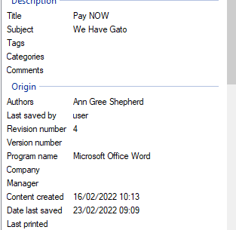
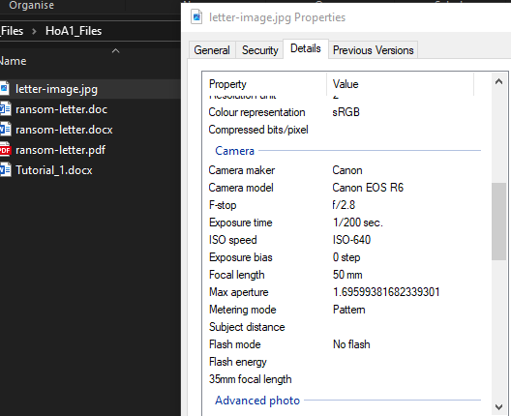
11:27, PROPERTIES
11:34, RANSOM-LETTER.DOC
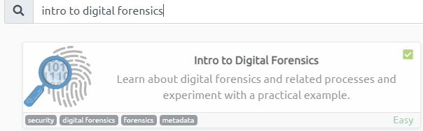
11:54

I’ve created a small list of sites that can help with the improvement of digital forensics skills. Two are free courses, and one is paid.

- Computer Forensics and Digital Forensics Materclass 2024+ from udemy.com. Offers versatile and permanent access to this course, and although the course is not free it is affordable given the service it provides.
- Digital forensics course from the Open University. This course is free and functions as an introduction into what Digital forensics are, what forensic scientists do and where the field might be headed in the future.
- Digital Forensics Course and Certification from eccouncil.org. This course is part of a free bundle that covers several basic aspects of cyber security, and is tailored to all types of people who’d like to start learning.
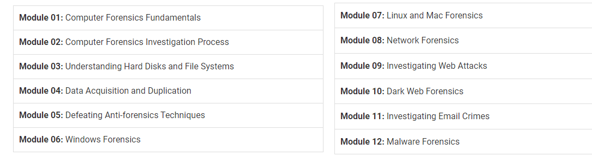

Modules in the free course for digital forensics from eccouncil.org
12:05
Digital forensics are one of my weaker areas in cyber security. I have worked in the field for a little over a year now and unfortunately there have not been many practical opportunities for me to practice digital forensics other than very basic things. I imagine the skillset that I will learn as part of this course will be used scarcely however will be invaluable when the need for it does arise. The main thing I think I need to learn about for now is what sort of tools can do what, and the laws surrounding digital forensics. Other than that, I think I have a solid grasp on the aspects covered in this lecture/tutorial.
Rating (out of 5):
Cybercrime: 2 (very basic knowledge on what is and isn’t illegal in cyber)
Investigations: 3.5 (have a good amount of experience with cyber investigations, though need to know more about what tools are available)
Evidences: 3

