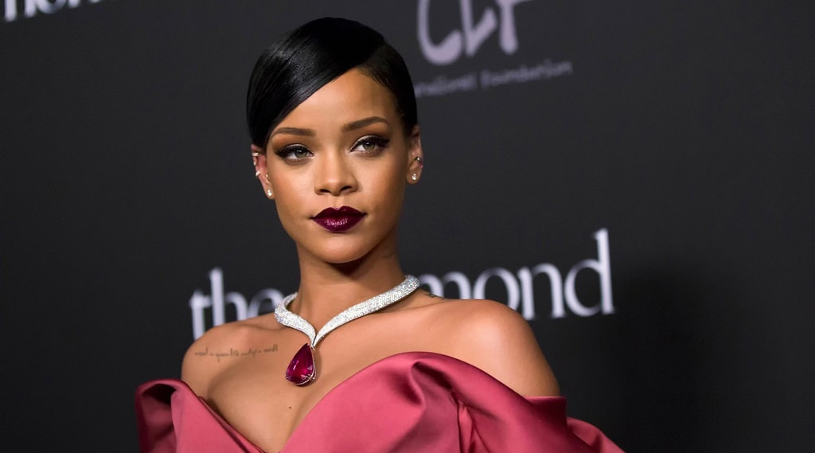

Robyn Rihanna Fenty, Barbadian singer, actress, fashion designer, and businesswoman
Born: 20 February 1988 (34y), Saint Michael, Barbados
Her success:
2005 she shook up the music industry
2017 she launched Fenty Beauty
2018, she launched her Savage X Fenty underwear brand
2019, she also announced the launch of her high-end fashion label Fenty

