Which digital tools are commonly used at UWTSD for Collaboration?

Student Name: Geanina-Elena Tronaru
Student ID:2118801
Lecturer Name: Seyed Nasirpourosgoei
Module Name : Digital Skills and Research Method
Module Code: BMSW 4003
Assignment Name: Task 2 - Research Paper

The Executive Summary

The following research paper has had a complex look into the digital tools that are commonly used by the students at the University of Wales Trinity Saint David. Having this in mind, there has been a mixture of the primary and secondary research in order for all information needed to be accumulated. The results section is expressing clearly the answers of all participants to each question that has been addressed throughout the questionnaire.

Table of Contents
The Executive Summary 2
Introduction 4
The Research Design 5
- • Question of the research 5
- • Method of the research 5
- • The ethics 6
The results of the research 7
Discussion of the research 9
The bottom line 11
Reference List 12
Appendix…………………………………………………………………………………...............13

Introduction

This academic paper is written for the Digital Skills and Research Methods module with the main purpose of developing research which to answer to the selected question regarding the collaboration using digital tools at the UWTSD. Having this in mind, the structure of this paper is going to be followed by answering to three main sections. The first section will discuss about the research design including the question, methods, and ethics used for this research that is ongoing, the second section will discuss the results that have been gathered using the questionnaire for the primary research method, and thirdly, a discussion is going to be carried out looking into the results from the primary and secondary research discussing if these are corresponding one to another, this being done to measure the evaluation of the research (Schwarts & Vignoles, 2012).

As it has been mentioned, this research is carried out to investigate collaboration using digital tools at UWTSD, however, before this, the audience needs to be informed about the meaning of both collaboration and digital tools. Speaking about collaboration, this is known as the process of interacting with other people for different purposes in a great variety of contexts, therefore this research is focusing on the academic context (Katz & Miller, 2013).

The Research Design

Question of the research

As it has been referenced in the presentation, the chose question for this exploration is "What is the most usually involved advanced instrument for coordinated effort at UWTSD". Thusly, to address this question both essential and auxiliary examination is being done (Eble & Gaillet, 2015)). The theory of this exploration is the Digital Tools are Helping understudies in turning out to be more drawn in with their courses while teaming up utilizing the advanced instruments.

Method of the research

The essential examination is characterized similar to the exploration did by and by, though the optional exploration remains into taking a gander at the aftereffects of an exploration that has been completed by another person (Lew, 2018). For the essential examination, a survey has been passed out towards ten understudies at the University of Wales Trinity Saint David, to address what strategies for joint effort are utilized in various settings including the settings of instructors, associates, etc. Hence, each question will allude to another unique circumstance or circumstance. For instance, one inquiry out of the five inquiries is posing to the members which computerized cooperative instrument they are utilizing to draw in with the instructor while having questions. The sort of information that is being aggregated all through this examination is the subjective information. The subjective information in research is the sort of exploration that is being addressed through words. The other kind of information, which won't be fundamentally present in this exploration is the quantitative information. This kind of information is the one addressing data through numbers. The main situation when the quantitative information will be utilized is the point at which the conversation of the outcomes will be embraced examining the number of understudies out of the ten have answered with a particular response.

The five inquiries that are posed in the survey are:
1. How frequently do you utilize advanced stages to reach out to individuals?
2. Since an understudy at the UWTSD, what stage did you end up utilizing the most for reaching out to the instructor?
3. Since learning at UWTSD, what stage did you utilize the most to draw in with partners?
4. Which stage do you view as best for advanced cooperation with teachers?
5. Do you find utilizing advanced apparatuses significant for cooperation?

Talking about how the members have been chosen for this exploration, it is critical to call attention to that partners from various classed have been halted and inquired as to whether they might want to answer a short poll with the end goal of an examination did. Accordingly, these surveys have been given out autonomously to keep away from peer tension or anything like this.
With regards to the optional examination while completing these, key literary works will be explored to see what different creators are talking about the advanced devices that are utilized for coordinated effort and their significance. One piece of writing that has been perused to gather data is composed by Berg, (2018) and entitled as "Superpowering individuals: planning the cooperative computerized association". This book examines about various stages that exist to unite individuals for various conversations. This incorporates Facebook, Microsoft Word, Gmail, Outlook, and numerous others. It is referenced in the book that this multitude of computerized stages are in exceptionally popularity in the present existence where everybody is so connected to the innovation gadgets. These assertions have likewise been upheld by Grassetti and Brookby, (2016) in their book entitled as "Progressing cutting edge educator training through computerized devices and application", as it is additionally referenced that these advanced instruments are assisting the understudies and instructors with finding the solutions/data they need in a faster way, upgrading more viable correspondence, participation, etc.

The ethics
The morals are assuming a critical part in research as this keeps issues or wrong things from occurring. Hence, in this exploration the principle morals that have been utilized incorporate secrecy, as indicated by the Data Protection Act 1998 it is a lawful necessity to keep all the data of all members secret (Brooks, 2014).

The results of the research
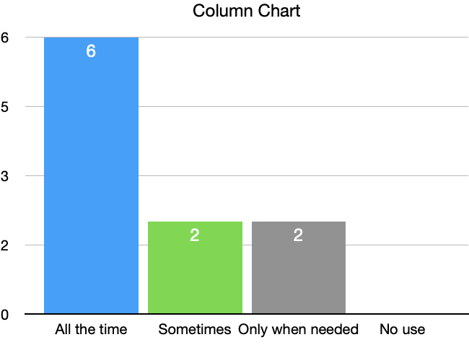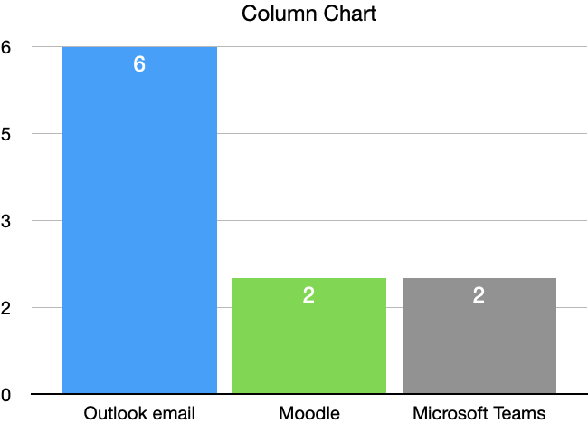
Answers for Question 1 Answers for Question 2

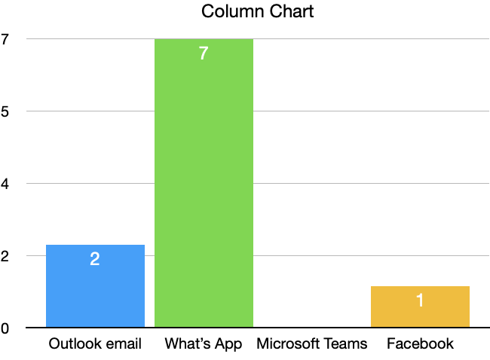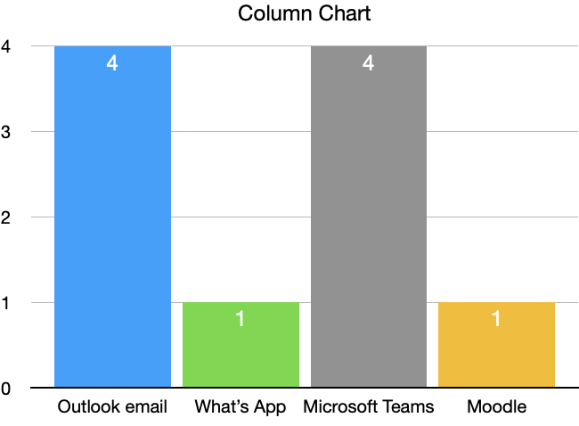
Answers for Question 3 Answers for Question 4

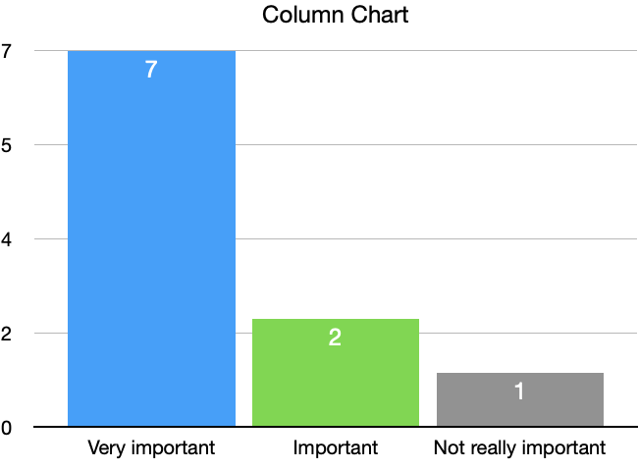
Answer for Question 5

Discussion of the research

Thinking about all that has been incorporated up until this point, it is essential to bring up that the outcomes addressed in the past segment are framing as it follows:

Question 1: For this inquiry, the majority of the members (six out of ten) have called attention to that computerized device are involved constantly to reach out to the speaker, though nobody out of the ten members referenced that there is no entrance of the advanced apparatuses.

Question 2: For this inquiry, six out of ten members referenced that viewpoint email stage is being utilized the most while attempting to arrive at the instructor of the module. Be that as it may, nobody has while the rest referenced about The Microsoft Teams planform and the Moodle.

Question 3: In this inquiry, the members addressed most with WhatsApp, while the second most famous response was Outlook Email. Q w e r d s a c v d f h Q w e r d s a c v d f h Q w e r d s a c v d f h Q w e r d s a c v d f h Q w e r d s a c v d f h Q w e r d s a c v d f h
Question 4. While talking about the viability of the advanced devices that are utilized for coordinated effort, the members have referenced that there are different stages that they viewed as compelling, in any case, four of the members referenced about Outlook Email, while other four referenced about Microsoft Teams. These two responses were the most widely recognized for this inquiry. Q w e r d s a c v d f h Q w e r d s a c v d f h Q w e r d s a c v d f h Q w e r d s a c v d f h Q w e r d s a c v d f h Q w e r d s a c v d f h Q w e r d s a c v d f h Q w e r d s a c v d f h
Question 5. For this last inquiry, when the members have been gotten some information about the viability of the advanced devices, it has been referenced by a large portion of the members (7) that the computerized apparatuses are vital, two referenced that these are significant, while only one revealed that the advanced instruments are not significant. Q w e r d s a c v d f h Q w e r d s a c v d f h
By and large, the responses to the resolved inquiries appear to bring up that the computerized stages are assisting the understudies in keeping contact with various individuals including their instructors. Particularly while concentrating on the web, the understudies needed to pose inquiries utilizing the visit from the Microsoft Teams stage, and keeping in mind that not in the examples, messages by means of Outlook should have been sent for any extra inquiries that the understudies might have had. Q w e r d s a c v d f h Q w e r d s a c v d f h Q w e r d s a c v d f h
Considering the data that has been gathered alongside the data that has been addressed from the literary works that have been chosen, the most compelling thing to call attention to is that the data aggregated with the data removed is relating great, as in the two situations from the essential exploration and from the auxiliary examination, it is framed that the advanced apparatuses do assume a significant part in the accomplishment as an understudy while alluding to teaming up with either speakers, different branches of the college, partners, etc for various purposes.

With regards to talking about assuming the examination has affirmed the underlying theory of the exploration, central thing to specify is that indeed, the aftereffects of the exploration have affirmed the speculation. This is on the grounds that in the speculation it is referenced that understudies connect well while teaming up utilizing different advanced instruments, and subsequently, taking into account that the greater part of the responses were framing more individuals utilizing computerized stages, and on the grounds that the majority of the responses were saying that these are significant in their learning, obviously the computerized apparatuses are having a critical vital that should be very much thought about while likewise running after the improvement of the computerized abilities, as in certain conditions, these could really assist the understudies with various exercises. Q w e r Q

The bottom line

The report discussed all three sections that have been described in the introduction using valid resources and clear explanations for the research question to be answered and concluded accordingly. The report demonstrated that the digital tools are playing a very important role in the collaboration of the students at the University of Wales Trinity Saint David. Q w e r d s a c v d f h

Reference List

- Brooks, R. (2014) Ethics and education research 1st Edition. SAGE Publications

- Berg, O. (2018) Superpowering People: Designing the Collaborative Digital Organisation. 1st Edition. John Wiley & Sons.

- Eble, M. F. & Gaillet, L. L. (2015) Primary research and writing: people, places, and spaces 1st Edition. Routledge.

- Grassetti, M. & Brookby, S. (2016) Advancing next-generation teacher education through digital tools and applications. 1st Edition. SAGE Publications

- Katz, J. H. & Miller, F. A. (2013) Opening doors to teamwork and collaboration: four keys that change everything. 1st Edition. Berrett-Koehler Publishers.

- Lew, K. (2018) Exploring secondary research investigation through science research projects. 1st Edition. The Rosen Publishing Group inc.

- Schwartz, S. J. & Vignoles, V. L. (2012) Handbook of identity theory and research. 1st Edition. Springer New York.

Appendix

1. How frequently do you utilize advanced stages to reach out to individuals?
2. Since an understudy at the University of Wales Trinity Saint David, what stage did you end up utilizing the most for reaching out to the instructor?
3. Since learning at UWTSD, what stage did you utilize the most to draw in with partners?
4. Which stage do you view as best for advanced cooperation with teachers?
5. Do you find utilizing advanced apparatuses significant for cooperation?

