ACCIDENT REPORT FORM
I haven’t had to use one during my research but I would use one like this BBC example.
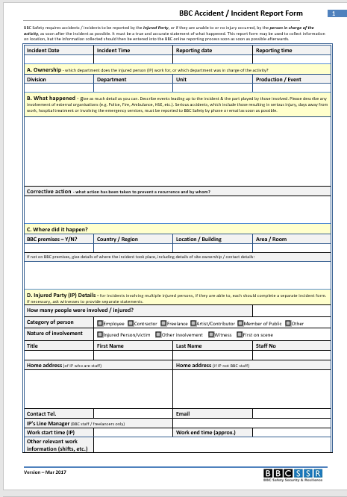
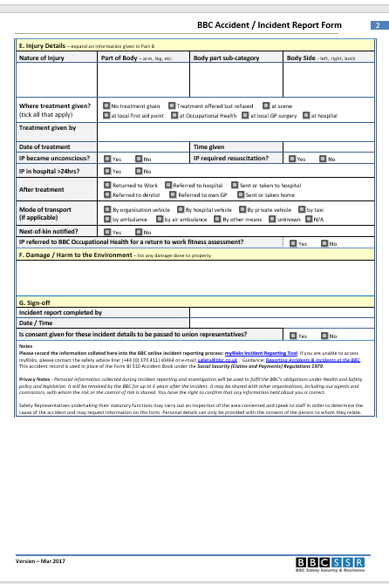

Source:
https://www.bbc.co.uk/safety/resources/forms-and-documents.html

