COVER PAGE
UNIVERSITY OF WALES TRINITY SAINT DAVID(UWTSD)
LONDON, CANARY WHARF

STUDENT NAME AND ID: RUHUL ISLAM RUBEL (2533221)
MODULE: SOFTWARE SOLUTION FOR BUSINESS
TERM: 1, ASSIGNMENT-1
CODE OF THE MODULE: ACCA 4026
GROUP:3
LECTURER OF THE MODUL: KWAME ASSA AGYEI

30-03-2026

STUDENT ID:2533221

STUDENT NAME AND ID: RUHUL ISLAM RUBEL (2533221)
MODULE: SOFTWARE SOLUTION FOR BUSINESS
TERM: 1, ASSIGNMENT-1
CODE OF THE MODULE: ACCA 4026
GROUP:3
LECTURER OF THE MODUL: KWAME ASSA AGYEI

STUDENT NAME AND ID: RUHUL ISLAM RUBEL (2533221)
MODULE: SOFTWARE SOLUTION FOR BUSINESS
TERM: 1, ASSIGNMENT-1
CODE OF THE MODULE: ACCA 4026
GROUP:3
LECTURER OF THE MODUL: KWAME ASSA AGYEI

STUDENT NAME AND ID: RUHUL ISLAM RUBEL (2533221)
MODULE: SOFTWARE SOLUTION FOR BUSINESS
TERM: 1, ASSIGNMENT-1
CODE OF THE MODULE: ACCA 4026
GROUP:3
LECTURER OF THE MODUL: KWAME ASSA AGYEI

STUDENT NAME AND ID: RUHUL ISLAM RUBEL (2533221)
MODULE: SOFTWARE SOLUTION FOR BUSINESS
TERM: 1, ASSIGNMENT-1
CODE OF THE MODULE: ACCA 4026
GROUP:3
LECTURER OF THE MODUL: KWAME ASSA AGYEI

STUDENT NAME AND ID: RUHUL ISLAM RUBEL (2533221)
MODULE: SOFTWARE SOLUTION FOR BUSINESS
TERM: 1, ASSIGNMENT-1
CODE OF THE MODULE: ACCA 4026
GROUP:3
LECTURER OF THE MODUL: KWAME ASSA AGYEI

STUDENT NAME AND ID: RUHUL ISLAM RUBEL (2533221)
MODULE: SOFTWARE SOLUTION FOR BUSINESS
TERM: 1, ASSIGNMENT-1
CODE OF THE MODULE: ACCA 4026
GROUP:3
LECTURER OF THE MODUL: KWAME ASSA AGYEI

STUDENT NAME AND ID: RUHUL ISLAM RUBEL (2533221)
MODULE: SOFTWARE SOLUTION FOR BUSINESS
TERM: 1, ASSIGNMENT-1
CODE OF THE MODULE: ACCA 4026
GROUP:3
LECTURER OF THE MODUL: KWAME ASSA AGYEI

STUDENT NAME AND ID: RUHUL ISLAM RUBEL (2533221)
MODULE: SOFTWARE SOLUTION FOR BUSINESS
TERM: 1, ASSIGNMENT-1
CODE OF THE MODULE: ACCA 4026
GROUP:3
LECTURER OF THE MODUL: KWAME ASSA AGYEI

STUDENT NAME AND ID: RUHUL ISLAM RUBEL (2533221)
MODULE: SOFTWARE SOLUTION FOR BUSINESS
TERM: 1, ASSIGNMENT-1
CODE OF THE MODULE: ACCA 4026
GROUP:3
LECTURER OF THE MODUL: KWAME ASSA AGYEI

STUDENT NAME AND ID: RUHUL ISLAM RUBEL (2533221)
MODULE: SOFTWARE SOLUTION FOR BUSINESS
TERM: 1, ASSIGNMENT-1
CODE OF THE MODULE: ACCA 4026
GROUP:3
LECTURER OF THE MODUL: KWAME ASSA AGYEI

STUDENT NAME AND ID: RUHUL ISLAM RUBEL (2533221)
MODULE: SOFTWARE SOLUTION FOR BUSINESS
TERM: 1, ASSIGNMENT-1
CODE OF THE MODULE: ACCA 4026
GROUP:3
LECTURER OF THE MODUL: KWAME ASSA AGYEI

STUDENT NAME AND ID: RUHUL ISLAM RUBEL (2533221)
MODULE: SOFTWARE SOLUTION FOR BUSINESS
TERM: 1, ASSIGNMENT-1
CODE OF THE MODULE: ACCA 4026
GROUP:3
LECTURER OF THE MODUL: KWAME ASSA AGYEI

STUDENT NAME AND ID: RUHUL ISLAM RUBEL (2533221)
MODULE: SOFTWARE SOLUTION FOR BUSINESS
TERM: 1, ASSIGNMENT-1
CODE OF THE MODULE: ACCA 4026
GROUP:3
LECTURER OF THE MODUL: KWAME ASSA AGYEI

STUDENT NAME AND ID: RUHUL ISLAM RUBEL (2533221)
MODULE: SOFTWARE SOLUTION FOR BUSINESS
TERM: 1, ASSIGNMENT-1
CODE OF THE MODULE: ACCA 4026
GROUP:3
LECTURER OF THE MODUL: KWAME ASSA AGYEI

STUDENT NAME AND ID: RUHUL ISLAM RUBEL (2533221)
MODULE: SOFTWARE SOLUTION FOR BUSINESS
TERM: 1, ASSIGNMENT-1
CODE OF THE MODULE: ACCA 4026
GROUP:3
LECTURER OF THE MODUL: KWAME ASSA AGYEI

STUDENT NAME AND ID: RUHUL ISLAM RUBEL (2533221)
MODULE: SOFTWARE SOLUTION FOR BUSINESS
TERM: 1, ASSIGNMENT-1
CODE OF THE MODULE: ACCA 4026
GROUP:3
LECTURER OF THE MODUL: KWAME ASSA AGYEI

STUDENT NAME AND ID: RUHUL ISLAM RUBEL (2533221)
MODULE: SOFTWARE SOLUTION FOR BUSINESS
TERM: 1, ASSIGNMENT-1
CODE OF THE MODULE: ACCA 4026
GROUP:3
LECTURER OF THE MODUL: KWAME ASSA AGYEI

STUDENT NAME AND ID: RUHUL ISLAM RUBEL (2533221)
MODULE: SOFTWARE SOLUTION FOR BUSINESS
TERM: 1, ASSIGNMENT-1
CODE OF THE MODULE: ACCA 4026
GROUP:3
LECTURER OF THE MODUL: KWAME ASSA AGYEI

STUDENT NAME AND ID: RUHUL ISLAM RUBEL (2533221)
MODULE: SOFTWARE SOLUTION FOR BUSINESS
TERM: 1, ASSIGNMENT-1
CODE OF THE MODULE: ACCA 4026
GROUP:3
LECTURER OF THE MODUL: KWAME ASSA AGYEI

STUDENT NAME AND ID: RUHUL ISLAM RUBEL (2533221)
MODULE: SOFTWARE SOLUTION FOR BUSINESS
TERM: 1, ASSIGNMENT-1
CODE OF THE MODULE: ACCA 4026
GROUP:3
LECTURER OF THE MODUL: KWAME ASSA AGYEI

STUDENT NAME AND ID: RUHUL ISLAM RUBEL (2533221)
MODULE: SOFTWARE SOLUTION FOR BUSINESS
TERM: 1, ASSIGNMENT-1
CODE OF THE MODULE: ACCA 4026
GROUP:3
LECTURER OF THE MODUL: KWAME ASSA AGYEI

STUDENT NAME AND ID: RUHUL ISLAM RUBEL (2533221)
MODULE: SOFTWARE SOLUTION FOR BUSINESS
TERM: 1, ASSIGNMENT-1
CODE OF THE MODULE: ACCA 4026
GROUP:3
LECTURER OF THE MODUL: KWAME ASSA AGYEI

STUDENT NAME AND ID: RUHUL ISLAM RUBEL (2533221)
MODULE: SOFTWARE SOLUTION FOR BUSINESS
TERM: 1, ASSIGNMENT-1
CODE OF THE MODULE: ACCA 4026
GROUP:3
LECTURER OF THE MODUL: KWAME ASSA AGYEI

DATE:
COURSE NAME: CerTHE COMPUTER SKILL FOR THE WORKPLACE
ASSIGNMENT TASK: PORTFOLIO

DATE:
COURSE NAME: CerTHE COMPUTER SKILL FOR THE WORKPLACE
ASSIGNMENT TASK: PORTFOLIO

DATE:
COURSE NAME: CerTHE COMPUTER SKILL FOR THE WORKPLACE
ASSIGNMENT TASK: PORTFOLIO

DATE:
COURSE NAME: CerTHE COMPUTER SKILL FOR THE WORKPLACE
ASSIGNMENT TASK: PORTFOLIO

DATE:
COURSE NAME: CerTHE COMPUTER SKILL FOR THE WORKPLACE
ASSIGNMENT TASK: PORTFOLIO

DATE:
COURSE NAME: CerTHE COMPUTER SKILL FOR THE WORKPLACE
ASSIGNMENT TASK: PORTFOLIO

DATE:
COURSE NAME: CerTHE COMPUTER SKILL FOR THE WORKPLACE
ASSIGNMENT TASK: PORTFOLIO

DATE:
COURSE NAME: CerTHE COMPUTER SKILL FOR THE WORKPLACE
ASSIGNMENT TASK: PORTFOLIO

DATE:
COURSE NAME: CerTHE COMPUTER SKILL FOR THE WORKPLACE
ASSIGNMENT TASK: PORTFOLIO

DATE:
COURSE NAME: CerTHE COMPUTER SKILL FOR THE WORKPLACE
ASSIGNMENT TASK: PORTFOLIO

DATE:
COURSE NAME: CerTHE COMPUTER SKILL FOR THE WORKPLACE
ASSIGNMENT TASK: PORTFOLIO

DATE:
COURSE NAME: CerTHE COMPUTER SKILL FOR THE WORKPLACE
ASSIGNMENT TASK: PORTFOLIO

DATE:
COURSE NAME: CerTHE COMPUTER SKILL FOR THE WORKPLACE
ASSIGNMENT TASK: PORTFOLIO

DATE:
COURSE NAME: CerTHE COMPUTER SKILL FOR THE WORKPLACE
ASSIGNMENT TASK: PORTFOLIO

DATE:
COURSE NAME: CerTHE COMPUTER SKILL FOR THE WORKPLACE
ASSIGNMENT TASK: PORTFOLIO

DATE:
COURSE NAME: CerTHE COMPUTER SKILL FOR THE WORKPLACE
ASSIGNMENT TASK: PORTFOLIO

DATE:
COURSE NAME: CerTHE COMPUTER SKILL FOR THE WORKPLACE
ASSIGNMENT TASK: PORTFOLIO

DATE:
COURSE NAME: CerTHE COMPUTER SKILL FOR THE WORKPLACE
ASSIGNMENT TASK: PORTFOLIO

DATE:
COURSE NAME: CerTHE COMPUTER SKILL FOR THE WORKPLACE
ASSIGNMENT TASK: PORTFOLIO

DATE:
COURSE NAME: CerTHE COMPUTER SKILL FOR THE WORKPLACE
ASSIGNMENT TASK: PORTFOLIO

DATE:
COURSE NAME: CerTHE COMPUTER SKILL FOR THE WORKPLACE
ASSIGNMENT TASK: PORTFOLIO

DATE:
COURSE NAME: CerTHE COMPUTER SKILL FOR THE WORKPLACE
ASSIGNMENT TASK: PORTFOLIO

DATE:
COURSE NAME: CerTHE COMPUTER SKILL FOR THE WORKPLACE
ASSIGNMENT TASK: PORTFOLIO

DATE:
COURSE NAME: CerTHE COMPUTER SKILL FOR THE WORKPLACE
ASSIGNMENT TASK: PORTFOLIO

DATE:
COURSE NAME: CerTHE COMPUTER SKILL FOR THE WORKPLACE
ASSIGNMENT TASK: PORTFOLIO

DATE:
COURSE NAME: CerTHE COMPUTER SKILL FOR THE WORKPLACE
ASSIGNMENT TASK: PORTFOLIO

DATE:
COURSE NAME: CerTHE COMPUTER SKILL FOR THE WORKPLACE
ASSIGNMENT TASK: PORTFOLIO

DATE:
COURSE NAME: CerTHE COMPUTER SKILL FOR THE WORKPLACE
ASSIGNMENT TASK: PORTFOLIO

DATE:
COURSE NAME: CerTHE COMPUTER SKILL FOR THE WORKPLACE
ASSIGNMENT TASK: PORTFOLIO

DATE:
COURSE NAME: CerTHE COMPUTER SKILL FOR THE WORKPLACE
ASSIGNMENT TASK: PORTFOLIO

DATE:
COURSE NAME: CerTHE COMPUTER SKILL FOR THE WORKPLACE
ASSIGNMENT TASK: PORTFOLIO

DATE:
COURSE NAME: CerTHE COMPUTER SKILL FOR THE WORKPLACE
ASSIGNMENT TASK: PORTFOLIO

Table of Contents
- PREFACE
- Task 1. Technological solutions that enable the development, management, and optimisation of e‑commerce website . i
a. Shopify .i
b. Wix .i
- Task 2. A mind‑map illustrating modern software applications ii
a. Create a mind map and describe how this technique can benefit business activities ii
b. Develop a mind map that outlines different types of modern software applications ii
- Task 3. Workplace productivity software iii
a. Identify four types of office software used to support business activities. iii
MicroSoft Word iii
MicrSoft PowerPoint iii
MicroSoft Excel iii
MicroSoft Access iii
b. A practical demonstration of two features commonly used in office software iii
Mail Merge iii
If Statement iii
- Task 4. Systems used to connect teams and streamline collaborative tasks iv

Provide one modern communication tool and one online collaboration Applications …………………………………………………………………………iv
MicroSoft Gmail iv
MicroSoft Teams iv
b. Describe one feature from a free communication tool and one feature from an online collaboration application iv
MS Outlook iv
Ms Teams iv
- Conclusion
References………………………………………………………………………………………………..04

PREFACE

The portfolio outlines the critical advantages of modern software programs, demonstrating how they enhance efficiency, strategy, and communication across various sectors. By integrating advanced digital tools such as e-commerce platforms, industrial mapping equipment, and team collaboration applications. organizations can significantly increase productivity and streamline operations.

Task 1. Technological solutions that enable the development, management, and optimisation of e‑commerce websites.
(a) Shopify


Functioning as a centralized, internet-hosted ecosystem, Shopify operates as a managed retail infrastructure that integrates inventory synchronization, payment gateways, and digital storefront architecture into a single subscription-based interface. It effectively removes the technical burden of server-side management, allowing merchants to deploy a scalable commercial presence through a browser-accessible framework. [1]

Advantage of the Shopify
(a). Mitigation of Technical Debt through Managed Abstraction
Unlike on-premises solutions that require manual patching, Shopify utilizes a managed abstraction layer where security protocols and core infrastructure updates are handled at the kernel level [1]. This ensures that scaling occurs without the accumulation of technical debt, as the underlying codebase is maintained by the provider rather than the individual merchant [2].
(b). Real Time Data Synchronization via Unified Architecture
Shopify operates on a single source of truth model, where inventory, order, and customer data originate from the same database cluster across all sales channels [1]. This eliminates the need for complex middleware or third-party bridge software, reducing data fragmentation and ensuring that multi-channel operations such as physical Point of Sale and digital storefronts remain perfectly synchronized in real time [2].

Limitations of the Shopify
(a) Architectural Constraints and Proprietary Logic
The platform’s managed monolith design limits deep level customization of the checkout sequence and core database schemas. Because the infrastructure is proprietary, developers are restricted to utilizing the Liquid templating language and specific API endpoints, which can hinder organizations requiring highly bespoke backend logic or non-standard data structures [1].
(b) Ecosystem Dependency and Variable Operational Overheads
Transitioning away from the ecosystem presents significant challenges due to vendor lock-in, as the underlying data architecture is non-transferable to self-hosted environments. Additionally, while the core service is subscription based, advanced functional scaling often necessitates third-party applications, leading to app bloat and escalating monthly operational expenditures that are difficult to forecast in the long term [2].
(b) Wix
Definition of Wix as a Cloud‑Mediated Development Environment

Functioning as a browser‑accessible, cloud‑orchestrated development environment, Wix operates as a visual site‑construction framework that abstracts server‑side complexity through a drag and drop design paradigm. Its architecture consolidates hosting, templating engines, content management utilities, and foundational e‑commerce modules into a unified interface, enabling non‑technical users to deploy functional digital storefronts without engaging with backend logic or infrastructure provisioning. By embedding automated payment workflows, product cataloguing mechanisms, and inventory governance tools, Wix positions itself as an entry level digital commerce ecosystem tailored for small‑scale enterprises seeking rapid deployment with minimal technical overhead [3].
Advantages of the Wix Platform
Wix’s principal advantage emerges from its emphasis on accessibility through interface‑level abstraction. The platform’s visual editor, extensive template repository, and integrated SEO and marketing subsystems collectively reduce the cognitive and operational load typically associated with web development. This consolidation of capabilities into a single, cloud‑managed environment mitigates the need for third‑party extensions, thereby lowering operational fragmentation and enabling entrepreneurs to maintain a coherent digital presence with limited technical literacy. Its all‑in‑one architecture also minimizes early‑stage expenditure, allowing micro‑enterprises to establish online visibility without incurring the infrastructural or developmental costs associated with bespoke solutions [3], [4].

Limitations of the Wix Platform
Despite its accessibility, Wix exhibits structural constraints that become increasingly pronounced as organizational complexity scales. Its underlying framework, optimized for simplicity rather than extensibility, can encounter performance bottlenecks under high‑traffic conditions or when executing complex data operations limitations characteristic of platforms lacking modular or microservices‑driven scalability pathways [5]. Furthermore, while surface‑level customization is readily achievable, deep‑tier modifications require engagement with proprietary scripting layers, restricting architectural freedom for developers seeking granular control over backend logic or SEO‑critical structures. As businesses mature, these constraints combined with limited integration depth and reduced backend configurability can necessitate migration to more specialized commerce infrastructures better suited for advanced operational demands [3].

Task 2. A mind‑map illustrating modern software applications

Creating and describing a mind map how this technique can benefit business activities

Concept of Mind Map.
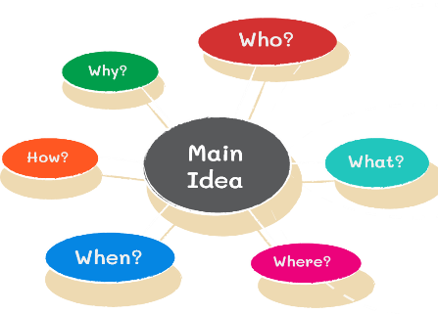
Mind mapping is a visual structuring technique that organises ideas around a central concept using branches and keywords. In modern business environments characterised by rapid change, remote work, and high information volume, mind mapping supports clearer planning, collaborative problem solving, and adaptive decision making. This paper examines how mind mapping enhances strategic development, project coordination, decision analysis, and innovation, and discusses its operational benefits for contemporary organisations.[6]

ABSTRACT
Contemporary organisations face increasing complexity due to digital transformation, remote work, and accelerating decision cycles. Traditional linear documentation often limits holistic understanding of interconnected tasks and organisational goals. Mind mapping provides a non-linear visual structure that mirrors associative thinking, enabling individuals and teams to perceive relationships between ideas more effectively. Recent research highlights the growing role of visualisation tools in managerial communication and collaboration [6]. This paper argues that mind mapping functions as a practical operational tool that improves clarity, flexibility, and collaborative performance in modern business contexts. Furthermore, mind mapping enhances knowledge retention by combining visual cues with concise keywords, making it a valuable tool for training and learning within organisations [7].

APPLICATIONS IN BUSINESS OPERATIONS
In strategic development, mind maps support integrative thinking by visually linking organisational objectives with risks, resources, and performance indicators. This enables decision-makers to detect patterns, opportunities, and misalignments that may be overlooked in text-based plans [6]. Organisations can also use mind maps to explore alternative strategies and assess potential risks before implementing decisions, increasing the likelihood of successful outcomes.
For project coordination, mind maps provide a clear overview of tasks, dependencies, and milestones, supporting accountability and shared understanding among team members. Visual task structuring complements knowledge management practices by making workflows easier to interpret and update in dynamic environments [7]. Companies adopting collaborative mind mapping report improved clarity in distributed teams and faster alignment on project priorities [8]. Mind mapping is also effective in decision analysis and innovation. Visual thinking tools encourage teams to display causes, alternatives, and potential outcomes within a single framework, supporting balanced judgement and creative exploration [9]. The open structure promotes divergent thinking, which is essential for generating innovative solutions in competitive business contexts. Additionally, visualisation can help stakeholders with diverse backgrounds communicate ideas effectively, enhancing inclusivity in decision-making.

OPERATIONAL BENEFITS

Operationally, mind mapping reduces cognitive overload by condensing complex information into structured visual forms. This supports prioritisation, efficient task management, and better time allocation, improving individual productivity. Shared mind maps function as collaborative artefacts, enabling distributed teams to maintain alignment and reduce ambiguity in virtual work settings [9]. Visual knowledge structures also facilitate learning, documentation, and onboarding by presenting procedures in accessible formats that are easier to revise as conditions change [7].
By enabling rapid modification, mind maps enhance organisational adaptability. As strategies or project requirements evolve, teams can update visual plans without reconstructing entire documents, supporting responsiveness in uncertain business environments. Furthermore, mind mapping encourages engagement by allowing all participants to contribute ideas simultaneously, improving team participation and innovation culture.
Mind mapping contributes to improved business operations by enhancing strategic clarity, collaborative coordination, and creative problem-solving. Its visual and flexible structure supports better decision quality and knowledge sharing, particularly in digital and hybrid workplaces. As organisations continue to manage complexity and change mind mapping is likely to remain a valuable operational method for improving planning effectiveness, team alignment, and adaptive organisational performance.[9]

b. Develop a mind map that outlines different types of modern software applications

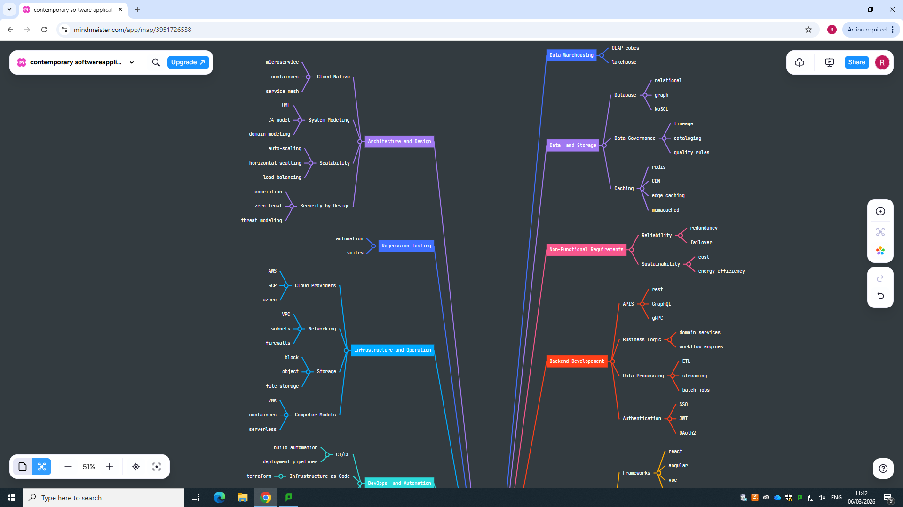

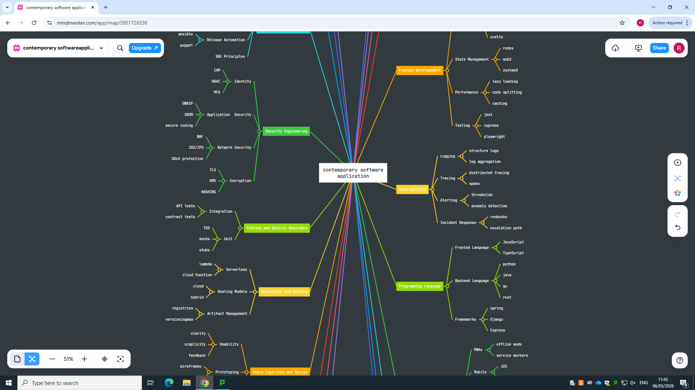

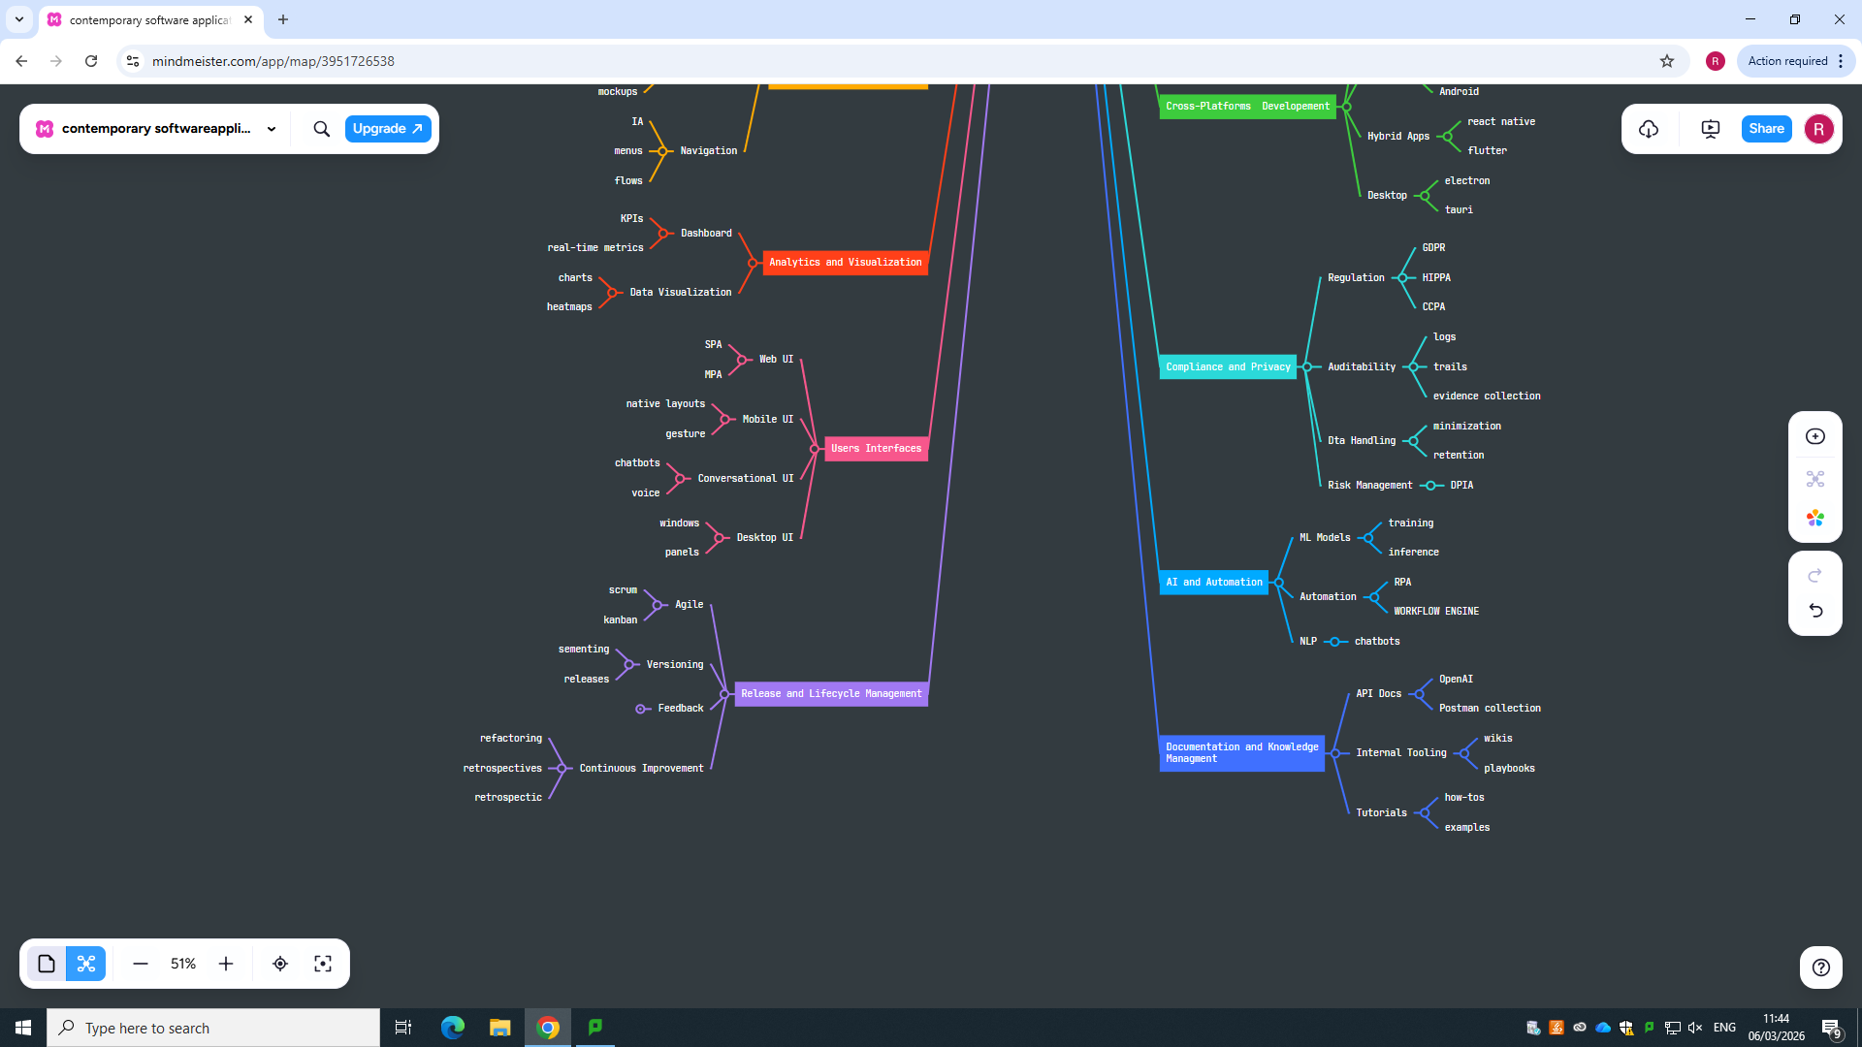

Task 3. Workplace productivity software

Identify four types of office software used to support business activities.

Abstract
Office software applications are essential tools used in modern business operations to create, manage, analyse, and communicate information clearly and efficiently. Among the commonly used office applications include Microsoft Word, Microsoft PowerPoint, Microsoft Excel as well as Microsoft Access. These tools are part of the Microsoft Office suite and are designed to improve productivity, accuracy, and communication within organisations.


MS Word
Microsoft Word has become one of the most influential tools in modern writing, reshaping how people produce and manage text since its introduction in the late twentieth century. By moving away from typewriters and other manual methods, it established a digital environment where documents can be created, edited, stored, and organised with far greater ease. This shift played a major role in the rise of digital literacy and changed communication practices across academic, professional, and business settings. One of the software’s strongest features is the freedom it gives users when drafting and revising text. Unlike traditional writing methods, digital documents can be adjusted, rearranged, or removed instantly without disrupting the rest of the work. Word also includes a wide range of formatting tools such as templates, style sets, and layout controls that help users design clear, polished, and visually structured documents. [10]
The program further improves writing quality through built‑in language tools, including spelling correction, grammar feedback, and vocabulary suggestions. Its collaborative functions, such as comments and track changes, make it possible for several people to review and refine the same document efficiently. Additionally, Word supports the inclusion of multimedia, hyperlinks, and other interactive elements, extending the purpose of documents beyond simple text. Overall, Microsoft Word operates as a versatile digital writing platform that shapes how people organise information, develop ideas, and communicate in contemporary digital environments.[10]

ADVANTAGES OF MS WORD
Microsoft Word provides numerous strengths that have contributed to its position as one of the most used programs for producing written documents. One of its most valuable features is the ease with which text can be altered. Writers can revise, remove, or reorganise material instantly, without having to recreate the document from the beginning. This capability speeds up the writing process and makes it far more efficient. The application also includes integrated language‑support tools such as spelling suggestions, grammar feedback, and a built‑in thesaurus that help users produce clearer and more accurate writing.[10]
Another major benefit is the software’s ability to help users structure their work in an organised and professional manner. Tools such as templates, headings, and style sets make it possible to design documents with a clear layout, which is especially helpful for academic assignments, business reports, and formal written tasks. Word also allows the insertion of tables, images, hyperlinks, and other visual elements, which enhances both the presentation and the functionality of a document.[10]
In addition, the program plays an important role in strengthening digital literacy by helping users develop essential computer‑based writing skills. Its collaborative features such as comments and tracked changes make it easier for several people to review, edit, and refine the same document. Altogether, Microsoft Word increases productivity, supports effective communication, and enables efficient management of documents in both educational and professional environments.[10]
LIMITATION OF MS WORD
Although Microsoft Word offers many strengths, it also has several drawbacks. One common concern is that users may rely too heavily on automated features like grammar and spelling suggestions, which can weaken their ability to recognise mistakes on their own. The convenience of constant editing can also encourage writers to begin drafting without sufficient planning, sometimes resulting in documents that lack clear organisation.[10]
Another challenge is that some of Word’s more advanced tools can be confusing for new or inexperienced users. Formatting problems may also arise, particularly when a file is opened on different devices or in other versions of the program, which can alter the layout unexpectedly. In addition, using Microsoft Word requires access to a computer and a valid software licence, which may not be available to everyone. These limitations can reduce the program’s usefulness for certain groups of users.[10]


MS PowerPoint
Microsoft PowerPoint is widely recognised as an accessible and versatile presentation tool that plays a significant role in contemporary teaching and learning environments. Its intuitive interface enables educators to design instructional materials that are visually rich, interactive, and pedagogically purposeful. One of its key strengths lies in its flexibility slides can be created, stored, adapted, and reused across multiple lessons, making it a practical resource for teachers working across different subjects and devices. Because presentations can be easily shared and accessed on various digital platforms, PowerPoint supports both classroom-based and remote learning contexts.[11]
In educational settings, PowerPoint contributes meaningfully to technology enhanced pedagogy. This is particularly evident in subjects such as History, where visual representation, chronological sequencing, and multimedia integration can significantly enrich the learning experience. Teachers often rely on PowerPoint to organise content in a structured and coherent manner, allowing them to present information step-by-step while incorporating text, images, audio, animations, and video. These features help create a more dynamic learning environment, enabling educators to capture students’ attention and maintain engagement throughout the lesson.[11]
The literature highlights several notable benefits associated with the use of PowerPoint in teaching. First, the software has been shown to enhance student engagement. Lessons supported by visually appealing slides tend to be more stimulating, encouraging learners to participate actively. When presentations include interactive elements such as embedded questions, hyperlinks, or multimedia students often demonstrate higher levels of interest and involvement.
Second, research suggests that PowerPoint can contribute to improved learning performance. Studies referenced in the source material indicate that students may achieve better academic outcomes when PowerPoint is used effectively. The software appears to support comprehension by presenting information in a clear, organised, and multimodal format. Furthermore, when students themselves are involved in creating or presenting slides, their understanding of subject content may deepen, as the process requires them to analyse, summarise, and communicate key ideas.[11]
Another important advantage is PowerPoint’s ability to support diverse learners. The tool can be particularly beneficial for students with physical disabilities or learning difficulties, as it allows them to engage with content at their own pace. Features such as visual cues, simplified text, and multimedia explanations can reduce the need for constant teacher intervention, promoting greater independence and accessibility.[11]
From a practical standpoint, PowerPoint also helps teachers save time. The software requires only basic digital skills, yet once a presentation is created, it can be reused or adapted with minimal effort. This efficiency makes it a valuable resource for educators managing heavy workloads or teaching multiple classes.
However, the effectiveness of PowerPoint is not universally agreed upon. While some studies report positive outcomes, others find little or no improvement in student performance. Poorly designed slides such as those overloaded with text or lacking visual clarity may fail to support learning and can even be less effective than traditional teaching methods. This inconsistency highlights a crucial point: PowerPoint is not inherently effective. Its impact depends largely on the quality of instructional design, the teaching strategies employed, and the extent to which students are encouraged to interact with the material.[11]


MS Excel
Microsoft Excel is described in the document as a highly utilised digital application that plays an important role in managing organisational data and supporting analytical tasks. Its widespread use is largely due to its ease of access and the familiarity that many employees have gained from using it over time. The study explains that Excel is commonly employed to assist decision-making processes by allowing users to organise, process, and interpret data effectively. It is especially useful for producing structured outputs such as tables, graphs, and summaries, which help managers identify patterns and assess organisational performance.
The document further outlines Excel’s contribution to business intelligence functions. Using advanced formulas, built-in features, and adaptable reporting tools, users can convert raw data into useful insights. These features enable the creation of analytical reports that support informed decision-making. Because Excel is flexible and can be adapted to different requirements, it is often used to design basic analytical models or dashboards for ongoing monitoring and evaluation activities.[13]
In addition to its analytical capabilities, Excel is also considered valuable for organising and transferring data. The study provides examples where Excel templates were used to structure information during system transitions or in situations where integrated databases were unavailable. This highlights Excel’s role as a temporary solution that helps maintain consistency and organisation in data management processes.
Despite these advantages, the document points out several drawbacks. A strong dependence on manual data entry can increase the likelihood of errors, and storing information across multiple spreadsheets may lead to fragmentation and difficulties in tracking data. Furthermore, the lack of real-time updates and the need to share files manually can cause delays and inconsistencies. The study also notes that many employees rely on Excel due to limited training in more advanced technologies, which may restrict the organisation’s ability to adopt more efficient systems. Overall, while Excel remains a useful tool, its effectiveness relies on proper training, well-structured processes, and its integration with other digital solutions.[14]


MS Access
Microsoft Access is a database application created by Microsoft that provides users with a practical way to store, organise, and manage information. As part of the Microsoft Office suite, it is widely used in educational institutions, small organisations, and various professional settings where structured data needs to be handled efficiently. Although it functions as a database tool, MS Access also incorporates features for analysing information, generating reports, and developing simple applications, making it more versatile than a basic data storage system.
At the core of MS Access are tables, which hold data in a structured format consisting of rows and columns. These tables can be linked through defined relationships, allowing users to manage connected information across different categories without unnecessary repetition. This relational structure supports accuracy and consistency within the database. Importantly, MS Access is designed to be accessible to individuals with limited technical knowledge, which makes it suitable for learners and users who are still developing their digital skills.[13]
One of the most significant functions of MS Access is its ability to perform data retrieval and manipulation through issues. Issues enable users to find, refresh, solve, and analyse information include on exact rules. This makes it easier to extract relevant insights from large collections of data. In addition to queries, the software includes forms, which act as user-friendly interfaces for entering and editing information, and reports, which allow data to be presented in a clear, organised, and printable layout. These features enhance the usability of the system and support a wide range of everyday data tasks.
MS Access also plays an important role in education, as it helps students develop essential digital, analytical, and organisational skills. By working with tables, queries, forms, and reports, learners gain a practical understanding of how information systems operate. These activities encourage critical thinking and problem-solving, as students must decide how to structure data, how to extract meaningful results, and how to present information effectively. Research suggests that using tools like MS Access supports the development of competencies related to data management, information processing, and the effective use of digital technologies.[13]
Another valuable aspect of MS Access is its capacity to support small-scale application development. Users can build simple, customised database applications without needing advanced programming knowledge. Built-in templates, macros, and design tools allow individuals and small organisations to create systems for tasks such as record keeping, inventory tracking, or customer management. This makes MS Access a practical solution for environments that require tailored data-handling tools but do not have the resources for complex software development.
Despite its strengths, MS Access does have limitations. It is primarily intended for single users or small groups, and it may not perform well when dealing with very large datasets or enterprise-level operations. Performance issues can arise when the database grows too large or when many users attempt to access it simultaneously. Nevertheless, for many educational and small business purposes, MS Access remains a reliable and efficient option.
In summary, Microsoft Access is a multifunctional application that extends beyond basic data storage. It offers an integrated platform for organising, analysing, and presenting information while supporting both learning and practical work. Its combination of accessibility and functionality makes it a valuable tool in academic, professional, and small organisational contexts.[13]

(b) A practical demonstration of two features commonly used in office software.”

Mail Merge
Step 1: Preparing the Main Document in Microsoft Word
For initiate to mail merge, I first got into Microsoft Word so that I can create a blank page. I drafted to core content of the letter, ensuring that only the generic text was included at this stage. Personalised information such as names, addresses, and greetings was intentionally omitted. This document functions as the primary template from which all individualised letters are generated. Establishing a clear and well-structured template is essential, as it ensures consistency across all merged outputs.
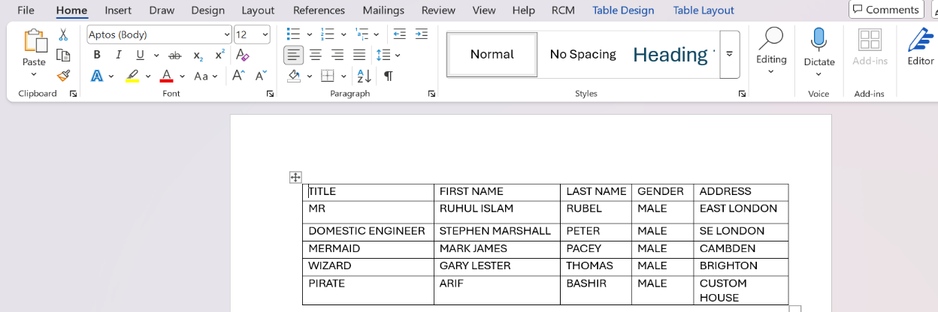

Step 2: Accessing the Mailings Tab
Once the template was prepared, I navigate the Mailings from the top. This section consolidates every mail merge feature, providing a structured workflow for managing data sources, inserting merge fields, previewing results, and finalising the merge. Accessing this tab is a crucial step because it transitions the document from a standard Word file into a dynamic, data driven template.

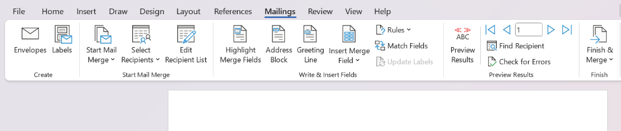
Step 3: Initiating the Mail Merge
I then selected Start Mail Merge and chose Letters as the document type. This action formally defines the nature of the output Word will produce. By selecting “Letters,” I instructed Word to generate multiple personalised letters, each based on the template I created. This step establishes the structural framework for the merge and ensures that the final output aligns with the intended communication format.
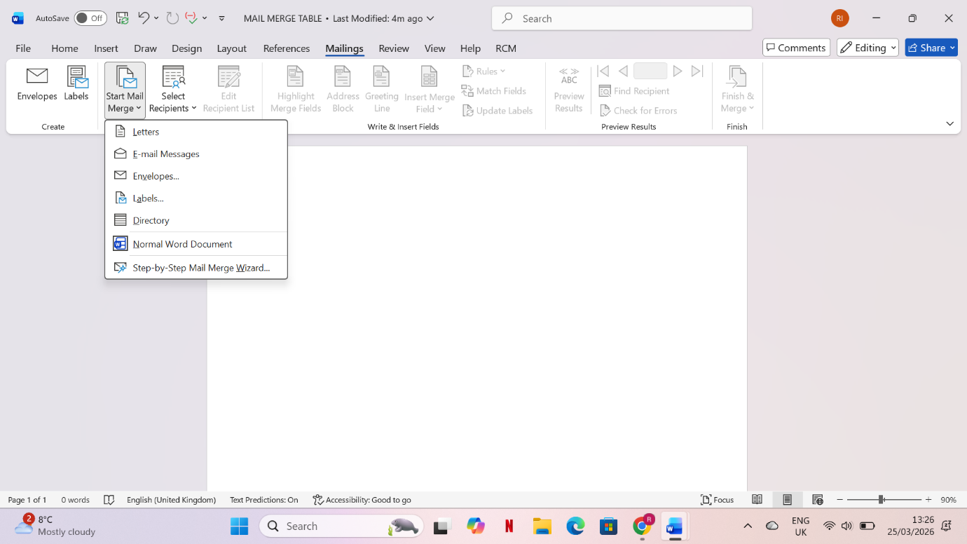
Step 4: Connecting to the Recipient Data Source
The next stage involved linking the Word document to an external data source. I selected Select Recipients → Use an Existing List, then located and opened my dataset. After choosing the appropriate sheet or table, Word displayed the recipient list for verification. This connection is fundamental to the mail merge process, as it enables Word to draw personalised information from the dataset and integrate it into the template. Ensuring the accuracy and structure of the data source is vital for preventing errors during the merge.
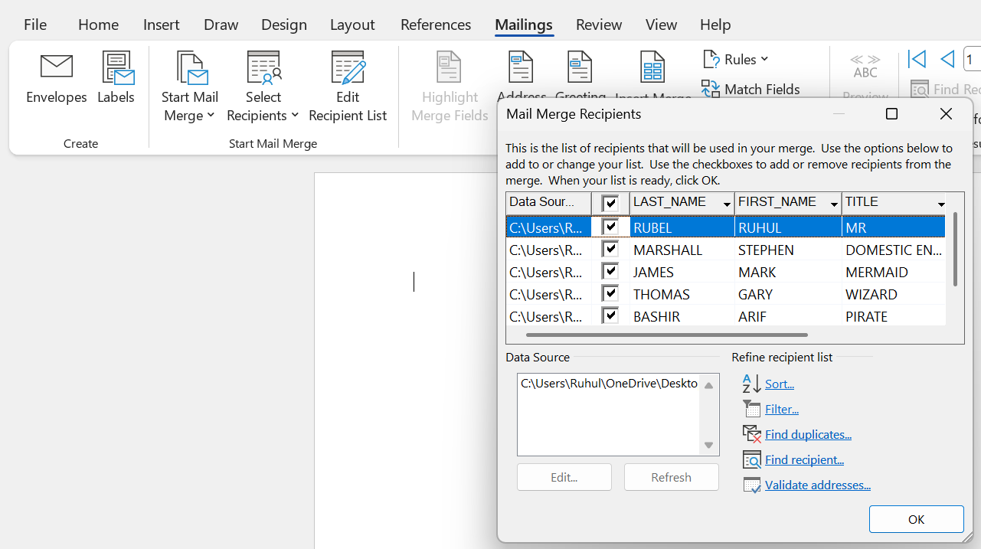
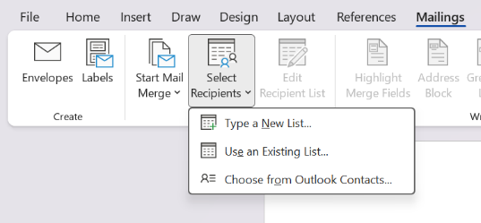

Step 5: Inserting Merge Fields into the Document
With the data source successfully connected, I proceeded to insert merge fields into the template. By positioning the cursor at the required locations and selecting Insert Merge Field, I added placeholders such as «FirstName», «LastName», «Address», and «City». These fields act as dynamic variables that Word replaces with actual data during the merge. This step is critical because it determines how personalised information will appear in each final document. Careful placement of merge fields ensures clarity, accuracy, and professional presentation.
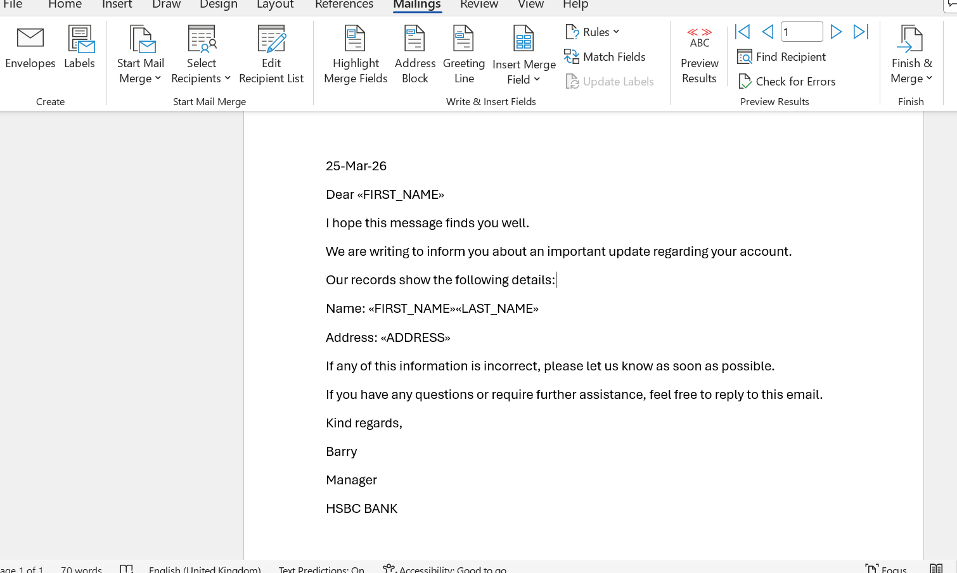

Step 6: Previewing the Merged Output
Before completing the merge, I used the Preview Results function to review how the personalised letters would appear. This feature allowed me to cycle through individual records and confirm that the correct data was being inserted into the appropriate fields. Previewing is an essential quality assurance step, as it helps identify formatting issues, missing data, or inconsistencies before generating the final documents.
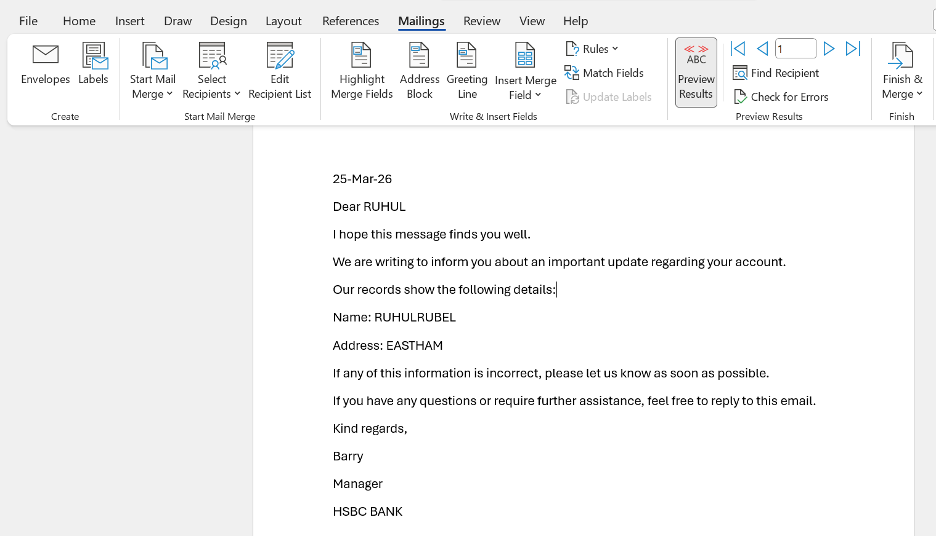
Step 7: Completing the Mail Merge
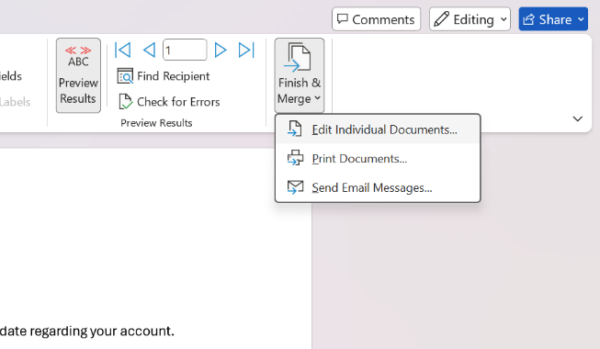
merge transforms the template and data source into a set of fully customised document to finalise the process, I selected Finish & Merge and chose Edit Individual Documents. This option generated a new Word file containing all personalised letters, allowing me to review, save, or print them as required. Completing the ents, demonstrating the efficiency and accuracy of Word’s mail merge functionality.

So final example or output of my mail merge below:
1.
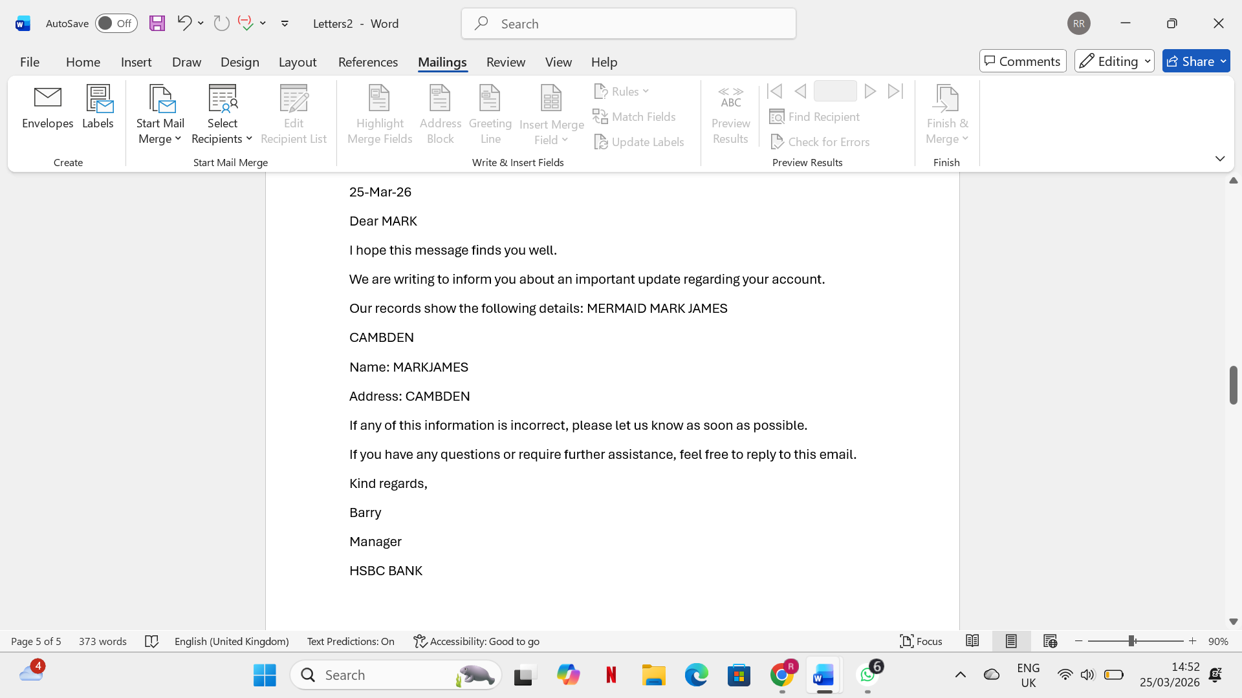
2.
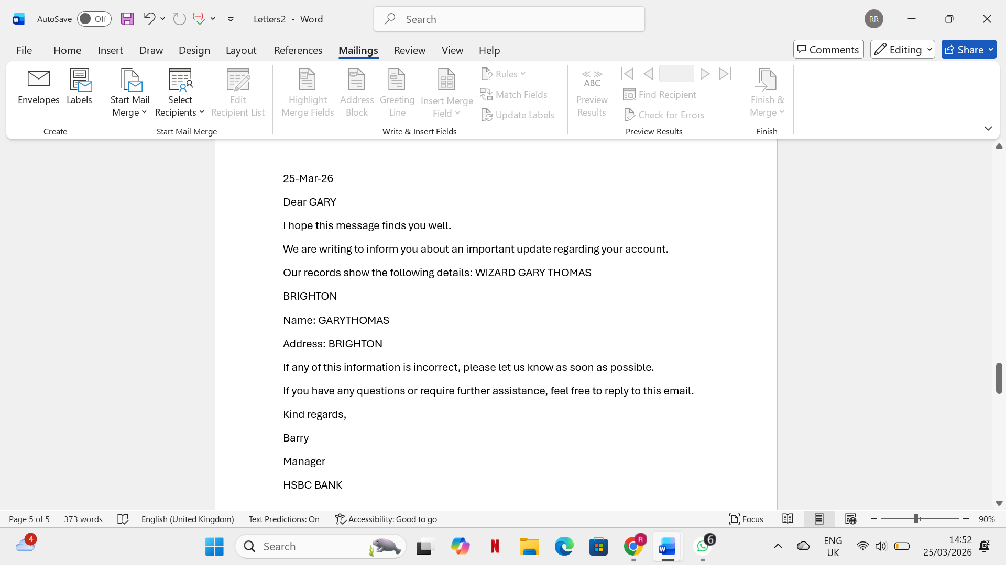

Through this process, I demonstrated the ability to use Microsoft Word’s mail merge feature to automate the creation of personalised documents. Each step from preparing the template to inserting merge fields and generating the final output required careful attention to detail and an understanding of how Word integrates external data sources. This task highlights the importance of digital literacy in producing efficient, accurate, and professional communication materials.

If Statement
STEP 1: CREATING THE DATA
I started by entering all the student information into Excel. This included their name, title, gender, class mark, exam mark, and total mark. Creating a structured dataset is important because Excel uses these values to calculate results and apply formulas correctly.
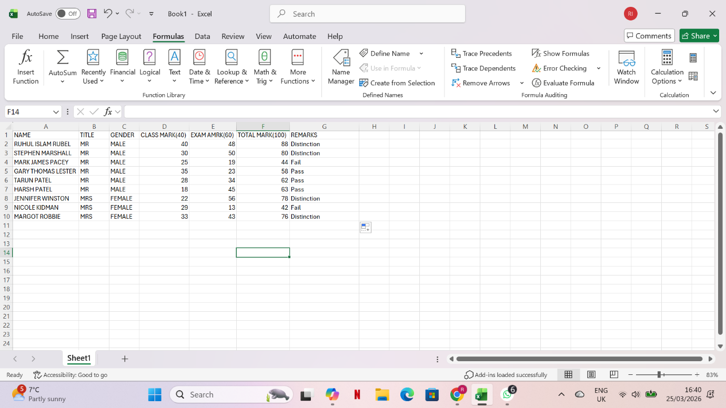

STEP 2: Adding the Number
I typed the Class Mark and Exam Mark for each student. These two numbers are needed to calculate the Total Mark. Excel uses these values to perform calculations. Without accurate numbers, the total and the final remarks would be incorrect.
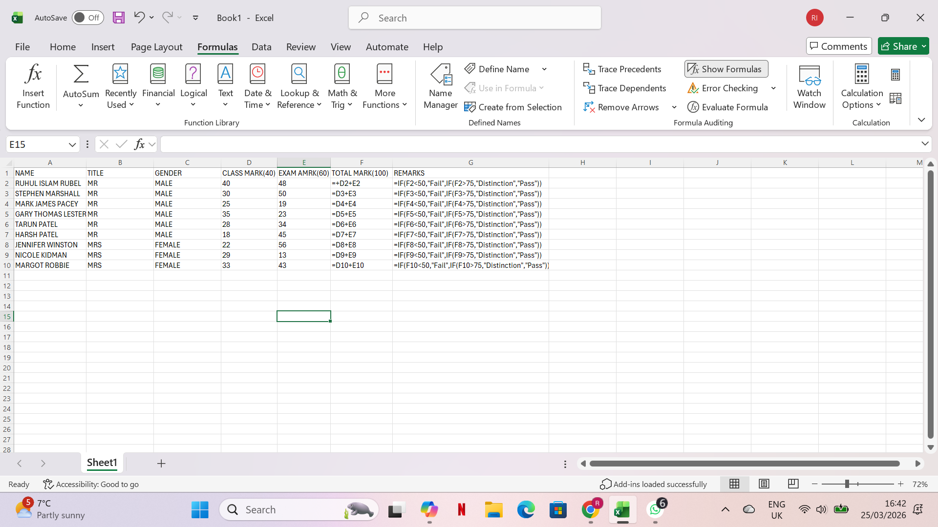

STEP 3: Getting the Total Marks
I added the Class Mark and Exam Mark together to get the Total Mark for each student.
For example:
= C3 + D3
The Total Mark is the value used to decide whether a student gets Fail, Pass, or Distinction.

STEP 4: Creating the IF Formula
In the Remarks column, I entered this formula:
=IF (F3<50,"Fail”, IF(F3>75,"Distinction","Pass")).
This formula automatically checks each student’s Total Mark and gives the correct remark,
- Less than 50 → Fail
- Greater than 75 → Distinction
- Anything in between → Pass
After entering the formula once, I dragged it down to apply it to all students
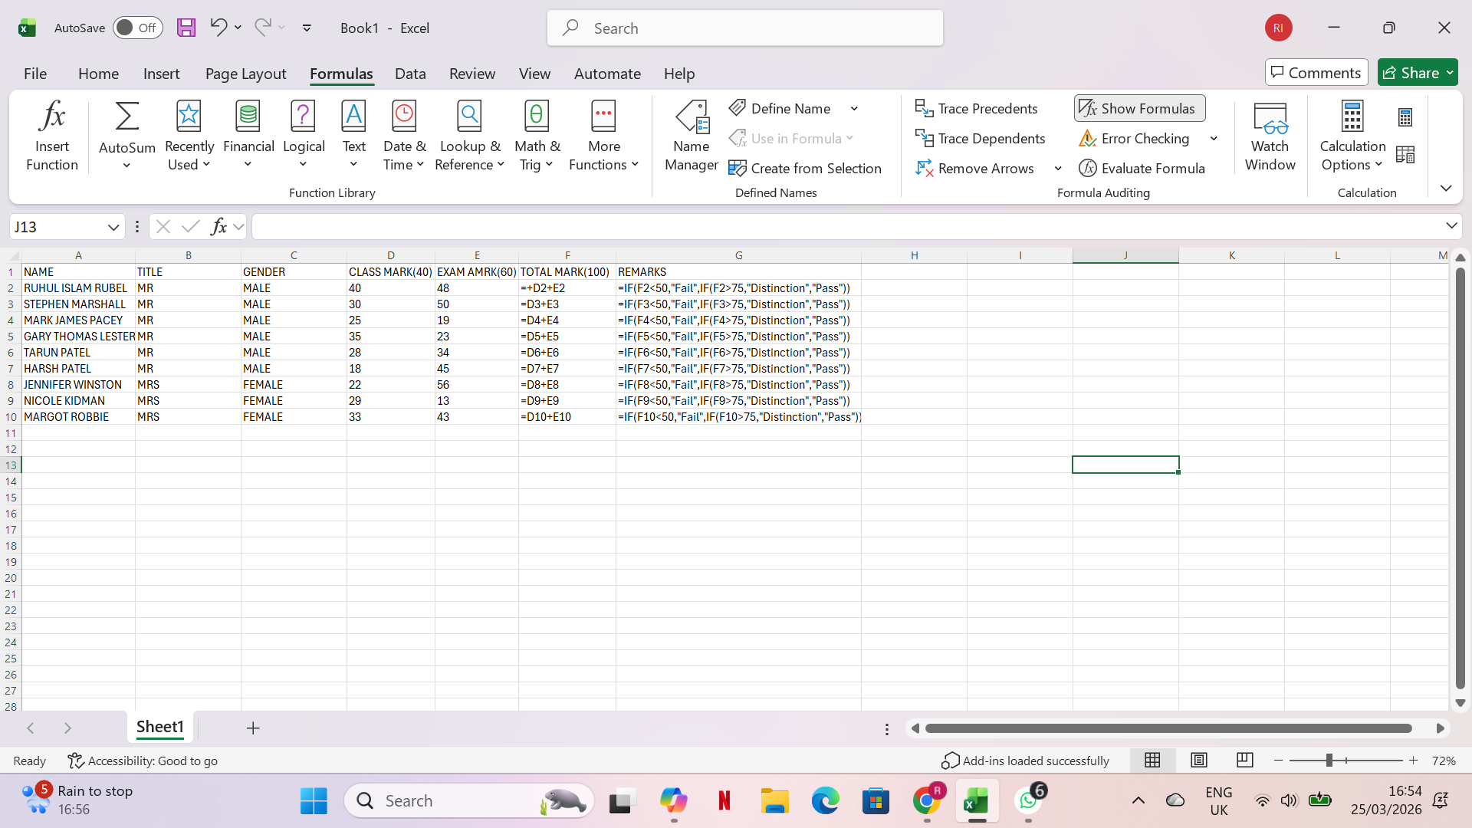

Step 5: Getting final output

Finally in my system I got my prefer result which shows that which student has got distinction and which student passed and whose are failed. So the final output is in screenshot below.

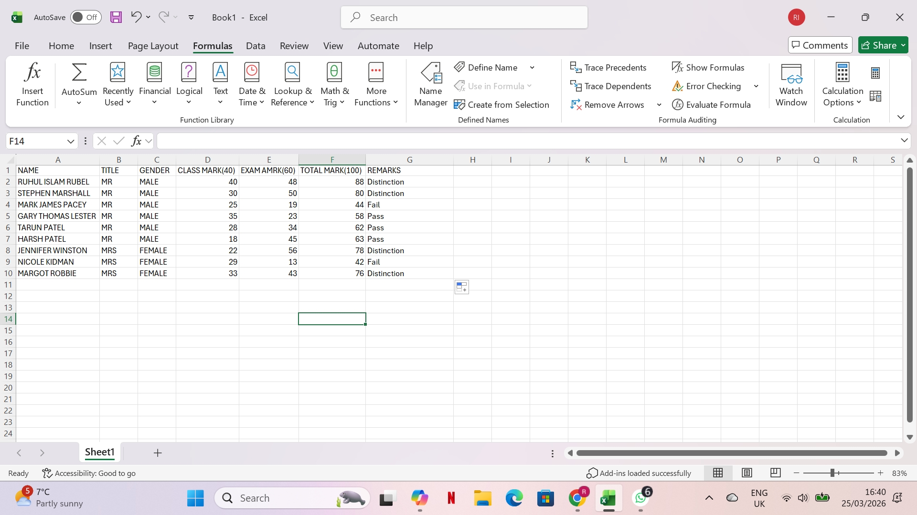

Task-4 (a) Provide one modern communication tool and one online collaboration application

Communication Application

GMAIL
Gmail is one of the most widely adopted email platforms in the modern digital environment, offering a reliable and efficient method for professional and personal communication. Developed by Google, it has become a core tool in business operations due to its accessibility, integration with cloud services, and strong security features. Gmail can be accessed through web browsers, mobile applications, and desktop clients, making it suitable for users working across different devices and locations.[15]
A key strength of Gmail is its clean and user-friendly interface, which is designed to help users manage high volumes of communication with minimal effort. Emails are automatically sorted into categories such as Primary, Social, and Promotions, reducing inbox clutter and ensuring that important messages remain visible. This automated organisation is particularly beneficial in business environments where employees receive frequent notifications, newsletters, and system updates. Gmail also uses threaded conversations, grouping related messages into a single chain. This feature helps users follow discussions more easily and reduces the likelihood of missing important replies.
Another major advantage of Gmail is its advanced search functionality. Google’s powerful search algorithms allow users to locate emails using keywords, sender names, file types, or date ranges. This capability is essential in workplaces where staff often need to retrieve past communication for auditing, reporting, or decision-making. Combined with generous cloud storage, Gmail enables users to maintain extensive email archives without worrying about storage limitations.[15]
Gmail also supports efficient file sharing. Users can attach documents, images, and other files directly to emails. When larger files need to be shared, Gmail integrates seamlessly with Google Drive, allowing users to send links instead of attachments. This not only saves storage space but also supports collaborative editing and version control, which are essential for teamwork and project management. Real-time notifications ensure that users are immediately informed of new messages, supporting timely communication.
Security is a central component of Gmail’s design. The platform includes advanced spam filtering, phishing detection, and two-factor authentication to protect sensitive information. These features help organisations safeguard confidential data and reduce the risk of cyber-attacks. Google’s continuous updates and machine-learning-based threat detection further strengthen Gmail’s security framework, making it a trusted communication tool for businesses of all sizes.
Overall, Gmail is an essential communication tool that enhances workplace productivity through its organised interface, advanced search capabilities, secure environment, and seamless integration with Google Workspace. Its combination of usability, reliability, and strong security makes it indispensable in modern business communication.[15]

Collaboration Application:

Google Meet
Google Meet is a cloud-based video conferencing platform designed to support real-time collaboration among individuals and teams. As remote and hybrid working models become increasingly common, tools like Google Meet have become essential for maintaining communication, teamwork, and productivity across geographically dispersed environments. The platform enables users to conduct virtual meetings, presentations, and group discussions with ease, making it an asset for modern organisations.
One of Google Meet’s most notable strengths is its high-quality video and audio performance. The platform supports large meetings and provides stable connectivity, allowing participants from different locations to communicate effectively. Joining a meeting is straightforward users simply click a link or join through Google Calendar, eliminating the need for complex setup procedures. This ease of access makes Google Meet suitable for both planned meetings and spontaneous discussions.[16]
Screen sharing is a central feature that enhances collaboration. Presenters can share documents, slides, or applications directly with participants, making the platform ideal for training sessions, project updates, and collaborative problem-solving. Google Meet also offers real-time captions, which improve accessibility and ensure that discussions remain clear for all participants, including those with hearing impairments or language barriers.
Integration with Google Workspace significantly enhances the user experience. Meetings can be scheduled directly through Google Calendar or Gmail, and invitations can be sent automatically to participants. This integration streamlines workflows, reduces administrative effort, and ensures that meeting details are synchronised across devices. Features such as meeting reminders, calendar notifications, and automatic link generation further support efficient collaboration.[16]
Security and privacy are central to Google Meet’s design. Meetings are encrypted, and hosts have control over participant access. Features such as waiting rooms, host controls, and participant management tools help maintain a secure and organised meeting environment. These security measures are essential for businesses that handle confidential information or conduct sensitive discussions online.
Google Meet also includes interactive features that support engagement and teamwork. Participants can use the chat function to share links or ask questions, while reactions and hand-raising tools help manage discussions in larger meetings. Breakout rooms allow teams to split into smaller groups for focused collaboration, making the platform suitable for workshops, training sessions, and educational activities.
Finally, Google Meet is a powerful collaboration tool that supports real-time communication and teamwork. Its ease of access, integration with Google Workspace, and strong security features make it well-suited for modern business operations. As organisations continue to adopt flexible working models, tools like Google Meet play a crucial role in maintaining productivity and supporting effective collaboration.[16]

b. Describe one feature from a free communication tool and one feature from an online collaboration application

GMAIL
Step 1: Accessing Gmail
To begin the demonstration, I opened Google Chrome and typed “Gmail” into the search bar. I clicked the official Gmail link, which directed me to my inbox since I was already signed in. The interface displayed my email list in the centre and navigation options on the left. This step shows how easily Gmail can be accessed from any device with an internet connection.
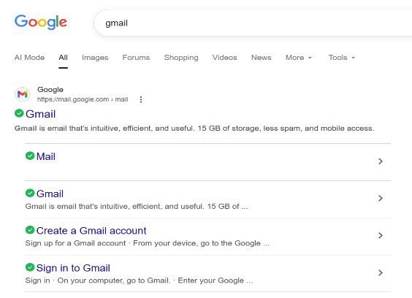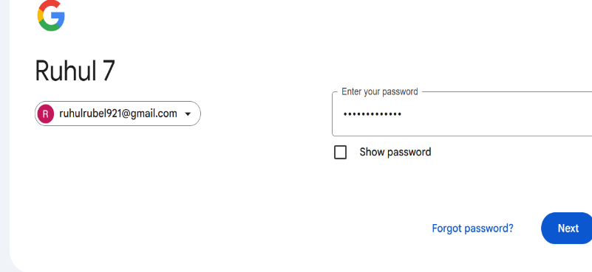
Step 2: Exploring Inbox Categories
Once inside Gmail, I examined the inbox categories: Primary, Social, and Promotions. I clicked each tab to observe how Gmail automatically sorts emails based on their content. This feature helps maintain an organised inbox and ensures important messages remain visible.
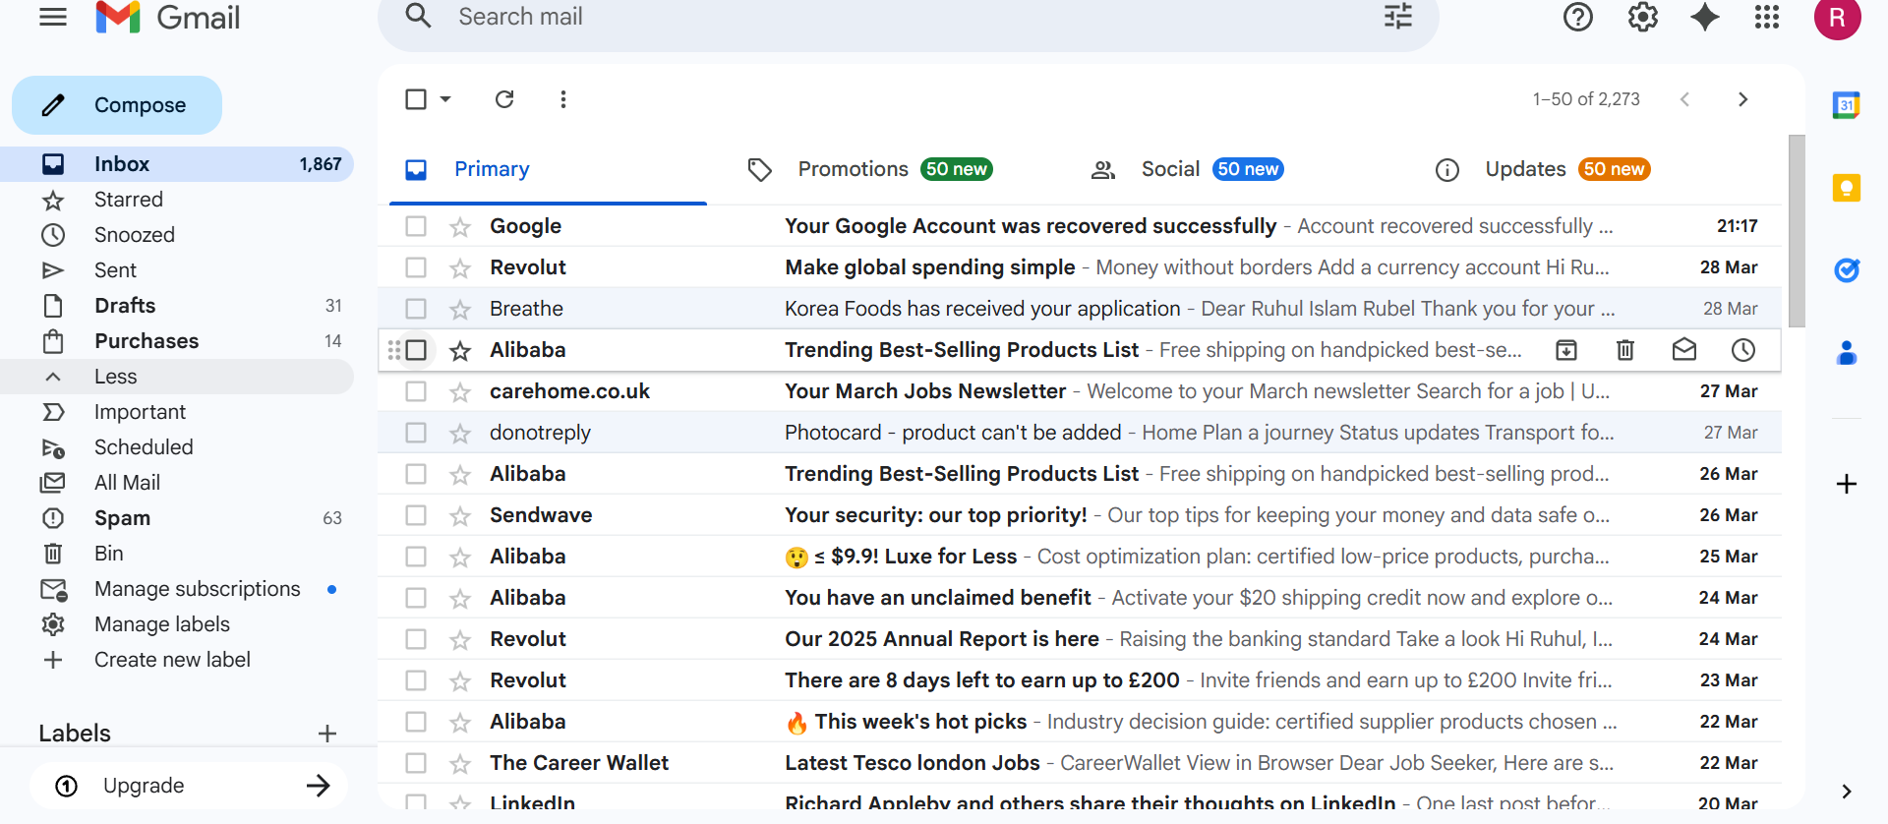

Step 3: Composing a New Email
Next, I clicked the “Compose” button on the left side of the screen. A small compose window appeared at the bottom-right corner. This is where I entered the recipient’s email address, added a subject line, and prepared to write my message. The layout is simple and intuitive, making it easy to start a new email quickly.

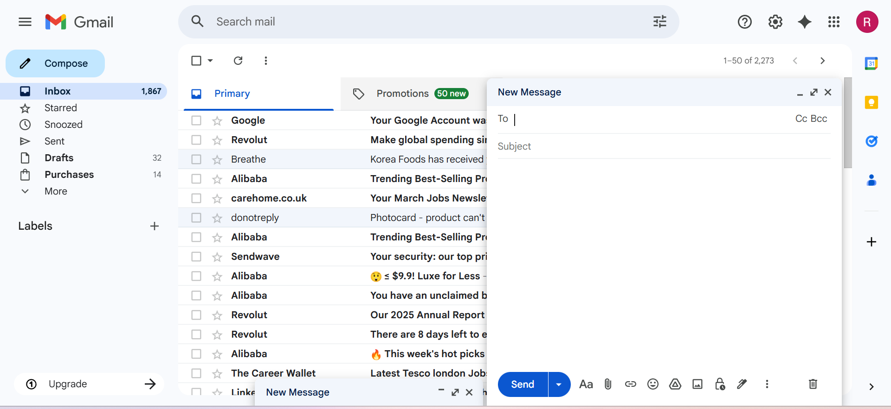
Step 4: Writing and Formatting the Email
I typed my message in the main text area and used formatting tools such as bold text and bullet points to structure the content clearly. Gmail’s formatting toolbar allowed me to present information professionally, which is essential in business communication.
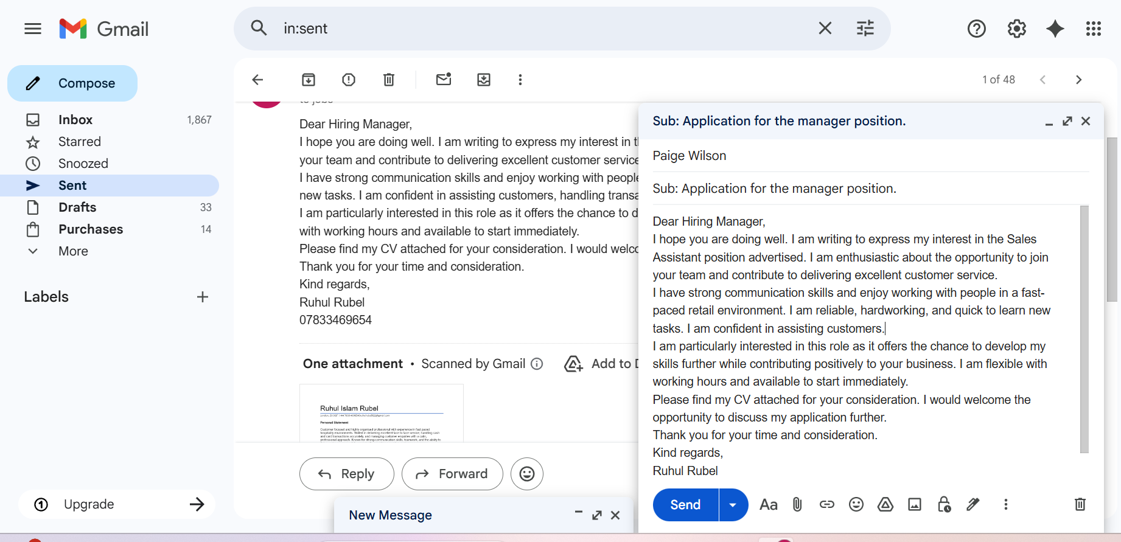
Step 5: Attaching Files
To demonstrate Gmail’s file-sharing capability, I clicked the paperclip icon to attach a PDF from my computer. I also used the Google Drive icon to insert a shared document. Both attachments appeared below the subject line, showing how Gmail supports multiple file types and cloud-based sharing. After reviewing the message and attachments, I clicked the blue “Send” button. A confirmation message appeared in the bottom-left corner saying, “Message sent”, indicating that the email was successfully delivered.

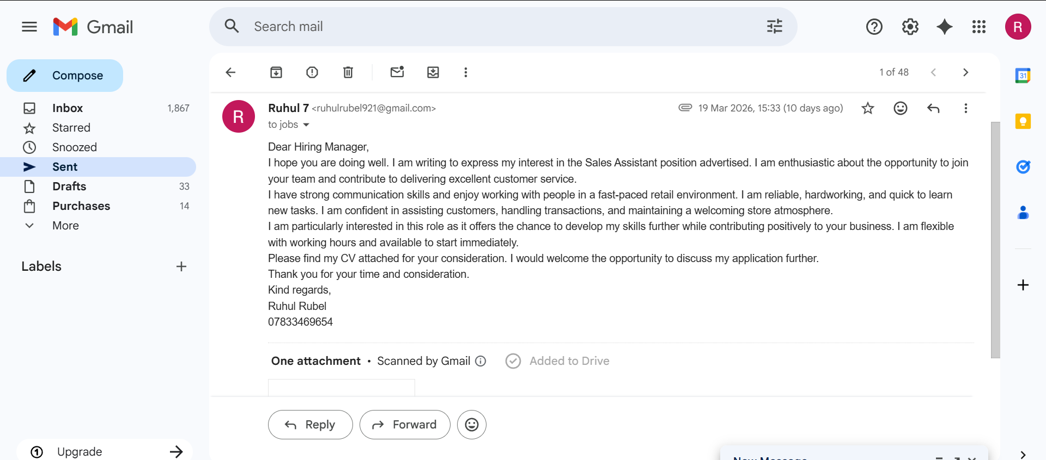
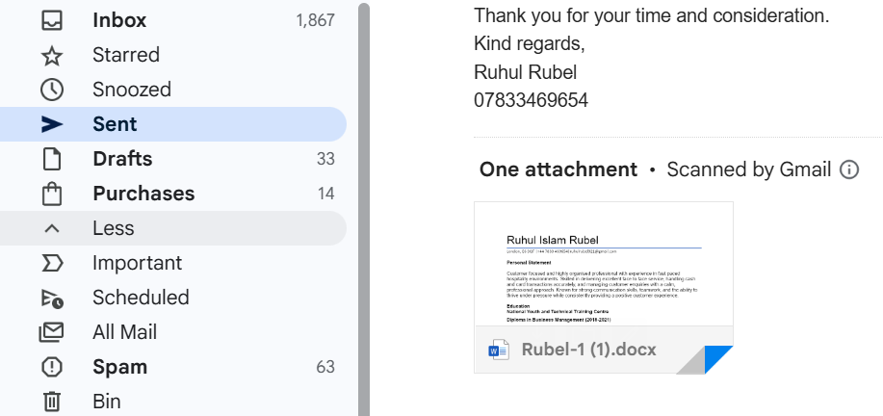
Step 7: Viewing the Conversation Thread
When the recipient replied, I opened the email and saw the entire conversation displayed in a single thread. This feature keeps all related messages together, making it easier to follow discussions and maintain communication history.
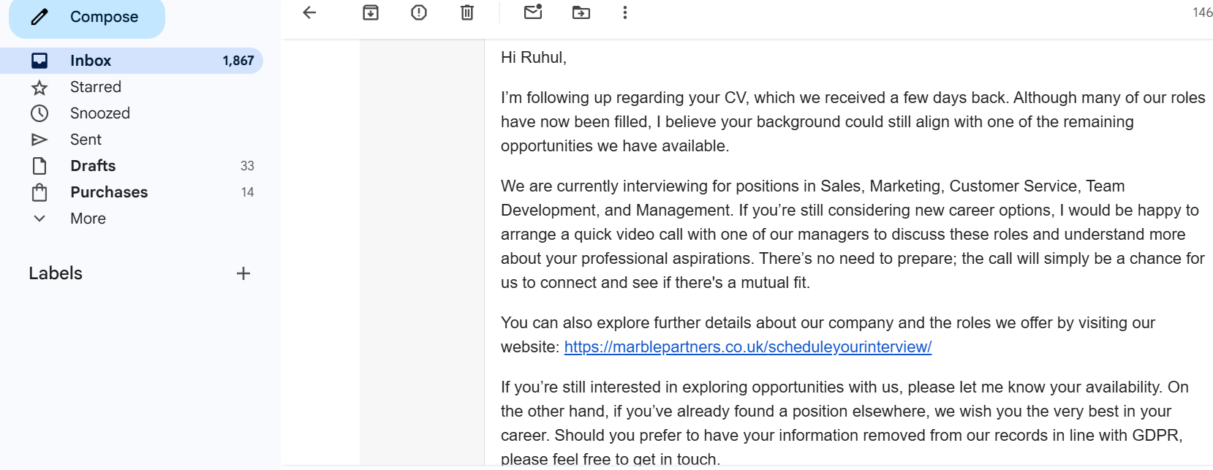

GOOGLE MEET
Step 1: Opening Google Meet
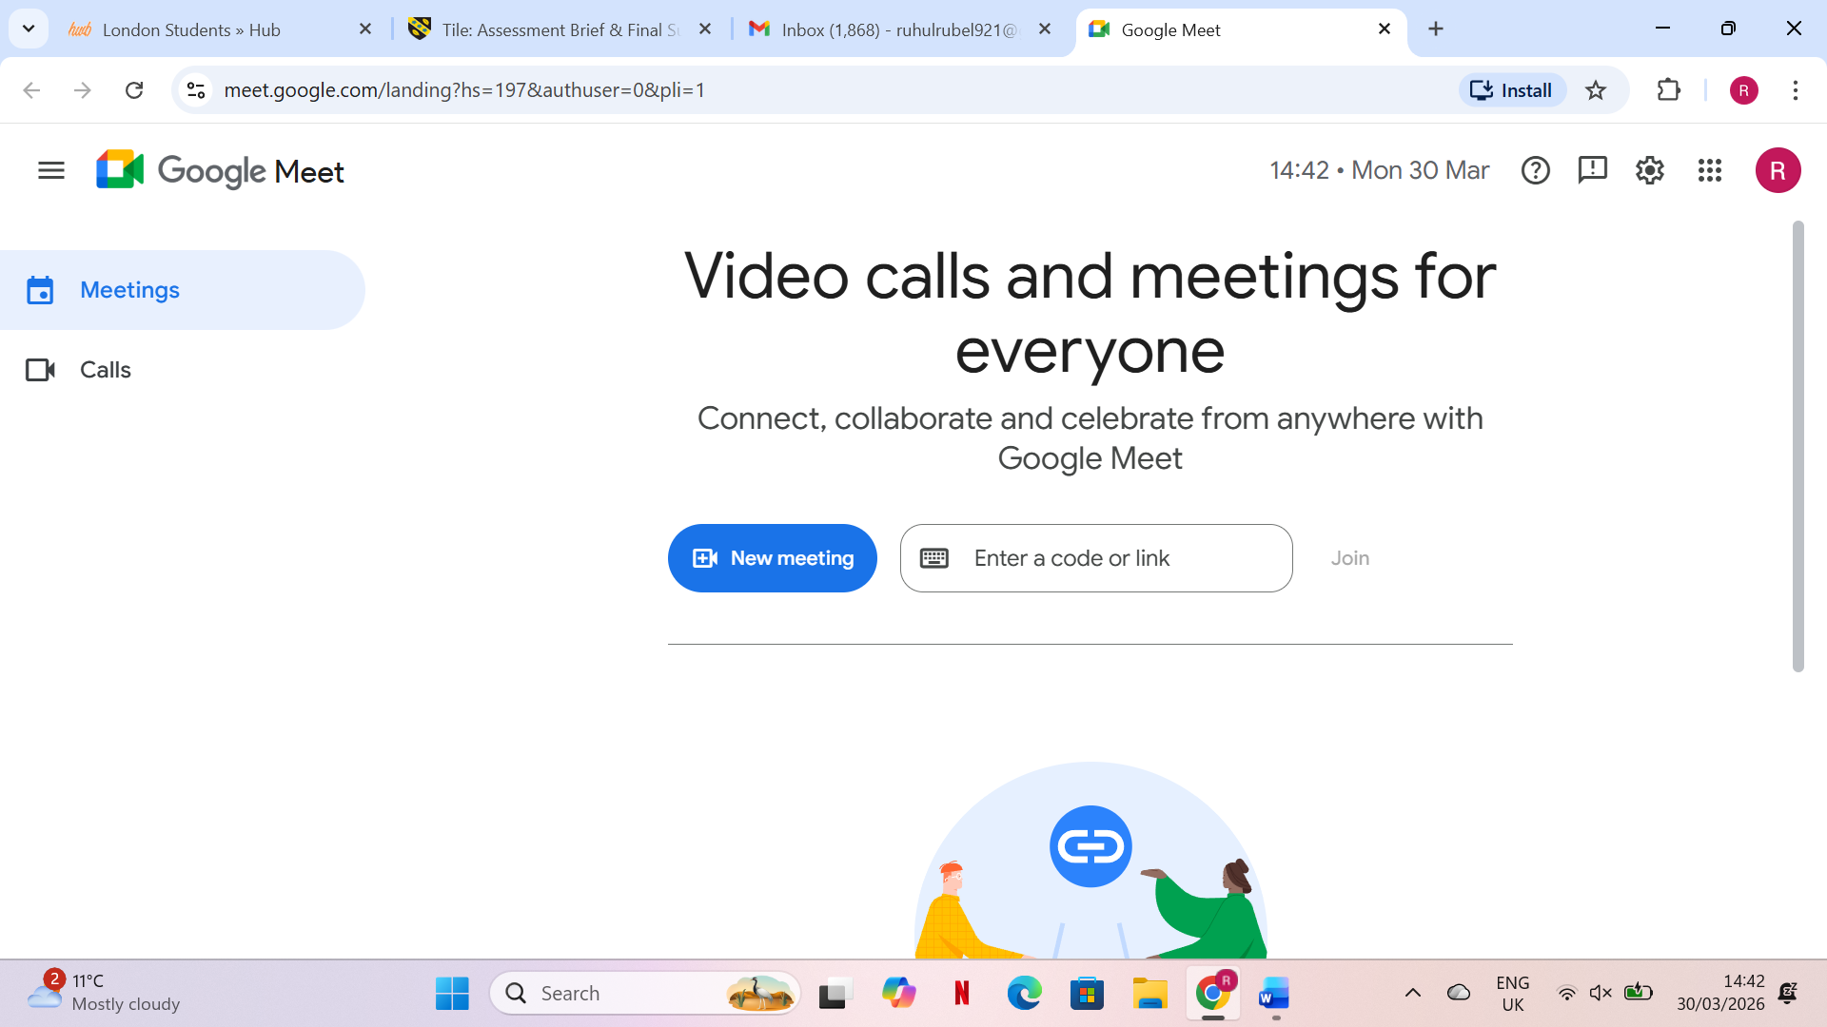
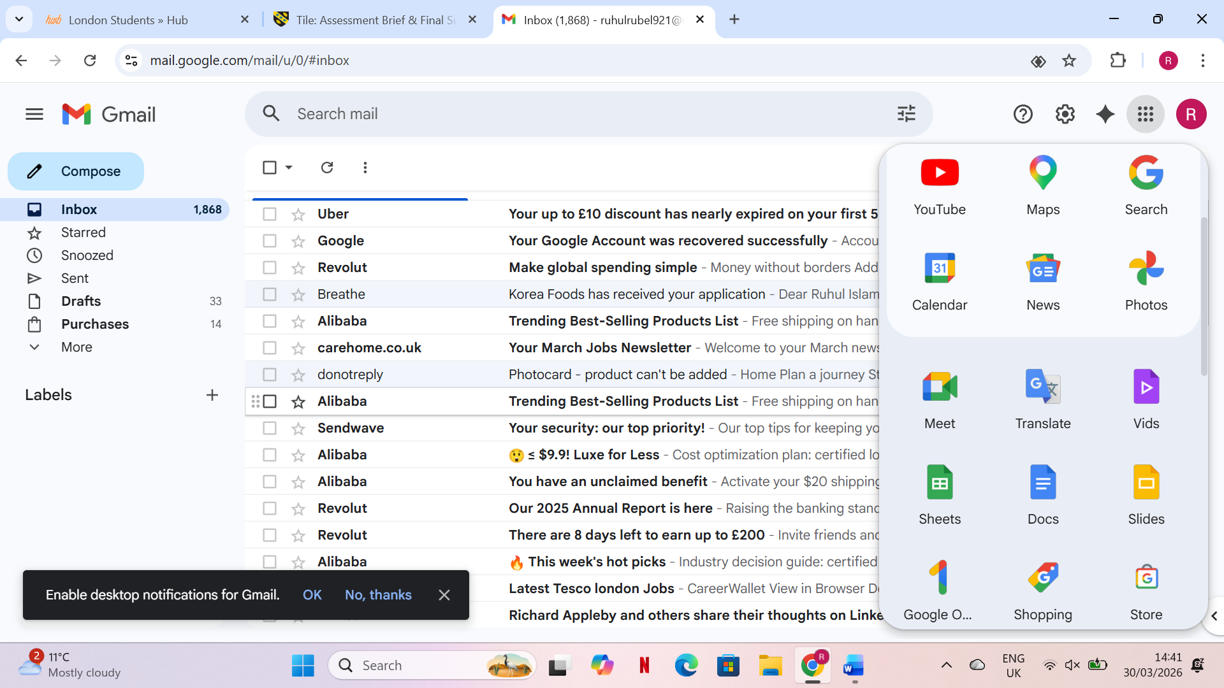
To begin the collaboration demonstration, I opened Google Chrome and searched for Google Meet. I clicked the official link, which took me to the Meet homepage. The interface displayed options to start a new meeting or join one using a code.

Step 2: Starting an Instant Meeting
I clicked New meeting and selected Start an instant meeting. A meeting window opened, showing my camera preview and the control bar at the bottom. This step demonstrates how quickly a meeting can be launched without scheduling.
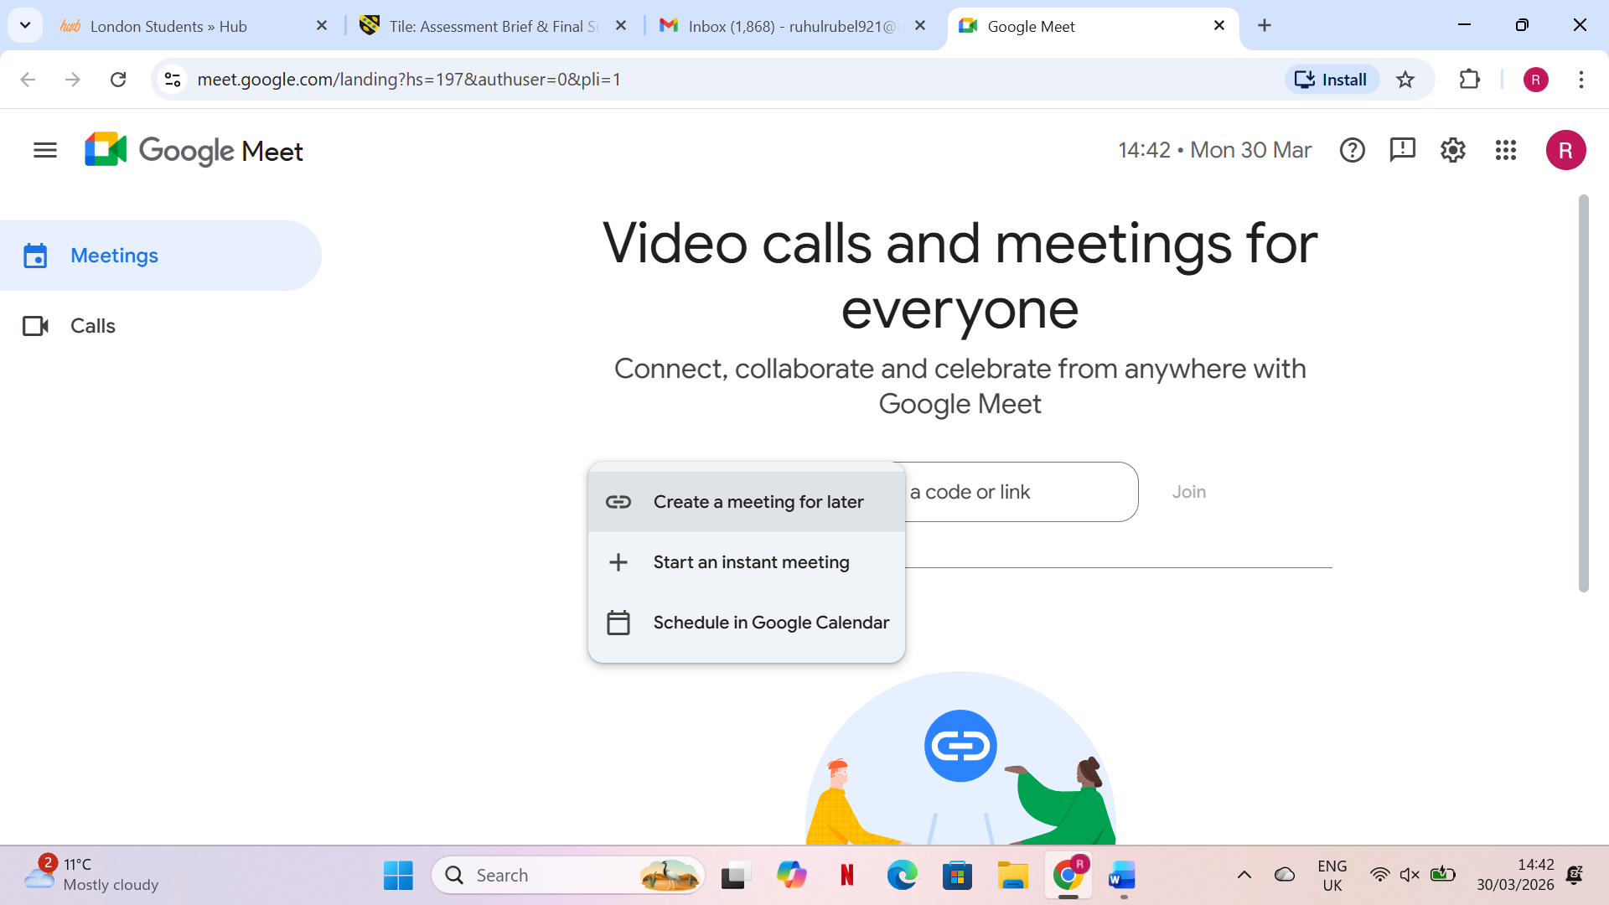
Step 3: Allowing Camera and Microphone Access
A pop-up appeared asking for permission to use my camera and microphone. I clicked Allow, enabling full participation in the meeting. This step is essential for video and audio communication.
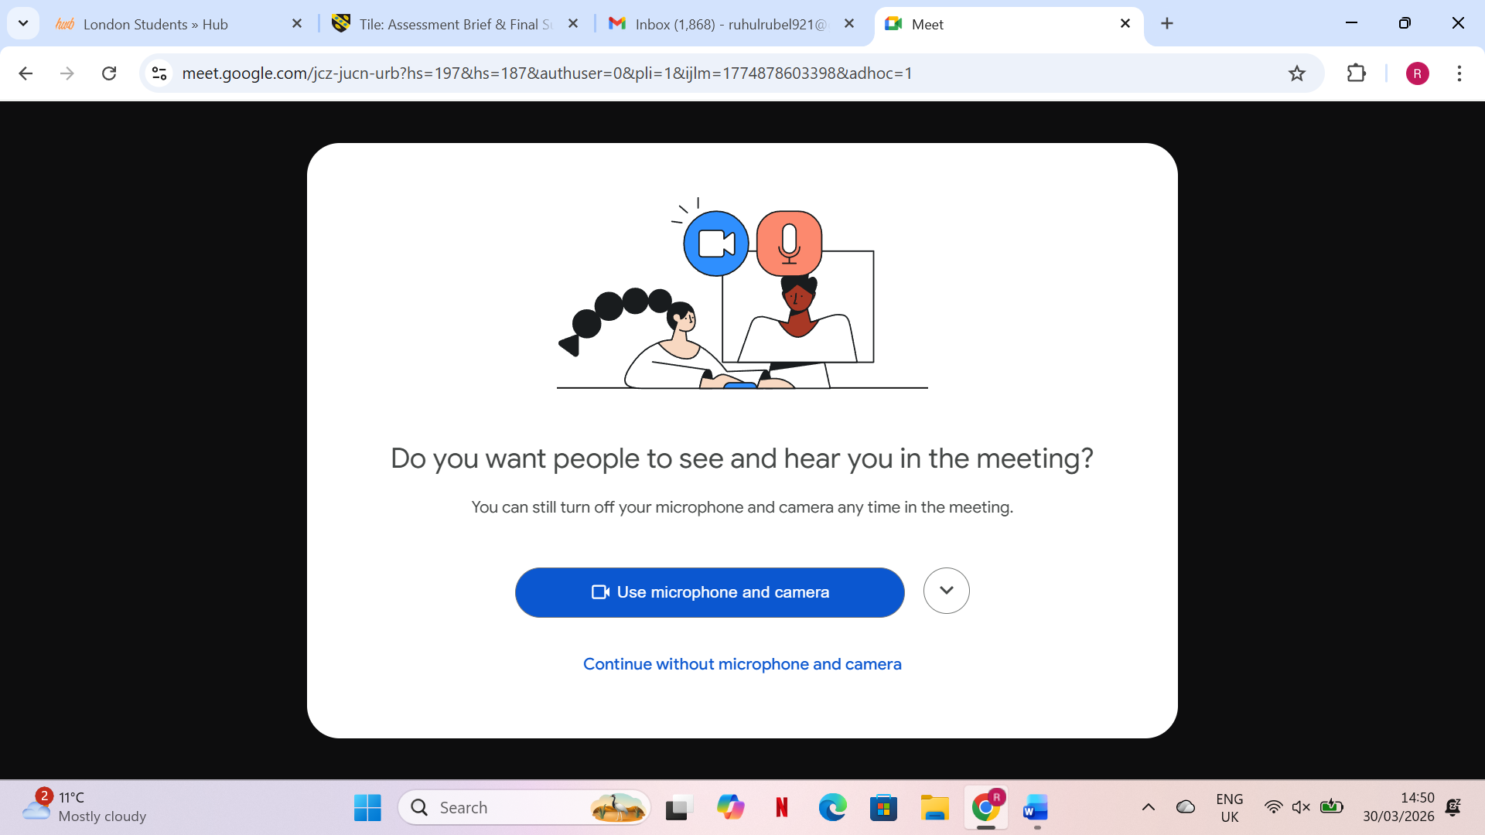
Step 4: Sharing the Meeting Link
Once the meeting started, I clicked Copy joining info to copy the meeting link. I then shared this link via Gmail to invite participants. This demonstrates how Google Meet supports quick and easy meeting invitations.

Step 5: Admitting Participants
When someone attempted to join, a notification appeared asking me to Admit or Deny them. I clicked Admit, showing how hosts can control access and maintain meeting security.


Step 6: Presenting My Screen
To demonstrate collaboration features, I clicked Present now and selected Your entire screen. Google Meet displayed a message saying, You’re presenting, confirming that participants could now see my screen. This feature is essential for presentations and group work.

Step 7: Using Captions and Chat
I turned on live captions using the CC button, and text appeared at the bottom of the screen as I spoke. I also opened the chat panel to send a message to participants. These tools support accessibility and communication during meetings.



Conclusion
This portfolio has shown how a range of digital tools contribute to efficient, technology‑supported business operations. By examining contemporary e‑commerce website builders, it becomes clear that online platforms now play a central role in helping organisations reach customers, manage transactions, and operate with greater flexibility. The mind‑mapping task further demonstrates how visual planning tools support clearer thinking, improved organisation of ideas, and more effective decision‑making in workplace environments.
The review of office applications highlights their importance as essential tools for creating, storing, analysing, and presenting information. Word processing, spreadsheets, presentations, and databases each serve a distinct purpose, and together they form the foundation of everyday administrative and analytical tasks. The practical testing of selected features reinforces how these applications can automate processes, reduce errors, and enhance productivity when used effectively.
The analysis of communication and collaboration tools shows how digital connectivity has become a core requirement in modern organisations. These applications enable teams to share information instantly, coordinate tasks, and maintain communication regardless of location. The practical demonstrations included in the portfolio provide evidence of how such tools can be applied in real scenarios to support teamwork and streamline workflows.
Overall, the assignment demonstrates that effective use of software solutions is essential for today’s business environment. Understanding their features, benefits, and practical applications enables individuals to work more efficiently, communicate more clearly, and contribute to improved organisational performance. The combined exploration and hands‑on testing across all tasks reflect the growing importance of digital literacy as a key skill for both current and future workplace demands.

References

[1] | Shopify, “The Cost of Delaying Unified Commerce in Retail.,” 24 January 2025. [Online]. Available: https://www.shopify.com/ca/blog/retail-tech-total-cost-ownership. [Accessed 28 February 2026].
[2] | G. Srivastava,N.Agrawal,D.Jindal,and Jyoti, “Redefining online retail: The Shopify revolution,” 2025. [Online]. Available: www.researchgate.net. [Accessed 28 February 2026].
[3] | R. Carter, “Wix Ecommerce Review 2026: Pros and Cons,” November 2025. [Online]. Available: https://ecommerce_platforms.com/articles/wix_ecommerce-review. [Accessed 1 March 2026].
[4] | P. Harris, “Pros and Cons of Using Wix ,13 Factor to Consider,” September 2025. [Online]. Available: https://www.enzuzo.com/blog/pros-and-cons-of-using-wix. [Accessed 1 March 2026].
[5] | EcommerceOneStop, “Wix eCommerce Developement:What's Possible and Where It Hits Limits,” August 2025. [Online]. Available: https://www.ecommerceonestop.com/blog/wix-ecommerce-development-whats-possible-and-where-it-hits-limits/ . [Accessed 1 March 2026].
[6] | A.Eppler,S.A Kernbach, “Visualization in management:From communication to collaboration,” 2020. [Online]. Available: https://doi.org/10.1108/JMD-02-2019-0068. [Accessed 5 MARCH 2026].
[7] | J.D Novak,A.J Canas, “The theory underlying concept maps and how to construct and use them,” 2020. [Online]. Available: https://cmap.ihmc.us/docs/theory-of-concept-maps. [Accessed 5 March 2026].
[8] | T.R Lin,H.C Wu, “Visual thinking tools and creativity in organisational problem solving,” 2022. [Online]. Available: https://doi.org/10.1111/caim.12467.
[9] | S.Raghuram,N.Hill,J.Gibbs, “Virtual work and collaboration in digital teams,” 2021. [Online]. Available: https://doi.org/10.1146/annurev-orgpsych-012420-055304. [Accessed 5 March 2026].
[10] | O. Kruse and C. Rapp, “Word Processing Software: The Rise of MS Word,” 2023. [Online]. Available: https://link.springer.com/chapter/10.1007/978-3-031-36033-6_2. [Accessed 17 march 2026].
[11] | C. M. I. F. Yun, “The effectiveness of Microsoft PowerPoint software in enhancing student performance in learning history.,” International Journal of Academic Research in Business and Social Sciences., vol. 15, no. 3, pp. 606-616, MARCH 2025.
[13] | N. E. Surkova, “Training Database Technology in DBMS MS Access,” International Journal of Advanced Studies, vol. 5, no. 1, pp. 28-33, 2015.
[14] | M. S. S. G. Dzieża, “Using MS Excel to Support an ERP System: a Corporate Management and Control Perspective,” International Journal of Advance Study and Research Work, vol. VOL.7 NO.2, pp. PP.1-6, APR.-JUN. 2024.
[15] | “Google,” Gmail features, 2024.
[16] | “Google,” Google meet overview, 2024.

