INTERNATIONAL BUSINESS
BUSINESS PLAN ON TESCO SUPERMARKET INTERNATIONAL SETUP IN FRANCE
STUDENT’S ID: 1806652
MARY MENA DORE-OKUOIMOSE
LECTURER; DR. JOHN LANG

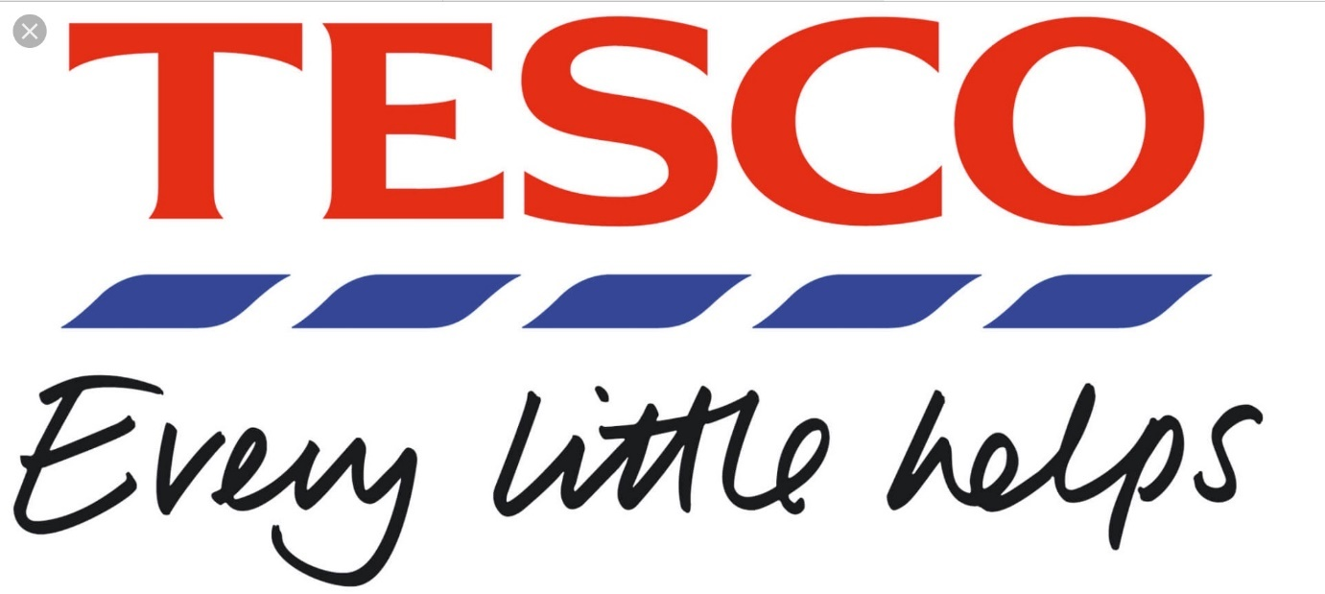
Table of Contents
Introduction 3
Overview of TESCO supermarket: 4
Background analysis 5
Is there a market for Tesco internalisation in France? 5
Brief background of the country hoping to do business 5
Culture characteristics of France and Tesco towards the business plan 8
The Cage framework. 12
External analysis of Tesco international In France 13
Market Entry method of Tesco into the France Market 14
Threat of Entry: Tesco will face low level entry barrier due to it being in the European economic forum, there will be increased bargaining power for Tesco suppliers in France, Tesco will have to face loyalty issues from other already established supermarkets customers in France. 16
The ways Tesco international select their clients, distributors and 17
partners 17
Tesco International negotiating conditions 17
Competitive advantage for Tesco international and their competitors 17
Market Selection 18
Concentration vs Diversification 18
Best Trade Areas 18
Target market definition for Tesco International in France 18
The Selection of Tesco target market 18
Marketing Mix of Tesco: 19
Operationalisation of Tesco’s Strategy: 21
Supply chain process for Tesco supermarket in France 21
Critical success factors of Tesco international as per PESTEL analysis 22
Growth strategies For Tesco in France 22
(KPIs) For Tesco. 22
Product and service selection for target market 23
Standardisation vs. adaptation with pricing strategy 24
Tesco is an international brand 24
Communication tools used by Tesco 25
Communication budget 25
Financial Ratio Analysis for Tesco 26
Contingency plan in case TESCO does not work in France 26
Recommendations 27
Conclusion 27
References 28
Appendix……………………………………………………………………………………..32

Introduction
International business is defined as doing trade of products and services around the world in various countries. This is facilitated either through controlling the business operations from a central headquarters or through setting up units of the organisation in operating countries (Sparks, 2011). Organisations and businesses have been expanding country by country gradually. The greater the company expands the more will be its reputation and dominance in the market. Expanding of business and organisation to international markets is known as internationalisation of the organisation this helps the company achieve economies of scale and scope and reduce units’ costs. In the following description, the factors that need to be acknowledged regarding internalisation of business will be discussed in a brief manner. The organisation selected for this purpose is Tesco private limited company. This will provide better insight into the concept of international business planning.

Overview of TESCO supermarket:
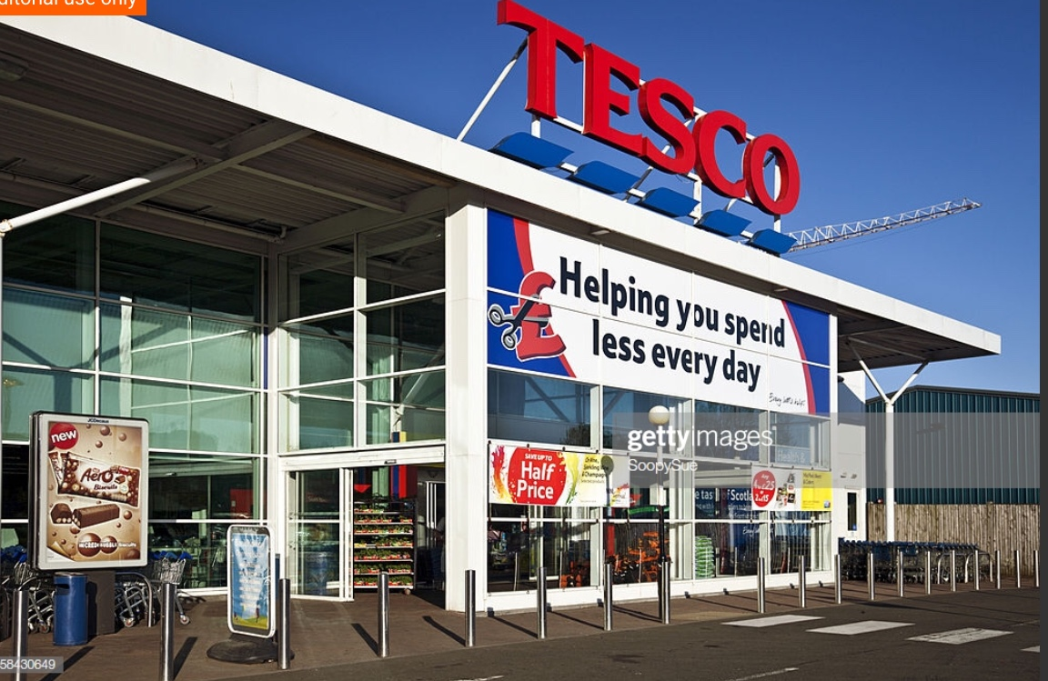
Tesco supermarket is one of the largest supermarkets in the world. It is operated under Tesco private limited company, which functions in retail industry. Tesco supermarkets are stores, which include the retail groceries food and household non-food products. Mainly the supermarket of Tesco is operated under the company name i.e. Tesco. However, in few of the latest supermarkets of Tesco they use the name as Tesco superstore (Ryu and Simpson, 2011). There are around 6,553 small and large stores of Tesco spread across the world. Tesco is a leading name in the retail industry of United Kingdom this is the basis of the economies mentioned on the previous page. The main business of Tesco was retiling grocery items but gradually, the market and business of Tesco was expanded to other non-food items (Prange and Verdier, 2011). The international expansion of the business of Tesco is already actively carried out across almost every continent. Its services and operations are active in all over the world. Recently, the company has been thinking to expand its business to some more countries (Knight, 2015). Therefore, there is a need to consider critical factors before internationalizing the organization in any other country, which in this case is France.

Background analysis

Is there a market for Tesco internalisation in France?
There is no Tesco international in France at the present time because when they entered the France market in the early 80’s and it was not a success due to the different lifestyle and shopping habits, which Tesco did not account for in their due diligence a business planning. However, Tesco expanded its business in France during 1990s but due to its failure, it withdrew. However, there is a scope for Tesco to leverage its business model into the market of France and its expansion might not be that unsuccessful this time (Wood et al. 2016).

Brief background of the country hoping to do business
France is one of the constituents of European Union and stands on third position in case of economy among the other countries of European Union (Pluta et al, 2011). As per the statistics of previous year, it was sixth country to have the strongest economy in the world. The main industries of France include manufacturing sectors, tourism, textiles, food processing and few more industries (Ryu and Simpson, 2011). As Tesco is a retailing company and handled food-processing business, there is a market available for Tesco in France.
According to the recent global competitive report index done in 2018, out of 140 economies(countries) around the world France scored a total of 78.01 points out of 100, which is an all time high compared to previous years. (world economic forum, 2018.)
Global Competitive Report for France in Graph.
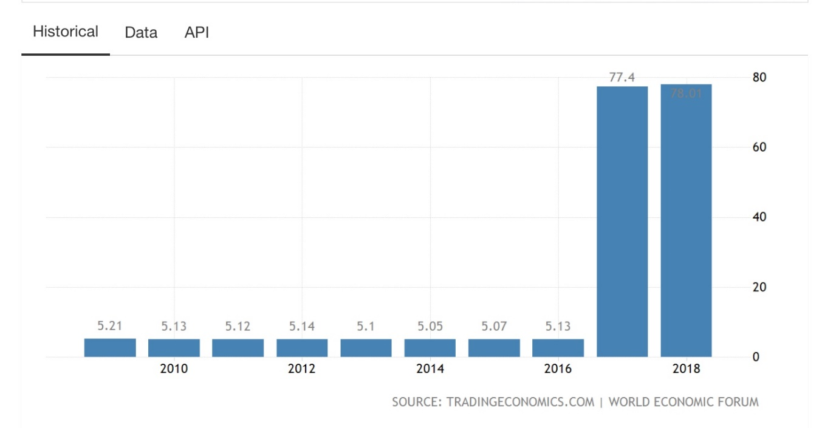

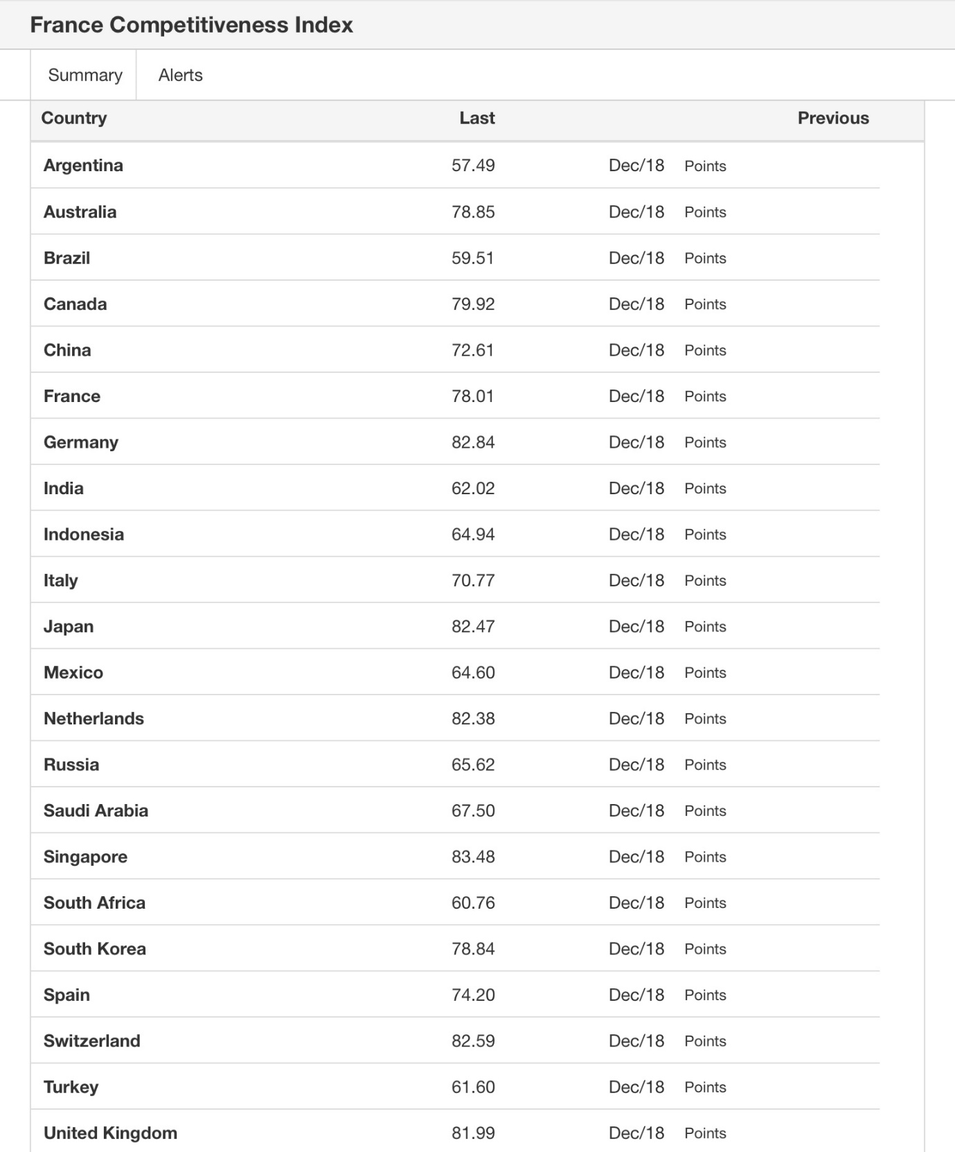

Check global competitive report for ranking between France and United Kingdom. Appendix -5

Culture characteristics of France and Tesco towards the business plan
Now talking about the culture of France, the culture of France especially Paris is one of the best cultures of the world. According to the data revealed by BBC, the country was positioned among the four most influencing counties in the world (Diallo, 2012). The positive culture of France is the outcome of successful historical incidents, forces from foreign and other external factors and the geography of the country. France has given valuable contribution in the areas like cinema industry, literature, fashion, science, technology and cuisines (Ghazinoory et al. 2016). It also has military, economic and political significance in the world. It was also the heart and core of high culture between the period of 17th and 19th century.

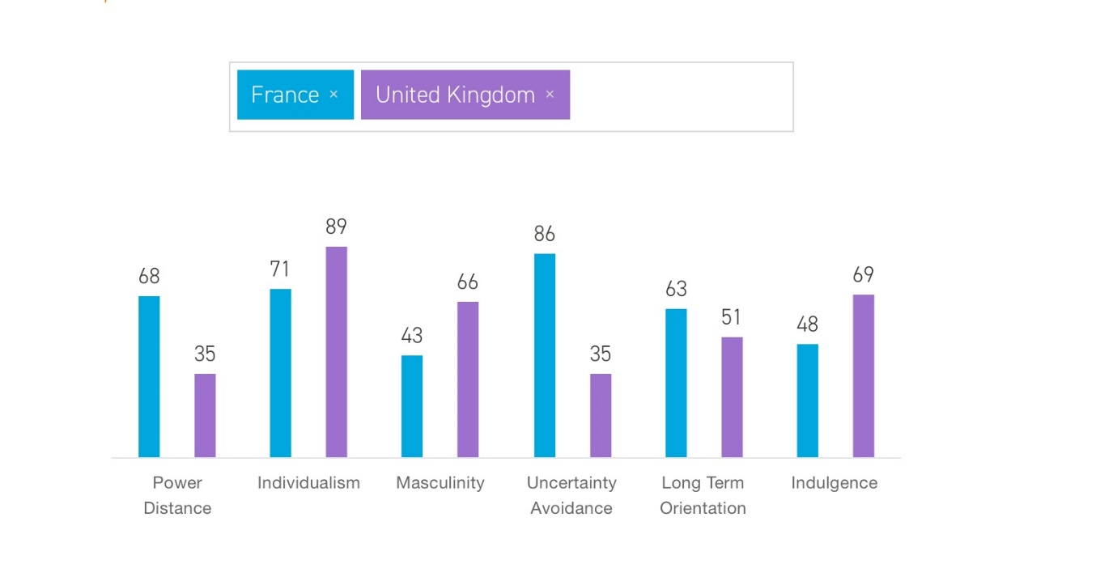
Hofstede’s typology for France’ culture (check Appendix 6 for graphs)

The culture of France can be evaluated through Hofstede’s five cultural dimensions, which are as follows:
Power distance- There is high power distance in France. People belonging to upper class dominated the people belonging to the lower class (Hofstede, 2011). While in Britain there is a belief that inequalities should be minimised, the British culture believes that where you are from should not limit how far you move up in life (Hofstede, 2015).
Individual vs group orientation- There is individualism among the people and culture of France and Britain and it is very little difference people in these two cultures believe in looking after themselves and their direct family, at 89% the UK is higher than France.
Uncertainty avoidance- There is high uncertainty avoidance in culture of France. People of France are very concerned about avoiding any type of uncertainty in their chorus and tasks (Hofstede, 2011).
Masculinity vs femininity- Both men and women have equal parts to play in the social culture of France, at 66% Britain is a masculine society compared to France masculinity is higher in Britain, However, there is anti-feminist mentality in the civil society of France.
Indulgence: with a high score of 69% for Britain compared to France score of 48% this indicates that people in Britain are more willing to indulge and realise their impulses more than people in France.
Long vs short-term orientation- The culture and society of France is long term oriented compared to Britain.
There are some areas where there are similarities and differences between the cultures in France and Britain.
SIMILARITIES | INDIVIDUALISM | FRANCE- in France the percentage is slightly lower than in UK. The range of food stuff or groceries in their stores do not need to differ too much as most people in France will tend to buy similar groceries not too much differentiation in the goods to be sold in the Tesco store in France. | BRITAIN – Individualism is slightly higher than France but it is similar.
DIFFERENCES | POWER DISTANCE | - There is a big gap in power distance in France compared to Britain | 1)In UK the power distance is not too high as there is opportunity for people to improve their status more than in France.
DIFFERENCES | UNCERTAINTY AVOIDANCE | - There is a very high uncertainty avoidance in France compared to Britain, Tesco France will not have to worry too much about changes in government powers or decisions. | 2)The uncertainty avoidance in the UK is low, but presently due to Brexit this will rise.
DIFFERENCES | MASCULINITY/FEMINITY | - In France both men and women have similar part to play in the social culture compare to the UK in this regard Tesco will have no problem in recruiting females or male staff for any job opening in their stores, there will be no preferential treatment or high pay to male it will be equal pay rate. | 3)Masculinity is higher in Britain compared to France.
DIFFERENCE | INDULGENCE | - The rate of people indulging in France is far lower than in Britain, Tesco supermarket will look for ways to make the people in \France to want to buy more goods for themselves to use either for parties, picnics, outings. | 4)People indulge themselves more in Britain than in France and this has helped Tesco in increasing their sales mostly on weekends.
DIFFERENCES | LONG TERM/SHORT TERM ORIENTATION | - The orientation is France is long term, it will take Tesco perhaps a while to gain a big market share in France but when they do am sure they will have loyal customers who will not want to switch from them quick. | 5)The orientation in UK is short term people will change stores as soon as they get somewhere cheaper or of better quality than their previous stores.

Just the way Hofstede typology looks at the cultural differences between France and Britain so also does the CAGE framework look at cultural distance, administrative distance, economic distance and geographic distance this tool will be good to use in devising an international plan for Tesco supermarket in France.

The Cage framework.
As Tesco international is focusing on internationalisation of its business, it is required to devise an international, plan and strategy for the company (Sparks, 2011). This can be done with the help of CAGE framework, which stands for cultural distance, administrative distance, geographic distance and economic distance. This is an important framework for helping evaluate the potential ease or difficulty of entry, for Tesco, into another market, in this case France. It helps us to evaluate the risks and transferability of the functional areas of the business, and if necessary, reconsider the options available.
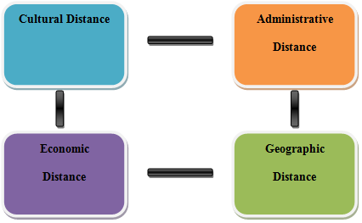
Figure 2- CAGE framework
(Source- Tesco plc. 2019)
Cultural distance- By moving into another culture i.e. France will create language barrier for the country. There will be more such impacts on the company, due to which, cultural distance is high for Tesco.
Administrative distance-The administrative aspects of Tesco international business in France will be related to changing currency, trading, rules, regulations, and foreign policies of France (Cavusgil et al. 2014). Therefore, administrative distance is high for Tesco while moving the business to France.
Geographic distance-The actual physical distance between France and unite kingdom not much. Therefore, the geographic distance is less for Tesco in this case.
Economic distance- The economy of France stands on sixth position, whereas the economic ranking of UK is on 5th position. Therefore, both the countries have similar type of economic value. Thus, the economic distance for Tesco, will be less in this case.
Having evaluated some of the risks above, for Tesco, it would seem that the economic distance based on the monetary standing of the two countries will be good to establish Tesco in France and it will be successful.

External analysis of Tesco international In France
The external analysis of Tesco international can be performed with the help of PESTLE analysis. Check Appendix 2 (Page 32)
Tesco will have to follow and adhere to the government laws in France when it moves there, although the UK economy is slightly ahead of that of France there is not too much difference. The social factor and lifestyle of people in France will influence how they shop and buy things in Tesco France; Tesco will have to take that into consideration. At present both Britain and France in recent years has made a lot of technological advancement and this will help Tesco in France in installing of their machines in their stores and warehouses, as Britain is still part of the European union more of the laws when it comes to trading in the European union is still the same until Britain leaves the EU. Having examined the external environmental factors of France, as a more or less receptive country to Tesco, I will now examine the internal resources and competencies of Tesco, to show how well equipped they are to enter that market.

Internal analysis of Tesco supermarket
SWOT analysis will be used for finding out the strengths and weaknesses of the external environment of Tesco supermarket and this can be analysed easily. Along with strengths and weaknesses, the threat and opportunities for the company can also be analysed with the help of SWOT analysis. Check appendix 1(Page 31)
According to the SWOT analysis, Tesco’s strength due to it being the major supermarket in Britain and it being recognised for selling excellent goods and products has helped it to boast its brand name even before moving into France.
Tesco has its weakness of high inventory cost due to mismanagement and Tesco will have to deal with these issues to avoid similar incidence in France. Tesco has the opportunity of growing its business in France and expanding to more other countries in Europe if it succeeds in France. There is the issue of big rival groceries stores in France giving Tesco a run for their money and the issue of Brexit is still an issue Tesco will have to deal with when Britain leaves the EU.

Tesco’s competencies for entering the French Market:
Tesco started expanding its business to other countries of Europe in 1995. The firm encourages the employment of females at senior position. The recession period made the company to lose its customers largely, but after that the quality, pricing techniques and expansion of stores helped the company to retrain its position. The company plans to open small convenience stores, which would change the habit of getting healthy groceries and becoming more health conscious (Gaudio, 2013). The strategy of Tesco, which it used in US to attract more customers by opening these small stores is that, they want their customers not to drive far and find convenience to these stores. Tesco has great competitors in France, which are Auchan and Carrefour. The pricing strategy of the company should be reasonable. The company should provide a large variety of fruits and vegetables, which many of the stores are not able to provide.

Market Entry method of Tesco into the France Market
Market entry strategy is essential for a company, entering a new market. It acts as a tool to clarify the aim of company. The clear goal of Tesco to provide good quality of groceries all around the world influences the company to expand its market. The company uses the native companies to establish itself and then gain profits. The competitor of Tesco in France has a great reputation and the company is expanded to over 15 countries. As the company is in UK, it needs to be more customers focused, provide its goods and services at a lower price and gain brand value (Hudák et al. 2017).
Competitive Environment:
Using Porter’s five forces, I will now analyze the competitive environment for Tesco.
Potters Five Forces. APPLIED TO FRANCE
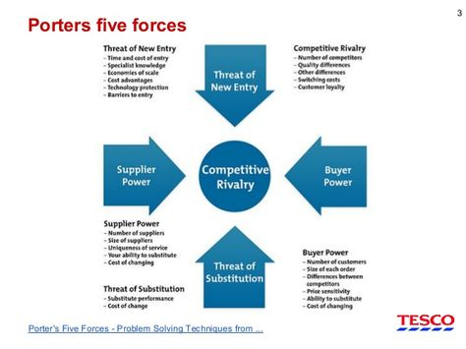

Threat of Entry: Tesco will face low level entry barrier due to it being in the European economic forum, there will be increased bargaining power for Tesco suppliers in France, Tesco will have to face loyalty issues from other already established supermarkets customers in France.
Competitive Rivalry: There will be high competition for Tesco supermarket from existing competitors in France, about 5% of the big supermarkets in France already own about 83% of the market share. There will be high cost for advertising, some of their competitors will already have the government of France support. High costumers’ loyalty.
Bargaining Power of Suppliers: There will be low competition for Tesco from suppliers as they can still use a lot of their UK suppliers due to free trade and open market with UK and France.
Bargaining Powers of Buyers: Buyers are sensitive to prices, if Tesco prices and discounts are better than that of their already existing rivals, they will gain more new costumers as buyers will want to compare alternative from internet information’s.
Threat of Substitutes: There are multiple substitute supermarkets in France offering similar food and grocers like Tesco perhaps cheaper, so Tesco will have to come up with other alternatives as they did in the UK such as Tesco club cards and Tesco airmiles shopping cards to reward their customers each time they shop at Tesco.
Logistics: Tesco will have to take into consideration the logistics issues it will face going into France if it will need to export most of its products from UK or obtain them in France and decide its supply chain either new suppliers in France or use old suppliers in UK, and Tesco like their stores to be the same in design all around UK and the other countries they have stores perhaps it will be the same with their store in France.
For Tesco to succeed in France they will need to take into consideration their distribution channels, supply chain, partners and their intended customers.

The ways Tesco international select their clients, distributors and

partners
The supply chain of the company is continuously increasing and helping the customers to satisfy their needs. The suppliers of the company have major control on the market and they are organized well. Manufacturers need to supply their products directly to the distribution centers rather than the stores (Hudák et al. 2017). The clients of Tesco help the company to gain flexibility and study the myriad ways to enhance their products.

Tesco International negotiating conditions
Negotiation of big supermarkets with their suppliers and distributors shows the shadiest area of retailing (Lowe et al. 2012). The suppliers want to tell the price as high as possible; the distributor wants the most profit and the clients need the product at the cheapest price. Tesco focuses on their customers rather than any of these. These supermarkets use wide range of psychological and strategic tactics to withdraw the best price from the manufactures. The tactics includes, misunderstanding of customers to disturbing the suppliers. Recognition is required for any type of organization before negotiation (Xie and Allen, 2013). A supplier always has the fear of losing his business and the company wants to give the least to suppliers. The power in these suppliers, clients and partners are not divided equally and they try to negotiate hard to manage those powers.

Competitive advantage for Tesco international and their competitors
Tesco will face competitors from several new and some existing rivals in the market. Competitors like Carrefour an already established supermarket in France, Aldi and Lidl will be a great competition for Tesco also, besides, there are some other rivals too present in the market of France like Euronics, Systeme U and Leroy Merlin (Schaltegger and Burritt, 2014). Tesco has a great brand portfolio, which will be one of the great competitive advantages for the company during its internationalisation in France. Other competitive advantages for Tesco will be its highly updated technologies and gadgets. These will help the company in performing their operations in much better ways as compared to its most of the rivals in France (Leuschner et al. 2013).

Market Selection

Concentration vs Diversification
When a product has high ability and potential to grow, then concentration strategy is used by companies. Bananas, corned beef and fresh beef are some of the most popular products of Tesco. The company can use vertical growth strategy to gain a strong competitive environment in France. Diversification strategy is used when the company has gained much reputation and experience in the market (Hautz et al., 2013). This strategy should be used by Tesco after the concentration strategy, as the company becomes aware of the vertical and horizontal concentration strategy. Concentric diversification enables the company to focus on the features that it had gained in the market of UK.

Best Trade Areas
An area from which a community or a company generates maximum of its customers is called the best trade area for a company. Tesco has a large chain of supermarkets, superstores and hypermarket all over Europe. It operates in more than 12 countries and 476,000 employees at these stores. The majority of customers of Tesco are from the United Kingdom. The aim of Tesco at France should be to meet the high demand of customers and should be able to combine the advantages of digital technology to its physical stores.

Target market definition for Tesco International in France
According to Morgan (2012), target market is the segment of particular market in which a marketing campaign is focused. This involves the process of identifying the most profitable areas in a market to launch its new products and services to the customers. The strategy of target marketing consists of segmentation of market and choosing which segment is appropriate for the new products and resolution of products that will be offered in those segments (Sparks, 2011). Tesco should use this strategy to launch their new products in the French market. The company should target a particular group of customers to buy their products and gain feedback from them.

The Selection of Tesco target market
The group of individuals who have similar needs, interests and understanding, should be the target market of any company. Tesco should understand the lifestyle of people, highest age group, and income of their consumers, education and occupation, dominant gender, social status of their customers for the selection of target market (Sparks, 2011). The company should create a group of individuals with similar interests and manufacture their products as per the requirement. An individual of age 50 has different interest and want different products than that of 20 years old (Sparks, 2011). At the starting, the company shall need to face many difficulties, but if once it becomes capable to handle the market, the company could easily gain high profits.

Marketing Mix of Tesco:
Tesco uses 4ps in its marketing mix for operation management. These 4ps of Tesco international can be understood from the followings:

Figure.3- 4Ps of marketing mix
(Source: Previews.123rf.com, 2019)
Product- The product range of Tesco in France will comprise of food products and groceries. This will provide numerous food options for the customers in France (Xie and Allen, 2013). Internationalising of Tesco in France can expand the product range of Tesco as Tesco keep on expanding its product range by adding products according to the demands of the local customers.
Price- pricing strategy of Tesco may vary in initial stages of internationalisation, as the company may offer attractive prices to the customers for gaining their loyalty and attentions.
Place- Tesco operates offline as well as online business. The products are retailed in superstore as well as on its online digital portals.
Promotions- The lower prices of the products offered by Tesco are one of the most attractive factors for the customers. If it internationalises to France, then the company can promote its brand by offering lower rates to customers as well as performing community related activities (Fan et al. 2015). This will create good brand image of Tesco in France also.

Operationalisation of Tesco’s Strategy:
Procedures- Tesco international is required to carry out its operation in France by conducting several procedures. Procedures are nothing but the instructions for performing task, which will have to be set in Tesco according to their existing technologies and gadgets (Gaudio, 2013). The allocation of task to the employees for attaining long and short-term goal will be the procedure, encompassed by operational requirement of Tesco international in France.
Policies-After establishing the procedures required for operation management, relevant policies should be designed by Tesco for carrying out the operations effectively (Ghazinoory et al. 2016). These policies can be security policies, customer policies etc.
Operational strategic plans- Tesco international will be required to set specific goals and targets to achieve periodically in French market. Then, Tesco international will have to assess the behaviour and preference of the customers in France. Through this, Tesco international will be able to, manufacture and provide only those products, which are most preferred by the French customers (Ghazinoory et al. 2016). This will help eliminating any kind of waste of products or extra coverage of space due to unnecessary products.

Supply chain process for Tesco supermarket in France
Through effective supply chain management, the raw material from the supplier can be purchased at lower cost and of best quality. This will help Tesco international in lowering the cost of production and earn more profit in business (Ghazinoory et al. 2016). Benefit of strategic planning for operations are that any kind of defect or mistake can be eliminated from the organisational processes and the operations can be completed in an effective manner. Supply chain management of Tesco is accomplished defectively due to proper demand management, integration, interaction or communication and collaboration. Tesco integrates its logistic and IT sector with its supply chain for getting better outcomes. Through proper communication with the suppliers, the relationship is maintained (Wood et al. 2016). Tesco also enhances its supply chain management through collaboration of several kinds of supply chains for specific demands and requirements. In this way, all the demands of the customers are fulfilled effectively by Tesco through proper operations and supply chain management. Check Appendix 5 for Supply chain Graph for Tesco

Critical success factors of Tesco international as per PESTEL analysis
Political- The governmental rules and regulations are followed by Tesco international.
Economic- Value of pound sterling is almost seven times greater than franc. This will be an advantage of Tesco international.
Social- Tesco performs various community services for the communities of its surrounding environment.
Technology- Use of upgraded gadgets and machineries will help the company in performing task more efficiently.
Legal- All the legal frameworks are obeyed by Tesco international.
Environmental- Tesco has huge concern for the environment and thus has a proper sustainability policy for its business (Diallo, 2012).

Growth strategies For Tesco in France
As the company has been a leading retail giant in UK, it can find itself a competent position in the market of France. The international growth strategy for Tesco in France could be through joint venture partnership, may be with other retail firms leading in France territory. The best part of the joint venture partnership is that it outlooks towards the contractual relations of the company before it comes up with a growth strategy through capital investment (Fan et al. 2015). Tesco’s best chance would be having an extra market coverage that will help to expand the export activities in quick pace. Moreover, the company has to set clear objectives that will ensure that their goal is to target customers by gaining competitive advantage through internalisation.

(KPIs) For Tesco.
- Recommended by Customers worldwide | 2.5% rise in customers since this year
- Recommended by Tesco staff as best place to work | Tesco latest survey 2018, 70% of their staff recommended Tesco as a great place to work.
- Trust Built with its suppliers | 58% of Tesco suppliers indicate they are satisfied doing business with Tesco
- Growth in Sales | In 2018 Tesco growth in sales was 2%
- Deliver Profit | After the fall in sales in 2014/2015 calendar year Tesco profits has started to rise again by 57.5%
- Improve operating cash flow | Which has gone up in the past year rising to 59.6% in 2018
Source: Tesco.com (2019)

 | JOINT VENTURES | EXPORT | STRATEGIC ALLIANCE | COLLABORATIVE AGREEMENT
COST BREAKDOWN | 5 | 7 | 5 | 6
REWARD BREAKDOWN | 6 | 5 | 7 | 7
RISK BREAKDOWN | 4 | 8 | 4 | 5
COMPLEXITY BREAKDOWN | 5 | 8 | 5 | 5
TOTAL | 20 | 28 | 21 | 23
There is far greater risk when it comes to exporting products from UK to France due to the fact that most food products have short shelf life span before they expire or get damaged during transportation. for the new Tesco international store in France followed by the collaborative agreements it will need to make with other alliance in France from my own estimation.

Product and service selection for target market
The products that are to be sold in France are selected by Tesco according to the buying preferences and pattern of the targeted customer group of France. The pricing of these products is also fixed accordingly. At the initial stage of the internationalisation of business in France, the prices of the products can be lowered by offering products at discount processes (Ryu and Simpson, 2011).

Standardisation vs. adaptation with pricing strategy
The products offered by Tesco in French market can be developed through Adaptation by upgrading some of its features with the demand of French customers. It can also be done through standardisation i.e. developing new equivalent products for the French customers (Diallo, 2012). The pricing strategy of Tesco in France will be designed by considering the pricing strategies of the existing retailing organisations of France. Tesco can also use cost plus and cost-based pricing strategies in the market of France.

Tesco is an international brand
Tesco plc is retailer of general merchandise and multinational groceries. The revenue operated by the company, hold the ninth position in the list of largest retailers of world. The company has expanded its goods and services all over the world and making it an international brand (Wood et al. 2016). The company has expanded by entering into the joint ventures with local groups such as, Samsung Group in South Korea and Charoen Pokphand in Thailand. In 2004, the amount of revenue generated outside the UK was high for the first time than its home market. Tesco in France owned a native retailer, named Catteau, which helped in the operation of 92 stores. Other than this, the company sold wine, beer and spirits to the customers in France.
Positioning of Tesco international in target market
The focus on the company is to target the customer for the wide range of health and beauty products. The company sells its finest product through the strategy of functional positioning (Manning, 2012). The company targets everyday people by its product and varied range. Tesco has gained much reputation through its fine quality and the cheap price products in the international market. Positioning is also referred as the understanding of a brand by the consumers and relation of that product or brand to other similar products by another company (Gaudio, 2013). Below positioning map shows Tesco has been leading in the retail market of UK quite good, and this will reflect in France while it will go towards internalization.
C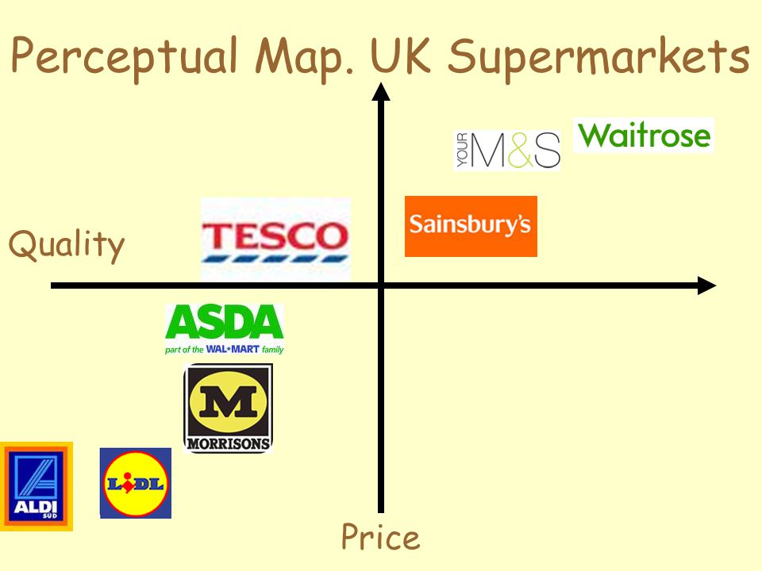
CARREFOUR
Figure 4: Positioning Map of Tesco presently
(Source: Sparks, 2011)

Communication tools used by Tesco
Communication is a strategy that engages the employees. This strategy attracts and retains the staff. Communication is not just the listening and fixing of the tasks. It involves more than this, it tries to make a better place to shop and enhances the work culture. Email enables employees to communicate valuable information and this technology helps to keep in touch with each other (Muller et al. 2012). Social networking websites such as Facebook and Twitter allow users to create free account and advertise the company at its most. Instant messengers are used to share instant messages and internet is used as a major source for communicating this information.

Communication budget
Budget Categories | Total Budget
Software & Subscriptions | $86,000
Public Relation | $40,000
Advertising (print) | $15,000
Advertising (online) | $60,000
Content Production | $37,000
Events & Sponsorship | $180,000
Creative Agency Fees | $250,000
Contact Lists | $35,000
Hoardings & Banners | $15,000
Memberships and Associations | $30,000
Totals | $748,000

Table.3- Communication budget
From the above table I will personally suggest Tesco to use advertising print and online advertising in France to reach people, but Tesco is a rich company they can afford to use all the above listed means of communication if they choose to.

Financial Ratio Analysis for Tesco
The top management of Tesco Corporation has identified the opportunity to start a new project in France and it was projected that the expense plan in France required initial investment of $ 1.2 million, the project is initiated with local partner under the joint venture strategy, and we have projected the cash inflow from three year as follow. The projections are made as per the information available from market and as per the research initiated by our in-house team. Check Appendix: 3 (Pages 29 – 37) For the Ratio analysis.

Contingency plan in case TESCO does not work in France
If Tesco does not work in France, then the contingency plan developed is regarding its promotion and change in marketing strategy. In the contingency plan, the marketing strategy will be developed according to the buying pattern of the customers of France (Yüksel, 2012). This will help in assessing their demands. This will help in serving them with more suitable products and services.
RISKS:
- Exchange rate risk for Tesco as the British pound is higher than the euro, so in terms of putting prices in the goods in the store it might become too expensive for people in France
- Unfair competition for already established brands like Carrefour in France with big market shares already.
- Political Uncertainty, if Britain leaves the EU the common market deal enjoyed by other European countries might no longer be there for the UK
- Language barrier, Tesco management team going to France will need to have a fair knowledge of how to speak French.

Recommendations
Internationalising the business in France is a big decision to make for Tesco, as its previous establishment in France during 1990s was not successful. However, time has changed and lots of factor has been shifted from negative to positive for the business of Tesco in France. Therefore, it is recommended that Tesco should prepare such strategies, which suits the culture and the target customers of France. The strategies and marketing behaviour of the existing competitor in French market should be assessed by Tesco before internationalising. Another recommendation for the company is that, it can collaborate with some of the famous organisations of France for facilitating proper growth of its business in the market of France. This can be done for temporary as well as permanent basis.

Conclusion
Expanding the business operations of Tesco in France is a great idea as the population of France is more than the pollution of United Kingdom. Therefore, internationalising in France will bring significant growth in the revenue generation of Tesco. However, there are some risks of failure, experienced from past business in France. Therefore, Tesco should make all the necessary arrangement and preparation for running its business effectively in France. Formulating proper strategy and business plan before internationalising will help the organisation in sustaining its business growth in an effective manner.

References
Cavusgil, S.T., Knight, G., Riesenberger, J.R., Rammal, H.G. and Rose, E.L., 2014. International business. Pearson Australia.
Diallo, M.F., 2012. Retailers' internationalization in emerging markets: A comparative study of a French and a local retailer's key success factors in Brazil. International Business Research, 5(10), p.91.
Fan, S., Lau, R.Y. and Zhao, J.L., 2015. Demystifying big data analytics for business intelligence through the lens of marketing mix. Big Data Research, 2(1), pp.28-32.
Gaudio, A., 2013. Target Advertising Effects on Campaign Success. http://digitalcommons.liberty.edu/cgi/viewcontent.cgi?article=1367&context=honors
Ghazinoory, S., Abdi, M. and Azadegan-Mehr, M., 2011. SWOT methodology: a state-of-the-art review for the past, a framework for the future. Journal of business economics and management, 12(1), pp.24-48.
Hautz, J., Mayer, M.C. and Stadler, C., 2013. Ownership identity and concentration: A study of their joint impact on corporate diversification. British Journal of Management, 24(1), pp.102-126. https://www.researchgate.net/profile/Christian_Stadler2/publication/230802115_Ownership_Identity_and_Concentration_A_Study_of_their_Joint_Impact_on_Corporate_Diversification/links/5ad8fdc10f7e9b28593c9d97/Ownership-Identity-and-Concentration-A-Study-of-their-Joint-Impact-on-Corporate-Diversification.pdf
Hofstede, G., 2011. Dimensionalizing cultures: The Hofstede model in context. Online readings in psychology and culture, 2(1), p.8.
Hudák, M., Madleňák, R. and Brezániová, V., 2017, September. THE IMPACT OF ADVERTISEMENT ON CONSUMER’S PERCEPTION. In CBU International Conference Proceedings (Vol. 5, pp. 187-191). https://www.journals.cz/index.php/CBUIC/article/download/923/pdf
Huo, B., 2012. The impact of supply chain integration on company performance: an organizational capability perspective. Supply Chain Management: An International Journal, 17(6), pp.596-610.
Knight, J., 2015. Updated definition of internationalization. International higher education, (33).
Leuschner, R., Rogers, D.S. and Charvet, F.F., 2013. A meta‐analysis of supply chain integration and firm performance. Journal of Supply Chain Management, 49(2), pp.34-57.
Lowe, M., George, G. and Alexy, O., 2012. Organizational identity and capability development in internationalization: transference, splicing and enhanced imitation in Tesco’s US market entry. Journal of Economic Geography, 12(5), pp.1021-1054. https://ink.library.smu.edu.sg/cgi/viewcontent.cgi?article=5658&context=lkcsb_research
Manning, A., 2012. National pay bargaining: please write to Tesco not the Times. British Politics and Policy at LSE. http://eprints.lse.ac.uk/48706/1/blogs.lse.ac.uk-National_Pay_Bargaining_please_write_to_TESCO_not_the_Times.pdf
Miečinskienė, A., Stasytytė, V. and Kazlauskaitė, J., 2014. Reasoning of export market selection. Procedia-Social and Behavioral Sciences, 110, pp.1166-1175. https://www.sciencedirect.com/science/article/pii/S1877042813056036/pdf?md5=5dced0f30e5c75fdfaa8920414578663&pid=1-s2.0-S1877042813056036-main.pdf
Morgan, N.A., 2012. Marketing and business performance. Journal of the Academy of Marketing Science, 40(1), pp.102-119. https://www.researchgate.net/profile/Neil_Morgan2/publication/226296519_Marketing_and_business_performance/links/00b4951daf3069256a000000/Marketing-and-business-performance.pdf
Muller, C., Vermeulen, W.J. and Glasbergen, P., 2012. Pushing or sharing as value‐driven strategies for societal change in global supply chains: two case studies in the British–South African fresh fruit supply chain. Business Strategy and the Environment, 21(2), pp.127-140. https://www.researchgate.net/profile/Arjen_Van_Witteloostuijn/publication/46683993_Nations_and_Firms_in_the_Global_Economy_an_introduction_into_international_economics_and_business/links/00b4952ca901531f95000000.pdf#page=114
Pluta-Olearnik, M., 2011. Internationalization of the service sector-marketing approach. Folia Oeconomica Stetinensia, 10(1), pp.175-185.
Prange, C. and Verdier, S., 2011. Dynamic capabilities, internationalization processes and performance. Journal of World Business, 46(1), pp.126-133.
Previews.123rf.com. (2019). [online] Available at: https://previews.123rf.com/images/amayante/amayante1704/amayante170400037/75584760-4-p-marketing-mix-elegant-icon-kit-hand-drawn-design-of-images-and-calligraphic-script-colorful-back.jpg [Accessed 15 Mar. 2019].
Reis, N.R., Ferreira, M.P. and Santos, J.C., 2011. The cultural models in international business research: A bibliometric study of IB journals (No. 76).
Ryu, J.S. and Simpson, J.J., 2011. Retail internationalization: Lessons from" Big Three" global retailers' failure cases. Journal of Business & Retail Management Research, 6(1).
Schaltegger, S. and Burritt, R., 2014. Measuring and managing sustainability performance of supply chains: Review and sustainability supply chain management framework. Supply Chain Management: An International Journal, 19(3), pp.232-241.
Sparks, L., 2011. Settling for second best? Reflections after the tenth anniversary of Wal-Mart's entry to the United Kingdom. International Journal of Retail & Distribution Management, 39(2), pp.114-129. http://dspace.stir.ac.uk/bitstream/1893/2994/1/Settling%20for%20Second%20Best%20Final%20Version.pdf
St2.depositphotos.com. (2019). [online] Available at: https://st2.depositphotos.com/1004907/7071/i/950/depositphotos_70712587-stock-photo-cultural-dimensions-business-diagram-illustration.jpg [Accessed 15 Mar. 2019].
Tesco plc. (2019). Tesco PLC. [online] Available at: https://www.tescoplc.com/ [Accessed 15 Mar. 2019].
Wood, S., Coe, N.M. and Wrigley, N., 2016. Multi-scalar localization and capability transference: exploring embeddedness in the Asian retail expansion of Tesco. Regional Studies, 50(3), pp.475-495. http://epubs.surrey.ac.uk/805545/25/Multi-Scalar%20Localization%20and%20Capability%20Transference.pdf
Wood, S., Wrigley, N. and Coe, N.M., 2016. Capital discipline and financial market relations in retail globalization: insights from the case of Tesco plc. Journal of Economic Geography, 17(1), pp.31-57.
Xie, Y. and Allen, C., 2013. Information technologies in retail supply chains: a comparison of Tesco and Asda. International Journal of Business Performance and Supply Chain Modelling, 5(1), pp.46-62.
Yawar, S.A. and Seuring, S., 2017. Management of social issues in supply chains: a literature review exploring social issues, actions and performance outcomes. Journal of Business Ethics, 141(3), pp.621-643.
Yoo, B., Donthu, N. and Lenartowicz, T., 2011. Measuring Hofstede's five dimensions of cultural values at the individual level: Development and validation of CVSCALE. Journal of International Consumer Marketing, 23(3-4), pp.193-210.
Yüksel, I., 2012. Developing a multi-criteria decision-making model for PESTEL analysis. International Journal of Business and Management, 7(24), p.52.

Appendix 1 SWOT ANALYSIS
Strengths | Weaknesses
- Tesco has strong and large brand portfolio.  - It has dominant position in the retail industry of United Kingdom (Yoo et al. 2011).  - Tesco has been recognised for its excellent quality services and products. | - High inventory cost due to ineffective inventory management.  - The company was accused of fraud in the year 2017.  - Share prices of the company have been decreasing in the recent time.
Opportunities | Threats
- Tesco has the opportunity of growing its business by offering low costs.  - The company has the opportunity of developing its business through its online websites and portals (Reis et al. 2011).  - Company can perform well during its initial stage of internalisation in France by offering higher discounts. | - The company has threat from its rivals like Lidl, which is also top grosser in French market.  - The devaluation of currency may create negative impact on the business in France.  - Tesco will have to face pricing competition if internationalised in France.

Table.2- SWOT analysis

Appendix 2
Factors | Description
Political factors | - If Tesco internationalises to France, then the governmental rules and regulations of France will have to be complied in the business operations of Tesco (Ryu and Simpson, 2011).  - Tesco will get affected by the conditions of roads and other transportation infrastructure of France.
Economic factors | - As the economy of France is a step behind UK’s economy, Tesco might pose some effects on its financial sectors.
Social factors | - There will be shift of culture and society for Tesco international while moving into France (Ghazinoory et al. 2016).  - The preference of products sold by Tesco may majorly differ in France as compare to United Kingdom.
Technological factors | - The technological factors like digital platform of Tesco will pose same kind of effect on business of Tesco regardless of its locations (Yawar et al. 2017).
Legal factors | - Laws and regulation of France will have to be followed by Tesco, while performing business in France.  - The punishments of law violation and criteria for it will be differing for Tesco international.
Environmental factors | - Tesco will have to perform its business sustainably in France.  - The sustainability policies of Tesco international will have to be amended a little according to rules in France.

Table 1: Pestel Analysis

Appendix 3

All Currency amount in ₣ | ₣ | ₣ | ₣
Period Ending | 2016 | 2017 | 2018
Net Income | -40,000 | 12,06,000 | 1,38,000
Operating Activities, Cash Flows Provided by or Used In
Depreciation | 12,98,000 | 10,87,000 | 12,31,000
Adjustments to Net Income | 1,98,000 | -3,11,000 | 9,25,000
Changes in Accounts Receivables | -98,000 | 29,000 | -58,000
Changes in Liabilities | 19,84,000 | 20,99,000 | 7,23,000
Changes In Inventories | 1,40,000 | 76,000 | 3,50,000
Changes in Other Operating Activities | -14,93,000 | -16,12,000 | -11,83,000
Total Cash Flow from Operating Activities | 19,89,000 | 27,82,000 | 21,26,000
Investing Activities, Cash Flows Provided by or Used In
Capital Expenditures | -12,05,000 | -14,40,000 | -8,71,000
Investments | 8,77,000 | 19,35,000 | -28,82,000
Other Cash flows from Investing Activities | 84,000 | 76,000 | 43,000
Total Cash Flows from Investing Activities | 2,79,000 | 6,66,000 | -6,15,000
Financing Activities, Cash Flows Provided by or Used In
Dividends Paid | -82,000 | -82,000 | -82,000
Sale Purchase of Stock | - | - | -
Net Borrowings | -18,63,000 | -34,18,000 | -7,59,000
Other Cash Flows from Financing Activities | 4,75,000 | 2,53,000 | 1,54,000
Total Cash Flows from Financing Activities | -13,87,000 | -32,36,000 | -6,04,000
Effect Of Exchange Rate Changes | -1,31,000 | 15,000 | 1,000
Change In Cash and Cash Equivalents | 7,39,000 | 2,27,000 | 9,08,000

Liquidity Ratios -1 |  |  |  |  | ₣ | ₣ | ₣
 |  |  |  |  | 2018 | 2017 | 2016
Current Assets ratio |  | Current Assets |  |  | 7077 | 7862 | 7102
 |  | Current liability |  |  | 8816 | 9159 | 8575
 |  |  |  |  | 0.802745 | 0.86 | 0.83
Quick assets Ratio |  | ('Cash Equivalent + marketable Security
 |  | Add : Account Receivable) |  |  | 6920 | 6892 | 6582
 |  | Current Liability |  |  | 8816 | 9159 | 8817
 |  |  |  |  | 0.784936 | 0.75 | 0.75
Working Capital Ratio |  | CA Less CL |  |  | -1739 | -1297 | -1473
Cash Ratio |  | Cash and Equivalents + Marketable Security |  |  | 1902 | 1424 | 1225
 |  | Current Liability |  |  | 8816 | 9159 | 9516
 |  |  |  | Ratio | 0.215744 | 0.155476 | 0.128731
Profitability ratios -2
Return on Equity |  | Profit after tax |  |  | 3529 | 3874 | 3272
 |  | Equity and Reserve |  |  | 3529 | 3874 | 3275
 |  |  |  |  | 1 | 1 | 1
Return on Assets |  | Profit after tax |  |  | 3529 | 3874 | 3275
 |  | Total Assets |  |  | 42870 | 42133 | 41245
 |  |  |  |  | 0.08 | 0.09 | 0.08
Net profit |  | Profit after tax |  |  | 3529 | 3874 | 3082
 |  | Sales |  |  | 29042 | 28205 | 28201
 |  |  |  |  | 0.12 | 0.14 | 0.11
Operating income |  | Operating income |  |  | 18921 | 17526 | 16285
Margin |  | Sales |  |  | 26011 | 26013 | 25103
 |  |  |  | Ratios | 0.73 | 0.67 | 0.65
Solvency Ratio |  | Profit after tax + Depreciation |  |  | 7999 | 8315 | 7315
 |  | Total Liability |  |  | 27856 | 27573 | 25573
 |  |  |  |  | 0.287155 | 0.3 | 0.29
Assets Turnover Ratio |  | Net Sales |  |  | 29042 | 28205 | 25103
 |  | Average of Total assets |  |  | 49947 | 42133 | 401255
 |  |  |  |  | 0.581456 | 0.67 | 0.06
Accounts Receivable Turnover
 |  | Net Sales |  |  | 29042 | 28205 | 24208
 |  | Average Gross Receivables |  |  | 2051 | 1539 | 1450
 |  |  |  | Ratio | 14.15992 | 18.33 | 16.7

Income Statement
All Currency in Euro ₣
 | ₣ | ₣ | ₣
 | 2016 | 2017 | 2018
Revenue | 54433.00 | 55,917.00 | 57,491.00
Cost of Revenue | 51579.00 | 53,015.00 | 54,141.00
Gross Operating Profit | 2854.00 | 2,902.00 | 3,350.00
Operating expenses
Research and development | - | - | -
Sales, general and administrative | 1874.00 | 1,734.00 | 1,786.00
Staff cost | - | - | -
Depreciation and amortization | - | - | -
Other Operating Expenses | 0.00 | 0.00 | 0.00
Total Operating Expenses | 1874.00 | $1,734.00 | 1,786.00
Operating income before interest and taxes | 980.00 | 1,168.00 | 1,564.00
Non-operating income | -818.00 | -1,023.00 | -266.00
Income before income taxes | 162.00 | 145.00 | 1,298.00
Provision for income taxes | -54.00 | 87.00 | 306.00
Net income from continuing operations | 216.00 | 58.00 | 992.00
Net Income | 138.00 | -40.00 | 1,206.00
Net income available for common shareholders | 138.00 | -40.00 | 1,206.00

APPENDIX 4 – GNAT CHAT FOR TESCO NEW STORE OPENING IN FRANCE (12MONTHS DURATION)
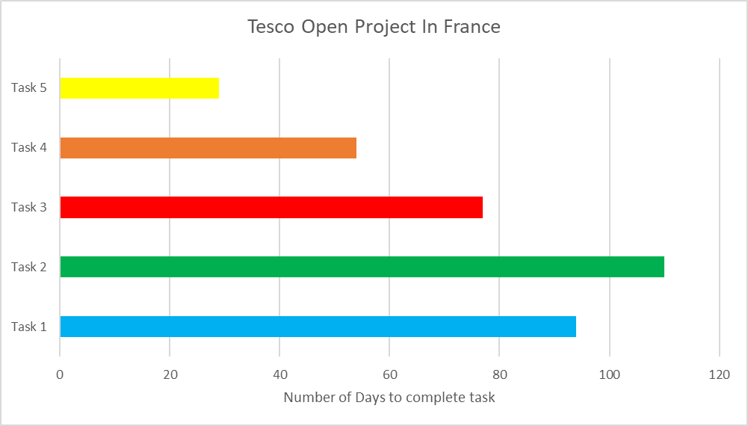

Appendix 5: Value Chain Analysis for Tesco
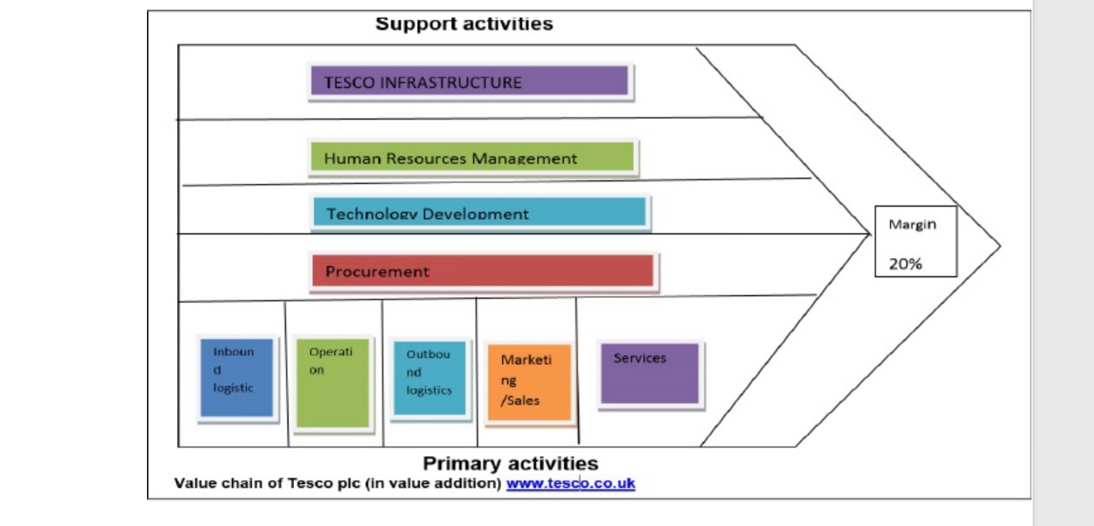
INFRASTUCTURE | Tesco supermarket has invested a lot on technology and innovation they use the ERP enterprise resources planning to take care of their inventory and this system is more innovative, they also use the EPOS and the EFTOS at their point of sale, this system helps to keep stock of inventory and lets them know how many products is remaining in their stock.(Tesco.com 2019)
HUMAN RESOURCES | Tesco has very good HR system management in place which uses different strategies to manage their staff. (Tesco.com 2019)
TECHNOLOGICAL DEVELOPMENT | People can now shop online for Tesco groceries and this can be delivered to them same day due to their technological innovation.
POCUREMENT | Tesco is constantly seeking to employ talented people in its work force and training are giving to their staff for leadership position in the company (Tesco, com 2019)
INBOUND LOGISTICS | Tesco has higher bargaining power over its suppliers due to its over 30% market share in UK, this will be different in France it will either have to still depend on some of its UK suppliers and also use some of its alliance in France to save cost.
OPERATION | Tesco supermarket has strong supply management and this has helped it to develop and gain a huge market share in UK if they can repeat this strategy in France am sure soon they will gain a good market share in France.
OUTBOUND LOGISTICS | Tesco uses both offline and online to carry out their outbound logistics to improve and maximise customers explore to their products.
MARKETING/SALES | Tesco uses their store club cards and airmiles to reward their customers and this has brought about the increase of sales. (data monitoring 2015)
SERVICES | Tesco is known as cost leader and uses products differentiation to gain more customers than its rivals.

Appendix 6


