HTML & CSS Web Development
  - ACCA4023

Benjamin Powell | 2015305 | 16/04/21
|L4 - Introduction to Web and Database Concepts
Contents
Introduction 2
Requirements 2
Implementation 2
Evaluation 7
References 12
Appendices 13

Introduction
Surfing websites is a trivial and oftentimes forgetful part of most people’s daily routine. It is quite fitting therefore, that as part of this assignment I was tasked with developing a website using techniques that would entice users to stay on my website, rather than becoming one of those forgetful websites we seem to visit once to never return. When developing the website, and subsequently this report there were major factors to keep in mind, Usefulness (usability and utility, Accessibility and SEO (Search engine optimization). This report provides an overview of each, as well as establishing how I have attempted to tie each factor into my own website. Other sections of the report establish the requirement of the project, the implementation and evaluation.

Requirements
As part of this assignment, I decided to create a website on a podcast that I have listened to frequently over the current lockdown during the COVI-19 pandemic, the Socially Distant Sports Bar.
The main purpose of the website is to advertise the podcast to attract new listeners to the podcast. As a result of this the website uses a large selection of links to a variety of social media linked to the podcast. The website focuses on the themes heavily seen in the podcast, including sports, pub humor and storytelling. The website also heavily focuses on the three presenters of the podcast, as they are ultimately the main draw and focus. The website also attempts to show small hints of the silly humor that is a major part of the experience, as an attempt to effectively tie the website with the podcast.
The target audience is for a specific, but ultimately large portion of people; those that enjoy sports and pub humor. Despite seeming to target a specific demographic, the site should not face too much difficulty appealing to users as sport is an incredibly popular subject. The podcast has been successful in reaching a relatively large collection of listeners, especially in Wales, drawing in an equivalent of a championship football match crowd per episode. My hope to be able to reach likeminded listeners from other areas of the world through the website.
The website is very relevant, by drawing similar themes and subject to those seen in the podcast. The website has also been sightly influenced by the promotional material used by the podcast, including color, art and presentation. Another goal of mine was to create a seamless link to that of my website to the podcast, so as they could be recognized as an extension of each other.

Implementation
Homepage – My Favorite Podcast: The Socially Distant Sports Bar
The homepage act as the introduction to the topic. In my homepage I added a section that provides an overview of the topic as well as providing some graphics that tie into the themes of the podcast. All pages use a navigation bar as well as a section dedicated to useful links, that enable easy navigation between each page.
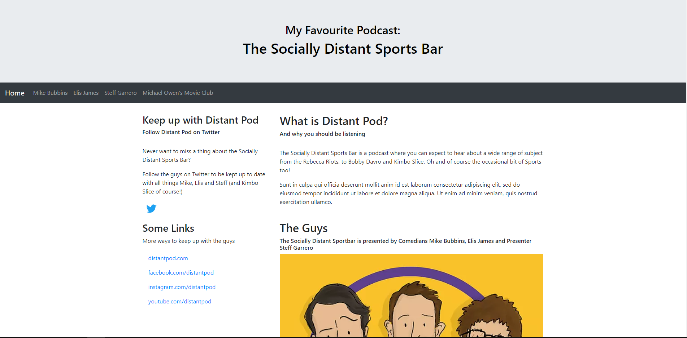
Figure 1 - Home Page

Page 2 – Who is Mike Bubbins
The second page of the website is used to introduce readers to one of the presenters of the podcast, Mike Bubbins. This page provides similar information to that which could be found on a Wikipedia page or other biographical website.
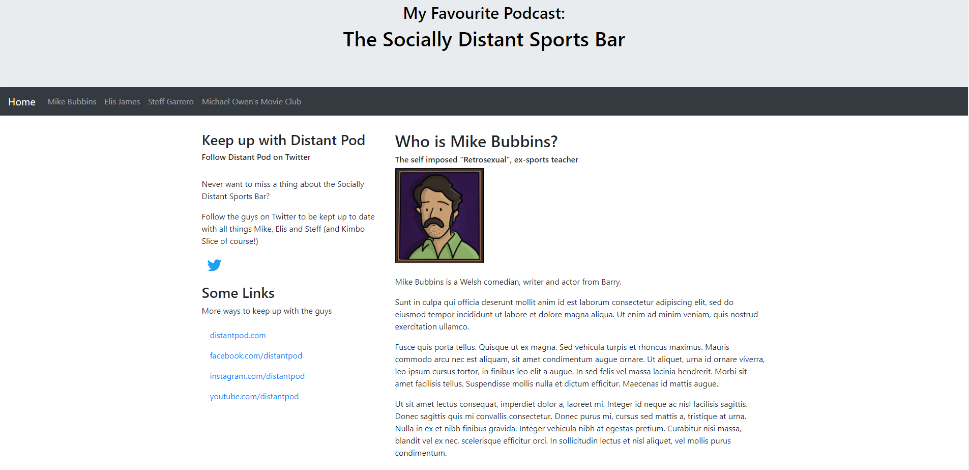
Figure 2 - Who is Mike Bubbins

Page 3 – Who is Elis James
The next page of the website follows the same structure of the previous page, although this time introducing fans to another presenter, Elis James.
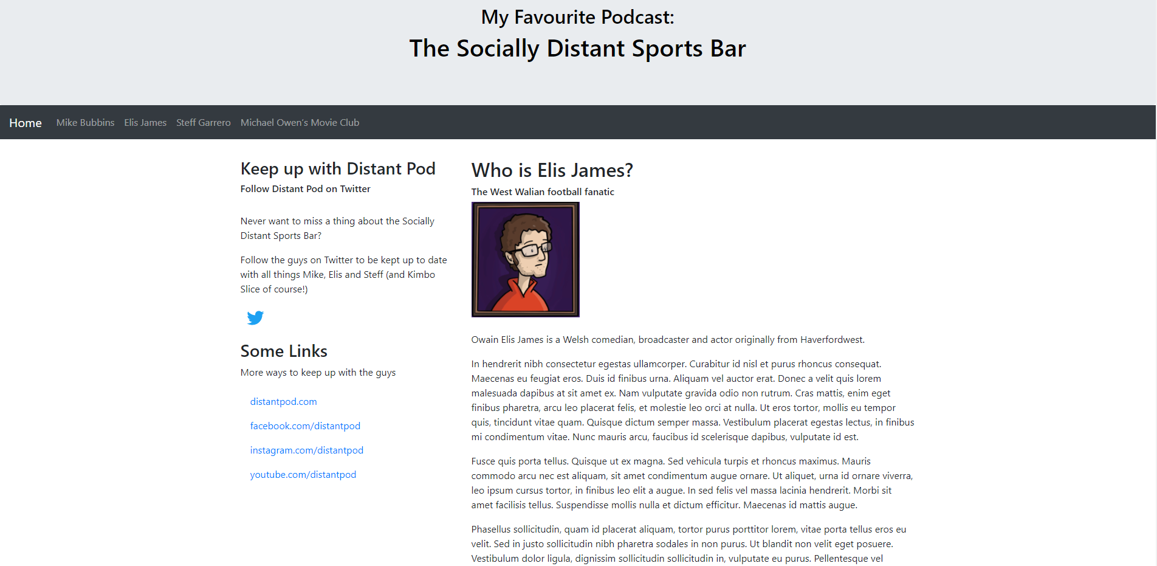
Figure 3 - Who is Elis James

Page 4 – Who is Steff Garrero
Similarly, page 4 provides readers with information on the final presenter of the podcast, Steff Garrero. This page also features the same structure as the previous pages by providing users with information on Steff life and previous work.
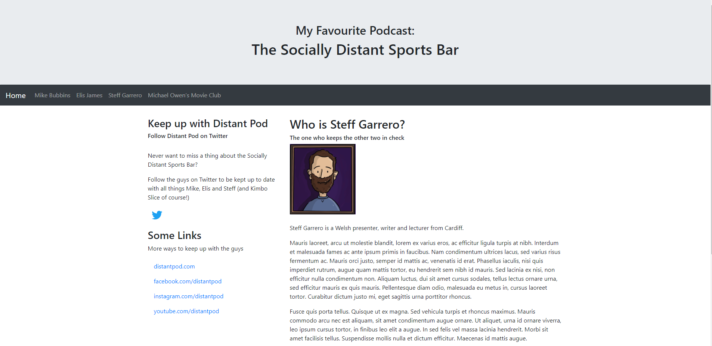
Figure 4 - Who is Steff Garrero

Page 3 – Michael Owen's Movie Club
The final page of the podcast differs from the previous pages by introducing another venture by the presenters of Distant Pod, the Michael Owen’s Movie Club. This is a monthly podcast exclusive to patrons that discusses the presenters’ favorite sports movies. The goal of this page is to offer additional content to those who may be considering listening to the main podcast, as well as introducing the project to those who maybe were not aware of its existence.
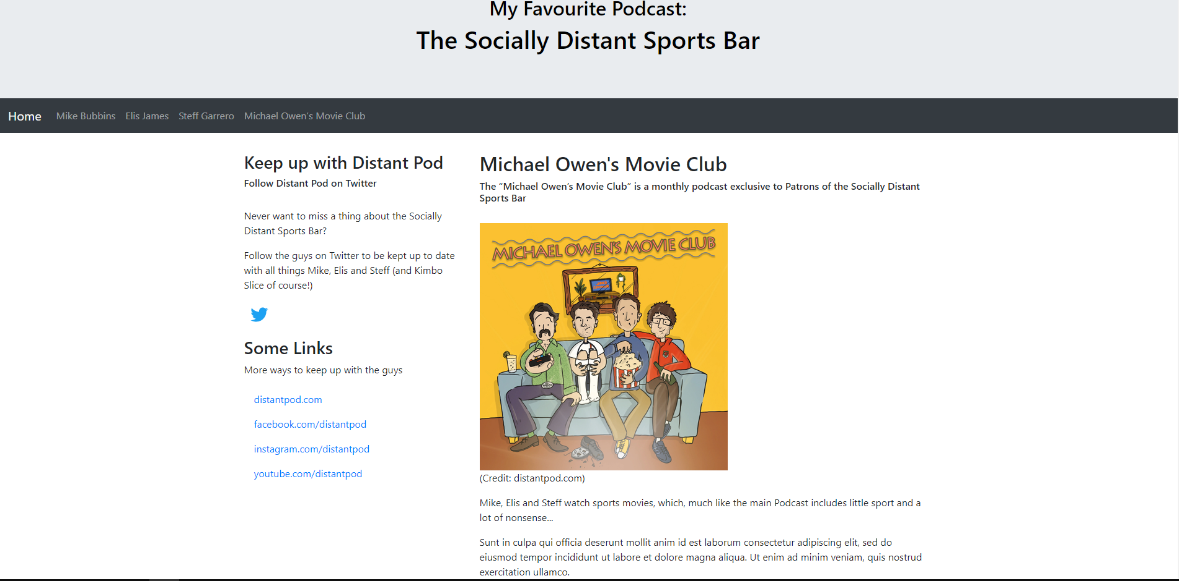
Figure 5 - Michael Owen's Movie Club
Validation
Using the validator tool by w3.org, I was able to validate both HTML and CSS code present in the homepage of my website. After using the tool, it was obvious that there were numerous errors in my code.
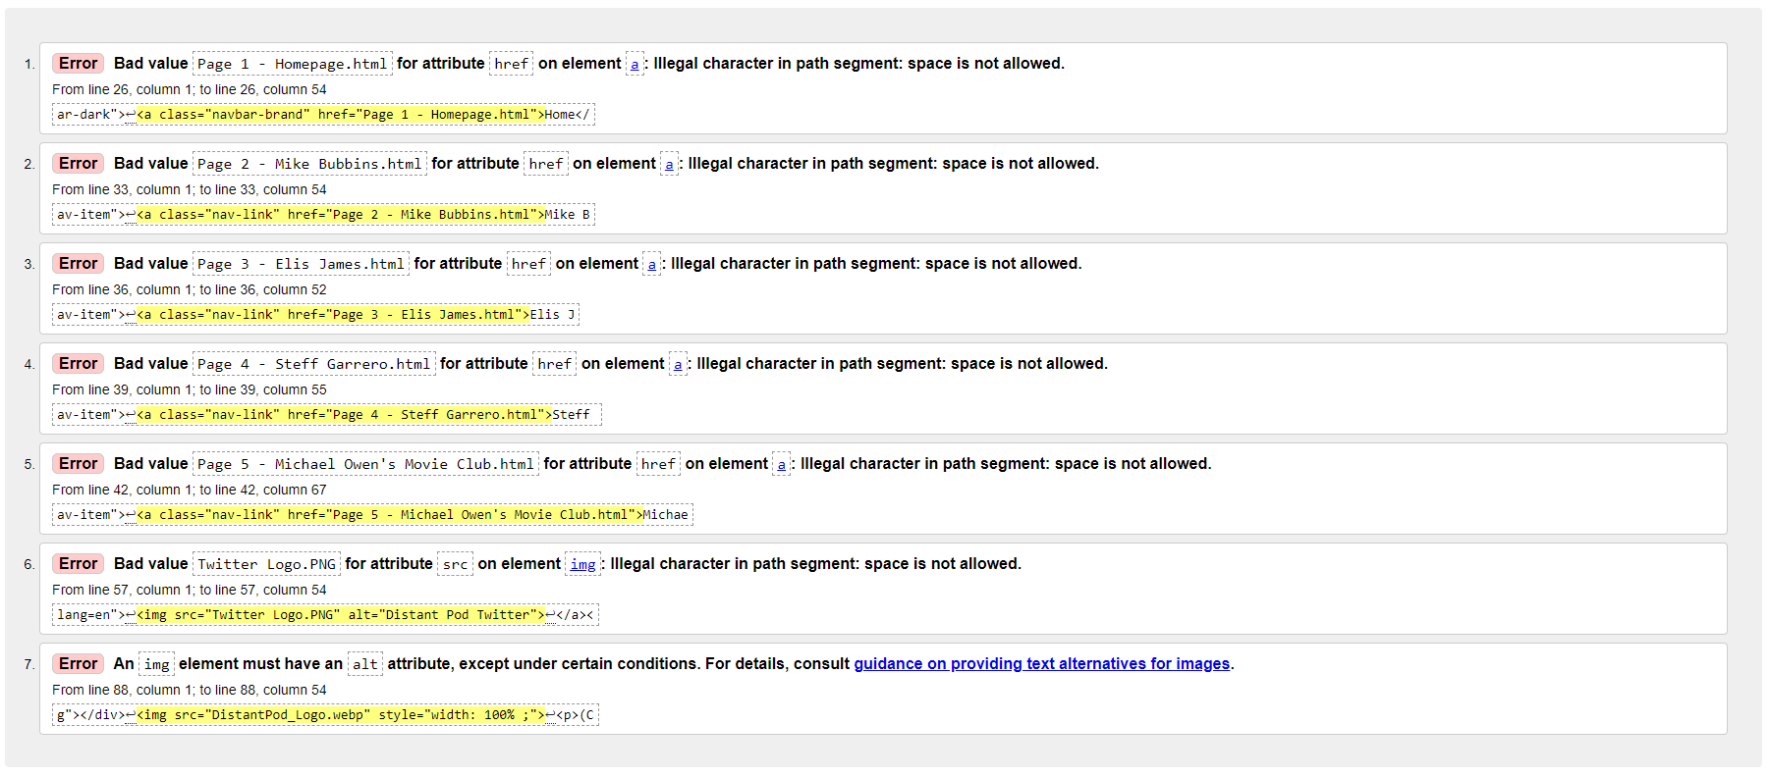
Fortunately, these errors were minor and required very little time to triage and resolve.
- Error 1-6 were due to an illegal character in path segment, specifically that space is not allowed when naming a .html file. This was an easy error to fix and took only a short amount of time to action.
- Error 7 was due to a missing alt attribute in an img element. Again, this was an easy fix which I was able to resolve quickly.
After fixing the above error I used the tool again to validate my code, this was the result:
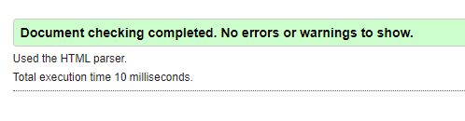

Evaluation
Usability
In its simplest form, website usability is the ability of user to navigate and use a website easily and efficiently. When considering the usability of a website the developer will determine a set of goals involving the usability and presentation of information so that is clearly accessible to the end user. Website with good usability is clear, concise and accessible, and factor in certain variables including users needs, devices and expertise to ensure that it is usable to all.
Good usability can be split into certain attributes to enable good usability. They include.
- Availability/Accessibility – Ensuring that a website is always accessible by users, despite what time or from where they attempt to access it.
- Clarity – Users are easily able to read and find the information they require from a website. This should factor in a user’s needs such as age and potential disability.
- Relevancy – A relevant website makes it obvious to user what service the websites provide to its users. A relevant website can define and determine the goals of its users, resulting in a more user-friendly website.
- Credibility – A credible website can provide assurance to its user that the information it holds is accurate and trustworthy. This is important to keep the attention of users.
- Learnability – This is where users can navigate around the website using their intuition. This is an important design element to ensure users do not get frustrated and can easily find the information they require.
The research paper, Research Trends in Web Site Usability: A Systematic Review, conducted in 2016, analyzed studies conducted into website usability in order to identify trends in the usability issues of websites. As part of the study, they researched into the most frequently used methods in Usability Studies to determine how usability is measured.
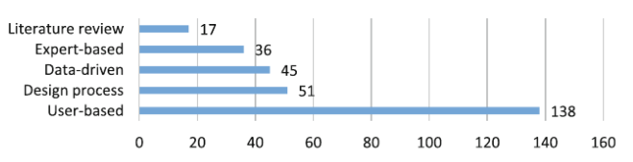
Figure 6 - Methods used in usability studies (Credit: Research Trends in Web Site Usability: A Systematic Review)
The figure above determines that the most common form of usability testing is a literature review, which can be further broken down into testing such as questionnaires, interviews, eye tracking etc. This identifies that developers take a greater deal od consideration into the feedback of user as opposed to observing how to interact with the website.
The report takes a deep evaluation of website studies conducted from 2005-2014 in order to identify trends in the usability issues of websites. In total near 200 studies were used as part of the evaluation. The paper was successful in identifying a wide range of trends connected to the usability of websites, the key findings include.
- The top 3 content of web sites were education (71 studies), business (28 studies), and health (21 studies).
- Very little consideration was taken for the user experience of special user groups (disabled users in 15 studies, expertise differences in 10, cultural differences in 7, individual differences in 5, gender differences in 3, child users in 3, and elderly users in 2).
Not including general usability issues, the most frequently addressed usability issue was identified as navigation (56), methodological issues (41), UI design (38), and finally accessibility (36)
The research paper concluded that the trends identified point towards important implications for future research, and that overall website usability is consistently being taken into less consideration by web developers, with a real concern for future web usability.

Accessibility
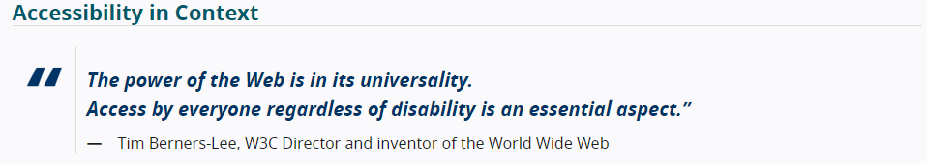
Figure 7 - Accessibility according to Tim Berners-Lee (Credit: w3.org)
Web accessibility is a concept that enables websites, tools and other technologies to be usable to all user, despite any challenges they may face. These challenges can include ability, technology (and lack thereof), language, ability and of course disability. Web accessibility seeks to ensure that all users can understand, navigate and interact with websites easily.
In order to ensure good accessibility, web developers much first understand the difficulties which a user may experience when using their site. A collection of disabilities that could affect a user’s ability to use a website are:
- Visual.
- Physical.
- Neurological.
- Auditory.
- Speech.
- Cognitive.
Accessibility is not strictly limited to disability however and may refer to difficulties that can be experienced by users without disability. This can include users using mobiles or other devices to access a website. Those with diminishing abilities due to ageing or even those with temporary disabilities for example broken bones.
As mentioned, a website with good accessibility much factor in the difficulty of its users. Obvious difficulties that make a user more likely to have trouble using a site include age, poor eyesight and other disabilities (see above). According to the same research paper conducted in 2016 called Research Trends in Web Site Usability: A Systematic Review, the authors identified that only 46% of users do not possess any underlying difficult which affect their website usability (defined as non-special user), leaving 54% of users with some level of difficulty.
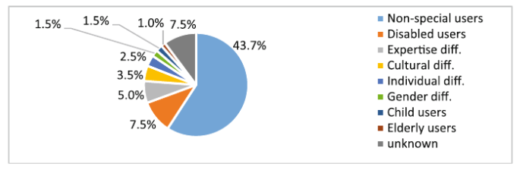
Figure 8 - User Proﬁle Distribution in Usability Studies (Credit: Research Trends in Web Site Usability: A Systematic Review)

Search Engine Optimisation
Search engine optimisation (or SEO) is a process used by a web developer to increase the visibility of their site on search results of search engines such a Google or Bing. Websites with a higher visibility tend to draw a larger audience.
The research paper A Review on Search Engine Optimization: Basics provides user with a greater understanding of SEO and provides a review on the current techniques employed by web developers. The paper can be split into section that provide user with a good grasp of SEO, including types of SEO, Existing Techniques and SEO tools. The paper concludes that SEO provides a great advantage to developers looking to increase the visibility of their site, thought these advantages are largely depends on the technique used. Ultimately the developer should employ the techniques that better suits their needs.
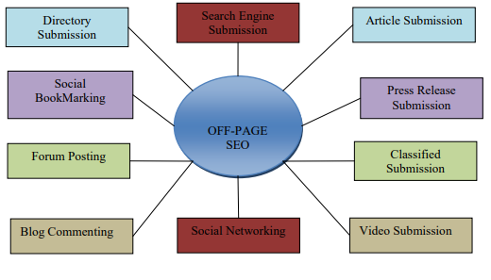
Figure 9 - Off-Page SEO (Credit: A Review on Search Engine Optimization: Basics)
The above figure shows a collection of Off-Page SEO techniques. The paper outlines the techniques that can be used by web developers and splits them into two categories: Off-Page SEO and On-Page SEO. Off page SEO includes methods that can be done off to increase traffic to a website. On-Page SEO on the other hand includes methods on page, by pointing the search engine crawlers read the website content. Both types of techniques can be effective when increasing the visibility of a website.
Evaluating my website
After studying the website, I developed I believe it to be very usable overall. On the case of the website being of a smaller size, users should not experience any difficult comprehending and navigating it. All information is relevant and concise, without providing too much information. Additionally, it is extremely easy to traverse, with easy access to a navigation bar situated at the top of each page. Also, my site is clean and utilizes plenty of open space as not to overwhelm the user.
In order to develop my site for future use it would be necessary to expand on the content provided, as it borders on being too simple. Additionally, I would need to ensure that the content is always kept current.
When developing my website, I placed a greater emphasis on the usability of the website over the visibility. As a result, I believe I lack several on-page SEO techniques that are essential to increase visibility of the webpage. However, this does not mean I neglected SEO entirely. Below are some on-page SEO techniques that can be found in my website:
- Optimised page titles and descriptions.
- Optimised page content.
- Headings and content formatting.
- Internal links and external links.
- Fast page loading speeds.
In order to increase the visibility of my website, I would look to incorporate the following techniques when developing my website in future:
- SEO Images and other multimedia elements.
- URL optimization.
- Increased mobile usability.
- Comments and on-page SEO.
Similarly, accessibility was not a major goal when developing the initial draft of my website. Despite this, the website should be overall accessible to most users, mainly due to its simple design and concept. My website was successful in creating a admirable level of contact between background and text, in both color and size (for example bold heading). The site also features a simple but effective placement which draws the user attention to a centerpiece, whether this is text or a graphic.
Despite this accessibility could be pushed further. An example of this would be to create a greater separation between the sites main content and secondary content (for example the “Some links” section). Also, more effort could be placed on creating a larger text to those with difficulty with eyesight.

References
Research Trends in Web Site Usability: A Systematic Review by Tuba Uğraş, S. Gulsecen, Ceren Çubukçu and Ipek Ili: https://www.researchgate.net/publication/304370784_Research_Trends_in_Web_Site_Usability_A_Systematic_Review
A Review on Search Engine Optimization: Basics by Subodh Gupta, Neha Agrawal and Sandeep Gupta: https://gvpress.com/journals/IJHIT/vol9_no5/32.pdf
DistantPod.com: https://www.distantpod.com/
DistantPod.com/twitter: https://twitter.com/distantpod?lang=en
On-Page SEO Techniques That’ll Boost Your Rankings (Checklist Included): https://www.reliablesoft.net/on-page-seo/
Validator.w3.org https://validator.w3.org/
What Is SEO / Search Engine Optimization?: https://searchengineland.com/guide/what-is-seo
Introduction to Web Accessibility: https://www.w3.org/WAI/fundamentals/accessibility-intro/

Appendices
Appendix 1 – Index.html
<!DOCTYPE html>
<html lang="en">
<head>
<title>Home | My Favourite Podcast: The Socially Distant Sports Bar</title>
<meta charset="utf-8">
<meta name="viewport" content="width=device-width, initial-scale=1">
<link rel="stylesheet" href="https://maxcdn.bootstrapcdn.com/bootstrap/4.5.2/css/bootstrap.min.css">
<script src="https://ajax.googleapis.com/ajax/libs/jquery/3.5.1/jquery.min.js"></script>
<script src="https://cdnjs.cloudflare.com/ajax/libs/popper.js/1.16.0/umd/popper.min.js"></script>
<script src="https://maxcdn.bootstrapcdn.com/bootstrap/4.5.2/js/bootstrap.min.js"></script>
<style>
.fakeimg {
background: #f9c22a;
}
</style>
</head>
<body>

<div class="jumbotron text-center" style="margin-bottom:0; background-image:url(0131_cr.jpg); color:#000000" >

<h2>My Favourite Podcast:</h2>
<h1>The Socially Distant Sports Bar</h1>
</div>

<nav class="navbar navbar-expand-sm bg-dark navbar-dark">
<a class="navbar-brand" href="Index.html">Home</a>
<button class="navbar-toggler" type="button" data-toggle="collapse" data-target="#collapsibleNavbar">
<span class="navbar-toggler-icon"></span>
</button>
<div class="collapse navbar-collapse" id="collapsibleNavbar">
<ul class="navbar-nav">
<li class="nav-item">
<a class="nav-link" href="Page_2_Mike_Bubbins.html">Mike Bubbins</a>
</li>
<li class="nav-item">
<a class="nav-link" href="Page_3_Elis_James.html">Elis James</a>
</li>
<li class="nav-item">
<a class="nav-link" href="Page_4_Steff_Garrero.html">Steff Garrero</a>
</li>
<li class="nav-item">
<a class="nav-link" href="Page_5_Michael_Owen's_Movie_Club.html">Michael Owen’s Movie Club</a>
</li>
</ul>
</div>
</nav>

<div class="container" style="margin-top:30px">
<div class="row">
<div class="col-sm-4">
<h3>Keep up with Distant Pod</h3>
<h6>Follow Distant Pod on Twitter</h6>
<br>
<p>Never want to miss a thing about the Socially Distant Sports Bar?</p>
<p>Follow the guys on Twitter to be kept up to date with all things Mike, Elis and Steff (and Kimbo Slice of course!)</p>
<p><a href="https://twitter.com/distantpod?lang=en">
<img src="Twitter_Logo.PNG" alt="Distant Pod Twitter">
</a></p>
<h3>Some Links</h3>
<p>More ways to keep up with the guys</p>
<ul class="nav nav-pills flex-column">
<li class="nav-item">
<a class="nav-link" href="https://www.distantpod.com/">distantpod.com</a>
</li>
<li class="nav-item">
<a class="nav-link" href="https://www.facebook.com/distantpod">facebook.com/distantpod</a>
</li>
<li class="nav-item">
<a class="nav-link" href="https://www.instagram.com/distantpod/">instagram.com/distantpod</a>
</li>
<li class="nav-item">
<a class="nav-link" href="https://www.youtube.com/channel/UCdPg-dFSGVMfzeE6ITe8ZAw">youtube.com/distantpod</a>
</li>
</ul>
<hr class="d-sm-none">
</div>
<div class="col-sm-8">
<h2>What is Distant Pod?</h2>
<h6>And why you should be listening</h6>
<!-- <div class="fakeimg">Fake Image</div> -->
<br>
<p>The Socially Distant Sports Bar is a podcast where you can expect to hear about a wide range of subject from the Rebecca Riots, to Bobby Davro and Kimbo Slice. Oh and of course the occasional bit of Sports too!</p>
<p>Sunt in culpa qui officia deserunt mollit anim id est laborum consectetur adipiscing elit, sed do eiusmod tempor incididunt ut labore et dolore magna aliqua. Ut enim ad minim veniam, quis nostrud exercitation ullamco.</p>
<br>
<h2>The Guys</h2>
<h6>The Socially Distant Sportbar is presented by Comedians Mike Bubbins, Elis James and Presenter Steff Garrero</h6>
<div class="fakeimg"></div>
<img src="DistantPod_Logo.webp" alt="DistantPodLogo" style="width: 100% ;">
<p>(Credit: distantpod.com)</p>
<p>Sunt in culpa qui officia deserunt mollit anim id est laborum consectetur adipiscing elit, sed do eiusmod tempor incididunt ut labore et dolore magna aliqua. Ut enim ad minim veniam, quis nostrud exercitation ullamco.</p>
</div>
</div>
</div>

<div class="jumbotron text-center" style="margin-bottom:0; background-color: #5e428b; height: 100px;">
<p> Copyright &copy; 2021 BP Web Stuff</p>
</div>

</body>
</html>

Appendix 2 – Page_2_Mike_Bubbins.html
<!DOCTYPE html>
<html lang="en">
<head>
<title>Mike Bubbins | My Favourite Podcast: The Socially Distant Sports Bar</title>
<meta charset="utf-8">
<meta name="viewport" content="width=device-width, initial-scale=1">
<link rel="stylesheet" href="https://maxcdn.bootstrapcdn.com/bootstrap/4.5.2/css/bootstrap.min.css">
<script src="https://ajax.googleapis.com/ajax/libs/jquery/3.5.1/jquery.min.js"></script>
<script src="https://cdnjs.cloudflare.com/ajax/libs/popper.js/1.16.0/umd/popper.min.js"></script>
<script src="https://maxcdn.bootstrapcdn.com/bootstrap/4.5.2/js/bootstrap.min.js"></script>
<style>
.fakeimg {
background: #f9c22a;
}
</style>
</head>
<body>

<div class="jumbotron text-center" style="margin-bottom:0; background-image:url(0131_cr.jpg); color:#000000" >

<h2>My Favourite Podcast:</h2>
<h1>The Socially Distant Sports Bar</h1>
</div>

<nav class="navbar navbar-expand-sm bg-dark navbar-dark">
<a class="navbar-brand" href="Index.html">Home</a>
<button class="navbar-toggler" type="button" data-toggle="collapse" data-target="#collapsibleNavbar">
<span class="navbar-toggler-icon"></span>
</button>
<div class="collapse navbar-collapse" id="collapsibleNavbar">
<ul class="navbar-nav">
<li class="nav-item">
<a class="nav-link" href="Page_2_Mike_Bubbins.html">Mike Bubbins</a>
</li>
<li class="nav-item">
<a class="nav-link" href="Page_3_Elis_James.html">Elis James</a>
</li>
<li class="nav-item">
<a class="nav-link" href="Page_4_Steff_Garrero.html">Steff Garrero</a>
</li>
<li class="nav-item">
<a class="nav-link" href="Page_5_Michael_Owen's_Movie_Club.html">Michael Owen’s Movie Club</a>
</li>
</ul>
</div>
</nav>

<div class="container" style="margin-top:30px">
<div class="row">
<div class="col-sm-4">
<h3>Keep up with Distant Pod</h3>
<h6>Follow Distant Pod on Twitter</h6>
<br>
<p>Never want to miss a thing about the Socially Distant Sports Bar?</p>
<p>Follow the guys on Twitter to be kept up to date with all things Mike, Elis and Steff (and Kimbo Slice of course!)</p>
<p><a href="https://twitter.com/distantpod?lang=en">
<img src="Twitter_Logo.PNG" alt="Distant Pod Twitter">
</a></p>
<h3>Some Links</h3>
<p>More ways to keep up with the guys</p>
<ul class="nav nav-pills flex-column">
<li class="nav-item">
<a class="nav-link" href="https://www.distantpod.com/">distantpod.com</a>
</li>
<li class="nav-item">
<a class="nav-link" href="https://www.facebook.com/distantpod">facebook.com/distantpod</a>
</li>
<li class="nav-item">
<a class="nav-link" href="https://www.instagram.com/distantpod/">instagram.com/distantpod</a>
</li>
<li class="nav-item">
<a class="nav-link" href="https://www.youtube.com/channel/UCdPg-dFSGVMfzeE6ITe8ZAw">youtube.com/distantpod</a>
</li>
<br>
</ul>
<hr class="d-sm-none">
</div>
<div class="col-sm-8">
<h2>Who is Mike Bubbins?</h2>
<h6>The self imposed "Retrosexual", ex-sports teacher</h6>
<img src="Mike Bubbins.PNG">
<br>
<br>
<p>Mike Bubbins is a Welsh comedian, writer and actor from Barry.</p>
<p>Sunt in culpa qui officia deserunt mollit anim id est laborum consectetur adipiscing elit, sed do eiusmod tempor incididunt ut labore et dolore magna aliqua. Ut enim ad minim veniam, quis nostrud exercitation ullamco.</p>
<p>Fusce quis porta tellus. Quisque ut ex magna. Sed vehicula turpis et rhoncus maximus. Mauris commodo arcu nec est aliquam, sit amet condimentum augue ornare. Ut aliquet, urna id ornare viverra, leo ipsum cursus tortor, in finibus leo elit a augue. In sed felis vel massa lacinia hendrerit. Morbi sit amet facilisis tellus. Suspendisse mollis nulla et dictum efficitur. Maecenas id mattis augue.</p>
<p>Ut sit amet lectus consequat, imperdiet dolor a, laoreet mi. Integer id neque ac nisl facilisis sagittis. Donec sagittis quis mi convallis consectetur. Donec purus mi, cursus sed mattis a, tristique at urna. Nulla in ex et nibh finibus gravida. Integer vehicula nibh at egestas pretium. Curabitur nisi massa, blandit vel ex nec, scelerisque efficitur orci. In sollicitudin lectus et nisl aliquet, vel mollis purus condimentum.</p>
<br>
<p>(Image Credit: distantpod.com)</p>
<br>

</div>
</div>
</div>

<div class="jumbotron text-center" style="margin-bottom:0; background-color: #5e428b; height: 100px;">
<p> Copyright &copy; 2021 BP Web Stuff</p>
</div>

</body>
</html>

Appendix 3 – Page_3_Elis James.html
<!DOCTYPE html>
<html lang="en">
<head>
<title>Elis James | My Favourite Podcast: The Socially Distant Sports Bar</title>
<meta charset="utf-8">
<meta name="viewport" content="width=device-width, initial-scale=1">
<link rel="stylesheet" href="https://maxcdn.bootstrapcdn.com/bootstrap/4.5.2/css/bootstrap.min.css">
<script src="https://ajax.googleapis.com/ajax/libs/jquery/3.5.1/jquery.min.js"></script>
<script src="https://cdnjs.cloudflare.com/ajax/libs/popper.js/1.16.0/umd/popper.min.js"></script>
<script src="https://maxcdn.bootstrapcdn.com/bootstrap/4.5.2/js/bootstrap.min.js"></script>
<style>
.fakeimg {
background: #f9c22a;
}
</style>
</head>
<body>

<div class="jumbotron text-center" style="margin-bottom:0; background-image:url(0131_cr.jpg); color:#000000" >

<h2>My Favourite Podcast:</h2>
<h1>The Socially Distant Sports Bar</h1>
</div>

<nav class="navbar navbar-expand-sm bg-dark navbar-dark">
<a class="navbar-brand" href="Index.html">Home</a>
<button class="navbar-toggler" type="button" data-toggle="collapse" data-target="#collapsibleNavbar">
<span class="navbar-toggler-icon"></span>
</button>
<div class="collapse navbar-collapse" id="collapsibleNavbar">
<ul class="navbar-nav">
<li class="nav-item">
<a class="nav-link" href="Page_2_Mike_Bubbins.html">Mike Bubbins</a>
</li>
<li class="nav-item">
<a class="nav-link" href="Page_3_Elis_James.html">Elis James</a>
</li>
<li class="nav-item">
<a class="nav-link" href="Page_4_Steff_Garrero.html">Steff Garrero</a>
</li>
<li class="nav-item">
<a class="nav-link" href="Page_5_Michael_Owen's_Movie_Club.html">Michael Owen’s Movie Club</a>
</li>
</ul>
</div>
</nav>

<div class="container" style="margin-top:30px">
<div class="row">
<div class="col-sm-4">
<h3>Keep up with Distant Pod</h3>
<h6>Follow Distant Pod on Twitter</h6>
<br>
<p>Never want to miss a thing about the Socially Distant Sports Bar?</p>
<p>Follow the guys on Twitter to be kept up to date with all things Mike, Elis and Steff (and Kimbo Slice of course!)</p>
<p><a href="https://twitter.com/distantpod?lang=en">
<img src="Twitter_Logo.PNG" alt="Distant Pod Twitter">
</a></p>
<h3>Some Links</h3>
<p>More ways to keep up with the guys</p>
<ul class="nav nav-pills flex-column">
<li class="nav-item">
<a class="nav-link" href="https://www.distantpod.com/">distantpod.com</a>
</li>
<li class="nav-item">
<a class="nav-link" href="https://www.facebook.com/distantpod">facebook.com/distantpod</a>
</li>
<li class="nav-item">
<a class="nav-link" href="https://www.instagram.com/distantpod/">instagram.com/distantpod</a>
</li>
<li class="nav-item">
<a class="nav-link" href="https://www.youtube.com/channel/UCdPg-dFSGVMfzeE6ITe8ZAw">youtube.com/distantpod</a>
</li>
<br>
</ul>
<hr class="d-sm-none">
</div>
<div class="col-sm-8">
<h2>Who is Elis James?</h2>
<h6>The West Walian football fanatic</h6>
<img src="Elis James.PNG">
<br>
<br>
<p>Owain Elis James is a Welsh comedian, broadcaster and actor originally from Haverfordwest.</p>
<p>In hendrerit nibh consectetur egestas ullamcorper. Curabitur id nisl et purus rhoncus consequat. Maecenas eu feugiat eros. Duis id finibus urna. Aliquam vel auctor erat. Donec a velit quis lorem malesuada dapibus at sit amet ex. Nam vulputate gravida odio non rutrum. Cras mattis, enim eget finibus pharetra, arcu leo placerat felis, et molestie leo orci at nulla. Ut eros tortor, mollis eu tempor quis, tincidunt vitae quam. Quisque dictum semper massa. Vestibulum placerat egestas lectus, in finibus mi condimentum vitae. Nunc mauris arcu, faucibus id scelerisque dapibus, vulputate id est.</p>
<p>Fusce quis porta tellus. Quisque ut ex magna. Sed vehicula turpis et rhoncus maximus. Mauris commodo arcu nec est aliquam, sit amet condimentum augue ornare. Ut aliquet, urna id ornare viverra, leo ipsum cursus tortor, in finibus leo elit a augue. In sed felis vel massa lacinia hendrerit. Morbi sit amet facilisis tellus. Suspendisse mollis nulla et dictum efficitur. Maecenas id mattis augue.</p>
<p>Phasellus sollicitudin, quam id placerat aliquam, tortor purus porttitor lorem, vitae porta tellus eros eu velit. Sed in justo sollicitudin nibh pharetra sodales in non purus. Ut blandit non velit eget posuere. Vestibulum dolor ligula, dignissim sollicitudin sollicitudin in, vulputate eu purus. Pellentesque vel pellentesque dolor. Nunc suscipit metus ac lacus lobortis finibus. Curabitur condimentum metus nibh, vitae varius tellus posuere eu. Aenean nec viverra lorem.</p>
<br>
<p>(Image Credit: distantpod.com)</p>
<br>

</div>
</div>
</div>

<div class="jumbotron text-center" style="margin-bottom:0; background-color: #5e428b; height: 100px;">
<p> Copyright &copy; 2021 BP Web Stuff</p>
</div>

</body>
</html>

Appendix 4 – Page_4_Steff_Garrero.html
<!DOCTYPE html>
<html lang="en">
<head>
<title>Steff Garrero | My Favourite Podcast: The Socially Distant Sports Bar</title>
<meta charset="utf-8">
<meta name="viewport" content="width=device-width, initial-scale=1">
<link rel="stylesheet" href="https://maxcdn.bootstrapcdn.com/bootstrap/4.5.2/css/bootstrap.min.css">
<script src="https://ajax.googleapis.com/ajax/libs/jquery/3.5.1/jquery.min.js"></script>
<script src="https://cdnjs.cloudflare.com/ajax/libs/popper.js/1.16.0/umd/popper.min.js"></script>
<script src="https://maxcdn.bootstrapcdn.com/bootstrap/4.5.2/js/bootstrap.min.js"></script>
<style>
.fakeimg {
background: #f9c22a;
}
</style>
</head>
<body>

<div class="jumbotron text-center" style="margin-bottom:0; background-image:url(0131_cr.jpg); color:##000000" >

<h2>My Favourite Podcast:</h2>
<h1>The Socially Distant Sports Bar</h1>
</div>

<nav class="navbar navbar-expand-sm bg-dark navbar-dark">
<a class="navbar-brand" href="Index.html">Home</a>
<button class="navbar-toggler" type="button" data-toggle="collapse" data-target="#collapsibleNavbar">
<span class="navbar-toggler-icon"></span>
</button>
<div class="collapse navbar-collapse" id="collapsibleNavbar">
<ul class="navbar-nav">
<li class="nav-item">
<a class="nav-link" href="Page_2_Mike_Bubbins.html">Mike Bubbins</a>
</li>
<li class="nav-item">
<a class="nav-link" href="Page_3_Elis_James.html">Elis James</a>
</li>
<li class="nav-item">
<a class="nav-link" href="Page_4_Steff_Garrero.html">Steff Garrero</a>
</li>
<li class="nav-item">
<a class="nav-link" href="Page_5_Michael_Owen's_Movie_Club.html">Michael Owen’s Movie Club</a>
</li>
</ul>
</div>
</nav>

<div class="container" style="margin-top:30px">
<div class="row">
<div class="col-sm-4">
<h3>Keep up with Distant Pod</h3>
<h6>Follow Distant Pod on Twitter</h6>
<br>
<p>Never want to miss a thing about the Socially Distant Sports Bar?</p>
<p>Follow the guys on Twitter to be kept up to date with all things Mike, Elis and Steff (and Kimbo Slice of course!)</p>
<p><a href="https://twitter.com/distantpod?lang=en">
<img src="Twitter_Logo.PNG" alt="Distant Pod Twitter">
</a></p>
<h3>Some Links</h3>
<p>More ways to keep up with the guys</p>
<ul class="nav nav-pills flex-column">
<li class="nav-item">
<a class="nav-link" href="https://www.distantpod.com/">distantpod.com</a>
</li>
<li class="nav-item">
<a class="nav-link" href="https://www.facebook.com/distantpod">facebook.com/distantpod</a>
</li>
<li class="nav-item">
<a class="nav-link" href="https://www.instagram.com/distantpod/">instagram.com/distantpod</a>
</li>
<li class="nav-item">
<a class="nav-link" href="https://www.youtube.com/channel/UCdPg-dFSGVMfzeE6ITe8ZAw">youtube.com/distantpod</a>
</li>
<br>
</ul>
<hr class="d-sm-none">
</div>
<div class="col-sm-8">
<h2>Who is Steff Garrero?</h2>
<h6>The one who keeps the other two in check</h6>
<img src="Steff Garrero.PNG">
<br>
<br>
<p>Steff Garrero is a Welsh presenter, writer and lecturer from Cardiff.</p>
<p>Mauris laoreet, arcu ut molestie blandit, lorem ex varius eros, ac efficitur ligula turpis at nibh. Interdum et malesuada fames ac ante ipsum primis in faucibus. Nam condimentum ultrices lacus, sed varius risus fermentum ac. Mauris orci justo, semper id mattis ac, venenatis id erat. Phasellus iaculis, nisi quis imperdiet rutrum, augue quam mattis tortor, eu hendrerit sem nibh id mauris. Sed lacinia ex nisi, non efficitur nulla condimentum non. Aliquam luctus, dui sit amet cursus sodales, tellus lectus ornare urna, sed efficitur mauris ex quis mauris. Pellentesque diam odio, malesuada eu metus in, cursus laoreet tortor. Curabitur dictum justo mi, eget sagittis urna porttitor rhoncus.</p>
<p>Fusce quis porta tellus. Quisque ut ex magna. Sed vehicula turpis et rhoncus maximus. Mauris commodo arcu nec est aliquam, sit amet condimentum augue ornare. Ut aliquet, urna id ornare viverra, leo ipsum cursus tortor, in finibus leo elit a augue. In sed felis vel massa lacinia hendrerit. Morbi sit amet facilisis tellus. Suspendisse mollis nulla et dictum efficitur. Maecenas id mattis augue.</p>
<p>Integer id neque ac nisl facilisis sagittis. Donec sagittis quis mi convallis consectetur. Donec purus mi, cursus sed mattis a, tristique at urna. Nulla in ex et nibh finibus gravida. Integer vehicula nibh at egestas pretium. Curabitur nisi massa, blandit vel ex nec, scelerisque efficitur orci. In sollicitudin lectus et nisl aliquet, vel mollis purus condimentum.</p>
<br>
<p>(Image Credit: distantpod.com)</p>
<br>

</div>
</div>
</div>

<div class="jumbotron text-center" style="margin-bottom:0; background-color: #5e428b; height: 100px;">
<p> Copyright &copy; 2021 BP Web Stuff</p>
</div>

</body>
</html>

Appendix 4 – Page_5 _Michael_Owen's_Movie_Club.html
<!DOCTYPE html>
<html lang="en">
<head>
<title>Michael Owen's Movie Club | My Favourite Podcast: The Socially Distant Sports Bar</title>
<meta charset="utf-8">
<meta name="viewport" content="width=device-width, initial-scale=1">
<link rel="stylesheet" href="https://maxcdn.bootstrapcdn.com/bootstrap/4.5.2/css/bootstrap.min.css">
<script src="https://ajax.googleapis.com/ajax/libs/jquery/3.5.1/jquery.min.js"></script>
<script src="https://cdnjs.cloudflare.com/ajax/libs/popper.js/1.16.0/umd/popper.min.js"></script>
<script src="https://maxcdn.bootstrapcdn.com/bootstrap/4.5.2/js/bootstrap.min.js"></script>
<style>
.fakeimg {
background: #f9c22a;
}
</style>
</head>
<body>

<div class="jumbotron text-center" style="margin-bottom:0; background-image:url(0131_cr.jpg); color:#000000" >

<h2>My Favourite Podcast:</h2>
<h1>The Socially Distant Sports Bar</h1>
</div>

<nav class="navbar navbar-expand-sm bg-dark navbar-dark">
<a class="navbar-brand" href="Index.html">Home</a>
<button class="navbar-toggler" type="button" data-toggle="collapse" data-target="#collapsibleNavbar">
<span class="navbar-toggler-icon"></span>
</button>
<div class="collapse navbar-collapse" id="collapsibleNavbar">
<ul class="navbar-nav">
<li class="nav-item">
<a class="nav-link" href="Page_2_Mike_Bubbins.html">Mike Bubbins</a>
</li>
<li class="nav-item">
<a class="nav-link" href="Page_3_Elis_James.html">Elis James</a>
</li>
<li class="nav-item">
<a class="nav-link" href="Page_4_Steff_Garrero.html">Steff Garrero</a>
</li>
<li class="nav-item">
<a class="nav-link" href="Page_5_Michael_Owen's_Movie_Club.html">Michael Owen’s Movie Club</a>
</li>
</ul>
</div>
</nav>

<div class="container" style="margin-top:30px">
<div class="row">
<div class="col-sm-4">
<h3>Keep up with Distant Pod</h3>
<h6>Follow Distant Pod on Twitter</h6>
<br>
<p>Never want to miss a thing about the Socially Distant Sports Bar?</p>
<p>Follow the guys on Twitter to be kept up to date with all things Mike, Elis and Steff (and Kimbo Slice of course!)</p>
<p><a href="https://twitter.com/distantpod?lang=en">
<img src="Twitter_Logo.PNG" alt="Distant Pod Twitter">
</a></p>
<h3>Some Links</h3>
<p>More ways to keep up with the guys</p>
<ul class="nav nav-pills flex-column">
<li class="nav-item">
<a class="nav-link" href="https://www.distantpod.com/">distantpod.com</a>
</li>
<li class="nav-item">
<a class="nav-link" href="https://www.facebook.com/distantpod">facebook.com/distantpod</a>
</li>
<li class="nav-item">
<a class="nav-link" href="https://www.instagram.com/distantpod/">instagram.com/distantpod</a>
</li>
<li class="nav-item">
<a class="nav-link" href="https://www.youtube.com/channel/UCdPg-dFSGVMfzeE6ITe8ZAw">youtube.com/distantpod</a>
</li>
</ul>
<hr class="d-sm-none">
</div>
<div class="col-sm-8">
<h2>Michael Owen's Movie Club</h2>
<h6>The “Michael Owen’s Movie Club” is a monthly podcast exclusive to Patrons of the Socially Distant Sports Bar</h6>
<br>
<div class="fakeimg"></div>
<img src="Michael Owen's Movie Club.JPG">
<p>(Credit: distantpod.com)</p>
<p>Mike, Elis and Steff watch sports movies, which, much like the main Podcast includes little sport and a lot of nonsense...</p>
<p>Sunt in culpa qui officia deserunt mollit anim id est laborum consectetur adipiscing elit, sed do eiusmod tempor incididunt ut labore et dolore magna aliqua. Ut enim ad minim veniam, quis nostrud exercitation ullamco.</p>
<p>Etiam sed eleifend dui, non posuere massa. Nunc lacinia neque in magna porttitor, a facilisis sem dictum. Pellentesque condimentum venenatis justo, semper condimentum elit ullamcorper ut. Aenean ullamcorper, tellus at facilisis vulputate, orci erat viverra sapien, eget luctus magna tellus in magna. In vel ex malesuada, faucibus dui sed, posuere nunc. Aenean faucibus velit eget iaculis ultricies. Mauris ultricies ac erat id laoreet.</p>
<p>To gain access to the Michael Owen’s Movie Club visit <a href="https://www.distantpod.com/patreon"> DistantPod.com</a>
</div>
</div>
</div>

<div class="jumbotron text-center" style="margin-bottom:0; background-color: #5e428b; height: 100px;">
<p> Copyright &copy; 2021 BP Web Stuff</p>
</div>

</body>
</html>

