Professional Portfolio plus 1,000 word Reflective Written Summary.
Marisa Pinto

Psychology for work

​​

​
​
​​

Table of contents:

Reflective Written Summary: 2
Evidence 1 4
Evidence 2 5
Evidence 3 6
References: 7
Appendix 8

Reflective Written Summary:

My preferred way of learning is visual so participating in this placement was out of my comfort zone. For this placement, I used admiral my current employment, because it required me to make my own decisions and be confident in what I do. It was largely based on listening and hands-on work. Due to experiencing calls, discussing personal difficulties and many changes, the thought of doing something wrong left me uneasy. Despite these negative feelings I was determined to learn and expand on my skills. Throughout this portfolio I will be using Gibbs’ Reflective cycle (1998) to reflect upon my experiences.

When beginning my placement, there was an emphasis on customer support. I engaged in training to enable me to adhere to the organisation's regulations. Such as using scripts when a customer stated additional needs because of their health. For example, Parkinsons disease or dyslexia. These situations occurred frequently but due to the sensitivity of them, when they first occurred it made me uneasy and anxious. Fortunately, the scripts were there to ensure consent was provided to record their situation and to provide additional support for me whilst recording them. There are adjustments that can be communicated with the customer such as providing follow up emails or speaking slower which ensures they receive more support than they would typically receive. Which according to Mouawad & Kleiner, (1996) this has been effective in ensuring businesses who provide more than the bare minimum are rated far better than their competitors. Despite this being a delicate situation and making me feel uneasy, I left these calls understanding the necessity of these procedures. It made me more empathetic as I try to put myself in others situation which has been important in reducing anxiety levels and increasing customer confidence (Naji et al., 2020). It allowed me to recognise logging this customer support would assist in both mine, others and the customers call journey. I learnt how important reflection is and its impact on successful decision making and communication (Adams et al., 2006). When originally experiencing this situation, I felt out of control and immense anxiety due to having to discuss a customer's personal struggle, this made me go into a spiral of negativity, not seeing any positives in these regulations. However, this new skill of reflection has really allowed me to comprehend the importance of not letting these subjective opinions of a situation influence the outcome. which allowed me to understand why protocols exist which indirectly improve my communication skills in which I can now handle problems or demands by just communicating.

Since my placement involved interacting with customers whose needs are constantly changing, I was required to learn new systems and triage routes. A lot of the new systems have overridden what I was first trained on. Additionally, as my job was heavily reliant on IT, when these new routes and systems were being implemented, our systems went down, which made working unsettling and challenging as I depended on the original way of working to help with the setup and flow of my calls. As a result, like many other trainings we have done, we were trained on how to temporarily operate without the system and trained on what was changing. This ensure that I can adapt to change and make my own decision which gives me more skills than many other job roles would give, which can help the company be at an advantage to its competitors due to this increase in knowledge (Noe & Tews, 2008). These changes and difficulties made me feel uneasy especially as it would not be the last time it occurs. However, the training which is provided in the appendix under evidence 2 made me feel ready to deal with what was coming as it outlined what was necessary and not only helped with the new procedure but also helped make me understand their reasoning. This made me open to changes and understand the necessity of these situations despite them feeling daunting at times, it also meant when the situation arose again, I never felt the same level of anxiousness, as I had felt prepared for it. Thus, it had put me at ease. As a result, I gained skills such as increased willingness to learn even if I was not aware of what was to come.

I have gained many skills from my placement. Since my job is mostly based around the use of IT I have had to deal and adapt to IT issues on numerous occasions. For example, I have had to frequently experience internet and system crashes when working from home, which makes it difficult for me to perform my role as a claims handler. Working from home means my job heavily relies on IT, and technical problems are one of the major concerns when remote working (Ferreira et Al., 2021). When these issues first occurred, it made me extremely anxious and caused me to panic, this panic put me in a worried state for most of the day. However, I used my reflective skills to discuss my issues with my manager and IT, I then allowed the situation to resolve itself as its out of my control. These IT issues have occurred when on call, so I had to voice what has happened to the customer and offer a callback. It was unsettling at first but with the new hybrid working it is not anything out of the ordinary. As my work is both based around IT and hybrid, these issues do arise a lot which often means I have needed to juggle these situations and find solutions to the problems, it has made me more resilient as I have learnt to adapt to these changes and continue despite all the setbacks (Ovans, 2015). Due to this, I feel that these experiences have increased my adaptability skills as I can overcome issues that arise. Furthermore, this has meant that I have been exposed to real life issues that can happen anytime and these challenges at work have helped develop further skills such as critical thinking (Membrillo-Hernández et al., 2019). I believe this placement has enabled me to gain a variety of transferable skills which will be useful in increasing my confidence in other job roles. Furthermore, I believe I can directly apply these newly gained skills to my current degree in psychology, particularly in enhancing my time management skills to meet deadlines and collaborative teamwork. Every difficulty I have faced whilst in my placement has been invaluable in my professional and personal development.

Evidence 1

This is the evidence of training I have done overtime for Customer Support. Such as learning how to log it, learning triggers and cues that suggest customer support is necessary and the necessary Scripts

These are scripts that i was trained on where I must follow whilst on the phone with a customer to ensure informed consent is collected to note customers’ needs

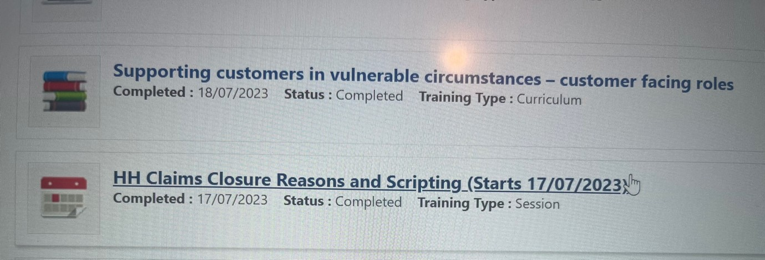

This training has emphasised the importance of listening to a customer and their needs and to identify if any future support is needed. As it has trained me to be able to pick up on things that may help the customer and also future handlers of a call/ claim when discussing situations with the policy holder.

Further on From the Script Training we were sent training on how to support the vulnerable customers by learning cues such as comments a customer makes on their situation and whether that falls into a category of needing customer support.

Evidence 2

This piece of evidence was compulsory training material I had to read when our system “Guidewire” Was undergoing a Upgrade, this discussed what was going to happen and for how long it was down for

We had to read through all the material they provided before going on calls to ensure we knew what was required. For example:
- We could not log into this system as it would slow the upgrading time.
- We needed to follow another procedure provided which gave customers the chance to call us back when it’s up and running or assigned them a callback.

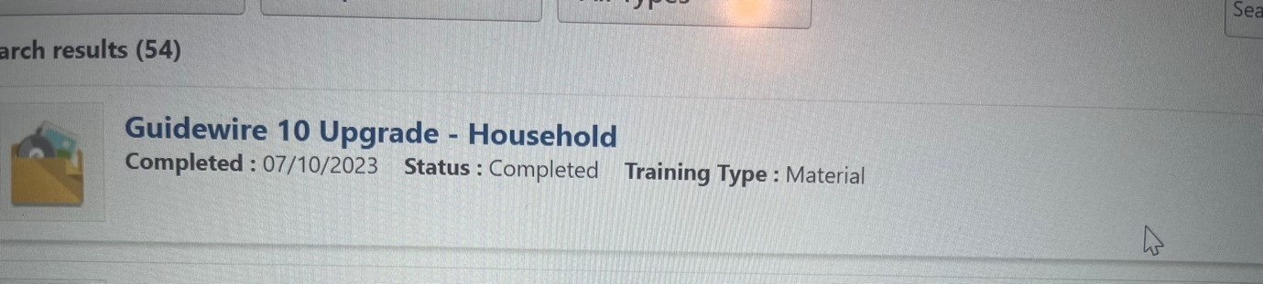

This document did touch up on really important information such as:
- Reinforcing the importance of not discussing any personal information with customers regarding their policy as there is no way of going through Data protection (DPA) due to the system being down for the upgrade.

Evidence 3
There have been many times in which I have had IT issues, I don’t have physical proof however, as my job relies on internet and service as our work style is hybrid when working from home sometimes this is not the best.
IT issues such as system failure/ Freezing, needing restarting or even just service and internet issues can all affect work. For example:
- Sometimes calls drop in which I need to call customers back.
- Sometimes a automatic restarts starts whilst I’m noting a claim and on call so I also need to contact the customer.
- Sometimes there’s IT issues in which I wont be able to find the PH policy or log anything in due to a glitch



Steps in place to resolve these issues such as:
- if it’s a consistent problem then you call IT and they will resolve it for you.
- Sometimes a full restart is sufficient.
- Sometimes the computer is overloaded so clearing browsing history works to fix certain IT glitches.
The job is mainly IT based so these things are bound to happen. Also, due to this new hybrid way of working these situations happen often therefore, you just need to take your time and try resolve them.

References:

Adams, C. L., Nestel, D., & Wolf, P. (2006). Reflection: A critical proficiency essential to the effective development of a high competence in communication. Journal of Veterinary Medical Education, 33(1), 58-64. https://jvme.utpjournals.press/doi/full/10.3138/jvme.33.1.58

Ferreira, R., Pereira, R., Bianchi, I. S., & da Silva, M. M. (2021). Decision factors for remote work adoption: advantages, disadvantages, driving forces and challenges. Journal of Open Innovation: Technology, Market, and Complexity, 7(1), 70. https://doi.org/10.3390/joitmc7010070

Gibbs, G. (1988). Learning by Doing: A guide to teaching and learning methods. Oxford Polytechnic

Gómez, E., Muñoz-Díaz, E., & Elizalde, H. (2019). Challenge based learning: the importance of world-leading companies as training partners. International Journal on Interactive Design and Manufacturing, 13(3), 1103–1113. https://doi.org/10.1007/s12008-019-00569-4

Mouawad, M., & Kleiner, B. H. (1996). New developments in customer service training. Managing Service Quality: An International Journal, 6(2), 49-56. https://www.emerald.com/insight/content/doi/10.1108/09604529610109774/full/html

Naji, Z., Salamati, P., & Koutlaki, S. A. (2020). The importance of empathy to alleviate patients’ anxiety. Burns, 46(4), 987–987. https://doi.org/10.1016/j.burns.2020.02.018

Noe, R. A., & Tews, M. J. (2008). Strategic training and development. In J. Storey, P. M. Wright, & D. Ulrich, The Routledge companion to strategic human resource management (pp. 262-284). Routledge Handbooks Online. http://ndl.ethernet.edu.et/bitstream/123456789/51370/1/57%202009.pdf#page=285

Ovans, A. (2015). What resilience means, and why it matters. Harvard Business Review, 5, 1-5. What Resilience Means, and Why It Matters (netfamilybusiness.com)

Appendix


Placement Information Form
Name of student: | Marisa pinto
Proposed placement setting and address: | 1 Langdon Rd, Swansea SA1 8AG
Proposed dates of placement: | Every weekend, from when it’s approved
Name and position of contact: | Admiral, Katie Davies Manger.
Email address: | Katie.davies15@admiralgroup.co.uk
Telephone number: | 07881 296606
Is a DBS required for you to attend this placement: | ☑️Yes  - No  If Yes, have you applied for this?  - Yes applied when I joined the job and it has been received. ________________  - No
Explain how your role in this organisation/on this placement meets the criteria for the assessment for the module  (e.g., what duties/tasks will you be undertaking that are relevant for the module assessment) | This job requires me to follow a set of requirements and procedures. One being we need to follow scripts to protect us, the company and the customers. We need to complete DPA checks anytime we speak to a customer to ensure their rights are met and we are not disclosing any information to a third party. We also need to follow proceeded when it comes to customer support, if any vulnerabilities are identified during a call it is our duty to ask them for their consent to note this in the system to make their claim processes flow a lot more smoothly. All of this I think will help meet the requirements of this module as working in an Industry of psychology require you to follow procedures and requires you to follow a set of ethical principles such as consent and confidentiality and privacy in which we are also required to follow in this company. This can help me get an insight into the responsibility I will have with handling personal data and also heaving able to speak with a customer under difficult circumstances and help their process run as smoothly as possible.



