1/14/2020
Jake Hughes (1901764)

Kids Club Cymru
Information Engineering

Context Diagram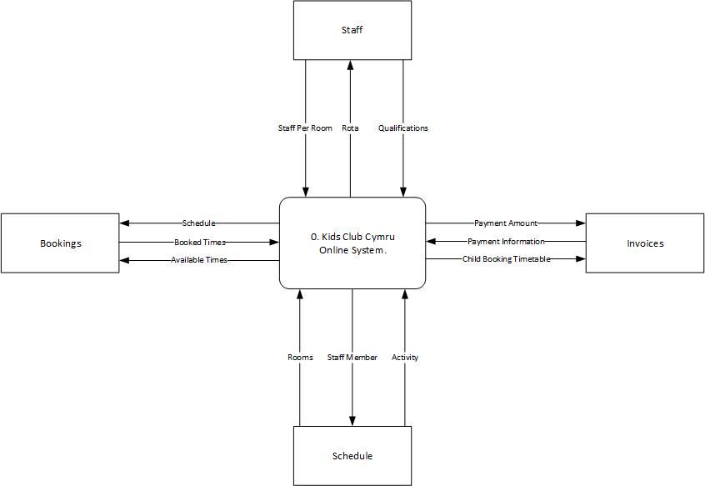

Level 0 Diagram
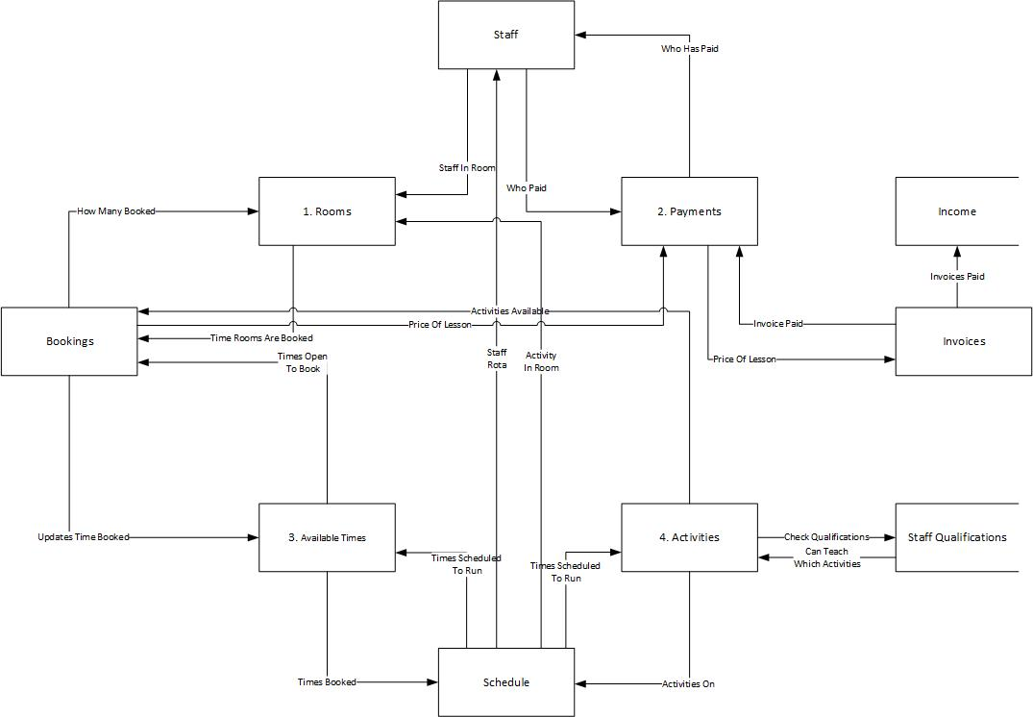

Level 1 Diagram
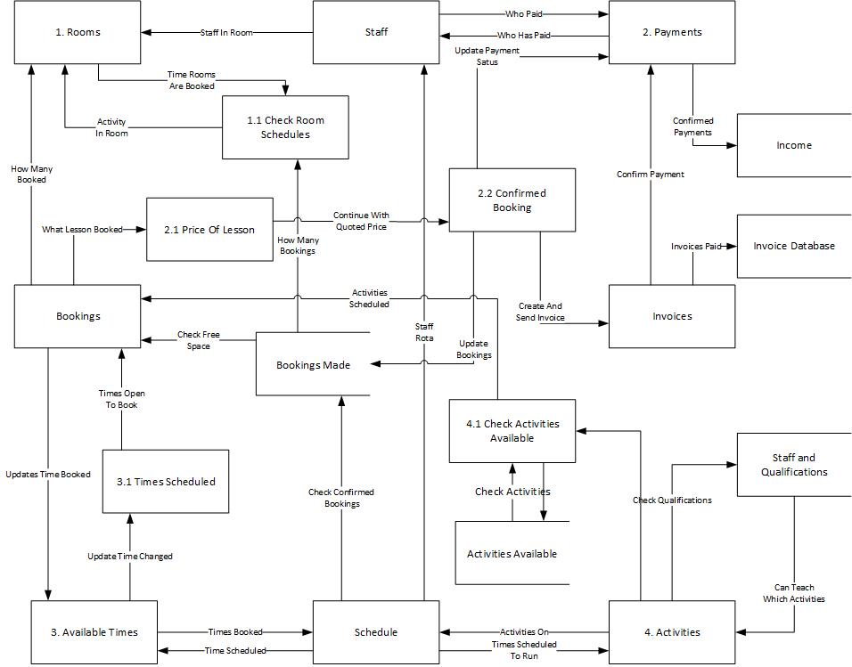

Entity Relationship Diagram



