

Evaluating the challenges of web accessibility for visually impaired users
by
Robert Iwan Jamieson

Supervisor: Dr Nicola J. Whitehead

Project submitted as part of the requirements for the award of
BSc (Hons) Computing (Software Engineering)

April 2023

DECLARATION
I, Robert Iwan Jamieson declare that I am the sole author of this Project; that all references cited have been consulted; that I have conducted all work of which this is a record, and that the finished work lies within the prescribed word limits.
This work has not previously been accepted as part of any other degree submission.
FORM OF CONSENT
I Robert Iwan Jamieson hereby consent that my Project, submitted in candidature for the Bachelor of Science: Computing (Software Engineering) degree, if successful, may be made available for inter-library loan or photocopying (subject to the law of copyright), and that the title and abstract may be made available to outside organisations.

Abstract
The web has evolved a lot since its inception. Modern websites are no longer static pages but are instead dynamic and complex. People rely on the web greatly in everyday life – including those that suffer with visual impairments. However, it can be difficult with poor eyesight to browse the web without the help of accessibility features. Fortunately, web accessibility specifications and guidelines such as the Web Content Accessibility Guidelines guides web developers to help ensure their website is accessible. Furthermore, developers can use web accessibility checking tools to automatically scan and check for compliance with these guidelines.
This paper includes an in-depth review of the existing literature surrounding web accessibility. The literature review is concluded with recommendations for good web accessibility practises. This paper also describes the process of designing and implementing a web accessibility checker. It is compared to other existing web accessibility checkers to reveal their performances.
A positivist and inductive approach is taken along with the strategies of conducting a literature review, software development and experiment. Risks, limitations, ethical issues and the validity, reliability, generalisability, data collections and evaluation methods of the project are considered. A waterfall software development methodology is undertaken and key resources including the software required to complete the project are set out.
The paper concludes that the results of each web accessibility checker including the one implemented cannot always be meaningfully compared to one another due to the differing ways the results are interpreted and displayed.
Suggestions for further work that could be made to the implementation are described. These include the additional functionality of checking for other success criterion and web accessibility guidelines and allowing users to choose a faster alternative to Selenium – requests. Finally, a personal reflection of the project is made.

Contents
List of tables 7
List of figures 7
Chapter 1 Introduction 9
Chapter 2 Research and review of literature 10
2.1 Common visual impairments 10
2.1.1 Cataract 10
2.1.2 Age-Related Macular Degeneration 10
2.1.3 Refractive error 11
2.1.4 Diabetic retinopathy 11
2.1.5 Glaucoma 12
2.1.6 General Accessibility 12
2.2 Web accessibility guidelines and specifications 12
2.2.1 Web Content Accessibility Guidelines 13
2.2.1.1 Early WCAG versions 14
2.2.1.2 WCAG 2.1 14
2.2.1.3 Not all developers follow the WCAG 16
2.2.2 User Agent Accessibility Guidelines 16
2.2.2.1 UAAG 2.0 17
2.2.3 Accessible Rich Internet Application 17
2.3 Assistive technology for computer use 18
2.3.1 Hardware 18
2.3.2 Software 19
2.4 Designing for the visually impaired 20
2.4.1 Empathic modelling and user trials 21
2.5 Web accessibility checkers 21
2.6 Conclusion 22
2.6.1 Recommendations for good web accessibility practise 23
Chapter 3 Methodology 24
3.1 Research Methodology 24
3.1.1 Philosophy 24
3.1.2 Approach 24
3.1.3 Strategies 24
3.1.3.1 Literature review 24
3.1.3.2 Software development 25
3.1.3.3 Experiment 25
3.1.4 Risks, limitations and ethical issues 25
3.1.5 Validity, Reliability and Generalisability 25
3.1.6 Data collection and its evaluation 26
3.2 Development Methodology 27
3.2.1 Software Development Methodology: Waterfall 27
3.3 Resources 27
3.3.1 Hardware Resources 27
3.3.2 Software Resources 27
3.3.3 Other Resources 28
Chapter 4 Design and Implementation 29
4.1 Design 29
4.1.1 Project requirements 29
4.1.2 Flow/process of the web checker 31
4.1.3 Website design 34
4.1.4 Required resources and software/applications 36
4.2 Implementation 36
4.2.1 Implementation process 36
4.2.2 Notable code 37
4.2.2.1 Requests vs Selenium 37
4.2.2.2 Functions 39
4.2.2.3 Code that may skip hundreds of lines of code 41
4.2.2.4 Re-check and Checking other websites from results page 41
4.2.2.5 URL Validation 42
4.2.3 System testing 44
Chapter 5 Testing/Results of Checker and Comparing Checker 45
5.1 Non-text Content 1.1.1 results 46
5.2 Language of page 3.1.1 results 48
5.3 Page titled 2.4.2 results 49
5.4 Total success criterions found to have faults/warnings out of 3 49
Chapter 6 Further evaluation of results and aim and objectives 51
6.1 Non-text Content 1.1.1 ANOVA and post-hoc results 51
6.2 Total success criterions found to have faults/warnings out of 3 with ANOVA results 53
6.3 Aim and objectives fulfilment 54
Chapter 7 Conclusion and further work 57
7.1 Suggestions for further work 58
Chapter 8 Reflection 59
Chapter 9 References 61
Chapter 10 Appendices 70
10.1 Appendix A (results found in Chapter 5) 70
10.2 Appendix B (results found in Chapter 6) 72

List of tables
Table 1: MoSCoW analysis table containing project requirements. 29
Table 2: Table of results revealing the websites that comply, have no result or do not comply with the Language of page 3.1.1 success criteria. 48
Table 3: Table of results revealing the websites that comply, have no result or display a warning for the Page titled 2.4.2 success criteria. 49
Table 4: Table revealing the ANOVA summary results found by using the initial results found in Figure 26. Results provided by (but slightly modified from) source: [110]. 51
Table 5: Table revealing the ANOVA result details found by using the initial results found in Figure 26. Results provided by (but slightly modified from) source: [110]. 52
Table 6: Table revealing the post-hoc results found by using the initial results found in Figure 26. Results provided by (but slightly modified from) source: [110]. 52
Table 7: Table revealing the ANOVA summary results found by using the initial results found in Figure 27. Results provided by (but slightly modified from) source: [110]. 53
Table 8: Table revealing the ANOVA result details found by using the initial results found in Figure 27. Results provided by (but slightly modified from) source: [110]. 54
Table 9: Table reveals the faults/warnings found for the Non-Text Content 1.1.1 success criteria results. 70
Table 10: Table of results revealing the websites that comply, have no result or do not comply with the Language of page 3.1.1 success criteria. 70
Table 11: Table of results revealing the websites that comply, have no result or display a warning for the Page titled 2.4.2 success criteria. 71
Table 12: Table reveals the total faults/warnings found for all of the success criterions. 71
Table 13: Table revealing the ANOVA summary results found by using the initial results found in Table 9. Results provided by source: [110]. 72
Table 14: Table revealing the ANOVA result details found by using the initial results found in Table 9. Results provided by source: [110]. 72
Table 15: Table revealing the post-hoc results found by using the initial results found in Table 9. Results provided by source: [110]. 73
Table 16: Table revealing the ANOVA summary results found by using the initial results found in Table 12. Results provided by source: [110]. 73
Table 17: Table revealing the ANOVA result details found by using the initial results found in Table 12. Results provided by source: [110]. 74

List of figures
Figure 1: Cataract eye condition visualization. Source: [5]. 10
Figure 2: Age-Related Macular Degeneration eye condition visualization. Source: [5]. 10
Figure 3: Refractive error eye condition visualization. Source: [5]. 11
Figure 4: Diabetic retinopathy eye condition visualization. Source: [5]. 11
Figure 5: Glaucoma eye condition visualization. Source: [5]. 12
Figure 6: Results revealing most popular assistive technologies used to access the UK government’s website. Source: [64]. 20
Figure 7: Flowchart representing main program process. 32
Figure 8: Flowchart representing the process of checking for compliance with a success criteria (Page Titled). 33
Figure 9: Wireframe of homepage website design. 34
Figure 10: Wireframe of results page website design. 35
Figure 11: Wireframe of simple results page website design. 36
Figure 12: Screenshot of requests related results. 38
Figure 13: Screenshot of Selenium related results. 38
Figure 14: Screenshot of code that automates scrolling down a webpage. Code inspired from source: [88] 38
Figure 15: Screenshot of old, unoptimized previously used code that writes results to a file. Code inspired from source: [89]. 39
Figure 16: Screenshot of new, optimized code in the main programming file. It writes results to a file. 40
Figure 17: Screenshot of new, optimized code that is within a function. It writes results to a file. Code inspired from source: [89]. 40
Figure 18: Screenshot of Selenium web driver code. Inspired by source: [90] 41
Figure 19: Screenshot of else if statement that can avoid hundreds of lines of code from executing. 41
Figure 20: Screenshot of PHP code retrieving URL from file and allowing users to easily re-check a website. Code inspired from sources: [91] [92]. 41
Figure 21: Screenshot of results page wireframe design. 42
Figure 22: Screenshot revealing the results page from the final implementation differing slightly from the designed results page. 42
Figure 23: Screenshot of old, previously used code’s console outputting errors regarding an invalid URL. 43
Figure 24: Screenshot revealing code related to how URLs are validated/dealt with. 43
Figure 25: Screenshot of the final implementation’s code outputting no errors. 43
Figure 26: Bar chart revealing the faults/warnings found for the Non-Text Content 1.1.1 success criteria results. 46
Figure 27: Bar chart revealing the total faults/warnings found for all of the success criterions. 49

Chapter 1 Introduction
This project will critically evaluate web accessibility, especially in relation to visually impaired users. Much of the research focuses on the Web Content Accessibility Guidelines (WCAG) 2.1 [1]; reliable accessibility related papers and assistive technology that helps disabled users browse the web such as screen readers [2].
Whilst the research aspect of this project will thoroughly evaluate web accessibility, the practical side of it aims to help web developers quickly understand whether their website complies with WCAG’s success criterion. A web accessibility checker will be developed to compete against other existing web accessibility checkers [2].
The aim of the project:
- To critically evaluate web accessibility for visually impaired users and develop a web accessibility checking tool which reviews WCAG compliance.
The objectives of the project:
- Research and critically evaluate the area.
- Based upon the research, set out recommendations for good web accessibility practice.
- Implement a web accessibility checker and compare the implemented and other existing web accessibility checkers to each other.
The requirements of the project are outlined in chapter 4.
This report has many chapters that are fundamental to the project’s success. Firstly, the research and review of literature discusses key topics, including web accessibility guidelines and specifications. After this, the project’s research and development methodologies as well as the resources required to complete the project are described. The design and implementation stage discusses and illustrates how the program was designed, developed and tested.
The report then compares web accessibility checkers (including the one implemented) and a further evaluation of the results and aim and objectives is followed. Finally, a conclusion and further work that could be done are discussed and the project is reflected on.

Chapter 2 Research and review of literature
This chapter describes common visual impairments; web accessibility guidelines/specifications; assistive technologies; designing for the visually impaired; web accessibility checking tools and recommendations for good web accessibility practise. These topics help to understand how visually impaired users struggle to use the web, but also how they are helped.

2.1 Common visual impairments
According to the World Health Organization (WHO) [3], “at least 2.2 billion people have a near or distance vision impairment” [3]. The National Health Service (NHS) [4] states that “more than 2 million people are living with sight loss” [4].
Visual impairments are therefore very common, with some more severe than others. Below, common visual impairments and how people deal with this disadvantage will be discussed.

2.1.1 Cataract

Cataracts are one of the most common visual impairments [3]. They blur the vision of the eye [5] and usually becomes more severe over time [6]. They can be described as feeling the need to clean your glasses when they aren’t in need of cleaning [6] – it’s simply the persons eyesight that is deteriorating. People with this eye condition are “more sensitive to light” [6] and can become blind [7].
Figure 1: Cataract eye condition visualization. Source: [5].
According to the WHO’s report in 2019 [5], an estimated “65.2 million” [5] people globally are affected by a cataract visual impairment [5]. People with cataracts will likely find it more difficult than usual to navigate poorly formatted websites due to their condition.

2.1.2 Age-Related Macular Degeneration

Age-Related Macular Degeneration (AMD) is estimated to affect “10.4 million” [5] people globally. People with this eye condition will likely find it difficult to read [8], including reading on the web because their central vision is “distorted or blurry” [8].
Figure 2: Age-Related Macular Degeneration eye condition visualization. Source: [5].
There are two variations of AMD, known as dry AMD and wet AMD [8]. Both leave patches on the eye [8]. Dry AMD effects more people with the condition, although develops slower than wet AMD [8]. Wet AMD on the other can lead to sudden permanent damage to the eye due to scarring [8]. Fortunately, according to the NHS, AMD “does not cause total blindness” [9].

2.1.3 Refractive error

Refractive errors are affecting a significant number of the world’s population. According to the WHO, refractive errors affect an estimated “123.7 million” [5] people world-wide. Refractive errors affect eyesight because it causes the vision to not focus as it ideally should, thus causing a blur [10]. Refractive errors lead to people getting “corrective glasses, contact lenses or refractive surgery” [10] to combat it.
Figure 3: Refractive error eye condition visualization. Source: [5].
There are different types of refractive errors, although four common ones are:
- Myopia - Far away things will be more blurry and harder to identify, read or see clearly [10].
- Hyperopia - Nearby things will be more blurry and harder to identify, read or see clearly [10].
- Presbyopia – Nearby things will be harder to identify, read or see clearly [10].
- Astigmatism - Causes “distorted vision” [10].
Refractive errors will therefore likely increase the difficulty in browsing the web, due to the difficulty reading and general blurry vision. Fortunately, this eye condition is treatable. Therefore, no additional assistive technologies such as screen readers may be needed.

2.1.4 Diabetic retinopathy
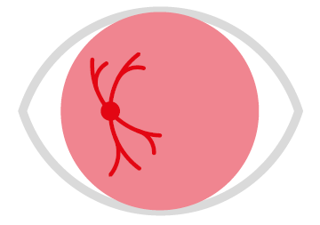
Diabetic retinopathy is estimated by the WHO to affect 3 million people globally [5]. Diabetic retinopathy in some cases can cause blindness [5]. This eye condition “usually develops in stages” [11] and can be treated [11]. As the name suggests, people with diabetes can develop the eye condition [11].
Figure 4: Diabetic retinopathy eye condition visualization. Source: [5].
The loss of vision is often due to damage to the retina, caused by “swelling” [5] and symptoms of the eye condition include blurriness and blindness [12]. Due to this, people effected by the condition will likely find it more difficult to navigate the web and in severe cases may partially or completely depend on assistive technologies.

2.1.5 Glaucoma

Glaucoma affects an estimated “6.9 million” [5] people world-wide [5] and affects eye sight when the optic nerve is damaged [13]. There are different types of glaucoma, although the primary open angle glaucoma type is the one that affects the most people in the UK [14].
Figure 5: Glaucoma eye condition visualization. Source: [5].
This eye condition can cause vision to become blurry [13], “usually” [13] effects both eyes as well as their peripheral vision and develops progressively over time [13]. As people affected by this eye condition’s vision becomes blurry and their peripheral vision deteriorates, they may find it difficult to notice content or features of a webpage that other users may easily spot.

2.1.6 General Accessibility
Disabled users affected by any of the above eye conditions and more may require additional help. Some eye conditions can be combatted via glasses and contact lenses as mentioned above. However, some people require more aid than that, such as aids that make use of “tactile and audio feedback” [15].
For general activity, some visually impaired people may need the use of “Low-tech aids” [15], such as:
- A long cane – Allows them to navigate and walk whilst having a sense of direction and what is ahead of them [15].
- Braille – This may be used primarily by those severely visually impaired or completely blind to read by using their hand to sense patterns [15].
When it comes to using the computer and browsing the web, disabled users, especially those with severe visual impairments may need to rely on assistive technologies to help them. These will be discussed in chapter 2.3.

2.2 Web accessibility guidelines and specifications
There are numerous web accessibility guidelines and specifications, although this report will discuss 3 prominent ones: Web Content Accessibility Guidelines (WCAG) [1], User Agent Accessibility Guidelines (UAAG) [16] and Accessible Rich Internet Application (ARIA) [17].

2.2.1 Web Content Accessibility Guidelines
WCAG is a web standard recognized internationally. As the name suggests, it offers guidance regarding web content for website developers. It offers a large range of web accessibility guidance to follow and multiple levels of compliance to aim for [2] [18] as it seeks to make the web accessible for people with a range of disabilities, including visual impairment [1].
Before WCAG was created, Vint Cerf, the creator of the TCP/IP and “FATHER OF THE INTERNET” [19] made his concerns of web accessibility known:
“The Internet is for everyone – but it won’t be if it is too complex to be used easily by everyone. Let us dedicate ourselves to the task of simplifying Internet’s interfaces and to educating all who are interested in its use” [20].
One month later, the first version of WCAG was published. Since then, multiple, updated versions of WCAG have been released [21] [22] [1], not necessarily to supersede its previous iterations but to build on them [1].
WCAG 2.1 adopts the Web Accessibility Initiative’s four main principles [23], known as POUR. If POUR is abided by, it allows for a range of disabled users to “use the web” [24]:
- Perceivable content – Users must be able to use at least one of their senses, such as their hearing, vision or touch senses to perceive content [24].
- Operable interfaces – Users must be able to navigate or perform actions the website offers [24].
- Understandable content – Users must be able to understand the content and operations that the website provides [24].
- Robust content – User agent technologies such as browsers and assistive technologies [24] such as screen readers must be able to function as intended “as technologies advance” [24].
The WCAG is not the only web accessibility guidelines. The United States “Rehabilitation Act of 1973” [25] requires websites to be accessible to those with disabilities [25]. Similarly, New Zealand’s “Web Accessibility Standard 1.1” (2019) [26] requires websites to be accessible [26]. What both of these acts/standards have in common is that they both refer to the WCAG guidelines.
The WCAG is therefore the web accessibility guidelines that is referred to in this document as it is internationally recognized and because some countries legally require the WCAG to be followed [27]. In the United Kingdom, websites must legally meet the WCAG’s 2.1 Level AA criteria [28] under the “Public Sector Bodies (Websites and Mobile Applications) (No. 2) Accessibility Regulations 2018” [28]. The WCAG’s conformance levelling criterion [1] will be discussed further in chapter 2.2.1.2.

2.2.1.1 Early WCAG versions
The first version of the WCAG (WCAG 1.0) was published in 1999 with the goal of promoting accessibility [21] and providing guidelines to developers to make “content more available to all users” [21]. The WCAG 1.0 contains 14 guidelines and over 60 checkpoints [29] that provide more details with written examples in: HTML, CSS, SMIL and MathML. [21]. Checkpoints have priority levels which state whether a web developer must, should or may satisfy/address a checkpoint (depending on how difficult disabled users would find it if they did not meet those checkpoints) [21]. WCAG 1.0 also introduced a conformance levelling criteria [21].
WCAG 1.0 was a good first step for web accessibility. However, overtime it became apparent that some guidelines were too ambiguous and hard to follow [30]. Furthermore, WCAG 1.0 had guidelines for specific technologies which became an issue as more technologies were developed [31].
WCAG 2.0 was released in 2008 [22] and made significant progress because the guidelines were written in such a way that they could be applied to existing and future web technologies, unlike WCAG 1.0 [31]. The updated guidelines were built upon the previous guidelines although now included “far more educational” [31] documentation. The WCAG 2.0 introduced POUR [22], covered more disabilities than WCAG 1.0 [32] and referred to sections as success criterion instead of checkpoints [32].

2.2.1.2 WCAG 2.1
The WCAG 2.1 was published in 2018 [1] and inherits all of the WCAG 2.0’s aspects, including the key aim of being “testable with a combination of automated testing and human evaluation” [22] [1]. As the guidance is improved in each WCAG version, it allows for web accessibility checkers [33] to better judge websites on their compliance with the guidelines. Web accessibility checkers will be discussed further in chapter 2.5.
Although the WCAG 2.0 was published almost a decade before the WCAG 2.1, the WCAG 2.1 does not “deprecate or supersede” [1] it. Importantly, it is backwards compatible with the WCAG 2.0 [34] as it only expands on it. It features 17 new success criterion [35] and includes definitions, guidelines and “additions to the conformance section” [1]. Users with visual impairment are one of the target audiences which the WCAG 2.1 aims to enhance accessibility guidance for, by adding additional success criterion for “users with low vision” [1].
The WCAG 2.1 also has new success criterion related to mobile phone web accessibility [35]. There is a huge amount of smartphone usage in 2022 [36], thus it is appropriate that the WCAG has updated its guidelines to accommodate for mobile web accessibility. This is important because visually impaired users depend on assistive technologies such as screen readers [37] to understand web content on both mobile and stationary devices. Assistive technologies that help visually impaired people to use the web will be discussed further in chapter 2.3.
The WCAG’s conformance levelling criteria was introduced in the WCAG 2.0 [34] and has since been updated in the WCAG 2.1 [1]. Success criteria of various guidelines are rated at one of three conformance levels: A, AA or AAA [1]:
- Level A – This is the minimum criteria a webpage falls under to be recognized as a webpage with satisfactory web accessibility compliance [1].
- Level AA – This is the level that laws and regulations from countries such as the UK and New Zealand instruct businesses to conform to [26] [28]. It is more difficult to achieve this level of compliance because there are further success criterion to follow, including all of the success criteria of Level A [1].
- Level AAA – This is the highest conformance level a webpage can conform to for the WCAG [1]. A webpage must satisfy the success criteria of the other levels as well as this one to conform to it [1]. Level AAA can be difficult to adhere to across all content on a website. The WCAG 2.1 guidelines themselves therefore do “not recommended” [1] adhering to Level AAA as a “general policy for entire sites” [1].
As is suggested, Level AA is the level that is most applicable to all webpages and thus should be strived for. If a webpage is Level AA compliant it will benefit visually impaired users greatly, as some of the success criterion it covers are:
- Audio descriptions for pre-recorded videos [1].
- Contrast [1].
- Increase/decrease of text size [1].

2.2.1.3 Not all developers follow the WCAG
One study published in 2016 found that out of 25 “e-Government websites in Turkey” [38], the majority of them do not satisfy the WCAG 2.0’s minimum levels of conformance.
Another study assessed the compliance of 33 Saudi Arabian University websites in regard to both the WCAG 1.0 and the WCAG 2.0’s combined 38 success criterions [39]. One of the web accessibility checkers it used, found “11% of known problems and 89% likely and potential issues” [39]. However, the study also suggested that these results are not conclusive [39] - a manual review would be needed to verify these supposed WCAG violations.
Generally, a websites lack of compliance with the WCAG could be due to:
- Lack of incentive - May not be legally required or enforced [40].
- Time consuming and costs [40] – Businesses may not want to hire experts in the area or may want their web developers to have their focus elsewhere.
- Misconceptions that accessible websites are “ugly and boring” [40], amongst other misconceptions.
- It being difficult to know whether their website is fully complying or not – even experts “may fail to perform a detailed meticulous review” [18]. Web accessibility checkers can help developers in this regard, but they cannot be fully relied upon [39].
It is no surprise then, that one study issued in 2013 that assessed the accessibility of hundreds of large enterprise websites [41] found that “85 % of the evaluated websites present more than 500 WCAG 2.0 level A errors” [41]. Not one of the websites assessed met the minimum accessibility requirements set out by the WCAG 2.0 [41].

2.2.2 User Agent Accessibility Guidelines
The User Agent Accessibility Guidelines (UAAG) is a separate set of guidelines to the WCAG, although is created by the same organization: W3C [16]. The UAAG differs to the WCAG because its guidelines are not aimed for website developers – it instead offers guidance to user agent developers to ensure that their user agents are accessible [16]. User agents refer to “browsers, browser extensions, media players, readers and other applications that render web content” [16].
The first version of the UAAG, UAAG 1.0 was published in 2002 [42]. The UAAG introduced key guidelines that when followed allow disabled users and their assistive technology to have much more control of web content [42]. The UAAG did this by recommending that only a keyboard be required for complete use of a web browser [43] and that other important aspects, such as the font size, style and webpage colours be modifiable by the end user [43].

2.2.2.1 UAAG 2.0
The UAAG 1.0 was recognized as a recommended W3C guideline when it was published [42]. However, the same cannot be said about UAAG 2.0 – it is not a “formal W3C Recommendation” [44] and W3C does not intend for it to be [44]. This is because testing of user agents would need to be carried out, although W3C say that testing these resources was not possible [44]. Despite of this, W3C still “recommend” [44] the use of the UAAG 2.0.
The UAAG 2.0’s latest iteration was published in 2015 [16] and introduced 5 key accessibility principles for user agents with the first three being “parallel” [16] to the first three WCAG principles [16] [24]:
- Perceivable – User agents must be perceivable so that the content of them can be accessed [16].
- Operable – Users must be able to easily communicate with user agents [16].
- Understandable – Users should be able to figure out how to use a user agent [16].
- Programmatic access – Assistive technologies must be able to control web content via the user agent [16].
- Specifications and conventions – The user agent must abide by “other accessibility specifications” [16], such as the WCAG [16]. The user agent must also abide by “platform conventions” [16], such as Windows [16].
The UAAG 2.0 also introduced success criteria and a very similar conformance levelling system to WCAG 2.1 [16] [1], ensuring user agent developers have a better understanding of their compliance status.

2.2.3 Accessible Rich Internet Application
Accessible Rich Internet Application (ARIA) [17] is a specification created by W3C. The ARIA was first published in 2014 [45], with the ARIA 1.1 being published in 2017 [17].
The ARIA specifications are used to outline good accessibility practises, such as by adding appropriate semantics [17] and by defining the “roles, states and properties in HTML code” [46]. By adding the appropriate semantics, it structures the website behind the scenes. This allows assistive technologies, such as screen readers [17] to accurately display the websites contents in a structured, well defined matter.
If no appropriate semantics are used, a screen reader may have to presume the order of the content and thus may get it wrong. Hence making the web content inaccessible or much more difficult to interpret for disabled users.
Semantics refer to “roles, properties and states” [47]. All of these elements influence how assistive technologies perceive content such as widgets [47]. Widgets dynamically update the webpage’s content in certain scenarios, which can cause some disabled users relying on assistive technologies “significant accessibility problems” [48]. Fortunately, the ARIA has mitigated this issue with its support for widgets [47]. For example, by including additional information within a tag, a screen reader can identify whether the code either relates to a button [49], radio button, check box, etc. This key information can then be relayed back to the disabled user.

2.3 Assistive technology for computer use
Assistive technologies can be hardware and software based [50] and greatly improve the quality of life of disabled users. They enable severely disabled people, such as blind people to use the web [51]. Without assistive technology, visually impaired users would be disadvantaged because of “the visually centric nature of the presentations of data” [52].
Fortunately, with the recognized importance of the guidelines and specifications mentioned in chapter 2.2, such as the WCAG, many assistive technologies have been able to understand web content with guidelines and specifications adapting to their needs.

2.3.1 Hardware
Hardware related assistive technologies include technologies such as finger readers [37], touchplates [53], refreshable braille displays [50] and haptic devices [52].
Touchplates emerged as there were concerns that touch screen devices lacked the “tactile feedback beyond simple vibration” [53]. Touchplates help in this regard as they are attached to a touch screen device and provide better tactile feedback and allow additional input and output methods [53]. Unfortunately, one of the technologies downsides is that although it communicates with the underlying software of the device – the hardware is only supported on an app to app basis [53]. It does not natively support applications and thus can have limited use [53], including for web browsers.
The Web Accessibility Initiative [54] (the creators of WCAG, UAAG and ARIA) have listed refreshable braille displays as an example tool that can be used by disabled users to make use of the web. Refreshable braille displays allow for text to be readable for visually impaired people that understand Braille [55], including text on webpages [56]. The device converts content into recognizable braille characters “by raising and lowering the dots (pins) dynamically” [50].
Refreshable braille displays recognize text and convert it accordingly [50]. However, in regards to web content, it is up to web developers to provide alternative text for content such as images and videos [1]. Otherwise, disabled users will not be able to understand what the image or video content represents.

2.3.2 Software
Assistive software to help visually impaired users is provided with all major smartphones, tablets and desktop and laptop Operating Systems (OSs). Each OS may differentiate slightly with their implementation of the accessibility options functionality; however, they are generally very similar. These are the basic functionalities and settings found in major OSs, including Windows and Android:
- Increase/decrease the size of apps and text [57, 58].
- Contrast ratio options [57, 58].
- Colour blind filter options (deuteranopia, protanopia, tritanopia) [57, 58].
- Magnifier [57, 58] (zoom tool).
- Voice assistant and/or screen readers [57, 58].
There are also basic functionalities and settings in major browsers that improve the useability and accessibility of webpages for users. Some of these functionalities are similar to the ones their OS provides, however these are specialized specifically for use within the browser. For instance, the Chrome browser includes the following accessibility features and settings:
- Allows for font size to be increased or decreased [59].
- Webpage content size can be increased or decreased (by using the zoom tool) [59].
- Live captions [59].
It’s important to note that webpages can include their own built-in accessibility settings. For example, YouTube videos include a playback speed option for its videos [60]. Some videos also include automatically generated captions [61], although they are not always accurate [62]. Additionally, further accessibility features for the web can be installed via browser extensions via third parties, such as Google’s High Contrast extension [63].
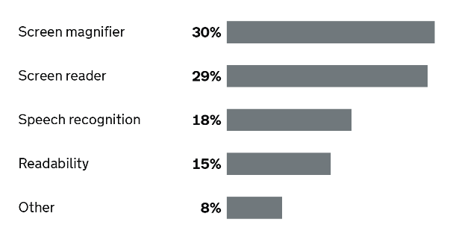
In a 2016 survey by the UK government that received 712 recorded responses [64], users were asked what type of assistive technology they used to access the government’s website [64]. As seen in Figure 6, screen magnifiers and screen readers were by far the most used assistive technology [64]. This comes to show how important it is for websites to follow key ARIA specifications, by using appropriate semantics [17] to ensure visually impaired users can understand the web page’s content.
Figure 6: Results revealing most popular assistive technologies used to access the UK government’s website. Source: [64].

2.4 Designing for the visually impaired
Web developers should design their websites to be accessible to as much people as possible, including visually impaired users. For websites to be accessible, they must allow disabled users and their assistive technologies to use the website to its fullest extent [65]. To do so, well established web accessibility guidelines and specifications including the WCAG, UAAG and ARIA should be followed, as described in chapter 2.2. The POUR principles of WAI [23] as mentioned in chapter 2.2 should also be adhered to.
By designing and developing an accessible website, it benefits all users as it also increases the usability of the website, for disabled and non-disabled users [65]. This leads on to the design for all idea: that services should be designed to accommodate to as much people as possible [66] from their “conception and throughout the entire development life-cycle” [15]. The design for all idea can be applied to when designing and developing websites.
An example of the design for all idea working to improve a websites accessibility and useability is this: Deaf users benefit from the accessibility option of seeing subtitles on a video. This also allows for better useability as any users may want to use subtitles to understand strong accents in a video or may use it in a loud atmosphere because they can’t hear the video.

2.4.1 Empathic modelling and user trials
Empathic modelling is used to simulate the perspective of disabled users [15]. It is used to develop an understanding and viewpoint of the difficulties disabled users, including visually impaired users face [15] – in this case when using a website. Empathic modelling is therefore helpful in testing whether any accessibility features included on a website are working as intended for their target audience.
Empathic modelling may be used instead of user testing actual visually impaired users due to ethical concerns, convenience, costs, amongst other reasons. For instance, it is convenient to simply wear “an old pair of glasses smeared with Vaseline” [15] to simulate a cataract eye condition. Complete blindness can also be simulated by simply covering a person’s eyes [15].
In contrast, finding users with the appropriate eye condition, recruiting them and ensuring all ethical concerns are adhered to is a more time consuming and likely costly approach. Despite of this, user trials, if conducted in an ethical manner are a great way of ensuring from first hand sources that a website meets their accessibility needs [67]. WAI states that:
“Involving users early in web projects results in better products for users, more efficient development, and other benefits to project stakeholders” [67].

2.5 Web accessibility checkers
Web developers should check whether they are conforming to the WCAGs. Two ways this can be done is by having an expert accessibility evaluator evaluate the webpage [39], or by the use of a web accessibility checking tool [68], or multiple of them, automatically evaluating a webpage.
Experts can manually determine whether a webpage follows the WCAG guidelines by manually testing webpage features and comparing their accessibility criteria to the guidelines [39]. Prominent assistive technologies may be used to test whether they work as intended or not [39].
Web accessibility checking tools on the other hand do not require any expertise. They can automatically compare the “Validity of HTML, XHTML, and style sheets” [39] to WCAG’s guidelines and success criterion [39]. Depending on how updated each tool is, determines which WCAG versions it allows users to evaluate [69]. W3C lists 46 WCAG 1.0 tools, 139 WCAG 2.0 tools and 85 WCAG 2.1 tools [70].
As mentioned in chapter 2.2.1, the WCAG has 3 levels of conformance: Levels A, AA and AAA [1]. Many tools, including AChecker [71] and QualWeb [72] allow for the filtering of results. Users can use the tools to evaluate each conformance level of the website or a specific conformance level [71, 72]. AChecker and QualWeb both flag and reveal the success criteria that is followed unsuccessfully or potentially unsuccessfully [71, 72].
One of the biggest advantages of web accessibility checkers compared to experts manually reviewing webpages is that they can review and point out faults swiftly [68]. Another advantage is that these tools have no “bias” [33], whilst experts may [33]. Additionally, they have the prospect to “discover more accessibility errors than human experts” [33].
However, web accessibility checkers do have their drawbacks when compared to experts manually reviewing webpages. Firstly, the tools can become somewhat outdated and in need of an update whenever a new WCAG version releases [73] - albeit that some WCAG versions are backwards compatible [34]. There is also the issue that these tools may occasionally miss faults or instead falsely flag accessible areas of the webpage as faults [33].
Another issue is that they cannot determine if all content conforms to the guidelines [33]. Human intervention is required in order to cover all of the guidelines and success criterion [74]. For example, although the web checkers can check to see if images or videos have an alternate text attribute, it is difficult for them to determine if it accurately represents the media [73, 75].

2.6 Conclusion
The literature review allowed for a better understanding of how visually impaired users use the web. It was found that some of the most common visual impairments include Cataracts, Age-Related Macular Degeneration, Refractive errors, Diabetic retinopathy and Glaucoma [5]. All of these visual impairments have the theme of causing people’s eyesight to blurry.
The most relevant and up-to-date web accessibility guidelines and specifications include the WCAG 2.1 [1], UAAG 2.0 [16] and ARIA 1.1 [17]. The WCAG includes many success criterion for web developers to follow, including a minimum conformance level [1].
According to a survey conducted in 2016 from the UK Government [64], screen readers and screen magnifiers are the most popular assistive technology [64]. Empathic modelling [15] and user trials have been identified as a good way of testing a website’s accessibility as it would be effective and helps avoid ethical issues.
The biggest advantage of web accessibility checkers is that they can identify conformance with accessibility guidelines quickly [68]. However, they are not always accurate [33] and manual verification is needed for some success criterion [74].

2.6.1 Recommendations for good web accessibility practise
Although adhering to web accessibility guidelines is demanded by law in countries such as the UK [28], it is quite difficult to know when and when a website is not complying with the guidelines. Below are ways companies can use to help them comply with the WCAG guidelines.
- Use multiple web accessibility checkers – they require no expertise, avoid bias [33] and can identify faults quickly [68]. However, do not rely solely on them.
- Expert manual verification. This will help robustly check whether a website is compliant or not.
- Strive to ensure that the websites usability [65] is good. Doing so can have the positive affect of also increasing the accessibility of the website [65].
- Web developers should educate themselves on the difficulties visually impaired users face in terms of their eyesight when it comes to accessing content.
- Websites can be tested from the perceived perspective of visually impaired users. This can be done via empathic modelling [15] by a sole developer or multiple users.
- Be wary of how assistive technologies help visually impaired users. For example, how screen readers relay content to a user depends on how well the content is structured behind the scenes [17]. Build the website with this in mind from the beginning.

Chapter 3 Methodology
In this chapter the research and development methodology that will be used in this project will be discussed.
Note: Some material in this chapter has been inherited from the project proposal [2].

3.1 Research Methodology
For the research methodology, the philosophy, approach, strategies, risks and limitations, ethical issues, validity, reliability, generalisability and data collection and evaluation methods will be discussed.

3.1.1 Philosophy
A positivist [76] approach will be used in this project, and will be used to complete a key objective, regarding testing the web accessibility checker’s performance compared to other web accessibility checkers. The positivist approach will be used here because it promotes “data collection and interpretation” [76] [77] – all web accessibility checkers will have data collected regarding their performance and will be further analysed.
The approach is also helpful for testing the program throughout its development. This is because positivism encourages observation [76].

3.1.2 Approach
An inductive approach [78] is used. When it comes to comparing each web accessibility checker to one another it is helpful to first make initial observations about the data [78]. An inductive approach provides “a simple, straight-forward approach for deriving findings linked to focused evaluation questions” [78]. In the case of this project, the objective of comparing web accessibility checkers needs to be met so that a hypothesis [78] can be made based on the results.

3.1.3 Strategies
Three strategies were identified for this project, as outlined below.

3.1.3.1 Literature review
A literature review is needed because it allows for a deeper understanding of the area surrounding web accessibility [79].

3.1.3.2 Software development
Software development is required at the implementation stage of this project so that a web accessibility checker can be developed. It will ensure the aim and an objective as well as the requirements of the project are fulfilled.

3.1.3.3 Experiment
Experimentation will be used throughout the development of the web accessibility checker. For example, code will be tested in multiple ways to ensure it is robust and varying implementations of the program will be done to experiment what works best.

3.1.4 Risks, limitations and ethical issues
Risks and limitations that the project COULD fault to, hence compromising the desired end result include:
- Running out of time, thus not being able to finish everything [77]. This could be due to trying to polish off the program too much, adding too much unnecessary functionality, etc. To avoid this, good project planning [77] and a focus on the ultimate end result must be a priority [2].
- Illness [77]. An illness such as the coronavirus disease may significantly affect the project planning and timescale. As a result, some features or aspects of the project may need to be scrapped or downscaled. To minimize this risk, a project timeline could account for some time off due to an unexpected illness [2].
- Difficulties learning the scripting/programming languages to create the website and develop the accessibility checker program to a good enough standard. [2]
- Loss of data. To avoid losing work related to this project, it shall be backed up in 3 separate locations – the cloud, local PC storage and a USB drive [2].
Ethical issues regarding data collection are a concern. It would be unethical to collect data from disabled people and unethical and legally questionable to gather data from vulnerable people who cannot properly give their consent to be a participant [2]. To avoid these issues, data will therefore only be collected from the analysis of the testing’s done when comparing web accessibility checkers.

3.1.5 Validity, Reliability and Generalisability
In order for the project’s integrity to be robust, it’s important that the generalisability, reliability and validity [80] of the project and its research is handled in the right way. To ensure the project’s reliability is not questioned, all data that is collected will be included in the report. This would ensure that the “exact replicability of the processes and the results” [80] could be made. The data collected will be discussed and displayed in charts and tables in the testing and further evaluation section [2].
Ensuring that “the results and conclusions are valid for the sample and context” [80] in regard to the project’s research is important and is one key way to ensure the project’s validity is secured. This project will therefore ensure that the WCAG, peer-reviewed journals and other reliable sources are used. By only using reliable and trustworthy sources, the validity of the project will be strong [2]. The validity of the project will be further strengthened when it comes to collecting and evaluating the data when comparing web accessibility checkers. This is because a quantitative [81] method will be taken, ensuring that the results are clear and transparent to all. The number of faults/warnings identified from each web checker will be counted and displayed in tables or charts for all to see.
Generalisability can be achieved regarding the results found from comparing web accessibility checkers to each other. Many studies, such as “Comparing Web Accessibility Evaluation Tools and Evaluating the Accessibility of Webpages: Proposed Frameworks” [33] compare popular web accessibility checkers. The results from studies such as that could be compared to one another, if sought out.

3.1.6 Data collection and its evaluation
By experimenting, there will be multiple iterations of the accessibility checker tool to make sure it is as reliable as possible by covering the WCAG effectively. Quantitative data will be manually collected by comparing the results of the program to other web accessibility checkers, such as AChecker [71] and QualWeb [72]. Tables and charts will be used to easily view side-by-side comparisons of the results. By doing this, the web accessibility checker implemented can be judged by its results compared to other established web accessibility checkers [2].
The use of quantitative analysis techniques such as descriptive statistics [81] will ensure that data is easy to understand [2]. Data will be gathered from multiple web accessibility checkers regarding the compliance of multiple websites to varying success criterion from the WCAG. The results will be discussed, and conclusions will be made.

3.2 Development Methodology
A development methodology is needed because it will allow for the project to be implemented in an organized and timely manner. Furthermore, it will allow the program to be robust and will ensure the aim, objectives and requirements are met.

3.2.1 Software Development Methodology: Waterfall
The waterfall methodology [82] is used instead of methodologies such as RAD [83] or Agile [83] because there is no feedback to be received from a customer [83]. The waterfall methodology’s advantage to this project is that it “gives a better understanding of the requirements, the logic of the codes and tests” [82]. This will allow for the project to be completed in a structured way.
The project is a personal project that is thoroughly planned out and thus it is not necessary for stages to be repeated, such as the design and implementation stage. The key stages after the aim and objectives and literature review include:
- Design (including the requirements)
- Implementation
- Testing and Results

3.3 Resources
The hardware, software and other resources used to complete the project will be discussed below.

3.3.1 Hardware Resources
Hardware resources for this project include:
- Home desktop PC and its accessories (mouse, keyboard, monitor) [2].
- Desktop PC at the UWTSD campus and its accessories (mouse, keyboard, monitor) [2].

3.3.2 Software Resources
Software resources for this project include:
- Windows 10 Home Edition [2] – For general needs.
- Python programming language and PyCharm framework - For main code. Python is used because it is supported by packages such as Beautiful Soup which allows for website scraping functionality [84].
- Python packages (Selenium, beautifulsoup4, webdriver-manager, time) – Allows or assists for web scraping functionality [84].
- PHP programming language - For website functionality and reading from and inputting to text files.
- HTML, CSS scripting languages [2] - For website functionality/design.
- Notepad++ - For coding HTML, PHP and CSS.
- XAMPP – For hosting website locally using Apache [85]. Code will be saved within the “htdocs” file directory.
- Browser (Edge) – For viewing website.
- Surfshark VPN – Used as a precaution in case IP is blocked from websites scraped.

3.3.3 Other Resources
Other resources for this project include:
- Access to the UWTSD library (including its online library and its included databases) [2].
- Other databases including: Google Scholar, ResearchGate, ScienceDirect., Semantic Scholar, Springer Journals, ACM Digital Library and IEEE Xplore digital library [2].
- Supervisor for the project: Dr Nicola J. Whitehead [2].
Now that the Research Methodology, Development Methodology and Resources required to complete the project have been described, the Design and Implementation chapter is next. It is in the next chapter and future chapters where the methodologies and resources described will have their influence.

Chapter 4 Design and Implementation
This chapter first sets out the decisions made in the design stage which helped meet the project’s objective, requirements and helped with development. The implementation stage describes and reflects on the process of developing the web checker program, including the challenges faced.

4.1 Design
For the design stage of the project, the following was considered:
- The requirements of the web checker/project.
- The interface of three webpages – the homepage, results and simple results page.
- The flow and process of the web checker behind the scenes.
- The resources required to create the web checker.

4.1.1 Project requirements
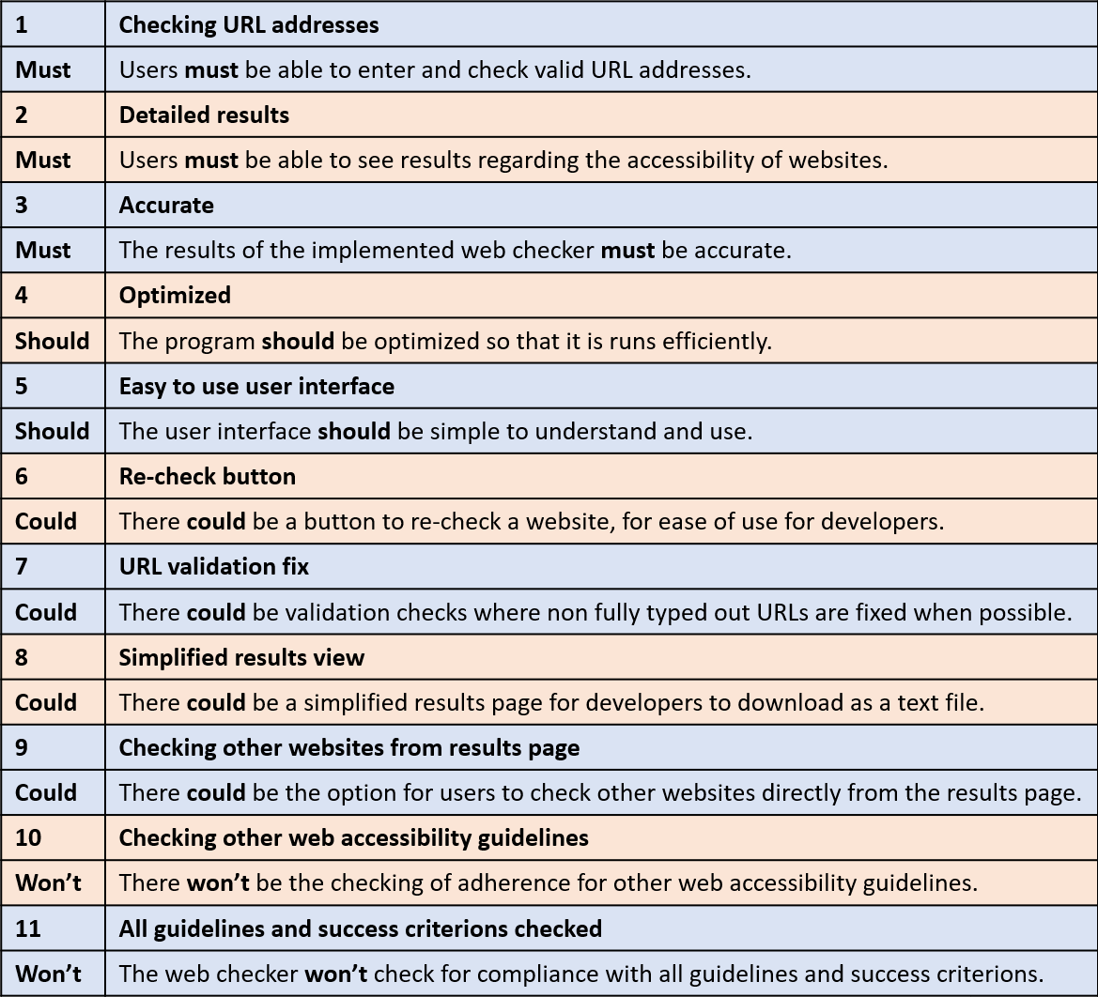
A MoSCoW analysis as seen below was used to outline the project’s requirements in a way which prioritizes them. Requirements either must, should, could or won’t be implemented.

Table 1: MoSCoW analysis table containing project requirements.
The requirements of the program that are top priority, include: allowing users to enter any valid URL address and to see a detailed and accurate results page. These are fundamental aspects of the project and must be implemented to ensure that the project is functional.
Other prioritizes that could be in the program but were found to not be absolutely essential included: a button that re-checks a website and a simplified results view. The re-check button would simply be for quality of life purposes. It means that the user would not have to return to the homepage to re-check their website again. Whereas the simplified results view would allow developers more freedom to do what they like with the results. For example, some developers may opt to download the results and highlight the issues they’ve fixed.
As the project must be finalized within just a few months’ time frame, it was important to decide early on the limits of what could be implemented. As suggested in chapter 2.2.1, the WCAG is well respected [1] and internationally recognized [27]. It is unrealistic due to the time frame to include other web accessibility guidelines that developers could check their website against. Hence, the latest version of WCAG (WCAG 2.1) [1] is chosen to be evaluated by the web checker.
As found in the research, the WCAG 2.1 has many success criterion [35] – it would be unrealistic to check against all of them. The following success criterion were therefore planned to be checked for compliance:
- Non-text Content 1.1.1 [1]
- Identify Input Purpose 1.3.5 [1]
- Page Titled 2.4.2 [1]
- Language of Page 3.1.1 [1]
This MoSCoW analysis helped ensure that not only the requirements of the project were prioritized, but also helped making the goal of being able to compare the web checker to other web checkers viable. This is because it allowed for a better understanding of what needed to be implemented so that a functioning web checker was developed.

4.1.2 Flow/process of the web checker
Two flowcharts were used to help envision the flow and process of the web checker program.
Flowchart of main python program

Figure 7: Flowchart representing main program process.
One of the first major aspects of the program that was identified was the fact that it would need many while loops – but most importantly, one major while loop that kept the program constantly running. This was important because the program has to be running constantly in order to check for users inputting a URL. Thus, as seen in Figure 7, there is no end to the flowchart. It will keep running until the program is manually stopped.
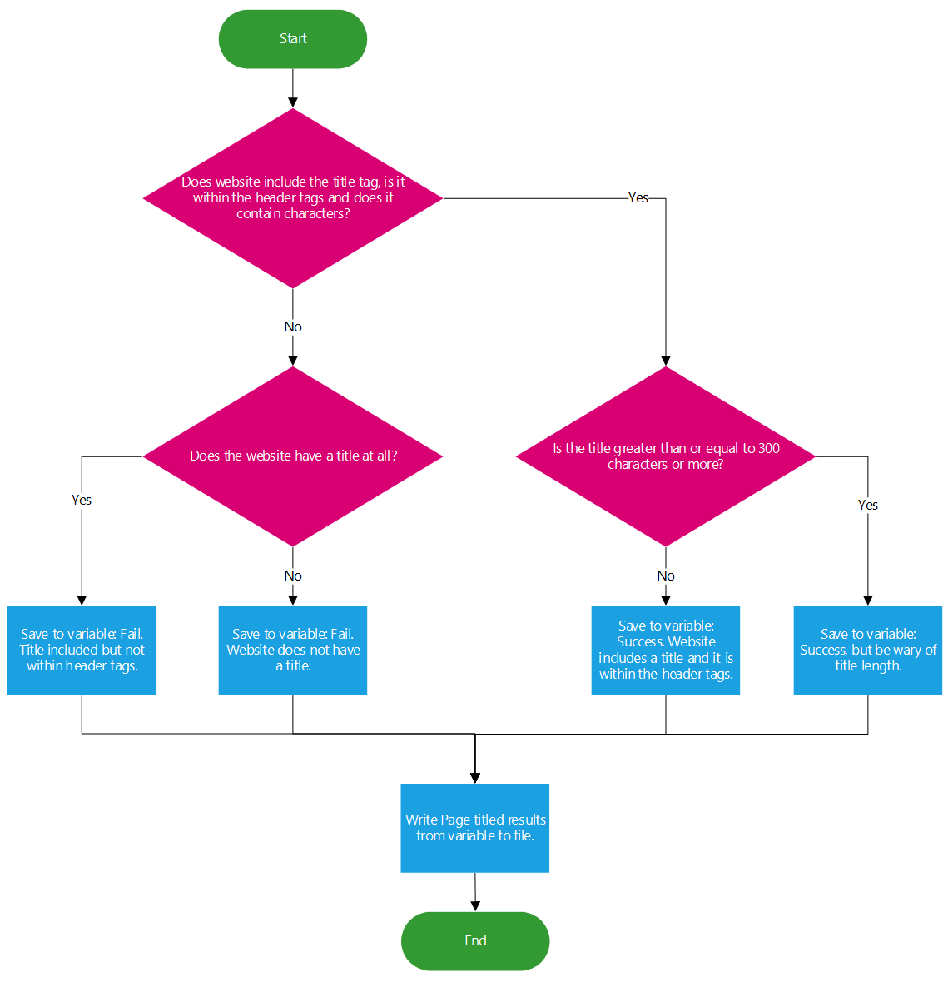
Flowchart of Page Titled success criteria being checked for compliance in python program
Figure 8: Flowchart representing the process of checking for compliance with a success criteria (Page Titled).
Checking for the compliance of each success criteria is somewhat different. However, this flowchart gives a good representation of the process or similar processes that would need to be undertaken to check for compliance with all success criterions. As HTML uses tags, elements and attributes, these can be looked for and checked against each success criteria.
During the design stage it was important to establish that users would want detailed results whenever possible - not just a simple acknowledgement of a failure. Presumably, developers want to know how their website does not comply with the guidelines, specifically. In the example in Figure 8 above that checks for a website title, there are four possible results that the developer could retrieve. For instance, they may be told that they have a title, but it’s not within the header tags – which is why they failed.

4.1.3 Website design
The website was planned to have three webpages, including the: Homepage, Results page and Simple results page. However, it unexpectedly ended up having four – this will be mentioned in chapter 4.2. These wireframes helped envision how the outputs of the program would look on the website. The wireframe diagram of the results page in particular allowed for the understanding that each success criteria would be outputted in separate boxes, thus it was important they were dynamic.
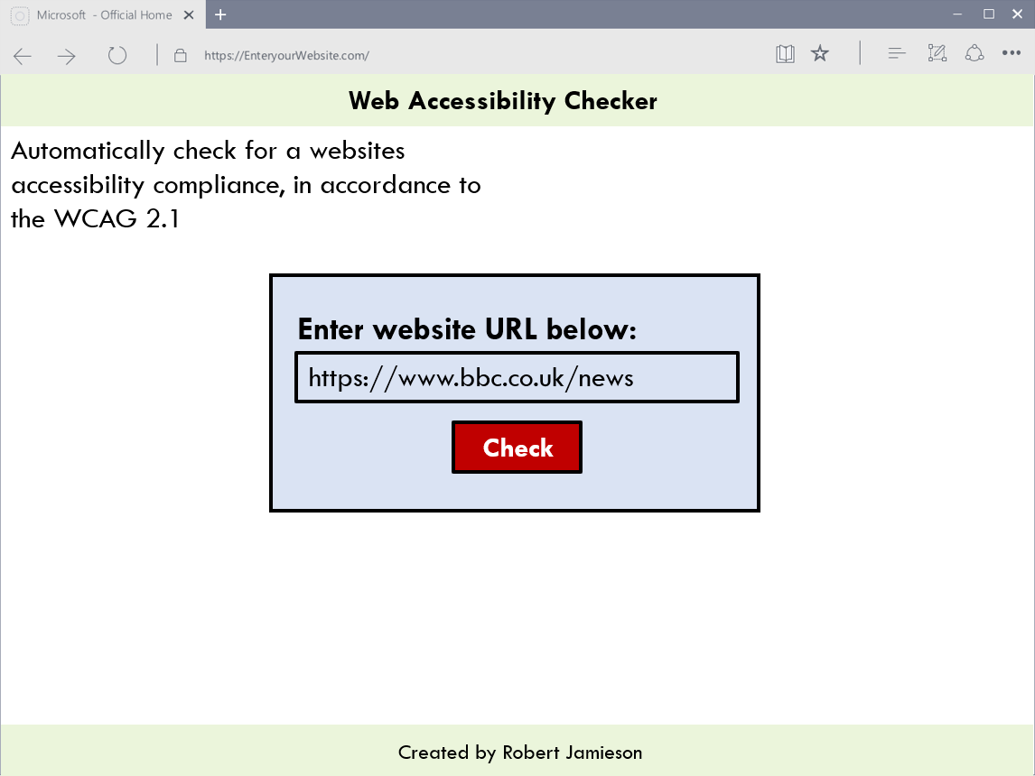
Homepage wireframe design

Figure 9: Wireframe of homepage website design.
As seen in Figure 9, this wireframe allowed for the idea of where a user would type a website’s URL and the house style design of the website.
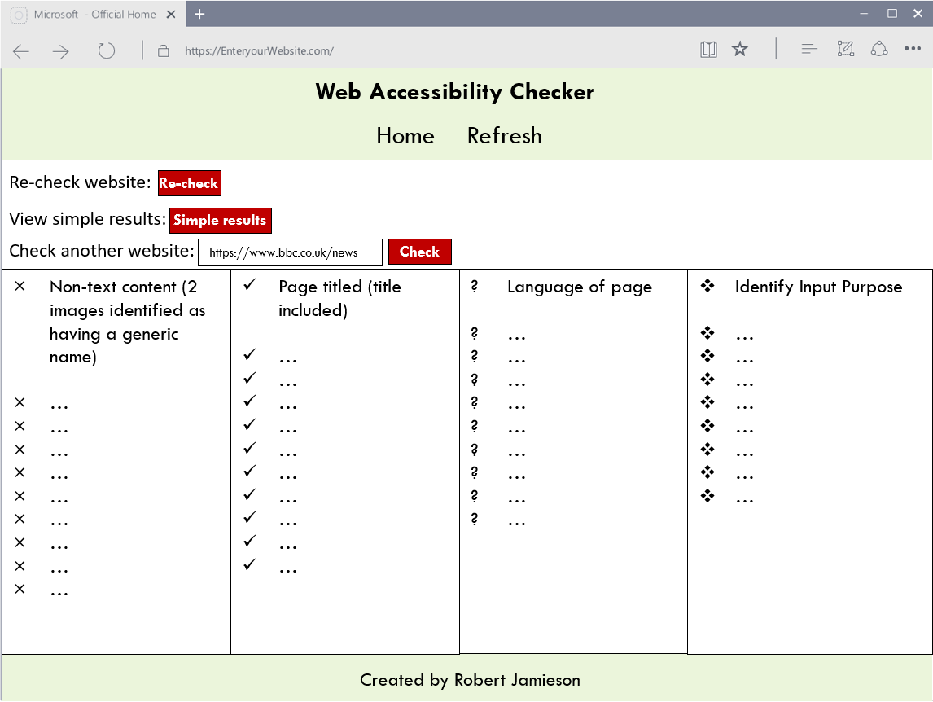
Results page wireframe design

Figure 10: Wireframe of results page website design.
The webpage is laid out in a way which accommodates each success criteria and their results, no matter how long they are. This is because the success criterions are designed to be within dynamic boxes. By default, users should see all success criteria results side by side. However, if a user is zoomed in far enough, the success criterion will start stacking – one on top of another. The results are designed so that they could even be viewed with ease on mobile devices. All success criterions are designed to be visible or visible when zoomed if the user simply scrolls down the page.

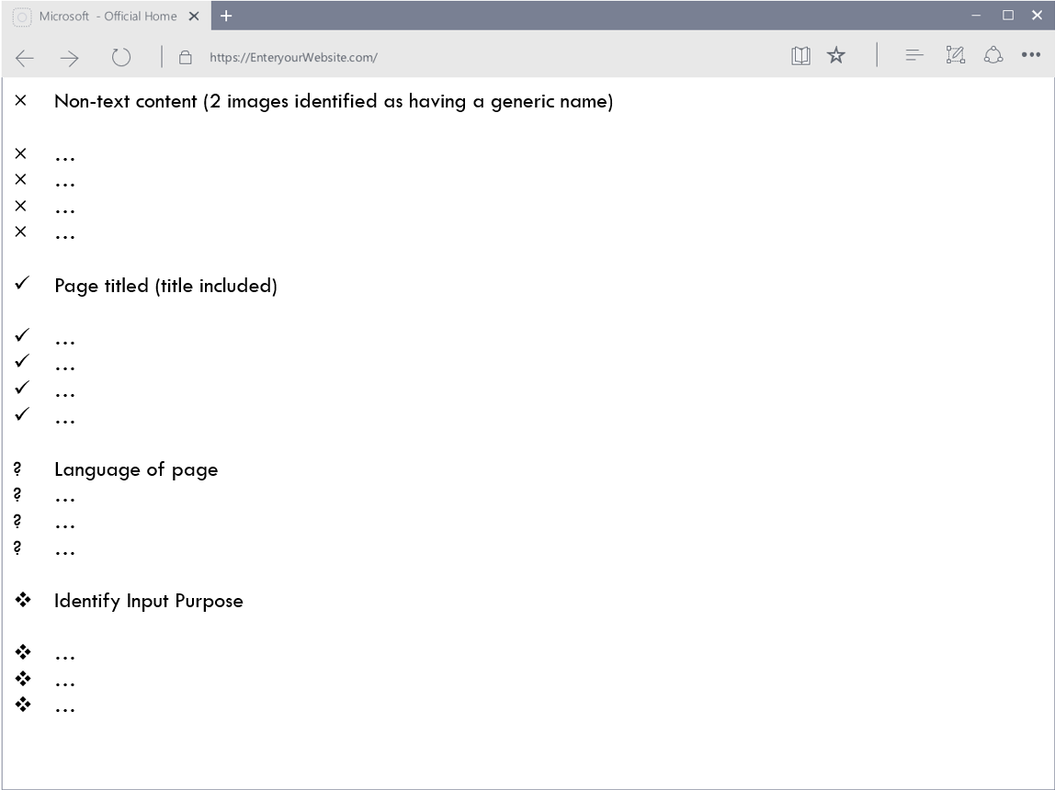
Simple results wireframe design

Figure 11: Wireframe of simple results page website design.
Figure 11 reveals a wireframe of the simple results webpage. This webpage has very limited formatting because developers are expected to download this page as a text file and e.g., highlight areas they’ve addressed. Thus, there is little to no formatting that could get in their way.

4.1.4 Required resources and software/applications
See chapter 3.3 for the required resources that allows for the project’s completion.
Python’s requests package, JavaScript and MySQL were intended to be used as well. However, as explained in chapter 4.2 below, they were not used in the final implementation.

4.2 Implementation
During the implementation stage, many aspects of the design stage were followed through as planned – however not everything was. Some plans were changed and features were altered to better the web accessibility checker.

4.2.1 Implementation process
When developing the web checker and website, most of the software set out to be used was used at some point. However, the MySQL database and JavaScript were never used. MySQL was not used because it was realized that not much data needed to be stored and that the data that needed to be stored was only temporary, thus text files would suffice. JavaScript was not used due to time-limitations and because it was ultimately not required to full-fill the aim, objectives or requirements set out.
Furthermore, although the requests package was used to send HTML requests – a superior alternative ended up being used instead: Selenium. Selenium was used because it is capable of automating browser actions [86], which can make a big difference. The difference between using requests and Selenium will be shown amongst the code snippets in chapter 4.2.2 below.
In the design stage it was foreseen that there would be three webpages – the homepage, results page and simple results page. Only these webpages were designed with wireframes. However, it became apparent during the implementation that there would need to be an additional webpage. In the final implementation, whilst the web checker is scraping the website and forming its results, the user is directed to a loading screen webpage. Shortly after, the user is re-directed to the results page. If they had been sent straight to the results page, they would not have seen their results as they had not loaded yet.
As mentioned, there was no wireframe design done for the loading screen webpage. However, it was easy enough to replicate the house style design of the rest of the website and implement a professionally looking webpage.

4.2.2 Notable code
This chapter describes snippets of code that were a major aspect to the program. These also include snippets that helped achieve the requirements set out in the MoSCoW analysis during the design stage.

4.2.2.1 Requests vs Selenium
Requests returns results much faster than Selenium with the web checker created. On pages with few images and where users don’t have to scroll down much, there isn’t any major differences in the results. However, with webpages that allow users to scroll down a lot - this is where a major issue can arise. Below the URL “https://www.bbc.co.uk/news” was checked using requests and checked again using Selenium.
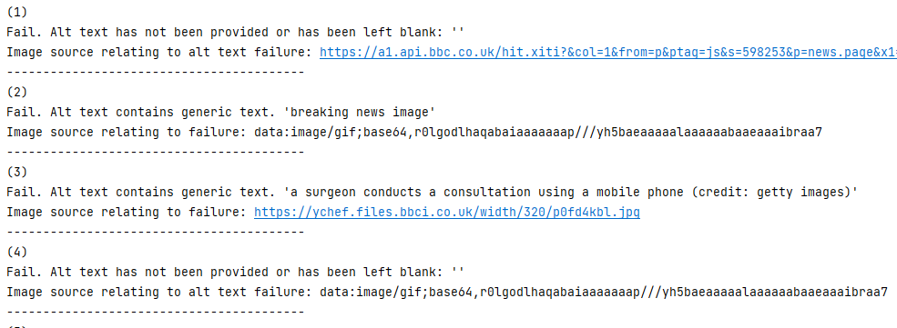
Requests aided results:
Figure 12: Screenshot of requests related results.
The results from this old version of the web checker in Figure 12 may be inaccurate. However, the major issue here is that many of the images being referred to have a strange and identical identification, starting with: “data:image/gif;base64”. This is the result of a technology called lazy loading [87]. It only loads the images when needed, e.g., when a user scrolls down far enough for them to load [87]. This means that developers would struggle to identify what image the web checker is referring to, thus making it more difficult to resolve any failures.
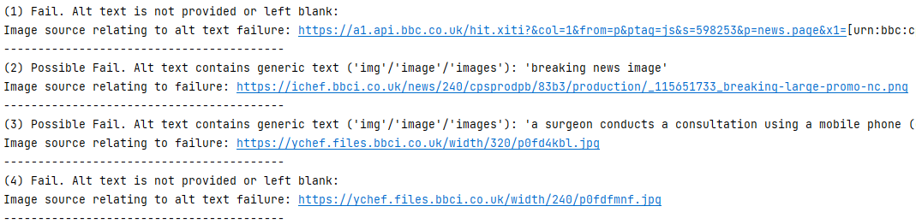
Selenium aided results:
Figure 13: Screenshot of Selenium related results.
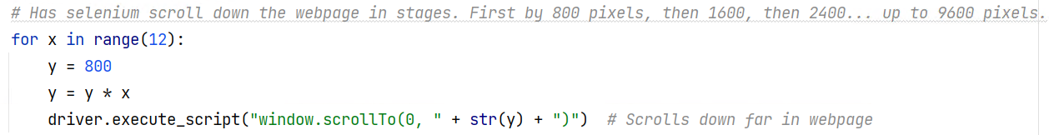
The results from the requests package took roughly 2 seconds to load, whilst Selenium took just more than 10x as long. However, when comparing result “(2)” and “(4)” from both results in Figure 12 and Figure 13, it is clear why Selenium is superior. Selenium is automated to scroll down the webpage as seen below:
Figure 14: Screenshot of code that automates scrolling down a webpage. Code inspired from source: [88]
Selenium therefore gets around the lazy loading technology and thus loads and correctly refers to all image sources, unlike requests. One of the requirements was that the web checker must be accurate. Therefore, although requests was originally intended to be used and despite its speed advantage, when implementing the web checker it became apparent that Selenium should be used instead.

4.2.2.2 Functions
Functions were implemented because there was lots of repeating code when writing to a text file. This was done because the program is constantly writing to files and often the same files. There is no need to repeat code constantly and thus these functions have been used.
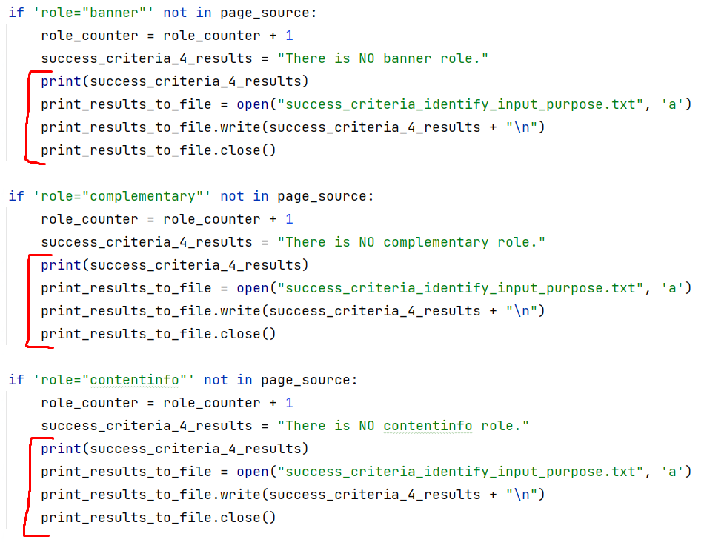
Old code, before functions:

Figure 15: Screenshot of old, unoptimized previously used code that writes results to a file. Code inspired from source: [89].

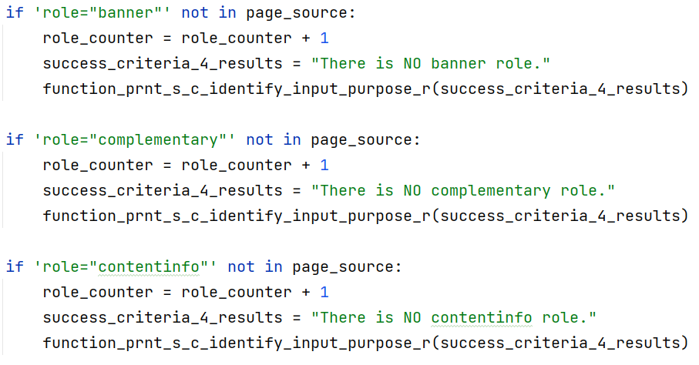
Final code, after functions implemented:

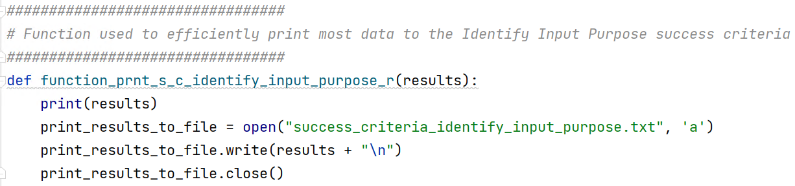
Figure 16: Screenshot of new, optimized code in the main programming file. It writes results to a file.
Figure 17: Screenshot of new, optimized code that is within a function. It writes results to a file. Code inspired from source: [89].
By implementing this function, it means that the same code can be re-used over and over instead of repeating lines of code. There are three other functions with a similar purpose, for writing to other text files. This means that the program is more efficient and will execute faster, thus helps achieve the requirement of optimizing the web checker.

4.2.2.3 Code that may skip hundreds of lines of code
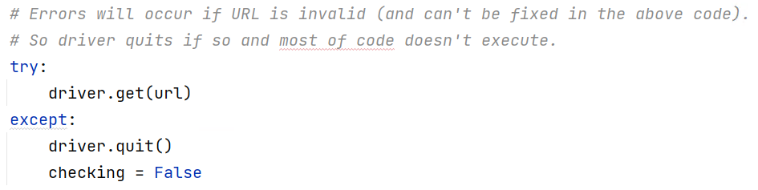
If the URL is found to be invalid, errors may occur. However, the program is told to keep running regardless. This is because the program will skip hundreds of lines of code that checks websites for compliance with the accessibility guidelines. It will instead only execute a few lines of code – enough to inform the user that the URL they entered is invalid.
Figure 18: Screenshot of Selenium web driver code. Inspired by source: [90]
Figure 19: Screenshot of else if statement that can avoid hundreds of lines of code from executing.
The “checking” variable will always be true, unless a URL is invalid. If a URL is valid, the website will be checked for compliance with the success criterions. It doesn’t run this portion of code if the variable is false because there is no point trying to check an invalid URL. This makes the code more efficient and thus once again helps to achieve the optimization requirement.

4.2.2.4 Re-check and Checking other websites from results page
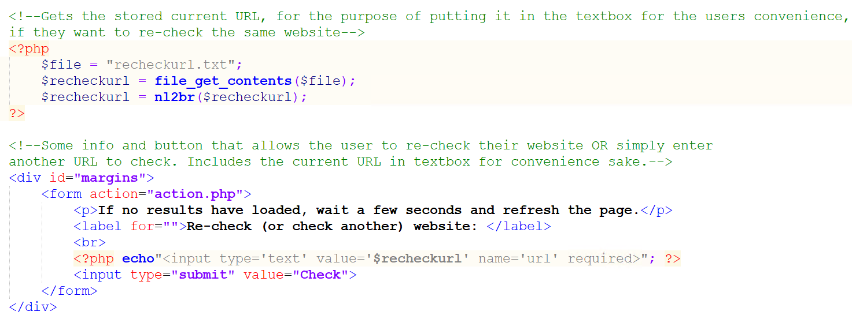
PHP results page code:
Figure 20: Screenshot of PHP code retrieving URL from file and allowing users to easily re-check a website. Code inspired from sources: [91] [92].
Screenshot from results page wireframe design:
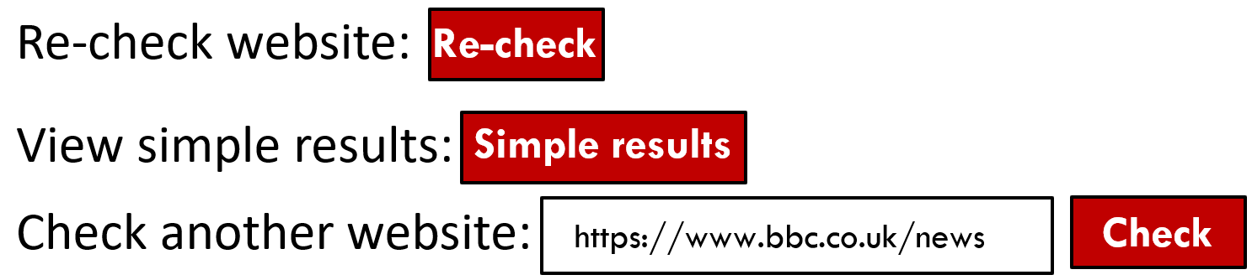

Figure 21: Screenshot of results page wireframe design.
Screenshot from final implementation’s result page:
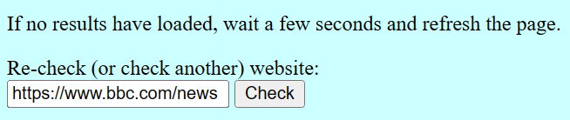

Figure 22: Screenshot revealing the results page from the final implementation differing slightly from the designed results page.
A re-check button and a button allowing for other websites to be checked from the results page were set out as requirements. These were also illustrated in the design stage, as seen from the snippet in Figure 21. However, when it came to implementing them it was found that there would be no need for two separate functionalities. Instead, they could be combined.
The last entered URL will always appear in the textbox. This means that users can easily re-check a website with a single click. If they want to check a different website, they can simply remove the URL in the textbox and type out another one. By making this change from the original design, it makes the website less cluttered and easier to use. Therefore, it helps full-fills the project’s requirement of having an easy to use interface.

4.2.2.5 URL Validation
Originally, the web checker only worked if the full URL of a website was typed in because the web driver only accepts URLs in this way. For example the URL “https://www.theguardian.com/uk” would work, but “www.theguardian.com/uk” and “theguardian.com/uk” would not work. The screenshot in Figure 23 below reveals what occurred when the not fully typed out URL “theguardian.com/uk” was entered.
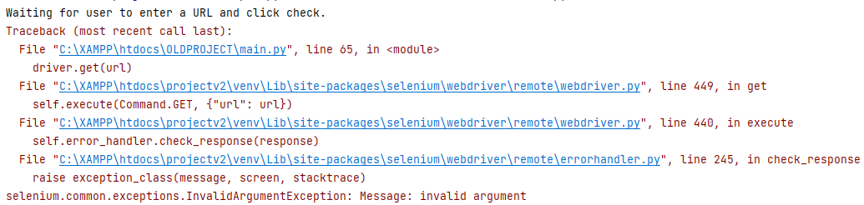
Console output before full URL validation:
Figure 23: Screenshot of old, previously used code’s console outputting errors regarding an invalid URL.
As seen above, the web driver cannot handle a URL that is not fully typed out. A fix for this was implemented, as seen below.
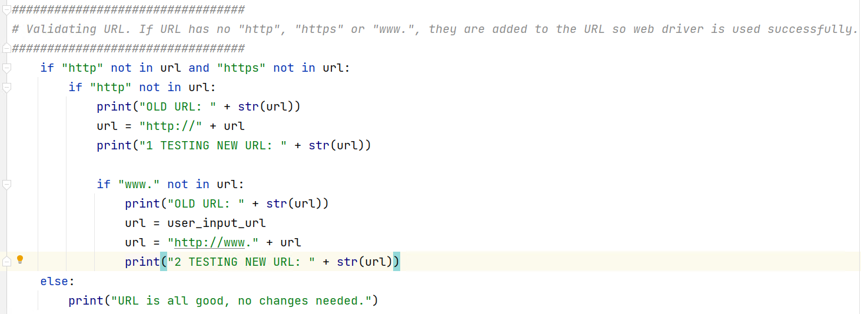
Final code for URL validation:
Figure 24: Screenshot revealing code related to how URLs are validated/dealt with.
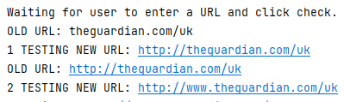
Final console output for URL validation:

Figure 25: Screenshot of the final implementation’s code outputting no errors.
The code recognizes that if no “http” or “https” are in the URL, it is not a fully typed out URL. It therefore seeks to resolve this, as seen in the console output from Figure 25. First, it recognizes that there is no “http” or “https” in the URL, thus adds it to the URL. Then it recognizes that there is no “www.” in the URL, thus adds it.
So, the resulting URL that is entered into the browser by Selenium’s automated process is “http://www.theguardian.com/uk”. However, this is still not exactly right because this URL should actually start with “https”. Fortunately, popular browsers including Edge automatically re-direct users to “HTTPS”, rather than “HTTP” if the website supports it [93].
Thus it was found that there is no need to apply “HTTPS” to a URL, only “HTTP” because Edge re-directs Selenium from “http://www.theguardian.com/uk” to “https://www.theguardian.com/uk”. By implementing this, it saves the end-user from having to type in full URLs as the program does it for them. It therefore helps full-fill the requirement of making the interface easier to use.
Note: All “must have”, “should have” and “could have” requirements from the MoSCoW analysis were implemented (despite not all of them being mentioned in the snippets above).

4.2.3 System testing
The program has been thoroughly tested to ensure that there are no bugs. Key tests that were performed have been outlined below:
- Users attempting to enter nothing for the URL will be prevented. A pop-up will appear informing them that they must enter something.
- The program will accept an invalid or URL that is not typed out in its entirety (e.g., no ‘https’). It will try to validate the URL, however if it can’t, it will inform the user that the URL is invalid. If it can validate the URL, it will operate as usual.
- If the program is closed abruptly, it may never get the opportunity to delete previously stored URLs. This would cause the next URL to be typed to be cojoined with the previous URL. To fix this, all files storing URLs are immediately cleared when the program is first executed.

Chapter 5 Testing/Results of Checker and Comparing Checker
From now on the web checker implemented will be referred to as ‘the web checker’. In this chapter, the web checker will be compared to other web checkers, including: AChecker [71], QualWeb [72] and WAVE [94]. To compare other web checkers to the web checker, only the success criterions that are checked for in the web checker will be checked for in all web checkers. However, the success criteria titled “Identify Input Purpose” will not be compared because the other web checkers do not clearly check for it.
It's important to also note that each web checker, including the web checker displays results differently. They do not always display results as a simple success or fail. The web checker displays results as either a fail, possible fail or success. Whereas AChecker for example, displays “Known problems” [95], “Likely problems” [95] and “Potential problems” [95].
For the sake of keeping each comparison consistent, all results that clearly indicate that there is a fail or possible fail for each success criteria will be noted and primarily referred to as fault(s)/warning(s).
The following WCAG 2.1 success criterions will be checked for:
- Non-text Content 1.1.1 [1].
- Page titled 2.4.2 [1].
- Language of page 3.1.1 [1].
The web checkers will check Welsh university homepages. Five university homepages will be checked, with 2 homepages being checked per university. This is because the Welsh and English version of each university’s homepage will be checked. In the test results, the Welsh version will be referred to as “CY” and the English version “EN”.
Homepages of the following Welsh universities will be checked:
- The University of Wales Trinity Saint David [96] [97].
- Cardiff University [98] [99].
- Swansea University [100] [101].
- Aberystwyth University [102] [103].
- Bangor University [104] [105].
All results displayed in the tables and charts in the following chapters were gathered from testing the websites mentioned above against the web accessibility checkers mentioned above.

5.1 Non-text Content 1.1.1 results
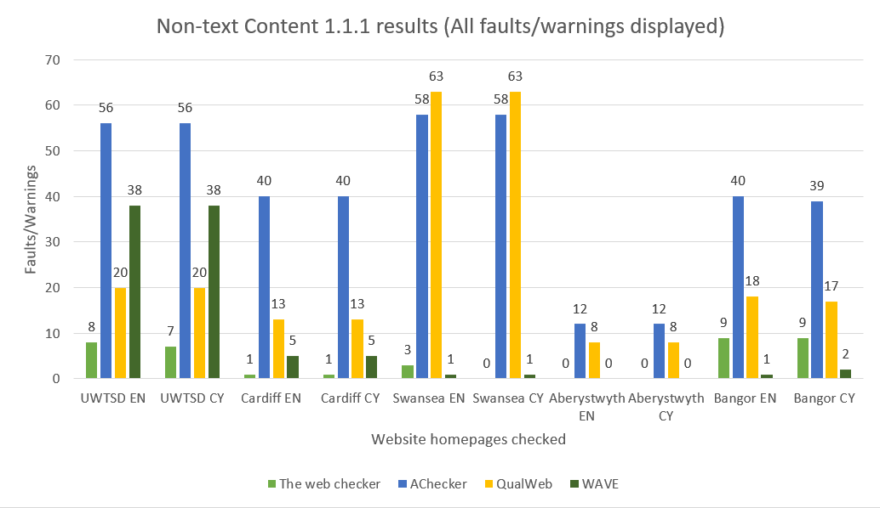
The total Non-Text Content indications of faults/warnings from each webpage tested from all specified web checkers is found below:

Figure 26: Bar chart revealing the faults/warnings found for the Non-Text Content 1.1.1 success criteria results.
The results above reveal that every webpage checked had at least 2 web checkers or more indicating that the webpage is not in compliance with the Non-text Content success criteria. 87.5% of all of the Welsh university webpages tested had 1 or more faults/warnings, according to all of the web checkers.
The web checker indicates that Swansea’s Welsh homepage complies with the success criteria. The web checker WAVE suggests there is 1 fault/warning. However, AChecker and QualWeb’s results widely differ to the web checker and WAVE’s results. AChecker suggests there is 58 faults/warnings, whereas QualWeb suggests there is 63 faults/warnings.
In all of the results bar 2, AChecker and QualWeb indicate more faults/warnings than AChecker and WAVE. This indicates that there is more depth to these web checkers. For instance, the web checker implemented checks to see if there is an alt text present. If there is, it checks to see if it contains characters and whether there is no generic text such as “image”. As long as this is the case throughout the website, it is considered to be complying with the success criteria.
AChecker on the other hand checks other aspects. Some of what it checks for includes:
- Whether the alternative text provided is relevant to the image [106].
- Whether images containing alt text are “decorative” [107]. Alt text should be left blank for images that are decorative [107].
- Whether the alt text provided is too lengthy (more than 100 characters) [108].
This is a reminder that web accessibility checkers differ widely in their interpretation of compliance and the displaying of results. For example, for AChecker it was rare for webpages to have any “Known problems” [95] or “Likely problems” [95] regarding the non-compliance of the success criteria. Instead, whilst gathering the results for AChecker, it was found that most results were overwhelmingly found from the “Potential problems” [95] section. Similarly, most results from QualWeb were classed as a “Warning” [109]. This means a manual review of the results is required to determine if these results are indeed failures.
This comes to show the difficulty of comparing each web checker to another. It also highlights the findings from the literature review – web checkers are not always accurate [33]. Web checkers cannot always say for sure whether a website passes a success criteria and thus instead indicate that there are potential faults that need to be manually checked.
The Non-text Content 1.1.1 results will be further evaluated in chapter 6.1 with an ANOVA and post-hoc test [110].

5.2 Language of page 3.1.1 results
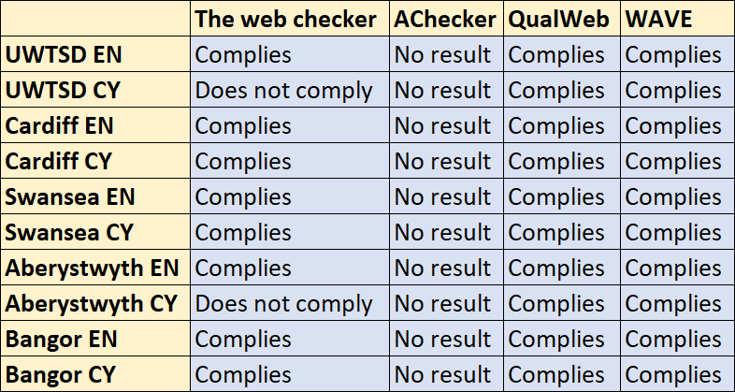

Table 2: Table of results revealing the websites that comply, have no result or do not comply with the Language of page 3.1.1 success criteria.
Table 2 reveals each web checker’s interpretation on whether a webpage complies, does not comply or if no results were found in regards to the language of page success criteria. Before running these tests, it was manually confirmed that ALL webpages do have a language set. However, not all webpages have the correct language set:
- UWTSD’s Welsh webpage has its language set as English, when it should be Welsh [97].
- Aberystwyth’s Welsh webpage has its main language set as English, when it should be Welsh because the entire webpage is Welsh [103].
This revelation means that the web checker is more accurate than the other web checkers when checking for language of page results. This is because it not only checks to see if a language is provided, it also checks to see if the language provided is accurate.
Note: Although AChecker has no results indicating the webpage has complied with the success criteria – it may only ever reveal whether a webpage does not comply with the success criteria. This may also be the case with WAVE with the results in Table 3 below.

5.3 Page titled 2.4.2 results
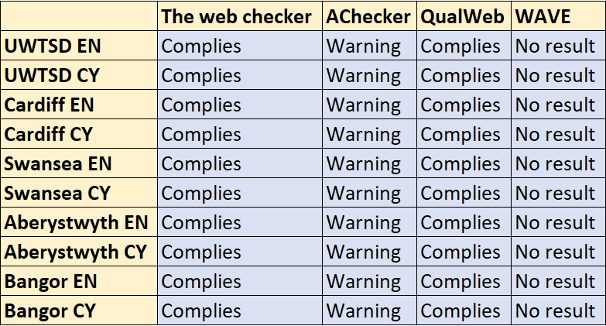

Table 3: Table of results revealing the websites that comply, have no result or display a warning for the Page titled 2.4.2 success criteria.
Table 3 reveals each web checker’s interpretation on whether a webpage complies or not, if it warns the user or if no results were found in regards to the page titled success criteria.
Manual checks reveal that all websites have a title within the header tags and thus comply with the success criteria. The web checker and QualWeb are therefore correct. AChecker however always warns that the title “might not describe the document” [111] whenever it identifies a title tag. This warning therefore prompts a user to manually confirm this.

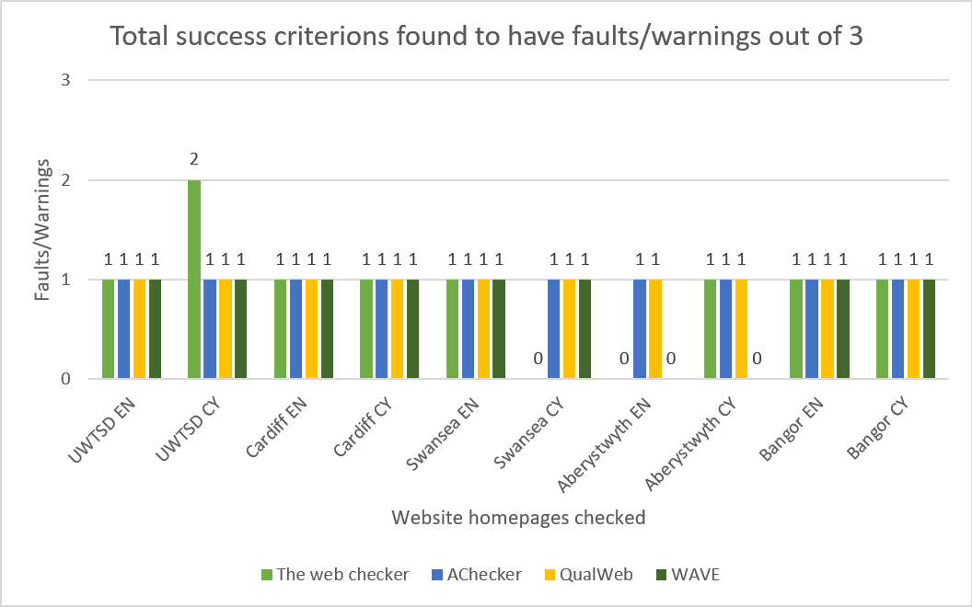
5.4 Total success criterions found to have faults/warnings out of 3

Figure 27: Bar chart revealing the total faults/warnings found for all of the success criterions.
The results in Figure 27 above reveal the total faults/warnings each web checker found for the 3 success criterions checked. In an overall finding between all web checkers, 90% of the webpages checked have at least 1 fault/warning out of the 3 success criterions. The UWTSD’s Welsh webpage however is the only webpage that a checker found faults/warnings for 2 out of the 3 success criterions checked.
These results will be further evaluated in chapter 6.2 with an ANOVA test [110].

Chapter 6 Further evaluation of results and aim and objectives
The Non-text Content and total success criterion failed results have been further evaluated via ANOVA and where necessary post-hoc testing’s [110]. All tables below have been slightly modified where appropriate for better viewing and understanding of the results per web checker.

6.1 Non-text Content 1.1.1 ANOVA and post-hoc results
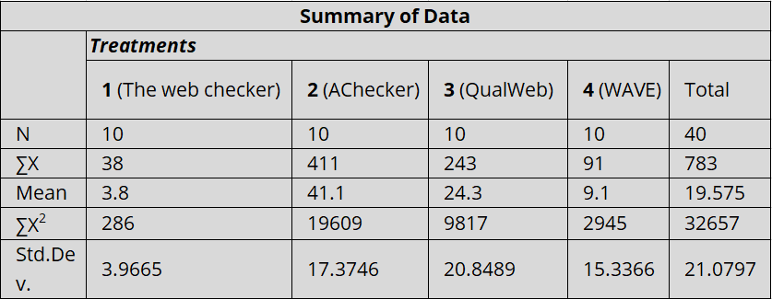
The results in this chapter have been formed from entering the results as seen in Figure 26 into the ANOVA and post-hoc calculator [110].

Table 4: Table revealing the ANOVA summary results found by using the initial results found in Figure 26. Results provided by (but slightly modified from) source: [110].
The ANOVA results reveal that AChecker and QualWeb have a much higher mean when it comes to displaying faults/warnings to the user. In this case, the mean of all web checkers from the webpages checked results in 19.575 faults/warnings.
This suggests that the university webpages tested need better accessibility in regards to the Non-text Content success criteria. However, as inferred in chapter 5.1, the high faults/warnings rate may be inflated much more than it otherwise would be due to overly cautious warnings from AChecker and QualWeb (that are displayed to prompt the user for manual review).
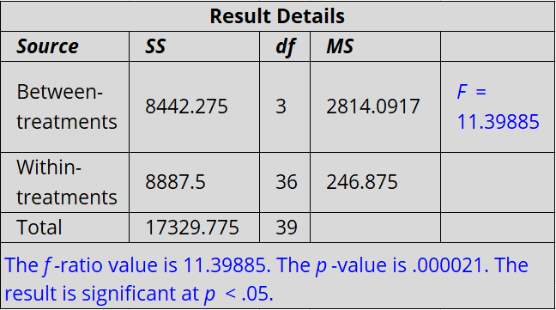

Table 5: Table revealing the ANOVA result details found by using the initial results found in Figure 26. Results provided by (but slightly modified from) source: [110].
The results in Table 5 above reveal that there is a significant difference in results for the web checkers. The results from the post-hoc testing from Table 6 below go into more detail about this.
Post-hoc results
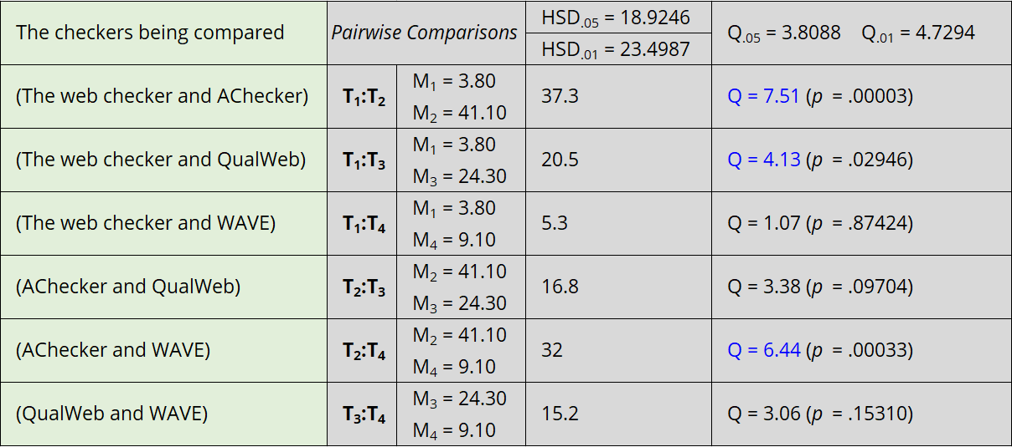

Table 6: Table revealing the post-hoc results found by using the initial results found in Figure 26. Results provided by (but slightly modified from) source: [110].
The column “The checkers being compared” was added to the table in Table 6 for clarity. From the results above, the following web checkers have a significant difference in their results for the Non-text Content success criteria:
- The web checker and AChecker
- The web checker and QualWeb
- AChecker and WAVE
These results once again indicate that AChecker and QualWeb are more thorough and warn users more for faults/warnings that need a manual review.
However, notably, according to the post-hoc results, although there is a significant difference between AChecker and WAVE, there is no significant difference between QualWeb and WAVE. This could be because whilst AChecker’s mean of finding 41.1 faults/warnings is 4x bigger than WAVE’s mean of 9.1, QualWeb’s mean of 24.3 is only 2x bigger than WAVE’s mean.

6.2 Total success criterions found to have faults/warnings out of 3 with ANOVA results
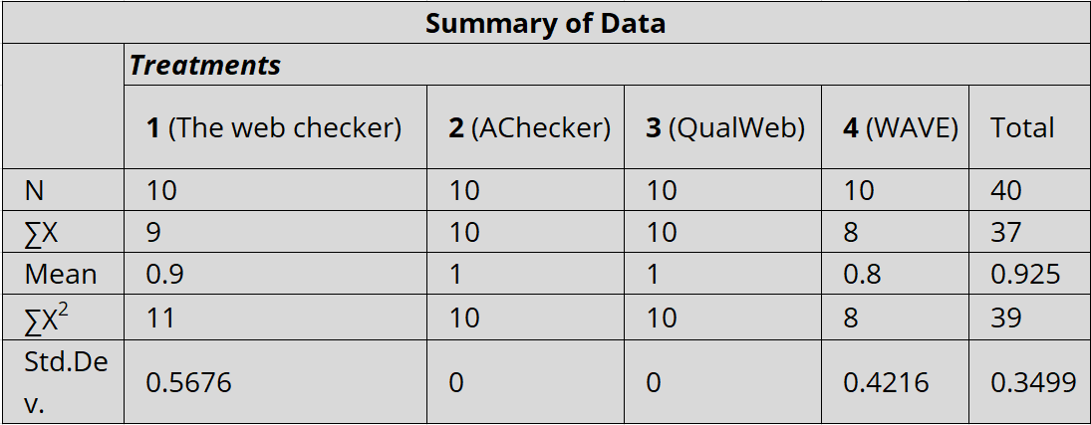
The results in this chapter have been formed by entering the results as seen in Figure 27 into the ANOVA calculator [110].
Table 7: Table revealing the ANOVA summary results found by using the initial results found in Figure 27. Results provided by (but slightly modified from) source: [110].

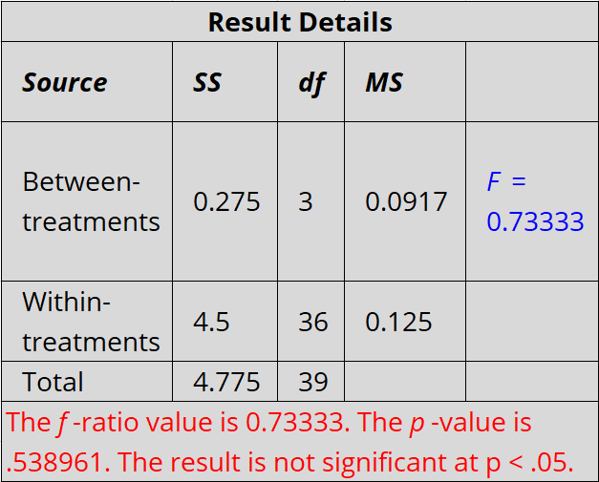
The results in Table 7 reveal that in total, the mean of 0.925 faults/warnings out of 3 success criterions are given for every webpage tested.

Table 8: Table revealing the ANOVA result details found by using the initial results found in Figure 27. Results provided by (but slightly modified from) source: [110].
The results show that there is no significant difference for each web checker when it comes to them detecting the overall faults/warnings found for the 3 success criterions for the webpages checked.
This can be attributed to the fact that although AChecker and QualWeb displayed much more faults/warnings than the other web checkers: only one fault is enough for the webpage to not comply with the success criteria. For example: Although AChecker found a mean of 41.1 faults/warnings for the Non-text Content success criteria as seen in Table 4, just 1 fault would have meant non-compliance.

6.3 Aim and objectives fulfilment
The aim and objectives of this project have been fulfilled throughout the project’s timeline.
The objectives of this project have been to:
- Research and critically evaluate the area.
This objective was fulfilled during chapter 2: Research and review of literature. Vital aspects that needed to be researched to get a better understanding of the area were undertaken. Including the research and critical evaluation of common visual impairments; web accessibility guidelines and specifications; assistive technology for computer use; designing for the visually impaired and web accessibility checkers.
This research allowed for the understanding of the common ways visually impaired users struggle to understand web content; the well-respected WCAG, UAAG and ARIA guidelines/specifications; how screen readers play a massive role in allowing for the understanding of content; empathic modelling and user trials; the different web accessibility checkers, including their advantages and disadvantages.
- Based upon the research, set out recommendations for good web accessibility practice.
The objective of setting out recommendations for good web accessibility practise was fulfilled in chapter 2.6.1. In summary, these recommendations included: using multiple web accessibility checkers; ensuring expert manual verification; striving for the improvement of usability of the website; educating developers on difficulties visually impaired users face; using empathic modelling technique to test websites and being wary of how assistive technologies operate.
- Implement a web accessibility checker and compare the implemented and other existing web accessibility checkers to each other.
The web accessibility checker has been fully implemented, with the requirements fulfilled. Furthermore, the comparisons of the web checkers can be seen in chapter 5 and 6. The web checker was compared to AChecker, QualWeb and WAVE regarding the following success criterions from the WCAG 2.1:
- Non-text Content 1.1.1 [1].
- Page titled 2.4.2 [1].
- Language of page 3.1.1 [1].
Websites were compared to these success criterions in particular because the web checker implemented covered these. All web checkers were compared thoroughly with a total of 10 webpages checked each for all of the success criterions listed. The results were discussed and further evaluated via an ANOVA test and post-hoc test where necessary.
The websites tested against the Non-text Content success criteria had a significant difference of results amongst different web checkers. However, the overall results in regards to the compliance of the websites checked against all 3 success criterion were not significant amongst different web checkers.
The aim of this project has been:
- To critically evaluate web accessibility for visually impaired users and develop a web accessibility checking tool which reviews WCAG compliance.
All of the objectives fulfilled helped fulfil the aim of this project. By fulfilling the objective of researching and critically evaluating the area, much of the aim has also been complete.
Furthermore, a web accessibility checking tool that checks for WCAG compliance has been developed. The tool implemented checks websites for compliance regarding four success criterion of WCAG 2.1 including:
- Non-text Content 1.1.1 [1].
- Identify Input Purpose 1.3.5 [1].
- Page titled 2.4.2 [1].
- Language of page 3.1.1 [1].
As discussed in chapter 4.2, it has been implemented robustly and thus can successfully check modern websites that use technology such as lazy loading which dynamically loads their content.
Therefore, the aim and objectives for this project have been fulfilled.

Chapter 7 Conclusion and further work
As discussed in chapter 6.3, the aim and objectives of this project have been fulfilled. All must have, should have and could have requirements set out in MoSCoW analysis during the design stage have been met as discussed in chapter 4.2.2.
Key areas that contributed to the fulfilment of the aim, objectives, requirements and completion of this project include:
- Research and review of literature. The research contributed to the understanding that: visually impaired users rely on assistive technology [64], including screen readers [64]; the WCAG 2.1 is credible and is the latest publication [1]; web accessibility checkers return a quick [68] but not always accurate result [33] and that there is room for improvement regarding good web accessibility practises.
- Design and Implementation. The design stage of the project helped contribute towards fulfilling the goals of the project as it prioritized features of the web checker. It also helped visualize how the processes of the program would work and the user interface of the website. The implementation stage is where many of the goals of the project were fulfilled because the web checker was successfully completed with all the must have, should have and could have requirements fulfilled.
- Testing/Results of Checker and Comparing Checker and Further evaluation of results. The completed web checker was thoroughly compared to other web checkers, including: AChecker, QualWeb and WAVE. All web checkers tested 10 of the same websites to check whether they complied with the WCAG 2.1’s Non-text Content 1.1.1, Page titled 2.4.2 and Language of page 3.1.1 success criterions. The results were mixed and due to the discrepancy between how each web checker checks for compliance and displays their results, the results were very difficult to compare. Therefore, in conclusion, the results of the web accessibility checkers cannot be completely meaningfully compared to each other because of the differing interpretation and displaying of the results.
The completed web checker implemented is very satisfactory in the timeframe given. However, with more time, there is room for improvement.

7.1 Suggestions for further work
The web checker implemented covers four success criterions, however there are many more success criterion that can be checked for compliance. If this project was expanded further, all of the success criterions that web checkers can realisticly check for in WCAG 2.1 could be covered. By doing so, it would mean web developers could rely further on the web checker to find faults. Web checkers can never be fully relied on – manual checking would still be required. Despite of this, with these changes added, visually impaired users could benefit as web developers could test their website for a much broader range of compliance before fully publishing their website.
Furthermore, as discussed in chapter 2.2.1, other web accessibility guidelines, such as the United States “Rehabilitation Act of 1973” [25] could be checked. The user could have the option of checking their website against one specific guideline or multiple guidelines. This would be incredibly useful for company websites that are available globally because they have the responsibility of not just complying with local web accessibility guidelines but with guidelines wherever their website is available.
Finally, one key expansion could be made to the web checker. Although Selenium was ultimately used due to its accuracy, in the implementation stage it was noticed that it is a slower alternative to requests. Thus, users could be given the option of very fast, but less accurate results by using requests but also be given the option of using Selenium for slower, but more accurate results.

Chapter 8 Reflection
Throughout this project, I have learned additional skills. It has also given me the opportunity to recap and apply my knowledge from previous modules into this project.
This project has made me understand the importance of time management and has improved my time management skills. Creating a timeline for each aspect of the project to be completed has allowed me to finish it on time. If I had not planned for the future, it is likely I would have run out of time.
I had no previous experience with the Python programming language, however had to learn it quickly because essential elements of the project relied on it. This project has given me the opportunity to develop my skills more with PHP, HTML and CSS. I had to understand processes I had not done before, such as transferring data from Python to PHP and vice versa.
Of course, I could not have done this project without the skills I have learned throughout my time studying at UWTSD. Essential modules including the “Introduction to Web and Database Concepts” helped me greatly as it gave me much of the knowledge I needed to build the website. As I mentioned, I had no experience with Python. However, the fundamental coding knowledge taught to me in modules such as “Software Development” and “Advanced Software Development” gave me a huge head start. With the programming knowledge gained I knew what to learn first for Python and thus quickly became familiar with the programming language’s syntax.
Another module which helped me tremendously was the “Changemakers: Creativity and Value Creation” module. It gave me a great understanding of how to conduct projects, including ideas such as using a MoSCoW analysis and wireframes for designing projects.
At the start of the project, I had no project schedule. This meant that a few weeks went by without much progress for the project as I had set no deadlines for myself. This meant I was not inclined to progress through the project very well. I eventually realized that I needed a robust schedule and had to look deeper into what needed to get done and by when. If I had the chance to start this project again, I would immediately set myself deadlines to complete certain goals. If I had done so earlier, I may have had some leeway and may have had time to improve my project in some areas. By not doing so, it put me under a lot of pressure to complete the project.
Finally, one crucial mistake I made was to try and code the project without a more fundamental understanding of Beautiful Soup’s functionalities. Initially I ignored some areas of Beautiful Soup that I did not fully understand and proceeded to try and program the web accessibility checker regardless. I now realize that this was a mistake because if I had taken extra time to familiarize myself with more of the fundamental aspects of Beautiful Soup earlier on, it would likely have made the web checker significantly easier to code.

Chapter 9 References

[1] | A. Kirkpatrick, J. O. Connor, A. Campbell and M. Cooper, “Web Content Accessibility Guidelines (WCAG) 2.1,” W3C, 5 Jun 2018. [Online]. Available: https://www.w3.org/TR/WCAG21/. [Accessed 4 Dec 2022].
[2] | R. I. Jamieson, “Evaluating the challenges of web accessibility for visually impaired users – Research Proposal,” 2022.
[3] | World Health Organization, “Blindness and vision impairment,” World Health Organization, 13 Oct 2022. [Online]. Available: https://www.who.int/news-room/fact-sheets/detail/blindness-and-visual-impairment. [Accessed 12 Dec 2022].
[4] | National Health Service, “Blindness and vision loss,” National Health Service, 22 Dec 2021. [Online]. Available: https://www.nhs.uk/conditions/vision-loss/. [Accessed 12 Dec 2022].
[5] | World Health Organization, World report on vision, 2019.
[6] | RNIB, “Cataracts,” RNIB, 1 Sep 2022. [Online]. Available: https://www.rnib.org.uk/your-eyes/eye-conditions-az/cataracts/. [Accessed 12 Dec 2022].
[7] | National Health Service, “Age-related cataracts,” National Health Service, 22 Dec 2020. [Online]. Available: https://www.nhs.uk/conditions/cataracts. [Accessed 12 Dec 2022].
[8] | RNIB, “Age-related macular degeneration (AMD),” RNIB, 1 Sep 2022. [Online]. Available: https://www.rnib.org.uk/your-eyes/eye-conditions-az/age-related-macular-degeneration-amd/. [Accessed 12 Dec 2022].
[9] | National Health Service, “What is AMD?,” National Health Service, 20 April 2021. [Online]. Available: https://www.nhs.uk/conditions/age-related-macular-degeneration-amd. [Accessed 12 Dec 2022].
[10] | World Health Organization, “Blindness and vision impairment: Refractive errors,” World Health Organization, 6 Oct 2013. [Online]. Available: https://www.who.int/news-room/questions-and-answers/item/blindness-and-vision-impairment-refractive-errors. [Accessed 12 Dec 2022].
[11] | Diabetes UK, “diabetic retinopathy — diabetes and eye problems,” Diabetes UK, [Online]. Available: https://www.diabetes.org.uk/guide-to-diabetes/complications/retinopathy. [Accessed 12 Dec 2022].
[12] | National Health Service, “Overview Diabetic retinopathy,” National Health Service, 16 Dec 2021. [Online]. Available: https://www.nhs.uk/conditions/diabetic-retinopathy/. [Accessed 12 Dec 2022].
[13] | National Health Service, “Overview Glaucoma,” National Health Service, 26 Feb 2021. [Online]. Available: https://www.nhs.uk/conditions/glaucoma/. [Accessed 12 Dec 2022].
[14] | RNIB, “Glaucoma,” RNIB, 1 Sep 2022. [Online]. Available: https://www.rnib.org.uk/your-eyes/eye-conditions-az/glaucoma/. [Accessed 12 Dec 2022].
[15] | C. Stephanidis, “42. Design for All,” Interaction Design Foundation, [Online]. Available: https://www.interaction-design.org/literature/book/the-encyclopedia-of-human-computer-interaction-2nd-ed/design-4-all?r=dr_nik_whitehead. [Accessed 12 Dec 2022].
[16] | J. Allan, G. Lowney, K. Patch and J. Spellman, “User Agent Accessibility Guidelines (UAAG) 2.0,” W3C, 15 Dec 2015. [Online]. Available: https://www.w3.org/TR/UAAG20/. [Accessed 4 Dec 2022].
[17] | J. Diggs, S. McCarron, M. Cooper, R. Schwerdtfeger and J. Craig, “Accessible Rich Internet Applications (WAI-ARIA) 1.1,” W3C, 14 Dec 2017. [Online]. Available: https://www.w3.org/TR/wai-aria-1.1/. [Accessed 4 Dec 2022].
[18] | S. Kumara, J. Shree and P. Biswas, “Comparing ten WCAG tools for accessibility evaluation of websites,” Technology and Disability 33 (2021), vol. 33, no. 3, pp. 163-167, 2021.
[19] | C. Dunlap, “Vint Cerf,” Father of the internet, p. 25, 1998.
[20] | V. Cerf, “The Internet is for Everyone,” Internet Society, 7 Apr 1999. [Online]. Available: https://www.internetsociety.org/news/speeches/2011/the-internet-is-for-everyone/. [Accessed 4 Dec 2022].
[21] | W. Chisholm, G. Vanderheiden and I. Jacobs, “Web Content Accessibility Guidelines 1.0,” W3C, 5 May 1999. [Online]. Available: https://www.w3.org/TR/WAI-WEBCONTENT/. [Accessed 4 Dec 2022].
[22] | B. Caldwell, M. Cooper, L. G. Reid, G. Vanderheiden, W. Chisholm, J. Slatin and J. White, “Web Content Accessibility Guidelines (WCAG) 2.0,” W3C, 11 Dec 2008. [Online]. Available: https://www.w3.org/TR/WCAG20/. [Accessed 4 Dec 2022].
[23] | S. A. Zahra, “Accessibility Principles,” W3C, 10 May 2019. [Online]. Available: https://www.w3.org/WAI/fundamentals/accessibility-principles/. [Accessed 17 Dec 2022].
[24] | Accessibility Guidelines Working Group, “Introduction to Understanding WCAG,” W3C, 1 Dec 2022. [Online]. Available: https://www.w3.org/WAI/WCAG21/Understanding/intro#understanding-the-four-principles-of-accessibility. [Accessed 4 Dec 2022].
[25] | U.S. General Services Administration, “IT Accessibility Laws and Policies,” U.S. General Services Administration, Nov 2022. [Online]. Available: https://www.section508.gov/manage/laws-and-policies/. [Accessed 4 Dec 2022].
[26] | New Zealand Government, “Web Accessibility Standard 1.1,” New Zealand Government, 3 Mar 2022. [Online]. Available: https://www.digital.govt.nz/standards-and-guidance/nz-government-web-standards/web-accessibility-standard-1-1/. [Accessed 4 Dec 2022].
[27] | S. Schmutz, A. Sonderegger and J. Sauer, “Implementing Recommendations From Web Accessibility Guidelines: A Comparative Study of Nondisabled Users and Users With Visual Impairments,” Human Factors and Ergonomics Society, vol. 59, no. 6, p. 957, 2017.
[28] | Central Digital and Data Office, “Understanding accessibility requirements for public sector bodies,” UK Government, 22 Aug 2022. [Online]. Available: https://www.gov.uk/guidance/accessibility-requirements-for-public-sector-websites-and-apps. [Accessed 4 Dec 2022].
[29] | D. Rømen and D. Svanæs, “Validating WCAG versions 1.0 and 2.0 through usability testing with disabled users,” Universal Access in the Information Society, vol. 11, p. 376, 2012.
[30] | G. Mbipom and S. Harper, “The Transition From Web Content Accessibility Guidelines 1.0 to 2.0: What This Means for Evaluation and Repair,” in Proceedings of the 27th ACM international conference on Design of communication, 2009.
[31] | M. Termens, M. Ribera, M. Porras, M. Boldú, A. Sulé and P. Paris, “Web Content Accessibility Guidelines: from 1.0 to 2.0,” in Proceedings of the 18th international conference on World wide web, 2009.
[32] | F. Kamoun, B. Mourad and E. Bataineh, “WCAG 1.0 versus WCAG 2.0 Web Accessibility Compliance: A Case Study,” pp. 95-96, 2013.
[33] | A. Alsaeedi, “Comparing Web Accessibility Evaluation Tools and Evaluating the Accessibility of Webpages: Proposed Frameworks,” Information, vol. 11, no. 1, pp. 1-5, 2020.
[34] | C. Spina, “WCAG 2.1 and the Current State of Web Accessibility in Libraries,” Journal of Library User Experience, vol. 2, no. 2, 2019.
[35] | S. L. Henry, “What’s New in WCAG 2.1,” W3C, 13 Aug 2020. [Online]. Available: https://www.w3.org/WAI/standards-guidelines/wcag/new-in-21/. [Accessed 5 Dec 2022].
[36] | statista, “Number of smartphone subscriptions worldwide from 2016 to 2021, with forecasts from 2022 to 2027,” statista, Feb 2022. [Online]. Available: https://www.statista.com/statistics/330695/number-of-smartphone-users-worldwide/. [Accessed 5 Dec 2022].
[37] | A. Bhowmick and S. Hazarika, “An insight into assistive technology for the visually impaired and blind people: state-of-the-art and future trends,” Journal on Multimodal User Interfaces, vol. 11, 2017.
[38] | Y. Akgül and K. Vatansever, “Web Accessibility Evaluation of Government Websites for People with Disabilities in Turkey,” Journal of Advanced Management Science, vol. 4, no. 3, 2016.
[39] | M. Akram, G. A. Ali, A. Sulaiman and M. u. Hassan, “Accessibility evaluation of Arabic University websites for compliance with success criteria of WCAG 1.0 and WCAG 2.0,” Universal Access in the Information Society, 2022.
[40] | S. Schmutz, A. Sonderegger and J. Sauer, “Implementing Recommendations From Web Accessibility Guidelines: Would They Also Provide Benefits to Nondisabled Users,” Human Factors and Ergonomics Society, vol. 58, no. 4, p. 612, 2016.
[41] | R. Gonc¸alves, J. Martins, J. Pereira, M. A.-Y. Oliveira and J. J. P. Ferreira, “Enterprise Web Accessibility Levels Amongst the Forbes 250: Where Art Thou O Virtuous Leader?,” Journal of Business Ethics, vol. 113, p. 363, 2013.
[42] | I. Jacobs, J. Gunderson and E. Hansen, “User Agent Accessibility Guidelines 1.0,” W3C, 17 Dec 2002. [Online]. Available: https://www.w3.org/TR/UAAG10/. [Accessed 10 Dec 2022].
[43] | J. Gunderson, “W3C user agent accessibility guidelines 1.0 for graphical Web browsers,” Universal Access in the Information Society, vol. 3, p. 39, 2004.
[44] | J. Spellman and J. Allan, “User Agent Accessibility Guidelines (UAAG) Overview,” W3C, May 2015. [Online]. Available: https://www.w3.org/WAI/standards-guidelines/uaag/. [Accessed 10 Dec 2022].
[45] | J. Craig, M. Cooper, L. Pappas, R. Schwerdtfeger and L. Seeman, “Accessible Rich Internet Applications (WAI-ARIA) 1.0,” W3C, 20 Mar 2014. [Online]. Available: https://www.w3.org/TR/wai-aria-1.0/. [Accessed 10 Dec 2022].
[46] | “Integrating WAI-ARIA suite through browser games’ components,” Proceedings of SBGames 2018, p. 664, 2018.
[47] | P. Thiessen and S. Hockema, “WAI-ARIA Live Regions: eBuddy IM as a Case Example,” Proceedings of the 2010 International Cross Disciplinary Conference on Web Accessibility, pp. 1-2, 2010.
[48] | A. Brown and S. Harper, “Dynamic injection of WAI-ARIA into Web content,” Proceedings of the 10th International Cross-Disciplinary Conference on Web Accessibility, p. 1, 2013.
[49] | C. Kim, E. Park and H. Lim, “A Study on the WAI-ARIA of Domestic Websites with High Session in Korea,” The Fifth International Conference on Building and Exploring Web Based Environments, p. 28, 2017.
[50] | S. Abou-Zahra and J. Brewer, “Tools and Techniques,” W3C, 15 May 2017. [Online]. Available: https://www.w3.org/WAI/people-use-web/tools-techniques/. [Accessed 16 Dec 2022].
[51] | I. Baazeem and H. Al-Khalifa, “Advancements in Web Accessibility Evaluation Methods: How Far Are We?,” Proceedings of the 17th International Conference on Information Integration and Web-based Applications & Services, p. 2, 2015.
[52] | L. Bowers and R. Hayle, “Creative haptics: An evaluation of a haptic tool for non-sighted and visually impaired design students, studying at a distance,” British Journal of Visual Impairment, vol. 39, no. 3, p. 215, 2021.
[53] | S. Kane, M. R. Morris and J. Wobbrock, “Touchplates: Low-Cost Tactile Overlays for Visually Impaired Touch Screen Users,” Proceedings of the 15th International ACM SIGACCESS Conference on Computers and Accessibility, pp. 1-3, 2013.
[54] | W3C, “Making the Web Accessible,” W3C, [Online]. Available: https://www.w3.org/WAI/. [Accessed 16 Dec 2022].
[55] | S. Kumari, A. Akole, P. Angnani, Y. Bhamare and Z. Naikwadi, “Enhanced Braille Display Use of OCR and Solenoid to Improve Text to Braille Conversion,” International Conference for Emerging Technology, p. 1, 2020.
[56] | RNIB, “An RNIB guide to braille displays for blind and partially sighted people,” RNIB, [Online]. Available: https://www.rnib.org.uk/living-with-sight-loss/assistive-aids-and-technology/everyday-tech/reading-and-writing/an-rnib-guide-to-braille-displays-for-blind-and-partially-sighted-people/. [Accessed 16 Dec 2022].
[57] | Microsoft, “Discover Windows accessibility features,” Microsoft, [Online]. Available: https://support.microsoft.com/en-us/windows/discover-windows-accessibility-features-8b1068e6-d3b8-4ba8-b027-133dd8911df9. [Accessed 16 Dec 2022].
[58] | Google, “Android accessibility overview,” Google. [Online]. Available: https://support.google.com/accessibility/android/answer/6006564. [Accessed 16 Dec 2022].
[59] | Google, “Products and Features,” Google, [Online]. Available: https://www.google.com/accessibility/products-features/. [Accessed 16 Dec 2022].
[60] | Google, “Speed up or slow down YouTube videos,” Google, [Online]. Available: https://support.google.com/youtube/answer/7509567. [Accessed 16 Dec 2022].
[61] | Google, “Manage subtitle settings,” Google, [Online]. Available: https://support.google.com/youtube/answer/100078. [Accessed 16 Dec 2022].
[62] | YouTube, “Use automatic captioning,” YouTube, [Online]. Available: https://support.google.com/youtube/answer/6373554. [Accessed 16 Dec 2022].
[63] | Google, “High Contrast,” Google, [Online]. Available: https://chrome.google.com/webstore/detail/high-contrast/djcfdncoelnlbldjfhinnjlhdjlikmph. [Accessed 16 Dec 2022].
[64] | UK Government, “Accessibility in government,” UK Government, 1 Nov 2016. [Online]. Available: https://accessibility.blog.gov.uk/2016/11/01/results-of-the-2016-gov-uk-assistive-technology-survey/. [Accessed 16 Dec 2022].
[65] | S. H. Lawton, S. Abou-Zahra and K. White, “Accessibility, Usability, and Inclusion,” W3C, 6 May 2016. [Online]. Available: https://www.w3.org/WAI/fundamentals/accessibility-usability-inclusion/. [Accessed 17 Dec 2022].
[66] | H. Persson, H. Ahman, A. A. Yngling and J. Gulliksen, “Universal design, inclusive design, accessible design, design for all: different concepts—one goal? On the concept of accessibility— historical, methodological and philosophical aspects,” Universal Access in the Information Society, vol. 14, p. 507, 2015.
[67] | S. L. Henry, S. Abou-Zahra and A. Arch, 28 Apr 2020. [Online]. Available: https://www.w3.org/WAI/planning/involving-users/. [Accessed 17 Dec 2022].
[68] | S. Abou-Zahra, N. Steenhout and L. Keen, “Selecting Web Accessibility Evaluation Tools,” W3C, 28 Mar 2020. [Online]. Available: https://www.w3.org/WAI/test-evaluate/tools/selecting/. [Accessed 18 Dec 2022].
[69] | K. Boyalakuntla, A. S. M. Venigalla and S. Chimalakonda, “WAccess - AWeb Accessibility Tool based on WCAG 2.2, 2.1 and 2.0 Guidelines,” vol. v2, 2021.
[70] | E. Eggert, S. Abou-Zahra and J. R. H. González, “Web Accessibility Evaluation Tools List,” W3C, [Online]. Available: https://www.w3.org/WAI/ER/tools/?q=wcag-21-w3c-web-content-accessibility-guidelines-21. [Accessed 18 Dec 2022].
[71] | AChecker, “AChecker Web Accessibility Checker,” AChecker, [Online]. Available: https://achecker.achecks.ca/checker/index.php. [Accessed 18 Dec 2022].
[72] | QualWeb, “ABOUT,” QualWeb, [Online]. Available: http://qualweb.di.fc.ul.pt/evaluator/https%253A%252F%252Fwww.bbc.co.uk%252Fnews. [Accessed 18 Dec 2022].
[73] | H. Y.Abuaddous, M. Z. Jali and N. Basir, “Web Accessibility Challenges,” International Journal of Advanced Computer Science and Applications, vol. 7, no. 10, p. 177, 2016.
[74] | S. L. Henry, “Evaluating Web Accessibility Overview,” W3C, 2 Feb 2022. [Online]. Available: https://www.w3.org/WAI/test-evaluate/. [Accessed 18 Dec 2022].
[75] | S. L. Henry, S. Rush, C. Watson, S. Keith, A. B. Leiserson, A. Arch, W. Dick, V. M. Miller, J. Sutton, I. Pouncey, D. Boudreau and T. Jewett, “Easy Checks – A First Review of Web Accessibility,” W3C, 28 Apr 2020. [Online]. Available: https://www.w3.org/WAI/test-evaluate/preliminary/. [Accessed 18 Dec 2022].
[76] | J. Dudovskiy, “Positivism Research Philosophy,” BUSINESS RESEARCH METHODOLOGY, [Online]. Available: https://research-methodology.net/research-philosophy/positivism/. [Accessed 14 Apr 2023].
[77] | R. I. Jamieson, “Welcome to my Research Portfolio,” 2022.
[78] | David R. Thomas, “A General Inductive Approach for Analyzing Qualitative Evaluation Data,” The American journal of evaluation, vol. 27, no. 2, pp. 238-246, 2006.
[79] | C. L. Winchester and M. Salji, “Writing a literature review,” Journal of Clinical Urology, vol. 9, no. 5, pp. 308-309, 2016.
[80] | L. Leung, “Validity, reliability, and generalizability in qualitative research,” Journal of family medicine and primary care, vol. 4, no. 3, pp. 324-326, 2015.
[81] | D. James and N. Simister, “QUANTITATIVE ANALYSIS,” intrac, 2017. [Online]. Available: https://www.intrac.org/wpcms/wp-content/uploads/2017/01/Quantitative-analysis.pdf. [Accessed 14 Apr 2023].
[82] | W. Singhto and N. Phakdee, “Adopting a Combination of Scrum and Waterfall Methodologies in Developing Tailor-made SaaS Products for Thai Service and Manufacturing SMEs,” in 2016 International Computer Science and Engineering Conference (ICSEC), Chiang Mai, 2016.
[83] | F. Q. Khan, S. Rasheed, M. Alsheshtawi, T. M. Ahmed and S. Jan, “A Comparative Analysis of RAD and Agile Technique for Management of Computing Graduation Projects,” Computers, Materials & Continua, vol. 64, no. 2, p. 781, 2020.
[84] | L. Richardson, “Beautiful Soup,” Crummy, 20 Mar 2023. [Online]. Available: https://www.crummy.com/software/BeautifulSoup/. [Accessed 2 Apr 2023].
[85] | Apache Friends, “XAMPP Apache + MariaDB + PHP + Perl,” Apache Friends, [Online]. Available: https://www.apachefriends.org/. [Accessed 2 Apr 2023].
[86] | Software Freedom Conservancy All, “Selenium automates browsers. That's it!,” Software Freedom Conservancy All, [Online]. Available: https://www.selenium.dev/. [Accessed 2 Apr 2023].
[87] | mozilla.org, “Lazy loading,” mozilla.org, 30 Mar 2023. [Online]. Available: https://developer.mozilla.org/en-US/docs/Web/Performance/Lazy_loading. [Accessed 3 Apr 2023].
[88] | B. Jacobson, “How to Scrape Dynamically Loaded Websites with #Selenium and #BeautifulSoup | #159,” YouTube, 19 Oct 2021. [Online]. Available: https://www.youtube.com/watch?v=F_WtRs2rZIQ. [Accessed 3 Apr 2023].
[89] | W3Schools, “Python File Write,” W3Schools, [Online]. Available: https://www.w3schools.com/python/python_file_write.asp. [Accessed 16 Apr 2023].
[90] | B. Muthukadan, “2. Getting Started,” [Online]. Available: https://selenium-python.readthedocs.io/getting-started.html. [Accessed 3 Apr 2023].
[91] | W3Schools, “PHP file_get_contents() Function,” W3Schools, [Online]. Available: https://www.w3schools.com/php/func_filesystem_file_get_contents.asp. [Accessed 16 Apr 2023].
[92] | The PHP Group, “nl2br,” The PHP Group, [Online]. Available: https://www.php.net/manual/en/function.nl2br.php. [Accessed 16 Apr 2023].
[93] | Microsoft, “Available for preview: Automatic HTTPS helps keep your browsing more secure,” Microsoft, 1 Jun 2021. [Online]. Available: https://blogs.windows.com/msedgedev/2021/06/01/available-for-preview-automatic-https-helps-keep-your-browsing-more-secure/. [Accessed 8 Apr 2023].
[94] | WAVE, “WAVE Web Accessibility Evaluation Tools,” WAVE, [Online]. Available: https://wave.webaim.org/. [Accessed 8 Apr 2023].
[95] | AChecker, “Web Accessibility Checker,” AChecker, [Online]. Available: https://achecker.achecks.ca/documentation/frame_content.php?p=checker/index.php. [Accessed 8 Apr 2023].
[96] | University of Wales Trinity Saint David, “CHOOSE YOUR STORY,” University of Wales Trinity Saint David, [Online]. Available: https://www.uwtsd.ac.uk/. [Accessed 8 Apr 2023].
[97] | University of Wales Trinity Saint David, “DEWIS EICH STORI,” University of Wales Trinity Saint David, [Online]. Available: https://www.uwtsd.ac.uk/cy/. [Accessed 8 Apr 2023].
[98] | Cardiff University, “Education that takes you further,” Cardiff University, [Online]. Available: https://www.cardiff.ac.uk/. [Accessed 8 Apr 2023].
[99] | Cardiff University, “Addysg sy’n mynd â chi ymhellach,” Cardiff University, [Online]. Available: https://www.cardiff.ac.uk/cy. [Accessed 8 Apr 2023].
[100] | Swansea University, “Happy Easter from Swansea University,” Swansea University, [Online]. Available: https://www.swansea.ac.uk/. [Accessed 8 Apr 2023].
[101] | Swansea University, “Pasg Hapus oddi wrth Brifysgol Abertawe,” Swansea University, [Online]. Available: https://www.swansea.ac.uk/cy/. [Accessed 8 Apr 2023].
[102] | Aberystwyth University, “Open Days 22 April 8 July Register Now,” Aberystwyth University, [Online]. Available: https://www.aber.ac.uk/en/. [Accessed 8 Apr 2023].
[103] | Aberystwyth University, “Diwrnodau Agored 22 Ebrill 8 Gorffennaf Cofrestrwch Nawr,” Aberystwyth University, [Online]. Available: https://www.aber.ac.uk/cy/. [Accessed 8 Apr 2023].
[104] | Bangor University, “FIND YOUR PLACE,” Bangor University, [Online]. Available: https://www.bangor.ac.uk/. [Accessed 8 Apr 2023].
[105] | Bangor University, “DIM OND Y GORAU,” Bangor University, [Online]. Available: https://www.bangor.ac.uk/cy. [Accessed 8 Apr 2023].
[106] | AChecker, “Web Accessibility Checker,” AChecker, [Online]. Available: https://achecker.achecks.ca/checker/suggestion.php?id=178. [Accessed 11 Apr 2023].
[107] | AChecker, “Web Accessibility Checker,” AChecker, [Online]. Available: https://achecker.achecks.ca/checker/suggestion.php?id=16. [Accessed 11 Apr 2023].
[108] | AChecker, “Web Accessibility Checker,” AChecker, [Online]. Available: https://achecker.achecks.ca/checker/suggestion.php?id=3. [Accessed 11 Apr 2023].
[109] | QualWeb, “SUMMARY,” QualWeb, [Online]. Available: http://qualweb.di.fc.ul.pt/evaluator/https%253A%252F%252Fwww.swansea.ac.uk%252Fcy%252F. [Accessed 11 Apr 2023].
[110] | Social Science Statistics, “One-Way ANOVA Calculator, Including Tukey HSD,” Social Science Statistics, [Online]. Available: https://www.socscistatistics.com/tests/anova/default2.aspx. [Accessed 11 Apr 2023].
[111] | AChecker, “Web Accessibility Checker,” AChecker, [Online]. Available: https://achecker.achecks.ca/checker/suggestion.php?id=54. [Accessed 11 Apr 2023].

Chapter 10 Appendices
Chapter 5 and 6 revealed data in either charts or tables. Below, all of the data collected will be revealed in the way in which they were originally found/noted.

10.1 Appendix A (results found in Chapter 5)
Non-text Content 1.1.1 results
 | The web checker | AChecker | QualWeb | WAVE
UWTSD EN | 8 | 56 | 20 | 38
UWTSD CY | 7 | 56 | 20 | 38
Cardiff EN | 1 | 40 | 13 | 5
Cardiff CY | 1 | 40 | 13 | 5
Swansea EN | 3 | 58 | 63 | 1
Swansea CY | 0 | 58 | 63 | 1
Aberystwyth EN | 0 | 12 | 8 | 0
Aberystwyth CY | 0 | 12 | 8 | 0
Bangor EN | 9 | 40 | 18 | 1
Bangor CY | 9 | 39 | 17 | 2
Table 9: Table reveals the faults/warnings found for the Non-Text Content 1.1.1 success criteria results.
Language of page 3.1.1 results
 | The web checker | AChecker | QualWeb | WAVE
UWTSD EN | Complies | No result | Complies | Complies
UWTSD CY | Does not comply | No result | Complies | Complies
Cardiff EN | Complies | No result | Complies | Complies
Cardiff CY | Complies | No result | Complies | Complies
Swansea EN | Complies | No result | Complies | Complies
Swansea CY | Complies | No result | Complies | Complies
Aberystwyth EN | Complies | No result | Complies | Complies
Aberystwyth CY | Does not comply | No result | Complies | Complies
Bangor EN | Complies | No result | Complies | Complies
Bangor CY | Complies | No result | Complies | Complies
Table 10: Table of results revealing the websites that comply, have no result or do not comply with the Language of page 3.1.1 success criteria.

Page titled 2.4.2 results
 | The web checker | AChecker | QualWeb | WAVE
UWTSD EN | Complies | Warning | Complies | No result
UWTSD CY | Complies | Warning | Complies | No result
Cardiff EN | Complies | Warning | Complies | No result
Cardiff CY | Complies | Warning | Complies | No result
Swansea EN | Complies | Warning | Complies | No result
Swansea CY | Complies | Warning | Complies | No result
Aberystwyth EN | Complies | Warning | Complies | No result
Aberystwyth CY | Complies | Warning | Complies | No result
Bangor EN | Complies | Warning | Complies | No result
Bangor CY | Complies | Warning | Complies | No result
Table 11: Table of results revealing the websites that comply, have no result or display a warning for the Page titled 2.4.2 success criteria.
Total success criterions found to have faults/warnings out of 3 results
 | The web checker | AChecker | QualWeb | WAVE
UWTSD EN | 1 | 1 | 1 | 1
UWTSD CY | 2 | 1 | 1 | 1
Cardiff EN | 1 | 1 | 1 | 1
Cardiff CY | 1 | 1 | 1 | 1
Swansea EN | 1 | 1 | 1 | 1
Swansea CY | 0 | 1 | 1 | 1
Aberystwyth EN | 0 | 1 | 1 | 0
Aberystwyth CY | 1 | 1 | 1 | 0
Bangor EN | 1 | 1 | 1 | 1
Bangor CY | 1 | 1 | 1 | 1
Table 12: Table reveals the total faults/warnings found for all of the success criterions.

10.2 Appendix B (results found in Chapter 6)
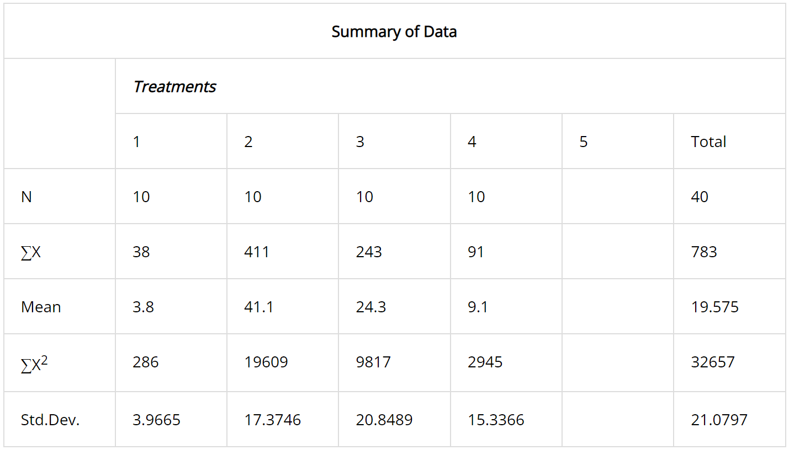
Non-text Content 1.1.1 ANOVA and post-hoc results
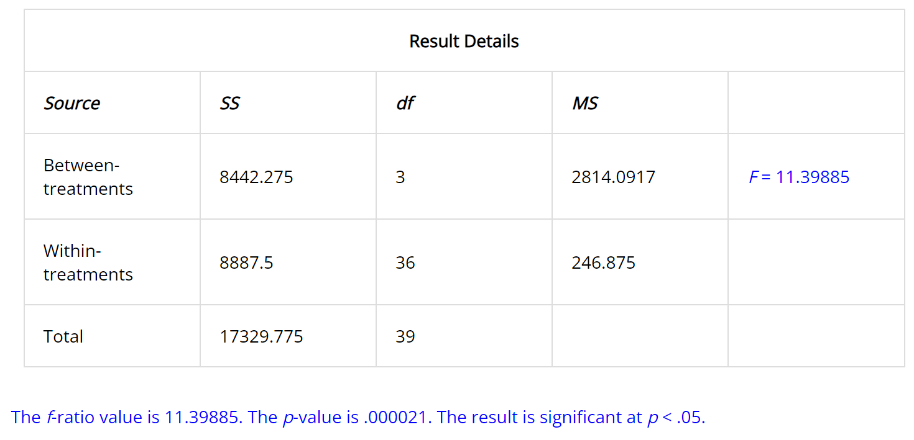
Table 13: Table revealing the ANOVA summary results found by using the initial results found in Table 9. Results provided by source: [110].
Table 14: Table revealing the ANOVA result details found by using the initial results found in Table 9. Results provided by source: [110].

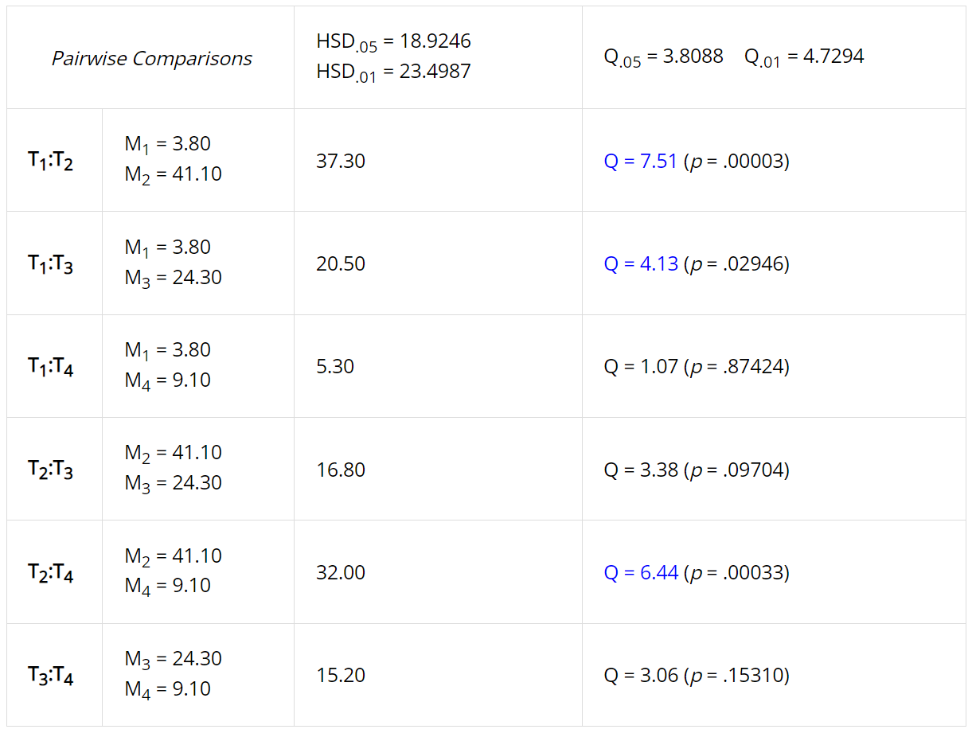
Table 15: Table revealing the post-hoc results found by using the initial results found in Table 9. Results provided by source: [110].
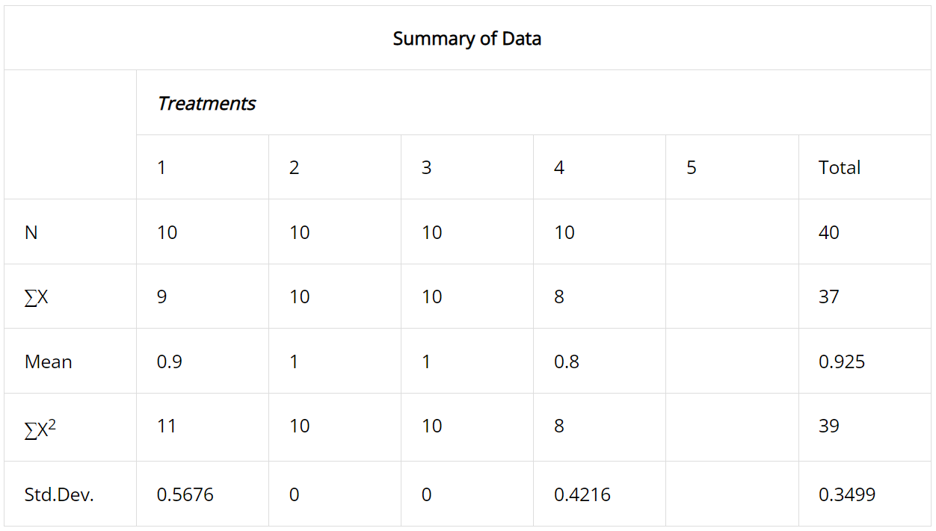
Total success criterions found to have faults/warnings out of 3 with ANOVA results
Table 16: Table revealing the ANOVA summary results found by using the initial results found in Table 12. Results provided by source: [110].
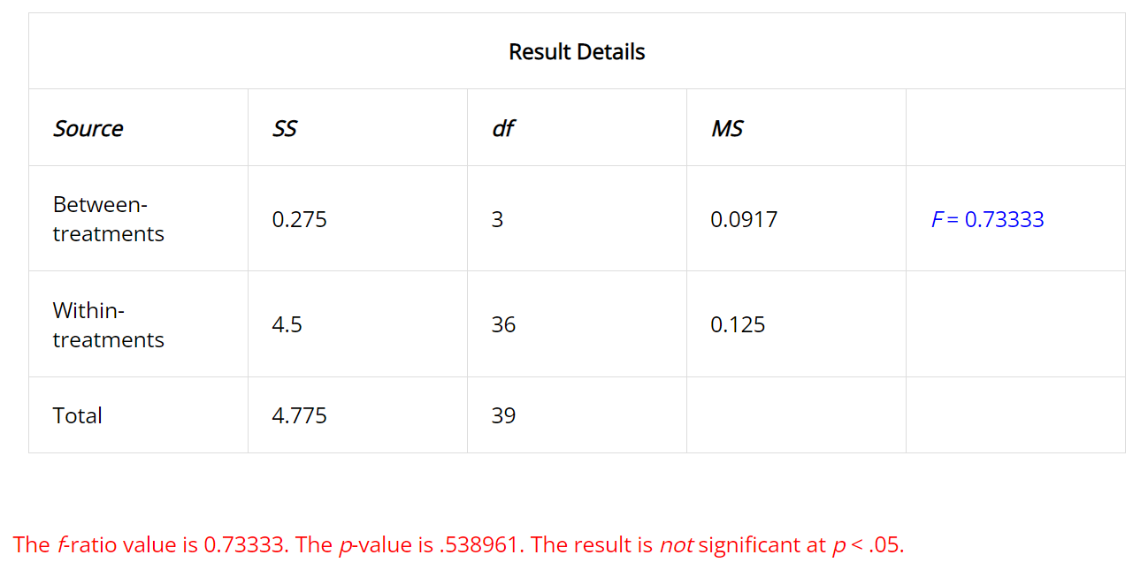
Table 17: Table revealing the ANOVA result details found by using the initial results found in Table 12. Results provided by source: [110].

