

Postgraduate/Distance Learning
Assignment coversheet & feedback form

THIS SHEET MUST BE THE FIRST PAGE OF THE ASSIGNMENT YOU ARE SUBMITTING (DO NOT SEND AS A SEPARATE FILE)

For completion by the student:
Student Name:
Danielle Marie Goldstein
Module code: HPCA7009  Module title: Skyscapes, Cosmology and Archaeology | Student ID number: 1710933 |  |  | Educational support needs:  No
Module tutor: Fabio Silva, Bernadette Brady and Kim Malville

Assignment due date: December 20th, 2019
If your module has multiple submissions, please indicate which piece of work this is.

1st 2nd X 3rd 4th 5th 6th
I confirm that this is my original work and that I have adhered to the University policy on plagiarism.
Signed Danielle Marie Goldstein
Email submission: if you are submitting this form via email, please tick this box X
(as a substitute for your signature) to confirm that you agree to the above declaration.
Assignment Mark
1st Marker’s Provisional mark
2nd Marker’s/Moderator’s provisional mark
Agreed Internal Mark:

External Examiner’s mark (if relevant)
Final Mark

NB. All marks are provisional until confirmed by the Final Examination Board.

For completion by Marker 1:
Comments:

Marker’s signature: |  |  | Date:
For completion by Marker 2/Moderator:

Comments:

Marker’s Signature: |  | Date:
AGREED INTERNAL MARK (where necessary):

Comment on process of arriving at agreed mark:

External Examiner’s comments (if relevant)

External Examiner’s Signature: |  | Date:

Celestial Alignments at Esna Temple
Word Count: 3674

Introduction
The aim of this research project was to conduct a simple fieldwork exercise to investigate the likelihood of celestial alignments at Esna Temple in Egypt. A number of key themes emerge from Esna Temple. The presence of the creator deity Khnum-Ra, particularly detailed ritual explanation to honor his presence is a well-known keynote to this temple. Other interesting aspects of this temple are the unification of Upper and Lower Egypt depicted through the columns of the temple, calendar stipulations, and an astrological mapping on the ceiling of the temple. The research undertaken in this project also points to the possibility that this temple could have been created to honor the goddess Neith as much as it was to honor Khnum. This research project set out to explore a question of the significance of the astrological ceiling at Esna in relationship to the temple itself, and questioned if significance of the astrological ceiling could be captured through simple measurements recorded in the field with tools including a clinometer and a global position system via an application through an iPhone. Given that Ancient Egyptian temples often have astronomical connections, the findings were computed at a later date to see if a connection could be made to this temple in alignment with a fixed star.

Location and cultural background of Esna Temple
Esna Temple is located within Upper Egypt, about 55 kilometers south of Luxor, and just west of the Nile River. The Ancient Egyptian name for the city of Esna was Iunyt or Ta-senet, sourced from the Arabic Isna and the Coptic Sne. This temple contains archaeological evidence that dates from as early as the Middle Kingdom of Ancient Egypt, however it was well known as an important cultural center in the Ptolemaic Period. It is believed that the temple was built in the 18th dynasty of Ancient Egypt, and was reconstructed during the 26th dynasty. Academic sources vary on their dating of this temple; for example, Dorian Greenbaum stated that the temple was built during the reigns of Ptolemy III and IV around 246–205 BCE, while Jochen Hallof stated that it was believed to be built during the reign of Ptolemy V during 205-145 BCE. Regardless of the exact timing, what exists of the temple today was built during a Graeco-Roman period of Egypt. Esna was built on top of the ancient city Lunyt, also known as Lunyn, which has a direct correlation to Iunyt. The decoration aspect of the construction of Esna Temple continued for roughly four hundred years. A unique characteristic of this temple is that it is approximately nine meters below sea level, which means that most of the ancient temple lies beneath the houses and businesses of the modern city of Esna, and these establishments have yet to be excavated. When one visits the temple in contemporary Egypt, the hypostyle hall is what remains for the visitor to experience. Hypostyle halls are a common theme in Ancient Egyptian temples that were designed to be positioned directly after the temple’s open court, which were quite often deep, and filled with columns. These columns were created for symbolic purposes, perhaps representing cosmic pillars holding up creation on earth to extend to the heavens, or the marshland vegetation sourced from the primordial waters.

Unique qualities of Esna Temple
There are a number of key features of Esna Temple that distinguish it from other temples in Egypt. These include the honoring of the creator deity Khnum-Ra, the appearance of the goddess Neith, a theme of unification of Upper and Lower Egypt presented through the temple columns, detailed ritual explanation outlining how to honor Khnum, a calendar, and a zodiacal mapping on the ceiling. It is believed that Esna was originally linked by a ceremonial way to the Nile and was the last Egyptian temple to be decorated with hieroglyphic texts.

A Dedication to Khnum
Historians identify this temple as one that’s dedicated to the creator god Khnum. Within the texts found at Esna, there are specific writings about four pillars of the sky that invoke an idea of the four sides or four corners, referring to the power of creation and the four directions. Radwan Abdel-Rady wrote that these four corners are symbols of the four cardinal points of the universe. These texts point to Khnum as creator of the world, one who keeps everything within the world in order, as Abdel-Rady stated, ‘He places the four sides of heaven’. Moustafa Gadalla wrote that Khnum is more accurately translated as a verb rather than a noun, and as a verb, his name means ‘to build’, ‘to fashion’, and ‘to put together’ both intellectually and physically. Gadalla related Khnum to the symbol of the Cosmic Egg, which contains all of the universe within in, indicative of the living space. He wrote that Khnum fashioned not just all of mankind, but was the ‘Father of the fathers’ of the Egyptian neteru. Neteru is a term that contains the entire pantheon of gods and goddesses in Egyptian culture, namely connecting each god or goddess with a particular aspect of nature. Khnum could also be considered the modeler, Maker of heaven, earth, the tuat, water, and the mountains, Governor of the House of Life, Creator of things that shall be, Source of the lands.’ According to Gadalla, Khnum is the ruler of space and time, which he differentiated from one another, comparing them as cut from the same cloth, just as the science of astronomy and its application of astrology. He sourced Ancient Egyptian texts that describe Khnum as Ruler of time who has particular zodiacal and Sothic connections, ‘who coordinated the movements of the sun and the moon at various seasons, and build up the year.’

The Hidden Goddess
Although many Egyptologists and academic experts described Khnum as the principle deity of Esna Temple, it could be argued that Neith and Khnum like two sides of one coin--as the principal deity of the temple. In other words, that her presence is just as significant, albeit subtle. The ancient site of Esna was once called Jwnyt, and an alternative name of the site was known as Ta-senet--or Tanet, which etiologically translates to ‘the seat of Neith’. Neith’s cult center is known to be Sais, a city in Lower Egypt. Neith, a creator goddess, is a known consort of Khnum. While Khnum formed all beings and objects materially on the potter’s wheel with his own hands, Neith created all beings cognitively, by thinking, and spelling their names. Texts found within the temple contain a narration that describes the creation of the world through seven powerful spells given by Neith.

Neith, also known as Net, Nit, or Niet, is a mother goddess, a goddess of healing like Sekhmet, and the verb of her name means ‘to weave.’ The mythology of Neith deems her a goddess of life who created herself out of the darkness, appearing to light the whole of creation much like the Sun. Alongside Hpi, she is a goddess of Nile, and the stories that have been passed down orally tell that Neith was a great fish who swam from Upper and Lower Egypt to the Mediterranean. She is a creatrix and a hidden goddess. Neith appears in different sites spanning across Egypt, including King Tut’s tomb, Nefertari’s tomb, and the Tomb of Ay. She is associated with both the two cobras of lower Egypt and the two wings of the vulture of Upper Egypt, deeming her presence as a statement to the unification of the lands of Egypt. Neith often appears with a knitting shuttle on her head. In the temple of Esna, she appears as the goddess of love when Khnum harvests lotus flowers to give to her.

Unification between Upper and Lower Egypt
This temple provided documentation of rituals to honor Khnum, outlining the annual festivals in which the people participated in ceremonies, feasts, and the religious thought that was in practice during the culmination of Egyptian paganism. Esna’s temple columns demonstrate an extensive devotion to sharing the performance of rituals that occurred at this site, particularly the ‘festival of the installation of the potter’s wheel’ and ‘the festival of raising the heaven’. It is said that fourteen of the eighteen columns are decorated with the text of one ritual that was to be celebrated on the first day of the third month of the winter season, which would be equivalent to February twenty fifth on the modern-day calendar. The texts share the complete sequence of ritual, hymns, litanies, recitations and offerings that were necessary. Khnum is depicted mainly in the southern half of the temple walls, in accordance with the location of his main cult center at Elephantine in Upper Egypt, and Neith is depicted mainly in the temple’s northern half of the temple walls, in accordance with her main cult center at Sais, which was a part of Lower Egypt. One could conclude that this temple is a symbolic and political demonstration of the unification between Upper and Lower Egypt by drawing a connection between Khnum of Upper Egypt and Neith of Lower Egypt, just as the papyrus carved columns signifies Upper Egypt and the lotus carved columns signifies Lower Egypt.

Stellar Markings
According to R. A. Parker, the temple at Esna shows the first depiction of the zodiac in Egypt. Part of the ceiling of this temple is decorated with the zodiac and representations of the star vault, planets, and constellations (see Figure 1). This zodiac was not native to Egypt, as it was a Babylonian import, however the exact date of this cultural exchange is unclear. Although this zodiac was sourced from Babylonian culture, the zodiac on the ceiling of Esna contains Egyptian artistic renditions, ‘In combination with the zodiac, however, are to be found in all the traditional elements of Egyptian astronomy, the decans, the Sun, Moon and planets, and the constellations. In particular, it is the decans that combine with the importation’. The zodiac also combines the decans within it. Decans marked the hours of the night throughout the year, constellations near the ecliptic, and were associated with deities. Greenbaum stated that the decans are beyond an artistic representation, and that the connection between the two systems of dividing the sphere of fixed stars entered the literary realm as containing a list of decans presented as subdivisions of zodiac signs, where the Egyptian scribes relied primarily on the Seti I B and the Tanis family of decans. Greenbaum differentiated that the decans are ‘hour regulating’, meaning that there is a stress of the rising of the decans, versus being classified as hour makers. The decans that appear at Esna demonstrate a significance in astrological practice. In the collaborative work of Juan Antonio Belemonte, Miguel Angel Molinero Polo, and Noemi Miranda, they noted that the star goddess Seshat appears in the astronomical ceiling of Esna. In this depiction she takes the place of Sothis-Sopdet, the divine personification of the star Sirius, who can be envisaged from the Pyramid Texts of the Old Kingdom and is explicitly so from the New Kingdom onwards.

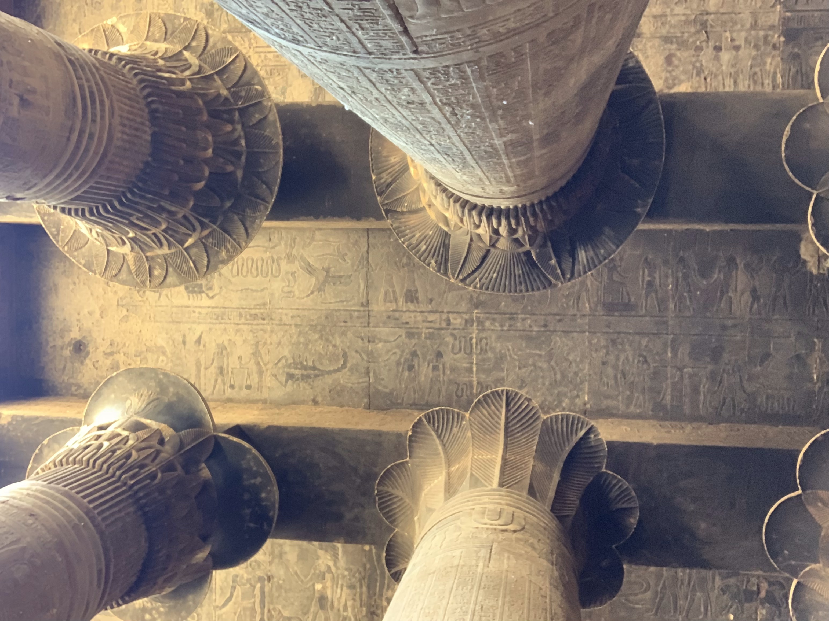
Figure 1 Danielle Marie Goldstein, Esna Zodiacal Ceiling, 18 April 2019, Digital Photograph

Scholarly background
Juan Antonio Belemonte is a scholar who has written a number of collaborative texts exploring Egyptian archaeoastronomy. Ronald Hutton defined archaeoastronomy as the study of ancient responses to the heavens. Part of Belemonte’s scholarly work includes a paper that he wrote alongside Mosalam Shalout, regarding what they termed the Nile hypothesis, or the concept proposing that the Nile was the main source of inspiration for the orientation of the temples in Upper Egypt. In this research, they measured over 330 ancient temples and shrines. In their research, they also attempted to disprove the Nile hypothesis, which they did by taking measurements of temples in areas out into the Western Desert. In this field work, they found that, at times, astronomical orientations dominate the alignment of the temples. Belemonte and Shalout claimed that the temples in Egypt were oriented with consideration to the cardinal directions, solar directions, and star alignments. Their research utilized a high-precision compass, which corrected for local magnetic declination, and a clinometer, but the goal was not about extremely precise alignments. Instead, they stated their intention was to measure as many of the buildings as possible, giving equal weight to each temple. Belemonte and Shalout went on to explain that magnetic declination is not likely to suffer alterations in Egypt, as it is mainly limestone and sandstone land. In their calculations of the azimuth and angular height, a mean error of in the determination of the corresponding declination was slight, described as plus or minus three fourths of a degree. As stated in the work of Matthew Robinson, problems arise in research when one does not make their own calculations, because the researcher lacks the awareness of the many variables that are involved in the process, which range from the of calculation of dates and the uncertainties that emerge. Therefore, it is essential in the practice of archaeoastronomy, for the researcher to obtain their own measurements and leave a trace for future researchers to add to the knowledge base.

Research Methodology
My research was rooted with the intention to investigate the likelihood of celestial alignments at Esna Temple. I completed this research with my colleague Ahmed Khalifa, who is an Egyptologist and operates an Egyptian based tour company. We arrived at Esna Temple on Thursday, April 18th, 2019, a little before 10:30 am by car and walked westbound on a small street path that intersects with the Nile. As noted earlier in this essay, Esna Temple is located to the west of the Nile River. The temple area is surrounded by a contemporary Egyptian city, bustling with vendors selling clothing, souvenirs, and other items for tourists. As one walks down the street, they arrive to the modern-day gate, which includes a security checkpoint and steps that lead down to the temple. As noted, the remains of Esna Temple are about nine meters below the street level, surrounded by a walled structure to protect the ruin of the temple. The temple is built from red sandstone.

The tools utilized for the field work included a pen, paper, clinometer, and a number of applications downloaded to my iPhone including GPS Tracks, a compass, and Voice Record. To be transparent, due to the fact I was traveling from the United States to Egypt, I did not have proper time to practice with the clinometer before arriving in Egypt, as this tool arrived in the mail the day before my departure. A clinometer (pictured in Figure 2) is a tool that is used to measure the angle of elevation, so that one may measure the height of things that they are unable to reach. The elementary mistake I made was not fully understanding how to utilize the clinometer. My colleague and I both found the instruction manual unclear, and in turn searched the Internet, hoping to find clarity on how to utilize the clinometer. However, it should be noted that I went into the field lacking confidence in my ability to capture raw data with accuracy.

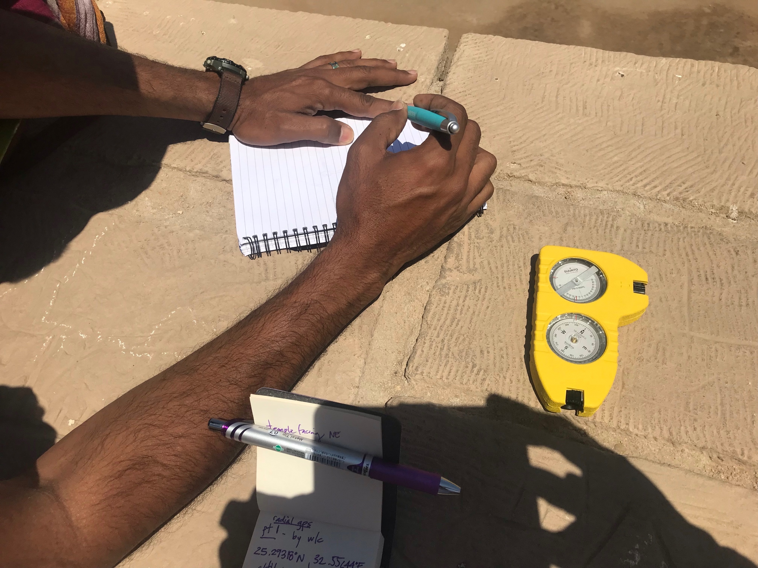
Figure 2 Danielle Marie Goldstein, Point 1 at Esna Temple, 18 April 2019, Digital Photograph

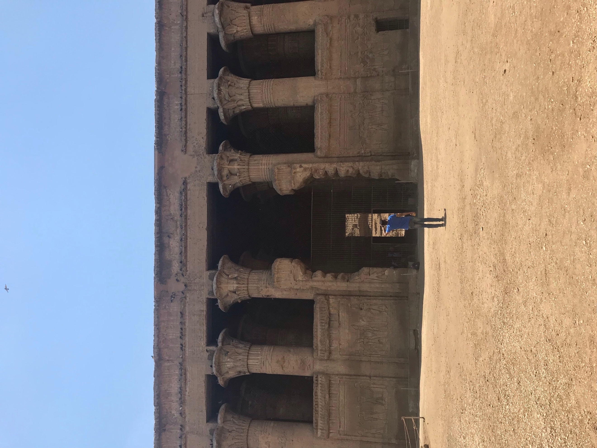
Figure 3 Entry View of Esna Temple, 18 April 2019, Digital Photograph
We began collecting data at 10:30 am, noting the weather was 22° and sunny. The first step was to place the clinometer on the ground at the front gates of the temple as seen in Figure 3, to read the compass, noting that the temple faces nearly thirty-five degrees northeast, which demonstrates that the temple is at a slight angle. I knew that to calculate the azimuth, it was essential to note that the direction of north is the zero point. My strategy was to select four spaces around the parameter of the temple, and the center of the front gates, to measure the azimuths and take their global positioning service.

The latitude of Esna Temple, from the center of what remains to be the main entrance, is 25.29360 degree north, the longitude 32.55635 east, with an altitude of 289.6 ft. I selected point one to be upstairs near the public washroom as seen in Figure 4. Here, the data captured demonstrated the latitude to be 25.29318 north, the longitude to be 32.55644 east, and the altitude 301.8 feet high. The azimuth is 325°. Point two is shown in Figure 5 which was taken up the steps. The latitude is 25.29314 north, longitude 32.55626 east, and altitude 283 feet. The calculated azimuth is 330°. The data for point three was captured near the modern-day entrance to the temple, at the ground level of the street where the temple guards greet you before you walk down the stairs to the actual site of the temple as shown in Figure 6. The latitude captured at point three is 25.28388 north, 32.55633 east, and the azimuth is 140°. The final point four where data was captured as shown in Figure 7 was at the back-northwest corner of the temple, also at the ground level of the street. The latitude is 25.29361° north, with a longitude 32.55577° east, and an azimuth of 150°.

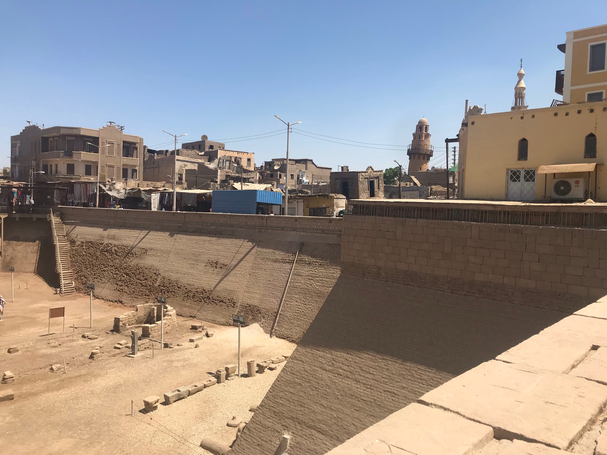
Figure 4 Danielle Marie Goldstein, Point 1 at Esna Temple, 18 April 2019, Digital Photograph

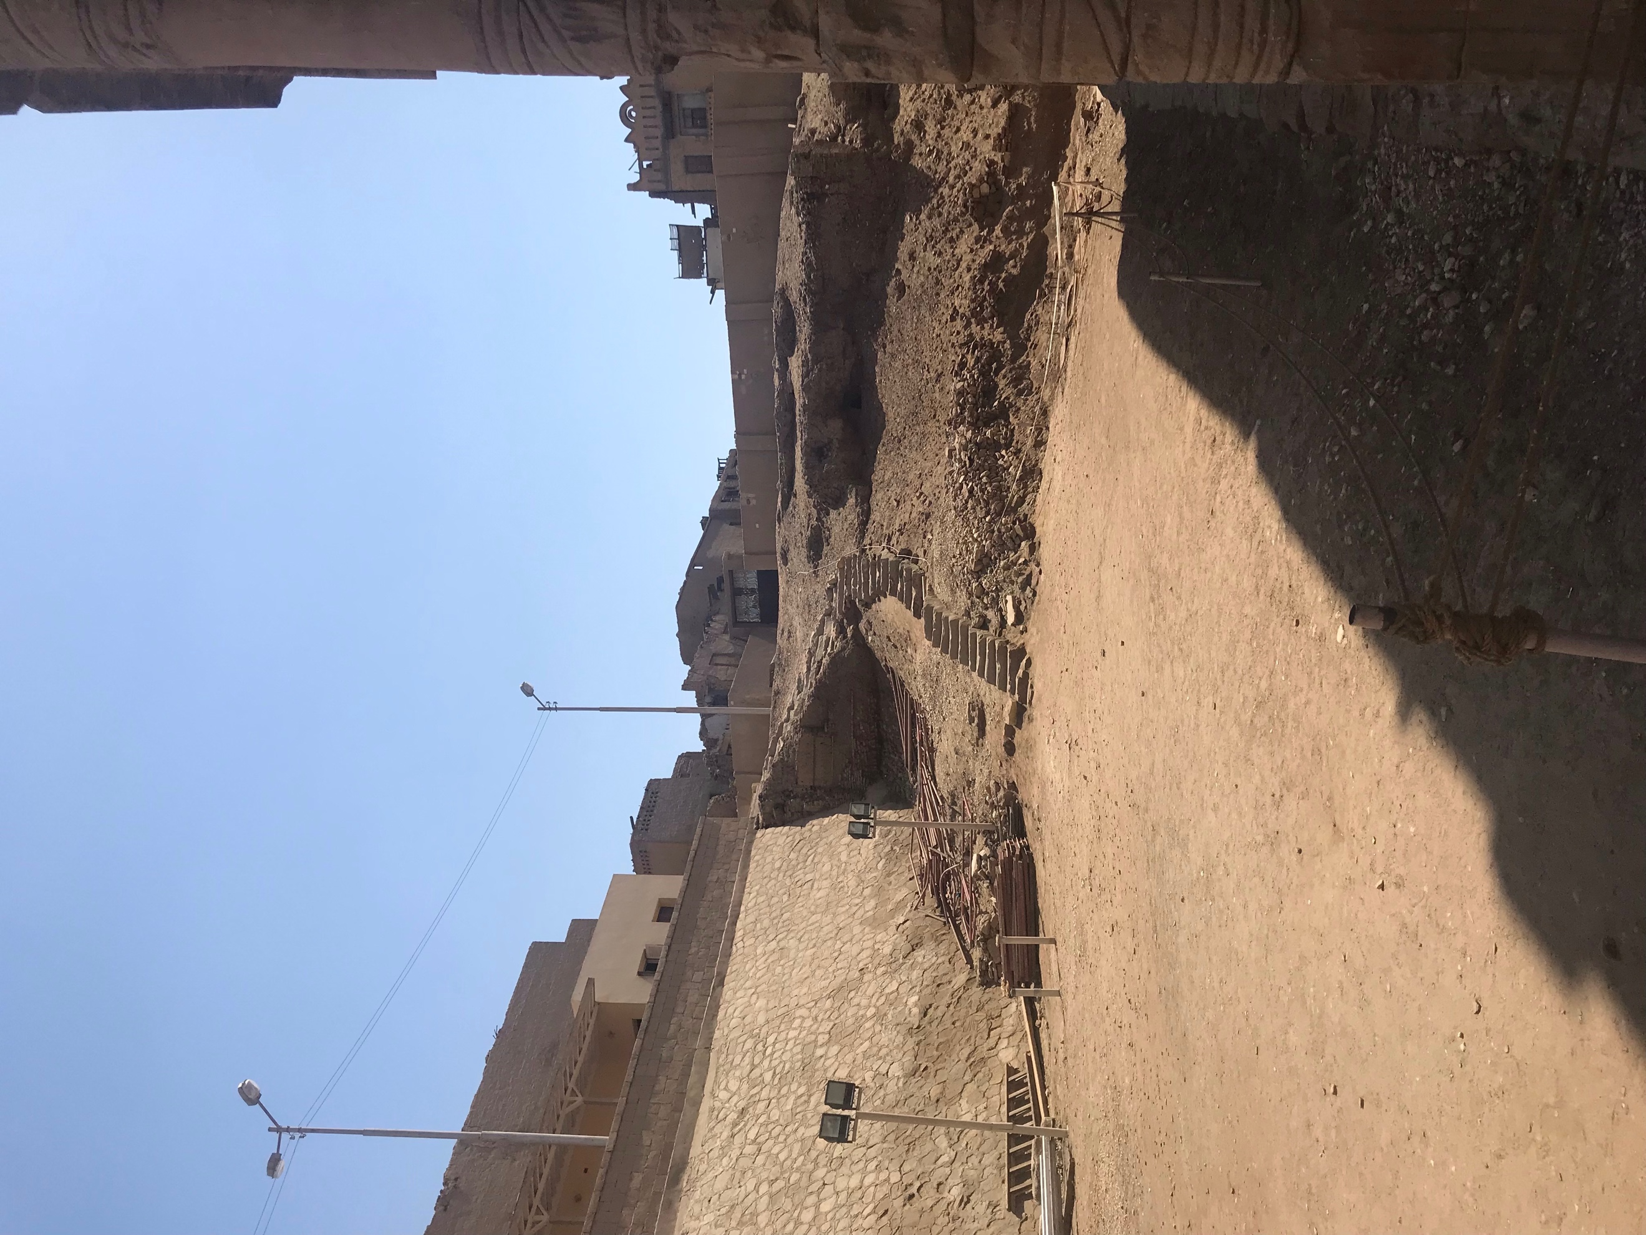
Figure 5 Danielle Marie Goldstein, Point 2 at Esna Temple, 18 April 2019, Digital Photograph

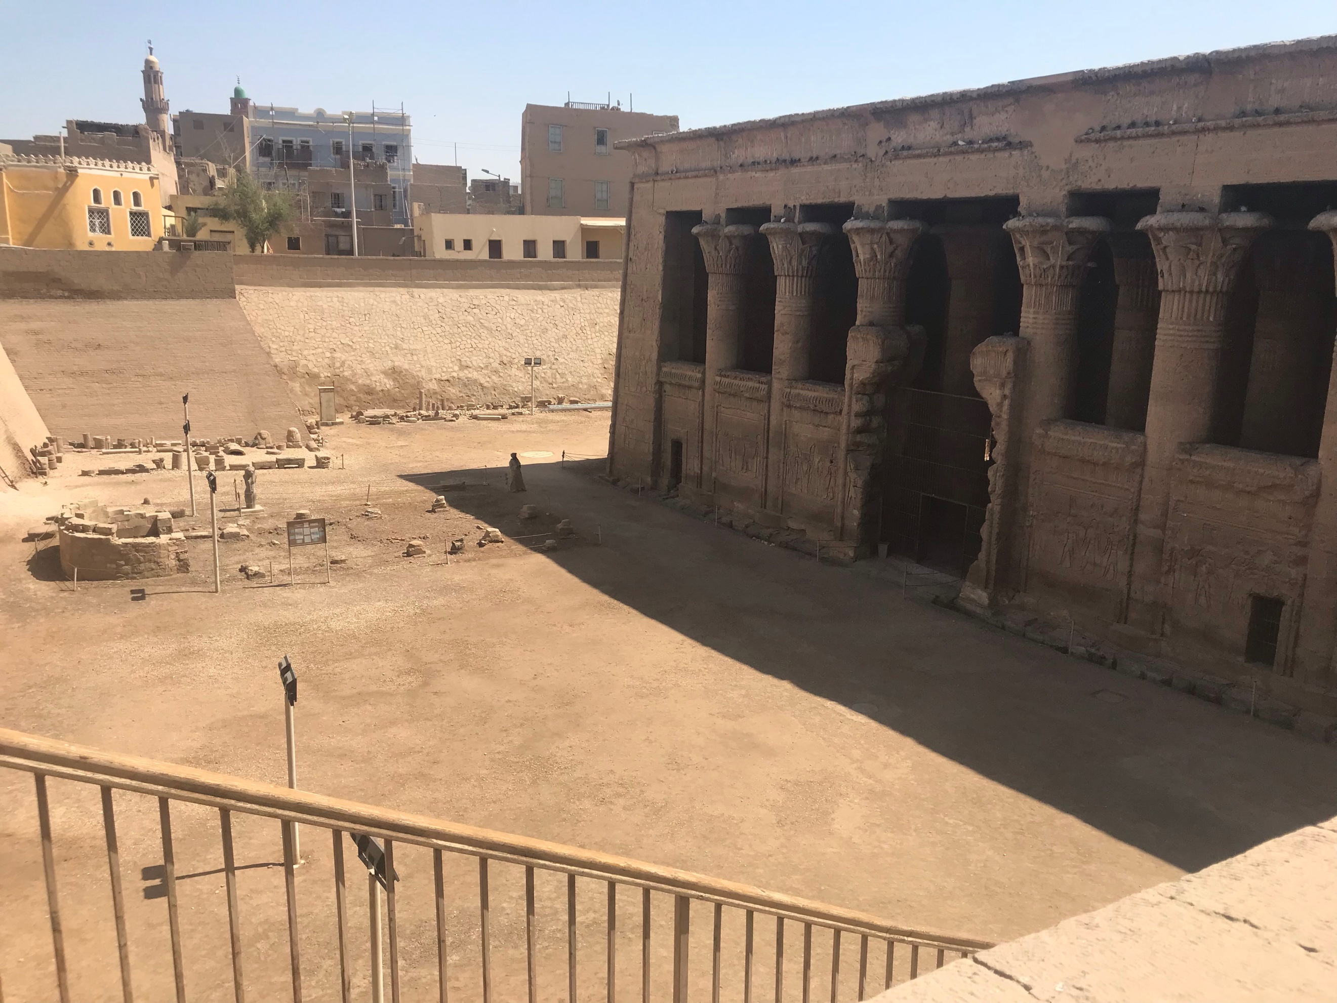
Figure 6 Danielle Marie Goldstein, Point 3 at Esna Temple, 18 April 2019, Digital Photograph

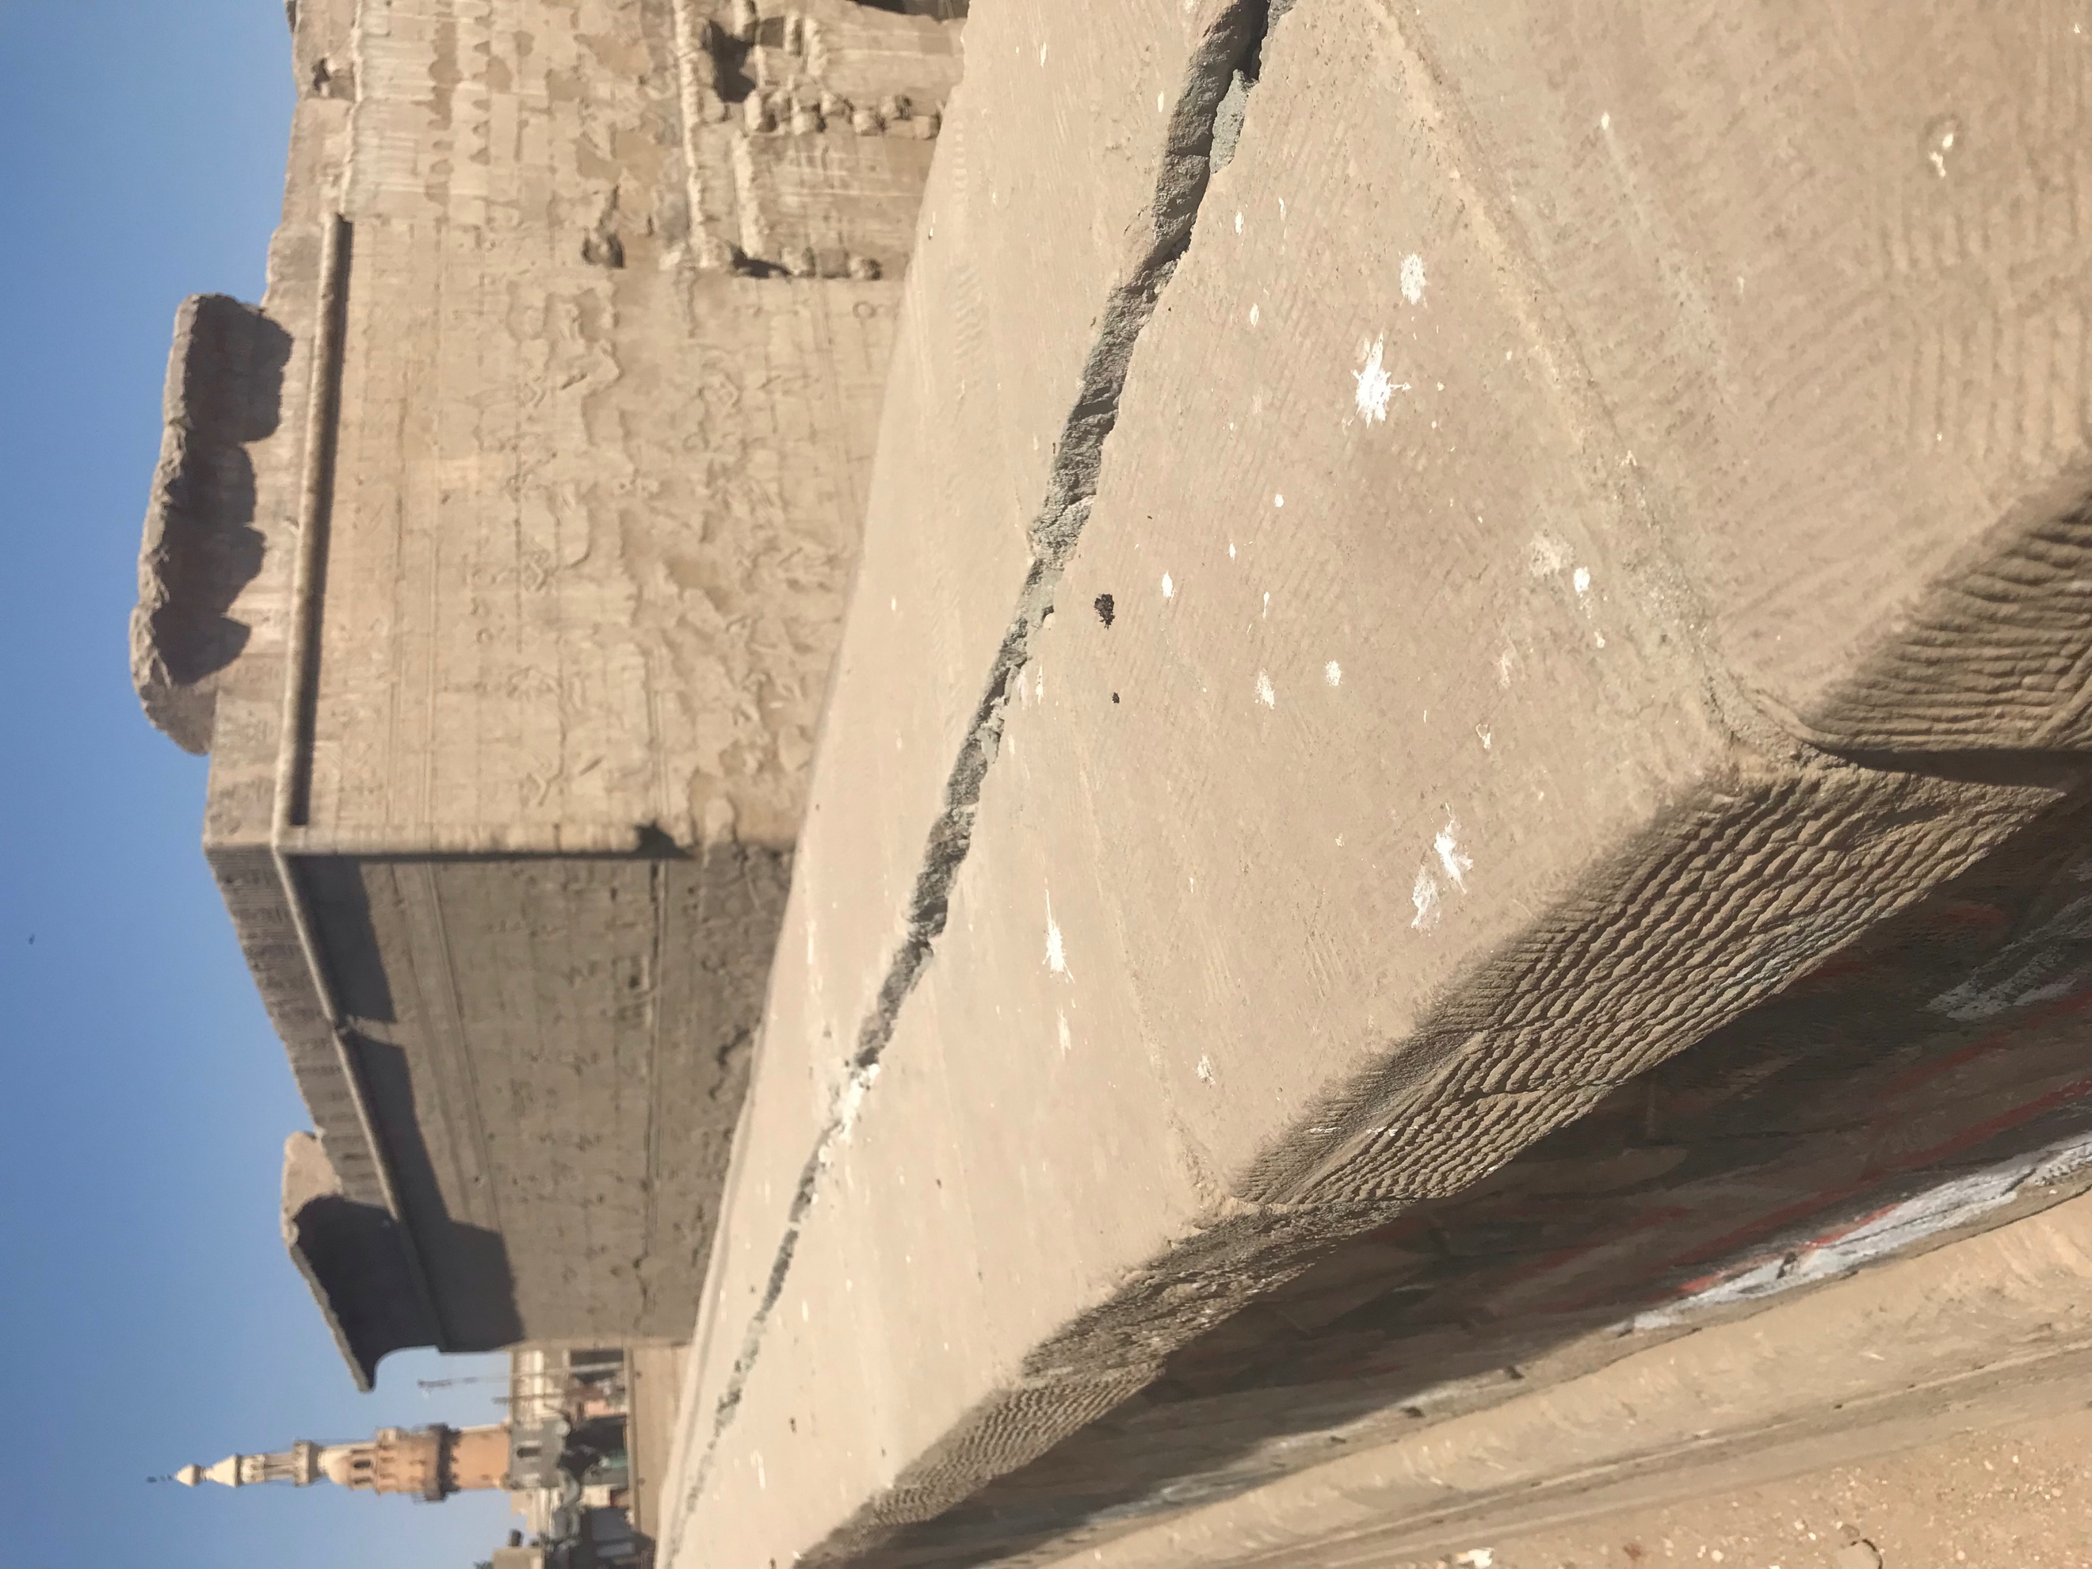
Figure 7 Danielle Marie Goldstein, Point 4 at Esna Temple, 18 April 2019, Digital Photograph
Measurements were also captured around the area on the ground below the zodiacal ceiling, from two places at either end of the walls of the temple and from the midpoint of the zodiacal ceiling of the temple. The latitude for all three of these spaces was 25.29335° north, and the longitude was 32.55623° east. Together, my colleague and I measured the length of the ceiling with a measuring application through an iPhone. Although it is hard to determine the level of accuracy, we measured that the length of the zodiacal ceiling is approximately 15.83 meters and the width of the zodiacal ceiling is approximately 2.5 meters.

Findings
Once home, I took the field measurements of the azimuths, altitude, and latitude to find the declination for the temple using a declination calculation spreadsheet created by Fabio Silva. I calculated four different declinations which included 23.65, 28.48, 22.43, and 22.08, which is demonstrated in Figure 7.

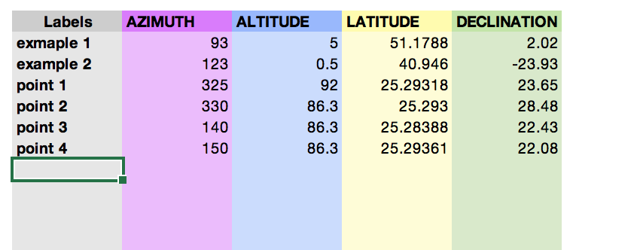
Figure 7

From these calculations, I gathered that there is an average declination of 24.16. I then looked to a reference table- provided through my Skyscapes studies to see if a declination could point to a particular fixed star. Belemonte, Shaltout, and Fekri, noted that Richard Wilkinson stated that it was common for temples in Egypt to be oriented on an east-west axis in correspondence to the Nile River, however on occasions an orientation to the sun or important stars was the priority. Knowing that Esna was built around 205 BCE, I chose to find a date from the Middle Kingdom of Egypt, as that is when the original temple ruins are dated, and it seemed essential to go back to the ruins of the first temple to truly understand possibility of a starry alignment. The Middle Kingdom of Egypt was from 1975 BCE to 1640 BCE. Looking at the reference table for Skyscapes the declination of the star Regulus was 24.17 in 2500 BCE, 24.09 in 2000 BCE, and 23.65 in 1500 BCE, therefore, I believe it is likely that Esna Temple is aligned with the fixed star Regulus. I spent many hours reading numerous sources on Egypt and Regulus, and it appears that this is a lesser known star for temples and other sites to be aligned with in ancient Egypt, however Jose Lull and Belemonte briefly mentioned the star Regulus. Some connect the Sphinx in Giza with the star Regulus. In a number of star texts, Regulus has connected with a great power. Richard Allen connected Regulus across many cultures, in India, it was the Mighty, to the Magh, the Great, in Persia, the Centre, in Arabia, the Kingly, and in classical Greek times, the Lion’s Heart, attached to ‘the belief that it ruled the affairs of the heavens.’ Richard Grossinger wrote, ‘Through the clearing, Regulus sits at the heart of a Lion, dozens of faint stars in his fur and on his paws.’

Final Thoughts
The greatest challenge I faced with this research project was that I had only one opportunity to complete this fieldwork with accuracy, as the site investigation work was completed thousands of miles from my home. In hindsight, I would practice with all of my tools at my home base before going out in the field for technical research. Much like C. Hawkes demonstrated in his Ladder of Inference, the archaeological record is always incomplete, as I conclude this research with many questions. Timothy Darvill wrote of the challenges within the field of skyscapes, which merges sky with archaeology, ‘Among the most intractable difficulties are the well-known hurdles of dealing with partial data, heavily damaged sites, inaccurate surveys, poor reconstructions, understanding the capabilities of technologies available to ancient cultures, and a poor or non-existent knowledge of the physical environment to inform questions of visibility and invisibility.’

Conclusion
The aim of this essay was to report the findings from a simple fieldwork exercise I performed at Esna Temple in Upper Egypt to determine the likelihood of celestial alignments. Esna Temple holds unique qualities that I discussed in this essay, including the dedication to Khnum and perhaps the hidden goddess Neith as well. Khnum as the ruler of space and time holds particular zodiacal and Sothic connections. The astrological ceiling at Esna holds much significance in ancient Egyptian history, and much like the hidden goddess Neith, still remains within mystery. However, my findings did lead me to believe that this temple could be aligned with the fixed star Regulus.

Bibliography
Abdel-Rady, Radwan S. A., ‘Goddesses of the Four Pillars of the Sky at the Temple of Esna’, sourced from Academia.edu, <https://www.academia.edu/35002621/GODDESSES_OF_THE_FOUR_PILLARS_OF_THE_SKYAT_THE_TEMPLE_OF_ESNA_Radwan_ABD_EL-RADY>, [accessed 1-20 July 2019], pp. 46-58

Abdelrady, Radwan S. A., ‘The temple of Esna’, sourced from Academia.edu, <https://www.academia.edu/34733085/The_Temple_of_Es_The_Temple_of_Es_The_Temple_of_Es_The_Temple_of_Esna_na_na_na_Chapter_Chapter_Chapter_Chapter_TWO_TWO_TWO_TWO_Chapter_2_The_temple_of_Esna_The_history_of_the_temple?source=swp_share>, [accessed 1-20 July 2019]

Allen, Richard Hinckley, Star Names: Their Lore and Meaning (New York: Dover Publications Inc., 1963)

Belemonte, Juan Antonio, Mosalam Shaltout, and Magdi Fekri, ‘Astronomy, Landscape and Symbolism: A Study of the Orientation of Ancient Egyptian Temples’, in In Search of Cosmic Order: Selected Essays on Egyptian Archaeoastronomy, ed. by Juan Antonio Belemonte and Mosalam Shaltout (Cairo: Supreme Council of Antiquities Press, 2009), pp. 215-250

Belemonte, Juan Antonio and Mosalam Shaltout, ‘Keeping Ma’at: An astronomical approach to the orientation of the temples in ancient Egypt’, (paper presented at the Instituto de Astrofisica de Canarias, Tenerife, Spain, 3 March 2009)

Belemonte, Juan Antonio, and Miguel Angel Molinero Polo and Noemi Miranda, ‘Unveiling Seshat: New Insights into the Stretching of the Cord Ceremony in In Search of Cosmic Order: Selected Essays on Egyptian Archaeoastronomy, ed. by Juan Antonio Belemonte and Mosalam Shaltout (Cairo: Supreme Council of Antiquities Press, 2009)

Darvill, Timothy ‘Afterword: Dances Beneath a Diamond Sky,’ in Skyscapes The Role and Importance of the Sky in Archaeology, ed. by Fabio Silva and Nicholas Campion (Oxford: Oxbow Books, 2015)

Etz, Donald V., ‘A New Look at the Constellation Figures in the Celestial Diagram’, Journal of the American Research Center in Egypt, Vol. 34 (1997), pp.143-161

Gadalla, Moustafa, Egyptian Divinities: The All Who Are the One (Greensboro: Tehuti Research Foundation, 2017)

Greenbaum, Dorian Gieseler, and Micah T. Ross, ‘The Role of Egypt in the Development of the Horoscope’, in Egypt in Transition Social and Religious Development of Egypt in the First Millennium BCE, ed. by Ladislav Bares, Filip Coppens and Kveta Smolarikova, (Prague: Charles University in Prague, 2010)

Grossinger, Richard The Night Sky Soul and Cosmos (Berkely: North Atlantic Books, 2014)

Hallof, Jochen, ‘Esna’, UCLA Encyclopedia of Egyptology, 1602 Version 1 (October 2011), pp. 1-15, https://escholarship.org/uc/item/6k78t4w9

Hutton, Ronald ‘The Strange History of British Archaeoastronomy’, Journal for the Study of Religion, Nature and Culture, Vol. 7, No. 4 (2013), pp. 376-396

Lichtheim, Miriam, ‘Hymns and Lamentations’, in Ancient Egyptian Literature Volume III: The Late Period, (Los Angeles: University of California Press, 2006)

Lull, Jose and Juan Antonio Belemonte, ‘The constellations of ancient Egypt’, in In Search of Cosmic Order: Selected Essays on Egyptian Archaeoastronomy, ed. by Juan Antonio Belemonte and Mosalam Shaltout (Cairo: Supreme Council of Antiquities Press, 2009), pp. 155-194

Mark, Joshua J. ‘Neith’, Ancient History Encyclopedia, (14 September 2016), <https://www.ancient.eu/amp/1-15013/> [accessed 15 July 2019]

Parker, R. A., ‘Ancient Egyptian Astrology’, Philosophical Transactions of the Royal Society of London. Series A, Mathematical and Physical Sciences, Vol. 276, No. 1257 (1974), pp.51-65

Robinson, Matthew, ‘Ardua et Astra: On the Calculation of the Dates of the Rising and Setting of Stars’, Classical Philology, Vol. 104, No. 3 (2009), pp.354-375

Wilkinson, Richard H., The Complete Temples of Ancient Egypt, (New York: Thames & Hudson, 2017)

Juan Antonio Belemonte and Mosalam Shaltout, ‘Keeping Ma’at: An astronomical approach to the orientation of the temples in ancient Egypt’, (paper presented at the Instituto de Astrofisica de Canarias, Tenerife, Spain, 3 March 2009), p 3.
Richard H. Wilkinson, The Complete Temples of Ancient Egypt, (New York: Thames & Hudson, 2017), p. 201.
Wilkinson, The Complete Temples of Ancient Egypt, p. 201.
Jochen Hallof, ‘Esna’, UCLA Encyclopaedia of Egyptology, 1602 Version 1 (October 2011), pp. 1-15, https://escholarship.org/uc/item/6k78t4w9, p. 1.
Radwan S. A. Abdelrady, ‘The temple of Esna’, sourced from Academia.edu, <https://www.academia.edu/34733085/The_Temple_of_Es_The_Temple_of_Es_The_Temple_of_Es_The_Temple_of_Esna_na_na_na_Chapter_Chapter_Chapter_Chapter_TWO_TWO_TWO_TWO_Chapter_2_The_temple_of_Esna_The_history_of_the_temple?source=swp_share>, [accessed 1-20 July 2019], p. 17.
Dorian Gieseler Greenbaum and Micah T. Ross, ‘The Role of Egypt in the Development of the Horoscope’, in Egypt in Transition Social and Religious Development of Egypt in the First Millennium BCE, ed. by Ladislav Bares, Filip Coppens and Kveta Smolarikova, (Prague: Charles University in Prague, 2010), p. 156.
Hallof, ‘Esna’, p. 3.
Abdelrady, ‘The temple of Esna’, p. 18.
Wilkinson, The Complete Temples of Ancient Egypt, p. 201.
Wilkinson, The Complete Temples of Ancient Egypt, p. 65.
Wilkinson, The Complete Temples of Ancient Egypt, pp. 65-66.
Wilkinson, The Complete Temples of Ancient Egypt, p. 202.
Abdel-Rady, ‘Goddesses of the Four Pillars of the Sky at the Temple of Esna’, p. 60.
Radwan S. A. Abdel-Rady, ‘Goddesses of the Four Pillars of the Sky at the Temple of Esna’, sourced from Academia.edu, <https://www.academia.edu/35002621/GODDESSES_OF_THE_FOUR_PILLARS_OF_THE_SKYAT_THE_TEMPLE_OF_ESNA_Radwan_ABD_EL-RADY >, [accessed 1-20 July 2019], pp. 46-58, p. 49.
Moustafa Gadalla, Egyptian Divinities: The All Who Are the One, (Greensboro: Tehuti Research Foundation, 2017), p. 145.
Gadalla, Egyptian Divinities, p.145.
Gadalla, Egyptian Divinities, p.145.
Gadalla, Egyptian Divinities, p.145.
Gadalla, Egyptian Divinities, p.146.
Gadalla, Egyptian Divinities, p.150.
Gadalla, Egyptian Divinities, p.150.
Hallof, ‘Esna’, p. 1.
Hallof, ‘Esna’, p. 2.
Joshua J. Mark, ‘Neith’, Ancient History Encyclopedia, (14 September 2016), < https://www.ancient.eu/amp/1-15013/> [accessed 15 July 2019]
Hallof, ‘Esna’, p. 1.
Hallof, ‘Esna’, p 9.
Ahmed Khalifa recorded oral transmission of Neith given to the author October 2018.
Ahmed Khalifa, oral transmission of Neith.
Ahmed Khalifa, oral transmission of Neith.
Wilkinson, The Complete Temples of Ancient Egypt.
Ahmed Khalifa, oral transmission of Neith.
Gadalla, Egyptian Divinities, p.150.
Miriam Lichtheim, ‘Hymns and Lamentations’, in Ancient Egyptian Literature Volume III: The Late Period, (Los Angeles: University of California Press, 2006), p. 7.
Hallof, ‘Esna’, p. 9.
Hallof, ‘Esna’, p. 5.
Wilkinson, The Complete Temples of Ancient Egypt, pp. 65-66.
R. A. Parker, ‘Ancient Egyptian Astrology’, Philosophical Transactions of the Royal Society of London. Series A, Mathematical and Physical Sciences, Vol. 276, No. 1257 (1974), pp.51-65, p. 61.
Hallof, ‘Esna’, p. 4.
Parker, ‘Ancient Egyptian Astrology’, p. 61.
Parker, ‘Ancient Egyptian Astrology’, p. 61.
Donald V. Etz, ‘A New Look at the Constellation Figures in the Celestial Diagram’, Journal of the American Research Center in Egypt, Vol. 34 (1997), pp.143-161, p 145.
Greenbaum and Ross, ‘The Role of Egypt in the Development of the Horoscope’, p. 156.
Greenbaum and Ross, ‘The Role of Egypt in the Development of the Horoscope’, p. 157.
Greenbaum and Ross, ‘The Role of Egypt in the Development of the Horoscope’, p. 156.
Juan Antonio Belemonte, Miguel Angel Molinero Polo and Noemi Miranda, ‘Unveiling Seshat: New Insights into the Stretching of the Cord Ceremony’ in In Search of Cosmic Order: Selected Essays on Egyptian Archaeoastronomy, ed. by Juan Antonio Belemonte and Mosalam Shaltout (Cairo: Supreme Council of Antiquities Press, 2009), pp. 197-212, p. 204.
Ronald Hutton, ‘The Strange History of British Archaeoastronomy’, Journal for the Study of Religion, Nature and Culture, Vol. 7, No. 4 (2013), pp. 376-396, p. 377.
Belemonte and Shaltout, ‘Keeping Ma’at’, p 3.
Belemonte and Shaltout, ‘Keeping Ma’at’, p. 3.
Belemonte and Shaltout, ‘Keeping Ma’at’, p. 8.
Belemonte and Shaltout, ‘Keeping Ma’at’, p. 2.
Belemonte and Mosalam Shaltout, ‘Keeping Ma’at’, p. 2.
Juan Antonio Belemonte, Mosalam Shaltout, and Magdi Fekri, ‘Astronomy, Landscape and Symbolism: A Study of the Orientation of Ancient Egyptian Temples’, in In Search of Cosmic Order: Selected Essays on Egyptian Archaeoastronomy, ed. by Juan Antonio Belemonte and Mosalam Shaltout (Cairo: Supreme Council of Antiquities Press, 2009), pp. 215-250, p. 220.
Matthew Robinson, ‘Ardua et Astra: On the Calculation of the Dates of the Rising and Setting of Stars’, Classical Philology, Vol. 104, No. 3 (2009), pp.354-375, p. 355.
Famous Historic Buildings, ‘Esna Temple’ < http://www.famous-historic-buildings.org.uk/esna.html> [accessed 15 July 2019]
https://s3.eu-west-2.amazonaws.com/skyscape-archaeology/ReferenceTables.html
Astronomy, Landscape and Symbolism: A study of the orientation of ancient Egyptian temples, p. 215.
Jose Lull and Juan Antonio Belemonte, ‘The constellations of ancient Egypt’, in In Search of Cosmic Order: Selected Essays on Egyptian Archaeoastronomy, ed. by Juan Antonio Belemonte and Mosalam Shaltout (Cairo: Supreme Council of Antiquities Press, 2009), pp. 155-194, p. 191.
Etheric, ‘Regulus: A Time Indicator’, < https://etheric.com/the-great-sphinx-monument-to-humanitys-survival-of-the-ice-age/> [accessed 14 December 2019]
Richard Hinckley Allen, Star Names: Their Lore and Meaning (New York: Dover Publications Inc., 1963), pp.255-256.
Richard Grossinger, The Night Sky Soul and Cosmos (Berkeley: North Atlantic Books, 2014), p. 22.
Timothy Darvill, ‘Afterword: Dances Beneath a Diamond Sky,’ in Skyscapes The Role and Importance of the Sky in Archaeology, ed. by Fabio Silva and Nicholas Campion (Oxford: Oxbow Books, 2015), pp. 140-148, p. 147.
Gadalla, Egyptian Divinities, p.150.

