STRATEGIC MANAGEMENT FOR SMEs

MODULE TITLE: STRATEGIC MANAGEMENT FOR SMES
MODULE CODE: BMSW 6104

DEZINERBULLZ ESSEX
(dezinerbullz.co.uk)

Student Name: Marina Ivanova
Student Number:2128092
Lecturer`s Name: Abdulah Naser

Table of Contents
Introduction 3
1.1 Overview of Dezinerbullz 3
1.2 Product Offerings and Services 3
1.3 Market Focus 3
2. Current Strategy Analysis 4
2.1 Mission and Vision of Dezinerbullz 4
2.2 Porter’s 5 Forces Analysis 4
3. External and Internal Environment Analysis 5
3.1 PESTLE Analysis 5
3.2 SWOT Analysis 7
4. Stakeholder Analysis 8
4.1 Identification of Main Stakeholders 8
4.2 Power/Interest Grid and Stakeholder Management Strategies 9
5. Strategic Growth Options 10
5.1 Suggested strategies 10
5.2 Strategic Growth Options Using Ansoff’s Matrix 11
6. Strategic Recommendations 12
6.1 Key Strategies for Long-Term Success 12
6.2 Implementation Plan 13
7. Competitor Reaction and Response Strategy 14
7.1 Anticipating Competitive Responses 14
7.2 Response Strategies to Maintain Competitive Edge 15
Conclusion 15
TASK 2 17
DezinerBullz Poster 17
References: 18

Introduction

1.1 Overview of Dezinerbullz
Dezinerbullz is a small business based in Essex UK, dedicated exclusively to rare coloured breeding of French Bulldogs, English Bulldogs and Pugs. They are primarily raising unique and high quality pets in rare coloured dogs as they are focusing on a niche market that values dogs on base of their aesthetic and health attributes. Industry best practices of genetic health and quality are at the core of the company’s breeding practice. Because of this, Dezinerbullz offers both the service of breeding and the canine fertility solution which makes it a service provider and a breeder in the elite bean field of pedigree dogs (Young, 2011; Fowler, 2017).

1.2 Product Offerings and Services
Within the dog breeding community, within Dezinerbullz we specialize in rare colour variations. They are offering Blue and Lilac French Bulldogs, English Bulldogs and Pus in fawn and platinum colours among their offerings. In addition to being rare, these colour variations need to be carefully selected genetically to ensure health and meeting breeding standards (Ahlawat et al., 2020). The business also offers canine fertility services such as artificial insemination (AI), sperm test, and fertility consultation, and as an important resource for local breeders, they certainly help (Marelli et al., 2020). By being at the intersection of breeding genetics and animal health within the breeding sector, Dezinerbullz are twofold focused on breeding and fertility services and differ from traditional breeders.

1.3 Market Focus
Dezinerbullz sits in the close to fit the market the need for specialized pets is growing. Breeding for rare colour traits increases the risk of inherited genetic disorder and therefore an approach that balances aesthetics and animal welfare (Leroy and Rognon, 2012). This niche that the company also fills with its fertility services is to solve common reproductive concerns affecting pedigree dogs that are often a result of selective breeding (Shaffer et al., 2018). As breeding and as fertility, Dezinerbullz’s expertise in sustainable breeding practices and promotion of canine welfare (Hedhammar et al., 2011).

2. Current Strategy Analysis

2.1 Mission and Vision of Dezinerbullz
Genetically sound dogs with rare colour variations accompanied by customer satisfaction and high quality are what Dezinerbullz mission’s. Broadly their commitment to quality gelates with the emerging trends in the dog breeding industry to focus on health, ethical practices and genetic diversity to combat inherited health issues (Ahlawat et al., 2020). In alignment with Dezinerbullz vision of building strong customer relationship and better service offering to make some difference in the competitive breeding sector (Fowler, 2017). The use of this approach follows Dezinerbullz’s alignment with already popularized customer-oriented strategy in the niche market which makes news breeding and engaging with the customer a priority. This corporate strategy is based on commitment to customer satisfaction as well as rare breeds while acing at its unique place among the canine breeding market (Young, 2011).

2.2 Porter’s 5 Forces Analysis
Applying Porter’s 5 Forces to Dezinerbullz's market provides insight into their competitive position in the niche dog breeding sector.
- Threat of New Entrants: Although new breeders may arise in the market, Dezinerbullz reduces this risk by creating barriers to entry based on knowledge and experience of rare coloureds and available clientele (Martínez Prior, 2018).
- Bargaining Power of Suppliers: Suppliers are used by the company for fertility tools and health services for breeding, therefore giving them control over moderate power. Dezinerbullz can be able to maintain quality and well as keeping costs down through strategic partnerships with good suppliers (Rodríguez and Narcisa, 2018).
- Bargaining Power of Buyers: Potential dog owners are very powerful customers, as they look for specific traits along with ethical breeding practices. Dezinerbullz’s efforts to keep buyer power in check by offering rare traits and health commitments selectively appeals to a picky audience of buyers (Alvarez Yepez and Garcia 2016).
- Threat of Substitutes: There are however alternatives such as adoption from shelters, which would compete but Dezinerbullz’s alternative focus on rare breeds (Cacao and Lombeida, 2017) reduces that competition.
- Competitive Rivalry: The competitive niche breeding market is in favour of Dezinerbullz, with their unique offering of unique breed and focus on health, cutting out some of the competition (Fowler, 2017).

3. External and Internal Environment Analysis

3.1 PESTLE Analysis
In the UK, political factors significantly influence dog breeding businesses, particularly with stringent regulations focused on animal welfare and breeding standards. Regulatory requirements mandate adherence to breeding practices that ensure genetic health, which is crucial for companies like Dezinerbullz that specialise in pedigree and rare breeds (Strasser and Schumacher, 1968). Compliance with these policies not only protects the welfare of the animals but also strengthens customer trust, which is essential in sustaining long-term relationships with ethically concerned clients (Mari, 2020).
Political Factors
The dog breeding sector is subject to a substantial degree to economic conditions. Economic stability helps provide customer money power, which is key for high value, luxury breeds for niche breeders like Dezinerbullz. Skill levels and technological investments affect economic factors that affect economic factors like breeding cost and profitability (Ishola et al., 2017). Moreover, regions, which include the UK, post industrialized economies also consider dog breeding as an additional source of agricultural income that ensures the viability of even dog breeding as a business during economic ups and downs (Mari, 2020).

Social Factors
Ethical breeding and genetic health awareness among the growing population of animal welfare adherents has made the customer shift to preferring reputable breeders. Societal expectations at Dezinerbullz lead to prioritising ethical practices in breeding healthy dogs who aren’t assembled in ways that harm welfare for their cuteness (Bryce, 2021). This is important for niche breeders as consumer expectation is set increasingly higher for transparency, sustainability and health-based breeding practices in their purchasing decisions (Jeppsson, 2014).
Technological Factors
Breeding practices have been vastly improved by the technological advancements including breeding technology, such as genetic testing and artificial insemination, that not only help select precisely traits, but also improve the genetic health. Dezinerbullz, with a focus on rare coloured breeds and breeding quality support, use modern fertility technology to suit their offering. Furthermore, as sophisticated breeding tools and genetic testing signify better operational efficiency and can prevent genetic health problems for niche breeders (Leighton et al., 2018).
Legal Factors
The breeding regulations serve the purpose of keeping animals safe and increasing the accountability of the production industry. UK breeding laws must be followed by Dezinerbullz which requires breeding frequency but must also ensure that breeding does not take place in an exploitative way and that genetic disorders are kept to a minimum. All these could lead to penalties which could in turn challenge their credibility and their business sustainability. The legal compliance in dog breeding is important to keep ethically sound, breeder and animal welfare and is a crucial factor for maintaining public trust (Bryce, 2021).
Environmental Factors
Environmental concerns in breeding industry and especially in the domain of sustainability practices are increasing. Breeders are increasingly pressed to adopt eco-friendly practices including reducing waste and constructive resource management (Jeppsson, 2014), as customers increasingly prefer them. Dezinerbullz isn’t just meeting customer expectations — it’s aggressively hammering down environmentally conscious practices that strengthen their ethical branding, establishing the breeders as a responsible breeder in a crowded market.

3.2 SWOT Analysis
Strengths
One of the reasons Dezinerbullz stands out in the competitive pet market is that it specializes in producing rare coloured dogs, a rare specialisation amongst pet stores. Given that their knowledge of genetic markers and selective breeding methods is utilized to produce Bulldogs and Pugs of conspicuously coloured variant, meeting the need for uncommon aesthetics in pedigree dogs (Dreger et al., 2019). Dezinerbullz focus on rare colours targets niche customer base willing to pay premium prices for their specialised offerings, and reinforce the company’s market position to generate higher margin (Wiener et al., 2017).
Weaknesses
With respect to weaknesses, Dezinerbullz focused on a very small set of rare coloured breeds can be a problem due to the potential of inbreeding and associated health issues. Genetic focus on particular genetic traits such as coat colour can decrease genetic diversity, which by extension increases the risk of hereditary disorders (Calboli et al., 2008). This niche approach also suggests that market growth may be constrained by very limited market sizes (Leroy and Rognon, 2012), since a restricted range of dog breeds as well as colour options could restrict the market base (customer) growth. These weaknesses can only be addressed through careful genetic management and diversifying the company’s breed variety, in order to protect both the health of the animals, as well as market appeal (Streitberger et al., 2012).
Opportunities
Dezinerbullz has multiple levers to draw on which have been enabled by the accelerated demand for ethically bred healthy pedigree dogs. With advances in genetic testing, genetic diversity is monitored through genetic diversity testing, and health risks are reduced by the practices of genetic testing which Dezinerbullz has adopted (Lampi et al., 2020). In addition, digital channels could expand our presence beyond Essex to gain access to a wider customer base, through on and offline marketing and e commerce, into the high demand pedigree dog market (Mortlock et al., 2015). They could collaborate even further with genetic research organisations in order to strengthen their reputation as an ethical breeder.
Threats
Meanwhile, faced with new competition among the narrow market, other breeders are coming on the market to copy what rare-coloured dogs have been doing. The breeding practices also come under regulatory pressure, especially given tightened regulations that will force an increase in operational costs (Bignardi and Santana, 2022). In addition, changes in economic conditions, for example, falls in disposable income, may reduce consumer spending on luxury pets and make the business more sensitive to such economic conditions. The long-term success of Dezinerbullz in the niche breeding market will keener on firming maintainability to regulatory and economic shift (Leroy et al., 2009).

4. Stakeholder Analysis

4.1 Identification of Main Stakeholders
Stakeholder management has been deemed crucial to sustainable growth in the niche dog breeding market for Dezinerbullz. Key stakeholders include:
- Customers: First, customers require rare coloured breeds with high genetic health and animal welfare which are the primary stakeholders. A growing number of customers consider ethical practices of breeding animals rather increasingly: this mirrors current developments in animal welfare concerns (Verbeke, 2009).
- Suppliers: Artificial Insemination/AI kits, and genetic testing services are provided to Dezinerbullz by suppliers. Without these suppliers, quality breeding outcomes and customer satisfaction (Tindano et al., 2017) would be compromised.
- Regulatory Bodies: Dezinerbullz have to comply with certain ethical breeding standards in order to survive, because of the unfair enforcement of animal welfare laws by regulatory stakeholders. It is not only required by a need of legal standing but also proof of credibility to welfare conscious customers (Customers that care about the welfare of animals) (Dockes et al., 2011).
- Employees: Employees are real internal stakeholders and are responsible for keeping daily operations and customer engagement going. Staff, skilled staff, and trained staff play an important role in the company’s brand reputation and quality standards this is crucial to retain and trust as customers (Parsons, 2013). Ensuring operational efficiency and consistency in service delivery, employee satisfaction and training are managed.

4.2 Power/Interest Grid and Stakeholder Management Strategies
- High Power/High Interest (Customers and Regulatory Bodies): They need proactive engagement. Customers demand ethically bred dogs of high quality (Immink et al., 2013) and Dezinerbullz must maintain open communication where both standards of health and of breeding are concerned. And regulatory bodies themselves require compliance: adherence itself reduces risks, but keeps the trust alive.
- High Power/Low Interest (Suppliers): Dezinerbullz’s operations are mostly dominated by suppliers who supply necessary breeding inputs. These relationships can be built up when regular communication regarding product quality and punctual payments, lead to reliable service continuity (Roessler et al., 2012).
- Low Power/High Interest (Employees): Although they have very limited power, employees are responsible for quality assurance and customer satisfaction. To maintain operational consistency in the future, Dezinerbullz needs to concentrate on employee engagement and training programs that will do much to impact customer experiences and brand perception (Aumüller and Coetzer, 2020).
- Low Power/Low Interest: This can mean that there are other external parties who have little influence and interest, and thus need a periodic update to maintain transparency without excessive resource allocation.

5. Strategic Growth Options

5.1 Suggested strategies
1. Expanding Service Offerings
Dezinerbullz has the potential to add value to its competitive position through diversifying services including genetic health screenings and canine behavioural training. These services support customer expectations for integrative services and make Dezinerbullz unique in its entirety as an integrative service provider (Rueda and Duban, 2018). By providing services above what’s typical when it comes to breeding, Dezinerbullz pokes into a developing market pet wellness that is ushering in more explored holistic approaches to a pets’ wellness and health (Beneli Donadon et al., 2023).
2. Digital Marketing
By building relationships with clients, Dezinerbullz can meet their needs and these improved relationships will help bring in future business. They can make targeted online campaigns and social media campaigns to cover their rare-colour breeds and unique services that increase brand visibility and customer engagement (Bruce et al., 2023). Niche markets, especially specialised dog breeding, requires digital marketing strategies tailored to customer’s preferences, and the 6W Model is one way of doing so (Gabelaia and Tchelidze, 2022). These tools allow Dezinerbullz to implement them and connect with possible clients at a cost-effective means.
3. Product Differentiation
To date, Dezinerbullz’s growth has been based on product differentiation via focus on its rare, ethically bred dog breeds. Using unique colour genetics and ethical breeding the company can become a premium breeder in the marketplace. The ability to differentiate helps Dezinerbullz win customer loyalty and target niche clientele who attach premium importance to pedigree and appearance (de Medeiros et al., 2022). Breeding techniques are continually improving and genetic research providing the foundation for continuous innovation of Dezinerbullz, the brand, and staying ahead of the competition.

5.2 Strategic Growth Options Using Ansoff’s Matrix
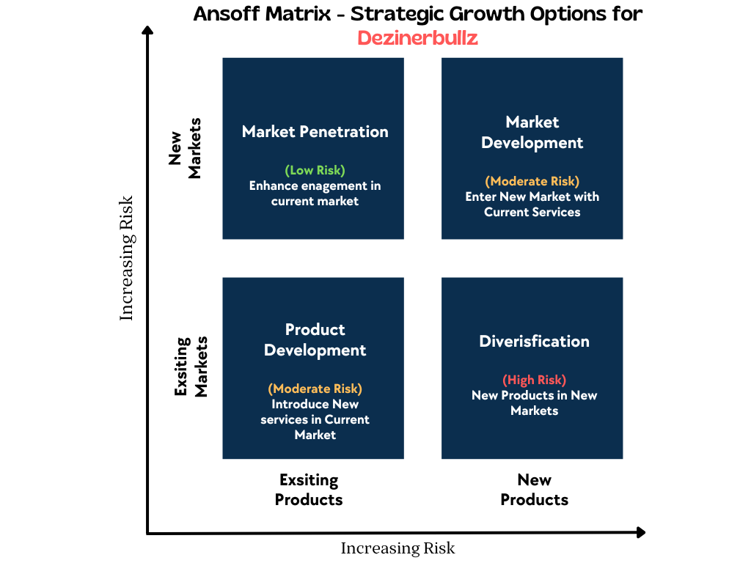
1. Market Penetration Strategy
Dezinerbullz’ entry into market penetration presents a low risk way to increase its customer base in existing markets through increased engagement with existing products and services. Stronger customer loyalty and improved repeat purchases can be a result of using digital marketing channels and promotional activities (Kukartsev et al., 2019). Collectively to focusing on targeted campaigns, especially platforms frequented by pet enthusiasts can increase collective market share in the niche dog breeding market (Johannesson and Palona, 2009). Ansoff’s low risk quadrant (growth within existing market boundaries) is this strategy as it benefits small to medium enterprises (SMEs) interested in capitalizing on the existing strengths and market familiarity (Hussain et al., 2013).
2. Service Development Strategy
Dezinerbullz service development is a moderate risk undertaking that seeks to develop the service through providing them with the service which meets changing customer needs. Related services, like Dezinerbullz puppy training and personalised pet care consultations, can be introduced by them to attract clients who prefer total care (Varadarajan, 1983). Iskandar et al. (2019) state that these additional services are extra services their customers want and it poses a means to differentiate in the niche breeding market. This strategy allows Dezinerbullz to move into service diversification thereby making the company able to expand outside its perimeter of pedigree breeding while continuing to remain as a specialist provider in the pedigree breeding industry (Jakšetić, 2020).

6. Strategic Recommendations

6.1 Key Strategies for Long-Term Success
Digital Presence
Expanding the Dezinerbullz’s customer base and boosting engagement will depend on projecting Dezinerbullz’s digital presence in a better way. With a solid digital marketing strategy, the company can use it as a social media and targeted online advertising to reach a target audience for rare colour Bulldogs and Pugs. Interactive, visually appealing platform will not only need to attract potential customers but also build customer loyalty (Ahmadi 2023). Dezinerbullz can improve customer experience by embracing digital technologies like mobile optimised website and personalised email campaign, which will not only improve its current status within the market but also enhance its reputation (Goi, 2023).
Customer Relationship Management (CRM)
The introduction of a CRM system will enable Dezinerbullz to handle customer data correctly, having the ability to offer personalised experiences and retain the customer. CRM platforms provide a streamlined way of interacting through storing in details customer history, providing personalized communication and the consistency in customer touch points (Saputra et al., 2019). As a well configured CRM customer segmentation would really help in targeted marketing based on the preferences and purchase history of the customer (Laker and Currie, 2001). Loyalty is particularly critical in the niche market, where the brand customer relationships are highly crucial in the buying decision (Steimer and Steimer, 2009).
Operational Improvements
Improvements in operational process can improve productivity and resource utilisation. Such as implementing efficient workflows such as automated scheduling and inventory management, will reduce the operational costs and minimise delays (Setia et al., 2013). It also invests in advanced breeding technologies that improve the quality of Dezinerbullz’s offer and strengthen its reputation as a responsible breeder (Lampropoulos et al., 2022). Without these improvements Dezinerbullz stays on top, complying with regulatory and customer requirements for animal welfare and genetic quality (Anyfioti et al., 2001).

6.2 Implementation Plan
Resources and Timelines
To succeed, resources are to be experimented on then allocated to technology, marketing and training of staff. Choosing the right platform for CRM deployment is crucial – a platform that sits well, meets Dezinerbullz’s needs. The time for the first 3-4 months of this, being the initial setup consisting of customisation and migration of data, are required. Within 1-2 months parallel investments in digital marketing tools such as social ad ad platforms and website optimization can be made. After CRM implementation, staff need to be trained to help adoption and use without any glitch, refresher courses should be regularly conducted, say every two years.
Change Management Consideration
Although Digital Transformation requires change management, it isn’t enough to just follow the rules. Transition will happen smoothly (Saputra et al. (2019)) with clear communication on benefits of electronic systems and CRM, along with structured training sessions. A feedback mechanism assists employees to raise concerns, and it makes for potentially changes and enhances system adoption. Also, assigning change champion within the team will increase engagement and improve the attitude toward these digital tools (Anyfioti et al., 2001). Regular updates and support systems can reduce resistance by aligning the team toward the organisation’s common goals.
With Dezinerbullz structuring implementation and supporting the workers during these changes, Dezinerbullz can thrive, grow sustainably, keep expanded customer relations, and operate more efficiently. A strategic approach is undertaken which not only elevates the experience of a customer but also contributes to market desire, placing Dezinerbullz as a progressive SME within pet breeding industry.

7. Competitor Reaction and Response Strategy

7.1 Anticipating Competitive Responses
Thus, in the relatively small but rapidly growing niche in dog breeding, Dezinerbullz’ growth strategies are likely to be replicated by competitors’ improving their breeding techniques and consumer interactions. For example, breeders may set certification labels to highlight welfare standards and genetic quality as ethical customers are watching (Rodrigues et al., 2023). Competitors could also exploit social media marketing to engage a more substantial audience in accordance with Dezinerbullz’s (Judijanto et al., 2024) digital marketing strategies. It is also possible that niche breeders can supplement customer service with providing what Nazgul (2021) calls value added services such as health screenings or behavioural consultations and then offer comprehensive care as Dezinerbullz does (Dendoncker et al., 2019).

7.2 Response Strategies to Maintain Competitive Edge
Dezinerbullz must differentiate by investing in a greater focus on customer loyalty and operational excellence to stay competitive. By raising the strength of its brand through welfare focused breeding practices Dezinerbullz could be a leader in the market leveraging the fact that some consumers value product and business without animal wellbeing (Ishola et al., 2017). Offering health and genetic updates on puppies will add something unique – an exclusive selling point of the commitment to transparency and quality (Wilson et al., 2018).
In addition, investing in innovative customer relationship management (CRM) tools also to help make communication more personalized and to nurture long term client relationships will further increase customers’ loyalty. Finally, Dezinerbullz monitors constantly market trends, such as changing breed popularity, to match offers to these factors (Auka and Langat, 2023), which helps them to resist competitor actions as well as customer needs (Auka and Langat, 2023).

Conclusion
Dezinerbullz’s strategic plan employs target strategies to steer growth in the dog breeding niche market on digital ground, customer relationship management and operational improvements. Based on the company’s goals on customer loyalty and market expansion, the integration of a market penetration strategy is perfectly in line with a move to enhance digital engagement. Meanwhile, service development initiatives are concurrently implemented by Dezinerbullz to address changing customer needs with a range of complete pet care services to reinforce differentiation and value amid a competitive niche.
These strategies highlight the impact on competitive positioning and adaptability in niche markets where customized products and services have a large impact on the growth and resilience of a country. With resource planning in place, capable change management, and effective implementation Dezinerbullz can capitalize on market opportunities, tackle industry challenges, and secure a long term sustainability and brand loyalty. The fact that this strategic focus now positions Dezinerbullz to stay on top within the specialized pet breeding field already puts it on the right lane to stay ahead and achieve steady growth.

TASK 2

DezinerBullz Poster
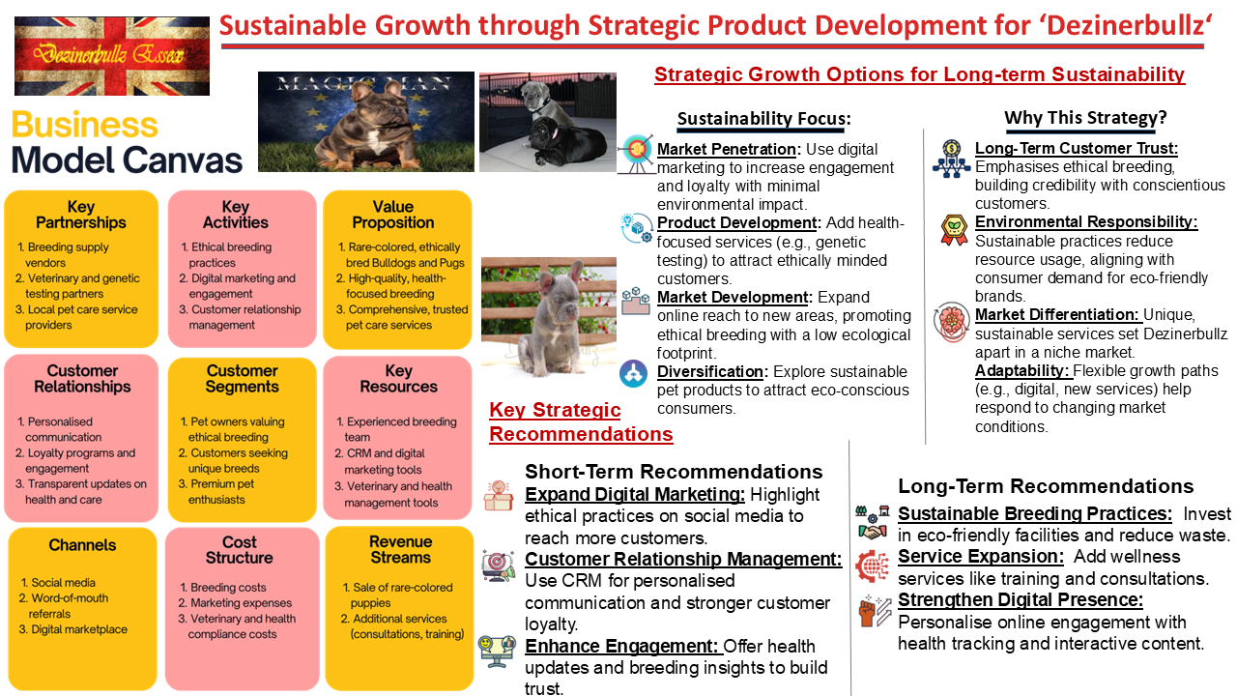

References:

- Ahmadi, A. (2023). Microsoft Customer Relationship Management for Small and Medium-Sized Enterprises. Asian Journal of Computer Science and Technology, 12(1), 3505. DOI: 10.51983/ajcst-2023.12.1.3505.
- Ahlawat, A., Odedra, M., & Dongre, V. (2020). Breeding Guidelines to Reduce Genetic Disorders in Dogs. Veterinary Genetics.
- Alvarez Yepez, A. Y., & García, P. M. (2016). Plan de negocio para Hotel de Mascotas Caninas en el sector norte de Guayaquil. Strategic Niche Management in Canine Services.
- Anyfioti, V., Dutta, S., & Evgeniou, T. (2001). Relationship Management Strategies in a Technology-Driven World. Strategic Marketing Journal.
- Aumüller, R., & Coetzer, E. (2020). Animal welfare in GLOBALG.A.P.'s integrated farm assurance standard for livestock. Revue Scientifique et Technique, 39(1), 271-281. DOI: 10.20506/rst.39.1.3075.
- Auka, D., & Langat, J. (2023). Effects of Strategic Planning on Performance of Medium Sized Enterprises in Nakuru Town. Journal of Business Performance.
- Beneli Donadon, F. A., Mannarelli Filho, T., Pazini, G. M., Pradella, L. O., & Ruiz Filho, A. (2023). Marketing como ferramenta estratégica para um posicionamento competitivo no agronegócio. Revista de Economia e Sociologia Rural, 16(47). DOI: 10.55905/rdelosv16.n47-001.
- Bruce, E., Shurong, Z., Ying, D., Yaqi, M., Amoah, J. K., & Egala, S. B. (2023). The Effect of Digital Marketing Adoption on SMEs Sustainable Growth: Empirical Evidence from Ghana. Sustainability, 15(6), 4760. DOI: 10.3390/su15064760.
- Bryce, C. M. (2021). Dogs as pets and pests: Global patterns of canine abundance, activity, and health. Integrative and Comparative Biology, 61(1), 154-163. DOI: 10.1093/icb/icab046.
- Bignardi, A., & Santana Júnior, M. L. (2022). Genetic diversity of Shepherd dog using pedigree analysis. Ciência Rural, 52(4). DOI: 10.1590/0103-8478cr20210827.
- Cacao, L., & Haro Lombeida, G. E. (2017). Plan de negocio para la creación de una empresa dedicada al hospedaje canino. Niche Market Viability for Canine Services.
- Calboli, F. C. F., Sampson, J., Fretwell, N., & Balding, D. (2008). Population Structure and Inbreeding From Pedigree Analysis of Purebred Dogs. Genetics, 179(1), 593-601. DOI: 10.1534/genetics.107.084954.
- Dendoncker, P.-A., de Keuster, T., Diederich, C., Dewulf, J., & Moons, C. (2019). On the origin of puppies: breeding and selling procedures relevant for canine behavioural development. Veterinary Record, 184(2), 104979. DOI: 10.1136/vr.104979.
- Dockes, A., Magdelaine, P., Daridan, D., Guillaumin, A., Rémondet, M., Selmi, A., Gilbert, H., Mignon-Grasteau, S., & Phocas, F. (2011). Stakeholder expectations in livestock breeding. Productions Animales, 24(1), 107-117. DOI: 10.20870/PRODUCTIONS-ANIMALES.2011.24.1.3233.
- de Medeiros, T. M., Alves, D., Matos, M. G., & Alves, C. (2022). Smartcoleira: pesquisa e design de produto para mercado pet. Pro-jetica, 13(1), 92-105. DOI: 10.5433/2236-2207.2022v13n1p92.
- Dreger, D., Hooser, B. N., Hughes, A. M., Ganesan, B., Donner, J., Anderson, H., Holtvoigt, L. E., & Ekenstedt, K. (2019). True Colors: Commercially-acquired morphological genotypes reveal hidden allele variation among dog breeds. PLoS ONE, 14(5), e0223995. DOI: 10.1371/journal.pone.0223995.
- Fowler, C. (2017). Guide for owners on the genetic issues of dog breeds. Companion Animal, 22(8), 494. DOI: 10.12968/COAN.2017.22.8.494.
- Gabelaia, I., & Tchelidze, L. (2022). Significance of Digital Marketing Strategies for Continuity of SMEs. International Journal of Management, 11(187-196). DOI: 10.53615/2232-5697.11.187-196.
- Goi, V. (2023). The Impact of Digital Technologies on the Companies’ Strategic Management. International Journal of Business, 42(2), 33. DOI: 10.46852/0424-2513.2.2023.33.
- Hedhammar, Å., Malm, S., & Bonnett, B. (2011). International and collaborative strategies to enhance genetic health in purebred dogs. The Veterinary Journal, 190(1), 10-12. DOI: 10.1016/j.tvjl.2011.06.018.
- Immink, V., Reinders, M., Tulder, R., & Trijp, J. V. (2013). The livestock sector and its stakeholders in the search to meet the animal welfare requirements of society. Journal of Consumer Studies, 17(3), 245-251. DOI: 10.3920/JCNS2013.1005.
- Ishola, O., Awosanya, E., & Adeniyi, I. (2017). Management and socio-economic determinants of profitability in dog breeding business in Oyo state, Nigeria. Sokoto Journal of Veterinary Sciences, 14(3), 47-52. DOI: 10.4314/SOKJVS.V14I3.5.
- Jeppsson, S. M. I. (2014). Purebred Dogs and Canine Wellbeing. Journal of Agricultural and Environmental Ethics, 27(5), 767-784. DOI: 10.1007/S10806-013-9470-Y.
- Judijanto, L., Febriyanto, W., & Supriandi, S. (2024). New Product Development Strategy and its Impact on MSME Growth. Small Business Journal, 2(8), 1227. DOI: 10.58812/wsis.v2i08.1227.
- Lampropoulos, G., Siakas, K., Viana, J. A. N., & Reinhold, O. (2022). Artificial Intelligence, Blockchain, Big Data Analytics, Machine Learning and Data Mining in CRM. IEEE Transactions on Strategic CRM, 5(6), 80. DOI: 10.1109/WI-IAT55865.2022.00080.
- Leighton, E., Hare, E., Thomas, S. G., Waggoner, L. P., & Otto, C. (2018). A Solution for the Shortage of Detection Dogs: A Detector Dog Center of Excellence and a Cooperative Breeding Program. Frontiers in Veterinary Science, 5, 284. DOI: 10.3389/fvets.2018.00284.
- Leroy, G., & Rognon, X. (2012). Assessing the impact of breeding strategies on inherited disorders and genetic diversity in dogs. The Veterinary Journal, 194(3), 398-402. DOI: 10.1016/j.tvjl.2012.06.025.
- Lampi, S., Donner, J., Anderson, H., & Pohjoismäki, J. (2020). Variation in breeding practices and geographic isolation drive subpopulation differentiation in dog breeds. Canine Genetics and Epidemiology, 7(1), 1-13. DOI: 10.1186/s40575-020-00085-9.
- Marelli, S., Beccaglia, M., Bagnato, A., & Strillacci, M. (2020). Canine fertility: The consequences of selection for special traits. Reproduction in Domestic Animals, 55(8), 1125-1131. DOI: 10.1111/rda.13586.
- Mari, F. (2020). A methodological proposal for the estimation of the Standard Output of dog breeding: A study case from Italy. Economia Agro-Alimentare, 22(1), 107-115. DOI: 10.3280/ecag1-2020oa10065.
- Mortlock, S., Booth, R., Mazrier, H., Khatkar, M., & Williamson, P. (2015). Visualization of Genome Diversity in German Shepherd Dogs. Bioinformatics and Biology Insights, 9, 37-45. DOI: 10.4137/BBI.S30524.
- Parsons, D. (2013). Animal Welfare, Market Power and Tangential Interests. Dignity and Animal Welfare Journal, 4(4), 45-57. DOI: 10.5565/rev/da.144.
- Renart, L. G., & Cabre, C. (2008). Paths to continuous improvement of a CRM strategy. Customer Relationship Management Journal.
- Roessler, R., Herold, P., Momm, H., & Zárate, A. V. (2012). Organisation of breeding under difficult framework conditions. Archives Animal Breeding, 55(6), 590-600. DOI: 10.5194/AAB-55-590-2012.
- Rodrigues, G. R. D., Oliveira, E. S., Rezende, V., França, J., & Raineri, C. (2023). Exploring buyer's preferences to propose strategies to improve dog welfare in Brazil. Journal of Animal Welfare, 7(3), 2282972. DOI: 10.1080/10888705.2023.2282972.
- Rueda, R., & Duban, J. P. (2018). Proyecto de viabilidad para la creación de la empresa Petlife Co. dedicada a la comercialización de productos para mascotas. University of Santo Tomas. DOI: 10.15332/tg.pre.2020.00096.
- Saputra, D. A., Handayani, P. W., & Satria, R. (2019). CRM Implementation Evaluation Using Maturity Assessment in Telecommunications. International Conference on Advanced Communication Systems, 8979692. DOI: 10.1109/ICACSIS47736.2019.8979692.
- Setia, P., Venkatesh, V., & Joglekar, S. (2013). Leveraging Digital Technologies: How Information Quality Leads to Localized Capabilities. MIS Quarterly, 37(2), 555-580. DOI: 10.25300/misq/2013/37.2.11.
- Shaffer, L., Ramirez, C., Phelps, P., Aviram, M., Walczak, M., Bar-Gal, G. K., & Ballif, B. (2018). An International Genetic Survey of Breed-Specific Diseases in Working Dogs. Journal of Applied Genetics, 59(1), 49-59. DOI: 10.1159/000486774.
- Steimer, F. L., & Steimer, T. (2009). Future mobile CRM in the automotive and tourist area. IEEE International Conference on Digital Ecosystems, 5276693. DOI: 10.1109/DEST.2009.5276693.
- Strasser, H., & Schumacher, W. (1968). Breeding dogs for experimental purposes. II. Assessment of 8-year breeding records for two Beagle strains. The Veterinary Record, 82(24), 712-717. DOI: 10.1111/J.1748-5827.1968.TB06783.X.
- Streitberger, K., Schweizer, M., Kropatsch, R., Dekomien, G., Distl, O., Fischer, M. S., Epplen, J., & Hertwig, S. T. (2012). Rapid genetic diversification within dog breeds as evidenced by a case study on Schnauzers. Animal Genetics, 43(5), 565-575. DOI: 10.1111/j.1365-2052.2011.02300.x.
- Tindano, K., Moula, N., Leroy, P., Traoré, A., & Antoine-Moussiaux, N. (2017). Market organisation and animal genetic resource management in sheep breeding. Animal Genetics Resources, 63(3), 127-136. DOI: 10.1017/S1751731117000477.
- Verbeke, W. (2009). Stakeholder, citizen and consumer interests in farm animal welfare. Proceedings of the British Society of Animal Science, 15(4), 175-186. DOI: 10.1017/s0962728600000725.
- Wilson, B., Serpell, J., Herzog, H., & McGreevy, P. (2018). Prevailing Clusters of Canine Behavioural Traits in Historical US Demand for Dog Breeds. Animals, 8(11), 197. DOI: 10.3390/ani8110197.
- Wiener, P., Sánchez-Molano, E., Clements, D., Woolliams, J., Haskell, M., & Blott, S. (2017). Genomic data illuminates demography and selection of a popular dog breed. BMC Genomics, 18(1), 1-11. DOI: 10.1186/s12864-017-3933-x.
- Young, A. (2011). Is there a healthy future for pedigree dogs? Veterinary Nursing Journal, 2(1), 4-5. DOI: 10.12968/VETN.2011.2.1.4.

