Managing People Assignment 1 2018 – A Business Case for Artificial Intelligence Application to Managing People



14th December 2018

MODULE NAME: Managing people: m5x00856
Name: Amy Collins
Student Number: 1703573
Executive Summary
The report looks at four key areas that surround the management of people relating to Royal Mail. It also considers what artificial intelligence (AI) can be used to improve these areas. AI is not a new concept, but is only recently being introduced into workplaces to work alongside humans rather than replace them. Royal Mail has stated that the technology they use may not be classed as AI but does help them improve in certain areas.
Royal Mail have a seven-week recruitment process, meaning that the recruitment team are fully tied up with new candidates rather than carrying out other tasks relating to their job role. Unilever, another large company, have gone fully digital with their recruitment process allowing candidates to have more freedom and be flexible with their time as well as freeing up more time for the recruitment team. The process asks candidates questions through an application which they respond to by recording themselves ready to upload online. AI systems will then scan through applicants and select them accordingly. One issue when using AI is that there can be bias throughout the recruitment algorithms meaning that certain candidates may be discriminated against unfairly.
Learning and development focusses on encouraging employees to be the best that they can be. Introducing learning and development sessions can leave employees feeling valued. Royal Mail offer a variety of learning and development sessions to its employees to keep them updated in business news and to help them improve their performance at the workplace. To encourage learning and development further, Royal Mail could introduce a chatbot that would enable employees to ask it any question and receive a beneficial answer. However, even though a chatbot would be great help to Royal Mail, it may not have all of the relevant information to respond to the query fully.
Royal Mail’s employees need to have a good level of employee engagement as many of them will regularly be dealing with customers, meaning they will be provided to offer excellent customer service. Royal Mail encourage employee engagement by allowing employees to access data on how they have contributed to the company’s recycling policy. Employees are always interested in ways that they can improve their performance, so Royal Mail could introduce a scheme where employees can ask their colleagues for feedback on their performance. However, there is a risk that this method could provide opportunity for employees to be bullied.
From a perspective of performance management, Royal Mail could use AI to monitor the strengths and weaknesses of their employees. This would allow them to identify where members of staff need developing. However, if the AI was to miss out on an area of development for a certain employee, they would go without relevant training which would affect company performance.
Table of Contents
1.0 Introduction 4
2. Recruitment 5
2.1 Use and Potential for AI in Recruitment 5
2.2 Disadvantages or Ethical Concerns 5
3. Learning and Development 6
3.1 Use and potential for AI in Learning and Development 6
3.2 Disadvantages or Ethical Concerns 6
4 Employee Engagement 7
4.1 Use and potential for AI in Employee Engagement 7
4.2 Disadvantages or Ethical Concerns 7
5 Performance Management 8
5.1 Use and potential for AI in Performance Management 8
5.2 Disadvantages or Ethical Concerns 8
6 Conclusion 9
7 References 10

1.0 Introduction
This report will discuss how artificial intelligence (AI) is affecting the way in which companies operate. The company that will primarily be discussed will be Royal Mail. Royal Mail is an organisation that operates in over 40 countries globally, delivering just under 15 billion letters annually. (Royal Mail Group Limited, 2018) The report is being carried out to determine the benefits and limitations of a company such as Royal Mail using artificial intelligence in relation to them and how they manage their people.
“Artificial intelligence, or AI, is the field that studies the synthesis and analysis of computational agents that act intelligently.” (Poole and Mackworth, 2017)
As times are changing rapidly, it’s vital for businesses to keep track on what is happening around them and monitor particular trends such as the future of AI. The concept is not new to the public eye, however it’s an opportunity to shine is among us (IESE, 2018).
Managing people in a world of AI can be challenging, as the technology grows there is less demand for human beings to complete particular tasks. With this comes job insecurity and demotivation, causing a business’ productivity levels to plummet. Even though AI can be a daunting aspect to consider, it can be used to work alongside humans rather than against them, giving them the opportunities to develop their skills and improve their performance (Krasadakis, 2017).
The report will discuss the four topics within managing people, recruitment, learning and development, employee engagement and performance monitoring in relation to Royal Mail and how they use artificial intelligence within these four key areas. Royal mail has officially stated that one of the most successful technological systems they use is the optical character system. This may not be considered as artificial intelligence, however is state of the art technology that helps them improve their productivity levels (WhatDoTheyKnow, 2012).



2. Recruitment
“Recruitment includes those practices and activities carried on by the organization with the primary purpose of identifying and attracting potential employees” (Barber, 1998. As cited in Yu & Cable, 2013:22)

2.1 Use and Potential for AI in Recruitment
The recruitment process for Royal Mail seems rather complex as there are several steps over 7 weeks to be considered an employee. Throughout this process, there is no use of artificial intelligence to make this process more straight forward for the candidate as well as the employer. The candidate must apply online as the first stage of the recruitment process. Selection from the employer comes next as the recruitment team need to consider the most appropriate applications, then the candidates will be given an interview based on their applications. The final stages consist of providing the candidates with their interview results along with an offer of the position if they were successful (Royal Mail Group, 2018).
In comparison to this recruitment process, other large companies have inputted artificial intelligence into their process in order to make it less time consuming for the company. By using this type of technology, it takes the pressures off the recruitment departments and makes the candidate feel more at ease. One prime example of a company effectively using AI as part of their recruitment process is Unilever. Unilever have gone fully digital in their process giving candidates the opportunity to take part in activities and answer questions as part of an online application. This is where the application can discover whether the candidate is a match for the job role they have applied for and therefore be selected for a digital interview. The interview consists of the candidate filming themselves answering a series of questions to later be analysed by artificial intelligence systems. Using this type of technology would be a great stepping stone for Royal mail to get the best candidates they can for the job (Hire Vue, 2018).
Royal Mail’s competitors such as Yodel and Hermes have similar recruitment processes, indicating that there is room for improvement in the industry as a whole. However, this does suggest that Royal Mail are not falling behind in terms of the technology that they use, but would also be of great advantage to them if they were to implement the type of technology that Unilever are currently utilising.

2.2 Disadvantages or Ethical Concerns
One problem that may be faced when introducing AI into the workplace may be bias within the algorithms in place when selecting potential candidates. This was experienced by global online retailer Amazon, who were forced to stop using their ‘secret AI recruiting tool that showed bias against women’ (Dastin, 2018). For example, if Royal Mail were to introduce a similar recruitmet programme to the one used at Amazon, there would be the potential for it to be set up with particular unintentional biases. One example of this could be that any digital application software used might be programmed to penalise CVs ‘that included the word “women’s,” such as “women’s chess club captain”’ as described by the Telegraph’s James Cook (2018). This would cause huge legal problems for the organisation as they could be found to be discriminating against candidates which is not only illegal and could see them fined, but could be the cause of negative publicity meaning that the reputation of Royal Mail would be at risk.



3. Learning and Development
“Learning and development, a subset of HR, aims to improve group and individual performance by increasing and honing skills and knowledge” (HRZone, 2018).
Learning and development is vital in an organisation as it encourages the employee to perform the best that they can be and help them gain confidence. Completing learning and development sessions in an organisation can make the employee feel valued within the organisation and therefore increase productivity levels (Docebo, 2018).

3.1 Use and potential for AI in Learning and Development
Royal mail is proud of the learning and development programmes as they state “We set our people up to succeed” (Vercida, 2018). Royal Mail offer a variety of L&D programmes to its employees, one being a thirty-minute weekly session known as Work Time Listening and Learning. This session allows the employees to get updated on the most recent business activity and news within the company (Vercida, 2018). Although there is no use of artificial intelligence within these sessions, there is still opportunities for it to be introduced.
Using chatbots within the organisation can be very beneficial as employees can communicate with the bots and obtain answers to any queries they have. This could save time as employees would not have to seek guidance directly from a manager or colleague.
Royal Mail could also introduce a system where employees can earn rewards on a mobile phone or tablet application by answering questions relating to the company and the procedures in place within various departments. This system could also be completed with online tutorials which can help develop individual’s skills and help them improve their learning within the workplace.

3.2 Disadvantages or Ethical Concerns
Even though using chatbots is a solid idea for encouraging learning and development within an organisation, it can have common faults. For example, the answers provided by the chatbot may not have all of the relevant information available for more specific queries, while it also might provide employees with incorrect answers if it fails to thoroughly understand the query.
With using an application where employees can earn rewards to encourage learning and development, it may be found that not all employees are interested in their personal development but only take part and answer the questions in order to win the prizes. This would defeat the object of the process.

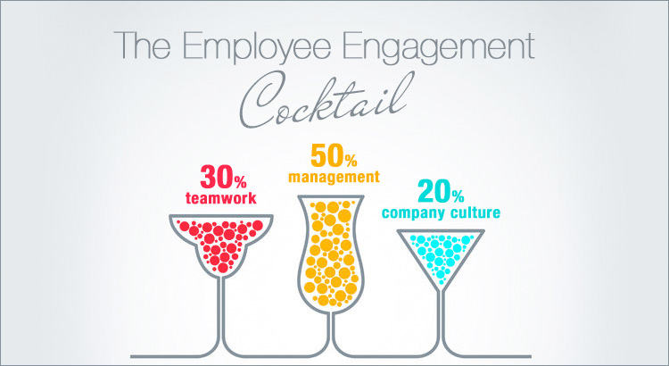

4 Employee Engagement
“Employee engagement is the emotional commitment the employee has to the organization and its goals.” (Kruse, 2012)
An organisation that has high employee engagement is seen to have an improved level of customer satisfaction. This would apply more to the Royal Mail delivery drivers, delivering high quality customer service when interacting face to face with customers (Moseley, 2018). Royal Mail explains ‘how it has implemented an ambitious, company-wide engagement programme to deliver sustainability success’ by allowing employees to access data showing ‘how much waste they diverted from landfill [and] how much they had recycled’ (Edie, 2017).

4.1 Use and potential for AI in Employee Engagement
Employees are always concerned about ways in which they can improve and are always asking for feedback on their performance. A company known as ‘How am I going?’ focuses on making ‘giving and receiving feedback a valuable and enjoyable experience, without fear or dread, and with a whole lot of benefits that can change your life’ (How am I going?, 2018). An employee can set up their own questions to find out how they are performing. These questions can be seen and answered by their colleagues as a way of helping them to improve their performance. If a company such as Royal Mail were to introduce this type of AI into their workforce, it would allow for a whole new meaning of learning and development as employees could see where they were performing compared to other colleagues and if they were accomplishing tasks to the standard set by their employer.

4.2 Disadvantages or Ethical Concerns
Even though this is seen as a great learning and development technique, it may have its downfalls. For example, work colleagues reviewing your performance or providing you with feedback may not use it the way it should be used. This type of AI can be used to target individuals within a workplace and be used to bully them. This again would provide Royal Mail with negative publicity, meaning that in the future people would not apply for a role within the company.

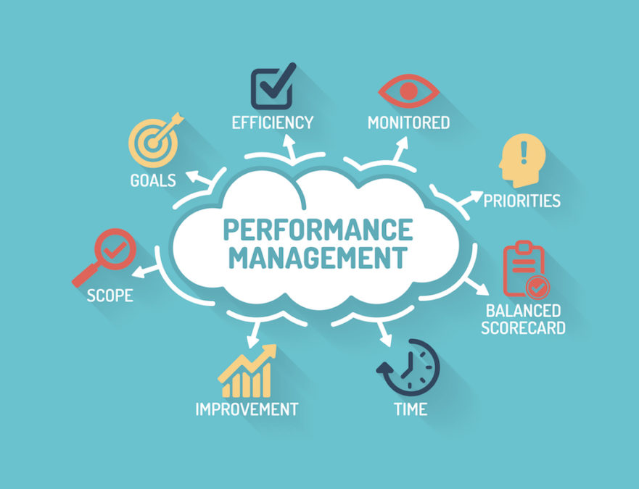

5 Performance Management
“Performance management is the activity and set of processes that aim to maintain and improve employee performance in line with an organisation's objectives.” (CIPD, 2018)
In relation to performance management, one of Royal Mail’s competitors, Yodel have introduced technology which allows their customers to track their deliveries right down to how many deliveries are scheduled before theirs. This is a game changer in this industry as more and more companies similar to Yodel are beginning to introduce this luxury for its customers. Although this is a benefit for its customers, it brings about a whole new type of stress for the delivery drivers as they need to ensure they performing at their best to keep the customers and employer satisfied.

5.1 Use and potential for AI in Performance Management
While there is no evidence of Royal Mail using it, AI has the potential to be able to monitor the strengths and weaknesses of employees in order to be able to provide them with tailored training regimes. This would increase the effectiveness of Royal Mail’s training while ensuring that the company do not waste money on training that is not relevant. It can also help to provide visual data on tasks undertaken within the company, making it easy to see where they are struggling and where they are not.

5.2 Disadvantages or Ethical Concerns
Using AI to provide specific training regimes for individual members of staff could be a risk as it could potentially miss out on vital areas of development for the employee. It could also become demotivating for the employee if they are continuously set the same training regimes which could affect their performance.

6 Conclusion
In conclusion, after considering the four areas that surround the management of people, it is clear to see that an organisation such as Royal Mail who, at this moment in time, do not use any AI should focus on recruitment if the opportunity should arise for them to introduce it. As mentioned previously, having digital interviews and questioning candidates through an online platform can free up so much more time for the organisation as AI can do it for them.
There are a series of issues that need to be addressed in relation to making the four areas simpler for employees at Royal Mail. The first recommendation would be that they need to invest into recruitment technology such as the one mentioned with relation to Unilever, this would provide the recruitment team at Royal Mail to invest their time into other aspects of their role.
The next suggestion would be that Royal Mail look into chatbots for their warehouse workers as this would enable them to ask questions relating to the role and the chatbot would be able to respond adequately to the employee.
Introducing a feedback and performance review programme would be beneficial to Royal Mail as each employee can monitor their own performance and keep a record of what they need to do in order to be performing to the required standard.

7 References
CIPD. (2018) “Performance Management: An Introduction” (Online) Available at: https://www.cipd.co.uk/knowledge/fundamentals/people/performance/factsheet (Accessed: 12 Dec. 2018)
Cook, J. (2018) “Amazon scraps 'sexist AI' recruiting tool that showed bias against women” (Online) Available at: https://www.telegraph.co.uk/technology/2018/10/10/amazon-scraps-sexist-ai-recruiting-tool-showed-bias-against/ (Accessed: 12 Dec. 2018)
Dastin, J. (2018) “Amazon scraps secret AI recruiting tool that showed bias against women” (Online) Available at: https://www.reuters.com/article/us-amazon-com-jobs-automation-insight/amazon-scraps-secret-ai-recruiting-tool-that-showed-bias-against-women-idUSKCN1MK08G (Accessed: 12 Dec. 2018)
Docebo. (2018) “Why is Learning & Development Important?” (Online) Available at: https://www.docebo.com/blog/learning-development-important/ (Accessed: 12 Dec. 2018)
Edie. (2017) “First-class sustainability: How Royal Mail is leading the way on employee engagement” (Online) Available at: https://www.edie.net/news/7/How-Royal-Mail-is-delivering-employee-engagement-with-sustainability/ (Accessed: 12 Dec. 2018)
Hire Vue. (2018) “Unilever’s Recruiting Process” (Online) Available at: https://www.hirevue.com/video/unilever-hirevue-recruiting-process (Accessed: 10 Dec. 2018)
HRZone (2018) “What is Learning and Development?” (Online) Available at: https://www.hrzone.com/hr-glossary/what-is-learning-and-development (Accessed: 10 Dec. 2018)
IESE. (2018) “10 Ways Artificial Intelligence Is Transforming Management” (Online) Available at: https://www.iese.edu/stories/10-ways-artificial-intelligence-is-transforming-management/ (Accessed: 9 Dec. 2018)
Krasadakis, G. (2017) “Artificial Intelligence: the impact on employment and the workforce” (Online) Available at: https://medium.com/innovation-machine/artificial-intelligence-3c6d80072416 (Accessed: 10 Dec. 2018)
Kruse, K. (2012) “What Is Employee Engagement” (Online) Available at: https://www.forbes.com/sites/kevinkruse/2012/06/22/employee-engagement-what-and-why/#4c7da3cd7f37 (Accessed: 12 Dec. 2018)
Moseley, C. (2018) “5 Reasons why employee engagement is important” (Online) Available at: https://blog.jostle.me/blog/5-reasons-why-employee-engagement-is-important (Accessed: 12 Dec. 2018)
Poole, D & Mackworth, A. “Artificial Intelligence Foundations of Computational Agents” Cambridge: Cambridge University Press.
Royal Mail Group Limited (2018) “About Us” Available at: https://www.royalmailgroup.com/en/about-us/ (Accessed: 8 Nov. 2018)
Royal Mail Group. (2018) “Our Recruitment Process” (Online) Available at: https://www.royalmailgroup.com/media/9858/our-recruitment-process.pdf (Accessed: 10 Dec. 2018)
Vercida. (2018) “Learning and Development at Royal Mail” (Online) Available at: https://www.vercida.com/uk/features/learning-and-development-at-royal-mail?company=13 (Accessed: 12 Dec. 2018)
WhatDoTheyKnow. (2012) “Artificial Intelligence Systems” (Online) Available at: https://www.whatdotheyknow.com/request/artificial_intelligence_systems (Accessed: 10 Dec. 2018)
Yu, Kang Y. T. & Cable, D. (2013) “The Oxford Handbook of Recruitment” New York: OUP USA.

