Marketing plan written for

JW Marriott- Singapore
__________________________________________
Student Name
Antonia Lupas
________________________________________________

Student ID number
2210502
___________________

Marketing Essentials BMIH4005

Component 2 - Marketing Plan

Lecturer
Ruth Taylor

________________________________



Table of Contents
Introduction 4
1. Marketing Mix 5
Product – 5
Price - 5
Place – 5
Promotion – 5
2. The Marketing Environment (Micro-SWOT). 6
3. The Marketing environment (Macro) PESTEL 7
Political 7
Economic 7
Social 7
Technological 7
Environmental 7
Legal 8
4. Creating Customer Value & Engagement 8
5. Effective Use of Digital Marketing 9
Email Marketing 9
Social Media Marketing 9
Video Marketing 9
Conclusion – 9
References 11
Appendix 1- email marketing 13
Appendix 2 – slides 15

Introduction
The JW Marriott is just one of the more than 80 stunning properties located all over the world in gateway cities and other one-of-a-kind settings that make up the luxury portfolio of Marriott International. The JW Marriott can be found in Singapore at 30 Beach Road, Nicoll Hwy, Access Via, and the city's zip code is 189763. Following the end of the pandemic lockdown, the JW Marriott hotel in Singapore intends to resume welcoming guests, by embracing the marketing mix, SWOT, and PESTEL analysis and creating customers value and engagement by keeping the safety aspects to reassure the guests through email marketing, social media marketing, and video marketing.

Marketing Mix

Product –
Spa experiences, healthy dining options, unforgettable moments, and plenty of room for the whole family are just a few of the hallmarks of the JW Marriott brand. Premium Aromatherapy Associates bath products, luxury bedding, and other luxuries can be found in each of the rooms at the JW Marriott. It also offers inspired venues, inspired weddings, The Grand Ballroom, and Art and Culture (Koh, 2018).

Price -
Maintaining customer satisfaction through a balanced quality framework and pricing strategy, JW Marriott sets hotel prices to maximize revenue without compromising the company's brand. The hotel's rates shift in response to seasonality, customer preferences, and operational and marketing costs (Chaffey and Ellis-Chadwick, 2019).

Place –
The location of the JW Marriott near the airport in SINGAPORE is ideal for travellers looking for a hotel near the airport. In order to expand its hotel portfolio, JW Marriott has adopted a mixed-channel strategy that includes both direct and indirect channels. Individuals may book a room on their website (Minazzi, 2015).

Promotion –
JW Marriott is committed to promoting its products exclusively in the digital space. As a global leader, they've built a website that showcases their full catalogue in exquisite detail and makes it simple to book hotel rooms online. There are ads, videos, and campaigns promoting it on a wide variety of social media platforms (Perera, 2017). Moreover, J.W. Marriott Singapore has relied on Cvent's search ad solutions for driving bookings and advertising the hotel to potential guests (Duffett, 2017).

The Marketing Environment (Micro-SWOT).
Strength
The first insight of JW Marriott is its high brand awareness and recall strategy. The hotel has more than 3700 resorts and hotels in over 70 countries. Although, it has strong free cash flow, which provides the hotel with the resources to expand to include new projects. Additionally, it has a successful track record for innovation of products and new product development (Dwivedi et al., 2015).
Weakness
JW Marriott is not positioned well, and its operations emphasise sales and corporate structure as family-focused businesses. However, In the new millennium, Marriott's emphasis on family has become a major liability in the hospitality industry. Moreover, the hotel excludes different working cultures in terms of not being successful in integrating companies with diverse cultures (Alshaketheep et al., 2020).
Opportunities
New online channel customers in the post-pandemic situation. Additionally, It's no secret that JW Marriott has poured a handsome amount of cash into their digital infrastructure in recent years. Marriott International now has access to a previously untapped market due to the investment. JW Marriott can use big data analysis to know the customer and their needs well (Dachyar and Sahir, 2020).
Threat
The rise in raw material prices and the vitality of the political environment in several markets worldwide bring currency fluctuation (Stephen, 2016).

The Marketing environment (Macro) PESTEL

Political
Marriott International operates in many countries, each of which has political problems. Marriott International's development plans may be impeded by political instability, which can impact the hotel. For example, the measures imposed by host governments during Covid 19 (Payne et al., 2017).

Economic
Waste management and conservation are government priorities. Lack of R&D funding is a grave threat in the current business climate. When the government interferes in the judiciary without cause, a fair trial and the rule of law are compromised. Raise climate-damaging emission levels. The high value of the US dollar reduces the number of international visitors visiting Marriott in several countries, including the US (Ketter and Avraham, 2021).

Social
1. In Singapore, more ethical communities live
2. Expense power is high.
3. In Singapore, the literacy rate is high (Payne et al., 2017).

Technological
Due to the rise in the use of digital appliances soon after Covid 19, JW Marriott should update itself with the most recent technologies. Like, Free and fast access to Wi-Fi and many other technological accesses (Stephen, 2016).

Environmental
Green problems in Singapore are very pertinent; hence the JW Marriot needed to concentrate on recycling and embrace echo-friendly as Seibel (Duffett, 2017).

Legal
Breaking rules pertaining to where a building can be constructed, how hotels must operate, and basic health and safety precautions.
- Paying lodging taxes.
- Higher labour costs and service reduction regulations (Dwivedi et al., 2015).

Creating Customer Value & Engagement
To enhance customer services, JW Marriott can embrace the survey and feedback from the customers who visit their hotel. There must be feedback and easy access to report a complaint. Moreover, social media platforms like Facebook, WhatsApp, and Instagram can be a more effective way to create customer value and engagement. 24/7 availability and replying to the queries of the customers will improve the services of JW Marriott hotel. In addition to this, there should be an application of the company to ease communication and booking of their offerings besides the website. The application can also provide the survey in the form of a Likert scale survey, similar to the Foodpanda application survey (Dwivedi et al., 2015).
Moreover, it is essential to reach the customers from own self; in this regard, Facebook inbox, replying to comments and solving the issues soon as possible will enhance customer loyalty with the JW Marriot brand. Moreover, JW Marriott can promote their destination and new products before it enters the market. In this essence, new and potential customers will be grabbed by using powerful content. JW Marriott can give more value to the guests and help them in breaking the monotony (Chaffey and Ellis-Chadwick, 2019).

Effective Use of Digital Marketing

Email Marketing
To attract new customers for JW Marriott after the pandemic lockdown, the most effective use of marketing can be email marketing. It is because email marketing can boost a high ROI along with providing the benefit of direct connection with the audience. The safety aspects to reassure the guests can be served effectually using this media (Stephen, 2016). An example is shown in appendix 1.

Social Media Marketing
To bring new customers to JW Marriott, social media marketing will serve as brand awareness which will boost audience engagement, improve branding and nurture relationships. Word of mouth using this platform can help the company to increase its range. Advertisements through Instagram, Facebook, and WhatsApp can help convey the message of new assures safety aspects soon after the reopening of the hotel (Tuten and Solomon, 2017).

Video Marketing
Using demos, event videos, webinars, live videos, and expert interviews, the safety and precautions after Covid 19 can be promoted. In this essence, the company can attain the familiar, which talks about safety and well-being. Thus, it can help the JW Marriott hotel to bring new customers post-pandemic (Minazzi, 2015).

Conclusion –
It can be concluded that JW Marriott needs an effective and strong digital presence of place and promotion in their marketing mix to attract new customers after the pandemic lockdown. Through email marketing, guests will feel more at ease with the property's security measures, social media marketing and video marketing. The company needs to work on positioning and serving adolescence because this is a potential target market and grab new customers. There is a positive correlation between the usage of the digital appliance after Covid 19 by the adolescence. Thus, an opportunity for JW Marriott. Social factors and customer preferences are the opportunities for the company, whereas political, economic, and legal factors serve as a threat. Technological factors can serve both opportunity and threat based on the marketing techniques JW Marriott uses. Thus, recommended technique to increase customer value and engagement is the use of social media, email marketing and video marketing to value the customers.

References
Alshaketheep, KMKI, Salah, A.A., Alomari, K.M., Khaled, A.S. and Jray, A.A.A., 2020. Digital marketing during COVID-19: Consumer's perspective. WSEAS Transactions on Business and Economics, 17(1), pp.831-841.
Chaffey, D. and Ellis-Chadwick, F., 2019. Digital marketing: strategy, implementation & practice. Pearson UK.
Chaffey, D. and Smith, P.R., 2017. Digital marketing excellence: planning, optimizing and integrating online marketing. Routledge.
Dachyar, AZNSM and Sahir, A., 2020. Hotel revival strategy planning with SWOT-Fuzzy AHP-TOPSIS: A case study of 4-star hotel.
Duffett, R.G., 2017. Influence of social media marketing communications on young consumers’ attitudes. Young Consumers, 18(1), pp.19-39.
Dwivedi, Y.K., Kapoor, K.K. and Chen, H., 2015. Social media marketing and advertising. The Marketing Review, 15(3), pp.289-309.
Evans, D., Bratton, S. and McKee, J., 2021. Social media marketing. AG Printing & Publishing.
Ketter, E. and Avraham, E., 2021. # StayHome today so we can# TravelTomorrow: tourism destinations’ digital marketing strategies during the Covid-19 pandemic. Journal of Travel & Tourism Marketing, 38(8), pp.819-832.
Koh, B.W.E., 2018. The future of the home rental phenomenon in the Singapore context.
Kumar, V. and Reinartz, W., 2016. Creating enduring customer value. Journal of Marketing, 80(6), pp.36-68.
Minazzi, R., 2015. Social media marketing in tourism and hospitality. Springer International Publishing Switzerland.
Payne, A., Frow, P. and Eggert, A., 2017. The customer value proposition: evolution, development, and application in marketing. Journal of the Academy of Marketing Science, 45(4), pp.467-489.
Perera, R., 2017. The PESTLE analysis. Nerdynaut.
Stephen, A.T., 2016. The role of digital and social media marketing in consumer behavior. Current opinión in Psychology, 10, pp.17-21.
TAKACS, J. and VADUVA, S.A., 2017. A swot analysis of the global hospitality industry. Revista Economica, 69(6).
Tuten, T.L. and Solomon, M.R., 2017. Social media marketing. Sage.

Appendix 1- email marketing
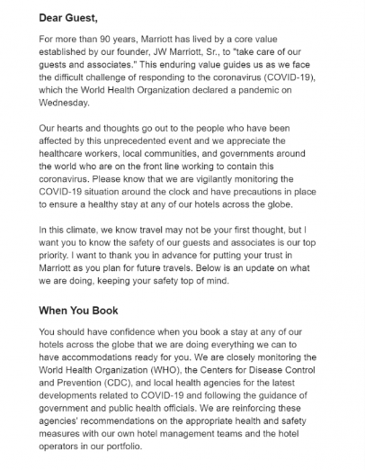

Appendix 2 – slides

Slide 1-
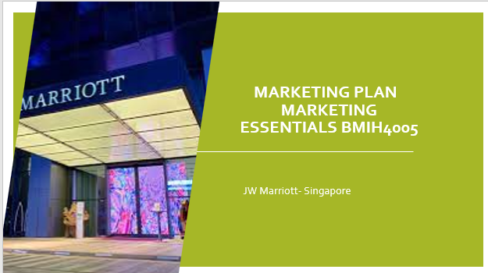

Slide 2-
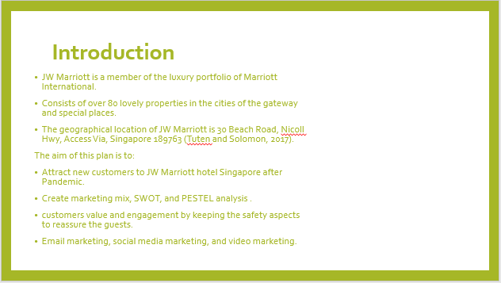

Slide 3-
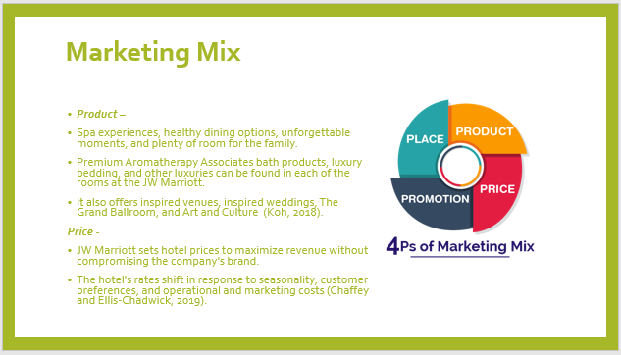

Slide 4-
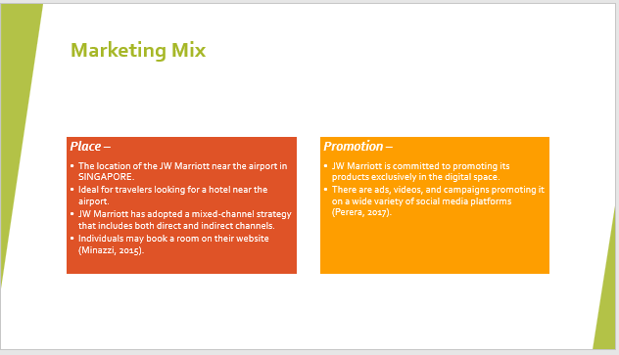

Slide 5-
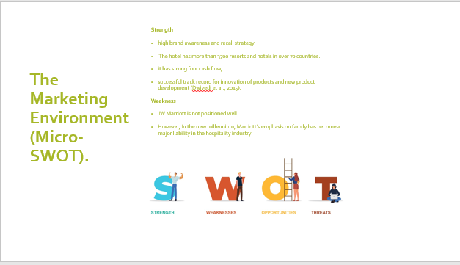

Slide 6-
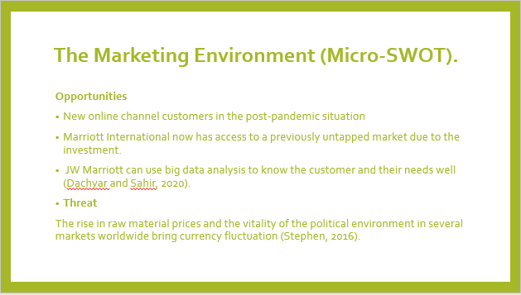

Slide 7
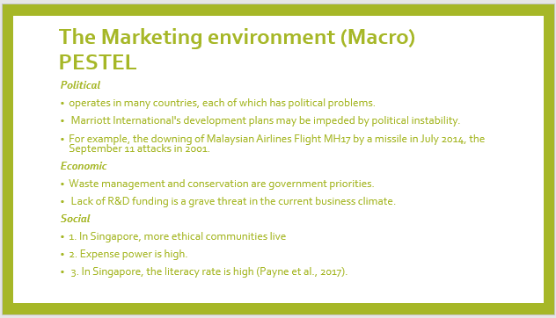

Slide 8
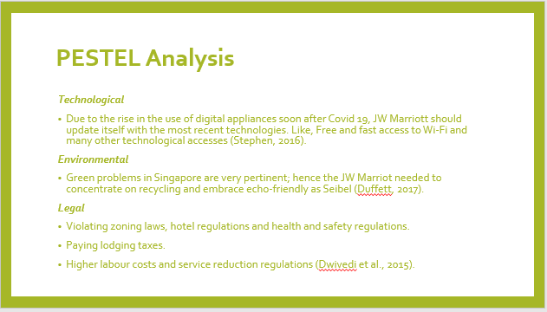

Slide 9
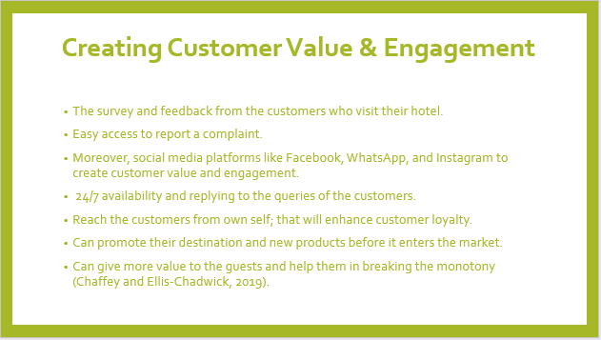

Slide 10
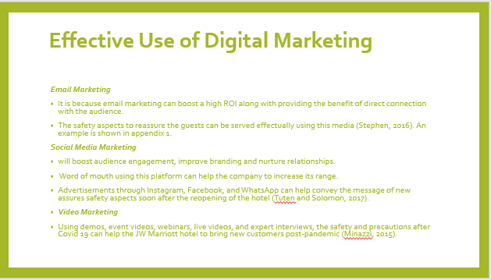

Slide 11
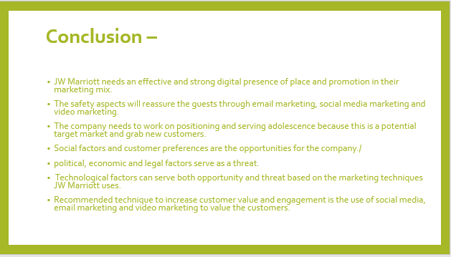

Slide 12
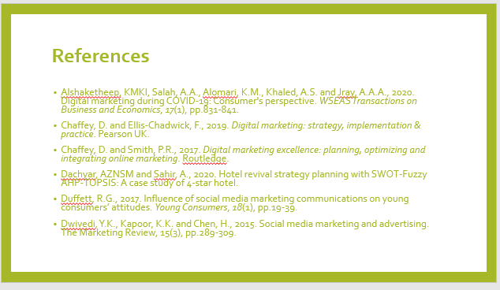

Slide 13
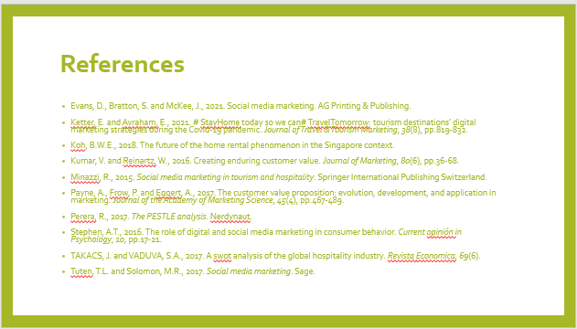

Slide 14


