Fundamentals of Construction Technology - ACBA4022
Assignment 2:
Technical Case Study: Comparative Analysis of Timber Twin Frame, Structural Insulated Panels (SIPs), and Brick and Block Construction Methods for a Two-Story Detached Domestic Building

Submission Date: 01/05/2025

Prepared by: Morgan Owens
For Review by: Gavin Traylor

Contents
Introduction 3
Offsite Construction 3
Comparative Analysis 8
Ground Floor Construction and Junctions with External Walls 8
Window Opening in External Wall 9
Eaves Detailing and Roof Structure 9
Recommendation 10
Conclusion 11
References 12

Introduction
Miss A Client has been granted planning permission to carry out the construction of a detached two-storey house on a reclaimed site. The client is considering three construction methods: Timber Twin Frame, Structural Insulated Panels (SIPs), and Brick and Block. This case study will compare the above noted methods to assist her decision in how to proceed with her construction.

My aim is to evaluate these construction methods based on their materials, methods, thermal performance, and suitability for the project. Within my assignment I will provide a detailed definition of Offsite Construction, show evidence of detailed sections and sketches for the proposed ground floor construction, window openings, eaves detailing, roof structure and provide my recommendation on which method I advise is the best construction method for the clients proposed plans while taking into consideration the appropriate Building Regulations for the construction.

Offsite Construction
Offsite construction means planning, designing, producing, and assembling building parts at a location other than where they will be finally installed. This method supports quick and efficient construction by making most components in a factory and then transporting them to the construction site for assembly. The methods of offsite construction include Volumetric Modular Construction, Panelised Construction, Hybrid Modular Construction and Component (Sub-Assembly) Construction.

Volumetric Modular Construction:
This offsite construction method involves prefabricating three-dimensional units, or modules, in a factory. Some examples of Volumetric Modular Construction which will be appropriate to my clients construction include bathrooms or kitchens, which can be built as modules and then assembled on-site. The benefits of this construction method for my client would include the reduced construction time, improved quality control, and less waste. The challenges of this construction method include transportation logistics, the initial cost, and design limitations.
(Zeeshan, 2024) (volumetric, 2023)

Panelised Construction:
This offsite construction method involves prefabricating flat panels, such as walls, floors, and roof sections, which are then assembled on-site. Some examples of Panelised Construction which my client can consider for their build includes wall, floor, and roof panels, which can be prefabricated in a factory setting and then assembled on-site. The benefits to my client in using this construction method is the increased flexibility in design, reduced construction time, and improved precision. Some challenges of this construction method for my client to consider include on-site assembly complexity, transportation logistics, and the initial cost.
(Salinger, 2024) (Gypsum, 29)

Hybrid Modular Construction:
This offsite construction method involves combining volumetric modules with panelised components, allowing for greater design flexibility and optimisation of both methods. Some examples of Hybrid Modular Construction include using volumetric modules for complex areas like bathrooms and kitchens, while the rest of the structure is built using panelised construction. The benefits of this construction method include optimised speed and design flexibility, improved quality control, and reduced waste. Some challenges of this construction method include coordination between different construction methods, transportation logistics, and the initial cost. This is a method my client may wish to consider if they are looking for more design flexibility while addressing a stricter timescale.
(Kivlehan, 2023) (theoffsiteguide.com, ND)

Component (Sub-Assembly) Construction:
This offsite construction method involves the prefabrication of smaller building components or sub-assemblies for example, our client may wish to consider roof trusses, floor cassettes, or wall sections, which are then assembled on-site. The benefits of this construction method include reduced on-site labour, improved construction efficiency, and better-quality control. Some challenges of this construction method include transportation logistics, initial cost, and coordination of sub-assemblies.
(falkbuilt, ND) (assembly, ND)
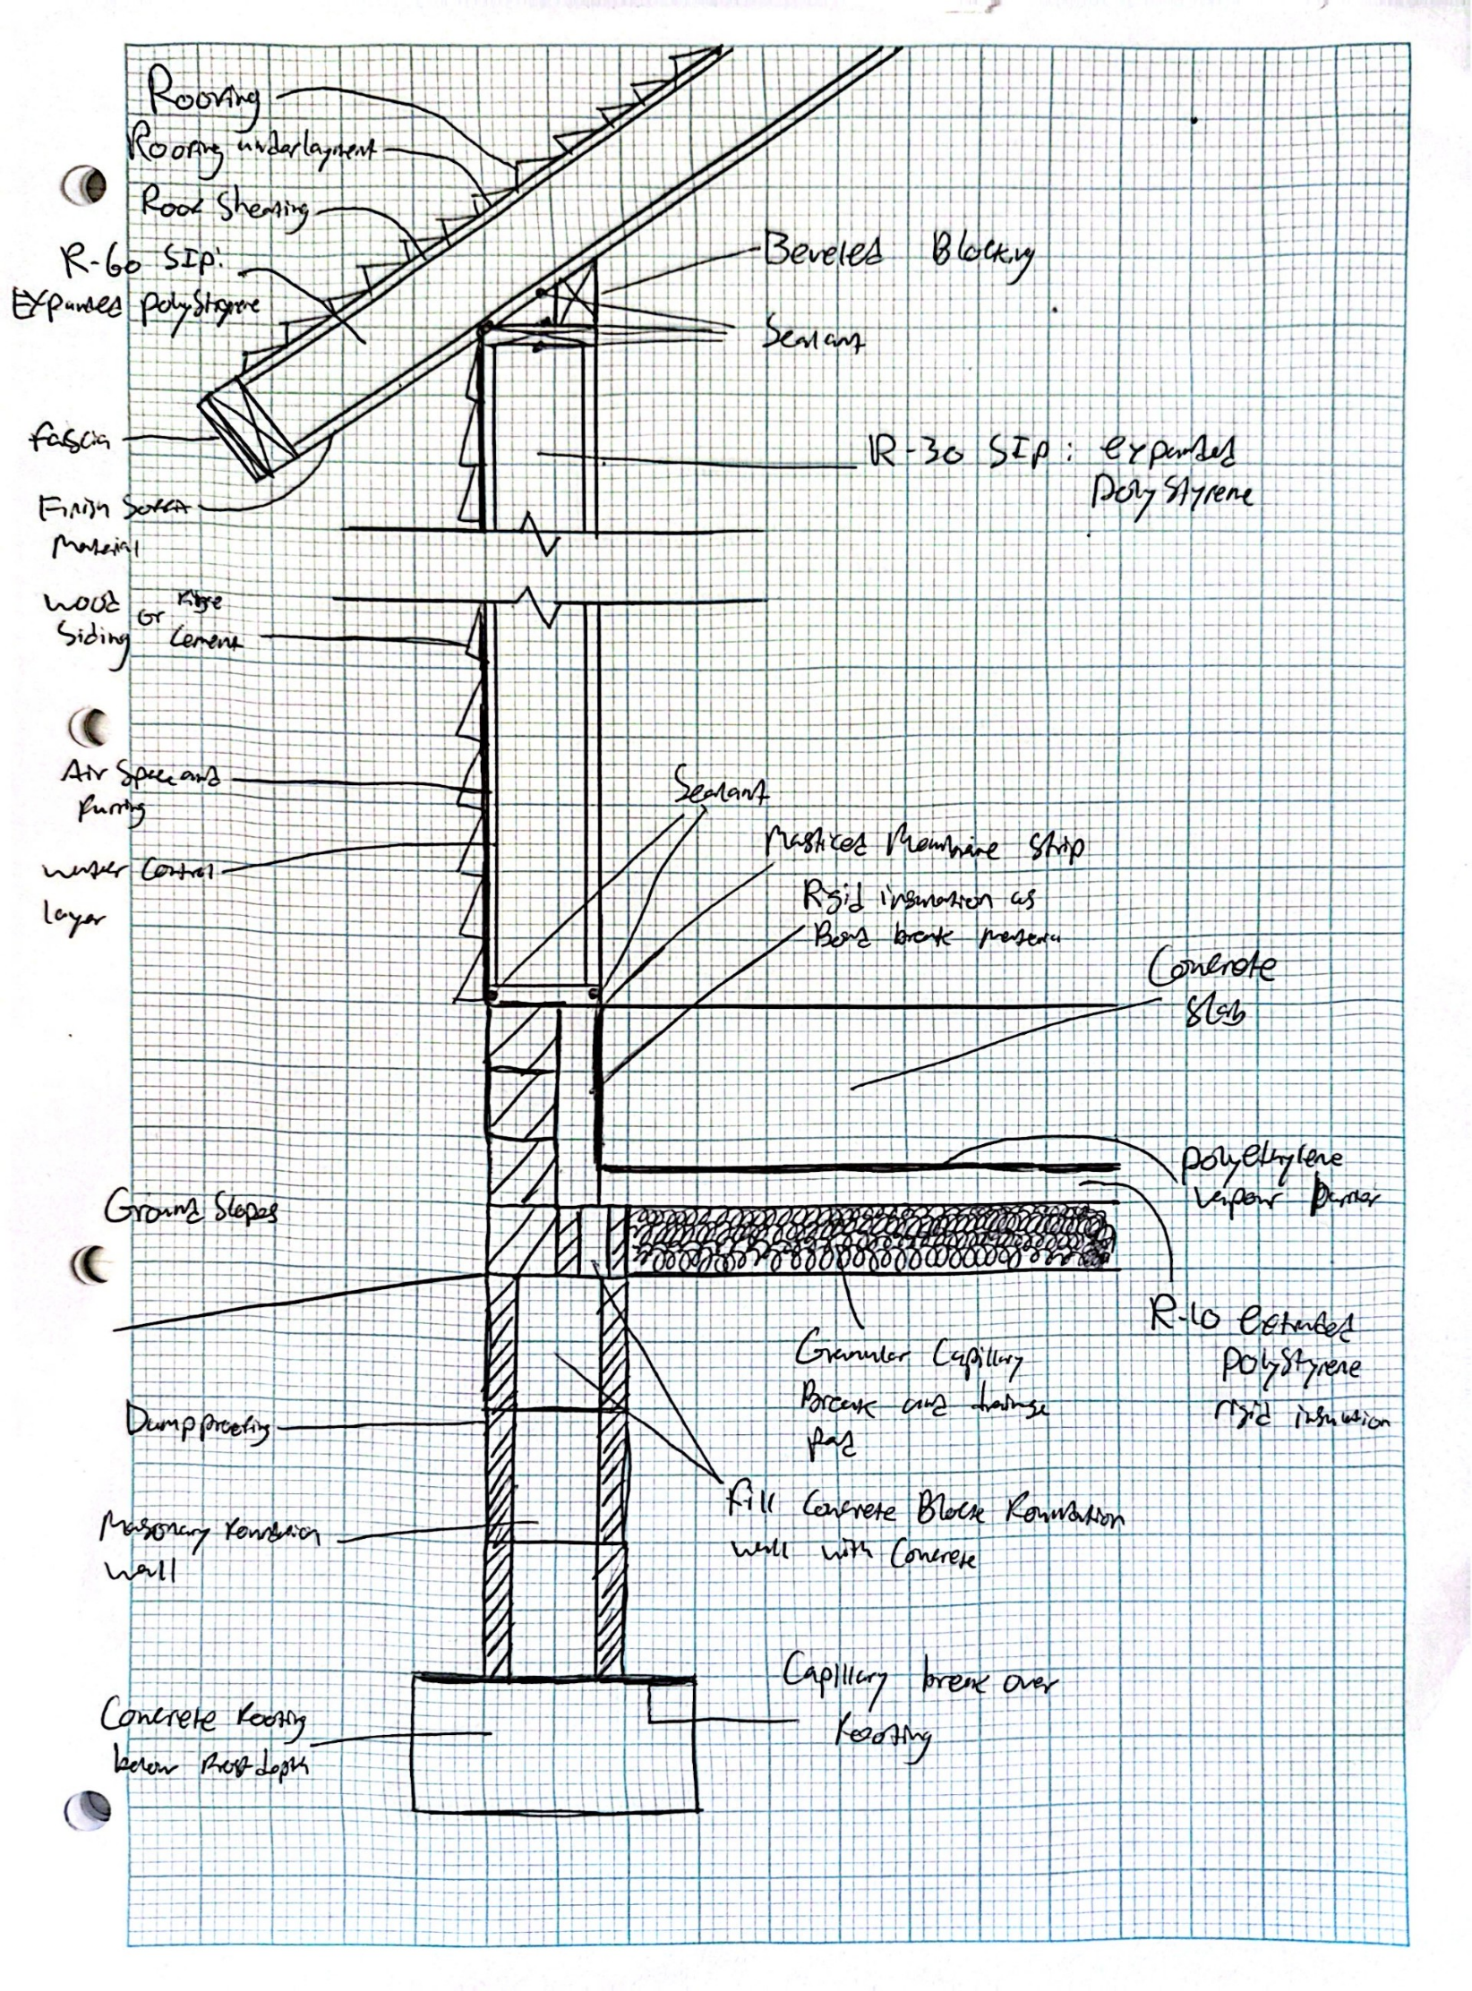

Twin Timber Frame Construction
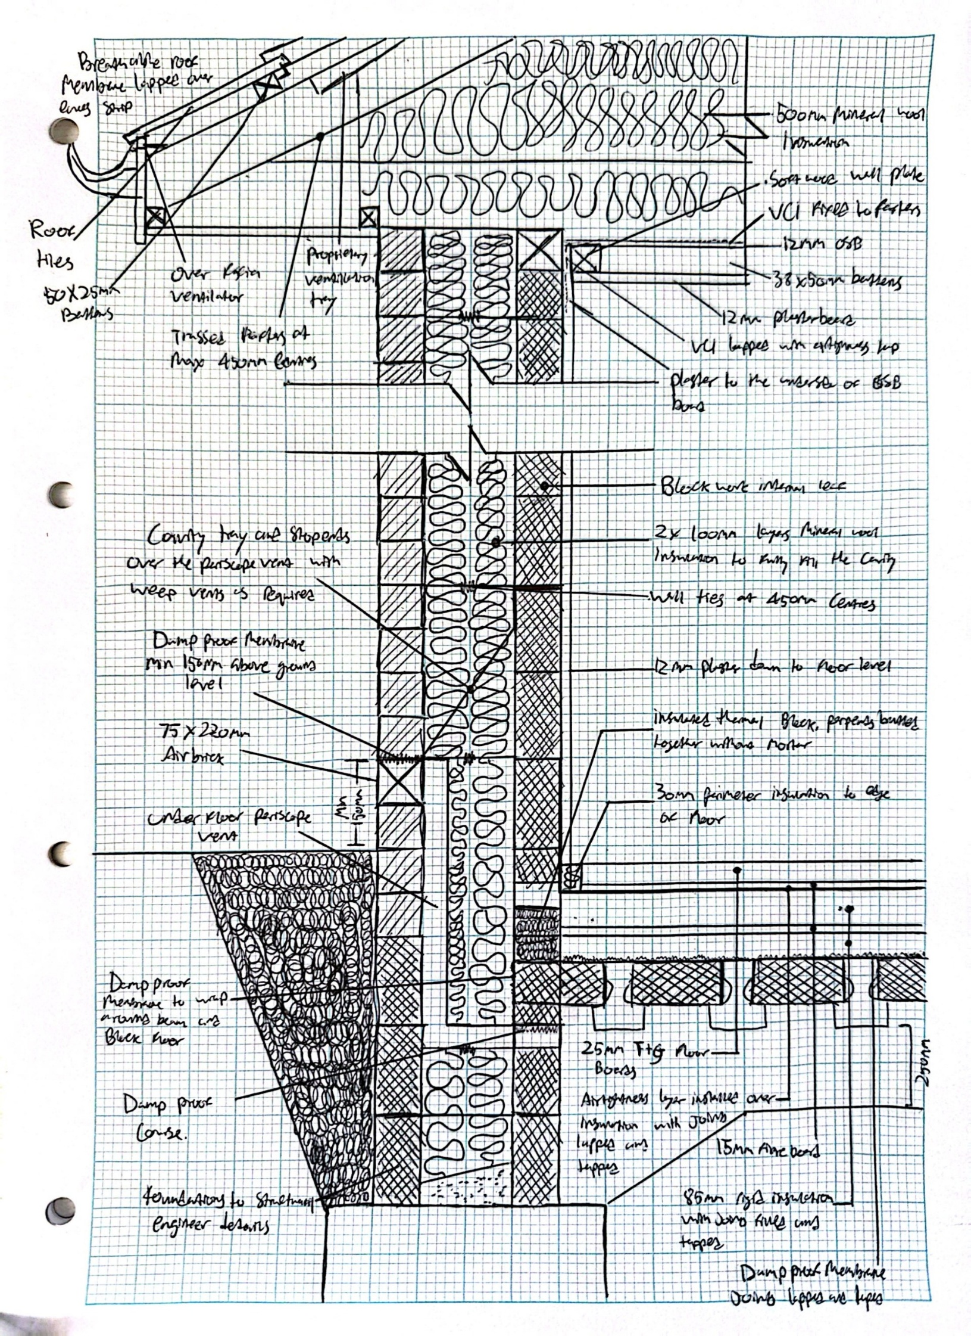

Brick and Block Construction
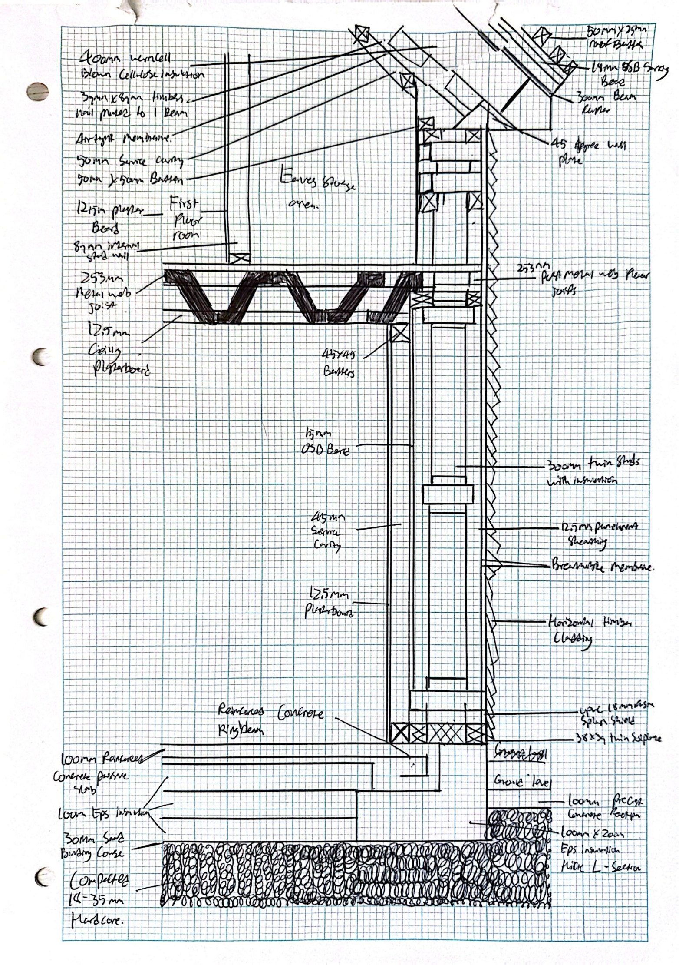

SIPs Construction

Comparative Analysis

Ground Floor Construction and Junctions with External Walls

Timber Twin Frame:
The ground floor can be constructed using either timber flooring or a concrete slab. Timber floors are often favoured for their natural insulation properties and ease of installation, while concrete slabs provide a solid and durable base capable of supporting heavier loads. External walls are typically made of two timber frames with insulation, such as mineral wool, placed between them to enhance thermal performance. These junctions are sealed with a damp-proof course (DPC) to prevent moisture ingress, which is crucial for avoiding damp and mould. Although timber frames offer good insulation, additional measures are often required to ensure thermal efficiency. Compliance with Approved Document L is essential to meet energy efficiency standards. While timber's natural insulating properties help reduce heat loss, extra insulation and careful sealing are necessary to meet modern energy standards.

(Government, 2023) (Enjily, 2005) (Clark, 2024)

SIPs:
The ground floor can be constructed using either a concrete slab or timber flooring, both of which are compatible with Structural Insulated Panels (SIPS). Concrete slabs provide a stable base, ideal for supporting heavier structures, while timber floors are suitable for lighter buildings. Junctions between panels are joined using splines or timber plates and sealed with foam or sealant to ensure a tight fit, reducing air leakage and enhancing thermal efficiency. SIPS offer excellent thermal performance due to their continuous insulation and airtightness, aligning well with the energy efficiency standards outlined in Approved Document L. These panels consist of insulating foam layered between two structural boards, providing high thermal resistance and effectively reducing heat loss.

(Government, 2023) (sips.org, 2023) (Valle, 2022)

Brick and Block:
The ground floor can be constructed using either a concrete slab or a suspended concrete floor. Concrete slabs offer a solid base, while suspended floors are suitable for areas with poor ground conditions. External walls typically consist of an outer brick layer and an inner block layer, with a gap in between filled with insulation material. Junctions are sealed with a damp-proof course (DPC) and cavity trays to prevent moisture ingress, providing good thermal mass and helping to regulate indoor temperatures. Compliance with Approved Document L is crucial for achieving energy efficiency, the thermal mass of brick and block helps store heat, but extra insulation is necessary to minimize heat loss and can be required to meet modern energy efficiency standards.

(Government, 2023) (Corfield, 2024) (Brooks, 2025)

Window Opening in External Wall

Timber Twin Frame:
The window is framed with timber headers and sills, providing structural support. Insulation around the frame and a vapour barrier are used to prevent heat loss and moisture ingress. The window is set within the timber frame, with insulation and a vapour barrier surrounding it to enhance thermal performance and prevent air leakage. Timber frames offer good insulation, but careful sealing is necessary to comply with the airtightness requirements in Approved Document L.

(Government, 2023) (Enjily, 2005) (Clark, 2024)

SIPs:
The window opening is cut in the panel and reinforced with timber headers and sills, with edges sealed using foam or sealant to ensure a tight fit and prevent air leakage. The SIPS panels provide structural support, while the foam or sealant maintains airtightness. The window is set within the panel, with sealant around it to keep air out and enhance thermal performance, meeting the standards set by Approved Document L. The continuous insulation provided by SIPS panels reduces thermal bridging and improves energy efficiency.

(Government, 2023) (sips.org, 2023) (Valle, 2022)

Brick and Block:
The window is framed with a concrete or steel lintel, providing structural support. The cavity around the window is insulated, and a cavity closer is installed to prevent heat loss and improve thermal performance. The window is set within the brick and block wall, with insulation and a cavity closer around it to enhance thermal performance and prevent air leakage. Brick and block construction offers good thermal mass but may require additional insulation to meet modern standards. Compliance with Approved Document L is necessary for providing proper insulation and the sealing around the window frame to ensure energy efficiency.

(Government, 2023) (Corfield, 2024) (Brooks, 2025)

Eaves Detailing and Roof Structure

Timber Twin Frame:
The eaves are constructed with timber rafters and fascia boards, covered with a breathable membrane to keep moisture out. This membrane allows moisture to escape while preventing water ingress, maintaining the integrity of the roof structure. The roof features a pitched design with timber trusses or rafters, providing structural support and efficient water drainage. Timber roofs offer good insulation, but careful detailing is required to prevent thermal bridging. Compliance with the thermal performance standards in Approved Document L is necessary. Proper insulation and sealing around the eaves are essential to prevent heat loss and ensure energy efficiency.
(Government, 2023) (Enjily, 2005) (Clark, 2024)

SIPs:
The eaves are constructed using SIP panels and timber fascia, sealed with a breathable membrane and tape to ensure air tightness and prevent moisture ingress. The SIP panels provide continuous insulation, enhancing thermal performance. The roof, which can be either flat or pitched, is also made with SIP panels, offering structural support and continuous insulation to reduce thermal bridging and improve energy efficiency. SIPs deliver excellent thermal performance due to their continuous insulation and airtightness, meeting the requirements of Approved Document L. Proper insulation and sealing around the eaves are essential to prevent heat loss and ensure energy efficiency.

(Government, 2023) (sips.org, 2023) (Valle, 2022)

Brick and Block:
The eaves are constructed with timber rafters or trusses and a fascia board, covered with a breathable membrane that allows moisture to escape while preventing water ingress, maintaining the integrity of the roof structure. The roof features a pitched design with timber or steel trusses, providing structural support and efficient water drainage. Brick and block construction offers good thermal mass but may require additional insulation to meet modern standards. Compliance with Approved Document L is crucial for energy efficiency.

(Government, 2023) (Corfield, 2024) (Brooks, 2025)

Recommendation

Recommended Method:
For Miss A Client's proposed construction, based on the information provided by the client and my analysis above, the construction method I would propose to recommend on this particular construction would be the use of Structural Insulated Panels (SIPs).

Reasoning for the Recommendation:
SIPs provide continuous insulation and airtightness, resulting in lower energy consumption and reduced heating costs. This method meets the energy efficiency standards set by Approved Document L, ensuring compliance with modern building regulations. The continuous insulation provided by SIPs reduces thermal bridging, which is a common issue in traditional construction methods. Additionally, SIPs can be prefabricated in a factory and assembled quickly on-site, significantly reducing construction time and labour costs.

This method allows for much faster project completion, which can be very helpful in meeting tight deadlines. SIPs also offer excellent structural strength and can withstand various environmental conditions, providing high load-bearing capacity suitable for a wide range of building types. Furthermore, SIPs are durable and require less maintenance over time, making them a cost-effective choice in the long run. The materials used in SIPs are resistant to pests, mould, and rot, which can extend the lifespan of the building. Although the initial cost of SIPs may be higher compared to traditional construction methods, the long-term benefits, including savings in energy bills and reduced maintenance costs, outweigh the initial investment. Transportation logistics and design limitations can be managed with careful planning, ensuring that the higher upfront cost is offset by the overall efficiency and durability of the building.

Conclusion
Offsite construction methods offer many benefits, including reduced construction time, improved quality control, and better thermal performance. SIPs stand out as the most cost-effective and efficient solution for Miss A Client's project. The superior thermal performance, speed of construction, and structural strength of SIPs make them the ideal choice for a two-storey detached house. While the initial cost may be higher, the long-term energy savings and durability of SIPs provide significant advantages over traditional construction methods. Therefore, I strongly recommend using SIPs for this project.

References
assembly, c., ND. component assembly. [Online]
Available at: https://www.componentassembly.com/
[Accessed 02 April 2025].
Brooks, E., 2025. www.self-build.co.uk/. [Online]
Available at: https://www.self-build.co.uk/building-brick-and-block/
[Accessed 07 April 2025].
Clark, H., 2024. timber-building.com. [Online]
Available at: https://timber-building.com/timber-building-101-frame-construction-methods/
[Accessed 01 April 2025].
Corfield, A., 2024. acarchitects.biz. [Online]
Available at: https://acarchitects.biz/self-build-blog/brick-and-block-construction
Enjily, T. R. a. V., 2005. norscot.co.uk. [Online]
Available at: https://norscot.co.uk/wp-content/uploads/2023/01/Timber-Frame-Construction-Process-Guide.pdf
[Accessed 30 March 2025].
falkbuilt, ND. Digital Component Construction. [Online]
Available at: https://falkbuilt.com/
[Accessed 01 April 2025].
Government, H., 2023. Conservation of fuel and power: Approved Document L. [Online]
Available at: https://www.gov.uk/government/publications/conservation-of-fuel-and-power-approved-document-l
[Accessed 03 April 2025].
Gypsum, N., 29. www.nationalgypsum.com. [Online]
Available at: https://www.nationalgypsum.com/ngconnects/blog/panelization/what-is-panelized-construction
[Accessed 02 April 2025].
Kivlehan, N. P., 2023. Hybrid modular construction: is it the future?. [Online]
Available at: https://ww3.rics.org/uk/en/modus/built-environment/construction/hybrid-modular-construction.html
[Accessed 02 April 2025].
Salinger, J., 2024. finehomebuilding.com. [Online]
Available at: https://www.finehomebuilding.com/2024/01/10/the-pros-and-cons-of-a-panelized-house
[Accessed 29 March 2025].
sips.org, 2023. What are SIPs?. [Online]
Available at: https://www.sips.org/what-are-sips
[Accessed 01 April 2025].
theoffsiteguide.com, ND. theoffsiteguide.com. [Online]
[Accessed 01 April 2025].
Valle, G., 2022. www.builderspace.com. [Online]
Available at: https://www.builderspace.com/sips-construction-24-pros-and-cons
[Accessed 01 April 2025].
volumetric, 2023. volumetric. [Online]
Available at: https://www.volumetric.co.uk/
[Accessed 28 March 2025].
Zeeshan, M., 2024. What is Volumetric Modular Construction?. [Online]
Available at: https://alsyedconstruction.com/what-is-volumetric-modular-construction/
[Accessed 28 March 2025].

