I have not used AI in my work
I have kept my notes

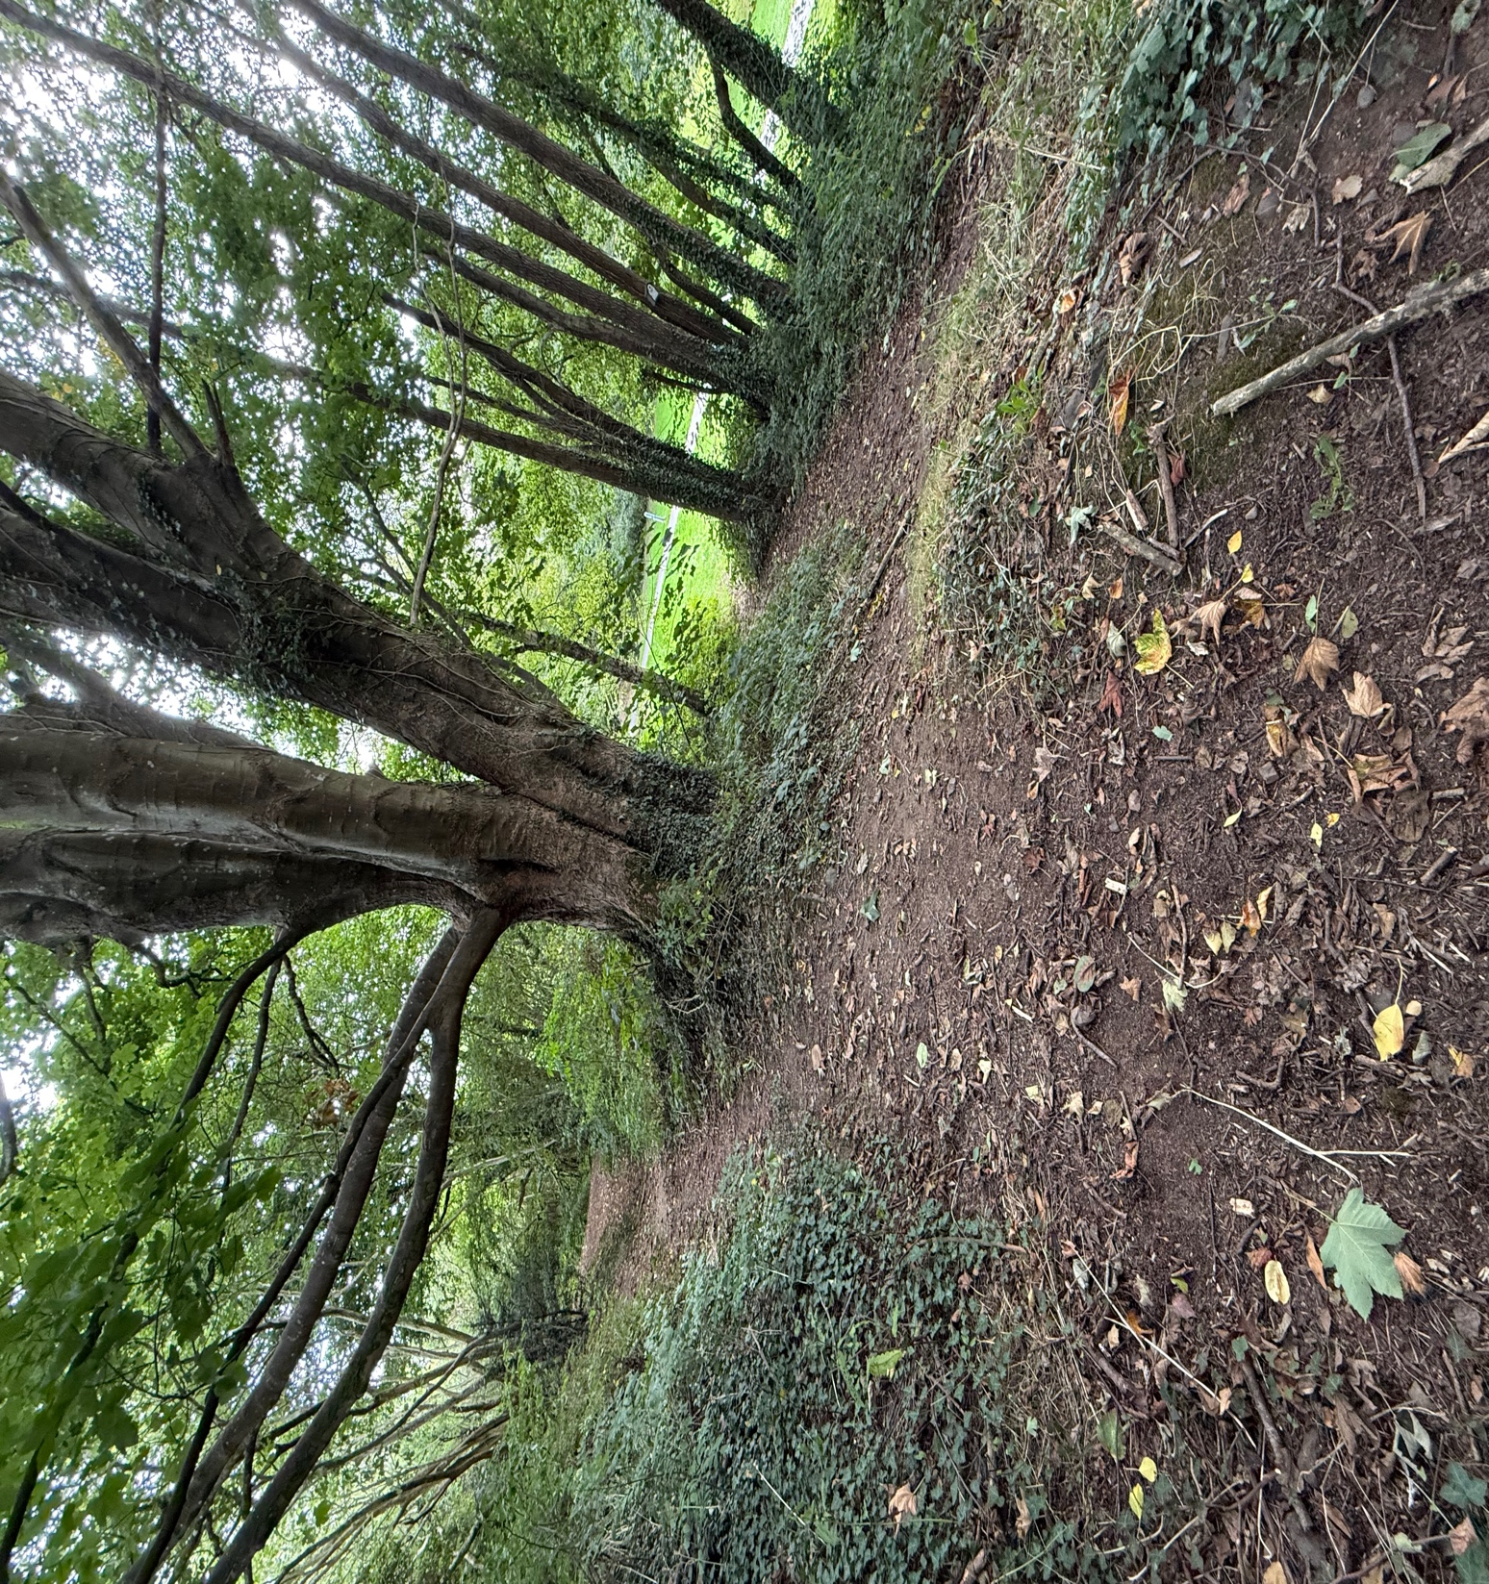
(Coles, 2025, Personal Picture)
Part 2

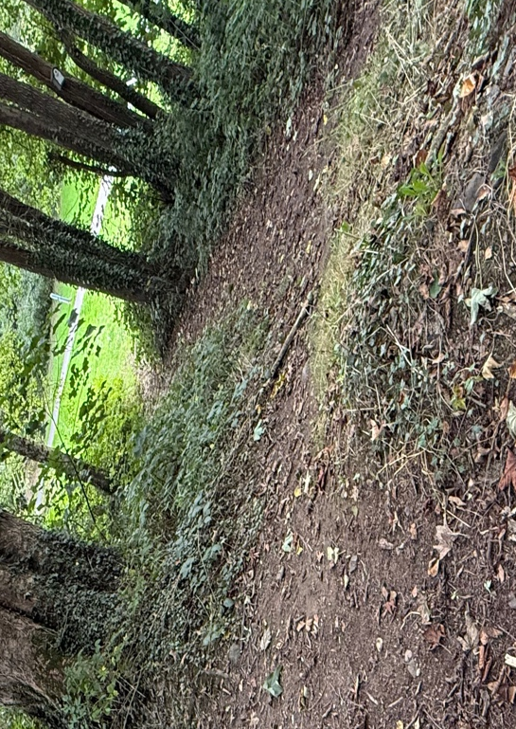
I took a group of six children aged 4–5 years old to the woodland. They were well-prepared for the outdoors, dressed in puddle suits and wellies. The children rushed through the fallen leaves, listening to the crunching as they ran. The woodland was calm and quiet with the sound of sticks cracking as we walked. The woodland provided the perfect setting for child-led learning with slopes and uneven terrain, scattered natural materials such as twigs, leaves, and stones, and a large, sturdy tree. There were two pathways, one sloping gently downhill, the other leading uphill. Both offered natural opportunities to experiment with gravity, motion and friction. With the adults observing and offering support when needed, the children quickly began to explore the different materials around them. Within minutes, one child asked, “Why did that one go faster?” this question was the start of a curious investigation into scientific and mathematical thinking through play.

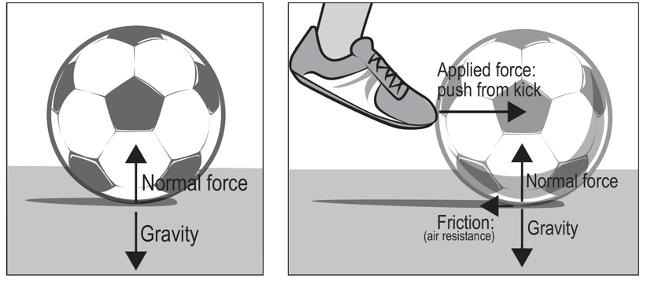
As the children gathered at the top of the slope, they began picking up natural materials from the ground. They gathered sticks, stones, pinecones, and leaves and instinctively started to roll them down the slope. One child placed a round stone at the top of the path and gave it a little push. It rolled quickly down the slope, bouncing slightly off tree roots before coming to a stop. Another child tried the same with a stick, watching it wobble and fall rather than roll. “That one didn’t work,” the child said. This kicked off a series of experiments, with the children comparing how different objects moved depending on their shape, size, or the surface they were rolled on. I stayed nearby, occasionally offering open-ended questions such as, “Why do you think that one went faster?”. As the experiments went on, the children began noticing that some objects rolled easily, while others stopped quickly, and they began to link these actions to the shape and texture of the object. This is early evidence of understanding concepts such as gravity, friction, and force. This type of play links to the Curriculum for Wales progression step where children “can communicate the effect forces have on themselves and on objects” (Welsh Government, 2019a). Through pushing, rolling, and observing different materials moving down the slope, the children began to describe and explain how forces like gravity and friction affect motion.
(Science connections, 2025)

As time went on, the children were beginning to plan their experiments. Some children were collecting specific materials, looking for rounder stones or longer and thicker sticks, trying to predict which would roll best. One child, held up a lumpy pinecone and a smooth pebble, she said “This one’s bumpy”, “but this one is slippy.” Then she rolled both from the same spot and watched as they rolled down the slope. The pinecone wobbled and stopped quickly, while the pebble rolled away quickly, going the furthest.

This was the point the children began comparing, they were noticing how different materials moved, and they began to notice why some went faster than others. The children started voicing their thoughts and testing new ideas based on the things they’d seen. After observing his stick come to a stop halfway down the slope, one child picked it up and thoughtfully said, “This one’s too bumpy. I need a smooth one.” Without any help from me, he scanned the ground with determination, he eventually found a smoother twig. He placed it at the top of the slope and gave it a little push. This time, it rolled much farther. Grinning, he shouted, “Told you!”. This moment is more than just playful investigation, it illustrated careful observation, reflection and self-correction. The child recognised a problem, thought of a solution, tested his idea, and evaluated the outcome. This demonstrates an early understanding of science through meaningful, hands-on play.

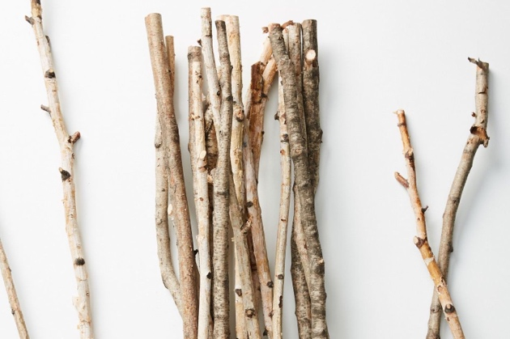
The children’s repeated testing and reflection clearly demonstrated that they were beginning to recognise patterns from their observations and investigations, this links with the Curriculum for Wales progression step ‘I can recognise patterns from my observations and investigations and can communicate my findings’ (Welsh Government, 2019a). They were able to communicate these results, showing their growing understanding of scientific concepts like force, gravity, and friction. I supported these moments by encouraging deeper thinking with questions such as “What do you notice about the ones that go further?” and “I wonder what would happen if you tried a heavier one?” These open-ended questions allowed the children to guide their own investigation while also connecting their observations to scientific language and understanding.

As their investigations developed, so did their mathematical language and ideas. Without formal instruction, the children began to compare distances, estimate speed, and make judgements based on size and weight of the object. One child placed a stick and a stone side by side at the top of the slope, saying, “Let’s see which one goes further.” Another child ran down to mark the end point of each object with a leaf, shouting, “This one won! It went the longest” This introduces early concepts of measurement, position, and order. The children naturally used language such as, “That one went longer,” “Mine was fastest,” and “Yours stopped before mine.” (Barr, 2018)
I supported this mathematical exploration by asking open-ended questions like “Which one went the furthest? How can you tell?” and “Can you put something down to show where it stopped?” These questions helped the children think about what they saw and explain their ideas. As they played, they started to use words about position, compare objects, and measure in their own ways. They were also beginning to collect simple information and record what happened, all as part of their play.


As their testing became more structured and intentional, the children began to sort and organise the materials they were using before rolling them. They grouped objects based on features such as size, shape, weight, and texture. One child carefully gathered all the stones and lined them up from smallest to largest, saying, “This one’s biggest, maybe it’ll win.” Another child began sorting objects like pinecones and sticks into groups, counting out loud, “Four stones, three sticks, three pinecones,” before arranging them into neat piles. Some children began to compare how many of each item they had, but also how each group behaved when rolled. “All the round ones go better,” one child noticed, therefore all the round ones went into their own pile. This spontaneous sorting and comparing demonstrated skills in organisation and mathematics. These behaviours link to the Curriculum for Wales Mathematics and Numeracy progression step “I have experienced grouping and sharing with objects and quantities, and I can group or share small quantities into equal-sized groups” (Welsh Government, 2010).

(Mikhail Blavatskiy, 2025)
The following week, we returned to the same woodland area. The children immediately remembered the slope and ran to gather materials again. What was interesting was how much more deliberate they were in their actions. Some even asked, “Where’s that big stone from last time?” and “Let’s make a ramp this time!” They began improving their tests by repeating past experiments with slight changes, which showed their thinking had progressed. Going back to the site gave the children the opportunity to combine what they’d discovered, deepen their understanding of forces and motion, and build on prior knowledge.

This simple woodland visit offered a rich, multisensory environment that naturally invited exploration of scientific and mathematical ideas. Through rolling, comparing, measuring, and reflecting, the children encountered real-world examples of gravity, friction, force, and measurement, all while actively playing. The adult role was not to lead, but to observe, providing just enough language through open-ended questions to help children make their own connections. Experiences like these demonstrate how outdoor environments can be powerful spaces for deep, connected learning, especially when children are given time and freedom to explore.

Experience exploring outdoor space in photograph | How will young people BENEFIT from this activity? | Hazards and associated risks | Who is at risk? | PRECAUTIONS in place to reduce the risk of injury | Overall risk after precautions  RATING: L/M/H
Children are collecting materials such as leaves, sticks and rocks and counting them to see who found the most of each material. | Children can develop their mathematical learning by counting leaves, sticks or rocks and develop their scientific learning by observing the seasonal changes (leaves changing colour) and plant growth and asking questions such as “why do leaves fall” | Exposed tree roots, and an uneven path causes a risk to fall. | The children are more at risk of tripping or falling as they have less developed coordination. | Encourage the children to walk carefully, make sure they have appropriate footwear on and ensure you supervise closely on slopes or near exposed tree roots. | Low
Children are having a competition to see who can find the longest stick, tallest tree and see who can find the most leaves. | Children can develop their mathematical learning by exploring length (how long is a stick?), height (how tall is the tree?), and volume (how many leaves fit in a bucket?). | Overhanging and dead trees risks an injury from falling branches in windy conditions. | The children and practitioners are at risk of being hurt by falling trees. | Conduct regular tree safety checks and avoid going during windy conditions or after a storm. | Medium
Children are collecting materials to see which ones roll down the slope the fastest and go the furthers. | Children can develop their scientific development by rolling materials down a hill. This develops basic physics concepts like friction, gravity, and material properties. | Sharp Sticks, Thorns, or Ivy can cause cuts, scratches, or allergic reactions. | The children and practitioners are at risk of being cut, scratched or receive an allergic reaction. | Teach children to handle materials carefully, remove hazardous plants if possible, and ensure first aid is available. | Low
The children are playing hide and seek in the forestry. | While playing hide and seek, children can demonstrate an understanding of positional language, using words like ‘behind’, ‘under’, and ‘next to’ to describe their hiding places and help others find them. | Due to the open area, there is a risk that the children could wander off and get lost | The children are at risk of getting lost | Set clear boundaries such as telling the children they cannot go beyond a certain point and give clear rules such as, stay where you can see an adult and no wondering off. | Low
The children are collecting materials and sorting them into different piles for size, colour and shape. For example, pointy leaves vs round leaves. | Sorting and organising objects found in the outdoor environment helps children to develop pattern recognition and early data handling skills. | Slippery surfaces. Mud, wet leaves and moss-covered logs can be slippery | The children and practitioners are at risk of slippering | Everyone must wear suitable footwear with a good grip. For example, wellies or walking boots, to reduce the risk of slipping. | Low
Exploring wildlife habitats and identifying where insects live. For example, under rocks and in bark. | Children develop respect for living things, as well as early ecological awareness and classification skills by observing, identifying and discussing insects in their natural habitat. | Lifting or handling heavy rocks and logs could result in them being dropper on feet or fingers, causing cuts, bruises or even fractures | The child or nearby children are at risk being hurt | Supervising the children closely when they are exploring large natural objects and encourage the children to look but don’t lift or ask an adult for help before lifting heavy thing. | Medium
The children are learning about the weather and seasonal changes. They are noticing how the weather affects the environment for example, it’s muddy after the rain and the leaves fall in the autumn. They are also having fun recording the daily weather. | Children could develop an understanding of natural changes, cause and effect, and observation over time by exploring how weather and seasons affect the outdoor environment. | The cold wet or windy weather and the hot or sunny weather could result in the children becoming dehydrated, uncomfortable, sunburnt, or hypothermic. | The children and practitioners are at risk | Check the weather forecast in advance and adjust the plans accordingly and ensure all children have on suncream in the heat and wear the appropriate clothing for different types of weather. For example, sunhats in the sun and waterproofs in the rain. | Low
The children are investigating the nature in the forestry by observing the leaves changing colour and exploring the life cycle of a plant or tree. | The children are developing skills in observation and understanding living things through hands-on exploration of plants and nature. | The children are at risk of bites, stings or allergic reactions if they come into contact with insects or animals. They could also get splinters, cuts or bruises from handling the natural materials like sticks or stones. | The children are at risk of being bitten, stung or getting splitters. | Ensure the children are supervised closely during explorations, teach the children to avoid touching unknown plants and encourage hand washing after all outdoor activities. | Low

Part 4 - The Role of Adults in Supporting Mathematical and Scientific Learning in Outdoor Environments in the Early Years

Outdoor environments offer exciting and meaningful ways for young children to explore mathematical and scientific concepts. In early childhood, children learn best through hands-on, real-world experiences, especially when they are curious and active in their environment (Forest School Association, 2021). This essay looks at how adults support outdoor learning by creating enabling environments that are rich in open-ended materials and based on children’s interests. The role of the adult is not to supervise but to guide learning by asking open-ended questions, offering materials like sticks, stones, pipes, and water and giving children time to explore their ideas (Welsh Government, 2023). Theories from Froebel, Piaget, Vygotsky, Bruner, Gibson, and Nicholson show that children learn through play, social interaction, and exploration. These theories support the idea that the environment and the adult’s role both shape how children think and learn. Loose parts are simple, everyday items that children can move and use in different ways. They are especially useful for developing maths and science thinking outdoors (Kathy Brodie 2024). Activities like sorting, counting, building, and experimenting help children understand key ideas like size, shape, weight, and cause and effect (Kennard, 2022). This essay will explore how enabling environments and loose parts, with adult support, help children build strong foundations in maths and science.

The role of the adult in supporting mathematical and scientific learning outdoors is to provide children with an enabling environment. An enabling environment in early childhood education should be designed to be stimulating, responsive, and developmentally appropriate, and offer children rich opportunities for play and exploration. In outdoor settings, enabling environments provide children with space and freedom to be curious and enhance deep thinking (Smedsrud, 2025). According to the Welsh Government (2023) effective environments should inspire a sense of awe and wonder, encouraging children to engage with both the living and non-living world around them. These spaces invite children to explore, experiment, problem-solve, and develop creativity and critical thinking as they interact with natural elements. Furthermore, Education Wales (2021) suggests such environments should offer time and space for contemplation, reflection, and physical challenge, supporting the development of both gross and fine motor skills. When well-supported by adults, these environments become rich contexts for scientific investigation and
mathematical thinking, helping children to notice patterns, test hypotheses, and engage in meaningful problem-solving rooted in real-world experiences (Education Wales, 2021).

Research by Maynard and Waters (2007) shows that outdoor environments, when carefully planned by adults, enhance children’s cognitive engagement, especially in problem-solving. Furthermore, recent evidence by Smedsrud et al. (2023) highlights that adult participation in designing and scaffolding outdoor play spaces through offering varied materials, asking open-ended questions, and creating safe yet challenging settings supports children’s critical thinking, attention span and understanding. Rather than instructing, adults in enabling environments act as facilitators, encouraging learning by asking open ended questions, such as “What do you think will happen if we add more stones?”. These questions support mathematical and scientific thinking in ways that are appropriate for the child’s development (Smedsrud et al., 2023). This links closely with Froebel’s educational philosophy, which positions the adult as a facilitator of learning rather than a direct instructor. Froebel believed that children learn best through self-initiated activity and exploration in nature, where adults support development by offering gentle guidance, encouragement, and meaningful interactions (Tovey, 2017).

A significant benefit of enabling outdoor environments is the ability to present real life, hands-on learning that encourage children to engage with mathematical and scientific thinking in purposeful ways (Kiviranta et al., 2024). Children playing outdoors might use sticks to measure and compare lengths or heights, group leaves or insects by size or colour or explore the cause and effect of rolling objects down a slope. In enabling environments, children interact with real-world materials and witness outcomes first hand, which helps them build an understanding instead of just remembering facts. Research by Young Children’s Attitudes Toward Science Learning in Early Learning Grades (2024) found that children who used real objects and learned through hands-on science activities had a deeper understanding than children who were taught in more abstract or symbolic ways.

The role of the environment for supporting learning is strongly reflected in the Reggio Emilia approach, which describes the environment as the third teacher (Strong-Wilson and Ellis, 2007). From this perspective, the environment supports children's thinking by being well-organised, visually appealing, and filled with materials that encourage exploration. Designing outdoor spaces based on children's interests, such as providing ramps, puddles, or building materials like logs, supports their independence and curiosity. (Strong-Wilson and Ellis, 2007). Similarly, Gibson’s (1979) theory of affordances says that the environment offers different opportunities to act depending on a person’s ability. For a child, a rock can be used for stacking, throwing, or counting and a puddle can be splashed in, measured, or used to throw rocks into. Adults help by paying attention to how children use these things and by adding materials, asking questions, or using language to help children learn more. Bruner (1961) also highlights that children learn best when they can explore and discover things for themselves. Outdoor environments support this kind of learning, especially in science and mathematics, by giving children the chance to experiment and solve problems through play.

The Curriculum for Wales encourages outdoor learning as part of its holistic child-centred approach. It supports learning through real-life problem solving, exploration, and creativity, which are all supported by enabling environments. The curriculum highlights the importance of children learning key ideas in mathematics and science through activities like exploring, comparing, observing, and asking questions. It also aims to develop confident, capable learners and creative thinkers (Welsh Government, 2023). The adult can support these goals by giving the children freedom to explore and investigate outdoors.

In a Scandinavian Forest school video children are observed negotiating real risks and making choices such as, sliding on ice, climbing trees, or building dens, while the adults step back and ask guiding questions rather than issuing direct commands for example a child climbing the tree was asked if he ever got scared, instead of being told to get down or to be careful (Microsoft Bing, 2025). This approach respects children as capable thinkers and supports their executive functioning and self-regulation (Vygotsky, 1978). Similarly in a forest school video by Siren films (2018) when a child wanted to make a bow and arrow, the adult provided the materials and offered help only when asked, encouraging the child with open ended questions like, “How can I help you?” This reflects scaffolding rather than direct instruction. The role of adults here is to facilitate rather than direct. In the video it also shows the older children mentoring younger ones, demonstrating peer learning and the social dimension of learning (Scholars, 2023). It highlights that children can also teach and support one another in a rich learning environment.

While the Scandinavian video shows children confidently using tools, exploring near water and climbing trees, these experiences are not always easily replicated in typical early years settings. In many nurseries, health and safety regulations, limited budgets, and staff-to-child ratios make such activities difficult to manage (Social Care Wales, 2018). For example, allowing children to use knives or play near a lake, as seen in the video, would require higher adult supervision ratios that are often financially unrealistic for most settings. However, one accessible alternative is the introduction of loose parts.

Loose parts are open-ended, low-cost materials such as sticks, stones, crates, fabric, and tubing. According to Nicholson’s (1971) theory, these materials support creativity, problem-solving, and exploration, and can be used flexibly to promote mathematical and scientific thinking. Loose parts not only make rich learning possible in budget-limited settings, but they also encourage children to take ownership of their play and learning, with adults acting as facilitators rather than instructors. Materials that can be moved and used in different ways are especially helpful in outdoor play, where they encourage children to explore maths and science through hands-on learning. Loose parts naturally support mathematical learning by encouraging children to engage in activities such as organising, patterning, counting, comparing, and measuring (Ranheim, 2020). For example, when children play with sticks, stones, or leaves, they might compare sizes, make patterns, or build balanced structures. These activities help them understand shapes, numbers, and problem solving. Which are key skills in early mathematics.

Scientific exploration is similarly supported through loose parts. Children investigate how different materials behave in different conditions, testing what floats or sinks, how different textures feel, or what happens when objects are pushed or dropped. These hands-on experiences promote them to ask questions, make predictions, and understand cause and effect (Waite-Stupiansky and Cohen, p12, 2020). For example, when children play with water, stones, and pipes, they begin to explore how gravity and flow behave. By changing different parts, they take part in simple experiments and start to test their own ideas. According to Piaget’s theory of constructivism, children actively learn through interaction with the environment around them. Loose parts provide hands-on materials that they need to do this. As they play and explore, children create ideas and understandings based on what they experience (Chand, 2024). Vygotsky (1978) further emphasised that learning is social, and the role of the adults is to help children learn more by scaffolding. Outdoors, adults can ask open-ended questions. These kinds of questions help children think more deeply and learn new ideas within their zone of proximal development (Cherry, 2023).

Research backs the value of loose parts in supporting cognitive development. A systematic review by Prins et al. (2022) found that access to loose parts in outdoor environments enhances children's engagement with science and maths by encouraging experimentation and conceptual thinking. Adults play a key role in organising and rotating materials, providing time for children to explore, and offering just enough support to guide without taking over. As Bilton (pg 58, 2010) explains, outdoor learning environments rich in loose parts allow children to shape their own learning experiences, which leads to deeper engagement and understanding.

In conclusion, the outdoor environment offers opportunities to support young children in exploring early mathematical and scientific learning in a fun, hands-on way. When these spaces are carefully planned and supported by adults, children are more likely to stay engaged, ask questions, and try out their ideas. Through carefully curated materials, mostly loose parts, and by offering opportunities for hands-on exploration, adults help children develop critical thinking, problem-solving, and investigation skills. Rather than directing the learning, adults play a facilitative role by asking open-ended questions, observing, and scaffolding the children’s learning to extend their thinking and skills. Theories from Froebel, Vygotsky, Piaget, and Nicholson reinforce the importance of active, child-led exploration supported by thoughtful adult interaction. The Curriculum for Wales also supports this approach by emphasising curiosity, real-world learning, and the development of capable, independent learners. While practical limitations such as budget and health and safety can be challenging, strategies such as using loose parts demonstrate how rich learning can still be achieved with minimal cost. Ultimately, when adults create enabling outdoor environments and take on a supportive role, they help children develop a strong foundation in mathematics and science that will benefit them for life.

Reference list

Barr, S. (2018) Anthropologie ridiculed for selling £40 bundle of twigs | The Independent, The Independent. Available at: https://www.independent.co.uk/life-style/anthropologie-bundle-twigs-decorative-online-retailer-twitter-a8647171.html (Accessed: 26 September 2025).

Bilton, H. (2010) Outdoor Learning in the Early Years Management and Innovation. 3rd edn. Routledge. Available at: https://research-ebsco-com.ezproxy.uwtsd.ac.uk/c/onvpsy/ebook-viewer/epub/ogq6abuqhn/section/top?location=https%25253A%25252F%25252Fresearch-ebsco-com.ezproxy.uwtsd.ac.uk%25252Fc%25252Fonvpsy%25252Fsearch%25252Fdetails%25252Fogq6abuqhn%25253Fdb%25253Dnlebk (Accessed: 26th September 2025).

Bruner, J. S. (1961). The Act of Discovery. Harvard Educational Review, 31, pp. 21-32. Available at: https://www.scribd.com/document/795272703/The-Act-of-Discovery-Bruner (Accessed: 24th September 2025).

Chand, S.P. (2024) Constructivism in education: Exploring the contributions of Piaget, Vygotsky, and Bruner, ResearchGate. International Journal of Science and Research. Available at: https://www.researchgate.net/publication/378071316_Constructivism_in_Education_Exploring_the_Contributions_of_Piaget_Vygotsky_and_Bruner (Accessed: 26th September 2025

Cherry, K. (2023) How Vygotsky defined the zone of proximal development, Verywell Mind. Available at: https://www.verywellmind.com/what-is-the-zone-of-proximal-development-2796034 (Accessed: 26th September 2025).

Education Wales (2021) Enabling Pathways. Available at: https://www.gov.wales/sites/default/files/consultations/2021-05/enabling-pathways-consultation-document_0.pdf (Accessed: 23rd September 2025).

Forest School Association (2021) What Is Forest School?, Forest School Association. Available at: https://forestschoolassociation.org/what-is-forest-school/ (Accessed: 26th September 2025).

Gibson, J.G. (1979) The ecological approach to visual perception. Lawrence Erlbaum.

Kathy Brodie (2024) The Magic of Loose Parts Play: Unleashing Creativity in the Early Years, Kathy Brodie: Free CPD for Early Years Professionals. Available at: https://www.kathybrodie.com/articles/loose-parts-play/ (Accessed: 26th September 2025).

Kennard, K. (2022) What is loose parts play in the EYFS? - Early Education, Early Education. Available at: https://early-education.org.uk/what-are-loose-parts-play-in-the-eyfs/?utm_source=chatgpt.com (Accessed: 26 September 2025).

Kiviranta, L. et al. (2024) ‘Outdoor Learning in Early Childhood education: Exploring Benefits and Challenges’, Educational Research, 66(1), pp. 1–18. Available at: https://doi.org/10.1080/00131881.2023.2285762.

Maynard, T. and Waters, J. (2007) ‘Learning in the Outdoor environment: a Missed opportunity?’, Early Years, 27(3), pp. 255–265. Available at: https://doi.org/10.1080/09575140701594400.

Microsoft Bing (2025) sbs news danish forest school - Search Videos, Bing.com. Available at: https://www.bing.com/videos/search?q=sbs+news+danish+forest+school&view=detail&mid=EF011D05822D0DFC1ECAEF011D05822D0DFC1ECA&FORM=VIRE (Accessed: 26 September 2025).

Mikhail Blavatskiy (2025) Stacked Rocks In A Forest Stock Photos, Pictures & Royalty-Free Images - iStock, Istockphoto.com. Available at: https://www.istockphoto.com/search/2/image-film?phrase=stacked+rocks+in+a+forest (Accessed: 28 September 2025).

Nicholson, S. (1971) ‘The Theory of loose parts: how not to cheat children’, Landscape Architecture, 62, pp. 30-34

Play Scotland (2025) Loose Parts Play - Play Scotland, Play Scotland. Available at: https://www.playscotland.org/schools-childcare/loose-parts-play/ (Accessed: 24th September 2025).

Prins, J. et al. (2022) ‘Nature play in early childhood education: A systematic review and meta ethnography of qualitative research’, Frontiers in Psychology, 13(13). Available at: https://doi.org/10.3389/fpsyg.2022.995164.

Ranheim, D. (2020) Take maths play outdoors with loose parts, Communityplaythings.co.uk. Available at: https://www.communityplaythings.co.uk/learning-library/articles/maths-play-with-loose-parts?srsltid=AfmBOopjoA8gVA36s1ovZWxUEng-BcN1TiA4jpXCIQw8jeDT_PIdUQv5 (Accessed: 25 September 2025).

Scholars, L. (2023) The benefits of bringing children of different ages together in early learning, Little Scholars. Available at: https://mylittlescholars.com.au/the-benefits-of-mixing-ages-together-in-early-learning/ (Accessed: 26th September 2025).

Science connections (2025) Science Connections, Scienceconnections.edu.au. Available at: https://scienceconnections.edu.au/behind-science/physical-sciences (Accessed: 26th September 2025).

Siren films (2018) What’s does effective teaching look like at the Little Forest Folks forest nursery?, Siren Films. Available at: https://www.sirenfilms.co.uk/library/whats-does-effective-teaching-look-like-at-the-little-forest-folks-forest-nursery/ (Accessed: 26 September 2025).

Smedsrud, T.M. et al. (2023) ‘Early Childhood Teachers’ Support of Children’s Play in Nature-Based Outdoor Spaces—A Systematic Review’, Education Sciences, 14(1), pp. 13–13. Available at: https://doi.org/10.3390/educsci14010013.

Smedsrud, T.M. (2025) ‘Supporting play: How early childhood teachers facilitate play through nature’s affordances’, Journal of Outdoor and Environmental Education. Available at: https://doi.org/10.1007/s42322-025-00216-5. (couldn’t find the volume or issue number).

Social Care Wales (2018) All Wales Induction Framework for Early Years and Childcare: Workbook five.Health and Safety in children’s care, learning, development and play. Available at: https://socialcare.wales/cms-assets/documents/Early-years-induction-framework_Workbook-5_Health-and-Safety.pdf (Accessed: 26th September 2025).

Strong-Wilson, T. and Ellis, J. (2007) ‘Children and Place: Reggio Emilia’s Environment as Third Teacher’, Theory into Practice, 46(1), pp. 40–47. Available at: https://doi.org/10.1080/00405840709336547.

Tovey, H. (2017) A FROEBELIAN APPROACH: Froebel’s principles and practice today, Froebel Trust. Froebel Trust. Available at: https://www.froebel.org.uk/uploads/documents/FT-Froebels-principles-and-practice-today.pdf (Accessed: 23rd September 2025).

Vygotsky, L.S. (1978) Mind in Society: the Development of Higher Psychological Processes. Harvard University Press. Available at: https://ebookcentral.proquest.com/lib/trinity/reader.action?docID=3301299&query=&c=UERG&ppg=5 (Accessed: 26th September 2025).

Waite-Stupiansky, S. and Cohen, L.E. (2020) STEM in early childhood education : how science, technology, engineering, and mathematics strengthen learning. Routledge.

Welsh Government (2019a) Descriptions of learning - Hwb, hwb.gov.wales. Available at: https://hwb.gov.wales/curriculum-for-wales/science-and-technology/descriptions-of-learning/ (Accessed: 18th September 2025)

Welsh Government (2019b) Descriptions of learning - Hwb, hwb.gov.wales. Available at: https://hwb.gov.wales/curriculum-for-wales/mathematics-and-numeracy/descriptions-of-learning/ (accessed: 18th September 2025).

Welsh Government (2023) Enabling learning - Hwb, hwb.gov.wales. Available at: https://hwb.gov.wales/curriculum-for-wales/designing-your-curriculum/enabling-learning (Accessed: 23rd September 2025).

