

BMCJ7001- Collective Reflective Report, Book Review and Academic poster.

Charlotte Smith
Word count- 2,686

Reflective Report

In this section, I will make examinations of offender rehabilitation and reintegration. I picked this topic since I am intrigued by it and want to know what they want to achieve and how these procedures function. I will examine these procedures to determine if they are effective in attempting to attain their objectives. To aid me in this process, I will employ the Gibbs' reflective cycle, a model that is highly useful when helping someone through the completion of a reflective piece of work.
Gibbs' reflective cycle has six phases and may be utilised as a standalone experience or in a circumstance where you need to reflect constantly. The first step of Gibbs' reflective cycle, according to the University of Edinburgh (2020), is description; here is when you describe what happened and when or where it happened. The second level is feelings; at this point, I would have to express my sentiments regarding a certain circumstance. The following two phases are assessment and analysis. In these stages, I will have to describe what went well and what did not go well, as well as why it did or did not go well. The next two steps are the conclusion and the action plan; for these, I will discuss what I have learned and what I would do differently if the experiment were repeated.
One of the major tenets of the criminal justice system is the notion of rehabilitating the offender and preventing them from reoffending. Coomber et al. (2017) agreed, adding that the penalty should be rapid and certain when administered, as well as harsh enough that the criminal learns a lesson and is prevented from committing additional crime. They also argue that the gravity of the crime should act as a deterrent to other criminals who may conduct a similar sort of offence, but that the penalty should not be so harsh that it prevents an offender from leading an honest life once they have been punished.
The process of resettlement is a technique used to aid in the rehabilitation of an offender. Hardwick et al (2014) describe resettlement as convicts who are prepared for their discharge back into the society and are assisted in reducing the likelihood of reoffending. Hardwick et al (2014) characterise the resettlement process as a means of reintegrating criminals into regular living settings, such as being able to maintain a job and having a secure place to reside.
My opinion on rehabilitation and resettlement is that it is extremely crucial although if no effort is made to modify an offender's behaviour, they will continue to commit crimes and wind up back in jail, causing prisons to become even more congested than they are now. Resettlement is critical in the pursuit of rehabilitation since one of the reasons some individuals commit crimes is to obtain money. If you provide them a solid employment and a safe place to live, that need will be met, and the desire to commit a crime will be eliminated.
Currently in England and Wales, especially when looking at the recent reoffending rates that were released for the months of July and September 2019, it appears to fall. According to the Ministry of Justice (2019), the reoffending rate was 26 percent and among adult offenders it was 25.6 percent. Furthermore, Wright (2013) adds that 58 percent of offenders reoffended 12 months following their release, and the causes for this reoffending include substance abuse issues, problematic family situations, unemployment, and financial difficulties (Wright, 2013). According to Allison and Grierson (2021), one possible explanation for reoffending is that convicts in England and Wales are not attending rehabilitation courses, with the number of courses begun and finished falling 62 percent in ten years, even though the prison population has been expanding. Another factor might be that short prison sentences have failed to deter recidivism (Siddique, 2021).
The government announced in 2014 that they wanted to house offenders in prisons close to where they lived before they were incarcerated and will likely return to when they are released, according to the BBC (2013), the plan was to create 70 of those very prisons with this new system helping rehabilitation of the prisoners from the moment that they are sentenced to prison, the prisoners involved in this project would be those serving 12 months or less and prisoners convicted of a crime.
The reason I believe that rehabilitation of prisoners is not operating is that there is not enough resources to help, I also believe that prisoners should be involved in such projects when they are ready, rather than having it imposed on them by the prison. Another reason prisoners may not want to be involved in such initiatives is because of pressure from their companions and possibly family, but they may also believe that it is not possible. Allison and Grierson (2021) agree that one reason rehabilitation is not functioning is due to a lack of resources. They also highlight the number of convicts who attend courses including domestic abuse and violence, but they do not explain why this is the case. To me, relocating prisoners to prisons close to where they have been living appears to be a good idea. This is because the prisoners have more access to their family members because they do not have to travel as far, and they are also better able to plan what they will do once they are out of prison, which means they can find a job and a place to live more easily. Codd (2007) supports the concept that a prisoner's family, particularly their wife, may be useful in their rehabilitation. She states that it can be significant it does come with its own set of obstacles, particularly if the strategy is to be enforced. The information I have taken from investigating these topics further is that, while rehabilitation and resettlement are innovative ideas in the hopes of reducing reoffending, evidence suggests that these programmes are currently not working, as evidenced by the fact that the number of offenders participating in rehabilitation courses is declining, as seen in this reflective report. The government's attempt to relocate convicts closer to their homes may also be failing since criminals continue to reoffend. What I also discovered during this journey is that life after jail may be difficult for an offender, owing to the bad stigma that accompanies prison time. This bad stigma may lead to a person not having a permanent work, which may lead to them not having a stable income, which may drive them to break the law again, and the pattern of someone going to jail will repeat itself. It is critical that we discover a good method of rehabilitation and reintegrating convicts so that the cycle does not repeat itself. I also believe that a positive outcome would be a reduction in the jail population.
What I believe should be conducted in the future is that low-level crimes, such as robbery and some sorts of drug criminality, should be subject to obligatory rehabilitation, particularly if the offender has a history of drug or alcohol abuse. I also believe they should be located in prisons close to where they live because being near their family members could aid in their rehabilitation. However, this should only be done if the offender's friends and family can be a positive influence; if this is not possible, they should be placed with people who can be a positive influence. I also feel that there should be occupations outside of jail that solely accept former inmates, so that they may have a job illuminating them having to look for one that will accept them. There should also be a form of housing available after they leave prison where they can stay and live if returning to their family home is not possible. If an offender has not had a stable home, their chances of reoffending may increase; this may also be related to them maintaining a stable job.

Academic Book Review

Academic Book/Journal Title: Conflict and Transnational Crime: Borders, Bullets and Business in Southeast Asia.
Author: Florian Weigand
Publication: Edward Elgar
Year: 2020

The ‘conflict-crime nexus’ has drawn an academic stage in recent years, with memorable contributions including Julia Muraszkiewicz’s collection Human Trafficking in Conflict: Context, causes and the Military (2021) and Crime, War and Global Trafficking (2009) by Christine Jojarth. Exaggeration of the nexus has often come from security organisations. As a result of this there has been a significant rise in the number of UN Security Council statements, debates and resolutions containing references to organised crime, with statements that overlap between trafficking and terrorist organisations becoming more frequent. Bosetti and De Boer once wrote:
“The explanation with regard to the increased prevalence of the “crime-conflict nexus” during the 1990s was relatively simple. The end of the Cold War, with the resulting drop in financial support from superpowers for armed actors fighting “proxy wars”, propelled armed actors (particularly non-state actors) to tap into other sources of conflict finance. This impetus, combined with globalization and modern technologies, provided new opportunities for local conflict actors to connect with criminal networks and illicit markets, thereby, facilitating access to supply chains that could fund and equip armed actors.” (Boer and Bosetti, 2015, p. 5).
The research within this book by Florian Weigand focuses on areas within Southeast Asia, particularly crimes associated with transnational protracted armed conflicts, of which involve state and nonstate actors are being fought. Using information from more than 100 interviews this article relies on opinions and statements from supporters or nonstate armed groups, government officials, smugglers, victims of conflict, civil society activists, and people smuggled or trafficked. Undermining the simplistic criminogenic explanations of nonstate actors fostering crime to enhance benefit directly Weigand’s book does exactly that.
With research undertaking into smuggling in four different conflict-ridden areas (Thailand-Malaysia, Indonesia–Philippines–Malaysia, Myanmar-China and Bangladesh-Myanmar), each region is thoroughly explored with a combination of compelling accounts to the conflict within the regions. In addition to different roles including state and nonstate organisations and their objective and structures and briefly surveying the local smuggling economy. The picture varied from region-to-region variers, however Weigand shows the common narrative between insurgents and rebels being the main drivers of smuggling activities in these areas is more irrational. Discovering that often state actors play the leading role in the smuggling chain within these areas. Seemingly counterintuitive, given that the state sets the scene by declaring whether goods are illegal or imposing tariffs or taxes at a higher rate on their importation. However, as explained by Weigand, armed nonstate groups that often lack territorial control or legitimacy deficits of which make it difficult for the undertaking of activities that jeopardize their relationship with local population. Although in contrast, state actors have created the opportunity for monopolization of cross-border traffic to push out competitors. Frequent smuggling often becomes an important source of revenue for the official who benefit through the taxing the traffic. The smuggling that falls outside of the control of these officials are regarded as subversive.
Revealing the standardized generic notion for nonstate actors benefitting from trafficking, particularly drug trafficking Weigand suggests that ‘heterogeneity is much more common that homogeneity’. Incentives from different places for example different levels of territorial control, concerns about accountability and legitimacy, all leading to differing approaches from nonstate actors for smuggling engagement. A few organisations remain impartial to the local smuggling economy whilst others have selective participation, only selling/ smuggling certain items. Only those who are engaged in global terrorism and receive outside support, can afford to ignore the undermining effect that may be encountered on the local smuggling economy. Weigand draws upon many other unanticipated conclusions, based on the evidence gathered. Readers will be shocked to discover that, the idea of smugglers crossing terrain contradicts the reality that most of the smuggling occurs in areas which maintain a good infrastructure. With zones of higher conflict maybe the source of illicit goods such as drugs, however, are more frequently avoided by traffickers due to the risk associated with crossing the zones of conflict.
Overall, the book is filled with other little gems, including a paradox that suggests that countries imposing heavy penalties on drugs trafficking including the death penalty, have the most complicit local officials with drugs smuggling.
Weigand posed a question at the commencement oof the book which some what fails to answer why state authorities have become heavily involved in smuggling when the option of taxing such goods is present. He suggests that the control of disputed territories and the justification of security forces being present may be the intended goal; state actors always find blame in the illicit traffic on nonstate actors whilst simultaneously gaining from the process on the side. Certainly, suggesting that the classification of behaviour as criminal is what lies at the heart of the ‘crime-conflict nexus’, creating many myths surrounding it. Within the open-minded and engaging study, Florian Weigand does academics a favour by exposing he shaky assumptions of the crime conflict nexus.
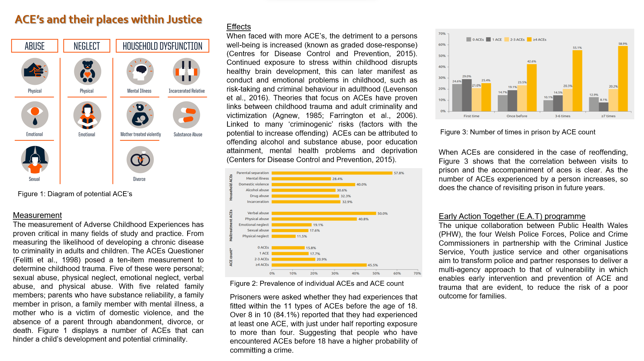
Academic poster: ACE’s and their Places within Justice

References

- Allison, E. and Grierson, J. (2021) England and Wales prisoners taking fewer rehabilitation courses. London: The Guardian Newspaper.
- BBC (2013) Resettlement prisons introduced in bid to cut reoffending. London: BBC
- Boer, J., and Bosetti, L. (2015) The Crime-Conflict “Nexus”; State of the Evidence. Brussels: United Nations University.
- Codd, H. (2007) Prisoners’ Families and Resettlement: A Critical Analysis. Cambrudge: The Harvard Journal. 46 (3), pp. 255-263.
- Coomber, R., Donnermeyer, J., McElrath, K., Scott, J. (2015) Key Concepts in Crime and Society. London: SAGE Publications.
- Felitti, V., Anda, R., Nordenberg, D., Williamson, D., Spitz, D., Edwards, V., Koss, M. and Marks, J. (1998) Relationship of childhood abuse and household dysfunction to many of the leading causes of death in adults. The Adverse Childhood Experiences (ACES) Study. Netherlands: Elsevier
- Ford, K., Barton, E., Newbury, A., Hughes, K., Bexeczky, Z., Roderick, J. and Bellis, M. (2019) Understanding the prevalence of adverse childhood experiences (ACE’s) in the male offender population in Wales: The Prisoner ACE Survey. Bangor: Bangor University.
- Hardwick, N., McDowell, P. and Wilshaw, M. (2014) Resettlement provision for adult offenders: Accommodation and education, training, and employment. London: HM Inspectorate of Prisons.
- Jojarth, C. (2009) Crime, Wat and Global Trafficking. Cambridge: Cambridge University Press.
- Levenson, P. (2017) Understanding childhood adversity, resilience, and crime. Edinburgh: The Scottish Government.
- Ministry of Justice (2021) Proven reoffending statistics: July to September 2019. London: MoJ
- Muraszkiewicz, J. (2020) Human Trafficking in Conflict: Context, Causes and the Military, Crime Prevention and Security Management. Switzerland: Palgrave Macmillan.
- Siddique, H. (2021) Short jail terms fail to prevent reoffending, says former England and Wales magistrate. London: Guardian Newspaper Article.
- University of Edinburgh. (2020) Gibbs’ Reflective Cycle. Edinburgh: Edinburgh University.
- Weigand, F. (2020) Conflict and Transnational Crime: Borders, Bullets and Business in Southeast Asia. Cheltenham: Edward Elgar.
- Wright, J. (2013) Transforming Rehabilitation: A summary of evidence on reducing reoffending. London: Ministry of Justice.

