Developing an MS Access Database for Coastal Tourism Management

Student name: Sohaan Sureshkumar

Student ID number: 2221048

Programme: Computing(software engineering)

Module: Introduction to Web and Database Concepts

Module code: ACCA4023

Section A:
1. The Identified users who might be able to access the DBMS for Coastal tourism management:

- Tourists and Customers:
Role: Tourists and customers make up the whole management system and hence are the primary users of the CTMS
Responsibilities:
- Exploring various packages offered including itineraries, pricing, and availability.
- Booking The services online
- Contacting Customer Support for assistance and enquiries.
- Referring the services to friends and family
- Giving feedback and leaving a review depending on experience.

- Customer service and support team:
Role : This team is responsible in supporting the tourists by assisting them and handling various enquiries raised by them.
Responsibilities :
- Handling all inquiries about various aspects and fulfilling any requests from tourists online
- Resolving first degree complaints and accepting feedback from customers about services.
- Ensuring tourists get the best experience they can.

- Local businesses :
Role: The local businesses are the stakeholders in the CTMS and have many responsibilities.
Responsibilities :
- Informing tourists about events, functions, hotels, restaurants, and wide range of other services they offer.
- Managing the business profile of theirs on the CTMS
- Responding to Inquiries about their business and sorting out any request by the customer.
- Advertising big deals, price drops and promotions and special offers
- Processing Online bookings for products and services for customers

- Database Administration team :
Role: The whole Backend of the CTMS is controlled and managed by the Database administrators
Responsibilities:
- Establishing security and ensuring integrity of the whole database
- Managing various user accounts and granting permission for various tasks.
- InCharge of arising technical issues related to the Database.
- Monitoring CTMS Quality and strengthening performance.
- Backing up data regularly to prevent loss of data.

2. Focusing on the departments that together make up the Coastal Getaways analogous to restaurants and Cafe businesses along with responsiblities are down below.
Although almost all of the types of Local businesses in the CTMS possess similar, if not the same departments which have the same objective:
If we take Restaurants and Cafes’ as an example ,The Different Departments Would be :

- Management Department:
The management Department would need to access the CTMS for Managing all the reservations,bookings, and extras linked to coastal tourism events.
This Department has responsibilities such as :
- Using the data on the CTMS they are able to plan staffing levels and the inventory depending on the expected bookings made.
- Collaborates with other departments for promotions and ensuring availabilities and reservations

- Catering Department:
This would need access to CTMS mainly to match the catering services to different events and bookings for accommodation.
The Responsibilities are:
- Monitor the database to adjust offerings based on preferences of the customers based on what customers want.
- To work along with the departments who hand events and accommodation for best service delivery.
- Utilize the CTMS to plan catering based on booked events.

- Marketing Department:
This Department mainly needs access for promoting content related to dining experiences in respect to coastal tourism.
The Responsibilities are :
- To Create various types of promotions which are targeted specifically to dining preferences of tourists
- To run advertisement campaigns targeting tourists and visitors.
- To use all the customer reviews, experiences, and feedback from CTMS into its marketing strategies.

- Customer service (Front of House):
This Department mainly uses the database for managing customer bookings and reservation and also in addressing the customer inquiries mostly related to dining
The Responsibilities:
- Ensuring if the tourists' availability matches with actual itineraries.
- Works together with other departments to optimize overall customer experience
- Uses the data from CTMS to give the best personalized assistance to customers during the reservation.

3. ENTITY RELATIONSHIP DIAGRAM (ERD)
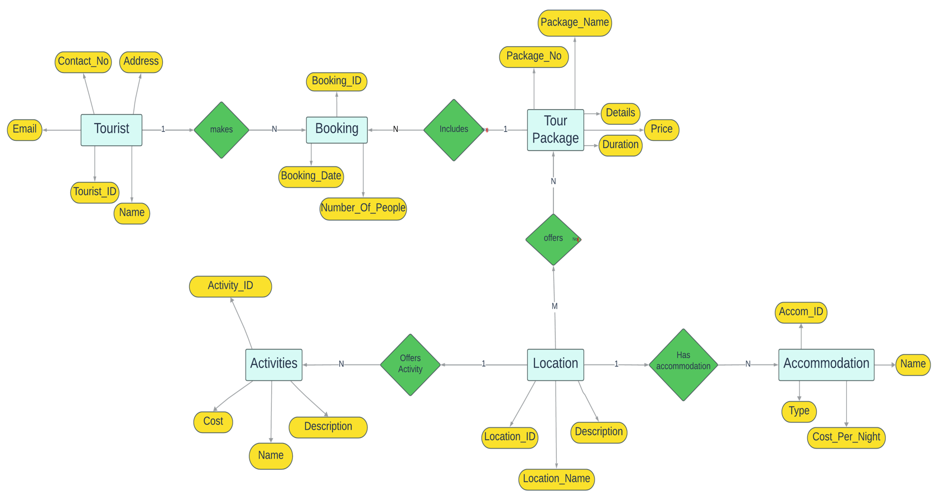
Tourist Entity:
This entity is vital for the storage of information about each individual tourists which includes personal details. This information is used to provide personalized services and tracking bookings:

Tour Package Entity:
This entity represents various types of packages with all of its details aswell such as time length, price, package name, and the description of it.

Booking Entity:
The Booking Entity acts like a bridge between the tourist and tour package entities which possesses individual booking information. It include important attributes like Booking date and the number of people included in a booking.

Location Entity:
This Entity shows different locations of where the tourist attraction activities take place associated with their accommodation as well. The attributes include name and description of the location.

Accommodation Entity:
Various available accommodations in respective locations are includes in the accommodation entity. This mainly helps in managing and offering open options with respect to their stay choice. The attributes include name of accommodation, type, and cost per night.

Activity Entity:
This entity shows various activities including tourist attractions offered in individual places. The attributes include name of activity, description , and cost.

4. Relational Schema
The relational database schema defines the framework for arranging and storing data by outlining the fields, primary keys, and foreign keys in each table.

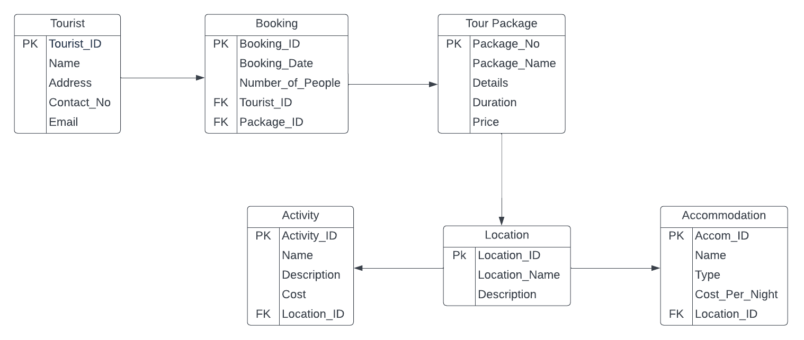

Tourist(Tourist_ID,Name,Address,Contact_No,Email)
Booking(Booking_ID,Booking_Date,Number_Of_People,Tourist_ID,Package_ID)
Tour Package(Package_No,Package_Name,Details,Duration,Price)
Location(Location_ID,Location_Name,Description)
Accommodation(Accom_ID,Name,Type,Cost_Per_Night,Location_ID)
Activity(Activity_ID,Name,Description,Cost,Location)

5. Creating A Database based on the ERD:
Under the "Tables" tab, I selected "Table Design."
Using the given schema as a guide, I created the tables, defining the fields, data types, and relationships.
Tables for tourists, tour packages, bookings, locations, accommodation, and activities were created and added respective datatypes.
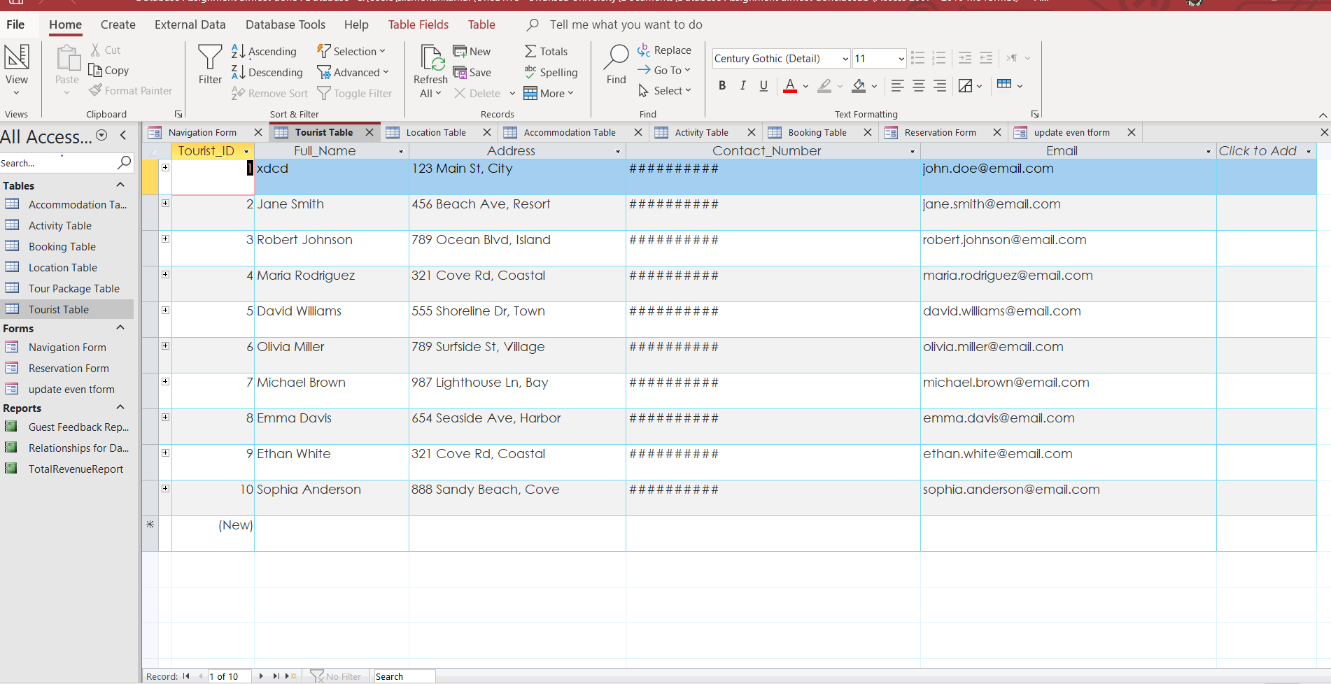
Under the Database Tools menu, I selected "Relationships."
I made table associations by dragging and dropping the relevant fields.
I Linked :
Tourist.Tourist_ID to Booking.Tourist_ID.
TourPackage.Package_ID to Booking.Package_ID.
Location.Location_ID to Accommodation.Location_ID.
Location.Location_ID to Activity.Location_ID.
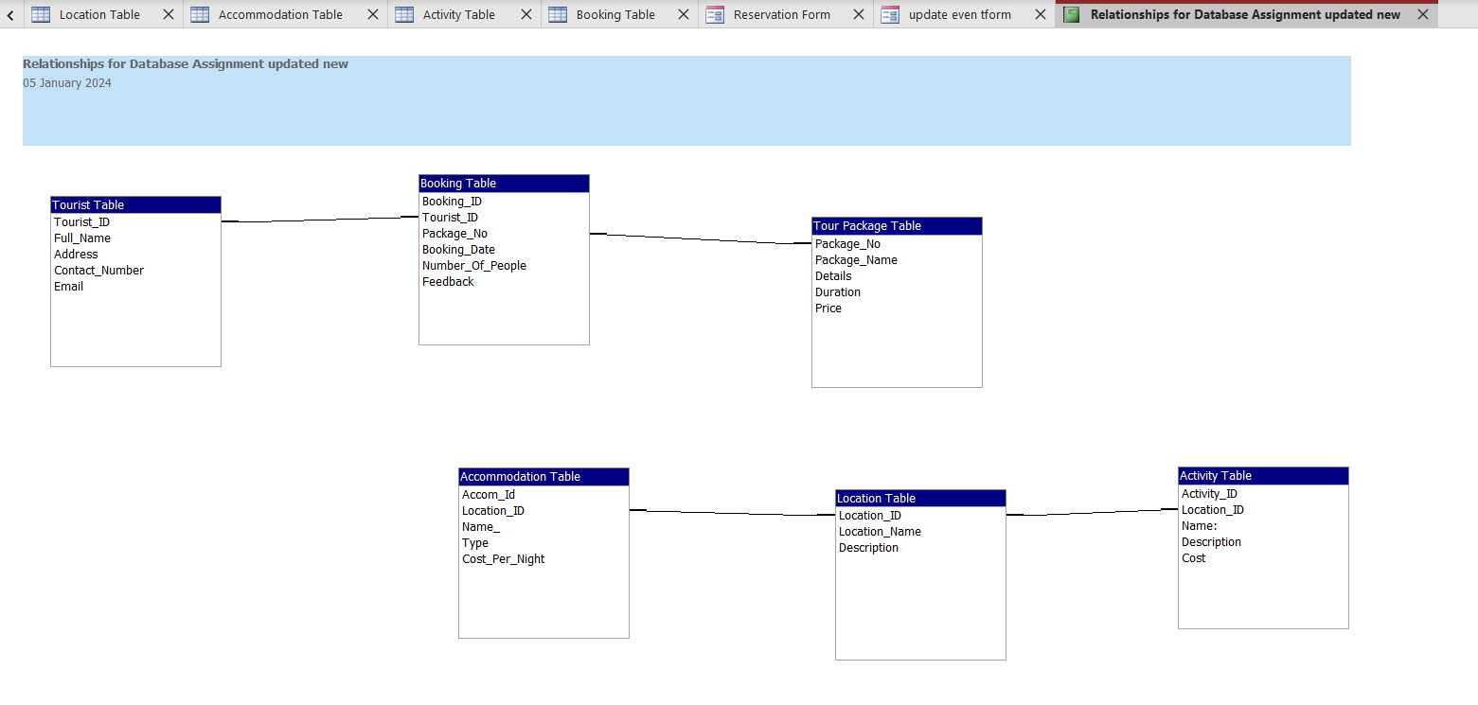

6. Developing and Designing Reports :

- Creating and Designing a Revenue Report:

Select the "Reports" option after launching Microsoft Access.
pressed the "Report Wizard" button to select the required tables and fields.
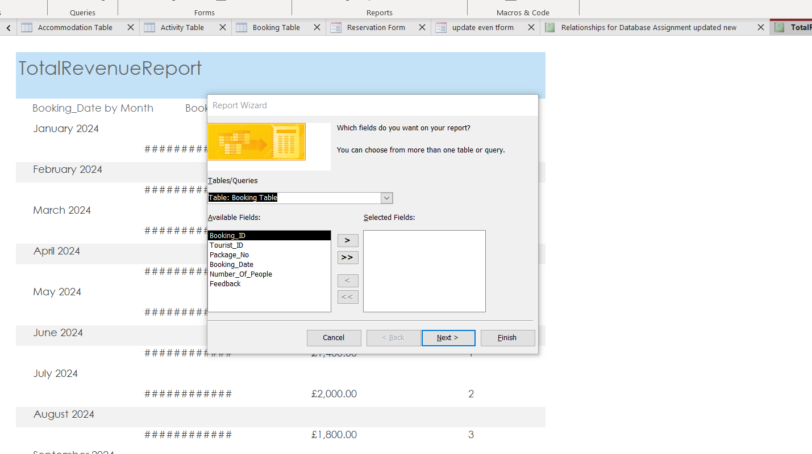
Added a total revenue summary by calculation and grouped the data based on the booking dates.
chose to examine individual booking details by selecting the "Detail" view.
Before previewing and evaluating the report, I saved it.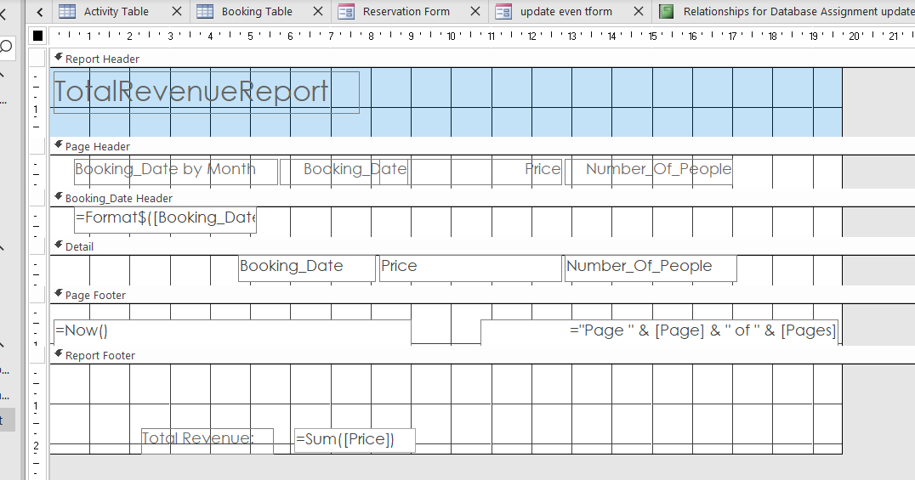

- Creating a Report on Guest Feedback:

I used the dependable Report Wizard once more, using tables like Feedback and Tourist this time.
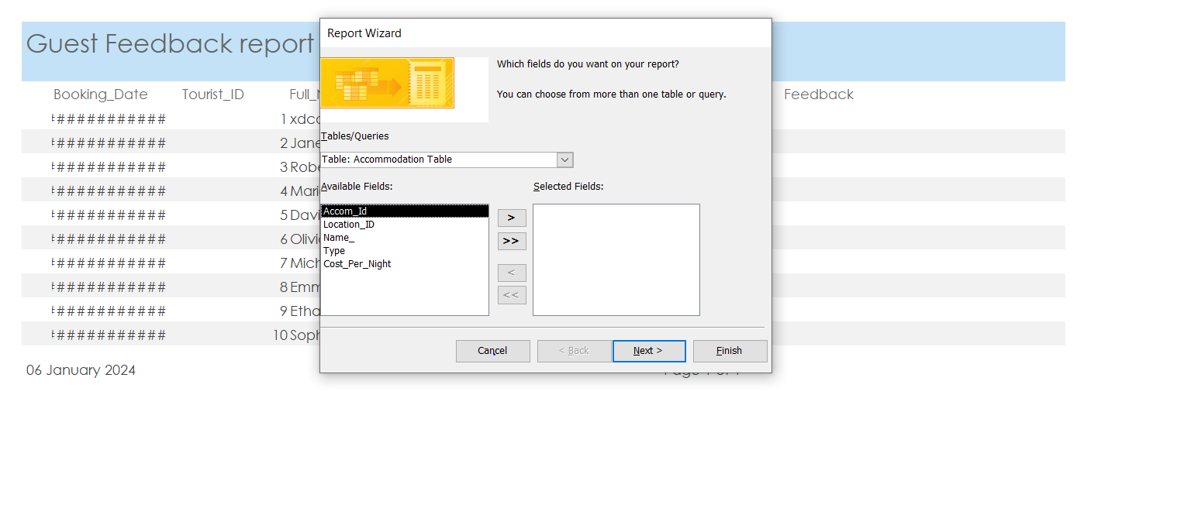
I selected the fields I wanted to see, organized the data, and created a report that displays each feedback entry individually.
selected a style and layout, saved the report, and opened the preview to give it a try.
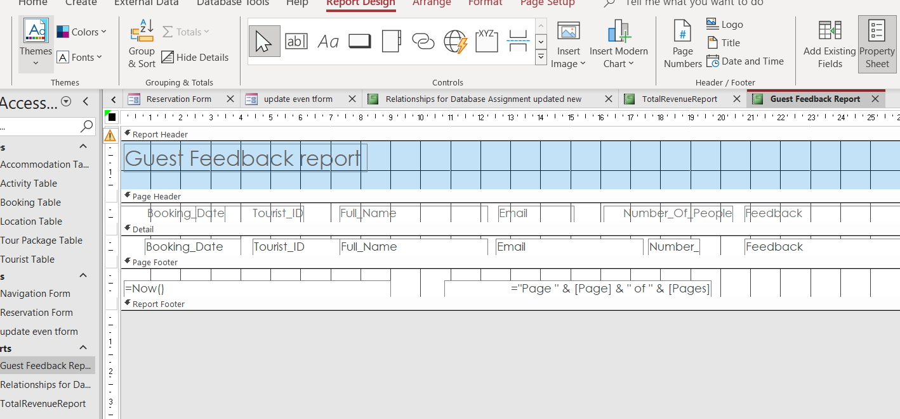

7. Making a Reservations Form for Tourists:
went to the "Forms" tab and saw that the Form Wizard was awaiting a response.
Choose the required fields to fill out the reservation form..
Included a few validation guidelines to ensure data accuracy..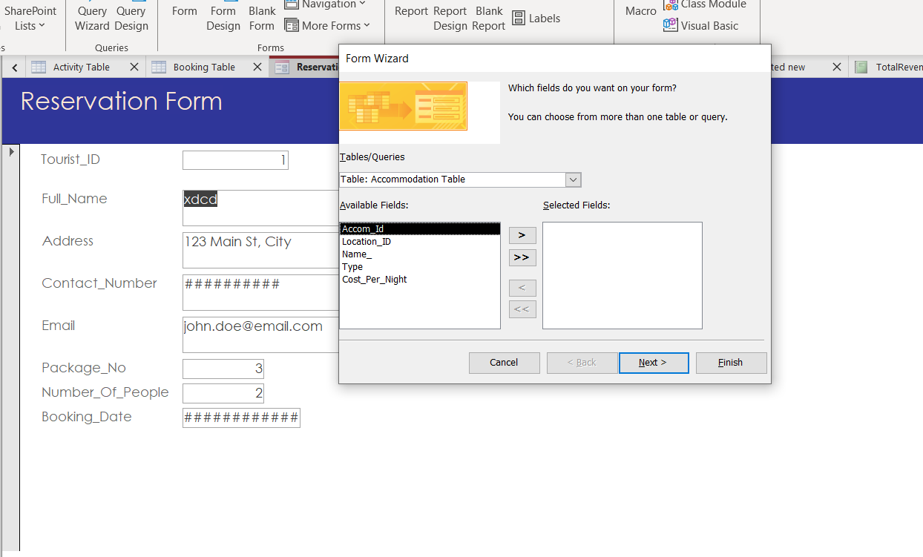
enhanced features that make the form enjoyable to use, such as buttons for submitting.
I saved the "ReservationForm" form and ran a test on it using some fake information.
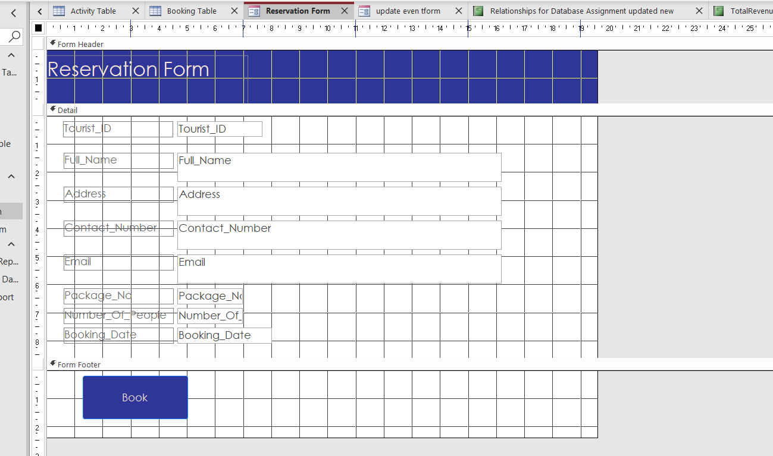
b.Making an Event Update Form:
Return to the Forms Wizard to create another masterwork, this one with an events-focused design.
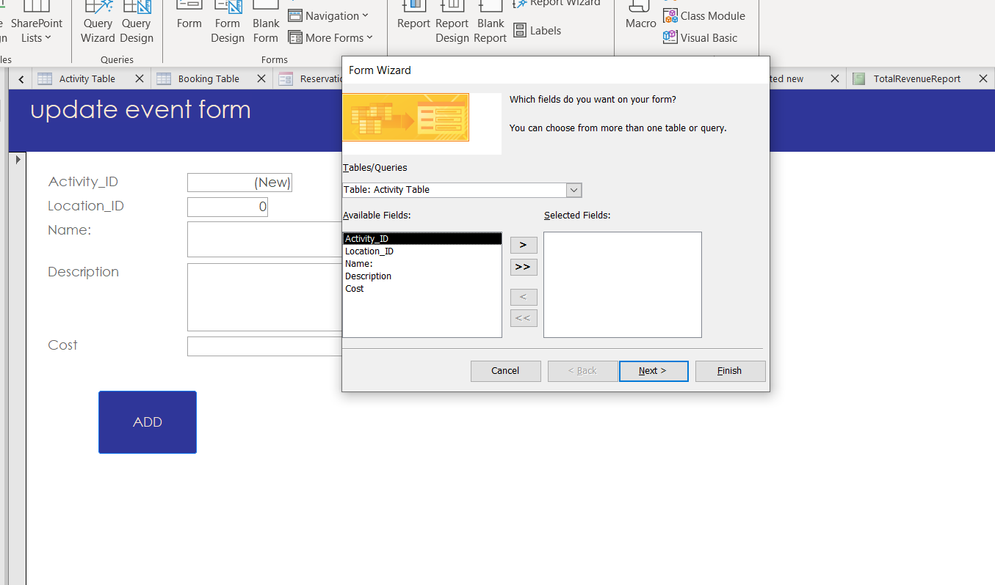
modified a few fields to make sure event organizers could quickly change information.
Additional validation rules were added to maintain order and guarantee accurate updates.
I saved the form under the name "EventUpdateForm" and tried using it to update some information about the event.
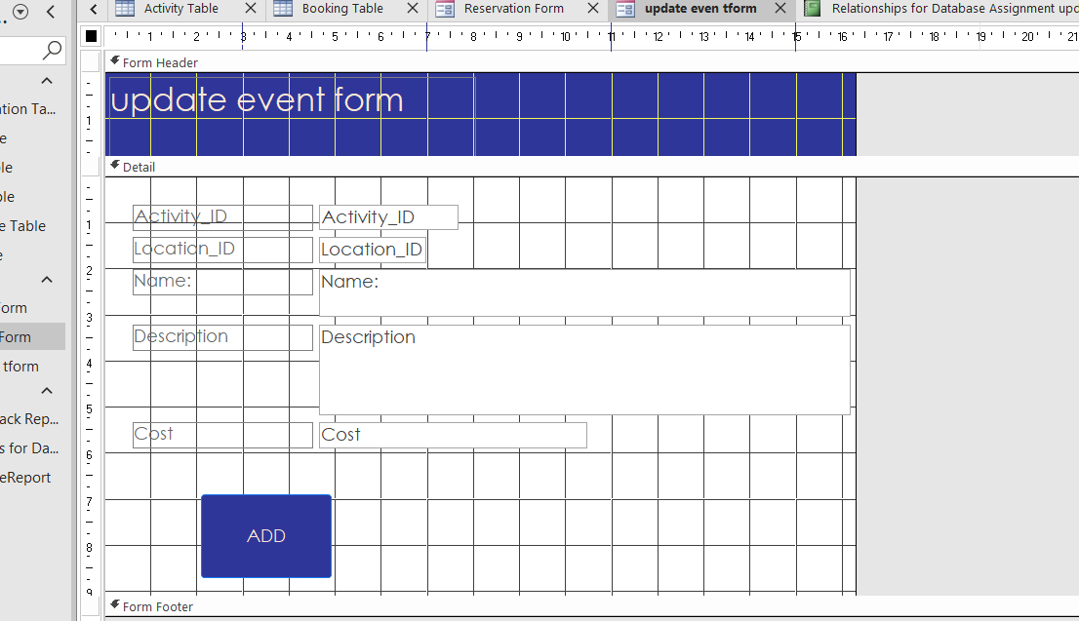

8. Creating an Easy-to-Use Menu for CTMS:
a. Enabling Users to Navigate Easily:
Select the "Forms" tab and you'll find the "Navigation" tool, which functions to make navigation simple.
created a navigation form with tabs for the various parts, such as reservations, packages, and tourists.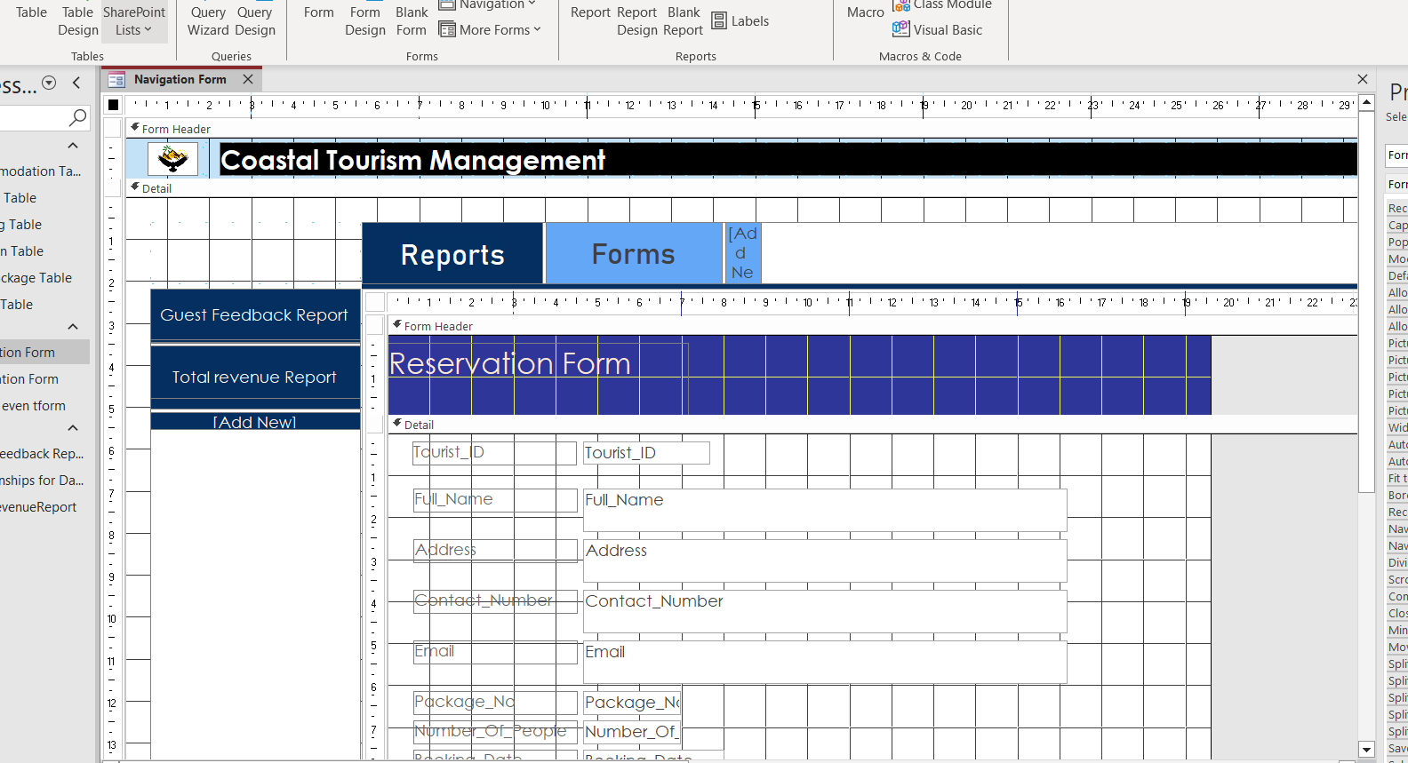
Organizing related items under each tab makes it easier for users to locate what they're looking for.

b. Presenting Choices Right Away After Opening:
I opened Microsoft Access and used the Form Wizard to create a startup form once more.
Selecting the primary table, most likely named "MenuOptions," option buttons were added for several functionalities, providing a user's quick start guide.
Keeping it straightforward allows consumers to see their options as soon as they open the database.
I saved the "StartupMenu" form and made it the first action under Access Options.
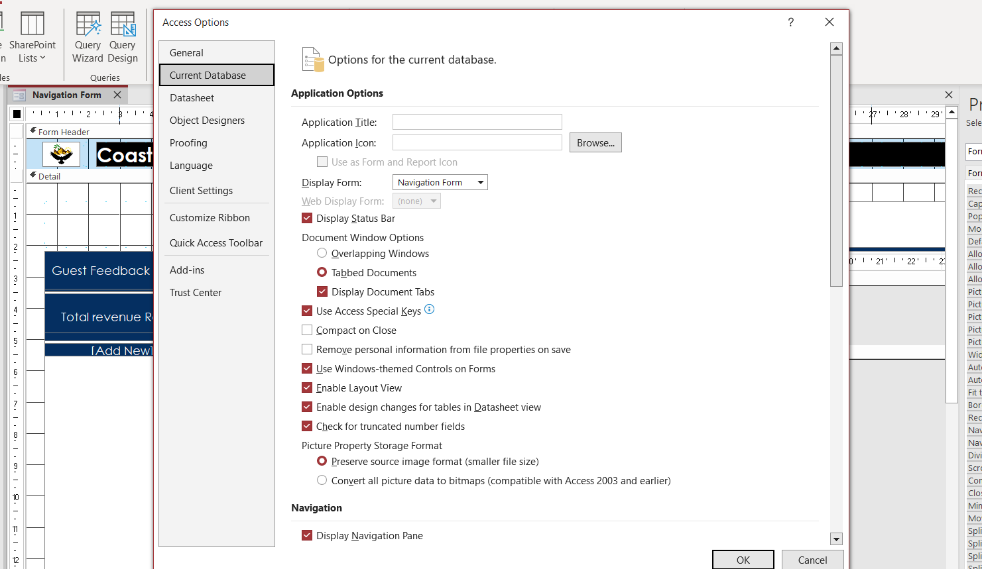
opened the database to test the startup form and enjoyed the instant access to many features.
9. The significance of a Microsoft Access database for Wales' coastal tourism management
Efficacy through Centralization:
The database acts as a single, consolidated location for all important data pertaining to coastal travel. Having all the information in one location simplifies access and management, including visitor data, environmental conditions, and legal needs. Making decisions is made more effectively and intelligently when precise, current information is readily retrieved by decision-makers thanks to this centralized approach.[1]

Customized Marketing to Improve the Visitor Experience
Personalized Marketing: The capacity to create customized marketing is a key benefit of keeping a customer database. Hotels are able to customize marketing campaigns to individual interests by storing personal information. Sending personalized offers, contacting clients by name, and executing focused email marketing campaigns are a few examples of this. The guest experience is made more relevant and meaningful by this individualized approach.[2]

Improved Cooperation and Teamwork:
The tourism industry along the coast necessitates the cooperation of a number of parties, including businesses, government agencies, local governments, and environmental groups. The database serves as a common area that promotes cooperation and teamwork. By allowing real-time information access, updating, and contribution from stakeholders, it facilitates improved coordination and integration of efforts for efficient management of coastal tourism.[2]

How a Database Enhances Coastal Tourism Management's Effectiveness and Efficiency:
Automation for Optimum Procedures:
Regular duties like handling vendor bids and keeping track of supplies are made easier by the database's automation features, which are emphasized in the reference. This automation improves the accuracy of the data utilized in decision-making while also saving time. Managers in charge of coastal tourism can effectively manage duties including supply tracking, vendor selection, and budgeting, guaranteeing more seamless operations.[3]

Personalized Communication to Establish Credibility
With no Managers can display information in a way that best fits the comprehension and preferences of each client by using data visualization tools.[3] In addition to fostering customer trust, this customized communication makes sure that the intricacies of coastal tourist projects are communicated in an understandable way.

10.
Difficulties in Making the Switch to Computerized Systems:
1. Opposition to Change:

Workers used to manual operations could object to the change because they think they will lose their jobs or have to undergo retraining.
The transition can be made easier by introducing an intuitive DBMS with user-friendly interfaces[4]. Emphasizing the advantages and ease of use of the new system should be the main goal of training programs.

2. Issues with Data Security:

Sensitive data security and privacy are concerns raised by the change, particularly in light of the rise in cyberattacks.
Access restrictions, encryption, and frequent security upgrades are just a few of the advanced security capabilities that DBMSs with these characteristics offer as a strong barrier against potential threats. Gaining the trust of stakeholders requires adherence to data protection standards.[4]

3. The Financial Effects:

Budgets may be strained when implementing computerized systems because of the upfront expenses for hardware, software, and employee training.
A scalable database management system (DBMS) enables affordable customization through a phased implementation method. By using this strategy, firms can reduce initial financial pressures by prioritizing key components[4].

Advantages of Making the Switch:

1. Increased Effectiveness:

Processes are streamlined by computerized technology, which demand less time and manual labor.
Activities like managing reservations, organizing itineraries, and interacting with clients become more effective. By automating monotonous processes, employees may concentrate on more important work, increasing productivity as a whole[5]:.

2. Tailored Client Experience:

Personalized services are made possible by computerized systems, which improves the client experience in general.
Customer loyalty is increased when services are customized according to their interests, for as with tailored recommendations or targeted promotions[5]. This individualized strategy helps generate favorable evaluations and recommendations from word-of-mouth.

DBMS's role :
1.Friendly User Interfaces:

Staff members' learning curves are shortened by DBMSs with intuitive user interfaces.
A user-friendly system promotes rapid adoption and lessens change-related resistance [6].. Employees find it easy to use the system, which facilitates a more seamless transfer.

2. Scalability in Budgetary Control:

Phased deployment is possible with a scalable database management system, allaying initial financial worries.
Based on financial limitations, organizations might rank the importance of important functionalities. This strategy allows for a gradual transition, reducing financial burden and enabling modifications in response to changing requirements.[6]

[1]M. S. N. Figueiredo and A. M. Pereira, “Managing Knowledge – The Importance of Databases in the Scientific Production,” Procedia manufacturing, vol. 12, pp. 166–173, 2017, doi: 10.1016/j.promfg.2017.08.021.
[2]“WHY ARE DATABASES IMPORTANT TO BUSINESS/HOTELS?,” www.linkedin.com. https://www.linkedin.com/pulse/why-databases-important-businesshotels-hazlina-hamid/
[3]“How database software can improve efficiency and speed for your business,” Microsoft.com, 2018. https://www.microsoft.com/en-ww/microsoft-365/business-insights-ideas/resources/how-database-software-can-improve-efficiency-and-speed-for-your-business (accessed Jan. 05, 2024).
[4]Shiksha Online, “Top 8 Disadvantages of DBMS - Shiksha Online,” Shiksha.com, Jan. 31, 2023. https://www.shiksha.com/online-courses/articles/top-8-disadvantages-of-dbms/#:~:text=Some%20of%20the%20main%20disadvantages
[5]geeksforgeeks, “Advantages of Database Management System - GeeksforGeeks,” GeeksforGeeks, Nov. 20, 2019. https://www.geeksforgeeks.org/advantages-of-database-management-system/
[6]“DATABASE MANAGEMENT SYSTEM (DBMS) (R-13 Autonomous).” Available: https://mrcet.com/downloads/digital_notes/ECE/III%20Year/DATABASE%20MANAGEMENT%20SYSTEMS.pdf

FINAL DATABASE VIEW:




