Six letters from Elizabeth Wagstaffe of Warwickshire to her husband TimothyWagstaffe, lawyer of Middle Temple
Shelfmark - Bodleian Library MS. Eng. c. 7903, fols. 38-49

Introduction
To complete this transcription exercise I used the magnifying tool on the Bodleian website to see the letters as clearly as possible. I also used a useful alphabet that looks at a variety of examples of lettering through time. I transcribed three pages of this manuscript to fully show my abilities. I went over the manuscript at least four times per section to make sure that I have properly looked at the letters and made the best judgment I can to make it as accurate as possible.

Commentary
Date for transcription 1– 11th of November 1616
Date for transcription 2 – 1st of July 1620
Date for transcription 3 – 21st of April 1621
This document is written in English and in Humanist script in Italic hand.
In transcription 3 there is a small hole near the bottom of the manuscript, so I had to work around it and try and figure out some of the missing letters when possible.
The letters are a great insight into the role of women at the start of the seventeenth century. The letters talk about a variety of things Elizabeth had been doing in her husband’s absence like looking over the building work that was happening in the home.

Historical context
The manuscript consists of a variety of letters between Elizabeth and her husband Timothy, between 1616 and 1622. Timothy Wagstaffe was a lord, and a lawyer who was away at the inns, and Elizabeth was the daughter of Puritan lawyer and politician Nicholas Fuller. Nicholas Fuller was a critic of James I's government.

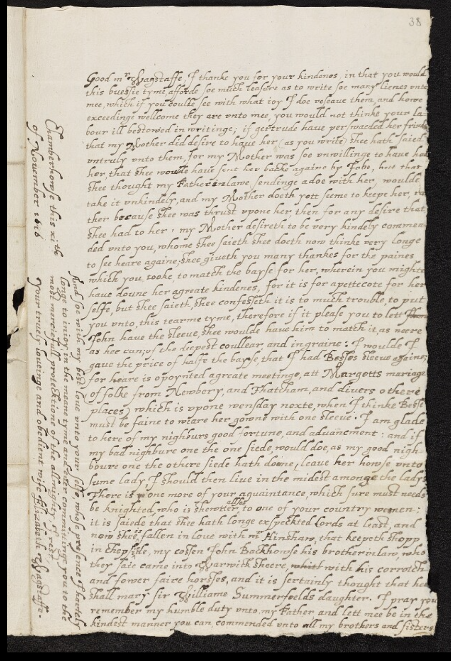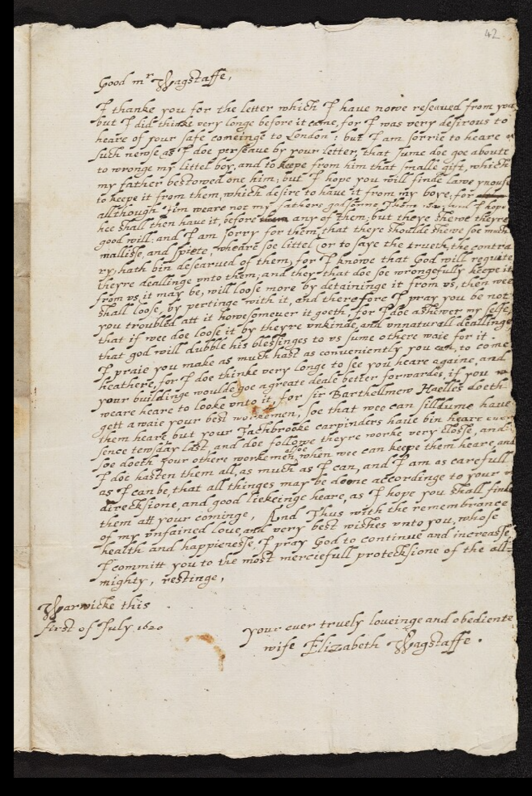
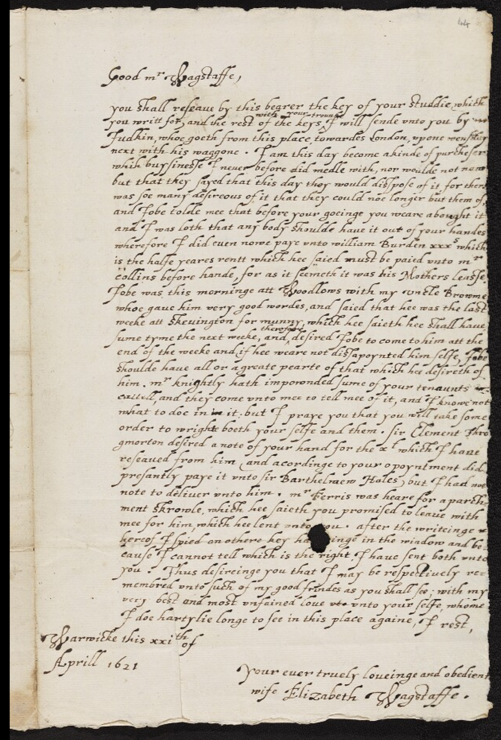
Transcription 1
Main Text
L1 - Good mr Wagstaffe, I thanke you for your kindenes, in that you would
L2 – this buestie tyme, afforde soe much leasure as to write soe many lienes unto
L3 – mee, which if you coulde see with what joy I doe reseave them, and home
L4 – exceedinge wellcome they are unto mee, you would not thinke your la -
L5- bour ill bestowed in writinge; if gertrude have perswaeded her frinds
L6- that my mother did desire to have her (as you write) shee hath saied
L7 – untruly unto them, for my Mother was soe unwillinge to have had
L8 – her, that shee woulde have sent her backe againe by Iobe, but that
L9 – shee thought my Father in lawe sendinge a doe with her, woulde
L10 – take it unkindely, and my mother doeth yet seeme to keepe her, ra
L11 – ther because shee was thrust upone her, then for any desire that
L12 – she had to her. My Mother desireth to be very kingely commen-
L13 – ded unto you, whome shee saieth shee doeth now thinke very longe
L14 – to see heare againe; she giveth you many thankes for the paines
L15 – which you tooke, to match the bayse for her, wherein you mighte
L16 – have doune her agreate kindenes, for it is for apettecote for her
L17 – selfe, but she saieth, shee confesleth it is to much trouble, to put
L18 – you unto, this tearme tyme, therefore if it please you to lett them
L19 – John have the sleeve, shee woulde have him to match it, as neere
L20 – as hee can; of the deepest coullear, and ingraine: I woulde I
L21 – gave the price of halfe the bayse, that I had Besies sleeve againe;
L22 – for heare is opoynted agreate meetinge, att Margetts mariage
L23 – of folke from Newbery, and Thatcham, and divers othere
L24 – places , which is upone wensday nexte, when I thinke Besie
L25 – must be faine to weare her gowne with one sleeve. I am glade
L26 – to here of my nighburs good fortune, and advancement: and if
L27 – my bad nighbure one the one siede, would doe, as my good nigh-
L28 – boure one the othere siede hath dome, leave her howse unto
L29 – sume lady, I should then live in the widest amonge the ladys
L30 – There is, one more of your aguaintance, which sure must needs
L31 – be knighted, who is shewtter allsoe to one of your country women;
L32 – it is saide that shee hath longe exspected lords at least, and
L33 – now shee is fallen in love with Mr Hinshaw, that keepeth shop
L34 – in chepsiede, my costen John Backhowse his brother in law, who
L35 – they saie came into Warwicksheere, whith with his corrotch
L36 – and fower faire horstes, and it is sertainly thought that hee
L37 – shall mary sir Williame Summerfeelds daughter. I pray you
L38 – remember my humble duty unto my Father and lett mee be in the
L39 – kindest manner you can, commended unto all my brothers and sisters.

Side text
L1 - Chamberhowse this xi th
L2 - of November 1616

L1 – And soe with my best love unto your selfe, whose presence I hartely
L2 – longe to injoy, in the meane tyme and ever committinge you to the
L3 – most merciefull protecktione of the allmighty, I rest,
L4- Your truely loveinge and obedient wife Elizabeth Wagstaffe.

Transcription 2

Main text
L1 – Good Mr Wagstaffe,
L2 – I thanke you for the letter which I have nowe reseaved from you
L3 – but I did thinke very longe before it came, for I was very desirious to
L4 – heare of your safe comeinge to London : but I am sorrie to heare n
L5 – such newse as I doe perseave by your letter, that sume doe goe aboute
L6 – to wronge my littel boy, and to keepe from him that smalle gift, which
L7 – my father bestowed one him; but I hope you will finde lawe ynoufe
L8 – to keepe it from them, which desire to have it from my boye: for although
L9 – allthough Tim weare not my fathers godsonne, Thom was and I hope
L10 – hee shall then have it, before whom any of them; but theye shewe theyre
L11 – good will: and I am sorry for them that theye shoulde shewe soe much
L12 – malliste, and spiete, wheare soe littel (or to saye the trueth, the contra
L13 – ry, hath bin desearved of them) for I knowe that God will regvite
L14 – theyre deallinge unto them ; and they that doe soe wrongefully keepe it
L15 – from us it may be, will loose more by detaininge it from us, then wee
L16 – shall loose, by pertinge with it, and therefore I pray you be not
L17- you troubled att it howesomever it goeth, for I doe ashewer my selfe
L18 – that if mee doe loose it by theyre unkinde and unnaturall deallinge
L19 – that god will dubble his blestinges to us sume othere waie for it.
L20 – I praie you make as much hast as conveniently you can, to come
L21 – heathere, for I doe thinke very longe to see you heare againe, and
L22 – your buildinge woulde goe agreate deale better forwardes, if you w
L23 – weare heare to looke unto it, for Sir Barthellmew Haelles doeth
L24 – get a waie your best workemen, soe that wee can silldume have
L25 – them heare but your Tachbrooke carpinders have bin heare ever
L26 – sence tewsday last and doe followe theyre worke very closte, and
L27 – soe doeth your othere workemen alsoe when wee can keepe them heare, and
L28 – I doe hasten them all, as much as I can, and I am as carefull
L29 – as I can be, that all thinges may be doone accordinge to your
L30 – direcksion, and good liekeinge heare, as I hope you shall finde
L31 – them att your cominge, And thus with the remembrance
L32 – of my unfained love, and very best wishes unto you, whole
L33 – health and happieneste, I pray God to continue and increaste
L34 – I committ you to the most merciefull protecksione of the all-
L35 – mighty, restinge,
L36 – Warwicke this
L37 – First of July 1620
L38 – Your ever truely loveinge and obediente
L39 – wife Elizabeth Wagstaffe.

Transcription 3

Main Text
L1 – Good mr Wagstaffe,
L2 – you shall reseave by this bearer the key of your studdie which
L3 – you writt for, and the rest of the keys with your trounke I will sende unto you by m
L4 – fudkin, whoe goeth from this place towardes London, upone wensday
L5 – next with his waggone. I am this day become akinde of purcheser
L6 – which buysineste I never before did medle with, nor woulde not now
L7 – but that they sayed that this day they would distpose of it, for there
L8- was soe many desireous of it that they could noe longer but them of,
L9 – and Iobe tolde mee that before your goeinge you weare abought it
L10 – and I was loth that any body shoulde have it out of your handes
L11 – wherefore I did even nowe paye unto William Burden xxx s which
L12 – is the halfe yeares rentt which hee saied must be paied unto mr
L13 – collins before hande, for as it seemeth it was his Mothers leaste.
L14 – iobe was this morninge att Woodlows with my uncle Browme
L15 – whoe gave him very good wordes, and saied that hee was the last
L16 – weeke att Skevington for munny, which hee saieth hee shall have
L17 – sume tyme the next weeke, and therefore desired Iobe to come to him att the
L18 – end of the weeke and if hee weare not distapoynted him selfe, Iobe
L19 – shoulde have all or agreate pearte of that which hee desireth of
L20 – him. Mr knightly hath impownded sume of your tenaunts
L21 – cattell, and they come unto mee to tell mee of it, and I knowe not
L22 – what to doe in in it: but I praye you that you will take some
L23 – order to wright boeth your selfe and them. Sir Clement thro
L24 – gmorton desired a note of your hand for the xt which I hane
L25 – reseaved from him (and acordinge to your opoyntment did
L26 – presantly paye it unto Sir Barthelmew Hales) but I had noe
L27 – note to deliver unto him. Mr Ferris was heare for a parch-
L28 – ment skrowle, which hee saieth you promised to leave with
L29 – mee for him, which hee lent unto you. after the writeinge w
L30 – hereof I spied on othere key ha[missing piece]inge in the window and be-
L31 – cause I cannot tell which is the right. I have sent both unto
L32 – you. Thus desireinge you that I may be respectively re-
L33 – membred unto such of my good frindes as you shall see; with my
L34 – very best and most unfained love uto unto your selfe, whome
L35 – I doe hartylie longe to see in this place againe, I rest,
L36 – Warwicke this xxith of
L37 – Aprill 1612
L38 – your ever truly loveinge and obedient
L39 – wife Elizabeth Wagstaffe.

REFERENCES
Bodleian Library ms. Eng. c. 7903, fols. 38-49 (no date) Digital Bodleian. Available at: https://digital.bodleian.ox.ac.uk/objects/74bda733-de22-4cdd-b76f-92703131aa5c/surfaces/963ec5e5-231d-4543-b19e-c0db3af12eaa/ (Accessed: 23 December 2023).
Emlo EMLO. Available at: http://emlo-portal.bodleian.ox.ac.uk/collections/?catalogue=elizabeth-wagstaffe-timothy-wagstaffe (Accessed: 28 December 2023).
Menna, G. (2023) Humanistic script - the story of the writing style of the Renaissance, DMMapp Blog. Available at: https://blog.digitizedmedievalmanuscripts.org/codicology/medieval-scripts/humanistic-script/ (Accessed: 28 December 2023).
Old law hands, large version. Available at: https://sites.rootsweb.com/~oel/lawhandslg.html (Accessed: 24 December 2023).

Old law hands, large version. Available at: https://sites.rootsweb.com/~oel/lawhandslg.html (Accessed: 24 December 2023).
Menna, G. (2023) Humanistic script - the story of the writing style of the Renaissance, DMMapp Blog. Available at: https://blog.digitizedmedievalmanuscripts.org/codicology/medieval-scripts/humanistic-script/ (Accessed: 28 December 2023).
Emlo EMLO. Available at: http://emlo-portal.bodleian.ox.ac.uk/collections/?catalogue=elizabeth-wagstaffe-timothy-wagstaffe (Accessed: 28 December 2023).
Bodleian Library ms. Eng. c. 7903, fols. 38-49 (no date) Digital Bodleian. Available at: https://digital.bodleian.ox.ac.uk/objects/74bda733-de22-4cdd-b76f-92703131aa5c/surfaces/963ec5e5-231d-4543-b19e-c0db3af12eaa/ (Accessed: 23 December 2023).

