DIGITAL SKILLS AND RESEARCH METHODS
(BMSW4003)

DARLIN ROSIS CASTILLO 1914225
NATALIA CASTANO 1917106
JEAN-LAURENT ZANMENOU 1916071
YSMAEL RAMIREZ ASENCIO 1912612
KAMAL SALEC 1909112
RUGEYRO ARENAS 1916149

ANUPAM MAZUMDAR
UNIVERSITY OF WALES: TRINITY SAINT DAVID.
PRIFYSGOL CYMRU: Y DRINDOD DEWI SANT.
07-MAY-2020
DARLIN ROSIS CASTILLO AND KAMAL SALEC
1909112 1914225
INTRODUCTION AND BACKGROUNG OF THE ORGAISATION
KAMAL SALEC
1914225
The use of technology in the fast food industry is an important factor in improving the sustainable supply chain. McDonald’s needs to ensure the evolution of its offer and the developing its operations with the best technology, both in the handling and processing of food as in the support of their business processes. This assignment deals with what the implantation of modern technology in McDonald’s has assumed. McDonald's is an Illinois Chicago-based American fast-service restaurant franchise. Its main products are hamburgers, fries, breakfast menus, soft drinks, smoothies, ice cream, desserts and, recently, fruit salads and other exclusive products for various countries. It serves approximately 68 million customers per day, 2 in more than 36,000 stores, in 118 territories and countries around the world. Technology is no longer a luxury or privilege worldwide; its use has become a fundamental element in the personal and business sphere. In such an active and globalized world, companies must be fast and efficient with all their resources, technology has come to solve problems and eliminate organizational barriers through innovative systems that are adaptable to the needs of each one. What used to take weeks and even months, is now possible to finish in a few minutes and without much effort or complication. When a company takes resistance to implant new technologies in each of its processes, it increases its chances of stagnating and being left behind, especially those in a growth stage that are not yet fully stabilized or positioned in the market. In the next assignment we will talk about the background of McDonald’s (how he was born and how he got to where he is today), and we will describe about how McDonald’s was before introducing modern technologies. After, we offer information on the modern technologies introduced in the company, the impact that the introduction of modern technologies has had, both positive and negative impacts, and in conclusion we will write about the lessons that can be drawn from the study carried out. McDonald’s has made good use of the new technologies since it has managed to reach the general public by implementing new strategies, facilities for ordering food, etc. Macdonald’s has known how to implement technological advances and all marketing strategies to reach the general public. This company has always taken advantage of innovations. To end, this company generates millions of dollars a year thanks to the adaptation and implantation of different technologies throughout the world.

DARLIN ROSIS CASTILLO
1909112

History
McDonald’s is an American fast food restaurant, is one of the largest chains in the word. In 1948 it was created the first McDonald’s managed for the brothers Richard and Maurice McDonald in San Bernardino, California. Its head office is in Oak Brook, Illinois. McDonald’s is known for its hamburger; they discovered the way to produce big quantities of food for small prices. Ray Kroc salesman saw a great opportunity to offer a franchise program to the McDonald brothers. Ray Kroc joined to the McDonald’s corporation as a franchise agent on April 15,1955, in the same year he opened the first McDonald’s franchise in Des Plaines, Illinois, in 1961 Ray Kroc bought out the McDonald’s corporation to the McDonald brother. In 1963 it was created the public face of McDonald’s as a clown the name Ronald McDonald, “while the double arch (m) symbol become McDonald’s most enduring logo in 1962, lasting far longer than the tall yellow arches that had once dominated earlier restaurant Rooftops”. (Britannica, 2018)

Aim and objectives
McDonald’s main aim is to serve good food in friendly and fun environment, to be a socially responsible company, and to provide good returns to its shareholder. The McDonald’s aim to provide its customer with food of a high standard, quick service and great value for money. The McDonald’s objectives are serving quality of food that its customer love and can trust, offer opportunities and support the local communities (McDonald's, 2017)

Mission and vision
McDonald mission is providing a fun and safe environment where its customer can enjoy good food made with quality ingredients at affordable prices, and to be the favourite place way to eat and drink. McDonald’s vision is to be the best faster service restaurant experience. Being the best means providing outstanding quality, service, cleanliness, and value, so that they make every customer happy.

Technology use
McDonald’s use many different technologies to improve its business processes and also to help McDonald’s perform at a consistently high level , for example Drive-thru where customer can order McDonald’s meals to go, mobile app, self-order kiosks that is very useful because the customer can see what they are ordering and also they tent to add more items than employee took it at a register, digital signage, through machine learning that technology is used to collect data from its millions of customer to make meal suggestions based in the menu items that are in trending. (Duprey, 2019)

Purpose
The McDonald’s purpose is to be the best fast food restaurant in world, with good quality of the food and giving to its customer exceptional service.

References
Britannica, T. E. (2018, aug 03). McDonald's Corporation . Retrieved from Encyclopaedia Britannica: https://www.britannica.com/topic/McDonalds
Duprey, R. (2019, may 6). McDonald's Technology Investments Are Helping to Drive Sales. Retrieved from the Motley fool: https://www.fool.com/investing/2019/05/06/mcdonalds-technology-investments-are-helping-to-dr.aspx
McDonald's. (2017). FAQ's. Retrieved from McDonald's: https://www.mcdonalds.com/gb/en-gb/help/faq.html
Meyer, P. (19, FEBRUARY 20). McDonald’s Mission Statement & Vision Statement (An Analysis). Retrieved from Panmore Institute: http://panmore.com/mcdonalds-vision-statement-mission-statement-analysis

NATALIA CASTANO
1917106
CHALLENGES BEFORE INTRODUCING MODERN TECHNOLOGY
The business before Cloud Computing
In the last years cloud computing has growth significantly and most of the companies has been implanted this tool for storing their documents before this tool it was tedious to storage all the information that the company held because it required more space in external memories which it needs more physical space and therefore it require more money to the company because they have to hire more staff to manage all this information, they have to train their staff which is an extra cost. Before cloud computing only the staff that were in the place where this information was storage could access to this information. (Hoffmann, 2018)
Customer Service before modern technology
McDonald’s has innovated in the way how they serve customers. They have implemented many ideas that has worked very well as the self-checkout kiosk and the McDonalds App. (Duprey, 2019)
The self-check-out has helped with the speed of serving customers, before it took more time to serve customers because sometimes customers did not know what to order or maybe the cashier did not take the right order so this has improve effectively communication between customer and the restaurant chain also before this advantage people that do not understand the language or people that are deaf had some difficulties to communicate what they wanted to order.
Additionally, when an employee took an order on the counter, customer used to limit their order on what they really need and now with these new screens where the customers’ orders their own food, they tend to add more items to their order.
Not everyone is happy with these self-services because they think these machines are taking over human being, and we can say McDonald’s do not need as much staff as before to serve customers.
McDonald’s also has introduced mobile ordering app which allows customers to make their order on the phone paying with debit card without need to wait in long queues, this leads to a satisfying experience to the customer. (Christie, 2017)

References
Hoffman, R (2017) How Technology is Changing Business
Available at: https://www.business2community.com/small-business/how-technology-is-changing-business-02125223
(Accessed: April 23, 2020)

Duprey, R. (2019) McDonald's Technology Investments Are Helping to Drive Sales

Available at: https://www.fool.com/investing/2019/05/06/mcdonalds-technology-investments-are-helping-to-dr.aspx
(Accessed: April 23, 2020)
Christie, S. (2017) McDonald’s has an app and it means you’ll never need to queue again https://www.thesun.co.uk/money/3279350/mcdonalds-has-an-app-and-it-means-youll-never-need-to-queue-again/
(Accessed: April 23, 2020)

JEAN-LAURENT ZANMENOU
1916071
INSIGHTS OF MODERN TECHNOLOGY INTRODUCED

YSMAEL RAMIREZ ASENCIO
1912612
IMPACTS OF MODERN TECHNOLOGY INTRODUCED
THE POSITIVE IMPACT OF NEW TECHNOLOGIES IN MCDONALD’S:
With the technology McDonald’s is making life easier for the customers.
- Technology make the ordering more efficient:
To make this possible, they decide to implement new technology such as a kiosk, mobile app, and Facebook ordering. With those technologies, they increment the number of customers per hour. The order is more effective because if you do your order by yourself you do not going to do mistakes in what you choose, but if you need to go to the counter and they taking the order for you the probability of an error occurring is higher, perhaps because of poor communication.

- Lower waiting time:
With this strategy, they reduce the waiting time of the customer for the order by taking. Now in any McDonald’s you can go in and you make your order by yourself in the Kiosk and like this, you do not need to wait much time.

- Lower staff cost:
One of the more important impacts of the new technology for the company is that they reduce the cost of the staff because if one machine can do the job of one person, they are saving money in staff but they continue with the same profit.

- Easy payments options:
They implement different types of payment methods such as contactless cads and contactless smart phone. (Fleming, 2019)
NEGATIVE IMPACT OF NEW TECHNOLOGY IN MCDONALD’S:
- Many people lose their job:
With the new technology to many people lost their job because they have now introduced the self-service, and they do not need many cashiers as before, now with one or two is more than enough. This can cause controversy because for the company it is a good point because they do not need to pay to many employees, but for the population obviously is not good.

- Kiosk without paper:
The kiosk is used as the self-service, but I have to said that there are not working properly because many times when you have sent your order the kiosk does not have a paper to print the number of your order and this usually lends itself to many mistakes.

References
Duprey, R., 2019. The Motley Fool. [Online]
Available at: https://www.fool.com/investing/2019/05/06/mcdonalds-technology-investments-are-helping-to-dr.aspx
[Accessed 14 April 2020].
Fleming, M., 2019. MarketingWeek. [Online]
Available at: https://www.marketingweek.com/mcdonalds-digital-transformation/
[Accessed 14 April 2020].
Peterson, H., 2015. Bussinesinsider. [Online]
Available at: https://www.businessinsider.com/heres-where-mcdonalds-went-wrong-2015-5?r=US&IR=T
[Accessed 14 April 2020].
Tin-yau, K., 2019. ejinsight. [Online]
Available at: https://www.ejinsight.com/eji/article/id/2254439/20190919-how-technology-is-transforming-mcdonald-s-operations
[Accessed 15 April 2020].
Zolman, L., 2018. qsrmagazine. [Online]
Available at: https://www.qsrmagazine.com/finance/how-mcdonalds-driving-fast-foods-technology-revolution
[Accessed 15 April 2020].

RUGEYRO ARENAS
1916149
LESSONS DRAWN FROM THE CASE STUDY AND CONCLUSION
TECHNOLOGY CAN HELP/SUPPORT ORGANISATIONS TO BE EFFICIENT/EFFECTIVE?
Modern technology help McDonald’s to become highly efficient and serve fresh food in a few minutes, food that usually takes between fifteen (15) and twenty minutes (20). Exists many challenges associated with the modern technology, an example of this is when we use McDonald’s application to order our food usually they give us the time when this will be ready but looking the congestions in the branches this impact if they do not have a development plan to manage the huge quantity of orders to make. This exhibit that companies further need to train up their employees and restaurant design to meet the rush of orders via the new platform. Example: self-checkouts and orders online via web browser or apps. McDonald’s had ensured that it is prepared to serve a high volume of orders via the new digital platform without similar hurdles. Technology is likely to aid the company in the coming years, but effective execution and employee training will also be key in different aspects in how to use the internal systems and how they can help the customers with enquires about the apps, offers and food services. (McDonald's, N/A)

References
McDonald's, N/A. McDonal's. [Online]
Available at: https://www.mcdonalds.com/gb/en-gb/help/faq/18651-what-technology-does-mcdonalds-use-to-help-provide-a-speedy-service.html
[Accessed 23 04 2020].

IMPORTANCE OF USING MODERN TECHNOLOGY AT WORKPLACE.
Technology has become an essential part of our personal lives, has drastically changed our workplaces. making easier our job, example, laptops, mobile applications, digital displays and many more useful items.
People are fascinated in getting the latest technology as cars, mobile phones, tablets, televisions even the latest fridge or washing machines. But if people are fascinated with this why not get the latest technology for our workplace? This advantage will help us to manage and keep our space and tasks organized and able to finish them on time and efficiently.
CONSEQUENCES OF NOT USING MODERN TECHNOLOGY IN MCDONALD’S.
McDonald's risks of not using modern technologies can be a poor execution of the strategic plan to be profitable. This plan is related to whether the company can remain relevant and can remain a brand that customers trust.
There are many components that can drive this:
- Motivate employees to achieve high levels of service to improve customer perceptions.
- Ability to drive restaurant improvements that achieve an optimal capacity, particularly during peak time hours in the busiest areas.
- Impact of new menus.
- Ability to keep restaurants update with modern technology.
There have been some criticism surrounding McDonald's about food quality and treatment of employees. These actions generate a bad perception to the customers and is when a worldwide company starts losing profit and give to micro companies the option to take advantages of this situations.

REFERENCES
Images
https://www.worldfinance.com/markets/the-rise-of-mcdonalds-from-super-sized-criticism-to-progressive-burger-company
https://www.bloomberg.com/news/articles/2019-11-13/mcdonald-s-finds-a-flaw-in-its-ordering-kiosks-no-cash-accepted
https://www.southernminn.com/waseca_county_news/news/article_f26618f3-316f-5d9e-8a07-a3939b213e4c.html

APPENDIX
INTRODUCTION AND BACKGROUNG OF THE ORGAISATION BY DARLIN ROSIS CASTILLO (1914225) AND KAMAL SALEC (1909112)
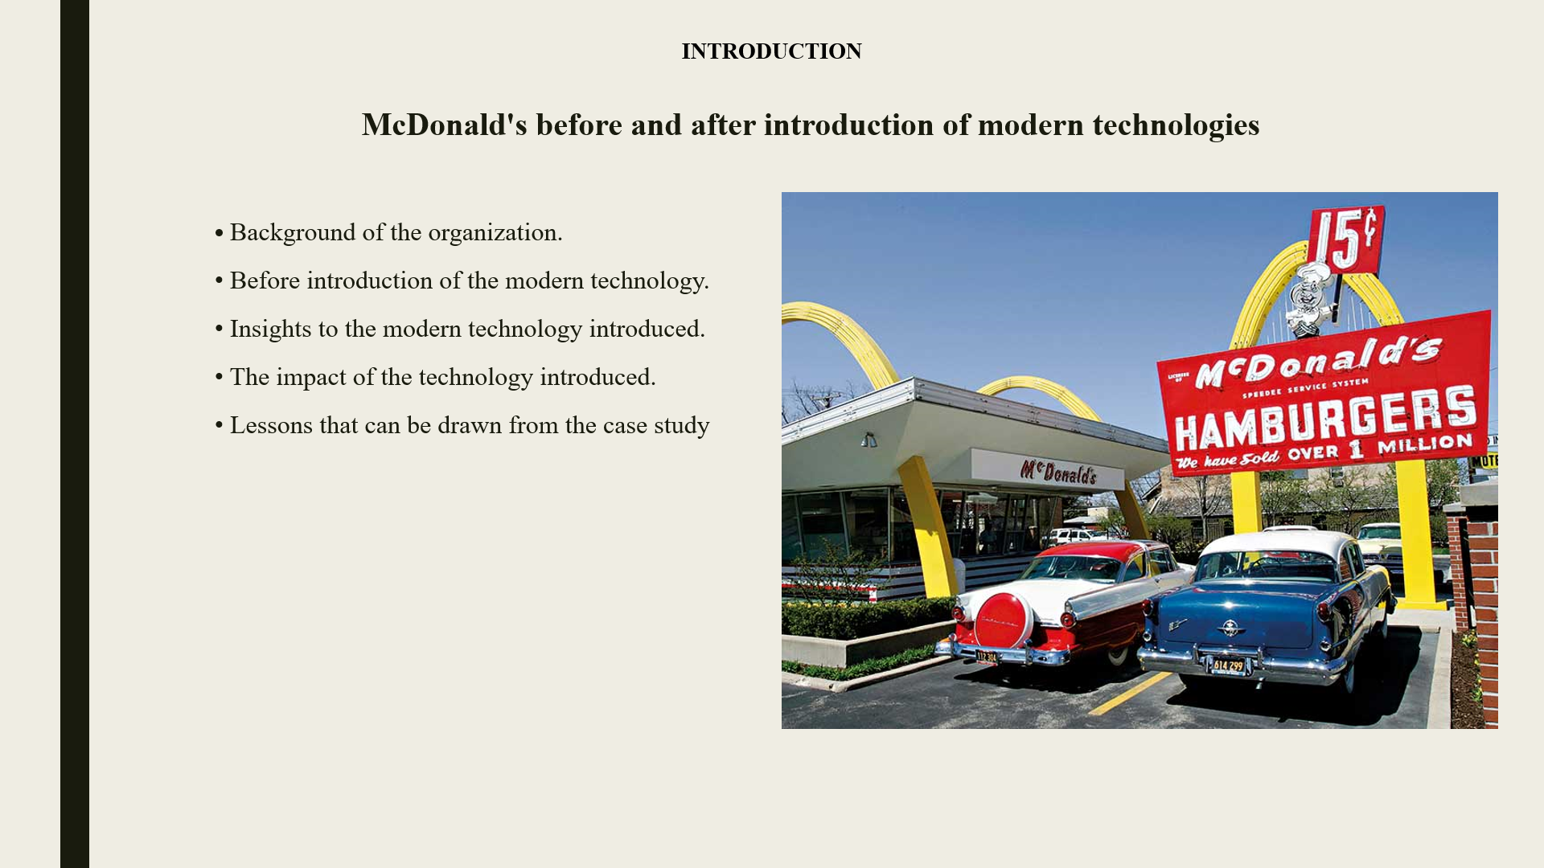

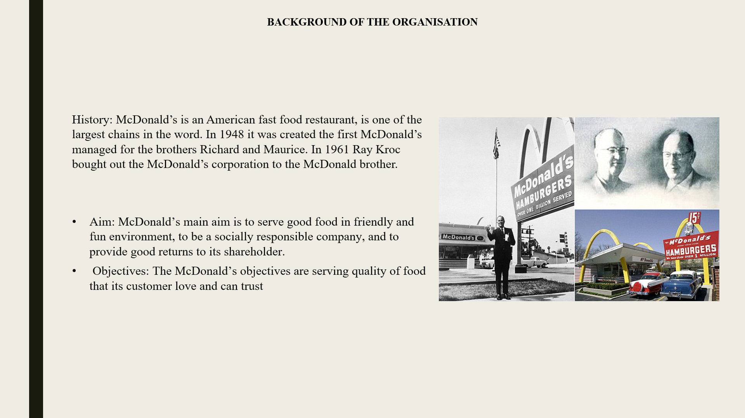
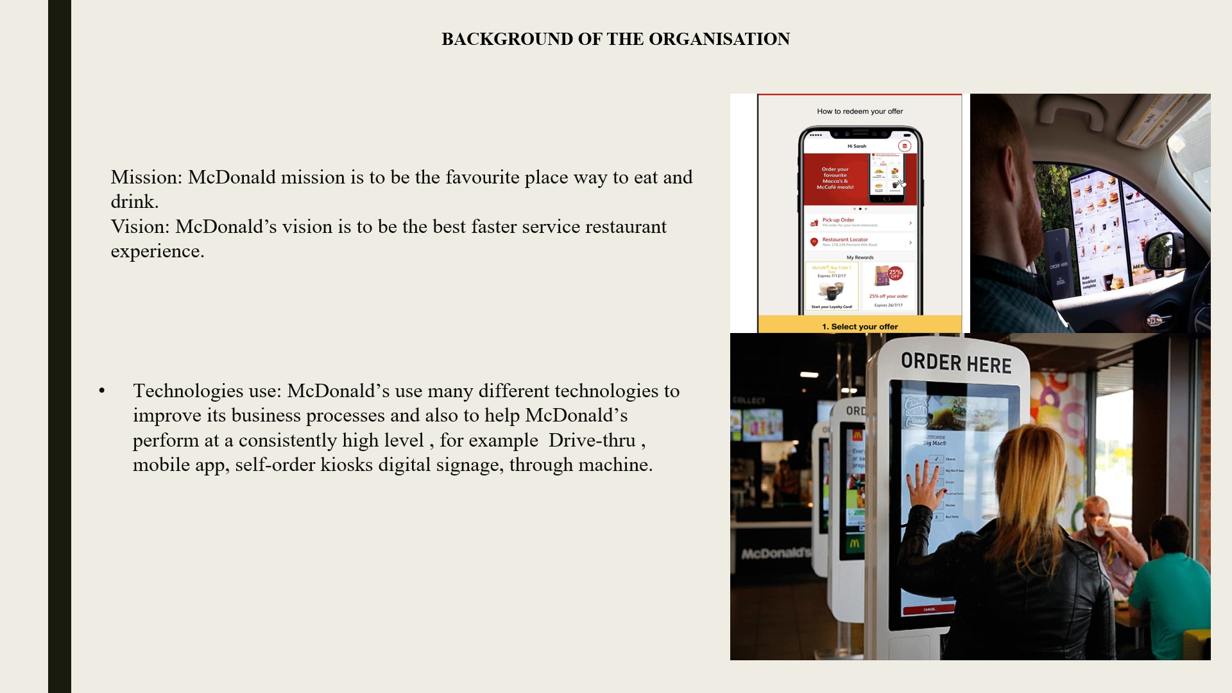

CHALLENGES BEFORE INTRODUCING MODERN TECHNOLOGY BY NATALIA CASTANO (1917106)

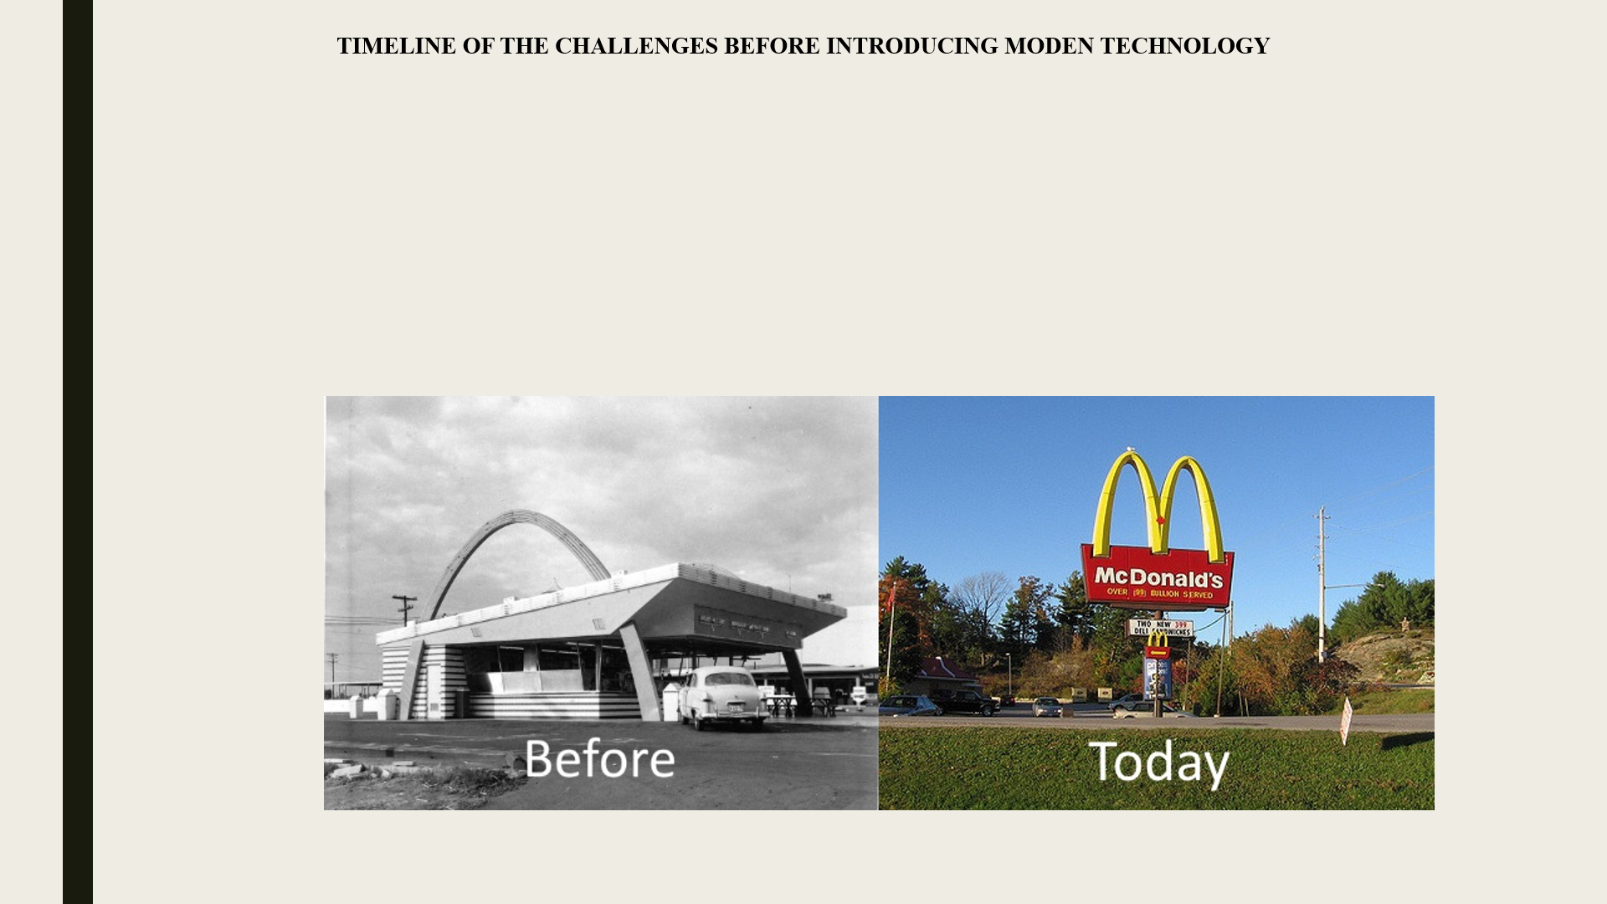

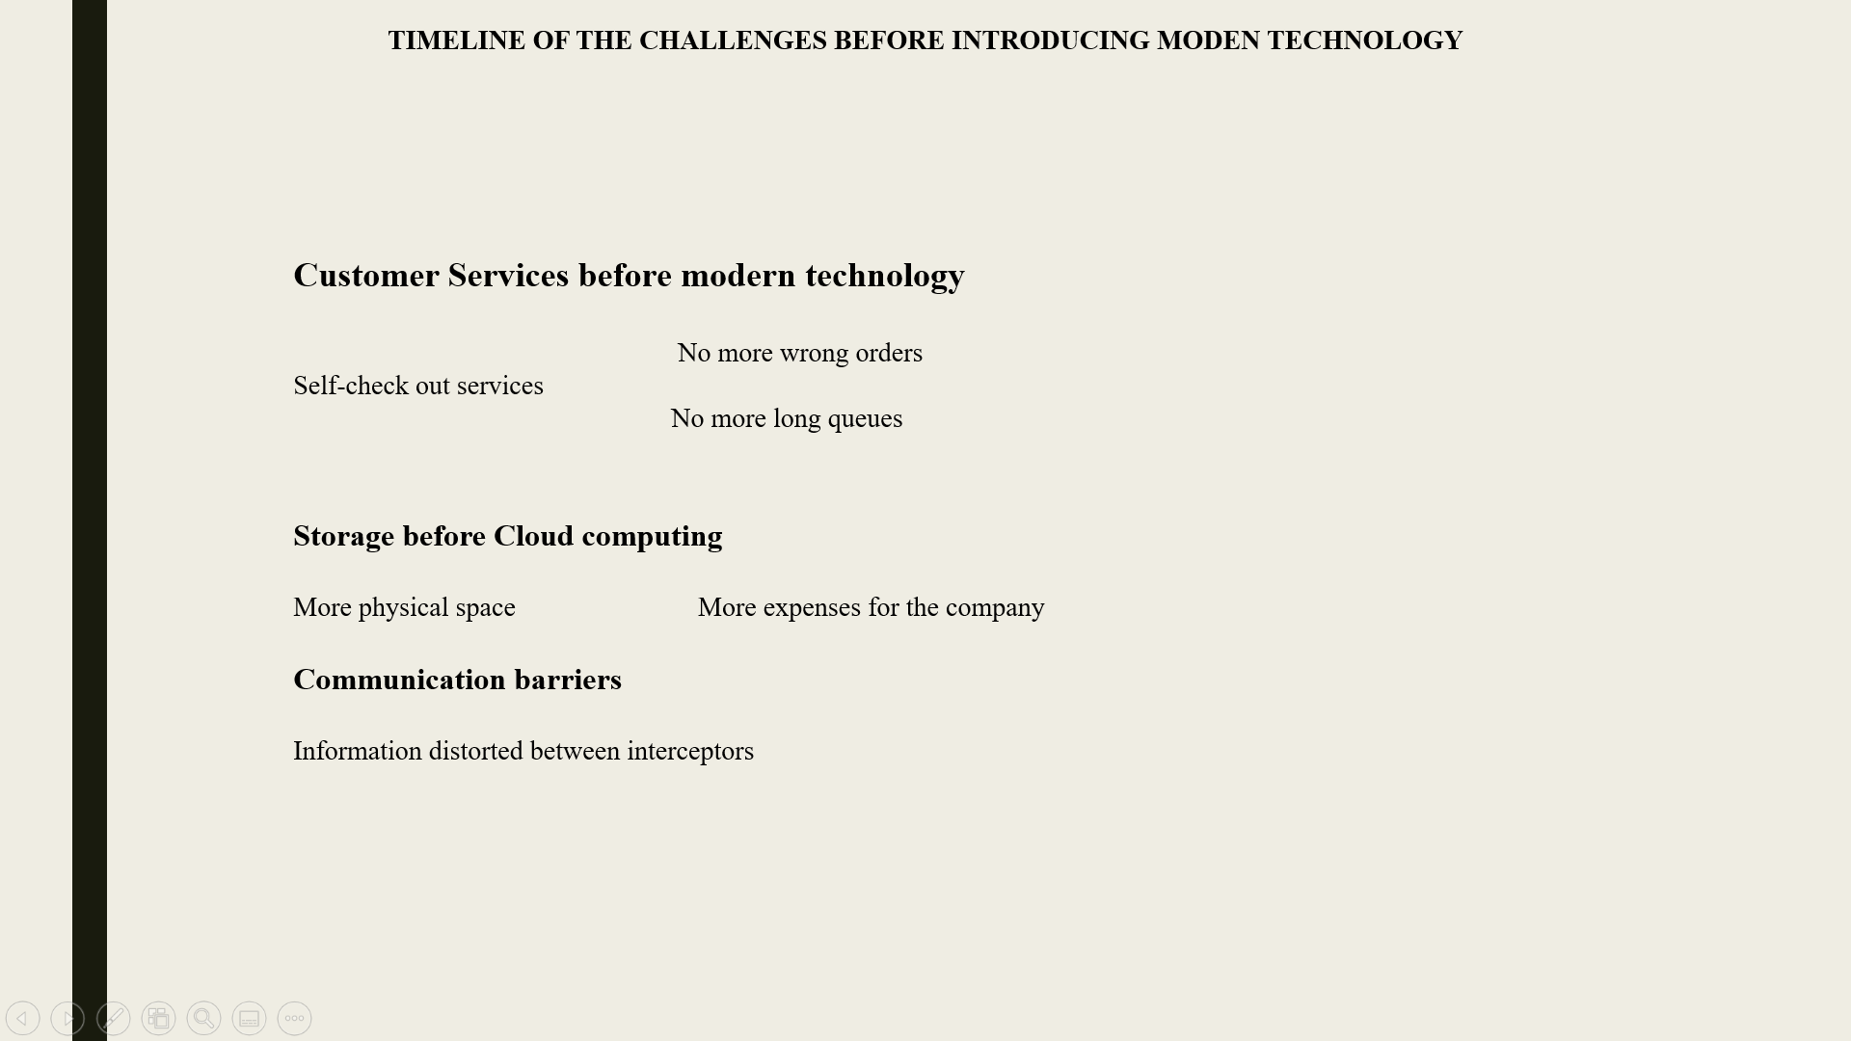

INSIGHTS OF MODERN TECHNOLOGY INTRODUCED BY JEAN-LAURENT ZANMENOU (1916071)

IMPACTS OF MODERN TECHNOLOGY INTRODUCED BY YSMAEL RAMIREZ ASENCIO (1912612)
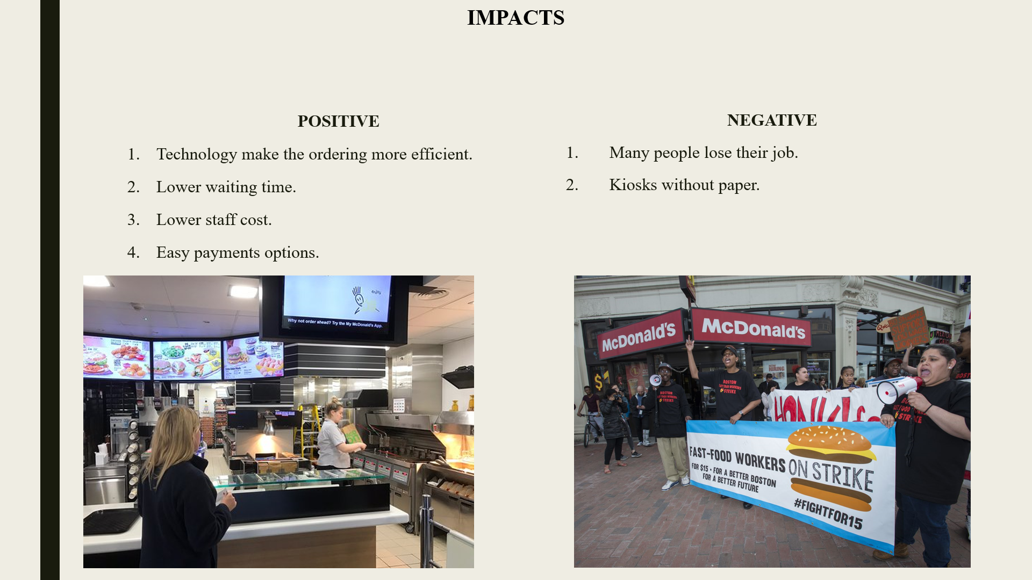

LESSONS DRAWN FROM THE CASE STUDY AND CONCLUSION BY RUGEYRO ARENAS (1916149)



