ACBA5010 BIM
Assignment 01. Letter to Client & Appended Outline BEP

Lecturer: Gavin Traylor
Student: Owen Brown (1901187)

Table of Contents
What is BIM? 2
The Benefits of BIM 2
BIM According to the ISO 19650 Maturity stage 2 3
Ensuring the Project Achieves BIM level 2 Maturity 4
1. Exchange Information Requirements (EIR) 4
2. BIM Execution Plan (BEP) 4
3. Common Data Environment (CDE) 5
4. Common Classification System 6
5. Construction-Operations Building Information Exchange (COBie) 6
6. Asset Information Model (AIM) 6
References 8
Appendices 10
Appendix 01. Outline BEP 10

Mr D Jones Owen Brown
Education Department UWTSD Construction
Civic Centre IQ Building
Oystermouth Road Kings Road
Swansea Swansea
SA1 3SN SA1 8EW

27 April 2021

REF: BIM Level 2. Ysgol Bae Abertawe

Dear Sir,

The purpose of this letter is to clarify what is meant by Building Information Modelling (BIM), explain the benefits of using BIM on built environment projects, and outline the measures that the project team for Ysgol Bae Abertawe will undertake to ensure the project achieves BIM level 2 maturity.

What is BIM?
BIM is a process, or a way of working, that is used to create and manage information on construction projects (NBS, 2016). Collaborative working practices supported digital technologies form the foundations of BIM, and enable buildings to be designed, created, and maintained in more efficient ways by embedding key asset and product data along with a 3D digital representation of the asset to effectively manage information throughout the stages (design, construct, operate, and decommission) of a project lifecycle (HM Government, 2012). Effective collaboration between the various project teams is achieved by sharing the project information in a single platform known as a ‘Common Data Environment’ (CDE) (Oracle, 2021). The CDE will be further explained later. In BIM level 2, each discipline works on a separate 3D model which is then fed into a federated model on the CDE (Saxon, 2016).
Since 2016 all centrally procured UK Government construction projects have been required to achieve BIM level 2, and this approach has been endorsed by the Welsh Government since 2013 through the Wales Construction Procurement Strategy (Constructing Excellence Wales, 2021).

The Benefits of BIM
BIM combines the endeavours of people, technology, and processes to add value to a project (NBS, 2016). The use of BIM also benefits construction projects by:

- Making processes faster and more efficient.
- Increasing productivity and delivery times.
- Reducing uncertainty.
- Calculating whole life costs and providing environmental data.
- Detecting clashes during the design stage.
- Improving on-site health & safety.
- Reducing construction generated waste.
(British Standards Institution (BSI), 2021a).

BIM According to the ISO 19650 Maturity stage 2
It is important to note that BIM level 2 maturity is a term that is used in BS1192 (2007) and PAS 1192-2:2013 (BSI, 2019). PD 19650-0:2019 states both documents have been withdrawn and were superseded in 2019 by the new ISO 19650 suite of international standards for BIM (Figure 1) (BSI,2019).
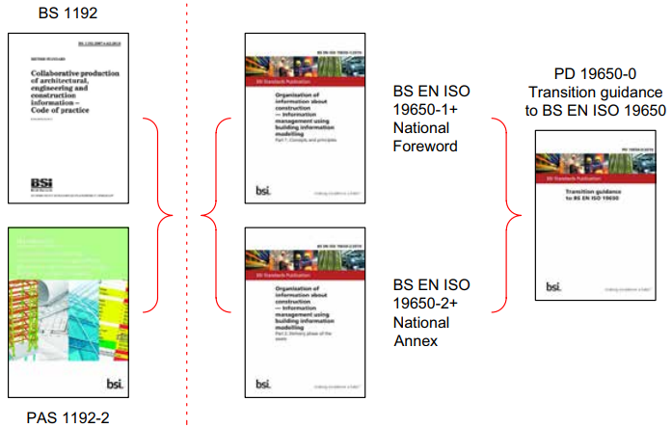
Figure 1. New International Standards for BIM (BSI, 2019).
To assist the transfer to the new standards, and to ensure that BIM level 2 is within the ISO 19650 framework, the British Standards Institution has published a national annex containing UK specific content (Walters, 2018). PD 19650-0:2019 also describes how under the new standards, what was previously referred to as BIM level 2, is now termed as BIM according to the ISO 19650 series, maturity stage 2 (BSI, 2019).

It could be argued that BIM level 2 and BIM maturity stage 2 are essentially one and the same. To avoid confusion between ISO 19650 BIM maturity stages, and the RIBA Plan of Work 2020 stages, the term BIM level 2 will be used in this letter.
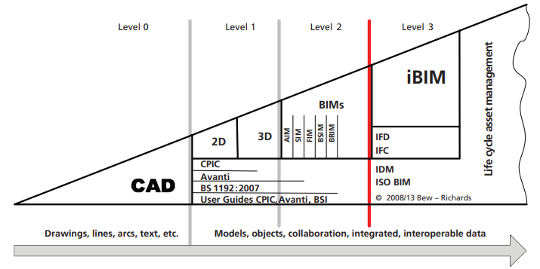
Figure 2. BIM Maturity Levels Described in PAS 1192-2:2013 (BSI, 2019).
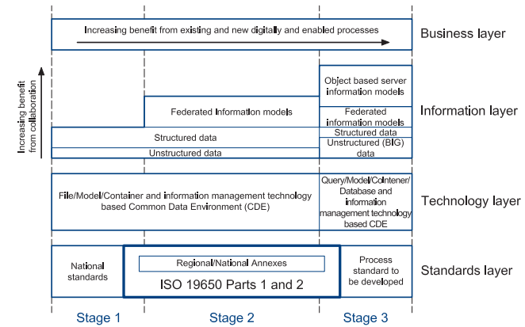
Figure 3. BIM Maturity Stages Described in PD 19650-0:2019 (BSI,2019).

Ensuring the Project Achieves BIM level 2 Maturity
To achieve BIM Level 2 maturity, the Ysgol Bae Abertawe project must:
- Have an Exchange Information Requirements (EIR) document.
- Have a BIM Execution Plan (BEP) document.
- Use a Common Data Environment (CDE) and ensure data is shared securely.
- Use a common classification system.
- Provide the client with a Construction-Operations Building Information Exchange (COBie) spreadsheet and an Asset Information Model (AIM) at handover.
(Autodesk, 2016).

1. Exchange Information Requirements (EIR)
The EIR is created early in the project to define the requirements of the employer regarding the amount of information and the level of detail the project information model should contain at the end of each RIBA stage, and forms part of the tender documentation (Scottish Futures Trust, 2021). The EIR is used to establish who will be sharing information, what information will be needed, define why the information is needed, and state when the information will be needed by (Scottish Futures Trust, 2021).

2. BIM Execution Plan (BEP)
A pre-contract BEP is prepared by tenderers to set out their competence, capability, approach, and capacity to meet the requirements of the EIR, and should include a project implementation plan, goals for information modelling and collaboration, a deliverable strategy, and project milestones that mirror the project programme (Barnes and Davies, 2015). On award of a contract, the successful tenderer submits a more detailed post-contract BEP that defines exactly how the information requirements of the EIR will be met by including information such as the roles and responsibilities, processes for collaboration and modelling, file naming conventions, authorisation processes, software exchange formats etc (Barnes and Davies, 2015).
An outline BEP for the Ysgol Bae Abertawe project (file name: 5010-UWTSD-XX-XX-SP-Z-0001) has been appended to this letter. Please not that some of the information can not be completed until the EIR has been received.

3. Common Data Environment (CDE)
A CDE aids collaboration in a managed environment by collecting, managing, and disseminating the relevant project information from multidisciplinary teams (Adams, 2018). The CDE forms a single source of information, that includes the 3D model and all the non-graphical project information, that enables team members to work collaboratively and avoid errors and duplication (Barnes and Davies, 2015).

BS EN ISO 19650-1(2018) requires the information within the CDE to be held in one of four states and be reviewed/approved before it is able to transition to the next state (Figure 4). The states and transitions are as follows:
- The work in progress state - task teams develop information that is held in an information container and is not visible to other task teams.
- The check/review/approve transition – the originating task team compare the information container against the agreed standards, methods, procedures, and delivery plan.
- The shared state – the information containers are made visible in a read/view only format to the appointing party for approval, and to the relevant appointed parties to coordinate with their own information. Should editing be required then the container should be returned to the work in progress state.
- The review/authorise transition – The accuracy, coordination, and completeness of all the information containers is compared against the relevant information requirements. Any containers not meeting the requirements should be returned to the work in progress state.
- The published state – contains information that has been authorised to be used for construction or operation of the asset.
- The archive state – A journal of previously shared and published information containers from the project are then held in this state.
(BSI, 2018a).
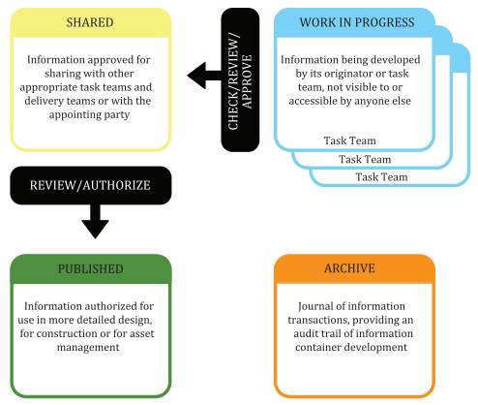
Figure 4. Common Date Environment (CDE) States and Transitions (BSI, 2018a).

Buildings are designed to last a long time, unlike the native software formats which due to updated versions can be difficult to open in as little as five years’ time, so it is recommend that all information from the published stage onwards is also available in a neutral format such as the Industry Foundation Class (IFC) to increase the longevity of the data (Institution of Structural Engineers, 2021). The Exchange formats for this project are listed in section 6.2 of the BEP.

The project data within the CDE must be shared in a safe and secure way. BS EN ISO 19650-5:2020 gives a framework to help organisations understand the security risks involved with sharing data on a CDE and provide solutions to reduce them to tolerable levels for the involved parties (Luck, 2020).

4. Common Classification System
Built environment projects generate large amounts of information that needs to be filed, retrieved, and referred to in a consistent and controlled way, and this is achieved by using a classification system which in the UK is Uniclass 2015 (UK BIM Alliance, 2019). Uniclass 2015 is unified classification system that can be used by all sectors of the construction industry to classify any sized item, from a University campus to a floor tile (Delany, 2017). In the UK, each information container must also have a unique ID that follows the naming conventions set out in the national annex to BS EN ISO 19650-2:2018 (BSI, 2018b).

5. Construction-Operations Building Information Exchange (COBie)
When a project nears completion, the updated information within the CDE will develop to represent what has been built and will be handed over to the client, and COBie is the exchange schema that the UK government have chosen to assist the client Facilities Management (FM) team with the Operations and maintenance (O&M) of the asset (Adams, 2018). Receiving boxes of paper drawings and bulky O&M manuals was the traditional way for the client to receive the asset information at handover, which could take countless hours to transfer into Computer Aided Facilities Management (CAFM) systems, but many CAD systems can now create and directly export building handover information via a spreadsheet in the UK COBie format, and a model in the neutral IFC format (Adams, 2018).

6. Asset Information Model (AIM)
The AIM is a single source of information (containing documentation, non-graphical data, and the federated building model) that has been approved and verified as a true representation of the as built asset, and is to be used by FM, end users, and clients in the Operation and Use stage (McPartland, 2017). The AIM will need to be updated throughout the lifecycle of the building following on from any works that affect the asset (BSI, 2021b). Planned or unplanned works during the operational phase are called trigger events (BSI, 2018a).

I hope that this letter has demonstrated the benefits of using BIM on construction projects and explained the steps that you and UWTSD Construction need to take in order for the project to comply with and achieve BIM level 2 maturity. If you have any queries or require further information, please do not hesitate to contact me.

Yours sincerely,


________________
Owen Brown
Lead Consultant
UWTSD Construction

References

Adams, J (2018) CPD: A Guide to Level 2 BIM. Available at: https://www.bimplus.co.uk/explainers/continuing-professional-development-guide-level-2-/ (Accessed: 27 March 2021).

Autodesk (2016) What is BIM Level 2? …Glad You Asked. Available at: https://bim360.autodesk.com/what-is-bim-level-2/ (Accessed: 27 March 2021).

Barnes, P. and Davies, N. (2015) BIM in Principle and in Practice. 2nd Ed. London: ICE Publishing.
BS 1192 (2007) Collaborative production of architectural, engineering and construction information. Code of practice. British Standards Institution.

British Standards Institution (2018a) BS EN ISO 19650-1:2018 Organization and digitization of information about buildings and civil engineering works, including building information modelling (BIM) - Information management using building information modelling. Part 1: Concepts and principles. British Standards Institution.

British Standards Institution (2018b) BS EN ISO 19650-2:2018 Organization and digitization of information about buildings and civil engineering works, including building information modelling (BIM) - Information management using building information modelling. Part 2: Delivery phase of the assets. British Standards Institution.

British Standards Institution (2019) PD 19650-0:2019 Transition guidance to BS EN ISO 19650. The British Standards Institution.

British Standards Institution (2021a) Building Information Modelling (BIM). Available at: https://www.bsigroup.com/en-GB/Building-Information-Modelling-BIM/ (Accessed 26 March 2021).
British Standards Institution (2021b) Little book of BIM. Available at: https://www.bsigroup.com/en-GB/Building-Information-Modelling-BIM/bim-design-and-construction/little-book-of-bim/ (Accessed: 29 March 2021).
Constructing Excellence Wales (2021) BIM. Available at: https://www.cewales.org.uk/current-programme/bim/ (Accessed: 27 March 2021).
Delany, S. (2017) What is Uniclass 2015? Available at: https://www.thenbs.com/knowledge/what-is-uniclass-2015 (Accessed: 29 March 2021).
HM Government (2012) Industrial strategy: government and industry in partnership. Building Information Modelling. Available at: https://assets.publishing.service.gov.uk/government/uploads/system/uploads/attachment_data/file/34710/12-1327-building-information-modelling.pdf (Accessed: 24 March 2021).

Institution of Structural Engineers (2021) An introduction to Building Information Modeling (BIM). London: The Institution of Structural Engineers.

Luck, A. (2020) ISO 19650-5: BIM: A security-minded approach to information management. Available at: https://shop.bsigroup.com/ProductDetail?pid=000000000030377794 (Accessed: 29 March 2021).

McPartland, R. (2017) What is the Asset Information Model (AIM)? Available at: https://www.thenbs.com/knowledge/what-is-the-asset-information-model-aim (Accessed: 29 March 2021).

NBS (2016) What is Building Information Modelling (BIM)? Available at: https://www.thenbs.com/knowledge/what-is-building-information-modelling-bim (Accessed 26 March 2021).
Oracle (2021) What is the common data environment (CDE) in construction. Available at: https://www.oracle.com/industries/construction-engineering/what-is-cde-and-bim/ (Accessed: 26 March 2021).

Saxon, R.G. (2016) BIM for Construction Clients. Newcastle upon Tyne: RIBA Enterprises.

Scottish Futures Trust (2021) Building Information Modelling. Stage 2 Concept. Create the Employers Information Requirements. Available at: https://bimportal.scottishfuturestrust.org.uk/level2/stage/2/task/8/create-the-employers-information-requirements (Accessed: 27 March 2021).

UK BIM Alliance (2019) Information management according to BS EN ISO 19650 Guidance Part 1: Concepts. Available at: https://www.ukbimframework.org/standards-guidance/ (Accessed: 29 March 2021).

Walters (2018) National Annex for BS EN ISO 19650-2 available for public comment. Available at: https://www.cdbb.cam.ac.uk/news/2018AugBSI_ISOTransition#:~:text=BS%20EN%20ISO,instead%20of%20employer%E2%80%99%E2%80%99 (Accessed: 26 March 2021).

Appendices

Appendix A. Outline BEP

UWTSD Construction Ltd

Outline Building Information Modelling (BIM) Execution Plan (BEP)

Project:
Ysgol Bae Abertawe

Project Number:
5010

File Number:
5010-UWTSD-XX-XX-SP-Z-0001

Revision | 01
Status | S0
Date Issued | 29/04/2021
Scale | NTS
Created by | OB
Checked by | OB
Approved by | OB
Sheet Number | N/A

Table of Contents
Amendment Record 2
1.0 Response to the EIR 3
2.0 Project Information 4
3.0 Management 5
3.1 Roles, Responsibilities, and Authorities 5
3.2 Major Project Milestones 5
3.3 PIM Deliverable Strategy 5
3.4 Survey Strategy 5
3.5 Existing Legacy Data 6
3.6 Approval of Information 6
3.7 PIM Authorisation Process 6
4.0 Planning and Documentation 7
4.1 Project Implementation Plan 7
4.2 Agreed Processes for Collaboration & Information Modelling 7
4.3 Task Information Delivery Plan 7
4.4 Master Information Delivery Plan 8
5.0 Standards, Methods, and Procedures 9
5.1 Volume Strategy 9
5.2 PIM Origin and Orientation 9
5.3 File Naming Convention 9
5.4 Layer Naming Convention 9
5.6 Drawing Sheet Templates 9
5.7 Annotations, Dimensions, Abbreviations, and Symbols 9
5.8 Metadata 9
6.0 IT Solutions 10
6.1 Software Versions 10
6.2 Exchange Formats 10

Amendment Record

Revision | Status | Notes | By | Date
01 | S0 | Outline BEP created. No EIR provided at this time | Owen Brown | 29/04/2021

1.0 Response to the EIR

This purpose of this BIM execution plan is to state how UWTSD Construction will meet the Information requirements listed in the following EIR:

Name | Revision
EIR has not been provided at this time | N/A

EIR  Section | Information Requirements | BEP  Section
Table 1. Directory of EIR Responses.

2.0 Project Information

Client | City and County of Swansea Council
Project Name | Ysgol Bae Abertawe
Project Number | 5010
Project Description | New build of 1FE infant school
Project Value | TBC
Procurement Route | Design & build
Contract Type | JCT Design and Build Contract 2016
Construction Start Date | TBC
Completion Date | TBC
Table 2. Project Information.

3.0 Management

3.1 Roles, Responsibilities, and Authorities

Role | Name | Company | Email & Phone
Client | David Jones | City and County of Swansea Council | d.jones@swansea.gov.uk  01792123456
Lead Consultant | Owen Brown | UWTSD Construction | o.brown@uwtsdconstruction.com  01792123457
Lead Designer | Jeff Jones | UWTSD Construction | j.jones@uwtsdconstruction.com  01972123458
Construction Manager | Tom Jones | UWTSD Construction | t.jones@uwtsdconstruction.com  01972123459
Table 3. Project Contact Information.
Authorities and responsibilities will be assigned to the above individuals when the EIR has been responded to.

3.2 Major Project Milestones

The major project milestones are aligned with the end of stages 0 to 6 of the RIBA Plan of Work 2020. With additional major project milestones during the manufacturing and construction phase. All project milestones will be listed in the Master Information Delivery Plan (MIDP) after the EIR has been responded to.

3.3 PIM Deliverable Strategy

At each major project milestone, the following deliverables will be exchanged (if available).

Graphical Models | Native models from task teams.  Federated IFC Model.
Documentation | Site plans, Floor plans, Sections, Elevations.
Non-graphical Data | Federated COBie.
Table 4. PIM Deliverable Strategy.

3.4 Survey Strategy

Survey Method | Delivery Format | Details, Notes:
GNSS Survey | DWG | Layers to comply with Uniclass 2015 & BS EN ISO 13567-2
Table 5. Survey Strategy.

3.5 Existing Legacy Data

Information provided and defined in the EIR will be integrated into the information model.

3.6 Approval of Information

The suitability of any information will be approved by the person identified in section 3.1 by undertaking the steps below:

1. Check that the deliverable complies with the standards, methods, and procedures in section 4.
2. Check that the dimensions of the deliverable are accurate (if applicable).
3. Check the spatial coordination of the deliverable (if applicable).
4. Check that there is sufficient attribute data in the deliverable.
5. Sign the ‘Checker’ box.
6. Check that the deliverable satisfies the purpose of issue.
7. Update the suitability code.
8. Update the revision code.
9. Sign the ‘Approver’ box.

3.7 PIM Authorisation Process

The following steps will be taken by the person responsible for reviewing supplier information prior to authorisation:

1. Confirm that the deliverable has been assessed against the IT constraints listed in the EIR.
2. Check that the deliverable meets the requirements of the Exchange of Information table in the EIR.
3. Review the appropriateness of the deliverable against the Client Strategic Purposes in the EIR.
4. Update the suitability code.
5. Update the revision code.

To prevent delays in the project programme, all information will be authorised within 5 working days of issue.

4.0 Planning and Documentation

4.1 Project Implementation Plan

BS EN ISO 19659 (2018) 5.3.3 requires the capability and capacity of task teams to be assessed. This has been achieved by each task team completing supply chain capability that assesses their BIM, IT, and resources to ensure they meet the requirements of the project.

Supplier/  Task Team | Discipline | Level of  Competence | Experience  (Years) | Name
UWTSD Construction | Architect | RIBA.  CAD & BIM Trained | 25 | Jeff Jones
UWTSD Construction | Architectural Technologist | CIAT  CAD & BIM Trained | 7 | Fred James
UWTSD  Construction | Site Manager | MCIOB  Using BIM on all projects since 2015 | 20 | Tom Jones
UWTSD Construction | Quantity Surveyor | FRICS | 30 | Jane Jones
Swansea Structural Services | Structural Engineer | MIStuctE  CAD & BIM Trained | 21 | Kate Jones
Swansea M&E | Mechanical & Electrical Engineer | MCABE | 15 | Jack Jones
Table 6. Project Implementation Plan.

4.2 Agreed Processes for Collaboration & Information Modelling

BS EN ISO 19650-2 (2018) 5.1.7 requires a Common Data Environment (CDE) to be set up by the appointing party to meet the projects needs and support collaboration.

Autodesk BIM 360 will be used as the CDE to store all Graphical Models, Non-graphical Data, and documentation for this project.

Autodesk BIM 360 will also be used for clash detection.

4.3 Task Information Delivery Plan

BS EN ISO 19650-2 (2018) 5.4.4 requires each task team to establish and maintain a Task Information Delivery Plan (TIDP).

The TIDP’s for this project will be added to the BEP after the EIR has been received.

4.4 Master Information Delivery Plan

BS EN 19659-2 (2018) 5.4.5 requires the lead appointed party to receive the TIDP’s from each task team and compile them into a Master Information Delivery Plan (MIDP).

The MIDP for this project will be appended to this document when all of the TIDP’s have been received.

5.0 Standards, Methods, and Procedures

5.1 Volume Strategy

No volume strategy has been assigned to the project.

5.2 PIM Origin and Orientation

Point | Northing | Easting | Elevation
Survey point | 192364.7 | 265976.9 | 0.0
Project base point 1 | TBC | TBC | TBC
Project Base Point 2 | TBC | TBC | TBC
Table 7. PIM Origin and Orientation.

5.3 File Naming Convention

Information containers will be identified using the naming convention set out in BS EN ISO 19650-2 (2018) National Annex.

5.4 Layer Naming Convention

CAD layers will be named according to the conventions set out in BS EN ISO 13567-2 (2017).

5.6 Drawing Sheet Templates

All deliverables for this project must be submitted on an A0 and A1 drawing sheet that has been rendered with the UWTSD title block.

5.7 Annotations, Dimensions, Abbreviations, and Symbols

All dimensions, symbols, and annotations used in this project will comply with BS 8541 (2011) parts 1 to 4.

5.8 Metadata

Information containers will be identified using the naming convention set out in BS EN ISO 19650-2 (2018) National Annex.

6.0 IT Solutions

6.1 Software Versions

Deliverable will only be generated using the software below.

Company | Use | Software | Version
Autodesk | Creating 2D models | AutoCAD | 2020
Autodesk | Creating 3D models & creating drawings | Revit | 2021
Autodesk | IFC exports & federation | BIM 360 | 2021
Autodesk | Common Data Environment | BIM 360 | 2021
Table 8. Project Software.

6.2 Exchange Formats

The authorised exchange formats for the project are.

Export Software | Version | Format
AutoCAD | .dwg | 2020
Revit | .rvt | 2021
BIM 360 | .ifc | 2021
BIM 360 | .xls | COBie-UK 2012
BIM 360 | pdf | 2021
Table 9. Exchange Formats.

