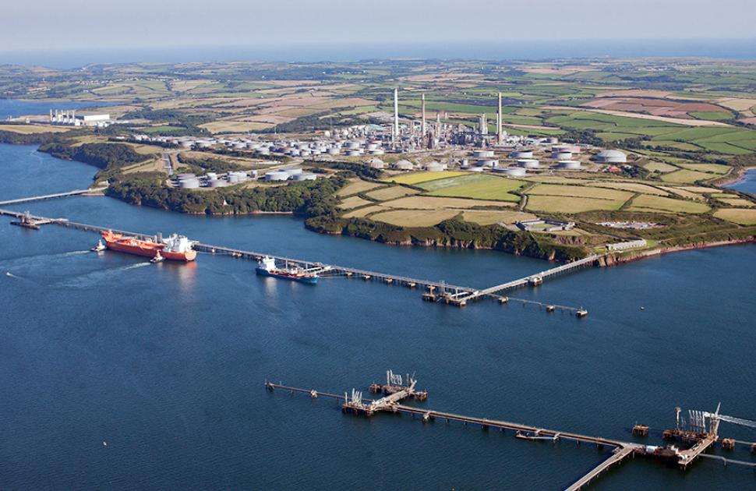

Process engineering practice – Hnc process operations
By Mark Jones

Contents Page

Introduction ……………………………………………………………………………….. Page 2
Task 1……………………………………………………………………………………… Page 2-4
Task 2……………………………………………………………………………………… Page 4-6
Reference Page……………………………………………………………………………. Page 7

Introduction

Throughout this assignment I will be talking about steam turbines on Valero oil refinery in Pembroke. I will be discussing the need for turbines, components of the turbines and also safety systems of turbines. The second part of the assignment I will be talking about the units that are located on the oil refinery.

Task 1

Throughout the oi refining industry, there are multiple types of process equipment and various types of machinery that are used to assist the process and ensure it is as efficient as it possibly can be. These pieces of equipment are used in synchronisation to ensure the process operates smooth and efficiently, ensuring product is as effective and to the best spec it can be.

What is a steam turbine?

A steam turbine is a piece of equipment used to provide kinetic energy to a pump within a process line, in order for the system to flow from one location to another. The steam for a turbine comes from heating water using natural gas in an industrial boiler. The steam is then transferred through the steam header to its different locations around site. In this instance it is a turbine and more specifically the high-pressure system of the turbine. The high-pressure system allows steam to go through and hit the rotor of the turbine, thus causing the vanes to spin and causing the turbine to spin too.
The shaft of the turbine is always connected to another device, such as a pump to allow generation of energy and allows for the process to flow.

Components of a Steam Turbine

There are many components to a steam turbine, most steam turbine are the same however some differentiate depending on the requirement and need of that particular turbine. The main components of a turbine are:

- Bearings – white metal bearings are the most common type of bearings used in steam turbines, this is due to the load capacity the bearings can withhold. The bearings are simple to change if needed and easy to test, using blue dye. The blue dye detects any scratches or damage internally to the bearings that the human eye may miss.
- Shaft – The shaft is attached to the rotor and is one of the main components of a turbine. This is effectively the power of the turbine which increases the speed of the pump. Shafts require a thorough balancing inspection before being fitted, this is so that the shaft will not vibrate excessively, thus causing the turbine to be less efficient.
- Governor – This is at the front of the turbine and is a separate component bolted to the turbine. The governor attaches to the turbine through a tschan coupling. The governor is used to control the speed of the turbine.
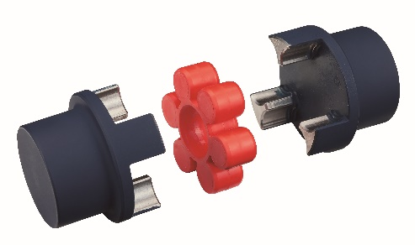
A Tschan Coupling.

- Coupling – A coupling connects the turbine to a further piece of equipment such as a pump. This transfers the force of movement from the turbine to the pump, thus causing a flow to occur. A coupling has membranes inside of it, so if a certain RPM is exceeded the membranes snap causing the coupling to break and the rotation to be cut.
- Rotor – The rotor is used to catch the steam and spins the shaft. The rotor blades are commonly angled, to give the correct angle to cause the spin to occur.

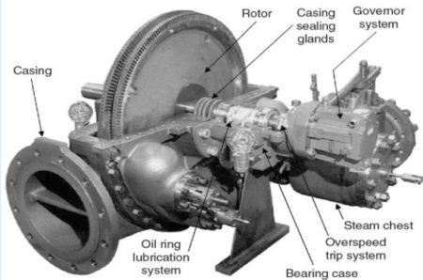
The image is a labelled diagram of a steam turbine.

As already mentioned, the principle of a steam turbine is to generate steam from high pressure (450lbs) through the rotor, spinning the rotor and generate movement. The steam then exits the low pressure (40lbs) side of the turbine and off back into the header to be recycled.

At Valero oil refinery, a turbine and pump set up is extremely common on all units, these set ups are used to pump:

- Cooling water around the units
- Product from tanks
- Finalised product to tanks
- Product to strippers to allow the product to be process

As steam turbines required dry superheated steam, this means that there are several issues that can arise with the turbines, which can cause them to fail. The biggest cause can be down to wet steam. This occurs mostly when the turbine starts up. It is imperative the turbine is drained and hot dry steam is coming out the drain before it is started up. Wet steam causes excessive vibration to pipes and the turbine, potentially causing rupture and can even cause damage to the rotors and insides of the turbine as rusting occurs.

Conditions that can lead to failure

Various aspects of a steam turbine must be monitored to ensure a chance of failure does not occur. This is pivotal from the smallest of failures occurring to the biggest occurring. This includes:

- Oil condition – The oil within a steam turbine must be checked every shift, to ensure it is clean, the correct colour and also no water in the sediment pot. Water causes the bearings to fail and the amount of water the bearings are subject to, depends on the speed the bearings fail. A dark coloured oil can indicate that bearings have failed.
- Vibration and temperature monitoring – Vibration and temperature checks are commonly used to ensure early detection of issues is identified, which minimises larger issues occurring.
- Working speed – a yearly PM is carried out on all turbines, to deduce any issues, part of the procedure is to check the running speed is correct, to ensure no over pressure of the turbine occurs or increase in flow, causing component failure.

Ways to eliminate the risk

Steam turbines pose hazards, which can cause severe injury to an individual. They also pose risks which can have a massive impact on the process as a whole. There are ways in which these hazards can be minimised so the risk is vastly reduced. This includes:

- PSVs – Pressure Safety Valves, if the pressure in the turbine gets too much, i.e too much pressure of steam, then a PSV will relieve the steam atmospherically and reduce the pressure to normal.
- Coupling guards – these are used to protect the coupling from any unwanted objects and more importantly protect anyone from putting their hand near a fast-rotating shaft.
- Cut ins – some turbines (depending on the importance) will have an automatic cut in installed, meaning that if the turbine trips, then the spare will automatically cut in and the process will not be greatly affected.
- Sensors – some turbines have particular sensors fitted to them, so that if the turbine exceeds its normal parameters or its SOL (Safe Operating Limit) it will cut out safely, without the operating needing to be in the dangerous area.

Task 2

Valero oil refinery produces a lot of product on a 24:7 basis. This means that there are different units, used for different aspects of the process. This process is used to get products to a certain spec and quality, in order for them to be sold on and used for further products. These units are all made up of vessels and equipment specifically designed so that the unit carries out the requirement the product needs to reach.

The main units that I will be discussing are the hydrotreater unit and the unifiner unit. These are two units based on the ‘white oils’ area of the refinery. Both units used hydrogen, along with an incoming feed, to produce further products which ‘purifies’ that product.
The unifiner feed is naphtha. Naphtha is mixed with hydrogen in a surge drum to remove the following ‘impurities’:
- Nitrogen and hydrogen = Ammonia
- Oxygen and hydrogen = H2O (Water)
- Sulphur and hydrogen = H2S (Hydrogen Sulphide)

The naphtha and hydrogen mixture then enter a stripper, which removes the impurities. This is done by reducing the pressure, which separates all of the mixture. The gasses (H2S and ammonia) will leave the top of the stripper, water will drain out of the sour water boot and then the remaining naphtha that is left over, will then split, so it can be sent through the splitters. The splitters split the naphtha into light and heavy. Light naphtha goes to the isomerisation unit and the heavy naphtha goes to the platformer.

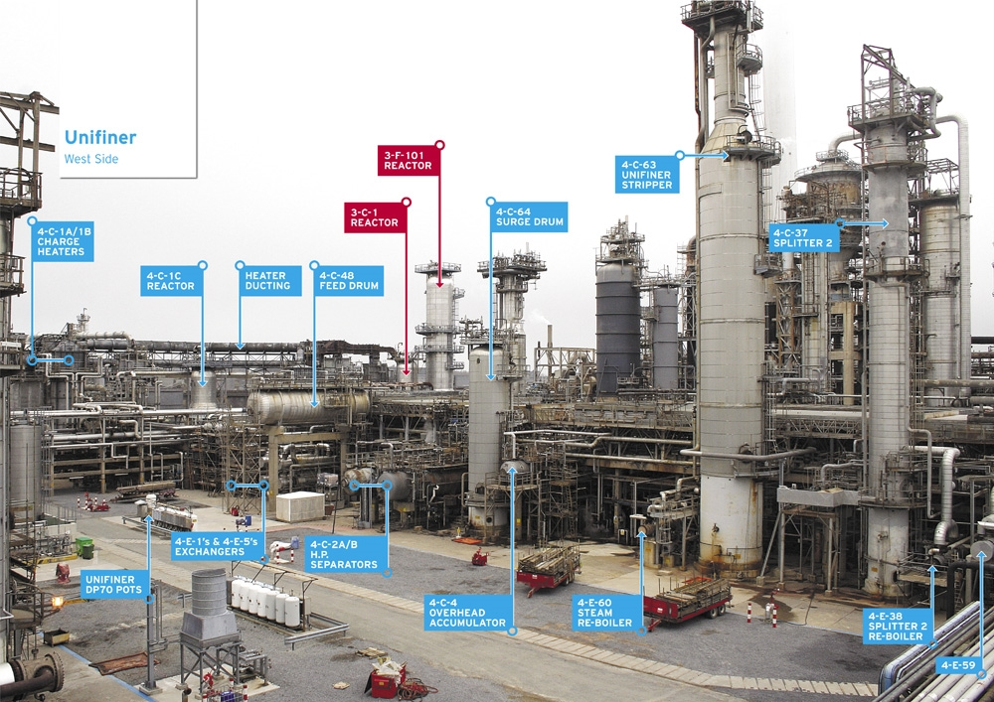

The image above is of the unifiner, located at Valero oil refinery.

The Hydrotreater 1 unit, is a unit with the same principle as the unifiner, in the way that it combines hydrogen with a feed product to remove impurities. The main feed for the hydrotreater unit is Diesel or Kerosene depending on the requirement of the product. The common feed is diesel, this is combines with hydrogen from the unifiner in the surge drum. This then creates:

- Nitrogen and hydrogen = Ammonia
- Oxygen and hydrogen = H2O (Water)
- Sulphur and hydrogen = H2S (Hydrogen Sulphide)

There is then a reaction called, hydrodesulphurisation. This is where the sulphur within the diesel combines with hydrogen, over a catalyst to create H2S. The mixture is then sent through two vessels at different pressures, in order achieve different outcomes. The reason for the first vessel is to remove any hydrogen form the system and recycle it around. The second vessel is used at a lower pressure to remove the impurities mentioned.
Once the mixture has been through the high pressure and low-pressure vessels, the final part of the process is to go through the re-run column, which is essentially a stripper column. This removes any final impurities or H2S that could be left tailgating in the line. This is a lower pressure again.

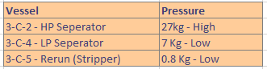
The table above shows the 3 main vessels within the Hydrotreater unit and the different pressures they operate at, in order to remove the H2S.

Once the product has left the rerun column, it will then transfer to off plots, so it can be stored safely ready for it to be distributed to required personnel.

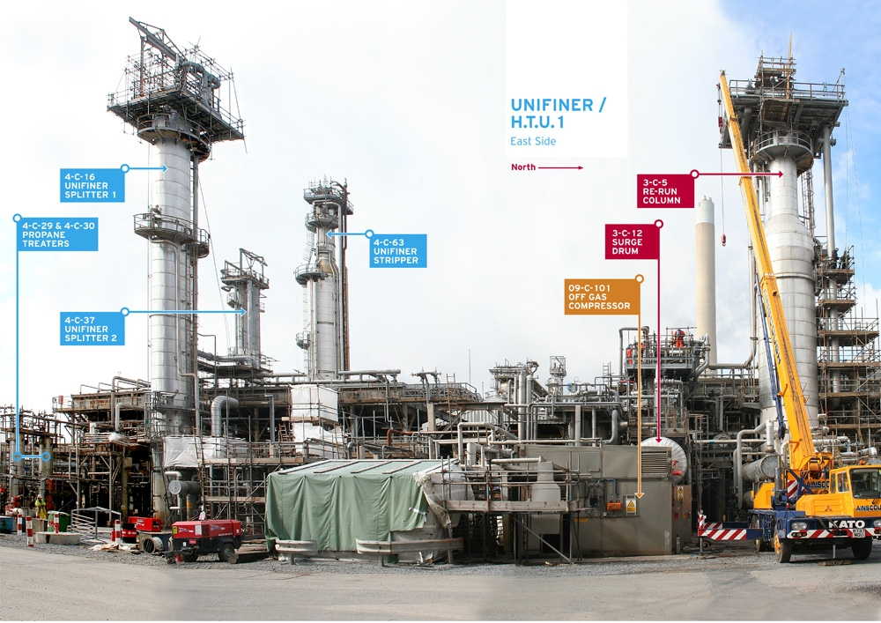

The image above is of the Hydrotreater 1 unit. There are 2 Hydrotreaters at Valero oil refinery in Pembroke.

Overall, at Pembroke refinery, there are many aspects that are added together in order for the process to be adequate, efficient and on spec. one little error within the process, means the process can be affected for days on end, with mass wastage occurring. An example of this could be a heater on a unit tripping. If this occurs it could become a major issue if an adequate operator is not on hand to restart the unit and if it is not done quickly and correctly, it can cause further issues within the unit or along for further units. Another issue could be if a pump trips, albeit the pump tripping briefly. This means a pressure decrease occurs, thus causing the system to fail and become off spec.

It is critical that operators at Valero oil refinery receive the correct training and are confident in carrying out troubleshooting on the unit. This is to avoid mass wastage and ensuring product is created safely and efficiently.

References

Mitsubishi. (2022). TSCHAN™Coupling. [Online]. Mitsubishi. Available at: https://www.mitsuboshi.com/products_search_en/general/item_22 [Accessed 25 April 2023].

. (2018). THE PRIME MOVERS/DRIVERS KNOWN AS STEAM TURBINES. [Online]. Process Tech Academy. Available at: https://www.processtechacademy.com/the-prime-movers-drivers-known-as-steam-turbines/ [Accessed 25 April 2023].

Mark Jones. (2023). Responsibility, Operational and Maintenance Acitivies. [Online]. .. Available at: . [Accessed 26 April 2023].

Valero Oil Refinery. (2020). Pembroke Refining. [Online]. .. Available at: https://refining.valero.com/en-us/pembroke/Pages/Departments/Refining/DepRef-Unifier.aspx [Accessed 26 April 2023].

Valero Oil Refinery - Pembroke. (2020). Hydrotreater 1. [Online]. .. Available at: https://refining.valero.com/en-us/pembroke/Pages/Departments/Refining/DepRef-Hydrotreater-1.aspx [Accessed 26 April 2023].

