The Serpent and the Woman in Genesis 3

The narrative of the Woman and the Serpent in Genesis 3 has been interpreted from the perspective of the Serpent and its role in manipulating the Woman to commit what is now regarded as the ‘original sin’ and on the other hand it has been interpreted from the view point of the Woman or Eve, that is was she who gave into temptation from the serpent but also convincing the Man or Adam to also disobey the orders that were given to them by the Lord, as the Lord provided them with food in the Garden of Eden but he instructed them that they shall not eat from the tree in the middle of the Garden.
How the Woman is represented in Genesis 3.
Eve was created to be a companion to the man, Adam, where he was put under a deep slumber and Eve was created from one of his ribs. Once created the Lord allowed Adam and Eve to all the food and resources that was before them in the Garden of Eden, however he forbade them from eating the fruit from the tree in the middle of the garden and further instructs them that they shall not touch it or they will die. Woman is manipulated and deceived into eating the fruit from the forbidden tree as the serpent entices her that eating from the tree will open one’s eyes and make them like God. Tempted by the Serpents words the Woman saw that the fruit was good to eat and she ate. The way that the Woman is represented in Genesis 3 is that she was manipulated and deceived by the serpent, the chapter makes no mention of the man however it does state the she gave the fruit to her husband after she consumed one. It further portrays the woman in a negative light when God is made aware of the transgression that the humans he created have committed. The Lord questions them if they have eaten from the tree from which he forbade and the man replies “The woman whom you gave to be with me, she gave me fruit from the tree, and I ate”, this portrayal of the woman in Genesis 3 conveys the message that women in nature are susceptible to temptation, deceitful and their actions are motivated purely by their self-interest and that man should protect themselves from the manipulative ways of the woman. Upon punishment the Lord said to the woman: “I will greatly increase your pangs in childbearing; in pain you shall bring forth children, yet your desire shall be for your husband, and he shall rule over you”, the punishment carried out by the Lord where the woman is to be inferior to the man is highlighted by Witcombe:
“For I do not allow woman to teach, or to exercise authority over men; but she is to keep silent. For Adam was formed first, then Eve. And Adam was not deceived, but the woman was deceived and became a transgressor. (1 Timothy 2:21-14)
Some bible verses have taken the blame off Adam and put it solely on Eve indicating that women were seen as inferior to men due to the actions of Eve and eating the fruit.

How the Serpent is represented in Genesis 3
The representation of the serpent is very much that of a manipulator and deceiver, as stated in Genesis 3 the serpent was crafty than any other animal that was created by God in the Garden of Eden highlighting his manipulative ways. The serpent entices the woman that by eating from the tree that God forbade the humans from taking fruit from would allow them to become like the Lord himself. It is through the use of these promises of becoming god-like that the serpent was able to take advantage of the woman’s curiosity and maybe selfishness that he was able to get the woman to eat from the forbidden tree. While the serpent did indeed deceive the woman into committing transgression, both the man and the woman did become god-like, they were now aware that what they had done was evil and they were able to make the distinction between the two (Good and Evil), by eating the fruit they’re eyes were opened as they now acknowledged that they were both naked and they felt shame. The serpent not only played to role of a deceiver but he was also responsible for the transition of human nature, by deceiving the woman, the humans were banished from the Garden of Eden and endured pain and labour but despite that the man and woman gained knowledge as they were enlightened and able to feel emotions such as joy. The serpent’s actions benefitted and disadvantaged humans.

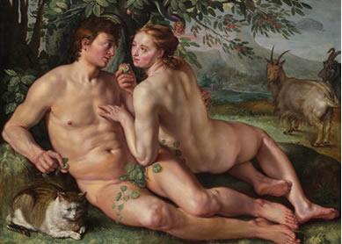
The representation of the woman and the Serpent in Art
The representation of Eve in art is often that in a negative way, she is often depicted in art as seducing Adam into committing sin alongside her. Tertullian as often denounced Eve as “the devil’s gateway” and has accused not only defying God but also manipulating Adam to disobey God also. This portrayal of Eve persuading Adam to commit sin along with her is depicted in Hendrick Goltzius’s The Fall of Man (1616), where Eve is portrayed attempting to seduce Adam as she has her hand of his chest seductively and gazing longingly in his eye while she holds the fruit in front of his face to entice him to eat it. It should be noted that in the art piece that the serpent is depicted with the head of a woman further reinforcing the negative portrayal of eve.
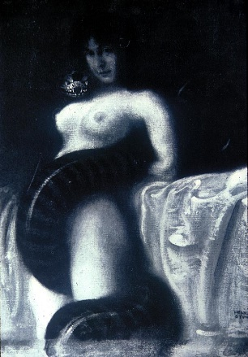
In some art pieces Eve and the Serpent are merged into one. An example of such would be this art piece by Franz von Stuck, entitled Sensuality. The image depicts a serpent coiling around a woman who stares seductively alongside with the serpent at the viewer. This again reinforces the negative light that Eve is portrayed in art as it illustrates women as a temptress to get men to do something by using her sexuality. The use of sex is illustrated in Von Stuck art piece as the serpent coiling between the legs of the woman represents as Phallus. Eve is as much seduced by the Adam’s “serpent” while he is seduced by Eve’s “apple”. Using sexuality, it links back to how Eve is portrayed as the villain in disobeying God, by using her sexuality she is able to seduce Adam is committing sin with her.

Bibliography

Adam and Eve, The Iconography: http://www.christianiconography.info/adamEve.html.
Doretta Cornell, M., Mother of all the living: Reinterpretations of Eve in Contemporary Literature http://web.a.ebscohost.com.ezproxy.uwtsd.ac.uk/ehost/pdfviewer/pdfviewer?vid=1&sid=4dc06dd9-8822-4a44-8ea6-cf1c8e0faca9%40sessionmgr4008.
Goltzius, H., The Fall of Man, 1616. National Gallery of Art, Washington, D.C. (Image).
Holy Bible with Apocrypha, NRSV.
Meyers, C., Rediscovering Eve: Ancient Israelite Women in Content, (Oxford Scholarship online, May 2013).
Sanders, T., Eve in Art: https://www.bibleodyssey.org/en/people/related-articles/eve-in-art.
Steadman, J. M., “Sin” and the Serpent of Genesis 3 “Paradise Lost”, (University of Chicago Press) http://www.jstor.org/stable/434976.
Von Stuck, F., Sensuality, 1891, Collection Abraham Somer, Los Angeles (Image).
Witcombe, C., Eve and the Identity of women: http://witcombe.sbc.edu/eve-women/.

Genesis. 3:3.
Gen. 2:21-22.
Gen. 3:2-3.
Gen. 3:4-5.
Gen. 3:6.
Gen. 3:12.
Christopher L. C. E. Witcombe, ‘Eve’s Identity http://witcombe.sbc.edu/eve-women/3eveidentity.html 14 March 2018.
Gen. 3:16.
C. Witcombe, ‘Eve’s Identity’, http://witcombe.sbc.edu/eve-women/3eveidentity.html 14 March 2018.
Gen. 3:7-10.
Ronald. Hendel, ‘Was the Snake in the Garden of Eden Satan. https://www.huffingtonpost.com/ronald-hendel/was-the-snake-in-the-garden-of-eden-satan_b_1900973.html 14 March 2018.
Theresa. Sanders, ‘Eve in Art’, https://www.bibleodyssey.org/people/related-articles/eve-in-art 14 March 2018.
C. Witcombe, ‘Serpents’ http://witcombe.sbc.edu/eve-women/serpents.html 14 March 2018

