

Assessment 1 – Reading Task Template
PART 1: Upload your photo of your A3 in-class notes here:
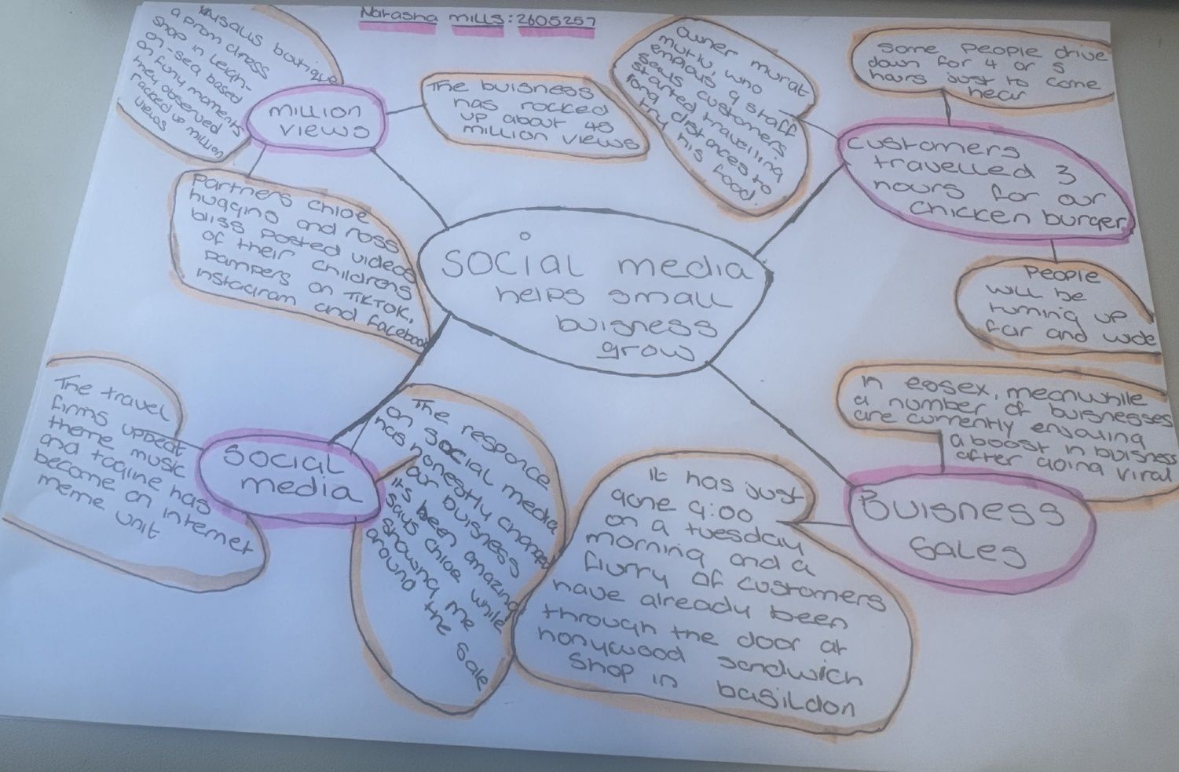

PART 2:
- Answer every question below in 1-3 full sentences.
- Use your own words. Do not use generative AI to answer these questions.
- Include a specific detail from the text when asked.
REMINDER
- The main idea is the overall message of the whole text.
- A key point helps to explain the main idea.
- A specific detail or example from the text shows that the key point is true.

- What is the main idea of the whole text? The main idea of the text is that small businesses are increasingly using social media platforms like TikTok, Facebook and instagram turn to online attention and customer engagement substantial livelihoods. Social media become a critical marketing tool for businesses, especially though post-pandemic. Examples include a chicken shop, vintage fashion and other small businesses that grew though viral content, customer reviews and online visibility are translating into actual income, customer loyalty and business growth.

- What is one key point that supports the main idea, and which specific example from the text shows this? Social media platforms like TikTok and instagram have become essential tools for small businesses to attract customers and turn online engagement into stories. Example: The article mentions the owner posted videos on TikTok showing customers waiting in long lines for their food. This online helped the business grow and reach more people, proving that social media can drive customer interest and livelihoods

- What is a different key point that supports the main idea, and which specific example from the text shows this? A different key point supporting the main idea is that social media can turn small local businesses’ into widely recognize brands by creating demand that draws customers from far away. This is shown in the text customers travelled three hours away for our chicken burger. It has just gone 09:00 on a Tuesday morning and a flurry of customers have already been though the door at honywood sandwich shop in Basildon.

- Which part of the text do you think is most important, and why? I think the most important of the text is the headline/main claim, and key supporting the examples, and the sentences. These parts are most important because they state the articles central topic, evidence, and real-world impact.
Reflection:
- What did you find difficult in this task (including in-class components), and why was it difficult? The most difficult part overall is reading the text accurately from the images first and then understanding the detailed business and social media content.

- What helped you with this difficulty, and how did it help you? I helped overcome this difficulty by reading the pages of the text over again in my head and matched the text with the photos, also my class team mates helped me to understand in groups of 2/4 individuals and all the communication.

