Strategic Management Analysis:
Hook Norton Brewery

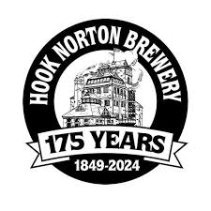

Student name | Radoslav Nikolov
Student ID | 2118366
Module code | BMSW6104
Assignment section | Strategic Management for SMEs
Lecturer’s name | Abdallah Naser

Table of Contents

Introduction to Hook Norton Brewery 3
Current Strategic Direction 4
Environmental Analysis 5
PESTLE Analysis of Hook Norton Brewery 5
SWOT Analysis of Hook Norton Brewery 6
Stakeholder Analysis: 8
Matrix for Hook Norton Brewery 8
Strategic Growth Choices and New Strategy 11
Key Strategic Recommendations 15
Conclusion 18
List of Reference 20

Introduction to Hook Norton Brewery
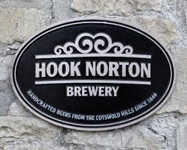
Source of Internet 1
Hook Norton Brewery, founded in 1849 by John Harris, is one of the few remaining family-owned breweries in the United Kingdom, located in the picturesque village of Hook Norton in Oxfordshire (Hook Norton Brewery, 2024). The brewery is renowned for its dedication to traditional brewing techniques, utilising a 25-horsepower steam engine that dates to 1899 to power parts of its brewing process. This commitment to preserving historical brewing methods sets Hook Norton apart in an industry increasingly dominated by large-scale, automated production (Hook Norton Brewery, 2024).
The brewery produces a variety of beers, including its flagship Old Hooky, a well-balanced ale with a fruity finish, and Hooky, a golden ale known for its light, hoppy taste. In addition to its core range, Hook Norton has ventured into producing seasonal and speciality brews to cater to modern craft beer enthusiasts (Hollingsworth, 2017). The brewery’s products are distributed through its own network of pubs, as well as in supermarkets and independent retailers across the UK and internationally.
Hook Norton Brewery is not only a producer of fine ales but also a significant contributor to its local community. The brewery offers tours, a museum, and a shop, making it a popular tourist destination. It actively engages with the community through events and collaborations, fostering a strong local presence (Hollingsworth, 2017).
Despite its traditional roots, Hook Norton Brewery faces the challenges of a dynamic and competitive market. The rise of craft breweries, changing consumer preferences, and economic fluctuations necessitate strategic adaptations to sustain its legacy while pursuing growth opportunities (Euromonitor International, 2023). The brewery’s ability to balance heritage with innovation will be crucial in navigating these challenges and securing its future in the evolving beer industry.

Current Strategic Direction

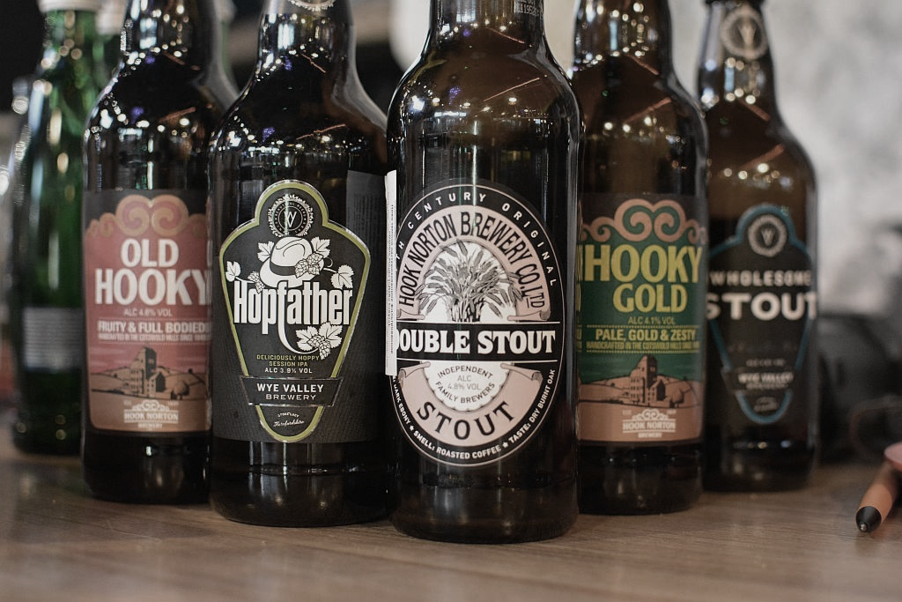
Source of Internet 2

Hook Norton Brewery's current strategic direction focuses on maintaining its heritage whilst expanding its market reach and adapting to modern consumer preferences. The strategy includes:

- Preserving traditional brewing methods to ensure product quality and brand authenticity.
- Expanding distribution networks to reach broader markets, including supermarkets and international markets.
- Innovating within its product range to include modern beer styles, such as craft beers, whilst still maintaining a core range of traditional ales.
- Enhancing customer experience through brewery tours, events, and direct consumer engagement via social media and digital marketing.
- Fostering sustainability by implementing eco-friendly practices in brewing and distribution.

Environmental Analysis

PESTLE Analysis of Hook Norton Brewery

A PESTLE analysis helps in understanding the macro-environmental factors that can impact Hook Norton Brewery's operations and strategic direction. This analysis examines Political, Economic, Social, Technological, Legal, and Environmental factors (see Table 1).
Table 1: PESTLE Analysis for Hook Norton Brewery
PESTLE Analysis | Details
Political Factors | Political stability and regulatory frameworks influence Hook Norton Brewery. The UK's exit from the EU (Brexit) has introduced new trade barriers, affecting the supply chain and export potential (Euromonitor International, 2023). Government policies on alcohol taxation impact pricing strategies and profitability.
Economic Factors | Economic conditions are crucial for the brewery's performance. Fluctuations in raw material costs, such as barley and hops, affect production costs (Smith, 2022). Economic downturns and rising inflation impact consumer spending, particularly on premium beers. The brewery must manage costs efficiently and possibly adjust product pricing (Office for National Statistics, 2023).
Social Factors | Social trends shape consumer preferences and behaviours. There is a growing demand for craft beers and locally produced beverages (Hollingsworth, 2017). Increasing health consciousness and awareness about alcohol's adverse effects are leading to a decline in alcohol consumption per capita. The brewery should consider offering low-alcohol or alcohol-free options.
Technological Factors | Advancements in brewing technology offer opportunities to improve efficiency and innovate the product line. Modern brewing equipment and techniques enhance production quality and capacity (Euromonitor International, 2023). E-commerce and digital marketing platforms help reach a wider audience and engage with consumers more effectively.
Legal Factors | Compliance with legal regulations is essential, including health and safety standards in production, packaging, and distribution. Licensing requirements for alcohol production and sales are stringent, requiring continuous monitoring and compliance (UK Government, 2023). Intellectual property laws protect the brand and products from infringement.
Environmental Factors | Environmental sustainability is crucial in the brewing industry. Climate change affects the availability and quality of raw materials, such as water and crops used in brewing (Smith, 2022). Hook Norton Brewery is committed to eco-friendly practices, reducing its carbon footprint and waste, which appeals to environmentally conscious consumers.
Francis J. Aguilar "Scanning the Business Environment." 1967

SWOT Analysis of Hook Norton Brewery

A SWOT analysis helps in identifying the internal strengths and weaknesses, as well as the external opportunities and threats facing Hook Norton Brewery. This analysis is crucial for understanding the brewery's current position and strategic potential (see Table 2).

Table 2: SWOT Analysis for Hook Norton Brewery

SWOT Analysis | Details
Strengths
Strong Brand Heritage and Reputation | Hook Norton Brewery has a rich history dating back to 1849, enhancing its brand reputation and attracting customers who value tradition and quality. (Hook Norton Brewery, 2024)
Traditional Brewing Methods | The brewery uses a steam engine and traditional brewing techniques, appealing to craft beer enthusiasts and preserving beer authenticity. (Hollingsworth, 2017)
Loyal Customer Base | Hook Norton has a dedicated local following, providing a stable revenue stream and supporting word-of-mouth marketing. (Hollingsworth, 2017)
Diverse Product Range | The brewery offers a variety of beers, including traditional ales, seasonal brews, and speciality beers, catering to different consumer preferences. (Euromonitor International, 2023)
Weaknesses
Limited Production Capacity | Reliance on traditional brewing methods can limit production capacity compared to larger, industrial breweries, hindering scalability. (Smith, 2022)
Higher Production Costs | Traditional brewing techniques and high-quality ingredients result in higher production costs, affecting pricing strategies and profit margins. (Office for National Statistics, 2023)
Dependence on the UK Market | A significant portion of sales is concentrated in the UK, exposing the brewery to local economic fluctuations and regulatory changes. (Euromonitor International, 2023)
Opportunity
Expansion into International Markets | There is significant potential to expand beyond the UK, particularly in Europe and Asia, where there is growing interest in craft beers. (Euromonitor International, 2023)
Growing Craft Beer Market | The global craft beer market is growing, and Hook Norton's traditional, high-quality brewing positions it well to capitalise on this trend. (Hollingsworth, 2017)
Product Diversification | Introducing new products, such as non-alcoholic beers or flavoured ales, can attract health-conscious consumers and diversify revenue streams. (Smith, 2022)
E-commerce and Digital Marketing | Leveraging e-commerce platforms and digital marketing can help reach a broader audience and enhance customer engagement. (Euromonitor International, 2023)
Threats
Intense Competition | The brewing industry is highly competitive, with many craft breweries and larger breweries with greater resources posing significant competition. (Smith, 2022)
Changing Consumer Preferences | Shifts towards healthier lifestyles and lower alcohol consumption can impact demand for traditional ales, requiring adaptation to stay relevant. (Office for National Statistics, 2023)
Economic Instability | Economic downturns can reduce consumer spending on premium beers, and inflation and rising raw material costs exacerbate this threat. (Office for National Statistics, 2023)
Regulatory Changes | Stringent regulations on alcohol production and sales can impose additional costs and operational challenges, necessitating resource-intensive compliance. (UK Government, 2023)

developed by Albert S. Humphrey 1960

Stakeholder Analysis:

Matrix for Hook Norton Brewery
High Power, Low Interest (Keep Satisfied)  - Government and Regulators  - Suppliers | High Power, High Interest (Key Players)  - Customers  - Shareholders/Owners
Low Power, Low Interest (Monitor)  - Media  - Competitors | Low Power, High Interest (Keep Informed)  - Employees  - Local Community
interest
power

Figure 1: R. Edward Freeman: Strategic Management: A Stakeholder Approach 1984

1. High Power, High Interest (Key Players)
Customers
Expectations: High-quality products, variety, consistency, and a memorable brand experience.
Power: High, as their preferences directly influence sales and brand reputation.
Strategy: Engage closely through feedback, loyalty programs, and product innovations to meet their needs and maintain satisfaction.
Shareholders/Owners
Expectations: Business growth, profitability, sustainability, and preservation of the brewery’s heritage.
Power: High, as they are decision-makers influencing strategic direction and financial investments.
Strategy: Maintain transparent communication, provide regular performance updates, and involve them in key strategic decisions.
2. High Power, Low Interest (Keep Satisfied)
Government and Regulators
Expectations: Compliance with regulations, health and safety standards, and tax contributions.
Power: High, as they can impose fines and operational restrictions.
Strategy: Ensure strict adherence to regulatory requirements, maintain proactive communication, and demonstrate corporate responsibility.
Suppliers
Expectations: Fair pricing, long-term partnerships, and reliable demand.
Power: Moderate to high, particularly for key raw materials like barley and hops.
Strategy: Develop strong, long-term relationships, negotiate fair contracts, and ensure timely payments.
3. Low Power, High Interest (Keep Informed)
Employees
Expectations: Job security, fair wages, career development opportunities, and a safe working environment.
Power: Moderate, as their performance and satisfaction impact production quality and efficiency.
Strategy: Foster a positive work culture, provide training and development, ensure safety standards, and offer competitive compensation.
Local Community
Expectations: Contribution to the local economy, responsible business practices, and support for local events and initiatives.
Power: Moderate, can influence brand perception and local support.
Strategy: Engage in community events, support local causes, and maintain open communication to build strong community ties.
4. Low Power, Low Interest (Monitor)
Media
Expectations: Interesting stories, newsworthy events, and transparency in business operations.
Power: Low to moderate, can influence public perception but does not directly affect daily operations.
Strategy: Maintain a positive relationship, provide regular updates, and respond promptly to inquiries.
Competitors
Expectations: N/A (focus on their own market position and strategies).
Power: Low, unless they initiate actions that significantly impact the competitive landscape.
Strategy: Monitor competitive actions, differentiate through unique value propositions, and stay ahead through innovation.

Strategic Growth Choices and New Strategy

Hook Norton Brewery must strategically plan its growth to sustain its heritage while expanding its market presence. Several strategic growth choices are available, each with distinct advantages and challenges. This section analyses these options using the Ansoff Matrix and proposes a new sustainable strategy.
Ansoff Matrix Analysis
The Ansoff Matrix offers a framework for understanding potential growth strategies through market penetration, market development, product development, and diversification (Ansoff, 1957).

Figure 2
Market Penetration
Strategy: Increase market share within existing markets by enhancing marketing efforts, promotional activities, and competitive pricing.
Advantages: Leverages existing capabilities and resources, lower risk compared to entering new markets.
Challenges: Market saturation, intense competition, limited growth potential.
Example: Intensifying promotions in the UK to boost sales of flagship beers like Old Hooky.
Market Development
Strategy: Expand into new geographical markets, both domestically and internationally.
Advantages: Access to new customer bases, potential for significant growth, risk diversification.
Challenges: Cultural differences, regulatory barriers, higher initial investment.
Example: Establishing distribution networks in Europe and Asia to tap into the growing craft beer markets (Euromonitor International, 2023).
Product Development
Strategy: Introduce new products to existing markets, such as innovative beer styles or complementary products.
Advantages: Meets changing consumer preferences, enhances product portfolio, increases market share.
Challenges: R&D costs, potential for product failure, cannibalization of existing products.
Example: Developing a range of low-alcohol or non-alcoholic beers to cater to health-conscious consumers (Smith, 2022).
Diversification
Strategy: Enter entirely new markets with new products, either related or unrelated to current offerings.
Advantages: High growth potential, diversification of business risk.
Challenges: Highest risk, significant resource investment, potential lack of expertise.
Example: Venturing into the production of cider or brewing equipment sales.
Proposed Strategy: Market Development and Product Development
Market Development:
Objective: Reduce dependency on the UK market and leverage the growing global interest in craft beers.
Actions:
Identify key international markets with high demand for craft beers, such as Germany, Japan, and the United States.
Form partnerships with local distributors and retailers to establish a foothold in these markets.
Utilize e-commerce platforms to reach a broader international audience and facilitate direct-to-consumer sales.
Product Development:
Objective: Cater to evolving consumer preferences and expand the product range to attract new customer segments.
Actions:
Develop a line of health-conscious beer options, including low-alcohol and non-alcoholic beers.
Introduce seasonal and specialty brews that align with global beer trends, such as fruit-infused ales or sour beers.
Invest in research and development to innovate brewing techniques and enhance product quality.
Justification:
This dual approach of market development and product development provides a balanced strategy that leverages Hook Norton Brewery's strengths while addressing external opportunities and threats. Expanding into international markets mitigates the risk of over-reliance on the UK market and opens new revenue streams. Simultaneously, product development caters to the shifting preferences towards health-conscious and innovative beer options, ensuring the brewery remains relevant and competitive (Euromonitor International, 2023; Smith, 2022).
Implementation Considerations
Investment in Infrastructure:
Upgrade brewing facilities to increase production capacity and support new product lines.
Establish international logistics and distribution networks.
Marketing and Branding:
Tailor marketing strategies to resonate with international audiences while preserving the brand's heritage.
Utilize digital marketing, social media, and influencer partnerships to enhance brand visibility globally.
Regulatory Compliance:
Navigate international regulations and ensure compliance with local laws in new markets.
Engage with local legal advisors to streamline market entry processes.
Sustainability Initiatives:
Implement eco-friendly practices across production and distribution to appeal to environmentally conscious consumers.
Communicate sustainability efforts as part of the brand’s value proposition.

Key Strategic Recommendations

To ensure long-term growth and sustainability, Hook Norton Brewery must adopt strategic initiatives that leverage its strengths, mitigate its weaknesses, capitalize on opportunities, and protect against threats. The following key strategic recommendations address these aspects comprehensively.
1. Expand International Market Presence
Objective: Diversify revenue streams and reduce reliance on the UK market.
Actions:
Market Research and Entry Strategies: Conduct thorough market research to identify high-potential international markets, such as Germany, Japan, and the United States, which have shown increasing interest in craft beers (Euromonitor International, 2023). Develop tailored market entry strategies for each region.
Partnerships and Distribution: Form strategic partnerships with local distributors and retailers to facilitate market entry and establish a strong presence. Consider joint ventures or alliances with established breweries in the target markets to leverage their distribution networks and market knowledge.
E-commerce Expansion: Utilize e-commerce platforms to reach international consumers directly. Develop a user-friendly online store capable of handling international orders and invest in digital marketing campaigns to increase brand visibility globally (Hollingsworth, 2017).
Justification: Expanding into international markets will diversify Hook Norton Brewery’s customer base, reduce market risk, and tap into the growing global demand for craft beers.
2. Innovate Product Portfolio
Objective: Cater to evolving consumer preferences and differentiate the product offerings.
Actions:
Health-Conscious Beers: Develop and launch a line of low-alcohol and non-alcoholic beers to attract health-conscious consumers. This aligns with the increasing trend towards healthier lifestyle choices (Smith, 2022).
Seasonal and Specialty Brews: Introduce limited-edition seasonal and specialty beers to create buzz and attract craft beer enthusiasts. This could include unique Flavors, experimental brews, and collaborations with other brands or influencers.
Sustainable Products: Focus on sustainability by creating beers with organic ingredients and eco-friendly packaging. Promote these products as part of the brewery’s commitment to environmental responsibility (Euromonitor International, 2023).
Justification: Innovating the product portfolio will keep Hook Norton Brewery relevant and competitive, addressing changing consumer trends and broadening its appeal.
3. Enhance Digital Marketing and Brand Presence
Objective: Increase brand awareness and customer engagement through digital channels.
Actions:
Social Media Marketing: Develop a robust social media strategy to engage with consumers, share the brewery’s story, and promote new products. Utilize platforms like Instagram, Facebook, and Twitter to create interactive content and foster community engagement.
Influencer Collaborations: Partner with influencers and bloggers in the food and beverage industry to reach a wider audience and enhance brand credibility.
Content Marketing: Invest in content marketing by creating engaging blog posts, videos, and podcasts that highlight the brewery’s heritage, brewing process, and new products. This will help in building a loyal online following (Euromonitor International, 2023).
Justification: Enhancing digital marketing efforts will expand Hook Norton Brewery’s reach, improve customer engagement, and increase sales through online channels.
4. Sustainability Initiatives
Objective: Integrate sustainable practices across operations to appeal to environmentally conscious consumers and reduce environmental impact.
Actions:
Green Brewing Practices: Implement energy-efficient brewing processes, reduce water usage, and adopt renewable energy sources. This could involve upgrading equipment and optimizing production methods.
Sustainable Packaging: Shift to sustainable packaging solutions, such as recyclable or biodegradable materials. Promote these efforts as part of the brand’s commitment to sustainability.
Community and Environmental Programs: Engage in local environmental initiatives and community programs to enhance corporate social responsibility (CSR). This could include tree planting, conservation projects, and educational campaigns on sustainability (Smith, 2022).
Justification: Sustainability initiatives will not only reduce operational costs and environmental impact but also strengthen the brand’s reputation among eco-conscious consumers.
5. Operational Efficiency and Innovation
Objective: Improve operational efficiency to reduce costs and support growth.
Actions:
Process Optimization: Conduct regular audits of brewing processes to identify areas for improvement. Implement lean manufacturing techniques to minimize waste and increase productivity.
Technology Integration: Invest in modern brewing technology to enhance product quality and consistency. This includes automation in brewing and packaging processes to streamline operations.
Training and Development: Provide continuous training and development opportunities for employees to foster innovation and improve operational efficiency. Encourage a culture of continuous improvement and employee engagement (Hollingsworth, 2017).
Justification: Enhancing operational efficiency will lower production costs, improve product quality, and support sustainable growth.

Conclusion

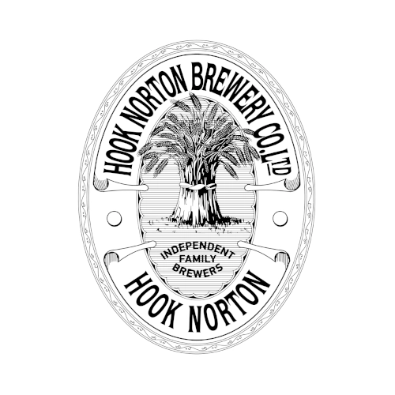
Source of Internet 3

Hook Norton Brewery, with its rich heritage and traditional brewing methods, stands as a notable player in the UK's craft beer industry. The strategic analysis conducted highlights the brewery's strengths, such as its strong brand reputation and loyal customer base, while also acknowledging challenges like limited production capacity and reliance on the domestic market (Hook Norton Brewery, 2024; Hollingsworth, 2017).
The PESTLE analysis reveals that Hook Norton operates in a complex environment influenced by political regulations, economic conditions, social trends, technological advancements, legal requirements, and environmental considerations (Euromonitor International, 2023). Understanding these factors is crucial for strategic planning and decision-making.
A SWOT analysis further underscores the brewery's robust internal capabilities and external opportunities, such as expanding into international markets and developing new product lines to cater to evolving consumer preferences (Smith, 2022). However, it also highlights significant threats from intense competition and economic instability.

Stakeholder analysis identifies key groups with varying levels of power and interest, including customers, shareholders, government regulators, suppliers, employees, and the local community. Managing these relationships effectively is essential for sustaining operational success and fostering goodwill (UK Government, 2023).
Strategic growth choices, evaluated using the Ansoff Matrix, point towards market development and product development as the most viable paths forward. By entering new international markets and innovating their product portfolio, Hook Norton can diversify its revenue streams and meet the demands of a broader audience (Ansoff, 1957; Euromonitor International, 2023).
Key strategic recommendations include expanding international market presence, innovating the product portfolio, enhancing digital marketing efforts, implementing sustainability initiatives, and improving operational efficiency. These strategies are designed to leverage Hook Norton's strengths, capitalise on opportunities, and address both internal and external challenges.
In conclusion, Hook Norton Brewery is well-positioned to grow sustainably by embracing a balanced approach of market expansion and product innovation. By doing so, it can enhance its competitive edge, cater to modern consumer preferences, and ensure long-term success in an ever-evolving industry.

List of Reference

- Ansoff, H. I. (1957). Strategies for Diversification. Harvard Business Review, 35(5), pp. 113-124.
- Barney, J, & Hesterly, W 2018, Strategic Management and Competitive Advantage: Concepts and Cases, Global Edition, Pearson Education, Limited, Harlow. Available from: ProQuest Ebook Central. [10 June 2024].
- Culp, M., 2012. Strategic Management. [online] New Delhi: World Technologies. Available at: https://www-dawsonera-com.ezproxy.uwtsd.ac.uk/abstract/9788132325833 [Accessed 11 June 2024].
- Euromonitor International. (2023). Alcoholic Drinks in the United Kingdom. [online] Available at: https://www.euromonitor.com/united-kingdom [Accessed 16 Jun. 2024].
- Goodman, M. & Dingli, S.M., 2013. Creativity and Strategic Innovation Management. Florence: Taylor and Francis.
- Lynch, R 2018, Strategic Management, Pearson Education, Limited, Harlow, United Kingdom. Available from: ProQuest Ebook Central. [15 June 2024].
- Mintzberg, H., Ahlstrand, B. & Lampel, J., 2008. Strategy Safari: The Complete Guide Through the Wilds of Strategic Management. London: FT Prentice Hall.
- Morden, T., 2007. Principles of Strategic Management. [online] Aldershot, England; Burlington, VT: Ashgate. Available at: http://www.tsd.ac.uk/en/lrc/onlineresources/e-books/ [Accessed 26 November 2013].
- Johnson, G., Whittington, R. & Scholes, K., 2011. Fundamentals of Strategy. 2nd ed. Pearson Prentice Hall.
- Hollingsworth, R. (2017). The Little Book of Craft Beer. London: HarperCollins.
- Hook Norton Brewery. (2024). About Us. [online] Available at: https://www.hooky.co.uk/about-us [Accessed 16 Jun. 2024].
- Office for National Statistics. (2023). Economic Review, UK. [online] Available at: https://www.ons.gov.uk/economy [Accessed 16 Jun. 2024].
- Smith, J. (2022). The Impact of Raw Material Costs on the Brewing Industry. Journal of Brewing Studies, 12(3), pp. 45-58.
- UK Government. (2023). Alcohol Licensing Laws. [online] Available at: https://www.gov.uk/alcohol-licensing [Accessed 16 Jun. 2024].
- Whittington, R, Regnér, P, Angwin, D, Johnson, G, Scholes, K, Whittington, R, Regnér, P, Angwin, D, Johnson, G, & Scholes, K 2019, Exploring Strategy, Text and Cases, Pearson Higher Education & Professional Group, Upper Saddle River. Available from: ProQuest Ebook Central. [11 June 2024].

