ACEA7009

Business Management in Projects

Table of Contents
Introduction 3
Fundamental Principles of Project Management 4
Key Points of Project Management in the Case Study 5
SWOT Analysis of the Fruit Smoothie Company 8
PESTEL Analysis of the Fruit Smoothie Company 10
Optimizing the Management and Use of Technology for Enhanced Communication Structure 13
Challenges of Moving to New Premises and Leadership Influence on Project Success 15
Conclusion 17
Reference 18

Introduction
Business expansion entails adequate project management, especially during the expansion process, whereby the form of business changes, for example from a small shop to a big store and the kind of product sold changing from one type to the other. At this stage, the fruit smoothie company has many opportunities and threats that arise due to its growth need for correct organizational structure, efficient leaders and promising technology for supply chain management. This paper will evaluate the strategic growth through the use of SWOT and PESTEL; establish changes within the organization and portray how leadership styles influence success. In this respect, by integrating the concept of structured project management, it will be possible to achieve long-term business development and improved business operations.

Fundamental Principles of Project Management
Project management can be described as the process of directing a project towards the achievement of several objectives in terms of time, cost, and scope. The key principles include:
- Clear Objectives and Scope – There can never be instances where the goals of the project are not clearly stated together with the end products expected and the measures of project success.
- Project Life Cycle - The existence of a project life cycle makes it easier to manage as it follows a sequence of initiation, planning, execution, monitoring and closing (Kerzner, 2018).
- Stakeholders Management – Such information facilitates the identification of the key stakeholders and the management of stakeholders such as the members of the team, suppliers, and customers to ensure that they are committed to the cause.
- Risk management – Evaluating risks that may affect the course of a project and coming up with ways to avert such an occurrence.
- Effective management of resources – To means employment of financial resources, human resources and other raw materials in an efficient manner.
- Quality Management - Quality Management can be described as the process of guaranteeing that all project outputs are up to specifications to improve customer satisfaction.
- Flexibility and Change Management – Responding to some alteration is a significant factor in ensuring the project manages to remain viable.
- Overseeing and supervision – Performance checking by means of KPIs assists in making timely corrective actions (Cabeças and Silva, 2021).
- Leadership and Teamwork – Strong leadership fosters motivation, collaboration, and efficiency within project teams.
By applying these principles, the effectiveness of projects is improved, the satisfaction of stakeholders is adequate, and growth is achieved in the long run.

Key Points of Project Management in the Case Study
Later in their lives, the fruit smoothie company seeks to expand the facility and diversify their production thus proper management of this project will determine success in the future business. The key considerations include:
1. Clear Objectives and Scope
As such general objectives of the firm, the firm needs to determine the location of the industrial estate, establish a new production line, and introduce new products such as coconut water and yoghurt-based drinks. It will also assist in the development of resource maps indicating how resources shall be deployable to realize the business growth strategies that have been set.
2. Project Life Cycle
It is necessary to divide the evident technical move and expansion into five phases (Cabeças and Silva, 2021):
- Initiation – Conduct feasibility studies, cost-benefit analysis, and risk assessment.
- Management – Ensure that the project is planned in terms of timeline, cost, and supplier agreements.
- Execution – Implement infrastructure setup, supply chain adjustments, and product development.
- Controlling – This involves tracking production progress, and supplier performance as well as ensuring that laid down quality standards are met.
- Closure – Check the success and effectiveness of the project.
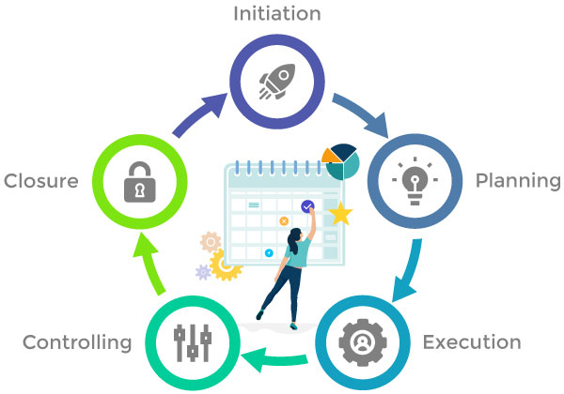
Figure: Project Management Cycle (NotifyVisitors, 2025)
3. Stakeholder Engagement
It would be pertinent to maintain a balance between continuing with the current supplier and transportation companies, supermarket partners and employees relationships and building new relationships with them. Organizational communication has been an issue in the delivery of services (Mir and Pinnington, 2014); therefore, there is a need to come up with a stakeholder management structure.
4. Risk and Change Management
Such a case implies certain financial, operating, and logistic risks when it comes to production expansion and relocation. Adapting to issues and challenges affecting the supply chain such as natural disasters, inability to meet regulatory requirements, and variations in demand forces is crucial (Radujković and Sjekavica, 2017).
5. Resource and Quality Management
The areas that require special attention are funding, staff and quality and work flow. The company should also ensure compliance with quality standards to sustain a healthy product image.
6. Communication Strategy
To address some problems faced in supply chain management, an efficient communication strategy should be planned and managed effectively to increase delivery and to be on par with all other departments (Meredith et al., 2017).
Introducing and implementing these project management principles suggests that the company can expand operations bringing in more clients while ensuring the avoidance of risks and poor-quality services.

SWOT Analysis of the Fruit Smoothie Company
The company must undertake a SWOT analysis to evaluate organisational strengths and weaknesses, as well as the opportunities and threats that exist in the environment for the purpose of expansion.
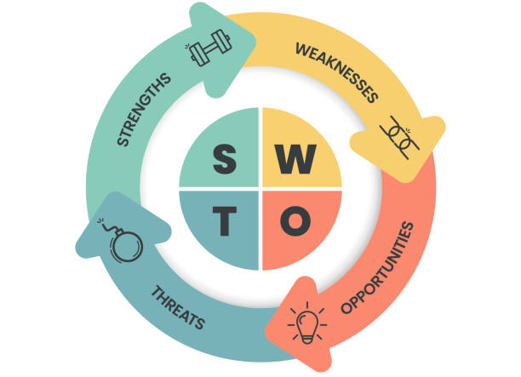
Figure: SWOT Diagram (Project Widget, 2023)
Strengths (Internal Positive Factors)
- Market Presence, Popularity and Identity – The company has sold well and has bagged contracts with two supermarket chains in the United Kingdom and one other is in discussion with them (Gido et al., 2018).
- Key suppliers are identified – Suppliers of fruits are established from the UK and Europe to meet the firm’s need for fresh produce of good quality.
- Specialized Products – Their smoothies are a means for consumers to hit the health and wellness and make their company attractive.
- Sound Relationship – They have strong relationships with their suppliers and transportation companies.

Weaknesses (Internal Negative Factors)
- The current establishment lacks the space for expansion to accommodate the manufacturing unit for a small business unit.
- With poor integration among the company, suppliers, and logistics partners, delivery of the necessities has been compromised, and the quality has been declining.
- As any firm advances in its business, it should have proper structures and project workflow to follow to enhance efficiency.
- They depend on limited suppliers and suppliers and therefore are prone to supply chain risks.
Opportunities (External Positive Factors)
- The new product development to differentiate and diversify its product portfolio can create new markets and revenue streams for the company by launching coconut water, healthy soups, yoghurt-based drinks and others.
- To achieve greater production capacity, moving from a commercial to an industrial area is best (Gido et al., 2018).
- Consumer awareness towards healthier, natural drinks increases their position on the market.
- Expanding through establishing and consolidating its current and future supermarket and online retail outlet associates should form the basis of the subsequent strategic direction.
Threats (External Negative Factors)
- Supply chain disruptions, because the more the number of products that are to be produced, the more the demands are placed on suppliers and this may cause some of the suppliers to be unable to meet the demand or supply material which may be insufficient (Gurl, 2017).
- There are some legal issues that might be viewed to pose obstacles to food safety and sustainability compliance in regard to several regulatory hurdles that may entice high costs.
- The level of inflation is increasing; it means that the operation cost also increases hence lowering the profits (Gurl, 2017).

PESTEL Analysis of the Fruit Smoothie Company
PESTEL analysis considers macro-business environment factors making it possible to estimate opportunities for the company’s growth and the prospects of its diversification.
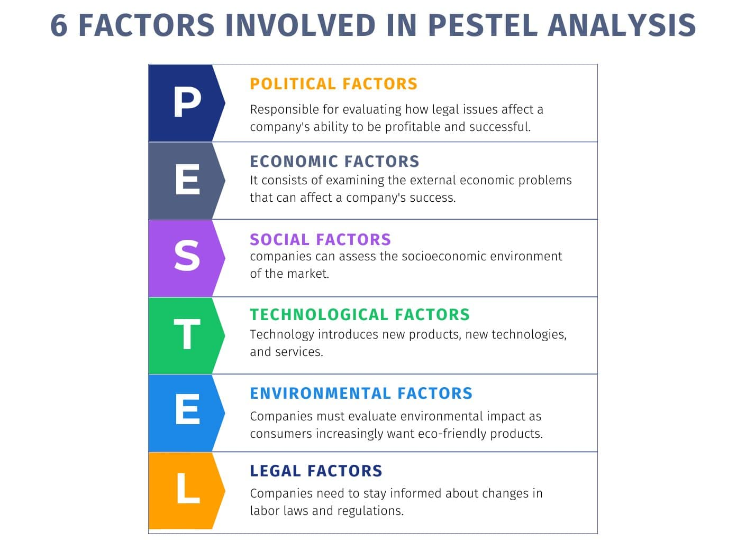
Figure: Factors Involved in PESTEL Analysis (QuestionPro, 2022)
1. Political Factors
- The UK has its meals and beverages labelling policies that have to be adhered to when the firm ventures into other products such as yoghurt-based drinks.
- The transition of fruits from Europe may be literally affected by tariffs, additional time consumption on customs, and regulations.
- It is possible for the company to receive government funding to support operations as well as expansion of operations and promotion of healthy foods through tax credits.
2. Economic Factors
- Concerning the pressure from inflation and high costs – the price of transport and raw materials is also an influencing factor on profitability.
- There might be reduced spending among consumers on some occasions, which makes it necessary for operators to alter price-setting strategies and settle for the usual price for more sales (Kerzner, 2018).
- The function of the beverage is advancing resulting in a high market growth in health drinks.
3. Social Factors
- A growing trend of people searching for organic and no-sugar-added product lines reflects expansion opportunities.
- Consumers are living busier lives as compared to earlier, which has led to a rise in demand for ready-to-drink value-added drinks (Kerzner, 2018).
- Consumers are becoming conscious of the environment and are therefore strict on the kind of packages used and the origin of goods.
4. Technological Factors
- An adaptation plan is to invest to acquire new production automated systems in the new facility.
- E-commerce and Digital Marketing – a powerful tool for increasing the customer base with the help of sales through the Internet and direct deliveries (Pinto, 2020).
- Inventory tracking and the proper use of artificial intelligence for logistics can help prevent delivery delays.
5. Environmental Factors
- Sustainability in sourcing – This involves making sure that farming is done in an ethical manner and that the food is packed in an environment-friendly manner in order to ensure that the company's reputation in the right track.
- Adverse weather – climate change may have an impact on the availability and price of fruits in the market.
6. Legal Factors
- There are some regulations that the UK Food Standards Agency (FSA) requires including labelling, hygiene, and nutritional information (Pinto, 2020).
- A larger facility means employment and hiring have to be done with respect to the Employment laws such as minimum wage and safety rules for the workers and their rights.
- In its new product lines, the company is required to achieve trademarks to prevent legal disputes on intellectual property.

Optimizing the Management and Use of Technology for Enhanced Communication Structure
The new and rapidly growing fruit smoothie firm has so far grown big, but not well structured, nor is its communication efficient. These have worked due to poor organization structure and coordination between the growers, the transport service provider and the internal teams since delivery has been missed and quality is deteriorating (Crawford, 2016). To sustain expansion, the company has to ensure that it develops and establishes a proper organizational structure as well as apply and incorporate the latest technologies in organizing the flows of communication and supply chain.
Well-structured organization is important for the smooth running of the organization in its daily operations. Currently, the responsibilities are not divided hierarchically amongst the three directors and all the decision-making powers belong to them. Once the company embarks on large-scale production and offers a wider range of products, it should change its structure to a functional structure where one unit deals with central activities. This means that there are separate sections of procurement, production, logistics, sales and marketing, all headed by competent officers. This means communication with growers and transport providers would have been located in a single person, the Head of Supply Chain Management, hence breaking a number of barriers of communication that cause delay. More so, the recruitment of a specialized Quality Control (QC) Manager helps maintain product quality in response to the increasing production rate. In this context, directors are able to delegate responsibilities so they do not waste time on operations that are problematic (Crawford, 2016).
This Internet communication technology may contribute to improving the communication and cooperation between growers, transport suppliers, and internal stakeholders. Recognition of an order and following it up for delivery as well as quality control have been a major issue mainly because of deficient information flow. The outcome of adopting this new technology is that it would be easier to track the delivery and stock status of sourced fruits through a Cloud-Based Supply Chain Management (SCM) System. SAP Business One or Net suite or, Microsoft Dynamic 365 allows farmers to update when fruits are available, while transportation providers can post active status on their delivery (Crawford, 2016). By using this system regarding automated alerts, all of the delays or shortages can be quickly tackled, so as not to cause supply issues.
One more enhancement is the Internet of Things (IoT) sensors to be implemented in the logistics industry. This makes it necessary to have conditions for the transportation of fresh fruits in order to meet the quality of the company. For this reason, incorporating temperature and humidity sensors in the transport vehicles allows the supply chain team of the company to have real-time information. If there are changes in the temperature it will be possible to give out alerts and take corrective measures before getting to the production unit of the fruit. This leads to higher quality control and minimizes wastage of resources in the building process.
It also applies to other teams within an organization as well. The company should however employ the use of project management software such as Trello, Asana or Monday.com so that various tasks that are being done in different departments can be handled accordingly. In the structured workflow, the procurement, logistics and production can be well aligned to avoid system log jams and confusion (Bryde, 2023). On the same note, with the establishment of a Customer Relationship Management (CRM) system or a sales force like Salesforce or HubSpot, the salespersons are in a position to monitor and analyse supermarket orders, demand and even suppliers. This is important since there will not be a case where a product is in excess or where there is a shortage leading to low sales.
Based on the current challenges, a recommended solution for improving real-time communication is the use of a common digital communication tool such as Slack or Microsoft Teams. Instead of using emails, growers, transporters and internal managers can send messages and moreover, they can share documents or schedule meetings in one location (Bryde, 2023). Their proper spa arrangement ensures that crucial decisions do not take much time to be made thus reducing time wastage.
Therefore, the departments will have subdivisions and leaders to make it easier to decision-making and take responsibility. Hence with the help of Cloud SCM, IoT sensors for supply chain, project management software, and digital communication tools the company should address the problem of supply chain management, communication, and quality control. These changes will help the organization to provide sustainable growth for the expansion of the new organization while also considering the operational standards.

Challenges of Moving to New Premises and Leadership Influence on Project Success
Some challenges of moving to a larger industrial facility include; disruptions in logistics in the process of moving and expansion, financial constrain and failure to meet regulatory requirements during expansion. It is therefore important that any change within the company is well planned so as not to hurt the supply of fruits, production and distribution to supermarkets. Use phased proof strategy to conduct operations in both the old and new premise to reduce on break in the production of goods and services. Also, employees may not be very much aware of the new environment which means that more so, they should be trained as well as onboarded according to the new environment.
Financial concerns are also critical. Expansion to a new office involves one having to purchase new equipment and furnishings and having to rent a bigger space, bringing about increased expenses. In light of this structure, the company could be at risk of suffering from several problems including incurring more costs that were initially planned for in the budget (Meredith et al., 2017). This should not be a problem since securing financial backing or government grants could help to ease the burden. In addition, the new premises have to conform to the UK food safety regulations that are indicative of sustainability hence requiring inspections and changes to be made on it from time to time.
Style of leadership will go a long way in determining how the transition process will be. An effective form of leadership is transformational leadership, which encourages the staff and imposes much emphasis on a change in values and culture. Leaders must therefore be clear on the advantages of implementing change in a bid to keep the employees motivated in the process. A transactional leadership approach that focuses on organization structure, performance, and rewards is effective during such changes since it keeps things steady and productive (Meredith et al., 2017). Since transactional leaders effectively define the goal and the course of action, they make sure that the goals and deadlines are met on time to encourage a smooth flow of activities.
Therefore, a Bodily situated leadership technique appears the most suitable for this kind of situation. An authoritarian approach is helpful while responding to problems in the logistics part because it will not take so much time for implementation of decisions. An exemplary approach is helpful in getting the participation of the workers in solving the challenges. With the application of transformational, transactional, and situational leadership, it will be relatively easier for the company to transition to the new geographical location while also overcoming every hurdle to create a long-lasting structure.

Conclusion
Key elements that influence success in this case are the availability of strategic project management, leadership and development of technology. With particular regard to supply chain issues, the inclusion of a supply chain department, better communication and a well-structured organisational map would help in increasing efficiency. Leadership patterns remain important, the transformational, transactional and situational approaches enhance transition and employees' participation. Applying the elements of the project life cycle, risk management, and stakeholders' cooperation will help the company to increase operations' scale, guarantee high-quality products, and become a competitive player in the UK environment.

Reference
Bryde, D.J., (2023). Project management concepts, methods and application. International Journal of Operations & Production Management, 23(7), pp.775-793.
Cabeças, A. and Silva, M.M.D., (2021). Project management in the fourth industrial revolution.
Crawford, L., (2016). Developing organizational project management capability: Theory and practice. Project Management Journal, 37(3), pp.74-86.
Gido, J., Clements, J. and Baker, R., (2018). Successful project management. Cengage Learning.
Gurl, E., (2017). SWOT analysis: A theoretical review.
Kerzner, H., (2018). Project management best practices: Achieving global excellence. John Wiley & Sons.
Meredith, J.R., Shafer, S.M. and Mantel Jr, S.J., (2017). Project management: a strategic managerial approach. John Wiley & Sons.
Mir, F.A. and Pinnington, A.H., (2014). Exploring the value of project management: linking project management performance and project success. International journal of project management, 32(2), pp.202-217.
Pinto, J.K., (2020). Project management: achieving competitive advantage. Pearson.
Radujković, M. and Sjekavica, M., (2017). Project management success factors. Procedia engineering, 196, pp.607-615.

