Indra Nooyi: An inspiring female leader


PepsiCo, Inc., is regarded as the second largest food and beverage business in the world, and a large part of its success can be attributed to its leader. Indra Nooyi, who served as the chairperson and CEO of PepsiCo, is an inspiring and visionary leader for many reasons. She was not only the first female CEO of PepsiCo but had also featured in Forbes’ list of the 100 most influential women in the world for over a decade. In addition, she exceled as a relationship-oriented leader, using innovative strategies to inspire and forge the way forward for women across the world.

Attentive to the needs and preferences of customers, Nooyi constantly engaged in understanding and responding to the rapidly changing trends in the industry. For example, during a business trip to China, she spent 10 days touring different cities in the region, studying the strategic market for PepsiCo. In an interview with Bloomberg’s David Rubenstein, her attention to customer preferences was evident through her story about surveying her friends’ kitchens during parties to see what products they used every day (and hoping to find some PepsiCo items in the mix).
Nooyi was also someone who provided direction. In 2012, she decided to create a design team to refresh the brand image, rethink the Pepsi packaging, and redesign its vending machines. Former head of 3M, Mauro Porcini became PepsiCo’s first Chief Design Officer overseeing design-led innovation across all the company’s brands. A pioneering decision at the time, this is now a strategy that many companies employ. This decision was successful and improved PepsiCo’s top and bottom line. It also increased the company’s customer appeal. For example, PepsiCo’s Design & Innovation team created a new fountain machine, allowing customers to select one flavor from more than 1,000 combinations.
As a female executive who had broken the highest glass ceiling in a global company, Nooyi is committed to promoting diversity and inclusion at all organizational levels. In 2010, the company launched a survey, focusing on female managers, to understand the reasons for the underrepresentation of women at executive levels. The findings showed that women lacked self-confidence and believed that men were more capable of networking and pushing forward. In response, PepsiCo launched a leadership development program for women called “Strategies for Success,” aimed to help women boost their confidence and help them effectively reach leadership roles in the organization. Within two years, the female representation in senior positions in the operations team increased from 0 to 33 percent.
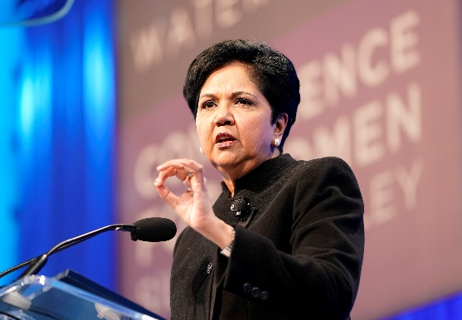
Nooyi has stated that the secret to her success at PepsiCo is her family. She attributes most of her strengths to the examples set by her parents. As an adolescent, she recalled the preoccupation of most parents was to marry off their daughters. But her parents were different. For instance, they supported Nooyi’s decision to leave India to study in the US. They also sought to make her and her sister more confident and aware of their talents. Over dinner, her mother used to pretend that they were each a leader of an important ministry of India and, every evening, they would list the things that they would have done in such roles. Even though this was just a game, Nooyi confesses that it helped her boost her self-confidence and inform her leadership style, and without such games she may not have been capable of becoming the leader she is today or garner the respect and admiration of others. In August 2018, Nooyi stepped down as the CEO and now serves on the board of directors of a non-profit organization in Connecticut, US, to support economic development efforts of the state.

Discussion questions:
- What examples are provided in this case for the leadership style Indra Nooyi exhibited? List and describe the leadership models, theories, or concepts you see in this case.
- Do you think Indra Nooyi’s decision to create a design unit at PepsiCo was effective in the food and beverage industry? Why?
- Examine the concept of servant leadership. What behaviors exhibited by Indra Nooyi indicate servant leadership? What had she done to promote a diverse and inclusive work environment? What other ways do you think could guide women’s career paths in an organization?
- What did the case teach you about leadership?

Source: Robbins, S., and Coulter, M. (2021) Management, Global Edition. 15th edn. Pearson. Pp. 504-505

