Assessment 2: Essay – Provide an auteur study of ONE of the directors studied on the module. You should pay particular attention to the way in which recurrent themes and cinematic styles are employed in AT LEAST TWO films by your chosen director.

Auteur Study on Director Tim Burton

Auteur theory is the idea that a director had complete creative control over his or her film project. Auteur directors usually have a unique style that is consistent in the majority of their projects, which can be reflected in a number of ways, some of these include themes, genre, editing, framing, shot type, composer and regular actors. Directors effectively turn themselves into a brand, once you start watching a film, you will know it was made by them. Auteur directors have passion and control of their projects in common, but the ways in which they go about putting their stamp on their movies varies from director to director. For example, Guillermo Del Toro is known for his work in the fantasy, horror genres and featuring creatively disturbing creatures in films such as Pan’s Labyrinth (2006) and The Shape of Water (2017), Edgar Wright for his fast, clever editing and dialogue in Shaun of the Dead (2004) and Hot Fuzz (2007) and Wes Anderson for his almost surrealist, play-like cinematography as featured in Moonrise Kingdom (2012) and Fantastic Mr Fox (2009). All art, including film, is subjective. Not everyone likes the same thing nor do they have to. Personally, I really like Edgar Wright’s films, though I’m not too fond of Wes Anderson’s style. However, I do appreciate that they have the audacity to make their films their way. Despite this, the focus of this essay will not be on any of these aforementioned auteur directors but will instead concentrate on Tim Burton, with the focus being his films Batman (1989) and Sleepy Hollow (1999), with plenty of references to some of his other features.
I am not personally a fan of Tim Burton, other than his 1989 Batman (1992’s Batman Returns is another story), but I do appreciate that he has his own style that he adheres to, his own brand that carries through his projects, more prominent in some films than in others and often blends the genres of fantasy, German expressionism and gothic horror.
The mise-en-scène typically shows off these genres. In the opening scene of Batman, an extreme long shot of Gotham City’s streets show it as dark, ridiculously tall buildings surround the citizens providing a sense of entrapment. The buildings appear slanted at street level, perhaps to suggest how unstable the city really is and the inclusion of small pockets of smoke and numerous archways give Gotham an otherworldly feeling, clearly borrowing from German expressionist films such as Nosferatu (F. W. Murnau, 1922) and The Cabinet of Dr Caligari (Robert Weine, 1920), as if to say that on the surface it is just a big city, but just wait and see the big bat creature fight off a killer clown. Not only is it otherworldly, but it also appears timeless, with different time periods clashing though costumes and props.
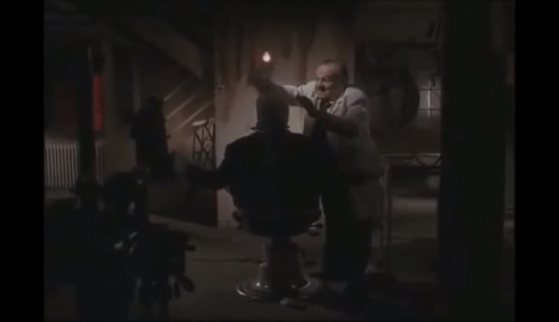
Elements of gothic horror can also be found, such as in the scene where Jack Napier sees himself as the Joker for the first time. The camera pans left across a grimy, dingy, dimly lit surgery, stopping on a long shot of the back of a chair with someone sitting in it, cloaked in shadow, being tended to by a doctor in a white coat who speaks with a European accent, some bloodied knives are shown in a close up on a tray. As Joker leaves, laughing as he descends into insanity, he smashes the light bulb, engulfing the room in complete darkness except for a flashing red light outside of the window, emulating a warning signal. Burton seems to be paying homage to classic Hammer Horror films, particularly by portraying Joker as Frankenstein’s monster. In this minute long scene, the audience never gets to see the “monster”, instead only seeing him as a silhouette, the reveal coming in a later scene as he commits his first criminal act after his rebirth.
Sleepy Hollow opens with an extreme close-up of some parchment where four drops of red liquid fall into a Mickey Mouse shape, looking like blood, before shots of a document being written up using a quill are show, where it then cuts back to the red liquid, which is now a bigger pool of what is revealed to be candle wax in order to seal the document. This misdirection leads the audience to expect violence, which is followed up on in the next scene where the coach driver and passenger lose their heads. This scene features allusions to gothic horror, through the use of the mist, and also intertextuality with the pumpkin scarecrow. Whilst a pumpkin was featured in the original The Legend of Sleepy Hollow story, the scarecrow shares a passing resemblance to the Pumpkin King in the opening of The Nightmare Before Christmas (Henry Selick, 1993), which Burton produced and has a writing credit on. Possibly showing his influence by gothic horror, Burton’s 1799 New York is shot to look a lot like Victorian era London. The German expressionism influence is clear in any scene inside the woods, through the use of mist and oddly shaped leafless trees creating natural arches.
Burton’s stories often centre on an outsider, a character that would not be considered normal in society, either because of a physical or mental issue. In the recent edition of their book Understanding Film Theory, Doughty and Etherington-Wright feature a quote from Burton as he reminisces about his childhood as he states that “[he] felt monsters were basically misperceived, they usually had much more heartfelt souls than the human characters”, which certainly explains why he focuses on such characters. This does not only apply to characters he creates but also to characters in his adaptations from existing texts, such a Bruce Wayne in Batman (1989) and Willy Wonka in Charlie and the Chocolate Factory (2005). Therefore, Burton and Batman seem like a natural fit as Bruce Wayne in this film is a mysterious figure that people seem to know by name but not as a person. A billionaire orphan raised by his butler Alfred after the death of his parents when he was a small boy, it makes sense that this character would feel alone, like an outsider. However, he also hides a secret that initially only he and Alfred know, that by night he stalks the rooftops, dishing out vigilante justice whilst dressed as a big black bat. Batman’s introduction in the beginning of the film is clearly influenced by gothic horror and German expressionism. A bird’s eye view of a tall rooftop with a shadowy figure standing on top of it that moves when there’s criminal activity. When two criminals are talking about if he is real or not, batman slowly glides down into an archway engulfed with smoke, cape spread outwards like Dracula, still cloaked in shadow and mystery, intimidating them through superstition.
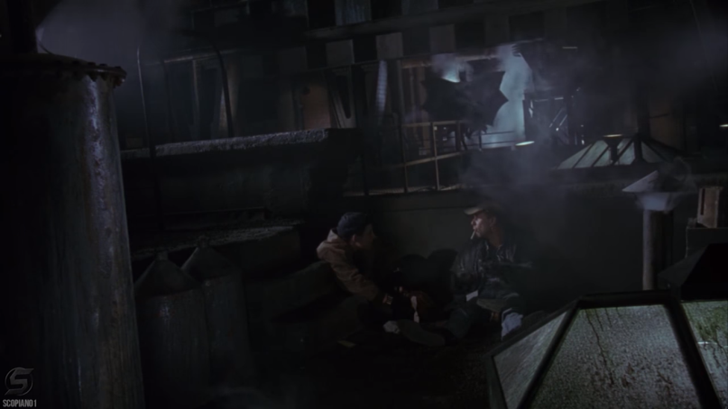
Ichabod Crane from Sleepy Hollow is also portrayed as an outsider. Like Wayne, he too had a traumatic childhood as his father killed his mother. As a police constable, he is ahead of his time, believing in forensic science and post-mortem examinations where the rest of the police do not, on top of his already quirky behaviour.
Tim Burton as an auteur does not only have the same themes and influences throughout his films. As an experienced director, he knows who he works well with and frequently teams up with the same cast and crew members for different projects. He has worked on several films with actors such as Johnny Depp, Helena Bonham Carter, Christopher Lee - which could be an extension of his appreciation for Hammer Horror -, Winona Ryder and Michael Keaton to name just a few. It would, however, be remiss of me to not mention an important part of Tim Burton’s films and his auteuristic vision, composer Danny Elfman. The scores that Elfman composes for the films he works with Burton on are iconic, instantly recognisable as Danny Elfman compositions in the same way that John Williams and Hans Zimmer are synonymous with theirs. The music is atmospheric and ranges from the exciting, triumphant theme of Batman to the fantasy flair of Edward Scissorhands (1990).
If someone dislikes one film by an auteur director, then they will most likely dislike the majority. However, for those that like a few or more it gives them a reason to look forward to the next Tim Burton film, the same way someone might be excited to see the next Marvel Studios movie. By looking at auteur theory as directors making passion projects, putting out art that expresses themselves and how they want something to be portrayed or conveyed with minimal to no studio interference then good for them.

Reference List
Films:
Batman (Tim Burton, 1989)
Sleepy Hollow (Tim Burton, 1999)
Books:
Doughty, R. And Etherington-Wright, C (2017) Understanding Film Theory second edition. London: Palgrave

