Fergus G.M. Russell
1810348@student.uwtsd.ac.uk
Abstract
The English longbow, when used with needle and heavy bodkin arrows, has long been held as the largest deciding factor in the outcome of the battle of Agincourt and as a decisive weapon when utilized by Henry V’s forces. This technical report makes use of historical accounts and information regarding the battle of Agincourt and utilizes a combination of principles used in the Ordnance Munitions and Explosive engineering domains, alongside technical investigations of the subject to determine if the longbow and bodkin arrows truly were decisive in the outcome of the battle.
Total Word Count: 4159. Body of Text: 3224
ACDA 6015 Technical authoring
A technical investigation on the effectiveness of the English Longbow and Bodkin arrows at the Battle of Agincourt

Contents
List of Figures 2
List of Tables 3
1.0 Introduction 4
2.0 Events of the Battle of Agincourt 4
2.1-The French Campaign 4
2.2-Eve of Battle 5
2.3-The Battle of Agincourt 5
3.0 Ordnance and Armour 6
3.1-Ordnance 6
3.2-Armour 7
3.3-Physics of Arrow Flight and Impact 7
3.3.1-Arrow Flight 7
3.3.2-Arrow Impact 9
3.3-Testing of Ordnance and Armour in Academic Literature 10
4.0 Discussion 15
5.0 Conclusion 16
6.0-References 17

List of Figures
Figure 1-Henry V Route Through France [2] 3
Figure 2-Tactical Map of the Battle of Agincourt [5] 4
Figure 3-Projectile Impact Behavior [9] 9
Figure 4-Graphic representation of flight path from Magier et al study [10] 10
Figure 5-Needle arrowhead FEA model impacting at 2.6 degrees and 52 degrees [10] 10
Figure 6-Heavy Bodkin arrow FEA model impacting at 2.6 degrees and 52 degrees [10] 11
Figure 7-Comparison of deformation of modelled arrowhead (right) and physical arrowhead (left) [10] 11
Figure 8-Arrow heads on test [11] 11
Figure 9-Short bodkin jack cloth test [11] 12
Figure 10-Short bodkin butted maille test [11] 12
Figure 11-Short bodkin riveted maille test [11] 12
Figure 12-short bodkin high quality riveted maille test 13
Figure 13-short bodkin coat of plate test [11] 13
Figure 14-short bodkin plate test-steel-1.2mm thick [11] 13

List of Tables
Table 1-Properties of Bodkin Arrow 6
Table 2-Properties of Armour 7
Table 3-Arrow Flight Model Data 8
Table 4-Kinetic Energy for Launch Angle 9

Introduction
Amongst certain military history circles there is a belief that the English Longbow was a decisive weapon which ensured the victory of Henry V against the French Dauphin in the Battle of Agincourt on 25th October 1415. Using a technical insight into the ordnance in use at the time, the longbow with bodkin arrow, and the armour used in the period as well as battlefield conditions and tactics this report aims to determine if this belief is justly held or if additional factors during the battle had a greater impact in securing victory for Henry V and his forces.

Events of the Battle of Agincourt
The battle of Agincourt is one of the many battles of Henry V, and his great-grand father Edward III, laying claim to the throne of France as a part of The Hundred Year War [1]. Not only was the Hundred Year war successful in bringing France under the Crown of Great Britain, a position held until 1801 when George III dropped the claim [1] but is a battle that has been lauded as a military success for a number of reasons including tactically, environmentally and, in some circles, technologically. Understanding the events of Agnincourt is vital in order to understand the impact certain weapon systems of the day may have had on the outcome of the battle.

2.1-The French Campaign
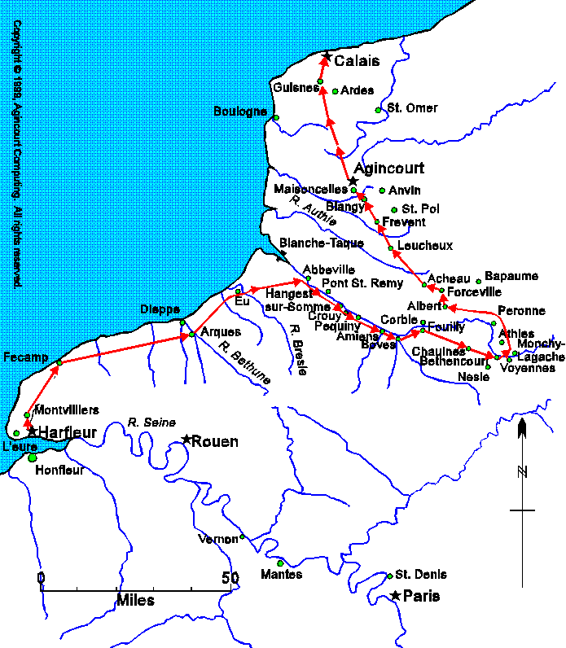
Figure 1-Henry V Route Through France [2]
Figure 1 shows the route Henry V and his forces took through France. Initially landing in Harfleur and laying siege to the town [3]. Henry V forces took Harfleur after 5 days when the towns garrison commander surrendered the town [1]. The siege of Harfleur took a toll on Henry’s forces with an estimated 2000 men killed and as much being sent back to England to recover, there was also a growing amount of dysentery within the force [1]. In order to have an impact and show Parliament a return on its investment in Henry V campaign, it was decided that the campaign in France would take the form of a Chevauchee, a form of quick raiding and pillaging in medieval times and traditionally was indiscriminate in who was killed [4]. Henry V however felt that the people of France were his subjects and therefore decided that only legitimate military targets would be engaged in such warfare [1]. The options open to Henry V to return to England were to either march to English held Bordeaux, a distance of 450 miles over land, or to English held Calais, a distance of 170 miles which was estimated to be covered in 8 days if the baggage train was reduced and the army was mounted [1]. On the 8th of October 1415 Henry V forces mounted up and began the march to Calais [1]. Along the march a number of French targets were engaged, and the French forces were amassing in order to cut Henry V off on his route to Calais. This cutoff happened at Azincourt on the 24th October 1415 [1].

2.2-Eve of Battle
Chroniclers of the time have suggested that the numbers of the French army may have reached as high as 200,000 however Corrigan suggests that the more realistic number is that the English forces were outnumbered 2 to 1, perhaps even 3 to 1 [1]. An estimate of Henry V’s forces for the battle is thought to be around 6000 men across men at arms and archers. The evening before the battle it rained constantly through the night and the battle was due to take place in an area that had freshly sown winter wheat [1]. This was an example of Henry V’s tactics which had been successful before of finding a favorable piece of ground and waiting out for an attack or wait out for the perfect time to strike [1].

2.3-The Battle of Agincourt
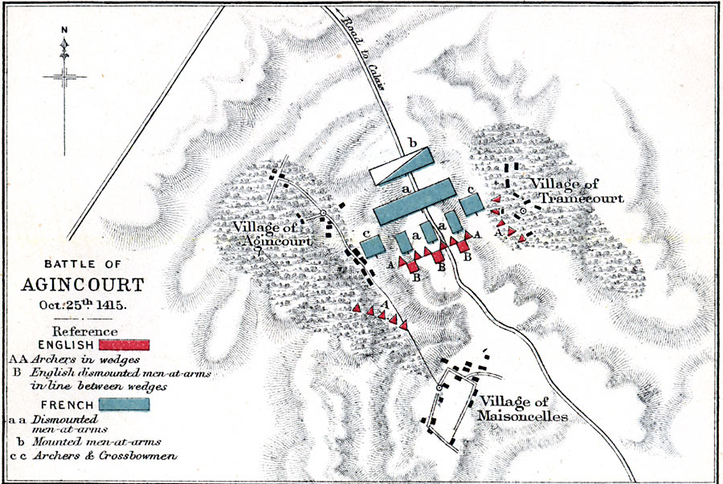
Figure 2-Tactical Map of the Battle of Agincourt [5]
Figure 2 shows the plan of the Battle of Agincourt. It is noted that the archers are in triangular shaped columns in a bid to achieve 360-degree coverage if required. Henry V was aware that in order to have the advantage of the ground he needed the French army to attack first. This attack was Induced by Henry V forces in the form of an opening salvo of arrows from the archers positioned around the battle [1]. It is believed that in the first thirty seconds of the battle 25,000 arrows were loosed on French forces resulting in “chaos, horror and surprise” [1]. Any arrows which found a target would have impacted where armour was the weakest such as through the maille or in joints in the armour [3]. In response to the opening salvo the French forces began their charge down the battlefield slope only to be confronted by Henry V battle groups and archers who had dug spikes into the ground to impale any horses and dismount their riders and had funneled the French charge into a small space restricting their ability to use their arms effectively [6]. The rain sodden terrain meant that any men at arms who had been felled from horseback had difficulty returning to their feet and were crushed further into the mud by forces coming over the top of them, because of this many French men at arms died as a result of suffocation and crushing in the main battle groups [6]. The chaos caused by the initial opening salvo and charge resulted in a number of French horses being scared and spooked which resulted in a number of them charging back through their own lines to seek safety thus causing further disruption and chaos to the French army [1]. It is thought that by the time the main melee of the battle started when both battle groups met that around half of the French forces was rendered incapacitated [1]. As the battle groups came together Henry V’s groups of archers were able to get closer, shooting at a distance of around 50 yards, at this distance it is historically thought that bodkin arrows would be capable of piercing armour plate [1]. As the prospect of the first French battle group being surrounded the thought of retreat began to rise however this proved difficult as the second battle group was impeding the retreat of the first, the result was the surrender of initially one or two French men at arms but then entire sub units surrendering to Henry V’s forces [1].
In the closing stages of the battle on the main field the French staged an attack on the English baggage train [1]. The following act as a result of the attack was carried out in order to prevent the sentiments of surrendered men at arms changing from surrender to instead turn on their captors and to scare off any attempt at attack from the third French battle group, Henry V ordered the execution of any remaining prisoners in the baggage train and with that the third battle group exited the field. The battle was over and as was tradition the battle would be named after the nearest castle that was present, in this case Azincourt however it is believed that a misunderstanding of language and pronunciation has resulted in the name Agincourt [1].

Ordnance and Armour

3.1-Ordnance
As part of the assignment brief, some details regarding the ordnance under analysis have been supplied. These are presented in Table 1.
Table 1-Properties of Bodkin Arrow
Property | Value
Type Of Ordnance | Bodkin Arrow
Delivery System | Longbow
Length of Bodkin | 115mm
Diameter of Arrow Shaft | 11.11mm
Mass of Arrow | 0.116kg
Density of Penetrator | Bodkin-6.25g/cm³, Yew Wood-0.67g/cm³
Angle of Obliquity to Impact | 30° to Normal or Greater
Velocity of System | 53.34m/s

3.2-Armour
As well as details on the Bodkin Arrow a number of details regarding the target have also been provided and are shown in Table 2
Table 2-Properties of Armour
Property | Value
Density of Plate Armour | Rank and File-2.85g/cm³, Knight-5.75g/cm³
Thickness of Armour Plate | 2.5mm-4mm
Yield Stress of Armour | 350MPa-600MPa
Velocity of Target | Foot Soldier-0.9m/s, Knight on Horseback-8.95m/s

3.3-Physics of Arrow Flight and Impact

3.3.1-Arrow Flight
The flight of the arrow will follow classic projectile motion equations. From the information provided it is possible to calculate an array of information such as the time of flight, maximum height reached and range. The first step of the calculation is to split the initial velocity into a series of components for the horizontal and vertical directions as shown in equations ( 1) and ( 2) [7]. Where u_{x} and u_{y} are the horizontal and vertical components, u is the initial velocity and θ is the launch angle.
$$u_{x}=u*cosθ$$
( 1)
$$u_{y}=u*sinθ$$
( 2)
Once in components the time of flight can be calculated for any desired angle using equation ( 3) [7]. Where T is the time of flight and g is the gravitational acceleration constant of 9.81m/s².
$$T=\frac{2*u*sinθ}{g}$$
( 3)
The range of the arrow can be calculated using equation ( 4) [7] where R is the range.
$$R=\frac{u^{2}*sin2θ}{g}$$
( 4)
Finally maximum height during the flight can be calculated firstly using equation ( 5) [7] to calculating the time maximum height is achieved and then by using equation ( 6) [7] to determine the height at that moment in time.
$$t_{h}=\frac{u*sinθ}{g}$$
( 5)
$$h=\frac{u^{2}*\sin^{2}θ}{2g}$$
( 6)
It can be assumed that the horizontal velocity of the arrow never changes due to losses, this significantly simplifies the calculations however will provide an optimistic value of range and impact velocity. Therefor the only velocity that changes will be the vertical component which has a downward acceleration of 9.81m/s². Using the height from equation ( 6) it is possible to calculate the final vertical component in the following manner using equation ( 7)
$$v_{y}=\sqrt{2*g*h}$$
( 7)
It can be assumed that when the arrow reaches its maximum height that its vertical velocity is 0 and therefore is accelerating under gravity as this point. Once the final vertical velocity is known the impact velocity and angle can be calculated by creating the resultant of the velocities in equation ( 8) and then calculating the inverse tan of the resultant to find the angle in equation ( 9)
$$v=\sqrt{v_{x}^{2}}±v_{y}^{2}$$
( 8)
$$θ_{impact}=\tan^{-1}\left(\frac{v_{y}}{v_{x}}\right)$$
( 9)
From these equations a table can be drawn up which models impact velocity and angle for a given launch angle and velocity. This data is presented in Table 3.
Table 3-Arrow Flight Model Data
From the data present the data set which most accurately matches the brief set out for a 30° oblique impact from normal predicts that a 30° launch angle was used giving a range of 251m, an altitude of 39m, a time of flight of 2.7 seconds and an impact velocity of 36.9m/s. This velocity will be required to calculate the impact properties of the arrow.

3.3.2-Arrow Impact
The arrow due to its mass and its velocity will impart kinetic energy on its target. The amount of kinetic energy it imparts could change depending on the closing speed of the target for example more energy will be imparted if the target if coming towards the flight of the arrow than if it were travelling away from the arrow. This is because momentum is conserved in all cases and can be represented by the equation ( 10) [8]. Where m is the objects mass and v are the objects velocity
$$m_{1}v_{1}=m_{2}v_{2}$$
( 10)
Further to this the energy that is imparted into the target will be represented by equation
$$E_{k}=\frac{1}{2}*m*v^{2}$$
( 11)
Using the data obtained from the modelling of the arrows flight and the given data on the parameters of the arrow, Table 4 presents the kinetic energy for each angle of launch modelled in Joules
Table 4-Kinetic Energy for Launch Angle
As can be seen for a launch angle of 30° which gives an impact angle of approximately 30° the arrow imparts 79.1J of energy into the target. Compare this value with that of a modern-day weapon such as a 9mm pistol. A modern 9mm Parabellum projectile may weigh approximately 8g and travel at a velocity of 400m/s, this gives a kinetic energy value of 643J of energy impacting into the target.
Another factor that affects the penetration effects of the arrow is the oblique nature of the impact. As specified, there is an impact angle of 30° to the normal. In studies carried out by Backman and Goldsmith [9] it was found that for velocities below 100m/s and impact angles 30° or greater that a projectile will ricochet off a target [9]. The graph shown in Figure 3 shows the projectile behavior at impact for a variety of angles and velocities.
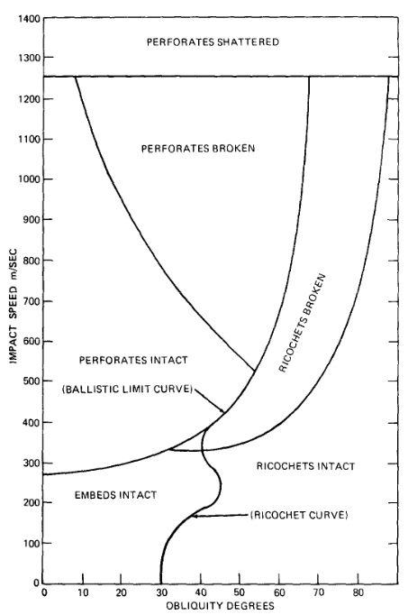
Figure 3-Projectile Impact Behavior [9]
This shows that for the properties specified the arrow is more likely to ricochet off the target than begin perforating the armour plate. If angles are less, then the arrow is more likely to penetrate the armour plate.

3.3-Testing of Ordnance and Armour in Academic Literature
Over time a number of academic scientific studies have been carried out investigating the capabilities of Bodkin arrows from the period of the 100 years war and the effect the weapon system has on armour. The first study performed by Magier et al. [10] which although investigating arrows and armour from the Battle of Crecy more than 50 years prior to Agincourt still hold relevance as this was of around the same time period. The study performed modelling on bodkin arrows and found that flight performance is similar to that calculated in section 3.3.1 and is shown graphically in Figure 4 [10]. It is however the Finite Element Analysis (FEA) modelling where the report delves further into the performance of impact. In this modelling two arrow heads were modelled, a needle type and a heavy bodkin type arrowhead. Various angles of impact were modelled however the report highlight two angles which best show the penetrative performance of both the needle and heavy bodkin arrow heads. These results are shown in Figure 5 [10] and Figure 6 [10].

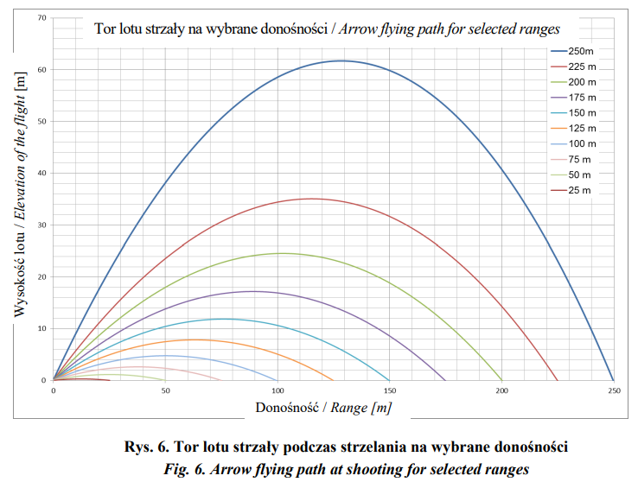
Figure 4-Graphic representation of flight path from Magier et al study [10]
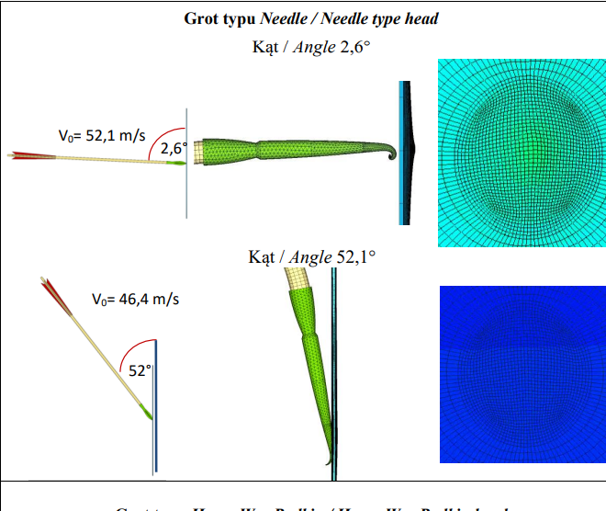
Figure 5-Needle arrowhead FEA model impacting at 2.6 degrees and 52 degrees [10]
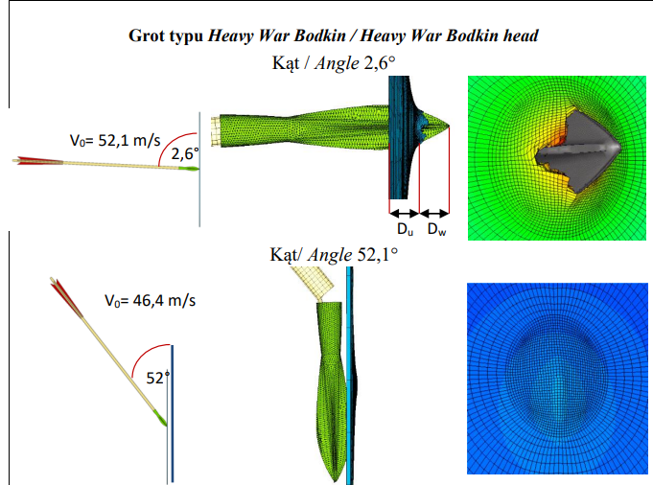
Figure 6-Heavy Bodkin arrow FEA model impacting at 2.6 degrees and 52 degrees [10]
The needle point arrow has then been compared with needle arrow heads which have gone through physical testing and the arrow heads have been damaged in a similar way as to that modelled thus adding validity to the numerical modelling.
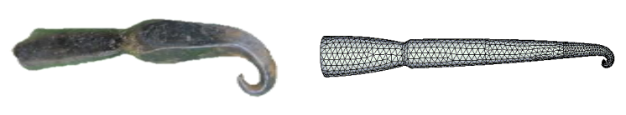
Figure 7-Comparison of deformation of modelled arrowhead (right) and physical arrowhead (left) [10]
The second academic study was carried out by Bane in 2006 [11]. In this study 4 different arrowheads were tested and are shown in Figure 8 [11]. These are the triangular broadhead, ogive broadhead, needle bodkin and short bodkin.
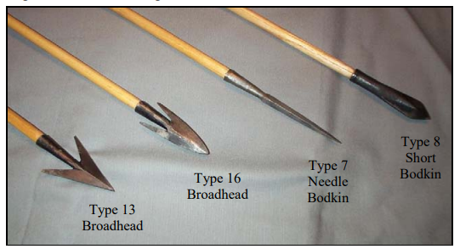
Figure 8-Arrow heads on test [11]
Similar modelling was carried out to determine energies involved with the arrow impacting the target and it was found that 74.1J would be imparted onto the target with a bow of 75 pounds draw strength. This is conservative of the values calculated in section 3.3.1 however is in the vicinity for an arrow impacting at an angle of 30°.
The armour that was chosen to be tested against were a cloth type armour consisting of multiple layers and deer skin, almost a medieval Kevlar, called jack cloth, butted and riveted maille of differing qualities, coat of plate armour and finally plate armour.
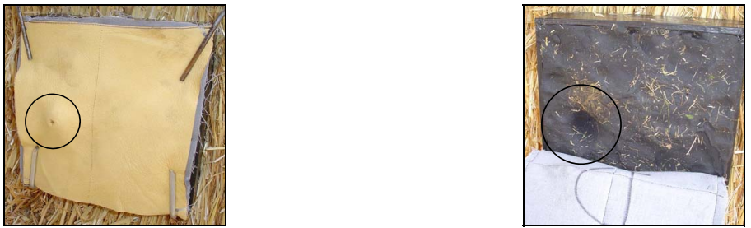
Figure 9-Short bodkin jack cloth test [11]
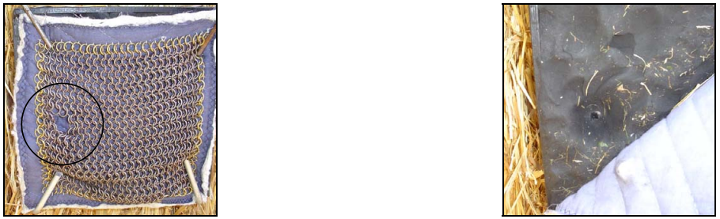
Figure 10-Short bodkin butted maille test [11]
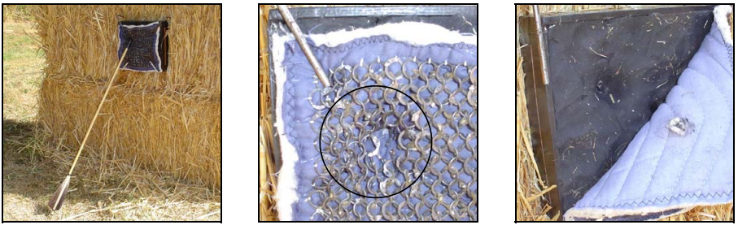
Figure 11-Short bodkin riveted maille test [11]
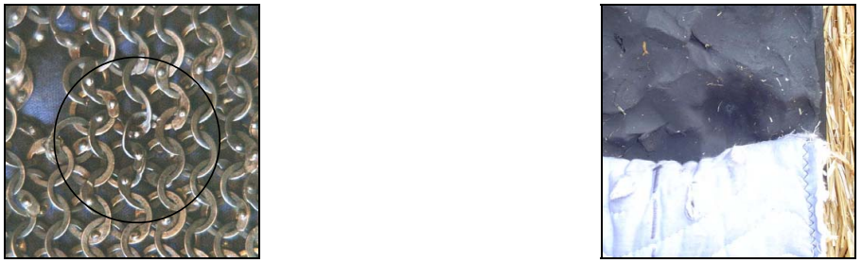
Figure 12-short bodkin high quality riveted maille test
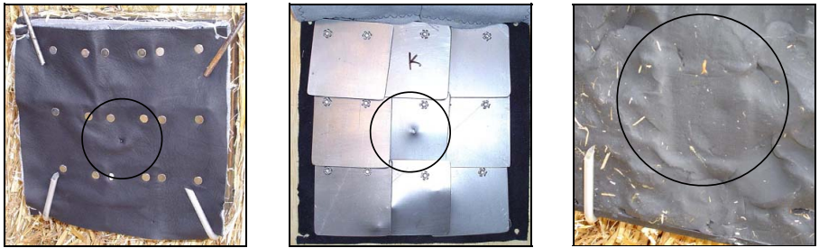
Figure 13-short bodkin coat of plate test [11]
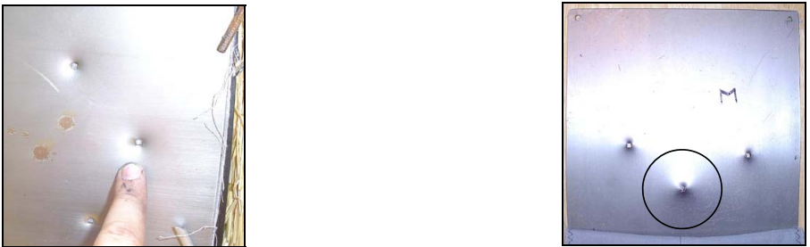
Figure 14-short bodkin plate test-steel-1.2mm thick [11]
Bane used armour testing criteria set out by the National Institute of Justice to determine if deformation into the body backplate would have been lethal or not. It was found that the jack cloth, coat of plates armour and plate armour were good at withstanding the deformation caused by the impact of the arrow however the maille armour performed less satisfactorily and it was found that the short bodkin caused rings of the maille to be pushed into the skin and caused deformations which would be regarded as lethal as set out by the criteria of the standards as set out by the National Institute of Justice [11].

Discussion
From the analysis undertaken for this report investigating the military tactics employed by Henry V and the events of the Battle of Agincourt, modelling the predicted energies imparted by the bodkin arrow under investigation and investigating academic studies which have performed studies in the field there are a number of points to discuss regarding if the English longbow and bodkin arrow were a deciding factor in the outcome of the battle of Agincourt.
Similar tactics to those employed by Henry V have been employed numerous times throughout history of forcing an enemy to fight in a section of ground which is either more familiar or can reduce contact with the enemy to a more manageable amount. Such tactics were employed by William Wallace at the Battle of Stirling Bridge where the English Infantry advanced and were funneled by the crossing eventually being cut off by Wallace’s Schiltron spear defence thus enabling victory for Wallace’s forces [12]. Henry V employed similar tactics by forcing the French to advance on the English in a narrow section of the field, thus limiting the numbers which could advance, and which had been freshly sown and turned to mud by the previous days rainfall thus limiting the speed of their advance. Henry V also made use of a Schiltron style tactic and deployed stakes in the ground to capture the advancing French cavalry and protect elements of Henry V's army.
The psychological impact of a weapon or a show of force can have a significant effect on the battlefield and the outcome of a war. As has been investigated in this report the Bodkin Arrow and Longbow played a significant part in causing the horses of the French cavalry to become scared and cause chaos on the battlefield by running back through their own lines, the fear of the English archers may have also been felt by the French army as there is no warning when and where the arrows may come from in the battlefield. As has been demonstrated by the technical academic studies carried out the arrow would need to find a gap in the armour and impact through the maille armour to cause significant injury and in some cases lethality to the target, the probabilities of this happening are low and in order to increase that probability a significant number of arrows need to be flying at once in order to potentially find a target, the potential of this happening may have induced more fear in the French army thus making them more susceptible to either retreat or surrender.
The weather conditions of the day before and day of the battle played a part in the outcome of the battle. There is significant historical research to suggest that many of the more heavily armoured French forces were suffocated either through a crush on the battlefield or by falling in the mud and being trampled by advancing forces coming over the top of them. This would have limited the numbers Henry V’s forces would have had to encounter in close quarter combat. The crushing element of the battlefield also played to Henry V’s advantage as it restricted the movements of the French forces reducing their ability to use their weapons effectively.
Because of the evidence raised through the analysis of the Battle of Agincourt it is the professional opinion that the longbow and bodkin arrow, although their use tactically important were not the major contributing factor to causing French losses and to ensuring Henry V’s victory at Agincourt and instead a more holistic viewpoint on the battle is required in that the tactics employed, the terrain of the battle, the weather conditions preceding it and the weaponry and forces available to Henry V all played significant roles in securing victory.

5.0 Conclusion
This report has performed an in-depth study into the Battle of Agincourt and attempted to answer if the English longbow and bodkin arrow were a significant attributing factor to Henry V’s victory. A significant number of sources have been consulted including historical based works and technical investigations carried out by academia. Modelling has also been performed to predict the dynamics of an arrow and the energies that such arrows may impart on a target and has compared this with academic studies which carried out both numerical models and physical testing. The report then proceeded to discuss the merits of the historical information and combined these with the scientific studies that have been carried out and drew an informed opinion that although tactically significant but not in terms of enemy losses, that a holistic viewpoint of the Battle of Agincourt is required to fully understand the Longbows place and impact in the battle.

6.0-References

[1] | G. Corrigan, A Great and Glorious Adventure: A Military History of the Hundred Years War, London: Atlantic Books, 2013.
[2] | Agincourt Computing, "Henry's Route to Agincourt, 8-29 October 1415," Agincourt Computing, 1999. [Online]. Available: http://www.aginc.net/battle/route-map.htm. [Accessed 7th October 2022].
[3] | R. H. Jarman, Agincort: The Story of a Battle, Stroud: Amberley Publishing, 2012.
[4] | Thought Co., "The Chevauchée Was a Brutal Way of Waging War," Thought Co., [Online]. Available: https://www.thoughtco.com/what-is-the-chevauchee-1221912. [Accessed 7th October 2022].
[5] | Florida Center for Instructional Technology, "Battle of Agincourt, October 25, 1415," University of South Florida, 2009. [Online]. Available: https://etc.usf.edu/maps/pages/400/431/431.htm. [Accessed 7th October 2022].
[6] | A. Curry, Great Battles: Agincourt, Oxford: Oxford University Press, 2015.
[7] | LibreTextss Physics, "3.3: Projectile Motion," [Online]. Available: https://phys.libretexts.org/Bookshelves/University_Physics/Book%3A_Physics_(Boundless)/3%3A_Two-Dimensional_Kinematics/3.3%3A_Projectile_Motion. [Accessed 18th October 2022].
[8] | The Physics Hypertextbook, "Conservation of Momentum," midwoodscience.org, [Online]. Available: https://physics.info/momentum-conservation/summary.shtml. [Accessed 18th October 2022].
[9] | M. E. Backman and W. Goldsmith, "The Mechanics of Penetration of Projectiles Into Targets," United States Naval Weapons Center, China Lake, 1978.
[10] | M. Magier, A. Nowak, T. Merda and P. Zochowski, "Numerical Analysis of English Bows Used In Battle of Crecy," Issues of Armament Technology, vol. 142, no. 2, pp. 69-85, 2017.
[11] | M. Bane, "English Longbow Testing Against Various Armour Circa 1400," Self, Unknown, 2006.
[12] | The National Wallace Monument, "The Battle of Stirling Bridge," The National Wallace Monument, [Online]. Available: https://www.nationalwallacemonument.com/the-battle-of-stirling-bridge/. [Accessed 25th October 2022].
[13] | The National Archives, "Why The Battle of Agincourt Happened," The National Archives, [Online]. Available: https://www.nationalarchives.gov.uk/agincourt/why-the-battle-of-agincourt-happened/. [Accessed 29 September 2022].
[14] | The National Archives, "Campaign and Battle," The National Archives, [Online]. Available: https://www.nationalarchives.gov.uk/agincourt/campaign-and-battle/. [Accessed 29th September 2022].
[15] | Khan Academy, "What is 2D projectile motion?," Khan Academy, [Online]. Available: https://www.khanacademy.org/science/physics/two-dimensional-motion/two-dimensional-projectile-mot/a/what-is-2d-projectile-motion. [Accessed 17th October 2022].

